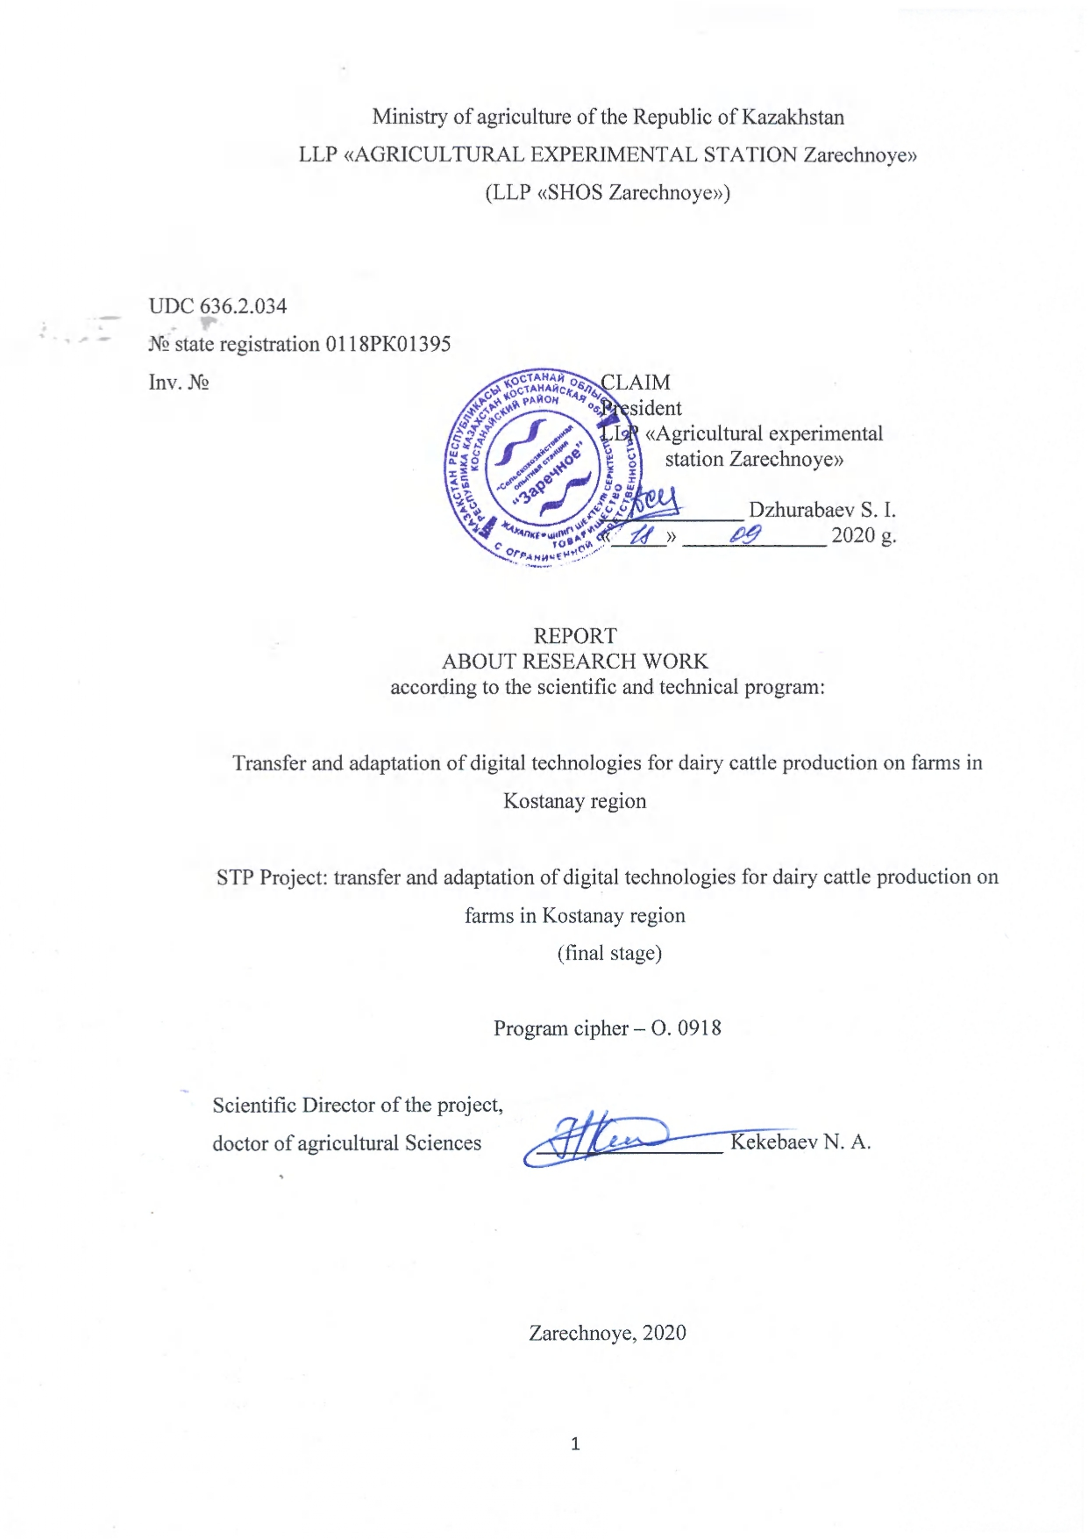
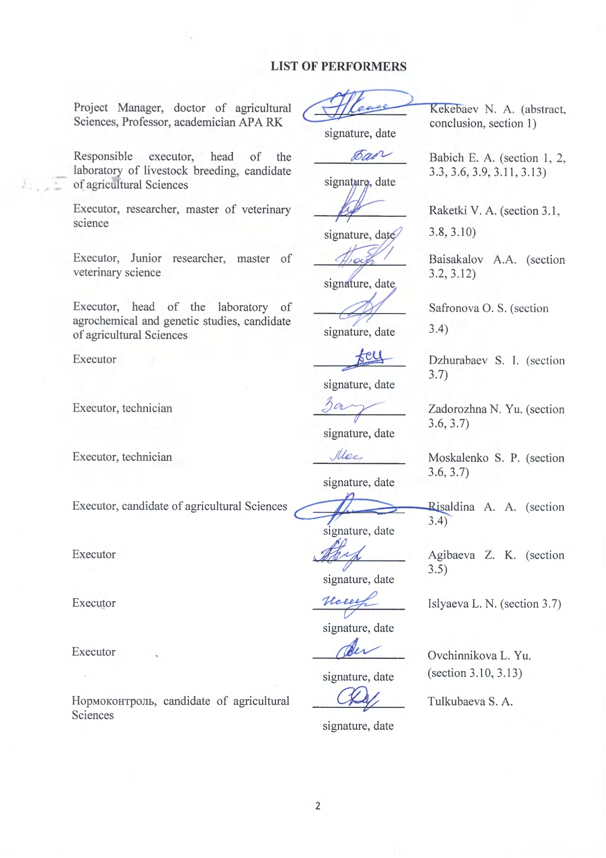

REPORT

Report 176 p., 12 figures, 42 tables, 53 sources, 12 applications.
DAIRY CATTLE, CATTLE, GROWTH, DEVELOPMENT, FEEDING, HERD MANAGEMENT, IMPLEMENTATION, DIGITALIZATION
The object of research is Holstein cattle.
The purpose of the work is to implement the transfer and adaptation of digital technologies for the production of dairy cattle on farms in Kostanay region.
Methods of work – zootechnical, analytical, economic.
Results and their novelty: the percentage of fruitful insemination by the visual insemination system increased by 32.1-33.7% and is the most rational. The average daily increase in live weight of calves with the cold method of keeping is higher by 10.1-10.7%, the profitability of growing increased by 12.9-13.0%. The introduction of digital technologies for weighing animals and modern injectors for veterinary treatments has halved the number of employees involved, and labor productivity has increased by 55.8%. The use of drugs and feed additives contributed to the intensification of redox and synthetic processes, strengthening the level of natural protection of the body and increasing the growth rate of young animals by 3.8-10.3%. A "feeding technologist's Tablet" has been created that allows you to automatically create rations, add new feeds and change the characteristics of existing ones; view and edit the cost of feed; plan feed consumption in groups; generate summary reports of feed consumption by productivity; summarize information on feed consumption; choose the diets for groups and print out any information from the calculations and database. 2 model farms were created in LLP «Turar» and LLP «Olzha AK Kuduk».
Field of application – dairy farms.
Recommendations for the implementation of research and development: the results of research can be used in the transfer of modern digital equipment, adaptation of foreign technologies in farms engaged in breeding dairy cattle.
Economic efficiency: the introduction of innovative equipment and technologies in production helped to reduce the cost of production, in particular milk by 2.88%, reduce the use of labor resources by 48.8-52.8%, increase the milk productivity of cows by 3.8-4.7%, profit by 17.9-18.9% and profitability by 6.1-6.3%.

CONTENT
INTRODUCTION …………………………………………………………………………... | 8
MAIN PART ………………………………………………………………………………… | 11
1 CHOOSING THE RESEARCH DIRECTION ……………………………………………. | 11
2 Research methodology …………………………………………………………………….. | 12
3 Research results …………………………………………………………………... | 14
3.1 Сomparative analysis of biotechnological reproduction мethods ……………………… | 14
3.2 Тechnologies for accelerated pregnancy detection and diagnosis of diseases of the reproductive system …………………………………………………………………………. | 15
3.3 Effectiveness of the cold method of keeping calves in the dairy period ………………. | 18
3.4 Efficiency of using alternative energy sources on farms ………………………………. | 23
3.5 Scientific methods for improving arable land: root and surface improvement of grass stands ………………………………………………………………………………………… | 25
3.6 Development of effective methods of veterinary treatment of animals and their weighing ……………………………………………………………………………………... | 27
3.7 Study of the influence of indoor microclimate on the reproductive capacity of cows … | 30
3.8 Introduction of effective manure removal systems on the farm, assessment of the economic efficiency of manure Processing …………………………………………………. | 35
3.9 Effectiveness of the effect of intensive feeding with the use of drugs and feed additives on the growth of live weight of young animals | 39
3.10 Еfficiency of using the «herd Management» system in production» ………………… | 42
3.11 Evaluation of the economic efficiency of using new equipment and technologies …... | 46
3.12 Vaccination plan. Effects of vaccines and medicines on animals ……………………. | 49
3.13 Feeding cows. Tablet technology for the feeding …………………………………….. | 52
Generalization and evaluation of research results …………………………………………... | 59
CONCLUSION ……………………………………………………………………………… | 60
LIST OF SOURCES USED …………………………………………………………………. | 62
Application A - Patent Research Report ………………………………………………... | 66
Application B - Calendar plan for 2018-2020 ………………………………………….. | 78
Application C - Tables for the report…………………………………………………… | 83
Application D - Drawings to the report ……………………………………………….. | 89
Application E - Information on purchasing equipment within the project …………….. | 106
Application F - The acts of implementation……………………………………………. | 107
Application G – List of published works …………………………………………….. | 109
Application H - Prints of published works………………………………….................. | 110
Application J – Report on seminars …………………………………………………... | 112
Application K – Information about a foreign expert…………………………………… | 114
Application L – Extract from the minutes of the Academic Council…………………. | 169
Application M - Reviews………………………………………………………………. | 175

TERMS AND DEFINITIONS

The following terms and definitions are used in this research report:
ANIMALS | animals used, or that can be used, to produce animal products
REPRODUCTION | permanent renewal of livestock for the purpose of agricultural production based on a number of zootechnical measures
FEED ADDITIVE | substances of organic, mineral and (or) synthetic origin used as sources of missing nutrients and minerals and vitamins in the diet of animals
GROWTH | accumulation of body weight
DEVELOPMENT | is the quality of changes that occur in the body, which is reflected visually and on changes in the exterior
MICROCLIMATE | the state of the internal environment of the room, which has both a positive and negative impact on the animal, is characterized by indicators of temperature, mobility and humidity
ECONOMIC EFFICIENCY | the ratio between the result of activity and the total current production costs
NUTRITION | the ability of feed to meet the natural needs of animals for certain nutrients for their life, as well as the production of livestock products

LIST OF ABBREVIATIONS AND DESIGNATIONS
The following abbreviations and designations are used in this research report:
LLP | – limited liability partnership
dr. | – drawing
p. | – page
tab. | – table
appl. | – application
n | – number of observations
тыс. | – one thousand
p/b | – purebred
bl/wht. | – black and white
сm | – centimeter
kg | – kilogram
% | – percentage
mon. | – month
goal. | – goals
Х | – arithmetic mean

INTRODUCTION
The relevance of the research. The intensive implementation of digitalization in agriculture promises to turn the industry into a high-tech business by increasing productivity and reducing unproductive costs, which are attributes of agriculture [1, 2, 3, 4, 5].
For a long time, agriculture has not been an attractive business for investors, due to the long production cycle, exposed to natural risks and large crop losses during cultivation, collection and storage, the inability to automate biological processes and the lack of progress in improving productivity and innovation [6, 7, 8, 9, 10]. The use of information technology in agriculture was limited to the use of computers mainly for financial management and tracking commercial transactions. Not so long ago, farmers started using digital technologies to monitor crops, cattle, and various elements of the agricultural process [11, 12, 13, 14, 15]. The growing demand for dairy products makes dairy farming an attractive investment industry. At the same time, modern technologies change the usual image of a dairy farm, providing comfortable living conditions for cows [16, 17, 18]. One of the main factors in using automated systems is to optimize the production process, reduce labor costs and improve working conditions.
According to GEA calculations, 39% of the working time on a "commercial" farm is spent on milking, 17% on feeding, 15% on management tasks, 7% on changing bedding, and 22% on other processes. On "professional" farms, the milking process takes 50% of the working time. The use of automatic milking systems allows you to optimize this process and reduce the number of workers employed on the farm. Automated systems are used not only for optimizing the milking process, but also for feeding, which is another promising area of application on the farm [19, 20, 21, 22, 23].
The use of robotic feed dispensers on the farm allows you to optimize feed usage, reduce leftovers, make optimal use of space, and ultimately reduce costs. For example, an automatic feeding system like Mix Feeder allows you to save up to 3 hours of working time per day and 10 kW of electricity per day [24, 25, 26].
Thus, the development of the dairy industry, as well as the entire agriculture, is determined by the use of new technologies, innovative solutions in the field of management, and the transition to automation of the production process.
The novelty of the research. For the first time in Kostanay region, the transfer and adaptation of digital technologies for the production of dairy products on farms will be introduced and studied on the basis of existing dairy farms.
Scientific and practical significance of research. In the conditions of Northern Kazakhstan, together with farmers engaged in breeding black-and – white and Holstein cattle, automation of the herd management system, through the integrated use of science-based feeding standards-the creation of a technologist's tablet for feeding, keeping and rearing repair young animals, system control of the microclimate in the premises will save up to 20% on feed, get an increase in milk yield up to 35% and reduce the need for labor resources up to 30-35%.
The goal of the project is to transfer and adapt digital technologies for automating the production of livestock products on the basis of two model dairy farms in Turar LLP and Olzha AK-Kuduk LLP from 100 cows.
Research problem:
1. Сonduct a comparative analysis of biotechnological methods of reproduction and determine the rational method of reproduction.
2. Implement a technology for rapid determination of pregnancy and diagnosis of diseases of the reproductive function.
3. Determine the effectiveness of the cold method of keeping calves in the dairy period, the economic efficiency of using new equipment to reduce production costs by using alternative energy sources and water supply on the farm.
4. Introduce scientific methods for improving arable land - technologies for root and surface improvement of grass stands using their own developments.
5. Develop effective methods of veterinary treatment of animals and their weighing. To study the influence of indoor microclimate on the reproductive capacity of cows.
6. Implement effective manure removal systems on the farm, evaluate the economic efficiency of thermal or other methods of processing manure.
7. To Study the effectiveness of the effect of intensive feeding with the use of drugs and feed additives on the live weight gain of young animals of various groups.
8. Evaluate the efficiency of using the «herd Management» system in production.
9. Evaluate the economic efficiency of using new equipment, the impact on cost, and the effective use of labor resources.
10. Study the effects of different vaccines and medications on animals and make a vaccination plan.
11. Create a balanced diet, measure and control feed consumption of the most productive animals, the effectiveness of feed additives; develop and implement a method for compiling feeding rations by gender and age groups based on the results of the analysis of feed used in the farm - create a tablet for a feeding technologist.
Information about patent research and conclusions from it:
Scientific and patent research was carried out on the topic of research from 2012 to 2020 in a number of countries: Kazakhstan-Russia.
As a result, the closest analogs are identified – patents that have a common focus. In General, the results of patent research have shown that the proposed specific areas of research are very relevant and protectable. Outside of Kazakhstan, many countries around the world are developing technologies for keeping, automating feeding, improving pastures, and managing livestock. Similar work is carried out in the all-Russian VNIIMS, GNU VIM of the Russian agricultural Academy, FGBOU VPO RGAU MSHA named after K. A. Timiryazev. Many institutes are developing new programs, technologies for growing and maintaining, determining pregnancy, and diagnosing diseases of the reproductive system.
Information about metrological support for research work.
GOST 55445-2013. Hay and Haylage.
GOST 4808-87. Hay.
GOST 31640-2012. Stern. Methods for determining the dry matter content.
Interim report:
2018 - transfer and adaptation of digital technologies for dairy cattle production on farms in Kostanay region, inventory number 0218RK01424;
2019 - transfer and adaptation of digital technologies for dairy cattle production on farms in Kostanay region, inventory number 0219RK01365.

MAIN PART
1 CHOOSING THE RESEARCH DIRECTION
Improvement of dairy cattle is an integral part of the intensification of milk production in Kazakhstan. The main indicators of cattle breeding intensification in the country are based on the achievements of scientific research and best practices. The intensification of dairy cattle breeding requires improvement and, in some cases, revision of traditional methods of breeding. First of all breeding work should be aimed at further increasing the genetic potential of animals while creating conditions for the most complete manifestation of this potential [27, 28, 29, 30].
In recent years, the conditions of the dairy cattle industry in Kazakhstan have undergone significant changes. A large decrease in the number of livestock and production of dairy products was allowed. The industry operates in a highly competitive environment with increasing imports. Despite certain measures taken by the government in recent years, the number of cows continues to decline, both in the Republic and in the Kostanay region. The decline in milk production has dramatically affected the level of consumption of milk and dairy products. In General, the profitability of milk production in Kostanay region is very low, and in most farms it is even unprofitable [31, 32, 33, 34, 35].
At the present stage of economic development of Kostanay region, dairy cattle breeding should be highly productive in order to be profitable, competitive and ensure food independence. Increasing productivity is inextricably linked to the economy of production. Payment for feed with dairy products is directly dependent on the amount of milk yield [36, 37, 38, 39].
A significant increase in dairy productivity of cows is associated with the intensification of dairy cattle breeding, which is based on a high level of selection and breeding work, as well as on new intensive technologies for feeding, keeping and organizing animal reproduction [40, 41, 42, 43].
Under these conditions, to ensure the growth of dairy productivity of cows, the Holstein breed was imported to the Kostanay region and Holstein cattle were carried out. The choice of this breed is determined by the excellent adaptability of animals to intensive technologies, due to a strong Constitution, good physique, udder suitability for machine milking and high intensity of milk production, exceptional ability to convert feed into products, intensive growth of young animals and high potential for milk productivity. To increase milk production, the role of large complexes, as well as investment projects for the construction of such complexes, is increasing, since only within their framework can modernization and innovation be carried out, which will bring animal husbandry to a new level [44, 45, 46, 47, 48, 49, 50, 51, 52, 53].
Thus, the implementation of the project will have a positive impact on the growth of macroeconomic, regional and industry indicators of the Republic.
2 Research methodology
The research was conducted according to the calendar plans for 2018, 2019 and 2020. (Appendix B).
Сomparative analysis of biotechnological reproduction Methods was performed using the rectocervical method and the Alphavision visual insemination system (France). Pregnancy was diagnosed with rectal and instrumental - with the help of ultrasound at different times after insemination (Draminski).
Three groups of heifers were formed by the method of paired analogues to study the effectiveness of the cold method of keeping calves of 20 heads each. The first group was kept using traditional technology, the second group – in individual houses on the street. The study of the growth of animals was carried out by determining the live weight by weighing monthly from birth to 6 months. Average daily and relative increments were calculated by growth periods.
To determine effective methods of veterinary treatment of animals, injectors (manufactured in New Zealand) for the introduction of medicines and a mobile veterinary machine were introduced; for weighing, TRU TEST electronic scales and mobile electronic scales were installed. 3 groups were also formed to study the effect of indoor microclimate on the reproductive capacity of cows. The first group was located at the end, at the entrance to the room; the second – in the center of the building; the third – from the end, at the end of the room. The microclimate parameters were measured at three points. The temperature was measured using a thermometer, relative humidity with a psychrometer, air velocity with an anemometer, and the concentration of harmful gases in the room using a gas analyzer. The manifestation of reproduction indicators was studied under different microclimate parameters. The study of the effectiveness of the effect of intensive feeding was carried out with the addition of feed additives to the diet.
The efficiency of using the «herd Management» system in production was evaluated by downloading data from the program on milk productivity per day, milk electrical conductivity, animal activity, insemination reports, and calving.
We analyzed the epizootic situation in Kostanay region, determined the use of vaccines and medications. The physiological state of the animals was studied before and after vaccination, taking into account temperature, pulse, and respiration.
A survey of pastures was conducted to determine the yield and Botanical composition. Feed consumption was taken into account by the control feeding method based on the difference in the mass of the given feed and uneaten residues. The feeding ration was made in accordance with the standards of Vish.
All digital material obtained as a result of research is entered into the PC database and processed using the grouping method. Statistical processing of the obtained materials was carried out by the method of variational statistics proposed by G. F. Lakin [30] using a PC in the Microsoft Excel program. The difference was considered reliable by the Student's criterion and indicated in the tables with the sign: * – at P < 0.05; ** – at P < 0.01; *** – at P < 0.001.

3 Research results
3.1 Сomparative analysis of biotechnological reproduction мethods
Reproduction of cattle is one of the most complex and time - consuming organizational, economic and technological processes in the technology of animal husbandry. The use of biotechnological methods of reproduction is of fundamental importance for the development of dairy cattle breeding. Low indicators of cow reproduction prevent an increase in the number of livestock, slow down the growth of milk and meat production, worsen the economic efficiency of production, and reduce the pace of the breeding process.
For a comparative analysis of biotechnological methods of reproduction in order to determine a rational method of reproduction on the basis of model farms of LLP «Turar» and LLP «Olzha AK Kuduk», artificial insemination was performed using the rectocervical method and the Alphavision visual insemination system (Appendix D, Fig. 1), which is a device for insemination in the form of a gun equipped with a camera that facilitates the work of specialists practicing artificial insemination. Thanks to the Alphavision system, direct contact of the gun with the vaginal wall is excluded during fertilization. Saving photos during fertilization using the Alphavision system allowed remote diagnostics (Appendix D, Fig. 2, G. 3).
Artificial insemination of 100 cows was carried out in LLP «Turar»: rectocervical method - 50 heads and 50 heads using the visual insemination system. As a result of scientific experience, it was established that the number of fruitfully inseminated animals was 28 heads. In individuals inseminated by the Alphavision visual insemination system, false hunting was detected during manipulations - closed cervix and endometritis with involvement in the inflammatory process of the cervix. Of the 50 animals, 39 were inseminated, of which 35 were pregnant after testing.
LLP «Olzha AK Kuduk» artificially inseminated 265 cows: 128 heads by rectocervical method and 137 heads by visual insemination system. The number of fruitfully inseminated animals was 74 heads using the rectocervical method. In individuals inseminated by the Alphavision visual insemination system (ADJ.D, Fig. 4), during manipulations, a false hunt was detected - a closed cervix and endometritis with involvement in the inflammatory process of the cervix. Out of 137 animals (ADJ. G, Fig. g. 5, G. 6), 109 heads were inseminated, of which 98 were pregnant after testing.
To determine the rational method of reproduction calculated costs of insemination in different ways, table 1. Control group cows were inseminated ectocervical method, and experimental group – visual insemination Alphavision.

Table 1 - Еffectiveness of insemination methods, 2019-2020
Indicator | Method of insemination
Indicator | LLP «Turar», 2019. |  | LLP «Olzha AK Kuduk», 2020
Indicator | control group | experimental group | control group | experimental group
Cows, heads | 50 | 50 | 128 | 137
Of them with signs of sexual hunting, heads | 50 | 50 | 128 | 137
Visualization of pathology during insemination, heads | - | 11 | - | 28
Inseminated, heads | 50 | 39 | 128 | 109
Pregnant, heads | 28 | 35 | 74 | 98
Price of 1 dose of seed, tenge | 1200 | 1200 | 1500 | 1500
Doses spent | 100 | 78 | 256 | 218
Cost of all doses | 120 000 | 93 600 | 384 000 | 327 000
Percentage of fruitful insemination | 56,0% | 89,7% | 57,8% | 89,9%

As a result, it was found that the use of the Alphavision visual insemination system in artificial insemination makes it possible to identify cows with signs of false hunting. The percentage of fruitful insemination in LLP «Turar» in 2019 increased to 89.7%, in LLP «Olzha AK Kuduk» 2020 to 89.9%.
Thus, a comparative analysis of the two methods of reproduction allowed us to determine that the rational method of reproduction is the use of the Alphavision visual insemination system. The percentage of fruitful insemination increased by 32.1 and 33.7%, than in ectocervical method.

3.2 Тechnologies for accelerated pregnancy detection and diagnosis of diseases of the reproductive system
Diagnostics of pregnancy of cows is of great production importance for dairy cattle breeding. Often slaughtered in the slaughterhouse cows are pregnant with 4 - 5 month old fetuses, which is the result of the lack of an early, accurate and completely objective method of diagnosis. For the same reason, it is not uncommon for pregnant cows to be considered infertile, and improper feeding regimens are applied to them, and insemination of pregnant cows in false hunting often leads to abortions. All this causes great economic damage.
Based on the analysis of the use of different methods for determining pregnancy, a more reliable result is obtained using ultrasound diagnostics (ultrasound).
LLP «Turar» and LLP «Olzha AK Kuduk» implemented the technology of accelerated pregnancy detection and diagnostics of reproductive function diseases using a portable DRAMINSKI ultrasound scanner with a rectal electro-mechanical 5.0 MHz sensor. Pregnancy determination using ultrasound was performed in the early stages - from 30 days after insemination. For comparative analysis, a rectal examination of the experimental livestock was performed in parallel. The results of the research are presented in table 2.

Table 2 – Diagnostics of pregnancy and infertility of cows by different methods
Method of research | Pregnancy days
Method of research | from 28 to 40 (n=75) |  | from 41 to 50 (n=68) |  | from 51 to 60 (n=55)
Method of research | pregnant | not pregnant | pregnant | not pregnant | pregnant | not pregnant
 | LLP «Turar»
Ultrasound diagnostics | 60 | 15 | 61 | 7 | 50 | 5
Rectal examination | 41 | 34 | 51 | 17 | 50 | 5
 | LLP «Olzha AK Kuduk»
 | from 28 to 40 (n=158) |  | from 41 to 50 (n=74) |  | from 51 to 60 (n=33)
Ultrasound diagnostics | 121 | 37 | 67 | 7 | 30 | 3
Rectal examination | 74 | 84 | 39 | 35 | 24 | 9

According to the results of ultrasound diagnostics, pregnancy for a period of 31-41 days was visualized as a cavity in the uterine horn containing fluid, in which a compactly located embryo with a size of 6-10 mm was viewed, figure 1.
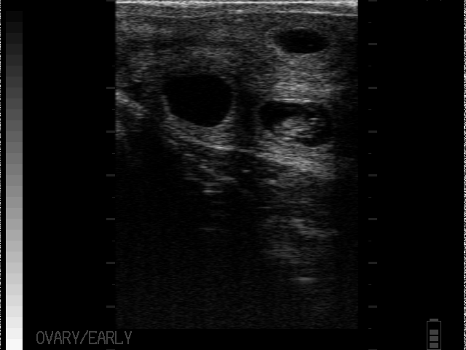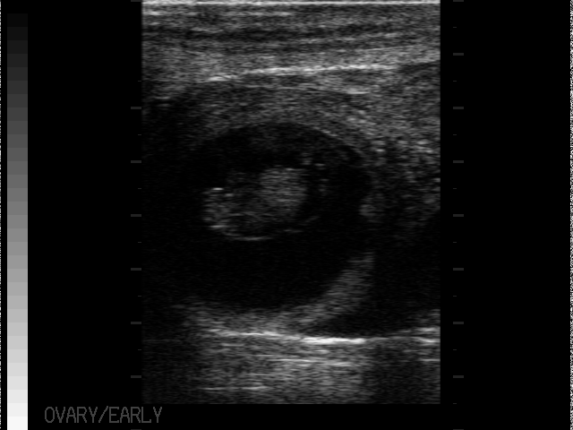
Figure 1 - Рregnancy period of 31-41 days
Analysis of the use of methods for diagnosing pregnancy, table 2 showed that from 28 to 40 days after insemination, ultrasound results diagnosed pregnancy in 60 cows, or 80%; 15 cows, or 20%, were doubtful. With rectal technique, pregnancy was diagnosed in 41 cows, or 55%, and 34 cows, or 45%, were doubtful.
Determination of pregnancy in the second group of animals from 41 to 50 days after artificial insemination, ultrasound examination allowed to determine pregnancy in 61 cows, or 90%, a dubious diagnosis was made in 7 cows, or 10%. According to the results of rectal examination, pregnancy was diagnosed in 51 cows, or 75%, and infertility in 17 cows, or 25%.
Examination of the third group of cows from 51 to 60 days after insemination by ultrasound showed pregnancy in 50 cows, or 90%, infertility in 5 cows, or 10%, which was later confirmed by rectal palpation, figure 2.
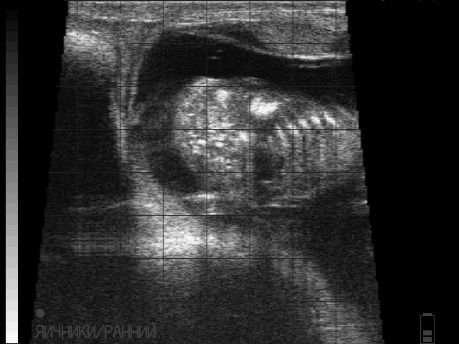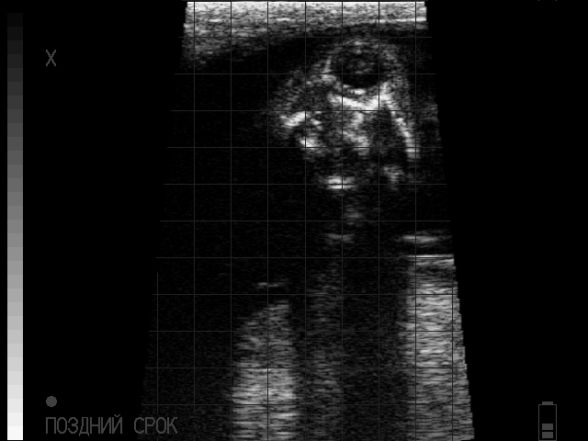
Figure 2 - Рregnancy - 51-60 days
Rectal pregnancy examination on day 60 after insemination confirmed the ultrasound data by 100%.
Therefore, the use of ultrasound scanning of cows from 31 days after insemination is the most effective method for determining pregnancy. Diagnosis at an earlier time increases the risk of false responses and fetal mortality.
LLP «Turar» and LLP «Olzha AK Kuduk» introduced diagnostics of diseases of the reproductive function and reproductive system using Raskan and Draminsky ultrasound scanners. Studies were conducted on cows with a service period of more than 85 days, the results are presented in table 3.

Table 3 - Results of the survey of reproductive functions and reproductive system of cows
Indicator | LLP «Turar» |  | LLP «Olzha AK Kuduk»
Indicator | number of goals | % | number of goals | %
Total examined | 200 | 100 | 285 | 100
Endometritis | 16 | 8,0 | 28 | 9,8
Atrophy of the ovary | 4 | 2,0 | 7 | 2,4
Luteal cyst | 41 | 20,5 | 62 | 21,7
Follicular cyst | 53 | 26,5 | 45 | 15,8
Uterine atony | 2 | 1,0 | 3 | 1,0
Persistent yellow body | 24 | 12,0 | 18 | 6,3

Analysis of the data in table 3 allowed US to reliably establish the diagnosis of diseases of the reproductive system based on the results of ultrasound diagnostics. The percentage of diseases varies from 1% to 26.5%. The most common diseases are ovarian cysts. Ultrasound scanning reliably determined the types of cysts: luteal - 20.5-21.7% and follicular – 15.8-26.5%, figure 3.
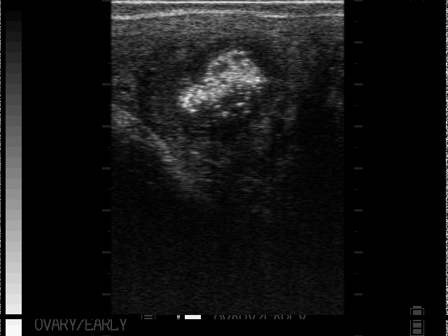  а | 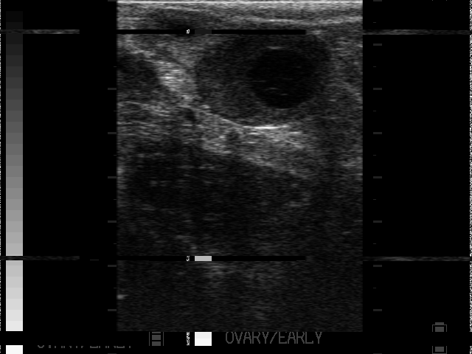  б | 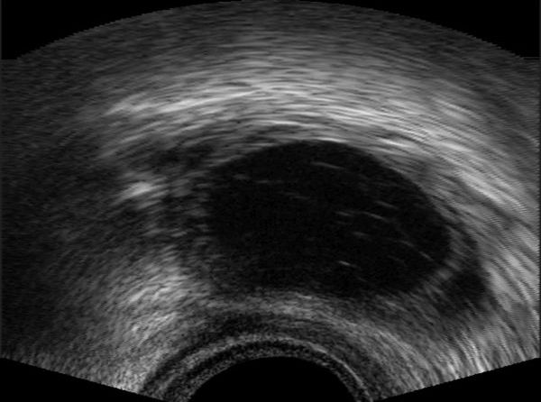  в
a – signs of endometritis; b – luteal cyst; C – follicular cyst
Figure 3 – Ultrasound diagnostics of cows reproductive organs
Thus, the introduction of ultrasound examination is the most effective method for rapid determination of pregnancy in the early stages and a reliable method for diagnosing the reproductive function of cows.

3.3 Effectiveness of the cold method of keeping calves in the dairy period
Technologies for growing young animals determine the future of cattle breeding. If calves are raised in poor conditions of keeping and feeding, they will not show high productivity, even if they come from highly productive parents.
The method of cold keeping calves is the most effective among all existing methods of raising calves for dairy production. Calves, starting from the daily age, are kept in special houses (individual or group) with an open-air enclosure. Houses are not insulated, only properly organized bedding.
The contents in the houses allows to eliminate forage competition, which typically occurs in groups of calves. Houses are easy to clean and disinfect, they can be moved from one site to another.
In 2018-2019, LLP «Turar» studied the effectiveness of the cold method of keeping calves in the dairy period, borrowed from American livestock breeders. The technology of the cold method of keeping in the dairy period on the farm is organized in 3 periods:
1 period – from birth to one month of age in individual houses on the street without a paddock (Appendix D, Fig. 7);
2 period - from 1 month to 3 months in individual houses on the street with a paddock (ADJ. G, Fig.G.8);
3 period - from 3 months of age to 6 months – in a loose way in the case of 15-20 heads.
When the calves reached the age of 3 months, they were transferred to cages for group loose keeping of 20 heads, located in a summer camp.
One of the objective indicators that allow us to obtain the most accurate efficiency of the cold method of keeping calves in the dairy period is the assessment of their growth and development.
The study of the dynamics of live weight of heifers from birth to 6 months in LLP «Turar» showed that under identical feeding conditions and different technologies for keeping calves, under the cold method, they grew more intensively than their peers using traditional technology, which is shown in table 4.

Table 4 – Age changes in live weight of calves during the dairy period with different technologies of keeping in LLP «Turar», kg (X±Sx)
Live weight | Traditional method | Cold method |  | The difference is cold to traditional ±
- at birth | 32,5±0,5 | 32,3±0,7
- at the age of 1 month | 54,8±1,0 | 56,5±1,2 |  | +1,7
- at the age of 2 months | 76,4±1,4 | 82,0±1,6* |  | +5,6
- at the age of 3 months | 95,7±1,8 |  | 105,0±2,0** |  | +9,3
- at the age of 4 months | 116,7±2,3 |  | 127,8±2,6** |  | +11,1
- at the age of 5 months | 136,0±2,8 |  | 150,2±3,1** |  | +14,2
- at the age of 6 months | 156,2±3,2 |  | 168,5±3,5* |  | +12,3

Analysis of the data in table 4 showed that there were no significant differences in live weight at birth in calves. In the future, when growing, there was a trend of superiority in live weight of calves of the cold method of growing and at the age of 1 month it was insignificant and unreliable – 1.7 kg. Then the difference increased reaching 5.6 kg at 2 months, at P≤0.05; at 3 months – 9.3 kg, at P≤0.01 and at the end of the milk period was 12.3 kg at P≤0.05.
For a more complete analysis, the absolute, average daily and relative live weight gains were calculated for the growing periods of two groups of heifers, presented in table 5.

Table 5 – Indicators of growth and development of heifers using traditional cultivation technology and cold growing method in LLP «Turar»
Age period | The absolute gain, kg | Average daily increase, g | Relative gain, %
Traditional method
0-3 months | 63,2±2,5 | 710±22 | 98,6
3-6 months | 60,5±3,3 | 680±27 | 48,0
Over the period | 123,7±4,8 | 690±32 | 131,1
Cold method
0-3 months | 72,7±2,1 | 810±20 | 105,9
3-6 months | 63,5±3,0 | 710±26 | 46,4
Over the period | 136,2±3,5 | 760±30 | 135,7

Comparing the weight growth of calves with different technologies of keeping in the dairy period, it should be noted that the absolute and average daily increases in live weight are higher in calves raised by the cold method. The average daily growth in this group over the entire growing period was higher by 70 g or 10.2% and amounted to 760 g, while in the group with traditional technology, it was 690 g. Calves reared using the cold method outperformed their peers reared using traditional technology in terms of growth intensity over the entire period. Their relative growth rate was 4.6% higher than in the first group.
Calculation of economic efficiency of the technology content of calves was carried out taking into account the cost of 1 kg of live weight gain prevailing in the economy and sales prices from data of the annual report, table 6. The calculation was performed by the head 1 and of body weight gain.

Table 6 – Economic efficiency of methods of keeping calves in 2019 in LLP «Turar»
Indicator | Traditional method | Cold method
1 | 2 | 3
Number of goals: at the beginning of the experience  at the end of the experience | 20  18 | 20  20
Absolute growth of 1 head, kg | 123,7 | 136,2
Average daily gain, g | 690 | 760
Cost of 1 kg of live weight gain, tenge | 854,1 | 782,3

Continuation of table 6
1 | 2 | 3
Sale price of 1 kg of live weight, tenge | 1200,0 | 1200,0
The total cost of the increase, tenge | 105658 | 106544
Total cost of sales, tenge | 148440 | 163440
Profit, tenge | 42782 | 56896
Profitability, % | 40,5 | 53,4

Data from table 6 showed that a higher increase in live weight was observed in calves with the cold method of keeping. They have significantly lower cost of 1 kg of live weight gain by 71.8 tenge, due to the fact that in the second group the safety of calves and their viability, as well as the intensity of growth and development, which favorably affects the further use of these calves and their future productivity.
In 2020, LLP «Olzha AK Kuduk» introduced a cold method for keeping calves during the dairy period. The technology of the cold method of keeping in the dairy period in the farm was organized in 2 periods:
1 period – from birth to 4 months of age in individual houses with a walking area (Appendix G, Fig. 9);
2 period – from 4 months of age to 6 months-in a loose way in the case of 15-20 heads.
When the calves reached the age of 4 months, they were transferred to cages for group loose keeping of 20 heads, located in a summer camp.
The study of the dynamics of live weight of heifers from birth to 6 months in LLP «Olzha AK Kuduk» showed that under identical feeding conditions and different technologies of keeping calves, under the cold method, they grew more intensively than their peers using traditional technology, which is shown in table 7.

Table 7 – Age changes in live weight of calves during the dairy period with different technologies of keeping in LLP «Olzha AK Kuduk», kg (X±Sx)
Live weight | Traditional method | Cold method | The difference is cold to traditional ±
1 | 2 | 3 | 4
- at birth | 31,8±0,6 | 31,3±0,5
- at the age of 1 month | 58,4±1,2 | 60,8±1,5 | +2,4
- at the age of 2 months | 82,7±1,7 | 86,1±2,0 | +3,4
Continuation of table 7
1 | 2 | 3 | 4
- at the age of 3 months | 104,2±2,1 | 113,7±2,5** | +9,5
- at the age of 4 months | 123,8±2,8 | 135,2±3,1** | +11,4
- at the age of 5 months | 146,5±3,2 | 160,1±3,7** | +13,6
- at the age of 6 months | 169,6±3,7 | 183,8±4,1* | +14,2

There were no significant differences in live weight at birth in calves. In the future, when growing, there was a trend of superiority in live weight of calves of the cold method of cultivation. So at the age of 1 month, it was insignificant and unreliable – 2.4 kg. In the age period of 3 months, it was 9.5 kg, at P≤0.01, and at the end of the milk growing period, 14.2 kg at P≤0.05.
For a more complete analysis, the absolute, average daily and relative live weight gains were calculated for the growing periods of two groups of heifers, presented in table 8.

Table 8 – Indicators of growth and development of heifers using traditional growing technology and cold growing method in LLP «Olzha AK Kuduk»
Age period | The absolute gain, kg | Average daily increase, g | Relative gain, %
Traditional method
0-3 months | 72,4±2,7 | 804±23 | 106,5
3-6 months | 65,4±3,6 | 727±29 | 47,8
Over the period | 137,8±5,0 | 765±35 | 136,8
Cold method
0-3 months | 82,2±2,5 | 913±22 | 113,5
3-6 months | 70,3±3,2 | 781±27 | 47,3
Over the period | 152,5±4,7 | 847±36 | 141,8

Comparing the weight growth of calves with different technologies of keeping in the dairy period, it should be noted that the absolute and average daily increases in live weight are higher in calves raised by the cold method. The average daily growth in this group over the entire growing period was higher by 82 g or 10.7% and amounted to 847 g, while in the group with traditional technology, it was 765 g. Calves reared using the cold method outperformed their peers reared using traditional technology in terms of growth intensity over the entire period. Their relative growth rate was 5.0% higher than in the first group.
Calculation of economic efficiency of the technology content of calves was carried out taking into account the cost of 1 kg of live weight gain prevailing in the economy and sales prices from data of the annual report, table 9. The calculation was performed by the head 1 and of body weight gain.

Table 9 – Economic efficiency of methods of keeping calves in 2020 in LLP «Olzha AK Kuduk»
Indicator | Traditional method |  | Cold method
Number of goals: at the beginning of the experience  at the end of the experience | 20  19 |  | 20  20
Absolute growth of 1 head, kg | 137,8 |  | 152,5
Average daily gain, g | 765 |  | 847
Cost of 1 kg of live weight gain, tenge |  | 832,7 | 763,7
Sale price of 1 kg of live weight, tenge |  | 1200,0 | 1200,0
The total cost of the increase, tenge |  | 114 748 | 116 472
Total cost of sales, tenge |  | 165 360 | 183 000
Profit, tenge |  | 50 612 | 66 528
Profitability, % |  | 44,1 | 57,1

Data from table 9 indicate that a higher increase in live weight was observed in calves with the cold method of keeping. They have significantly lower cost of 1 kg of live weight gain by 69.0 tenge, due to the fact that in the second group the safety of calves and their viability, as well as the intensity of growth and development, which favorably affects the further use of these calves and their future productivity.
Thus, calves raised by the cold method in LLP «Turar» and LLP «Olzha AK Kuduk» had a high rate of live weight gain, the profitability of raising calves was higher by 12.9% and 13.0%, respectively.

3.4 Efficiency of using alternative energy sources on farms
The integrated use of non-traditional energy sources to replace spent fuel resources is an urgent problem, the solution of which, first of all, from a technical point of view, will allow achieving tangible results both in economic and environmental terms.
The main direction of energy saving in animal husbandry is to optimize the need for technical equipment according to the criterion of energy efficiency, taking into account the size of the farm, systems and methods of maintenance, and the adopted feeding technology. Currently, in Kazakhstan, there is a question about the effectiveness of using new equipment to reduce production costs using alternative energy sources. One of these sources is solar panels, which do not require expenses during operation, but the cost of this equipment is very high.
The conducted research on the economic efficiency of using new equipment in LLP «Turar» and LLP «Olzha AK Kuduk» is presented in table 10.

Table 10 - Distribution of energy costs for performing work on farms per head in LLP «Turar» and LLP «Olzha AK Kuduk», 2019
Types of  mechanized work performed | Electricity consumption,  kW/h per year | LLP «Turar» (n=780) | LLP «Olzha AK Kuduk» (n=550)
Feed preparation and distribution | 32 | 24960 | 17600
Water supply and drinking | 25 | 19500 | 13750
Heat supply and microclimate | 318 | 248040 | 174900
Milking | 226 | 176280 | 124300
Primary processing of milk | 57 | 44460 | 31350
Manure cleaning | 37 | 28860 | 20350
Total | 695 | 542 100 | 382 250

According to calculations, the specific electricity consumption per cow per year in a dairy farm is on average up to 695 kW/h. The cost of 1 kW of electricity is currently 23.2 tenge. On average, according to farms, 16,124 tenge is spent for electricity per 1 head. On average, 1,560 kW is spent per day in LLP «Turar» and 1,100 kW in LLP «Olzha AK Kuduk», or 36,192 tenge and 25,520 tenge. In the year 13210,0 thousand tenge and 9314,8 thousand tenge, respectively. The cost of installing a solar battery for a livestock complex with a capacity of 500 cows is 366,000 thousand tenge. The service life is 20 years. The efficiency of this equipment is variable and depends on several factors. The main one is the intensity and duration of insolation, which, in turn, is determined by weather conditions, the length of the day and night, that is, the latitude of the area. To do this, we conducted an economic analysis. Based on the service life of the solar battery, the costs of LLP «Turar» for electricity payment for 20 years were calculated at 13210.0 tenge * 20 years = 264200 thousand tenge and LLP «Olzha AK Kuduk» - 9314.8 * 20 years = 186296 thousand tenge.
Based on the results obtained, it is established that solar panels can not fully meet the needs of the economy in electricity, but they contribute to resource conservation and are an environmentally friendly device.

3.5 Scientific methods for improving arable land: root and surface improvement of grass stands
Haphazard and rather intensive use, lack of pasture rotation, annual mowing and grazing of grass without providing recreation grounds for seeding the most valuable forage plants, as well as the lack of cultural and technical measures led to a sharp decrease in yield and an increase in the cost of hay.
The most rational measures to increase the productivity of natural forage lands are surface and radical improvement.
The geobotanical survey of the pastures of LLP «Turar» and LLP «Olzha AK Kuduk» in 2019 allowed us to determine the low yield of natural pastures - 1.5-2.7 C/ha. Crops of perennial grasses are degraded, since the last sowing was carried out in 1975. Farms have significant areas of natural pasture. Of the total area of pastures, low-yielding ones account for 95.3% in LLP «Turar» and 82.4% in LLP «Olzha AK Kuduk». In the spring of 2019, a survey of vegetation cover was conducted. The summer after regrowth of weeds conducted a second survey determined the species composition: pink sow Thistle, Tartary lettuce, wormwood, sedge, feather grass, fescue and other grasses (ADJ. G, Fig. G. 10, G. 11).

Table 11 - A set of perennial forage grasses with the seeding rate used
Forage culture/sports | Direct sowing of perennial grasses | Used seeding rate, kg/ha
Zhitnyak/Batyr | crop | 10
Lucerne/Rayhan | crop | 4
Rump b/o/Akmola 91 | crop | 14
Esparcet/Shortandinsky 83 | crop | 40
Total: wheat grass + alfalfa + b/o rump+esparcet | crop | 68

Before sowing for 10 days, the plots were previously treated with a continuous herbicide Hurricane-Forte at the rate of 1.5 l/ha. After drying of the vegetative mass and the death of weeds, the site was again treated with a BZSS-12 harrow, without disturbing the soil sod (ADJ. G, Fig. g. 12, G. 13).
The presence of moisture (after precipitation), seed Was planted to a depth of 2-3 cm with seed drills SZT-2.1 (anchor Coulter). After sowing, the soil was rolled up with ring rollers (zkk-6). Further, after regrowth of herbs, a survey was conducted. The results are shown in table 12.

Table 12 - Plant species composition and height
Species composition | Plant height, cm
 | LLP «Turar» | LLP «Olzha AK Kuduk»
Perennial weeds:
Yarutka field | 12,1±0,7 | 11,8±0,5
Chicken millet | 7,4±0,5 | 7,5±0,6
Shepherd's bag | 8,3±0,6 | 8,0±0,7
Sown herbs:
Zhitnyak | 5,0±0,3 | 5,2±0,4
Rump b/o | 4,7±0,5 | 4,5±0,8
Volosnec | 3,9±0,4 | 4,0±0,3
Sainfoin | 4,3±0,5 | 4,1±0,7

Radical improvement was carried out on pastures of low Botanical value with an area of 10 hectares. The main task was to destroy the old-growth sod and create an artificial agrophytocenosis. To do this, we used the technology of accelerated tending with perennial herbs. The sections were harrowed three times by BDT-2.2 to a depth of 10-12 cm with simultaneous Zigzag harrowing (Appendix D, Fig. 14, 15).
In the selected areas in the summer, a mixture of grasses was sown to a depth of 2-3 cm with the SZT-2.1 seeder (anchor Coulter) and the soil was rolled with ring rollers (zkk-6). The results of surface and radical improvement of pastures are presented in table 13.

Table 13 - Results of land survey after pasture improvement works
Indicator | Height of vegetation cover, cm
Indicator | LLP «Turar» | LLP «Olzha AK Kuduk»
Surface improvement area:  Cereals  Leguminous crop | 7,8±0,5  5,2±0,4 | 7,5±0,4  5,3±0,7
Site of radical improvement:  Cereals  Leguminous crop | 6,7±0,4  4,1±0,2 | 6,4±0,5  4,1±0,3

The relationship between individual species of perennial grasses when they grow together is of practical importance. The components in such mixtures have a favorable relationship, as well as competitive features, which justifies the need for joint cultivation of cereals and legumes of perennial grasses. The correct quantitative combination of components in the grass mixture allows the most effective use of environmental factors, without reducing the yield when young medium-long grasses fall out, ensuring a smooth change of dominants.
Thus, the introduction of scientific methods for improving arable land using technologies of indigenous and surface improvement of grass stands allowed us to diversify the species composition of forage grasses, increase the yield of natural land by 5.3% and meet the need of animals for green and coarse feed, which increased milk productivity by 18-25%.

3.6 Development of effective methods of veterinary treatment of animals and their weighing
One of the labor-intensive processes on modern farms and complexes for the production of animal products is weighing and veterinary treatment of animals. The lack of reliable and accurate equipment requires additional labor or does not make it possible to carry out the necessary zootechnical and veterinary manipulations in full.
Until 2019, LLP «Olzha AK Kuduk» used mechanical scales to control live weight gain. At the same time, the weighing process took a lot of time and technical staff, the animals were stressed, which affected their live weight.
To minimize negative factors during this event, in 2019, electronic scales "TRU-TEST" (New Zealand) were installed with a stationary reader and sensors (Appendix D, Fig. 16, 17, 18).
When weighing animals, the following advantages of the new electronic scales "TRU-TEST" are established: simplicity and convenience of operation, accurate and automatic weighing, identification of animals. The presence of a steel corrugated weighing platform with a rubber coating allows you to organize the movement of cows without sliding and stress. The main advantage of weighing animals is the electronic identification and recording of results during the movement of the animal, the ability to install scales in any convenient place, reducing the time and cost of organizing and conducting this event.
LLP «Olzha AK Kuduk» reduced the time for weighing animals by simplifying the work and automatically entering the results into the database on the live weight of the animal. The time spent for weighing animals on electronic and mechanical scales is shown in table 14.

Table 14 - Time of weighing animals on different scales and use of labor force
Indicator | Electronic scale | Mechanical scales
Weighing time of 1 animal, s | 7,5 ±7 | 40,2±10
Technical staff involved, people. | 3 | 7

Analyzing the data in table 14, it was found that weighing 1 animal on an electronic scale with animal identification took an average of 7.5 seconds, which is 5.3 times less than on conventional mechanical scales previously used in the farm. The number of technical personnel involved also decreased by 2.3 times. The ease of use of new digital equipment makes it easier for livestock workers to work.
In 2018, LLP «Turar» installed mobile modern electronic scales of Russian production (Appendix G, Fig. 19).
When weighing animals in LLP «Turar», the following advantages of new modern equipment, in particular electronic scales, are established: simplicity and convenience of operation, weighing is fast, accurate and automatic, a steel corrugated weighing platform does not allow the cow's hooves to slide, gates on both sides at the ends for the convenience of corralling and driving the animal head first, there is a rest sensor, the weighing terminal is installed in any convenient position.
Installation of electronic scales has significantly reduced the time of weighing animals, by simplifying the work. The time spent on weighing animals on electronic and mechanical scales is shown in table 15.
Table 15 – Time spent on weighing animals on electronic and mechanical scales in LLP «Turar», 2018 data
Indicator | Electronic scale | Mechanical scales
The time of weighing, with | 15±4 | 32±8
Technical staff involved, people. | 4 | 7

Analysis of the data in table 13 showed that the time spent on weighing animals using modern electronic scales in Turar LLP was significantly reduced – by 2 times.
Veterinary treatment of animals is a very important event that takes a lot of time. For example, the administration of medicines, vaccines, and vitamins takes a very long time and requires additional staff.
To reduce the use of labor of livestock workers in LLP «Turar» and LLP «Olzha AK Kuduk», SIMCRO injectors were introduced into use (Appendix d, Fig. 20).
According to the results of the conducted studies, it was found that these devices allow for vaccination and fortification with the introduction of 2 drugs simultaneously, which significantly reduces the time for veterinary treatments, table 16.

Table 16 - Indicators spent on animal vaccination in LLP «Olzha AK Kuduk»
Indicator | SIMCRO injector | The introduction of the two drugs Injector SIMCRO | Shilova Dispenser | Introduction of two drugs  with the Shilova dispenser
Vaccination time of 1 head, sec | 5,0±2 | 5,5±7 | 16,1±3 | 36,8±2
Technical staff involved, people | 2 | 2 | 3 | 4
Number of animals in 60 minutes, goal. | 357 | 357 | 102 | 67

Analysis of the data in table 16 showed that the introduction of a single drug: a vaccine or a vitamin with a modern SIMCRO injector takes 5 seconds, which is three times less than when using a standard Shilova dispenser. The number of treated animals for 60 minutes was 357 heads, which is 3.5 times more than when using standard devices. A similar trend is observed when two drugs are administered simultaneously. The number of technical personnel involved is also decreasing. So, when using modern innovative devices, it is necessary to involve two people - a veterinary specialist and an assistant, while with standard devices, the number increased by 1.5-2 times.
Thus, the introduction of digital technologies for weighing animals and modern injectors for veterinary treatments has reduced the number of personnel involved by half and increased the number of animals served during the weighing process. Labor productivity increased by 55.8%.

3.7 Study of the influence of indoor microclimate on the reproductive capacity of cows
It is known that when keeping animals indoors, it is important to create an optimal microclimate and maintain it during all periods of the year, which is a combination of the physical state of the air environment, its gas, microbial and dust pollution, taking into account the condition of the building itself and technological equipment.
All this made it necessary to conduct research on the influence of microclimate on the reproductive capacity of cows in LLP «Olzha AK Kuduk» and LLP «Turar».
Cows in LLP «Olzha AK Kuduk» are kept in a standard building for loose keeping of 370 heads of cattle with boxes for rest, isolated from the feeding zone.
The main indicators of the microclimate of livestock premises for the period of experience are presented in table 17.

Table 17 – Main parameters of the microclimate in the livestock premises of LLP «Olzha AK Kuduk», 2020
Month of research | Temperature, ° C | Relative humidity, % | Air speed, m/s | Ammonia content, mg/m3 | The content of carbon dioxide, %
group I (n=125)
April | 7,2±0,4 | 76,2±2,1 | 0,37±0,10 | 17,4±0,9 | 0,20±0,03
March | 6,4±0,6 | 73,1±1,7 | 0,42±0,04 | 13,7±0,3 | 0,16±0,01
February | 6,9±0,5 | 71,1±2,0 | 0,50±0,07 | 18,6±0,3 | 0,19±0,02
January | 6,5±0,3 | 72,3±1,9 | 0,45±0,05 | 18,3±0,5 | 0,18±0,02
group II (n=118)
April | 9,1±0,5 | 87,5±2,3 | 0,20±0,02 | 22,3±0,9 | 0,28±0,02
March | 8,9±0,4 | 85,7±1,9 | 0,23±0,02 | 21,9±0,8 | 0,27±0,04
February | 9,0±0,5 | 84,1±2,1 | 0,21±0,01 | 21,2±0,8 | 0,26±0,03
January | 8,4±0,3 | 82,3±1,6 | 0,19±0,02 | 19,8±0,6 | 0,21±0,02
group III (n=124)
April | 7,0±0,5 | 76,1±3,8 | 0,29±0,02 | 19,9±0,9 | 0,24±0,03
March | 6,5±0,6 | 72,9±1,6 | 0,27±0,01 | 17,7±0,5 | 0,19±0,02
February | 6,9±0,4 | 73,3±2,9 | 0,25±0,01 | 19,3±0,7 | 0,23±0,02
January | 6,3±0,6 | 75,5±3,4 | 0,38±0,01 | 20,6±0,8 | 0,25±0,03

Analyzing the data in table 17, it was found that during the research period, the air temperature was within the normal range in the experimental points of the room, but slightly higher in the center of the room where the animals of the second group were placed, by 2-3°C. The study of relative humidity was also observed in the center of the livestock room, where the second group of animals were located. At the ends of the barn, relative humidity was within the normal range, and the value of this indicator ranged from 71.1% to 76.2% at the entrance to the room (group I) and from 72.9% to 76.1% at the exit (group III).
A similar pattern was observed in the study of gases in the room. Thus, the accumulation of carbon dioxide and ammonia in the center of the room was slightly higher during the entire experiment, deviating from the norm by 0.02-0.07% and 2-3 mg/m3, respectively. At the ends of the room, the gas content corresponded to zoohygienic standards.
Analyzing the overall individual parameters of the microclimate, it was determined that the most favorable zone with optimal microclimate indicators for placing animals is the zone at the ends of the building.
Individual clinical indicators of experimental cows are presented in the table 18.

Table 18 – Clinical indicators of experimental animals in LLP «Olzha AK Kuduk»
Indicator | January | February | March | April
group I (n=125)
Body temperature, ° C | 38,2±0,3 | 38,4±0,1 | 38,3±0,3 | 38,5±0,3
Heart rate, beats per minute | 64±2,1 | 63±2,5 | 65±2,6 | 64±2,4
The number of respiratory movements per minute | 25±1,2 | 24±1,1 | 25±1,0 | 25±1,2
group II (n=118)
Body temperature, ° C | 38,7±0,1 | 38,8±0,3 | 38,9±0,2 | 39,0±0,3
Heart rate, beats per minute | 68±2,0 | 70±2,4 | 72±2,2 | 71±1,7
The number of respiratory movements per minute | 26±1,0 | 29±1,1 | 30±0,8 | 28±0,7
group III (n=124)
Body temperature, ° C | 38,5±0,1 | 38,2±0,3 | 38,3±0,2 | 38,5±0,0
Heart rate, beats per minute | 65±2,7 | 67±3,1 | 70±3,3 | 69±2,9
The number of respiratory movements per minute | 25±1,7 | 27±1,5 | 23±0,9 | 29±1,1

The data in table 18 indicate that a decrease in air velocity, accumulation of harmful gases and an increase in humidity led to an increase in the pulse rate and the number of respiratory movements in animals located in the center of the room (the second group) compared to cows placed at the end of the building (the first and third groups).
The main goal was to study the reproductive capacity. Therefore, our task was to compare the indicators of cow reproduction depending on the parameters of the microclimate, table 19.

Table 19 – Indicators of cow reproduction in the stable period in LLP «Olzha AK Kuduk»
Indicator | group I (n=125) | group II (n=118) | group III (n=124)
Number of cows that came to sexual hunting | 93 | 49 | 88
Duration of sexual hunting, hours | 12,5±1,2 | 11,4±1,1 | 12,9±1,3
Average duration of the sexual cycle, days | 20,4±0,5 | 21,3±0,6 | 21,0±0,4
Service period, days | 89±2,7 | 98±3,8 | 88±2,8

Analysis of table 19 showed that in the second group, the number of cows during the study period that showed signs of sexual hunting was 49 heads, which is 32.9% and 29.4% less than in the first and third groups, respectively. There were no significant differences in the duration of sexual hunting and sexual cycles. However, the service period in the second group was 98 days, which is 9 days and 10 days more than in the first and third groups, respectively.
Similar studies were conducted in 2019-2020 in LLP «Turar» in a room for loose keeping of 500 heads of cattle with rest boxes isolated from the feed zone.
The main indicators of the microclimate of livestock premises for the entire period of the study are presented in table 20.

Table 20 – Main parameters of the microclimate in LLP «Turar» 2019
Month of research | Temperature, ° C | Relative humidity, % | Air speed, m/s | Ammonia content, mg/m3 | The content of carbon dioxide, %
group I (n=82)
April | 6,8±0,5 | 75,2±2,3 | 0,35±0,11 | 17,4±0,9 | 0,20±0,03
March | 6,1±0,4 | 72,1±1,6 | 0,31±0,05 | 13,7±0,3 | 0,16±0,01
February | 5,7±0,6 | 73,3±1,9 | 0,47±0,09 | 18,6±0,3 | 0,19±0,02
January | 5,9±0,4 | 71,3±2,1 | 0,42±0,03 | 18,3±0,5 | 0,18±0,02
group II (n=79)
April | 10,3±0,5 | 87,5±2,3 | 0,20±0,02 | 22,3±0,9 | 0,28±0,02
March | 9,9±0,5 | 85,7±1,9 | 0,23±0,02 | 21,9±0,8 | 0,27±0,04
February | 9,2±0,4 | 84,1±2,1 | 0,21±0,01 | 21,2±0,8 | 0,26±0,03
January | 8,5±0,5 | 82,3±1,6 | 0,19±0,02 | 19,8±0,6 | 0,21±0,02
group III (n=85)
April | 7,3±0,6 | 76,1±3,8 | 0,29±0,02 | 19,9±0,9 | 0,24±0,03
March | 6,7±0,4 | 72,9±1,6 | 0,27±0,01 | 17,7±0,5 | 0,19±0,02
February | 6,1±0,5 | 73,3±2,9 | 0,25±0,01 | 19,3±0,7 | 0,23±0,02
January | 5,9±0,6 | 75,5±3,4 | 0,38±0,01 | 20,6±0,8 | 0,25±0,03

Analyzing the data in table 20, we can conclude that during the entire time of the study, the air temperature was within the normal range in the studied points of the room, but slightly higher – in the center of the room where the animals of the second group were placed, by 2-3 ° C. However, when studying the relative humidity of the air, an increase of 7-12% in the center of the room was revealed in comparison with zoohygienic norms (group II). At the ends of the cowshed, the relative humidity was within the normal range, and the value of this indicator ranged from 71.3 to 75.2% at the entrance to the room (group I) and 72.9 and 76.1 at the exit from the room (group III). The accumulation of carbon dioxide and ammonia in the center of the room (group II) was slightly higher during the experiment, deviating from the norm by 0.01-0.08% and -2 mg/m3, respectively. At the ends of the room, the gas content corresponded to zoohygienic standards.
Individual clinical indicators of experimental cows are presented in table 21.

Table 21 – Clinical indicators of experimental animals in LLP «Turar»
Indicator | January | February | March | April
group I
Body temperature, ° C | 38,6±1,7 | 38,6±1,4 | 38,5±1,6 | 38,5±1,9
Heart rate, beats per minute | 67±2,8 | 61±2,9 | 65±2,7 | 67±2,8
The number of respiratory movements per minute | 25±1,2 | 23±1,1 | 21±1,0 | 24±1,2
group II
Body temperature, ° C | 39,0±1,9 | 38,9±2,3 | 39,2±2,7 | 39,0±2,4
Heart rate, beats per minute | 72±2,9 | 69±3,4 | 71±3,2 | 78±3,7
The number of respiratory movements per minute | 30±1,6 | 29±1,9 | 27±1,8 | 31±0,9
group III
Body temperature, ° C | 38,9±1,8 | 38,7±1,5 | 39,1±1,7 | 38,8±1,5
Heart rate, beats per minute | 70±2,7 | 65±3,1 | 69±3,3 | 73±2,9
The number of respiratory movements per minute | 28±1,7 | 25±1,5 | 24±0,9 | 28±1,1

Analyzing the data in table 21 shows that a decrease in air velocity, accumulation of harmful gases and an increase in humidity led to an increase in the pulse rate and the number of respiratory movements in animals that were located in the center of the room (group II) compared to cows placed at the end of the building (groups I and III).
The analysis of reproduction indicators depending on the microclimate parameters is presented in table 22.

Table 22 – Indicators of cow reproduction in the stable period
Indicator | group I (n=82) | group II (n=79) | group III (n=85)
Number of cows that came to sexual hunting | 58 | 35 | 61
Duration of sexual hunting, hours | 13,5±1,2 | 12,3±2,3 | 14,0±1,8
Average duration of the sexual cycle, days | 20,5±0,8 | 21,0±0,4 | 20,8±0,5
Service period, days | 92±3,2 | 108±4,4 | 91±3,4

Based on the data in table 22, it can be concluded that in the first and third groups kept at the entrance to the room, the number of cows that came to sexual hunting is greater than in the individuals kept in the center of the cowshed. In the first and third groups, the duration of sexual hunting was slightly longer, and the service period was shorter, which is probably due to more favorable conditions in this zone.
Consequently, the parameters of the microclimate of livestock premises of LLP «Olzha AK Kuduk» and LLP «Turar» correspond to zoohygienic standards. But at the ends of the premises, less gases accumulated and the number of cows that came in time for sexual hunting was 29.4-32.9% more in LLP «Olzha AK Kuduk» and 26.4-27.4% more in LLP «Turar».
Thus, analyzing, in General, individual parameters of the microclimate in livestock premises, we can conclude that the most favorable zone for placing animals is the zone at the ends of the room - the number of animals that showed signs of sexual hunting is 26.4-32.9% more.

3.8 Introduction of effective manure removal systems on the farm, assessment of the economic efficiency of manure Processing
Changing the structure of the livestock industry, introducing new ways of keeping animals and removing manure from livestock premises – all this challenges science and industry to develop and implement new manure removal systems adapted to local natural and climatic conditions and environmentally safe and economically accessible technologies for manure disposal.
Depending on the technology of keeping animals in livestock complexes, solid and semi-liquid manure is formed.
In LLP «Turar» and LLP «Olzha AK Kuduk», animals are kept loose. With this technology, liquid and thick manure is formed, in which the dry matter content reaches 13-20%.
In the livestock premises of the LLP «Turar» complex, a Delta scraper unit is installed (Appendix D, Fig. 21), which removes manure from the open longitudinal passages of the farm. A special feature of this type of manure removal is the "careful" attitude to animals. If the speed of the scraper is low enough, if there is an obstacle in its path, the operation is automatically stopped and an audible signal is given. Actual use in the autumn and winter period, which allowed to prevent solidification of manure.
Manure storage facility in LLP «Turar» of open ground type. It takes 3-4 months in spring and summer, and 5-6 months in winter, to bring the litter manure to a semi-matted state with dense laying.
LLP «Olzha AK Kuduk» has installed a manure removal system using a TSN-2.0 B scraper conveyor (Appendix D, Fig. 22) in the conditions of a livestock complex with simultaneous loading into vehicles.
Manure is the main supplier of minerals, microelements necessary for plant growth, and a source of increasing the content of humus in the soil. It plays an important role in the circulation of substances in nature, as it returns to the soil a significant amount of organic matter and mineral compounds.
Manure processing, which was previously used in LLP «Olzha AK Kuduk», by the method of passive composting in burts, does not meet the modern requirements of efficient agricultural production. We have implemented a system for processing manure using Organic Farming live thermophilic bacteria.
To determine the effectiveness of using live thermophilic bacteria, 2 burts were formed: 1 Burt - control by passive Burt composting and 2 Burt - experimental using live thermophilic bacteria Organic Farming. The experimental Burt was formed with a height of 1.5 m and a width of 2 m. the top layer was sprinkled with live thermophilic Organic Farming bacteria and mixed (ADJ. G, Fig. G. 23, G. 24, G. 25). Inside the collar was made of the ventilation openings to prevent overheating.
In the control Burt, 21 days after the start of the experiment, no significant changes were found, and in the experimental Burt there was almost no characteristic smell (urea and manure), the consistency and color changed, the temperature inside reached 40°C, on the surface it was about 30 °C, which contributed to the almost complete absence of flies and insects.
For a comparative assessment of the technologies under consideration, analytical and calculation work was carried out, during which the capital and operating costs associated with the introduction of manure processing on the basis of LLP «Olzha AK Kuduk» with a population of 1,575 heads of cattle were determined. Comparison of Biogen losses for these technologies was carried out on the basis of experimental data. The results are presented in table 23.

Table 23 – Еconomic indicators of technologies for processing cattle manure in 2020 LLP «Olzha AK Kuduk»
Indicator | Technology
Indicator | passive pile composting | Burt composting with live thermophilic bacteria
The output of fertilizers, tons/year | 4792 | 7141
Capital expenditures for disposal, mln. TNG. | 48,7 | 52,6
Operating costs for disposal, mln TNG/year | 24,1 | 25,5
Specific capital expenditures for utilization, TNG./year | 889,3 | 598,6
Specific operating costs for utilization, TNG./year | 477,9 | 348,0
Specific capital expenditures for obtaining a product (fertilizer), TNG./year | 1133,7 | 872,5
Specific operating costs for obtaining the product (fertilizer), TNG./year | 363,0 | 228,6
Emission of nitrogen (N) | 26 | 23

As a result of the analysis, it was found that with the same initial data, the lowest indicator of specific capital expenditures for processing the generated manure is the technology of pile composting with live thermophilic bacteria – 598.6 tenge/t. During the year, this technology processes up to 7141 tons, which is 67.1% more than with passive pile composting. Specific capital expenditures amounted to 598.6 tenge/t, specific operating costs – 348 tenge/t. Ammonia emission with this technology was 23%.
In LLP «Turar», manure was processed by composting into piles and thermally. Thermal processing of manure allows you to reduce the mass by 3-5 times, and the physical properties of dry fertilizer allow you to apply it to the soil with almost all machines designed for applying mineral fertilizers.
Also, 2 burts were formed: 1 control Burt by the method of passive Burt composting (Appendix G, Fig. 26) and 2 experimental Burt using thermal drying (Appendix G, Fig. 27). Figure 3 shows manure after thermal processing.
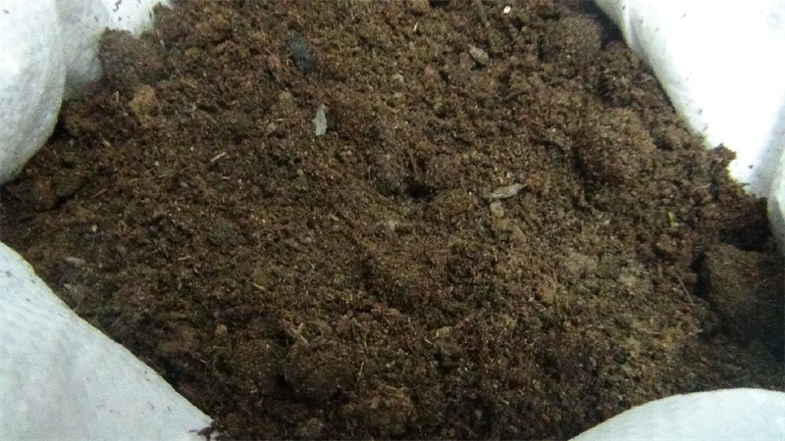
Figure 3 – Manure after thermal processing
Comparative analysis of manure processing methods: thermal and using live thermophilic bacteria allowed us to establish their advantage over composting in burts. The advantages of thermal processing showed the following: the minimum relative humidity of the finished product is 12-15%, there is no unpleasant smell, and the possibility of applying the resulting product to the soil by most machines designed for spreading mineral fertilizers; obtaining additional products – bedding for cattle and small-scale implementation of the resulting fertilizer due to its high quality characteristics. Short processing time: 1-2 days. Table 24 shows the economic indicators of thermal manure drying and passive pile composting in Turar LLP.

Table 24 – Еconomic indicators of technologies for processing cattle manure in LLP «Turar»
Indicator | Technology
Indicator | passive pile composting | thermal drying
The output of fertilizers, tons/year | 14430 | 2860
Capital expenditures for disposal, mln. TNG. | 94,6 | 99,0
Operating costs for disposal, mln TNG/year | 24,2 | 154,0
Specific capital expenditures for utilization, TNG./year | 2417,25 | 10857,0
Specific operating costs for utilization, TNG./year | 610,5 | 3374,25
Specific capital expenditures for obtaining a product (fertilizer), TNG./year | 1468,5 | 31542,5
Specific operating costs for obtaining the product (fertilizer), TNG./year | 376,75 | 9817,5
Emission of nitrogen (N) | 23-25 | up to 50
As a result of the analysis, it was found that with the same initial data, the lowest indicator of specific capital expenditures for processing the generated manure is the technology of passive pile composting – 2417.25 tenge/t. Thermal processing is the least economically justified. Specific capital expenditures amounted to 10,857. 0 tenge/t, specific operating costs – 3374.25 tenge/t. However, with this technology, the highest ammonia emission was observed – up to 50%.
Thus, the introduction of manure removal systems in the livestock complexes of LLP «Turar» and LLP «Olzha AK Kuduk» has shown its effectiveness. Installation of the Delta scraper system in LLP «Turar» and the TSN-2.0 B scraper conveyor in LLP «Olzha AK Kuduk» made it possible to automatically clean the channels from manure every 2-3 hours, which ensured cleanliness and comfortable conditions for animals, and maintenance became less expensive due to the automation of the process. Thermal drying is less cost-effective than the technology of pile composting, but it guarantees disinfection of the final product from pathogenic microflora and parasites in a short time by minimizing the impact of external natural factors, but nitrogen emissions into the environment reach 50%. The use of live thermophilic bacteria by Organic Farming significantly accelerated the processing of manure into organic fertilizer, reducing ammonia emissions by up to 23%.

3.9 Effectiveness of the effect of intensive feeding with the use of drugs and feed additives on the growth of live weight of young animals
An important factor affecting the profitability of livestock production is the effective use of feed. Due to the age-related deficiency of certain enzymes in the digestive juices of animals, insufficient activity of some of them, as well as due to the presence of difficult-to-hydrolyze components in feed, up to a third of the organic matter of animal feed is not digested and digested. One of the ways to increase the efficiency of the use of nutrients in the feed diet is the use of biological preparations in animal feeding, feed additives that are introduced into animal diets in the form of specially prepared compositions.
Due to the large range of drugs and feed additives in 2018-2020, the effect of drugs and feed additives on the growth of live weight of young animals was studied.
So, in 2018, LLP «Turar» studied the effectiveness of the biological product «Lactobifadol» containing the microbial mass of lactic acid bacteria Lactobacillus acidophilus, Bifidobacterium adolescentis and the feed additive «Kalfostonik» (ADJ. B, table B. 1) on the growth of live weight of young animals in the dairy period, table 25.

Table 25 – Dynamics of live weight of young animals in the dairy growing period in LLP «Turar» (indicators of 2018)
Indicator | Group of animals
Indicator | control (n=7) | I experienced (n=8) | II experienced (n=7)
Live weight, kg:  at the beginning of the experience | 48,7±1,1 | 49,1±0,9 | 48,8±1,3
at the end of the experience | 80,5±0,7 | 88,3±1,4* | 86,1±1,5
The increase at the time of the experience, kg | 31,8±0,9 | 39,2±1,3 | 37,3±1,3
Average daily growth, g | 530±16 | 653±22 | 622±21
Growth intensity, % | 39,5±1,7 | 44,4±2,3 | 43,3±1,9

The results obtained in 2018 indicate that young animals that received the compound feed preparation «Lactobifadol» (1st experimental group) and the feed additive «Kalfostonik» (2nd experimental group) in live weight exceeded the analogues of the control group by 7.8 kg, or 9.7% (P<0.05) and 5.6 kg, or 6.9%, respectively.
Dynamics of live weight of young animals from 6 to 12 months with the addition of the drug «Chiktonik» to the diet (ADJ. B, table. Q. 2) (1-I experienced) and feed additive «Felucen» (ADJ. B, table B. 3) (2nd experimental) in LLP «Olzha AK Kuduk» in 2019 is presented in table 26.

Table 26 - Dynamics of live weight of young animals in LLP «Olzha AK Kuduk» (indicators of 2019)
Indicator | Group of animals
Indicator | control  (n=26) | I experienced (n=30) | II experienced (n=28)
Live weight, kg: at the beginning of the experience | 156,8±1,5 | 159,3±2,0 | 158,7±1,8
at the end of the experience | 210,4±2,8 | 227,3±3,4*** | 225,8±3,2***
The increase at the time of the experience, kg | 53,6±1,1 | 68,0±0,9*** | 67,1±1,2***
Average daily growth, g | 600±21 | 760±25*** | 750±23***
Growth intensity, % | 25,4±1,2 | 29,9±1,3 | 29,7±1,5
It was found that young animals of the 1st and 2nd experimental groups had a significant advantage in live weight gain over their peers in the control group by 16.9 kg, or 7.4% (P<0.001) and by 15.4 kg, or 7.3%, respectively. The growth rate in the experimental groups was higher by 4.5% and 4.3%.
In 2020, we continued to study the effect of intensive feeding with the addition of the drug "P 63-1" to the diet in LLP «Olzha AK Kuduk» (ADJ. B, table B. 4) (1st experimental) and the feed additive «VMK 63» (ADJ. B, table B. 5) (2nd experimental) on the increase in live weight of young animals from 6 months of age, table 27.

Table 27 – Dynamics of live weight and average daily growth of calves in LLP «Olzha AK Kuduk»
Indicator | Group of animals
Indicator | control (n=28) | I experienced (n=32) | II experienced (n=30)
Live weight, kg: at the beginning of the experience | 161,3±3,5 | 159,8±4,1 | 164,0±4,3
at the end of the experience | 239,3±5,7 | 262,8±6,8*** | 270,3±4,1***
The increase at the time of the experience, kg | 78,0±2,5 | 103,0±3,2*** | 106,3±3,0***
Average daily growth, g | 866±26 | 1144±37*** | 1181±40***
Growth intensity, % | 38,9 | 48,7 | 48,9

Analysis of the data obtained showed that during the study period, calves that received the compound feed preparation «P 63-1» (1st experimental group) and the feed additive «VMK 63» (2nd experimental group) exceeded the live weight of the control group analogues by 23.5 kg, or 8.9% (P<0.001) and 31 kg, or 11.5% (P<0.001), respectively.
In 2020, LLP «Turar» studied the effect of the drug «Chiktonik» (1st experimental) and the feed additive «VMK-TU 62» (ADJ. B, table B. 6) (2nd experimental) on the increase in live weight of heifers of the dairy growing period, the results are presented in table 28.

Table 28 – Dynamics of live weight and average daily growth of heifers in LLP «Turar»
Indicator | Group of animals
Indicator | control (n=27) | I experienced (n=25) | II experienced (n=31)
Live weight, kg: at the beginning of the experience | 48,7±1,1 | 49,1±0,9 | 48,8±1,3
at the end of the experience | 120,6±3,7 | 132,5±4,4 | 137,4±3,5
The increase at the time of the experience, kg | 71,9±2,3 | 83,4±2,8 | 88,6±3,3
Average daily growth, g | 798±16 | 927±32 | 984±41
Growth intensity, % | 84,9 | 91,8 | 95,2

The data in table 28 show that the young animals that received the compound feed preparation «Chiktonik» (1st experimental group) and the feed additive «VMK-TU 62» in live weight exceeded their peers in the control group by 11.9 kg, or 8.9% (P<0.05) and by 16.7 kg or 18.8%, respectively.
Thus, the scientific and economic experiments conducted in 2018-2020 to study the effect of intensive feeding with the use of drugs and feed additives on the live weight gain of young animals of various groups showed a positive result. The use of drugs and feed additives contributed to the intensification of redox and synthetic processes, strengthening the level of natural protection of the body. As a result, the growth rate of young animals increased by 3.8-10.3%, which increased the absolute and average daily increase in live weight by 8.9-18.8%.

3.10 Еfficiency of using the «herd Management» system in production»
The electronic system "herd management" is an automated system that allows you to combine all data about the state of the animal in one computer database. The system allows you to get and control all indicators, make and execute important production decisions at the right time.
LLP «Turar» and LLP «Olzha AK Kuduk» installed "herd Management" Dayri Plan consisting of the following elements: a processor and control equipment, equipment identification, equipment for record milk production, the equipment for monitoring the status of cows, software, equipment, to move cows around the farm (ADJ. G, Fig. G. 28).
The main element is software. The database has cards for each animal, and farm specialists enter all the necessary information about the animals: feeding mode, health status, pregnancy, start-up, calving, insemination, rectal examination, milk indicators, and other physiological and production data.
To identify animals, LLP «Turar» uses rescounters - foot chips - a bandage on the leg with a sensor, figure 4 and LLP «Olzha AK Kuduk» uses responders - a collar with a sensor.
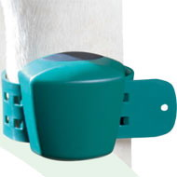
Figure 4 - Foot chip
The rescounter and responder is an electronic identification card of the cow: it recognizes it when entering the milking parlor where the antennas are installed, figure 5.
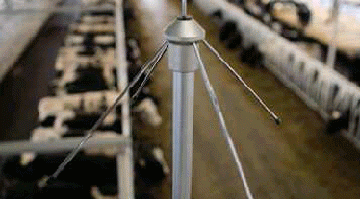
Figure 5 - Reading Antenna
The system takes into account the individual milk yield and sends the cow to its group or pen for treatment. The "herd management" system in farms is equipped with milking place controllers, milk counters and electronic pulsators (ADJ. G., Fig. g. 29, G. 30).
In LLP «Turar» and LLP «Olzha AK Kuduk», cows are formed into groups based on their physiological state, i.e. calving dates, and placed in sections: Group 1 - 1-2 months after calving, group 2 - 2-6 months after calving, group 3 - 6-8 months after calving, group 4 - cows of the first calving during the milking period, group 5 - highly productive animals, group 6 - animals under treatment. First-calving and new-calving cows are milked three times. Morning milking on farms begins at 6.00 am for the entire milking stock, at 12.00 am only animals are milked with three milking times, and at 18.00 hours for the entire milking stock. In LLP «Turar», cows are milked in the Carousel milking parlor (Appendix D, Fig. 31), in LLP «Olzha AK Kuduk» in the Herringbone milking parlor (Appendix D, Fig. 32).
Productivity data is automatically recorded in the program at each milking, and the amount of milk produced and its electrical conductivity are measured. Electrical conductivity correlates with the concentration of somatic cells in milk and if the measurement of the first portion shows increased electrical conductivity, the display turns on the warning function - flashing red lights.
To confirm the reliability of warning signals about increased electrical conductivity of milk, an analysis of the quantitative determination of somatic cells in milk was performed individually in LLP «Turar», Fig. 6 and LLP «Olzha AK Kuduk», Fig. 7.

Figure 6 - Dynamics of changes in the number of somatic cells over the period of scientific research, thousand units/ml (2019 data)

Figure 7 - Dynamics of changes in the number of somatic cells over the period of scientific research, thousand units/ml (data for 2020)
Timely decisions made by specialists of the veterinary service for the treatment of animals allowed to reduce this indicator in LLP «Turar» from 1059 thousand units/ml to 319 thousand units/ml and in LLP «Olzha AK Kuduk» from 983 thousand units/ml to 403 thousand units/ml.
The main useful indicators for studying the effectiveness of using the "herd Management" system in production are the analysis of the milk productivity report in the program, as well as the quality indicators of milk, table 29 and 30.

Table 29 - Indices of milk productivity of cows in the context of groups in LLP «Turar»
Group | Indicator
Group | daily milk yield on average per 1 head per group, kg | mass fraction of fat, % | mass fraction of protein,% | number of somatic cells, thousand units/ml
group I - 1-2 months after calving (n=108) | 31,4±1,4 | 3,65±0,02 | 3,28±0,03 | 276±21
group II – 3-4 months after calving (n=180) | 19,2±1,8 | 3,79±0,02 | 3,24±0,02 | 577±18
group III - 6-8 months after calving (n=144) | 8,5±1,6 | 3,85±0,01 | 3,26±0,02 | 495±25
group IV - cows of the first calving during the distribution period (n=180) | 29,3±1,4 | 3,68±0,02 | 3,23±0,01 | 255±22
group V - highly productive animals (n=144) | 38,2±2,1 | 3,61±0,01 | 3,26±0,01 | 349±17
group VI - animals on treatment (n=48) | the milk is delivered separately, heat-treated, and fed to fattening calves

Table 30 - Indices of milk productivity of cows in the context of groups in LLP «Olzha AK-Kuduk»
Group | Indicator
Group | daily milk yield on average per 1 head per group, kg | mass fraction of fat, % | mass fraction of protein,% | number of somatic cells, thousand units/ml
1 | 2 | 3 | 4 | 5
group I - 100 days after calving (n=205) | 32,3±1,8 | 3,67±0,02 | 3,25±0,03 | 318±26
group II – 4-6 months after calving (n=141) | 21,3±2,3 | 3,81±0,03 | 3,22±0,02 | 403±21
group III – 6-8 months after calving (n=88) | 10,4±2,6 | 3,93±0,02 | 3,27±0,03 | 365±32

Continuation of table 30
1 | 2 | 3 | 4 | 5
group IV - highly productive animals (n=56) | 35,6±3,2 | 3,65±0,02 | 3,22±0,02 | 255±29
group V - animals on treatment (n=60) | the milk is delivered separately, heat-treated, and fed to fattening calves

The evaluation of the efficiency of using the "herd Management" system in production in LLP «Turar» and LLP «Olzha AK Kuduk» showed that all work is based on automatic identification of animals, entering data into the Central computer, analyzing the information received and making decisions based on this data. Automatic identification is carried out by rescounters and responders, which are fixed on the forelimb in the area of the pastern and on the collar, respectively. At the moment when the animal takes its milking place, information about the animal's number is read from the rescounter or responder and data on milking and milk productivity are entered. If there is a sharp change in indicators, the system informs you that this animal requires increased attention. Based on this data, experts make a decision about the animal. When a cow is retired, its rescounter or responder is used for another animal.
Thus, the "herd management" program in LLP «Turar» and LLP «Olzha AK Kuduk» is linked to milking equipment, where information about the productivity, reproduction, and physiological state of animals is collected, updated, and recorded. Processing all data using the program allows you to make optimal decisions in a timely manner, both for an individual animal and for the herd as a whole.

3.11 Evaluation of the economic efficiency of using new equipment and technologies
The sustainable and efficient functioning of milk — producing organizations largely depends on the technologies and technical equipment used. The issue of expediency and efficiency of introducing innovative technologies for keeping, feeding and milking cows is particularly acute.
Depending on the method of keeping cows, there are tethered and loose technologies. Loose technology consists in keeping animals in group sections of the cowshed, where it is possible to move freely and access food. It creates better conditions for mechanization of technological processes, significantly reducing labor costs for animal care. In loose housing system the content of coarse and succulent feed is fed at the feed fence. Distribution of feed is made to animals in groups, taking into account the level of milk yield and the period of lactation. Concentrated feed is given to cows individually in feeders during milking. This feeding procedure increases feed costs by 10-15% per 1 centner of milk.
When you harness the technology content of cows are placed in individual stalls on a leash using the litter. Feeding cows produced in winter-stall period of the feeders or feed fence, in the summer cows graze on the pastures. Milking is carried out in stalls in the milk pipeline, distribution of feed by mobile and stationary feed dispensers. The advantage of the tethered system is the possibility of spot and dosed feeding of animals, which can not be achieved with a loose method of keeping. However, this technology provides a high level of labor costs.
In the agricultural organizations of Kostanay region, the technology with tethered keeping of cows prevails. In conditions of a shortage of feed, this makes it possible to spend them more economically and individually to maintain life, since the animals are in a state of hypodynamia (limited motor activity). On the world market of machinery and equipment for dairy cattle breeding, equipment has appeared that allows the introduction of a loose system of maintenance. This technology is preferred on medium and large farms, where it allows you to mechanize all elements of production, increase labor productivity and use the genetic potential of animals. Good sanitary and hygienic conditions in the milking parlor or on the milking platform ensure high quality of milk and, as a result, allow you to increase the sales price of products.
Reduction of labor costs for servicing cows with the loose method is achieved by upgrading those elements of the technological cycle that are carried out using manual labor with the tethered system. In addition, modern equipment is less energy-consuming than outdated analogues. In modern market conditions, these requirements are exacerbated by the sharp rise in the cost of energy and equipment. Therefore, optimization of their use is an objective necessity for increasing the competitiveness of domestic dairy cattle breeding.
Practical experience shows that the most positive results are achieved when switching to technologies of loose keeping of animals and milking cows in milking parlors.
In LLP «Turar», the annual productivity of cows is more than 6.0 thousand, in LLP «Olzha AK Kuduk» more than 5.0 thousand. High efficiency of milk production has been achieved here, herd management systems, visual insemination, modern diagnostics of diseases of the reproductive system, and intensive technology for rearing young animals have been introduced. As a result, labor costs per 1 cent of milk production range from 1.2 to 3 people per hour (with traditional technologies, 5-7 people per hour). Feeding of animals is carried out on the basis of balanced diets, taking into account the biochemical parameters of animal blood, which reduces feed costs and increases the productivity of animals by 15-20%.
Options for implementation in LLP «Turar» were the use of a milk taxi with electronic control of one-time milk drinking, the technology of the «cold» method of rearing young animals. Calves raised using the new technology were characterized by high growth and development intensity and stable immunity. The age of fruitful insemination was reduced from 18 months to 16 months. Thus, the period of productive use of cows increased by 60 days.
The introduction of the Alphavision (France) visual insemination system in LLP «Turar» and LLP «Olzha AK Kuduk» increased the percentage of fruitful insemination to 89.7-89.9%. At the same time, 1.6 doses of semen were spent on 1 fruitful insemination, compared to the traditional method, which used 2.0 doses. The use of the Draminsky ultrasound scanner allowed timely diagnosis of diseases of the reproductive system and targeted treatment, which reduced the duration of treatment, and drug costs decreased by 12.8%.
The installation of a veterinary machine and electronic scales allowed to reduce the number of labor resources used in production processes. The time spent on weighing was reduced from 30.2-40.2 seconds to 7.1-7.5 seconds. The number of technical personnel involved has decreased from 7 to 3. the use of modern SIMCRO injectors has reduced the time for the introduction of vaccines and vitamins by 3.5 times.
Tables 31 and 32 present data on the comparative economic efficiency of keeping animals using traditional and modern technology (with the introduction of new equipment and technologies.

Table 31 – Economic efficiency in LLP «Olzha AK Kuduk» (per 1 cow per year)
Indicator | Traditional technology | Modern technology | +/-
Average annual number of dairy cows, head. | 450 | 450 | -
Productivity per animal, kg | 5023,1 | 5220,3 | +197,2
Average annual milk yield per 1 cow, с | 50,2 | 54,1 | +3,9
Labor costs, pers.-h/1 с of milk | 4,3 | 2,1 | -2,2
Sale price of 1 с of milk, tenge | 13 500 | 13 500 | -
The cost of production, KZT | 505 304 | 520 328 | +15 024
Revenue, thousand tenge | 677 700 | 730 350 | +52 650
Profit, thousand tenge | 172 396 | 210 022 | +37 626
Level of profitability, % | 34,1 | 40,4 | +6,3

Table 32 – Economic efficiency in LLP «Turar» (per 1 cow per year)
Indicator | Traditional technology | Modern technology | Change  +/-
Average annual number of dairy cows, head. | 785 | 785 | -
Productivity per animal, kg | 6175 | 6480 | +305
Average annual milk yield per 1 cow, с | 61,7 | 64,8 | +3,1
Labor costs, pers.-h/1 с of milk | 3,6 | 1,9 | -1,7
Sale price of 1 с of milk, tenge | 13 500 | 13 500 | -
The cost of production, KZT | 658 972 | 660 350 | +1 378
Revenue, thousand tenge | 832 950 | 874 800 | +41 850
Profit, thousand tenge | 173 978 | 214 450 | +40 472
Level of profitability, % | 26,4 | 32,5 | +6,1

Analysis of the obtained economic results of the introduction of new technological equipment in LLP «Turar» and LLP «Olzha AK Kuduk» showed that the productivity of cows in LLP «Olzha AK Kuduk» increased by 197.2 kg, in LLP «Turar» by 305 kg. The installation of modern equipment has had a positive effect on the use of labor resources. Thus, the number of labor resources decreased by 1,7-2,2 people-h/1 kg of milk. Despite the increase in the cost of production, due to increased productivity and economical use of feed, the profit increased in LLP «Olzha AK Kuduk» by 37626 tenge, in LLP «Turar» by 40472 tenge. The level of profitability increased by 6.1-6.3%.
Thus, the introduction of innovative equipment and technologies in production helped to reduce the cost of production, in particular milk by 2.88%, reduce the use of labor resources by 48.8-52.8%, increase the milk productivity of cows by 3.8-4.7%, profit by 17.9-18.9% and profitability by 6.1-6.3%.

3.12 Vaccination plan. Effects of vaccines and medicines on animals
The safety and health of dairy cattle is an important aspect of productivity, as they are producers of milk and dairy products that we consume daily. Cattle are often susceptible to many different diseases, which even after 2-3 hours after infection can lead to the death of the animal. To prevent a fatal outcome and preserve the health of animals, timely scheduled vaccinations are carried out and medications are administered.
The monitoring conducted in 2019 of the Fedorovsky district, where the LLP «Turar» livestock complex is located, and in 2020 of the Kostanay district, where the LLP «Olzha AK Kuduk» livestock complex is located, is safe for epizootic diseases. However, in 2018 and 2019, there were foci of diseases such as nodular dermatitis and hypodermatosis 10-12%. In order to prevent the occurrence of diseases, a vaccination and drug administration plan was developed and implemented in LLP «Turar», table 33 and LLP «Olzha AK Kuduk», table 34.

Table 33 - Vaccination and drug administration plan in LLP «Turar» (2019)
Name of the drug/vaccine | 20 february -10 march | After 14 days | After 14 days | After 14 days | After 14 days | After 14 days
Nitox | +
vaccine against lumpy skin disease dermatitis |  | +
The vaccine against anthrax |  |  | +
Rabies vaccine |  |  |  | +
A vaccine against pasteurellosis |  |  |  |  | +
Ivermec |  |  |  |  |  | +

Table 33 - Vaccination and drug administration plan in LLP «Olzha AK Kuduk» (2020)
Name of the drug/vaccine | 20 february-10 march | After 14 days | After 14 days | After 14 days | After 14 days | After 14 days
Nitox | +
vaccine against lumpy skin disease dermatitis |  | +
The vaccine against anthrax |  |  | +
Rabies vaccine |  |  |  | +
A vaccine against pasteurellosis |  |  |  |  | +
Ivermec |  |  |  |  |  | +

The study of clinical indicators - body temperature, pulse rate and respiration per minute before and after vaccination with different vaccines is presented in tables 35 and 36.

Table 35 - Clinical indicators of animals before and after vaccination in LLP «Turar» (2019)
Indicator | Группа
Indicator | I  (against anthrax) | II  (pasteurellosis) | III  (Rabies)
Number of goals | 14 | 14 | 14
 | before vaccination
Temperature °C | 37,5 ±0,2 | 38,1 ±0,1 | 37,9 ±0,2
The frequency of the respiratory movements, times | 12,0±1,5 | 13,5±1,1 | 12,8±1,3
Heart rate, times | 50,0±2,3 | 48,5±1,9 | 51,1±2,1
 | after vaccination
Temperature °C | 38,5 ±0,2 | 39,5 ±0,1 | 39,0 ±0,2
The frequency of the respiratory movements, times | 12,5±1,6 | 15,0±1,3 | 15,3±1,1
Heart rate, times | 51,2±2,4 | 55,3±2,1 | 54,7±2,3

Table 36 - Clinical indicators of animals before and after vaccination in LLP «Olzha AK Kuduk» (2020)
Indicator | Группа
Indicator | I  (against anthrax) | II  (pasteurellosis) | III  (Rabies)
Number of goals | 16 | 20 | 25
 | before vaccination
Temperature °C | 38,2 ±0,1 | 38,0 ±0,2 | 38,4 ±0,2
The frequency of the respiratory movements, times | 12,5±1,4 | 13,2±1,5 | 13,8±1,2
Heart rate, times | 49,0±2,0 | 50,0±1,5 | 50,8±2,5
 | after vaccination
Temperature °C | 38,7 ±0,2 | 39,0 ±0,2 | 39,4 ±0,1
The frequency of the respiratory movements, times | 13,0 ±1,2 | 14,2±1,5 | 15,0±1,3
Heart rate, times | 52,0±2,5 | 53,3±2,0 | 54,0±2,3

Data from tables 35 and 36 show that in LLP «Turar», the rectal temperature in animals before vaccination was in the range of 37.5-38.1°C, in LLP «Olzha AK Kuduk» 38.0-38.4°C. After the introduction of vaccines, this indicator did not change significantly and was within the physiological norm. The animals ' breathing was deep and rhythmic. According to the table, the pulse rate before vaccination was 48.5-51.1 beats, which is 1.2-6.8 beats less than after vaccination.
To determine the protective function of the blood, the content of gamma globulins was determined, figure 8.
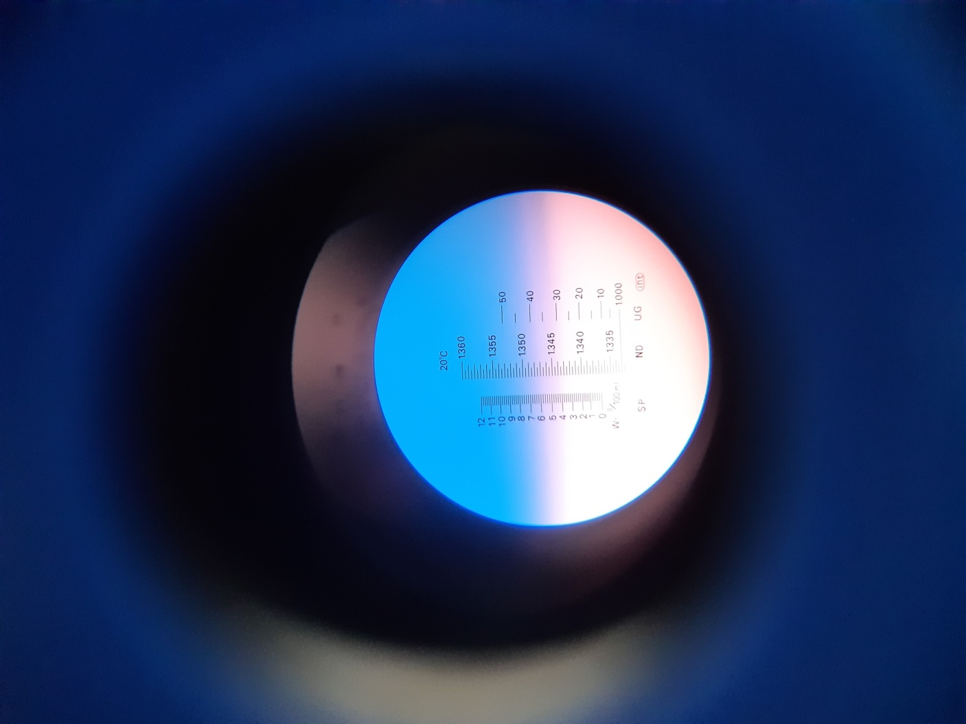
Figure 8 - Determination of blood gamma globulins
Thus, the data of clinical indicators indicated that the physiological state of animals during the vaccination period, according to the plan, was within the normal range. The number of blood gamma globulins that perform a protective function after vaccination was 35.0% in LLP «Turar» and 37.4% in LLP «Olzha AK Kuduk», which indicates high rates of immunity formation against epizootic diseases according to the vaccination plan.

3.13 Feeding cows. Tablet technology for the feeding
The fullness of feeding is determined by the presence of a certain amount of energy and nutrients in the diets in accordance with the needs of animals, where the optimal ratio between coarse, juicy and concentrated feeds should be observed. A full and balanced diet is a success of good productivity and health of such cows. For such cows, the amount of concentrated feed can be increased to 45% of the total daily diet, because milk is formed from feed nutrients in the mammary gland, which functions intensively during lactation.
Analysis of the feed base of LLP «Turar» and LLP «Olzha AK Kuduk» showed that farms provide animals with high-quality feed of their own production. Silage is prepared from corn mown in the waxy ripeness phase, haylage from a mixture of cereals and legumes, concentrates from wheat, barley and oats. In the summer, the feed is used for perennial (bonfire, sweet clover) and annual (rapeseed) grasses. According to tables 37 and 38, actually in the diet (ADJ. In, table B. 7, B. 8) animal feeding contains 83.7 g and 84.2 g of digestible protein per 1 EK, respectively.

Table 37 - Concentration of nutrients in the diet used per 1 EKE in LLP «Turar»
Indicator
Dry matter, kg | 1,13
Raw protein, g | 140,8
Digestible protein, g | 83,7
Raw fiber, g | 270,8
Sugar, g | 56,7
Calcium, g | 4,8
Phosphorus, g | 2,8

Table 38 - Concentration of nutrients in the diet used per 1 EKE in LLP «Olzha AK Kuduk»
Indicator
Dry matter, kg | 1,14
Raw protein, g | 141,3
Digestible protein, g | 84,2
Raw fiber, g | 265,9
Sugar, g | 55,9
Calcium, g | 5,1
Phosphorus, g | 3,0

In the structure of the diet in LLP «Turar», coarse feed occupied 15.8%, juicy - 50.9% and concentrated - 28.0%, in LLP «Olzha AK Kuduk» - 21.6%, 51.3% and 27.1%, respectively.
According to the needs of the body of high-yielding dairy cows in nutrients in LLP «Turar» and LLP «Olzha AK Kuduk», rations for feeding cows for the first phase of lactation were compiled, table 39 and 40. The mixture of concentrates consisted of wheat 50%, oats 15% and peas+soy - 35%.

Table 39 - Rations for highly productive cows of LLP «Turar»
Indicator | Daily milk yield, kg
Indicator | 25-29 | 30-34 | 35-40
1 | 2 | 3 | 4
Hay, kg | 5 | 5 | 5
Corn silage, kg | 7 | 8 | 9
Grain haylage, kg | 6 | 7 | 8
Continuation of table 39
1 | 2 | 3 | 4
Concentrates, kg | 10,0 | 12,0 | 12,0
Cake, kg | 0,8 | 1,2 | 1,5
Table salt, g | 75 | 100 | 100
Kalfostonik, g | 100 | 100 | 100
The diet contains:
EКЕ | 19,38 | 22,74 | 23,41
Dry matter, kg | 18,18 | 21,11 | 21,83
Raw protein, g | 2983,6 | 3568,1 | 3735,6
Digestible protein, g | 2269,5 | 2729,1 | 2856,7
Raw fiber, g | 3136,9 | 3531,8 | 3680,5
Sugar, g | 568,78 | 676,52 | 722,0
Calcium, g | 80,21 | 92,36 | 97,83
Phosphorus, g | 72,14 | 87,04 | 91,81

Table 40 - Rations for cows with different levels of productivity in LLP «Olzha AK Kuduk»
Indicator | Daily milk yield, kg
Indicator | 19-22 | 23-25 | 25-30
1 | 2 | 3 | 4
Hay, kg | 5 | 5 | 5
Corn silage, kg | 7 | 7 | 8
Grain haylage, kg | 5 | 6 | 7
Concentrates, kg | 8,0 | 10,0 | 10,0
Cake, kg | 0,8 | 1,2 | 1,2
Potatoes, kg | 3,0 | 3,0 | 4,0
Table salt, g | 75 | 100 | 100
Kalfostonik, g | 100 | 100 | 100
The diet contains:
EКЕ | 17,27 | 20,32 | 20,91
Dry matter, kg | 16,59 | 19,11 | 19,81
Raw protein, g | 2538 | 3092,5 | 3163,5
Digestible protein, g | 1880,7 | 2326,7 | 2371,1

Continuation of table 40
1 | 2 | 3 | 4
Raw fiber, g | 2961,7 | 3223,8 | 3408,8
Sugar, g | 537,1 | 621,32 | 654,02
Calcium, g | 71,87 | 81,9 | 86,98
Phosphorus, g | 62,17 | 77,1 | 78,38

Analysis of the compiled scientifically based feeding rations showed that for 1 EKE there were 117-122 g of digestible protein in LLP «Turar», 0.93-0.94 kg of dry matter and 108.8 - 114.5 g of digestible protein in LLP «Olzha AK Kuduk», and 0.96 - 0.95 kg of dry matter in dry matter.
To determine the effectiveness of balanced diets, a scientific and economic experiment was conducted with the determination of feed consumption of the most productive animals, i.e. feed consumption, table 41 and 42.

Table 41 - The Number of feed and uneaten residues per day in LLP «Turar»
Indicator | Daily milk yield, kg
Indicator | 25-29 | 30-34 | 35-40
Feed consumption per 1 head per day: | 28,8 | 34,2 | 35,5
eaten per day, kg | 27,6±0,6 | 33,5±0,4 | 34,2±0,7
Uneaten leftovers, kg | 1,1±0,3 | 1,0±0,7 | 1,2±0,5

Table 42 - The Number of feed and uneaten residues per day in LLP «Olzha AK Kuduk»
Indicator | Daily milk yield, kg
Indicator | 19-22 | 23-25 | 25-30
Feed consumption per 1 head per day: | 28,8 | 32,2 | 35,2
eaten per day, kg | 27,0±0,8 | 31,5±0,6 | 34,0±0,5
Uneaten leftovers, kg | 1,8±0,5 | 0,7±0,6 | 1,2±0,7

Data from tables 41 and 42 indicate that the amount of uneaten residues averaged 2.2-6.2%. The feed was well prepared: the hay was crushed, then the haylage, silage, concentrates and feed additive were mixed. Feeding was performed consistently and often 4 times a day. To balance and improve the economic indicators of the diet, we used a feed additive – «Kalfostonik» at the rate of 100 g per 1 head for 10 days. Feed additive was mixed with concentrates and fed in the morning feeding (ADJ. G, Fig. G. 33).
When group feeding animals, the difference in needs between individual animals is usually taken into account «by eye». Software packages support a strict individual approach to animals, even when group feeding, calculating «personal supplements» to the group diet.
Developed and implemented in LLP «Turar» and LLP «Olzha AK Kuduk», the «Feeding technologist's tablet» software package for optimizing daily rations of cattle feeding consists of the following modules:
- feeding rations - after determining the group of animals for which the diet will be balanced, the Feed reference defines the feed components that will be included in the diet. The reference list includes a list of feeds, as well as the nutritional value of each feed, figure 9.

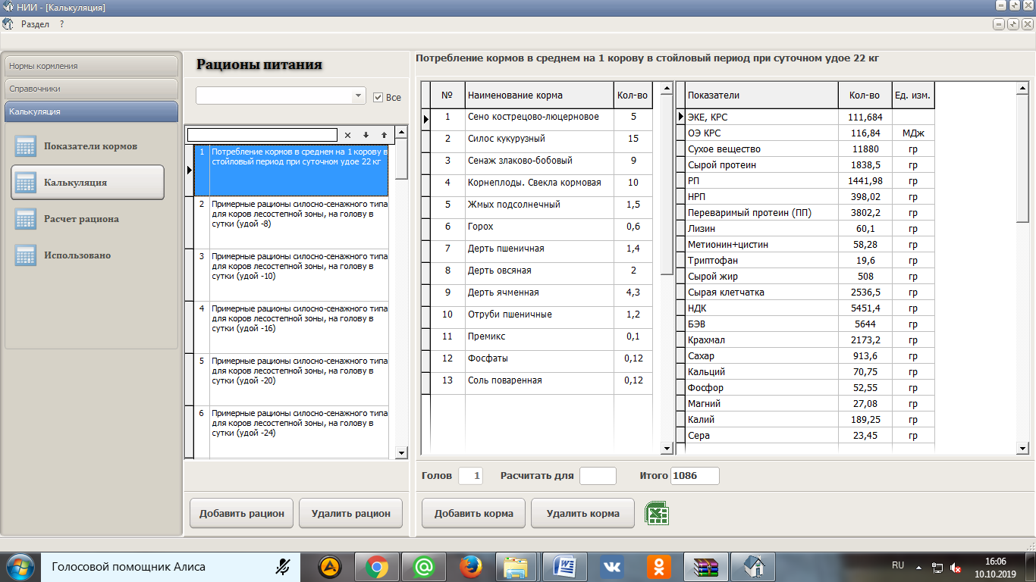
Figure 9 - Preparation of diet together with the simultaneous evaluation of the nutritional value
- feed - allows you to enter indicators of feed analysis conducted in the laboratory and calculate the structure of the diet, figure 10;
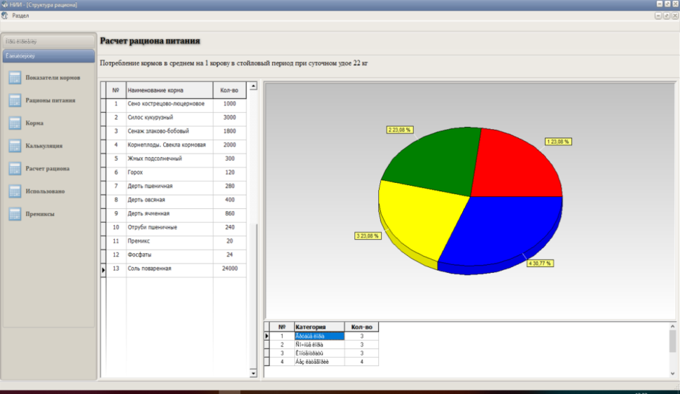
Figure 10 - Calculation of the ration structure

- calculation - allows you to calculate the ration used, figure 11;
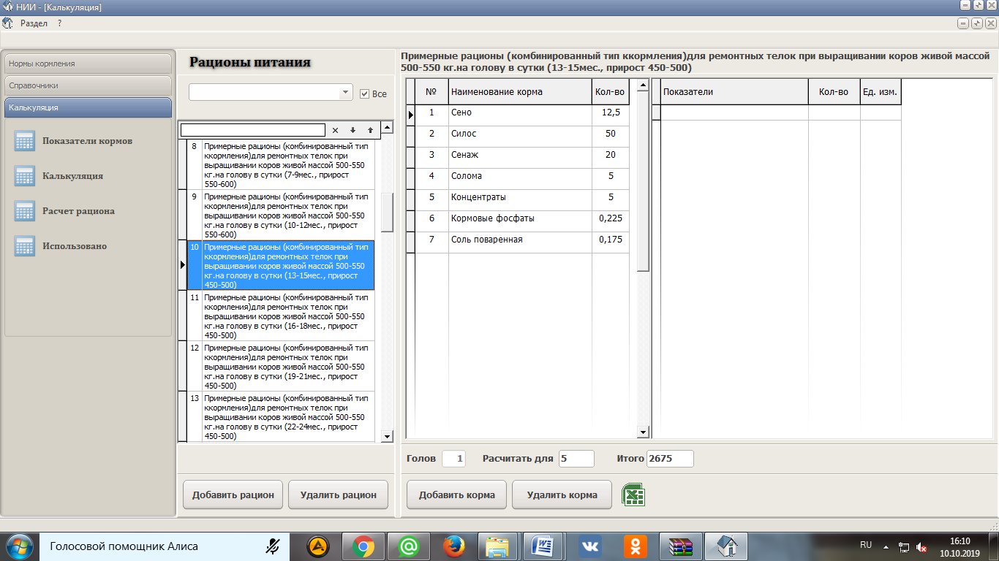
Figure 11 - Calculation of the cost of the prepared ration

- enriching the diet with premixes - allows you to balance the diet by micro and macro elements;
- getting various output documents.
Based on the information available in the program, the zootechnician of the farm can form a feed plan according to the scheme, figure 12.
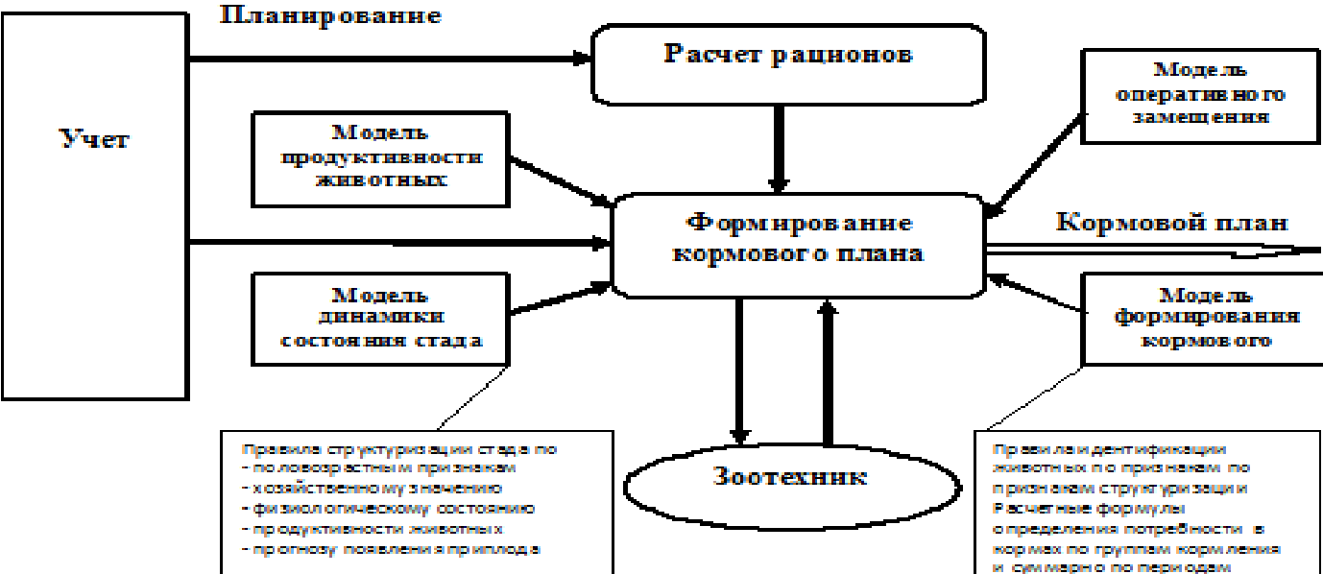
Figure 12 - Formation of the feed plan on the tablet of the feeding technologist
The feeding ration is compiled by a specialist when working with the reference book "Feed" and when choosing feed for calculation.
Thus, the introduction of the «feeding technologist Tablet» allowed you to create diets using the nutritional components available in the application database; make new feeds and change the characteristics of existing ones; view and edit the cost of feed; plan feed consumption in groups; generate summary reports of feed consumption by productivity; summarize information on feed consumption; select diets for groups and print any information from calculations and databases.

Generalization and evaluation of research results
The use of the Alphavision visual insemination system (France) contributed to an increase in fruitful insemination by 32.1-33.7%. ultrasound diagnostics of pregnancy is more effective, the reliability of the results obtained is higher by 29.7%.
Raising calves by the "cold" method during the dairy period is effective. The growth rate is higher by 4.6-7.7%, the average daily increase in live weight is more by 10.7%, and the profitability of production is higher by 12.9-13.0%.
The introduction of scientific methods for improving arable land using technologies for root and surface improvement of grass stands allowed us to diversify the species composition of forage grasses, increase productivity, and meet the need of animals for green and coarse feed.
The introduction of digital technologies for weighing animals and modern injectors for veterinary treatments has reduced the number of personnel involved by half and increased the number of animals served.
The analysis of microclimate indicators showed that the most favorable zone for placing animals is the zone at the ends of the room - the number of individuals who showed signs of sexual hunting is 26.4-32.9% more.
Thermal drying is less cost-effective, but guarantees disinfection of the final product from pathogenic microflora and parasites in a short time by minimizing the impact of external natural factors, but nitrogen emissions into the environment reach 50%. The use of live thermophilic bacteria by Organic Farming significantly accelerated the processing of manure into organic fertilizer, reducing ammonia emissions by up to 23%.
The introduction of innovative equipment and technologies in production helped to reduce the cost of production, in particular milk by 2.88%, reduce the use of labor resources by 48.8-52.8%, increase the milk productivity of cows by 3.8-4.7%, profit by 17.9-18.9% and profitability by 6.1-6.3%.
The tablet of the feeding technologist allowed you to create rations using the nutritional components available in the application database; make new feeds and change the characteristics of existing ones; view and edit the cost of feed; plan feed consumption in groups; generate summary reports of feed consumption by productivity; summarize information on feed consumption; select rations for groups and print any information from calculations and the database.

CONCLUSION
Based on the conducted research, the following conclusions can be drawn:
1. Using the Alphavision visual insemination system as one of the reproduction methods allowed to increase the percentage of fruitful insemination by 32.1-33.7% and is more rational.
2. The introduction of ultrasound scanning allows you to determine pregnancy from 28 to 40 days after insemination with an accuracy of 89.9%.
3. The average Daily increase in live weight of calves with the cold method of keeping is higher by 10.1-10.7%, the profitability of growing increased by 12.9-13.0%.
4. The introduction of digital technologies for weighing animals and modern injectors for veterinary treatments has reduced the number of personnel involved by half and increased the number of animals served during the weighing process. Labor productivity increased by 55.8%.
5. Alternative energy sources contribute to resource conservation and are an environmentally friendly device. During the service life of 20 years, only 72.2% of the cost of the energy source will be recouped in LLP «Turar» and 50.9% in LLP «Olzha AK Kuduk».
6. The introduction of scientific methods for improving arable land using technologies of indigenous and surface improvement of grass stands has diversified the species composition of forage grasses, increased the yield of natural land by 5.3%.
7. The most favorable zone for animal placement is the zones at the ends of the room - the number of animals that showed signs of sexual hunting is 26.4-32.9% more.
8. Thermal drying guarantees disinfection of the final product from pathogenic microflora and parasites, but the nitrogen emission to the environment reaches 50%. The use of live thermophilic bacteria Organic Farming significantly accelerated the processing of manure into organic fertilizer with a reduction in ammonia emissions to 23%.
9. The Use of drugs and feed additives increased the growth of young animals by 3.8-10.3%, which increased the absolute and average daily increase in live weight by 8.9-18.8%.
10. The use of electronic identification of cows made it possible to take into account individual milk yield, form groups of animals taking into account their physiological state, and organize the order of movement to the milking parlor. Constant monitoring of the electrical conductivity of milk with the determination of the number of somatic cells allowed to reduce this indicator by 2.4-3.3 times.
11. The Introduction of innovative equipment and technologies in production helped to reduce the cost of production, in particular milk by 2.88%, reduce the use of labor resources by 48.8-52.8%, increase the milk productivity of cows by 3.8-4.7%, profit by 17.9-18.9% and profitability by 6.1-6.3%.
12. The number of blood gamma globulins performing a protective function after vaccination was 35.0% in LLP «Turar» and 37.4% in LLP «Olzha AK Kuduk», which indicates high rates of immunity formation against epizootic diseases according to the vaccination plan.
13. The tablet of the feeding technologist allowed you to create diets using the nutritional components available in the application database; make new feeds and change the characteristics of existing ones; view and edit the cost of feed; plan feed consumption by groups; generate summary reports of feed consumption by productivity; summarize information on feed consumption; select diets for groups and print any information from calculations and the database.

LIST OF SOURCES USED
1 Kostomakhin N. M., Shmargun A.V. Modern technologies of growing young animals in dairy cattle breeding // Chief zootechnik. - 2006. – No. 6. – P. 21-27. (рус.яз.)
2 Makharinets G. G. Innovations in technologies of meat cattle Breeding // Bulletin of the don state agrarian University. – 2012. – No. 1 (3). – P. 28-31. (рус.яз.)
3 Tillack P.U.A. AuswirkungenveränderterProduktionsverfahren auf den Reproduktionspzozes von Tierpoduktionsbetrieben. /Nierzucht. – Berlin, 1988. – No.8. – Р. 359. (англ.яз.)
4 Plyashchenko S. I., Trofimov A. F. keeping cows on farms and complexes. – Mn.: Urajay, 1985. – 152 p. (рус.яз.)
5 Bozeman C., Lindlay W., Branson J. Bovine enterotoxaemia // J. Amer. Veterin. Med. Assoc. - 1962. - No. 9. - P. 64-75. (англ.яз.)
6 Carotta N. I. GieneprevenzionedellemalattiedelconiglioRivista di Coniglicoltura, 1984; т. 21. - Nо.3. – P. 27-31. (англ.яз.)
7 Grossman L. G. On the norms of mineral substances for cattle // Agriculture abroad. - 1974. - No. 5. – P. 9-12. (рус.яз.)
8 Peyve ya. V. Microelements and their significance in agriculture. - Selkhozgiz, 1961. – 63 p. (рус.яз.)
9 Yaroshkevich A. P. Еffectiveness of vitamin D supplements in the diets of dairy cows // In: Full - fledged feeding of ruminants in conditions of intensive use. - M., 1990. – 52 p. (рус.яз.)
10 Porzig E. Ur sachen und AuswirkungenvoVerhaltensstörungen auf die LeistungsausschpfiingbeuRindern // Mh. Veter. – Med., 1980. - T.35. - No. 2.- 47 p. (англ.яз.)
11 Sambraus H. IndividuellebindungzwischenRindern // ZBL. Veterinarmed. - 1976. - No 3. – P. 248-357. (англ.яз.)
12 Baranov D. I. influence of various diets and feedings on the activity of microflora and the concentration of ammonia in the rumen of cows. In the book: Feeding farm animals. – M., 1960. – 41 p. (рус.яз.)
13 Bogdanov G. A. Feeding farm animals. – M.: Agropromizdat, 1990. – 625 p. (рус.яз.)
14, and Borisenko, E. J. Effect of feeding on morphological and physiological characteristics of cattle. // Bulletin of agricultural Sciences. – 1957. – No. 3. – P. 34. (рус.яз.)
15 Venediktov a.m. Chemical feed additives in animal husbandry. – M.: Kolos, 1979. – 159 p. (рус.яз.)
16 Voynar A. I. Biological role of microelements in the body of animals and humans. – M.: Higher school, 1960. – 98 p. (рус.яз.)
17 Krasnoshchekova T. A., Khinevich V. I. Influence of the type of feeding on the milk productivity of cows in the BAM zone // Collection of scientific works technology of milk and meat production in the far East. – Blagoveshchensk, 1993. – 55 p. (рус.яз.)
18 Sambraus H., Steneil Н. Das Sozialgeschehengruppenhaltenerkalber. // Berlin and Munch en Tierarzte Wochenschr. – 1987. – №17. – P. 81-88. (англ.яз.)
19 Porzig E. Das Verhaltenlandwirtschaftlicher Nutztiere. – Berlin, 1973. - P. 63. (англ.яз.)
18 Sambraus H., Steneil Н. Das Sozialgeschehengruppenhaltenerkalber. // Berlin and Munch enTierarzteWochenschr. – 1987. – №17. – P. 81-88. (англ.яз.)
19 Porzig E. Das Verhaltenlandwirtschaftlicher Nutztiere. – Berlin, 1973. - P. 63. (англ.яз.)
20 Veris J. Sledovanivy branuchprojern v chovanitelafpopresunu dovkta v prubehujejichone mocheni // Sb. Vysoke Scoly Zemed. 1988. – T.48. – P.150. (англ.яз.)
21 Oder V. Comportawentodeilevacehe in stadulazionelibersincform. //Zootécnico. – 1975. – T. 22. No. 6. – P. 120-123. (англ.яз.)
22 Phillips C.J., Schofield S.A. The effect of supplementary light on the probuction and behavions of daily cows. //Anim. Product. 1989. - T.48. –No.2. - 303p. (англ.яз.)
24 Bryzgalina C. Organization of beef cattle breeding in dairy farms //Economist. – 2008. – No. 12. – Pp. 83-84. (рус.яз.)
25 voynar A. I. biological role of microelements And their application in agriculture and medicine. – 1970. – 20 p. (рус.яз.)
26 Balanin V. I. Zoohygienic control of microclimate in livestock and poultry premises. // Library of a practical veterinary doctor. – L.: Agropromizdat, 1988. -142 p. (рус.яз.)
27 Baibuttsyan A. A., Apinyan G. K. growing calves in the Central Chernozem zone // Bulletin of the Michurinsk state agrarian University. - 2001. – Vol. 3. – P. 154-155. (рус.яз.)
28 Valeev N., Gurevich Yu. Growing calves of dairy age outside the premises // Dairy and meat cattle breeding. – 1986. – No. 7-8. – P. 14-16. (рус.яз.)
29 Vattio M. A. growing calves from birth to weaning. Overview of the right management approaches // Main aspects of milk production. – 2007. – No. 3. – P. 7-9. (рус.яз.)
30 Ivanov V., Melnikov S. "Cold – hot" method of keeping calves: what is good and what is bad // Dairy and meat cattle breeding. - 2009. - No. 3. – P. 7-9. (рус.яз.)
31 Molchanov M., Filenko B. technology of growing calves in lightweight construction premises // Scientific and technical Bulletin of the Institute of animal husbandry. – 1990. – P. 37-38. (рус.яз.)
32 Titarenko E. Cold method of keeping calves / E. Titarenko. // Milk and feed. Management. - 2005. – No. 4. – P. 36-39. (рус.яз.)
33 Shamraeva T. V., Bardakov V. D. method of cold growing calves // Intensif. livestock in the Republic of Khakassia. Novosibirsk, 1989. – P. 58-61. (рус.яз.)
34 Shermatov S. M., Khabibulov M. A. growing calves in houses in the open air // Zootechnia. - 1993. – No. 12 – P. 18-20. (рус.яз.)
35 Trishina A. K. growing calves in unheated premises // Zootechny. 1997. – No. 3. – P. 25-27. (рус.яз.)
36 Sirotkin V. I. growing calves. - M.: Rosselkhoznadzor, 1987. – 126 p. (рус.яз.)
37 Zubriyanov V., Bakhteeva Z., Lyashenko V. Effective method of growing calves // Dairy and meat cattle breeding. – 2006. – No. 6. – P. 22-23. (рус.яз.)
38 Larina O. V., Shomina E. I. Assessment of growth and development of calves in the meat direction of productivity in farms of the Voronezh region // In the collection: Current issues of veterinary medicine and animal husbandry technology materials of the scientific and educational conference of the faculty, researchers and postgraduates of the faculty of veterinary medicine and animal husbandry technology. - 2012. - 206 p. (рус.яз.)
39 Muminov A. A. Natural resistance of the body of cows and calves of early age // Prevention and control of infectious, invasive and non-infectious diseases of agricultural animals in Tajikistan. - 1989. – 89 p. (рус.яз.)
40 Svechin K. B. Individual development of farm animals. - K: Harvest, 1976. – 285 p. (рус.яз.)
41 Plyashchenko S. I., Khokhlova I. I. Microclimate and productivity of animals: textbook. – Kolos, 1976. – 208 p. (рус.яз.)
42 My Sibikin Alternative Yu. Heating, ventilation and air conditioning: study guide for students of SPO institutions in the specialty 140102 "Heat supply and heat engineering equipment" – 5th ed., ster. – Moscow: Academy, 2008. – 303 p. (рус.яз.)
43 Amerkhanov R. A., Garkavy K. A., Shevchuk I. V. solving the problem of air exchange in livestock premises: Energy supply and energy saving in agriculture. – M.: GNU resh, 2003. – 385 p. (рус.яз.)
44 Afanasyev V. N., Mishukov B. G., Pushkin N. processing of manure from livestock farms and complexes. - 1981. – P. 35. (рус.яз.)
45 Geletukha G. G., Kobzar S. G. Modern technologies of anaerobic fermentation of biomass // EcoTechnologies and resource conservation. Fuel and energy. Kiev, 2002. – No. 4. (рус.яз.)
46 Gridnev P. I. Mechanical and technological justification of effective functioning of technical systems for preparing manure for its use: author's abstract.. d-RA tekhn. nauk. – M., 1997. – 36 p. (рус.яз.)
47 Afanasyev V. N., Mishukov V. N. processing of manure from livestock farms and complexes: Guidelines . - 1981. - 19 p. (рус.яз.)
48 Puzankov A. G. et al. Bioenergy plant for manure processing // Mechanization and electrification of rural households. - 1994. – No. 5-6. – P. 7-8. (рус.яз.)
49 Fokina V. D., Khitrov A. N. processing of manure into biogas: Review. inform // VASKHSHYA. - M., 1981. (рус.яз.)
50 Pimentel E. C. G., Erbe M., Knig S., Simianer H. Genome partitioning of genetic variation for milk production and composition traits in Holstein cattle // Front. Livest.Genomics. -2011. - Vol. 2. - P. 19. (англ.яз.)
51. Bull selection and use in northern Australia. 4. Calf output and predictors of fertility of bulls in multiple-sire herds / Holroyd R. G. [et al.] // Anim. Reprod. Sci. - 2002. - Vol. 71. - P. 67-79. (англ.яз.)
52. De Jong G. Type classification in the Netherlands // Veepro Holland. - 2000. - P. 20-21. (англ.яз.)
53. Genetic relationships between body condition score and reproduction traits for Canadian Holstein and Ayrshire first-parity cows / Bastin C., Loker S., Gengler N., Sewalem A., Miglior F. // J. Dairy Sci. - 2010. - Vol. 93. - Р. 2215-2228. (англ.яз.)

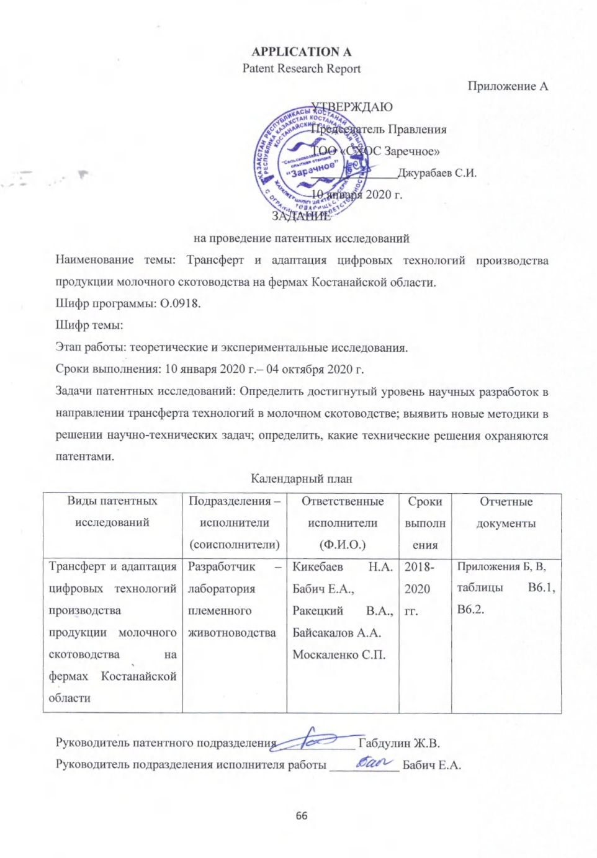

Приложение Б

Регламент поиска
Наименование темы: «Трансферт и адаптация цифровых технологий производства продукции молочного скотоводства в Костанайской области».
Шифр темы: О.0918.
Этап работы: теоретические и экспериментальные исследования.
Дата и номер задания на проведение патентных исследований №2 от 11 февраля 2020 г.
Цель поиска информации: Изучить уровень научных разработок в направлении трансферта и адаптации современных технологий в моочном скотоводстве.
Обоснование регламента поиска: Путем использования современных достижений и технологий в животноводстве разработать и внедрить эффективные технологии в отрасли молочного скотоводства для Костанайской области».
Начало поиска – февраль 2020 г. Окончание – декабрь 2020 г.
Предмет поиска (объект исследования его составные части) | Страна поиска | Источники информации, по которым будет проводиться поиск
Предмет поиска (объект исследования его составные части) | Страна поиска | Патентные |  | НТИ |  | Ретроспективность | Наименование информац. базы (фонда)
Предмет поиска (объект исследования его составные части) | Страна поиска | Наименование | Классификационные рубрики МКИ, НКИ | Наименование | Рубрики УДК и др. | Ретроспективность | Наименование информац. базы (фонда)
1 | 2 | 3 | 4 | 5 | 6 | 7 | 8
Способ воспроизводства высокопродуктивного стада коров.  Способ стимуляции воспроизводительной функции высокопродуктивных коров.  Управление технологическим процессом в молочном скотоводстве.  Способ определения рейтинга мясного скота.  Способ повышения продуктивности молодняка крупного рогатого скота. | Страны СНГ: Россия, Беларусь, Украина. | Изобретения стран мира 2010-2018 гг. Официальный бюллетень патентного ведомства РК. | А01К67/02; А61Н23/00; А01К1/00; А23К1/00;  А01К67/00;  А61К36/00; А01К67/02  G01N33/04.  АО61В10/00  А01Л67102. | Отчеты о НИР, журналы «Вестник сельскохозяйственной науки Казахстана», «Зоотехния», сборник научных трудов, «Главный зоотехник», |  | 2011-2018 гг. | РНТБ  Патентный фонд  Научн. Библиотека ф. НИИКОХ  РАСХН,  РНСХБ, Научн.  библиотека НЦНТИ

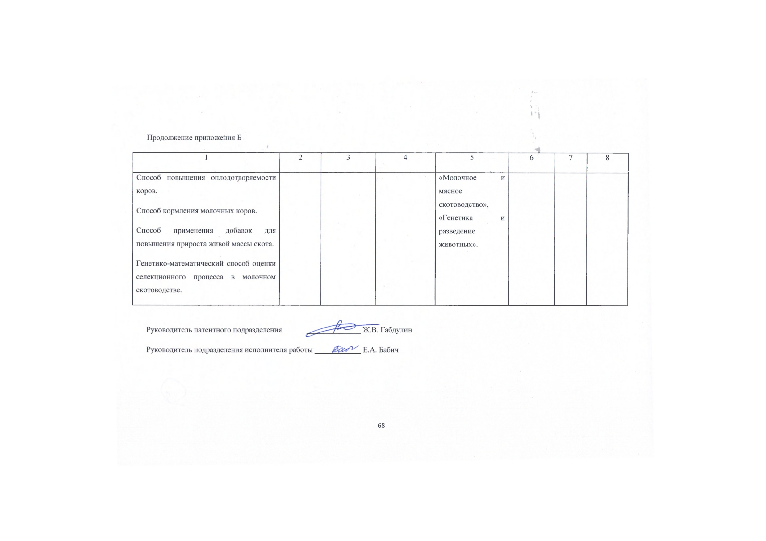

Приложение В
Форма отчета о поиске
В.1. Поиск проведен в соответствии с заданием председателя правления Джурабаева С.И. по теме «Трансферт и адаптация цифровых технологий производства продукции молочного скотоводства в Костанайской области», задание №1 от и Регламентом поиска №2 от 11 февраля 2020 г.
В.2. Этапы работы – Разработать эффективные способы ветеринарной обработки животных, изучить влияние микроклимата на показатели воспроизводства, внедрить систему навозоудаления.
В.3. Начало поиска – февраль 2020 г. Окончание – октябрь 2020 г.
В.4. Сведения о выполнении регламента поиска: Регламент поиска выполнен в полном объеме.
В.5. Предложения по дальнейшему проведению поиска и патентных исследований – тема является патентоспособной. В результате проведенной работы будут разработаны эффективные способы ветеринарной обработки животных, изучено влияние микроклимата на показатели воспроизводства, внедрена система навозоудаления.
В.6. Материалы, отобранные для последующего анализа.

Таблица В.6.1. – Патентная документация
Предмет поиска (объект исследования, его составные части) | Страна выдачи, вид и номер охранного документа, классификационный индекс | Заявитель (патентообладатель), страна. Номер заявки, дата приоритета, конвекционный приоритет, дата публикации | Название изобретения (полной модели, образца). Цель его создания.
1 | 2 | 3 | 4
Метод холодного выращивания в молочный период | РФ, патент.  RU 2076592  МПК А 01К67/02 | Россия.  Моноенков М.И.  Дата приоритета: 06.10.2011  Дата публикации: 24.05.2013 | Сущность изобретения: способ повышения продуктивных качеств и резистентности.
Метод холодного выращивания в молочный период | РФ, патент.  RU 2614781  МПК A 01K 1/00 | Россия.  Головань Валентин Тимофеевич  Юрин Денис Анатольевич  Кучерявенко Алексей Викторович Дата заявки:25.05.2016  Дата публикации:29.03.2017 | Домик для телят с выгулом. Полезная модель относится к животноводству, в частности к оборудованию для содержания телят.
Влияние микроклимата | УА, патент  RU A61L 9/22  МПК A61L 9/22 | Украина.  Бойчук Олег Владимирович  Дата заявки:21.03.2018  Дата публикации: 17.07.2018 | Устройство для очистки и регенерации воздуха. Полезная модель относится к области очистки и нормализации воздуха в закрытых жилых и промышленных помещениях.

Продолжение таблицы В.6.1
1 | 2 | 3 | 4
 | РФ, патент.  RU 174297  МПК 01K 1/00 | Россия.  Иванов Валентин Станиславович  Каурова Злата Генадьевна  Дата заявки:22.12.2016  Дата публикации:11.10.2017 | Устройство для очистки воздуха в животноводческом помещении. Полезная модель относится к устройствам очистки воздушной среды, преимущественно сельскохозяйственных помещений для содержания животных.
Термическая переработка навоза | РФ, патент.  RU 2014000629  МПК 6270A14 | Россия.  Валентин Андреевич КОЧЕРГА  Василий Борисович АНДРИАНОВ  Дата приоритета 2013.08.22  Дата публикации 2015.02.26 | Способ получения органического удобрения. Изобретение относится к сельскому хозяйству, может быть использовано при производстве органических удобрений.
 | РФ, патент.  RU 2646630  МПК C05F 3/00 | Россия.  Рабинович Галина Юрьевна  Мартьянова Ирина Александровна Дата заявки:13.06.2017  Дата публикации:06.03.2018 | Способ получения биоудобрения. Изобретение относится к биотехнологии и сельскохозяйственной микробиологии.

Продолжение таблицы В.6.1
1 | 2 | 3 | 4
Применение препаратов и кормовых добавок | УА, патент.  UA 105420 (У)  МПК A23K10/30 | Украина.  Институт сельского хозяйства Закарпатской области национальная академия аграрных наук НААН Украины.  Седило Григорий Михайлович  Федак Наталья Николаевна  Дата приоритета: 2015.06.16  Дата публикации: 2016.03.25 | Комбикорма для ремонтного молодняка телят. Комбикорм для ремонтных телочек (7-12 мес .) содержит зерно пшеницы, ячменя, овса, ржи, кукурузы, пшеничные отруби, жом свекловичный сухой, премикс, содержащий витамин D и микроэлементы купрум, цинк, кобальт, йод в форме неорганических солей, монокальций фосфат, глауберову и поваренную соль.
 | РФ, патент.  RU 2663014  МПК A23K 20/20 | Россия.  Никифорова Мария Павловна  Дата заявки:14.08.2017  Дата публикации:01.08.2018 | Способ изготовления биологически активной кормовой добавки для животных и птиц. Изобретение относится к кормам, специально предназначенным для животных, а именно к кормовым биологически активным добавкам (БАД).

Продолжение таблицы В.6.1
1 | 2 | 3 | 4
Ветеринарные обработки животных и их взвешивание | РФ, патент.  RU 2083102  МПК А 01К67/02 | Россия.  Научно-исследовательский институт ветеринарной генетики и селекции.  Петухов В.А.  Эрнст Л.К.  Незавитин Л.Г.  Желтиков А.И.  Короткевич О.С.  Куликова С.Г. Маренков В.Г.  Дата приоритета: 03.04.2012  Дата публикации: 24.05.2013 | Способ комплексного отбора быков-производителей по устойчивости потомства к болезням. Изобретение предназначено для использования при создании стад крупного рогатого скота, резистентных к ряду заболеваний.

Продолжение таблицы В.6.1
1 | 2 | 3 | 4
 | РФ, патент.  RU 2668124 (С1)  МПК A61K35/66 | Россия.  ФРС Государственное бюджетное образовательное учреждение высшего образования Южно-Уральский государственный университет  Щербаков Павел Николаевич  Щербакова Татьяна Борисовна  Дата приоритета: 2017.11.30  Дата публикации: 2018.09.26 | Лечение и профилактическое средство для молодняка сельскохозяйственных животных и способ профилактики респираторных заболеваний у телят и его применение. Изобретение относится к области ветеринарии и биотехнологии и представляет собой препарат для профилактики респираторных болезней телят.

Таблица В.6.2. – Научно-техническая, конъюнктурная, нормативная документация и материал государственной регистрации (отчеты о научно-исследовательских работах)
Предмет поиска | Наименование источника информации с указанием страницы источника | Автор, фирма технической документации | Год, место и орган издания
1 | 2 | 3 | 4
Биотехнологические методы воспроизводства. Диагностика стельности коров | Биотехнологические методы воспроизводства в селекционно-племенной работе в животноводстве Кыргызстана. с. 102-105 | Жунушева А.Т. | 2017г. Известия национальной академии наук Кыргызской республики
 | Сравнительный анализ различных способов биотехнологических методов воспроизводства. с. 112-116 | Далибаев Е.К.  Ахметов Д.М.,  Майкотов А.Н.  Несибаева А.К. | 2018г. Сборник научных трудов по материалам Международной научно-практической конференции.
 | Внедрение современного биотехнологического способа воспроизводства стада крупного рогатого скота. с. 170-171 | Куценко А.Ю.  Яковенко П.П. | 2017г. Сборник статей по материалам 72-й научно-практической конференции студентов по итогам НИР за 2016 год.
 | Осеменение ремонтных телок голштинской породы разного происхождения сексированным семенем. с. 22-28 | Ляшенко В.В.  Урядов П.Н.  Каешева И.Н.  Губина А.В. | 2018г. Главный зоотехник. №12
 | Преимущества инновационного метода IDEXX Visual Pregnancy Test для определения стельности у коров. с. 169-174 | Лящук Ю.О.  Новак А.И.. | Журнал Известия международной академии аграрного образования Номер: 42-1 Год: 2018
 | Ранняя диагностика стельности коров голштинской породы с помощью иммуноферментного анализа на основе белков, ассоциированных со стельностью. с. 29-31 | Жерносенко А.А.  Машнин А.В.  Петров К.И. | 2016г. Молочное и мясное скотоводство. № 1.
Метод холодного выращивания в молочный период | Выращиваем телят холодным методом. с. 53-56 | Кашин А.  Колесников В. | 2018г. Животноводство России. № 2.
Метод холодного выращивания в молочный период | Повышение резистентности и продуктивности телят методом холодного выращивания. с. 2487-2489 | Костеша Н.Я.  Иванов А.Г.  Дементьева Е.С. | 2017г. Материалы XXIII съезда Физиологического общества им. И. П. Павлова с международным участием
Метод холодного выращивания в молочный период | Применение холодного метода при выращивании ремонтного молодняка с. 64 | Горелик О.В.  Никонова А.Л. | Журнал Молодежь и наука. 2018. № 5. Екатеринбург
Влияние микроклимата | Экологические факторы и их влияние на микроклимат животноводческих помещении. с.141-143 | Ворожбит Н.М. | 2015г. Пути повышения эффективности орошаемого земледелия. № 1 (57).
 | Программа учета, идентификации и статистической обработки данных о животном.с.99-101. | Липовик В.О.  Малофеев Ю.М.  Липовик А.С. | 2013 г. Журнал «Вестник Алтайского государственного аграрного университета« № 5 (103).
 | Контроль живой массы и диагностика состояния здоровья крупного рогатого скота. с. 46-51. | КрауспВ.Р.  Харатян Г.А. | 2016 г. Журнал «Инновации в сельском хозяйстве«№ 6 (21).
 | Совершенствование технологии и технических средств утилизации навоза крупного рогатого скота.с.273. | Юданова А.В. | 2011 г. Журнал «Инженерно-техническое обеспечение АПК» Реферативный журнал. № 1.
 | Анализ технологий переработки твердого навоза и помета, адаптированных к условиям северо-западного федерального округа. с. 133-146. | Уваров Р.А. | 2017 г. Журнал «Технологии и технические средства механизированного производства продукции растениеводства и животноводства«№ 93.
 | Современные методы утилизации навозосодержащих и сточных вод. с. 86-90. | Неверова О.П.  Ильясов О.Р.  Зуева Г.В.  Шаравьев П.В. | 2015 г. Журнал «Аграрный вестник Урала« № 1 (131).

APPLICATION B
Calendar plan for 2018-2020
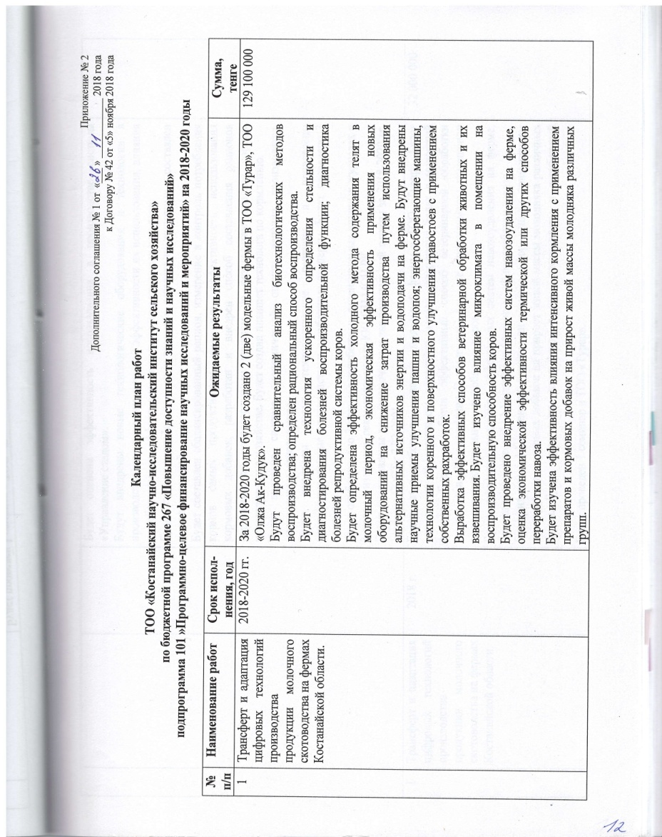

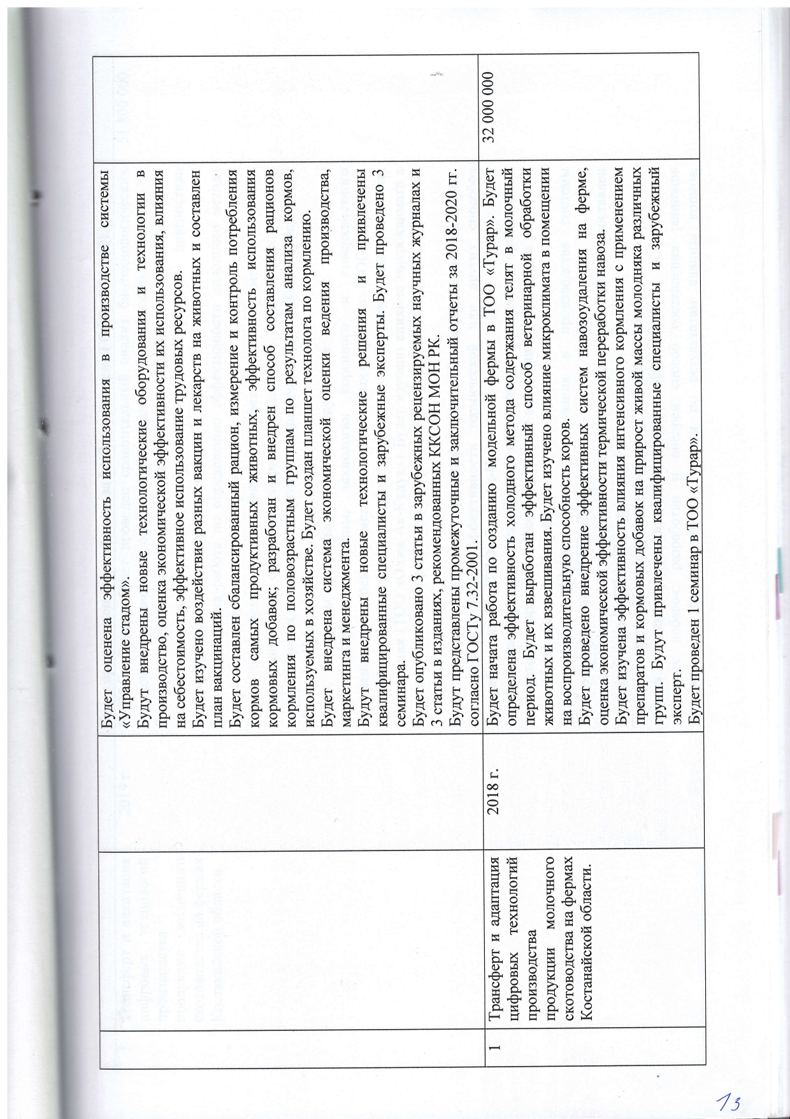
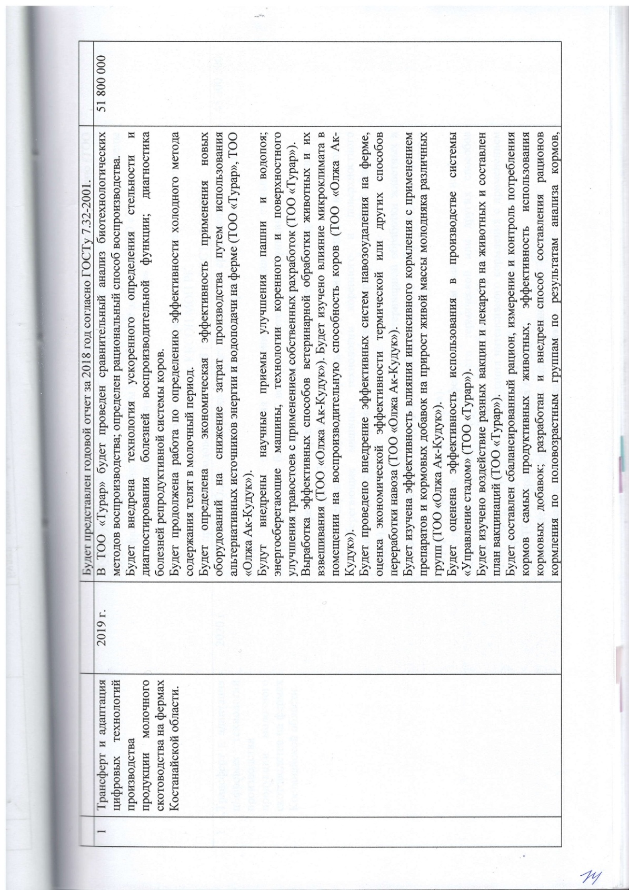
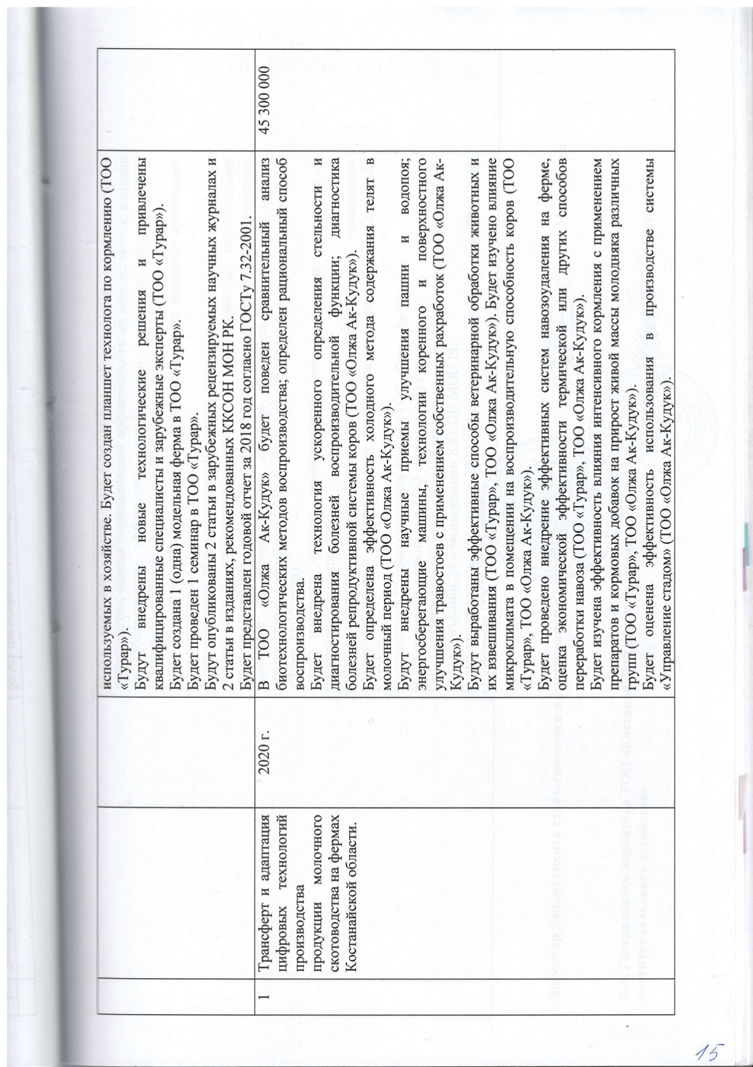


APPLICATION C
Tables for the report
Table B. 1 – Сomposition of the feed additive «Kalfostonik» (in 1 kg)
Name | Unit | Quantity
Vitamin А | М.Е. | 600 000
Vitamin Д3 | М.Е. | 200 000
Vitamin В1 | mg | 100,0
Vitamin В2 | mg | 200,0
Vitamin В6 | mg | 10,0
Vitamin В12 | mg | 1,1
Vitamin Е | mg | 75,0
Vitamin К3 | mg | 25,0
Nicotinic acid | g | 1,25
Calcium pantothenate | mg | 500,0
choline chloride | g | 25,0
DL-methionine | g | 10,0
L-lysine | g | 2,5
Gentian root | g | 5,0
Carnitine hydrochloride | g | 10,0
Msg | g | 7,5
Sodium chloride | g | 25,0
Magnesium carbonate | g | 5,0
Sodium Selenite | g | 36,5
Manganese (as sulfate) | mg | 480,0
Zinc (as sulfate) | mg | 504,0
Iron (as sulfate) | mg | 600,0
Copper (in the form of sulfate) | mg | 125,0
Cobalt (in the form of sulfate) | mg | 105,0
Potassium iodide | mg | 124,0
Calcium carbonate | g | 443,9
Dicalcium phosphate | g | 300,0

Table B.2 - Composition Tectonica
Name | Unit
Vitamin А | 2500 МЕ
Vitamin Е | 3,75 мг
Vitamin В₁ | 3,5 мг
Vitamin В ₂ | 4 мг
Vitamin В₆ | 2 мг
Vitamin В₁₂ | 10 мкг
Vitamin К₃ | 250 мкг
Dexpanthenol | 15 мг
Haline chloride | 400 мкг
Inositol | 2,5 мкг
Biotin | 2 мкг
Methionine | 5 мг
Lysine | 2,5 мг
Histidine | 900 мкг
Arginine | 490 мкг
Asparaginova acid | 1,45 мг
Threonine | 500 мкг
Serine | 680 мкг
Glutamic acid | 1,16 мг
Proline | 510 мкг
Glycine | 575 мкг
Alanine | 975 мкг
Cystine | 150 мкг
Valine | 1,1 мг
Leucine | 1,5 мг
Isoleucine | 125 мкг
Tyrosine | 340 мкг
Phenylalanine | 810 мкг
Tryptophan | 75 мкг
Filler | до 1 мл

Table V. 3 – Composition supplements Felucen
Name | Unit
1 | 2
Easily digestible carbohydrates | 75 %
High-purity table salt | 90%
Phosphorus | 0,058%
Calcium | 0,033 %
Iodine | 22,5 мг/кг
Selenium | 4,4 мг/кг
Magnesium | 0,24 %
Continuation of table B. 3
1 | 2
Sulfur | 3,6 %
Cobalt | 24,5 мг/кг
Manganese | 330 мг/кг
Zinc | 1560 мг/кг
Copper | 175мг/кг
Vitamin A | 500 000 МЕ
Vitamin E | 70 мг

Table B. 4 – Composition Of P 63-1 - 1%
РЕЦЕПТ
Продукция: П 63-1 - 1%
Назначение: Для телок
Наименование компонентов:
Шрот соевый (46%) асв 48%
Шрот подсолнечный СП (34%)асв 37%Шрот рапсовый – БККЗ
Масло подсолн.нераф. 1с. – БККЗ
Меласса свекловичная – БККЗ
Дрожжи кормовые з.б.
Лизин L сульфат 65/53% - БККЗ
Соль поваренная 1с пом.0 - БККЗ
Монокальцийфосфат крупка – БККЗ
Извест.мука (жив./птица) – БККЗ
Качественные показатели | количество | Качественные показатели | количество
Обм.эн. КРС,МДж/кг  Корм единицы в 100кг  Сухое вещество, %  Сырой протеин, %  Переварим прот. (КРС), %  Расщепляемый прот. (РП), %  Нерасщепляемый прот. (НРП),%  Сырой жир, %  Сырая клетчатка, %  Сырая зола, %  БЭВ  Крахмал, %  Сахар %  М,доляЛПУ/сахар+крахмал/%  Лизин %  Метионин %  Метионин+цистин%  Треонин %  Кальций, % | 10.17  102.82  85.58  31.95  23.93  22.49  7.94  5.23  11.20  6.21  3.48  6.17  9.66  1.67  0.67  1.17  1.24  0.40  2.31 | Фосфор, общий, % Натрий, % Хлор,% Хлорид натрия, %  Калий, %  А ретинолацетат,млн. МЕ/т D3,холекальцеферол. Млн. МЕ/ Е,  DLG-Токоферол ацет-т г/т  Марганец г/т  Цинк г/т Железо ( ll ),г/  Медь г/т Кобальт г/т йод г/т Сера элементарная г/т Селен г/т  Магний г/т  Агидол П, г/т Бутилгидрокситолуол,г/т | 0.90  0.71  1.06  1.74  1.03  133.00  26.50  174.50  100.00  250.00  0.00  90.00  15.00  14.00  300.00  4.00  1000.00
Table B. 5 – Composition of the VMK 63
РЕЦЕПТ
Продукция: ВМК 63
Назначение: для молодняка КРС
Стандарт на продукцию: ГОСТ Р 52528-2006
Наименование компонентов:
Шрот соевый (46%) асв 48% - БККЗ
Шрот подсолнечный СП (34%)асв 37%- БККЗ
Монокальцийфосфат крупка – БККЗ
Извест.мука (жив./птица) – БККЗ
ПС 63-1_17412_179750_ПС
Качественные показатели
Качественные показатели | количество | Качественные показатели | количество
Обм.эн. КРС,МДж/кг  Корм единицы в 100кг  Сухое вещество, %  Сырой протеин, %  Переварим прот. (КРС),%  Расщепляемый прот. (РП),%  Нерасщепляемый прот. (НРП)  Сырой жир,%  Сырая клетчатка,%  Сырая зола,%  БЭВ  Крахмал, %  Сахар %  М,доляЛПУ/сахар+крахмал/%  Лизин %  Метионин %  Метионин+цистин%  Треснин % | 7.15  85.79  90.56  30.14  23.15  22.20  7.11  1.22  15.71  6.41  28.94  4.66  5.38  10.04  1.11  0.68  1.21  1.12 | Триптофан,%  Кальций,%  Фосфор общий,% Натрий,% Хлор,%  Хлорид натрия % Калий, % А ретинолацетат,млн. МЕ/т D3,холекальцеферол. Млн. МЕ/т Е,  DLG-Токоферол ацет-тг/т Марганец г/т  Цинк г/т  Медь г/т  Кобальт г/т  йод г/т  Сера элементарная г/т  Селен г/т  Магний г/т | 0.37  2.49  2.90  0.07  0.06  0.13  0.90  40.00  10,00  5.00  20.00  50.00  25.00  7.50  7.50  48.90  0.50  0.13

Table B. 6 – Сomposition of the feed additive «VMK-TU 62»
РЕЦЕПТ
Продукция: ВМК-ТУ 62
Назначение: Для телок
Стандарт на продукцию: ГОСТ Р 52528-2006
Наим. Компонентов:
Шрот соевый (46%) асв 48% - БККЗ
Шрот подсолнечный СП (34%)асв 37%- БККЗ
Монокальцийфосфат крупка – БККЗ
Извест.мука (жив./птица) – БККЗ
ПС 62-2_17412_179750_ПС
Качественные показатели:
Качественные показатели | количество | Качественные показатели | Количество
Обм.эн. КРС,МДж/кг  Корм единицы в 100кг  Сухое вещество, %  Сырой протеин, %  Расщепляемый прот. (РП), %  Нерасщепляемый прот. (НРП),%  Сырой жир, %  Сырая клетчатка, %  Сырая зола, %  БЭВ  Крахмал, %  Метионин+цистин%  Треснин %  Селен г/т  Магний г/т | 7.09  78.82  84.70  29.52  20.79  8.31  1.06  12.93  5.82 25.07  2.31  1.18  1.44  5.00  0.50 | М,доля ЛПУ/  Лизин, %  Метионин, %  Метионин+цистин%  Треонин%  Триптофан%  Кальций %  Фосфор общий %  Натрий, %  Хлор, %  Хлорид натрия, %  Калий, % | 7.09  1.22  0.62  1.13  1.10  0.38  2.75  3.02  0.06  0.05  0.11  1.00

Table B. 7 - Аverage daily ration of cows during lactation, used in LLP «Olzha AK Kuduk»
Name | Unit
Wheat hay, kg | 5
Grain haylage, kg | 6
Corn silage, kg | 13
Concentrates , kg (50%wheat+50%barley) | 8
The diet contains
EKE | 17,59
Dry matter, kg | 19,88
Crude protein, g | 2476,68
Digestible protein,g | 1472,3
Raw fiber, g | 4763,38
Sugar, g | 997,36
Calcium, g | 84,44
Phosphorus, g | 49,26

Table B. 8 - Аverage daily ration of cows during lactation, used in LLP «Turar»
Name | Unit
Wheat hay, kg | 5
Grain haylage, kg | 6
Corn silage, kg | 13
Concentrates , kg (50%wheat+50%barley) | 8
The diet contains
EKE | 17,59
Dry matter, kg | 19,88
Crude protein, g | 2476,68
Digestible protein,g | 1472,3
Raw fiber, g | 4763,38
Sugar, g | 997,36
Calcium, g | 84,44
Phosphorus, g | 49,26

APPLICATION D
Drawings to the report
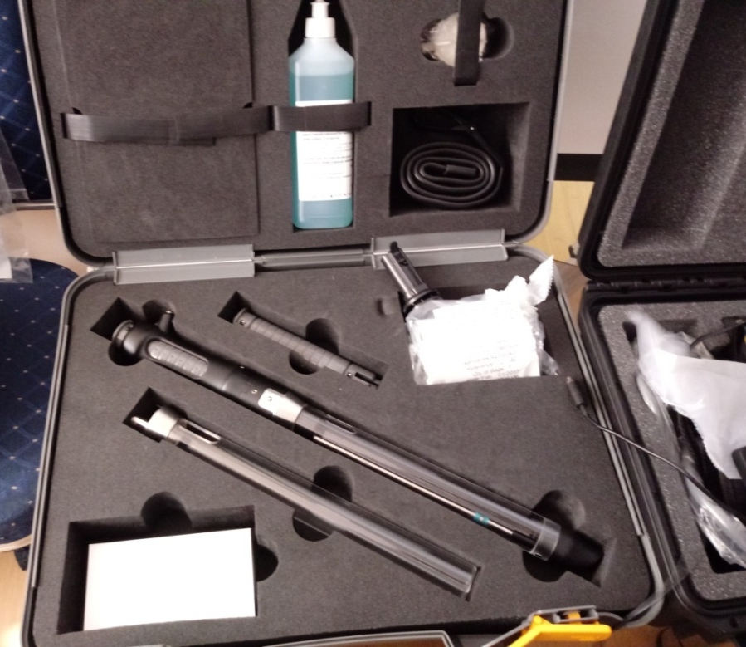
Figure G. 1 - Alphavision visual Insemination system (France)

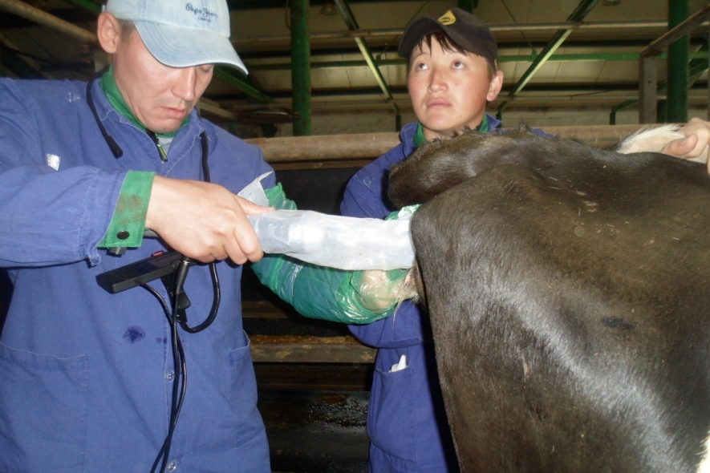
Figure G. 2 - Employees of the laboratory of livestock breeding Raketsky V. A. and Вaisakalov A. A. conduct artificial insemination using the Alphavision visual insemination system In «Turar» LLP in 2019

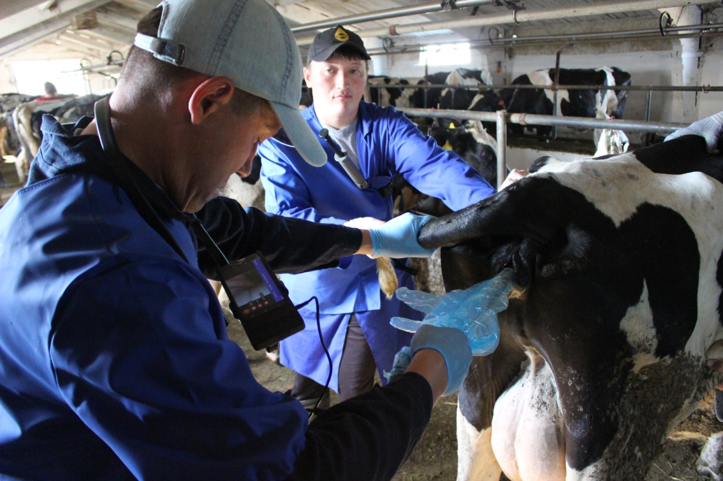
Figure G. 3 - Employees of the laboratory of livestock breeding Raketsky V. A. and Вaisakalov A. A. conduct artificial insemination using the Alphavision visual insemination system in «Olzha AK Kuduk» LLP in 2020


Figure G. 4 – Insemination by the Alphavision visual insemination system

Figure G. 5 - The cervix with a pronounced vascular pattern



Figure G. 6 – The Cervix of the uterus with hemorrhage

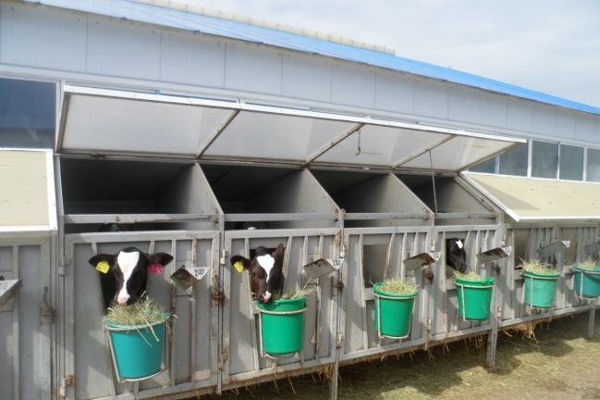
Figure G. 7 - Keeping calves in individual houses Without a paddock in «Turar» LLP

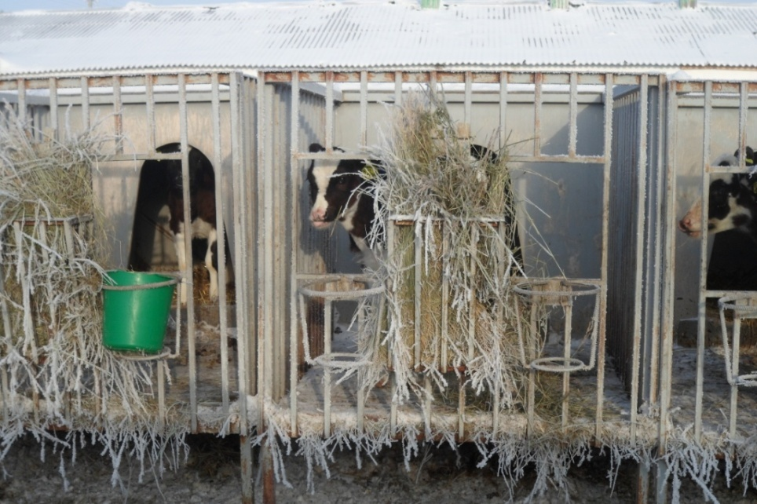
Figure G. 8 - Growing calves in individual houses With a paddock in «Turar» LLP
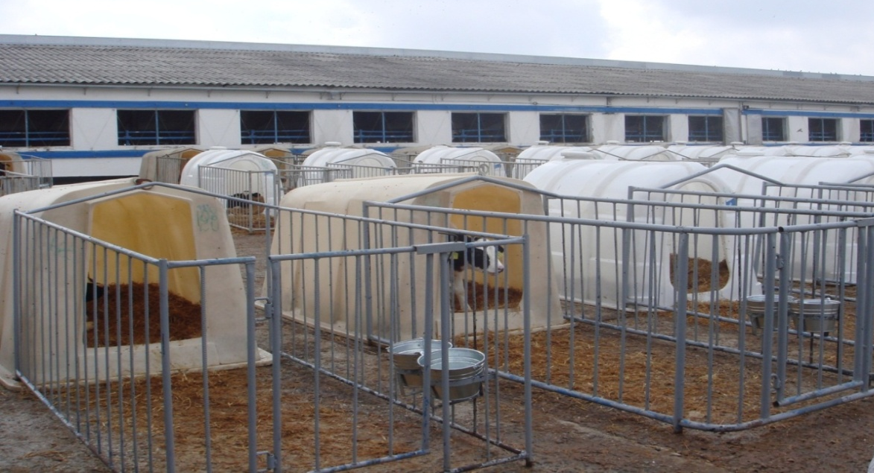
Figure G. 9 - Keeping calves in individual houses with a paddock in «Olzha AK Kuduk» LLP

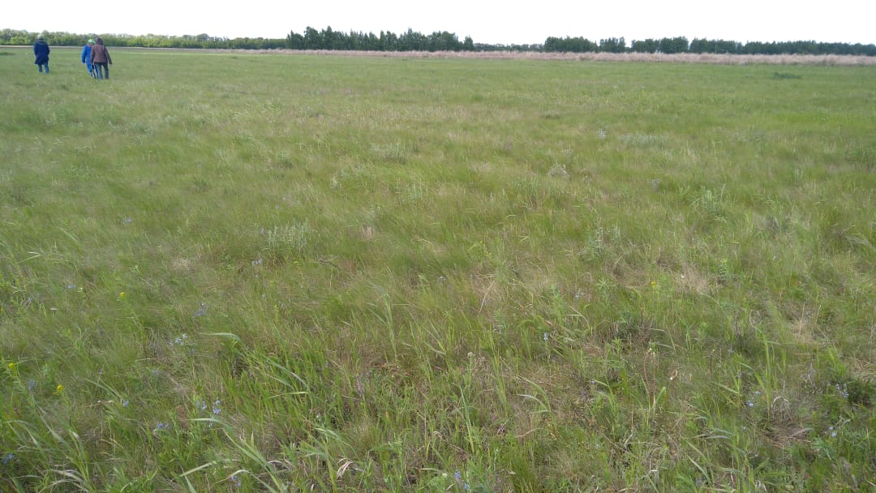

Figure G. 10 - Survey of pasture vegetation in «Turar» LLP
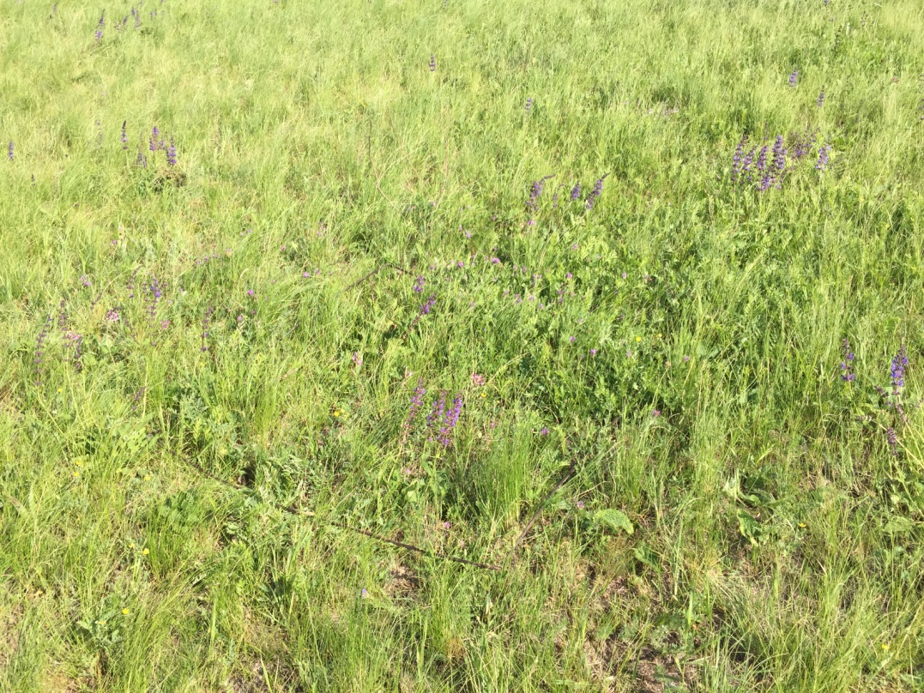

Figure G. 11 - Survey of pasture vegetation In «Olzha AK Kuduk» LLP

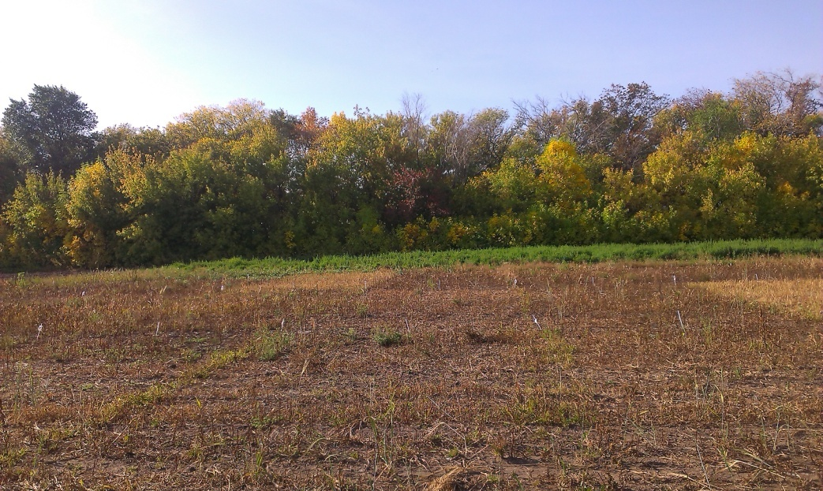
Figure G. 12 - Land grazing after treatment with the herbicide in LLP «Turar»
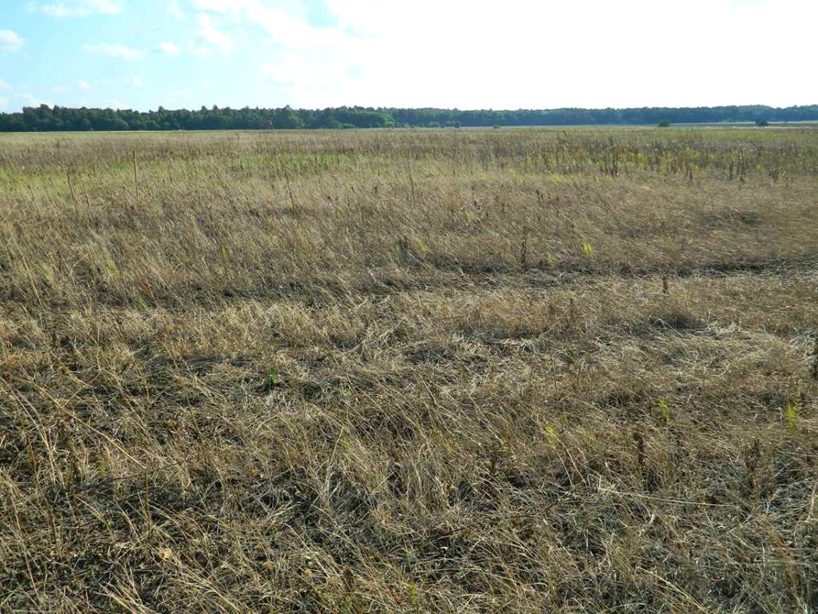
Figure 13 - Рasture plot after herbicide treatment in «Olzha AK Kuduk» LLP

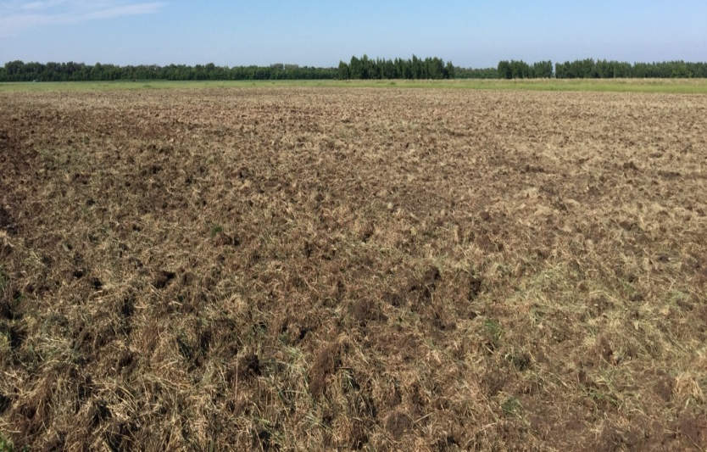
Figure G. 14 - Section after three-time treatment with disk harrows BDT -2.2 in «Turar» LLP
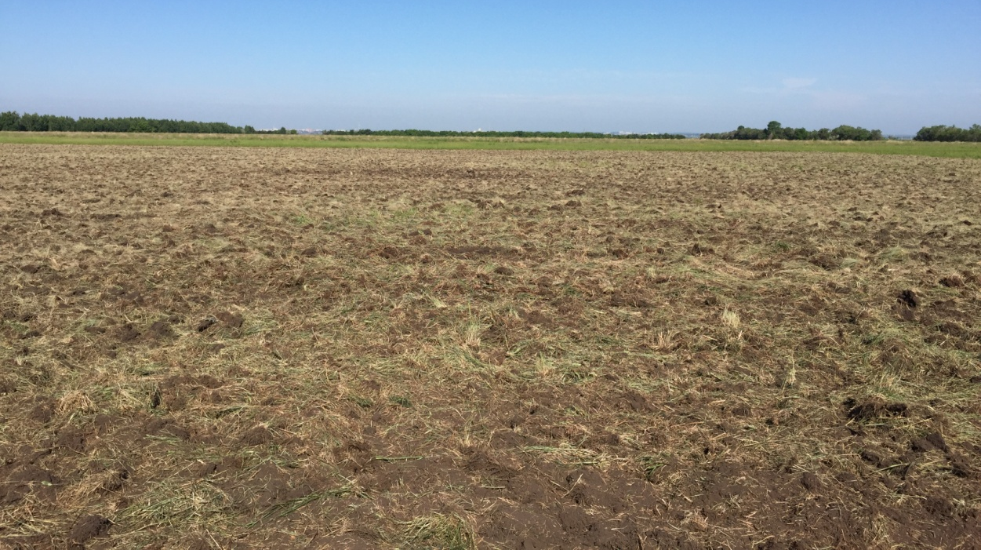

Figure G. 15 - Plot after three-time treatment with disk harrows BDT -2.2
in «Olzha AK Kuduk» LLP

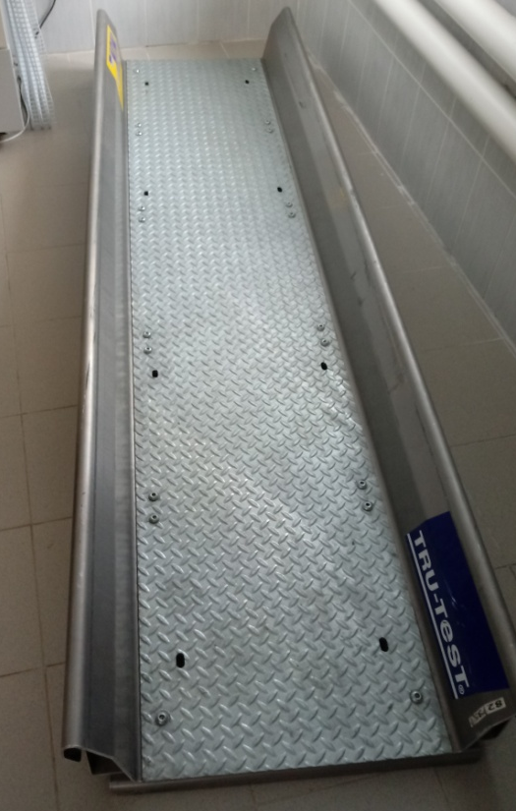
Figure G. 16 - Еlectronic weighing platform «TRU-TEST»
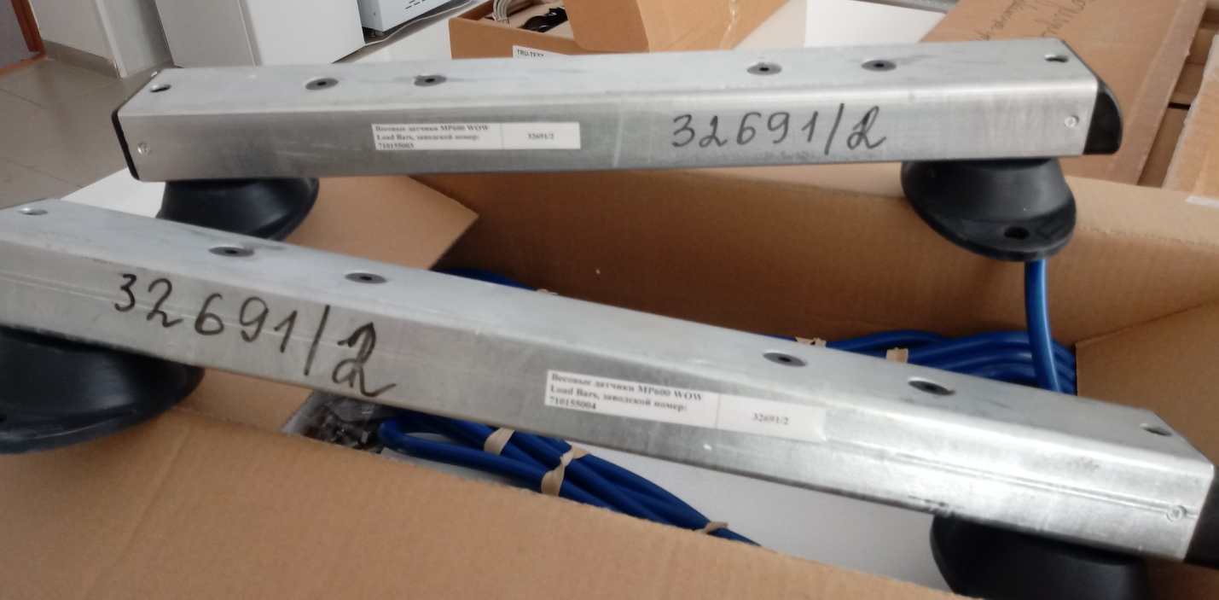
Figure G. 17 - Вeam For weighing electronic scales «TRU-TEST»

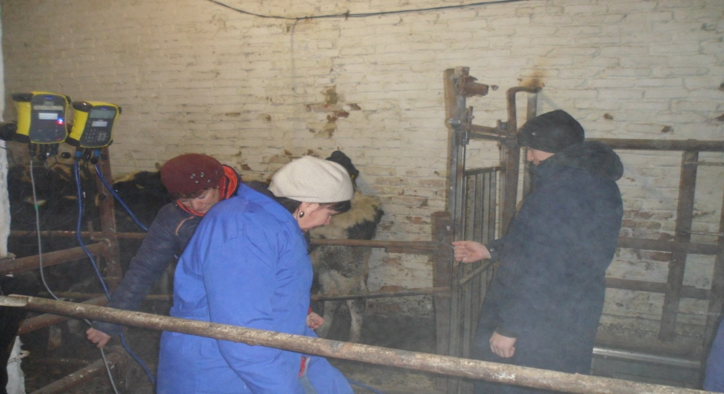
Figure 18 - Weighing heifers In «Olzha AK-Kuduk» LLP on electronic scales «TRU-TEST»
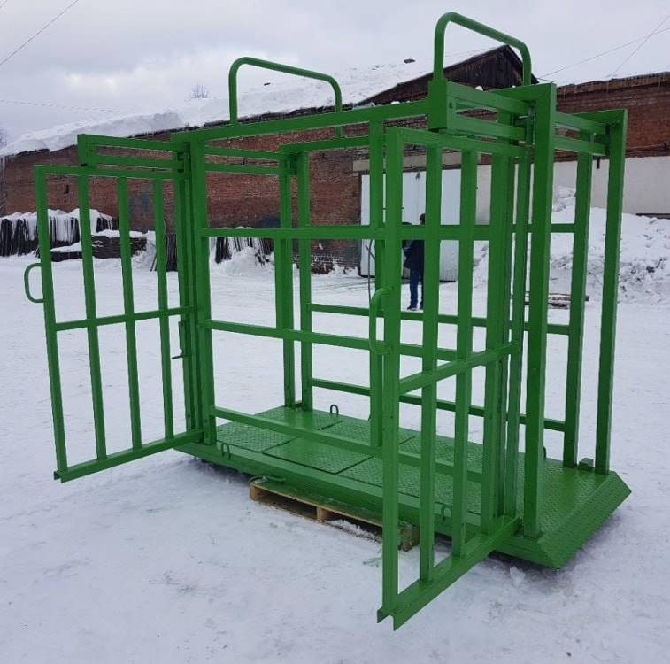
Figure G. 19 – Scales for weighing (electronic) in «Turar» LLP
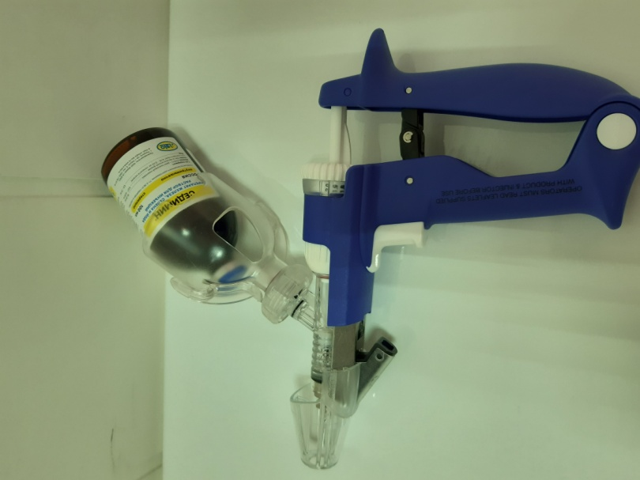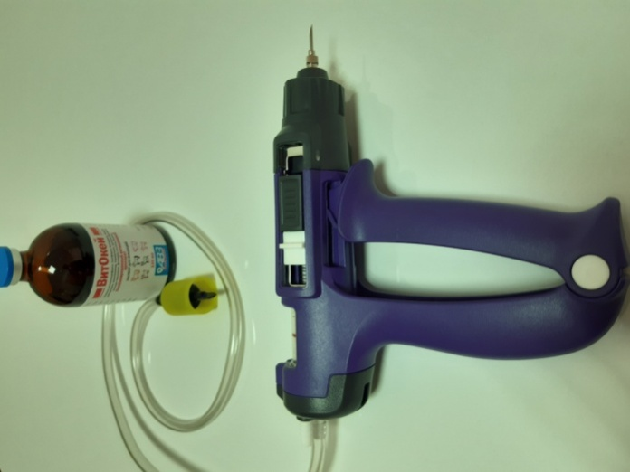
Figure G. 20 - SIMCRO injectors
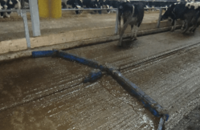
Figure G. 21 – Delta scraper installation DSU-170 in «Turar» LLP

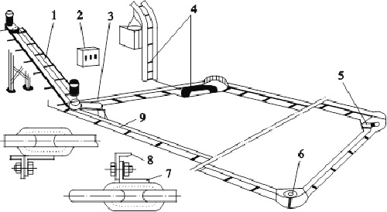
Figure G. 22 - Installation diagram of the TSN-2.0 B scraper conveyor (1 - inclined conveyor; 2 - control Cabinet; 3 - horizontal conveyor drive; 4 - tensioner; 5, 6 - rotary devices; 7 - brackets; 8 - scraper; 9 - chain)

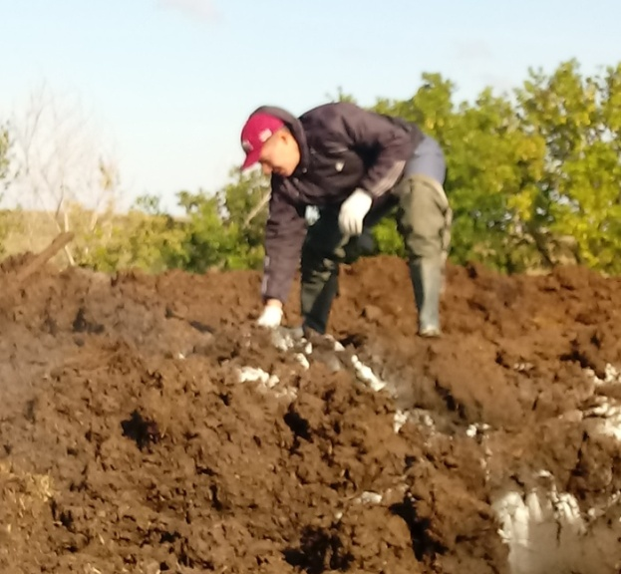
Figure G. 23 - Introduction of live thermophilic bacteria Organic Farming

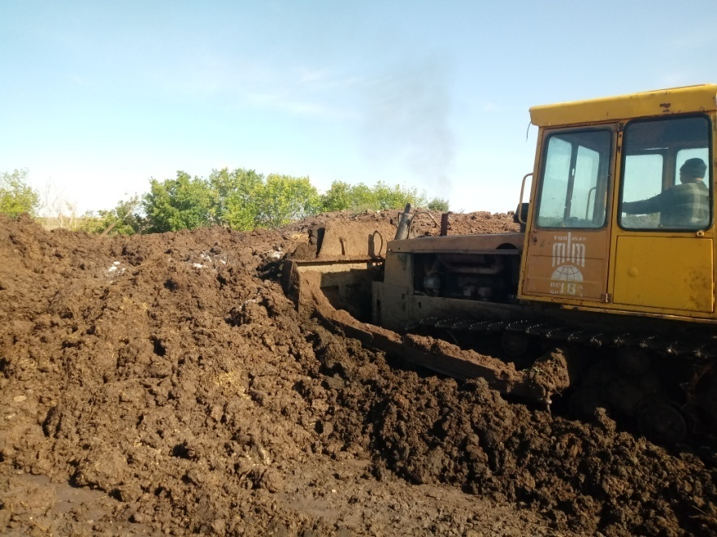
Figure G. 24 - Formation of the Burt
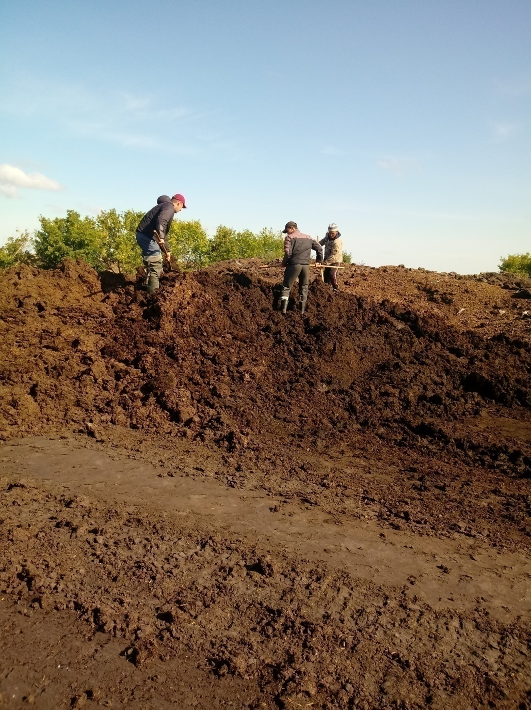
Figure G. 25 - Mixing of the Burt

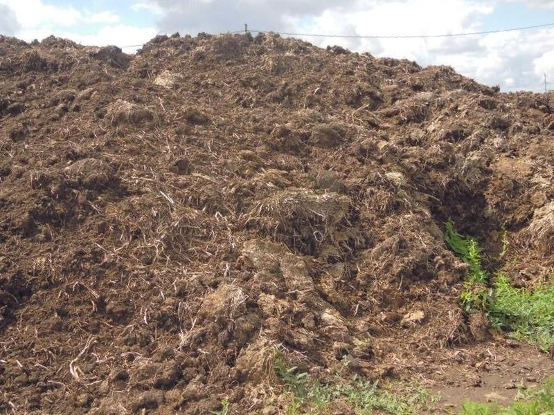
Figure G. 26 – Passive pile composting of manure
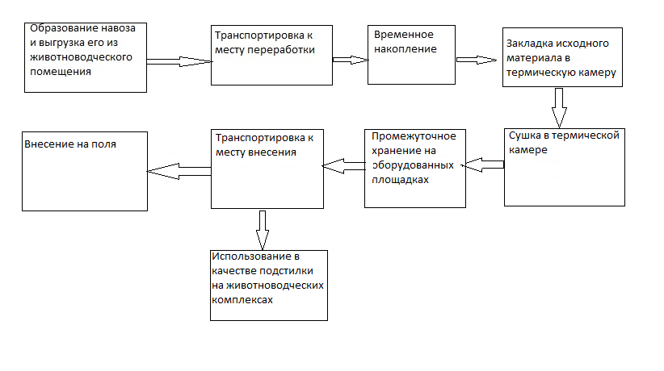
Figure G. 27 – Technology of thermal drying of manure

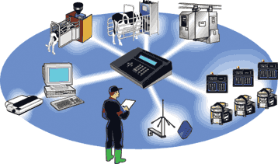
Figure G. 28 – System "herd management"
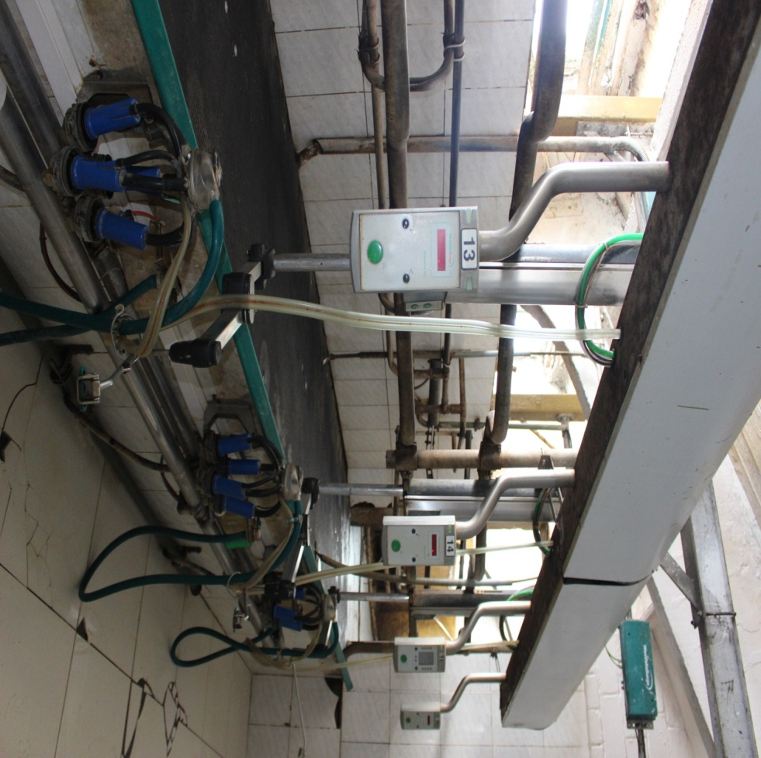
Figure G. 29 - Cow Milking position, the milk meter and electronic pulsator
LLP «Olzha AK-Kuduk»

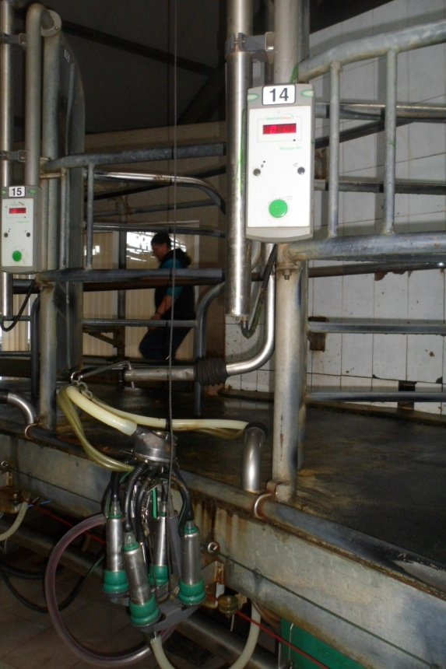
Figure 30 - Milking place, milk Meter and electronic pulsator in «Turar» LLP
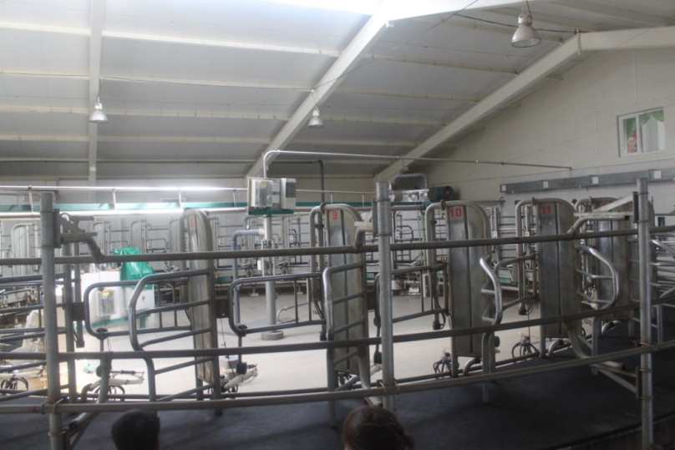
Figure G. 31 - Milking parlor "Carousel" in LLP «Turar»

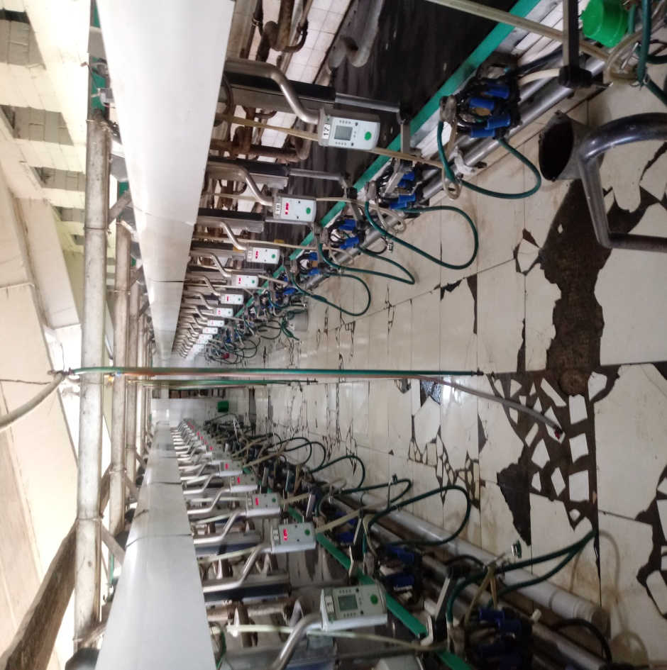
Figure G. 32 - Milking parlor «Herringbone»
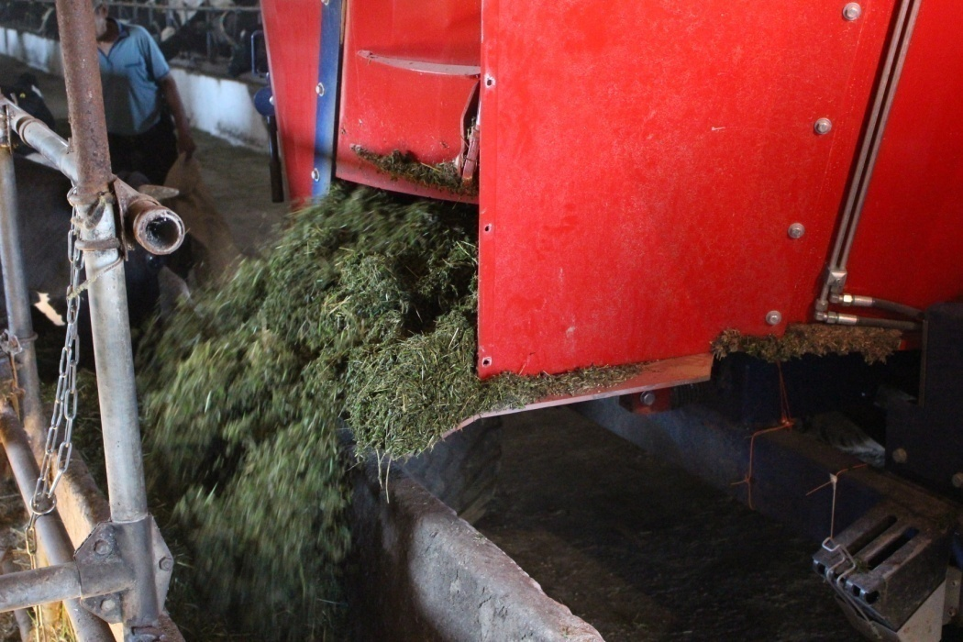
Figure G. 33 – Distribution of feed in «Olzha AK Kuduk LLP»

APPLICATION E
Information on purchasing equipment within the project
The following equipment was purchased at the expense of program-targeted funding:
1. Alpha Vision visual insemination system (France).
2. Draminski ultrasound scanner (Poland).
3. Dewar vessel (USA).
4. Refractometer for determining immunoglobulins in the blood.
5. Digital microscope.
6. Veterinary machine.
7. Mobile electronic scales (Russia).
8. Electronic stationary scales (weighing when moving animals).
9. Mobile milking machines.
10. Scraper conveyor TSN-2.0 B.
11. Tanker milk cooler automatic washing.
12. Pump for scraper manure removal systems.
13. Somatos-mini Viscometer for determining somatic cells in milk.
14. Inframilk infrared milk analyzer.
15. Ejaculator with suitcase and power supply
16. KU-203 crusher.
17. Rescounters and responders – electronic identifiers.

APPLICATION F
The acts of implementation
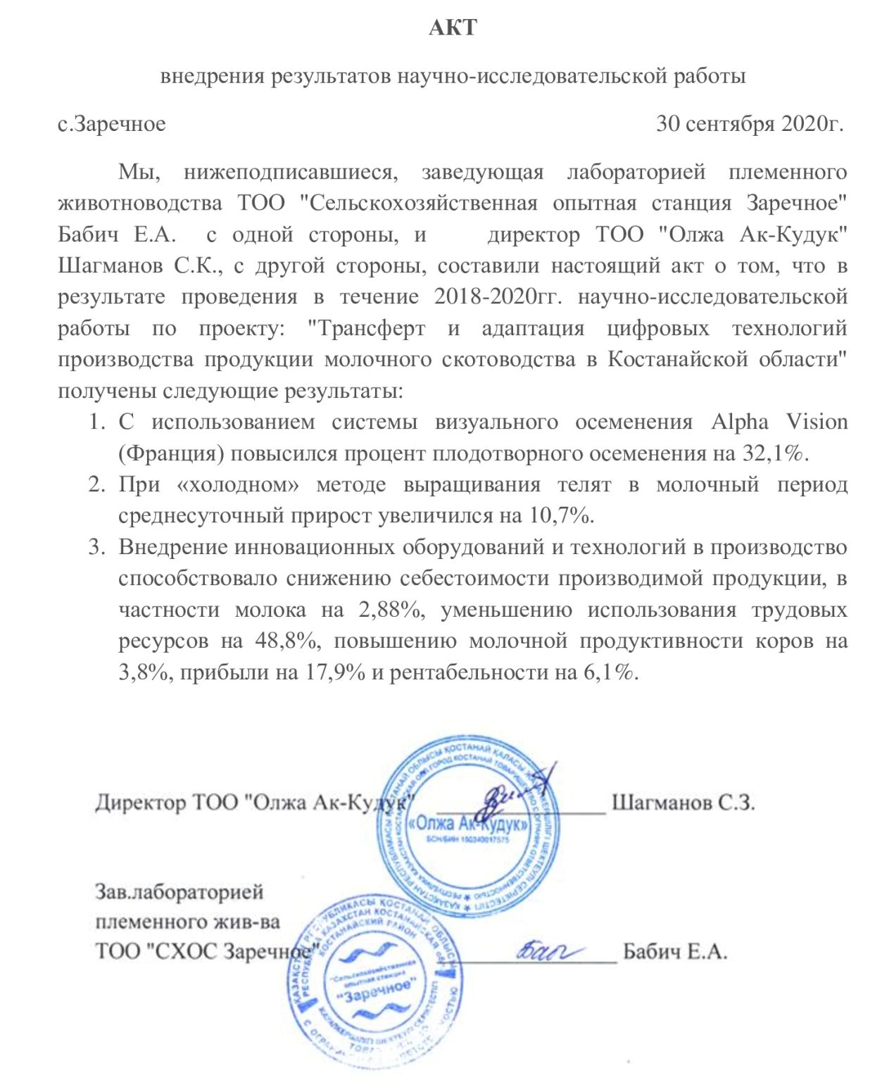
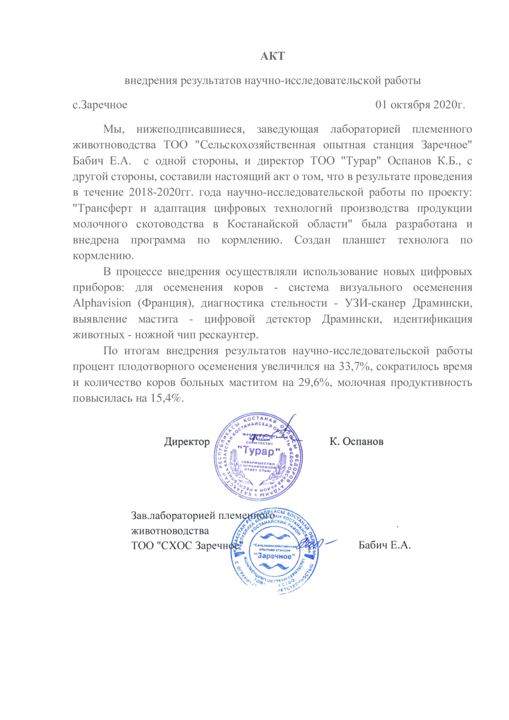

APPLICATION G
List of published works
1. Raketki V. A. Milk yield of cows of Holstein breed American breeding bred in the conditions of Northern Kazakhstan / V. A. Roketskii, A. Baisakalov // Scientific support of innovative development of the agro-industrial complex of the regions of the Russian Federation: collection of articles on the results of international conferences. scientific and practical Conf., Kurgan-Nalchik, February 2018. P. 879-884. (рус.яз.)
2. Babich E. A. influence of genotype on morphofunctional properties of udder of cows of the first calving / E. A. Babich, L. Yu. Ovchinnikova// Dairy and beef cattle breeding. 2018. No. 1. P. 16-18. (рус.яз.)
3. Babich E. A. assessment of the exterior of repair heifers by growing periods / E. A. Babich// Experimental and theoretical research in modern science: collection of articles on the results of the XVIII international conference. scientific.-pract. Conf. Novosibirsk, may 2018. No. 9 (18). P. 63-68. (рус.яз.)
4. Dependence of Growth and Development of Stock Rearing in Northern Kazakhstan on the Origin of Servicing Bulls – ELENA ANATOLYEVNA BABICH*, NABIDULLA AKHANOVICH KIKEBAYEV, VITALY ANATOLEVICH RAKETSKY AND ABDRAKHMAN ABDYBEKULY BAISAKALOV, Annals of Agri-Bio Research 24 (1): 134-138, 2019. (англ.яз.)
5. Babich, E. A. influence of indoor microclimate on the reproductive capacity of cows / E. A. Babich, V. A. Raketsky, A. A. Baisakalov // Science and education. - №1 (54). - 2019. - p. 90-94.
6. Raketsky, V. A. Efficiency of using the electronic detector "Draminsky" In determining subclinical mastitis / V. A. Raketsky, A. A. Baisakalov, S. P. Moskalenko// Science and education. - №1 (54). - 2019. - Pp. 312-316. (рус.яз.)
7. The Growth and Development of Replacement Heifers Using the Cold Housing Method During the Preweaning Period - Elena Anatolyevna Babich*, Lyudmila Yuryevna Ovchinnikova, Olga Stanislavovna Safronova, Advances in Animal and Veterinary Sciences, 2019, Volume 7, Special Issue 1, Page 1. (англ.яз.)
8. Babich, E. A. efficiency of using the "herd management" system in production / E. A. Babich, Zh. S. Zhaksumbay, S. P. Moskalenko // Science and education. - №2-1 (59) – 2020. – pp. 14-19. (рус.яз.)
9. Elena Anatolyevna Babich, Lyudmila Yuryevna Ovchinnikova, Aleksandr Aleksandrovich Ovchinnikov, Zhanara Serikovna Zhaksumbay MILK PRODUCTIVITY AND TECHNOLOGICAL PROPERTIES OF THE MILK FROM THE HOLSTEIN AND BLACK-MOTLEY COWS - 2020, in print, (англ.яз.)

APPLICATION H
Prints of published works
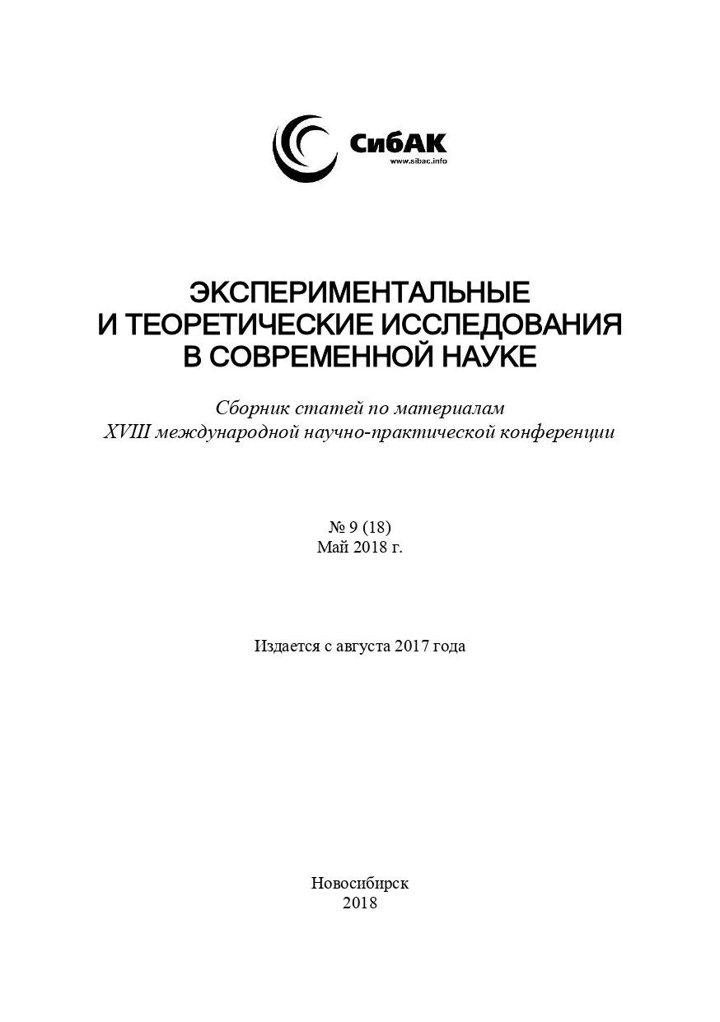
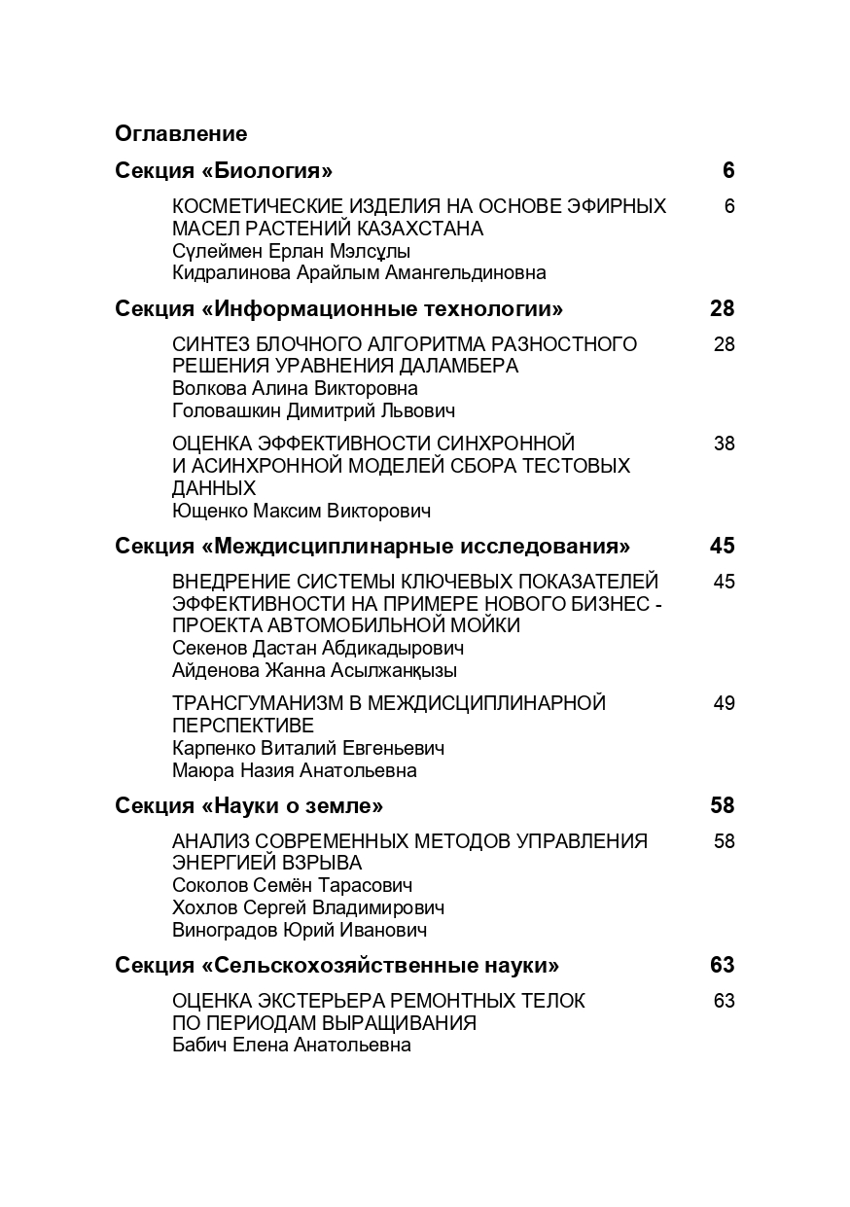
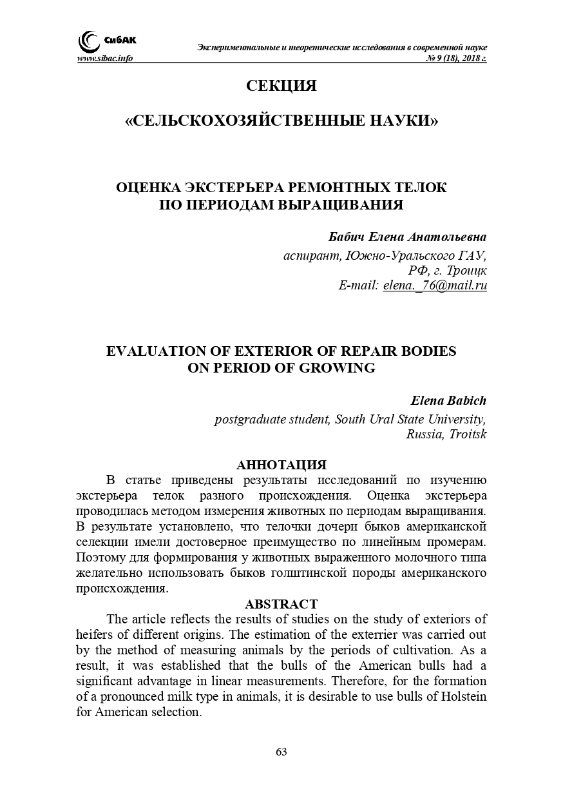
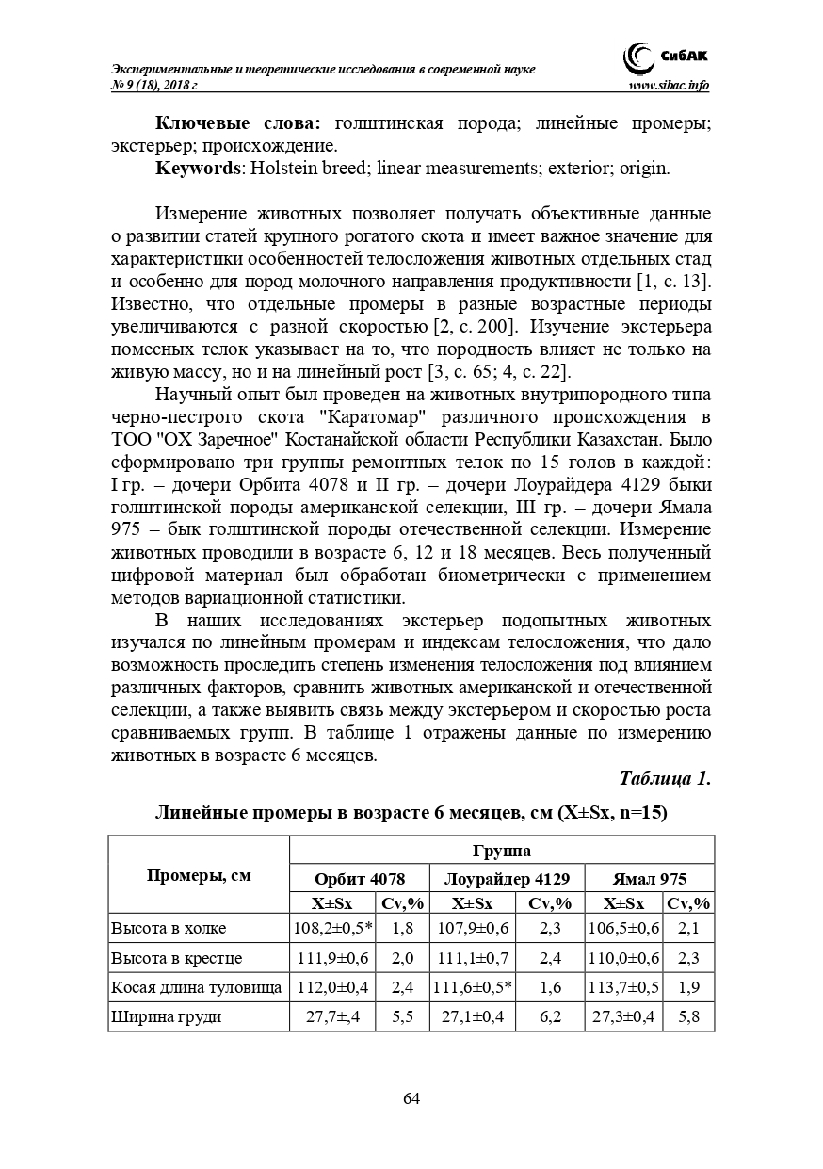
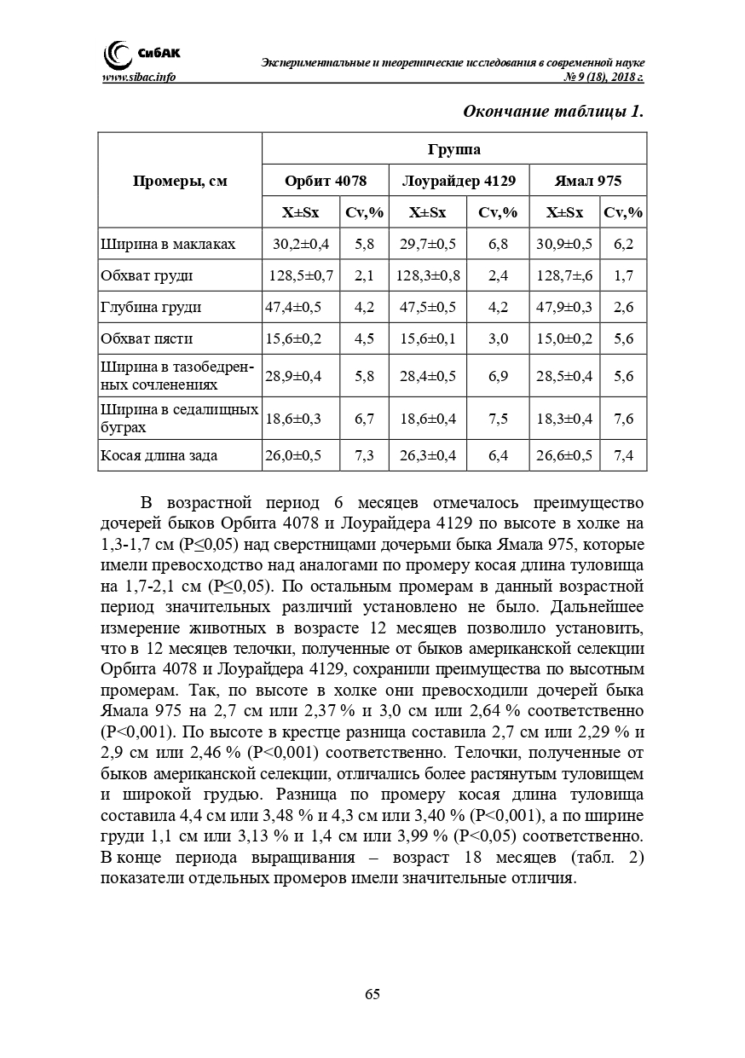
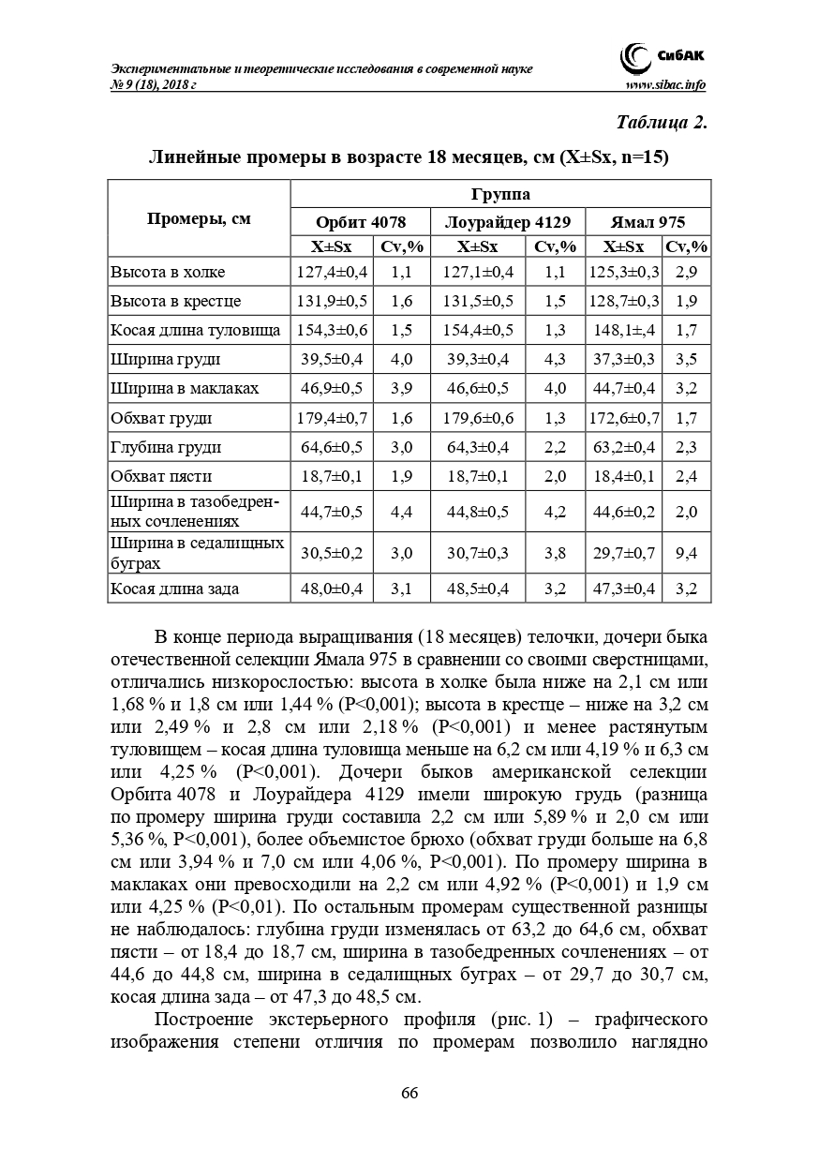
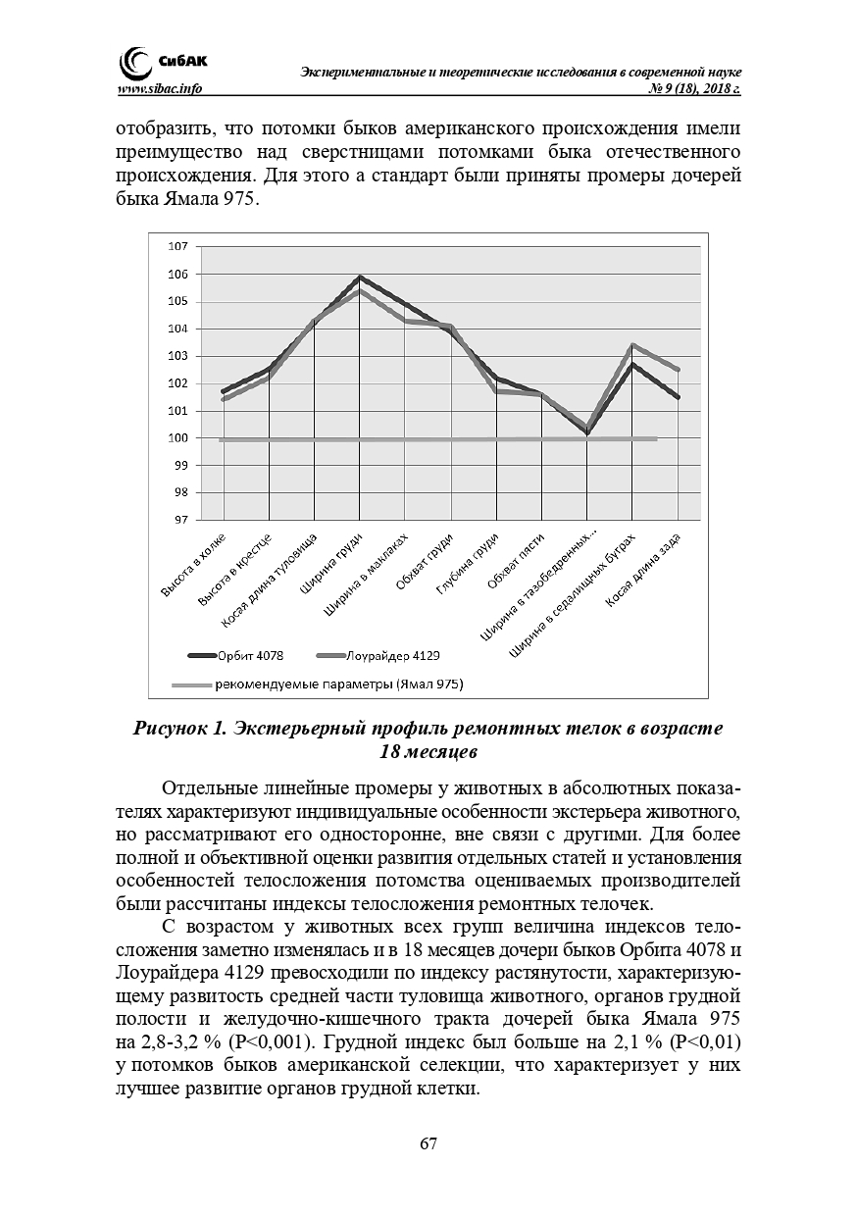
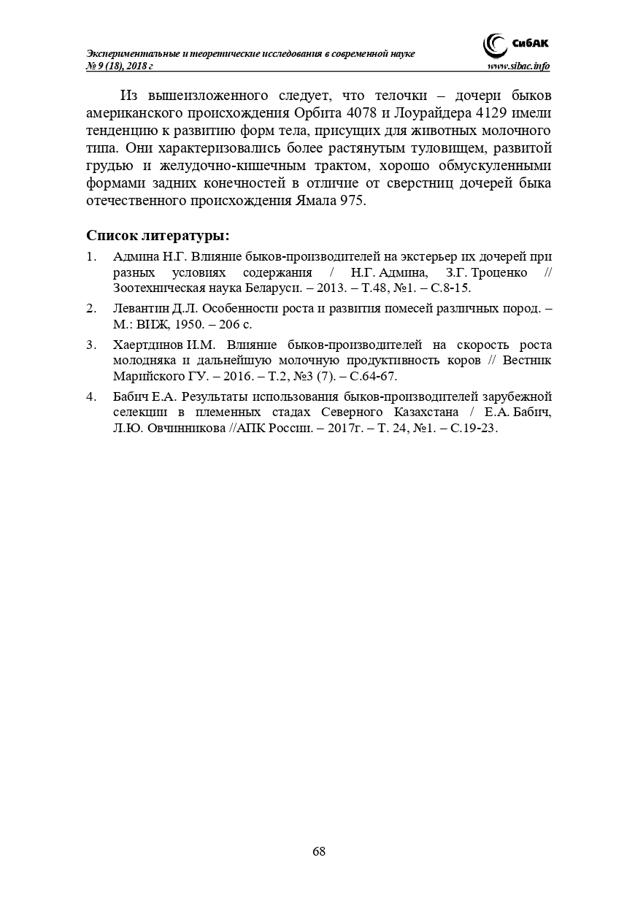
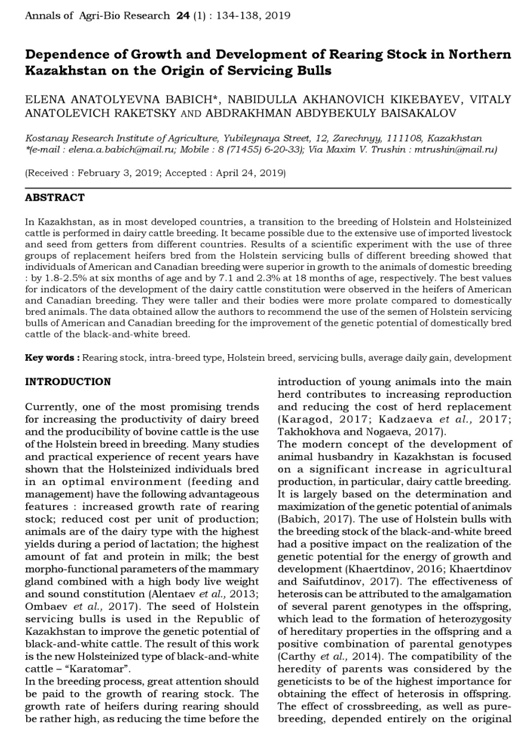
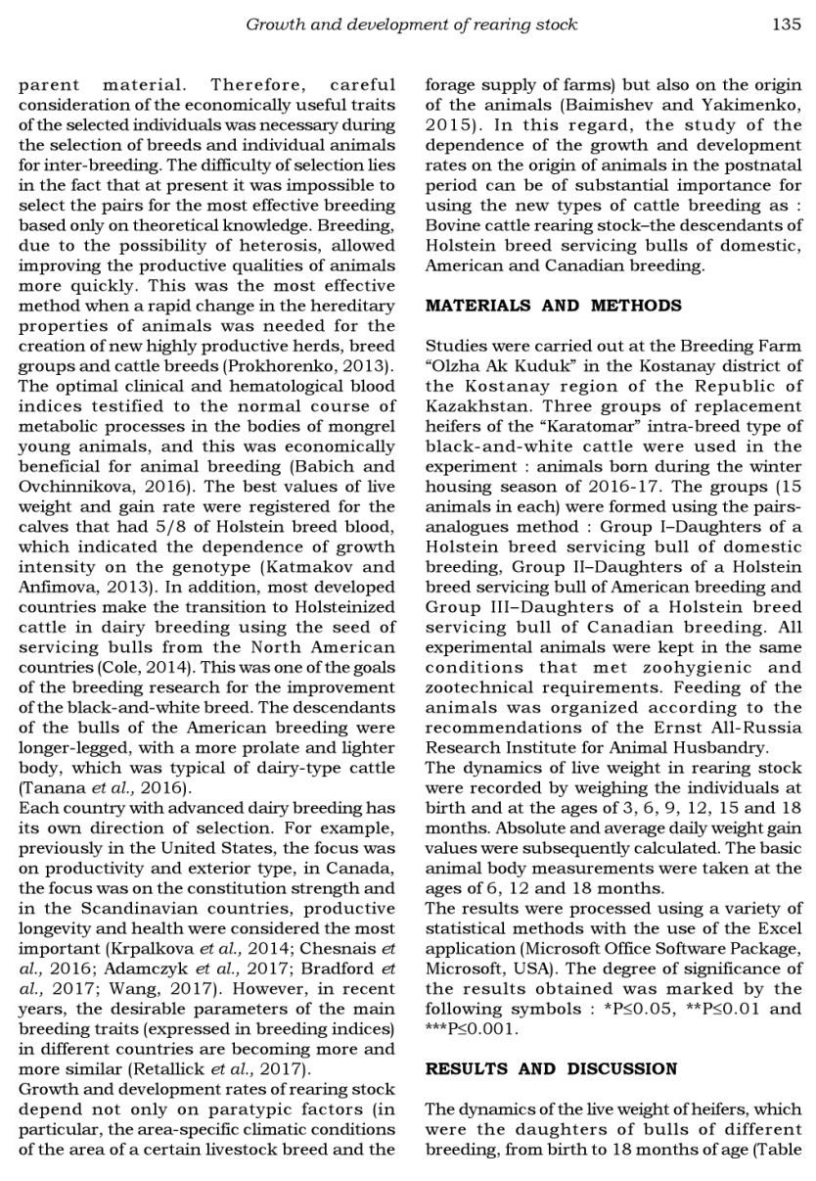
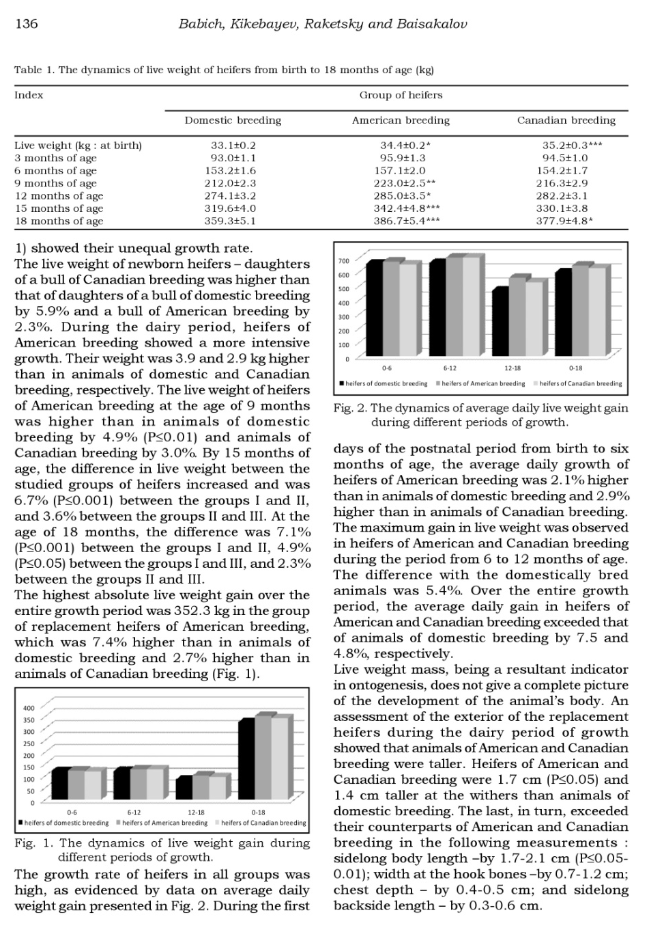
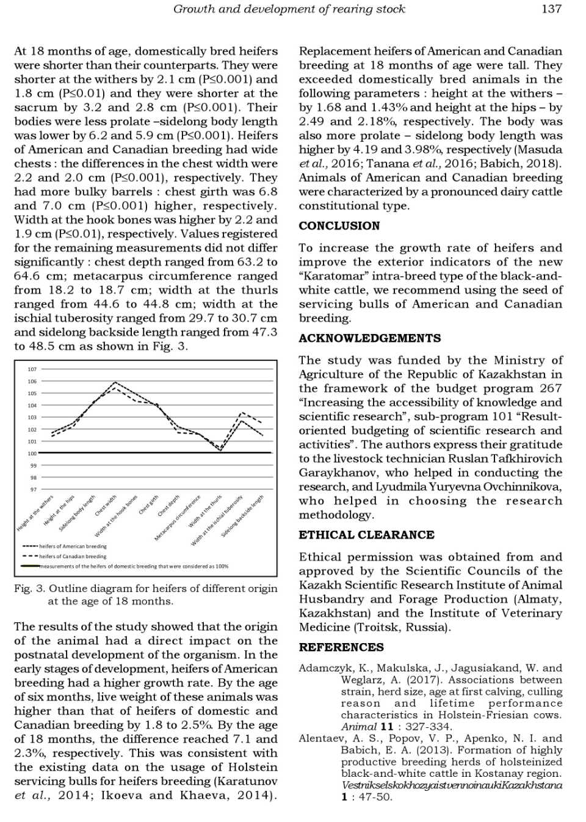
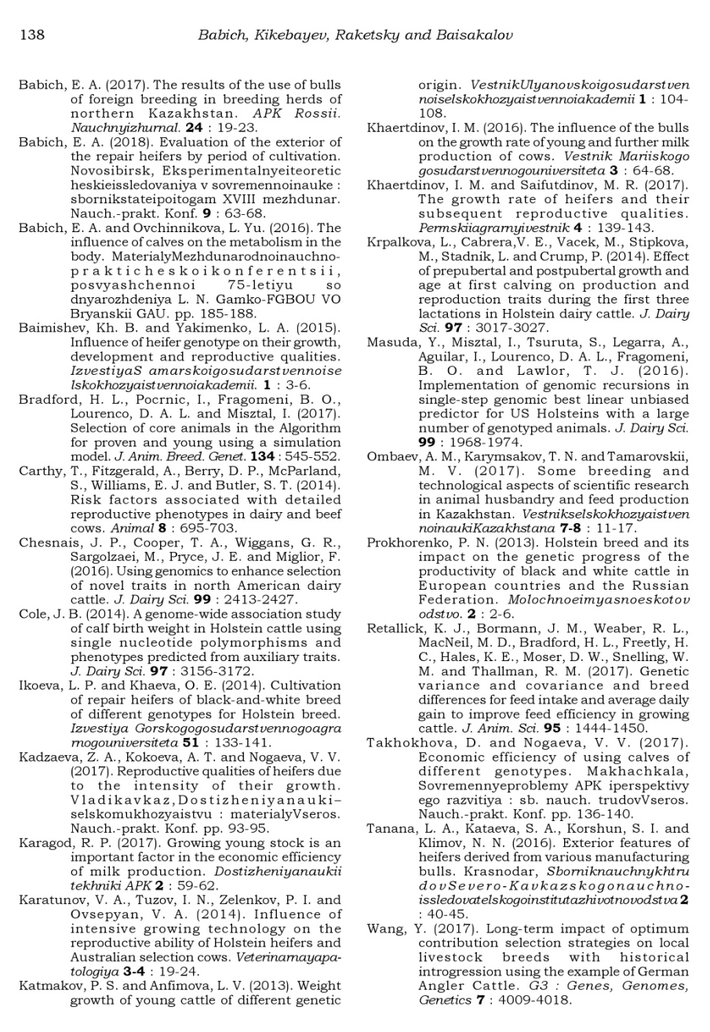
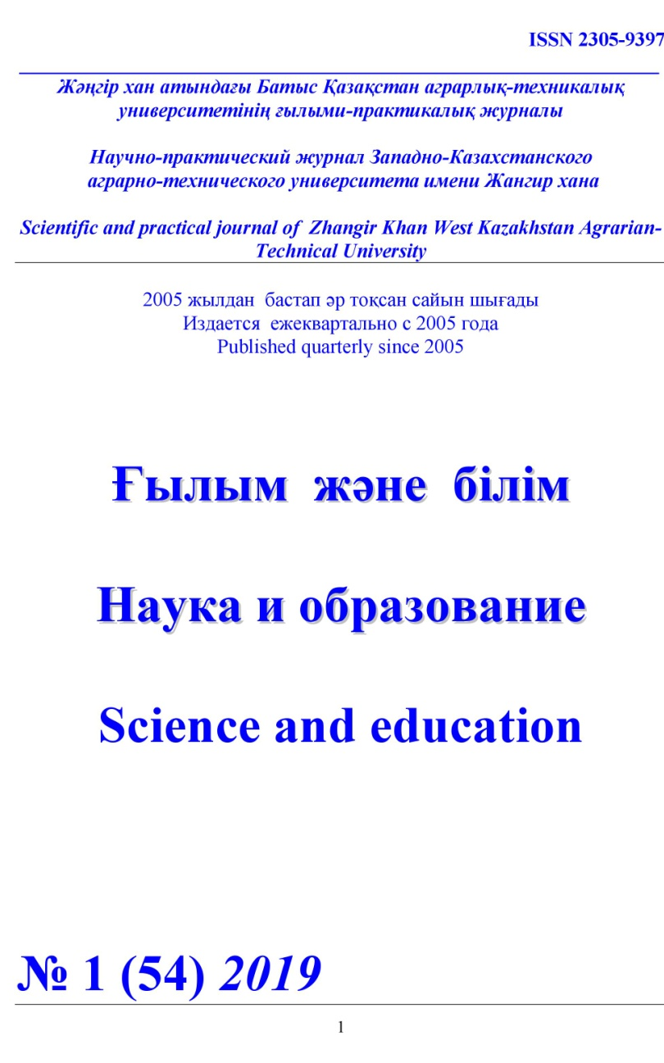
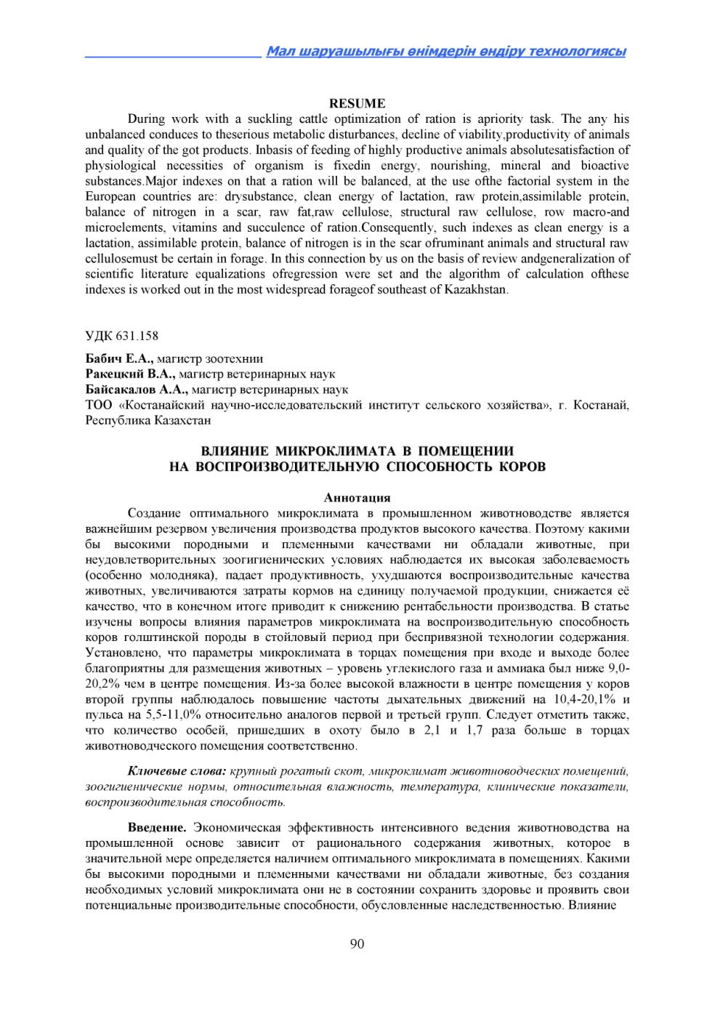
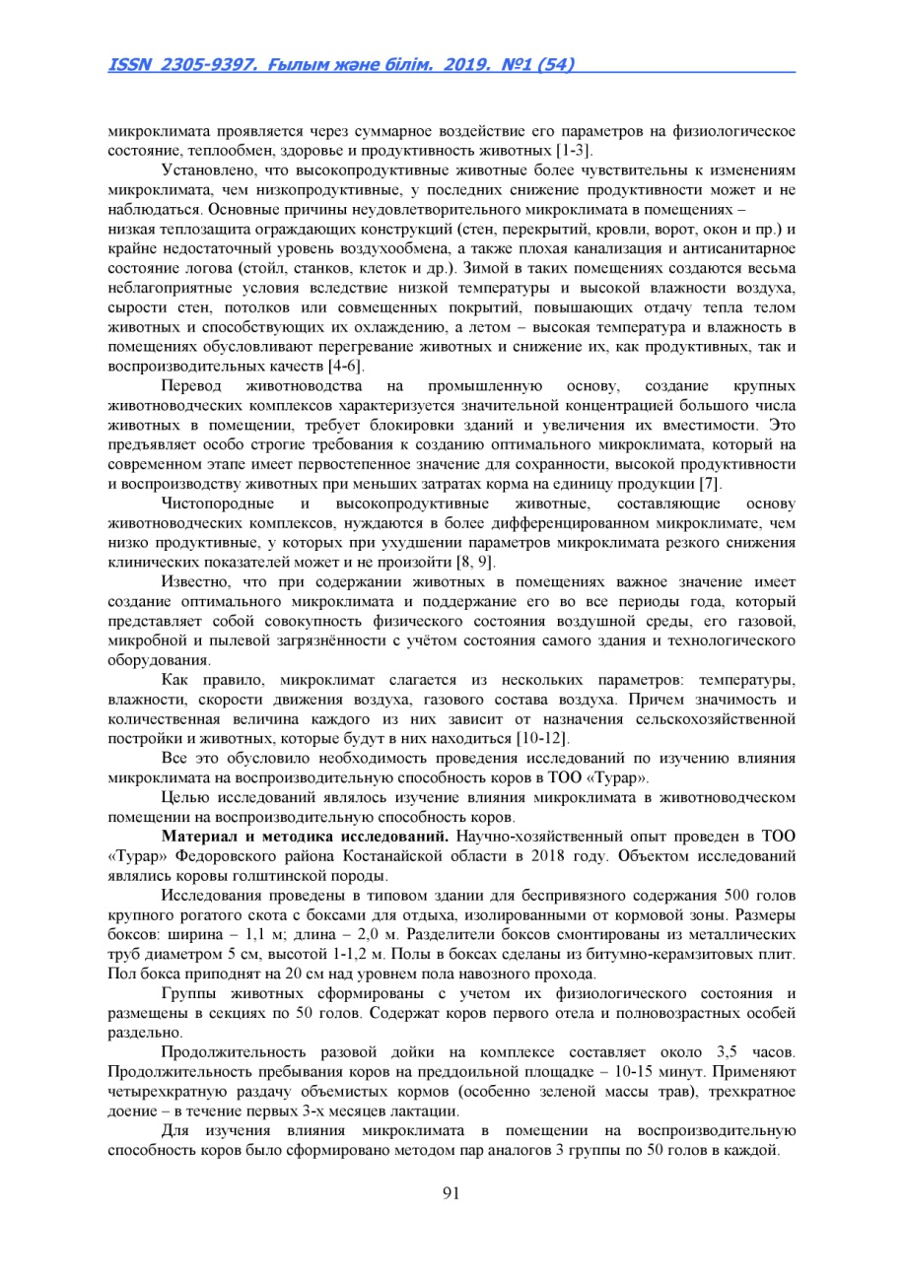
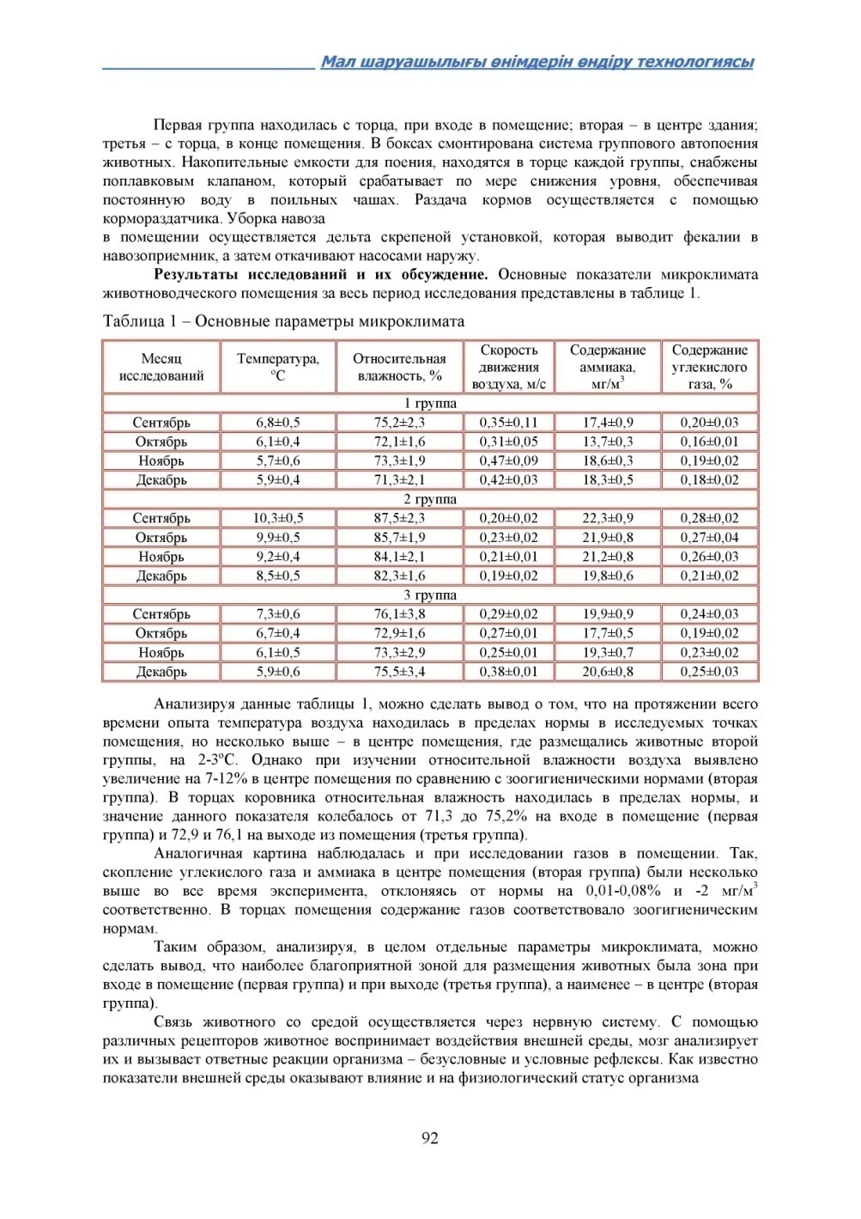
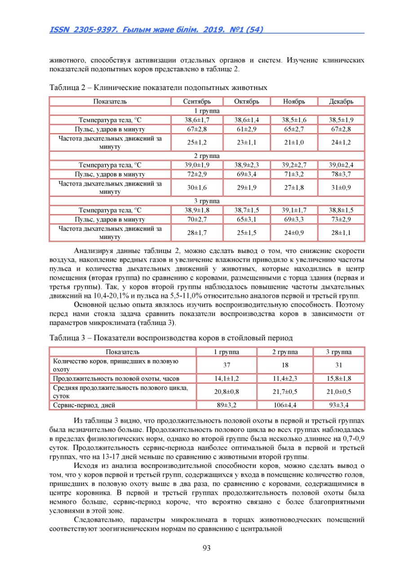
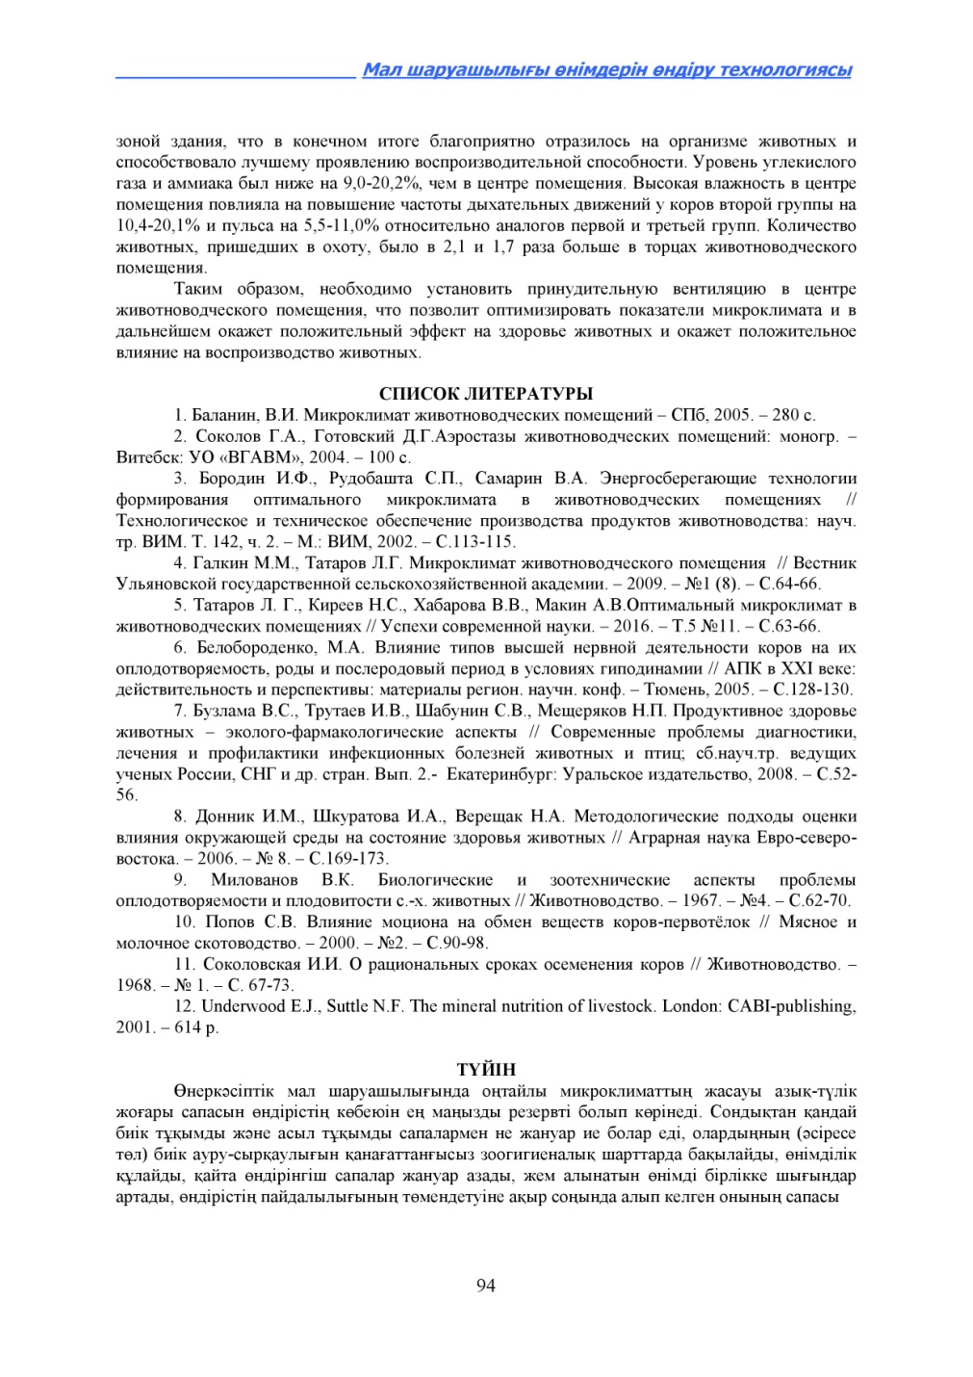
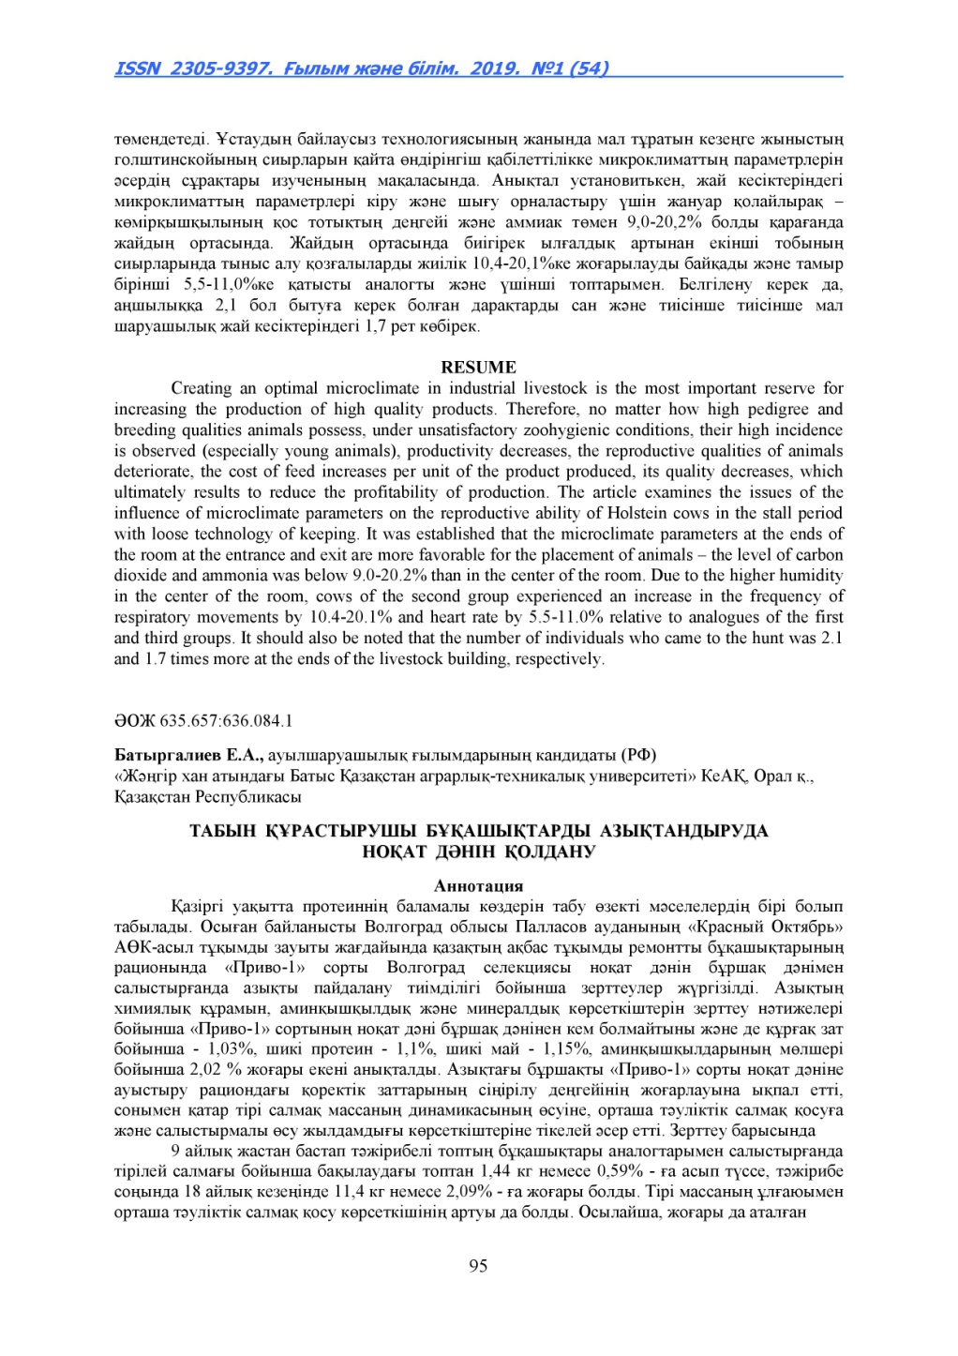
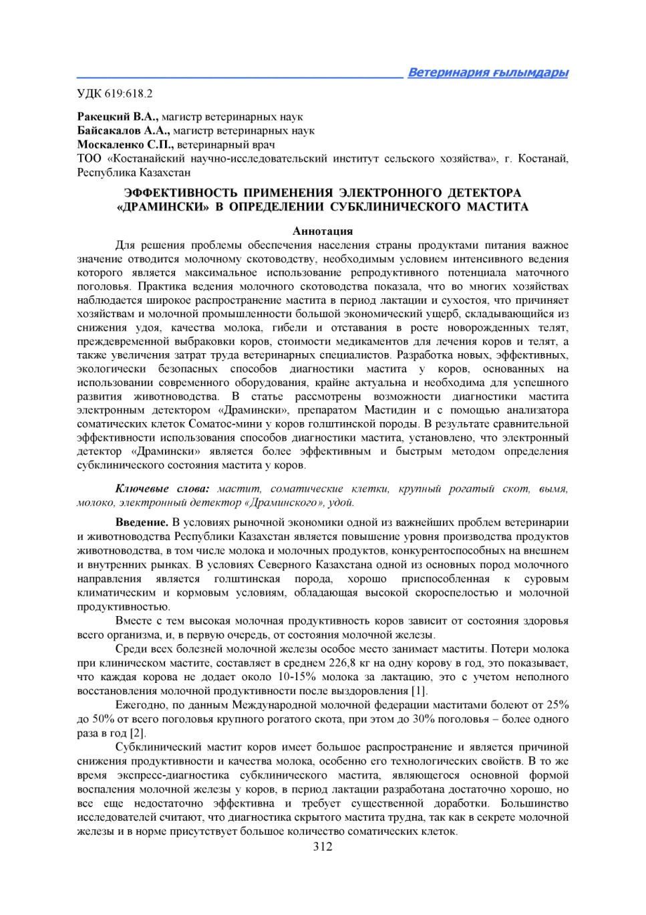
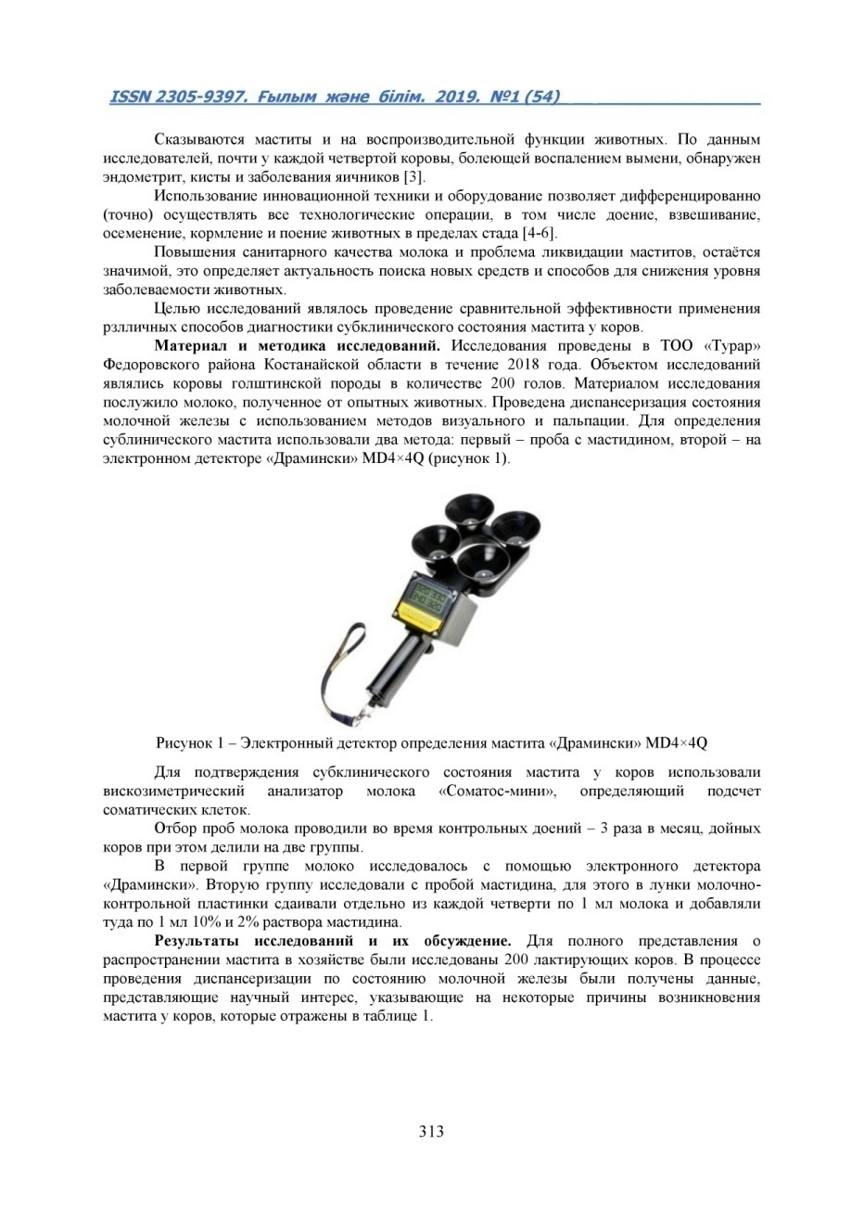
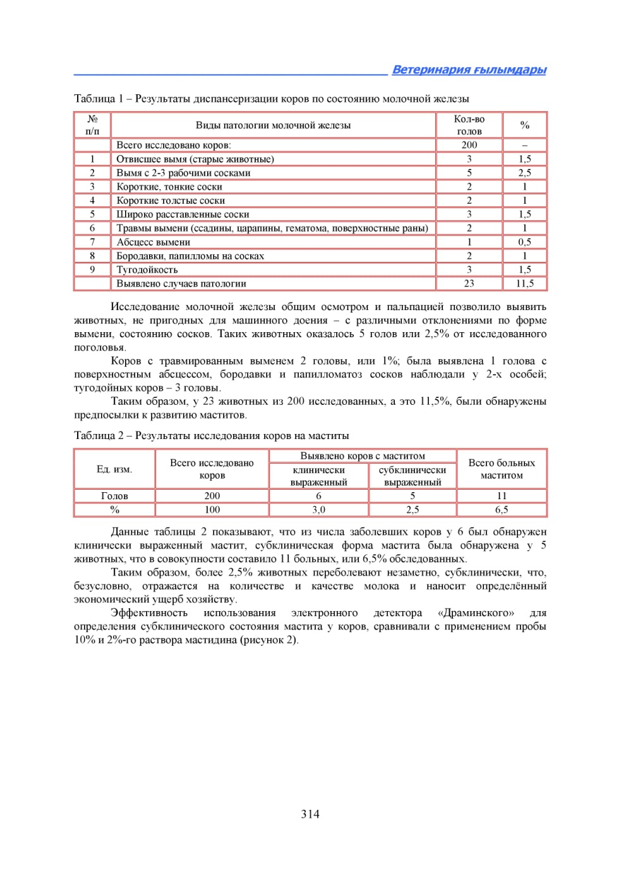
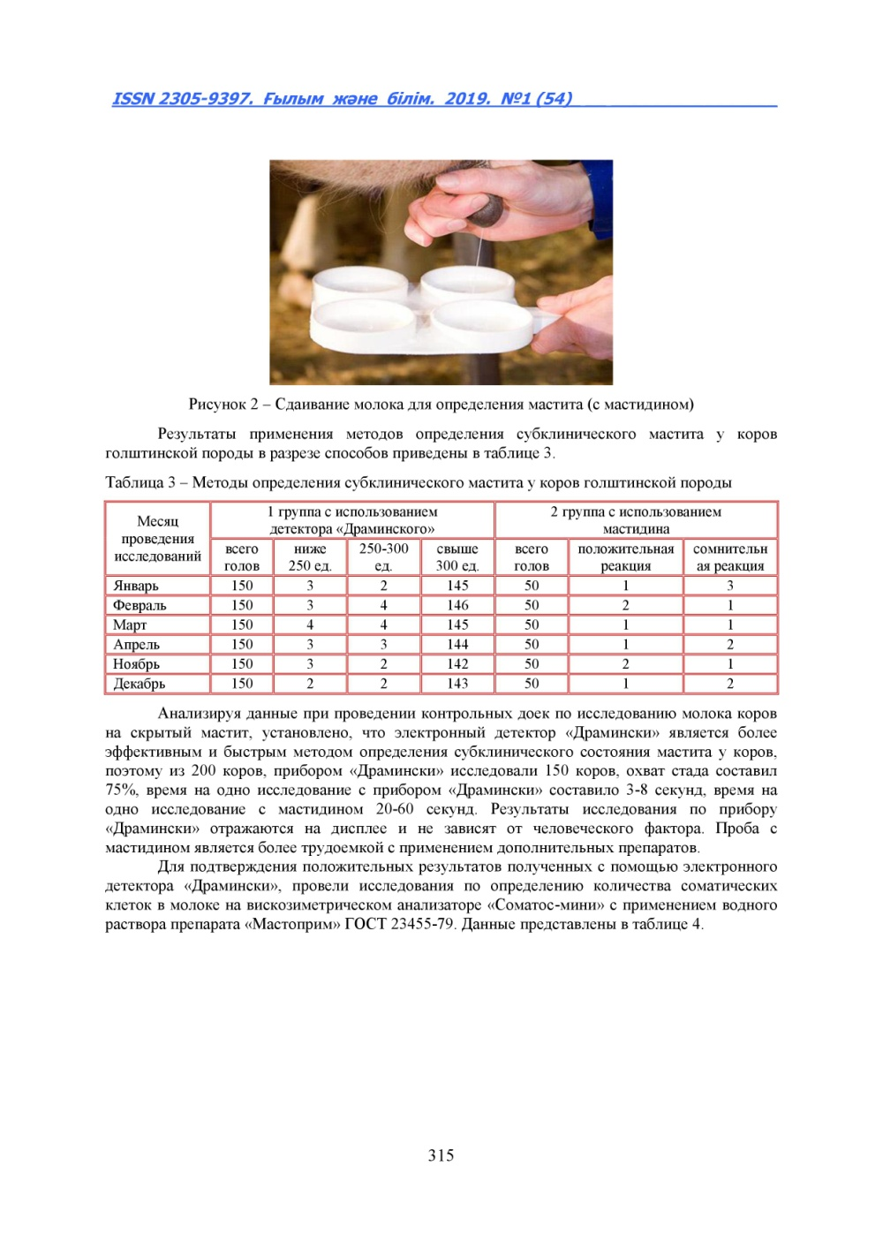
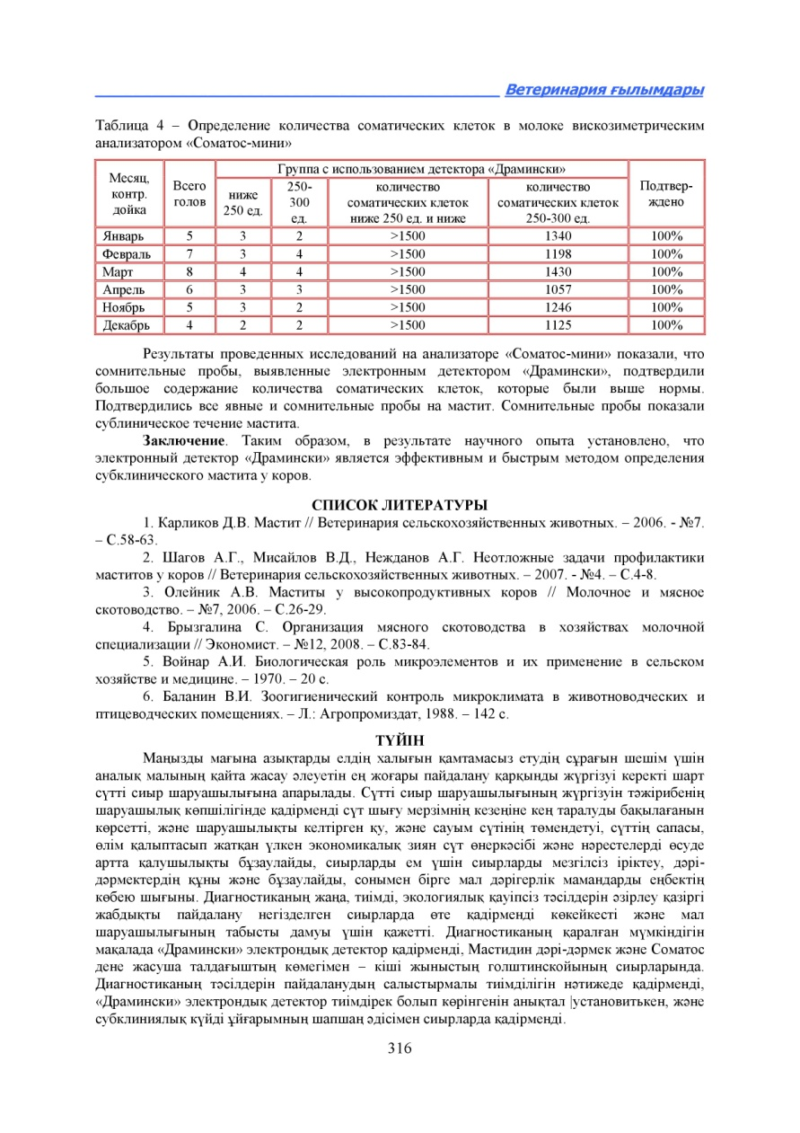
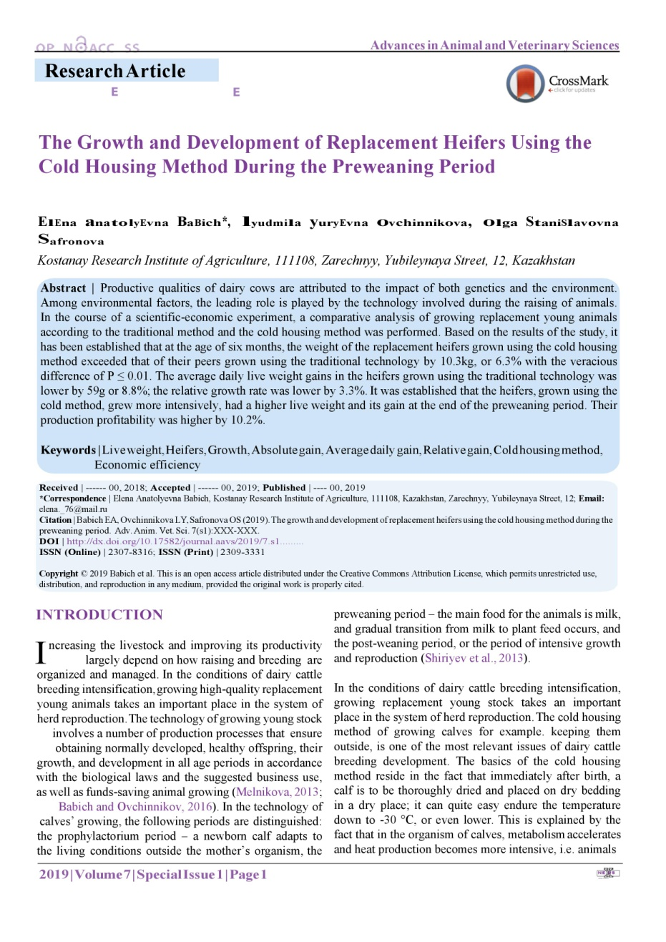
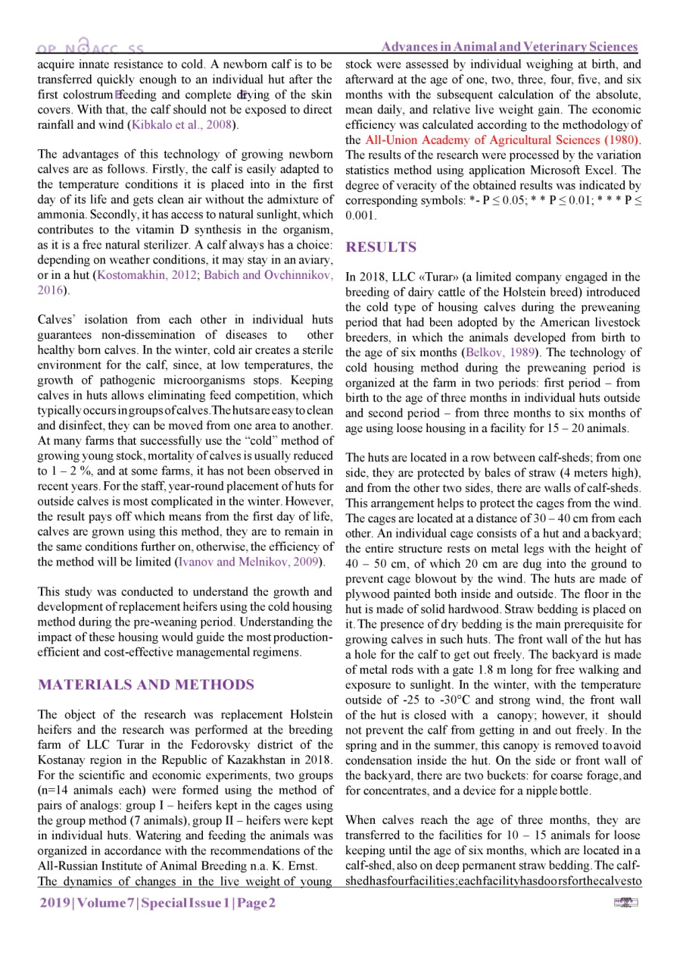
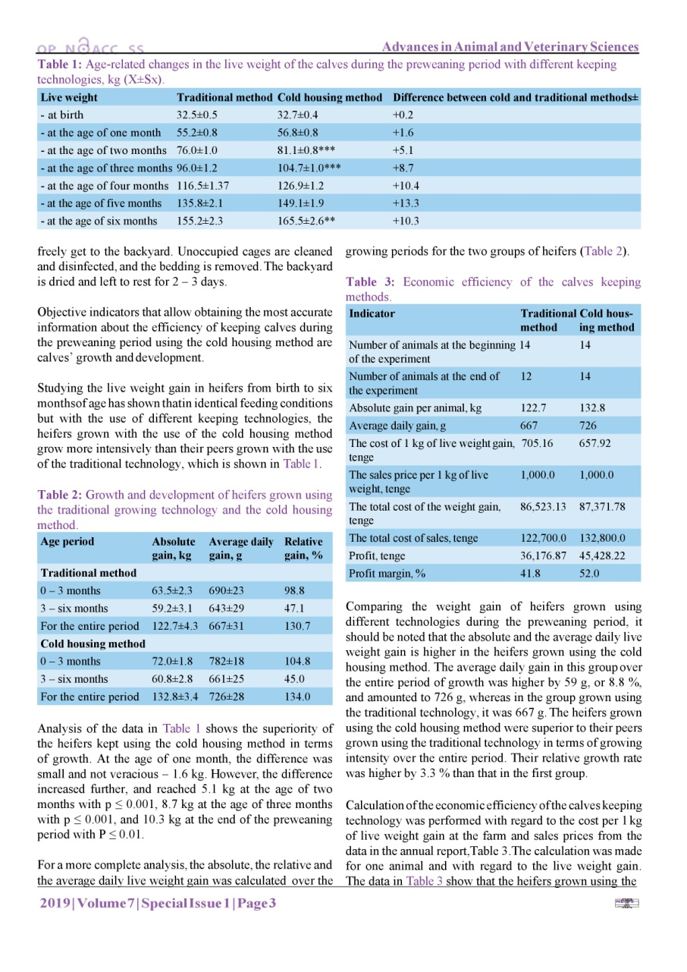
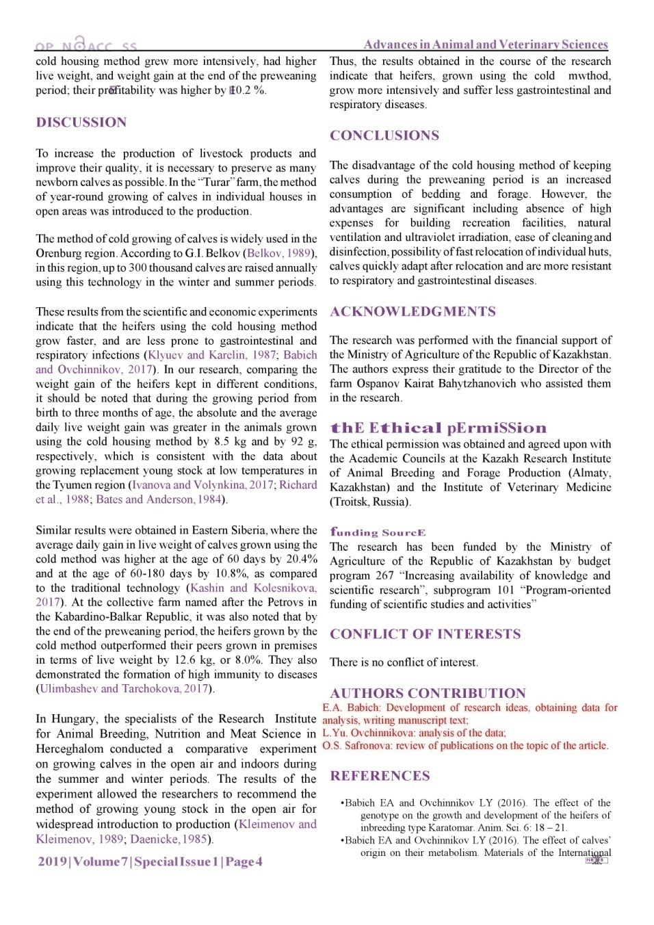
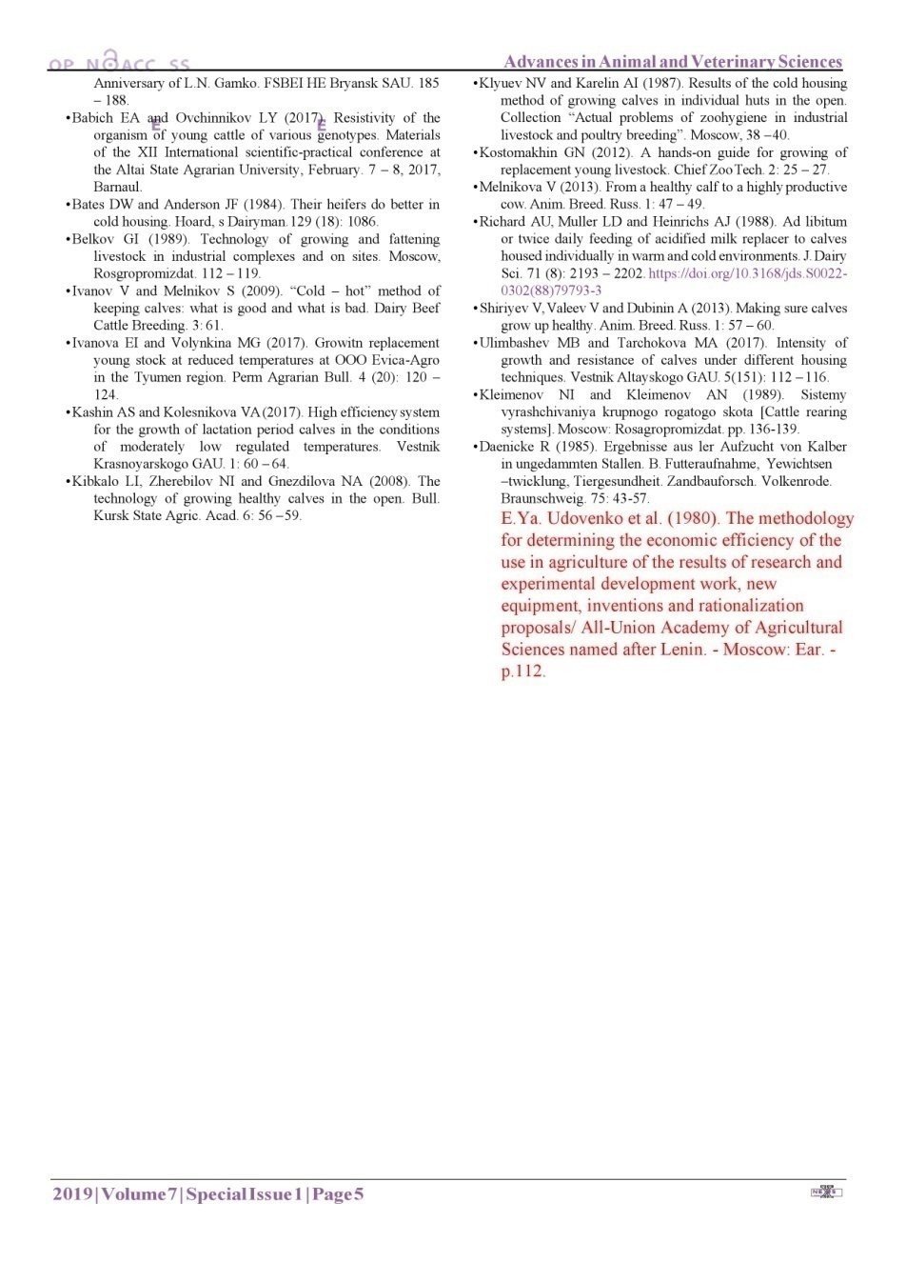
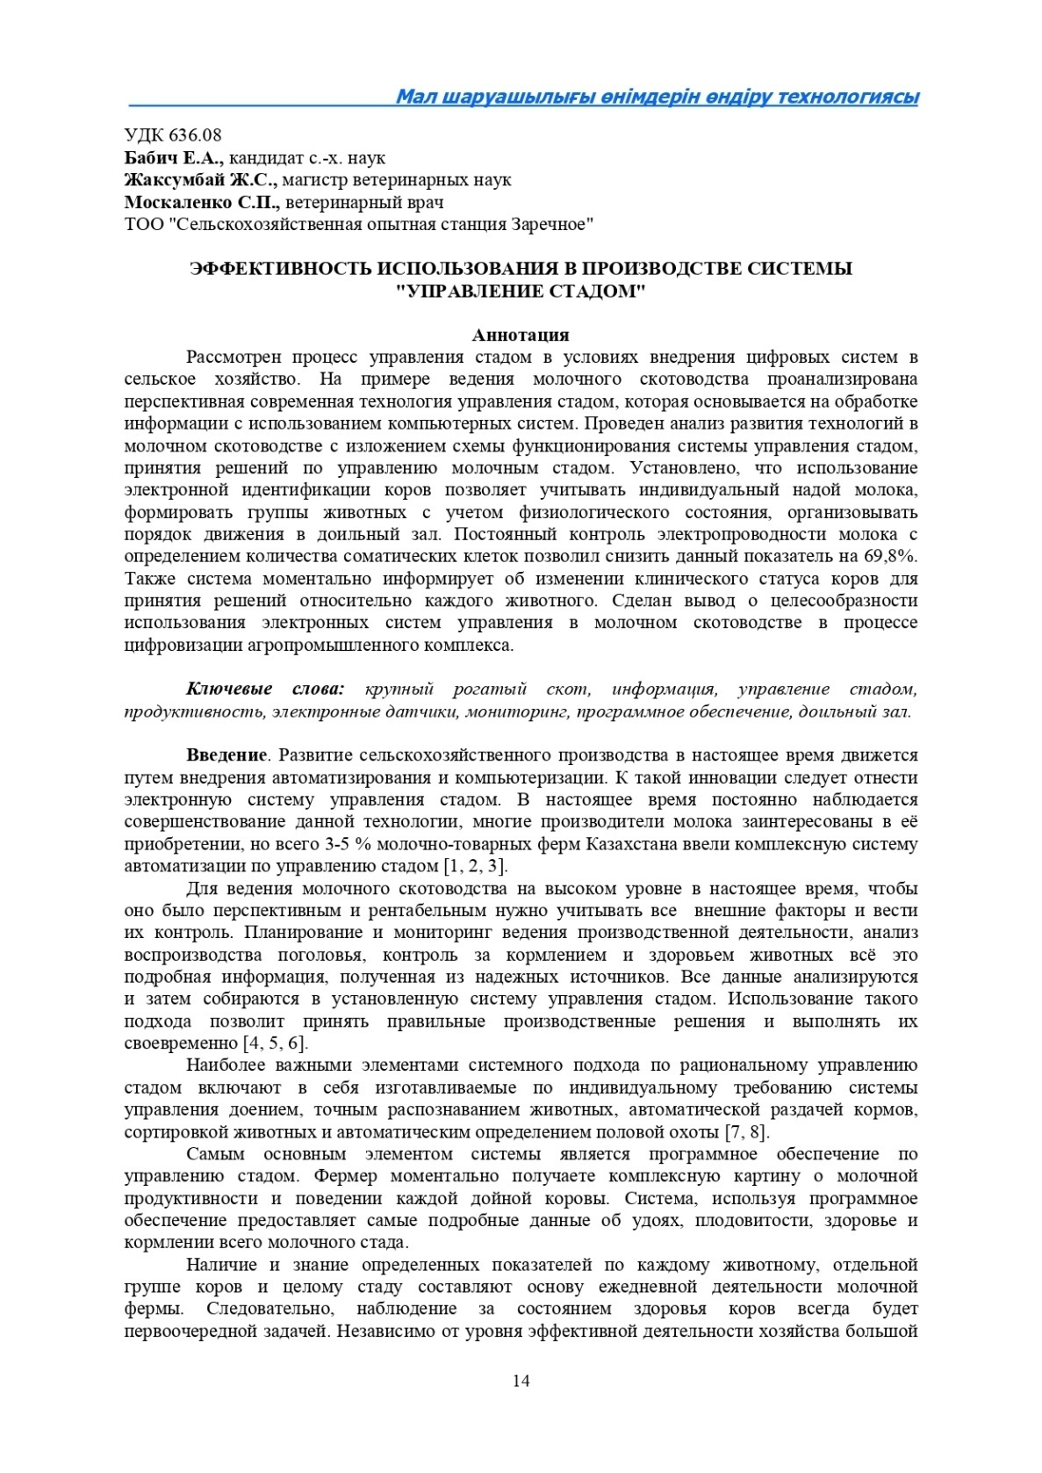
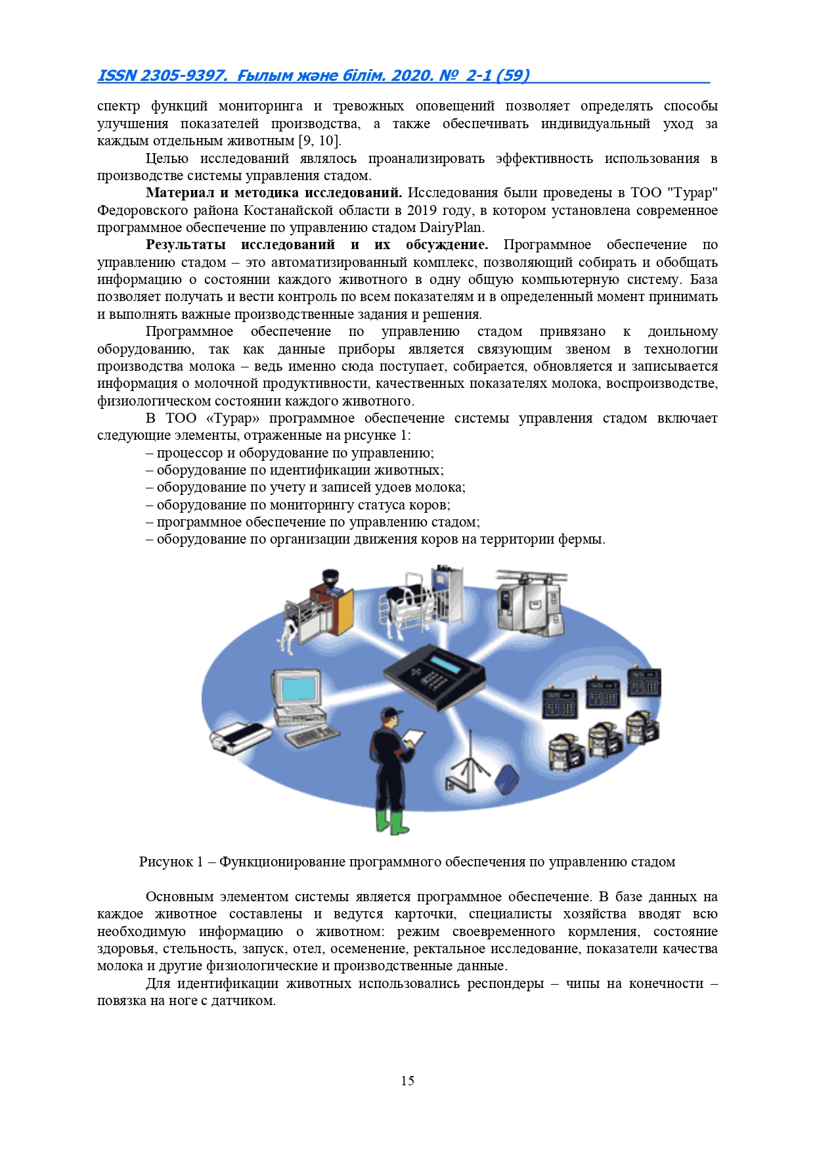
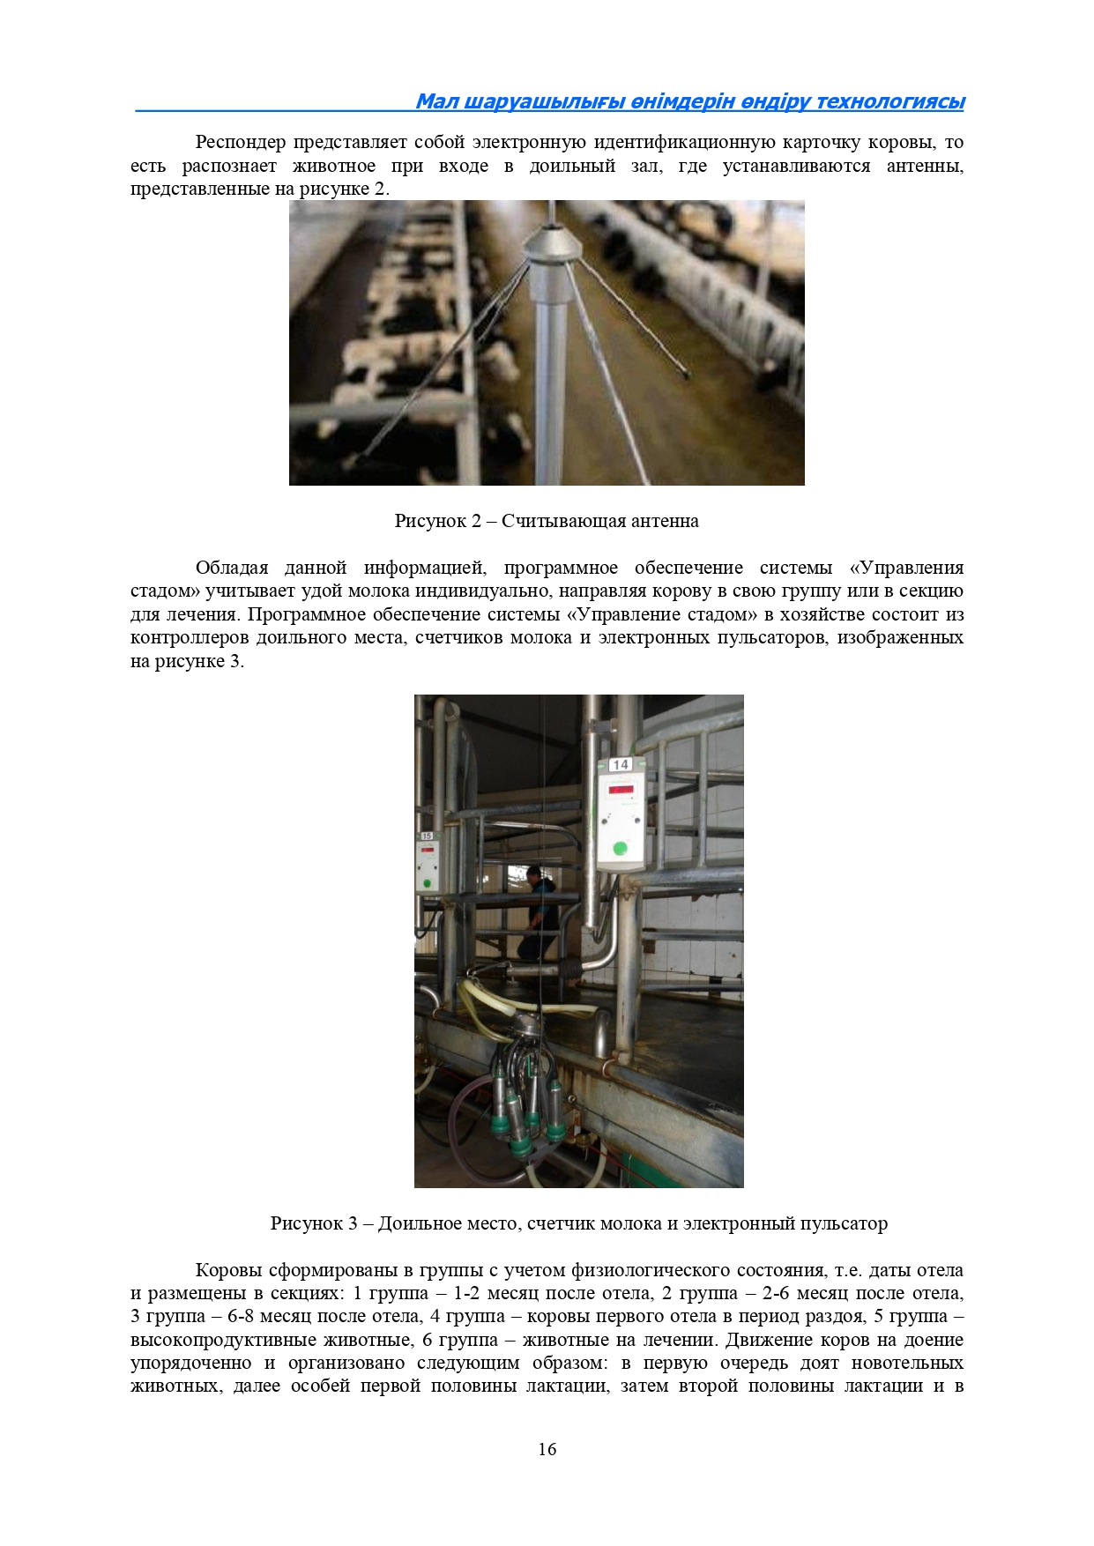
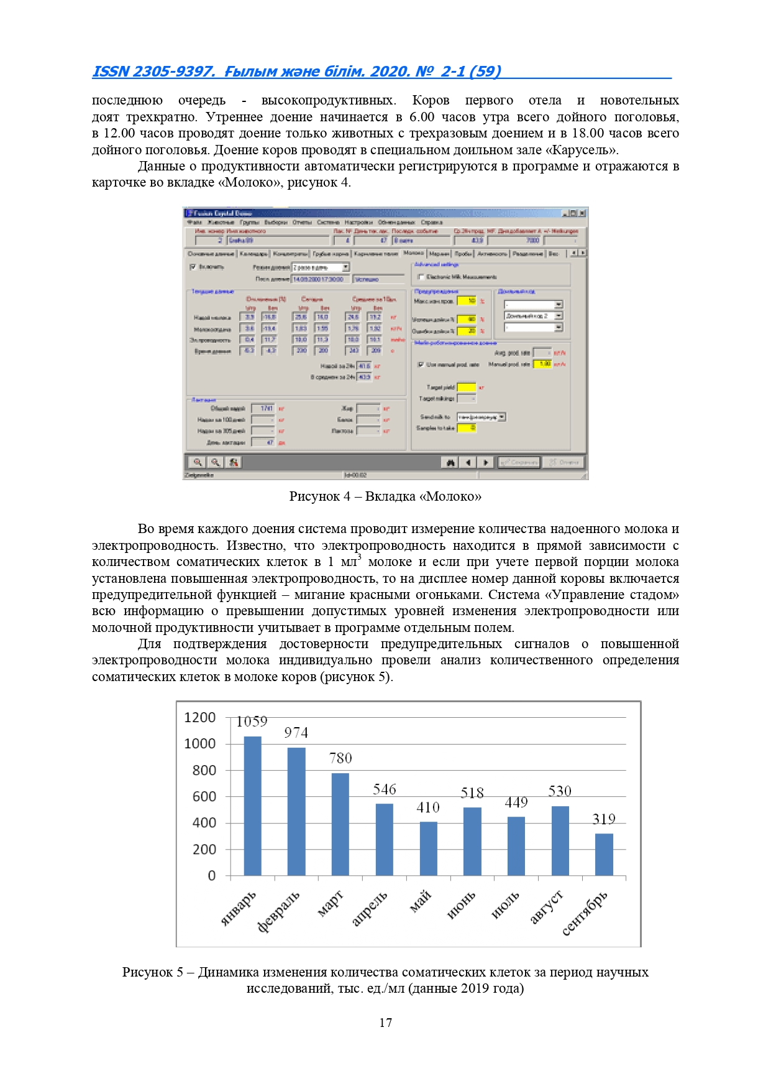
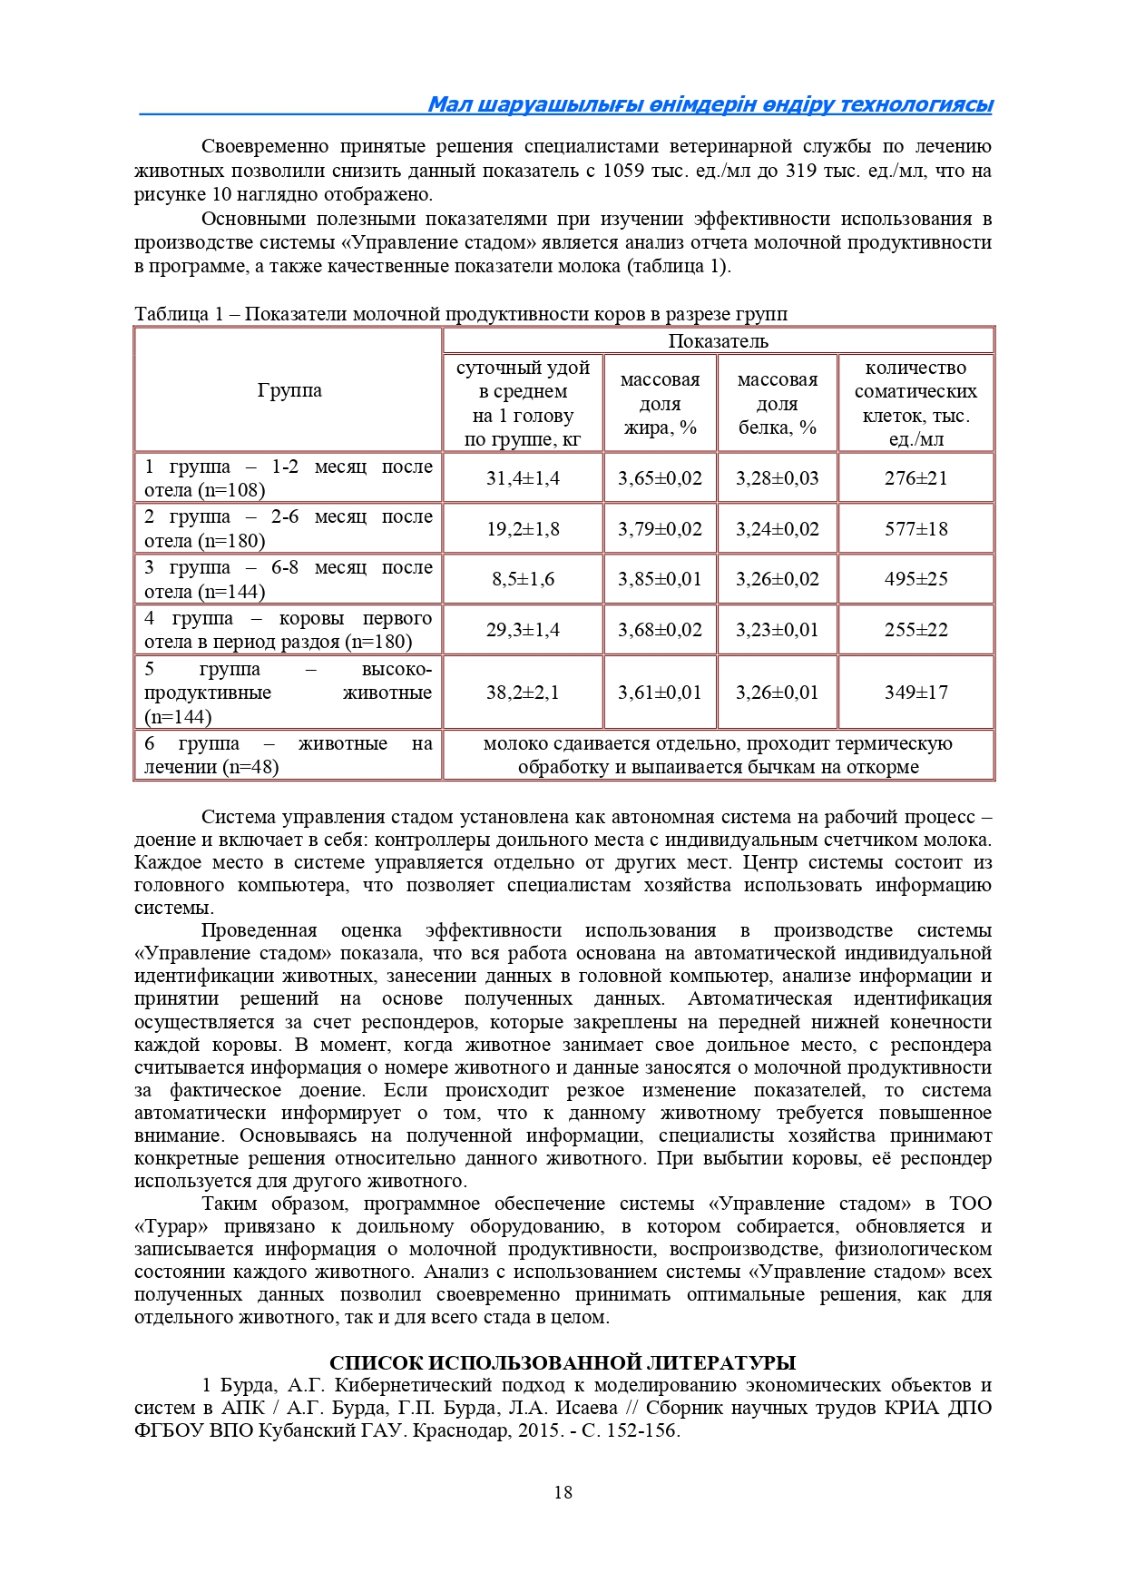
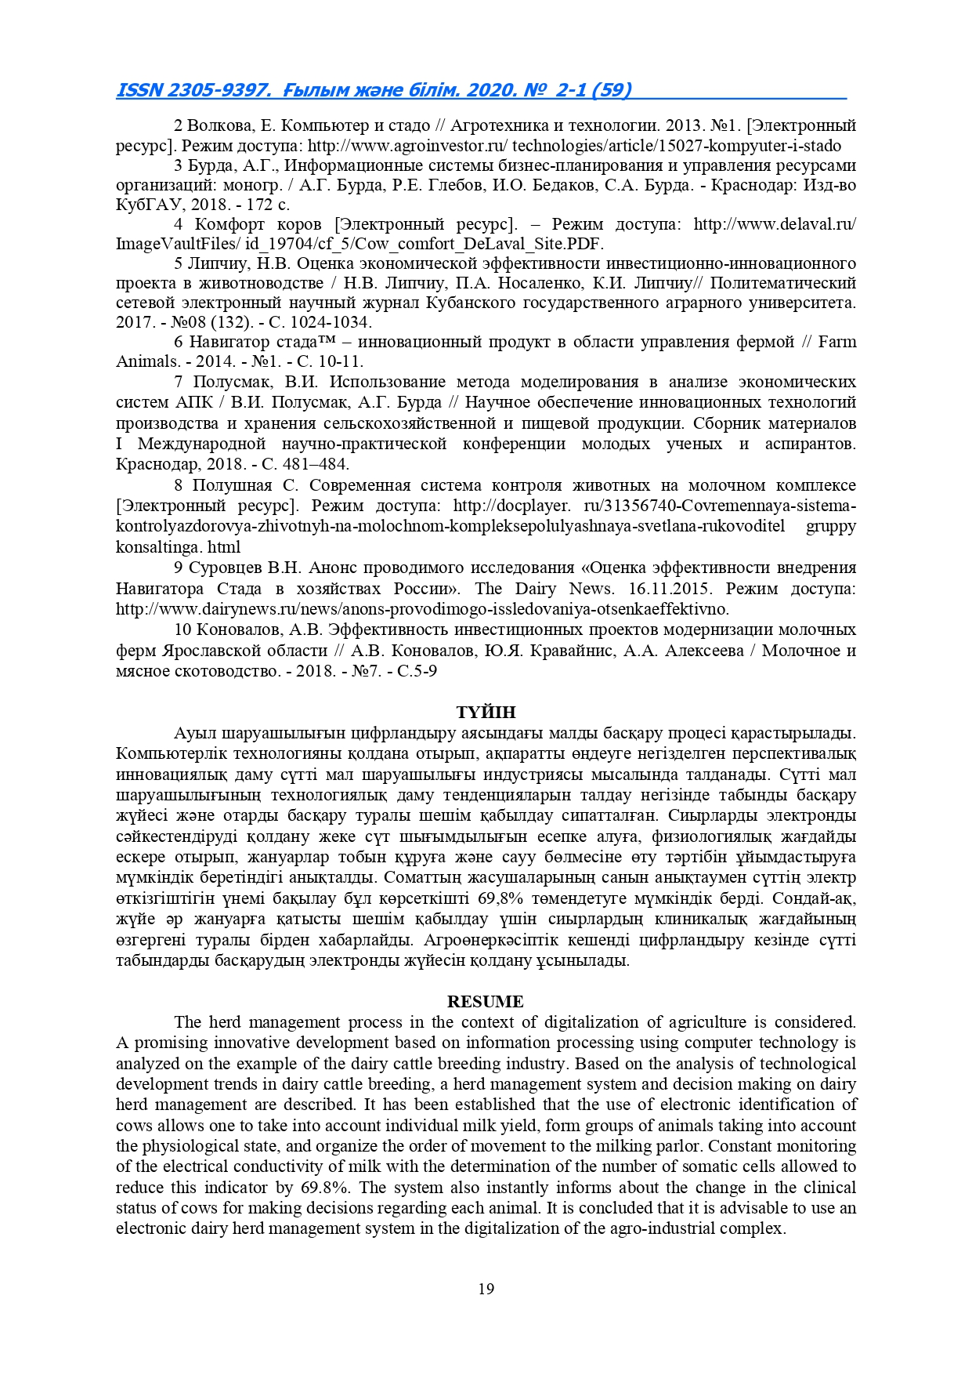
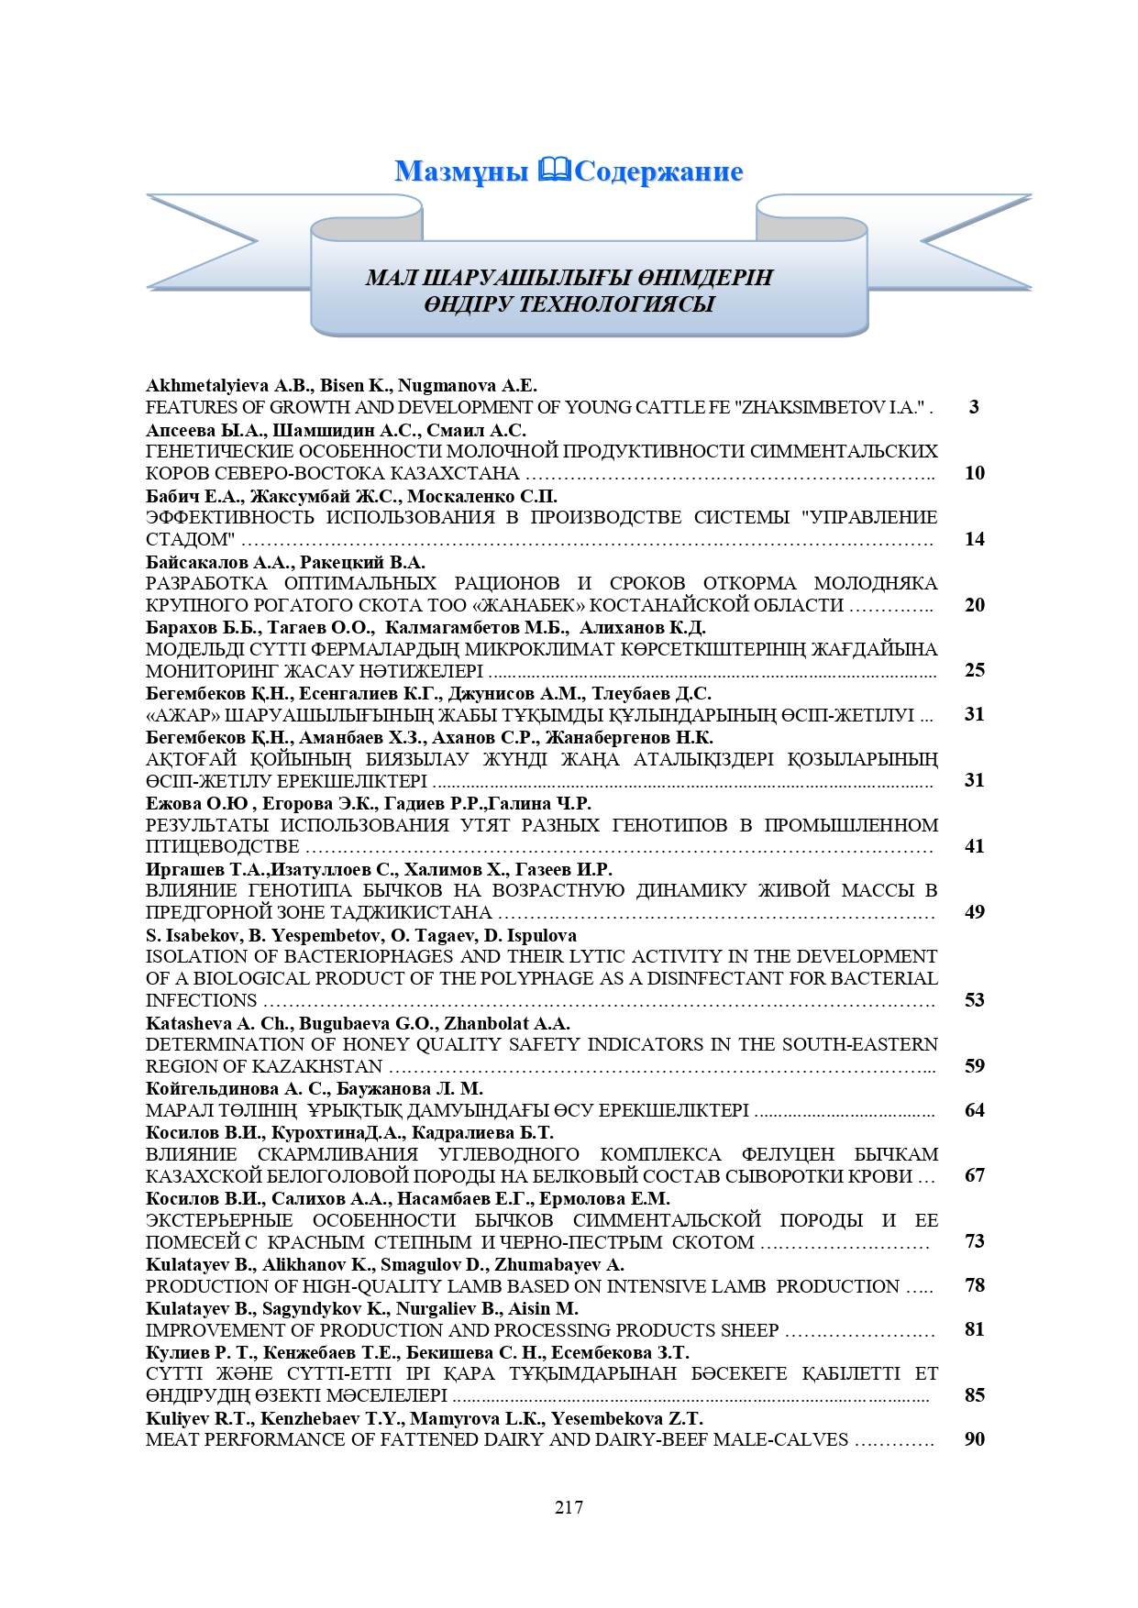
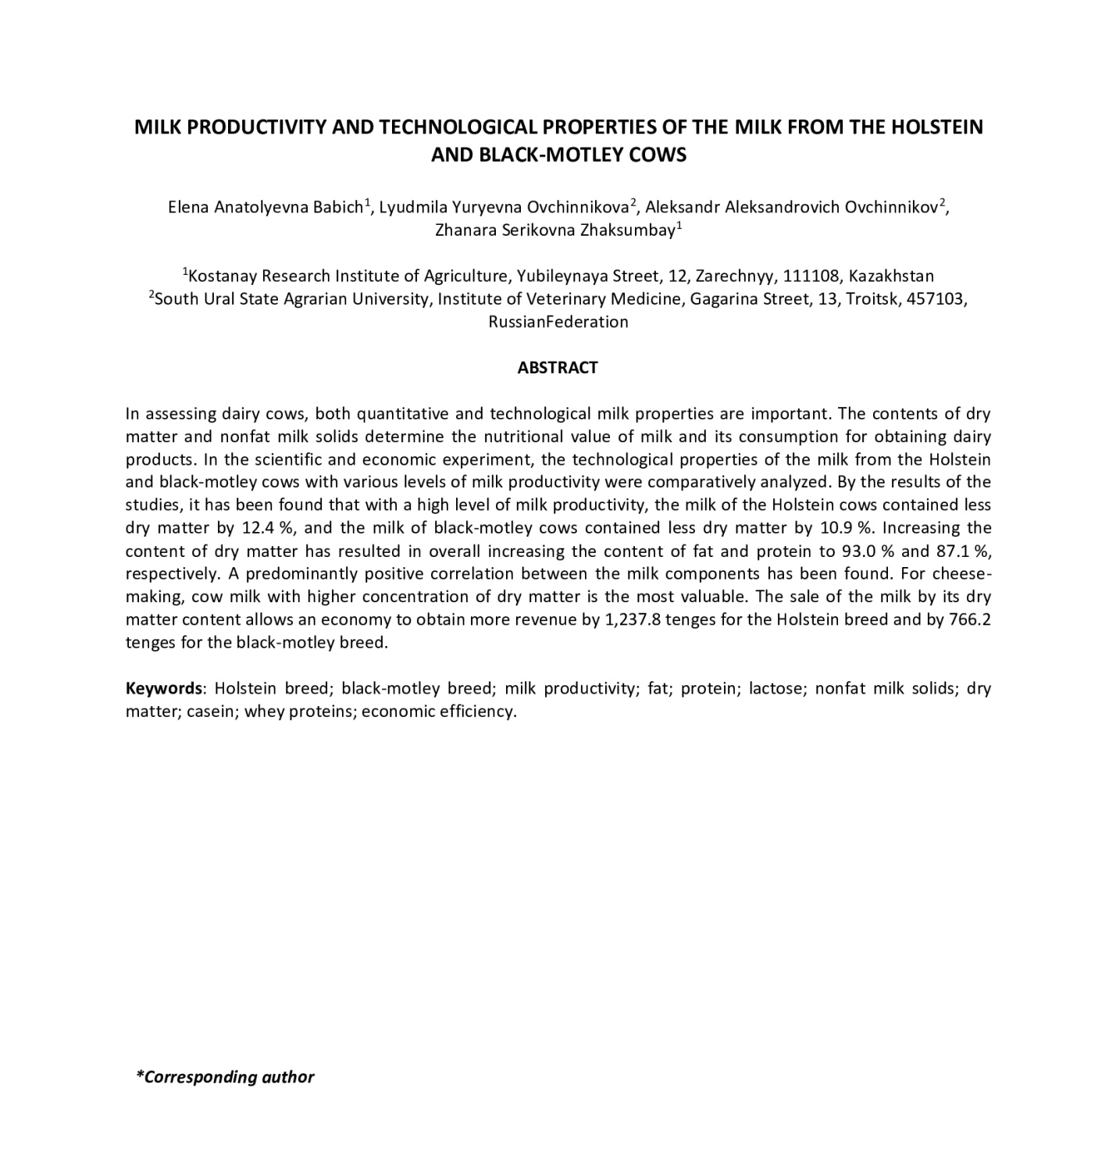
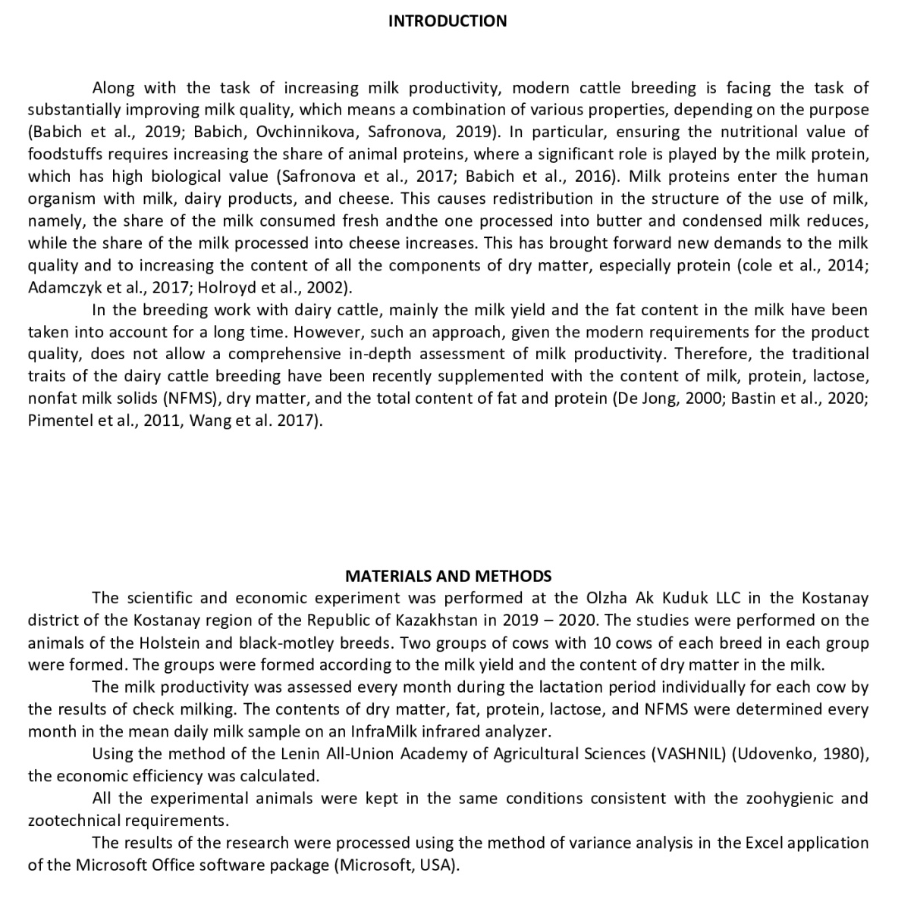
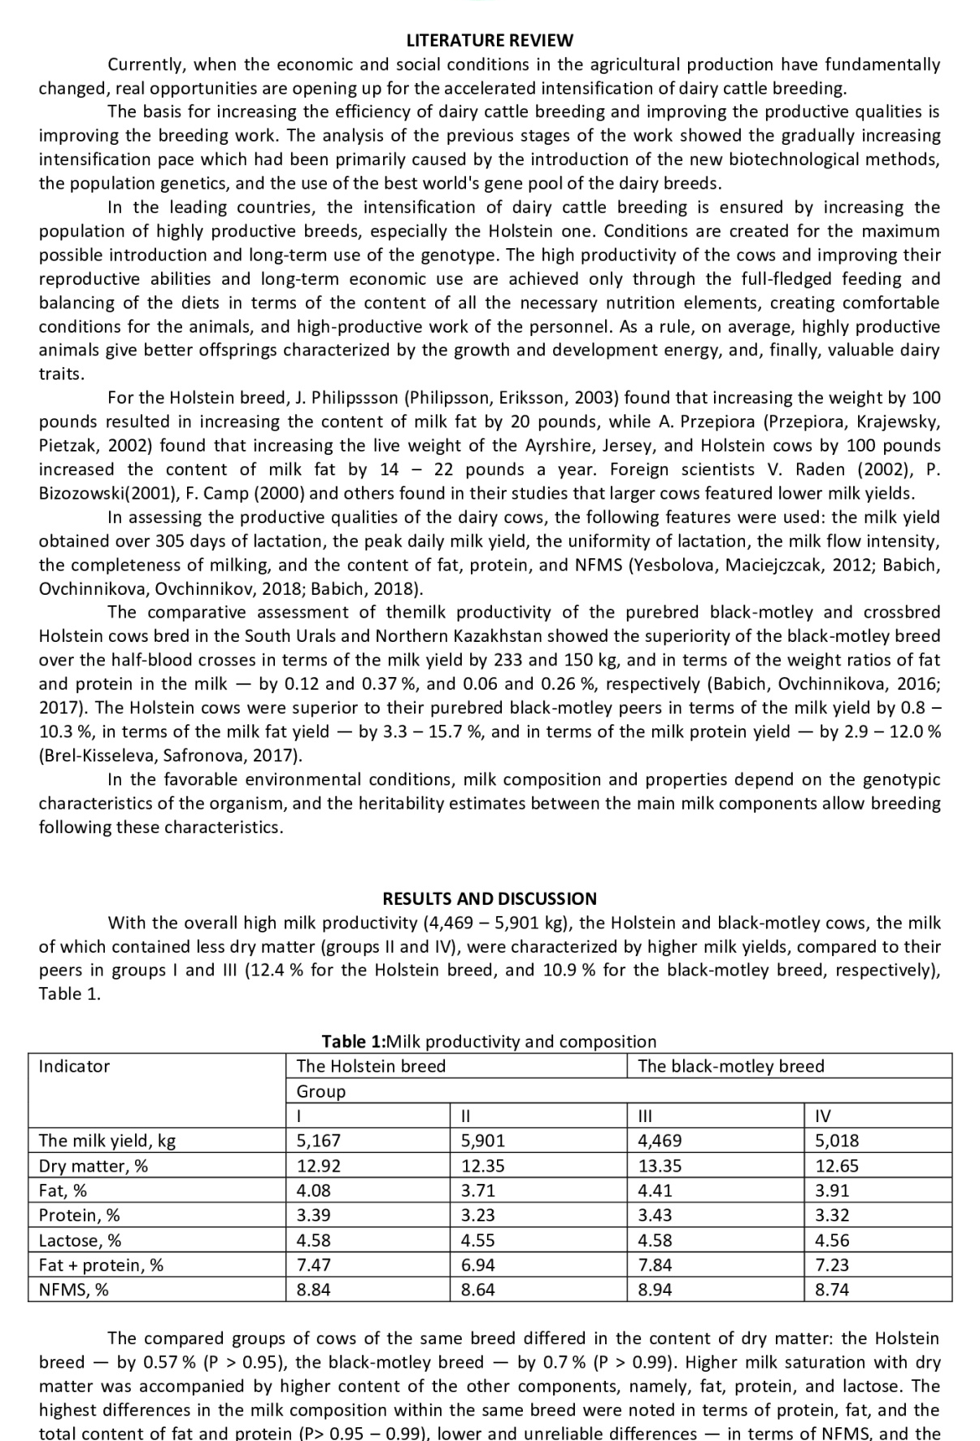
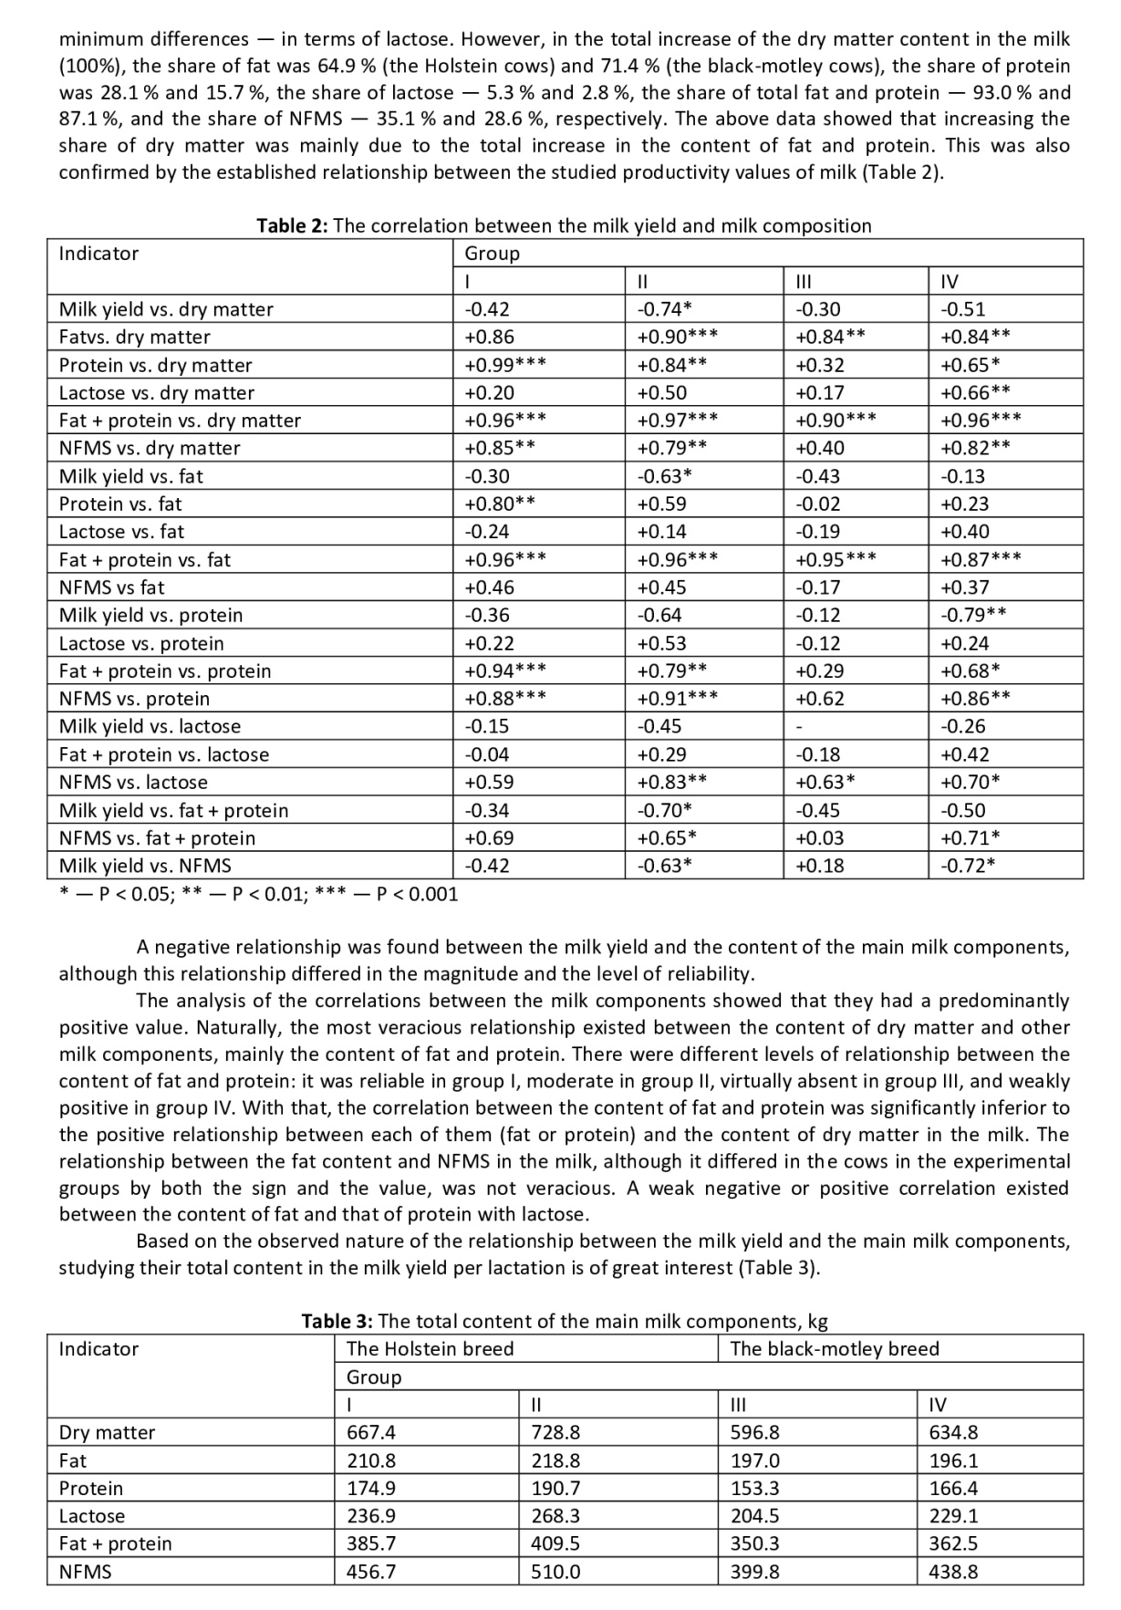
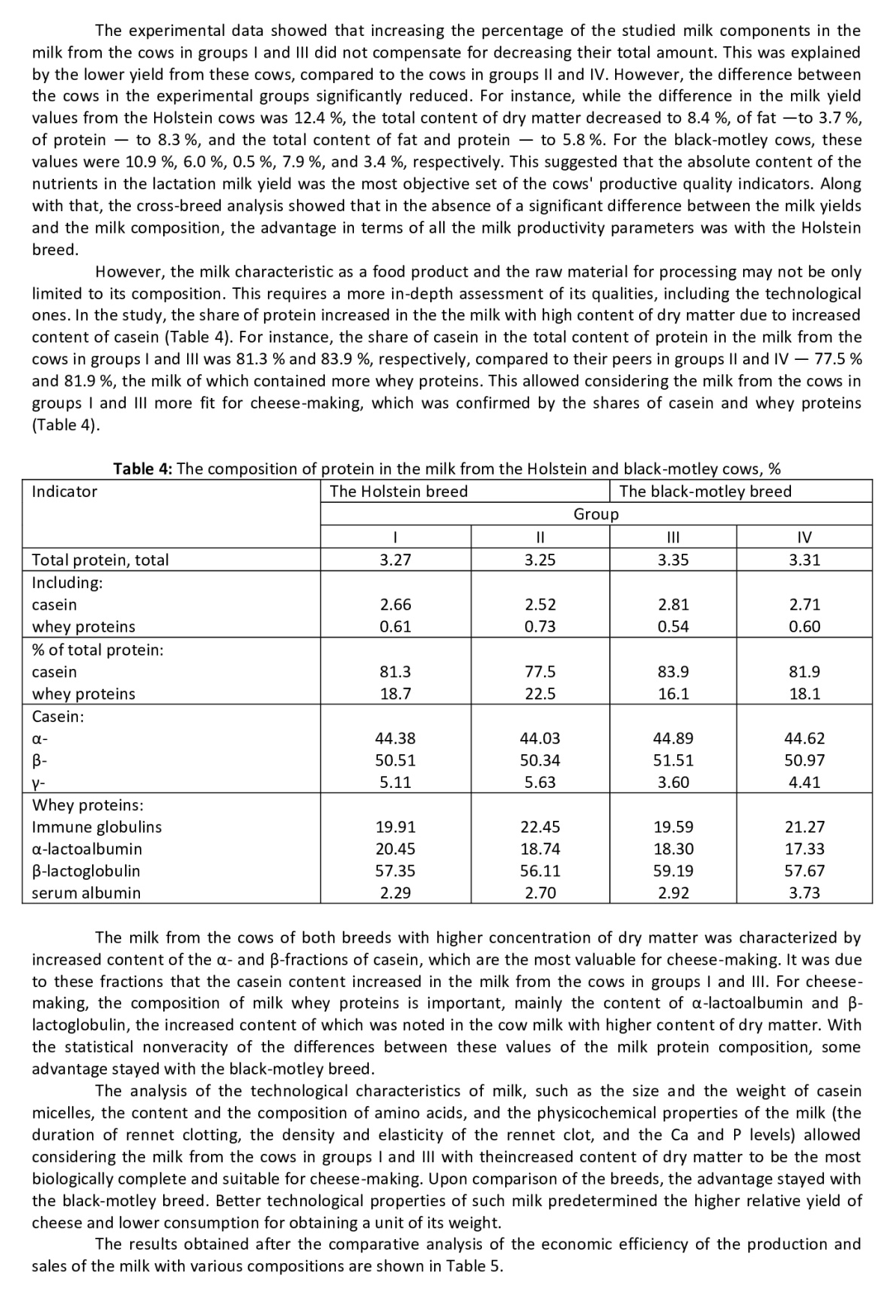
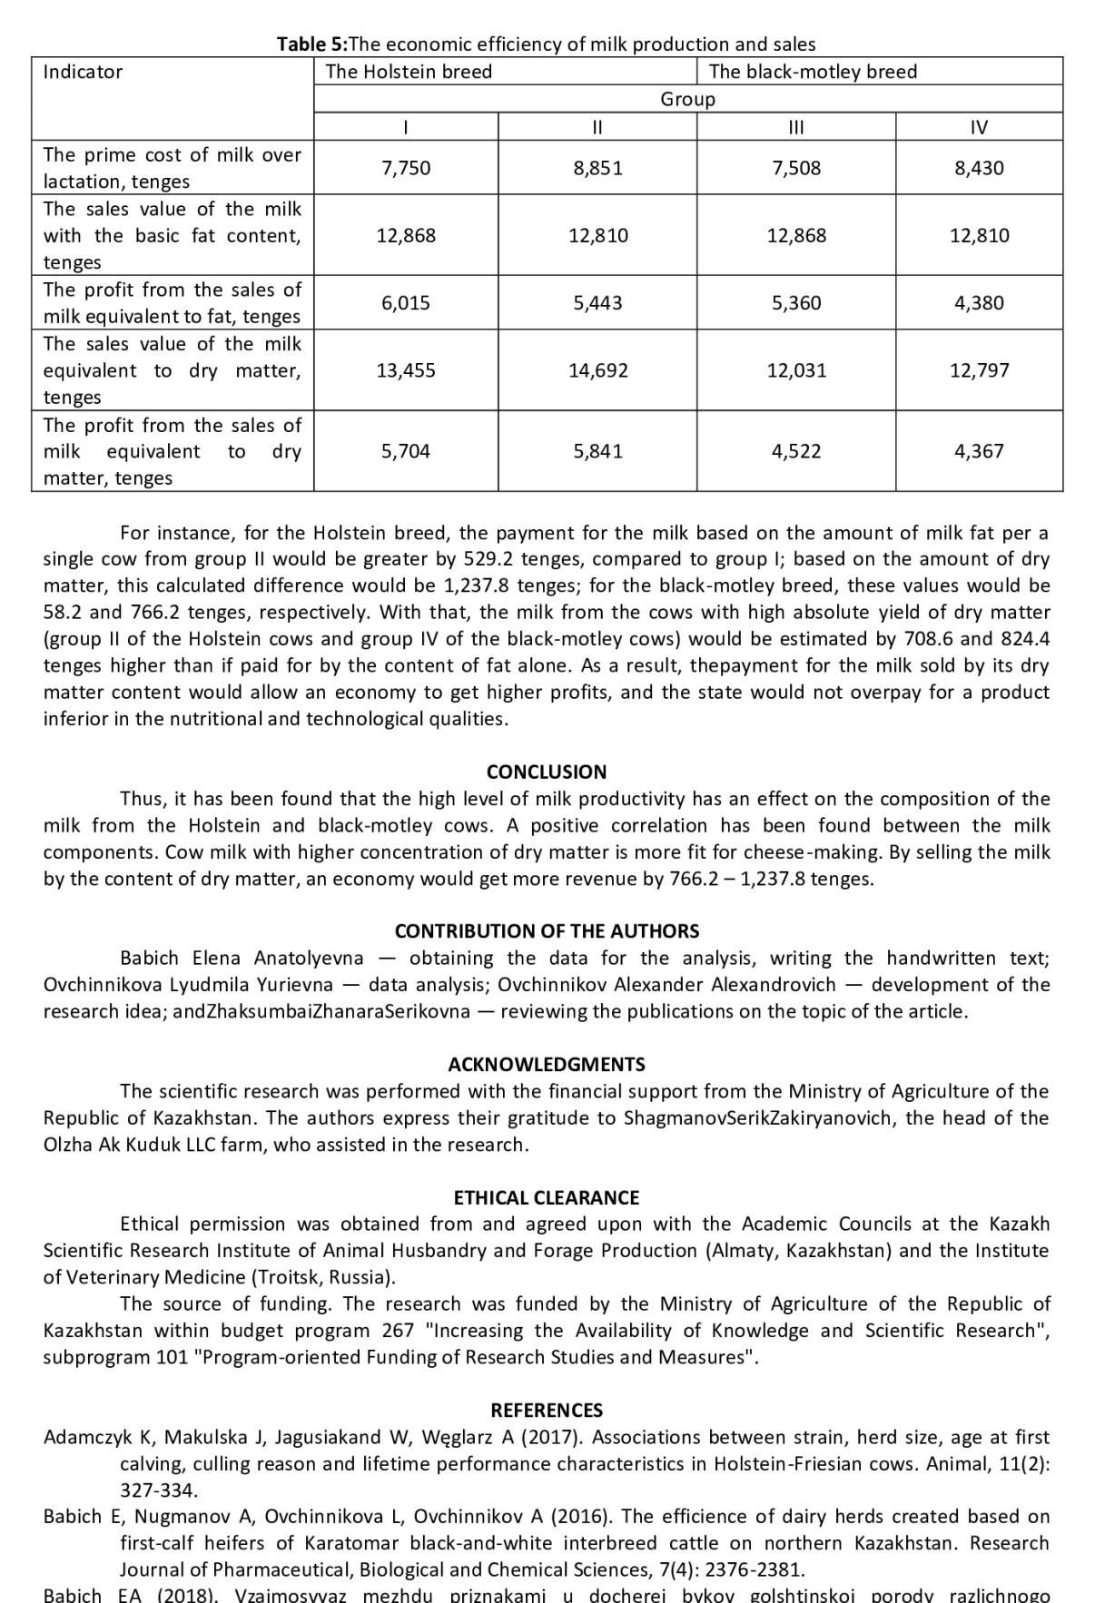
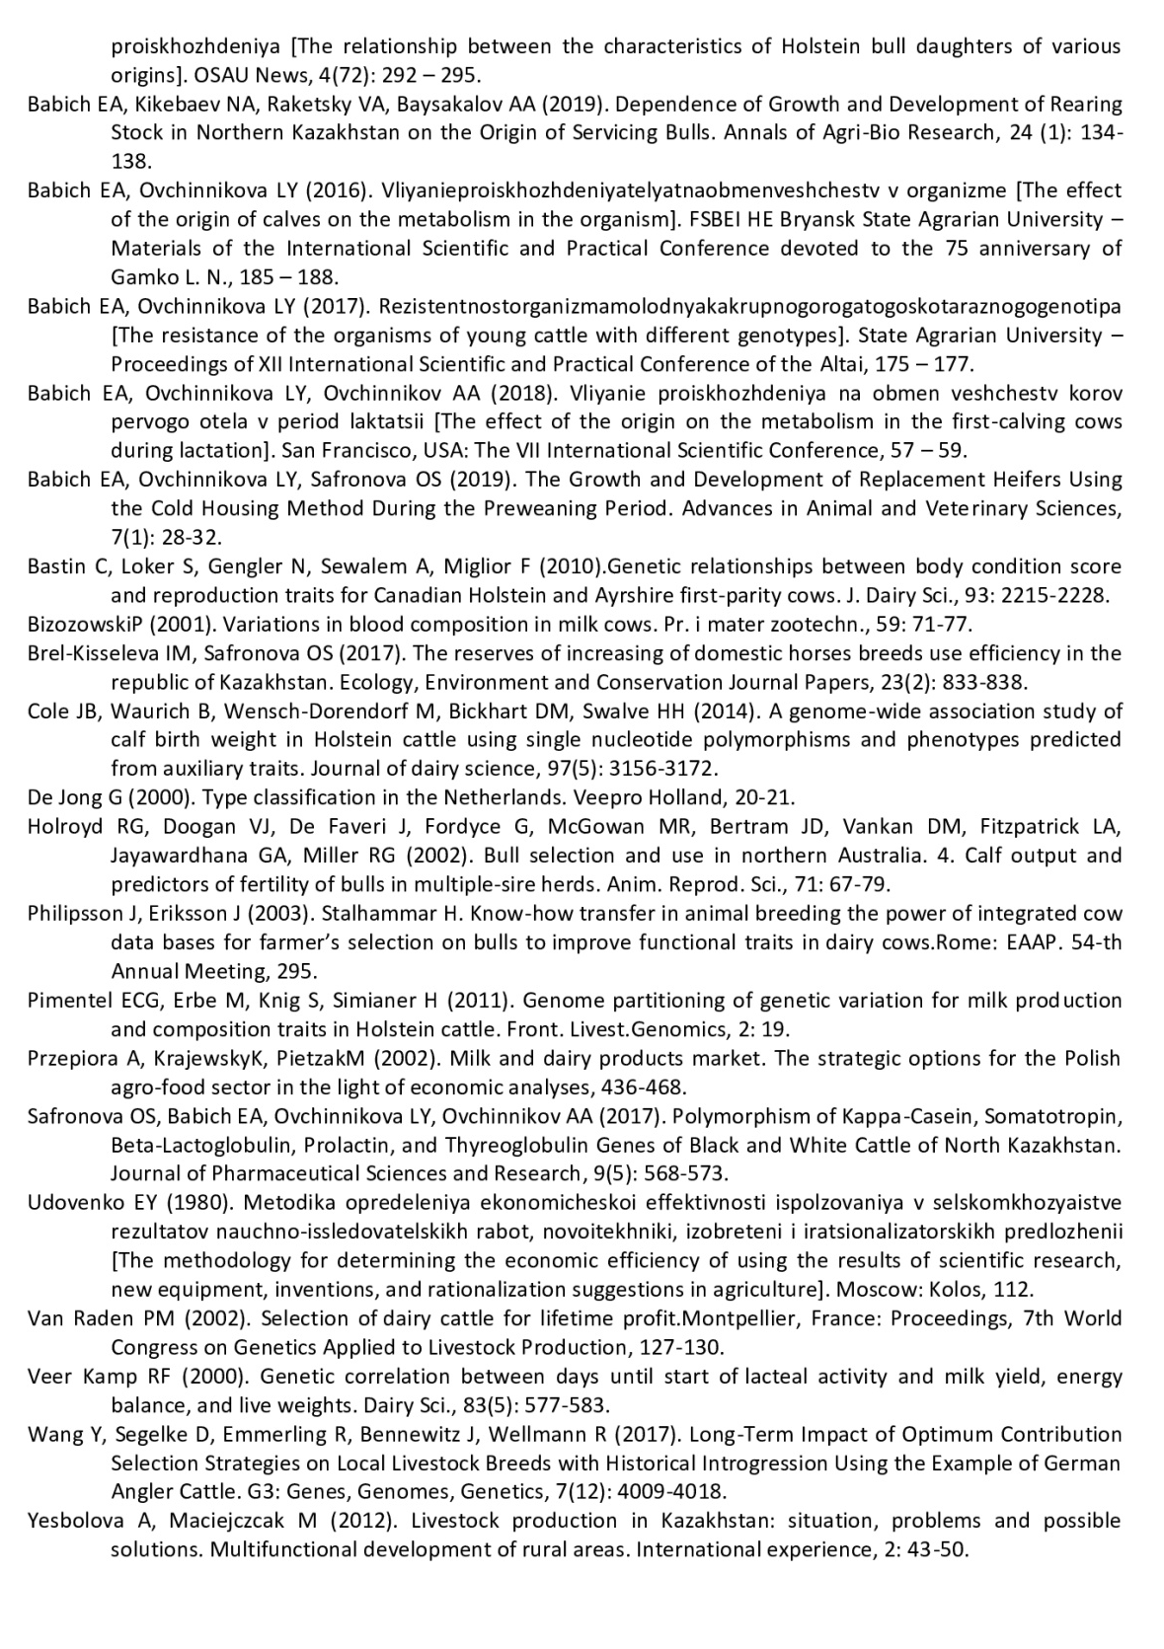

Application J
Report on seminars
2018 year

2019 year
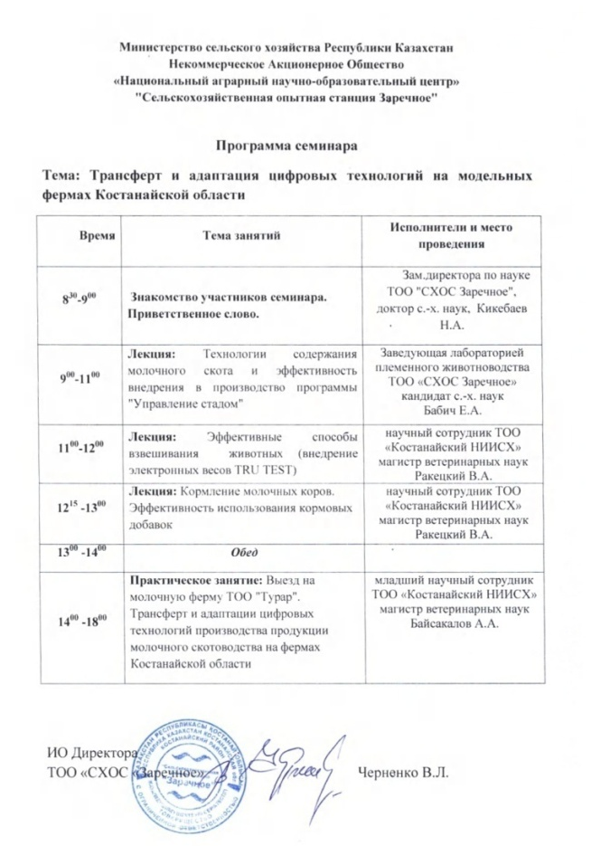
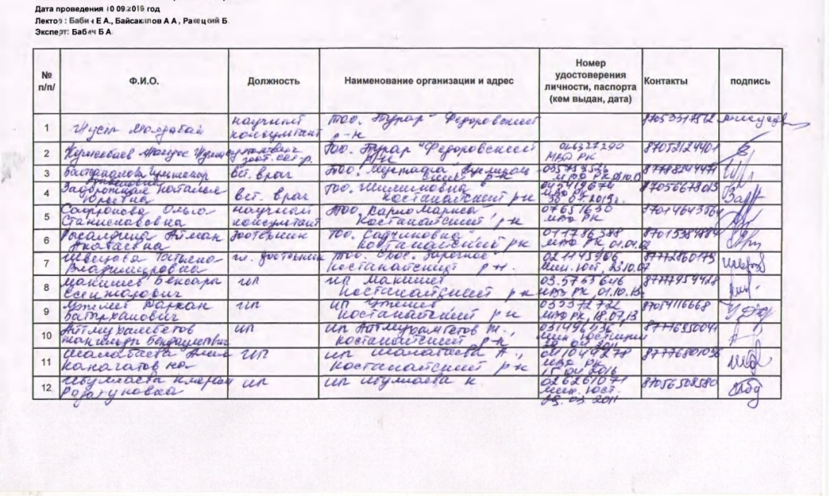

2 online seminars were held in 2020 on the following topics:
1. technologies for keeping dairy cattle and herd management programs. This workshop, held remotely on may 13, 2020, was attended by 57 people.
2. prevention and treatment of gynecological diseases of cows. Artificial insemination of farm animals. The seminar was held in the form of an online consultation on may 20, 2020, which was attended by 65 people.
In connection with the introduction of the COVID 19 quarantine, seminars were held remotely.
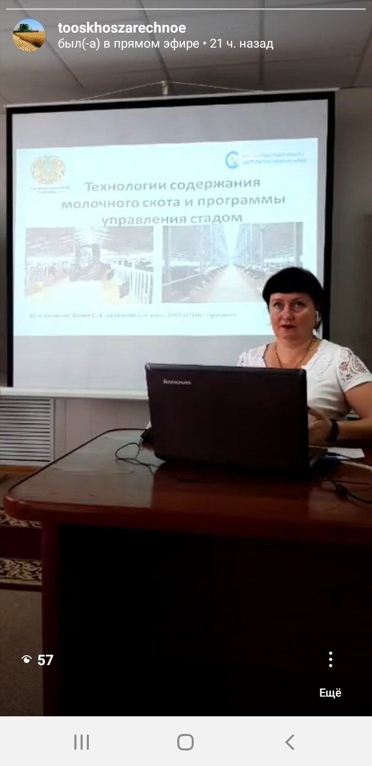
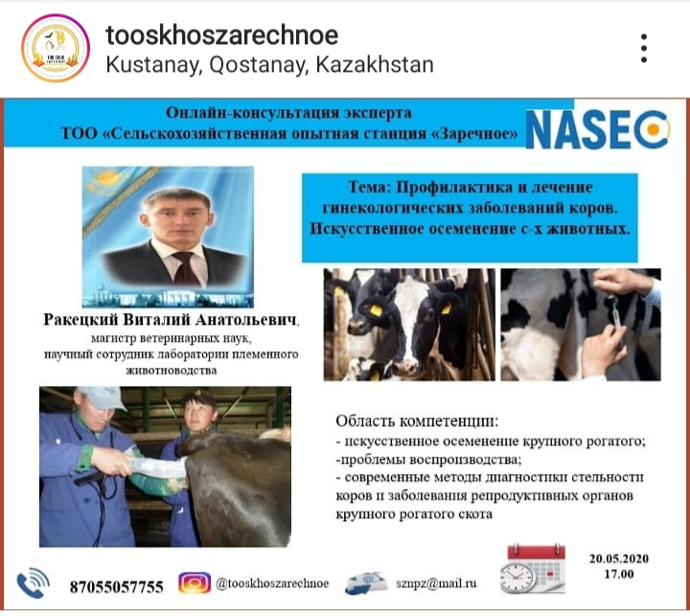

Application K
Information about a foreign expert
Lyudmila Ovchinnikova, doctor of agricultural Sciences, Professor, South Ural state agrarian University, Russian Federation. During his time at the University, he is engaged in the study, implementation and adaptation of innovative technologies in dairy cattle breeding, forecasting the duration of economic use of domestic and foreign cattle breeding, improving the productivity of animals and milk production technology. Has a scientific school of post-graduate students and a trained candidate of Sciences. Participated in the implementation of the grant in the Republic of Kazakhstan, contractual issues with agricultural enterprises of the Russian Federation.



Application L
Extract from the minutes of the Academic Council
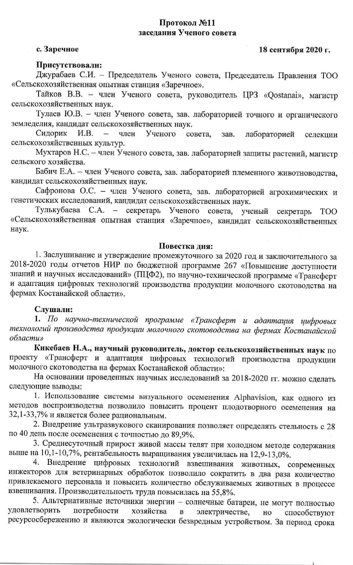
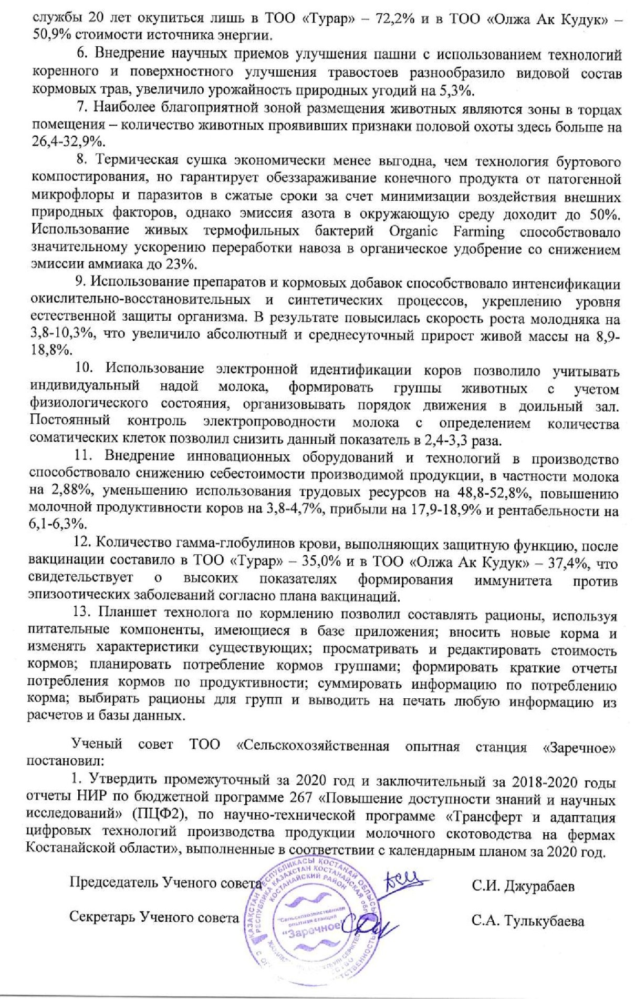

Application M
Reviews
Internal review
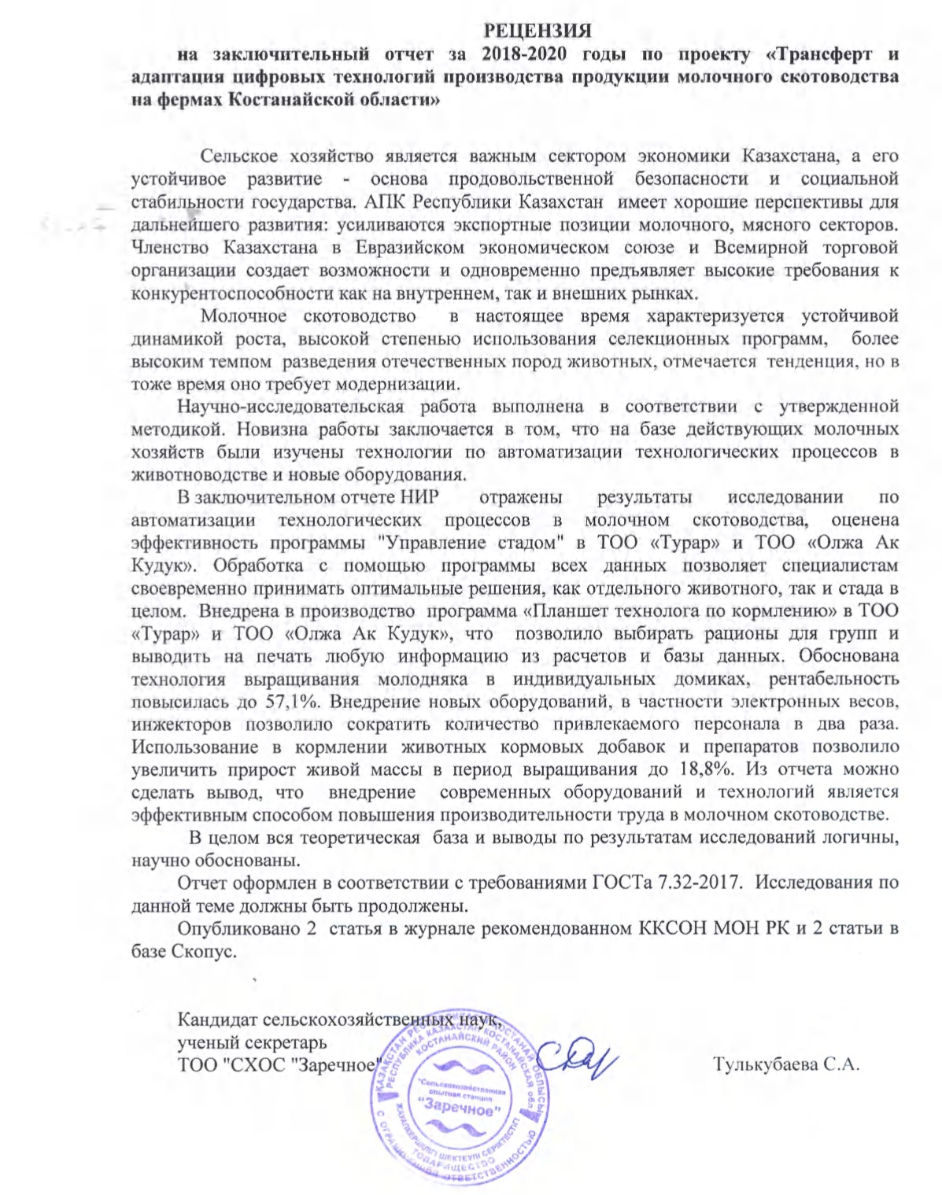

External review
