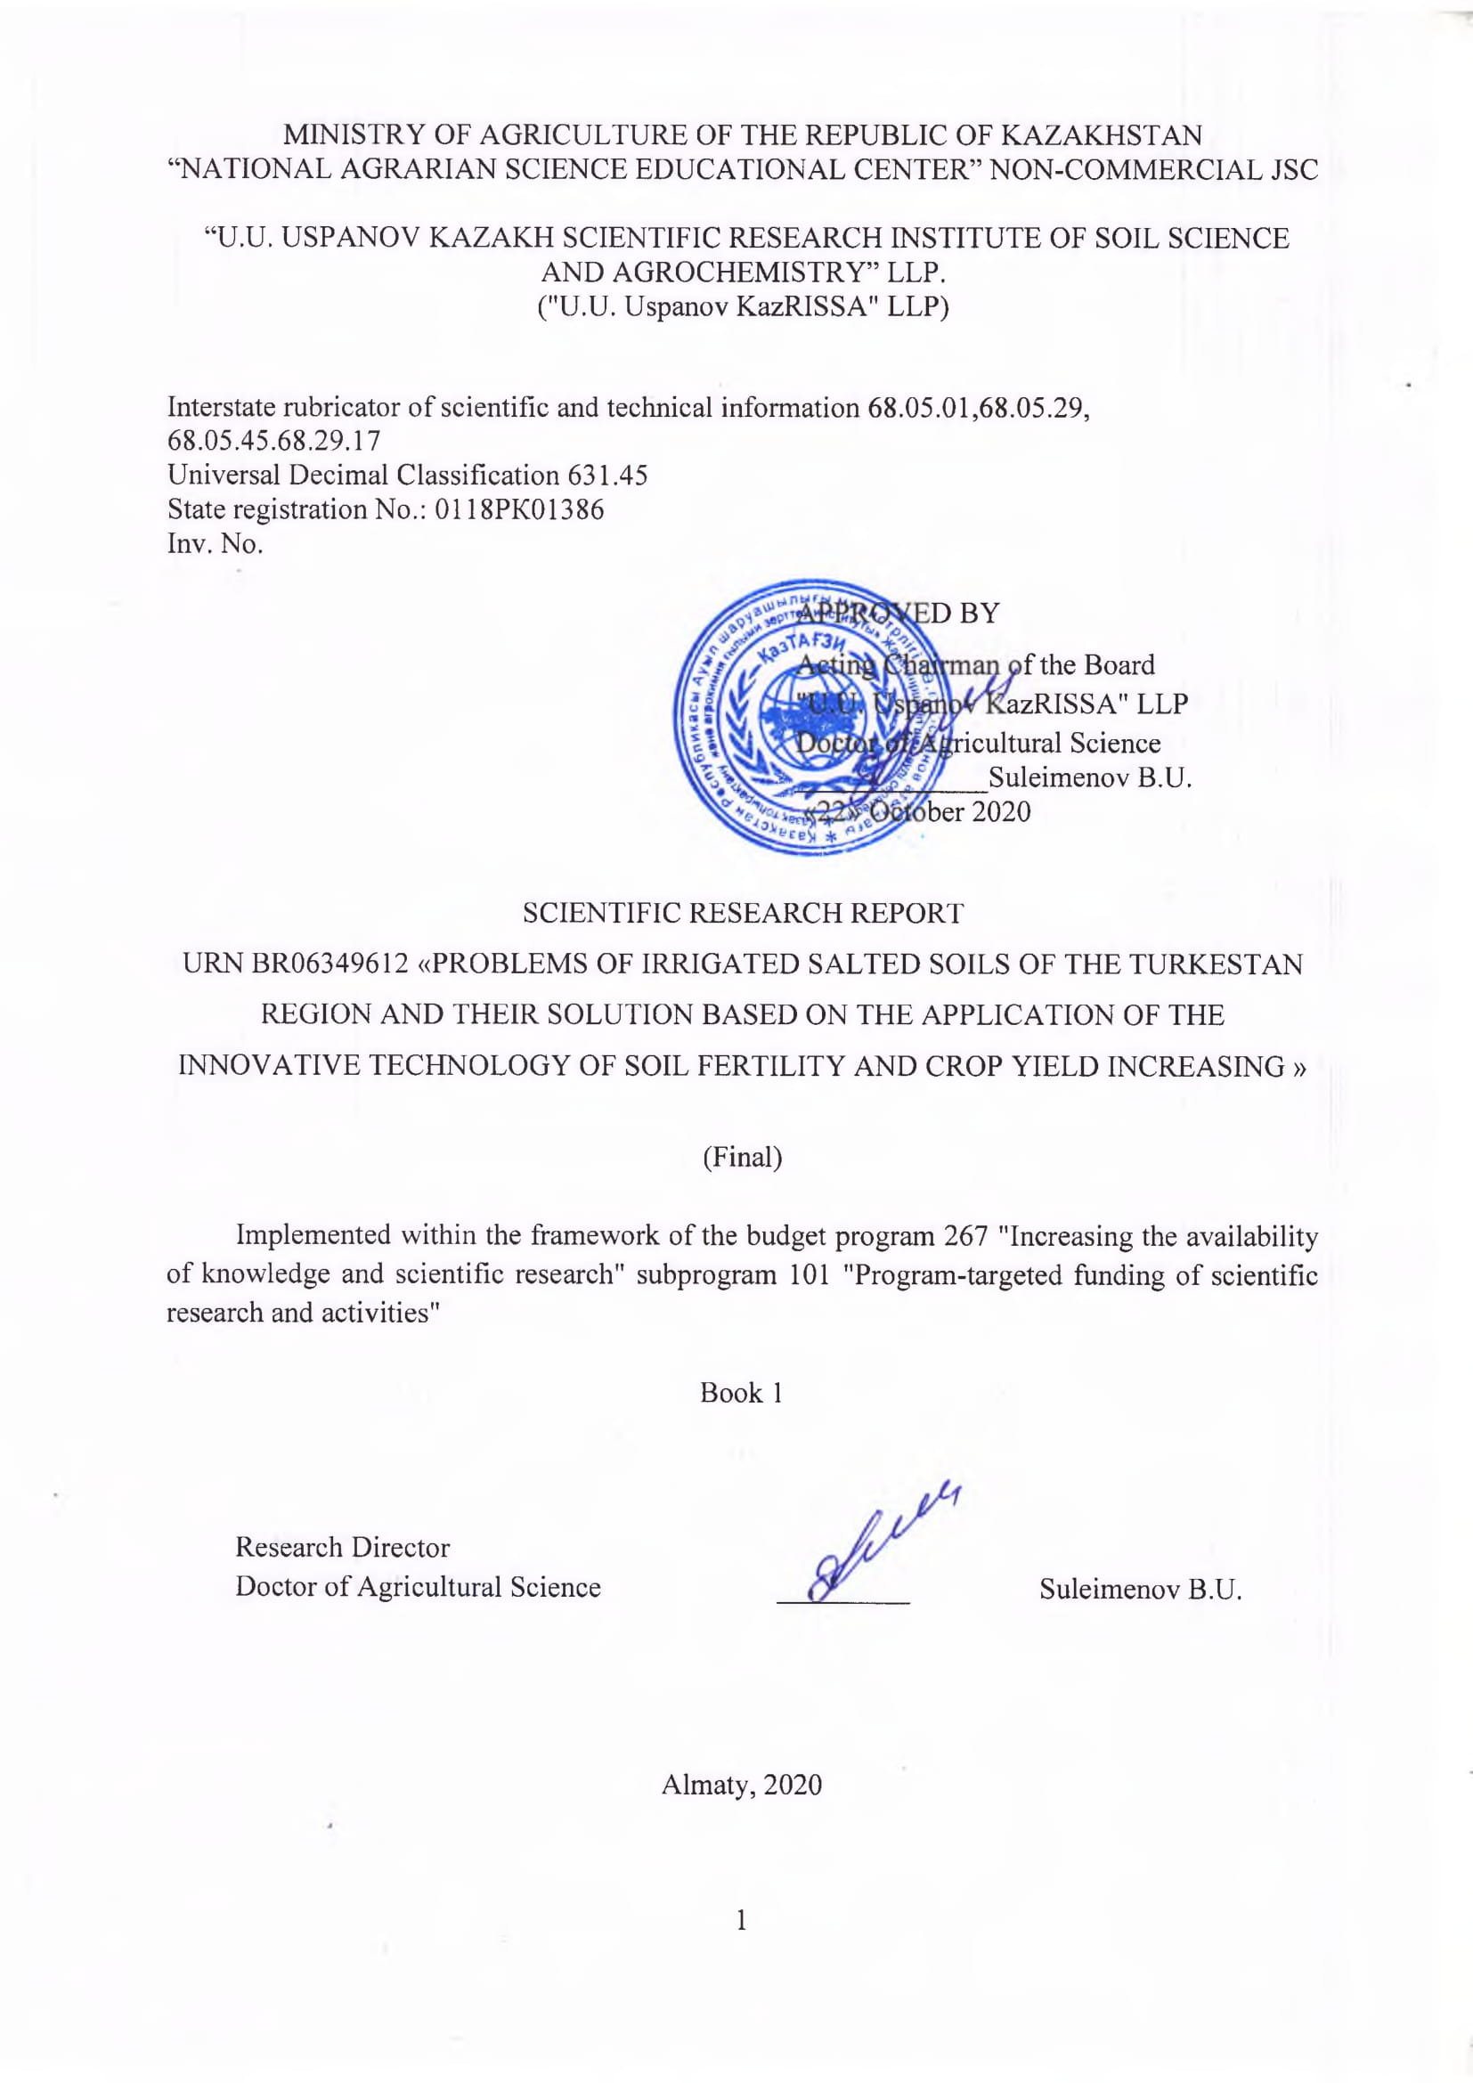

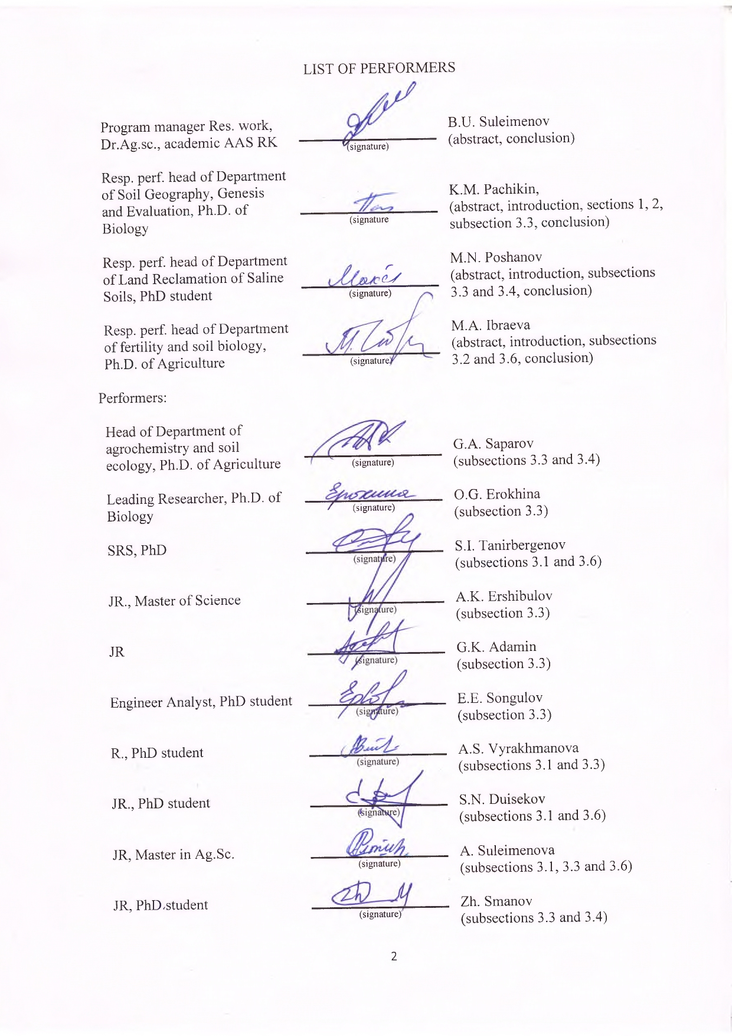



Реферат
Есеп 835 бет., 2 кітап, 28 сурет, 11 кесте., 69 әдебиет көздері, 8 қосымша.
ТҰЗДАНҒАН ТОПЫРАҚТАР, ҒАРЫШТЫҚ ТҮСІРІЛІМДЕР, ҒАРЫШТЫҚ ТҮСІРІЛІМДЕРДІ ДЕШИФРЛЕУ, ГЕОАҚПАРАТТЫҚ ТЕХНОЛОГИялар, ТОПЫРАҚ ДЕРЕКТЕРІНІҢ қорЫ, ТОПЫРАҚтың ТҰЗдылығын төмендетудің БИОЛОГИЯЛЫҚ ӘДІСІ, ТОПЫРАҚТАРДЫҢ ТҰЗДАНУ КАРТАСЫ, АГРОХИМИЯЛЫҚ КАРТОГРАММАЛАР, ТОПЫРАҚ КАРТАСЫ, ТОПЫРАҚТАР ДЕГРАДАЦИЯСЫНЫҢ КАРТАСЫ, ТопЫРАҚ БОНИТЕТ БАЛЫНЫҢ КАРТАСЫ, Өнімділік.
Зерттеу нысаны: Шәуілдір суармалы алқабының шығыс, орталық және шығыс бөліктерінің топырақтары, шалғынды-сұр тұзданған (сор, кей жерлерде сортаңданған) топырақтар басым.
Жұмыстың мақсаты: топырақтың құнарлылығын және ауыл шаруашылығы дақылдарының өнімділігін арттырудың инновациялық технологиясын қолдану арқылы Түркістан облысының суармалы тұзданған топырақтарының мәселелерін шешу.
Жұмыс жүргізу әдістері: топырақ және агрохимиялық зерттеулердің жалпы қабылданған далалық және зертханалық әдістері; карта жасаудың геоақпараттық технологияларын қолдану; топырақты қашықтықтан (ғарыштық) зерттеу; микробиологиялық және молекулалық-биологиялық.
Жұмыс нәтижелері және олардың жаңалығы: Түркістан облысы шегінде топырақ деградациясының негізгі басты себептері мен олардың ауыл шаруашылығы дақылдарының өнімділігіне әсеріне кешенді қашықтықтан (ғарыштық) мониторинг жүргізу әдісі бағдарлама шеңберінде алғаш рет әзірленуде және бұл орындалған жұмыстың жаңалығы болып табылады.
2 пилоттық шаруашылық аумағында ауыл шаруашылығы айналымынан шыққан тұзды «тыңайған» жерлерді игеру технологиясына өндірістік тексеру жүргізілді; Тұздану дәрежесі мен химизмі бойынша 6 карта, 2 пилоттық шаруашылықтың 1-ші тұз қабатының тереңдігі мен сортаңдануаның 4 картасы жасалды. Институт технологиясын өндіріске енгізгеннен жүгері дәнінің қосымша өнімділігі 20,5-тен 23,6 % дейін артты.
Жалпы ауданы 92000 га құрайтын 3 топырақ картасы жасалды.
Топырақтың деградациясының критерийлері әзірленді және жалпы ауданы 92000 га құрайтын топырақ жамылғысы деградациясының картасы жасалды.
Бонитет шкаласы құрылып, жалпы ауданы 92000 га аумақтың топырақ балл бонитетінің 3 картасы жасалды.
Ауданы 1507 га, әрбір пилоттық шаруашылықтың топырағының тұздану дәрежесі және қоректік элементтердің мөлшері бойынша бағалау нәтижелері алынды.
4897 топырақ кескінінің мәліметтері топырақ мәліметтер қорына енгізілді.
3 пилоттық шаруашылық аумағында топырақтың тұздануын төмендету биологиялық әдісіне өндірістік сынақ жүргізілді. Тұзданған топырақтардың биологиялық белсенділігін арттыратын микробиологиялық препарат әзірленді.
1507 га ауданға 70 шаруа қожалық аумағында дәндік жүгері өнімділігін 33,8-34,1%-ға, әлсіз және орташа тұзданған топырақтарда және қатты тұзды топырақтарда 14,5% - ға арттыра отырып, тұзданған топырақтардың құнарлылығын және ауыл шаруашылығы дақылдарының өнімділігін арттыру бойынша институт технологиясын енгізу жұмыстары жүргізілді.
Өнімділіктің артуына байланысты шығындардың өтелімділігін, 1 га жұмсалған шығындарды бағалау және өтелімділік мерзімдерін көрсете отырып әзірленген технологияның тиімділігіне талдау жүргізілді.
Нәтижелерді қолдану аясы - ауыл шаруашылығы
abstract
Report 835 pages, 2 books, 28 figures, 11 tables, 69 sources, 8 appendices.
saline SOILS, satellite images, satellite IMAGES DECRYPTING, GEOINFORMATION TECHNOLOGIES, soil dataBASE, BIOLOGICAL METHOD of desalinization, map OF soil salinity, AGROCHEMICAL cartogram, SOIL MAP, SOIL degradation MAP, SOIL BONITET SCORES MAP, CROP YIELD.
Object of the Research: soils of the right bank, central and eastern part of Shaulder irrigation massif, mostly medow serozemic alkaline soils (saline, partially slightly saline soils).
Aim of the Research: solving the problems of irrigated saline soils of the Turkestan region through the application of the innovative technology to increase soil fertility and crop yields.
Research methods: standard field and laboratory methods of soil and agrochemical research; application of geographic information mapping technologies; remote (satellite) soil research; microbiological and molecular biological methods.
Research results and its novelty:
The integrated remote (satellite) method of the program originally developed for monitoring the main leading causes of soil degradation and their impact on crop yields within the territory of the Turkestan region, is a novelty of the performed research.
Field test of the technology for reclamation of saline "fallow" lands out of agricultural turnover was carried out on the territory of 2 pilot farms; 6 maps of the degree and chemistry of salinity and 4 maps of alkalinity and occurrence of the 1st salt horizon for 2 pilot farms were compiled. An increase in the grain maize yield from the implementation of the institute's technology was from 20.5 to 23.6%.
3 soil maps were compiled for the total area of 92,000 hectares.
Criteria of soil degradation were developmed and 3 maps of soil cover degradation were compiled for the total area of 92 000 ha.
Appraising scale and 3 maps of soil bonitet score were compiled for the total area of 92, 000 ha.
The results of assessing the soils of each pilot farm by the degree of salinity and content of nutrients on the area of 1507 hectares were obtained.
The results for 4897 soil horizons were filled into the soil database.
On the territory of 3 pilot farms, a field test of the biological method of soil desalinization was carried out. A microbiological preparation has been developed that increases the biological activity of saline soils.
On the area of 1507 hectares, the Institute's technology was implemented to improve the fertility of saline soils and the productivity of agricultural crops in 70 peasant farms with an increase in the yield of grain maize was from 33.8 to 34.1% on slightly and medium saline soils, and 14.5% on highly saline soils.
An analysis of the effectiveness of the developed technology was carried out, indicating the estimated cost per 1 hectare, cost recovery due to increased productivity, indicating the payback period.

Sphere of application of the results - agriculture

Content
Page
TERMS AND DEFINITIONS | 7
LIST OF ABBREVIATIONS AND DESIGNATIONS | 9
introduction | 11
Main part of THE SCIENTIFIC RESEARCH REPORT
1 SELECTION OF THE RESEARCH DIRECTION | 13
2 OBJECT AND METHODS OF THE RESEARCH
2.1. Object of the research | 15
2.2. Research methods | 15
3 Research results
3.1 To develop a technology for the reclamation of salted “waste” lands out of agricultural production using the remote (satellite) method for determining soil salinity | 16
3.2 To conduct a field test of the biological method of desalinization of saline soils using cultivation of licorice Glycyrrhiza glabra L | 24
3.3 To apply the technology to increase the fertility of saline soils and crop yields (grain maize) and teach farmers the basics of the technology | 30
3.4 To conduct an analysis of economic efficiency of the implemented and developed technologies, including cost assessment of the application of technologies per 1 ha, analysis of cost recovery due to increased productivity, indicating the payback period | 45
3.5 To create microbiological preparations that contribute to increasing the fertility of low-productive saline soils and give recommendations on their use | 48
3.6 To conduct annual training seminars and field days in order to demonstrate the benefits of the technology used in the program | 55
CONCLUSION | 56
References | 64
APPENDIX A - Scientific and organizational activities in 2020 | 70

TERMS AND DEFINITIONS

In the present Scientific Research Report, the following terms are used with the corresponding definitions:
Humus - | The main organic matter of the soil, containing nutrients needed by higher plants.
GIS- | Geographic information system is a system for collecting, storing, analysing, and graphically visualizing spatial (geographic) data and related information about the necessary objects.
Soil degradation - | The set of processes that lead to a change in soil functions, quantitative and qualitative deterioration of its properties, a gradual decrease in fertility. There are the following types of soil degradation: erosion, salinization, pollution and desertification.
Saline soils - | readily-soluble mineral salts in its whole profile or in its part in the amount harmful to plants (more than 0.1-0.3%).
CFU- | Colony forming units - an indicator showing the number of bacteria colonies formed in 1 ml of environment.
CFU/gr- | Colony forming units - an indicator showing the number of bacterial colonies formed per 1 gram.
Microbiology - | The science about living organisms, invisible to the human naked eye (microorganisms): bacteria, archaebacteria, microscopic fungi and algae, as well as protozoa and viruses. Microbiology area of interests includes their systematics, morphology, physiology, biochemistry, evolution, role in ecosystems and the possibility of practical use.
Mineral fertilizers - | Inorganic compounds containing essential nutrients for plants. Depending on the contained type of nutrients, fertilizers can be simple or complex. Simple (one-sided) fertilizers contain one kind of nutrient. Complex, or multilateral fertilizers, contain two or more essential nutrients at the same time.
Soil fertility - | The ability of soil to satisfy the need of plants for nutrients, moisture and air, as well as to provide conditions for their normal life.
Soil - | The surface layer of the Earth's lithosphere, which is fertile and represents a multifunctional heterogeneous open four-phase (solid, liquid, gaseous phases and living organisms) structural system, formed as a result of rocks weathering and vital activity of organisms.
Soil map - | A graphical image on cartographic basis, spatial layout of soil differences on any territory with a certain scale. By the scale, content and purpose, maps are divided into detailed, large-scale, medium-scale, small-scale and schematic map.
Resource-saving technology- | Crop cultivation technologies aimed at saving material supplies, resources, petroleum, oil and lubricants (POL), leading to product cost reduction.
Crop yield – | The amount of crop production in tons and centners per unit of the cultivated area of 1 ha or 1 m2 (in greenhouses, hotbeds).
Soil revegetation- | A set of measures for the accelerated cultivation of saline soils by cultivating plants in crop rotation.
Strain- | A pure culture of microorganisms of one species which morphological and physiological features have been studied. Different strains of microorganisms of the same species vary in a number of properties.

LIST OF ABBREVIATIONS AND DESIGNATIONS

The following abbreviations and designations are used in the Research Report:
А – humus accumulative;
В – humus transient;
С – soil-forming material;
АВ, ВС, СД – intermediary.
Superscripts for the designation of genetic horizons and soils indicate:
c – carbonated;
s – solonchak;
ss – slightly saline;
a – alkalinized;
ch – channery;
sn – saline.
DB – database
ha – hectare
GIS – geographic information systems

gr/l – gram per 1 litre,
gr/cm3 – gram per cubic centimetre
a.m. active material

SАА – starch-and-ammonia agar

kg – kilogram

kg/ha – kilogram per hectare
km – kilometre
PF – peasant farm
l/ha – litre per hectare

m² - square meter

m3/ha – cubic meter per hectare

mg – milligram

mg% - milligram percent
mg/kg- milligram per 1 kilogram of soil
mg-eq/100 milligrams - equivalent per 100 grams of soil
mm – millimetre

mln– million
mln/ha – million per hectare
mln. pc/ha – million pieces per hectare

MPA – meat-and-peptone agar
RDC – research and development center
SAC - soil adsorption complex
r-river
RK – Republic of Kazakhstan
сm – centimeter
cm² - square centimeter
t – tonne
t/ha – tonne per hectare
i.e. – that is
"U.U. Uspanov KazRISSA" LLP - “U.U. Uspanov Kazakh Scientific Research Institute of Soil Science and Agrochemistry” Limited Liability Partnership
ths. ha - thousand hectare
ths/gr. thousand per gram
FSBEI of HE “RSAU - K.A. Timiryazev MAA” - “Russian State Agrarian University – Moscow K.A. Timiryazev Agricultural Academy” Federal State Budgetary Educational Institution of Higher Education
с/ha – centner per hectare

pc/m² - pieces in 1 m²

pc.– pieces
СО₂ – carbon dioxide
С -1-1 physiologically active humic preparation - adaptogen
K – potassium
N – nitrogen
О₂ – oxygen
рН – soil solution reaction
% – percent
ºС – degree Celsius
GPS18 - Global Positioning System
GPS “Garmin 62 s” - Global Positioning System
MapInfo Professional– cartography program

INTRODUCTION
The topical problem of the country in the conditions of intensive development of economic relations in the agricultural sector is the rational and effective use and protection of soil resources, in particular, preservation and reproduction of soil fertility and productivity of arable lands. Currently, the processes of degradation and anthropogenic desertification are increasing every year in the republic. On the irrigated areas of the south and southeast of Kazakhstan, the problem of their reclamation condition has sharply aggravated, the areas of the so-called “unused”, “waste” lands have increased, 35.8 (16.6%) million hectares of saline soils and 58.2 (27%) million hectares of alkaline soils of the total agricultural land area are registered [1]. In order to solve this problem, it is necessary to improve farming standards and economic efficiency. This is possible due to the rational use of land resources with the implementation of new progressive agricultural technologies that ensure reproduction of soil fertility and stable level of crop yields.
The main tasks of the agro-industrial complex are identified as principal directions of economic and social development of Kazakhstan for the period up to 2050, namely: achieving of sustainable growth of agricultural production, reliable provision of the country with food and agricultural raw materials, joining efforts of all sectors of the complex to obtain high final results in accordance with the developed programs. In this regard, an important place is given to soil fertility. According to the message of the President of the Republic of Kazakhstan K. Tokayev dated September 2, 2019 "Constructive public dialogue is the basis of stability and prosperity of Kazakhstan" it is planned to increase the area of irrigated land to 3 million hectares by 2030 and ensure an increase in agricultural production by 4.5 times [2].
For successful implementation of the Strategy "Kazakhstan - 2050", it is necessary to improve agricultural systems based on the results of fundamental and applied research of soil and agrochemical science and other industries aimed at strengthening technological policy. In this regard, it is necessary to improve the existing and develop new scientifically grounded technologies for increasing the fertility of agricultural lands and to develop specific action plans for the survey of arable land and the rational use of fertilizers.
At the present time, complex remote sensing method of soil research is one of the promising methods of satellite monitoring of soils, the positive effect of which is timely assessment of soil fertility level and adoption of prompt measures to improve it.
Scientific novelty. The complex remote (satellite) method of monitoring main leading causes of soil degradation and their impact on the yield of agricultural crops within the republic is being developed for the first time within the framework of the program.
Aim of the Program - solving the problems of irrigated saline soils of the Turkestan region through the application of innovative technology to increase soil fertility and crop yields.
Objectives of the Research for 2018-2020: 1. To develop technology for the reclamation of salted “waste” lands that have left agricultural turnover using the remote (satellite) method for determining soil salinity; 2 To conduct a field test of the biological method of desalinization of saline soils using cultivation of licorice Glycyrrhiza glabra L; 3. Application of the technology to increase fertility of saline soils and productivity of agricultural crops (grain maize), training farmers the basics of technology; 4. To conduct an analysis of the economic efficiency of the implemented and developed technologies, including: to assess the costs of applying technologies per hectare, analyzing cost recovery due to increased productivity, indicating the payback period; 5. To create microbiological preparation that contribute to increasing the fertility of low-productive saline soils and give recommendations on their use. 6. To conduct annual training seminars, field days in order to demonstrate the benefits of technology used in the Project.
Issues, presented in the Report, are of high priority, since they are aimed at solving the most important problem - the problem of increasing the effective soil fertility and productivity of agricultural crops.
Below is given the list of prepared interim reports performed under the budget program 267 "Increasing the availability of knowledge and scientific research" subprogram 101 "Program-targeted financing of scientific research and activities" under the scientific and technical program "Problems of irrigated saline soils of the Turkestan region and their solution based on the use of innovative technologies for increasing soil fertility and productivity "(URN BR06349612):
1. 2018: Registration number 0118РК01386; inventory number 0218РК01404
2. 2019: inventory number 0219РК00728

MAIN PART OF THE SCIENTIFIC RESEARCH REPORT

1 SELECTION OF THE RESEARCH DIRECTION
Soil and land resources in agriculture are considered as one of the leading sectors of the economy. Currently, the problem of land degradation is one of the most acute in the world and requires close attention. The current area of arable land in the world is 1.5 bln. ha or 0.25 ha per capita. Over the last 25 years the number of arable land per capita has been halved [3].
The areas of degraded and unproductive lands in Kazakhstan, as in the rest of the world, are increasing every year. Soil fertility has significantly decreased in large areas, content of humus in non-irrigated zone has decreased by one third from the initial content, and up to 60% in irrigated zone [4].
At the extended meeting of the Kazakhstan’s Government on September 9, 2016 concerning the prospects for the country's socio-economic development, it was noted that the priority direction is to include the irrigated lands into use. It was instructed to include into the turnover at least 600 thousand hectares of irrigated lands within five years. These tasks were outlined in the State Program for the Development of the Agro-Industrial Complex of the Republic of Kazakhstan for 2017-2021, and in the Plan for the Development of Irrigated Lands until 2028. It is planned to increase its area to 3.5 million hectares by 2028, i.e., to add about 1.5 million hectares of new irrigated land into agricultural use [5].
In the Message to the people of Kazakhstan "Third modernization of Kazakhstan: global competitiveness" dated January 31, 2017, the First President N.A. Nazarbayev gave specific instructions to the Government of the Republic of Kazakhstan to immediately start solving problems on the implementation of digital technologies in the agro-industrial complex [6]. Preservation of soil fertility is one of the primary problems of today's agriculture. In this regard, the development of scientific foundations and technologies for the rational use of land resources, compilation of a soil information system using GIS technologies is very important [7].
Today, Earth remote sensing methods are widely used in the agro-industrial complex of many countries of the world (USA, Canada, European Union countries, India, Japan, etc.). Surveys from space not only increase the accuracy, uniformity, objectivity and frequency of observations, but also significantly improve the methods of operational control of crops condition and forecasting of yield. With the help of remote sensing data and GIS technologies, it becomes possible to monitor large areas of the territory, to obtain objective information about the current state of the soil cover. The use of remote sensing methods in soil science gave a great benefit to the development of soil mapping and monitoring of the soil cover. The problem of assessment of soil salinization by remote methods has not been solved yet [8-10]. Directions for the development of space monitoring of soil salinization are at the initial stage in Kazakhstan. U.U. Uspanov Kazakh Scientific Research Institute of Soil Science and Agrochemistry is now working to create a soil information system for the republic (including database, computerized soil map, map of soil bonitet scores, etc.).
The positive experience of using satellite data was gained by the Institute's scientists as a result of the implementation of a number of projects to develop methods for satellite mapping of soil salinity using the example of irrigated areas in the south and southeast of the republic [11-16].
The implementation of the program is aimed at solving the key problems of irrigated saline soils of the Turkestan region through the use of innovative technology to increase soil fertility and crop yields.
The Shaulder irrigation massif (ancient Otyrar oasis), the territory of which is characterized by severe reclamation conditions with a predominance of saline soils, was chosen as the object of Research. Soil salinity of this massif is largely determined by the specifics of land use - intensive development of irrigation in the south of the republic. IT technologies are widely used in the work - GIS, soil information system, methods of remote (satellite) soil research, digital mapping, etc. The developed complex remote sensing method of soil research is one of the promising methods of satellite monitoring of soils, the positive effect of which is a timely assessment of soil fertility level on the irrigation massif and the implementation of prompt measures to improve it.
Research work carried out under the scientific and technical program: "Problems of irrigated saline soils of the Turkestan region and their solution based on the use of innovative technology to increase soil fertility and productivity" are notable by the integrated approach in solving the tasks. Developed methods of complex monitoring of the level of soil fertility and their influence on the productivity of agricultural crops according to satellite data can be used in other arid regions.

2 OBJECT AND METHODS OF THE RESEARCH
2.1 Objects of the Research
The object of the study is soil cover of the right-bank, central and eastern part of the Shaulder irrigation massif of the Turkestan region.
The massif is dominated by meadow-gray-earth saline (saline, patchily slightly saline) soils, which occupy medium-level surfaces, and are formed on saline, weakly layered loamy and clay deposits with mid depth (4-6 m) occurrence of mineralized groundwater under thinned cereal halophytic shrubby vegetation with ephemera and wormwood [17].
Detailed description of soil and climatic conditions of the research object is given in the interim report for 2018.

2.2 Research Methods
Research methods include standard field and laboratory methods of soil and agrochemical research; use of geoinformation mapping technologies, remote (satellite) soil investigation, routine microbiological and molecular biological methods.
Soil research has been carried out using ground-based methods and high-tech satellite and geoinformation technologies.
The report presents the methodology for conducting research in each reviewed task of the program. Thus, all necessary soil research methods have been involved to complete the tasks of the program.

3 RESEARCH RESULTS
For all tasks of the program of 2018-2020, an electronic basis of the information system (GIS) of the research object was created, which was replenished annually from 2018. Currently, the storage and analysis of soil data based on information systems (GIS) is a new promising direction in soil science. Soil information system is becoming the most effective means of obtaining, storing, processing and using information about soil properties and their spatial distribution. In this regard, at the first stage of the work, an electronic basis for the soil information system of the research object was created. For this purpose, 6 sheets of topographic maps were used: K-42-29, K-42-30, K-42-41, K-42-42, K-42-53, K-42-53, with scale 1: 100,000, they were scanned and partially digitized in GIS environment using MapInfo professional program (Appendix A. Figure A.1). It is known that currently available topographic maps have not been updated for quite a long time, and in most cases the ground situation is outdated. Therefore, in order to clarify the situation on the ground, satellite images were downloaded from open sources and used (digitized) (Appendix A., Figure A.2). In most cases, images were downloaded from the Landsat satellite, which has a large base of free images that correctly reflects the current situation. Using the above cartographic materials and satellite images, thematic layers were created - lakes, rivers, channels, irrigated lands, an irrigation network, roads and railways, settlements and other layers, which are an integral part of any information system, each layer has the corresponding attributive information, which is in the database of the information system. The results for 149 soil sections (734 soil horizons) were filled into the soil database during 2018-2020; for soil-reclamation survey - 3019 horizons; agrochemical survey - 1129 horizons. Total 4897 soil horizons.

The final report presents the results of the research on the following objectives:
3.1 To develop technologies for the reclamation of salted “waste” lands out of agricultural turnover using the remote (satellite) method for determining soil salinity
Methodology
When using satellite methods, the methodology of Pankova, Mazikova [18] were used as a basis, supplemented by the works of her students Rukhovich [19] and Konyushkova [20], experience of the previous works has been used [21-26]. Ground surveys were carried out in accordance with the “All-Union Instruction ... [27] and Guidelines [28].
Along with traditional method (laying sections, drilling wells), the Progress 1T field portable salinometer was used for salt surveys. GPS 18 “Garmin” and netbook “ASUS” were used for delineation of soil contours from satellite images. GPS “Garmin 62s” global positioning system has been used to determine the coordinates of section points.
For general analysis, techniques described in the manual “41” were used [29]. The assessment of saline soils was based on 3 main criteria: chemistry (type) of salinity, degree of salinity and depth of occurrence of the salt horizon. Chemistry of saline soils was determined by the composition of anions and cations [30-34]. Statistical processing has been carried out by standard methods using program package analysis "Excel - 97" and "Atte Stat" [35-37].
Results of the Research
Currently the problem of reclamation condition gets worse, areas of so-called “unused” and “waste” secondary-saline lands have increased on the irrigated areas in the south of Kazakhstan. In the Turkestan region in 1991 there were 495.8 thousand hectares of irrigated land, in 2000 - 500.4 thousand hectares, in 2017 - 570.3 thousand hectares, in 2018 - 545.0 thousand hectares; changes from 1991 to 2018 amounted to +49.2 thousand hectares, and from 2018 to 2017 -25.3 thousand hectares [38]. The problems of increasing salinity of irrigated soils in the Turkestan region led to a decrease in the yield of agricultural crops. In order to develop methods for the restoration of degraded "waste" lands with saline soils, first of all, it is necessary to assess their current state, and secondly, to develop scientific basis for the re-development of "fallow" secondary saline lands. To select representational ground territories and plots in the allocated main territories with lands out of agricultural use, a reconnaissance survey of the territory of the massif was carried out using the stock materials of the Kazakh Research Institute of Soil Science and Agrochemistry named after U. U. Uspanov and archival satellite pictures. We used images of the local KazEOSat-2 satellite with a spatial resolution in a panchromatic mode of 1.0 meters on the ground and in a multispectral mode (4 imaging channels - blue, green, red and near infrared) - 6 meters and Landsat 8 OLI, which has a spatial resolution of 15 and 30 meters, respectively, in panchromatic and multispectral resolution (Appendix A, Figure A.3). Although Landsat 8 OLI images have a lower spatial resolution (30 m), they are distinguished by a large number of spectral channels in the infrared range. Due to the fact that, in most cases, fields with high soil salinity are abandoned, reference plots of “fallow” lands out agricultural use with saline soils with pixel images of clear brightness, were selected (Appendix A, Figure A.4). To exclude temporarily unused lands (for 1 and 2 years), Landsat 8OLE panchromatic images for the last 4 years (2015-2018) and a synthesized KazEOSat-2 2018 multispectral image were analyzed.
A map of “fallow lands” with saline soils was compiled on the lands selected in 2018 that were out of agricultural use with their vector layers (Figure 1).
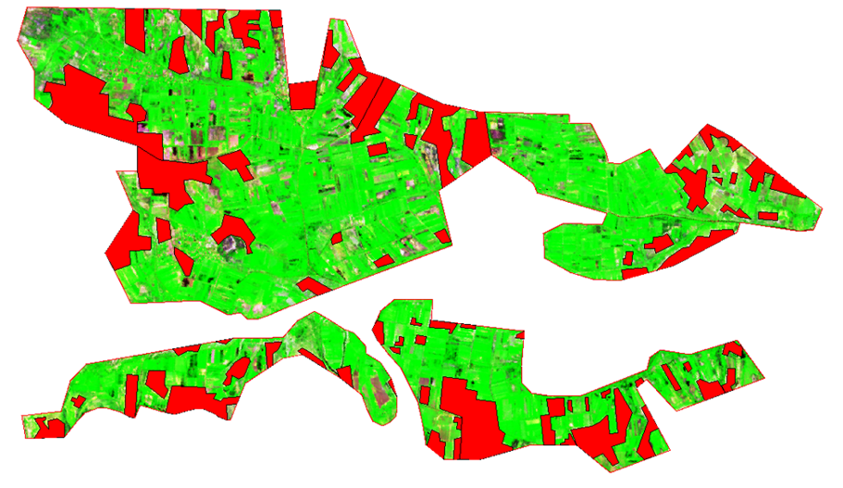
Figure 1 - Vector layer (red) of homogeneous abandoned "fallow" lands with saline soils

Proceeding from the purpose of the study, relationship between the brightness characteristics of satellite images with soil salinity and development of a regression model for this relationship, it was necessary to create an information system for the object of research. For this purpose, a satellite and ground survey of the territory was carried out synchronously in place and time.
In order to assess the degree of soil salinity a traditional ground salt survey (large-scale 1: 1000) was carried out on the territories of 2 test plots of PF "Nesip-E" and PF "Almas" with the area of 15.47 hectares. Regression analysis in the STATISTICA 10.0 software environment was carried out for each investigated soil layer to establish the relationship between soil salinity and satellite imagery data. Soil sampling for analysis of water extraction of soils, routinely in land reclamation studies, has been carried out from three calculated depths (0-20, 20-50 and 50-100 cm).
The results of soil analysis were filled into electronic spatially coordinated database of the research object, which contains data on the numbers of sections, coordinates of their location (longitude, latitude), depth of sampling, electrical conductivity and soil temperature. A fragment of the database is shown in Figure 2 below.

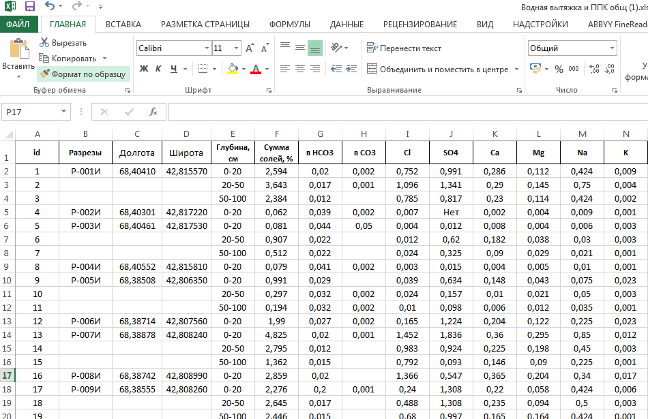
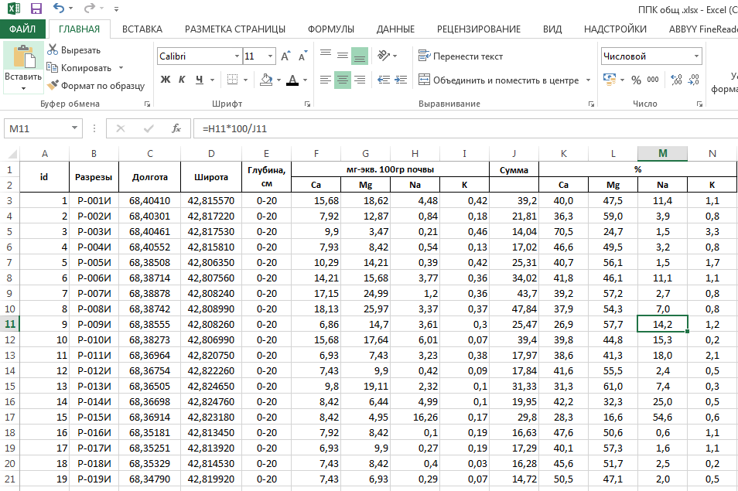

Figure 2 - Fragment of the spatially coordinated database of the research object

Maps of salinity and alkalinity of soils of the selected test plots were compiled in the Mapinfo professional environment, using the generated information system (GIS) of the object of study (Figure 3, 4)

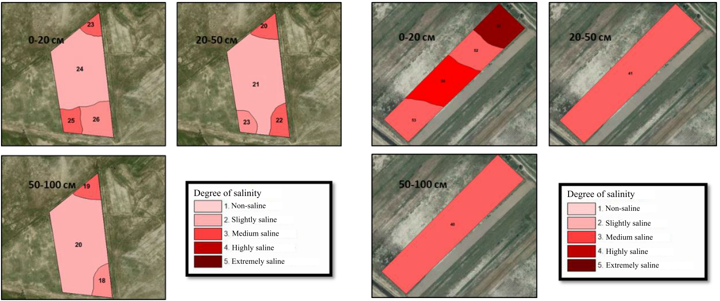

Figure 3 - Map of salinity of 0-20, 20-50 and 50-100 cm layers of pilot (on the left) and second (on the right) test plots

When compiling soil salinity maps for points with field research data in GIS, the values of pixel brightness for all spectral channels of Landsat 8 OLI satellite images were extracted and the values of pixel brightness ratios in different channels and vegetation indices were calculated. The effectiveness of these indices is determined by the features of the reflection, mainly empirically. It was found that the soils of the experimental plots are saline from the surface, excluding small area (about 4 hectares). At the same time, the soils on the second plot are distinguished by a relatively higher salinity than the soils of the first plot. Thus, the soils of the first plot have passed into the category of "fallow" lands relatively recently (5-10 years), and the soils of the second plot are old "fallow" lands. This is also indicated by the depth of soil contours with different degrees of salinity. There are only small contours of slightly alkaline soils (Figure 4), which practically do not affect soil fertility with salinization.

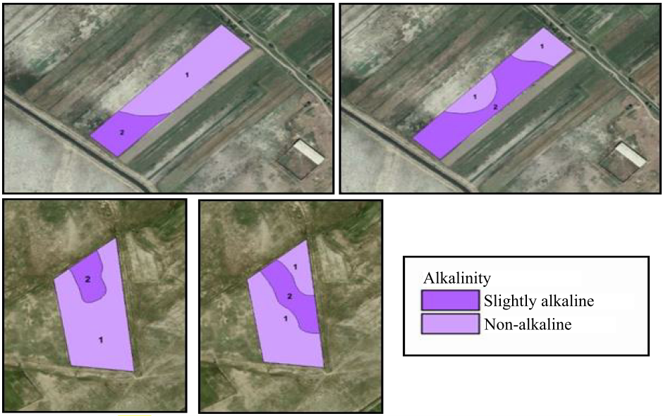

Figure 4 - Map of alkalinity of soil layers 0-20 and 20-50 cm of the first (on the left) and second (on the right) experimental plots

Soil-agrochemical survey was carried out to assess the supply of soils of 2 investigated test plots of PF "Nesip-E" and "Almas" with basic nutrients on the area of 15.47 hectares, the results of which are shown in Table 1 for PF "Nesip-E".
From the data in Table 1, it can be seen that there was a loss of humus on the entire area of waste land, compared with their virgin analogues.
The soils of these lands are very poor in the content of one of the main nutrients, the easily hydrolyzed form of nitrogen. According to the content of nitrogen the soils on the area of 5.7 hectares (59.5%) are classified as “low”; 2.01 ha (21.0%) - “very low”; only on 1.87 ha (19.5%) the content of this form of nitrogen is "average", there is an acute need in nitrogen fertilizers (Appendix A, Table A1).

Table 1- Humus soil grouping of PF “Nesip-E”

Group No. | Humus content | Humus, % | Area, ha | % of area
1 | Very low | < 2.0 | 9.58 | 100.0
2 | Low | 2.1 – 4.0 | - | -
3 | Average | 4.1 – 6.0 | - | -
4 | Increased | 6.1 – 8.0 | - | -
5 | High | > 8.0 | - | -
Total | - | - | 9.58 | 100.0

Table A.2 of the Appendix A provides data on the supply of mobile phosphorus. The soils of the surveyed farms territory are very variegated and have all groups of mobile phosphorus supply, except for "very low" and "very high" degrees. It should be noted that when these lands are back into the agricultural turnover, such variegation requires leveling the background.
Potassium reserve of the surveyed soils turned out to be quite variegated, although more favorable, more than 50% of the soil area has “high” and “very high” degree of supply, 31.4% - “increased” and only 12.4% of the surveyed territory belongs to "medium" gradation (Appendix A, Table A3).
Map of humus content and cartograms of soils supply with basic nutrients were compiled and doses of mineral fertilizers were calculated for the practical use of farms' lands and for conducting an experiment with the Institute's technology. From the above cartogram, it can be seen that according to the content of humus and easily hydrolyzed nitrogen, the soils are depleted, with variegated content of potassium and phosphorus. Leveling of background is required by the recommended doses of fertilizers (Appendix A, Figure A5, А6). As an example, there are doses of mineral fertilizers calculated for the planned harvest for PF "Nesip-E" (Appendix A, table A4-А6). On the selected 2 plots of PF "Nesip-E" and "Almas" with an area of 15.47 hectares, research work was carried out to develop a technology for the reclamation of lands that are out of agricultural use. For example, we will give activities carried out on the waste land of PF "Nesip-E": 1. Land treatment; 2. Plowing and harrowing of the soil; 3. Water-charging irrigation; 4. Application of mineral fertilizers; 5. Presowing treatment of corn seeds; 6. Spraying of corn plants during the growing season; 7. Supplementary feeding with nitrogen fertilizers; 8. Furrow irrigation of corn plants; 9. Harvesting operations.
In spring of 2019 the following activities were done: cultivation of soil with heavy discs in 2 gangs, plowing to a depth of 27-29 cm, harrowing with heavy harrows, water-charging irrigation with a rate of 1000-1300 m³ per hectare and application of mineral fertilizers recommended according to the cartogram of the content of main nutrients.
Sowing of corn was carried out in May at a depth of 6-8 cm in a rows with distance between row of 70 cm at the rate of 20-22 kg of seeds per 1 ha. Spraying of corn plants with physiologically active aqueous solution of C-1-1 was carried out in the phase of 4-5 leaves, and 6-7 leaves, when the first and second layers of nodal roots of corn are formed. Rate of consumption of spray material is 300 liters per 1 ha. Watering corn plants was performed 4-5 times per season. Corn harvesting was carried out in the phase of full grain ripeness (table 2).

Table 2 - Yield of grain maize on waste lands of PF "Nesip-E" and "Almas"

Variants |  | Growth, с/ha
Control | Technology | с/ha | %
PF "Nesip-E"
76.8±0.01 | 92.7±0.83 | 15.9±0.83 | 20.7±1.07
PF "Almas"
50.1±0.01 | 60.3±4.25 | 10.2±4.25 | 20.4±8.48

As can be seen from Table 2, introduction of "waste" land into agricultural turnover with the use of innovative technology gave an increase in yield by an average of 20.5%. Work on the production control of the Institute's technology was continued in 2020 during reclamation of "waste" lands with saline soils out of agricultural use on the territory of PF "Tilegen". Table 3 shows the yield of grain maize on the waste lands of PF "Tilegen", as well as the economic efficiency from the introduction of innovative technology (Appendix A, Table A7).

Table 3 – The yield of grain maize on waste lands of PF "Tilegen"

Variants |  | Growth, с/ha
Control | Technology | с/ha | %
PF "Tilegen"
62.9±0.73 | 77.8±0.91 | 14.8±0.48 | 23.6±0.79

The table shows that an average increase of 23.6% was obtained due to the Institute's technology when growing grain maize on saline soils. Economic efficiency of implementation of the innovative technology compared with the existing technology was 84.7 thousand tenge / ha, cost recovery for the technology was 2.38 tenge, for to the control variant - 1.98 tenge.
Since 2018, together with scientists from the Center for Agricultural Landscape Research (Germany), research has been carried out with new forms of fertilizers (providing consulting and microfertilizers used on saline soils for the cultivation of agricultural crops). On May 11-18, 2019 in the field conditions, small-plot experiments were laid using foreign ameliorants from Germany with the following options. The area of each plot was 2 m², total area of the experiment was 48 m². According to the recommendation, fertilizers were applied before sowing corn.
Experiment variants:
- Control; 2. Cuxin Hangepetunien; 3.Cuxin Redu-BAC; 4.Cuxin Zimmerpflanzen; 5. Ferrous sulphate; 6. FZB 42 (Bacillus amyloliquefaziens); 7. Bacterial mixture of five lignite-based lignite eluates; 8. DCM Redu-BAC

Fertilizers in variants No. 2,3,4 are organic liquid fertilizers based on squeezed sugar beet. The recommended application rate is 100 ml/m², 200 ml was applied per plot. In option No. 5, the preparation of ferrous sulfate was implemented at a dose of 50 g/m². In option 6, preparation FZB 42 (Bacillus amyloliquefaziens) was added (ABITEP.de), which is produced by ABITEP Company in Berlin (Germany). On variant No. 7, bacterial mixture of five lignite eluates based on lignite was implemented. Variant no. 8 - DCM Redu-BAC, application rate 100 ml / m². Sowing maize corn "Baltabay 777" was performed on May 26, 2019. To determine the initial state of soils of the plot, 48 soil samples were taken from 0-25 cm and 25-50 cm. According to the results of agrochemical surveying, the soils of the small-plot experiment are very poorly provided with humus, easily hydrolyzed form of nitrogen and mobile phosphorus; by the content of exchangeable potassium, the soils are characterized as increased content. According to the degree of acidity of the soil – they are alkaline (9,2). The soils are inhabited by various ecological and trophic groups of microorganisms, among which salt-tolerant oligotrophic microorganisms occupy a dominant position; their level in the soil is 6.8 · 10⁶ -1.3 · 10⁷ CFU / g soil. The data obtained are shown in Appendix A, tables А8-А9. A positive reaction of corn plants to the studied factors was noted in the analysis of plant height indicators. During the vegetation season, biometric observations of corn growth were carried out. It was found that the number of leaves per plant did not depend on the morpho-biological characteristics of the corn variety and was the same when all types of fertilizers were applied except for Cuxin Zim-merpflanzen, Ferrous sulfate (Appendix A, table А10-А12). The use of Cuxin Zimmerpflanzen fertilizer significantly increased the average plant height by 55.5 cm. The number of ears was higher when Cuxin Redu-BAC, Ferrous sulfate, FZB (Bacillus amyloliguefazien) fertilizers were applied for 5, 2, 3 and 2, 3 pcs, respectively. The height of the ear attachment when applying all types of fertilizers is almost the same and ranges from 28-31cm. Appendix A. Tables A11 and 12 provide data on the structure and biological yield of grain maize.
The tendency of growth of grain maize yield from the use of the tested fertilizers was recorded. According to the data of one year, it is difficult to make definite conclusions; it is necessary to conduct many years of research using ameliorants from Germany in order to obtain more stable results.
Summary and evaluation of research results
- Field test of the technology for the reclamation of saline "fallow" lands out of agricultural turnover was carried out on the territory of 2 pilot farms; 6 maps on the degree and chemistry of salinity and 4 maps of alkalinity and occurrence of the 1st salt horizon for 2 pilot farms were compiled; an increase in the yield of grain maize of 20.5 - 23.6% was obtained from the implementation of the Institute's technology.
- According to the results of small-plot field test, using foreign ameliorants (Germany), low tendency to increase the yield of grain maize was determined, depending on the tested fertilizers.

3.2 To conduct a field test of the biological method of desalinization of saline soils using cultivation of licorice Glycyrrhiza glabra L
Methodology
On the area of 600 m² (each plot 200 m²), an experiment was performed to test biological method of soil desalinization. The first plot with slightly saline soil is located on the territory of PF "Orken" (1st pilot farm). The second plot with medium saline soil is located on the territory of PF Mukhit (2nd pilot farm), the third plot is highly saline, is located on the territory of PF Bagdat-2 (3rd pilot farm). Bedding-up of soils and water-charging irrigation was carried out before planting. Licorice Glycyrrhiza glabra L was planted in a vegetative way: underground stem of 15-30 cm long with 2-3 buds are set vertically, observing the polarity. The distance between the cuttings in rows is 30 cm, the row spacing - 70 cm. The cuttings are deepened into the soil by 2-4 cm, so that their top is 2-3 cm from the soil surface. The implementation of the experiment is shown in Figure 5.

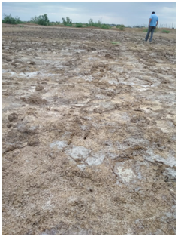 | 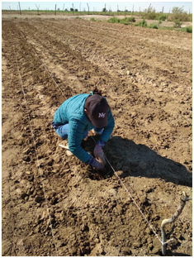 | 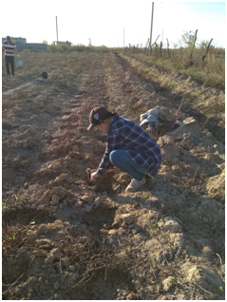
Figure 5 - Working moments of planting licorice Glycyrrhiza glabra L on experimental plots

During the experiment (spring 2019, autumn 2019 and the end of 2020), a detailed (1:2000) salt survey of the pilot farms territories was carried out, soil samples have been taken from the sections of the 1st, 2nd and 3rd pilot farms, at depths of 0- 20, 20-50 and 50-100 cm (15 soil samples in spring and autumn), degree of salinization was determined to a depth of 1 m, which became the basis for creation of salinization maps. They were used to compare the change in the degree of soil salinity for the period of two vegetation seasons during the experiment of the biological method of salinization of saline soils using the cultivation of licorice Glycyrrhiza glabra L.
Results of the Research
Currently, biological methods of soil desalinization using a system of salt-tolerant agricultural crops and halophytes are extremely promising. Phytomelioration is an ecologically safe auxiliary and main measure for increasing the fertility of alkaline soils [39]. The use of salt-tolerant crops and halophytes in the system of ameliorative crop rotations ensures a decrease in the level of groundwater, removal of salts by the aboveground mass, enrichment of the soil with organic substances and an increase in the biological activity of the soil. Based on the results of the salt survey, maps of soil salinity were compiled for 0-20, 20-50 and 50-100 cm layers of PF "Orken" (1st pilot farm) (Figure 6). From the provided maps with the degree of salinity, it can be seen that in spring more than half of the soils of PF “Orken” are medium saline in the 0-20 cm layer; 20-50 cm horizon is represented by slightly saline soils; there are both slightly saline and non-saline soils at a depth of 50-100 cm. Maps of the degree of salinity, compiled according to the samples taken in the fall of 2019, show that the area of ​​slightly saline soils has increased in the arable horizon, and medium saline soils have sharply decreased. A small area with highly saline soil has appeared in the corner of the plot, which indicates the influence of external factors.

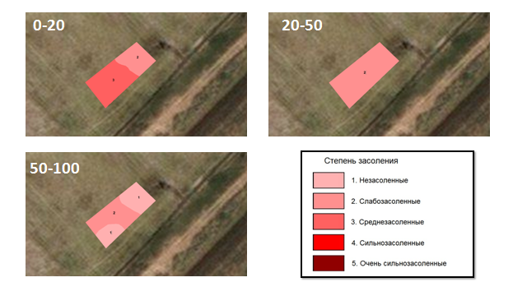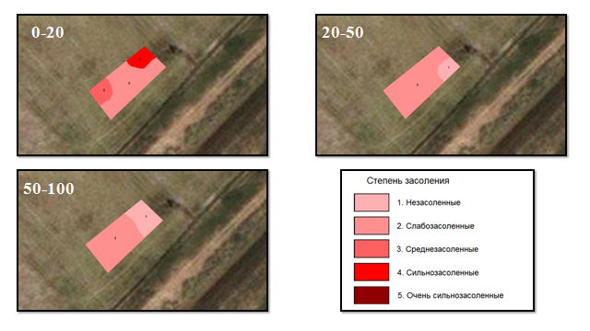

Figure 6 - Map of salinity of 0-20, 20-50 and 50-100 cm layers
of PF “Orken” (1st pilot farm), on the left-sampling in spring, on the right-sampling in autumn

In the 50-100 cm layer, the area of slightly saline soils increased and, accordingly, the area of non-saline soils decreased, which is explained by the rise in the groundwater level. The soils of the 2nd pilot farm (PF "Mukhit") are more saline than those of the 1st plot (PF "Orken") (Figure 7).

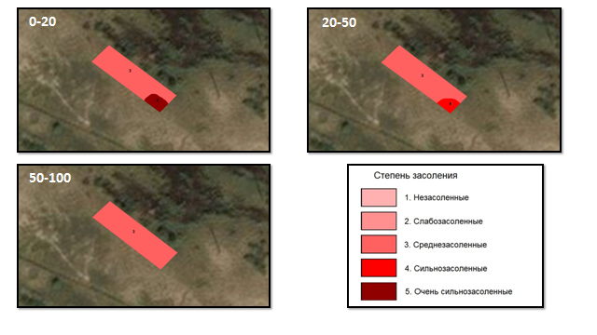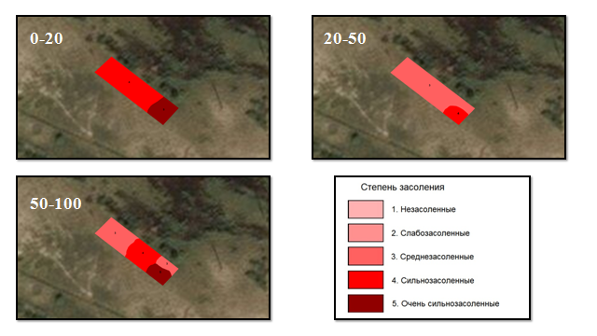

Figure 7 - Map of salinity of 0-20, 20-50 and 50-100 cm layers
of PF “Mukhit” (2nd pilot farm), on the left-sampling in spring, on the right-sampling in autumn

The third pilot farm PF "Bagdat" is distinguished by “extremely” and “high” degree of soil salinization along all horizons, the arable horizon is fully represented by extremely saline soils, and saline soils partially occur in the lower horizons (Figure 8).

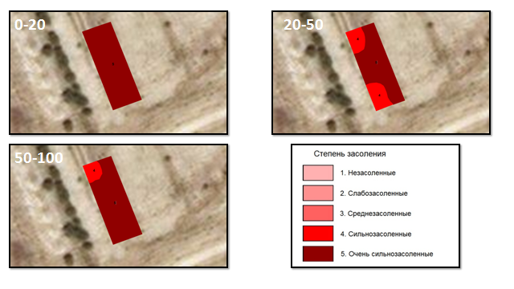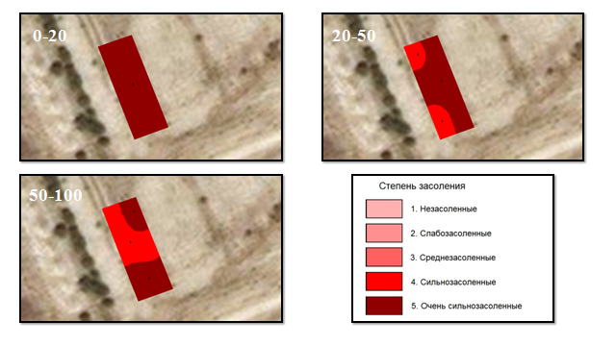

Figure 8 - Map of salinity of 0-20, 20-50 and 50-100 cm layers of PF “Bagdat” (3rd pilot farm), on the left-sampling in spring, on the right-sampling in autumn

During the growing season of 2019, nursing plantings of culm segments of licorice Glycyrrhiza glabra L were carried out at the experimental plots. Observations of the growth and development of licorice Glycyrrhiza glabra L showed that the best growth was seen on slightly saline soil, where more than 80% of the plants have taken roots. On medium saline - about 30%, and on highly saline - about 10% (Figure 9).

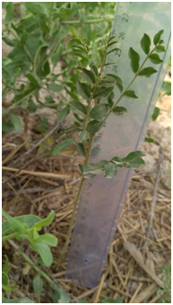 | 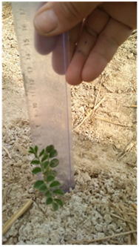 | 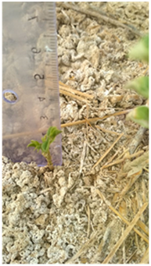 | 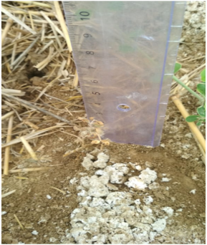
Figure 9 - Observations of the growth of licorice Glycyrrhiza glabra L at test plots (2019)

The data of autumn soil sampling showed that there were no changes in the degree of salinity in the arable horizon and in the layer of 20-50 cm. In the 50-100 cm horizon, the proportion of highly saline soils increased and, accordingly, extremely saline soils decreased. Thus, according to the results of the obtained data, no sharp changes were noticed in desalinization process of the soils of test plots, which is confirmed by the literature data. According to Akinchina N.A. and Toderich K. the time of soil desalinization is about 3-5 years and 6-7 years for an extremely degree of soil salinity [40].
Final assessment of the biological method of desalinization of saline soils using licorice Glycyrrhiza glabra L was given in 2020. During the growing season, nursing plantings of licorice were carried out at test plots. Observations of growth and development of licorice (Figure 10) showed that the best growth was seen on slightly saline soil, where more than 80% of Glycyrrhiza glabra L have taken roots.

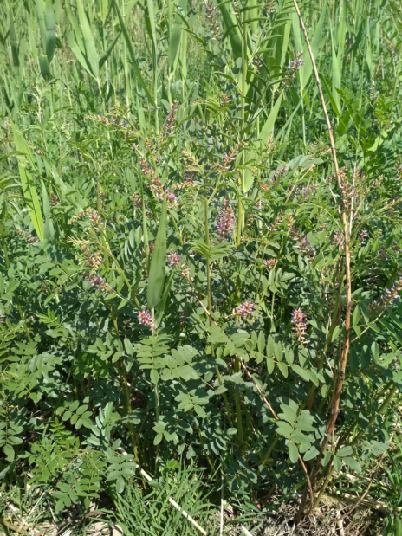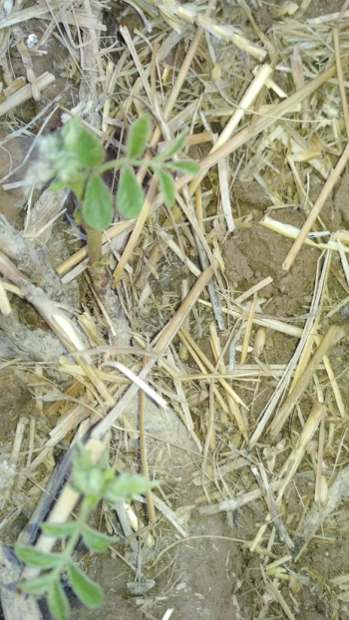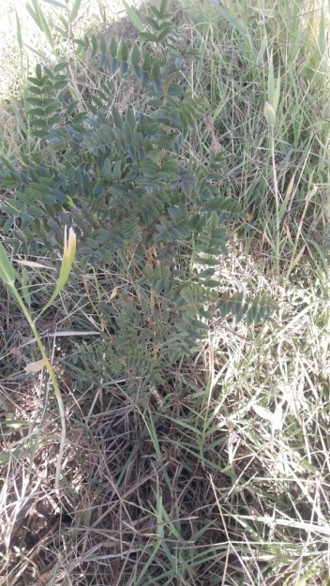

Figure 10- Development of licorice on slightly, medium and highly saline soils
of the test plots (2020)

As you know the phytomeliorative effect depends on the life span and productivity of plants, ratio of the underground and aboveground parts of biomass, structure and nature of the profile distribution of the root system, etc.
From the above Figure 10 it can be seen that there is a difference in the development of licorice plants on slightly, medium- and highly saline soils of the test plots. This condition of the plants is explained by the problems of irrigation in farms, with a shortage of irrigation water and high air temperatures during the growing season of plants.
From given maps with a degree of soil salinity (data from spring 2019 and autumn 2020 of soil sampling) of PF "Orken", it can be seen that the degree of soil salinity fell by half (Figure 11) during two growing seasons in the plowing horizon. During planting of licorice, the degree of salinity of the antecedent soil was non-saline in 40% of the surveyed territory, then in the fall of the reporting year it was already 80%, i.e., the soil is desalinated during the growth and development of licorice.

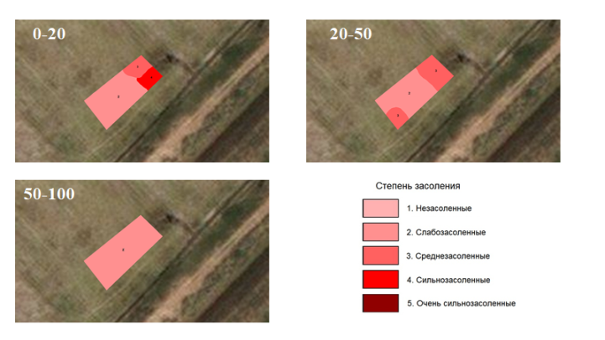
Figure 11 - The degree of soil salinity in the planting area of licorice in PF "Orken"
(1st pilot farm), in spring of 2019 (on the left) and in the fall of 2020 (on the right)

While in the soils of PF "Mukhit" with medium saline soils in the initial state on 95% of the territory, where licorice plants did not take root, the degree of salinity in the fall of 2020 turned into extremely saline on the whole farm territory (Figure 12). In the soils of PF "Bagdat 2" with highly saline soils, no changes occurred, soils also remained extremely saline, which can be seen from the maps in Figure 13. On these two plots licorice plants were strongly depressed (Figure 10)

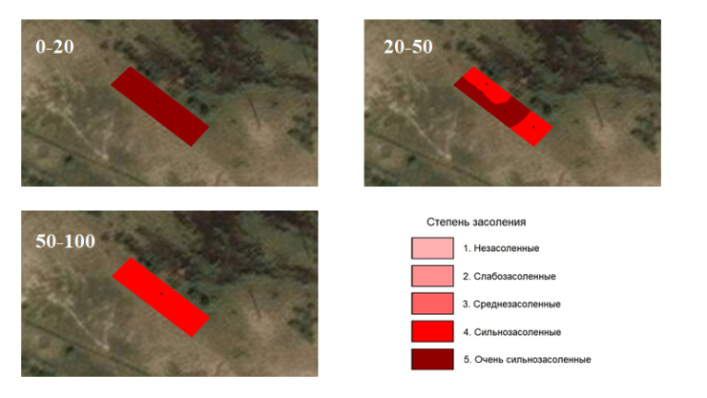

Figure 12 - The degree of soil salinity in the area of planting licorice in PF "Mukhit" (2nd pilot farm) in spring of 2019 (on the left) and in the fall of 2020 (on the right)
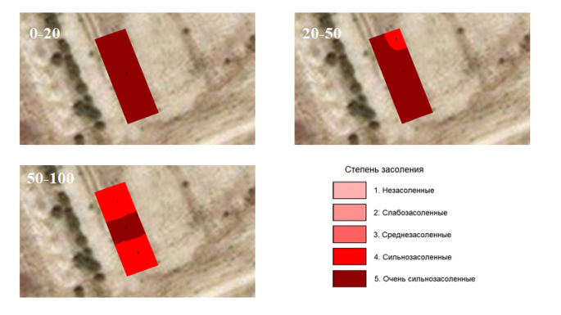
Figure 13 - The degree of soil salinity in the area of planting licorice in PF "Bagdat 2" (3rd pilot farm) in spring of 2019 (on the left) and in the fall of 2020 (on the right)

It can be noted by analyzing the obtained data, that the decrease in salt withdrawal from highly saline soil is mainly associated with a decrease in phytomass alienated from the field. This fact should be considered when choosing plots for priority phytomeliorative reclamation in the examined region. The use of irrigation significantly contributes to the withdrawal of salts from saline soil, especially its frequency and rates of vegetation irrigation, which are connected with the depth of moisture and permissible limit of pre-irrigation soil dehydration, depth of location and degree of groundwater mineralization, which ensures the drainage of waste water, as well as agricultural techniques.
Due to irrigation problems, this desalinization method turned out to be unacceptable not only on highly saline soil, but also on medium saline soil. Previous researches of the Institute’s from the on saline soils of the Akdala irrigation massif were effective on medium saline soils [41].
But, nevertheless, the yield of licorice (grown when planting with root cuttings) on slightly and medium saline soil was -16.85 c / ha in 2019; 42.3 c / ha of dry weight and 28.8 c / ha of roots in 2020. Also, there was a decrease in soil salinity in the area with slightly saline soils of PF "Orken" (Figure 14).

Figure 14 - Change in the degree of soil salinity at PF “Orken” when planting licorice Glycyrrhiza glabra L
As can be seen from the figure, when planting licorice in the spring of 2019, the soils of PF "Orken" were in condition from slightly to medium saline. After the growth of licorice during the growing season, the amount of salts was at the level of slightly saline, and at the end of next year (autumn 2020) it was already referred to the group of non-saline soils in terms of the degree of salinity
Summary and evaluation of research results
- 27 maps of soil salinization under licorice crops Glycyrrhiza glabra L have been compiled.
- An assessment of the biological method of saline soil desalinization with the help of licorice Glycyrrhiza glabra L was given at various degrees of saline soils on the territory of 3 pilot farms. It has been established that in conditions of secondary saline soils, licorice Glycyrrhiza glabra L reduces the degree of soil salinity by one or two gradations, it allows to develop saline lands that have come out of agricultural use.
Thus, under the conditions of a field test, production test of the biological method of soil desalinization on the territory of 3 pilot farms (PF "Orken", PF "Mukhit", PF "Bagdat-2") was conducted.

3.3 To apply the technology to increase the fertility of saline soils and crop yields (grain maize) and teach farmers the basics of the technology
Methodology.
The main concept that determines the methods of obtaining factual material, as well as its processing, is the genetic approach [42]. The research is based on the comparative geographical method [43]. At the stage of conducting routine field studies, morphological methods [44,45] were used to ensure the reliability and validity of field soil diagnostics, soil mapping and characteristics of the main morphological properties of soils. The use of instrumental methods is associated with laboratory analytical studies of selected samples that were carried out according to generally accepted methods [29, 46]. The compilation of a preliminary model of the soil map of the test plot (1: 100,000) was carried out using traditional mapping methods, as well as using GIS technologies and remote sensing materials [43,44]. The main method for processing satellite information is indirect indication decryption [47-50], which is based on establishing the relationship of soil with the landscape components that are best displayed on satellite images. Large-scale multispectral satellite images of the Landsat type were used for decoding, with GoogleMap and BingMap. Work on compilation of the soil map was carried out in the environment of Map Info Professional. A structure has been developed and location-based electronic database of the main indicators of effective soil fertility has been created. Soil-meliorative and soil-agrochemical surveys of the examined object were conducted in order to solve this group of problems. These surveys consisted of systematic selection of soil samples and their analysis, and filling of the obtained analytical data into an electronic database. The coordinates of the soil sampling plot were determined using Garmin GPS 18 paired with ASUS netbook, i.e., soil sampling plots were plotted on the map during field work using MapInfo Professional software. When compiling the map of bonitet scores regional grading scale methods [51] were used.
As the estimated soil parameters, the following has been used:
- the content of humus in the layer 0-50 cm, expressed in %;
- average-weighted content of absorbed sodium and magnesium in 0-50 cm layer, expressed as % of the sum of the absorbed bases (absorption capacity) as an objective indicator of salt alkalinity;
- average-weighted content of salt in % and average-weighted salinity type (salt toxicity indicator) in 0-50 cm layer of salinity detection;
- degree of hydromorphosis.
Work on compiling a map of humus content in soils and assessing their current humus state was carried out by conducting traditional ground-based soil survey of the territory of examined object according to [50] Guidelines for conducting ... [51] and the Methodological Guidelines ...[52]. To determine the coordinates of sampling points and fertilizer elements, the GPS “Garmin 62s” was paired with “ASUS” netbook, i.e. soil sampling locations were mapped directly during fieldwork using Map Info professional program. Then, the selected soils were analyzed in laboratory for the content of humus, basic nutrients, pH and basic salt-forming ions. Then, the obtained analytical data were subjected to variational-statistical processing [34] and the average “background” content of humus, basic nutrients, pH and toxic salts were calculated.

Results of the Research
A reconnaissance survey was carried on the territory of the Shaulder irrigation massif (right-bank, central and eastern parts) of the Turkestan region, during which soil sections were laid, morphological description was carried out, soil samples were taken to determine their physical and chemical properties. Based on the survey results, 3 soil maps, 3 soil degradation maps and 3 maps of bonitet scores with scale 1: 100,000 and total area of ​​92.0 ths. ha were compiled (27.3 ths. ha in 2018, 35.4 ths. ha in 2019 and 29.3 ths. ha in 2020). Representative territories for the implementation of technology for increasing the fertility of saline soils and corn productivity in pilot farms were selected. Figure 15 shows the survey plots for 2018-2020.

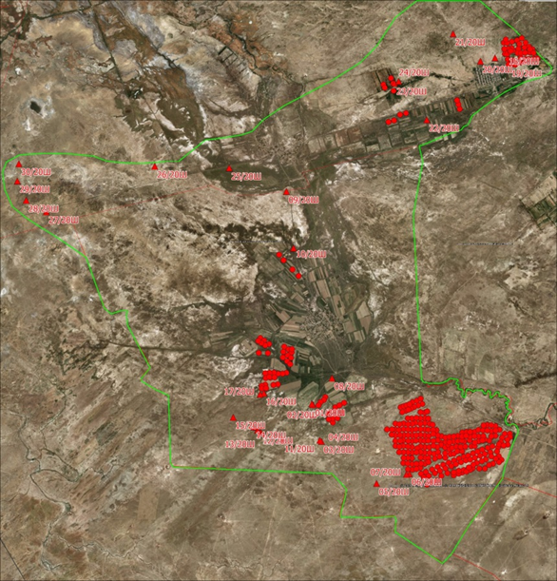

Figure 15 - Location of survey plots for 2018-2020

The morphological structure of the soils of the Shaulder irrigation massif was studied. For which genetic horizons were distinguished in the soil profile when laying soil sections. Detailed description of the morphological properties of soils (color, moisture, compaction, presence of roots, soil structure, field determination of the mechanical composition, presence of carbonate and salt new formations) was performed according to these horizons.
Location of the soil sections and sampling sites is given in Appendix A. Figure A7.
Full description of morphological characteristics of the studied soils for 2018-2020 is given in Appendix A.
To determine the main chemical, physical and physico-chemical properties, chemical analyzes of soils were carried out - total humus, gross nitrogen, CO₂, exchange cations (Ca, Mg, Na, K), hydrolyzed nitrogen, mobile phosphorus and potassium, the amount and composition of readily soluble salts, mechanical (granulometric) composition. The results for 2018-2020 are shown in Appendix A, tables A 13 – A.17.
In accordance with the research program and the calendar plan, a soil data base was created for the entire surveyed territory for 2018-2020.
The location of the plots of soil sections and sampling is given in Appendix A, Figure 1. The soil database is geographically linked and is included as a component of GIS.
At the beginning of 2020, the database contained 119 soil sections (614 horizons). In 2020, 30 sections (135 horizons) were added. The obtained data are filled into the soil database, currently there are 149 sections for 749 horizons in the soil base. Along with the new data for 2018-2020, materials of agrochemical surveys conducted within the framework of the program were used, as well as materials from previous years and archival data.
The soil database is geographically linked and is included as a component in GIS. Example of system interface in application MapInfoPro with 2020 data is shown in Figure 16.

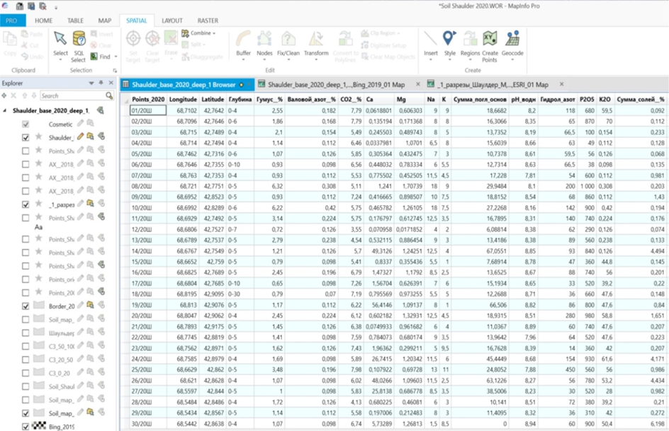
Figure 16– Soil database fragment for 2020

Soil maps. For three surveyed areas, soil maps were compiled using traditional methods of route survey, as well as remote sensing materials and GIS technologies with a scale of 1: 100,000. The areas of soil maps: for 2018 - 27.3 ths. ha, 2019 - 35.4 ths. ha and 2020 - 29.3 ths. ha. Each contour carries information on the structure of soil cover (complexes, combinations, spotting), on taxonomic classification of the soil components in accordance with the numbers in legend (max. two in the line), and their percentage ratio. Reduced versions of soil maps are presented in Figures 17-19, and увеличенный вариант почвенных карт the original ones in Appendix A 8-А10.

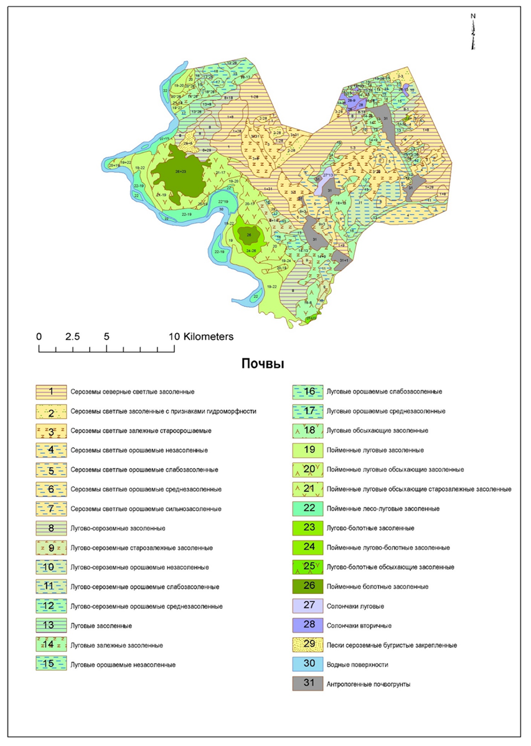

Figure 17- The soil map of the right-bank Schaulder irrigation massif, 2018 (Appendix А, Figure А8)

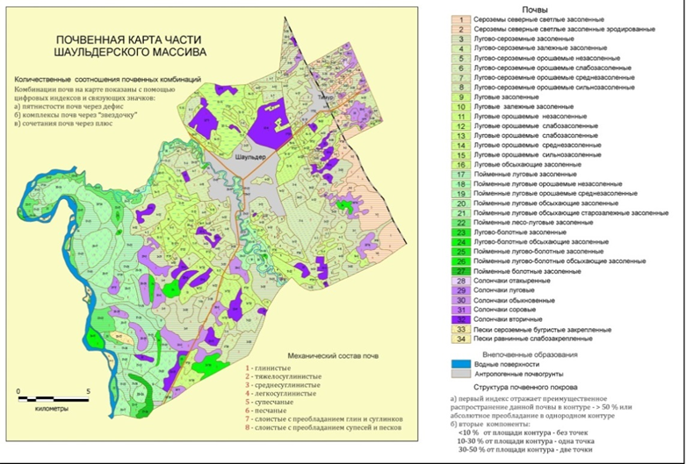

Figure 18- Soil map of the central part of the Shaulder massif, 2019
(Appendix A, Figure A9)

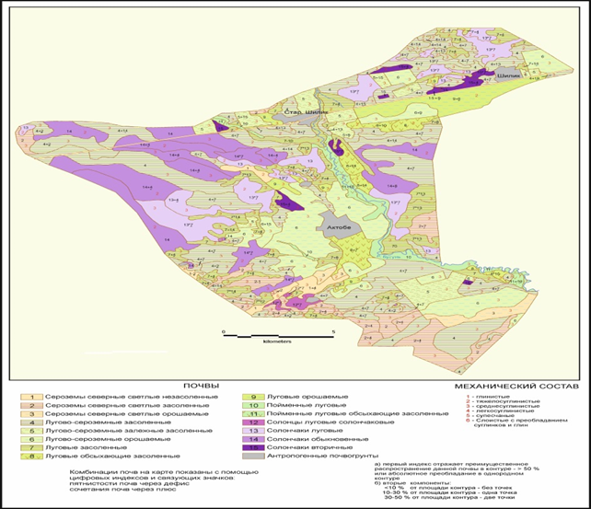

Figure 19 - Soil map of the eastern part of the Shaulder massif, 2020, scale 1: 100,000 (Appendix A, Figure A10)

Work on the compilation of a soil degradation map was carried out during the research to determine the degree of soil degradation. The maps of soil cover degradation (right bank, central and eastern parts of the Shaulder irrigation massif) are given in Appendix A in Figures А11-А13.
Knowledge of the quantitative value characterizing the degree of degradation has great practical importance, since it allows calculating the costs of restoring the lost soil fertility. Based on economic calculations, decisions are made on the further use of soils. In this regard the normative documents of RK, created with the participation of leading experts in the field of soil science, were used as the basis for determining the degree of soil degradation of the characterized territory [53,54]. The main criteria and parameters of soil degradation are reflected in Appendix A. Table А.18.
With prolonged irrigation of soils in the lower (sub-arable) part of the profile, the mechanical composition becomes heavier, mainly due to the clay fraction. Granulometric composition of the arable horizon can vary significantly even within the same field due to irrigation erosion occurrence, which causes an increase of the sandy fraction in the washed-out zone, and the silt and clay fraction - in the accumulative zone. The removal of fine soils, humus and nutrients leads to a sharp decrease in the microaggregation of soils and, as a result, deterioration of physical properties, especially the structural state. With a close bedding of mineralized groundwater to the surface, high irrigation rates can lead to a rise in their level, and, as a result, to secondary soil salinization. In general, the degree of anthropogenic degradation of irrigated soils in the surveyed areas varies from weak to very strong.
The bonitet scores map is based on the methodology [50] and regional appraising scale. Bonitet score maps (right-bank, central and eastern parts of the Shaulder irrigation massif) are given in Appendix A. in Figures А.14-А.16. Appraising scales for the studied soils of the Shaulder massif are presented in Appendix A Table А.19, А.20. They cover all soil taxonomic unit identified in the legends to soil maps.
Currently the problem of their reclamation condition gets worse, areas of “waste” secondary-saline lands have increased on the irrigated areas of the republic. Plots of land with "unused" soils due to the high degree of salinity were transferred to the category of fallow lands. In such difficult conditions, it is practically impossible for farmers of peasant farms to obtain stable high yields. On the territory of 1507 hectares of 70 farms in Otyrar district of the Turkestan region (Appendix A - List of surveyed soils of 70 peasant farms in the Otrar district of the Turkestan region for 2018-2020), a traditional large-scale (1: 10000) salt survey was carried out by laying soil sections with soil sampling from three depths - 0- 20, 20-50, 50-100 cm. Figure 20 shows the layout of farms, and an enlarged view of the points of soil sampling and their numbers. 3019 soil samples were taken during soil reclamation survey for the period of 2018-2020.
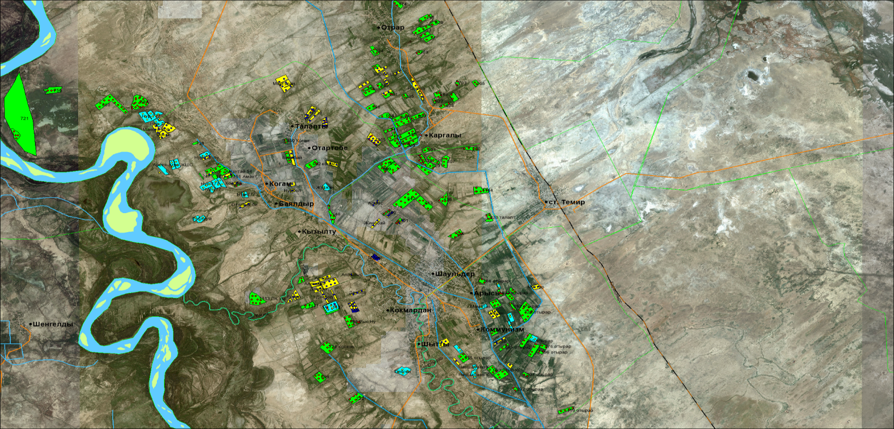

Figure 20 - The layout of farms, and enlarged view of selection points of soil samples and their numbers

Using the generated information system (GIS) of the research object in MapInfo professional environment, maps of the degree of salinization of soils of all participating farms were compiled. For example, here are maps of the degree of salinity at 0-20, 20-50 and 50-100 cm. from soil layers of PF "Nur-777" and "Arsen-Agro" (Appendix A, Figure A.17, A.18). According to the results of salt survey, it was found that in the arable horizon 69.3% of the surveyed lands of PF “Nur-777” are non-saline, 14.7% are slightly saline, and 7.1% are highly saline soils. Soils of PF "Arsen-Agro" are extremely saline on the surface with an area of 4.8%, slightly saline - 51.3%, medium saline - 19% and non-saline on 15.4% of the area of the surveyed soil. In other words, saline soils are found with varying degrees, which is typical for all 1507 hectares of soils of 70 peasant farms. As an example, Figures A.19-А.21 (Appendix A) show maps of degree and chemistry of salinization and the depth of 1st salt horizon of PF “Kurmash”, PF “Orken”, PF “Tilegen” and Alihan Agro.kz LLP.
Thus, the results of soil assessment of each pilot farm by the degree of salinity in the area of 1507 ha were obtained. At specially organized training seminars, farmers got cards on the degree of soil salinization, an explanation was given on how to use them in practice.
To assess the current state of soil fertility of the studied farms, in addition to soil reclamation survey, a soil-agrochemical survey was carried out on the area of 1507 hectares in 70 farms in 2018-2020, to determine the content of humus and basic nutrients (NPK), with the selection 1129 soil samples. Soil-agrochemical survey remains one of the main estimated indicators of positive and negative consequences of economic activity on its fertility. The Research allows not only to determine the direction of soil fertility changing but also to develop measures to stabilize soil fertility in each specific farm. An assessment of soils of each peasant farm by the content of total humus, easily hydrolyzable nitrogen, mobile phosphorus and exchangeable potassium was conducted based on the results of the agrochemical survey. The information on the grouping of soils according to the supply with the main elements of nutrition is provided. It is known that humus plays a leading role in the formation of soil fertility and increasing the sustainability of agriculture. It serves as a nutrition source for plants, determines and regulates the physicochemical and biological properties of the soil. According to the results of an agrochemical survey, the soils of these farms can be classified as very depleted, degraded. The soils of the surveyed territory have very low 99.0% (1491.9 hectares of the surveyed area) and low content of humus on the area of 15.1 hectares (1.0%) (Table 4).

Table 4 - Grouping of soils by humus content
Group No. | Humus content | Humus, % | Area, ha | % of area
1 | Very low | < 2.0 | 1491.9 | 99.0
2 | Low | 2.1 – 4.0 | 15.1 | 1.0
Total | - | - | 1507.0 | 100.0

As you know, in the complex of measures to increase the productivity of crop production, a large role belongs to the provision of a balanced nutrition of agricultural crops and, first of all, nitrogen. In opposition to the assessment of plant nutrition with phosphorus and potassium it is almost impossible to make a long-term forecast for nitrogen, since its content in the soil depends on the weather conditions of each specific year, cultivated crop, predecessor, and a number of other conditions.
The soils of these farms are very variegated in the content of one of the main nutrients, the easily hydrolyzed form of nitrogen. According to the content of nitrogen the soils on the area of 581.2 hectares (38.6%) are classified as “very low”; 544.0 ha (36.1%) - “low”; 220.0 ha (14.6 %) – “average” and only on 161.8 ha (10.7%) the content of this form of nitrogen ranges from “increased” to “high” (Appendix, Table 21). Graphic charts of distribution of soil groups for all studied properties were compiled in order to assess the shares of each group of soils from the total surveyed area. The information on the content of easily hydrolysable nitrogen is shown in Figure 21.

Figure 21 - Distribution of soil groups according to the degree of availability of easily hydrolyzed nitrogen

Mechanism of distribution of easily hydrolysable nitrogen over the territory of the surveyed farms are described by the compiled polynomial equation (R² = 0.7021). Thus, almost all soils (89.3%) of 70 peasant farms need nitrogen fertilizers and only 10.7% of the area (161.8 ha) have an optimal content of this form of nitrogen and do not require nitrogen fertilization.
The role of phosphorus for plants can hardly be overestimated, the assimilation of phosphorus by plants begins literally in the first days from the moment of seed sprouting. Due to good phosphorus nutrition the yield increases significantly and the quality of agricultural products improves. As can be seen from Appendix A. Table 22, the soils of the surveyed farms territory are very variegated by reserves of mobile phosphorus and have all types of gradation from "very low" to "very high", more than 43% of the soil area has an average degree of supply. Such a variegated content of available phosphorus in soils requires leveling the background of the content of this element, i.e. it is necessary to apply the recommended doses of fertilizers strictly according to the cartogram, Figure 22.

Figure 22 - Distribution of soil groups according to the degree of supply with mobile phosphorus
For the studied property, a polynomial equation was also compiled, reliably (R² = 4104) describing the regularities of the distribution of mobile phosphorus on the surveyed territory. These data can later be used to predict the content of mobile phosphorus in the soil.
Potassium is one of the main nutrients that create a corn yield; it participates in the synthesis and outflow of carbohydrates in plants, determines the water-holding capacity of cells and tissues, affects the resistance of plants to unfavorable environmental conditions and the susceptibility of crops to diseases.
The reserve of potassium in soils of the surveyed area turned out to be also rather variegated. 572.7 hectares (38.0%) have a high content of exchangeable potassium, 331.5 hectares (22.0%) - increased, 271.3 hectares (18.0%) - extremely high and 331.5 hectares (22, 0%) - medium and low content (Appendix A. Table 23). Consequently, the content of exchangeable potassium in the soil of the surveyed farms is subject to the same regularity as that of mobile phosphorus, i.e. very variegated, gradation from low to extremely high, and it is also necessary to apply potash fertilizers in accordance with the cartogram to level the background.

Figure 23 - Distribution of soil groups according to the degree of exchangeable potassium content

The compiled polynomial equation (R² = 0.7087) also most reliably describes the content of exchangeable potassium by soil groups.
Territorially linked large-scale thematic maps of the main indicators of effective soil fertility: humus content, cartograms of the content of easily hydrolyzable nitrogen, mobile forms of phosphorus and potassium were compiled characterizing the state of soil fertility of the studied territories of 70 farms on the area of ​​1507 hectares, and considering their supply of nutrients, using spatially coordinated analytical data with GIS technologies. For example, Figure 24 shows the compiled maps of the humus content and cartograms for the provision of soils with an easily hydrolyzed form of nitrogen, a mobile form of phosphorus and potassium in the soils of the Asia Agro Group PK on 850 hectares.
As it can be seen from the cartograms the soils taken for the example of the farm are heterogeneous in terms of the content of nitrogen, phosphorus and potassium. It is necessary to apply different doses of fertilizers in accordance with the cartogram for a balanced supply of soils with NPK. This characteristic can be referred to the surveyed soils of all 1507 hectares of the Otyrar district of the Turkestan region, as evidenced by the data in the tables (Appendix A., table А.24-А.26).

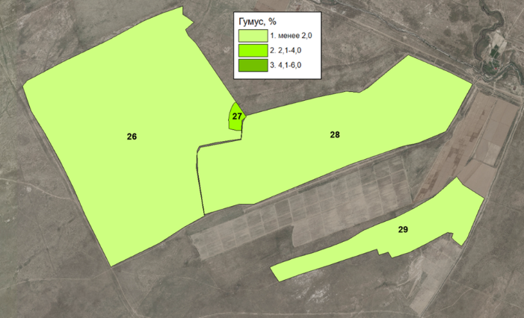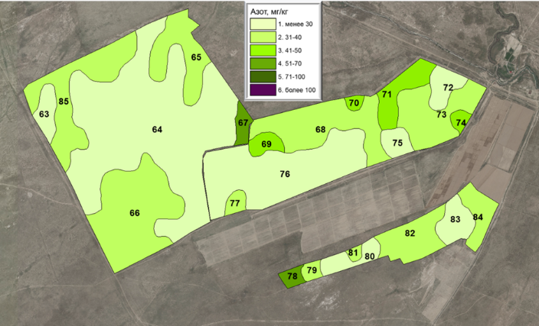

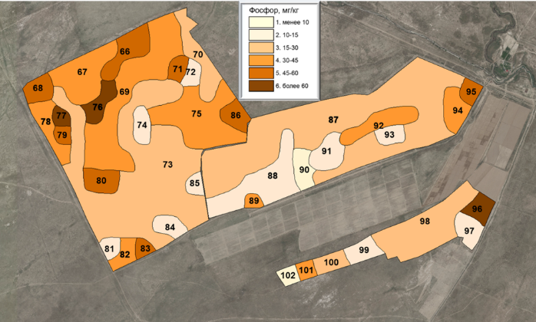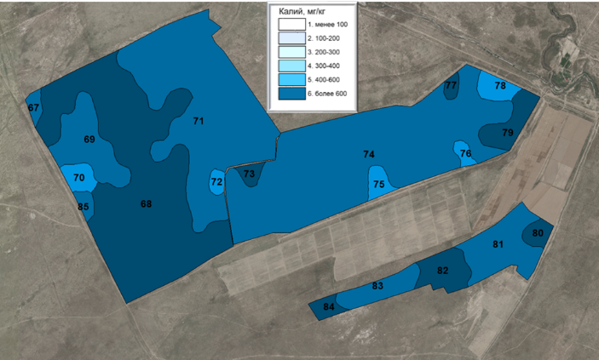

Figure 24 - Map of humus content and cartograms of reserves of easily hydrolyzed form of nitrogen, mobile form of phosphorus and potassium in the soils of PF Asia Agro Group

Considering the heterogeneity of the soil cover in terms of the content of mobile forms of nutrients, cartograms obtained make it possible to coordinate the rates of fertilization for the planned yield. For this purpose, according to the obtained data on the content of nutrients in the soil of peasant farms, which are easily hydrolyzable nitrogen, mobile phosphorus and exchangeable potassium, the doses of carbamide, ammonium nitrate, ammophos, superphosphate and potassium sulfate were calculated for the planned corn yield (8 t/ha) according to the above cartograms.
Calculations were carried out based on the indicators given in Table 5 for the planned yield according to the methodology [55]. This method takes into account the removal of nutrients from the soil by the planned yield, content of mobile nutrients in the soil (kg/ha), coefficient of the use of nutrients from the soil and fertilizers. In order to create the planned yield, missing part of the nutrient elements of the soil is fully replenished through the application of fertilizers. Calculation of fertilizer doses for the planned yield is calculated only for the leading crop of the crop rotation - corn.
Figure 25 provides calculation example of nitrogen fertilizers in Office Excel, which shows that the soils of a given farm need nitrogen fertilizers (in kg/ha of active ingredient), due to the average content of easily hydrolysable nitrogen in the soil -48 mg/kg. In the same way, calculations were carried out for other types of fertilizers.

Table 5- Indicators factored when calculating the doses of fertilizers for the planned yield

Indicators | N | P₂O₅ | K₂O
Planned yield, t/ha | 8 | 8 | 8
Removal of fertilizer elements (FE) 1 t of production, kg | 35 | 10 | 37
Fertilizer element of planned crop, kg | 280 | 80 | 296
Utilization rate of fertilizer element from soil, % | 60 | 40 | 25
Utilization rate from fertilizer, % | 70 | 30 | 60

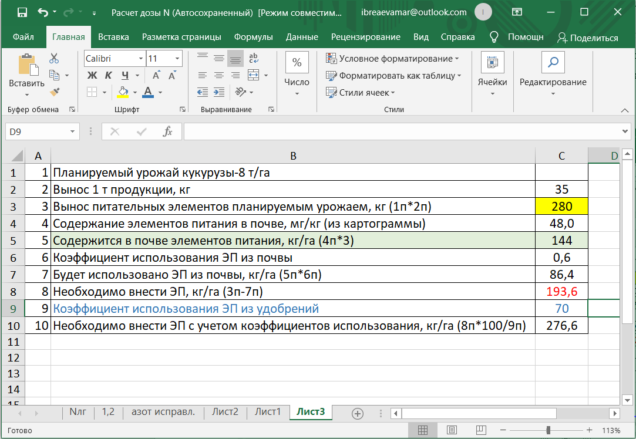

Figure 25 - Fragment of the calculation of the required number of nitrogen fertilizers for the planned corn crop with an average content of easily hydrolyzable nitrogen in the soil, where: n is a point

Appendix A, Tables A27-А29 shows an example of recommended doses of fertilizers for the studied soils of the PF "Asia Agro Group" for the planned yield of corn grain (8 t/ha), which is based on the cartograms of the content of nutrients.
Table 6 shows the results of variational-statistical processing of the obtained analytical data (1129 soil samples) for the main indicators of effective soil fertility [34]

Table 6 - Variation-statistical indicators of effective soil fertility surveyed in 70 peasant farms (1507 hectares) of the Shaulder irrigation massif for 2018-2020

Indicators | Statistical factors
 | n | M±m | t-criteria |  | ± t_{0,05 *} m | V, %
 |  |  | t_{fact.} | t_{0,05}
Humus, % | 1129 | 1.8±0.07 | 13.5 | 1.96 | 0.14 | 248.8
Easily hydrolysable nitrogen, mg/kg | 1129 | 40.6±1.00 | 40.6 | 1.96 | 1.96 | 82.7
Р₂О₅, mg/kg | 1129 | 29.5±0.64 | 46.0 | 1.96 | 1.26 | 73.0
К₂О, mg/kg | 1129 | 451.3±5.18 | 87.1 | 1.96 | 10.16 | 38.5

The calculated values of Student's t-test show that for the studied soils at 0.95% level of reliability of all studied parameters, the value of t_{fact}. far more than t_{tab}. The limits of the confidence interval are rather narrow, ranging from 0.14 for humus and up to 10.16 for the exchange form of potassium. The content of humus is subject to significant fluctuations, the coefficient of variation is 248.8 %, which, according to official grading, refers to the degree of "extremely high", and indicates their diversity in the soil as 2%, considering that 1129 soil samples were analyzed. The degree of variation of easily hydrolysable nitrogen and exchangeable potassium is also very high, but less expressed than that of humus. Calculated mean values ​​reliably reflect the statistically significant true value of the mean of the studied soil properties, and on this basis, the mean "background" content of the studied elements in the soils of the research object can be taken as the values ​​indicated in Table 6 It is known that soils with such humus values (1.8 ± 0.07%) refers to soils with a very low humus content, i.e. to degraded, dehumified soils. According to generally accepted grading of soils with the basic elements of soil nutrition of the studied area, there is “medium” content of the mobile form of phosphorus (29.5±0.64 mg/kg) and “high” content of potassium (451.3±5.18 mg/kg).
It should be noted that variational-statistical analyzes of the obtained data provide statistically reliable mean, “background” contents of the studied elements in the soils of the irrigation massif. “Low” and “very low” humus content has been established on this basis, which, along with salinization, can limit the effective fertility of the studied soils.
After assessing the current state of the studied soils on the area of ​​1507 hectares, the Institute's technology was implemented to increase the fertility of saline soils and grain maize yield. Table 7 shows the obtained data on the yield of grain maize from application of technology depending on the degree of salinization of soils, so variants for seed treatment and spraying of vegetative plants increased the yield of corn on non-saline soils to 42.1% with the yield on the control variant of 76.3 c/ha. In slightly and medium saline soils with yields in the range of 86.1 - 88.9 c/ha, the increase was 33.8 - 34.1 %, respectively, compared with the control (64.3-66.3 c/ha). In highly saline soils, the application of the technology allowed to obtain a corn crop in the range of 55.5 c/ha against 48.4 c/ha in the control, i.e. the increase was 14.5 %.

Table 7 – The influence of technology on the yield of grain maize, с/ha

Degree of salinity | Variants |  | Growth, с/ha
 | Control | Technology | с/ha | %
Non saline | 76.3±0.38 | 108.5±3.09 | 31.8±3.10 | 42.1±3.98
Slightly saline | 66.3±1.02 | 88.9±1.74 | 22.6±1.04 | 34.1±1.47
Medium saline | 64.3±1.01 | 86.1±1.76 | 21.7±0.95 | 33.8±1.22
Highly saline | 48.4±1.11 | 55.5±2.28 | 7.1±1.34 | 14.5±2.51

The analysis of the costs of implementation of the technology and analysis of payback periods are given in section 3.4 below. The implemented technology for increasing the fertility of saline soils and increasing the productivity of agricultural crops provided an increase in the yield of grain maize from 14.5% on highly saline soils to 42.1% on non-saline soils.
Thus, the possibilities of obtaining sufficiently high grain maize yield in the unfavourable land reclamation environment of Shaulder irrigation massif were demonstrated on the area of 1507 hectares of 70 peasant farms.

Summary and evaluation of research results
- Three soil maps were compiled (for the right bank, central and eastern parts of the Shaulder irrigation massif, covering an area of 92 thousand hectares) of the Turkestan region.
- Criteria of soil degradation have been developed and 3 map of soil cover degradation were compiled for the total area of 92 ths. ha;
- Appraising scale and 3 map of soil bonitet score map were compiled on an area of 92 ths. ha;
- On an area of 1507 hectares of 70 peasant farms, a large-scale (1: 10000) soil reclamation survey was carried out with the selection of 3019 soil samples from three depths - 0-20, 20-50, 50-100 cm, 270 maps of the degree of salinity were compiled, 98 maps of salinity chemistry, 39 maps of the depth of occurrence of the 1st salt horizon of soils by soil layers 0-20, 20-50 and 50-100 cm
- Agrochemical survey was carried out on 70 peasant farms with the area of 1507 hectares, 370 cartograms of soil nutrients (humus, easily hydrolyzed nitrogen, mobile phosphorus and exchangeable potassium) were compiled, doses of mineral fertilizers were calculated for the planned corn yield.
- On an area of 1507 hectares in 70 farms, the Institute's technology was implemented in order to improve the fertility of saline soils and increase the yield of agricultural crops, which provided an increase in the yield of grain maize from 33.8-34.1% on slightly and medium saline soils, and on highly saline soils - 14.5%.

3.4 To conduct an analysis of economic efficiency of the implemented and developed technologies, including cost assessment of the application of technologies per 1 ha, analysis of cost recovery due to increased productivity, indicating the payback period
Methodology
The economic efficiency of the implemented technology is calculated according to the methodology [56].
Results of the Research
When assessing the use of land resources (agricultural land, including arable land), the main criteria is the increase in gross production. production of gross output and main types of products per unit of land area (grain per 100 hectares of arable land). The importance of yield as an economic indicator is that it reflects the extent and efficiency of land use. It should be noted that the value of the yield has a direct impact on the value of other indicators [57].
The experience of individual agricultural farms shows that an increase in the efficiency of the use of material resources is ensured as a result of their rational and economical use: the use of resource-saving technologies that ensure a decrease in the specific consumption of fuels and lubricants, seeds, fertilizers, electricity and other resources ; the use of material resources in priority areas, allowing them to get the greatest cost recovery; the use of material resources in optimal proportions [58].
Many scientists define economic efficiency in relation to agriculture as the degree of rational use of land and other means of production, as well as the return on costs of agricultural production [59-61].
U.U. Uspanov Kazakh Scientific Research Institute of Soil Science and Agrochemistry proposed an innovative technology in the conditions of the Shaulder irrigation massif used for different degrees of soil salinity.
Analysis of the costs of implementing the technology is given below. When calculating the economic efficiency of production, the whole technological process of growing grain maize in Shaulder irrigation massif was taken into account. The technological map included all costs for mechanized and manual work, the cost of fuels and lubricants, fertilizers, seeds, pesticides, irrigation water, as well as overhead costs (table 8).

Table 8 – Costs for the technological process of growing grain maize in the conditions of the Shaulder irrigation massif

No. | Type of works | Cost in tenge
 |  | Traditional technology | Technology of U.U. Uspanov KazRISSA
1 | Assessment of the degree of salinity and soils reserves of basic nutrients | 0 | 2443.2
2 | Reclaiming | 13000 | 13000
3 | Laying of temporary sprinklers (2 times) | 10000 | 10000
4 | Irrigation 4 times (payment for the services of irrigators) | 16000 | 16000
5 | Closure of temporary sprinklers (2 times) | 10000 | 10000
6 | Harrowing | 5000 | 5000
7 | Chiseling | 13000 | 13000
8 | Land forming | 5000 | 5000
9 | Pre-sowing seed treatments | 0 | 2720
10 | Corn sowing | 5000 | 5000
11 | Seeds | 65000 | 65000
12 | Cultivation 2 times | 10000 | 10000
13 | Two times spraying with the preparation BioEcoGum | 0 | 6000
14 | Furrowing 1 time | 5000 | 5000
15 | Cost of water 1000 m3 х 4 times | 13000 | 13000
16 | Corn handling | 25000 | 25000
17 | Fertilizer | 17000 | 17000
18 | Taxes | 5500 | 5500
19 | Unexpected expenses 10% | 15000 | 15000
 | Total expenses | 237500 | 248663.2
 | Additional costs for technology implementation, tenge |  | 11163.2

Economic efficiency has been calculated in comparison with the existing technology for growing grain maize. The total costs, profit, cost recovery, cost of production, profitability of production on fields with the use of existing technology and on fields using an innovative technology of the Institute were determined. The data on corn productivity and economic efficiency of the introduced technology were obtained (table 9).
Table 9- Cost-effectiveness of introducing innovative technology on grain maize cultivated in the soils of different degree of salinity

Economic and business showings | Non saline soils |  | Slightly saline soils |  | medium saline soils |  | Highly saline soils
 | Current technology | Innovative technology | Current technology | Innovative technology | Current technology | Innovative technology | Current technology | Innovative technology
Total cost, ths. tenge | 245.5 | 258.2 | 243.8 | 254.8 | 243.5 | 254.4 | 240.8 | 249.1
Gross crop of grain, tonne | 7.6 | 10.9 | 6.6 | 8.9 | 6.4 | 8.6 | 4.8 | 5.6
Grain cost, ths. tenge/t | 60.0 | 60.0 | 60.0 | 60.0 | 60.0 | 60.0 | 60.0 | 60.0
Total selling value, tenge/ha | 457.8 | 651.0 | 397.8 | 533.4 | 385.8 | 516.6 | 290.4 | 333.0
Operating profit, tenge/ha | 212.3 | 392.8 | 154.0 | 278.6 | 142.3 | 262.2 | 49.6 | 83.9
Cost of 1 kg of grain, tenge | 32.2 | 23.8 | 36.8 | 28.7 | 37.9 | 29.5 | 49.7 | 44.9
Profitability, % | 86.5 | 152.1 | 63.2 | 109.3 | 58.5 | 103.1 | 20.6 | 33.7
Cost recovery, tenge/tenge | 1.86 | 2.52 | 1.63 | 2.09 | 1.58 | 2.03 | 1.21 | 1.34
Economic efficiency of innovative technology, th. tenge/ha | - | 180.5 | - | 124.6 | - | 119.9 | - | 34.2

Considering all economic and business indicators, we can conclude that the proposed innovative technology in the conditions of the Shaulder irrigation massif to varying degrees of saline soils allows you to make profit from 83.9 to 392.8 thousand tenge per 1 ha. (Table 15). While, with the existing cultivation technology, the profit ranged from 49.6 to 212.3 tenge per 1 ha. It should be noted that the efficiency decreased with increasing degree of salinity. At the same time, as expected, the cost of production of corn grain decreased with the improvement of the reclamation state of the soil, that is, the lowest cost of production of corn grain, regardless of technology, was noted on non-saline soils - 23.8-32.2 tenge/kg, at 44.9-49.7 tenge/kg on highly saline soils. The profitability of production was 86.5 -152.1% on non-saline soils, and 20.6-33.7 % on strongly-saline soils.
The economic efficiency of the implementation of growing grain maize compared to the existing technology ranged from 180.5 ths. tenge/ha on the non-saline soils up to 34.2 ths. tenge/ha on highly saline soils.
Cost recovery is also used as an indicator of the comparative economic efficiency of capital investments when choosing the best technology variant. The analysis of the payback periods due to the introduction of the technology showed that the payback (tenge/tenge) with the existing technology varied from 1.21 to 1.86 tenge, with the innovative technology it varied from 1.34 to 2.52 tenge.
Replenishment with new data from the processing of literary sources:
For the period of 2018-2020, on the topic of the current program, the scientific literature in the amount of 71 (far and near abroad) have been worked out and analyzed (Appendix A, reference 1-71)
Summary and evaluation of research results
An analysis of the effectiveness of the developed technology was carried out, indicating the estimated cost per 1 hectare, cost recovery due to increased productivity, indicating the payback period.
The obtained analysis of economic efficiency indicates the possibility of obtaining high yields of corn under conditions of Shaulder irrigation massif, which is characterized by difficult reclamation conditions.

3.5 To create microbiological preparations that contribute to increasing the fertility of low-productive saline soils and give recommendations on their use

Methodology
In accordance with GOST - 28168 - 89 “Soils. Sampling” [62], soil samples were taken from 5 areas of different salinity for microbiological analyzes. Plants were selected for selecting rhizospheric microorganisms resistant to salinization.
The biological activity of the soil was determined by gas chromatography based on the intensity of CO2 emission by soil (soil “respiration”) using Crystal-5000-2 chromatograph (Russia). In soil samples, substrate-induced respiration (SIR) was determined by the method proposed by J. Anderson and K. Domsh [63] (modified by N.D. Ananiyeva) [64]. The number and composition of soil microorganisms were studied by the method of nutrient plates (Koch method) [65]. To identify bacteria, we used meat-peptone agar (MPA), fungi - Czapek's medium, actinomycetes - Waxman's medium, cellulose-destroying microorganisms - Hutchinson's medium. Estimation of the nimber of anaerobic nitrogen-fixing bacteria Clostridium was carried out in a liquid Vinogradsky medium. Density of aerobic nitrogen fixers Azotobacter was determined by the method of overgrowing soil lumps in Ashby's medium [66].
Results of the Research
Currently, the problem of soil salinity, which limits the growth and productivity of plants, is becoming increasingly important.
Decrease in productivity of the most important agricultural crops due to moisture deficit and soil salinity is 20-50% [67]. A promising method for the remediation of saline soils is the use of microbial biological products. Microorganisms can significantly increase the resistance of plants to salt stress. They can stimulate the growth and development of plants due to the production of phytohormones, increase the solubility of phosphates, etc., and protect them from phytopathogenic fungi and bacteria [68, 69].
The results of the studies have shown that all ecological and trophic groups of microorganisms are widely represented in the soils of the examined territory. The data obtained are given in (Appendix A, Figure A22-27).
Soil samples were taken from 5 plots with varying degrees of salinity (Figure 26). In addition, plants with highly saline soil were selected for isolation of rhizosphere microorganisms resistant to salinity.

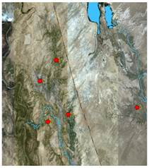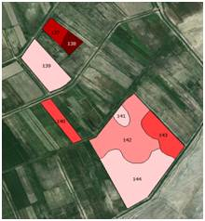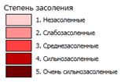

Figure 26 - Scheme of soil sampling
(enlarged view of one of the sections on the right)

Microorganisms-ammonifiers that use organic forms of nitrogen have been identified. Since the representatives of bacteria Pseudomonas, Bacillus and fungi Aspergillus most actively participate in the ammonification processes.
The presence of microorganisms using the mineral forms of bacteria nitrogen, actinomycetes was detected on starch-ammonia agar (SAA) and specific medium for actinomycetes (Actinomycete isolation). It was found that oligotophes predominate in the studied soils, their level in the soil is - 6.8 · 10⁶ -1.3 · 10⁷ CFU / g of soil. This indicates that the soil is richly populated with microorganisms. The total number of actinomycetes was studied on a specific medium for actinomycetes. The quantitative composition of actinomycetes on specific media for actinomycetes is 6.6 × 10⁶ - 7.3 × 10⁶ CFU / g soil. Bacteria using mineral forms of nitrogen grown on the SAA medium are (6.7 ± 0.10) · 10⁶ - (1.2 ± 0.14) · 10⁷. As a rule, fungi make up 10-20% of the total number of microorganisms in the soil (1.0 · 10² - (1.8 · 10³).
Thus, the soils of examined plot are inhabited by various ecological-trophic groups of microorganisms, among which salt-tolerant oligotrophic microorganisms occupy a dominant position.
To isolate pure cultures of microorganisms and create a collection of strains from soils of different degrees of salinity, 189 strains were isolated, 147 of which were analyzed by MALDI spectrometry. The spectra were recorded in a linear mode with delayed ion extraction on the Autoflex Speed ​​instrument (Bruker Daltonics, Germany). The phylogenetic position of 12 strains belonging to the order of actinomycetes was determined on the basis of a comparative analysis of the nucleotide sequences of 16S rRNA gene fragments. The results of the analysis showed that 8 of them belong to different species of the genus Streptomyces. Organisms of the genus Agromyces, Lentzea, Nocardiopsis, Kitasatospora are also present.
In general, bacteria of the Bacillus (23%) and Streptomyces (9%) genus dominate among the cultures isolated from soil samples.
To assess salt tolerance, the isolated strains were cultivated on media with different NaCl concentrations - 10, 12, 15%, as well as media free of NaCl. A number of strains have shown the ability to grow in saline environments, which makes it possible to classify them as moderate halophiles. A significant part of them can grow on non-saline environments, that is, they are facultative halophiles. 4 strains were isolated from extremely saline soil, which can grow only on saline environments. Halophilic microorganisms are promising for the creation of microbiological preparations.
Then the experience of introducing active strains into the soil was conducted with the use of microbiological preparation. The preparation contains: Bacillus subtilis 10⁹ CFU / ml, Bacillus amiloliquefaciens 10⁹ CFU / ml, Flavobacterium arborescenc 10⁹ CFU / ml.
Experiment variants:
1 control - nonsaline soil (non-treated seeds)
2 nonsaline soil (treated seeds)
3 control - slightly saline soil (non-treated seeds)
4 slightly saline soil (treated seeds)
5 control - medium saline soil (non-treated seeds)
6 medium saline soil (treated seeds)
7 control - highly saline soil (non-treated seeds)
8 highly saline soil (treated seeds)
9 highly saline soil + preparation (non-treated seeds)
10 highly saline soil + preparation (treated seeds)
For the experiment, the soil of varying degrees of salinity was placed in vegetation vessels (836 g of soil per vessel) in accordance with the experimental scheme. Seeds of maize Pioneer G 98 (hybrid) were soaked before sowing for 20-30 minutes in a solution (10 ml / 100 ml of water) of the microbiological preparation, then sown into vegetative vessels (5 pcs. per vessel) in 3-time repetition. The preparation contains active strains of Bacillus subtilis (10⁹ CFU/ml), Bacillus amyloliquefaciens (10⁹ CFU/ml) and Flavobacterium arborescens (10⁹ CFU /ml) (Figure 27). After 4 weeks, the plants were removed from the vessels and analyzed. The total length of the plants, the length of aerial part (stem) and the root were determined. Then the plants were dried and the dry weight of the whole plant, aerial part and root system were weighed separately. The results were processed statistically and are presented in table 10.

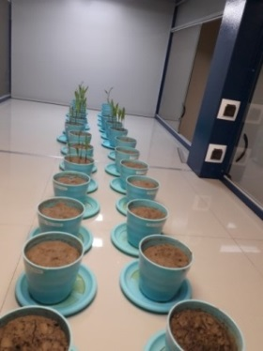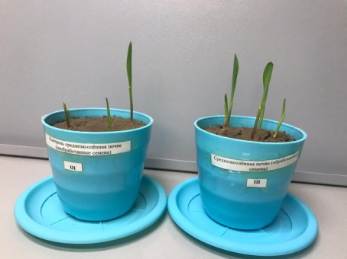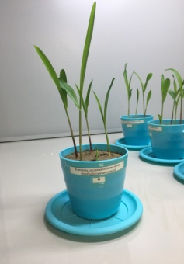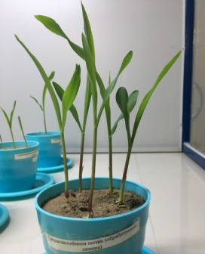
Б
А
А
Б

Figure 27 - General view of the laboratory experiment on the introduction of active strains with corn, and state of corn after 10 days and after a month in medium saline soils, control (no treatment) (A) and treated with the preparation (B)

Table 10 - Influence of a microbiological preparation on the growth of corn Pioneer G 98 (laboratory experiment)

Variant |  | Length, cm. |  |  | Weight, gr.
 |  | plant | stem | root | plant | stem | root
Slightly saline soil | control | 32.4±2.5 | 27.7±2.4 | 4.8±1.0 | 0.4±0.1 | 0.2±0.1 | 0.2±0.1
 | experiment | 43.6±4.7 | 33.9±3.4 | 9.8±3.2 | 1.3±0.4 | 0.6±0.2 | 0.7±0.3
Medium saline soil | control | 32.6±4.1 | 29.5±3.1 | 3.1±1.0 | 0.5±0.2 | 0.2±0.1 | 0.3±0.2
 | experiment | 43.4±5.5 | 34.8±2.4 | 8.6±3.6 | 1.9±0.5 | 0.7±0.4 | 1.2±0.3
Highly saline soil | control | 10.8±2.0 | 6.3±1.8 | 4.9±0.8 | 0.8±0.1 | 0.1±0.0 | 0.7±0.1
 | experiment | 9.0±4.2 | 6.0±5.7 | 3.0±1.4 | 1.0±0.5 | 0.1±0.0 | 0.9±0.5
Extremely saline soil | control | 0 | 0 | 0 | 0 | 0 | 0
 | experiment | 0 | 0 | 0 | 0 | 0 | 0

The results of the analysis showed that, on slightly saline soil, treatment with the preparation gave a significant increase in the total length of plants (by 35%), stem (by 22%), and root (by 104%). Characteristics have tripled: increase in total weight of plants - by 225%, weight of stem - by 200% and weight of root - by 250%. It should be noted that treatment with the preparation has the greatest stimulating effect on the root system.
The use of the preparation leads to a significant increase of dry biomass of plants, which indicates a rapid accumulation of dry matter in plant organs as a result of more intensive work of the root system.
The revealed tendencies were even more visible on medium saline soil. The total length of plants increased by 33%, stem - by 18%, and the root - by 177%. Dry weight of corn plants increased even more: total weight - by 280% (more than 3.5 times), stem weight - by 250% (3 times), root weight - by 300% (4 times). The obtained data demonstrates a greater response of the root system to the application of preparation compared with the aerial part of plants.
On highly saline soil, no significant differences were found between the treated plants and control plants. In both variants, there is a significant decrease in germinating ability of seeds, a strong inhibition of growth and death of plants during the growing season. By the time the experiment was finished, no more than 5 plants remained in each variant. There is a sharp decrease in all indicators, both length and dry mass of plants in comparison with slightly and medium saline soils. The use of a microbiological preparation is not effective. In extremely saline soil, corn seeds practically lose their germination, both in experimental and in control variant, and by the time the experiment was over, the plants in all vegetative vessels had died.
Thus, the results of the experiment showed that the tested microbiological preparation is effective only on slightly and medium saline soil.
The microbiological preparation was developed on the basis of a consortium of bacterial strains Bacillus subtilis, Bacillus amyloliquefaciens and Flavobacterium arborescens, isolated from the natural environment, not genetically modified, possessing cellulosolytic and nitrogen-fixing abilities. The regulation is the result of studying the main technological parameters:
• Isolation of bacterial strains synthesizing biologically active substances
• Characterization of bacterial strains, including cultural-morphological and physiological-biochemical properties
• Storage and cultivation of strains on nutrient media
• Microaerophilic cultivation of bacterial inoculum
• Obtaining a bacterial biological product based on bacterial cultures
The manufacturing technology of a microbiological preparation is shown in the figure A28, Appendix A
Cultivation of bacterial strains on agar medium (solid-phase cultivation) is carried out on nutrient media prepared according to the table (Appendix A. Table A.30). The media are sterilized at 1.0 atm. or 0.5 atm. within 30 minutes, poured hot into sterile Petri dishes and / or sterile tubes and leave for 6 hours. The inoculation of bacterial cultures is carried out with a microbiological loop by the streaking method into Petri dishes and / or sterile test tubes with a frozen agar medium. Petri dishes and / or sterile culture tubes are incubated for 48 h in a thermostat at 28°C.
Evaluation of the quality of inoculum of bacterial strains is carried out according to the cultural and morphological properties. Daily bacterial cultures are transferred by flushing using 0.9% NaCl solution into sterile tubes and 0.1 ml of culture fluid is taken to control the quality of inoculum. The state of the cultures is controlled by microscopy to assess the presence of extraneous microflora. The concentration of bacteria is determined in the Goryaev chamber. The concentration of bacterial cultures is 2.0×10¹⁰ cells / ml.
Microaerophilic cultivation of strains is carried out in liquid nutrient media, which are prepared according to Table A30. (Appendix A).
After 2-4 days of cultivation, the contents of the mattresses with bacterial cultures are sterilely combined in equal volumes and transferred into 4-liter bottles with a sterile 0.9% potassium chloride solution, 100 ml of humic acid salts, 50 g of a water-soluble complex of trace elements in chelated form are added (Mo and B - in non-organic form), 0.5 g each of calcium propionate and sodium ascorbate, 50 g of succinic acid and 5 g of alanine are then brought to a volume of 4 liters. The standard storage temperature for the biological product is + 4°C. The resulting biological product contains bacterial cells of microorganisms in an amount of at least 2.0x10⁹ cells / ml.
The resulting microbiological preparation is stored in closed storage rooms. In sterile mattresses of 1-liter volume, 250 ml of medium is added, then autoclaved at 1.0 atm. within 30 minutes and inoculated with an appropriate bacterial culture. At the same time, at least 6.0x10¹⁰ cells are introduced into 1 mattress. The cultivation is carried out microaerophilically for 2-4 days at 28°C.
The quality of bacterial cultures is assessed according to the criterion - the number of viable cells. To determine the number of viable bacterial cells, staining with 4 μM fluorescent dye propidium iodide is carried out, which stains only bacteria with impaired permeability due to penetration and interaction with nucleic acids (excitation wavelength 510-560 nm and emission 590 nm). Thus, this method only stains dead and damaged cells. The number of viable cells should be more than 98% of the total number of cells in the bacterial culture.
The list of materials required for the manufacture of a microbiological preparation is given in Table A3. (Appendix A. table A31).
Recommendations for the use of a microbiological preparation
The main components of the microbiological preparation are: a culture of bacteria of the Bacillus subtilis 8 strain; culture of bacteria of the strain Bacillusamyloliquefaciens; a culture of bacteria of the Flavobacterium arborescens strain; potassium chloride - according to GOST 4568-95; succinic acid - according to GOST 6341-95; boric acid - according to GOST 18704-78; water-soluble complex of microelements in chelate form (Mo and B in inorganic form): iron chelate Fe (DTPA), iron chelate Fe (EDTA), manganese chelate Mn (EDTA), zinc chelate Zn (EDTA), copper chelate Cu (EDTA) , calcium chelate Ca (EDTA), boron (B), molybdenum (Mo) - according to TU 2189-038-32496445-2004; salts of humic substances - an aqueous solution of potassium lignohumate - according to GOST 2431-007-71452208-05. Quality indicators of a microbiological preparation are presented in Table 11.

Table 11 - Indicators of the quality of the microbiological preparation

Name of the indicator
The number of viable microorganisms, CFU / ml, not less, including:  Bacillus subtilis | 10⁹
Bacillus amiloliquefaciens | 10⁹
Flavobacterium arborescens | 10⁹
Volume solids, % | 0,8-0,9
рН | 6.57

The preparation is used as a microbiological fertilizer for pre-sowing seed treatment and application for fertilizing for agricultural crops. Approximate norms and terms of drug introduction:
cereals, leguminous plants, industrial, fodder crops, pre-sowing seed treatment at the rate of 0.2 l / t of seeds, the consumption of the working solution - 10 l / t;
cereals, leguminous plants - foliar feeding of plants during the growing season 2-4 times at the rate of 3.5-4.0 l / ha, the consumption of the working solution is 200-300 l / ha.
Summary and evaluation of research results
As a result of performed analysis of microbial community, a qualitative analysis of microorganisms, their dominant forms were identified and described, their biological activity was determined, and pure cultures of microorganisms were isolated, a collection of strains was created and their effectiveness was evaluated. 4 strains were isolated from extremely saline soil, which can grow only on saline environments.
A microbiological preparation has been developed that increases the biological activity of saline soils.
3.6 Conducting annual training seminars and field days in order to demonstrate the benefits of technology used in the program
The farmers of peasant farms were shown the possibility of obtaining sufficiently high yields of grain maize in a dysfunctional reclamation environment, through the introduced technology.
Practical training was held with farmers on the use of salt maps and agro-chemical cartograms and technology elements - presowing seed treatment, spraying of vegetative plants were carried out by a special team of scientists, i.e. each farmer or group of farmers was engaged in pre-sowing seed treatment with the direct participation and supervision of scientists (Figure 28)

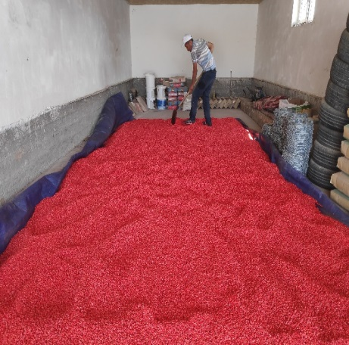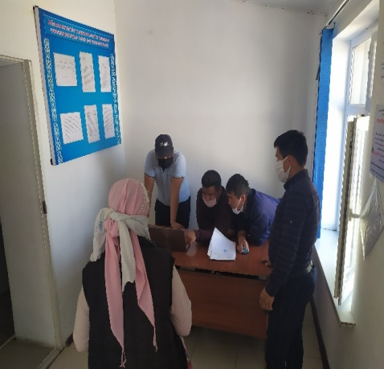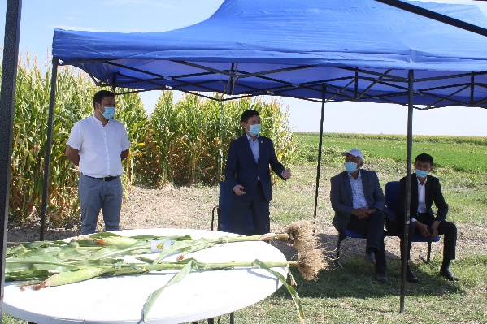

Figure 28- About the activities carried out within the targeted program financing

Three Field Days were carried out during 2018-2020. Appearance in media: in print - 9, on TV –9. (Appendix B)

CONCLUSION (2018-2020)

For all tasks of the program in 2018-2020, an electronic basis of the information system (GIS) of the object of study was created. During the period of the study the results were filled: on 149 soil sections (749 soil horizons); soil reclamation survey -3019 horizon; agrochemical survey - 1129 horizons. 4897 samples in total.
In conclusion, the research results are presented according to the program objectives:
1 To develop technologies for the reclamation of salted “waste” lands out of agricultural production using the remote (satellite) method for determining soil salinity.
Field test of the technology for the reclamation of saline "fallow" lands out of agricultural turnover was carried out on the territory of 2 pilot farms; 6 maps on the degree and chemistry of salinity and 4 maps of solonetzicity and occurrence of the 1st salt horizon for 2 pilot farms were compiled; an increase in the yield of grain maize from 20.5 to 23.6% was obtained from the implementation of the Institute's technology.
According to the results of a small-plot field test, using foreign ameliorants (Germany), low tendency to increase the yield of grain maize was determined, depending on the tested fertilizers.
2 Conducting a field test of the biological method of desalinization of saline soils using the cultivation of licorice Glycyrrhiza glabra L
A production test of the biological method of soil desalinization was carried out on the territory of 3 pilot farms (PF "Orken", PF "Mukhit", PF "Bagdat-2").
On an area of 600 m² (each plot 200 m²), the biological method of resalinization of saline soils using licorice Glycyrrhiza glabra L was evaluated. It has been established that in conditions of secondary saline soils, licorice reduces the degree of soil salinity by one or two gradations, it allows to develop saline lands that have come out of agricultural use.
3 Apply technology to increase the fertility of saline soils and crop yields (grain maize) and teach farmers the basics of technology
Three soil maps were compiled for the right bank, central and eastern parts of the Shaulder irrigation massif of the Turkestan region, covering an area of 92 thousand hectares.
Criteria of soil degradation have been developed and 3 map of soil cover degradation were compiled for the total area of 92 ths. ha;
Appraising scale and 3 map of soil bonitet score were compiled on the area of 92 ths. ha;
On an area of 1507 hectares of 70 peasant farms, a large-scale (1: 10000) soil reclamation survey was carried out with the selection of 3019 soil samples from three depths - 0-20, 20-50, 50-100 cm; 270 maps of the degree salinity, 98 maps of salinity chemistry, 39 maps of the depth of the 1st salt horizon of soils by soil layers 0-20, 20-50 and 50-100 cm were compiled.
Agrochemical survey was carried out on 70 peasant farms with the area of 1507 hectares, 370 cartograms of soil nutrients (humus, easily hydrolyzed nitrogen, mobile phosphorus and exchangeable potassium) were compiled, doses of mineral fertilizers were calculated for the planned corn yield.
On an area of 1507 hectares in 70 farms, the Institute's technology was implemented to increase the fertility of saline soils and increase the productivity of agricultural crops, which provided an increase in the yield of grain maize from 33.8-34.1% on weakly and medium saline soils, and on highly saline soils - 14.5%.
4 To conduct an analysis of economic efficiency of the implemented and developed technologies, including cost assessment of the application of technologies per 1 ha, analysis of the cost recovery due to increased productivity, indicating the payback period.
An analysis of the effectiveness of the developed technology was carried out, indicating the estimated cost per 1 hectare, cost recovery due to increased productivity, indicating the payback period.
The economic efficiency from the implementation of Institute's technology during growing grain maize ranged from 180.5 ths. tenge/ha on the non-saline soils up to 34.2 ths. tenge/ha on highly saline soils compared to the existing technology. Cost recovery with the existing technology ranged from 1.21 to 1.86 tenge, and with innovative technology of the institute it ranged from 1.34 to 2.52 tenge.
5 To create microbiological preparations that contribute to increasing the fertility of low-productive saline soils and give recommendations on their use.
As a result of performed analysis of microbial community, a qualitative analysis of microorganisms, their dominant forms were identified and described, their biological activity was determined, and pure cultures of microorganisms were isolated, a collection of strains was created and their effectiveness was evaluated. 4 strains were isolated from extremely saline soil, which can grow only on saline environments. A microbiological preparation has been developed that increases the biological activity of saline soils.
- Conducting annual training seminars, field days in order to demonstrate the benefits of technology used in the program.
Three Field Days were held to demonstrate the advantages of the introduced technology.
Media appearances: in print - 9, on TV - 9

Target production for 2018 -2020

In order to develop “The technology for reclamation of salted “waste lands” that are out of agricultural use”, the following maps were compiled:
1. 21 maps of the degree of salinity by soil layers: 0-20, 20-50 and 50-100 cm (scale:1000);
2. 10 maps of alkalinity by soil layers: 0-20 and 20-50 cm;
3. 4 maps of the humus content for 0-20 cm soil layer and 12 maps for 0-20 cm soil layer with basic nutrients (NPK);
4. 27 maps of soil salinization under licorice Glycyrrhiza glabra L crops.

In order to demonstrate the advantages of “Technology for increasing the fertility of saline soils and crop yields (grain maize)” and teaching farmers the basics of the technology, the following maps were compiled on 1507 ha of the researched lands:
- 3 soil maps (right-bank, central and eastern parts of the Shaulder irrigation massif, area of 25.0; 35.4; and 29.3 ths. ha, scale: 100,000) - electronic version.
- 3 maps of soil degradation (right-bank, central and eastern parts of the Shaulder irrigation massif, area of 25.0; 35.4; and 29.3 ths. ha, scale: 100,000) - electronic version.
- 3 maps of soil bonitet scores (right-bank, central and eastern parts of the Shaulder irrigation massif, area of 25.0; 35.4; and 29.3 ths. ha, scale: 100,000) - electronic version.
8. 270 maps of salinity for 0-20, 20-50 and 50-100 cm soil layers (scale: 10000);
9. 98 maps of salinity chemistry for 0-20, 20-50 and 50-100 cm of soil layers (scale: 10000);
10. 39 maps of the depth of the 1st salt horizon of soils (scale: 10000);
11. 370 cartograms of soil supply with humus, readily hydrolyzable nitrogen, mobile phosphorus and exchangeable potassium

According to the research results the following publications were released:
16 in publications recommended by the Committee for Control in the Sphere of Education and Science of the Ministry of Education and Science of the Republic of Kazakhstan; 6 in publications with the IF citation index (Web of Science Core Collection & Scopus); 12 in peer-reviewed scientific publications (RSCI) and international conferences, symposium, etc.; 3 recommendations were prepared and issued.

The implementation of the technology was conducted on the area of 1507 hectares.
Media appearances: in print-9, on TV-9.
Three Field Days were held.

* During the period of this program, the team of U.U. Uspanov Kazakh Scientific Research Institute of Soil Science and Agrochemistry suffered a loss:
Saparov Abdulla Saparovich, the Head of the program, Head of the organization, academician of the National Academy of Sciences of the Republic of Kazakhstan and the Academy of Agricultural Sciences of the Republic of Kazakhstan suddenly died on July 10, 2020.
Otarov Azimbay, the leading scientist of the institute, soil scientist, ameliorator, candidate of biological sciences passed away on May 9, 2019.
They were the most caring, professionally competent and active persons. On behalf of all employees, we express our gratitude to them for their creative approach to the tasks set and the successful implementation of this program.
CONCLUSION
In 2018 y.
By deciphering a series of Landsat 8OLE images of the same date (August 2015-2018) using the classification according to the training set by the “maximum similarity” method, abandoned “fallow” lands with saline soils were identified on the territory of the Shaulder massif. The classification on Landsat 8OLE multispectral images was carried out in a combination of channels (7-5-2) "false colors". 2 test plots were selected on the territory for the development of reclamation technology of saline "waste" lands that are out of agricultural use. The soils of the first plot have passed into the category of "fallow" lands relatively recently (5-10 years), and the soils of the second plot are old "fallow". This conclusion is confirmed by the data on the depth of the occupied area of soils with different degrees of salinity.
For the experiment on the biological desalinization of soils, areas with saline soils both from the surface and at all depths were selected. They have various degrees of salinity and are a quite old “fallow” lands with secondary saline soils.
To select the plots, a field reconnaissance survey of the territory of the massif was carried out, during which soil sections were laid, soil samples were taken to determine their physical and chemical properties. According to the research results the following publications were released: soil map for the area of 25,000 ha (scale 1: 100,000), soil degradation map, and bonitet score map. Slightly and medium degraded soils prevail. Secondary salinization and agrodepletion are the main factors of degradation.
The results of large-scale (1: 10000) salt surveys showed that the areas of saline soils increase with depth, from 19% in the upper 0-20 cm layer to 47.6% in the 50-100 cm layer.
The assessment of soils of 26 farms was carried out. 106 soil samples were selected and, based on the results of analyzes, 104 maps of the content of humus and basic nutrients were compiled. Practically on the entire area of farms’ arable soils (507 hectares), in comparison with their virgin analogues, there was a remarkable loss of humus, which undoubtedly affects the yield of cultivated crops. It was also found that in farms, soils with a increased and high content of easily hydrolysable nitrogen make up only 6.2% of the total area, i.e. there is an acute deficiency of nitrogen in the soil, which will lead to soil degradation and sharp decrease in its productivity.
The reserves of mobile form of phosphorus and exchangeable potassium turned out to be quite variegated; in order to obtain a high yield, 67.3% of the areas require phosphorus fertilizers.
The yield of grain maize from the use of technology, depending on the degree of soil salinity, increased from 11.5 to 33.0 percent. Net income from 1 hectare due to an increase in the yield of grain maize from the use of technology, depending on the degree of soil salinity, amounted to 129.9 to 29.5 thousand tenge, and the additional costs for their use did not exceed 1.8% of the cost of additional products.
The maximum number of bacteria and fungi was found in non-saline soils. At the same time, the number of bacteria in saline soils remains at a high level. Dominant forms of microorganisms were identified and described as a result of their qualitative analysis. From enrichment cultures that showed a high level of nitrogenase activity, pure cultures of bacteria were isolated on DAS media.

In 2019 y.
An electronic base of GIS information system with data of the soil cover of the right-bank Shaulder irrigation massif for all tasks of the program was created
Space and ground survey (scale 1: 1000) of the territory was carried out synchronously in place and time on the territories of 2 test plots of PF "Nesip-E" and "Almas" with the area of 15.47 hectares. The final versions of the algorithm for decoding soil salinity have been developed. The maps of soils salinity and alkalinity were compiled. A soil-agrochemical survey was carried out: the soil is depleted in the content of humus and easily hydrolysable nitrogen; very variegated content of phosphorus and potassium is observed; the background leveling is required by using the recommended doses of fertilizers.
The Institute’s technology has been used for field testing of methods for the re-development of “waste” lands with saline soils in PF “Nesip-E” and "Almas", where the average yield of grain maize is 20.5 %.
On an area of 600 m² (200 m² each plot), the biological method of resalinization of saline soils using licorice Glycyrrhiza glabra L was evaluated. The first plot with slightly saline soil, the second plot with an average degree of salinity, the third plot is highly saline. The survival rate of planted licorice cuttings was 80% on slightly saline soil, 30% on medium saline soil, and 10% on highly saline soil. %. In the first year, according to the results of studies and the autumn sampling of soils from salt survey, no significant changes in the degree of soil salinity were revealed.
Soil map, map of soil degradation and map of bonitet scores with scale 1: 100000 of the area of 35.4 ths. ha were compiled. Morphological, chemical, physical and physicochemical properties of soils have been studied. Criteria for soil degradation have been developed. A rating scale has been created.
A large-scale (1: 10000) salt survey was carried out on the area of 500 hectares of the studied farms. Large-scale (1: 10000) salt maps according to the degree of salinity, maps of the chemistry of soil salinity and depth of salinity of the 1st salt horizon were compiled in the GIS environment. It was established that saline soils increase with depth. In the upper 0-20 cm layer, salinity is 29%, and in the 50-100 cm layer - up to 44%. The results of soil-agrochemical survey on the examined territory (500 hectares) showed that 495.6 hectares have very low content of humus and easily hydrolyzable nitrogen (99.1 %), variegated content of phosphorus and potassium (from “low” to “high» degree of content). In accordance with the cartogram, the doses of nitrogen, phosphorus, and potassium fertilizers were calculated and sent to farmers in spring.
As a result of performed analysis of microbial community of the studied soils of the Shaulder irrigation massif, a qualitative analysis of microorganisms, their dominant forms were identified and described, their biological activity was determined, and pure cultures of microorganisms were isolated, a collection of strains was created and their effectiveness was evaluated. 4 strains were isolated from extremely saline soil, which can grow only on saline environments.
The technology to increase the fertility of saline soils and grain maize yield was implemented on the area of ​​500 hectares. Depending on the degree of soil salinity, the yield of grain maize increased to 40.0% on non-saline soils compared to the control variant with 71.1 centners / ha. In slightly and medium saline soils - 81.2 - 83.9 c / ha compared to the control (62.5-63.5 c / ha), the increase was, respectively, 30.0 - 32.1%. In highly saline soils, the increase in the yield of grain maize was 11.4%, with a harvest under control variant - 47.1 centners / ha. The innovative technology of the Institute implemented on saline soils of the Shaulder irrigation massif makes it possible to obtain a profit from 61.8 to 336.0 thousand tenge per 1 ha.
The economic efficiency from the implementation of Institute's innovative technology during growing grain maize ranged from 162.6 ths. tenge/ha on the non-saline soils up to 29.4 ths. tenge/ha on highly saline soils compared to the existing technology. Cost recovery (tenge/tenge) with the existing technology ranged from 1.16 to 1.83 tenge, and with innovative technology of the institute it ranged from 1.30 to 2.56 tenge.
At the farms of the Shaulder irrigation massif, practical exercises have been conducted with farmers on the use of salt maps and agrochemical cartograms, as well as technology elements (presowing seed treatment, spraying vegetative plants).
One Field Day was held. Five media appearances, including 2 on TV.

In 2020 y.
Replenishment of the soil base of GIS information system with data of the soil cover of the eastern part of the Shaulder irrigation massif for all tasks of the program continued in 2020: the results were filled for 30 soil sections (134 soil horizons), for soil-reclamation survey (309 horizon) and for agrochemical survey (149 horizons).
1 To develop technologies for the reclamation of salted “waste” lands out of agricultural production using the remote (satellite) method for determining soil salinity.
The Institute’s technology has been used for field testing of methods for the re-development of “waste” lands with saline soils in PF “Tilegen”, where the average yield of grain maize is 23.6 %. The final version of method of the development of “waste” lands that have come out of agricultural use was determined.
2 Conducting a field test of the biological method of desalinization of saline soils using the cultivation of licorice Glycyrrhiza glabra L
On an area of 600 m2 (each plot 200 m2), the biological method of resalinization of saline soils using licorice Glycyrrhiza glabra L was evaluated. It has been established that in conditions of secondary saline soils, licorice reduces the degree of soil salinity by one or two gradations, it allows to develop saline lands that have come out of agricultural use.
3 Apply technology to increase the fertility of saline soils and crop yields (grain maize) and teach farmers the basics of technology
Reconnaissance survey of the eastern part of the Shaulder irrigation massif was carried out. Soil map, map of soil degradation and map of bonitet scores with a scale of 1: 100000 and area of 29.3 thousand hectares were compiled. Morphological, chemical, physical and physicochemical properties of soils have been studied.
A large-scale (scale 1:10000) salt survey has been conducted on the area of ​​500 hectares of the studied farms. In the GIS environment, large-scale (1:10000) salt maps have been compiled according to the degree of salinity. Maps of the soil salinity, chemistry and salinity depth of the 1st salt horizon have been made. It was established that the soils on the territory of 22 peasant farms are saline in varying degrees. Based on the results of agrochemical surveys on the studies territory (500 hectares), 88 cartograms were compiled on the supply of soils with nutrients (humus, easily hydrolyzed nitrogen, mobile phosphorus and exchangeable potassium), the doses of mineral fertilizers were calculated for the planned yield;
On the area of 500 hectares in 22 peasant farms, the Institute introduced technology to increase the fertility of saline soils and the productivity of grain maize. The increase from the technology amounted to 34.7 -36.0 % on slightly and medium saline soils, and on highly saline soils it is 19%.
At the farms of the Shaulder irrigation massif, practical exercises have been conducted with farmers on the use of salt maps and agrochemical cartograms, as well as technology elements (presowing seed treatment, spraying vegetative plants).
4 To conduct an analysis of economic efficiency of the implemented and developed technologies, including cost assessment of the application of technologies per 1 ha, analysis of the cost recovery due to increased productivity, indicating the payback period.
The economic efficiency of the implementation of growing grain maize compared to the existing technology ranged from 156.6 ths. tenge/ha on the non-saline soils up to 52.3 ths. tenge/ha on highly saline soils. Cost recovery (tenge/tenge) with the existing technology ranged from 1.28 to 1.83 tenge, and with innovative technology of the institute it ranged from 1.48 to 2.40 tenge. The profitability of production was 82.5 -139.6 % on non-saline soils, and 28.3-48.2 % on strongly-saline soils.
5 To create microbiological preparations that contribute to increasing the fertility of low-productive saline soils and give recommendations on their use.
The result of the experiment on the introduction of active strains into the soil showed that the tested microbiological preparation is most effective only on the slightly and medium saline soil of the Turkestan region.
- Conducting annual training seminars, field days in order to demonstrate the benefits of technology used in the program.
One “Field Day was held, media appearances: in print-3, on TV-4.

REFERENCE
- Shimshikov B.E., Batyrkhanov D.S. Geographic information system – a new direction for sustainable management of soil resources // Eurasian Journal of Ecology. – 2016. – Vol. 41, № 2. – P. 168-171. (In Russian)
- Message of the President of the Republic of Kazakhstan K. Tokayev dated September 2, 2019 "Constructive public dialogue is the basis of stability and prosperity of Kazakhstan" – URL: https://www.akorda.kz/ru/addresses/addresses_of_president/poslanie-glavy-gosudarstva-kasym-zhomarta-tokaeva-narodu-kazahstana (02.09.2019). (In Russian)
- Margulis V.Yu. Quantitative assessment of soil salinity for saline lands leaching // Soils of the largest irrigation and reclamation systems in the cotton-growing zone. Thesis of Soil Institute named after V.V. Dokuchaev. –M., -1975. - pp. 3–78. (In Russian)
- Saparov A.S. Presentation "Soil Research in Kazakhstan". – URL: http://www.fao.org/fileadmin/user_upload/GSP/docs/eurasian_workshop/Soils_of_Russiaba.pdf (20.11.2013). (In Russian)
- Nurseitov Zh.T., Kaldybayev S.K. Adaptive landscape system of land reclamation in Kazakhstan (theory, methodology, practice) / monograph. - Almaty. - 2020. - 491 p. (In Russian)
- Messages of the President to the people of Kazakhstan, January 31, 2017. – URL: https://www.akorda.kz/ru/addresses/addresses_of_president/poslanie-prezidenta-respubliki-kazahstan-nnazarbaeva-narodu-kazahstana-31-yanvarya-2017-g( 31.01.2017). (In Russian)
- Akhtyrtsev BP Degradation of soil resources and the problem of their optimization // Bulletin of Voronezh University. Series geography, geoecology. - 2000. - № 1. - P. 98. (In Russian)
- Mueller L., Saparov A., Lischeid G. Novel measurement and assessment tools for monitoring and management of land and water resources in agricultural landscapes of Central Asia. – Springer Science & Business Media, 2013. – 715 p. DOI10.1007/978-3-319-01017-5.
- Saparov A.S., Pachikin K.M., Erokhina O.G. Digital soil mapping for the assessment of land resources // Source book of the International scientific and practical conference "Agro-ecological foundations for increasing productivity and sustainability of agriculture in the XXI century", dedicated to the 100th anniversary of the birth of K.B. Babayeva. –Almalybak. - 2013.- pp. 267-270. (In Russian)
- Otarov A. Concentration of heavy metals in irrigated soils in Southern Kazakhstan //Novel Measurement and Assessment Tools for Monitoring and Management of Land and Water Resources in Agricultural Landscapes of Central Asia. – Springer, Cham, 2014. – P. 641-652. - URL: https://link.springer.com/chapter/10.1007/978-3-319-01017-5_41.
- Gabdullin B.S., Zhogolev A.V., Savin I.Yu., Otarov A., Ibraeva M.A., Golovanov D.L. Use of multispectral satellite data to decipher the salinity of soils in irrigated areas (illustrated by South Kazakhstan). Reporter of Moscow University, Vol. 5. Geography. 2015. No. 5. pp. 34-41. (In Russian)
- Savin I. Yu., Otarov A., Zhogolev A. V., Ibrayeva M. A Identification of long-term changes in the area of saline soils of the Shaulder irrigation massif based on Landsat satellite images // Reporter of the Soil Institute named after V.V. Dokuchaev ". - 2014. – Vol. 74. - pp. 49-65. (In Russian)
- Duisekov S. D, Otarov A., Kaldybaev S. K., Poshanov M. N., Laiskhanov Sh. U. The operational method of conducting large-scale salt survey and drawing salinity level maps of irrigated lands of the Akdalinsky array // Biosciences Biotechnology Research Asia. – 2015. – Vol. 12. P. 547-557.
- Laishanov Sh.U., Otarov A., Savin I. Y., Tanirbergenov S.I., Mamutov Z.U., Duisekov S.N., Zhogolev A. Dynamics of Soil Salinity in Irrigation Areasin South Kazakhstan // Polish Journal of Environmental Studies. -2016. – Vol. 25, № 6. P. 2469-2475.
- Otarov А., Duisekov S., Poshanov M. Study of soil salinity in Akdala irrigation area using GIS technology // Abstract Book, 9th International Soil Science Congress on “The Soul of Soil and Civilization” / Side, Antalya, Turkey (16.10.2014). P. 580.
- Gabdullin B.S., Golovanov D.L., SavinI.Yu.,Zhogolev A.V., Otarov A., Smanov Zh. M. Soil salinity assessment in Southern Kazakhstan using remote sensing data // Materials of International Conference “Global Soil Map 2017” / Moscow, Russia (July 4-6, 2017). P. 58.
- Zhikhareva G.A., Kurmangaliyev A.B., Sokolov S.S. Soils of the Kazakh SSR. Shymkent region. Vol 12.- Alma-Ata. 1969.-410 p. (In Russian)
- Pankova E.I., Mazikov V.M. Methodological recommendations on the use of aerial photography materials for assessing soil salinity and conducting salt surveys of irrigated areas of the cotton-growing zone on a large and medium scale//Institute of Soil Science named after VV Dokuchaev. - М., - 1985. – 49 p. (In Russian)
- Rukhovich D.I. Long-term dynamics of salinization of irrigated soils in the central part of the Hungry Steppe and methods of its identification: Dissertation abstract, Candidate of biological sciences - M., 2009.- 20 p. (In Russian)
- Konyushkova M.V. Mapping of the soil cover and soil salinity of the solonetz complex based on digital analysis of satellite survey (on the example of the Dzhanybek station): Dissertation abstract, candidate of agricultural sciences –М., 2010. - 20 p. (In Russian)
- Tanirbergenov S., Suleimenov B., Saparov A., Soltanayeva A., Kabylbekova B. The fertilizer system increasing the salt tolerance and productivity of cotton in the conditions of saline soils in southern Kazakhstan // Research Journal of Pharmaceutical, Biological and Chemical sciences. – 2016. – Vol. 7, № 6. P. 147-155.
- Vyrakhmanova A.S., Otarov A., Saparov A.S., Suska-Malavska M., Duisekov S.N., Poshanov M.N., Tanirbergenov S.I. The ecological status of irrigated saline soils of the Shaulder massif of the Turkestan region // EurAsian Journal of BioSciences. – 2020. – Vol. 14, № 1. P. 347-354.
- Duisekov S.D., Otarov А., Kaldybaev S.K., Poshanov M.N., Laiskhanov Sh.U. The operation method of conducting large-scale salt survey and drawindg salinity maps of irrigated lands of the Akdalinsky array // Biosciences Biotechnology Research Asia. – 2015. – Vol. 12. P. 89-102.
- Layskhanov Sh., Otarov A., Savin I., Zhogolev A., Duisekov S. Using space data and cartographic methods for assessing degraded arid agricultural landscapes // New methods and results of landscape studies in Europe, Central Asia and Siberia. - 2018. -P. 233-237. (In Russian)
- Laiskhanov S.U., Mamutov Z.U., Karmenova N.N., Tleubergenova K.A., Ashimov T.A., Kobegenova X.N., Smanov Z.M. Dynamics of Microbiological Activity of Soils in the Natural Landscapes of the Shaulder Massif (The Mid-Stream of the Syr Darya River) //Journal of Pharmaceutical Sciences and Research. – 2018. – Vol. 10, № 7. P. 1697-1700.
- Poshanov M.N., Otarov A., Ibrayeva M.A., Duisekov S., Suleimenova A. Experience of using the space method for detecting the "fallow" saline lands of the irrigated zone out of agricultural circulation and assessing their current state // Soil Science and Agrochemistry , - 2020. - No. 1. - P. 29-41. (In Russian)
- Nosin V.A., Fedorin Yu.V., Friev T.A. All-Union Instruction on Soil Investigations and Compilation of Large-Scale Soil Maps of Land Use. - M.: Kolos-S, 1973 . - 95 p. (In Russian)
- Guidelines for conducting a large-scale soil survey in the Kazakh SSR. - Alma-Ata. - 1979. - 137 p. (In Russian)
- Arinushkina E.P. Manual for chemical analysis of soils. - М.: MSU Publishing House - 1977. - 489 p. (In Russian)
- Bazilevich N.I., Pankova E.I. Salinity classification experience // Soil Science. - 1968. - No. 11. - P. 3-15. (In Russian)
- Songulov E. To the characteristics of irrigated and fallow saline soils of the Turkestan region (on the example of the Shaulder irrigation massif) / XXIII Dokuchaev youth readings "Soil in the context of global climate change" dedicated to the 115th anniversary of the Central Museum of Soil Science named after V.V. Dokuchaev, St. Petersburg (March 1-4, 2020). - P. 275-277. (In Russian)
- Kornienko V.A., Korobkin V.A. On the issue of drawing up salinity maps // Bulletin of the Academy of Sciences of the Kazakh SSR. – 1976. – No. 1. - pp. 54-56. (In Russian)
- Kan B.M. Temporary guidelines for conducting soil reclamation surveys, drawing up design estimates and reclamation of solonetzic and soda-saline irrigated soils of the Kazakh SSR. - Alma-Ata. 1985. - 83 p. (In Russian)
- Dmitriyev E.A. Mathematical statistics in soil science. - M., 1995.- 320 p. (In Russian)
- Dospekhov B.A. Field experiment technique. - M., 1979.- 416 p. (In Russian)
- Savich V.I. Application of variation statistics in soil science: study guide. – М.: Publishing house RSAU-Moscow Agricultural Academy.- 1972. – 103 p. (In Russian)
- Wolf V.G. Statistical processing of experimental data. - M., 1966 .- 255 p. (In Russian)
- Land resources "National report on the state of the environment and use of natural resources in the Republic of Kazakhstan for 2017. - URL: http://ecogosfond.kz/kz-2018-zhylda-y-aza-stan-respublikasyny-tabi-i-resurstaryn-pajdalanu-zh-ne-orsha-an-ortany-zhaj-k-ji-turaly-ltty-bajandama-ru-nacionalnyj-doklad-o-sostojanii-okruzhajushhej-sredy-i-ob-ispolzovanii-pr/ (05.02.2018). (In Russian)
- Truskavetskiy R.S., Tkach V.I. / Guidelines for the management of saline soils. Edited by R. Vargas, E. I. Pankova, S. A. Balyuk, P. V. Krasilnikov and G. M. Khasankhanova / Published by the Food and Agriculture Organization of the United Nations and Lomonosov Moskow State University. Food and Agriculture Organization of the United Nations. -Roma. -2017.- pp. 49-51. – URL: https://ecfs.msu.ru/images/publications/Rukovodstvo_po_zasolen.pdf (24.05.2019). (In Russian)
- Akinchina N.A., Toderich K. Application of halophytes for biogas production and restoration of saline lands. Analytical report. National University of Uzbekistan, ISBA (International Center for Agricultural Development on Saline Lands, Regional Office for the North Caucasus and Caucasus). Tashkent – 2011, 117 p. www.cer.uz (14.09.2011). (In Russian)
- Otarov A., Duisekov S., Poshanov M., Smanov G. The results of the works on development of the method for biological reclamation of saline soils by planting Glycyrrhiza glabra L / Abstracts of the 3rd International Workshop – 2017. “Eco-Environment Safety along the Silk-Road” / Issyk-Kul, Kyrgyzstan, Boz-Beshik, 2017. - Р. 30-33.
- Dokuchaev V.V. To the doctrine of natural zones. Horizontal and vertical zones // - Works. M .: AN SSSR. - 1951. - T. 6. - P. 398-414. (In Russian)
- Sokolov I.A. Theoretical problems of genetic soil science. - Novosibirsk: Humanitarian Technologies, 2004. – 288 p. (In Russian)
- Isachenko A.G. Methods of applied landscape research. - L., 1980. – 222 p. (In Russian)
- Rozanov B.G. Soil morphology. - M., 2004 .- 432 p. (In Russian)
- Alexandrova L.N., Naydenova O.A. Laboratory and practical classes in soil science. - L., 1986. - 295 p. (In Russian)
- Aerospace methods in soil science. - M., 1989.- 128 p. (In Russian)
- Smirnov L.E. Aerospace methods of geographical research. - Saint-Petersburg: Saint Petersburg University, 2005 .- 348 p. (In Russian)
- Kravtsova V.I. Space methods of soil research. - M.: Aspect-Press, 2005.- 180 p. (In Russian)
- Varennikova V.M., Gubina E.I., Kotlyarova V.N., Tazhmagambetova T.K., Karimova M.Sh., Sergeenko A.I. Instructions for conducting large-scale soil surveys of the lands of the Republic of Kazakhstan. - Almaty. - 1995.- 85 p. (In Russian)
- Savin I. Yu., Simakova MS Satellite technologies for inventory and monitoring of soils in Russia // Modern problems of remote sensing of the Earth from space. - 2012. - T. 9, No. 5. - P. 104-115. (In Russian)
- Florinsky M.A., Lunev M.I., Kuznetsov A.V. Methodological instructions for conducting a comprehensive agrochemical survey of agricultural soils // M .: Scientific and technical center. inform., propaganda and advertising. - 2004 . - 35 p. (In Russian)
- Instructions on the implementation of state control for the protection and use of land resources. Ministry of Ecology and Bioresources of the Republic of Kazakhstan. Republican normative document. РНД 03.7.0.06-96. –Almaty- 1996. – URL: https://online.zakon.kz/Document/?doc_id=31134598#pos=0;0 (21.08.1995). (In Russian)
- Environmental requirements in the field of protection and use of land resources (including agricultural land). RND Protection of land resources. Ministry of Agriculture of the Republic of Kazakhstan. - Astana. – 2005. – URL: https://online.zakon.kz/Document/?doc_id=30005488 (дата обращения 12.04.2005). (In Russian)
- Eleshev R.E., Ramazanova S.B., Smagulov T.S. Course work on the subject of fertilizer application system: methodical instructions. –Almaty.- 1999. - 64 p. (In Russian)
- Methods of Economic Research in Agroindustrial Production / ed. by V.R. Boeva. M: All-Russian Research Institute of Agricultural Economics В.Р., 1999. - 260 p. (In Russian)
- Bondina N.N. The use of basic reserves for increasing the efficiency of agricultural production in modern conditions // Niva Povolzhya. - 2014.- No. 2. - P. 105-110. (In Russian)
- Bondina N., Bondin I, Zubkova T. A system of indicators for assessing the economic efficiency of agricultural production // Moscow Economic Journal. -2015. – No. 3 – P 77-82. (In Russian)
- The use of intensive technologies in a market economy: the experience of ZAO APK Yunost, Dolzhansk district, Oryol region, ed. by E.S. Stroyeva. – Orel., 2004. -46 p. (In Russian)
- Shafronov A.D. Production efficiency and factors of its growth // APK: Economics, management. - 2003. - No. 4. - P. 52-58. (In Russian)
- Obolensky K.P. Determination of the economic efficiency of agricultural production (theory and practice). - M., 1963.- 308 p. (In Russian)
- GOST - 28168 - 89 “Soils. Sample selection". - М.: Standardform, 2008. – URL: http://docs.cntd.ru/document/1200023554 (01.04.1990). (In Russian)
- Anderson J.P.E., Domsch K.H. A physiological method for the quantitative measurement of microbial biomass in soils // Soil Biol. Biochem. - 1978. - Vol. 10, № 3. P. 314–322.
- Ananyeva N.D., Blagodatskaya E.V., Demkina T.S. Assessment of the stability of microbial complexes to natural and anthropogenic influences // Soil Science. - 2002. - No. 5. -pp. 580-587. (In Russian)
- Tepper E.Z., Shilnikova V.K., Pereverzeva G.I. Workshop on Microbiology. -M., 1987.- 239 p. (In Russian)
- Lysak L.V., Dobrovolskaya T.G., Skvortsova E.N. Methods for assessing bacterial diversity of soils and identification of soil bacteria. -M., 2003.120 p. (In Russian)
- Shrivastava P., Kumar R. Soil salinity: a serious environmental issue and plant growth promoting bacteria as one of the tools for its alleviation // Saudi journal of biological sciences. – 2015. – Vol. 22, № 2. P. 123-131.
- Blinkov E.A., Tsavkelova E.A., Selitskaya O.V. Formation of auxin by the strain Klebsiella planticola TSKhA -91 and its influence on the development of seeds of the cucumber (Cucumis Sativus L.) // Microbiology. -2014. -Vol. 83, №5. –P. 543-544. (In Russian)
- Selitskaya O.V., Emtsev V.T., Sokolova A.Ya., Kolesnikov O.V. Peculiarities of plant colonization by the introduced population of Klebsiella planticola under the influence of stress factors // News of the Timiryazev Agricultural Academy. - 2013. No. 1.- pp. 48-56. (in Russian)

