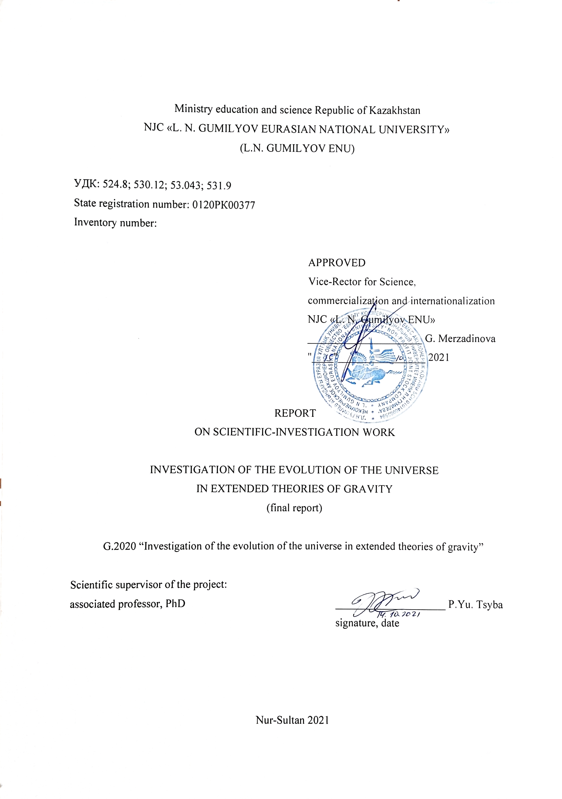

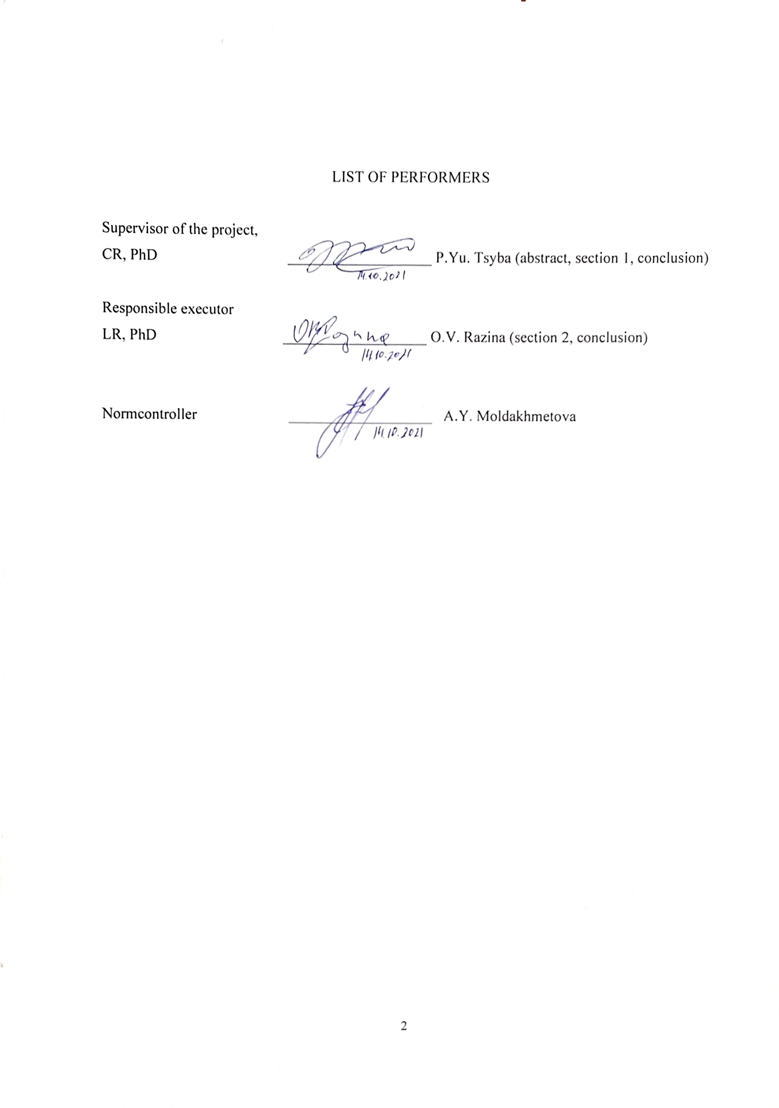**РЕФЕРАТ**

Есеп 68 бет, 11 сур., 2 кес., 121 дер. көз., 3 қос.

КОСМОЛОГИЯ, ГРАВИТАЦИЯ, ИНФЛЯЦИЯ, KҮНГІРТ ЭНЕРГИЯ, ҮДЕМЕЛI ҰЛҒАЮ

Зерттеу нысанасы. Тұтас Ғалам.

Жобаның мақсаты Ғаламдық эволюцияны сипаттайтын және космологиялық бақылау деректерімен үйлесетін, материяның жалпыланған өрістерімен гравитацияның кеңейтілген теорияларына негізделген, космологиялық модельдерді жасау және олардың шешімдерін зерттеу

Зерттеу әдістері. Аналитикалық және сандық.

Жұмыс нәтижелері. Аналитикалық және сандық космологиялық шешімдерді жасап, оларды космологияның арнайы әдістерімен тексердік. Тахиондық және скалярлық модельдерді зерттей отырып, түрлендірудің формалық инвариантты Эйнштейн теңдеуінің жаңа шешімдерін алу үшін қолдануға болатындығын және тұрақсыз космологиядан тұрақтыға және керісінше ауысуға мүмкіндік беретінін көрсетті. Модельдердің тәуелсіз тиімді параметрлерін анықтап және оларды бақылау деректерімен салыстырдық.

Қолдану саласы. Зерттеулер іргелі сипатқа ие болғандықтан, нәтижелердің негізгі тұтынушылары қазақстандық және халықаралық ғылыми қоғамдастық пен университеттер болады. Жұмыс нәтижелері оқу процесіне енгізілуі мүмкін және сол арқылы релятивистік астрофизика, релятивистік аспан механикасы, жалпы салыстырмалылық сияқты жоғары курс студенттеріне, магистранттар мен PhD докторанттарына арналған арнайы курстарды оқу кезінде пайдаланылуы мүмкін.

Экономикалық тиімділігі. Жоба бойынша зерттеулер іргелі сипаттамаларға ие болғандықтан, бұл жоба шеңберінде техника-экономикалық тиімділігі қарастырлмаған.

Жұмыстың маңыздылығы. Жоба нәтижелері теориялық физика саласында жаңа бәсекеге жарамды ғылыми кадрларды дайындауда және осы бағыт бойынша жұмыс жасап жатқан қызметкерді қызықтыруға мүмкіндік береді және осының салдарынан ҚР ғалымдарының ғылыми қызығушылық аясын кеңейтеді. Жобаның нәтижелері Ғаламның эволюциясы туралы идеялардың дамуына әсер етеді.

**ABSTRACT**

Report p. 68., 11 fig., 2 tab., 121 sour., 3 app.

COSMOLOGY, GRAVITY, INFLATION, DARK ENERGY, ACCELERATED EXPANSION

The object of the study. The universe as a whole.

The aim of the project is to develop cosmological models and study their solutions based on extended theories of gravity with generalized fields of matter that consistently describe the evolution of the universe and are consistent with cosmological observational data.

Research methods. Analytical and numerical.

The results of the work. Analytical and numerical cosmological solutions were constructed and tested by special cosmological methods. Studying tachyon and scalar models, we have shown that the form invariance of transformations can be used to obtain new solutions to the Einstein equation and allows us to move from unstable cosmology to stable and vice versa. The independent optimal parameters of the models were determined and compared with the observational data.

Scope of application. Since the research is fundamental, the main consumers of the results will be the Kazakh and international scientific community and universities. The results of the work can be introduced into the educational process and thus can be used when reading special courses for undergraduates, undergraduates and PhD students, such as relativistic astrophysics, relativistic celestial mechanics, general relativity.

Economic efficiency. Research on this project is of a fundamental nature, therefore, technical and economic implementation was not envisaged within the framework of the project.

The significance of the work. The results of the project can affect the training of new competitive scientific personnel in the field of theoretical physics and contribute to the involvement of already working personnel in this area, thereby expanding the field of scientific interests of scientists of the Republic of Kazakhstan. The results of the project will influence the development of ideas about the evolution of the universe.

**CONTENT**

|  |  |
| --- | --- |
| INTRODUCTION……...…………………………………………………......................... | 6 |
| 1 Analysis of cosmological tachyon and fermion model and observation data constraints. | 9 |
| 1.1 Model ………………………………………………………………………..………. | 10 |
| 1.2 Solution………..………………………………………………………...…………… | 13 |
| 1.3 Statefinder parameters…..……………………………………………………………. | 15 |
| 1.4 Observational Data…………………………………………………………….…....... | 17 |
| 1.4.1 Supernovae Ia data……………………………………………………..….……… | 17 |
| 1.4.2 BAO data………………………………………….……………………….……... | 17 |
| 1.4.3 $H(z)$ data…………………………………………….………………….………… | 19 |
| 1.4.4 CMB data…………………………………………….………………….………... | 20 |
| 1.5 Conclusion………………………………………….……………………………....... | 22 |
| 2 Tachyonization cosmological model in the framework of linear form invariance transformations…………………………………….………………………..…………….. | 24 |
| 2.1 Model ……………………………………………………………….………………. | 25 |
| 2.2 Linear form-invariance of the transformations ……………………………………… | 26 |
| 2.3 Tachyon model ……………….……………………………………………..………. | 27 |
| 2.3.1 Statefinder parameters.…………………………………………………………… | 29 |
| 2.3.2 Solution.……..……………………………………………………………………. | 30 |
| 2.4 Scalar field…………………………………………………………..……………….. | 33 |
| 2.4.1 Slow roll parameters and spectral indices ………………………….…………….. | 34 |
| 2.4.2 Search for solution …………………………………………….…………………. | 36 |
| 2.5 Conlusion…………………………………………………………………………….. | 39 |
| CONCLUSION ………………………………………………………………………….. | 41 |
| REFERENCE ……………………………………………………………………………. | 44 |
| APPENDIX A. List of published works based on the results of the research………..…... | 54 |
| APPENDIX B. Contract for the implementation of scientific, scientific and technical projects, technical specification and work schedule……………………………..……….. | 56 |
| APPENDIX С List of published works based on the results of the research for 2020….... | 68 |

**INTRODUCTION**

2020 Report: Investigation of the evolution of the universe in extended theories of gravity, inventory No. 0220РК01611.

Assessment of the current state of the problem. The inflationary era came after the era of quantum gravity of our universe. Inflation is considered the most promising candidate to describe its post-Punk era. The inflationary scenario is interesting, since most inflationary theories solve complex problems of the standard Big Bang cosmology, such as horizon and flatness problems. However, to date, it has not been possible to make a direct check of the inflation of the Universe. The simplest description of inflation is realized by a single scalar field, the so-called inflanton, slowly sliding from the peak of the self-interacting potential to the minimum point in the context of the slow-rolling approximation [1]-[4]. Then the inflation ends when the inflaton disintegrates, at the last stage, in the process of reheating [5]-[7].

Our universe is currently undergoing an accelerated expansion phase. This is confirmed by various observational data [8]-[11]. Due to the lack of a complete understanding of the nature of accelerated expansion, its source is called dark energy. Many models of dark energy have been proposed in the literature [12]-[28].

Relevance. Currently, many groups of cosmologists from the USA, Europe, Russia and other countries are engaged in research on the evolution of the Universe. Cosmology is a rapidly developing field of knowledge not only as a theoretical aspect. As a result of the development of the cosmological direction, new research methods are emerging, the latest electronic computers are being used for the analysis and processing of the results. Taken together, this is important because they indirectly contribute to the development and introduction of new methods of analysis and technologies into the daily life of society.

Novelty. We consider the observational component in the study of the evolution of the Universe. It is this part that is the pinnacle in this project. Important information for identifying the class of the most realistic theoretical models can be obtained from cosmological observational data such as Supernova Ia, BAO. Due to the presence of supernovae, it was found [9], [29] that in the framework of a flat and homogeneous Universe, the cosmological lambda term has a positive sign. If we generalize, we can say that the universe contains dark energy. The task is to study its properties. And in this study, supernovae play an important role.

Connection with another research works. Numerous experimental tests of the theory of gravity – laboratory, in the Solar System, in our galaxy and cosmological - are able to detect even a small (on the order of a percent or less) deviation of the law of gravitational interaction from Einstein's. However, it is necessary to create a reliable and well-founded theoretical model. As a result, such topics have become in demand in many countries of the world, both in the West and in the East, strong theoretical groups working in this field have emerged.

Perspective and scientific and practical significance. The main idea of this project is to identify new extended cosmological models of the dynamic forms of the evolution of the Universe and compare them with cosmological observational data and verification by theoretical methods. A large number of leading foreign theoretical groups work in this field. Our proposed project also lies in this direction, and as its specific directions we have chosen those that will help to support the domestic school of theoretical physics at the modern level.

Information about the scientific and technical level of development, patent research and conclusions from them. The scientific and technical level of development corresponds to the level adopted for similar tasks in world practice. The project is carried out in stages, in accordance with the calendar plan and calculation of the estimated cost. During the implementation of this project, it was not planned to conduct patent research.

The aim of the project is to develop cosmological models and study their solutions based on extended theories of gravity with generalized fields of matter that consistently describe the evolution of the universe and are consistent with cosmological observational data.

The main objectives of the project for 2020-2021 as a whole (APPENDIX B)

– for 2020

Task 1. Physically relevant theoretical models fitting and obtaining evolution equations.

– for 2021

Task 2. The construction of analytical cosmological solutions and their verification by special methods of cosmology.

Task 3. The construction of numerical cosmological solutions and their verification by special methods of cosmology.

Task 4. Defining independent optimal model parameters and their comparison with observational data.

Expected results in 2021

- Analytical cosmological solutions will be constructed and tested by special methods of cosmology.

- Numerical cosmological solutions will be constructed and tested by special cosmological methods.

- Independent optimal parameters of the models will be determined and compared with observational data.

The basis and initial data for the implementation of the project. Extract No. 1 from the Minutes of the Meeting No. 4 of the National Scientific Council on the priority direction "Scientific research in the field of natural sciences" dated October 4, 2020.

Agreement No. 312 dated November 16, 2020 for the implementation of scientific, scientific and technical projects for grant financing under the project "Study of the evolution of the Universe in extended theories of Gravity" between the State Institution "Committee of Science of the Ministry of Education and Science of the Republic of Kazakhstan" and the Non-profit Joint Stock Company "L.N. Gumilev Eurasian National University" of the Ministry of Education and Science of the Republic of Kazakhstan (APPENDIX B).

Project completion dates - 01.10.2020 - 30.09. 2021

The amount of financing for 2021 is 1,998 thousand tenge.

**1 Analysis of cosmological tachyon and fermion model and observation data constraints**

Tachyon is a non-stable field, which might be a basis for modifications of string theory. A tachyon field can play one of the leading roles in the modern accelerated expansion of the universe due to dark energy [30]-[36]. Also, it makes a big contribution to inflationary models [37]-[40] and brings a useful role in cosmology with different shapes of the tachyon potentials [41]-[45]. The tachyon Lagrangian was extended in the work [46], where as a result barotropic index could take the different values, giving rise to phantom and complementary tachyons [34], [36], [46]. The standard tachyon can behave as an inflaton field in early epoch, and like matter in late epoch. The phantom tachyon field provides rapid expansion and its energy density is gradually increasing. The complementary tachyon field always plays the role of matter [36], [47]-[49]. In the work [45] was illustrated, that a standard tachyon field, after applying a form invariance symmetry to it, can generate a complementary tachyon field and a phantom tachyon field. In [36] tachyonization of ΛCDM model was made for spatially flat, homogeneous and isotropic Friedman-Robertson-Walker (FRW) space-time. There was shown that the standard and complementary tachyon fields in the limiting case generate ΛCDM model was shown. The energy-momentum tensor of the tachyon field is the sum of the two tensors associated with the dark matter and the energy density of the vacuum [50]. The tachyon potential has the non-stable maximum at the origin, decreasing almost to zero as the field grows to infinity. At present, there are many models of dark energy and any of them can be used to describe the dynamics of the universe [51]-[58]. Some of these models are based on scalar fields and some of them are similar to inflationary models [1]-[4] or based on fermionic fields [16]-[18], [28], [59]-[66]. Particularly, it was shown, that the fermion field plays a very important role in the isotropization of the initially anisotropic space-time, the formation of a free singularity of cosmological solutions, and the explanation of the late acceleration time. Models with fields of electrodynamic origin [19]-[20], [67] are also of great interest. Action with of the Fµν electromagnetic field tensor or $F_{μν}^{a}$ Yang-Mills fields allow to find new interesting solutions to cosmological problemsYang-Mills fields can interact with themselves and with each other, which is non-linearity, the superposition principle is not fulfilled for them, and its non-linearity complicates the search of solutions. For the first time confirmation of the accelerating expansion of the universe appeared in Type Ia supernova observations [8], [9]. Follow-up observations such as: baryon acoustic oscillations [68], large-scale structure of the universe [29], [69], CMB observation [70], [71], weak gravitational lensing [72], as well as the calculation of the Hubble parameter [73] depending on the redshift confirmed this phenomenon. Due to the periodic updating of observational data and the emergence of many theoretical models of dark energy there was a need to create certain statistics, which could differentiate from each other and from the models with a cosmological constant, the models are affected by various types of dark energy [74]. One of these statistics is proposed in [75] pair of statefinder parameters {r, s}. Statefinder parameters investigate the dynamics of the expansion of the universe through higher-order derivatives of the scale factor.

**1.1 Model**

Let us present of the investigating model described by following Einstein-Hilbert action (1.1)

$S=\frac{1}{16πG}\int{d^{4}}x\sqrt{-g}\{\frac{1}{2}R+L_{ϕ}+L_{D}\},$ (1.1)

where R is the scalar curvature.

The density of the Lagrangian of the tachyon field *ϕ* takes the form (1.2)

$L_{ϕ}=-V_{1}\left(ϕ\right)\sqrt{1-∂_{μ}ϕ∂^{μ}ϕ},$ (1.2)

here $V_{1}\left(ϕ\right)$ is the potential of the tachyon field.

The dynamics of the spinor field ψ is given by the density of the (1.3)

$L_{D}=\frac{i}{2}\left[\overline{ψ}Γ^{μ}D_{μ}ψ-\left(D_{μ}\overline{ψ}\right)Γ^{μ}ψ\right]-V_{2}\left(\overline{ψ}ψ\right),$ (1.3)

where $V_{2}\left(\overline{ψ}ψ\right)$ denotes the self-interacting potential of the spinor field, depending on the bilinear function $\overline{ψ}ψ$.

By varying the action (1.1) with respect to tetrads the Einstein equations read (1.4)

$R_{μν}-\frac{1}{2}g_{μν}R=-T_{μν},$ (1.4)

where Tµν is the energy-momentum tensor and is equal to (1.5)

$T_{μν}=\frac{i}{4}\left[\overline{ψ}Γ_{μ}D_{ν}ψ+\overline{ψ}Γ_{ν}D_{μ}ψ-D_{ν}\overline{ψ}Γ_{μ}ψ-D_{μ}\overline{ψ}Γ_{ν}ψ\right]+\frac{V_{1}\left(ϕ\right)}{\sqrt{1-∇_{ρ}ϕ∇^{ρ}ϕ}}∇_{μ}ϕ∇_{ν}ϕ- - g_{μν}\left(\frac{i}{2}\left[\overline{ψ}Γ^{ρ}D_{ρ}ψ-\left(D_{ρ}\overline{ψ}\right)Γ^{ρ}ψ\right]-V_{2}\left(\overline{ψ}ψ\right)-V_{1}\left(ϕ\right)\sqrt{1-∂_{ρ}ϕ∂^{ρ}ϕ}\right).$ (1.5)

Variation of the action (1.1) with respect to $ϕ$ the Klein-Gordon equation for tachyon gives (1.6)

$∇^{μ}∇_{μ}ϕ+\frac{1}{2}\frac{∇_{μ}ϕ∇^{μ}\left(∇_{ν}ϕ∇^{ν}ϕ\right)}{\left(1-∇^{ν}ϕ∇_{ν}ϕ\right)}+\frac{V_{1ϕ}}{V_{1}}=0$. (1.6)

Finally, varying the action (1.1) with respect to spinor field ψ and its conjugate $\overline{ψ}$ the Dirac equations we obtain (1.7)-(1.8)

$iΓ^{μ}D_{μ}ψ-\frac{∂V_{2}\left(\overline{ψ}ψ\right)}{∂\overline{ψ}}=0,$ (1.7)

$iD_{μ}\overline{ψ}Γ^{μ}+\frac{∂V_{2}\left(\overline{ψ}ψ\right)}{∂ψ}=0.$ (1.8)

We assume a spatially flat FRW space-time with metric (1.9)

$ds^{2}=-dt^{2}+a{\left(t\right)}^{2}\left(dx^{2}+dy^{2}+dz^{2}\right),$ (1.9)

where *a(t)* is scale factor of the universe. Action (1.1) together with metric (1.9) can be written as (1.10)

$S=\frac{1}{8πG}\int{dt}\{-3\dot{a^{2}}a+a^{3}\frac{i}{2}\left[\overline{ψ}γ^{0}\dot{ψ}-\dot{\overline{ψ}}γ^{0}ψ\right]-a^{3}V_{2}-a^{3}V_{1}\sqrt{1-\dot{ϕ^{2}}}\}.$ (1.10)

We use a homogeneous and isotropic the universe, in which the fields of fermions and tachyons are exclusively functions of time, and in this case the equations of motion for these fields can be written in the form (1.11)-(1.13)

$\dot{ψ}+\frac{3}{2}Hψ+iV_{2u}γ^{0}ψ=0,$ (1.11)

$\dot{\overline{ψ}}+\frac{3}{2}H\overline{ψ}-iV_{2u}\overline{ψ}γ^{0}=0,$ (1.12)

$\frac{\ddot{ϕ}}{1-\dot{ϕ^{2}}}+3H\dot{ϕ}+\frac{V_{1ϕ}}{V_{1}}=0.$ (1.13)

From the Einstein equations (1.4) together with the expression for the energy-momentum tensor (1.5) we obtain the Friedman equations (1.14)-(1.15)

$3H^{2}=ρ,$ (1.14)

$3H^{2}+2\dot{H}=-p,$ (1.15)

where $H=\frac{\dot{a}}{a}$ is the Hubble parameter and the total energy density ρ nd the total pressure p are determined by the expressions (1.16)-(1.17)

$ρ=\frac{V_{1}}{\sqrt{1-\dot{ϕ^{2}}}}+V_{2},$ (1.16)

$p=-V_{1}\sqrt{1-\dot{ϕ^{2}}}-V_{2}+V_{2u}u.$ (1.17)

We introduce an expression relating the pressure and energy density of the tachyon field by the barotropic index γ, so that $p=\left(γ-1\right)ρ$ for analyzing the stability of solutions. In this case, it follows from the equations (1.16), (1.17) that $\dot{ϕ^{2}}=γ$ at $V_{2}=V_{20}u^{γ}$, where V20 is constant. hen from the Friedman equations (1.14)-(1.15) follows that (1.18)-(1.19)

$3H^{2}=\frac{V_{1}}{\sqrt{1-γ}}+V_{20}u^{γ},$ (1.18)

$\dot{ρ}+\frac{3γHV_{1}}{\sqrt{1-γ}}+3V_{20}γHu^{γ}=0.$ (1.19)

Let us differentiate the equation (1.18) по времени t with respect to time (1.20)

$\dot{ρ}=\frac{\dot{V_{1}}}{\sqrt{1-γ}}+\frac{\dot{γ}V_{1}}{\sqrt{1-γ}\left(1-γ\right)}+V_{20}γu^{γ-1}\dot{u}.$ (1.20)

Using the equation (1.19) and taking into account that $\dot{u}=-3Hu$ we obtain a differential equation for the barotropic index γ (1.21), in which the function of the fermionic field potential is

$\dot{γ}=2\left(γ-1\right)\left(3Hγ+\frac{\dot{V_{1}}}{V_{1}}\right).$ (1.21)

To obtain asymptotically stable solutions, the barotropic index should tend to a constant value, namely γ = γ0. In this case, an asymptotic differential equation can be obtained from (1.21). At γ = γ0 = const it follows that $\dot{γ}=0$ and (1.22)

$\left(γ_{0}-1\right)\left(3Hγ_{0}+\frac{\dot{V_{1}}}{V_{1}}\right)=0.$ (1.22)

At $γ_{0}≠1$ we get $3Hγ_{0}+\frac{\dot{V_{1}}}{V_{1}}=0$. Solving this differential equation, we get (1.23)

$V_{1}=\frac{V_{10}}{a^{3γ_{0}}}.$ (1.23)

Rewriting (1.21) using (1.23) we obtain the following

$\dot{γ}=6H\left(γ-1\right)\left(γ-γ_{0}\right).$ (1.24)

The solution of the differential equation (1.24) at $γ_{0}≠1$ is (1.25)

$γ=\frac{γ_{0}-Ca^{6\left(γ_{0}-1\right)}}{1-Ca^{6\left(γ_{0}-1\right)}},$ (1.25)

where C is the integration constant.

**1.2 Solution**

Relation between the energy density of the tachyon field and the scale factor obtained from (1.16) and (1.23)

$ρ_{ϕ}=\frac{V_{10}}{\sqrt{1-γ_{0}}}a^{-3γ_{0}},$ (1.26)

and similar to the ratio of an ideal fluid with a constant barotropic index. Let us find and investigate the exact solution for the tachyon field with the following potential (1.27)

$V_{1}=\frac{\sqrt{1-γ_{0}}}{γ_{0}ϕ^{2}}.$ (1.27)

The potential diverges at the early time period when $ϕ→0$, which corresponds to the behaviour of a typical potential in the context of bosonic string theory. The potential has a unique local maximum at an early epoch and a unique global minimum at a later time, in which tends to zero [46]. The global minimum lies at infinity [47]. For this potential, the equation of the tachyon field (1.13) takes the form (1.28)

$\frac{\ddot{ϕ}}{1-{\dot{ϕ}}^{2}}+3H\dot{ϕ}-\frac{2}{ϕ}=0.$ (1.28)

Several works have found the exact solutions for the tachyon field [48]-[49]. Generalizing the ideas obtained in these works, we study the equations of motion by specifying the linear dependence of the tachyon field on the cosmological time (1.29)

$ϕ=\sqrt{γ_{0}}t,$ (1.29)

which corresponds to the above expression ${\dot{ϕ}}^{2}=γ$, at $γ=γ_{0}$ и $0<γ_{0}<1$. From the equations (1.28) and (1.29) we find the Hubble parameter (1.30) and scale factor (1.31)

$H=\frac{2}{3γ_{0}t}$ (1.30)

$a=a_{0}t^{\frac{2}{3γ_{0}}},$ (1.31)

where $a_{0}$ is an integration constant equal $a_{0}={\left(\frac{γ_{0}^{2}V_{10}}{\sqrt{1-γ_{0}}}\right)}^{\frac{1}{3γ_{0}}}$.

From the Dirac equations (1.11)-(1.12) taking into account the scale factor (1.31) we find the spinor field function $ψ$ and the bilinear function $u=\overline{ψ}ψ$ (1.32)-(1.34)

$ψ_{l}=\frac{c_{l}}{t^{\frac{1}{γ_{o}}}}e^{iD\left(t\right)}, \left(l=1,2\right),$ (1.32)

$ψ_{k}=\frac{c_{k}}{t^{\frac{1}{γ_{o}}}}e^{-iD\left(t\right)}, \left(k=3,4\right),$ (1.33)

$u=\frac{c}{a^{3}}=\frac{c}{a_{0}^{3}t^{\frac{2}{γ_{0}}}}$, (1.34)

where $c_{j}$ obeys the following condition $c=|c_{1}|^{2}+|c_{2}|^{2}-|c_{3}|^{2}-|c_{4}|^{2}={\left(\frac{1}{3\sqrt{1-γ_{0}}}\right)}^{\frac{1}{γ_{0}}}$ and (1.35)

$D(t)=\frac{V_{20}γ_{0}^{2}}{γ_{0}-2}{\left(\frac{c}{a_{0}^{3}}\right)}^{γ_{0}-1}t^{\frac{2-γ_{0}}{γ_{0}}}+D_{0j}$. (1.35)

The energy density and pressure in general form and componentwise for the tachyon and fermionic fields will take the form, respectively (1.36)-(1.37)

$ρ=ρ_{ϕ}+ρ_{f}=\frac{4}{3γ_{0}^{2}t^{2}}, ρ_{ϕ}=\frac{1}{γ_{0}^{2}t^{2}}, ρ_{f}=\frac{1}{3γ_{0}^{2}t^{2}},$ (1.36)

$p=p_{ϕ}+p_{f}=\frac{4(γ_{0}-1)}{3γ_{0}^{2}t^{2}}, p_{ϕ}=\frac{γ_{0}-1}{γ_{0}^{2}t^{2}}, p_{f}=\frac{γ_{0}-1}{3γ_{0}^{2}t^{2}}.$ (1.37)

**1.3 Statefinder parameters**

The various properties of dark energy are highly dependent on the chosen model. In order to distinguish between different and competing cosmological models involving dark energy, certain evaluation criteria is needed. In the works, [74], [75] two parameters, which called statefinder, are introduced, it makes possible to distinguish several models of dark energy. The $r$ parameter is the next cosmological parameter after the Hubble parameter $H$ and the deceleration parameter $q$, and $s$ is a linear combination of $q$ and $r$ is chosen so that it does not depend on the dark energy density. The statefinder parameters are calculated for different investigated models of dark energy, with a constant and variable parameter of the equation of state $ω$. In the case of a cosmological constant, the pair $r$ and $s$ takes on a particularly simple form. These parameters contain the scale factor $a(t)$ and its third time derivative $t$ (1.38)-(1.39)

$r=\frac{\overset{⃛}{a}}{aH^{3}}=\frac{\ddot{H}}{H^{3}}-3q-2,$ (1.38)

$s=\frac{r-1}{3(q-1/2)},$ (1.39)

where $q$ is the deceleration parameter equal to $q=-a\ddot{a}/{\dot{a}}^{2}=-\ddot{a}/aH^{2}$. The statefinder parameters are geometric diagnostics, since they are constructed from the space-time metric [76].

For the scale factor (1.31), the statefinder parameters (1.38) and (1.39) are (1.40)-(1.41)

$r=1-\frac{9}{2}γ_{0}+\frac{9}{2}γ_{0}^{2},$ (1.40)

$s=γ_{0}.$ (1.41)

The analysis makes it possible to distinguish between the simplest of all models - the $ΛCDM$-model and the investigated model of dark energy. For the $ΛCDM$--model, the value of the first statefinder parameter is equal to $r=1$, even when the density of matter changes from a large value in the early period ($Ω_{m}≅1,t<<t_{0}$) to a small value in the late evolution period ($Ω_{m}→0,t>>t_{0}$). $\{r,s\}=\{1,0\}$– - is the fixed point for $ΛCDM$-model [74].

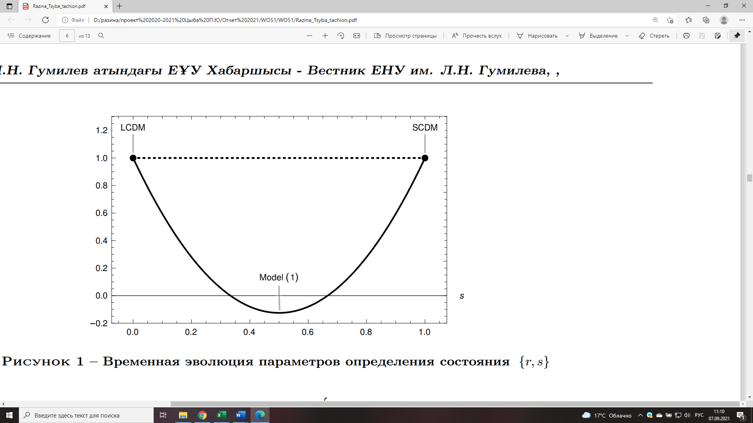

Figure 1 – Time evolution of statefinder parameters $\{r,s\}$

The second statefinder parameter $s$ has properties that complement the properties of the first $r$. Since $s$ is clearly independent of $Ω_{m}$, some of the properties belonging to $r$, are violated in the combined pair of state definition parameters $\{r,s\}$. The figure 1 shows the time evolution of the statefinder parameters of $\{r,s\}$. As can be seen from the figure, $s$ monotonically decreases to zero, and $r$ first decreases from one to a minimum value, and then increases to one. Our model is located to the right of the fixed point of the $ΛCDM$-model ($r=1,s=0$).

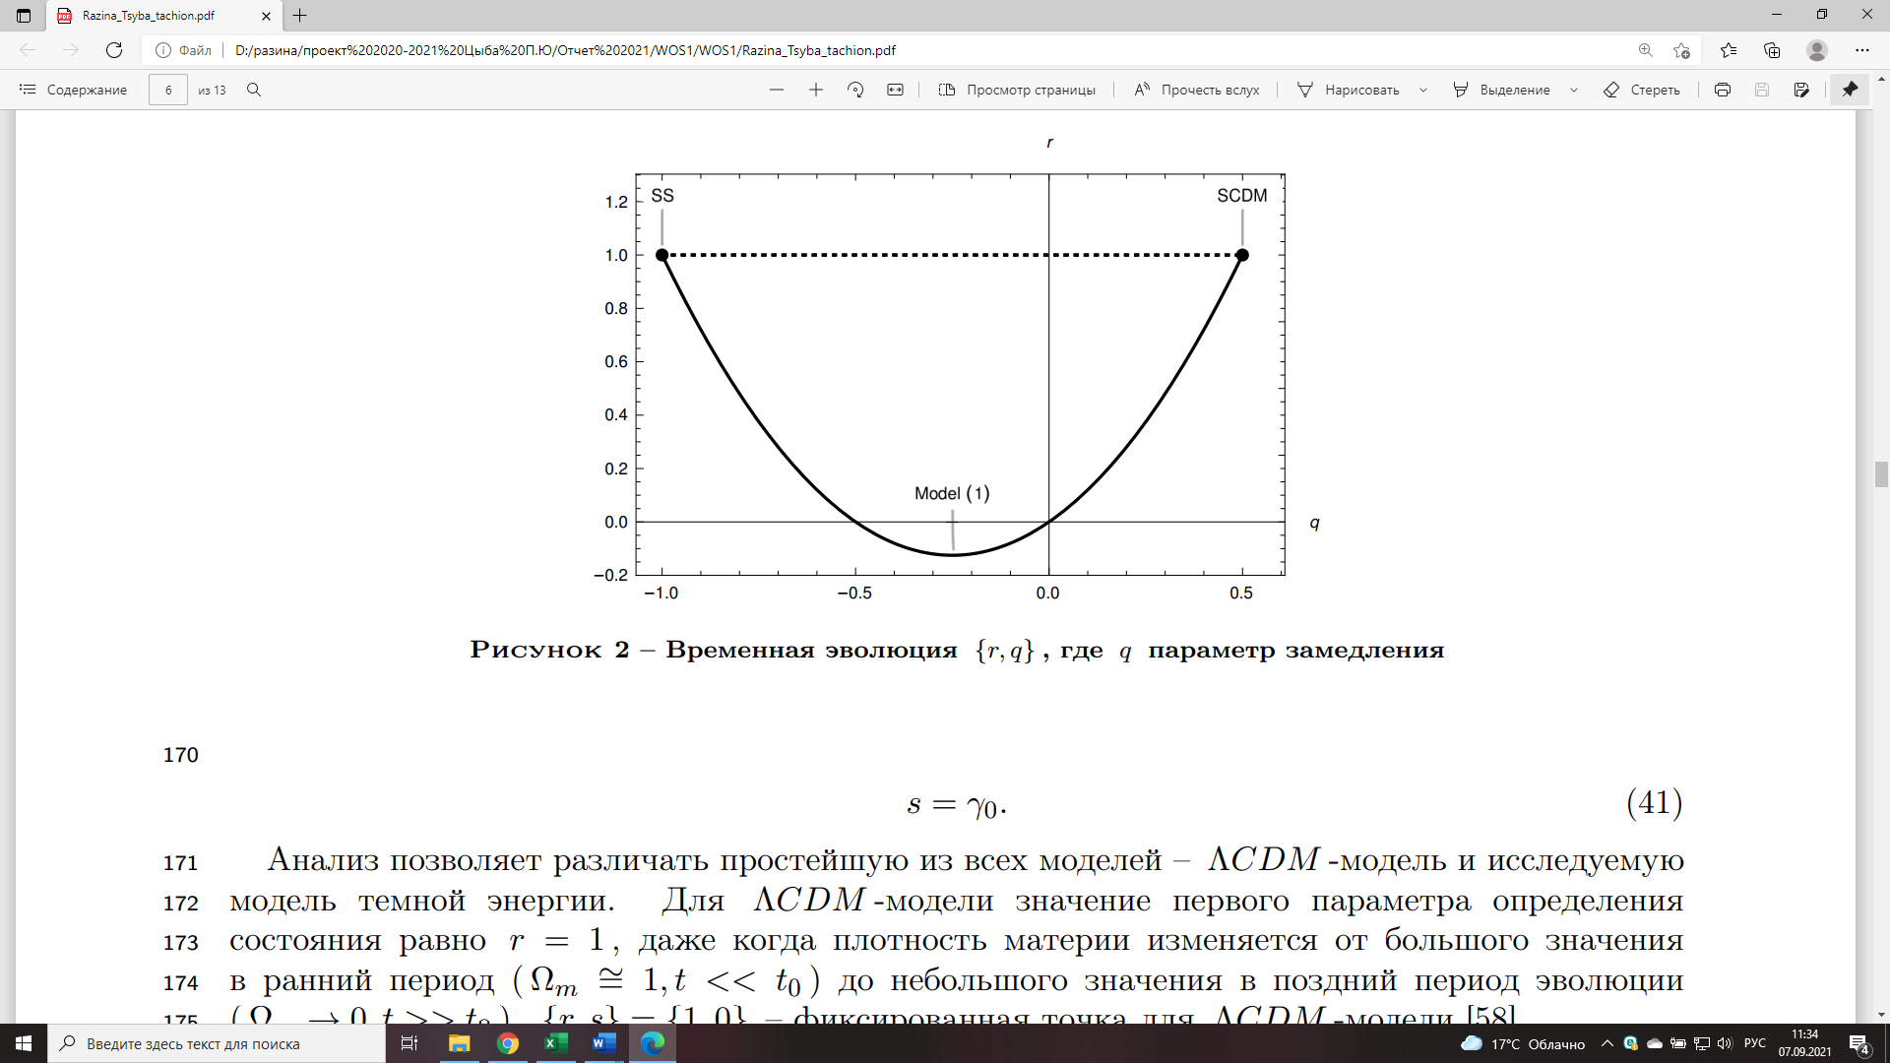

Figure 2 – Time evolution of $\{r,q\}$, where $q$ is the deceleration parameter

Figure 2 shows the time evolution of $\{r,q\}$, which from the equation (1.38) for the scale factor (1.31) is (1.42)

$r(q)=2q^{2}+q.$ (1.42)

The dependence graph $\{r,q\}$ passes in the past through the point $(r=1, q=0.5)$ corresponding to the universe with a predominance of matter (SCDM) and the point in the future $(r=1, q=-1)$ corresponding to stable state (SS) – which is de Sitter extensions. The lower the curve on the s-r graph, the less relevant the problem of coincidences becomes. The resulting curve does not differ qualitatively from the curves constructed in the previously studied models.

**1.4 Observational Data**

In this work, we use catalogue provided Union 2.1 data which contains 580 points from Type Ia Supernovae [77]. BAO data described in Table 1 [73], [78]-[95]. We also use 30 estimations as the Hubble parameters $H(z)$ measured from differential ages of galaxies and BAO data and summarised in Table 2, [96]-[101]. Finally, the CMB parameters are considered from the Plank mission [102]. In order to proceed with the analysis we make use of the technique of the minimum $χ^{2}$, which establishes the best set of the parameters. To do this, we use a two-dimensional grid, so that the free parameters are reduced for theoretical reasons, or due to marginalization.

For comparing the predictions of the model with the above sets of observational data, we use the functions $χ_{i}^{2}(i=SN,H,BAO,CMB)$, and the total function (1.43)

$χ_{tot}^{2}=χ_{SN}^{2}+χ_{H}^{2}+χ_{BAO}^{2}+χ_{CMB}^{2}.$ (1.43)

1.4.1 Supernovae Ia data

Union 2.1 compilation consists [77] $N_{SN}=580$ SNe Ia SNe Ia with their observed distance module $μ_{i}=μ_{i}^{obs}$ for redshift $z_{i}$ in the interval $0≤z_{i}≤1.41$. In order to fit free parameters of our model we compare $μ_{i}^{obs}$ with the theoretical value $μ^{th}(z_{i})$, where distance modulies is given by (1.44)

$μ(z)≡μ^{th}(z)=5\log_{10}\frac{D_{L}(z)}{10pc}, D_{L}(z)=c(1+z)\int_{0}^{z}{‍}\frac{d\tilde{z}}{H(\tilde{z})} .$ (1.44)

Here $D_{L}(z)$ is the luminosity distance. Corresponding function $χ^{2}$ is calculated by taking into account the differences between the SNe Ia observational data and model-specific predictions with parameters $p_{1},p_{2},…$, in view (1.45)

$χ_{SN}^{2}(p_{1},p_{2},…)=\min_{H_{0}}\sum_{i,j=1}^{N_{SN}}{‍}Δμ_{i}(C_{SN}^{-1})_{ij}Δμ_{j},$ (1.45)

where $Δμ_{i}=μ^{th}(z_{i},p_{1},…)-μ_{i}^{obs}$, $C_{SN}$ is the $580×580$ covariance matrix [93].

1.4.2 BAO data

Barion acoustic oscillations are obtained from galaxy clustering analysis and include measurements of two cosmological parameters [103] (1.46)

$d_{z}(z)=\frac{r_{s}(z_{d})}{D_{V}(z)}, A(z)=\frac{H_{0}\sqrt{Ω_{m}^{0}}}{cz}D_{V}(z),$ (1.46)

where $r_{s}(z_{d})$ is the sound horizont at the decoupling epoch and $D_{V}(z)$ is given by $D_{V}(z)=[\frac{czD_{L}^{2}(z)}{(1+z)^{2}H(z)}]^{1/3}.$

The values (1.46)) was estimated for the redshift $z=z_{i}$ of galaxies from a peak in the correlation function of the galaxy distribution at the comoving sound horizont scale $r_{s}(z_{d})$, which correspond to the decoupling of the photons $z_{d}$. In this work, we use the BAO data from refs. [73], [78]-[95] for the parameters (1.46, which provides $N_{BAO}=17$ data points for $d_{z}(z)$ and 7 data point for $A(z)$, and $C_{A}$ both shown in Table 1. We use the covariance matrices $C_{d}$ and $C_{A}$ for correlated data from [87], [90], described in detail in Refs. [104]. So the $χ^{2}$ for the values (1.46) and (1.47) yields

Table 1 – Values of $d_{z}(z)=r_{s}(z_{d})/D_{V}(z)$ и $A(z)$ (46) with errors

|  |  |  |  |  |  |  |
| --- | --- | --- | --- | --- | --- | --- |
| $z$ | $d_{z}(z)$ | $σ_{d}$ | $A(z)$ | $σ_{A}$ | Reference | Survey |
| 0.106 | 0.336 | 0.015 | 0.526 | 0.028 | [89] | 6dFGS |
| 0.15 | 0.2232 | 0.0084 | - | - | [94] | SDSS DR7 |
| 0.20 | 0.1905 | 0.0061 | 0.488 | 0.016 | [87, 90] | SDSS DR7 |
| 0.275 | 0.1390 | 0.0037 | - | - | [87] | SDSS DR7 |
| 0.278 | 0.1394 | 0.0049 | - | - | [88] | SDSS DR7 |
| 0.314 | 0.1239 | 0.0033 | - | - | [90] | SDSS LRG |
| 0.32 | 0.1181 | 0.0026 | - | - | [83] | BOSS DR11 |
| 0.35 | 0.1097 | 0.0036 | 0.484 | 0.016 | [87, 90] | SDSS DR7 |
| 0.35 | 0.1126 | 0.0022 | - | - | [91] | SDSS DR7 |
| 0.35 | 0.1161 | 0.0146 | - | - | [80] | SDSS DR7 |
| 0.44 | 0.0916 | 0.0071 | 0.474 | 0.034 | [90] | WiggleZ |
| 0.57 | 0.0739 | 0.0043 | 0.436 | 0.017 | [81] | SDSS DR9 |
| 0.57 | 0.0726 | 0.0014 | - | - | [83] | SDSS DR11 |
| 0.60 | 0.0726 | 0.0034 | 0.442 | 0.020 | [90] | WiggleZ |
| 0.73 | 0.0592 | 0.0032 | 0.424 | 0.021 | [90] | WiggleZ |
| 2.34 | 0.0320 | 0.0021 | - | - | [86] | BOSS DR11 |
| 2.36 | 0.0329 | 0.0017 | - | - | [85] | BOSS DR11 |

$χ_{BAO}^{2}(p_{1},p_{2},…)=Δd⋅C_{d}^{-1}(Δd)^{T}+ΔA⋅C_{A}^{-1}(ΔA)^{T} ,$ (1.47)

where $Δd$ and $ΔA$ column vector $Δd_{i}=d_{z}^{obs}(z_{i})-d_{z}^{th}(z_{i})$ и $ΔA_{i}=A^{obs}(z_{i})-A^{th}(z_{i})$.

1.4.3 $H(z)$ data

The Hubble parameter valueа $H$ at certain redshift $z$ can be measured with two methods: (1) extraction $H(z)$ from BAO data [73], [78]-[81], [83]-[86], [105] and (2) making $H(z)$ estimation from differential ages $Δt$ [96]-[101] via the following relation $H(z)=\frac{\dot{a}}{a}≈-\frac{1}{1+z}\frac{Δz}{Δt}.$ In this paper we used only $N_{H}=30$ values $H(z)$, estimated from differential ages of galaxies, represented in Table 2. The theoretical values $H^{th}(z_{i},p_{1},…)$, naturally depend on $H_{0}$. so the $χ^{2}$ function is marginalized over $H_{0}$ [106] in view (1.48)

Table 2 - Hubble parameter values H (z) with errors $σ_{H}$ from Refs [80]-[85]

|  |  |  |  |  |  |  |  |
| --- | --- | --- | --- | --- | --- | --- | --- |
| $z$ | $H(z)$ | $σ_{H}$ | Reference | $z$ | $H(z)$ | $σ_{H}$ | Reference |
| 0.070 | 69 | 19.6 | [99] | 0.4783 | 80.9 | 9 | [101] |
| 0.090 | 69 | 12 | [96] | 0.480 | 97 | 62 | [97] |
| 0.120 | 68.6 | 26.2 | [99] | 0.593 | 104 | 13 | [98] |
| 0.170 | 83 | 8 | [96] | 0.6797 | 92 | 8 | [98] |
| 0.1791 | 75 | 4 | [98] | 0.7812 | 105 | 12 | [98] |
| 0.1993 | 75 | 5 | [98] | 0.8754 | 125 | 17 | [98] |
| 0.200 | 72.9 | 29.6 | [99] | 0.880 | 90 | 40 | [97] |
| 0.270 | 77 | 14 | [96] | 0.900 | 117 | 23 | [96] |
| 0.280 | 88.8 | 36.6 | [99] | 1.037 | 154 | 20 | [98] |
| 0.3519 | 83 | 14 | [98] | 1.300 | 168 | 17 | [96] |
| 0.3519 | 83 | 14 | [98] | 1.363 | 160 | 33.6 | [100] |
| 0.3802 | 83 | 13.5 | [101] | 1.430 | 177 | 18 | [96] |
| 0.400 | 95 | 17 | [96] | 1.530 | 140 | 14 | [96] |
| 0.4004 | 77 | 10.2 | [101] | 1.750 | 202 | 40 | [96] |
| 0.4247 | 87.1 | 11.2 | [101] | 1.965 | 186.5 | 50.4 | [100] |

${\tilde{χ}}_{H}^{2}=\sum_{i=1}^{N_{H}}{‍}{\left[\frac{H^{obs}(z_{i})-H^{th}(z_{i},p_{j})}{σ_{H,i}}\right]}^{2}, χ_{H}^{2}=\min_{H_{0}}{\tilde{χ}}_{H}^{2}.$ (1.48)

1.4.4 CMB data

As opposed to the described above SNe Ia, BAO and $H(z)$, data corresponding to the late-time era $0<z≤2.36$, cosmological observations associated with CMB radiation [107]-[108] include parameters at the photon-decoupling epoch $z_{*}≈1090$ ( $z_{*}=1089.90±0.30$ [102]), particularly the comoving sound horizon $r_{s}(z_{*})$ and the transverse comoving distance (1.49)

$r_{s}(z)=\frac{1}{\sqrt{3}}\int_{0}^{1/(1+z)}{‍}\frac{da}{a^{2}H(a)\sqrt{1+[3Ω_{b}^{0}/(4Ω_{r}^{0})]a}} , D_{M}(z_{*})=\frac{D_{L}(z_{*})}{1+z_{*}}=c\int_{0}^{z_{*}}{‍}\frac{d\tilde{z}}{H(\tilde{z})} .$ (1.49)

In the present work, we use the CMB parameters in the following form [107], [108] in form (1.50)

$x=(R,l_{A},ω_{b})=(\sqrt{Ω_{m}^{0}}\frac{H_{0}D_{M}(z_{*})}{c}, \frac{πD_{M}(z_{*})}{r_{s}(z_{*})}, Ω_{b}^{0}h^{2})$ (1.50)

with the estimations (distance priors) [108] equal (1.51)

$R^{Pl}=1.7448±0.0054, l_{A}^{Pl}=301.46±0.094, ω_{b}^{Pl}=0.0224±0.00017.$ (1.51)

Here $Ω_{b}^{0}$- s the present time baryon fraction. The distance priors (1.51) with their errors $σ_{i}$ and the the covariance matrix

$$C_{CMB}=P{\tilde{C}}_{ij}σ_{i}σ_{j}P, \tilde{C}=\left(\begin{matrix}1 & 0.53 & -0.73 \\ 0.53 & 1 & -0.42 \\ -0.73 & -0.42 & 1\end{matrix}\right)$$

where derived in ref. [108] from the Planck collaboration data [102] with free amplitude of the lensing power spectrum. For the value $z_{*}$ we use the fitting formula [107]-[109]; the sound horizon $r_{s}(z_{*})$ is estimated from equation (49) as the correction $Δr_{s}=\frac{dr_{s}}{dz}Δz$.

Hence, the $χ^{2}$, function corresponding to the data (1.50)-(1.51), is obtained as follows (1.52)

$χ_{CMB}^{2}=\min_{H_{0},ω_{b}}{\tilde{χ}}_{CMB}^{2}, {\tilde{χ}}_{CMB}^{2}=Δx⋅C_{CMB}^{-1}(Δx)^{T}, Δx=x-x^{Pl}$ (1.52)

which is minimized by marginalizing over the additional parameter $ω_{b}=Ω_{b}^{0}h^{2}$. However, for the joint analysis of $H(z)$ and CMB data, the marginalization over $H_{0}$ is calculated simultaneously (1.53)

$χ_{H}^{2}+χ_{CMB}^{2}=\min_{H_{0}}({\tilde{χ}}_{H}^{2}+\min_{ω_{b}}{\tilde{χ}}_{CMB}^{2}).$ (1.53)

We present the results for the model considered here. The results of calculating the minimum of the function (1.43) for the model (1.30) are shown in Fig. 3-6. The figure 3-6 shows the corresponding functions of min $χ_{SNe}^{2}$, min $(χ_{SNe}^{2}+χ_{H}^{2})$, min $(χ_{SNe}^{2}+χ_{H}^{2}+χ_{BAO}^{2})$ и min $(χ_{SNe}^{2}+χ_{H}^{2}+χ_{BAO}^{2}+χ_{CMB}^{2})$. The figure 7 shows the dependence of min $χ^{2}$ on $γ_{0}$ and $Ω_{m}$.

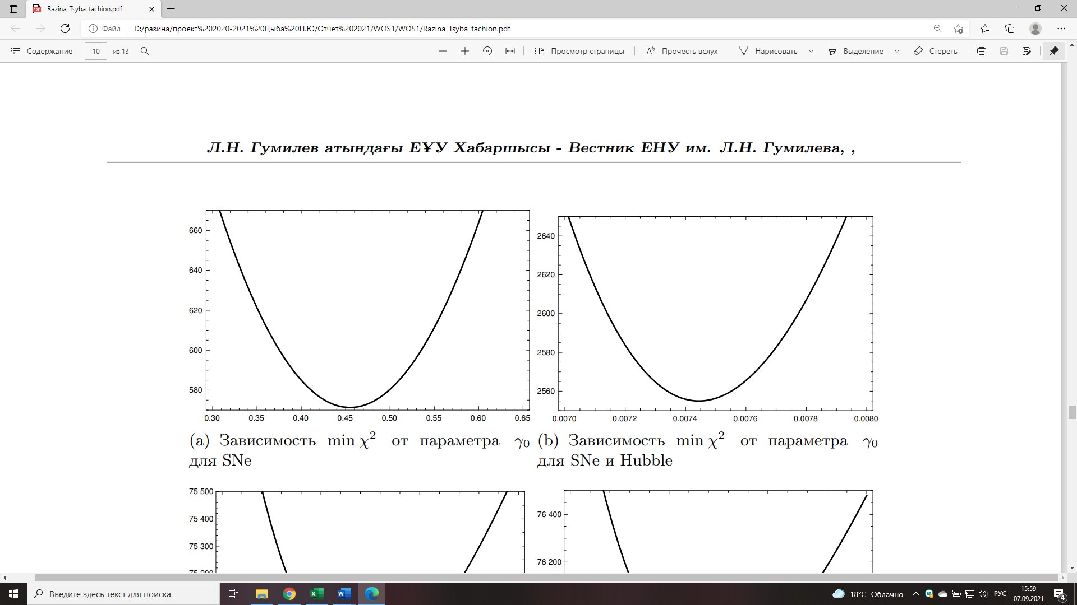

Figure 3 – Dependence of min $χ^{2}$ via $γ_{0}$ for SNe



Figure 4 – Dependence ofmin $χ^{2}$ via $γ_{0}$ for SNe and Hubble

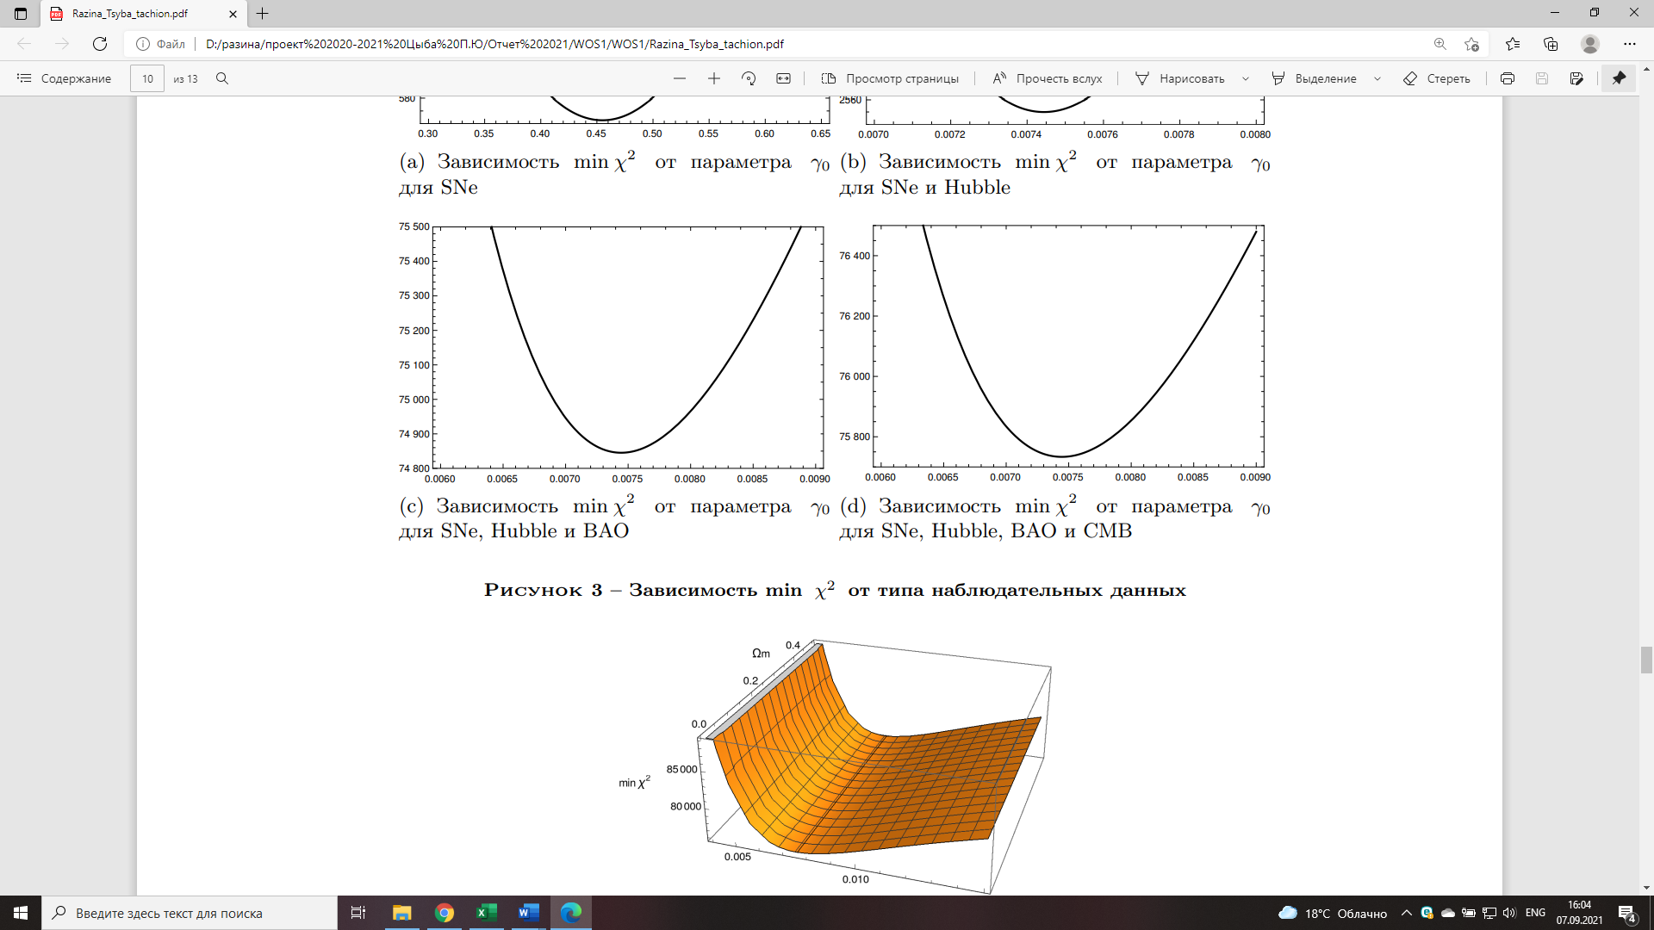

Figure 5 – Dependence of min $χ^{2}$ via $γ_{0}$ for SNe, Hubble and BAO



Figure 6 – Dependence of min $χ^{2}$ via $γ_{0}$ for SNe, Hubble, BAO and CMB

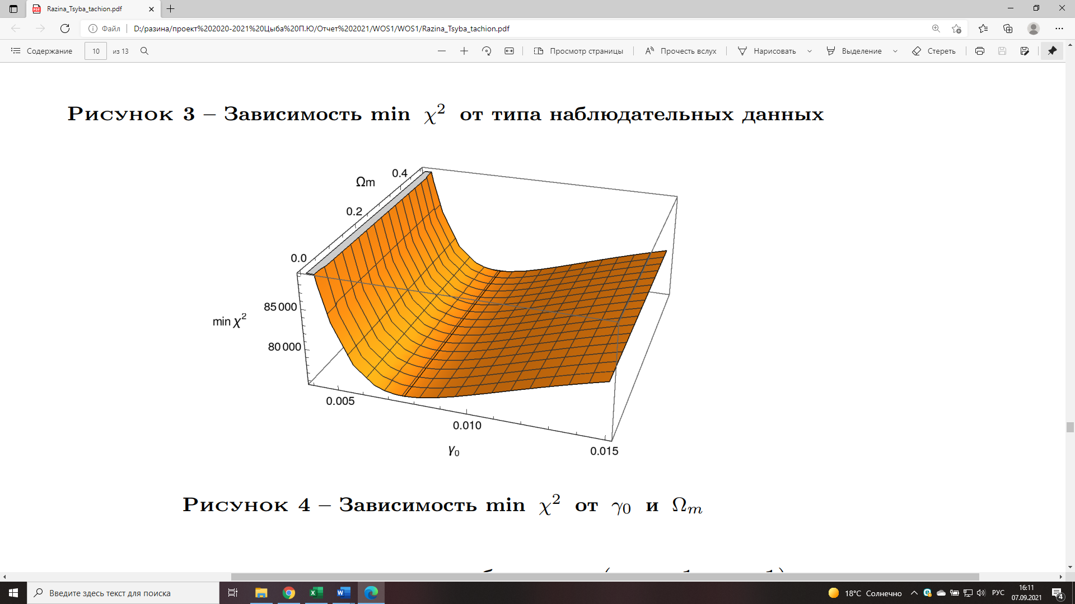

Figure 7 – Dependence of min $χ^{2}$ on $γ_{0}$ and $Ω_{m}$

**1.5 Conclusion**

The tachyonization method allows us to consider a cosmological model with the fermion field and the containing the tachyon field controlled by the potential. We have obtained the standard inverse square potential, which is widely used for tachyons, as well as the corresponding power law solutions for the scale factor. The tachyonization of the model under study was determined from the stability analysis and from the exact solutions of the standard tachyon field controlled by a given potential (1.27) together with the fermionic field with the controlled potential $V_{2}=V_{20}u^{γ}$.

It is seen that our obtained results, tachyon-fermionic model using stander parameters, is in agreement with the theory proposed in [74]. From the figure 2 it is clearly seen that our model starts from the predicted point in the past , which corresponds to the SCDM of the universe with a predominance of matter, and ends its evolution at a point in the future , which corresponds to the de Sitter extension.

Figure 3-6 demonstrates that as a result of the analysis of the model using supernova SNe we get and (figure 3) adding the data Hubble minimum increases , but at the same time the parameter decreases significantly (figure 4) data from BAO strongly changes the position of the minimum , but at the same time the parameter decreases slightly (figure 5); further application of CMB data leads to a slight increase in , and at the same time a slight increase in the parameter (figure 6). The large value is critical in relation to the Akaike information criterion . However, simultaneously, a decrease in the parameter makes this model stable and provides the possibility of a theory with an ordinary tachyon according to the criterion [45].

**2 Tachyonization cosmological model in the framework of linear form invariance transformations**

Our universe is currently undergoing an accelerated expansion phase. This is confirmed by various observational data [8]-[11]. Theorists speculate that there is a component of matter that currently dominates the energy density of the universe, which is why gravity is repulsive even under standard general relativity. Due to the lack of a complete understanding of the nature of this component, it is called dark energy. Many models of dark energy have been proposed in the literature [12]-[22]. In this article, we will consider a dark energy model based on a tachyon field using methods of form-invariance transformations (FIT). Features of these methods are the fact that with the help of FIT an unstable cosmological solution transforms into a stable one and vice versa.

Form-invariance transformations preserves the form of the equations of motion, since it has form-invariance symmetry (FIS) [110]. It was shown [111] that transformations affect the Hubble expansion rate, energy density, and pressure of the cosmic fluid. Such transformations belong to the Lie group. FIS defines a set of identical cosmological models, since each representation of the Lie group is associated with a certain cosmology, through certain fluids. From the quantum field theory, the T-duality comes, which connects a theory compactified on a circle of radius $R$ with another compactified theory on a circle of radius $1/R$ [112], [113]. In cosmology, the duality of the scale factor is used [114], which reflects the invariance property of the equations of motion. For the spatially flat FRW metric, the radius $R$ is replaced by the scale factor $a$, and the dual transformation $a→a^{-1}$ connects the contracting cosmology with the expanding one [111]. In [34], a method for obtaining phantom k-essence cosmologies using FIS is shown, in which phantom symmetry affects the potential, which leads to an expanded super-accelerated tachyon field.

Due to the emergence of a large number of different theoretical models and the improvement in the reliability of observational data, there is a need for reliable statistics that could distinguish cosmological models of dark energy from each other and from the $ΛCDM$ model. One of these statistics is the pair of the statefinder parameters $\left\{r,s\right\}$ [74]. In this paper, we will derive formulas for these parameters after applying FIT and find their values for the power scale factor. Then compare the results with the fixed point $ΛCDM$ model. From the standard tachyon field will get additional and the phantom field, as resalt we will do full tachionization of the flat universe, that is we will research model at all possible values of the barotropic index. Expansion of the barotropic index value will allow searching for a stable cosmological solution.

**2.1 Model**

In the model we are investigating, we choose the action in the form (2.1)

$S=\frac{1}{16πG}\int{‍}d^{4}x\sqrt{-g}\{\frac{1}{2}R+L_{m}\},$ (2.1)

where $R$– is Ricci scalar, $L_{m}$– is density of matter Lagrangian

Our aim is investigating internal symmetry Einstein equations jointly spatially flat, homogeneous, and isotropic universe FRW (1.9). Einstein equations conjointly FRW universe tend to Friedman equations (2.2)-(2.3)

$3H^{2}=ρ,$ (2.2)

$3H^{2}+2\dot{H}=-p,$ (2.3)

where $H=\frac{\dot{a}}{a}$ is a Hubble parameter and “dot” denotes derivatives with respect to the cosmic time.

A consequence of the Friedman equations (2.2)-(2.3) is an energy conservation equation (2.4)

$\dot{ρ}+3H(ρ+p)=0.$ (2.4)

For another cosmological model filled with an ideal fluid with energy density $\overline{ρ }$ and pressure $\overline{p}$, one can obtain similar expressions (2.5)-(2.7)

$3{\overline{H}}^{2}=\overline{ρ},$ (2.5)

$3{\overline{H}}^{2}+2\dot{\overline{H}}=-\overline{p},$ (2.6)

$\dot{\overline{ρ}}+3\overline{H}(\overline{ρ}+\overline{p})=0.$ (2.7)

The investigated cosmological models are invariant with respect to each other and it is possible to introduce a relationship between the energy densities (2.8)

$\overline{ρ}=\overline{ρ}(ρ).$ (2.8)

The Friedman equations have three unknown variables $(H,p,ρ)$, and using connection (2.8) can find relation for that variables (2.9)-(2.11)

$\frac{\overline{ρ}}{ρ}=\frac{3{\overline{H}}^{2}}{3H^{2}}, ⇒ \overline{H}=H{\left(\frac{\overline{ρ}}{ρ}\right)}^{\frac{1}{2}},$ (2.9)

$\overline{ρ}+\overline{p}=\frac{\dot{\overline{ρ}}}{\dot{ρ}}{\left(\frac{ρ}{\overline{ρ}}\right)}^{\frac{1}{2}}(ρ+p)=\frac{d\overline{ρ}}{dρ}{\left(\frac{ρ}{\overline{ρ}}\right)}^{\frac{1}{2}}(ρ+p),$ (2.10)

$\overline{p}=-\overline{ρ}+\frac{d\overline{ρ}}{dρ}{\left(\frac{ρ}{\overline{ρ}}\right)}^{\frac{1}{2}}(ρ+p).$ (2.11)

Each of investigating cosmological models is filled with perfect fluid with a barotropic equation of states accordingly $p=(γ-1)ρ$ и $\overline{p}=(\overline{γ}-1)\overline{ρ}.$ Barotropic indices $γ$ and $\overline{γ}$ have the next connection (2.12)

$\overline{γ}=\frac{\overline{ρ}+\overline{p}}{\overline{ρ}}=\frac{d\overline{ρ}}{dρ}{\left(\frac{ρ}{\overline{ρ}}\right)}^{\frac{3}{2}}γ.$ (2.12)

Form invariance transformation (2.9)-(2.12), generates Lie group [111]. The form-invariance of the symmetry is confirmed by the form-invariance of the transformations and shows the equivalence of the investigating models.

**2.2 Linear form-invariance of the transformations**

FIT can be introduced by following linear function [111] in view (2.13)

$\overline{ρ}=n^{2}ρ,$ (2.13)

where $n$ is arbitrary constant. In that case equations (2.9)-(2.11) take the form вид (2.14)-(2.16)

$\overline{H}=nH,$ (2.14)

$\overline{ρ}+\overline{p}=n(ρ+p),$ (2.15)

$\overline{p}=n\left[p+(1-n)ρ\right].$ (2.16)

Linear FIT induces linear expresses of variables $(H,p,ρ)$. We obtain power law connection for scale factors by integrating Eq. (2.17)

$\overline{a}=a^{n}$ (2.17)

and from Eq.(2.12) transformation for barotropic index (2.18)

$\overline{γ}=\frac{γ}{n}.$ (2.18)

We can relate the scale factor a of the original cosmological model to the scale factor $\overline{a}=a^{n}$ of another model due to the existence of the structure of the Lie group [45], [111].

**2.3 Tachyon model**

Let us investigate the behavior of the tachyon field and will show its transformation in accordance with the FIT (2.13)-(2.16). Density of matter Lagrangian tachyon field in a FRW metric becomes (2.19)

$L_{ϕ}=-V(ϕ)\sqrt{1-{\dot{ϕ}}^{2}},$ (2.19)

here $V(ϕ)$ is potential of tachyon field. We substitute Lagrangian (2.19) in action (2.1) using the Euler-Lagrange equation and obtain a dynamical system for the tachyon field as follows (2.20)-(2.21)

$3H^{2}=ρ,$ (2.20)

$3H^{2}+2\dot{H}=-p,$ (2.21)

where energy density $ρ$ and pressure $p$ are defined by expressions (2.22)-(2.23)

$ρ=\frac{V}{\sqrt{1-{\dot{ϕ}}^{2}}},$ (2.22)

$p=-V\sqrt{1-{\dot{ϕ}}^{2}}$ (2.23)

and Klein-Gordon equation (2.24)

$\frac{\ddot{ϕ}}{1-{\dot{ϕ}}^{2}}+3H\dot{ϕ}+\frac{V_{ϕ}}{V}=0.$ (2.24)

We obtain an expression connecting the square of the derivative of the tachyon field ${\dot{ϕ}}^{2}$ and the barotropic exponent $γ$, substituting into the equation of state $p=(γ-1)ρ$ the value of the energy density $ρ$ Eq. (2.22) and pressure $p$ Eq.(2.23)to analyze the stability of solutions. In this case it follows that (2.25)

$γ={\dot{ϕ}}^{2},$ (2.25)

where $0<γ<1$. Speed of sound $c_{s}^{2}=1-γ>0$ or take into account (2.25)

$c_{s}^{2}=1-{\dot{ϕ}}^{2}.$ (2.26)

The converted energy density and pressure of the tachyon field are equal (2.27) и (2.28)

$\overline{ρ}=\frac{\overline{V}}{\sqrt{1-{\dot{\overline{ϕ}}}^{2}}}=\frac{n^{2}V}{\sqrt{1-{\dot{ϕ}}^{2}}}$, (2.27)

$\overline{p}=-\overline{V}\sqrt{1-{\dot{\overline{ϕ}}}^{2}}=-\left(1-\frac{\dot{ϕ^{2}}}{n}\right)\frac{n^{2}V}{\sqrt{1-{\dot{ϕ}}^{2}}},$ (2.28)

where we used FIT (2.13) and pressure (2.16). From Eq. (2.18) and Eq. (2.25) -- (2.29)

${\dot{\overline{ϕ}}}^{2}=\frac{\dot{ϕ^{2}}}{n}$ (2.29)

We obtain the transformation expression for the tachyon field $\overline{ϕ}=\frac{ϕ}{\sqrt{n}}$, integrating the last expression. The transformation conditions for the potential of the tachyon field and the speed of sound are (2.30) and (2.31)

$\overline{V}=\overline{ρ}\sqrt{1-{\dot{\overline{ϕ}}}^{2}}=n^{2}V\sqrt{\frac{1-\frac{\dot{ϕ^{2}}}{n}}{1-\dot{ϕ^{2}}}},$ (2.30)

${\overline{c}}_{s}^{2}=1-{\dot{\overline{ϕ}}}^{2}=1-\frac{\dot{ϕ^{2}}}{n}$. (2.31)

FIT allows you to move from a non-stable cosmology to a stable one and vice-versa. A static universe containing an ideal fluid is always stable at the speed of sound $c_{s}^{2}>1/5$. If the initially investigated model has a barotropic index $γ$ corresponding to an unstable solution, then after using the transformation rule (2.31) we can obtain a stable cosmological model.

The usual tachyon field corresponds to $0<γ<1$. Tachyonization of the model at $1<γ$ will be achieved by the complementary tachyon field $ϕ_{c}$, and at $γ<0$- thephantom tachyon field $ϕ_{ph}$. These two kinds of tachyon field can be introduced from the tachyon field analyzed above by applying the transformations [34], [36], [46].

The complementary tachyon field $ϕ_{c}$ characterized by $1<γ$ or $1<{\dot{ϕ}}_{c}^{2}$ and expressions for it can be obtained from the standard tachyon field by an internal transformation $1-γ→-(1-γ)$, $1-{\dot{ϕ}}^{2}→-(1-{\dot{ϕ}}_{c}^{2})$ and $\sqrt{1-{\dot{ϕ}}^{2}}→\sqrt{-1}\sqrt{1-{\dot{ϕ}}_{c}^{2}}=i\sqrt{1-{\dot{ϕ}}_{c}^{2}}$. Having carried out a simultaneous replacement, we get (2.32) и (2.33)

${\overline{ρ}}_{c}=\frac{\left|\overline{V}\right|}{\sqrt{{\dot{\overline{ϕ}}}_{c}^{2}-1}},$ (2.32)



${\overline{p}}_{c}=\left|\overline{V}\right|\sqrt{{\dot{\overline{ϕ}}}_{c}^{2}-1}$. (2.33)



The phantom tachyon field $ϕ_{ph}$ characterized by $γ<0$, ${\dot{ϕ}}_{ph}^{2}=-γ$ and expressions for it can also be obtained from the standard tachyon field by an internal transformation. In that case $\sqrt{γ}→-i\sqrt{-γ}$, $ϕ→iϕ_{ph}$ and ${\dot{ϕ}}^{2}→i^{2}{\dot{ϕ}}_{ph}^{2}=-{\dot{ϕ}}_{ph}^{2}$. Having carried out a simultaneous replacement, we get (2.34) и (2.35)

${\overline{ρ}}_{ph}=\frac{\overline{V}}{\sqrt{1-{\dot{\overline{ϕ}}}^{2}}}=\frac{n^{2}V}{\sqrt{1-{\dot{ϕ}}^{2}}},$ (2.34)



$\overline{p}=-\overline{V}\sqrt{1-{\dot{\overline{ϕ}}}^{2}}=-\left(1-\frac{\dot{ϕ^{2}}}{n}\right)\frac{n^{2}V}{\sqrt{1-{\dot{ϕ}}^{2}}}.$ (2.35)

Expressions for two new types of tachyon fields were found using simple internal symmetries. All of them are needed to describe the time evolution of the scale factor (2.17) for all values of $γ$ and to carry out complete tachyonization of the flat FRW universe filled with an ideal fluid with barotropic equations of state $p=(γ-1)ρ$.

2.3.1 Statefinder parameters

The various properties of dark energy are highly dependent on the chosen model. Previously, specific evaluation criteria were invented in order to distinguish between different and competing cosmological models involving dark energy. In [74], [116], two parameters, called statefinders, were introduced, which make it possible to distinguish several models of dark energy. These parameters contain the scale factor $a(t)$ and its third derivative with respect to cosmic time $t$ (2.36), (2.37)

$r=\frac{\overset{⃛}{a}}{aH^{3}}=\frac{\ddot{H}}{H^{3}}-3q-2,$ (2.36)

$s=\frac{r-1}{3(q-1/2)},$ (2.37)

where $q$ is deceleration parameter $q=-a\ddot{a}/{\dot{a}}^{2}=-\ddot{a}/aH^{2}$. Using Eq. (2.14) and Eq. (2.17) we get transformation condition for statefinder parameters and deceleration parameter (2.38)-(2.40)

$\overline{r}=\frac{\overset{⃛}{\overline{a}}}{\overline{a}{\overline{H}}^{3}}=\frac{a^{2}\overset{⃛}{a}}{n^{2}{\dot{a}}^{3}}+3\frac{(n-1)a\ddot{a}}{n^{2}{\dot{a}}^{2}}+\frac{(n-1)(n-2)}{n^{2}},$ (2.38)

$\overline{s}=\frac{\overline{r}-1}{3(\overline{q}-1/2)}=\frac{2}{3n}\left(1-\frac{a^{2}\overset{⃛}{a}+(3n-1)a\dot{a}\ddot{a}}{2a\dot{a}\ddot{a}+(3n-2){\dot{a}}^{3}}\right),$ (2.39)

$\overline{q}=-\frac{\overline{a}\ddot{\overline{a}}}{{\dot{\overline{a}}}^{2}}=-\frac{a\ddot{a}}{n{\dot{a}}^{2}}+\frac{1-n}{n},$ (2.40)

where to derive the transformation conditions, we used the derivatives (2.41)-(2.43)

$\dot{\overline{a}}=na^{n-1}\dot{a},$ (2.41)

$\ddot{\overline{a}}=n(n-1)a^{n-2}{\dot{a}}^{2}+na^{n-1}\ddot{a},$ (2.42)

$\overset{⃛}{\overline{a}}=n(n-1)(n-2)a^{n-3}{\dot{a}}^{3}+3n(n-1)a^{n-2}\dot{a}\ddot{a}+na^{n-1}\overset{⃛}{a}.$ (2.43)

2.3.2 Solution

Let consider case when in transformation (2.13) $n^{2}=1$. When our solution divided into two subcases $n=1$ (2.44) and $n=-1$ (2.45)

$\overline{H}=H, \overline{ρ}+\overline{p}=ρ+p, \overline{a}=a,$ (2.44)

$\overline{H}=-H, \overline{ρ}+\overline{p}=-(ρ+p), \overline{a}=\frac{1}{a}.$ (2.45)

The first subcase corresponds to the identical transformation, and the second case corresponds to the dual transformation, for which the energy density $\dot{ρ}=-3H(ρ+p)≥0$ is an increasing function of time [111].

For $n=1$, the equations for the statefinder parameters and the deceleration parameter (2.38)-(2.40) take the standard form (2.36)-(2.37), and for $n=-1$ we get(2.46)-(2.48)

$\overline{r}=\frac{a^{2}\overset{⃛}{a}}{{\dot{a}}^{3}}-\frac{6a\ddot{a}}{{\dot{a}}^{2}}+6,$ (2.46)

$\overline{s}=-\frac{2}{3}\left(1-\frac{a^{2}\overset{⃛}{a}-4a\dot{a}\ddot{a}}{2a\dot{a}\ddot{a}-5{\dot{a}}^{3}}\right),$ (2.47)

$\overline{q}=\frac{a\ddot{a}}{{\dot{a}}^{2}}-2.$ (2.48)

From the conservation equation (2.4) we wet (2.49)

$\frac{\dot{ρ}}{ρ}=-3H(1+ω),$ (2.49)

where $ω$ equation of state parameter depends on cosmic time accordingly $ω=p/ρ$. We substitute equation (2.49) in Friedman equations (2.2) take the form (2.50)

$1+ω=-\frac{2\dot{H}}{3H^{2}},$ (2.50)

where we used the next relation $\frac{\dot{ρ}}{ρ}=\frac{2\dot{H}}{H}$. For tachyon field $\frac{p}{ρ}=ω={\dot{ϕ}}^{2}-1$. When we can get expression $\dot{ϕ}={\left(-\frac{2\dot{H}}{3H^{2}}\right)}^{\frac{1}{2}}$, by integrating which we get (2.51)

$ϕ(t)=\int{‍}{\left(-\frac{2\dot{H}}{3H^{2}}\right)}^{\frac{1}{2}}dt.$ (2.51)

We multiply equations (2.22) and (2.23) and use the Friedman equation (2.2) we get (2.52)

$ρp=-V^{2}, V=(-ρp)^{\frac{1}{2}}=(-ω)^{\frac{1}{2}}ρ=3H^{2}{\left(1+\frac{2\dot{H}}{3H^{2}}\right)}^{\frac{1}{2}}.$ (2.52)

For any scale factor $a(t)$ find the time dependence of the potential $V(t)$ and the tachyon field $ϕ(t)$*,* using equations (2.51) and (2.52) and hence the potential $V(ϕ)$. Also, from equation (2.51) we can conclude that for these models always $\dot{H}<0$. The tachyon potential, by analogy with the potential of a scalar field, can be used to control the expansion of the universe.

Consider the case when the expansion of the universe obeys the power law (2.53)

$a=a_{0}t^{α},$ (2.53)

where $a_{0}$ and $α$ are some positive constants, and for the accelerated expansion of the universe it is necessary $α>1$. In this case, equations (2.51) and (2.52) have the following solutions (2.54)

$ϕ(t)={\left(\frac{2}{3α}\right)}^{\frac{1}{2}}t+ϕ_{0}, V(t)=3α^{2}{\left(1-\frac{2}{3α}\right)}^{\frac{1}{2}}\frac{1}{t^{2}},$ (2.54)

where $ϕ_{0}$ integration constant. We find the potential $V(ϕ)$ (2.55) by replacing $t$ from Eq. (2.54)

$V=\frac{V_{0}}{(ϕ-ϕ_{0})^{2}},$ (2.55)

where $V_{0}=2α{\left(1-\frac{2}{3α}\right)}^{\frac{1}{2}}$. This potential diverges at $ϕ=ϕ_{0}$ and corresponds to the typical potential of bosonic string theory. The converted scale factor is $\overline{a}={\overline{a}}_{0}t^{\overline{α}}$ с ${\overline{a}}_{0}=a_{0}^{n}$ и $\overline{α}=nα.$ Expressions (55) correspond to the usual tachyon at $0<γ<1$. For the complementarytachyon field $ϕ_{c}$ at $1<γ$, which is a stiff matter with a cosmology of deceleration, using FIT we obtain (2.56)

${\overline{ϕ}}_{c}={\left(\frac{2}{3\overline{α}}\right)}^{\frac{1}{2}}t+ϕ_{c0}, \overline{α}=\frac{1}{3}\left(1±\sqrt{1-\frac{9V_{0}^{2}}{4}}\right).$ (2.56)

For phantom tachyon field $ϕ_{ph}$ with $γ<0$

(2.57)

${\overline{ϕ}}_{ph}={\left(-\frac{2}{3\left|\overline{α}\right|}\right)}^{\frac{1}{2}}t+ϕ_{ph0}, \overline{α}=\frac{1}{3}\left(1-\sqrt{1+\frac{9V_{0}^{2}}{4}}\right).$ (2.57)

For the scale factor (2.53), the statefinder parameters (2.36)-(2.37)and the deceleration parameter take the form (2.58)

$r=1-\frac{3}{α}+\frac{2}{α^{2}}, s=\frac{2}{3α}, q=-1+\frac{1}{α}$ (2.58)

and after FIT at $n=-1$ parameters (2.46)-(2.48)

$\overline{r}=1+\frac{3}{α}+\frac{2}{α^{2}}, \overline{s}=-\frac{2}{3α}, \overline{q}=-1-\frac{1}{α}.$ (2.59)

We exclude the parameter $α$ from equations (2.58) and (2.59)

$r(s)=\frac{9}{2}s^{2}-\frac{9}{2}s+1, r(q)=2q^{2}+q$ (2.60)

$\overline{r}(\overline{s})=\frac{9}{2}{\overline{s}}^{2}-\frac{9}{2}\overline{s}+1, \overline{r}(\overline{q})=2{\overline{q}}^{2}+\overline{q}$ (2.61)

Point $\{r,s\}=\{1,0\}$ is fixed point for $ΛCDM$-model [23]. It can be seen from equations (2.60)-(2.61)that the graphs of the functions $r(s)$ and $\overline{r}(\overline{s})$ pass through this point and are located to the right of it. Dependency graphs $\{r,q\}$ and $\{\overline{r},\overline{q}\}$ pass in the past through the point $\{1, 0.5\}$ corresponding to the universe with a predominance of matter (SCDM) and the point in the future $\{1,-1\}$ corresponding to stable state (SS) - de Sitter extensions.

**2.4 Scalar field**

Let us explore the behaviour of the scalar field and show transformation in FIT accordance (2.14)-(2.16). Matter Lagrangian of the scalar field for FRW metric equal to (2.62)

$L_{b}=\frac{1}{2}\dot{φ^{2}}-V\left(φ\right),$ (2.62)

here V (ϕ) is potential of the scalar field. In case of the scalar field, Einstein equation (2.20)-(2.21) and Klein-Gordon equation take the form (2.63)

$\ddot{φ}+3H\dot{φ}+V_{φ}=0$ (2.63)

where energy density ρ and pressure p are defined by expressions (2.64), (2.65)

$ρ=\frac{1}{2}\dot{φ^{2}}+V\left(φ\right),$ (2.64)

$p=\frac{1}{2}\dot{φ^{2}}-V\left(φ\right).$ (2.65)

Using the equation (2.64) and (2.65) we can find dependence on time of potential V(ϕ) and the scalar field for any scale factor *a*(t). It means, that potential V(ϕ) (2.66) и (2.67)

$φ=\int{\sqrt{-2\dot{H}}dt},$ (2.66)

$V\left(φ\right)=\dot{H}+3H^{2}.$ (2.67)

The solution will be considered as neutral stable if the condition the speed of sound $c_{s}^{2}=1-γ>1/5$ satisfies. To analyse the stability of the solutions, we obtain an expression relating the square of the derivative of the scalar field ${\dot{φ}}^{2}$ and barotropic index $γ$, substituting into the equation of state $p=\left(γ-1\right)ρ$ the energy density $ρ$ (2.64) and the pressure $p$ (2.65). In this case it follows that (2.68)

$γ=\frac{ρ+p}{ρ}=\frac{{\dot{φ}}^{2}}{ρ},$ (2.68)

where $0<γ<1$ and speed of sound equals to (2.69)

$c_{s}^{2}=1-\frac{{\dot{φ}}^{2}}{ρ}.$ (2.69)

The converted energy density and pressure of the scalar field are equal to (2.70) and (2.71)

$\overline{ρ}=\frac{1}{2}{\dot{\overline{φ}}}^{2}+\overline{V}\left(\overline{φ}\right)=n^{2}\left(\frac{1}{2}{\dot{φ}}^{2}+V\left(φ\right)\right),$ (2.70)

$\overline{p}=\frac{1}{2}{\dot{\overline{φ}}}^{2}-\overline{V}\left(\overline{φ}\right)=\frac{n\left(2-n\right)}{2}{\dot{φ}}^{2}-n^{2}V\left(φ\right),$ (2.71)

where we used the FIT (2.13) and expression for pressure (2.16). From (2.18) and (2.68)

${\dot{\overline{φ}}}^{2}=n{\dot{φ}}^{2}.$ (2.72)

After integrating the last equation, we obtain a transformation expression for the scalar field $\overline{φ}=\sqrt{n}$. The transformation conditions for the potential of the scalar field and the speed of sound are (2.73) и (2.74)

$\overline{V}=\frac{n\left(n-1\right)}{2}{\dot{φ}}^{2}+n^{2}V\left(φ\right),$ (2.73)

$\overline{c_{s}^{2}}=1-\overline{γ}=1-\frac{{\dot{ϕ}}^{2}}{nρ}.$ (2.74)

The transformations of the time dependence of the potential $\overline{V}\left(t\right)$ and the scalar $\overline{φ}\left(t\right)$ equial to (2.75) and (2.76)

$\overline{φ}=\int{\sqrt{-2\dot{\overline{H}}}dt}=\int{\sqrt{-2n\dot{H}}dt},$ (2.75)

$\overline{V}\left(φ\right)=\dot{\overline{H}}+3{\overline{H}}^{2}=n\dot{H}+3n^{2}H^{2}.$ (2.76)

2.4.1 Slow roll parameters and spectral indices

For description of inflation, we introduce the slow roll parameters in terms of the Hubble parameter (2.77), [67], [117]

$ϵ_{H}=-\frac{\dot{H}}{H^{2}}, η_{H}=-\frac{\ddot{φ}}{H\dot{φ}}=-\frac{1}{2}\frac{\ddot{H}}{H\dot{H}}.$ (2.77)

The slope of the potential $ϵ_{V}(φ)$ and the curvatureа $η_{V}(φ)$, hich are called the parameters of the slow roll are defined through the potential and the scalar field function, as follows [118], (2.78)

$ϵ_{V}(φ)=\frac{1}{2}{\left(\frac{V_{φ}}{V}\right)}^{2}, η_{V}(φ)=\frac{V_{φφ}}{V}.$ (2.78)

If the potential of the scalar field and the scalar field function are expressed by the respect with terms of a time derivative, then expressions (2.78) can be rewritten as (2.79) [67], [119],

$ϵ_{V}(t) = \frac{1}{2{\dot{φ}}^{2}}{\left(\frac{\dot{V}}{V}\right)}^{2},{ η}_{V}(t) =\left(\frac{\ddot{V}}{{\dot{φ}}^{2}}-\frac{\dot{V}\ddot{φ}}{{\dot{φ}}^{3}}\right)\frac{1}{V}.$ (2.79)

If they are small, they will equal to slow roll in Hubble parameter terms (2.80)

$ϵ_{V}≈ϵ_{H},$ (2.80)

$η_{V}≈η_{H}+ϵ_{H}.$ (2.81)

For the emergence and continuation of the inflationary stage, it is necessary that these parameters are in the area (2.82)

$ϵ_{V}(ϕ)<<1, \left|η_{V}(ϕ)\right|<<1.$ (2.82)

A useful quantity is the number of e-folds defined as $N=ln(a)$, which measures the amount of space-time expansion. The slow roll approximation yields a N given by as (2.83)

$N=\int_{t_{1}}^{t_{2}}{‍}Hdt=\int_{φ_{end}}^{φ}{‍}\frac{H}{\dot{φ}}dφ,$ (2.83)

where $φ_{end}$ is the value at the end of inflation, when (2.82), executes, and the upper limit in the integral is the value relative to the value of $φ$ at crossing the horizon. If the value of the potential function $V(φ)$ is known one can make predictions about inflation, that can be experimentally verified by measuring the power spectrum [120]. It is counted backwards in time from the end of inflation. In other words, N = 60 - is before the end of inflation.

Slow roll parameters approximately describe of the inflation dynamic and observational features of different models. We use the following spectral indices, which we find through the parameters of the slow roll [120], to compare our model with observational data (2.84)

$$n_{S}-1=-4ϵ_{H}+2η_{H}≈-6ϵ_{V}+2η_{V},$$

$n_{T}=-2ϵ_{H}≈-2ϵ_{V},$ $r_{*}=16ϵ_{H}≈16ϵ_{V},$ (2.84)

where $n_{S}$ is the scalar spectral index, $n_{T}$ is the tensor spectral index and $r_{*}$ is the tensor-to-scalar ratio.

2.4.2 Search for solution

Let's consider the case, when expansion of the universe is described by power law solution (2.85)

$a=a_{0}t^{α},$ (2.85)

where $a_{0}$ and $α$ arbitrary and positive constants, and for the accelerated expansion of the universe it is necessary $α>1$. In that case equations (2.66) and (2.67) have the next solutions (2.86)

$φ(t)=\sqrt{2α}lnt+φ_{0}, V(t)=\frac{V_{0}}{t^{2}},$ (2.86)

where $φ_{0}$ integration constant and $V_{0}=α(3α-1)$. From (2.86) we can findц $V(φ)$ replacing $t$ in view (2.87)

$V=V_{0}e^{\frac{\sqrt{2α}}{α}(φ_{0}-φ)}.$ (2.87)

Energy density $ρ$ and pressure $p$ are determined, respectively, from the expressions (2.64) and (2.65)

$ρ=\frac{3α^{2}}{t^{2}}, p=\frac{α(2-3α)}{t^{2}}.$ (2.88)

Slow roll parameters in Hubble terms, using (2.77) and into account scale factor (2.85) take the form (2.89)

$ε_{H}=\frac{1}{α}, η_{H}=\frac{1}{α}.$ (2.89)

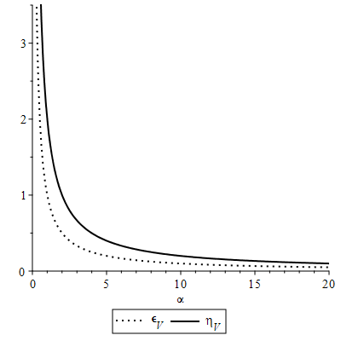

Figure 8 – Dependence of the e-folding via cosmic time (2.90) via $α$.

Slow roll parameters in potential terms, using (2.79) and into account scale factor (2.85) take the form (2.90) and were shown on figure 8

$ε_{V}=\frac{1}{α}, η_{V}=\frac{2}{α}.$ (2.90)

As follows from (2.89) and (2.90) conditions (2.80) and (2.81) are satisfied for the case under study. The transformed scale factor is $\overline{a}={\overline{a}}_{0}t^{\overline{α}}$ с ${\overline{a}}_{0}=a_{0}^{n}$ и $\overline{α}=nα$. In this case, the equations (2.75) and (2.76) have the following solutions (2.91)

$\overline{φ}(t)=\sqrt{2αn}lnt+{\overline{φ}}_{0}, \overline{V}(t)=\frac{αn(3αn-1)}{t^{2}},$ (2.91)

where ${\overline{φ}}_{0}=\sqrt{n}φ_{0}$ is integration constant. From (2.91) we find $\overline{V}(\overline{φ})$ replacing $t$, in resalt we get (2.92)

$\overline{V}={\overline{V}}_{0}e^{\frac{\sqrt{2αn}}{αn}({\overline{φ}}_{0}-\overline{φ})},$ (2.92)

where ${\overline{V}}_{0}=αn(3αn-1)$. The transformed energy density is $\overline{ρ}$ and pressure $\overline{p}$ are determined, respectively, from the expressions (2.70) and (2.71) equials to (2.93)

$\overline{ρ}=\frac{3n^{2}α^{2}}{t^{2}}, \overline{p}=\frac{(2-3nα)}{t^{2}}.$ (2.93)

The transformed slow roll parameters in Hubble terms are (2.94)

${\overline{ε}}_{H}=\frac{1}{nα}, {\overline{η}}_{H}=\frac{1}{nα}.$ (2.94)

The transformed slow roll parameters in potential terms are (2.95)

${\overline{ε}}_{V}=\frac{1}{nα}, {\overline{η}}_{V}=\frac{2}{nα}.$ (2.95)

As follows from (2.94) and (2.95) for the transformed model, the conditions (2.80) and (2.81). E-folds accordingly (2.83) for the scale factor (2.85) take the form (2.96)

$N=lnt^{α}.$ (2.96)

Time dependence of the function (2.96) is presented by figure 9. The spectral indices (2.84) in terms of the $α$ parameter and the e-folding (2.96) are equal (2.97)

$n_{S}=1-\frac{2}{α}=1+lnt^{-\frac{2}{N}},$ $n_{T}=-\frac{2}{α}=lnt^{-\frac{2}{N}},$ $r_{*}=\frac{16}{α}=lnt^{\frac{16}{N}}=8(1-n_{S}).$ (2.97)

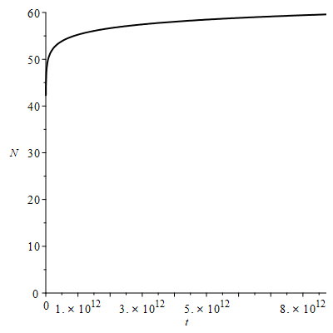

Figure 9 – Dependence of the e-folding via cosmic time $t$, at $α=2$

Figures 10 and 11 show graphs of the dependence of spectral indices (2.97) on the parameter $α$ and time $t$, at $N=60$ ( $n_{S}$ dotted line, $n_{T}$ solid line and $r_{*}$ dotted line).

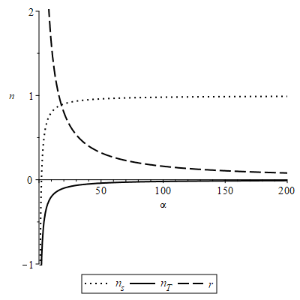

Figure 10 – Dependence of the spectral indices (2.97) via $α$

The values of the scalar spectral index $n_{S}$ and the boundaries of the value of the tensor-scalar ratio $r_{*}$ are given by the expression [121], Plank data accordingly

$n_{S}=0.9649±0.0042 (68\% CL),$ (2.98)

$r_{0.002}<0.056 (95\% CL).$ (2.99)

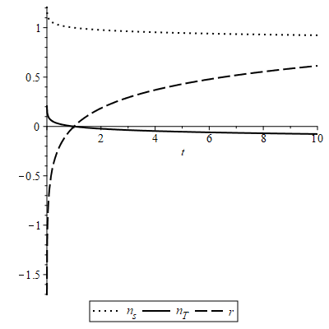

Figure 11 – Dependence of the spectral indices (2.97) via time $t$, at $N=60$

**2.5 Conlusion**

By investigating our model, we have shown that FIP can be used to obtain new solutions to the Einstein equation. For the tachyon field, the possibility of the existence of two types of expanded tachyons was proved in the same way as in [36]. From the standard tachyon field $(0<γ<1)$, additional $(1<γ)$ and phantom $(γ<0)$ tachyon fields were obtained. With the help of these fields, a complete tachyonization of the flat universe of the FRU filled with an ideal liquid with barotropic equations of state $p=(γ-1)ρ$ was carried out\rho for all values of $γ$ and scale factor (2.53).

In the study of the scalar field, it was shown that the FIP allows you to move from an unstable cosmology to a stable one and vice versa. A static universe containing an ideal fluid is always stable at the speed of sound $c_{s}^{2}>1/5$. From the expression (2.68) for the studied model with a power scale factor (2.85), it follows that $γ=\frac{{\dot{φ}}^{2}}{ρ}=-\frac{2\dot{H}}{3H^{2}}=\frac{2}{3α}$ Therefore, the speed of sound is equal to $c_{s}^{2}=1-γ=1-\frac{2}{3α}>1/3$,at $α>1$ which is necessary for the accelerated expansion of the Universe and our initial model is always stable. After applying the FEP, the speed of sound is equal to $c_{s}^{2}=1-\frac{2}{3nα}$ and since there are no restrictions on n, the transformed model can be both stable and unstable.

**CONCLUSION**

Brief conclusions on the results of the work of 2021 and its individual stages.

The results of the second year of work on the project were completed in full in accordance with the calendar plan (Application A-С). The results obtained can be summarized as follows:

1 The tachyonization method allows us to consider a cosmological model with the fermion field and containing the tachyon field controlled by the potential. We have obtained the standard inverse square potential, which is widely used for tachyons, as well as the corresponding power law solutions for the scale factor. The tachyonization of the model under study was determined from the stability analysis and from the exact solutions of the standard tachyon field controlled by a given potential (1.27), together with the fermionic field with the controlled potential $V_{2}=V_{20}u^{γ}$.

It is seen that our obtained results, tachyon-fermionic model using statefinder parameters are in agreement with the theory proposed in [74]. From the figure 2 it is clearly seen that our model starts from the predicted point in the past , which corresponds to the SCDM of the universe with a predominance of matter, and ends its evolution at a point in the future , which corresponds to the de Sitter extension.

Figure 3-6 demonstrates that as a result of the analysis of the model using supernova SNe we get and (figure 3) adding the data Hubble minimum increases , but at the same time the parameter decreases significantly (figure 4) data from BAO strongly changes the position of the minimum , but at the same time the parameter decreases slightly (figure 5); further application of CMB data leads to a slight increase in , and at the same time a slight increase in the parameter (figure 6). The large value is critical in relation to the Akaike information criterion . However, simultaneously, a decrease in the parameter makes this model stable and provides the possibility of a theory with an ordinary tachyon according to the criterion [45]. The speed of sound for this model, which is confirmed by the observational data, is $c_{s}^{2}=1-γ_{0}=0.992>1/5$. Considering the Lagrangian of the tachyon field with allowance for ${\dot{ϕ}}^{2}=γ_{0}=0,00744$, which is small, it can be seen that only the potential part will make the main contribution to the Lagrangian of the tachyon field. That is, the kinetic energy of the tachyon field will be small compared to the potential energy. This leads to a slow roll effect in the late universe, that is, accelerated expansion. From the figure 7 it follows that the model under study has a minimum only with respect to the parameter $γ_{0}$ and the impossibility of achieving minimum with respect to the parameter $Ω_{m}$.

Along with the obtained advantages, the tachyon-fermionic model has a disadvantage - the Akaike parameter is high compared to the $ΛCDM$ model. Another drawback of the investigated model is the difference of the $Ω_{m}$ parameter from the predictions of the $ΛCDM$ model.

2 By researching model, we have shown that form invariance transformations can be used to obtain new solutions to the Einstein equation. As in [36], we proved the possibility of the existence of two types of extended tachyons. The complementary ($1<γ$) and the phantom $(γ<0$) tachyon fields were obtained from the standard tachyon field ( $0<γ<1$). These fields were used to complete tachyonization of the FRW universe filled with an ideal fluid with barotropic equations of state $p=(γ-1)ρ$ for all values $γ$ and scale factor (2.53).

A method was shown for finding the time dependence of the potential $V(t)$ and the tachyon field $ϕ(t)$ for any scale factor $a(t)$. We were convinced that the tachyon potential, by analogy with the potential of a scalar field, can be used to control the expansion of the universe.

Derived formulas of the statefinder and the deceleration parameter after applying FIT. From the performed study of our tachyon model using statefinder, it can be seen that the results obtained $\{r,s\}=\{1,0\}$ agree with the theory proposed in [74].

3 The researching results indicate that form invariance transformations can be used to obtain new solutions to the Einstein equations. Moreover, FIT allows to move from an unstable cosmology to a stable one and vice versa. The static universe containing an perfect fluid is always stable at the speed of sound $c_{s}^{2}>1/5$. From the expression (2.68) for the model under study with (2.85) it follows that $γ=\frac{{\dot{φ}}^{2}}{ρ}=-\frac{2\dot{H}}{3H^{2}}=\frac{2}{3α}$. Therefore, the speed of sound is $c_{s}^{2}=1-γ=1-\frac{2}{3α}>1/3$, which is necessary for the accelerated expansion of the universe and our original model always stable. After applying FIT, the speed of sound is $c_{s}^{2}=1-\frac{2}{3nα}$ and since there are no restrictions on $n$ the transformed model can be both stable and unstable.

Method for finding the time dependence of the potential $V(t)$ and the scalar field $φ(t)$ for any scale factor $a(t)$ was illustrated. The scalar field potential can be used to control the expansion of the universe that has been verified.

The slow roll parameters were found and their graphs were plotted. From the graph 8 it can be seen that for $α→∞$ the slow roll parameters are $ϵ_{V}(ϕ)<<1$, $\left|η_{V}(ϕ)\right|<<1$ and the model under study describes the inflationary stage. After applying FIT, the model also describes inflation, but the beginning or end of the inflationary stage will depend not only on the value $α$ and also on the value $n$. The graphs 10 and 11 show the dependence of the spectral indices (2.97) on the parameter $α$ and $t$. The results of the investigated model have been shown in the graph 10 at large values of $α$ are in good agreement with the observational data of Planck (2.98)-(2.99).

Recommendations for using the results. The results of the work can be used by scientists working in similar areas.

Assessment of technical and economic efficiency of implementation. Technical and economic implementation was not envisaged within the framework of the project.

Justification of the scientific and technical level. The scientific and technical level of the conducted research corresponds to the level adopted for similar tasks in world practice.

**REFERENCE**

1 Armendariz-Picon C., Damour T., Mukhanov V.F. k-inflation // Physical Letters B. – 1999. – Vol. 458, N7. – P. 209-218.

2 Armendariz-Picon C., Mukhanov V.F., Steinhardt P.J. Essentials of k-essence // Physical Review D. – 2010. – Vol. 63, N10. – P. 3510.

3 Chiba T., Okabe T., Yamaguchi M. Kinetically driven quintessence // Physical Review D. – 2000. – Vol. 62, N2. – P. 3511.

4 De Putter R., Linder E.V. Kinetic k-essence and Quintessence // Astroparticle Physics. – 2007. – Vol. 28, N2. – P. 263-272.

5 Kofman L., Linde A. D., and Starobinsky A. A. Reheating after inflation // Physical Review Letters. – 1994. – Vol. 73. – P. 3195.

6 Shtanov Y., Traschen J. H., and Brandenberger R. H. Universe reheating after inflation // Physical Review D. – 1995. – Vol. 51. – P. 5438.

7 Shokri M., Sadeghi J., Setare M. R. and Capozziello S. Nonminimal coupling inflation with constant slow roll // International Journal of Modern Physics D. – 2021 – Vol. 30, N09. – P. 2150070.

8 Perlmutter S., Aldering G., Goldhaber G., Knop R.A., NugentP., Castro P.G., Deustua S., Fabbro S., Goobar A., Groom D.E., Hook I. M., Kim A.G., Kim M.Y., Lee J.C., Nunes N.J., Pain R., Pennypacker C.R., Quimby R., Lidman C., Ellis R.S., Irwin M., McMahon R.G., Ruiz-Lapuente P., Walton N., Schaefer B, Boyle B.J., Filippenko A.V., Matheson T., Fruchter A.S., Panagia N., Newberg H.J.M., Couch W.J. Measurements of and from 42 High-Redshift Supernovae // Astrophysical Journal. – 1999. – Vol. 517, N2. – P.564.

9 Riess A.G., Filippenko A.V., Challis P., Clocchiattia A., Diercks A., Garnavich P.M., Gilliland R.L., Hogan C.J., Jha S., Kirshner R.P., Leibundgut B., Phillips M.M., Reiss D., Schmidt B.P., Schommer R.A., Smith R.Ch., Spyromilio J., Stubbs Ch., Suntzeff N.B., Tonry J. Observational Evidence from Supernovae for an Accelerating Universe and a Cosmological Constant // Astronomical Journal. – 1998. – Vol. 116, N3. – P. 1009.

10 Riess A. G. et al. Type Ia supernova discoveries at $z>1$ from the Hubble Space Telescope: Evidence for past deceleration and constraints on dark energy evolution // Astrophysical Journal. – 2004. – Vol 607. – P.665–687.

11 Spergel D.N., Verde L., Peiris H.V., Komatsu E., Nolta M.R., Bennett C.L., Halpern M., Hinshaw G., Jarosik N., Kogut A., Limon M., Meyer S.S., Page L., Tucker G.S., Weiland J. L., Wollack E., Wright E.L. First Year Wilkinson Microwave Anisotropy Probe (WMAP) Observations: Determination of Cosmological Parameters // Astrophysical Journal Supplements Series. – 2003. – Vol. 148, N1. – P. 175.

12 Nojiri S. and Odintsov S. D. The future evolution and finite-time singularities in F(R)-gravity unifying the inflation and cosmic acceleration // Physical Review D. – 2008. – Vol. 78. – P. 046006.

13 Nojiri S. Odintsov S. D. Introduction to Modified Gravity and Gravitational Alternative for Dark Energy // International Journal of Geometric Methods in Modern Physics. – 2007. – Vol. 04, N01. – P. 115-145.

14 Bamba K., Nojiri S. and Odintsov S. D. Future of the universe in modified gravitational theories: Approaching to the finite-time future singularity // Journal of Cosmology and Astroparticle Physics. – 2008. – Vol. 0810. – P. 045.

15 Bamba K., Odintsov S. D., Sebastiani L., Zerbini S. Finite-time future singularities in modified Gauss-Bonnet and F(R,G) gravity and singularity avoidance // The European Physical Journal C. – 2010. – Vol. 67. – P. 295.

16 Kulnazarov I., Yerzhanov K., Razina O., Myrzakul Sh., Tsyba P., Myrzakulov R. G-essence with Yukawa Interactions // The European Physical Journal C. - 2011. - Vol.71, N7. - P. 1698

17 Razina O., Myrzakulov Y., Serikbayev N., Myrzakul S., Nugmanova G., Myrzakulov R. G-essence cosmologies with scalar-fermion interactions // European Physical Journal Plus. - 2011. - Vol.126, N9. - P. 85

18 Cai Y.F., Wang J. Dark Energy Model with Spinor Matter and Its Quintom Scenario // Classical and Quantum Gravity. – 2008. – Vol. 25, N16. – P. 5014.

19 Razina O., Tsyba P., Meirbekov B., Myrzakulov R. Cosmological Einstein-Maxwell model with g-essence // International Journal of Modern Physics D. – 2019. – Vol. 28, N10. – P. 1950126.

20 Razina O., Tsyba P., Sagidullayeva Z. M. Power solution of the f(R)-gravity with Maxwell term and g-essence // Bulletin. of the University of Karaganda-Physics. – 2019. – Vol.1, N93. – P. 94-102.

21 Bamba K., Razina O., Yerzhanov K., Myrzakulov R. Cosmological evolution of equation of state for dark energy in G-essence models // International Journal of Modern Physics D. – 2013. – Vol. 22, N6. – P. 1350023.

22 Myrzakulov R., Saez-Gomez D., Tsyba P. Cosmological solutions in F(T) gravity with the presence of spinor fields // International Journal of Geometric Methods in Modern Physics. – 2015. – Vol. 12. – P.1550023.

23 Mandal S., Myrzakulov N., Sahoo P.K., Myrzakulov R. Cosmological bouncing scenarios in symmetric teleparallel gravity // European Physical Journal Plus. – 2021. – Vol. 136. – P. 760.

24 Iosifidis D., Myrzakulov N., Myrzakulov R. Metric-Affine Version of Myrzakulov F(R,T,Q,T) Gravity and Cosmological Applications // Universe. – 2021. – Vol. 7, N8. – P. 262.

25 Myrzakulov N., Bekov S., Myrzakulova Sh., Myrzakulov R. Cosmological model of F(T) gravity with fermion fields via Noether symmetry // Journal of Physics: Conference Series. – 2019. – Vol. 1391, N1. – P. 012165.

26 Myrzakulov K., Kenzhalin D., Myrzakulov N. Teleparallel gravity with non-minimally coupled f-essence via Noether symmetry approach // Journal of Physics: Conference Series. – 2021. – Vol. 1730, N1. – P. 012022.

27 Saridakis E.N, Myrzakul S, Myrzakulov K, Yerzhanov K. Cosmological applications of F (R,T) gravity with dynamical curvature and torsion // Physical Review D. – 2020. – Vol. 102. – P. 023525.

28 Yerzhanov K., Yesmakhanova K., Tsyba P., Myrzakulov N., Nugmanova G., Myrzakulov R. g-Essence as the cosmic speed-up // Astrophysics and Space Science. – 2012. – Vol. 341, N2, – P.681-688.

29 Tegmark M., Strauss M., Blanton M., Abazajian K., Dodelson S., Sandvik H., Wang X., Weinberg D., Zehavi I., Bahcall N., Hoyle F., Schlegel D., Scoccimarro R., Vogeley M., Berlind A., Budavari T., Connolly A., Eisenstein D., Finkbeiner D., Frieman J., Gunn J., Hui L., Jain B., Johnston D., Kent S., Lin H., Nakajima R., Nichol R., Ostriker J., Pope A., Scranton R., Seljak U., Sheth R., Stebbins A., Szalay A., Szapudi I., Xu Y. Cosmological parameters from SDSS and WMAP // Physical Review D. – 2004. – Vol. 69, N10. – P. 3501.

30 Padmanabhan T. Accelerated expansion of the universe driven by tachyonic matter // Physical Review D. – 2002. – Vol. 66. – P. 021301.

31 Feinstein A. Power-law inflation from the rolling tachyon // Physical Review D. – 2002. – Vol. 66. – P. 063511.

32 Abramo L. R. W. and Finelli F. Cosmological dynamics of the tachyon with an inverse power-law potential // Physics Letters B. – 2003. – Vol. 575, N3. – P.165.

33 Aguirregabiria J. M. and Lazkoz R. Tracking solutions in tachyon cosmology // Physical Review D. – 2004. – Vol. 69. – P. 123502.

34 Aguirregabiria J. M., Chimento L.P. and Lazkoz R. Phantom k-essence cosmologies // Physical Review D. – 2004. – Vol. 70. – P. 023509.

35 Calcagni G., and Liddle A. R. Tachyon dark energy models: Dynamics and constraints // Physical Review D. – Physical Review D. – 2006. – Vol. 74. – P. 043528.

36 Chimento L. P., Forte M., Kremer G.M., Ribas M. O. Tachyonization of the $Λ$ CDM cosmological model // General Relativity and Gravitation. – 2010. – Vol. 42. – P. 1523-1535.

37 Campuzano C., del Campo S., and Herrera R. Curvaton reheating in tachyonic inflationary models // Physics Letters B. – 2006. – Vol. 633. – P. 149.

38 Chattopadhyay S., Debnath U., and Chattopadhyay G. Acceleration of the Universe in presence of tachyonic field // Astrophysics and Space Science. – 2008. – Vol. 314. – P. 41.

39 del Campo S., Herrera R., and Toloza A. Tachyon field in intermediate inflation // Physical Review D. – 2009. – Vol. 79. – P. 083507.

40 Jain R. K., Chingangbam P., and Sriramkumar L. Reheating in tachyonic inflationary models: Effects on the large scale curvature perturbations // Nuclear Physics B. – 2011. – Vol. 852. – P. 366.

41 Bagla J. S., Jassal H. K. and Padmanabhan T. Cosmology with tachyon field as dark energy // Physical Review D. – 2003. – Vol. 67. – P. 063504.

42 Guo Z. K. and Zhang Y. Z. Cosmology with tachyon field as dark energy // Journal of Cosmology and Astroparticle Physics. – 2004. – Vol. 0408. – P. 010.

43 Copeland E. J., Garousi M. R., Sami M. and Tsujikawa S. What is needed of a tachyon if it is to be the dark energy? // Physical Review D. – 2005. – Vol. 71. – P. 043003.

44 Rudinei C. de Souza, Kremer Gilberto M. Primordial scalar perturbations in tachyonic power-law inflation // Physical Review D. – 2014. – Vol. 89. – P. 027302.

45 Sanchez G Extended tachyon field using form invariance symmetry // Physical Review D. – 2014. – Vol.90. – P. 027308.

46 Chimento L. P. Extended tachyon field, Chaplygin gas, and solvable k-essence cosmologies // Physical Review D. – 2004. – Vol. 69 – P. 123517.

47 Shi Sh.-G., Piao Y-S., Qiao C.-F. Cosmological Evolution of a Tachyon-Quintom Model of Dark Energy // Journal of Cosmology and Astroparticle Physics. – 2009. – Vol. 0904. – P. 027.

48 Rangdee R, Gumjudpai B. Tachyonic (phantom) power-law cosmology // Astrophysics and Space Science. – 2014. – Vol. 349. – P. 975.

49 Novosyadlyj B Tachyonic fields in cosmology // arXiv:1311.0227v3.

50 Chimento L P Interacting fluids generating identical, dual and phantom cosmologies // Physics Letters B. – 2006. – Vol. 633. – P. 9.

51 Nojiri S. and Odintsov S. D. Introduction to Modified Gravity and Gravitational Alternative for Dark Energy // International Journal of Geometric Methods in Modern Physics. – 2007. – Vol. 4, N1. – P. 115.

52 Bamba K., Nojiri S. and Odintsov S. D. The universe future in modified gravity theories: approaching the finite-time future singularity // Journal of Cosmology and Astroparticle Physics. – 2008. – Vol. 0810. – P. 045.

53 Elizalde E., Khurshudyan M., Nojiri Sh. Cosmological singularities in interacting dark energy models with an ω(q) parametrization // International Journal of Modern Physics D. – 2019. – Vol. 28. – P. 1950019.

54 Elizalde E., Khurshudyan M. Cosmology with an interacting van der Waals fluid // International Journal of Modern Physics D. – International Journal of Modern Physics D. – 2018. – Vol. 27. – P. 1850037.

55 Elizalde E., Lidsey J., Nojiri Sh., Odintsov S. Born-Infeld Quantum Condensate as Dark Energy in the Universe // Physics Letters B. – 2003. – Vol. 574. – P. 1.

56 Cognola G., Elizalde E., Nojiri S., Odintsov S. D., Sebastiani L. and Zerbini S. Class of viable modified f(R) gravities describing inflation and the onset of accelerated expansion // Physical Review D. – 2008. – Vol. 77. – P. 046009.

57 Cognola G., Elizalde E., Nojiri S., Odintsov S. D. and Zerbini S. Dark energy in modified Gauss-Bonnet gravity: Late-time acceleration and the hierarchy problem // Physical Review D. – 2006. – Vol. 73. – P. 084007.

58 Elizalde E., Nojiri S. and Odintsov S. D. Late-time cosmology in a (phantom) scalar-tensor theory: Dark energy and the cosmic speed-up // Physical Review D. – 2004. – Vol. 70. – P. 043539.

59 Razina O., Jamil M., Myrzakulov Y., Myrzakulov R. Modified Chaplygin Gas and Solvable F-essence Cosmologies // Astrophysics and Space Science. – 2011. – Vol.336, N12. – P.315-325.

60 Ribas M.O., Devecchi F.P., Kremer G.M. Fermions as sources of accelerated regimes in cosmology // Physical Review D. – 2005. – Vol. 72, N12. – P. 3502.

61 Samojeden L.L., Devecchi F.P., Kremer G.M. Fermions in Brans-Dicke cosmology // Physical Review D. – 2010. – Vol. 81, N2. – P. 7301.

62 Samojeden L.L., Kremer G.M., Devecchi F.P. Accelerated expansion in bosonic and fermionic 2D cosmologies with quantum effects // Europhysics Letters. – 2009. – Vol. 87, N10. – P. 1.

63 Wang J., Cui S.-W., Zhang C.-M. Thermodynamics of Spinor Quintom // Physics Letters B. – 2010. – Vol. 683, N2-3. – P. 101-107.

64 Ribas M.O., Devecchi F.P., Kremer G.M. Cosmological model with non-minimally coupled fermionic field // Europhysics Letters. – 2008. – Vol. 81, N1. – P. 9001.

65 Momeni D, Myrzakulov Y, Tsyba P, Yesmakhanova K, Myrzakulov R Fermionic DBI and Chaplygin gas unified models of dark energy and dark matter from f -essence // Journal of Physics Conference Series. – 2012. – Vol. 354. – P.012011.

66 Rakhi R., Vijayagovindan G.V., Indulekha K. A cosmological model with fermionic field // International Journal of Modern Physics A. – 2010. – Vol. 25, N13. – P.2735.

67 Razina O V, Tsyba P Yu, Myrzakulov R, Meirbekov B, Shanina Z Cosmological Yang-Mills model with k-essence // Journal of Physics Conference Series. – 2019. – Vol. 1391. – P. 012164.

68 Eisenstein D.J., Zehavi I., Hogg D.W., Scoccimarro R., Blanton M.R., Nichol R.C., Scranton R., Seo H., Tegmark M., Zheng Z., Anderson S., Annis J., Bahcall N., Brinkmann J., Burles S., Castander F.J., Connolly A., Csabai I., Doi M., Fukugita M., Frieman J. A., Glazebrook K., Gunn J.E., J. S. Hendry J.S., Hennessy G., Ivezic Z., Kent S., Knapp G.R., Lin H., Loh Y., Lupton R.H., Margon B., McKay T., Meiksin A., Munn J.A., Pope A., Richmond M., Schlegel D., Schneider D., Shimasaku K., Stoughton C., Strauss M., SubbaRao M., Szalay A.S., Szapudi I., Tucker D., Yanny B., York D. Detection of the Baryon Acoustic Peak in the Large-Scale Correlation Function of SDSS Luminous Red Galaxies // Astrophysical Journal. – 2005. – Vol. 633, N2. – P.560.

69 Seljak U., Makarov A., McDonald P., Anderson S., Bahcall N., Brinkmann J., Burles S., Cen R., Doi M., Gunn J., Ivezic Z., Kent S., Lupton R., Munn J., Nichol R., Ostriker J., Schlegel D., Tegmark M., Van den Berk D., Weinberg D., York D. Cosmological parameter analysis including SDSS Ly-alpha forest and galaxy bias: Constraints on the primordial spectrum of fluctuations neutrino mass, and dark energy // Physical Review D. – 2005. – Vol. 71, N10. – P. 3515.

70 Spergel D.N., Bean R., Dor O., Nolta M.R., Bennett C.L., Dunkley J., Hinshaw G., Jarosik N., Komatsu E., Page L., Peiris H.V., Verde L., Halpern M., Hill R.S., Kogut A., Limon M., Meyer S.S., Odegard N., Tucker G.S., Weiland J.L., Wollack E., Wright E.L. Wilkinson Microwave Anisotropy Probe (WMAP) three years results: Implications for cosmology // Astrophysical Journal Supplement Series. – 2003. – Vol. 172, N2. – P. 377.369

71 Komatsu E., Smith K.M., Dunkley J., Bennett C.L., Gold B., Hinshaw G., Jarosik N., Larson D., Nolta M.R., Page L., Spergel D.N., Halpern M., Hill R.S., Kogut A., Limon M., Meyer S.S., Odegard N., Tucker G.S., Weiland J.L., Wollack E., Wright E.L. Seven-Year Wilkinson Microwave Anisotropy Probe (WMAP) Observations: Cosmological Interpretation // Astrophysical Journal Supplement Series. – 2011. – Vol. 192, N2. – P. 18.

72 Jain B., Taylor A. Cross-correlation Tomography: Measuring Dark Energy Evolution with Weak Lensing // Physical Review Letters. – 2003. – Vol. 91, N14. – P.1302.

73 Gaztanaga E., Cabre A., Hui L. Clustering of Luminous Red Galaxies IV: Baryon Acoustic Peak in the Line-of-Sight Direction and a Direct Measurement of H(z) // Monthly Notices of the Royal Astronomical Society. – 2009. – Vol. 399, N3. – P. 1663.

74 Alam U, Sahni V, Saini T. D., Starobinsky A. A. Exploring the Expanding Universe and Dark Energy using the Statefinder Diagnostic // Monthly Notices of the Royal Astronomical Society. – 2003. – Vol.344. – P.1057.

75 Sahni V., Saini T. D., Starobinsky A. A., Alam U. Statefinder -- a new geometrical diagnostic of dark energy // Journal of Experimental and Theoretical Physics Letters. – 2003. – Vol. 77. – P. 201.

76 Sanchez G, Santillan O. P. Perturbations in some models of tachyonic inflation // General Relativity and Gravitation. – 2015. – Vol.47. – P.118.

77 Suzuki N. et al. The Hubble space telescope cluster Supernova Survey: V. Improving the dark energy constraints above z > 1 and building an early-type-hosted supernova sample // The Astrophysical Journal. – 2012. – Vol. 746. – P. 85.

78 Blake C. et al. The WiggleZ Dark Energy Survey: Joint measurements of the expansion and growth history at z < 1 // Monthly Notices of the Royal Astronomical Society. – 2012. – Vol. 425, N.1. – P. 405.

79 Busca N. G. et al. Baryon Acoustic Oscillations in the Ly-α forest of BOSS quasars // Astronomy and Astrophysics. – 2013. – Vol. 552. – P. A96.

80 Chuang C-H. and Wang Y. Modeling the Anisotropic Two-Point Galaxy Correlation Function on Small Scales and Improved Measurements of H(z), DA(z), and f(z) from the Sloan Digital Sky Survey DR7 Luminous Red Galaxies // Monthly Notices of the Royal Astronomical Society. – 2013. – Vol. 435, N1. – P. 255.

81 Chuang C-H. et al. The clustering of galaxies in the SDSS-III Baryon Oscillation Spectroscopic Survey: single-probe measurements and the strong power of f(z)σ8(z) on constraining dark energy // Monthly Notices of the Royal Astronomical Society. – 2013. – Vol.433, N4. – P. 3559.

82 Anderson L. et al. The clustering of galaxies in the SDSS-III Baryon Oscillation Spectroscopic Survey: Measuring D_A and H at z=0.57 from the Baryon Acoustic Peak in the Data Release 9 Spectroscopic Galaxy Sample // Monthly Notices of the Royal Astronomical Society. – 2014. – Vol. 439. – P. 83.

83 Anderson L. et al. The clustering of galaxies in the SDSS-III Baryon Oscillation Spectroscopic Survey: Measuring D_A and H at z=0.57 from the Baryon Acoustic Peak in the Data Release 9 Spectroscopic Galaxy Sample // Monthly Notices of the Royal Astronomical Society. – 2014. – Vol. 441. – P. 24.

84 Oka A., Saito Sh, Nishimichi T., Taruya A., Yamamoto K. Simultaneous constraints on the growth of structure and cosmic expansion from the multipole power spectra of the SDSS DR7 LRG sample // Monthly Notices of the Royal Astronomical Society. – 2014. – Vol. 439, N3. – P. 2515.

85 Font-Ribera A. et al. Quasar-Lyman α Forest Cross-Correlation from BOSS DR11: Baryon Acoustic Oscillations // Journal of Cosmology and Astroparticle Physics. – 2014. – Vol. 05. – P. 027.

86 Delubac et al. T. Baryon acoustic oscillations in the Lyα forest of BOSS DR11 quasars // Astronomy and Astrophysics. – 2015. – Vol. 574. – P A59.

87 Percival W. J. et al. Article Navigation Baryon acoustic oscillations in the Sloan Digital Sky Survey Data Release 7 galaxy sample // Monthly Notices of the Royal Astronomical Society. – 2010. – Vol. 401. – P. 2148.

88 Kazin E. A. et al. The Baryonic Acoustic Feature and Large-Scale Clustering in the Sloan Digital Sky Survey Luminous Red Galaxy Sampl // The Astrophysical Journal. – 2010. – Vol. 710. – P. 1444.

89 Beutler F. et al. Article Navigation The 6dF Galaxy Survey: baryon acoustic oscillations and the local Hubble constant // Monthly Notices of the Royal Astronomical Society. – 2011. – Vol. 416. – P. 3017.

90 Blake C. et al. The WiggleZ Dark Energy Survey: mapping the distance–redshift relation with baryon acoustic oscillations // Monthly Notices of the Royal Astronomical Society. – 2011. – Vol. 418. – P. 1707.

91 Padmanabhan N. et al. A 2 per cent distance to z = 0.35 by reconstructing baryon acoustic oscillations – I. Methods and application to the Sloan Digital Sky Survey // Monthly Notices of the Royal Astronomical Society. – 2012. – Vol. 427. – P.2132.

92 Seo H.-J. et al. Acoustic scale from the angular power spectra of SDSS-III DR8 photometric luminous galaxies // The Astrophysical Journal. – 2012. – Vol. 761. – P. 13.

93 Kazin E. A. et al. The WiggleZ Dark Energy Survey: improved distance measurements to z = 1 with reconstruction of the baryonic acoustic feature // Monthly Notices of the Royal Astronomical Society. – 2014. – Vol. 441. – P. 3524.

94 Ross A. J. et al. The clustering of the SDSS DR7 main Galaxy sample – I. A 4 per cent distance measure at z = 0.15 // Monthly Notices of the Royal Astronomical Society. – 2015. – Vol. 449. – P. 835.

95 Aubourg E., et al. Cosmological implications of baryon acoustic oscillation measurements // Physical Review D. – 2015. –Vol.92, N12. – P. 123516.

96 Simon J., Verde L. and Jimenez R. Constraints on the redshift dependence of the dark energy potential // Physical Review D. – 2005. – Vol.71, N 12. – P. 123001.

97 Stern D., Jimenez R., Verde L., Kamionkowski M. and Stanford S. A. Cosmic chronometers: constraining the equation of state of dark energy. I: H(z) measurements // Journal of Cosmology and Astroparticle Physics. – 2010. – Vol. 2010, N02. – P. 008.

98 Moresco M. et al. Improved constraints on the expansion rate of the Universe up to z ∼ 1.1 from the spectroscopic evolution of cosmic chronometers // Journal of Cosmology and Astroparticle Physics. – 2012. – Vol. 2012, N08. – P. 006.

99 C. Zhang et al., Four New Observational H(z) Data From Luminous Red Galaxies of Sloan Digital Sky Survey Data Release Seven // Research in Astronomy and Astrophysics. – 2014. – Vol.14, N 10. – P. 1221.

100 Moresco M. Raising the bar: new constraints on the Hubble parameter with cosmic chronometers at z ∼ 2 // Monthly Notices of the Royal Astronomical Society. – 2015. – Vol. 450, N1. – P. 16.

101 Moresco M. et al. A 6% measurement of the Hubble parameter at z∼0.45: direct evidence of the epoch of cosmic re-acceleration // Journal of Cosmology and Astroparticle Physics. – 2016. – Vol.2016, N05. – P. 014.

102 Planck Collaboration, P. A. R. Ade et al. Astronomy and Astrophysics. – 2016. – Vol.594, NA13. – P.63.

103 Eisenstein D.J.et al. Detection of the Baryon Acoustic Peak in the Large-Scale Correlation Function of SDSS Luminous Red Galaxies // The Astrophysical Journal. – 2005. – Vol.633, N2. – P. 560.

104 Nojiri S., and Sergei D. Odintsov S.D. and Gomez D. S-Ch. and German S. Sharov Modeling and testing the equation of state for (Early) dark energy // Physics of the Dark Universe. -- 2021. -- Vol.32, N 2212. -- P.100837.

105 Anderson L. et al. The clustering of galaxies in the SDSS-III baryon oscillation spectroscopic survey: baryon acoustic oscillations in the data releases 10 and 11 galaxy samples // Monthly Notices of the Royal Astronomical Society. 2014. Vol. 441, N 1. -- P. 24–62.

106 Sharov G. S., Bhattacharya S., Pan S., Nunes R. C. and Chakraborty S. A new interacting two-fluid model and its consequences // Monthly Notices of the Royal Astronomical Society. – 2017. – Vol. 466. N3. – P. 3497.

107 Wang Y. and Wang S. Distance Priors from Planck and Dark Energy Constraints from Current Data // Physical Review D. – 2013. – Vol. 88, N4. – P. 069903.

108 Huang Q.-G., Wang K., Wang S. Distance priors from Planck 2015 data // Journal of Cosmology and Astroparticle Physics. – 2015. – Vol. 2015, N12. – P. 022.

109 Hu W. and Sugiyama N. Small-Scale Cosmological Perturbations: An Analytic Approach // The Astrophysical Journal. – 1996. – Vol .471, N2. – P. 542.

110 Gieres F. Symmetries in Physics // Proceedings of the fifth Seminaire Rhodanien de Physique. – 1997. – Vol.1. – P.42.

111 Chimento L. P., Richarte M. G., Sanchez G. Form invariance symmetry generates a large set of FRW cosmologies // Modern Physics Letters A. – 2013. – Vol. 28, N 4. – P. 1250236.

112 Green M. B., Schwarz J. H., Witten E. Superstring theory. – England: Cambridge University Press, 1987. – 469 p.

113 Polchinski J. String Theory I - II. – England: Cambridge University Press, 1998. – 531 p.

114 Veneziano G. Scale factor duality for classical and quantum strings // Physics Letters B. – 1991. – Vol. 265. – P. 287.

115 Forte M. Linking phantom quintessences and tachyons // Physical Review D. – 2014. – Vol. 90. – P. 027302.

116 Sahni V., Saini T.D., Starobinsky A. A., Alam U. Statefinder – A new geometrical diagnostic of dark energy // Journal of Experimental and Theoretical Physics Letters. – 2003. – Vol. 77. – P. 201.

117 Bekov S., Myrzakulov K., Myrzakulov R., Gomez DSC General Slow-Roll Inflation in f(R) Gravity under the Palatini Approach // Symmetry-Basel. – 2020. – Vol. 12. – P. 1958.

118 Lidlle A., Lyth D. Cosmological Inflation and Large-Scale Structure. – England: Cambridge university press, 2000. – 400 p.

119 Tsyba P., Razina O., Barkova Z., Bekov S. and Myrzakulov R. Scenario of the evolution of the universe with equation of state of the Weierstrass type gas // Journal of Physics: Conference Series. – 2019. – Vol. 1391. – P. 012162.

120 Mauricio G. Slow-roll inflation in $f(R,T)$ gravity and a modified Starobinsky-like inflationary model // Physics of the Dark Universe. – 2021. – Vol.31. – P. 100768.

121 Akrami Y. et al. Planck 2018 results. X. Constraints on inflation // Astronomy & Astrophysics. – 2020. – Vol. 641. – P.A10.

**APPENDIX A**

**List of published works based on the results of the research**

Scientific publications in international scientific publications included in the Web of Science and Scopus database with an impact factor:

1 Tsyba P.Yu., Razina O.V., Suikimbayeva N. Analysis cosmological tachyon and fermion model and observation data constraints // International Journal of Modern Physics D. – 2021. – P. 2150114. doi:10.1142/S0218271821501145 (Q2, IF=2,461, percentile =68).

Scientific publications in scientific publications included in the Web of Science and Scopus database without impact factor and recommended by CCSES:

1 Razina O.V., Tsyba P.Yu., Suikimbayeva N. Tachyonization cosmological model in the framework of linear form-invariance transformations // Eurasian Physical Technical Journal. – 2021. – Vol. 18, N3(37). – P. 93-100. (CiteScore =0.7, percentile =11)

Scientific publications in international foreign conferences:

1 Razina O.V., Tsyba P.Yu., Suikimbayeva N. Application of the form invariance transformations of the scalar cosmological model in inflation theory // 10th International Conference on Mathematical Modeling in Physical Sciences. Journal of Physics: Conference Series. – 2021. – accepted for printing. (CiteScore =0.7, percentile =18)

Scientific publications in international conferences held in Kazakhstan:

1 Nurzhau N.B., Razina O.V. Classical electrodynamics in power cosmology // International scientific and practical conference "Shokan okulary-25", Kokshetau. - 2021. - Vol. 4. - p.318-322. (in Russian)

2 Avdiyev M. Solution for cosmological model with Maxwell generalizations and scalar field // International Conference Science and Education-2021, Nur-Sultan. - 2021. - pp.169-173. (Scientific supervisor Tsyba P.Yu.) (in Russian)

3 Nurzhau N. Modified gravitational model with hybrid expansion law // International Conference Science and Education-2021, Nur-Sultan. - 2021. - p.216-221. (Scientific supervisor Razina O.V.) (in Russian)

4 Rakhatov D. Cosmological model of electromagnetic interaction with generalizations of Gauss-Bonnet gravity // International Conference Science and Education-2021, Nur-Sultan. - 2021. - p.221-226. (Scientific supervisor Tsyba P.Yu.) (in Russian)

5 Tolegenova A. Power evolution of the Universe in Valetsky-type cosmology // International Conference Science and Education-2021, Nur-Sultan. - 2021. - p.239-244. (Scientific supervisor Razina O.V.) (in Russian)

Scientific publications in the journals of the Republic of Kazakhstan:

1 Nurzhau N., Rozina O.V. Dynamics of a modified exponential model inspired by a scalar and Maxwell field // Bulletin of the L.N. Gumilyov Eurasian National University. Physics and Astronomy series. – 2021 - № 2(135). – Pp. 31-37. (in russian)

Scientific publications submitted for review for publication in scientific journals:

1 Kassenova T.K., Tsyba P.Yu., Razina O.V., Myrzakulov R. Three-partite vertex model and knot invariants // Physica A: Statistical Mechanics and its Applications. –2021. – submited to the journal (Q2, IF=3,263).

**APPENDIX B**

**Contract for the implementation of scientific, scientific and technical projects, technical specification and work schedule**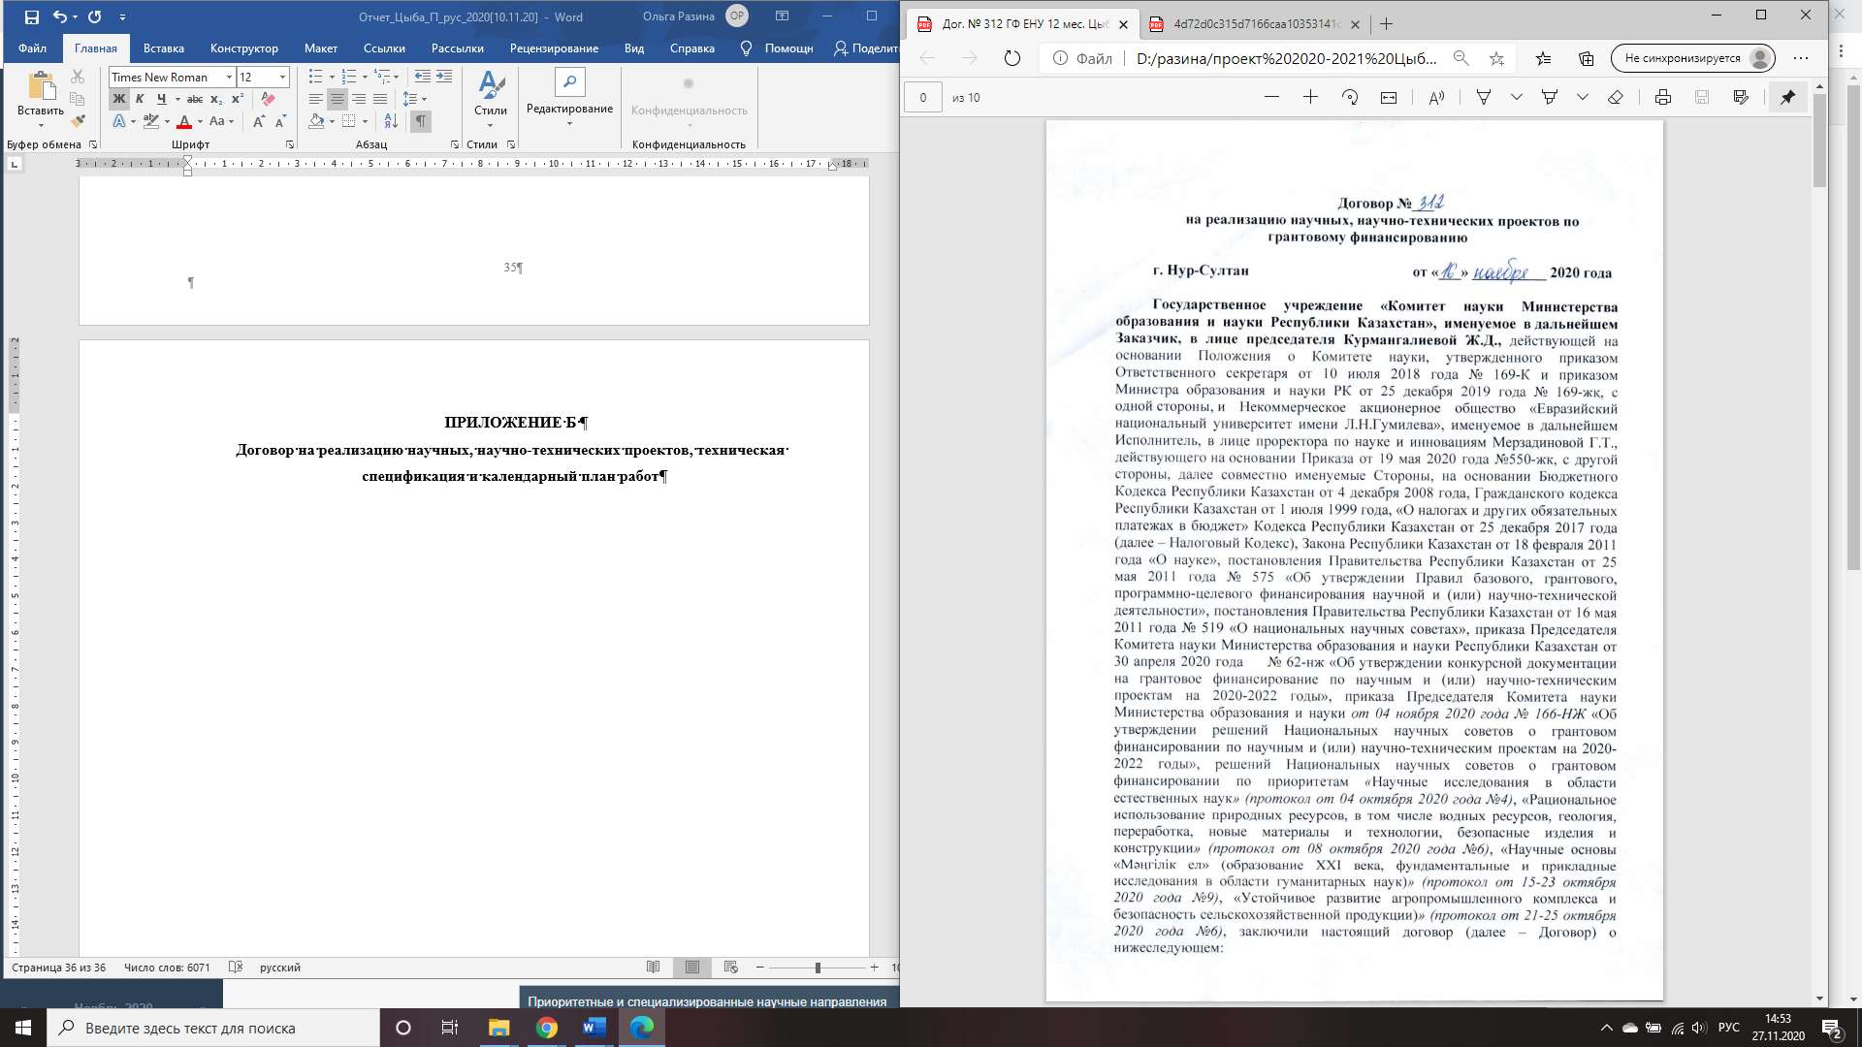

# 

# 

# 

# 

# 

# 

# 

# 

# 

**CALENDAR PLAN**

**1. Non-profit joint-stock company «L.N. Gumilyov Eurasian national university»**

**1.1. The name of the priority area for which the application is submitted.** 8. Research in the field of natural sciences

**1.2. The name of the specialized scientific field in which the application is submitted, type of research.** 8.2 Fundamental and applied research physics and astronomy

**1.3. Project title Investigation.** AP08955524Investigation of the evolution of the universe in extended theories of gravity.

**1.4. The total amount of the project** is 4998000 (four million nine hundred and ninety-eight thousand) tenge, including by year for the performance of work according to paragraph 3:

- for 2020 in the amount of 3000000 (three million) tenge;

- for 2021 in the amount of 1998,000 (one million nine hundred and ninety-eight thousand) tenge.

**2. Characteristics of scientific and technical products according to classification criteria and economic indicators**

**2.1 Направление работы:** Фундаментальные исследования. Физико-математические.

**2.2** **Scope of application:** Higher educational institutions and research institutes.

**2.3 The end result:**

**- for 2020:** Relevant theoretical models will be determined and evolutionary equations will be obtained

**- for 2021:** Analytical cosmological solutions will be constructed and verified by special methods of cosmology. Numerical cosmological solutions will be constructed and verified by special cosmological methods. Independent optimal parameters of the model will be determined and compared with observational data. Based on the results of the project 1 (One) publication in science-technical journal World Scientific Publishing or American Physical Society or Springer Science publisher house incoming in 1(first), 2(second), 3(third) quartil in Web of Science database and(or) percentile CiteScore in Scopus database no less 50(fifty) will be published. And 1(one) publication in domestic edition will be published by recommended CCSES.

**2.4 Patentability:** The results of research on this project are theoretical, therefore patent activity is not provided.

**2.5 Scientific and technical level (novelty):** Investigation of dark energy models of the modified theory of gravity with various types of kinetic coupling. Consideration of models of dark energy with higher-order invariants, scalar and fermionic fields, obtaining evolutionary equations by methods of symmetry theory, obtaining cosmographic parameters, energy dominance conditions, approximation by methods of Pade and Chebyshev polynomials, comparison with cosmological observational data of SNIa, BAO, Hubble.

**2.6 The use of scientific and technical products is carried out by:** Sharing according to the legislation of the Republic of Kazakhstan.

**2.7 Type of use of the result of scientific and (or) scientific and technical activities:** The results of the study can be used as special courses for undergraduates and PhD students in universities as well as in scientific research in this field.

**3. The name of the works, the timing of their implementation**

|  |  |  |  |  |
| --- | --- | --- | --- | --- |
| Job code, stage | The name of the work under the contract, the main stages of its implementation | Deadline | | Expected result |
| Start | Finish |
| 2020 | | | | |
| 1 | Physically relevant theoretical models fitting and obtaining evolution equations. | Oktober | December | Physically relevant theoretical models will be determined and evolutionary equations will be obtained. |
| 2021 | | | | |
| 2 | Construction of analytical cosmological solutions and their verification by special methods of cosmology | January | March | Analytical cosmological solutions will be constructed and verified by special methods of cosmology |
| 3 | Construction of numerical cosmological solutions and their verification by special methods of cosmology | April | June | Numerical cosmological solutions will be constructed and verified by special cosmological methods |
| 4 | Determination of independent optimal parameters of the model and their comparison with observational data | July | September | Independent optimal parameters of the model will be determined and compared with observational data.  Based on the results of the project 1 (One) publication in science-technical journal World Scientific Publishing or American Physical Society or Springer Science publisher house incoming in 1(first), 2(second), 3(third) quartil in Web of Science database and(or) percentile CiteScore in Scopus database no less 50(fifty) will be published. And 1(one) publication in domestic edition will be published by recommended CCSES. |

**APPENDIX С**

**List of published works based on the results of the research for 2020**

Scientific publications in the journals of the Republic of Kazakhstan:

1 Tsyba P.Yu., Razina O.V. Determination of evolutionary equations for the generalized cosmological model // Bulletin of Kokshetau State University named after Sh. Ualikhanov. Natural Sciences series. - 2020. - N3. - pp. 11-19. (in Russian)