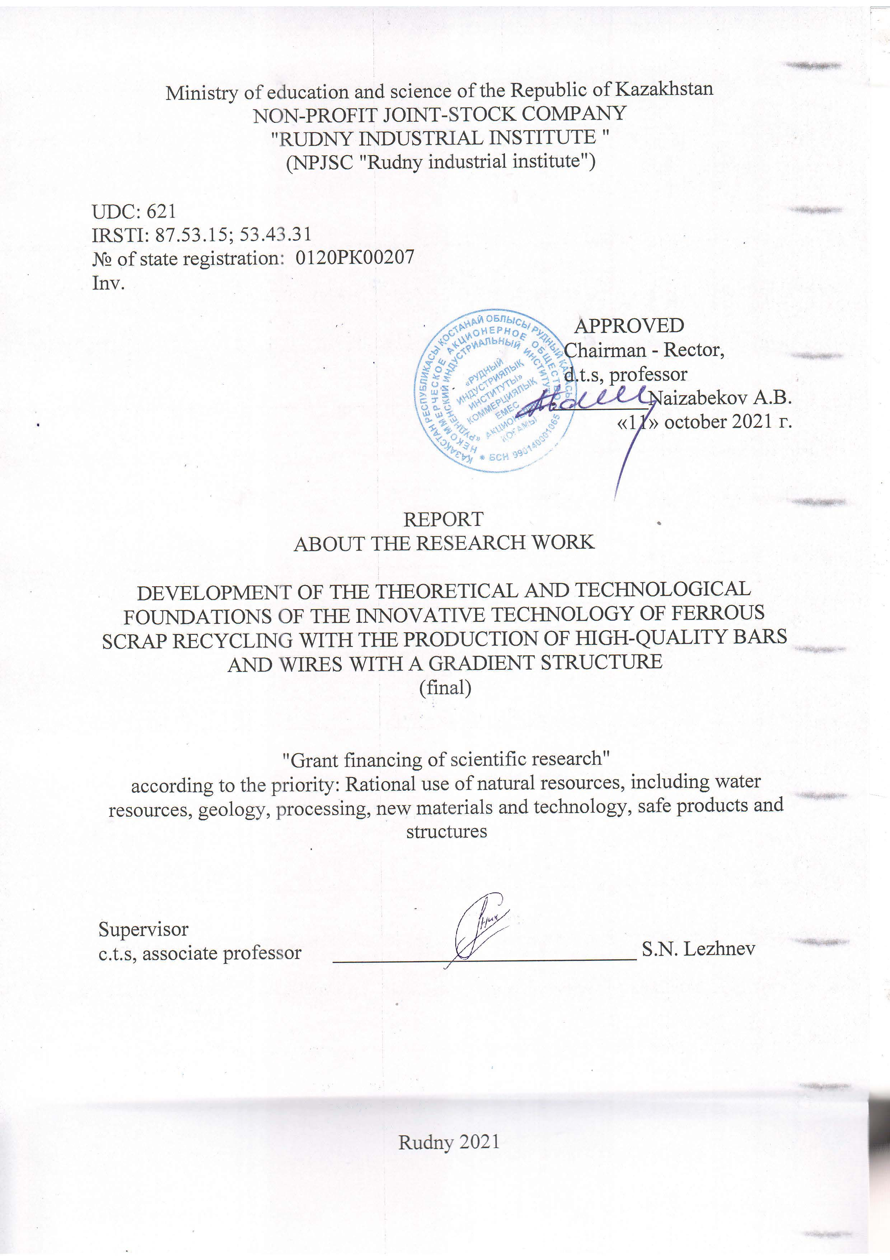
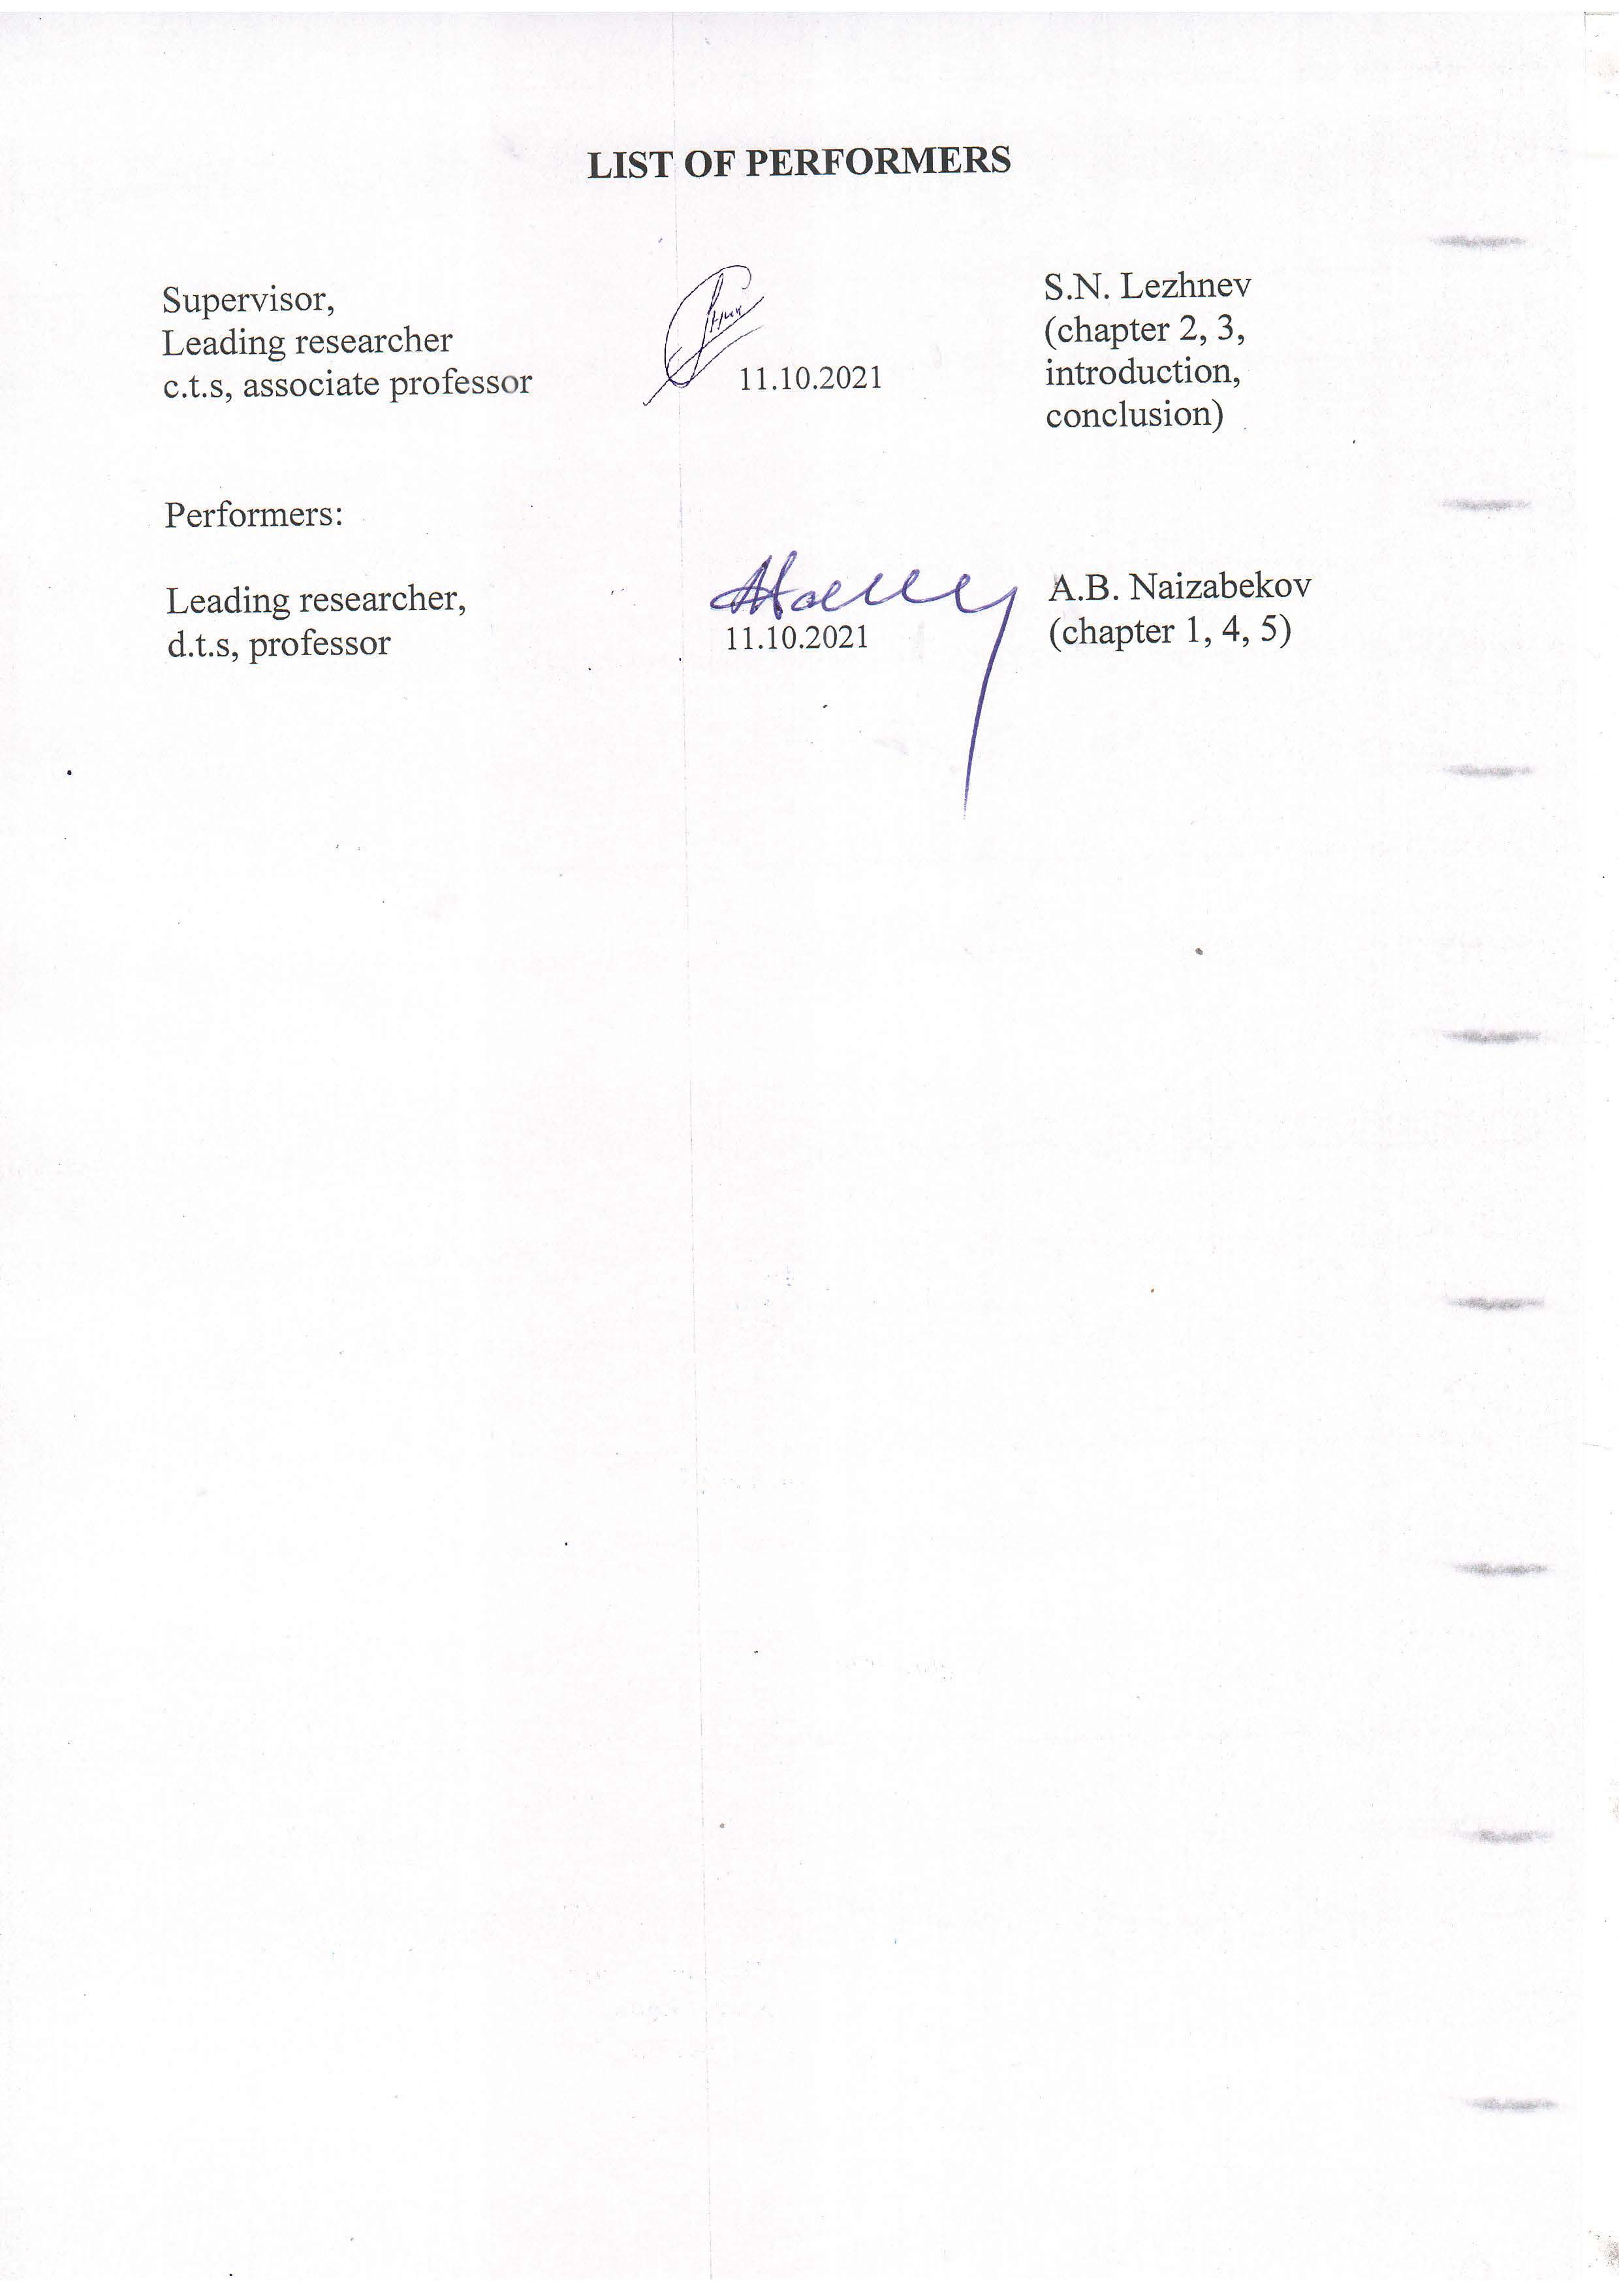

ABSTRACT

Report 48 p., 1 book, 21 fig., 32 references, 2 annex.
RECYCLING, METALLURGY, METAL FORMING, ROLLING, SCRAP METAL, METAL, STRUCTURE, MECHANICAL PROPERTIES
The object of the research is the technology of recycling bar scrap of ferrous metals without melting it, and due to processing on a radial-shear rolling mill and on a drawing mill to obtain high-quality round bars and wire with a gradient structure and an increased level of mechanical properties.
The aim of the project is to develop theoretical and technological bases for obtaining high-quality metal products from ferrous scrap bars based on the identification of regularities in the formation of a gradient structure by the method of intense plastic deformation implemented during radial shear rolling and subsequent drawing.
The ideal modern solution for the disposal of scrap metal is its recycling for further use for human needs.
It is difficult not to agree that one of the simplest ways of processing ferrous scrap and alloys is its remelting and further secondary use. But there is also another known method of processing some metal products that have served their service life – this is the method of hot processing them with pressure to obtain a ready-made commercial product. And one of the varieties of such scrap metal processing is the recycling of failed metal products by processing them using one of the promising methods of hot pressure treatment, namely radial shear rolling.
In the course of the work, the development, theoretical (based on computer modeling) and experimental research of the technology of recycling of bar scrap of ferrous metals at radial-shear rolling and drawing mills was carried out.
The analysis of the results of modeling the evolution of the microstructure showed that the proposed technological scheme for recycling bar scrap in the form of a reinforcement profile allows us to obtain finished metal products with a gradient ultra-fine-grained structure along the cross-section of the deformable workpiece.
The results of computer modeling were confirmed by the results of a physical experiment. Thus, in the course of the conducted studies, a wire with a diameter of 8 mm was obtained from bar scrap in the form of reinforcement made of steel grade 18G2C of class A-II (A300) GOST 5781-82 with an initial diameter of 25 mm, which in its properties fully corresponded to a reinforcement rod with a diameter of 8 mm made of more expensive and high-quality steel grade 20XG2C of class A-IV (A600) GOST 5781-82.

TABLE OF CONTENTS

INRTODUCTION…………………………………………………………….  THE MAIN PART OF THE RESEARCH REPORT ………………………..  1 Analysis of scientific, technical and patent literature on the topic of research  and development of technology for recycling bar scrap of ferrous metals ….  2 Computer simulation of the processes of radial-shear rolling of ferrous metal  bar scrap in the form of reinforcement and subsequent drawing with the  study of the influence of a new recycling method on the possibility of  obtaining a gradient structure….…………………………………………….  3 Conducting a laboratory experiment on the recycling of various bar scrap of  ferrous metals on a radial-shear rolling machine with subsequent drawing …  4 Conducting studies of the microstructure and mechanical properties of bars  and wire from a pilot batch of samples obtained during the deformation of  ferrous metal bar scrap at radial shear rolling and drawing mills…………….  4.1 Conducting studies of the microstructure and mechanical properties of  bars and wire from a pilot batch of samples obtained by deforming pieces  of reinforcement made of 18G2C steel at radial shear rolling and drawing  mills ………………………………………………………………………  4.2 Conducting studies of the microstructure and mechanical properties of  bars from a pilot batch of samples obtained by deforming samples made  of 12X18N9T austenitic stainless steel on radial shear rolling mills…… ..  5 Development of recommendations for the introduction of a new technology  for recycling bar scrap of ferrous metals in the industry ……………………  CONCLUSION……………………………………………………..................  REFERENCES…………………………………………………………………  ANNEX А List of publications on the research topic …………………………  ANNEX B Calendar plan ……………………………………………………... | 5  6  6  10  23  26  26  30  34  36  38  40  41
INTRODUCTION

One of the most important problems in the field of environmental protection is the problem of waste disposal of various industries and their further consumption. Therefore, for more than a decade, much attention has been paid around the world to the development of various methods not only for waste disposal, but also for their recycling, i.e. recycling, including scrap metal, which is a special category of waste, and is very often called "iron garbage". The following categories of scrap metal can be distinguished: iron scrap; stainless metal scrap; cast-iron spent elements; non-ferrous metal scrap; scrap of precious metals. At the same time, the disposal of waste, both ferrous and non-ferrous metals, is a useful process for the economy of any country. This is due, firstly, to economic aspects, since the processing and secondary use of these wastes has a favorable effect on the extraction of natural resources, since the need for them is reduced and there is a saving of minerals, as well as labor and economic reserves. Secondly, this is also due to environmental aspects, since in most modern metal products, in addition to iron, there are a large number of other chemical elements that, when destroyed, gradually enter the soil and groundwater, and many of these elements, including toxic ones. Therefore, in any country, special attention is paid to the development of technologies for the disposal of metals and their scrap for further processing with the aim of further use for human needs. One of the simplest and most frequently used methods of recycling scrap of ferrous and non-ferrous metals and alloys is its remelting and further secondary use. At the same time, most often, the scrap metal is pre-sorted by chemical composition, taking into account the metal quality indicator, by its type, and in addition, it can take place after the content of alloying and carbon components in the scrap metal. But there is also another known method of processing some metal products that have served their service life – this is the method of hot processing them with pressure to obtain a ready-made commercial product.
Therefore, the purpose of this project is to develop theoretical and technological foundations for obtaining high-quality metal products from ferrous scrap based on identifying patterns of formation of a gradient structure by the method of intense plastic deformation, implemented during radial shear rolling and subsequent drawing.
The goal of the project is achieved by an in-depth analysis of modern technologies for recycling bar scrap of ferrous metals and the development of a technology for producing high-quality round bars and wire with a gradient structure and an increased level of mechanical properties, as well as its study using computer modeling and physical experiment.

THE MAIN PART OF THE RESEARCH REPORT

1 Analysis of scientific, technical and patent literature on the topic of research and development of technology for recycling bar scrap of ferrous metals

Today, the metallurgical industry has become one of the most developed branches of production. In the Kazakh market, the metallurgical industry is one of the first places. That is why the issue of the secondary use of scrap metal is very relevant. The solution to this issue has become all kinds of ways of processing scrap metal, which is quite profitable for enterprises of the metallurgical industry.
It should be noted that secondary raw materials are the most necessary element in the melting of metal, through the use of recycled scrap metal, there is a significant reduction in the cost of the entire production. The savings are visible in everything, both in the costs of the charge-type material and in the costs of energy resources, and much more. In addition, the processing and secondary use of scrap metal, both non-ferrous and black, reduces the burden on the use of natural resources in this area, especially since they are already quite severely depleted today. All these factors listed above are a significant argument in the processing of metal.
As a rule, the most frequent is the processing of ferrous scrap. This is due to the fact that today steel is being manufactured in large quantities, the technological process of casting which involves a sufficiently large amount of scrap metal to mix it with cast iron. At the same time, it is worth noting that the peculiarity of this technological process is that the greater the amount of scrap will be used during smelting, the better the finished product will be, in this case steel.
The basis of the preliminary processing of scrap metal includes such processes as sorting, in which the metal is separated by categories and varieties. To date, there are several categories of scrap metal. Firstly, it is the separation of non-ferrous and ferrous metal scrap, since they cannot be put into one technological process.
The next stage of processing is the cutting and cutting of scrap metal. Further, the scrap metal is sorted according to the content of carbon substances in it, according to the content of the alloying composition, according to its quality indicators, which today there are about twenty-eight types.
Ferrous metal scrap and cast iron scrap are distributed. The first type of scrap includes such groups as chips, as well as metal, which is waste from the foundry industry, and scrap metal, which is formed as a result of household use and waste material of industrial production. The next type is cast iron scrap, which can also be in the form of chips and foundry waste. Another type is this type of scrap metal, such as stainless steel scrap. This group includes metal processing waste and used materials that have failed.
Processing of non-ferrous scrap metal is a more complex process and is performed separately for each type of non-ferrous metal. As a rule, the most commonly used recycling of batteries that contain a sufficiently large amount of lead. This metal can be successfully used for further purposes, and is easily processed. The same is the case with products containing mercury, as well as with scrap of precious metals.
It is difficult not to agree that one of the simplest ways of processing ferrous scrap and alloys is its remelting and further secondary use. But in some countries of the world, in addition to its remelting, another method of processing has entered into practice, namely, the recycling of some metal products that have served their service life by various methods of hot pressure treatment to obtain a ready-made commercial product.
One of the first such technologies is the technology of processing railway rails by hot rolling in calibers in order to obtain flange profiles, which was developed at the beginning of the last century by the American scientist E. E. Slick [1]. Subsequently, a number of technologies were proposed aimed at processing railway rails by hot rolling in order to obtain metal products of various profiles and purposes [2-11]. One of these technologies has found application at a new metal rolling plant in the city of Tula (Russia) at the site of the former JSC Kombainmashstroy, which involves rolling railway rails into construction fittings.
Also, another method of processing failed metal products is currently gaining momentum - this is the recycling technology, by processing these metal products using one of the promising methods of hot pressure treatment, namely radial shear rolling [12]. Since it is radial-shear rolling [13] that makes it possible to obtain long-length products from various materials with a gradient ultra-fine-grained structure [14-20] and in addition, this method is the most technologically advanced and easy to implement compared to many other methods of metal processing by pressure, which cause intense plastic deformations during the deformation process. The direction of radial-shear rolling began its development at NUST MISIS S.P. Galkin in the early 90s [21] and is a screw rolling according to a three-roll scheme, similar to the scheme used for stitching pipes in pipe rolling production [22]. And the main difference of the scheme proposed by S.P. Galkin is the feed angle increased to α = 18°-20° at the usual rolling angle β = 5°. This is what contributes to the development of the strongest vortex deformation from the surface to the center during the implementation of radial shear rolling, and the possibility of avoiding the appearance of tensile stresses in the axial part of the workpiece. On the basis of the proposed scheme of radial-shear rolling at NUST MISIS, a number of rolling mills were developed and put into small-scale production under the leadership of S.P. Galkin, and one of these mills is the SVP-08 mill, where physical experimental work on our research topic was carried out. And one of such technologies is the innovative technology of recycling of pumping rods (SHN) using the technology and mini-installation of radial-shear rolling in the conditions of JSC "Ochersk Machine-Building Plant" [23-25] and used railway axles [26]. This method is based on the principle of hot radial-shear screw rolling (RSSR) of a used and not repairable rod SHN 7/8” (22 mm) to SHN 3/4” (19 mm) by reducing the cross-sectional diameter of the bar body. The rolling temperature over the cross-sectional area and the length of the bar is 1150±15°C. This method of rolling allows you to eliminate internal and surface defects of the bar due to diffusion. One of the features of this process is the final compression of the surface and adjacent layers in the direction of the metal flow, which contributes to obtaining a high-quality surface with a high level of strength and plasticity. Also, the process of radial-shear screw rolling of the SHN rod allows to obtain a fine-grained structure of the workpiece and evenly distribute the carbide components [27].
The technological process during the repair of SHN consists of several successive stages. First, a visual inspection and rejection of the rods (suitable for traditional or deep repair and not suitable for restoration) is carried out, then the equipment is sorted by classes to select the optimal rolling mode, after which the cutting of the rolling parts, removal of scrapers, washing, straightening, heating and rolling of the rod are carried out. Then the bars are flaw-tested and sorted by steel grades. At the next stage, forging and heat treatment of the rod are performed, followed by shot blasting, thread rolling and welding of scrapers. At the end of all operations, the finished metal products are packed and delivered to the warehouse for storage and subsequent shipment to the customer [27]. The rod is edited on a special rolling mill to give it the necessary straightness. On the rolling line, the prepared rod passes through an induction heating unit, where it is heated to the rolling temperature. The heated rod is fed into the crate of the rolling mill, where the diameter is directly rolled – from a larger to a smaller one. Then, already in the forging process, the SHN head is formed with the identification information applied to the square. At the same time, the appropriate temperature regime is selected for each steel grade. The subsequent heat treatment of the rods includes normalization and tempering and is designed to relieve internal stresses, as well as to obtain the necessary physical and mechanical properties. The temperature mode is selected depending on the class of rods and the steel grade. To remove scale from the body of the rod after heat treatment and surface hardening (hardening), shot blasting is used. The next stage is the application of the thread, which is obtained by plastic deformation as a result of rolling with thread-rolling heads on automatic lines and modernized rotary lathes. Depending on the customer's requirements, polyamide scrapers can be additionally welded onto the rod body.
The offered technology of recycling of bar scrap of ferrous metals is based on the use of radial-shear rolling technology for its processing in order to obtain a high-quality commercial product in the form of bars of circular cross-section. When using the radial-shear rolling technology together with the drawing technology it is possible to obtain high-quality wire with a gradient ultrafine-grained structure.

Conclusions on the chapter

Recycling of scrap metal is one of the most important areas in the production of metals and alloys, as well as in the manufacture of various metal products; this activity is called recycling. A review of the scientific, technical and patent literature has shown that the recycling of scrap metal can be carried out either by melting it, or by a technology that is currently gaining popularity at some metallurgical and machine-building plants and which includes the processing of expired metal products by hot pressure treatment. Currently, there are many specialized enterprises in Kazakhstan for the reception, storage and processing of scrap (waste) of ferrous metals, which have a large amount of black scrap in the form of long bars of various diameters, scraps of bars of various diameters, as well as fittings of various diameters and lengths, which could be processed using hot pressure treatment.
For such processing of bar scrap of ferrous metals, we propose to use the technology of radial shear rolling in order to obtain a high - quality commercial product in the form of round cross-section bars, and when combined with drawing technology - to obtain high-quality wire with a gradient ultrafine-grained structure.

2 Computer simulation of the processes of radial-shear rolling of ferrous metal bar scrap in the form of reinforcement and subsequent drawing with the study of the influence of a new recycling method on the possibility of obtaining a gradient structure

For computer modeling, the Deform program (SFTC, USA) was chosen, which allows you to simulate pressure treatment processes of any complexity. Modeling is carried out by the finite element method (FEM). To create a basic model of radial-shear rolling, it was decided to use the parameters of the existing SVP-08 radial-shear rolling machine installed at the Rudny Industrial Institute (Rudny, Kazakhstan). The initial billet in the form of a reinforcement profile had a diameter of 16 mm and a length of 100 mm.
The following route deformation technology was developed:
1) The initial workpiece is heated to 1100°C, then rolled on a radial shear rolling machine from a diameter of 16 mm to 14 mm. The purpose of this stage is to remove longitudinal and transverse reinforcing ribs;
2) The resulting workpiece is cooled to 700°C, then rolled on a radial shear rolling machine from a diameter of 14 mm to 10 mm in several passes. The purpose of this stage is the implementation of severe plastic deformation in the workpiece to obtain a gradient ultrafine-grained structure;
3) Cooling of the rolled billet to 20°C and subsequent drawing from a diameter of 10 mm to a diameter of 8 mm in 2 passes. The purpose of this stage is to align the helical surface obtained after radial-shear rolling and give the workpiece a marketable appearance.
The material of the initial billet was chosen DIN BSt420S steel, which is the closest analogue of 18G2C reinforcing steel. Two-stage heating during radial-shear rolling was chosen for the following reasons. At the first stage, when it is necessary to remove the reinforcing ribs, it is advisable to heat the workpiece more strongly to ensure greater plasticity of the metal. At the second stage, when the purpose of rolling is intensive grinding of grains, it is advisable to reduce the temperature to the level of the beginning of recrystallization.
The speed of rotation of the rolls was equal to 50 rpm, as the nominal value on the SVP-08 radial shear rolling mill. The coefficient of friction at the contact of the workpiece and the rolls was assumed to be 0.7, as the recommended value for hot rolling in Deform, the type of friction according to Siebel. This type of friction is recommended for processes where the contact pressure is higher than the yield strength (a characteristic state for processes of severe plastic deformation). When drawing, the friction coefficient at the contact of the workpiece and the drawing tool was assumed to be 0.15, which corresponds to the polished surface of the drawing with the use of lubrication.
The mechanical and thermal problems were solved simultaneously by setting a non-isothermal type of calculation. At the same time, the following heat transfer coefficients recommended by the DEFORM software package for hot rolling were set for the workpiece:
- with the environment = 50 W/( m² · K);
- with deforming tools = 5000 W/(m² · K).
To create the geometry of the rolls, the KOMPAS-3D solid-state modeling program was used, while preserving the finished geometry in the STL format. When rolling, the rolls and the drawing tool were taken by rigid bodies, and the material of the workpiece was elastic-plastic. When creating a grid of finite elements on the workpiece, a relative type of construction was chosen – a range of edge lengths of 0.4-0.8 mm was set.
In the course of computer modeling, we studied the shape change of the workpiece during the implementation of various stages of deformation and analyzed the stress-strain state at these stages of deformation.
To assess the deformed state, the "equivalent strain" criterion was used [28], the value of which depends on the values of the main strains and is determined by the formula:

(1)

When considering the stress state, the "equivalent stress" criterion was used to estimate the average level of emerging stresses [28]. This criterion depends on the values of the main stresses and is determined by the formula:

(2)

For a full assessment of the emerging stresses, the criterion "average hydrostatic pressure" was studied [28], which allows us to estimate the magnitude of stresses taking into account the sign, i.e. to estimate the magnitude of tensile and compressive stresses. This criterion is derived from the values of the main stresses and is determined by the formula:

(3)

Figure 2.1 shows the successive stages of forming the workpiece during deformation according to the proposed route technology.
At the first stage of deformation, the workpiece in the form of a reinforcement profile receives only a small compression, which knocks down the longitudinal and transverse ribs (Figure 2.1 b). Here, due to the compression of only the sections of the ribs, the total length of the workpiece practically does not change. In this case, the contour of the section of the workpiece due to the unevenness of compression in the radial direction acquires an irregular shape – irregularities are clearly visible on the surface.

а) 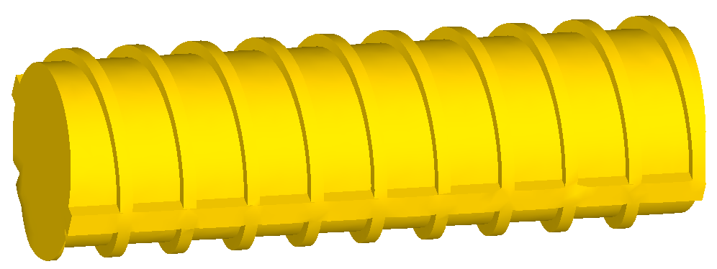

b) 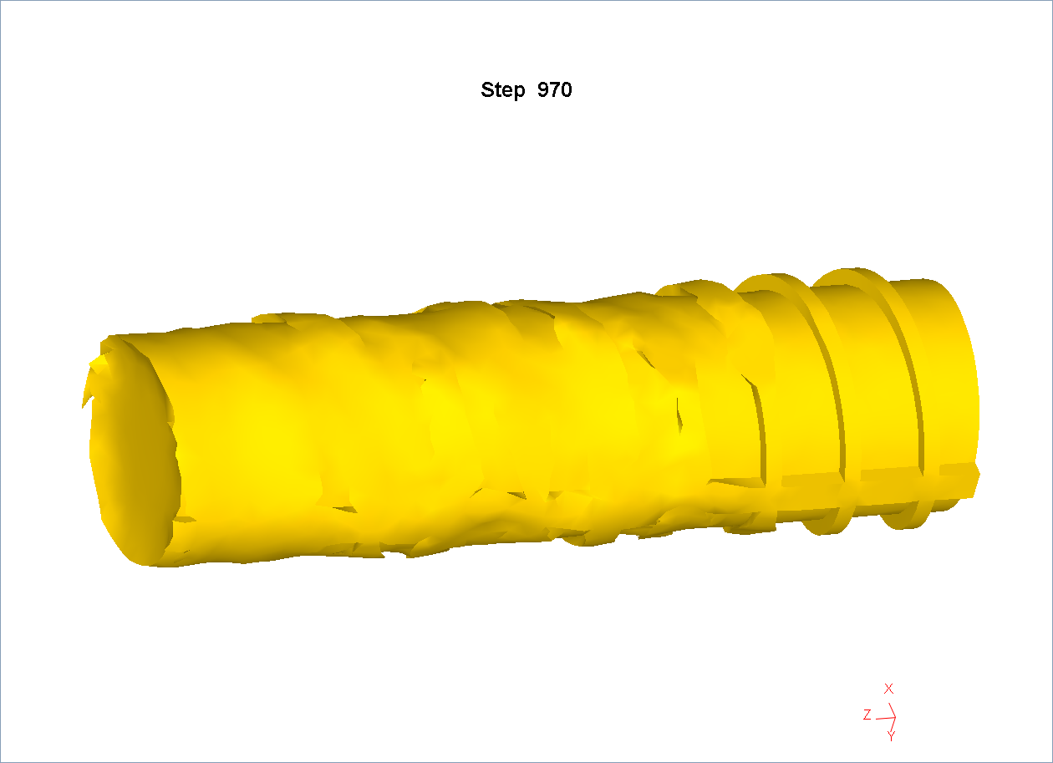
c) 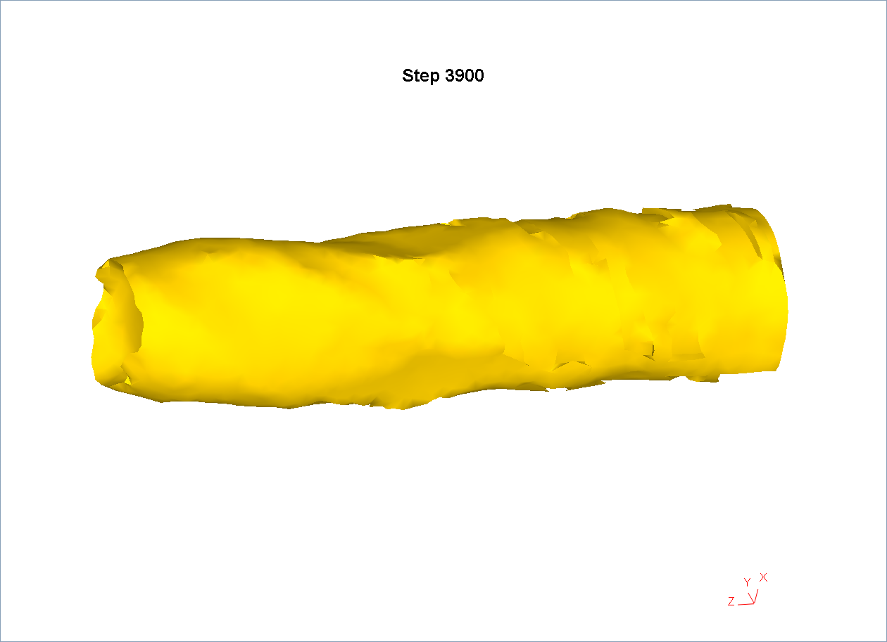
d) 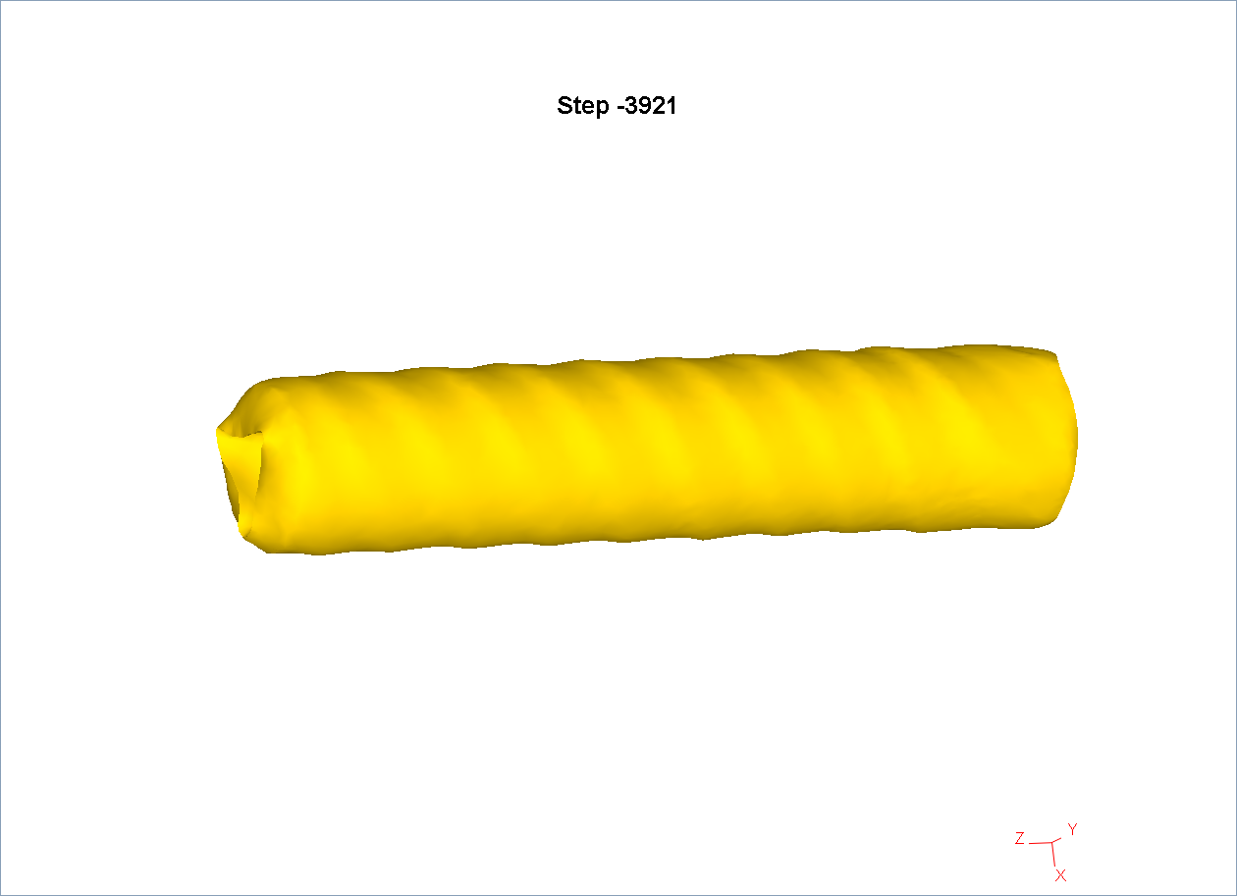
e) 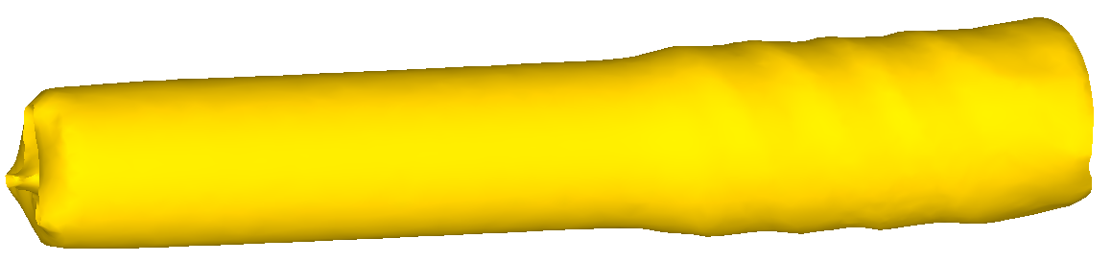
a – the initial workpiece; b - first stage of deformation;
c –second stage of deformation, after the first compression by 2 mm;
d –second stage of deformation, after four compressions of 1 mm;
e - third stage of deformation
Figure 2.1 - Forming of the workpiece

At the next stage, the workpiece is rolled from a diameter of 14 mm to 10 mm. At first, it was decided to roll the workpiece in 2 passes with a compression of 2 mm in each. As a result, it was revealed that, despite the rolling out of the surface irregularities from the first stage, the overall profile of the workpiece after the first compression by 2 mm acquires a kind of helical contour, becoming similar to a drill (Figure 2.1 c). This is the result of uneven compression at the first stage and a sufficiently large compression at the current stage. To reduce the possible effect of screw formation, an attempt was made to reduce the level of single compression to 1 mm and increase the total number of passes at the second stage to four. As a result, after passing all four passes of deformation, the workpiece acquired a more regular round shape (Figure 2.1 d). At the same time, a small helical profile is still observed on the surface, but its level is quite commensurate with the resulting helical line, which is often observed during radial-shear rolling of ordinary round blanks.
At the last stage, the rolled billet was subjected to drawing from a diameter of 10 mm to a diameter of 8 mm in 2 passes. After the first drawing cycle, the surface of the workpiece acquires a completely regular round shape (Figure 2.1 e). Thus, the proposed route technology of deformation allows to obtain a rod (wire) of the correct geometric shape from the initial reinforcement billet.
When analyzing the equivalent strain, it was decided to consider the longitudinal section of the workpiece, since in this case it becomes possible not only to numerically estimate the parameter, but also its distribution over the section (Figure 2.2).

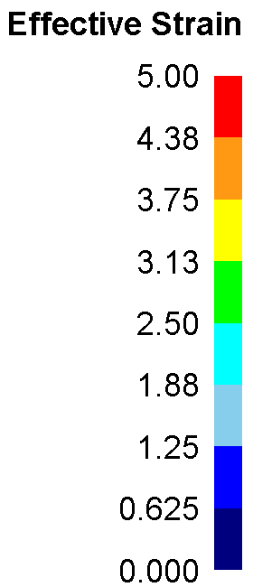
а)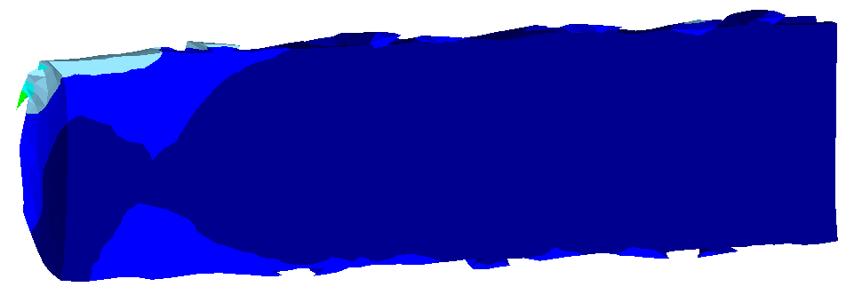

b)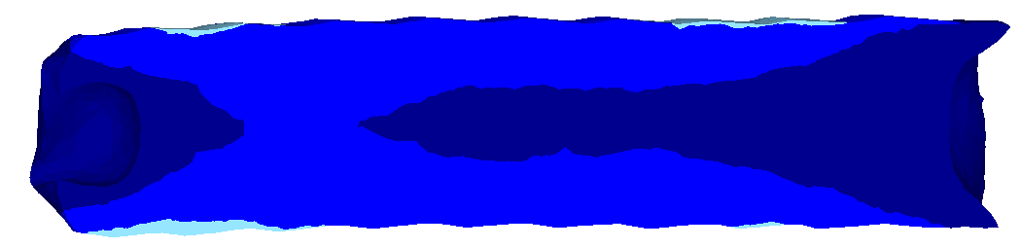
c)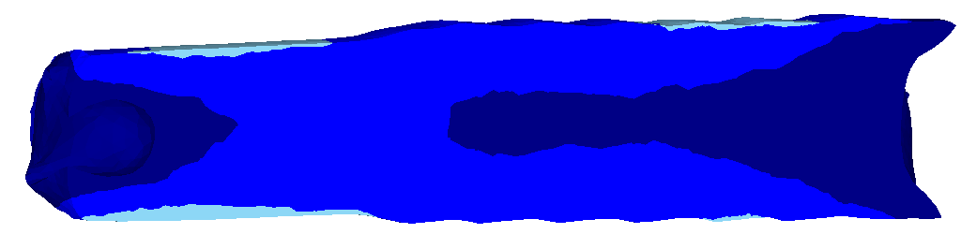
a – after the first stage of deformation;
b - after the second stage of deformation;
c - after the third stage of deformation
Figure 2.2 - Equivalent strain

At the first stage, the strain develops mainly in the surface layers of the workpiece. The only exception is the front end of the sample, where the deformation penetrates deep due to the initial capture of the workpiece by the rolls. The average level of equivalent strain at the first stage is 0.6-0.7. At the second stage, the workpiece is subjected to four compressions of 1 mm. Due to the implementation of such a deformation scheme, the inner zones of the workpiece begin to be worked out - the equivalent strain increases throughout the entire cross-section of the workpiece, creating a gradient distribution pattern (from 0.4 in the center to 1.25 on the surface). At the third stage, when drawing, the workpiece also receives an increase in strain in the entire cross-section – in the central zone, the level of equivalent strain reaches 0.6, gradually increasing to 1.64 on the surface.
When considering the components of the stress state (equivalent stress and average hydrostatic pressure), it was decided to consider them in the cross-section of the workpiece, since, unlike equivalent strain, these parameters act in the zones of the direct deformation process and are reset when the load is removed.
Considering the equivalent voltage at the first stage (Figure 2.3 a), it can be noted that the maximum values of this parameter develop only on the reinforcement ribs, reaching 250 MPa. In the main section of the workpiece, the stress level is reduced to 150-170 MPa. Due to the RSR scheme, three separate deformation foci are formed in the cross-section, the depth of penetration into the workpiece is not symmetrical, since in any arbitrary cross-section, some rolls will compress the ribs, others will contact the main body of the workpiece.
At the second stage (Figure 2.3 b), due to the lack of reinforcing ribs, compression according to the RSR scheme is carried out already over the entire body of the workpiece. As a result, the distribution of all three foci of deformation deep into the workpiece becomes more symmetrical. The maximum stress level develops in the areas of metal contact with the rolls and reaches 200 MPa.
At the third stage (Figure 2.3 c), when drawing a rolled billet cooled to room temperature, the stress level increases sharply – on the surface, their value reaches 750 MPa, gradually decreasing to 680 MPa in the center. When drawing a conventional round-section blank, the nature of the stress distribution is annular. In this case, an annular stress distribution is observed with the effect of overlapping the triangular symmetry of the deformation foci at the previous RSR stage. In other words, the presence of a small helicity (Figure 2.1 d) leads to a distortion of the annular shape of the deformation focus during drawing.
When considering the average hydrostatic pressure, it was noted that the distribution of this parameter is in many respects similar to the distribution of the equivalent voltage. So, at the first stage (Figure 2.4 a), the main development of the average hydrostatic pressure occurs on the reinforcement ribs – compressive stresses reaching -420 MPa arise here. At the same time, the level of compressive stresses in the main body of the workpiece is significantly lower, about -180 MPa. At the same time, an asymmetric nature of the stress distribution over the cross-section is also observed due to uneven compression along the diameter.

а) 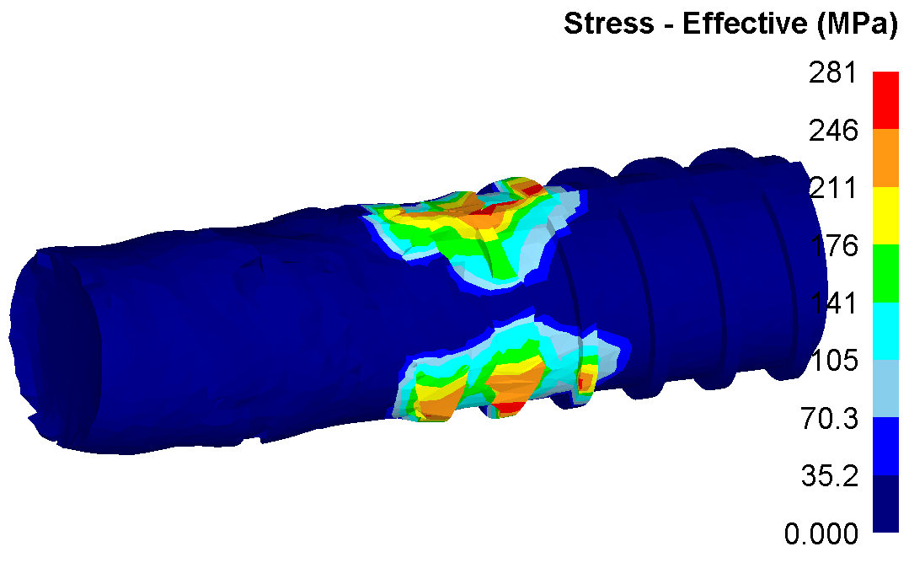 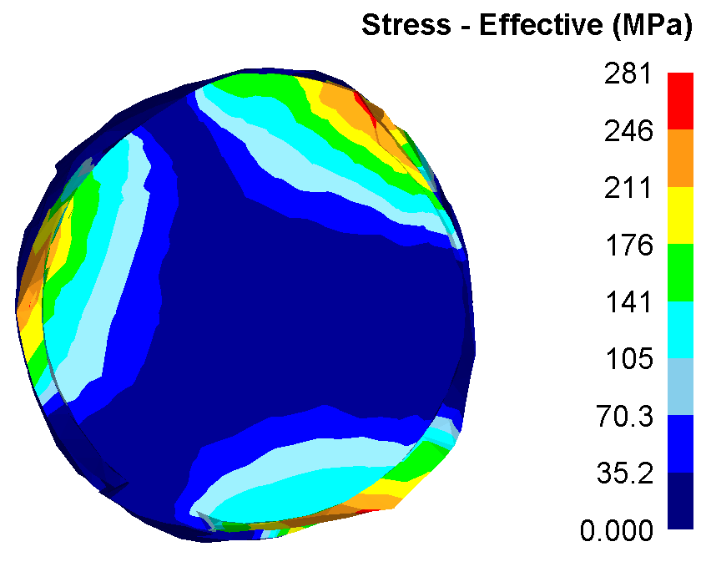

b) 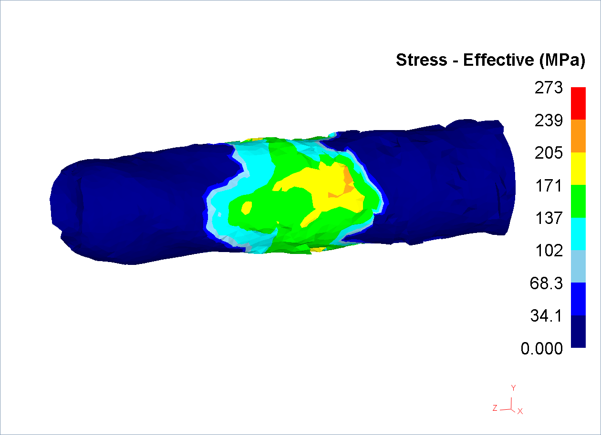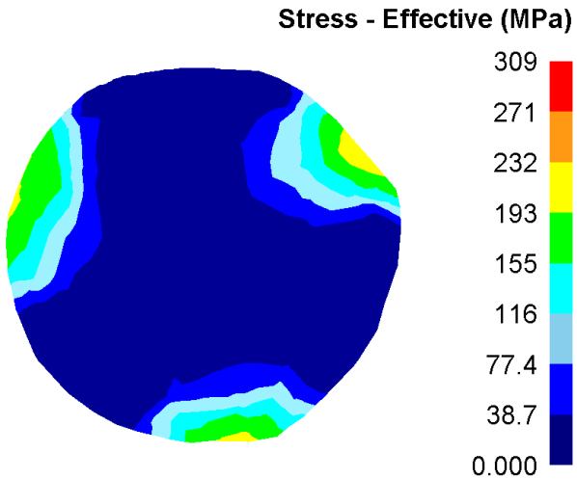

c) 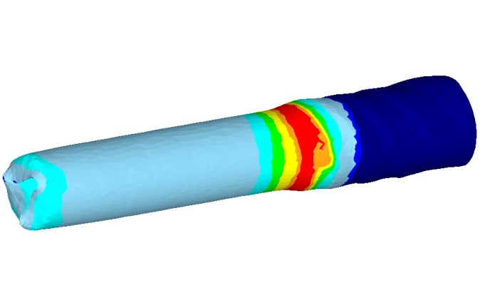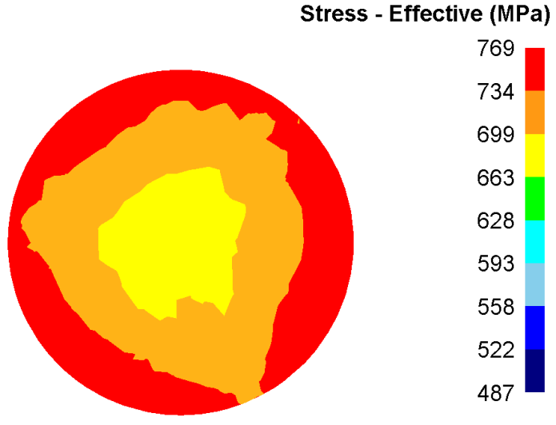
Figure 2.3 - Equivalent stress on the surface and in the section of the workpiece

At the second stage (Figure 2.4 b), when the entire body of the workpiece is compressed according to the RSR scheme, the distribution of all three deformation foci deep into the workpiece becomes more intense and symmetrical. The maximum level of compressive stresses develops in the areas of metal contact with the rolls and reaches -360 MPa.
At the third stage (Figure 2.4c), when drawing the rolled billet at room temperature, the stress level increases sharply. At the same time, the nature of the distribution of the average hydrostatic pressure changes dramatically – if at the first two stages of radial shear rolling, the deformation foci mainly consisted of compressive stresses, then at the drawing stage, both compressive and tensile stresses are present in the annular deformation focus. In the inclined section of the portage, where compression is carried out along the diameter, compressive stresses act on the surface, their value reaches -490 MPa. When moving deep into the workpiece, their intensity decreases, and tensile stresses at the level of 60 MPa already act in the central zone. In a rectilinear calibration belt, a section of surface tensile stresses reaching 170 MPa occurs on the surface of the workpiece. In the future, after the workpiece leaves the drawing, a uniform field of tensile stresses at the level of 35-40 MPa is created in its entire cross-section due to the pulling action at the front end of the workpiece.

а) 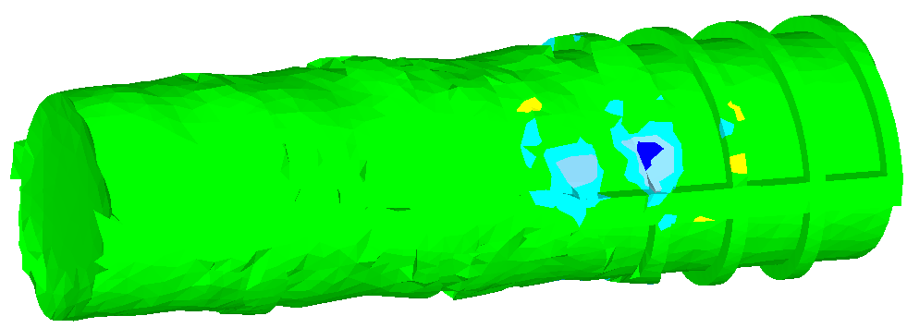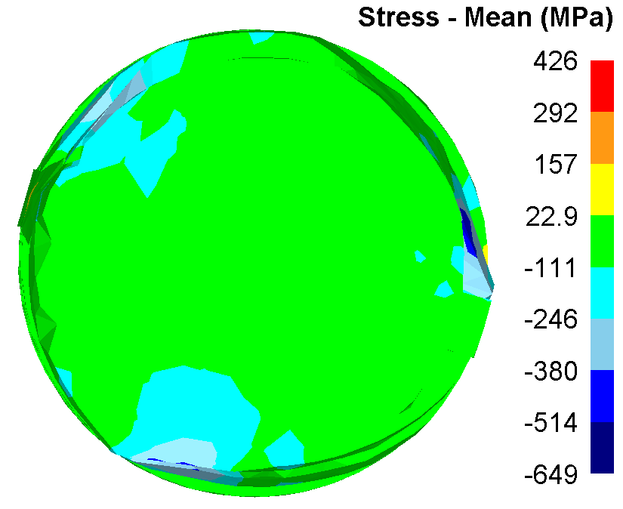
b) 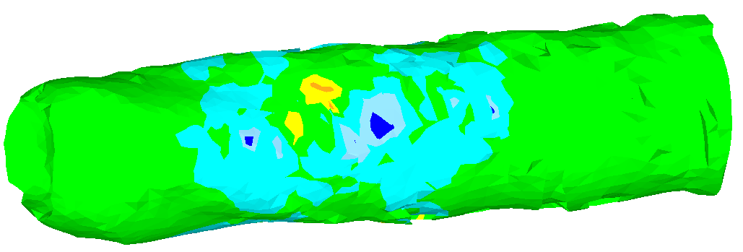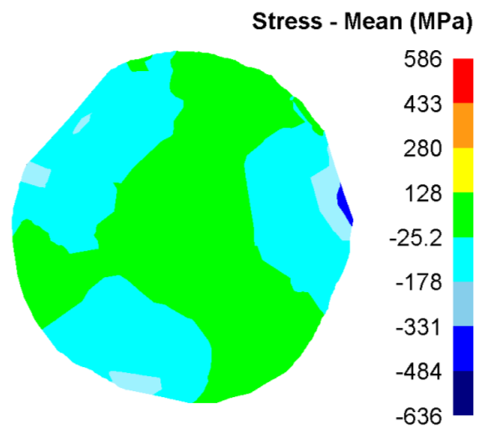
c) 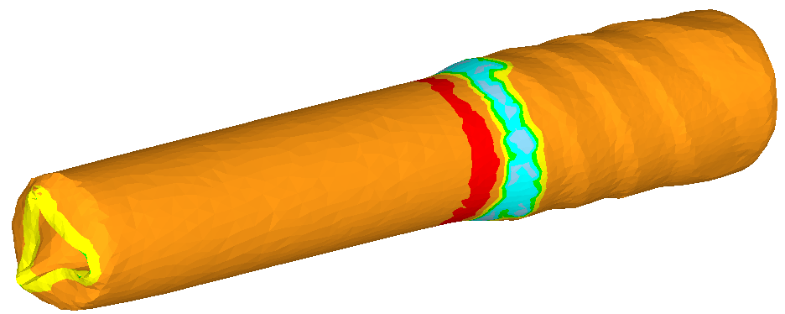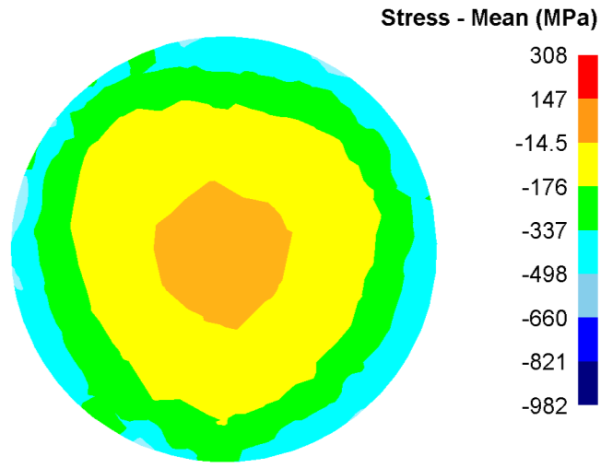
Figure 2.4 - Average hydrostatic pressure on the surface and in the section of the workpiece

From the obtained pictures of the stress state in Figures 2.3 and 2.4, it is clearly visible that completely different conditions are created during radial shear rolling and drawing, differing both in the numerical value of the stresses and in the nature of their distribution in the section of the workpiece. Therefore, when studying the evolution of the microstructure, it is advisable to conduct a study of the change in grain size after each of these stages.
To model the microstructure, it was decided to use the Cellular Automata method, which was significantly revised in the 12th version of the Deform program. This method allows you to simulate not only the change in size, but also the shape of the initial grains. To study the microstructure evolution, 2 points were selected – on the longitudinal axis of the workpiece and in the surface area (Figure 2.5).
When creating a model in the new version of Deform, it is now also possible to specify a slice plane for viewing the structure (Figure 2.6). Theoretically, this will allow us to obtain different patterns of grain size changes depending on the type of cross-section (longitudinal or transverse).

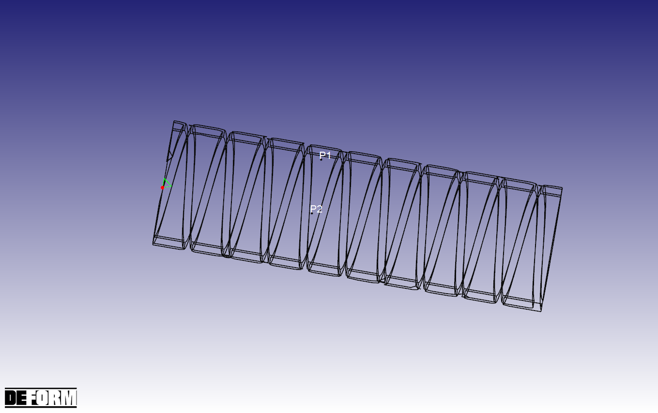
Figure 2.5 - Selected areas P1 and P2 for microstructure study

Additional calculation modules are used to calculate the grain shape. The key feature is the choice of interaction between neighboring calculated lattice cells (grains). The Deform program provides 2 different interaction mechanisms: Moore and Von-Neumann. Figure 2.7 clearly demonstrates their differences when using the same values of the interaction radius.

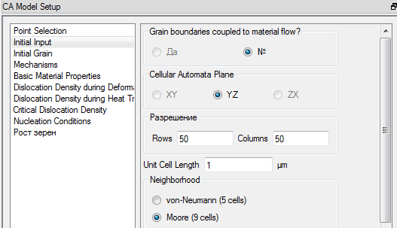

Figure 2.6 - Model View parameters

By default, the preferred mechanism is the Moore mechanism, because in this case, the number of cells remains constant both in the horizontal and vertical directions, and in the diagonal. A value equal to 12 microns was taken as the initial grain size. At the same time, the dimensions of the window for modeling were set to 100 x 100 microns. Figure 2.8 shows the initial structure for modeling.

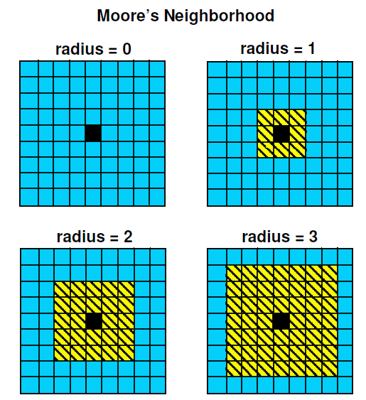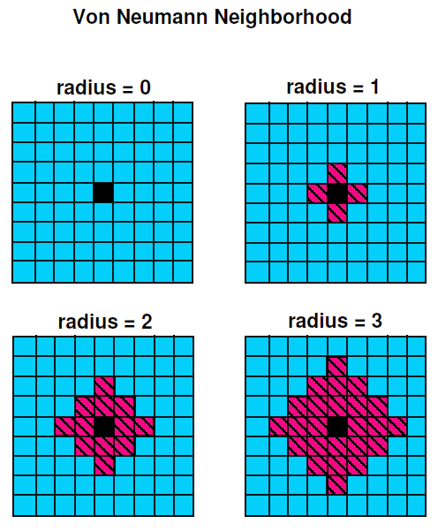

Figure 2.7 - Interaction mechanisms in the Cellular Automata model

Figure 2.8 - Initial structure

Initially, when modeling, the YZ plane corresponding to the cross-section of the workpiece was selected. After the radial-shear rolling stage, the following results were obtained (Figure 2.9).
From Figure 2.9, it can be noted that the grain size change is calculated quite correctly in accordance with the deformation-velocity principles of radial shear rolling described in [29-30], i.e. the surface layers of the workpiece receive a greater increase in deformation, so here the initial grain is crushed more intensively (from 12 to 5 microns). The axial zone is worked out very poorly, so the change in grain size is insignificant here (from 12 to 10 microns). However, it is known from the above-mentioned works that laminar metal flow prevails in the axial zone during radial-shear rolling, as a result, the initial grains are practically not crushed, but are strongly stretched in the direction of rolling. In Figure 2.9, this effect is not observed, since the picture data are obtained in a cross-section. To verify the correctness of the simulation, an additional calculation was performed at the same points, but already in the XY plane corresponding to the longitudinal section of the workpiece. The calculation results are shown in Figure 2.10. It is clearly seen that in this case, the deformation-velocity characteristics of the radial-shear rolling process are already taken into account – in the surface zone, there is an almost identical shape and size of grains recorded earlier in the cross section. In the axial zone, the grains are stretched in the longitudinal direction, practically without changing their size in area-narrowing to 6-7 microns in height, the grains lengthen to 13-15 microns.

а)b) 
Figure 2.9 - Structure after radial-shear rolling in the cross section of the workpiece: a - surface zone; b - axial zone

In view of the revealed dependencies on the direction of the section, it was decided to consider the structure after the drawing stage also in two directions. Figures 2.11-2.12 show the results of calculating the microstructure after drawing in the transverse and longitudinal directions for the surface and axial zones. It can be noted that even after the drawing stage, where sufficiently high tensile stresses are applied, the equiaxial shape of the grains in both zones continues to be preserved in the cross section of the workpiece (Figure 2.11). At the same time, the surface zone during drawing, as well as during radial-shear rolling, receives a higher level of elaboration. As a result, the grain size here is 4-5 microns. In the axial zone, the increase in deformation is extremely small, as a result, the grain size here decreases to 8-9 microns.

а)b) 
Figure 2.10 - Structure after radial-shear rolling in the longitudinal section of the workpiece: a - surface zone; b - axial zone
а)  b)
Figure 2.11 - Structure after drawing in the cross section of the workpiece:
a - surface zone; b - axial zone

When considering the results of modeling the structure in the longitudinal direction, it was revealed that the scheme of the stress-strain state during drawing affects the shape of the grains along the entire section of the workpiece, as a result of which the grains are pulled in both zones. Moreover, this effect has a pronounced gradient character – the maximum grain elongation is recorded in the axial zone (here the grains, narrowing to 5-6 microns in height, lengthen to 16-18 microns); when moving in the direction from the center to the surface, the level of grain extraction decreases noticeably (only a small number of grains are observed here, stretching along the length up to 6-8 microns and decreasing in height up to 3-4 microns).

а) 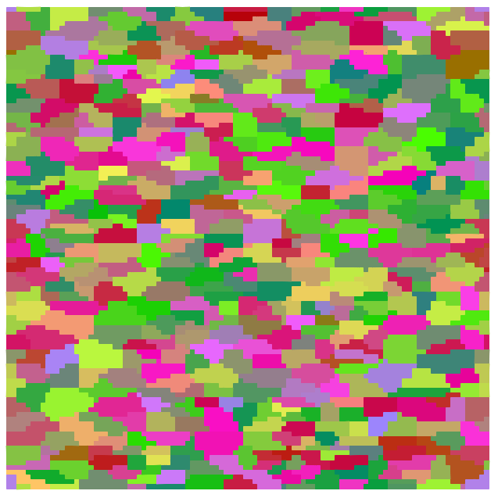b) 
Figure 2.12 - Structure after drawing in the longitudinal section of the workpiece:
a - surface zone; b - axial zone

Conclusions on the chapter

This chapter presents the results of computer modeling of a new technology for recycling bar scrap in the form of a reinforcement profile, which includes two pressure treatment technologies: radial shear rolling and drawing. The results of computer modeling showed that at the first stage of radial-shear rolling at a temperature of 1100°C, the ribs of the reinforcement profile, both longitudinal and transverse, are rolled out. With the further implementation of the radial-shear rolling process, but already at a temperature of 700°C, a favorable stress-strain state is created in the deformable metal to obtain bars of a circular cross-section with a gradient structure. The introduction of such a pressure treatment method as drawing at room temperature into the proposed technological scheme for recycling bar scrap made it possible to obtain a rod (wire) of the correct geometric shape with a diameter of 8 mm.
The analysis of modeling the evolution of the microstructure showed that the proposed technological scheme of recycling allows us to obtain a gradient structure along the cross-section of the deformable workpiece. The different nature of the gradient was also noted. If only a grain size gradient is observed in the cross section, then a grain shape gradient is also recorded in the longitudinal section.

3 Conducting a laboratory experiment on the recycling of various bar scrap of ferrous metals on a radial-shear rolling machine with subsequent drawing

In order to confirm the possibility of recycling various metal scrap, laboratory experiments were conducted using the SVP-08 radial-shear rolling mill (Rudny Industrial Institute) and the V-1/650M industrial drawing mill (South Ural State University, Russia).
As the initial blanks, the following were used:
- pieces of rusty reinforcement made of steel grade 18G2C class A-II (A300) GOST 5781-82 with a diameter of 25 mm and a length of 250 mm, which were previously subjected to homogenizing annealing before deformation;
- bar scrap metal in the form of studs with a diameter of 36 mm (the studs were sawn into samples with a length of 200 mm) made of 12X18H9T austenitic stainless steel (0.12% C, 18% Cr, 9% Ni, 2% Mn, 0.8% Ti), which were previously used as parts of metal structures at the Temirtau Electrometallurgical combine, and after the end of their service life were melted at the same enterprise.
Prior to deformation, the obtained samples were also subjected to homogenizing annealing. In general, austenitic steel is a special type of stainless steel that has wide applicability in various industries due to its properties: heat resistance, cold resistance, corrosion and electrochemical resistance. Therefore, this material is widely in demand in the following areas of the national economy: construction; pulp and paper production; food industry; transport engineering (including space and aircraft construction); chemical industry; electric power and electronics, etc. The melting technology of this steel and further manufacturing of various metal products and parts of metal structures from it is quite expensive.
The technology of scrap recycling in the form of reinforcement included three stages: the 1st stage - rolling out the reinforcement profile itself to obtain a conventional cylindrical billet; the 2nd stage – rolling the obtained cylindrical billets in order to obtain bars with an ultrafine - grained gradient structure; the 3rd stage-cold deformation (at room temperature) of the bars obtained at the radial-shear rolling mill on the drawing mill.
At the first stage, pieces of reinforcement with a diameter of 25 mm were heated in a Nabertherm R120/1000/13 tubular furnace to a temperature of 1100°C with an exposure of 25 minutes before deformation on the SVP-08 radial shear rolling machine. After that, these pieces of reinforcement were deformed on a radial shear rolling mill to a diameter of 22 mm in two passes with an absolute compression step of 1.5 mm in diameter according to the scheme shown in Figure 3.1.
After obtaining blanks with a diameter of 22 mm with a cross-sectional shape close to cylindrical, they were cooled to a temperature of 700°C with exposure in a Nabertherm R120/1000/13 tubular furnace to equalize the temperature along the cross-section of the blanks. At the second stage, the deformation of workpieces with a diameter of 22 mm was carried out with an absolute compression step of 2 mm in diameter according to a similar scheme to a diameter of 10 mm in six passes.

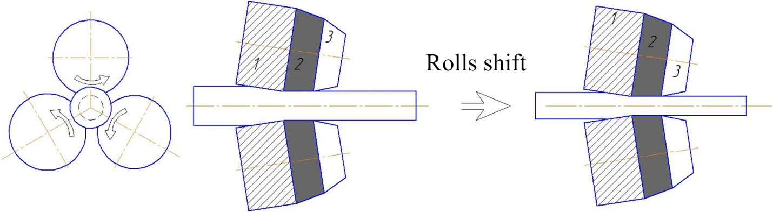
Figure 3.1 - Scheme of radial-shear rolling

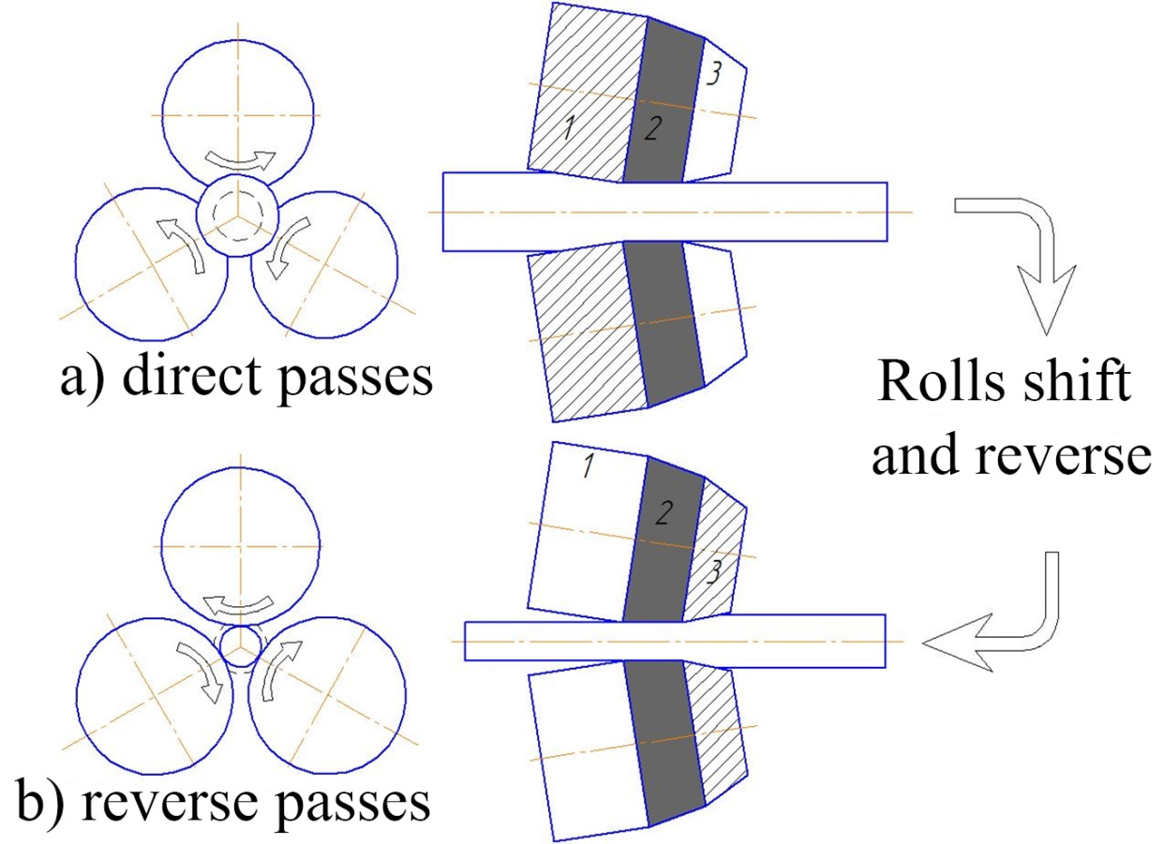
Figure 3.2-Scheme of reverse radial-shear rolling

At the third stage of scrap recycling in the form of reinforcement, cold deformation (at room temperature) of rods with a diameter of 10 mm obtained at a radial shear rolling mill on a drawing mill was carried out. Drawing was carried out in four passes before obtaining a wire with a diameter of 8 mm. At the same time, portages with a diameter of 9.6 mm, 9.0 mm, 8.6 mm and 8.0 mm were used in accordance with GOST 9453-75 (Form 12).
The technology of recycling of bar scrap made of stainless austenitic steel 12X18N9T is as follows. Before deformation at the SVP-08 radial shear rolling mill, samples with a diameter of 36 mm and a length of 200 mm (previously subjected to homogenizing annealing) were heated in a Nabertherm R120/1000/13 tubular furnace to a temperature of 850°C with an exposure of 36 minutes. The rolling of a bar with a diameter of 36 mm was carried out on a radial shear rolling mill up to a diameter of 20 mm in four passes with an absolute compression step of 4 mm in diameter according to the scheme proposed in [31] and presented in Figure 3.2. In these figures, the roll sections are indicated by numbers: 1-the crimp section for straight passes; 2 – the calibration section for all passes; 3 – the crimp section for reverse passes.

Conclusions on the chapter

Laboratory experiments were carried out on the recycling of bar scrap of ferrous metals: the first on the processing of scrap metal in the form of reinforcement on a radial-shear rolling mill with subsequent drawing to obtain high-quality wire with a diameter of 8 mm; the second on the processing of stainless steel bar scrap by hot deformation according to the scheme of reversible radial-shear rolling to obtain high-quality bars with a diameter of 20 mm, which confirmed the possibility of recycling various bar metal scrap.

4 Conducting studies of the microstructure and mechanical properties of bars and wire from a pilot batch of samples obtained during the deformation of ferrous metal bar scrap at radial shear rolling and drawing mills

4.1 Conducting studies of the microstructure and mechanical properties of bars and wire from a pilot batch of samples obtained by deforming pieces of reinforcement made of 18G2C steel at radial shear rolling and drawing mills

After carrying out all 3 stages of recycling of bar scrap in the form of reinforcement, microslips for optical microscopy and TEM objects for studying the fine structure, as well as standard samples for mechanical tests, were prepared from the initial sample (after homogenizing annealing) and after each pass. The microstructure was studied using an OLYMPUS BX53M optical microscope, and the fine structure was studied using a JEM-2100 transmission electron microscope (JEOL, Japan) at an accelerating voltage of 200 kV. The microstructure was studied in the center and on the periphery of the cross-section of the rod.
The mechanical properties were determined by testing the rupture of standard cylindrical samples on the Instron 5966 testing machine according to 1497-84. At the same time, three duplicate samples were taken for the gap test for each point of the experiment (after each pass).
The analysis of the evolution of the microstructure showed that the low-alloy steel of the 18G2C grade in the initial state (after homogenizing annealing) has a perlite-cementite structure, the secondary cementite is located along the grain boundaries (Figure 4.1), the average grain size is 25 microns.

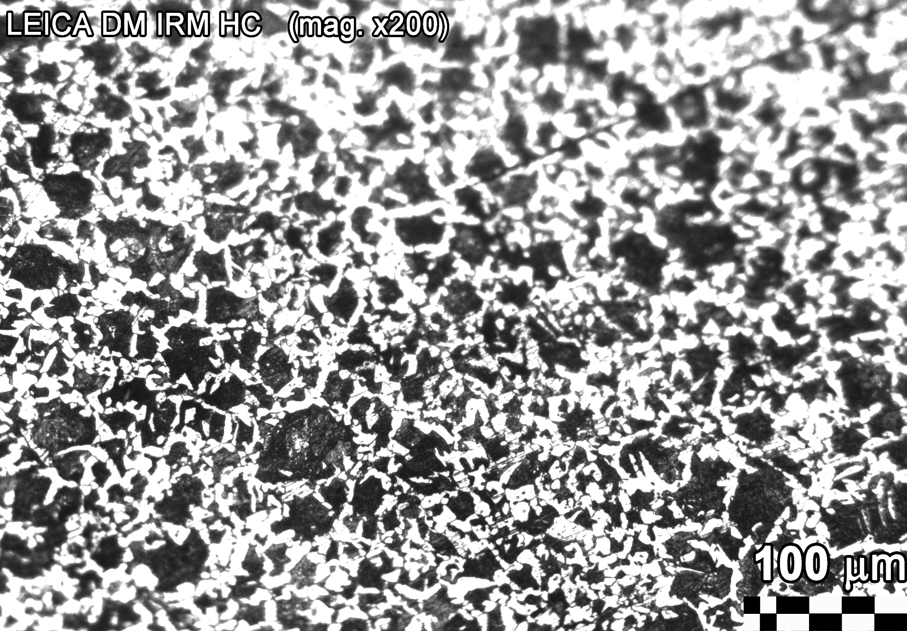
Figure 4.1 - Microstructure of steel 18G2C in the initial state (after homogenizing annealing)

The analysis of the microstructure after eight passes (2 preliminary ones at the beginning of deformation temperature of 1100°C and 6 main ones at the beginning of deformation temperature of 700°C) of deformation at the SVP-08 radial-shear rolling mill showed that grain fragmentation is observed in the peripheral part of the 18G2C steel bar as a result of the formation of dislocation walls and the formation of deformation cells. Despite the high dislocation density, a large number of dislocation-free subgrains are also observed (Figure 4.2a). Recrystallized regions with a low dislocation density were also found in the microstructure, which are a sign of the development of dynamic recrystallization during deformation. The detected recrystallized grains are distinguished not only by the absence of dislocations in the grain body, but also by the close-to-equilibrium structure of the disorientation boundaries, as evidenced by the weak banded electron-microscopic contrast at these boundaries. The structure of the central zone consisted of long and narrow grains elongated in the direction of rolling with a size lying in the range of 1-2 microns (Figure 4.2b).

а) 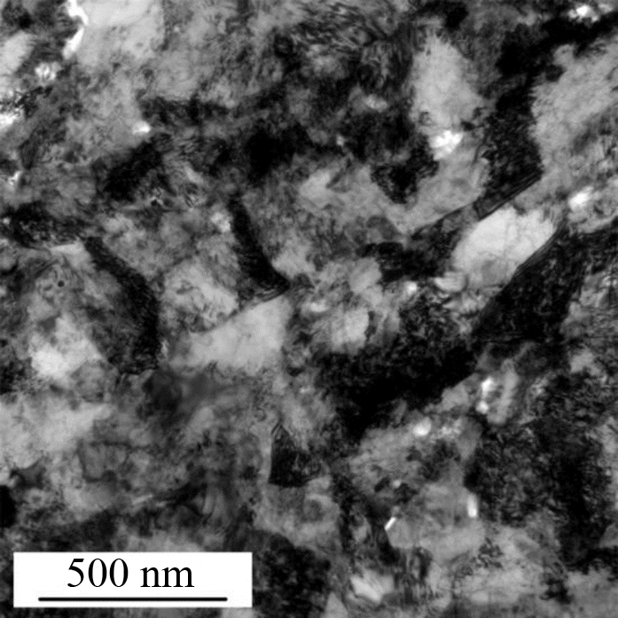 b) 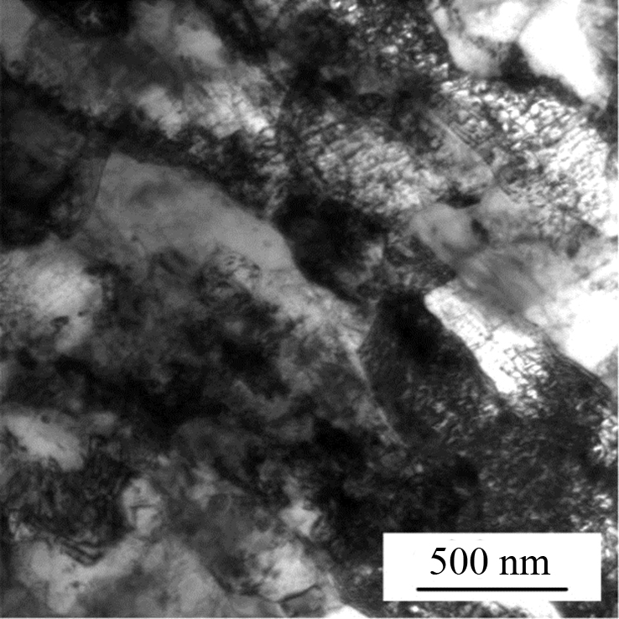

Figure 4.2 - Microstructure of the peripheral (a) and central (b) parts of the 18G2C low-alloy steel bar after 8 passes of RSR

After analyzing the evolution of the microstructure, the mechanical characteristics of 18G2C steel bars obtained after 8 passes (2 preliminary and 6 main) of reversible radial shear rolling were studied. The mechanical characteristics were also determined for the initial non-deformable sample previously subjected to homogenizing annealing.
According to the statistically processed results of mechanical tests, the average value of the properties was determined and graphs of the dependence of strength and plastic properties on the number of passes were constructed (Figure 4.3).

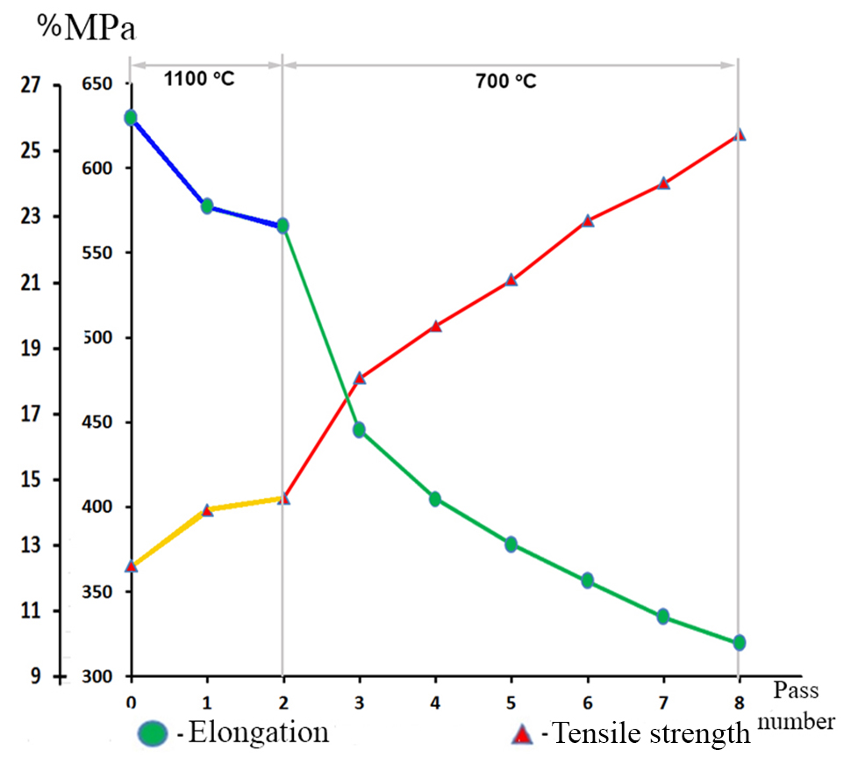
Figure 4.3 - Graph of the dependence of the strength and plastic properties of steel 18G2C on the number of passes

The results of mechanical tests showed that the initial (averaged) values of mechanical properties are: tensile strength 365 MPa; elongation 26%. After all 8 passes on the radial-shear rolling mill, the mechanical properties of 18G2C steel change as follows: strength properties increase, and plastic properties fall. Thus, the value of the tensile strength after 8 passes increased to a value of 620 MPa, and the elongation, which is one of the indicators of the plastic properties of any material, decreased to a value of 10%. At the same time, it can be seen from the graphs that these changes do not occur monotonically: after the first deformation pass, when the temperature of the beginning of deformation of the reinforcement profile was 1100°C, there was a sharp increase in the strength index and a drop in the elongation value, during the second pass these values did not change significantly. After cooling the workpiece obtained after 2 passes to a temperature of 700°C and the subsequent 3rd pass, we again observe an intensive change in the mechanical properties of 18G2C steel (there is a sharp increase in the tensile strength, and a significant drop in the relative elongation). In the future (after a sharp jump in properties during the implementation of the 3rd pass), a smooth change in the mechanical characteristics of 18G2C steel is already observed.
Metallographic analysis of the wire obtained during four drawing passes at room temperature showed that as a result of the uneven distribution of deformation along the cross-section of the initial workpiece, there is a slight grain grinding in the transverse direction (Figure 4.4a). In the longitudinal direction, the grains are lengthened and somewhat thinned to form a visible axial texture (Figure 4.4b). The microstructure of the central zone in the longitudinal direction becomes slightly more fine-grained (0.5-1 microns) and pronounced, which is naturally associated with the elongation of ferrite grains in the longitudinal direction and a decrease in the cross-section of the grains in the transverse direction during the drawing process.

а) 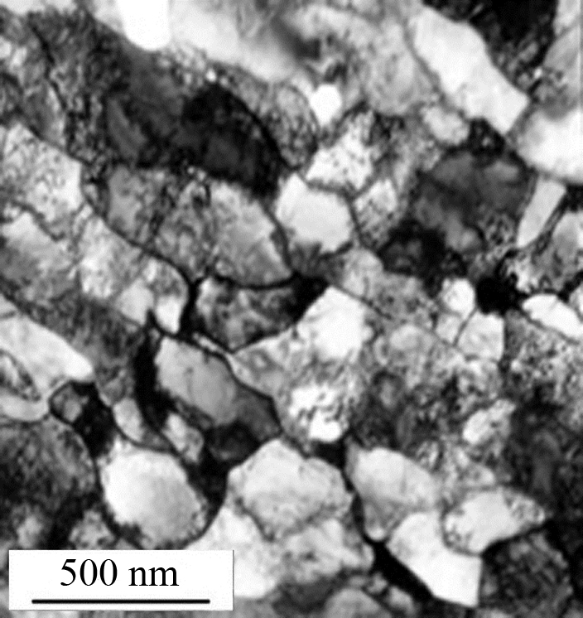 b) 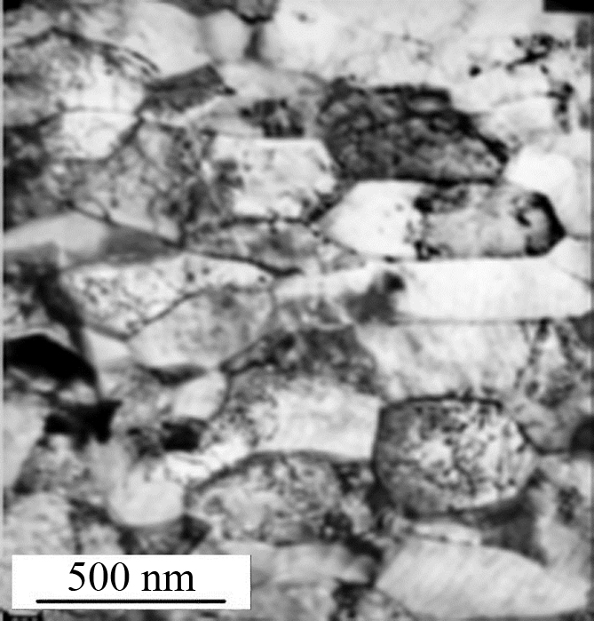
Figure 4.4 - Microstructure of low-alloy steel 18G2C after 4 drawing passes:
a - transverse direction, b - longitudinal direction

The study of the mechanical properties of the obtained steel reinforcement wire made of 18G2C steel was carried out on an Instron 5966 testing machine according to GOST 10446-80. The conducted studies of mechanical properties have shown that the tensile strength of the obtained cold-formed wire with a diameter of 8 mm made of 18G2C steel is 910 MPa, and the elongation is 6.2%, which, in terms of strength and plastic properties, corresponds to the properties of reinforcing rods made of more expensive and high-quality 20XG2C steel of class A-IV (A600) GOST 5781-82, including smooth ones with a diameter of 6 and 8 mm, manufactured most often by agreement of the manufacturer with the consumer in coils. Thus, reinforcing bars, including smooth ones, made of 20XG2C steel have a strength limit value equal to 900 MPa, and a relative elongation value of 6%.

4.2 Conducting studies of the microstructure and mechanical properties of bars from a pilot batch of samples obtained by deforming samples made of 12X18N9T austenitic stainless steel on radial shear rolling mills

After the deformation of the bar scrap made of 12X18N9T stainless austenitic steel on the radial-shear rolling mill, after each pass 30 mm long cylinders were cut out of the obtained bars with a diameter of 32, 28, 24 and 20 mm and from the initial sample with a diameter of 36 mm, which were subsequently used for preparing micro-grinds and cutting samples for mechanical testing and measuring microhardness along the cross section of the bar.
The microstructure was studied using a transmission electron microscope JEM-2100 (JEOL, Japan) at an accelerating voltage of 200 kV. The microstructure was studied in the center and on the periphery of the cross-section of the rod. The mechanical properties were determined by testing for rupture of flat samples in the form of strips of 30x3x0.3 mm on the Instron 5966 testing machine. Microhardness measurements were carried out on a Duramin-5 microhardness meter with software (GOST 9450-76 "Metals. The method of measuring microhardness by indentation of a diamond pyramid") on the basis of Belarusian State Technological University. For the rupture test and determination of microhardness, three duplicate samples were taken for each point of the experiment (after each pass).
The analysis of the microstructure of the obtained rods with a diameter of 20 mm showed that an ultra-fine-grained microstructure with equiaxed grains and a size in the range of 0.4-0.6 microns was obtained in the peripheral part of the rod (Figure 4.5a). In the structure of the sample, one can see structural elements surrounded by both thin boundaries characteristic of the grain structure and wide non-equilibrium boundaries more inherent in the subgrain (cellular) structure. As well as areas that are practically free of dislocations and areas with an increased density of dislocations. The electronogram has the form of separate reflexes located along a circle and having an azimuthal blur. Therefore, the structure can be characterized as equiaxed grain-subgrain.

а) 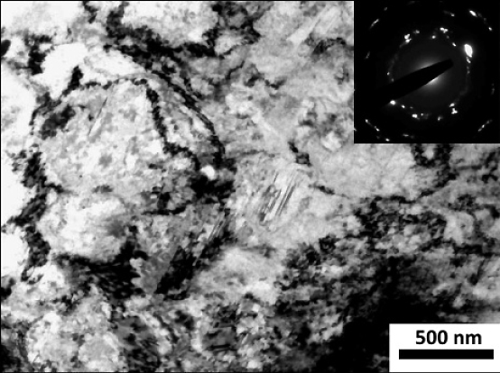b) 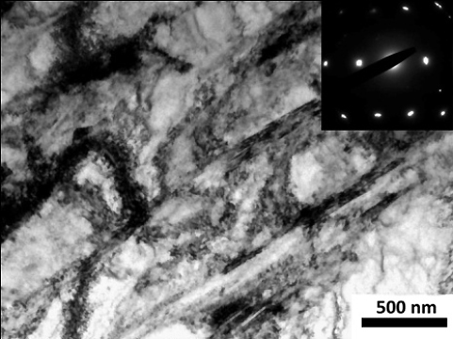
Figure 4.5 - Microstructure of the peripheral (a) and axial (b) parts of the 12X18N9T austenitic stainless steel after radial-shear rolling
The structure of the central zone consisted of long and narrow grains elongated in the direction of rolling with a size lying in the range of 3-4 microns (Figure 4.5b). There are some very thin deformation twins in the grains, the proportion of which does not exceed 6 %.
After metallographic analysis, the microhardness and mechanical properties of 12X18H9T austenitic stainless steel bars obtained after each pass of radial-shear rolling, as well as the initial non-deformable sample, were studied. The results were averaged over the passes and presented as a graph in Figure 4.6.
It can be seen from the graph in Figure 4.6 that the initial (averaged) values of mechanical properties are: tensile strength 525 MPa; elongation 38%; microhardness 180 HV. After all the passes (the total degree of deformation is 44.4%) at the radial shear rolling mill, the average microhardness level for 12X18H9T steel increased to 341 HV (with a maximum value of 359 HV). At the same time, there is an almost smooth growth of this indicator from aisle to aisle. The mechanical properties of 12X18N9T steel also change monotonously depending on the number of passes, with only one difference: strength properties increase, and plastic properties fall. Thus, the value of the tensile strength after 4 passes increased to a value of 1092 MPa, and the elongation, which characterizes the plasticity of any material, decreased to a value of 15%.

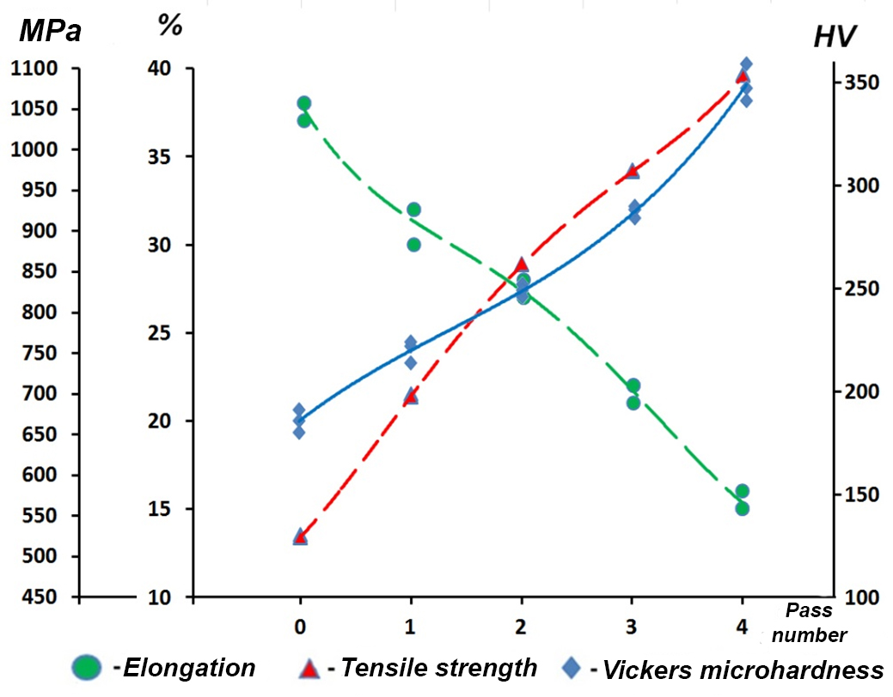
Figure 4.6 - Mechanical properties and microhardness of 12X18N9T austenitic stainless steel after radial-shear rolling by passes
In order to further confirm the presence of structural inhomogeneity in stainless austenitic steel subjected to deformation on a radial shear rolling mill, microhardness was measured along the cross-section of a bar rolled up to a diameter of 20 mm. The microhardness measurements were recorded every millimeter of the cross-section. The results of the microhardness measurement are shown in Figure 4.7. It can be seen from the distribution graph that the results of metallographic studies on the structural inhomogeneity along the cross-section of a bar made of 12X18N9T stainless austenitic steel subjected to radial-shear rolling are confirmed, since there is a gradual decrease in the microhardness level in the central zone of the bar by an average of 10.3 %.

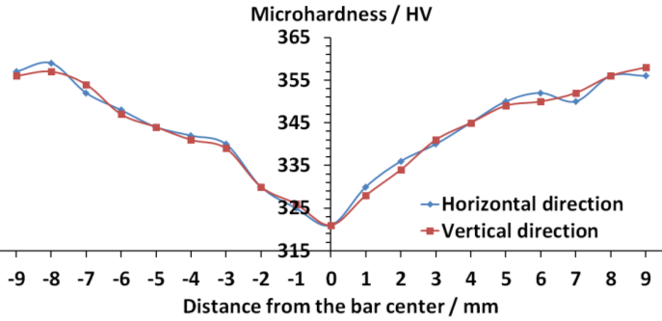
Figure 4.7 - Microhardness (HV) of 12X18H9T austenitic stainless steel after radial-shear rolling

Conclusions on the chapter

Thus, it can be concluded that the conducted studies have confirmed not only the possibility of using radial shear rolling, combined with drawing, if necessary, for processing various ferrous metal wastes to obtain a marketable product in the form of a metal rod and wire, but also the possibility of obtaining a fine-grained structure, which in turn will provide a significant increase in mechanical properties, and, accordingly, the quality of the resulting metal products.
For example, the implementation of the process of deformation of bar scrap in the form of a reinforcing profile on the SVP-08 radial shear rolling mill allows you to significantly disperse its structure, and the degree of grinding of the structure is higher, the greater the degree of deformation. Thus, carrying out eight deformation passes of the reinforcement profile made of 18G2C steel at the SVP-08 mill allowed reducing the average transverse grain size by almost 30 times (from 25 to 0.8 microns) compared to the initial state after homogenizing annealing. The change in the size of the initial grain, previously subjected to homogenizing annealing of bar scrap in the form of reinforcement during its deformation on the radial shear rolling mill, led to a significant change in its mechanical characteristics. Thus, the tensile strength of 18G2C steel after deformation increased almost 1.7 times to a value of 620 MPa, and the elongation, which is one of the indicators of the plasticity of the material, also decreases by 2.6 times, reaching 10%, against the initial 26%, while the decrease in the plasticity index in this case is within the normal range for materials subjected to severe plastic deformation.
The subsequent combination of radial-shear rolling with drawing is an effective way to obtain high-quality wire with an ultra-fine-grained gradient structure, which is not inferior in properties to wire from more expensive steel grades. Thus, in the course of our research, we obtained a wire with a diameter of 8 mm from a bar scrap in the form of reinforcement made of steel grade 18G2C of class A-II (A300) GOST 5781-82 with an initial diameter of 25 mm, which in its properties fully corresponded to a reinforcement rod with a diameter of 8 mm made of more expensive and high-quality steel grade 20XG2C of class A-IV (A600) GOST 5781-82
And in the course of the conducted studies on the deformation of bar scrap in the form of pins made of 12X18N9T stainless austenitic steel on a radial-shear rolling mill in a rolled bar, a microstructure of two different types was obtained: at the periphery an equiaxial ultrafine-grained structure was obtained with a grain size of 0.4-0.6 microns; in the axial zone an oriented striped texture was obtained. This discrepancy in the structure of the peripheral and axial zones, together with the results of measuring the microhardness across the cross-section of samples made of 12X18N9T austenitic stainless steel with a total degree of deformation of 44.4%, just indicate the gradient nature of the formed microstructure. Obtained after the implementation of the proposed method of recycling metal products made of stainless austenitic steel, which have served their service life, can now find further application in the manufacture of responsible parts, including those working in aggressive environments.

5 Development of recommendations for the introduction of a new technology for recycling bar scrap of ferrous metals in the industry

It is proposed to introduce into production a new technology for recycling bar scrap of ferrous metals using radial-shear rolling technology for its processing in order to obtain a high-quality commercial product in the form of round cross-section bars with a gradient ultra-fine-grained structure and an increased level of mechanical properties. Or use it (the technology of radial-shear rolling) together with the drawing technology, but already to obtain high-quality wire. The proposed technology of recycling of bar scrap of ferrous metals makes it possible to exclude a number of processes from the technological chain, including the most energy - and labor-intensive process, namely its remelting.
The technology of recycling of bar scrap of ferrous metals is as follows: Bar scrap of ferrous metals is sorted by chemical composition (to assign the necessary temperature regime for heating it before deformation) and diameter (to set the initial gap between the rolls, which ensures the capture of the workpieces of the rolls and its deformation with a certain compression). After sorting the scrap, the recycling process itself begins.
If the bar scrap in the form of a reinforcing profile or various stepped shafts and axes is subjected to deformation at the radial shear rolling mill, then at the first stage of deformation, this bar scrap is heated to a temperature of 1100-1200°C, depending on the steel grade. Then such a billet is fed to the radial shear rolling mill and is set in the mouth of the rolls, which capture and roll it. Rolling is carried out until a standard cylindrical billet is obtained. Then the resulting cylindrical billet is cooled to a temperature of 700-850°C, depending on the steel grade.
Before deforming a bar scrap of a certain diameter, it is fed into an induction unit, in which it is heated to a temperature of 700-850°C, depending on the steel grade. The heating time and exposure time depends on the initial diameter of the bar scrap and the method of its placement in the furnace and is determined by reference data for this steel grade.
The choice of a radial-shear rolling machine depends on the maximum diameter of the workpieces deformed on it in the form of bar scrap. So, for recycling of bar scrap with a diameter not exceeding 40 mm, you can use the SVP-08 radial-shear rolling mill (such a mill is installed at the Rudny Industrial Institute), and for recycling of bar scrap with a diameter from 40 mm to 140 mm, you can already use the SPVP-40-140 radial shear rolling mill of IPDM Engineering LLC (Russia). These mills are rolled according to a three-roll scheme with a feed angle α = 18°-20° and a rolling angle β=5°, which contributes to the development of the strongest vortex deformation from the surface to the center, while excluding the appearance of tensile stresses in the axial part of the workpiece.
Rolling of workpieces in the form of bar scrap on a radial-shear rolling mill can be carried out both according to the usual scheme (i.e. in one direction) and according to the reverse scheme, by switching the direction of rotation of the motor and, accordingly, the rolls.
To exclude the influence of reheating on the microstructure of the deformable metal, deformation on a radial-shear rolling mill must be carried out from one heating in 6-8 passes, ensuring a total degree of compression in the range from 4 to 6 [32]. At the same time, the reversible scheme allows reducing the time required for 6-8 deformation passes. Adjustment of the position of the rolls for the next compression is carried out, thanks to the convenient design of the SVP-08 and SPVP-40-140 mills. If more compression is required than is provided for 6-8 passes of deformation, the resulting billet in the form of a rod is sent to the induction unit for heating and then rolled again according to a similar scheme to the desired diameter (the desired total degree of deformation).
The correction of the rod obtained at the radial-shear rolling mill can be carried out on a special rolling mill, which allows giving the rod the necessary straightness.
If it is required to obtain a wire and a rod with a diameter of less than 10 mm, then the technological scheme of recycling must include the drawing operation (in a cold state) on a drum drawing mill to obtain wire or a chain drawing mill to obtain both rods with a diameter of less than 10 mm and wire.
The drawing technology for the implementation of recycling of bar scrap does not differ in any way from the usual drawing technology and consists in the following: the end of the rod obtained at the radial shear rolling mill is sharpened on the cutting machine by entering it into the appropriate caliber 5-6 times, with a 90° rotation. The pre-pointed end of the wire is set in a drag (with a diameter of the initial workpiece of 10 mm, the drag is selected with a diameter of 9.6 mm), installed in a fiber holder located in a container for lubrication, and its capture is carried out with filling pliers. Next, the process of drawing the workpiece through the drag itself is carried out. If it is necessary to obtain a wire of a smaller diameter, the drawing changes and the process is repeated.
This recycling technology can be used for the production of high-quality bars, and in some cases, responsible parts, and wires from metal products that have served their service life.

CONCLUSION

The purpose of this project is to develop the theoretical and technological foundations for obtaining high-quality metal products from ferrous scrap bars based on the identification of patterns of formation of the gradient structure by the method of severe plastic deformation, implemented during radial shear rolling and subsequent drawing.
A review of the scientific, technical and patent literature has shown that the recycling of scrap metal can be carried out either by melting it, or by a technology that is currently gaining popularity at some metallurgical and machine-building plants and which includes the processing of expired metal products by hot pressure treatment. Currently, there are many specialized enterprises in Kazakhstan for the reception, storage and processing of scrap (waste) of ferrous metals, which have a large amount of black scrap in the form of long bars of various diameters, scraps of bars of various diameters, as well as fittings of various diameters and lengths, which could be processed using hot pressure treatment.
For such processing of bar scrap of ferrous metals, it is proposed to use the technology of radial-shear rolling in order to obtain a high-quality commercial product in the form of round cross-section bars, and when combined with drawing technology, it is already used to obtain high-quality wire with a gradient ultrafine-grained structure.
Computer modeling of the processes of radial-shear rolling of bar scrap of ferrous metals in the form of reinforcement and subsequent drawing was carried out. The analysis of the results of computer modeling showed that at the first stage of radial-shear rolling at a temperature of 1100°C, the ribs of the reinforcement profile are rolled out. When this reinforcement profile is further deformed on a radial-shear rolling mill at a temperature of 700°C, a favorable stress-strain state is created in the metal to obtain bars of a circular cross-section with a gradient ultra-fine-grained structure. The introduction of the drawing operation at room temperature into the proposed technological scheme of recycling of bar scrap allows you to get a wire of the correct geometric shape. The analysis of the results of modeling the microstructure evolution showed that the proposed technological scheme for recycling bar scrap in the form of a reinforcement profile allows us to obtain finished metal products with a gradient ultra-fine-grained structure along the cross-section of the deformable workpiece. The different nature of the gradient was also noted. If only a grain size gradient is observed in the cross section, then a grain shape gradient is also recorded in the longitudinal section.
Laboratory experiments were carried out on the recycling of bar scrap of ferrous metals: the first on the processing of scrap metal in the form of a reinforcing profile on a radial-shear rolling mill with subsequent drawing to obtain high-quality wire with a diameter of 8 mm; the second on the processing of stainless steel bar scrap by hot deformation according to the scheme of reversible radial-shear rolling to obtain high-quality bars with a diameter of 20 mm, which confirmed the possibility of recycling various bar metal scrap.
The results of the conducted laboratory experiments showed:
-when the reinforcement profile made of 18G2C steel was deformed at the RSP-08 mill, the average transverse grain size decreased by almost 30 times (from 25 to 0.8 microns) in eight cycles compared to the initial state after homogenizing annealing. This led to a significant change in the mechanical characteristics: the tensile strength of 18G2C steel after deformation increased by almost 1.7 times to a value of 620 MPa, and the elongation, which is one of the indicators of the plasticity of the material, decreased by 2.6 times, reaching 10%, against the initial 26%, while the decrease in the plasticity index in this case is within the norm for materials subjected to intense plastic deformation.
- the subsequent combination of radial-shear rolling with drawing made it possible to obtain wires with an ultra-fine-grained gradient structure that is not inferior in properties to wires made of more expensive steel grades. Thus, in the course of the conducted studies, a wire with a diameter of 8 mm was obtained from bar scrap in the form of reinforcement made of steel grade 18G2C of class A-II (A300) GOST 5781-82 with an initial diameter of 25 mm, which in its properties fully corresponded to a reinforcement rod with a diameter of 8 mm made of more expensive and high-quality steel grade 20XG2C of class A-IV (A600) GOST 5781-82.
- when deforming a bar scrap in the form of pins made of 12X18N9T stainless austenitic steel on a radial shear rolling mill, a microstructure of two different types was obtained in the resulting bar: at the periphery - an equiaxial ultra-fine-grained structure with a grain size of 0.4-0.6 microns in the axial zone - an oriented, striped texture. Analysis of the results of mechanical properties showed that after all passes (the total degree of deformation is 44.4%) on the radial shear rolling mill, they monotonically change depending on the number of passes, with only one difference: strength properties increase, and plastic properties fall. Thus, the value of the ultimate strength after 4 passes increased to a value of 1092 MPa, and the elongation, which characterizes the plasticity of any material, decreased to a value of 15%, while the average microhardness level for steel grade 12X18H9T increased to 341 HV (with a maximum value of 359 HV. At the same time, there is an almost smooth growth of this indicator from aisle to aisle. The discrepancy in the structure of the peripheral and axial zones, together with the results of measuring the microhardness across the cross-section of samples made of 12X18N9T austenitic stainless steel with a total degree of deformation of 44.4%, just indicate the gradient nature of the formed microstructure.
Based on the results of the research, recommendations were developed for the application and implementation of the developed technology for recycling bar scrap of ferrous metals in production.

REFERENCES

1 USA 1086789 B21 1914.
2 USA 4982591 B21 1991.
3 Бахтинов Ю.Б. О целесообразности перекатки изношенных рельсов в сортовые профили // Производство проката. - 2000. -№7. - С. 2-4.
4 РФ 2509615 B21 2014.
5 РФ 2511201 B21 2014.
6 РФ 2491139 B21 2013.
7 РФ 2574531 B21 2016.
8 РФ 2541211 B21 2015.
9 Рожков Г.К., Левандовский С.А., Саранча С.Ю., Моллер А.Б., Кинзин Д.И., Тулупов О.Н. Разработка современной ресурсосберегающей технологии производства арматурного проката и мелющих шаров // Моделирование и развитие процессов обработки металлов давлением. – 2019. - №3 – С. 18-22.
10 Бадюк С.И., Лещенко А.И. Получение сортовых профилей проката из изношенных железнодорожных рельсов // Обработка материалов давлением. - 2010. - №4. - С. 162-167.
11 Смирнов В.К., Шилов В.А., Михайленко А.М. Технология переработки железнодорожных рельсов на сортовой прокат // Сталь. - 1995. - №2. - С. 46-48.
12 РФ 2293619 B21 2007.
13 Galkin S.P. Radial shear rolling as an optimal technology for lean production // Steel in Translation. – 2014. - №44. – Р. 61-64.
14 Akopyan, T.K. , Belov N.A., Aleshchenko A.S., Galkin S.P., Gamin Y.V., Gorshenkov M.V., Cheverikin V.V., Shurkin P.K. Formation of the gradient microstructure of a new Al alloy based on the Al-Zn-Mg-Fe-Ni system processed by radial-shear rolling // Materials Science and Engineering A. – 2019. -Vol. 746. – P. 134-144.
15 Dobatkin S., Galkin S., Estrin Y, Serebryany V., Diez M., Martynenko N., Lukyanova E., Perezhogin V. Grain refinement, texture, and mechanical properties of a magnesium alloy after radial-shear rolling // Journal of Alloys and Compounds. – 2019. - Vol. 774. – P. 969-979.
16 Li Wang Y., Molotnikov, A., Diez M., Lapovok R., Kim H.-E., Tao Wang J., Estrin Y. Gradient structure produced by three roll planetary milling: Numerical simulation and microstructural observations // Materials Science and Engineering A. – 2015. - Vol. 639. – P. 165-172.
17 Derevyagina L.S., Gordienko A.I., Pochivalov Y.I., Smirnova A.S. Modification of the Structure of Low-Carbon Pipe Steel by Helical Rolling, and the Increase in Its Strength and Cold Resistance // Physics of Metals and Metallography. – 2018. - Vol. 119. – P. 83-91.
18 Diez M., Kim H.E., Serebryany V., Dobatkin S., Estrin Y. Improving the mechanical properties of pure magnesium by three-roll planetary milling // Materials Science and Engineering A. – 2014. - Vol. 612. – P. 287-292.
19 Bajor T., Kulakowska A., Dyja H. Analysis of the rolling process of alloy 6005 in a three-high skew rolling mill // Materials. – 2020. – Vol. 13. - article number 1114.
20 Skripalenko M.M., Romantsev B.A., Galkin S.P., Kaputkina L.M., Skripalenko M.N. Study of Strain and Structural Peculiarities in Different Stages of Two- and Three-High Screw Rolling // Steel in Translation. – 2019. - Vol. 49. - P. 709-715.
21 Galkin S.P. Regulating radial-shear and screw rolling on the basis of the metal trajectory // Steel in Translation. – 2004. – Vol. 34. – P. 57-60.
22Valiev R.Z., Alexandrov I.V., Zhu Y.T., Lowe T.C. Paradox of strength and ductility in metals processed by severe plastic deformation // Journal of Materials Research. – 2002. - Vol. 17. – P. 5-8.
23 РФ 2356718 B21 2009.
24 Галкин С.П., Романцев Б.А. Инновационная технология рециклинга насосных штанг с применением технологии и министанов радиально-сдвиговой прокатки в условиях ОАО «Очерский машиностроительныи завод» // Инженерная практика. - 2014. - №9. – С. 58-61.
25 Осачук Э.А. Ремонт насосных штанг по принципу горячей радиально-сдвиговой винтовой прокатки // Инженерная практика. - 2017. - №2. – C. 14-18.
26 Гревцева В.В., Галкин С.П. Экспериментальное опробование технологии повторного использования железнодорожных осей с применением радиально-сдвиговой прокатки // 72-е Дни науки студентов НИТУ "МИСиС". - 2017. – C. 27-30.
27 Ремонт насосных штанг радиально-сдвиговой винтовой прокаткой – URL: http://buran.dn.ua/index/2018/2011908545-remont-nasosnyh-shtang-radialno-sdvigovoy-vintovoy-prokatkoy/ (дата обращения 03.11.2020)
28 Lenard, J.G. Metal Forming Science and Practice. Elsevier Science, 2002.
29 Galkin S.P., Radial shear rolling as an optimal technology for lean production, Steel in Translation 44 (2014), 61-64.
30 Arbuz, A.; Kawalek, A.; Ozhmegov, K.; Dyja, H.; Panin, E.; Lepsibayev, A.; Sultanbekov, S.; Shamenova, R. Using of Radial-Shear Rolling to Improve the Structure and Radiation Resistance of Zirconium-Based Alloys. Materials 2020, 13, 4306.
31 Галкин С.П., Харитонов Е.А. Реверсивная радиально-сдвиговая прокатка. Сущность, возможности, преимущества // Титан. - 2003. - №1. - С. 39-45.
32 Найзабеков А.Б., Арбуз А.С., Лежнев С.Н., Панин Е.А.,Койнов Т.А. Разработка и исследование технологии формирования ультрамелкозернистой структуры в нержавеющей аустенитной стали для использования ее в качестве конструкционного материала в ядерной индустрии. – Рудный: РИИ, 2020. – 121с.

ANNEX А

List of publications on the research topic

1 Lezhnev S., Naizabekov A., Panin E., Volokitina I., Kuis D. Recycling of stainless steel bar scrap by radial-shear rolling to obtain a gradient ultrafine-grained structure// Metalurgija 60 (2021) 3-4, 339-342. (Indexed in Scopus at the time of publication of the article: 60th percentile).
2 Lezhnev S.N., Naizabekov A.B., Volokitina I.E., Panin E.A., Kuldeyev E.I. Radial-shear rolling as a new technological solution for recycling bar scrap of ferrous metals// Complex Use of Mineral Resources. №1 (316), 2021, 46-52. (recommended by KOKSON, included in the Web of Science database).
3 Лежнев С.Н., Найзабеков А.Б., Волокитина И.Е., Панин Е.А.,Куис Д.В. Рециклинг пруткового лома нержавеющих металлов радиально-сдвиговой прокаткой с получением в нем градиентной ультрамелкозернистой структуры// Литье и металлургия, 2021 №2 – С. 61-67.
4 Лежнев С.Н., Найзабеков А.Б., Панин Е.А., Куис Д.В., Касперович А.В. Перспективы использования станов радиально-сдвиговой прокатки для рециклинга пруткового лома черных металлов// Сборник статей III Международной научно-технической конференции «Минские научные чтения-2020», 2021. Т.2. – С. 46-51.
5 Lezhnev S., Naizabekov A., Panin E., Kuis D., Kasperovich A. Modeling and experimental evaluation of the possibility of using a radial-shear rolling mill for recycling bar scrap of ferrous metals// XVIII International Congress «Ma-chines, Technolоgies, Materials», Bulgaria, Proceedings, 2021, Volume I. – p.41-43.
6 Патент на полезную модель №6213 Способ рециклинга пруткового лома черных металлов. Найзабеков А.Б., Лежнев С.Н., Панин Е.А., Куис Д.В., Касперович А.В., 2021.

ANNEX B

Calendar plan

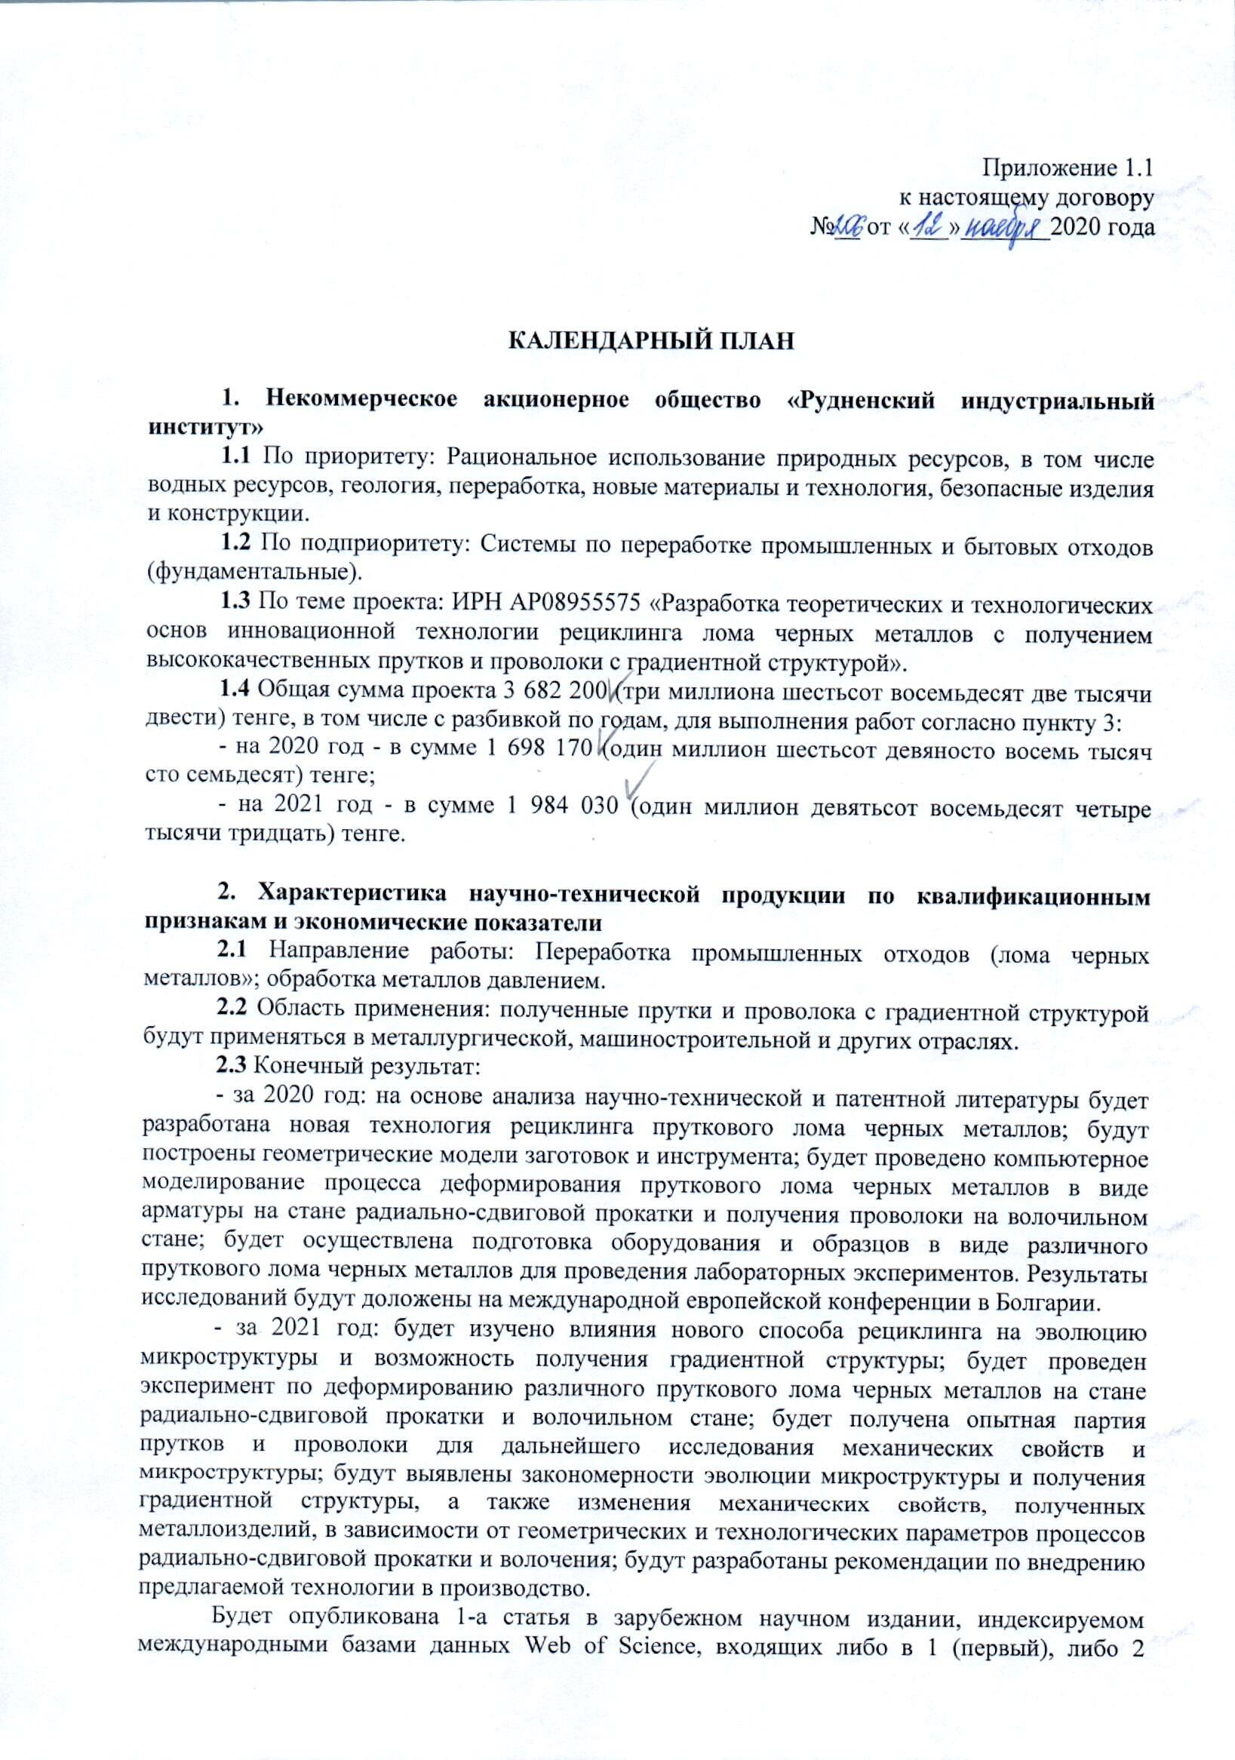

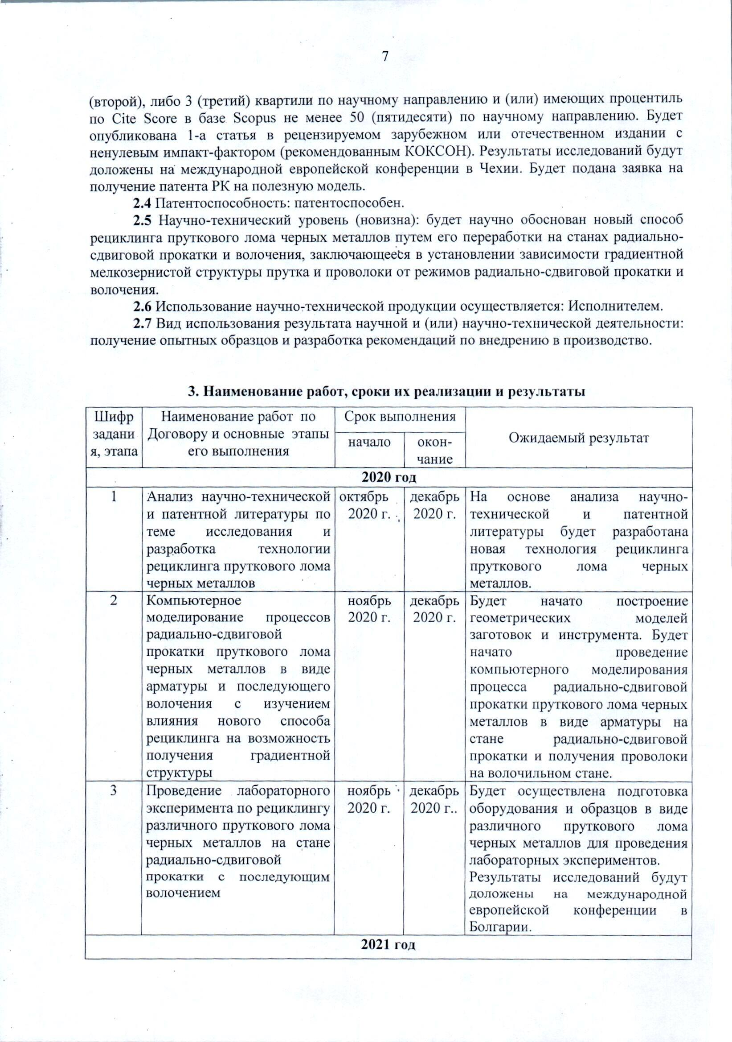

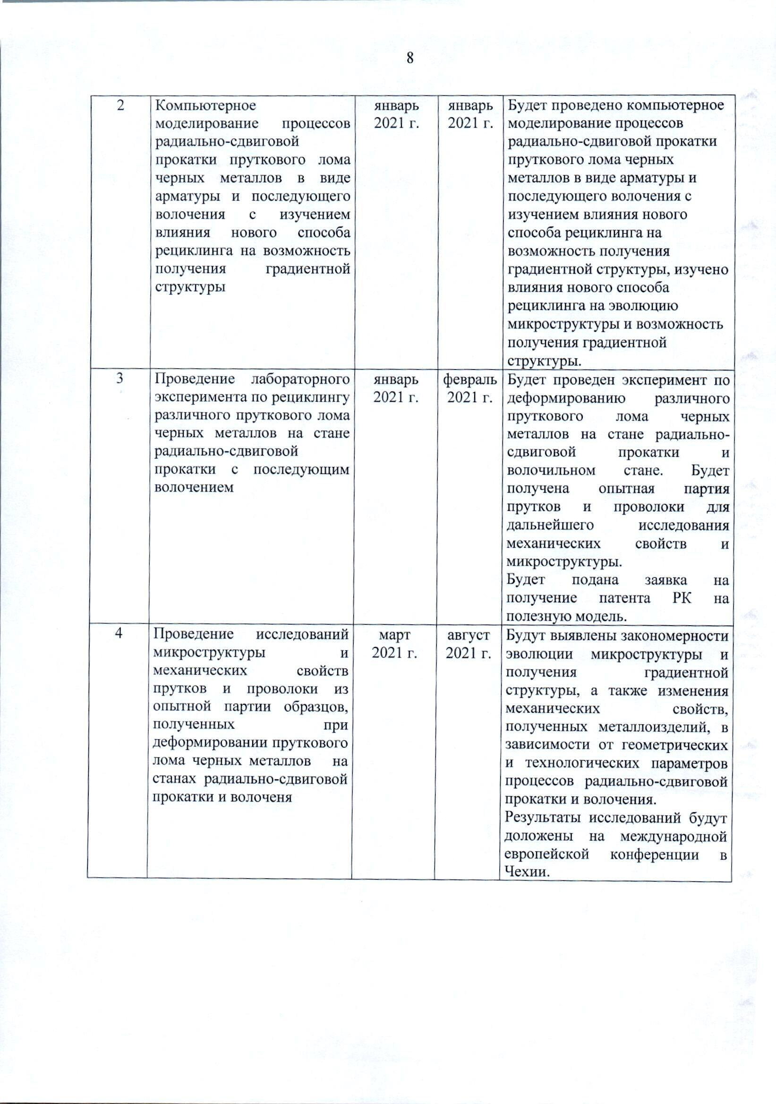

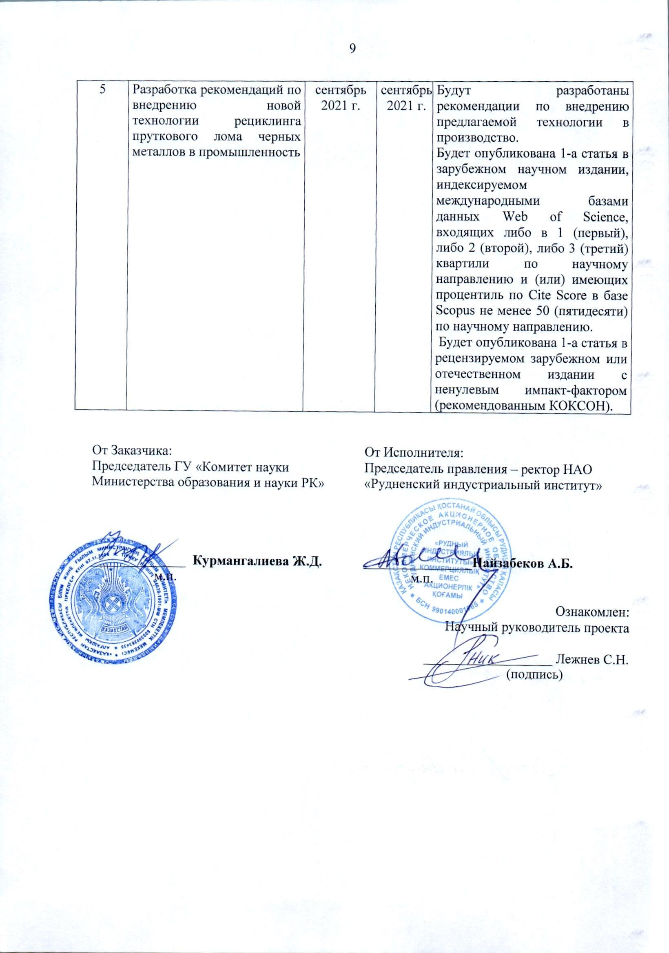

Приложение 1.1
к настоящему договору
№__ от «___»_______20__ года

CALENDAR PLAN

1. Name of the contractor: Non-profit Joint Stock Company "Rudny Industrial Institute" of the Ministry of Education and Science of the Republic of Kazakhstan
1.1 Priority: Rational use of natural resources, including water resources, geology, processing, new materials and technology, safe products and structures.
1.2 Sub-priority: Systems for processing industrial and household waste (fundamental).
1.3 On the topic of the project: IRN AP08955575 "Development of theoretical and technological foundations of innovative technology for recycling ferrous scrap with the production of high-quality bars and wire with a gradient structure".
1.4 The total amount of the project is 3682200 (three million six hundred eighty two thousand two hundred) tenge 00 tiyn, including by year, for the performance of work according to paragraph 3:
- for 2020 - in the amount of 1698170 (one million six hundred ninety eight thousand one hundred seventy) tenge 00 tiyn;
- for 2021 - in the amount of 1984030 (one million nine hundred eighty four thousand thirty) tenge 00 tiyn.

2. Characteristics of scientific and technical products by qualification criteria and economic indicators
2.1 Direction of work: Processing of industrial waste (scrap of ferrous metals; metal processing by pressure).
2.2 Scope of application: resulting bars and wire with a gradient structure will be used in the metallurgical, machine-building and other industries.
2.3 Final result:
- for 2020: based on the analysis of scientific, technical and patent literature, a new technology for recycling of ferrous metal bar scrap will be developed; geometric models of blanks and tools will be built; computer modeling of the deformation process of ferrous metal bar scrap in the form of reinforcement on a radial-shear rolling mill and wire production on a drawing mill will be carried out; preparation of equipment and samples in the form of various ferrous metal bar scrap for laboratory experiments will be carried out. The results of the research will be reported at the International European Conference in Bulgaria.
- for 2021: the influence of a new recycling method on the microstructure evolution and the possibility of obtaining a gradient structure will be studied; an experiment will be conducted on the deformation of various ferrous scrap bars at a radial-shear rolling mill and a drawing mill; an experimental batch of bars and wires will be obtained for further research of mechanical properties and microstructure; the regularities of the evolution of the microstructure and the production of a gradient structure, as well as changes in the mechanical properties of the obtained metal products, depending on the geometric and technological parameters of the radial shear rolling and drawing processes, will be revealed; recommendations for the introduction of the proposed technology into production will be developed.
1 article will be published in a foreign scientific publication indexed by the international databases Web of Science, included either in the 1st (first), or 2nd (second), or 3rd (third) quartiles in the scientific direction and (or) having a percentile of CiteScore in the Scopus database of at least 50 (fifty) in the scientific direction. 1 article will be published in a peer-reviewed foreign or domestic publication with a non-zero impact factor (recommended by KOKSON). The results of the research will be reported at the international European conference in the Czech Republic. An application for a patent of the Republic of Kazakhstan for a utility model will be submitted.
2.4 Patentability: Patentable.
2.5 Scientific and technical level (novelty): a new method of recycling bar scrap of ferrous metals by processing it at radial-shear rolling and drawing mills will be scientifically substantiated, which consists in establishing the dependence of the gradient fine-grained structure of the bar and wire on the modes of radial-shear rolling and drawing.
2.6 The use of scientific and technical products is carried out by: by contractor.
2.7 Type of use of the result of scientific and (or) scientific and technical activities: obtaining prototypes and developing recommendations for implementation into production.

3. Name of works, terms of their implementation and results
Cipher of the task, stage |  | Name of the work under the Contract and the main stages of its implementation | Due date |  |  |  | Expected result
 |  |  | start |  | finish
2020 year
1 |  | Analysis of scientific, technical and patent literature on the topic of research and development of technology for recycling bar scrap of ferrous metals | October 2020 y. |  | 31 December  2020 y. |  | Based on the analysis of scientific, technical and patent literature, a new technology for recycling bar scrap of ferrous metals will be developed.
2 |  | Computer simulation of the processes of radial-shear rolling of ferrous scrap bars in the form of reinforcement and subsequent drawing with the study of the influence of a new recycling method on the possibility of obtaining a gradient structure | 01  November 2020 y. |  | 31 December  2020 y. |  | Geometric models of workpieces and tools will be built. Computer simulation of the process of deformation of ferrous metal bar scrap in the form of reinforcement at the radial shear rolling mill and wire production at the drawing mill will be carried out.
3 |  | Conducting a laboratory experiment on the recycling of various ferrous scrap bars on a radial shear rolling machine with subsequent drawing | 01  December 2020 y. |  | 31 December  2020 y. |  | The preparation of equipment and samples in the form of various bar scrap of ferrous metals for laboratory experiments will be carried out.  The results of the research will be reported at the International European Conference in Bulgaria.
2021 year
2 |  | Computer simulation of the processes of radial-shear rolling of ferrous scrap bars in the form of reinforcement and subsequent drawing with the study of the influence of a new recycling method on the possibility of obtaining a gradient structure | 01  January 2021 y. |  |  | 31 January  2021 y. |  | The influence of the new recycling method on the evolution of the microstructure and the possibility of obtaining a gradient structure will be studied.
3 |  | Conducting a laboratory experiment on the recycling of various ferrous scrap bars on a radial shear rolling machine with subsequent drawing | 01  January 2021 y. |  |  | 28 February  2021 y. |  | An experiment will be conducted on the deformation of various ferrous scrap bars on a radial shear rolling machine and a drawing mill. An experimental batch of rods and wires will be obtained for further investigation of mechanical properties and microstructure.  An application for a patent of the Republic of Kazakhstan for a utility model will be submitted.
4 |  | Conducting studies of the microstructure and mechanical properties of rods and wire from a pilot batch of samples obtained during deformation of ferrous metal bar scrap at radial shear rolling and drawing mills | 01  March 2021y. |  |  | 31  August 2021 y. |  | The regularities of the evolution of the microstructure and the production of a gradient structure, as well as changes in the mechanical properties of the obtained metal products, depending on the geometric and technological parameters of the radial shear rolling and drawing processes, will be revealed.  The results of the research will be reported at the international European conference in the Czech Republic.
5 |  | Development of recommendations for the introduction of a new technology for recycling bar scrap of ferrous metals in the industry | 01  September 2021 y. |  |  | 30 September 2021 y. |  | Recommendations on the introduction of the proposed technology into production will be developed.  1 article will be published in a foreign scientific publication indexed by the international databases Web of Science, included either in the 1st (first), or 2nd (second), or 3rd (third) quartiles in the scientific direction and (or) having a percentile of Cite Score in the Scopus database of at least 50 (fifty) in the scientific direction.  1 article will be published in a peer-reviewed foreign or domestic publication with a non-zero impact factor (recommended by KOKSON).
 | Customer:  Chairman of the State Institution "Committee of Science of the Ministry of Education and Science of the Republic of Kazakhstan"  ______________ Kurmangalieva Zh.D.  Stamp place |  |  | Contractor :  Chairman of the Management Board - Rector of the NPJSC "Rudny Industrial Institute" of the Ministry of Education and Science of the Republic of Kazakhstan  ________________ Naizabekov A.B. .  Stamp place  Informed :  Scientific supervisor of the project  ___________________ Lezhnev S.N. .  (sign)

