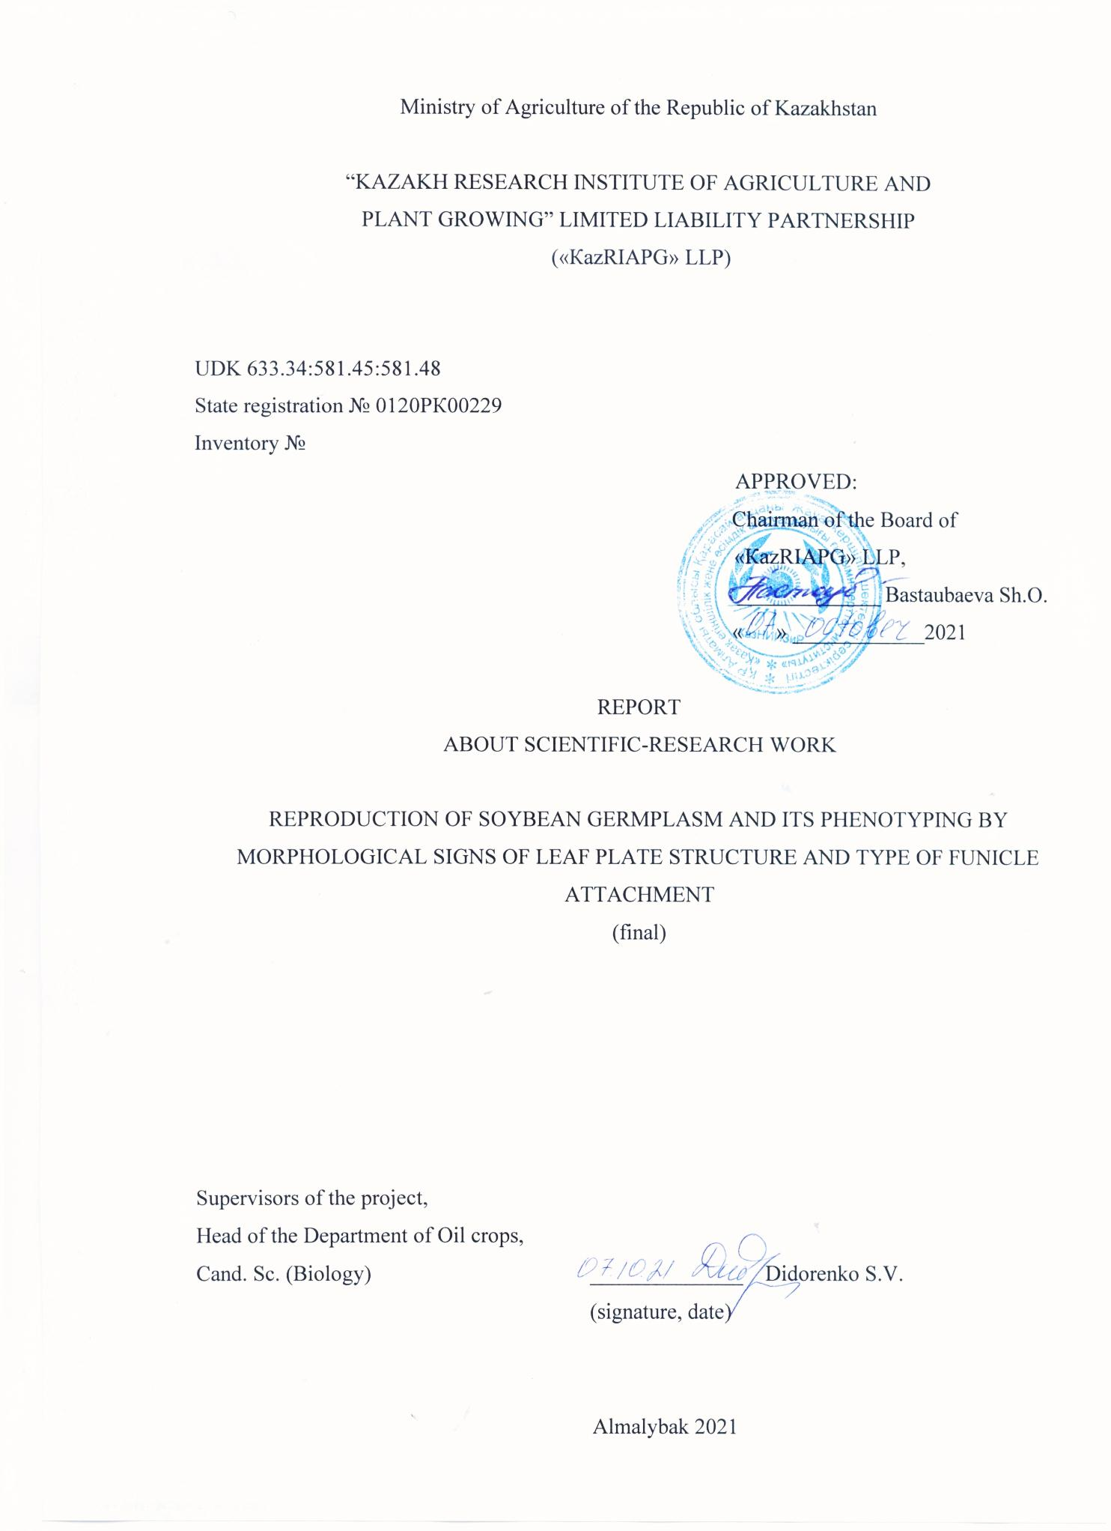

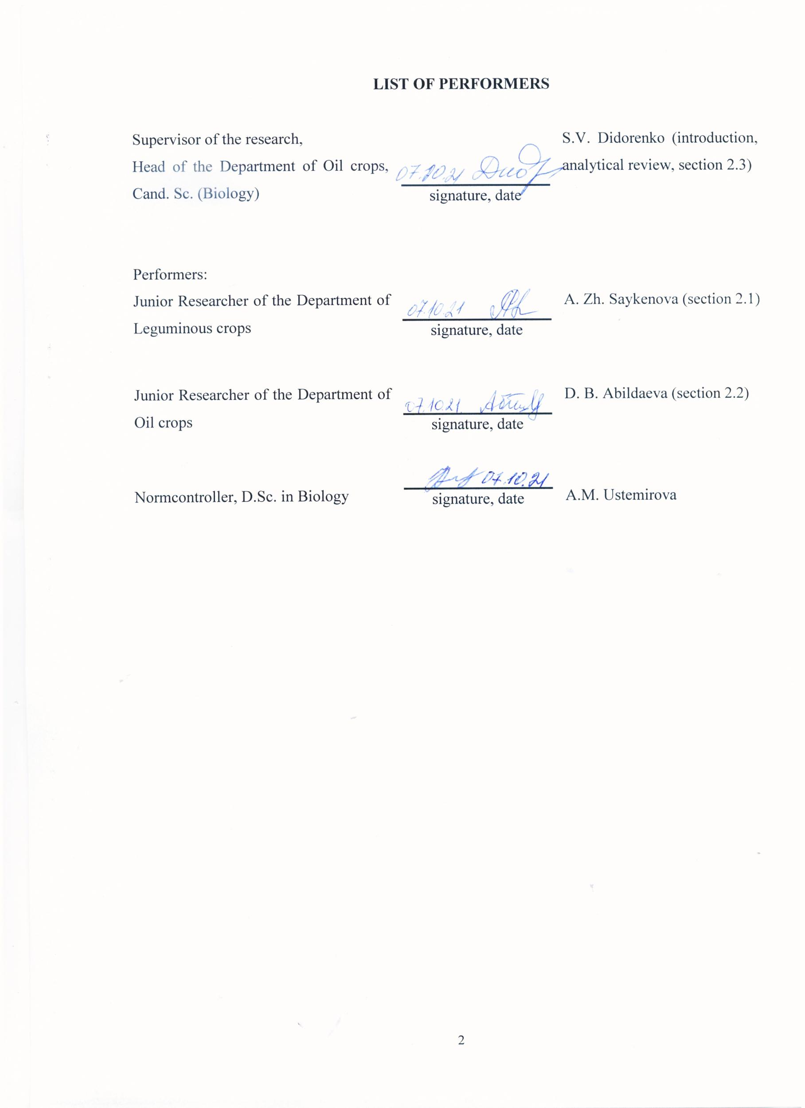

**ABSTRACT**

Report 48 pages, 1 book, 3 tables, 8 figures, 34 sources, 5 attachments

SOYBEAN, HERMOPLASMA, PHENOTYPE, MORPHOLOGY, LEAF, FUNICULUS

Research object: soybean collection.

Purpose: Reproduction of soybean germplasm and identification of cultivars with a lanceolate leaf shape and non-shattering forms.

Research methods: field and laboratory.

Results: The variety samples were identified for the presence of a white eye on the scar, which indicates a dense accretion of the funiculus with the bean flaps. 393 varieties with this trait are identified. In the world collection, which is available in the fund of LLP "KazRIAPG", non-shattering varieties from Poland, Canada, Moldova, France, Sweden, Czechoslovakia, China, Denmark, and Kazakhstan have been identified. Data on the shape of the leaf blade of soybean germplasm of the department of leguminous crops of LLP "KazRIAPG" are collected and systematized. Out of 1790 cultivars, 128 were isolated with a lanceolate and triangular leaf shape. From the world collection, the largest number of samples with a triangular leaf shape is characteristic of Chinese varieties - 45 cultivar varieties. Narrow-leaved cultivars from Kazakhstan - Pamyat UGK and Viktory, Russia - Lanceolate and Krasivaya Mechta, France - Sponsor, Belarusian - Volma, Osmon, Mezenka, Oressa, Voronezhskaya 31 were identified. The cultivar varieties were reproduced and put into storage

Within the framework of the project, an article "Monitoring of yield and quality indicators of soybean varieties when creating diverse ecotypes in Kazakhstan" was prepared and submitted for publication in the journal with a CiteScore percentile in the Scopus 41 database. An article was published in a foreign journal-Legumes and cereals (Russia (IF RSCI 0.471) "Phenotyping of soy germplasm Glycine Max (L.) Merr., on the basis of seed non-shattering". The checklist of the characteristic collection of soy Glycine Max.L. (narrow-leaved, scar with an eye) has been published. The results of the work are published on the official portal of “KazRIAPG” LLP Facebook.

**ТҰЖЫРЫМ**

Есеп 48 парақ, 1 кітап, 3 кесте, 8 сурет, 34 деректер, 5 қосымша

ҚЫТАЙБҰРШАҚ, ГЕРМОПЛАЗМА, ФЕНОТИП, МОРФОЛОГИЯ, ЖАПЫРАҚ, ТҰҚЫМСАҒАҚ

Жұмыстың мақсаты: қытайбұршақ коллекциясы.

Мақсаты: Қытайбұршақ гермоплазмасын көбейту және ланцет тәріздес пішінді жапырақ және шашылмайтын формалары бар сұрыпты үлгілерді анықтау.

Зерттеу әдістері: танаптық және зертханалық.

Нәтижелері: Қытайбұршақ дәніндегі тұқымкіндігінде ақ көзше болуы бойынша сортүлгілерді сәйкестендіру жұмыстары жүргізілді, бұл тұқымсағақтың бұршақ жармасымен тығыз өсуін көрсетеді. Осы белгімен 393 сортүлгілері анықталды. «ҚазЕӨШҒЗИ» ЖШС қорындағы әлемдік коллекцияда Польша, Канада, Молдова, Франция, Швеция, Чехословакия, Қытай, Дания және Қазақстанның шашылмайтын сорттары анықталды.

ЖШС «ҚазЕӨШҒЗИ» дәнді бұршақ дақылдар бөлімінің қытайбұршақ гермплазмасының жапырақ тақтасының формасы туралы мәліметтер жинақталып және жүйеленді. 1790 сортүлгілерінен 128 ланцет және үшбұрышты пішінді формалар анықталды. Әлемдік коллекциядан үшбұрышты жапырақ пішінді үлгілердің ең көп саны қытай сортүлгілеріне - 45 сортүлгілері тән. Қазақстанда тасжапырақты сортүлгілер - Память ЮГК және Viktory, Ресей - Ланцетовидная және Красивая меча, Франция - Sponsor, Белорусь - Волма, Осмонь, Мезенка, Оресса, Воронежская 31.

Жоба шеңберінде Scopus 41 базасында CiteScore бойынша процентиль бар журналда "Қазақстанда алуан түрлі экотиптерді құру кезінде қытайбұршақ сорттарының өнімділігі мен сапалық көрсеткіштерінің мониторингі" мақалалар дайындалып, баспаға ұсынылды. Мақала шетелдік журналда жарияланды - Бұршақ және жарма дақылдары (Ресей (IF РИНЦ 0,471) "Glycine Max (L.) merr қытайбұршақ гермоплазмасын фенотиптеу, тұқым шашылмау белгісі бойынша".Қытайбұршақ Glycine Max.L. топтамасының каталогы жарияланды (тар жапырақ, көзі бар дән). Жұмыс нәтижелері «ҚазЕӨШҒЗИ» ЖШС Facebook ресми порталында жарияланды.

**CONTENT**

|  |  |
| --- | --- |
| INTRIDUCTION………………………………………………..…………………….……... | 7 |
| MAIN PART of the RSW report …………………………………………………………….. | 11 |
| 1 Research materials and methods …………………………………………………….…….. | 11 |
| 1.1 Scope of work ...…………………………………….………………………….……….. | 11 |
| 1.2 Research methods …………………………………….………………………………… | 11 |
| 2 Research results…………..……………………………….………………………………... | 13 |
| 2.1 Phenotyping of soybean germplasm by morphological characteristics……..……..……. | 13 |
| 2.1.1 Phenotyping of soybean germplasm based on morphological features of the funiculus structure ………..…………………..……………….…………................. | 13 |
| 2.1.2 Collection and systematization of data on the morphological structure of the leaf surface of soybean germplasm …………………...…………………….…………... | 15 |
| 2.2 Reproduction and preservation of seed material of soybean germplasm .……………… | 15 |
| 2.2.1 Preparation of soybean germplasm seed material for sowing, as well as for short-term and long-term storage ……………………………………………………..….. | 15 |
| 2.2.2 Sowing of seed material of soybean germplasm at the field station of "KazRIAPG" LLP…………………………………………………………………………………. | 16 |
| 2.2.3 Soybean germplasm seeding care ………...………………………….…….………. | 17 |
| 2.2.4 Harvesting of soybean germplasm seed ………….………………………………… | 19 |
| 2.3 Promotion of the results obtained …….………………………………………………… | 19 |
| Қорытынды......................................................................................................................... | 21 |
| CONCLUSION ...………………………………………………….…………………………. | 22 |
| LIST OF USED SOURCES …………………….……………………...………………….… | 23 |
| ATTACHMENT А - Availability of personnel for the task execution ….……………….….. | 26 |
| ATTACHMENT B – List of published works..…………………………….…………......…. | 27 |
| ATTACHMENT C - A copy of the contract work plan…………...……………………….. | 28 |
| ATTACHMENT D - Patent Research Report ……………………………….……….……... | 34 |
| ATTACHMENT E – The act of depositing extrabudgetary funds by a private partner ……. | 48 |

**DEFINITIONS, SYMBOLS AND ABBREVIATIONS**

In this RSW report, the following terms are used with appropriate definitions, symbols and abbreviations:

"KAZRIAPG" LLP is a limited liability partnership "Kazakh Research Institute of Agriculture and Plant Growing".

GRIN - Germplasm Resources Information Network.

All-RUIPG is the All-Russian Institute of Plant Growing named after N. I. Vavilov in St. Petersburg.

NPGS- National Plant Germplasm System.

pcs- pieces

**INTRODUCTION**

The relevance of the topic. Soy *Glycine max (L.) Merr*. — one of the main protein-oilseed crops with a wide range of applications: food, feed, technical and medical, textile [1,2,3,4,5,6,7].

Taking into account the high nutritional value and protein content, soy is defined as a strategic crop. Half of the world's reserves of vegetable protein consumption are soy proteins. One third of the vegetable oil consumed by humans in the world is soy [8].

World soybean production is growing annually, and in 2019, the sown area of soybeans amounted to 139.5 million hectares. Currently, three countries – the United States, Brazil and Argentina - account for more than 80% of global soybean production. The sown area of soybeans in Kazakhstan over the past 10 years has increased by more than 2.5 times from 53.6 thousand hectares in 2009 to 139,5 thousand hectares in 2019, however, the yield for this period increased slightly — c 18,0 c/ha to 20.7 c/ha.

In Kazakhstan, the only selection center for soybeans is "KazRIAPG" LLP, which is the main holder of the genetic fund of cereals and leguminous crops. Soybean breeding has been carried out here since 1961 and is successfully continuing at the present time. Over the years, more than 30 varieties of this crop have been created, of which 17 have been approved for use, and 5 varieties are in State variety testing. Primary and elite seed production of varieties approved for use has been established. The main characteristics for which soybean breeding is carried out are: yield, various groups of ripeness, seed quality (protein content, oil content) and drought resistance. Selection based on drought tolerance is mainly based on selection for morphological and biochemical markers.

The main soybean-sowing region in the Republic is the irrigated arable land of the Almaty region (107 thousand hectares). Limiting factors for increasing the acreage in the republic are such factors as the growing season [9, 10], photopereodic sensitivity [11], resistance to diseases [12], resistance to unfavorable climatic factors, frost, salt and drought resistance [13, 14].

Assessment of the current state of knowledge of the problem. The effectiveness of working with any agricultural crop is largely determined by the presence of an extensive and diverse source material. Its creation is the first and very important stage of the selection process.

The creation of the source material begins with the collection and study of various forms. For decades, the All-Russian Institute of Plant Growing named after N. I. Vavilov in St. Petersburg (VIR) remains to be the main collectable institution in the space of Eastern Europe and Russia. Its checklists are available online at [www.vir.nw.ru](http://www.vir.nw.ru) [15, 16, 17, 18].

The collection of the Ukrainian Institute of Crop Production named after V. Y. Yuryev in Kharkiv includes more than a thousand varieties of soybeans [19].

The most extensive scientific collection of soybeans is maintained by the National Plant Germplasm System (NPGS) under the auspices of the US Department of Agriculture. It contains about 18 thousand samples [20, 21].

Like the samples of the All-RuRIPG collection, they are also available for order, the checklist can be found on the website grain.jouy.inra.fr. Also, on the linked Germplasm Resources Information Network (GRIN) website [www.ars-grin.gov](http://www.ars-grin.gov) you can pre-search for samples that meet the specified conditions, i.e. with any set of agronomic, biochemical and other parameters.

The "Soya-Sever" company maintains a collection of soybeans, which includes about 300 varieties of various origins (from China, Japan, USA, Canada, France, Poland, Ukraine, Russia, etc.), mainly of 00 ripeness group.

For breeding purposes, the source material must be well studied and divided into types according to the main characteristics: yield, length of the growing season, resistance to adverse environmental conditions (drought, dry winds, excessive waterlogging, frost), resistance to diseases and pests, suitability for mechanized harvesting, seed quality and response to various cultivation techniques [22, 23, 24].

A large amount of collection material is involved in the breeding process for soybeans in “KazRIAPG” LLP. They were obtained in cooperation with the following organizations: All-Russian Research Institute of Plant Growing named after N.I. Vavilov (Russia, St. Petersburg), All-Russian Research Institute of Oilseeds named after V.S. Pustovoyta (Russia, Krasnodar), Siberian Research Institute of Plant Growing and Breeding of SB of the RAAS (Russia, Novosibirsk), Institute of Plant Industry named after Yuryev (Ukraine, Kharkov), Soybean Institute (Ukraine, Poltava Region), "Soya Sever" Corporation (Belarus). Replenishment, study and preservation of the collection of soybeans in LLP "KazRIAPG" resumed after the collapse of the Union and has been continuously conducted for more than 20 years [25].

The strategy and tactics of replenishing the collection is a living process. At each stage of the development of society, it is necessary to take into account the priorities of the development of agriculture, breeding and the country as a whole. The expansion of the distribution area of soybeans in the northern and southern directions of the Republic revealed the need to create varieties that are resistant to drought stress and changes in daily temperatures, which lead to cracking of the beans.

Loss of soybean seeds in varieties unstable to cracking can reach 34–99% [26; 27]. Bean cracking is necessary for their offspring to reproduce in wild plants, but is a major cause of crop loss in crops. Leguminous species disperse seeds by breaking the pod along the ventral suture after maturation [28]. In cultivated soybeans (*Glycine max*), the non-growing pod is the main sign of domestication, which is targeted by artificial selection [29].

Cultivation of genotypes resistant to cracking in different climatic conditions often leads to the loss of this resistance. Many researchers who have studied this sign have paid attention to the fact that when overstocking, especially in conditions of alternating dry and rainy days, the risk of cracking beans increases markedly. And under conditions of prolonged droughts at the last stages of soybean organogenesis, premature opening of beans was often observed even in varieties highly resistant to cracking [30, 31]. Soybeans are less prone to cracking when watered than when not watered. Cracking is also influenced by fluctuations in night and day temperatures.

In 1952, A. Eglitis, a pea breeder, in the 2nd hybrid generation, stated the sign of non- shattering. In a scientific report for 1954, he gives the following characteristic of this trait: "The hybrid form of peas obtained from crossing the varieties vitellinum and coronatum is particularly interesting and promising. Peas in plants of this form are held firmly and do not fall out even from the open pods. The peculiarity of this phenomenon is that due to deep anatomical changes in the structure of the funiculus and the grain scar, their strong fusion occurred" [32].

There is no consensus in the literature on the effect of the non- shattering trait on seed yield. Experimental data and breeding practice have shown the possibility of creating non- shattering varieties with yields at the level of traditional ones.

One of the morphological signs of drought tolerance in soybeans can be narrow-leaved. A decrease in transpiration with this shape of the leaf blade leads to a decrease in transpiration and an economical distribution of liquid.

As a result of many years of work on the collection, preservation and study of the collection in the department of leguminous crops, two gene pool checklist were published [33, 34]. However, none of them provides data on the morphological description of the characters selected for research in this project.

The scientific novelty lies in the fact that during the implementation of this project, for the first time in Kazakhstan, work will be carried out on an extensive morphological description of the leaf blade and the structure of the funiculus of collection soybean samples. A search will be carried out for specimens with a lanceolate leaf blade and a tightly attached funiculus to the seed. The purposeful use of the selected varieties will allow researchers to include them in breeding programs for the creation of varieties with signs of drought resistance and non-shattering seeds.

The significance of the project is determined by the fact that the research will reproduce and preserve the extensive genetic material of soybeans, phenotyping will be carried out according to the traits of leaf morphology and attachment of seeds to bean flaps, and narrow-leaved and non- shattering varieties of soybeans will be identified.

Purpose: Reproduction of soybean germplasm and identification of variety samples with lanceolate leaf shape and non-shattering forms.

Research objectives:

1) Phenotyping of soybean germplasm by morphological characteristics of the structure of the leaf blade and attachment of funiculus to the seed to identify variety samples with lanceolate leaf blade and non- shattering forms;

2) Reproduction of soybean germplasm in order to renew the seed material;

3) Preparation of germplasm seed material for short-term storage (2-3 years).

Expected results:

1) Phenotyping of soybean germplasm based on the structure of funiculus will be carried out. Samples with a sign of dense fusion of funiculus and bean flaps will be highlighted.

2) Long-term material on the morphological structure of the leaf surface of soybean germplasm will be systematized.

3) Soy germplasm seeds will be reproduced and prepared for storage.

4) The results of scientific research carried out within the framework of the project will be published in 1 peer-reviewed foreign publication or scientific journal recommended by ССFES and in 1 journal with a CiteScore percentile in the Scopus database of at least 35 (thirty-five).

5) The checklist of soybean germplasm will be issued by "KazRIAPG" LLP.

6) The results of the work will be disseminated to the community of scientists and the general public with the involvement of Internet resources on the official portal of LLP "KazRIAPG" Facebook.

The project is registered in the database under the Registration number 0120РК00229 and has the inventory number of the interim report 2020 – 0220РК01558.

**MAIN PART OF THE RSW REPORT**

**1 Materials and methods of research**

**1. 1 Scope of work**

The research material is an extensive collection of soybeans of the leguminous crops department of "KazRIAPG" LLP, consisting of germplasm of foreign varieties of the world collection, and domestic breeding material (table 1).

Table 1 - The volume of nurseries for phenotyping morphological traits

|  |  |  |
| --- | --- | --- |
| Name of the nursery | Origin | Number of samples, pcs |
| Soy gene pool | World collection of 26 countries | 891 |
| Soy Collection | Domestic varieties | 30 |
| Hybrid nursery | F1- F5 | 438 |
| Breeding nursery | SP1 - SP2 | 353 |
| Control nursery | Domestic constant numbers | 60 |
| Nursery of preliminary variety testing | Domestic constant numbers | 21 |
| Nursery of competitive variety testing | Domestic constant numbers | 27 |
| TOTAL |  | 1790 |

**1.2 Research methods**

The morphological assessment of the degree of attachment of funiculus to the seed is carried out by the presence of a characteristic white eye on the seed scar (figure 1).

|  |  |
| --- | --- |
| C:\Users\01\Desktop\соя рубчик\IMG_20201104_114508.jpg | **C:\Users\01\Desktop\соя рубчик\IMG_20201104_114514.jpg** |
| 1 | 2 |

1- with eye, 2- without eye

Figure 1 – Type of scar

Morphological assessment of soybean leaves. All observations are performed on the leaves of the middle tier that have completed growth and differentiation. To describe the shape of the leaf surface, the UNOX TG/80/6 database "GUIDELINES FOR THE CONDUCT OF TESTS FOR DISTINCTNESS, HOMOGENEITY AND STABILITY" is used (figure 2).

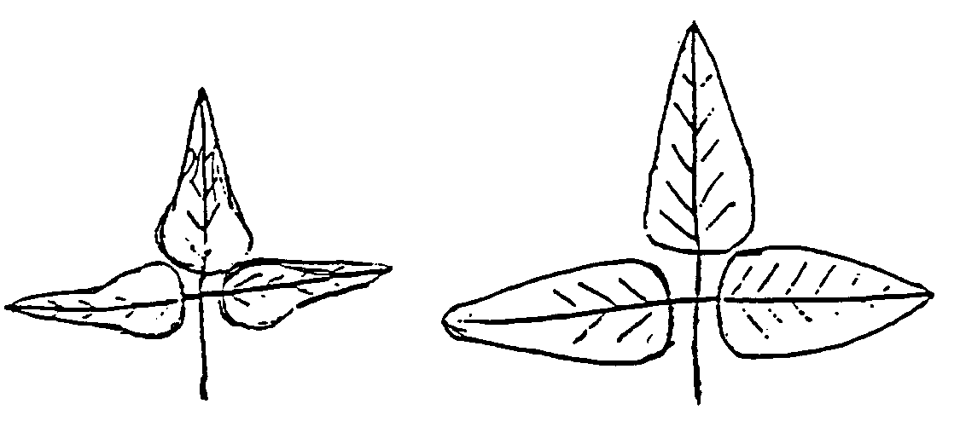

1 2

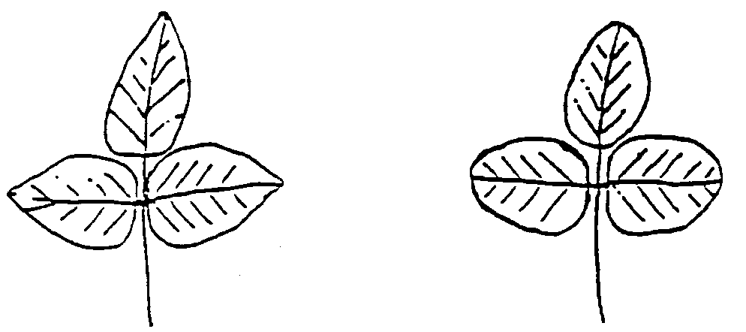

3 4

1-lanceolate, 2-triangular, 3-pointed-ovate, 4 rounded-ovate

Figure 2 - The shape of the side leaf

**2 Research results**

**2.1 Phenotyping of soybean germplasm by morphological features**

2.1.1 Phenotyping of soybean germplasm by morphological features of the funiculus structure

The variety samples were identified for the presence of a white eye on the scar, which indicates a dense fusion of the funiculus with the leaves of the bean. With such a fusion of the seed and the leaves, even when they crack during the growing season, there is no shattering of seeds. Regardless of the main color of the scar – yellow, brown or black, samples with a characteristic white eye were found (figure 3).

|  |  |  |
| --- | --- | --- |
| C:\Users\01\Desktop\соя рубчик\IMG_20201031_121707_1.jpg | C:\Users\01\Desktop\соя рубчик\IMG_20201104_114550.jpg | C:\Users\01\Desktop\соя рубчик\IMG_20201104_114508.jpg |
| 1 | 2 | 3 |

1- Almaty (Kazakhstan), 2 –Krasivaya mecha (Russia), 3-Spritna (Ukraine)

Figure 3-The presence of a white eye on the scar

As a result of phenotyping, 393 samples with the presence of a characteristic eye were selected. The largest number of non-shattering variety samples from the world collection available in the fund of "KazRIAPG" LLP were of Russian and Ukrainian origin – 25 and 16 variety samples, respectively. The collection contains single non-shattering variety samples from Poland, Canada, Moldova, France, Sweden, Czechoslovakia, China, Denmark.

Of the varieties of domestic selection, only two have this feature – Almaty and Zara. The Zara variety is actively used in the breeding program as a mother form, so the collection of hybrid and breeding nurseries has a fairly large number of lines with this trait. The largest number is characteristic of the hybrid nursery F1-F5-246 lines (table 2). From 20 to 100% of lines in hybrid populations of F3 with the participation as the parent form of the Zara variety have this trait.

Table 2 - Results of phenotyping of soybean germplasm by the sign of tight attachment of funiculus to the pod flaps

|  |  |  |
| --- | --- | --- |
| Name of the nurser | Number of samples, pcs | Name of the variety sample |
| 1 | 2 | 3 |
| Soybean gene pool | 63 | (Soer-5, PEP 27, Maleta, Lancetnaya, Krasivaya Mecha, Soer -3, Soer 4, Soer 345, Veidelevskaya 17, Primorskaya 495, Svapa, OPUS, Soer 7, Hera, Samer 1, SK Unica, Osmon, SK Elana , Soer 2-95, Samer 2, All-RUIAC 1374, PEP17, Krapinka) –Russia, (Masha) - Serbia, (Romantika, Spritna, Annushka, Chernivitskaya 7, Prikorpat'ska 81, Ustya, Malvina, Estofita, Feya, Odesskaya 150, Almaz , Anthracite, Kirovogradskaya 3, l 113-08, Viktorina) - Ukraine, Sepia - France, Turijskaja masnaja, Toury - Czechoslovakia, (1040-4-2, 840-2-7, Fiskeby III, N 840-5-3) - Sweden, (6792) -Denmark, (8532, Buster, Maple Ridge, Kofu) - Canada, (1674, 00533) - China, (Moldavian 65, Albisoara, to 4926, 8541) -Moldova, (Kollekcyina, LMF, Aldana ) - Poland, (Almaty, Zara, Black Rose) - Kazakhstan |
| Hybrid nursery | 246 | F2 (Zara/Maleta)-118 lines,  F3 (Zara/Maleta) – 9 lines, F3 (Zara/Soer 5) - 15 lines, F3 (Zara/1022) - 5 lines, F3 (Zara/1017) - 7 lines, F3 (Zara/Hua ya Dou) - 8 lines, F3 (Zara /Hei He 47) - 13 lines, F3 (Zara/Xiong Nong 26) - 15 lines, F3 (Zara / Ascacubi) - 10 lines, F3 (Zara/ Trijumf) - 7 lines, F3 (Zara/Ivushka) - 5 lines, F3 (Zara/YUGK Pamyat)- 7 lines, F3 (Zara/Zhansaya)- 17 lines, F3 (Zara/Luna) - 14 lines, F5-1 line |
| Breeding nursery | 60 | SP1 (Zara/Zen)- 4 lines, SP1 (Zara/Buso)- 5 lines, SP2 (Zara/Dawn)- 7 lines, SP2 (Zara/Ustya)- 3 lines, SP2 (Zara/347)- 3 lines, SP2 (Zara/234) - 4 lines, SP2 (Zara/670)-5 lines, SP2 (Zara/Rosa)- 8 lines, SP2 (Zara/Perizat)-3 lines, SP2 (Zara/ Xinjiang D10)-10 lines, SP2 (Zara/ Nadezhda)- 3 lines, SP2 (Zara / Hybrid yellow)-5 lines |
| Control nursery | 17 | K 46/5, K 46/1, K 46/2, K 46/4 (Odesskaya 150/Safrana); K 13/1, K 13/2, K 13/6, K 13/3 (Odesskaya 150/ Zen); K 28/4, K 28/3, K 28/6 (Slavia/ Desna); K 34/3 (Almaty / Santana); K 47/4,(Almaty /Vilana); LT 38/1 (Lastochka/ Sulamit); LT 26/2 (Zara/ Hybrid yellow); K 15/3 (Odessa 150/Harbin); LT 17/2 (Zara/Rosa) |
| Nursery of preliminary variety testing | 5 | CT 41/4 (Zara / Zhansaya); I 23/8, I 23/7 (Zara/Korsak); RK 152/2 (00533); RK 206/1 (K6477) |
| Nursery of competitive variety testing | 2 | IT 24/4 (Zara/ Cheremosh);  IT 24/2 (Zara/ Cheremosh) |
| TOTAL | 393 |  |

2.1.2 Collection and systematization of data on the morphological structure of the leaf surface of soybean germplasm

Data on the shape of the leaf plate of the soybean germplasm of the leguminous crops department of "KazRIAPG" LLP were collected and systematized. From 1790 variety samples, 128 with a lanceolate and triangular leaf shape were selected (table 3). From the world collection, the largest number of samples with a triangular leaf shape are characteristic of variety samples of Chinese selection - 45 variety samples. Narrow – leaved cultivars from Kazakhstan – Memory of YUGK and Viktory, Russia –Lanceolate and Krasivaya Mecha, France – Sponsor, Belarusian-Volma, Osmon, Mezenka, Oressa, Voronezh 31 were identified.

Table 3 - Results of phenotyping of soybean germplasm on the basis of narrow-leaved

|  |  |
| --- | --- |
| Name of the nursery | Number of samples, pcs |
| Soybean gene pool | 58 |
| Soybean Collection | 2 |
| Hybrid nursery | 15 |
| Breeding nursery | 51 |
| Control nursery | 0 |
| Nursery of preliminary variety testing | 1 |
| Nursery of competitive variety testing | 1 |
| TOTAL | 128 |

It is characteristic to note that when creating domestic soybean varieties – Pamyat of YUGK and Viktory, samples of Chinese breeding were used as paternal forms.

Hybrid populations obtained from crossing with samples of Chinese and French breeding are being tested in hybrid and breeding varieties of domestic selection.

**2.2 Reproduction and preservation of soybean germplasm seed material**

2.2.1 Preparation of soybean germplasm seed material for sowing, as well as for short-and long-term storage

393 cultivars and hybrid lines with an eye on the scar and 128 cultivars and hybrid lines with a narrow-leaved sign were prepared for sowing. The sowing rate is 25 pieces per running meter. To ensure short-term storage for 1-3 years, Doy Pak packages with a Zip Lock were purchased for the purpose of repeated use and research during seed storage. Seeds with the specified characteristics were carefully selected; substandard and shriveled seeds were rejected. "Doy pak" are filled in the amount of 1000 pieces for each breeding number (figure 4). The label displays information about the crop, variety, originator country, harvest year and feature.

|  |  |
| --- | --- |
| C:\Users\user\Desktop\Desktop\фото мон 2021\IMG_20210309_144618.jpg | C:\Users\user\Desktop\Desktop\фото мон 2021\IMG_20210407_111726_1.jpg |

Figure 4 - Preparation of seeds for sowing and storage

2.2.2 Sowing of seed material of soybean germplasm at the field station of "KazRIAPG" LLP

In order to reproduce, multiply and renew the seed material of soybean germplasm, on April 29, manual sowing of two characteristic collections was carried out - 393 cultivars and hybrid lines with an eye on the scar and 128 cultivars and hybrid lines with a narrow-leaved sign (figure 5). Plot size is 1 running meter, 25 seeds, sowing depth is 4 cm. Sowing was carried out at the optimum time for a given crop.

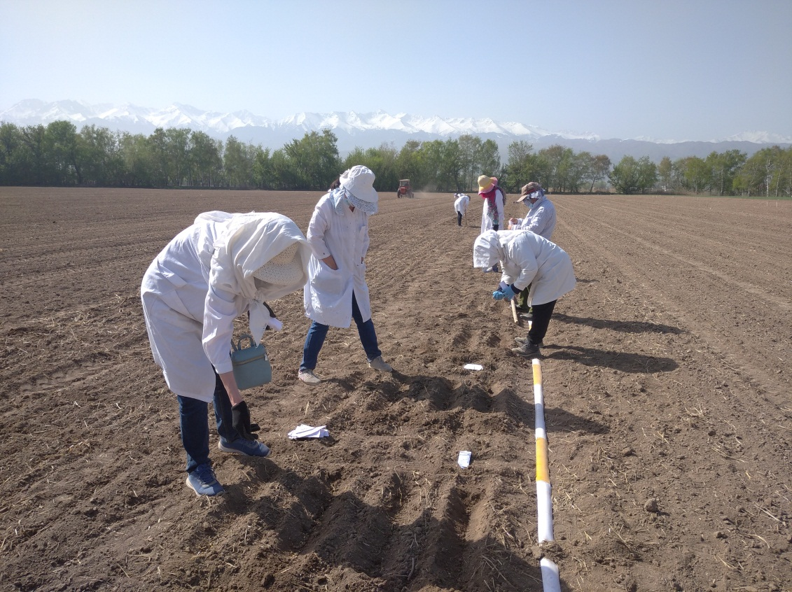

Figure 5 - Sowing of collection samples of soybeans, field station of "KazRIAPG" LLP

2.2.3 Soybean germplasm seeding care

Traditionally, the care of soybean crops consists of chemical and mechanical weeding, loosening and organization of irrigation (figure 6). On the day of sowing, the field station was treated with the soil herbicide Gezagard at a dose of 2.5 l/ha, after 30 days the field was treated with contact herbicides Bazagran 3 l/ha and Zelek 1 l/ha. Vegetation irrigation is organized. During the growing season, the collection samples were watered by the irrigation method 4 times on June 15, June 25, July 10 and July 25.

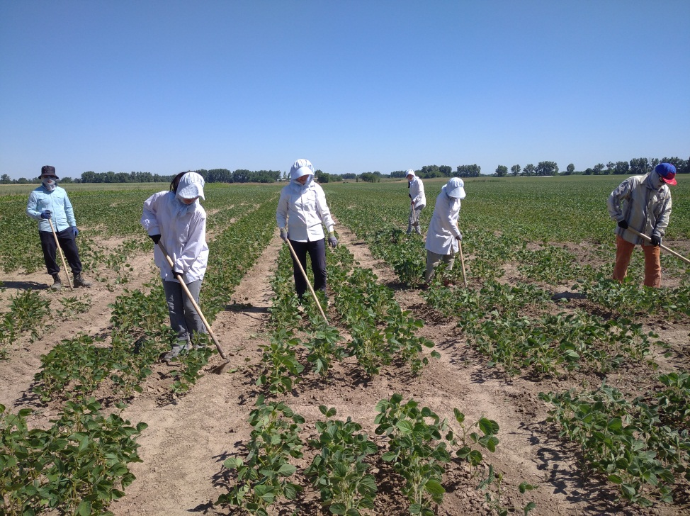

Figure 6 - Manual weeding and loosening of collectible variety samples of soybeans

During the growing season, phenological measurements were carried out, the study of the leaf blade – determining the shape, size, color intensity (figure 7).

|  |  |
| --- | --- |
| C:\Users\user\Desktop\Desktop\фото мон 2021\IMG_20210715_134205_1.jpg | C:\Users\user\Desktop\Desktop\фото мон 2021\IMG_20210715_140502 (1).jpg |
| а | б |

a - general view of the nursery, b-study of the morphological characteristics of variety samples of soybeans

Figure 7 - Reproduction and study of variety samples of soy

2.2.4 Harvesting of soybean germplasm seed material

Harvesting of the seed material was carried out manually as variety samples matured from August 5 to September 25. During harvesting, variety samples were recorded that were prone to cracking, but due to the dense accretion of funiculus with the leaves of the bean, the seeds did not shed during cracking (figure 8). In the storage rooms, in order to avoid injury to the seeds, threshing was carried out manually.

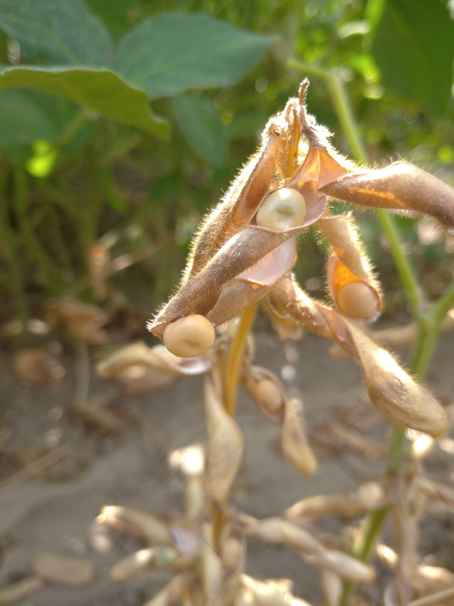

Figure 8-Soybean varietal with the non-shattering feature

**2.3 Promotion of the results obtained**

Within the framework of the project, an article was published in a foreign magazine - Legumes and cereals (Russia (IF RSCI 0.471), in Agrivita magazine, which has a CiteScore percentile in the Scopus database - 41% (Attachment B).

Within the framework of the project, a catalog has been published that contains information on two collections with a description of morphological characters. The first collection with a narrow leaf structure has a description of the type of leaf blade - triangular or lanceolate, size and color intensity of the leaf surface. The second collection of non-shedding soybeans contains information about the seed - its color, size, scar characteristics - color and size.

The catalog is intended for researchers working in the field of soybean breeding, as well as students and undergraduates in agronomic specialties.

The project was completed in accordance with the timetable under Contract No. 248 for the implementation of scientific, scientific and technical projects for grant funding (Attachment B). A patent search was carried out, confirming the patentability of this topic (Appendix D). The results of the work were published on the official portal of KazRIAPG" LLP Facebook dated 09/26/2021.

**Қорытынды**

Қытайбұршақ дәніндегі тұқымкіндігінде ақ көзше болуы бойынша сортүлгілерді сәйкестендіру жұмыстары жүргізілді, бұл тұқымсағақтың бұршақ жармасымен тығыз өсуін көрсетеді. Осы белгімен 393 сортүлгілері анықталды. «ҚазЕӨШҒЗИ» ЖШС қорындағы әлемдік коллекцияда Польша, Канада, Молдова, Франция, Швеция, Чехословакия, Қытай, Дания және Қазақстанның шашылмайтын сорттары анықталды.

ЖШС «ҚазЕӨШҒЗИ» дәнді бұршақ дақылдар бөлімінің қытайбұршақ гермплазмасының жапырақ тақтасының формасы туралы мәліметтер жинақталып және жүйеленді. 1790 сортүлгілерінен 128 ланцет және үшбұрышты пішінді формалар анықталды. Әлемдік коллекциядан үшбұрышты жапырақ пішінді үлгілердің ең көп саны қытай сортүлгілеріне - 45 сортүлгілері тән. Қазақстанда тасжапырақты сортүлгілер - Память ЮГК және Viktory, Ресей - Ланцетовидная және Красивая меча, Франция - Sponsor, Белорусь - Волма, Осмонь, Мезенка, Оресса, Воронежская 31.

Жоба шеңберінде Scopus 41 базасында CiteScore бойынша процентиль бар журналда "Қазақстанда алуан түрлі экотиптерді құру кезінде қытайбұршақ сорттарының өнімділігі мен сапалық көрсеткіштерінің мониторингі" мақалалар дайындалып, баспаға ұсынылды. Мақала шетелдік журналда жарияланды - Бұршақ және жарма дақылдары (Ресей (IF РИНЦ 0,471) "Glycine Max (L.) merr қытайбұршақ гермоплазмасын фенотиптеу, тұқым шашылмау белгісі бойынша".Қытайбұршақ Glycine Max.L. топтамасының каталогы жарияланды (тар жапырақ, көзі бар дән). Жұмыс нәтижелері «ҚазЕӨШҒЗИ» ЖШС Facebook ресми порталында жарияланды.

**CONCLUSION**

The variety samples were identified for the presence of a white eye on the scar, which indicates a dense accretion of the funiculus with the bean flaps. 393 varieties with this trait are identified. In the world collection, which is available in the fund of LLP "KazRIAPG", non-shattering varieties from Poland, Canada, Moldova, France, Sweden, Czechoslovakia, China, Denmark, and Kazakhstan have been identified. Data on the shape of the leaf blade of soybean germplasm of the department of leguminous crops of LLP "KazRIAPG" are collected and systematized. Out of 1790 cultivars, 128 were isolated with a lanceolate and triangular leaf shape. From the world collection, the largest number of samples with a triangular leaf shape is characteristic of Chinese varieties - 45 cultivar varieties. Narrow-leaved cultivars from Kazakhstan - Pamyat UGK and Viktory, Russia - Lanceolate and Krasivaya Mechta, France - Sponsor, Belarusian - Volma, Osmon, Mezenka, Oressa, Voronezhskaya 31 were identified. The cultivar varieties were reproduced and put into storage

Within the framework of the project, an article "Monitoring of yield and quality indicators of soybean varieties when creating diverse ecotypes in Kazakhstan" was prepared and submitted for publication in the journal with a CiteScore percentile in the Scopus 41 database. An article was published in a foreign journal-Legumes and cereals (Russia (IF RSCI 0.471) "Phenotyping of soy germplasm Glycine Max (L.) Merr., on the basis of seed non-shattering". The checklist of the characteristic collection of soy Glycine Max.L. (narrow-leaved, scar with an eye) has been published. The results of the work are published on the official portal of “KazRIAPG” LLP Facebook.

**LIST OF USED SOURCES**

1 Petibskaya V.S. Soy - raw material for creating functional food products // Scientific and technical bulletin of VNIIMK. - 2002. - N 126. - P.76-83 (in Russian).

2 Nekrasov. T.E. Trends in the field of functional products // Oils and fats. - 2005. - N 11 (57). - P.2-4 (in Russian).

3 Qi D.H., Lee C.F. Influence of soybean biodiesel content on basic properties of biodiesel-diesel blends // Journal of the Taiwan Institute of Chemical Engineers. - 2014. - Vol. 45, No. 2. P.504-507 (in English).

4 Hill J., Nelso E., Tilman D., Polasky S., Tiffany D. Environmental, economic and energetic costs, and benefits of biodiesel and ethanol biofuels // Proceedings of National Academy of Sciences of the United States of America. - 2006. - Vol. 103, No. 30. P.11206-11210 (in English).

5 Yi L. The soybean protein fiber - a healthy and comfortable fiber for the 21st century, Fibers and Textiles in Eastern Europe. - 2004. - Vol. 12, No. 2/46. P.8-9 (in English).

6 Ko K.P., Park S.K., Yang J.J., Ma S.H., Gwack J., Shin A. Intake of soy products and other foods and gastric cancer risk: a prospective study // Journal Epidemiology. - 2013. Vol. 23, No. 5. P.337–343 (in English).

7 Brooks M.M. Soybean protein fibers - past, present and future. In: Woodhead publishing series in textiles // Biodegradable and sustainable fibers. Cambridge. - 2005. - Vol. 47. P.398-440 (in English).

8 Podobedov A.V., Tarushkin V.I. World production of soybeans // Agrarian science. - 1998. - N 6. - P.8-11 (in Russian).

9 Abugalieva S., Didorenko S., Anuarbek S., Volkova L., Gerasimova Y., Sidorik I., Turuspekov Y. Assessment of Soybean Flowering and Seed Maturation Time in Different Latitude Regions of Kazakhstan. - 2016. - Vol. 11 (12). R. 287-295 (in English).

10 Zatybekov A., Abugalieva S., Didorenko S., Gerasimova Y., Sidorik I., Anuarbek Sh., Turuspekov Y. GWAS of agronomic traits in soybean collection included in breeding pool in Kazakhstan // BMC Plant Biology. - 2017. - N 179. P.63-70 (in English).

11 Markirat Sh., Babissekova D.I., Didorenko S.V., Yerzhebaeva R.S. Identification of photoperiod sensitivity gene E7 in soybean cultivars and breeding lines using SSR markers // News of the National Academy of Sciences of the Republic of Kazakhstan. - 2019. - Vol. 5, No. 53. P.66-72 (in English).

12 Zatybekov A., Abugalieva S., Didorenko S., Rsaliyev A., Turuspekov Y. GWAS of a soybean breeding collection from South East and South Kazakhstan for resistance to fungal diseases // Vavilov Journal of Genetics and Breeding. - 2018.- N 22 (5). - pp. 536-543 (in English).

13 Yerzhebaeva R.S., Didorenko S.V., Daniyarova A.K. Assessment of drought resistance of soybean varieties by anatomical, morphological and physiological characteristics // Bulletin of KazNU. Biological series. - 2015. - N 3 (65). - P.286-291 (in Russian).

14 Amangeldieva A.A., Daniyarova A.K., Alchimbaeva P.A., Anapiyaev B.B., Didorenko S.V., Erzhebaeva R.S. Assessment of collection samples of soybeans by anatomical-morphological and physiological-biochemical signs of drought resistance // Bulletin of KazNU. Almaty. - 2019.- N 1 (78). - P.88-100 (in Russian).

15 Shchelko L.G. The role of the VIR soybean gene pool in solving the problem of breeding // Breeding, seed production and technology of soybean cultivation. Tbilisi, Georgian Scientific Research Institute named after I. Yu.N. Lomouri. - 1983 .-- P.81 - 86 (in Russian).

16 Shchelko L.G., Bulakh P.P., Demchenko V.P., Sedova T.S. New sources of economically valuable traits of soybeans in the world collection of VIR // Reserves for increasing the productivity of soybeans. Novosibirsk: VASKHNIL SO, VNII soybean. - 1990 .- P.13-18 (in Russian).

17 Vishnyakova M.A. The gene pool of grain legumes VIR is a source of source material for promising areas of breeding // International scientific and practical conference “Genetic resources of cultivated plants. Problems of mobilization, inventory, preservation and study of the gene pool of the most important agricultural crops for solving priority problems of breeding ”. - 2002. - P.236-238 (in Russian).

18 Vishnyakova M.A., Burlyaeva M.O., Seferova I.V., Nikishkina M.A. Search for sources of valuable traits in the soybean gene pool from the VIR collection for solving urgent problems of breeding // Scientific support for the production of leguminous and cereal crops: Collection of scientific papers / All-Russian Research Institute of leguminous and cereal crops. Orel, 2004 .-- pp. 317-377 (in Russian).

19 Kobyzeva L.N., Ryabchun V.K., Bezugla O.M. Catalog of the collection of soybeans of the National Center for Plant Genetic Resources of Ukraine. Initial material for breeding soybeans in the conditions of the eastern forest-steppe of Ukraine. Issue 1. Kharkov. - 2002 .-- 103 p. (In Russian).

20 Kovalevich M.D., Musorina L.I. Breeding value of soybean samples from the USA and Canada // Proceedings on the applied bot. gene. and sat down. All-Russian Research Institute of Plant Growing. - 1984. - N 89. - P.39-44 (in Russian).

21 Shchelko L.G. Use in breeding of the soybean gene pool of the USA and Canada // Nauchn.tekh. bull. VASKHNIL CO. - 1984. - N 27. - P.27-32 (in Russian).

22 Shchelko L.G., Kozhushko N.N. Drought tolerance of collection samples of soybeans from the Chinese GenCenter and the Far East // Collected Scientific Tr. by applied bot., gene. and sat down. All-Russian Research Institute of Plant Growing. - 1985. - N 91. - P.27-31 (in Russian).

23 Tolokonnikov V.V., Tolochek V.I., Isupova O. New varieties of the Volgograd selection of soybeans for adaptive cultivation technology // Bulletin of the APK of Volgograd region. - 2003. - N 4. - P.15-16 (in Russian).

24 Yasevich N.V., Melnikova E.N. Study of the relative drought resistance of soybean samples from the VIR collection // Soybean breeding in the Far East. VASKHNIL CO. - 1990. - N 2. - P.17-23 (in Russian).

25 S.V. Didorenko Collection, study and use of the soybean gene pool (Glycine Max.L.) in Kazakhstan // International conference "Ways to increase the efficiency of using the genetic resources of leguminous crops in breeding." Petersburg. - 2016. - P.43-45 (in Russian).

26 Hymowitz T., Newell C.A. Taxonomy, speciation, domestication, dissemination, germplasm resources and variation in the genus Glycine // In: "Advances in Legume Science" - Kew: Royal Botanic Gardens, GB. - 1980. P. 251–264 (in English).

27 Philbrook B., Oplinger E.S. Soybean field losses as influenced by harvest delays // Agronomy Journal. - 1989. No. 81. P. 251–258 (in English).

28 Tiwari S.P., Bhatia V.S. Character of pod anatomy associated with resistance to pod dehiscence in soybean // Ann. - 1995. - Vol. 76. P.483–485 (in English).

29 Hymowitz, T. On the domestication of soybeans // Econ. - 1970. - Vol. 24. P.408-421.

30 Suzuki M., Fujino K., Funatsuki H. A major soy-bean QTL, qPDH1, controls pod dehiscence without marked morphological change // Plant Production Science, The Crop Science Society of Japan, Tokyo, Japan. - 2009. - Vol. 12, No. 2. P. 217-223 (in English).

31 Tukamuhambwa P., Dashiell K.E, Rubaihayo P., Nabasirye M. Determination of field yield loss and effect of environment on pod shattering in soybean // African Crop Science Journal. - 2002. - Vol. 10, No. 3. Р.203–209 (in English).

32 EglitisA. Paksaugu sēlekcija un seklkopiba // Paraugstām ražām. Rīgā - 1959. P.61-68.

33 Meirman G.T., Didorenko S.V., Karyagin Yu.G. Catalog - Soybean gene pool collection: Comprehensive characterization of soybean varieties (Glycine Max.L.) by biological properties and economically valuable traits in the conditions of the South-East of Kazakhstan // Almaty. 2008 .-- 18 p. (In Russian).

34 Didorenko S.V., Kudaibergenov M.S. Catalog of the characteristic collection of soybeans: Asyl kitap. 2014 .-- 195 p. (In Russian).

**ATTACHMENT** А

**Availability of personnel for the task execution**

|  |  |  |  |  |
| --- | --- | --- | --- | --- |
| Task name | Total | Including | | |
| with higher education | из них имеющих степень | |
| Doctor of Science | Ph.D. |
| АР08955940 Reproduction of soybean germplasm and its phenotyping by morphological signs of leaf plate structure and type of funicle attachment | 3 | 3 | 0 | 1 |

**ATTACHMENT B**

**List of published works**

Articles in Domestic magazines and collections

1 Didorenko S.V., Abildaeva D.B. Catalog of the characteristic collection of soybeans Glycine Max.L. (narrow-leaved, scar with an eye) .- Almaty, 2021.-15 p.

Articles, abstracts in the Foreign countries

1 Didorenko S.V., Ageenko A.V., Sagit I., Abildaeva D.B., Saikenova A.Zh. , Kanatkyzy M. Phenotyping of soybean germplasm Glycine Max (L.) Merr., On the basis of non-shedding seeds // Journal of legumes and cereals (Russia (IF RSCI 0.471) No. 1 (37) 2021.-С. 53-59 DOI: 10.24412 / 2309-348X-2021-1-53-59

2 Didorenko, S. V., Abugaliyeva, A. I., Yerzhebayeva, R. S., Plotnikov, V. G., & Ageyenko, A. V. (2021). Monitoring quality and yield capacity of soybean varieties during the creation of various ecotypes in Kazakhstan. AGRIVITA Journal of Agricultural Science, 43 (3), 558-568. https://doi.org/10.17503/agrivita.v43i3.2799

Publications in the media and on the Internet resources

Didorenko S.V. The results of the work of the department of leguminous crops under the project of the State Fund of the Ministry of Education and Science of the Republic of Kazakhstan (AP 08955940) 12 months / Public group Agro-Zharshy / (26.09.2021)

URL: <https://www.facebook.com/groups/586118081747746/posts/1461360344223511/>

**ATTACHMENT C**

**A copy of the contract work plan**

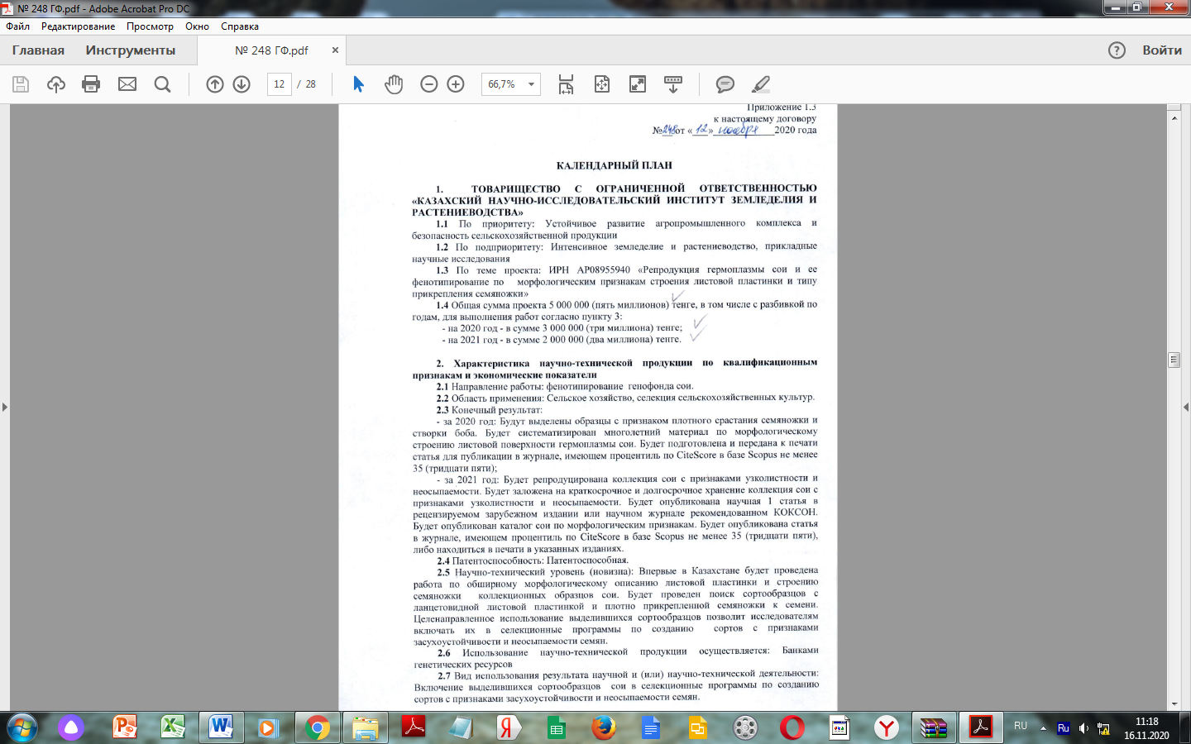

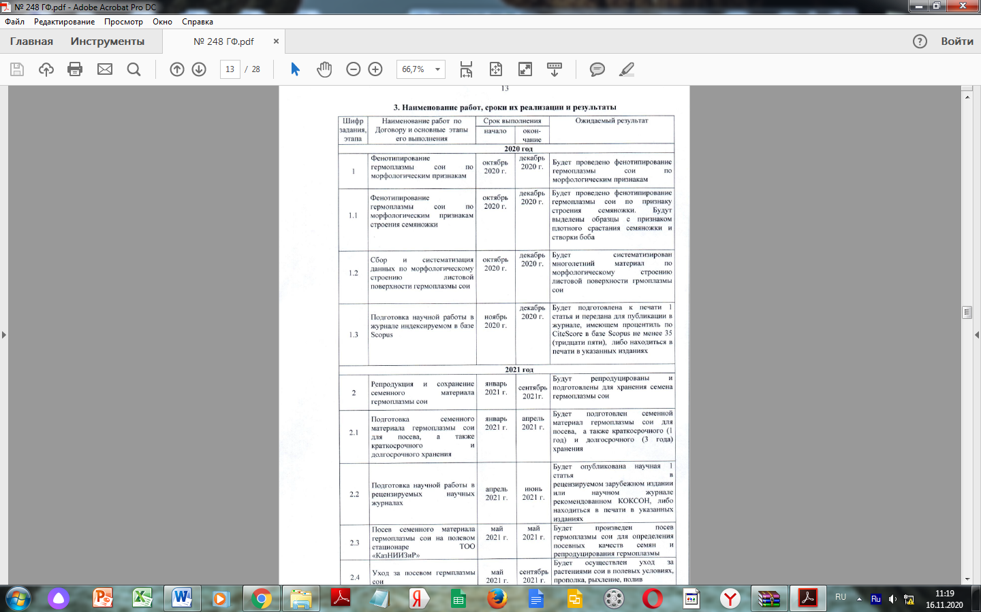



Appendix 1.3

to this agreement

No. 248 dated November 12, 2020

**WORK PLAN**

**1.** LIMITED LIABILITY PARTNERSHIP "KAZAKH SCIENTIFIC RESEARCH INSTITUTE OF AGRICULTURE AND PLANT GROWING"

**1.1** According to the priority: Sustainable development of the agro-industrial complex and the safety of agricultural products.

**1.2** According to the sub-priority: Intensive agriculture and crop production, applied scientific research.

**1.3** On the topic of the project: IRN AR08955940 " Reproduction of soybean germplasm and its phenotyping by morphological signs of leaf plate structure and type of funicle attachment "

**1.4** The total amount of the project is 5000000 (five million) tenge, including by year, for the performance of works according to paragraph 3:

- for 2020-in the amount of 3000000 (three million) tenge;

- for 2021 - in the amount of 2000000 (two million) tenge.

**2. Characteristics of scientific and technical products according to qualification criteria and economic indicators**

**2.1** Direction of work: phenotyping of the soybean gene pool.

**2.2** Scope of application: Agriculture, selection of agricultural crops.

**2.3** Final result:

- for 2020: Samples with a sign of dense fusion of funiculus and bean flaps will be isolated. Long-term material on the morphological structure of the leaf surface of soybean germplasm will be systematized. 1 article will be prepared for publication in a journal with a CiteScore percentile in the Scopus database of at least 35 (thirty five).

- for 2021: A collection of soybeans with signs of narrow-leaved and non-shattering will be reproduced. A collection of soybeans with signs of narrow-leaved and non-shattering will be put into short-term and long-term storage. 1 research article will be published in a peer-reviewed foreign publication or scientific journal recommended by CQAEA. Soybean morphological checklist will be published. 1 article will be published in a journal with a CiteScore percentile in the Scopus database of at least 35 (thirty five).

**2.4** Patentability: Patentable.

**2.5** Scientific and technical level (novelty): For the first time in Kazakhstan, work on an extensive morphological description of the leaf blade and the structure of funiculus of collection samples of soybeans will be carried out. A search for variety samples with lanceolate leaf blade and tightly attached funiculus to the seed will be conducted. Purposeful use of the emerging variety samples will allow researchers to include them in breeding programs to create varieties with traits of drought tolerance and non-shattering seeds.

**2.6** The use of scientific and technical products is carried out by: Banks of genetic resources

**2.7** Type of use of the result of scientific and (or) scientific and technical activities: Inclusion of the allocated variety samples of soybeans in breeding programs to create varieties with signs of drought tolerance and non-shattering seeds.

**3. Name of work, terms of their implementation and results**

|  |  |  |  |  |  |
| --- | --- | --- | --- | --- | --- |
| Task code, stage | The name of the work under the Agreement and the main stages of its implementation | Deadline | | | Expected results |
| start | | end |  |
| **2020** | | | | | |
| 1 | Phenotyping of soybean germplasm by morphological characteristics | October,  2020 | | December,  2020 | Phenotyping of soybean germplasm by morphological characteristics will be carried out |
| 1.1 | Phenotyping of soybean germplasm by morphological features of the structure of funiculus | October,  2020 | | December,  2020 | Phenotyping of soybean germplasm based on the structure of funiculus will be carried out. Samples with a sign of dense fusion of funiculus and bean flaps will be selected. |
| 1.2 | Collection and systematization of data on the morphological structure of the leaf surface of soybean germplasm | October,  2020 | | December,  2020 | Long-term material on the morphological structure of the leaf surface of soybean gramoplasm will be systematized |
| 1.3 | Preparation of scientific article in a journal indexed in the Scopus database | November,  2020 | | December,  2020 | 1 article will be prepared for publication in a journal with a CiteScore percentile in the Scopus database of at least 35 (thirty five). |
| **2021** | | | | | |
| 2 | Reproduction and preservation of seed material of soybean germplasm | January,  2021 | | September,  2021 | Soy germplasm seeds will be reproduced and prepared for storage. |
| 2.1 | Preparation of soybean germplasm seed material for sowing, as well as for short-term and long-term storage | January,  2021 | | April, 2021 | Seed material of soybean germplasm will be prepared for sowing, as well as for short-term (1 year) and long-term (3 years) storage. |
| 2.2 | Preparation of scientific work in peer-reviewed scientific journals | April,  2021 | | June,  2021 | 1 research article will be published in a peer-reviewed foreign publication or scientific journal recommended by CQAEA. |
| 2.3 | Sowing of seed material of soybean germplasm at the field station of "KazRIAPG" LLP | May,  2021 | | May,  2021 | Soybean germplasm will be sown to determine the sowing qualities of seeds and germplasm reproduction |
| 2.4 | Soy germplasm seeding care | May,  2021 | | September, 2021 | Soybean plants will be cared for in the field conditions, weeding, loosening, watering. |
| 2.5 | Publishing a soybean checklist | June,  2021 | | August, 2021 | Soybean morphological checklist will be published |
| 2.6 | Harvesting of soybean germplasm seed | August,  2021 | | September, 2021 | Harvesting of soybean seed material will be carried out for the purpose of storage. 1 article will be published in a journal with a CiteScore percentile in the Scopus database of at least 35 (thirty five). |
| From the Customer:  Chairman  State Institution "Committee of Science of the Ministry of Education and Science of the Republic of Kazakhstan"  \_\_\_\_\_\_\_\_\_\_\_\_\_ Kurmangalieva Zh. D.  stamp | | | From the Performer:  Chairman  of the Management Board of  "Kazakh Scientific Research Institute of  Agriculture and Plant Growing" LLP  \_\_\_\_\_\_\_\_\_\_\_\_\_\_\_\_\_\_\_\_ Ageenko A.V.  Stamp  Familiarized with:  Supervisors of the project \_\_\_\_\_\_\_\_\_\_\_\_\_\_\_\_\_\_\_  Didorenko S. V. | | |

**ATTACHMENT D**

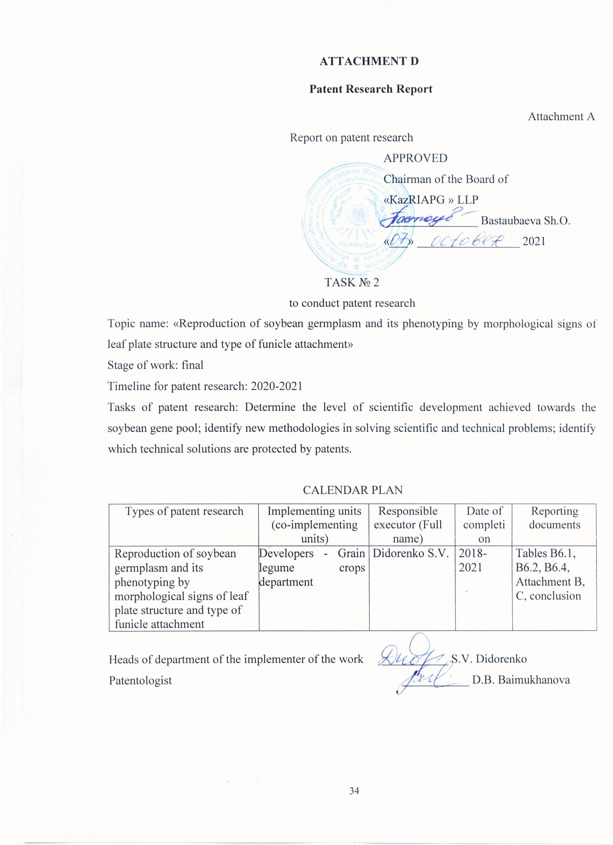

Rationale for the search

Scientific and patent examination of the research topic was carried out from 2019 to 2021 in several leading countries: Russia, USA, Germany, Sweden, Japan, Bulgaria, Italy, Canada, Poland, etc., in the following classes A01N 5/00, A01N 5/10, A01N 3/00, C12N 5/14 A01C 1/00.

The main literary sources, which served as a basis for the work performed: Research reports, journals: «Crop Biology», «Plant Physiology», «Breeding and Seed Production», «Genetics», «Bulletin of Agricultural Science of Kazakhstan», «Agricultural Biology», «Agrarian Science», «Forage Production», «Bulletin of RAAS», «Oil Crops», Abstract Journal (Botany, section on leguminous and cereal crops).

As a result, the closest analogues, patents with a common focus but which do not overlap directly with the project, are highlighted. Overall, the results of the patent studies showed that the proposed specific areas of research works are highly relevant and protectable. The patentability lies in the creation of a new starting material for soybeans.

There are no similar or similar alternative and competing areas in Kazakhstan, as breeding research on soybean is conducted in «Zarechnoye AES» LLP, «SRILCP» LLP, «Aktubinskaya AES» LLP, «East Kazakhstan AES» LLP, «Oilseed experimental farm» LLP. However, research at the above research institutions does not address the phenotyping of the collection.

Attachment B

Search regulation no. 2

Topic name:«Reproduction of soybean germplasm and its phenotyping by morphological signs of leaf plate structure and type of funicle attachment»

Stage of work: final

Date and number of the assignment for patent research: No. 2 dated October 20, 2020

Purpose of information search: Determining the technical level of development of the soybean gene pool.

Justification of the search regulations

Start of search – 20.10.2020 End of search – 30.08.2021

|  |  |  |  |  |  |  |  |
| --- | --- | --- | --- | --- | --- | --- | --- |
| Search subject (object  research, its components, goods) | Search country | Sources of information to be searched | | | | Retro-performance | Name of the information base |
| Patent | | STI | |
| Name | Classification headings of the ICI | Name | Headings UDC, etc. |
| 1 | 2 | 3 | 4 | 5 | 6 | 7 | 8 |
| Soybean gene pool | Kazakhstan, Russia, USA, France, Great Britain, Germany,  Sweden, Canada, Japan,  Italy, Hungary | Bulletin «Discoveries and Inventions», «Inventions of the World Countries», Official Bulletin of RK. Description of inventions to patents, CD-ROM «Patents of Russia» | А01Н 3/00 C12N 5/14  А01Н 5/00  А01Н 5/10  А01С 1/00 А01С 7/00  А 01В79/02  А01Н 1/00 А01Н  4/00А01Н 1/00 | Research reports, journals:  «Biology of agricultural crops», «Physiology of plants», «Selection and seed production», «Genetics», «Bulletin of agricultural science of Kazakhstan», «Agricultural biology», «Agricultural science», «Feed production», «Biotechnology. Theory and Practice», «Bulletin of the RAAS», Abstract | 631.51  631.531  631.432  631.811.98  631.8  631.521 | 2019-2021 | RPF, fund of KRIAPG,  FIIP |

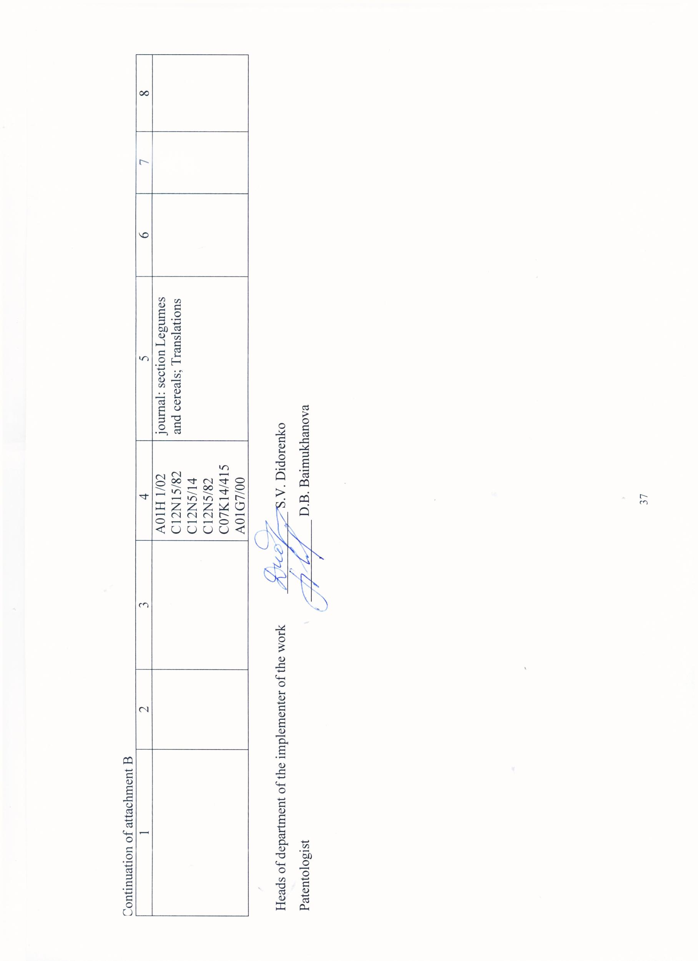

Attachment C

Search report form

1 The search was carried out in accordance with the assignment of the Acting Chairman of the Board Sh.O. Bastaubaeva on this topic: «Reproduction of soybean germplasm and its phenotyping by morphological signs of leaf plate structure and type of funicle attachment», assignment No. 2 dated 20.10.2020 and Request for Proposal No. 2 dated 20.10.2020

2 Stage of work: final

3 Start of search: 20.10.2020 End of search: 30.08.2021

4 Information on the implementation of the search regulations: The search regulations have been fully implemented

5 Suggestions for further search and patent research: The topic is patentable.

6 Materials selected for subsequent analysis

Table C.6.1 - Patent documentation

|  |  |  |  |
| --- | --- | --- | --- |
| Search subject (research object, its constituent parts) | Country of issue, type and number of the title of protection. Classification index | Applicant (patentee), country. Application number, priority date, Convincing priority, publication date | Name of the invention (full model, sample), the purpose of its creation |
| 1 | 2 | 3 | 4 |
| Soybean gene pool | Kazakhstan, patent №944 | «Kazakh Research Institute of Agriculture and Plant Growing» LLP Didorenko S.V., Kudaibergenov M.S., Ageenko A.V., Abugalieva A.I.  application no. 2019/006.4  priority date 11.03.2019  publication date 31.12.2020 | Soybean variety «Ai Saule» |

Continuation of the table C.6.1

|  |  |  |  |
| --- | --- | --- | --- |
| 1 | 2 | 3 | 4 |
|  | Kazakhstan, patent №945 | «Kazakh Research Institute of Agriculture and Plant Growing» LLP, «Kostanay Research Institute of Agriculture» LLP Didorenko S.V., Kudaibergenov M.S., Abugalieva A.I., Sidorik I.V., Plotnikov V.G., Zinchenko A.V.  application no. 2019/008.4  priority date 11.03.2019  publication date 31.12.2020 | Soybean variety «Svetlyachok» |
| Kazakhstan, patent №946 | «Kazakh Research Institute of Agriculture and Plant Growing» LLP Ageenko A.V., Dosmukhambetov T.M., Sagitov A.O., Ageenko V.M., Ageenko V.V., Bastaubaeva Sh.O., Didorenko S.V., Kudaibergenov M.S., Abugalieva A.I.  application no. 2019/009.4  priority date 11.03.2019  publication date 31.12.2020 | Соя «Viktory» |
| Russia, patent  №2685151  IPC  А01Н 1/01 | Russia, «Orel State Agrarian University named after N.V. Parakhin» FSBEI Amelin.A.V., Chekalin.E.I., Salnikova N.B.  application no. 2017143264  priority date 11.12.2017  publication date 16.04.2019 | Method for assessing and selecting high-yielding soybean genotypes by stomatal water vapour conductivity |

Table C.6.2 - Scientific and technical, market, regulatory documentation and materials of state registration (reports on research works)

|  |  |  |  |
| --- | --- | --- | --- |
| Search subject | Name of the source of information, indicating the source page | Author (s), firm (holder) of technical documentation | Year, place and authority of publication |
| 1 | 2 | 3 | 4 |
| Soybean gene pool | Somaclonal lines as starting material in soybean breeding for early maturity and drought tolerance, pp. 103-107 | S.V. Didorenko,  A.I. Abugalieva,  R.S. Erzhebaeva,  I.V. Sidorik,  O.A. Rozhanskaya | 2018, Russia, IV International Conference «Gene pool and plant breeding», Novosibirsk |
| Characterisation of the varietal gene pool of oilseeds by fatty acid composition and selection for quality, pp. 572-577 | A.I. Abugalieva,  O.A. Gavrilova,  S.V. Didorenko,  L. Dolgikh,  M.Z. Konyrbekov,  L.N. Gatske,  R. Iskakov,  M.B. Tashmukhambetov,  I.M. Anfilofyev,  A.S. Masimgazieva | 2018, Russia, Scientific Innovations to Agricultural Production: Proceedings of the International Scientific and Practical Conference dedicated to the 100th Anniversary of the Omsk State Agrarian University |
| Very early soybean variety Vita, pp. 157-160 | S.V. Zelentsev,  E.V. Moshnenko,  A.A. Tkacheva,  M.V. Trunova | 2018, Russia, Oilseeds. Scientific and Technical Bulletin. All-Russian Scientific Research Institute of Oilseeds, No.4 |
| Georgia soybean variety, pp. 45-46 | E.V. Gureeva,  T.A. Fomina | 2018, Russia, Biology. section 04B. Botany. Moscow, no. 6. |

Continuation of the table C.6.2

|  |  |  |  |
| --- | --- | --- | --- |
| 1 | 2 | 3 | 4 |
|  | Source material for early maturing soybean varieties, pp. 52-57 | A.Y. Nekrasov | 2018, Russia, «Grain legumes and cereals», No. 3 |
| Soybean gene pool from the VIR collection to advance the crop's agronomic range northwards, pp. 41-46 | I.V. Seferova,  M.A. Vishnyakova | 2018, Russia, «Grain legumes and cereals», No. 3 |
| Screening of a soybean collection for early maturity and productivity under conditions of the left-bank forest-steppe of Ukraine, pp. 63-69 | L.G. Belyavskaya,  A.M. Rybalchenko | 2019, Russia, «Grain legumes and cereals», No. 1 |
| Screening of collection soybean accessions for early maturity and productivity under Ryazan region conditions, pp. 13-16 | Е.V. Ureeva | 2019, Russia, «Verkhnevolzhye Agroindustrial Complex Bulletin», No. [3 (47)](https://elibrary.ru/contents.asp?id=41238729&selid=41238732) |
| Results of the study of soybean samples at the Far East VIR Experimental Station in 1990-2017, pp. 59-65 | I.V. Seferova,  P.P. Bulakh | 2019, Russia, «Proceedings of Applied Botany, Genetics and Breeding», Vol. 180, No. 4 |
| Research of source material for soybean breeding in the forest-steppe conditions of Samara Zavolzhye, pp. 43-47 | A.V. Kazarina,  E.A. Atakova,  I.S. Abramenko | 2019, Russia, «Izvestia of the Samara Scientific Centre of the Russian Academy of Sciences», Vol. 21, No.[6 (92)](https://elibrary.ru/contents.asp?id=42492561&selid=42492568) |
| Evaluation of collection samples of soybean on anatomical-morphological and physiological-biochemical traits of drought tolerance, pp. 88-100 | A.A. Amangeldieva,  A.K. Daniyarova,  P.A. Alchimbayeva,  B.B. Anapiyayev,  S.V. Didorenko,  R.S. Erzhebaeva | 2019, Kazakhstan, «Bulletin of KazNU», No.1 (78) |
| Comparative characteristics of SOKO soybean varieties under the conditions of the private farm Nedogonov A.P., pp. 106-111 | A.A. Nedogonov,  M.M. Sazonenko,  V.V. Kazakova | 2019, Prague, «Innovative approaches in modern science», No.2 (8) |

Continuation of the table C.6.2

|  |  |  |  |
| --- | --- | --- | --- |
| 1 | 2 | 3 | 4 |
|  | Results of a study of the soybean collection for breeding purposes, pp. 49-53 | F.A. Davletov,  A.M. Dmitriev,  K.P. Gainullina,  I.I. Akhmadullina | 2020, Russia, «Izvestia of the Orenburg State Agrarian University» No. 1 (81) |
| Comparative analysis of seed quality of collection samples of soybean Glycine Max (L.) Merr. grown under irrigated and non-irrigated conditions in the South-East of the Republic of Kazakhstan, pp. 58-66 | R.S. Yerzhebaeva,  S.V. Didorenko,  A.I. Abugalieva,  A.V. Ageenko | 2020, Russia, «Grain legumes and cereals», No. 3 (35) |
| Evaluation of NDVI and QY values for screening a soybean collection for drought tolerance, pp. 104-117 | S.V. Didorenko,  A.A. Amangeldieva,  R.S. Yerzhebayeva,  A.I. Abugaliyev | 2020, Kazakhstan, «Bulletin of Science of the S. Seifullin Agrotechnological University», No. 3 (106) |
| Soybean trait collection as a basis for new generation varieties, pp. 86-92 | E.M. Fokina,  G.N. Belyaeva,  D.R. Razantzwey | 2020, Russia, «Bulletin of the Far Eastern Branch of the Russian Academy of Sciences», No. 4 (212) |
| Soybean trait collections as source material for different breeding routes, pp. 61-62 | D.B. Abildaeva,  S.V. Didorenko,  A.Z. Saikenova,  М. Kanatkyzy,  R.Zh. Kassenov | 2021, Kazakhstan, «Proceedings of the International Scientific-Practical Conference «Actual problems of agronomy» in the context of adaptation to global climate change», dedicated to the 75th anniversary of Doctor of Agricultural Sciences, Professor, Academician of the National Academy of Sciences of Kazakhstan and Academy of Agricultural Sciences of Kazakhstan Meirman G.T. |

Continuation of the table C.6.2

|  |  |  |  |
| --- | --- | --- | --- |
| 1 | 2 | 3 | 4 |
|  | Phenotyping of soybean germplasm Glycine Max (L.) Merr., pp. 53-59 | S.V. Didorenko,  A.V. Ageenko,  I. Sagit,  D.B. Abildaeva,  A. Zh. Saikenova,  M. Kanatkyzy | 2021, Russia, «Grain legumes and cereals», No. 1 (37) |
| Molecular characterization of soybean accessions from the international collection of the plant gene resources of Canada: germplasm identification, pp. 127-139 | N. Kabwe,  A. Sarah,  M. Paul | 2021, USA, «Journal of Crop Improvement», Vol. 35, №5 |

Table C.6.3 – Number of published titles by year (inventive activity)

|  |  |  |  |  |  |
| --- | --- | --- | --- | --- | --- |
| Object of the technology and its constituent parts | Country of submission | Number of patents, published applications by year of application (excluding generic patents) | | | |
| 2019 | 2020 | 2021 | total |
| Russia | 1 | - | - | 1 |
| Kazakhstan | - | 3 | - | 3 |

As a result of the patent information search for 2018-2021, 4 soybean protection documents were identified, including 1 for Russia and 3 for Kazakhstan. Such results do not allow to determine the global patent situation.

Conclusion

Outside Kazakhstan, soybean breeding is carried out in many countries of the world. Similar work is carried out at the All-Russian Research Institute of Oilseeds named after V.I. V.S. Pustovoit (Russia, Krasnodar), at the Armavir OS (Russia), at the Donskoy OS (Russia, at the Ukrainian Research Institute of Agriculture (Ukraine), at the VIR (Russia, St. Petersburg), at the All-Russian Institute of Breeding and Genetics, at the International Research Institute of Plant Production (ICRISAT, India), Soya-Sever Co. LLC (Minsk, Belarus), VNIIZh (St. Petersburg, Russia), in the USA, Canada, China, Yugoslavia, France. However, they have a different focus related different soil and climatic conditions.

These research institutes have accumulated a certain amount of theoretical and factual material on breeding and genetic research in the field of legume crops. Efficient methods of castration, pollination and isolation have been developed, as well as methods of selecting breeding material based on a range of economic and biological traits.

Consider a number of works presented in scientific and technical information, close in the direction of our topic.

The effectiveness of any crop is largely determined by the availability of extensive and diverse source material. This represents the first and very important step in the breeding process.

The creation of source material begins with the collection and study of a variety of forms. For decades, the Vavilov All-Russian Institute of Plant Industry in St. Petersburg (VIR) has been the main collecting institution in Eastern Europe and Russia. Its catalogues are available online at www.vir.nw.ru (Shchelko L.G. et al., 1983, Shchelko L.G. et al., 1990, Vishnyakova M.A., 2002; Vishnyakova M.A., et al., 2004).

The collection of the V.Y. Yuriev Ukrainian Institute of Plant Industry in Kharkiv includes over a thousand soybean varieties (Kobyzeva et al., 2002).

The most extensive scientific collection of soybean is maintained by the National Plant Germplasm System (NPGS) under the auspices of the US Department of Agriculture. It contains about 18 thousand specimens (M.D. Kovalevich, L.I. Musorina, 1984, L.G. Schelko, 1984).

Like the VIR collection samples, they are also available to order and the catalogue can be consulted at grain.jouy.inra.fr. In addition, the linked Germplasm Resources Information Network (GRIN) website www.ars-grin.gov allows you to pre-search for samples that meet specified conditions, i.e. with any set of agronomic, biochemical and other parameters.

The company «Soya-North» maintains a collection of around 300 soybean varieties of various origins (from China, Japan, USA, Canada, France, Poland, Ukraine, Russia, etc.), mainly in the 00 group of ripeness.

For breeding purposes, the original material should be well studied and divided into types according to the main traits: yield, length of the growing season, resistance to adverse environmental conditions (drought, dry weather, excessive overwatering, frost), resistance to diseases and pests, suitability for mechanized harvesting, seed quality and response to various cultivation methods (Shchelko L.G., Kozhushko N.N., Tolokonnikov V.V. N.V. Yassevich, E.N. Melnikova, 1990).

A large amount of collection material is used in the soybean breeding process at KRIAPG LLP. They are obtained in cooperation with the following organizations: All-Russian Research Institute of Plant Breeding named after N.I. Vavilov (Russia, St. Petersburg), All-Russian Research Institute of Oil Crops named after V.S. Pustovoit (Russia, Krasnodar), Siberian Research Institute of Plant Breeding and Selection SB RASKH (Russia, Novosibirsk), Yuryev Institute of Plant Breeding (Ukraine, Kharkov), Soya Institute (Ukraine, Poltava region), Corporation «Soya-North» (Belarus). The replenishment, study and preservation of the soybean collection at KRIAPG LLP was resumed after the collapse of the Union and has been continuously maintained for over 20 years (Didorenko S.V., 2016).

The strategy and tactics of collection replenishment is a living process. At each stage of societal development, the priorities of agricultural development, breeding and the country as a whole need to be taken into account. The expansion of the soybean range to the north and south of the Republic has revealed the need to develop varieties resistant to drought stress and daily temperature variations that lead to bean cracking.

Seed losses in soybean varieties that are not susceptible to cracking can be as high as 34-99% (Hymowitz T., Newell C. A.,1980; Philbrook B., Oplinger E. S., 1989).

Bean cracking is necessary for the reproduction of their offspring in wild plants, but is a major cause of yield loss in agricultural crops.

Legume species disperse seeds by breaking the pod along the abdominal seam after ripening ( Tiwari and Bhatia, 1995 ). In cultivated soybean ( Glycine max ), the non-growing pod is a major domestication trait targeted by artificial selection ( Hymowitz, 1970 ; Harlan, 1992 ).

Cultivation of cracking-resistant genotypes under different climatic conditions often results in a loss of this resistance. Many researchers who have studied this trait have drawn attention to the fact that the risk of bean cracking increases markedly during overstocking, especially under conditions of alternating dry and rainy days. And under conditions of prolonged drought in the last stages of soybean organogenesis premature opening of beans was often observed even in highly cracking resistant varieties (Philbrook B., Oplinger E.S., 1989; Suzuki M., Fujino K., Funatsuki H. , 2009; Tukamuhambwa P., Dashiell K.E. , 2002). Soybeans are less prone to cracking when watered than when not watered. Cracking is also influenced by differences in night and daytime temperatures.

In 1952, pea breeder A. Eglitis noted the trait of non-sprouting in the 2nd hybrid generation. He describes this trait in his 1954 scientific report as follows: "The hybrid form of pea obtained by crossing the varieties Vitellinum and Coronatum is particularly interesting and promising. The peas in this form are firmly attached to the plant and do not fall out even when the pods are open. The peculiarity of this phenomenon is that due to profound anatomical changes in the structure of seed peduncle - funiculus and kernel rumen, they are firmly fused" (Eglitis A., 1959).

There is no consensus in the literature on the effect of non-shrinkage trait on seed yield. Experimental data and breeding practice have shown that it is possible to develop non-shrinking varieties with yields at the level of conventional.

One of the morphological signs of drought tolerance in soybeans can be narrow-leafed. Reduced transpiration with this leaf blade shape results in reduced transpiration and economical liquid distribution.

As a result of many years of collection collection collection, preservation and study in the department of legume crops, two catalogues of the gene pool have been issued (Meirman G.T., Didorenko S.V., Karyagin Y.G., 2008, Didorenko S.V., Kudaibergenov M.S., 2014). However, none of them provides data on the morphological description of the traits selected for the study in this project.

**ATTACHMENT E**

**The act of depositing extrabudgetary funds by a private partner**

