Ministry of Energy of the Republic of Kazakhstan

REPUBLICAN STATE ENTERPRISE

ON THE BASIS OF ECONOMIC CONTROL RIGHT

“NATIONAL NUCLEAR CENTER OF THE REPUBLIC OF KAZAKHSTAN”

(RSE NNC RK)

UDC 621.039.6; 533.9.08; 621.039.66

SRSTI 29.27.51; 44.33.33; 29.19.16

Reg. No. 0120РК00311

Inv. No.

APPROVED BY

Director General RSE NNC RK,

Dr. Sc. (Phys.-Math.), Professor

________________E.G. Batyrbekov

“___”___________2021

RESEARCH REPORT

INVESTIGATION OF CARBIDIZED LAYER FROMATION ON THE TUNGSTEN SURFACE UNDER PLASMA IRRADIATION

(Final)

Theme Code: АР08955992

|  |  |  |
| --- | --- | --- |
| Supervisor of Research, First Deputy Director, “Institute of Atomic Energy” Branch RSE NNC RK, PhD | _________________  signature, date | V.V. Baklanov |

Kurchatov 2021

**LIST OF EXECUTORS**

|  |  |  |
| --- | --- | --- |
| Supervisor of Research, First Deputy Director, “Institute of Atomic Energy” Branch RSE NNC RK, PhD | _____________________  signature, date | V.V. Baklanov  (in full) |
| Principal Investigator, Engineer, Laboratory for Material Testing under Fusion Reactor Conditions | _____________________  signature, date | G.K. Zhanbolatova  (in full) |
| Executors: |  |  |
| Researcher, Radiative Material Study Laboratory | _____________________  signature, date | Ye.А. Kozhakhmetov  (Chapter 2.2) |
| Head of Group, Reactor Fuel Testing Laboratory | _____________________  signature, date | N.А. Suleimenov  (Chapter 1.2) |
| Engineer, Radiative Material Study Laboratory | _____________________  signature, date | N.А. Orazgaliyev  (Chapter 1.2) |
| Normative Supervisor | _____________________  signature, date | G.V. Surgutanova |
|  |  |  |

**ABSTRACT**

Report contains 36 p., 8 figures, 4 tables, 21 references, 3 appendixes.

FUSION ENERGY, ITER, TOKAMAK, KТМ, DIVERTOR, PLASMA, PLASMA-SURFACE INTERACTION, TUNGSTEN, CARBIDIZATION, TUNGSTEN CARBIDE

Research object: carbidized layer formation on the tungsten surface under plasma irradiation.

Research purpose: experimental study of carbidized layer formation on the tungsten surface under conditions simulating plasma effect in the KTM tokamak.

Research methods: implementation of experiments for tungsten surface carbidization on the simulation test-bench with plasma-beam installation; mass spectrometer method; optical microscopy and scanning electron microscopy; X-ray diffraction analysis.

Results of work:

* experiments have been implemented to assess an effect of tungsten sample surface temperature on carbidized layer formation under plasma irradiation,
* surface of tungsten samples has been researched after the experiments,
* dependency of carbidized layer formation on temperature of tungsten sample surface has been determined.

Field of application: the results of studying the process of carbidized layer formation on a tungsten surface under conditions of plasma irradiation can be used to develop a coating technology, as well as to study the interaction of plasma with a carbidized tungsten surface.

The key results of the research have been published in scientific journal recommended by CCES and tested both in regional and at international conferences. According to the results of research, a manuscript has been submitted into peer-viewed foreign scientific journal Materials Research Express.

**РЕФЕРАТ**

Есеп 36 бет, 8 сур., 4 кесте, 21 көздер, 3 қосымша.

ТЕРМОЯДРОЛЫҚ ЭНЕРГЕТИКА, ИТЭР, ТОКАМАК, КТМ, ДИВЕРТОР, ПЛАЗМА, ПЛАЗМА-БЕТТІК ӨЗАРА ӘРЕКЕТТЕСУ, ВОЛЬФРАМ, КАРБИДИЗАЦИЯ, ВОЛЬФРАМ КАРБИДІ

Зерттеу объектісі: плазмалық сәулелену кезінде вольфрам бетінде карбидтелген қабатты қалыптастыру процесі.

ҒЗЖ мақсаты: КТМ токамагында плазмалық әсер етуді имитациялайтын жағдайларда, вольфрам бетінде карбидтелген қабатты қалыптастыру процесстерін эксперименттік зерттеу болып табылады.

Зерттеу әдістері: плазмалық-шоқтық қондырғымен имитациялық стендте вольфрамның бетін карбидтеу бойынша эксперименттер жүргізу; масс-спектрометрия әдісі; оптикалық микроскопия және сканерлеуші электрондық микроскопия; рентгенқұрылымдық талдау.

Жұмыстың нәтижелері:

* вольфрам үлгісінің беткі температурасының плазмалық сәулелендіру кезінде карбидтелген қабаттың қалыптасуына әсерін бағалау бойынша эксперименттер жүргізілді,
* эксперименттерден кейін вольфрам үлгілерінің бетіне зерттеулер жүргізілді,
* вольфрам үлгісінің беткі температурасынан карбидтелген қабаттың қалыптасуының тәуелділігі анықталды.

Қолдану саласы: плазмалық сәулелену кезінде вольфрам бетінде карбидталған қабаттың түзілу процесін зерттеу нәтижелерін жабу технологиясын жасау үшін, сондай-ақ плазманың карбидталған вольфрам бетімен әрекеттесуін зерттеу үшін қолдануға болады.

Зерттеу жұмыстарының негізгі нәтижелері БҒССҚК ұсынған ғылыми журналда жарияланды және аймақтық пен халықаралық конференцияларда сыналды. Зерттеу нәтижелері бойынша мақала қолжазбасы рецензияланған шетелдік Materials Research Express ғылыми журналына баспаға берілді.

**CONTENT**

INTRODUCTION 7

MAIN PART OF RESEARCH REPORT 9

1 Experiments on assessing the temperature effect of tungsten sample surface on carbidized layer formation under plasma irradiation 9

1.1 Description of the installation 9

1.2 Conditions for experiments in PBI 10

2 Research of tungsten sample surface after the experiments 12

2.1 Method for X-ray phase analysis of the surface of tungsten samples 12

2.1.1 Method for processing and analysis of diffraction patterns 13

2.1.2 Phase composition identification 13

2.1.3 Method for assessing quantitative content 14

2.1.4 Result of the phase composition identification 14

2.1.5 Results of semi-quantitative content assessment 16

2.2 Method for microstructure analysis of sample surface 17

2.2.1 Microstructure analysis results 17

3 Assessment of the effect of the tungsten sample surface temperature under plasma irradiation on the formation of a carbidized layer 21

CONCLUSION 24

LIST OF REFERENCES 25

APPENDIX А (obligatory) Calendar Schedule 27

APPENDIX B (reference) Diffractometric Data Cards 33

APPENDIX C (obligatory) List of publications on the theme 36

**LIST OF ABBREVIATIONS**

This research report uses the following abbreviations:

|  |  |  |
| --- | --- | --- |
| PT | – | pure tungsten |
| KTM | – | Kazakhstani Material Testing Tokamak |
| PBI | – | plasma-beam installation |
| BPD | – | beam-plasma discharge |
| SEM | – | scanning electron microscope |
| FR | – | fusion reactor |
| NC | – | numerical control |
| EBG | – | electron beam gun |
|  |  |  |

INTRODUCTION

Tungsten (W) due to its physical and chemical properties is widely used in the modern fusion facilities as plasma-faced material [1], [2]. However, the researches of recent years have showed that use of tungsten does not fully solve problems accompanying the interaction between plasma and divertor surface [3]–[5]. Therewith, most thermonuclear installations use either tungsten coatings applied to graphite and carbon-graphite materials, or uncoated graphite materials, as, for example, in the Kazakhstani Materials Testing KTM Tokamak [6]. The presence of various materials such as tungsten and carbon in the chamber of installation will result in the formation of mixed layers on the plasma-facing surfaces in the form of tungsten carbides, which can affect the performance of the material. This circumstance determines the interest in continuing the research of the tungsten carbide formation under plasma irradiation.

The relevance of this research is in the fact that formation of mixed layers, in particular, carbidized layers, under the operating conditions of the KTM tokamak has not yet been investigated. In addition, dependence of the carbidized layer formation on the tungsten surface temperature under plasma irradiation has not been studied. To operate the KTM tokamak and obtain correct results, it is necessary to study possible scenarios for the interaction between plasma with the surface of candidate FR material samples during experiments.

The scientific novelty of the work is in the fact that tungsten surface carbidization in a simulation test-bench with PBI is a fundamentally new method for implementing the coating method, and the temperature range of a carbidized layer formation under plasma irradiation in PBI has been determined.

The practical significance of the research is in the fact that obtained research results will enable predicting the possibility of creating conditions for tungsten carbide formation on the test samples during the KTM tokamak operation.

The implementation of the project was conducted in accordance with the schedule given in Appendix A.

In 2020, within the framework of this project, a theoretical analysis of the literature on the formation of a carbidized layer on tungsten surface under conditions of plasma irradiation was conducted, the conditions for experiments in the plasma-beam installation were determined, and samples for experiments in the plasma-beam facility [7] were prepared.

The purpose of the research in 2021 is experimental study of carbidized layer formation on the tungsten surface under conditions simulating plasma effect in the KTM tokamak.

Within the framework of the project research in reporting period, the following tasks were solved:

* experiments on assessing the temperature effect of tungsten sample surface on carbidized layer formation under plasma irradiation,
* research of tungsten sample surface after the experiments,
* determination of dependency of the carbidized layer formation on temperature of tungsten sample surface.

MAIN PART OF RESEARCH REPORT

1. Experiments on assessing the temperature effect of tungsten sample surface on carbidized layer formation under plasma irradiation
   1. Description of the installation

As an installation for studying the process of surface carbidization to tungsten, as well as determining the effect of the temperature of the sample surface on carbidization, a simulation test-bench with PBI was used [8], [9]. A general view of the simulation test-bench with PBI is shown in the Figure 1.

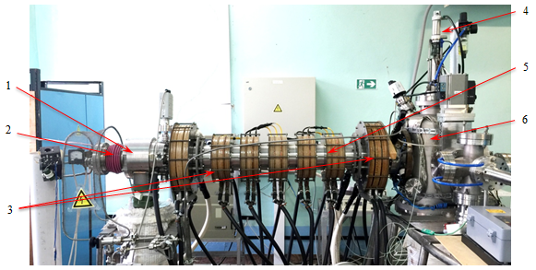

1 – EBG chamber; 2 – EBG; 3 – electromagnetic coil; 4 – Langmuir probe;

5 – BPD chamber; 6 – interaction chamber

Figure 1 – General view of PBI

PBI is a plasma-beam installation with longitudinal magnetic field where plasma generation occurs due to BPD arising when electrical beam passes through the gas. The EBG, EBG pumping chamber, electromagnetic system for creation of longitudinal magnetic field, vacuum chamber of BPD interaction with materials with a possibility of producing an ultrahigh vacuum of about 10-6 Pa and diagnostic system.

The principle of the installation operation is described below. The electron gun generates an axially symmetric electron beam. An axially symmetric electron beam is focused (compressed/expanded in cross section) and transported by a longitudinal magnetic field with an induction of up to 0.1 T into the interaction chamber. Plasma is generated in the BPD chamber when the electron beam interacts with the working gas, which is introduced into the chamber using a gas injection system. Various types of gases can be used as work ones. Using a gas injection system, vacuum valves and differential pumping diaphragms, it is possible to control the gas density distribution, which allows changing operating modes over a wide range of parameters.

The plasma cord flows freely along the lines of force of the magnetic field from the BPD chamber to the interaction chamber, falls on the sample of the test materials, which is placed on the target device.

* 1. Conditions for experiments in PBI

To research the effect temperature of the tungsten surface on carbidized layer formation, samples were prepared in the form of pellets with a thickness of (2.0±0.1) mm from a tungsten rod of ∅ 10 mm of pure tungsten [10].

The end surface of the cut samples is prepared by mechanical grinding and polishing methods using the DualPrep-3 grinding and polishing machine in manual mode using water-cooling. In the course of surface preparation, silicon carbide (SiC) sanding paper with grit sizes P800, P1200 and P2500 was used.

After sample preparation, the samples were placed in polyethylene bags with the markings corresponding to the carbidization temperature.

Previously, recrystallization annealing was used to eliminate the cold-hardening caused by plastic deformation that occurs during the manufacture (drawing) of the rods, as well as changes in the surface layer of the samples resulting from the cutting of the tungsten rod into blanks. The recrystallization annealing of the samples was carried out on the PBI in the electron beam mode. The temperature of the sample side heated by the electron beam at 3600 s exposure was 1350 °C [11]. One sample was chosen as the initial one for the study before and after recrystallization annealing.

After annealing, methane (CH4) was fed into the chamber to a pressure of ~ 10-1 Pa.

The carbidized layer formation on the PBI proceeds with the participation of hydrocarbons, which are formed when CH4 is injected into the discharge zone as a result of ionization by an electron beam. The structural features of the CH4 molecule upon interaction with electrons causes a number of possible reactions: reaction (2) describes the process of single ionization, as a result of which a molecular ion is formed, reaction (3a) - (3b) correspond to the processes of dissociative ionization with the formation of fragment ions and neutral fragments, and reaction (4) corresponds to the decomposition of CH4 [12].

|  |  |  |
| --- | --- | --- |
|  | , | (2) |
|  | , | (3a) |
|  | , | (3b) |
| $$2CH_{4}$$ | $\underset{→}{выше 1400℃}C_{2}H_{2}+3H_{2}$. | (4) |

During experiments on tungsten carbidization, these reactions proceed in the interaction chamber, as evidenced by the spectrum of residual gases shown in Figure 2.

|  |
| --- |
|  |
| Figure 2 – Composition of residual gases in the interaction chamber during the experiment |

The diagram shows that the interaction chamber is dominated by hydrogen molecules, methane and acetylene radicals.

The conditions for experiments to assess the surface temperature effect of the tungsten sample on the formation of the carbidized layer are presented in Table 1.

Table 1 – Conditions of the experiments in PBI to form carbidized layer

|  |  |  |  |  |  |  |
| --- | --- | --- | --- | --- | --- | --- |
| Sample # | Power of electron beam, W | Work gas pressure (methane), Pa | Ion energy, eV | Temperature, °С | Ion current, mА | Irradiation duration, s |
|
| Т-700 | 54.6 | (1.01-1.03)·10-1 | 500 | 700 | 22 | 3600 |
| Т-800 | 41.8 | (1.01-1.05)·10-1 | 500 | 800 | 30 | 3600 |
| Т-900 | 112 | (1.01-1.04)·10-1 | 500 | 900 | 29 | 3600 |
| Т-1000 | 237.8 | (1.01-1.06)·10-1 | 500 | 1000 | 39 | 3600 |
| Т-1100 | 97.2 | (1.05±0.05)·10-1 | 500 | 1100 | 22 | 3600 |
| Т-1200 | 407.1 | (1.03±0.05)·10-1 | 500 | 1200 | 62 | 3600 |
| Т-1300 | 253.5 | (1.08±0.05)·10-1 | 500 | 1300 | 76 | 3600 |
| Т-1400 | 565.6 | (1.01±0.05)·10-1 | 500 | 1400 | 110 | 3600 |
| Т-1500 | 470.4 | (1.03±0.05)·10-1 | 500 | 1500 | 102 | 3600 |
| Т-1600 | 936 | (1.05±0.05)·10-1 | 500 | 1600 | 197 | 3600 |
| Т-1700 | 492 | (1.03±0.05)·10-1 | 500 | 1700 | 70 | 3600 |

Temperature on the front and back sides of the sample surface was monitored using METIS M318 and IMPAC ISR 6 Advanced pyrometers and a WR-5/20 tungsten-rhenium thermocouple, respectively. The use of two pyrometers is due to the different ranges of measured temperatures. The METIS M318 pyrometer has a spectral range of 1.65–2.1 µm, a temperature range of 150–1200 °С. Pyrometer IMPAC ISR 6 Advanced is two-channel with spectral ranges of 0.90 μm and 1.05 μm, temperature range 800-2500 °С.

After the irradiation, the tungsten samples were cooled to room temperature in a vacuum interaction chamber and removed from it for further studies of the irradiated surface state.

1. Research of tungsten sample surface after the experiments
   1. Method for X-ray phase analysis of the surface of tungsten samples

X-ray diffraction patterns from the sample surface were taken on an Empyrean diffractometer in Cu Кα-radiation, with a scanning linear detector PIXcel1D.

The exposure time during shooting was 30.6 s, the scanning pitch size for diffraction patterns was 0.026º2θ, the investigated angular range was 5-153º2θ.

The operating mode of the PIXcel1D detector is a scanning line detector. Radiation: Cu Kα; voltage and current: 45 kV, 40 mA. A fixed divergence slit with an angular divergence of 1°, an anti-scattering slit of 2°, an incident beam mask with marking 20, providing an incident beam width of 19.9 mm were used.

* + 1. Method for processing and analysis of diffraction patterns

The diffraction patterns were processed using the HighScore program for processing and search. The processing procedures for the initial diffraction patterns are as follows:

1. separation and removal of lines corresponding to Кα2 radiation,
2. background determination,
3. searching for peaks,
4. search for correspondence of peaks in available databases without restrictions on known parameters,
5. automatic identification from the list of candidates with the highest marks,
6. fitting the calculated profile over the entire range of angles of the diffraction patterns with a pitch of ~ 40°2θ, with the intensity range limited from 0% to 10% of the maximum intensity. Fitting the profile leads to the formation of refined numerical values of the peak parameters necessary for determining the phase composition, analyzing the structural state (the so-called calculated parameters),
7. viewing the accepted reference cards and searching for cards in accordance with known data (about chemical composition, space group, etc.)

Procedures (2-5) are performed using the automated procedure (“batchoperation”) IdeAll of the HighScore software. This provides the ideal conditions for peak search procedures and matching reference cards.

* + 1. Phase composition identification

It is known that metallic W phase has a cubic system (space group Im-3m). Transition metals with a body-centered cubic structure (V, Nb, Ta, Cr, Mo, W) form carbides with a cubic or hexagonal metal sublattice. Two carbides are distinguished in the W–C system: lower tungsten carbide (W2C) with a hexagonal close-packed lattice and higher tungsten carbide (WC) with a simple hexagonal lattice.

To identify the phase composition of the surface of the W samples, diffractometric data cards W2C and WC were used, as well as a metal W card from the Crystallography Open Database [13] and the PDF-2 ICDD Release 2004 database (Tables B.1 – B.6, Appendix B).

* + 1. Method for assessing quantitative content

The quantitative content was estimated by the corundum number method. This method is also called the Reference Intensity Ratio (RIR) method [14]. The reference phase intensity is the ratio of the maximum line intensities of the analyzed and reference phases in their mixture in a 1:1 ratio. As a rule, corundum is used as a reference phase. The values of corundum numbers are given in the database cards.

The phase content was calculated based on the formula (5)

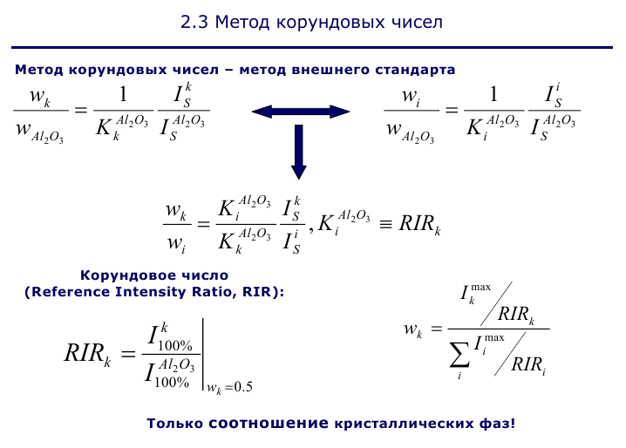. (5)

To ensure high accuracy, it is recommended to use the corundum number method for the analysis of fine powders prepared without the formation of textures. Given our conditions, the method was applied as a semi-quantitative one.

* + 1. Result of the phase composition identification

The overlay of diffraction patterns from the samples is shown in Figure 3 [15], [16]. Taking into account the identical conditions of the diffraction experiment, the visual differences in the diffraction patterns indicate differences in the phase composition and structure. Analysis of candidate phase cards showed good agreement with the diffractometric data cards of carbides.

It is difficult to unambiguously determine the lattice type of the W2C phase due to the superposition of the lines of the orthorhombic lattice on the lines of the hexagonal lattice. The choice of this or that card was conditioned by the coincidence of the position of the lines in the card with the maximum peak intensity.

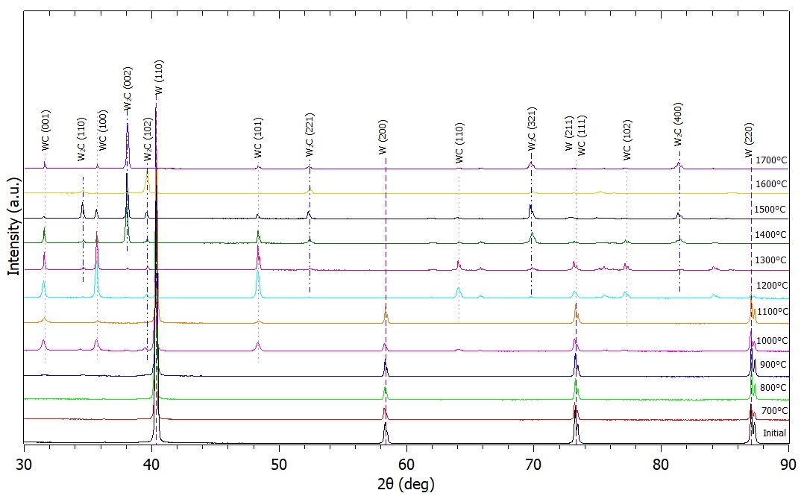

Figure 3 – Diffraction patterrn samples irradiated at surface temperature of   
700–1700 °С for 3600 s

With an increase in the carbidization temperature, a change in the phase composition and an increase in the number of tungsten carbide phases are observed:

– in the initial state and at a carbidization temperature of 700 °C and 800 °C, the base of the phase composition is metallic tungsten of the cubic system (space group Im-3m),

– at a carbidization temperature of 900 °C, the W2C phase of the orthorhombic system appears in the phase composition (space group Pbcn (60)). Metallic tungsten remains the basis of the phase composition,

– at a temperature of 1000 °C, in addition to the phase of the orthorhombic carbide W2C, the phase of the higher tungsten carbide WC of the hexagonal system appears in the composition (space group P-6m2 (187)). The basis of the phase composition is the cubic phase of metallic tungsten,

– at a temperature of 1100 °C, the base of the phase composition remains the metallic W of the cubic system (space group Im-3m). In addition to the hexagonal W2C phase, the WC phase of the hexagonal system appears (space group P-6m2 (187)). WC phase texture is observed,

– beginning with a carbidization temperature of 1200 °C, there is a noticeable increase in the WC phase of the hexagonal system (space group P-6m2 (187)). The cubic W phase and the W2C phase of the hexagonal system are also noted,

– an increase in temperature to 1300 °С leads to an increase in the WC phase of the hexagonal system and a decrease in the hexagonal W2C phase,

– at 1400 °C, the metallic W phase disappears from the phase composition. The intensity of the WC phase peaks decreases, and the intensity of the W2C phase peaks increases. Two types of W2C have been identified (hexagonal and orthorhombic). The maximum peak on the diffraction pattern is the W2C peak, indexed by (hkl) as (002) for the hexagonal system, but according to the card data, the peak with indices (-1-10) should be the maximum. This indicates the presence of texture in the sample, namely, the texture of the W2C phase,

– at a temperature of 1500 °C, the main phase remains the W2C phase of the orthorhombic system. WC peak intensity decreases,

– at a temperature of 1600 ° C, two types of W2C were also identified in the phase composition. Similarly to the result at 1400 °C, the maximum peak in the diffraction pattern is the W2C peak, indexed by (hkl) as (002) for the hexagonal system,

– at a temperature of 1700 °C, the main phase remains the W2C hexagonal system.

* + 1. Results of semi-quantitative content assessment

The results of the semi-quantitative content of the X-ray phase analysis of the samples are presented in Table 2.

Table 2 – Results of semi-quantitative phase analysis of samples

| Sample | Results of semi-quantitative analysis of phase composition | | | |
| --- | --- | --- | --- | --- |
| W (cub.) | WC  (hexagon., P-6m2) | W2C (ortoromb., Pbcn) | W2C (hexagon., P-31m) |
| Исходный | 100 | - | - | - |
| Т-700 | 100 | - | - | - |
| Т-800 | 100 | - | - | - |
| Т-900 | 97 | - | 3 | - |
| Т-1000 | 80 | 16 | 4 | - |
| Т-1100 | 88 | 10 | 2 | - |
| Т-1200 | 10.7 | 79.1 | - | 10.3 |
| Т-1300 | 0.6 | 89.7 | - | 9.6 |
| Т-1400 | 0 | 26.7 | 1.6 | 71.8 |
| Т-1500 | 0 | 12.1 | 87.9 | - |
| Т-1600 | 1.2 | - | 43.9 | 54.8 |
| Т-1700 | 0 | - | 14 | 86 |

* 1. Method for microstructure analysis of sample surface

The structure and elemental composition of the surface of tungsten samples after irradiation in PBI were studied in the topographic contrast mode using a JEOL-6390 scanning electron microscope with a JED-2300 energy dispersive spectral analysis attachment.

* + 1. Microstructure analysis results

Visible defects (cracks, pores, etc.) were not found on the surface of the initial tungsten sample before and after recrystallization annealing. The microstructure of the initial tungsten sample before and after annealing is shown in Figure 4 [17].

|  |  |
| --- | --- |
|  |  |
| а) before annealing | b) after annealing |

Рисунок 4 – Микроструктура поверхности вольфрамовых образцов до и после отжига

The results of determining the chemical composition of the sample surface are shown in Table 3.

Table 3 – Elemental analysis of the surface of tungsten samples at zooming × 100

|  |  |  |  |  |
| --- | --- | --- | --- | --- |
| Name | С | | W | |
| Mass fraction, % | Atomic fraction, % | Mass fraction, % | Atomic fraction, % |
| Before annealing | 2.29 | 26.42 | 97.71 | 73.58 |
| After annealing | 3.24 | 33.92 | 96.76 | 66.08 |

In the process of annealing, the surfaces of the tungsten samples were thermally etched. The SEM image of the microstructure of the thermally etched surface of a tungsten sample is shown in Figure 5. The structure of the annealed sample is characterized as fine-grained. Small grains, the size of which varies in the range of 2–3 µm, tend to accumulate and are distributed around relatively large grains less than 10 µm in size, outlining them along the perimeter.

|  |  |
| --- | --- |
| C:\Users\Пользователь\Desktop\234\Ganiya\ish\500[.jpg | C:\Users\Пользователь\Desktop\234\Ganiya\ish\2000x.jpg |

Figure 5 – Microstructure of a thermally etched surface of a tungsten sample

Upon visual inspection, the surface of the samples after irradiation on PBI at temperatures from 700 °C to 1200 °C is characterized by the presence of a continuous coating of a dark shade. The surface of the samples irradiated in the temperature range 1300–1700 ° С have a metallic luster and visually do not differ from the substrate [18].

SEM images of the surface of the samples are shown in Figure 6. On the surface of the samples irradiated at 800 °C and 900 °C (Figure 6b, c), a coating is observed in the form of a continuous film. In Figures 6d-e, areas of delamination and partial destruction of the formed film are noticeable. With an increase in temperature, the level of internal stresses exceeds the level of adhesion of the film to the tungsten surface, which leads to its delamination. At the same time, by the nature of destruction, the carbon film is fragile. After irradiation at a temperature of 1300 °C, a dense carbon film with growths of a predominantly globular structure was formed on the surface of the sample (Figure 6g). Whereas on the surface of the sample irradiated at 1400 °C, cracks are observed that intersect with each other, forming a mesh over the entire surface of the sample (Figure 6h). A similar character of the surface, as can be seen in Figures 6g – l, is inherent in all samples irradiated at temperatures from 1300 °C to 1700 °C, however, with increasing temperature, the width and number of cracks increases.

Brittle intercrystalline fractures of the identified cracks indicate the presence of “hot cracks” that arise in the solid-liquid state at the end of crystallization. Starting from 1400 °C, a large number of evenly distributed pores with a size of less than 1 µm appear on the surface of the samples (Figure 6h–k). At the same time, for samples T-1500 and T-1700, the surface is characterized by a pronounced grain structure (Figure 6i-k). In contrast to the initial state, after irradiation on PBI, a uniform distribution of grains with a size of ~ 10 μm is observed.

|  |  |  |
| --- | --- | --- |
|  |  |  |
| а) 700 °C | b) 800 °C | c) 900 °C |
|  |  |  |
| d) 1000 °C | e) 1100 °C | f) 1200 °C |
| C:\Users\Пользователь\Desktop\234\Ganiya\1300\2000-1.jpg | C:\Users\Пользователь\Desktop\234\Ganiya\1400\2000-4.jpg | C:\Users\Пользователь\Desktop\234\Ganiya\1500\2000.jpg |
| g) 1300 °C | h) 1400 °C | i) 1500 °C |
| C:\Users\Пользователь\Desktop\234\Ganiya\1600\2000.jpg | C:\Users\Пользователь\Desktop\234\Ganiya\1700\2000.jpg |  |
| j) 1600 °C | k) 1700 °C |  |

Figure 6 – SEM images of the structure of the investigated surface of tungsten samples after plasma irradiation

According to the results of local elemental analysis given in Table 4, the carbon film on the surface of tungsten samples consists of several layers, which differ in the ratio of the main components.

Table 4 – Local elemental analysis of the region of delamination and partial destruction of the formed film on the surface of tungsten samples, corresponding to points 1–22, 29–36 in Figures 6a and 6d – f, at zooming of × 100

|  |  |  |  |  |  |  |  |  |  |
| --- | --- | --- | --- | --- | --- | --- | --- | --- | --- |
| Name | C | | W | | Name | C | | W | |
| Mass fraction, % | Atomic fraction, % | Mass fraction, % | Atomic fraction, % | Mass fraction, % | Atomic fraction, % | Mass fraction, % | Atomic fraction, % |
| 1 | 66.49 | 96.81 | 33.51 | 3.19 | 16 | 34.17 | 88.82 | 65.83 | 11.18 |
| 2 | 71.19 | 97.42 | 28.81 | 2.58 | 17 | 67.01 | 96.88 | 32.99 | 3.12 |
| 3 | 71.22 | 97.43 | 28.78 | 2.57 | 18 | 67.08 | 96.89 | 32.92 | 3.11 |
| 4 | 61.07 | 96.00 | 38.93 | 4.00 | 19 | 84.85 | 98.85 | 15.15 | 1.15 |
| 5 | 6.47 | 51.42 | 93.53 | 48.58 | 20 | 84.21 | 98.79 | 15.79 | 1.21 |
| 6 | 15.51 | 73.75 | 84.49 | 26.25 | 21 | 9.82 | 62.51 | 90.18 | 37.49 |
| 7 | 71.71 | 97.49 | 28.29 | 2.51 | 22 | 11.84 | 67.28 | 88.16 | 32.72 |
| 8 | 55.12 | 94.95 | 44.88 | 5.05 | 29 | 59.22 | 95.69 | 40.78 | 4.31 |
| 9 | 73.52 | 97.70 | 26.48 | 2.30 | 30 | 67.50 | 96.95 | 32.50 | 3.05 |
| 10 | 12.83 | 69.25 | 87.17 | 30.75 | 31 | 48.21 | 93.44 | 51.79 | 6.56 |
| 11 | 12.32 | 68.25 | 87.68 | 31.75 | 32 | 42.49 | 91.88 | 57.51 | 8.12 |
| 12 | 17.47 | 76.41 | 82.53 | 23.59 | 33 | 9.98 | 62.92 | 90.02 | 37.08 |
| 13 | 76.50 | 98.03 | 23.50 | 1.97 | 34 | 8.60 | 59.01 | 91.40 | 40.99 |
| 14 | 76.60 | 98.04 | 23.40 | 1.96 | 35 | 94.67 | 99.63 | 5.33 | 0.37 |
| 15 | 48.31 | 93.47 | 51.69 | 6.53 | 36 | 94.20 | 99.60 | 5.80 | 0.40 |

1. Assessment of the effect of the tungsten sample surface temperature under plasma irradiation on the formation of a carbidized layer

X-ray and microstructural studies of the surface of tungsten samples after plasma irradiation showed that, within the studied temperature range, interaction between tungsten and methane occurs with the formation of tungsten carbides.

After irradiation at 700 °C, most likely, crystallization centers appear on the surface of the tungsten sample, as a result of their growth, subsequently, with increasing temperature, a continuous carbon film is formed. The dependence of the elemental composition of the tungsten sample surface on the irradiation temperature is shown in Figure 7. The graph in Figure 7 shows that the mass fraction of carbon increases after irradiation at temperatures from 700 °C to 900 °C, while the tungsten content decreases. This indirectly indicates an increase in the thickness of the carbon coating.

However, according to the results of X-ray phase analysis after irradiation of the samples at temperatures from 700 °C to 900 °C, the basis of the phase composition of the surface of the samples is metallic tungsten with a body-centered cubic crystal lattice, as in the initial state. This indicates that higher temperatures are required for diffusion of carbon into tungsten to form tungsten carbides.

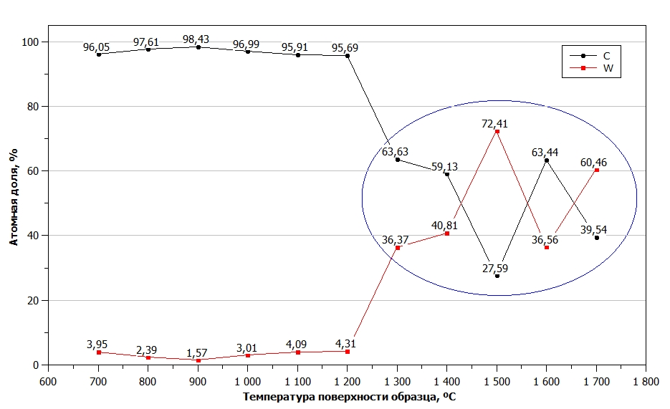

Figure 7 – Dependence of the elemental composition of the tungsten sample surface on the irradiation temperature

According to the results of elemental analysis, with an increase in the irradiation temperature of tungsten samples up to 1300 °C, a decrease in the mass fraction of carbon is observed. This is due to delamination, partial destruction of the formed film in local areas, as well as the onset of diffusion of carbon into tungsten. After irradiation of the surface of the samples at a temperature of 1400 ° C and above, a sharp change is observed in the ratios of atomic fractions between carbon and tungsten. It is possible that at high temperatures a thermally unstable carbon film is destroyed and carbon on the surface of the samples is already chemically bound, forming new phases.

Figure 8 shows a graph of the dependence of the quantitative content of phases on the tungsten surface on the irradiation temperature, built according to Table 2.

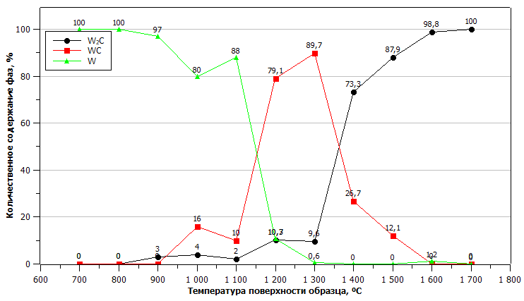

Figure 8 – Dependence of the quantitative content of phases on the surface of tungsten samples on the irradiation temperature

The graph shows that the diffusion of carbon into tungsten with the formation of WC occurs after irradiation at a temperature of 1000 °C. After irradiation at temperatures from 1100 °C to 1500 °C, the simultaneous formation of two phases of tungsten carbides is observed.

After irradiation at temperatures above 1400 °C, the content of the tungsten phase on the sample surface is zero, indicating that metallic tungsten in the near-surface region has completely reacted and W2C becomes the basis of the phase composition of the sample surface. The results obtained are in good agreement with the literature data [19] - [21].

From the analysis of the results of X-ray structural and microstructural studies, it is obvious that the phase transformations are greatly influenced by an increase in the surface temperature of the samples under plasma irradiation.

CONCLUSION

Based on the work on the theme of grant financing in 2021, experimental work was carried out to assess the surface temperature effect of a tungsten sample on the carbidized layer formation under plasma irradiation.

According to the results of X-ray diffraction analysis of the surface of tungsten samples, it was found that interaction between methane and tungsten leads to WC formation after irradiation at 1000 °C. Irradiation at temperatures from 1100 °C to 1300 °C leads to the simultaneous formation of WC and W2C carbide phases. The phase composition of the sample surface after irradiation at temperatures from 1500 °C to 1700 °C is based on W2C.

Microstructural analysis showed that, on the surface of the samples irradiated at temperatures from 700 °C to 1200 °C, the presence of a carbon coating in the form of a continuous film is observed. The surface of the samples after irradiation at temperatures from 1300 °C to 1700 °C has a metallic luster and does not visually differ from the surface of the original sample. This can be explained by the fact that at high temperatures, the thermally unstable carbon film is destroyed and carbon on the surface of the samples is already chemically bound, forming tungsten carbide phases, as evidenced by the results of X-ray diffraction analysis.

From the analysis of the results of the research, it is obvious that the phase transformations occurring on the surface of the tungsten-based plasma irradiated with methane are most importantly influenced by an increase in the temperature of the sample surface during irradiation. It has been experimentally established that interaction between tungsten and methane in a wide temperature range can occur with simultaneous or sequential formation of the carbide phases W2C and WC.

The data obtained will have practical application in the formation of a program for studying the interaction between plasma and surface of samples of candidate TNR materials during experiments at the KTM tokamak.

LIST OF REFERENCES

Pintsuk G., Hasegawa A. Tungsten as a plasma-facing material // Reference Module in Materials Science and Materials Engineering.– 2019.– <https://doi.org/10.1016/B978-0-12-803581-8.11696-0>.

Bolt H., Barabash V., Federici G., Linke J., Loarte A., Roth J., Sato K. Plasma facing and high heat ﬂux materials-needs for ITER and beyond // Journal of Nuclear Materials.– 2002.– Vol.307.– P. 43–52.

1. Budaev V.P., Fedorovich S.D., Dedov A.V. [et al.] High-heat flux tests of tungsten divertor mock-ups with steady-state plasma and e-beam // Nuclear Materials and Energy.– 2020.– Vol.25.– <https://doi.org/10.1016/j.nme.2020.100816>.

Rieth M., Doerner R., Hasegawa A., Ueda Y., Wirtz M. Behavior of tungsten under irradiation and plasma interaction // Journal of Nuclear Materials.– 2019.– Vol.519.– P. 334–368.– <https://doi.org/10.1016/j.jnucmat.2019.03.035>.

1. Rakhadilov B.K., Miniyazov A.Z., Skakov M.K. [et al.], Structural Modification and Erosion of Plasma-Irradiated Tungsten and Molybdenum Surfaces // Technical Physics.– 2020.– Vol.65.– P.382–391.– <https://doi.org/10.1134/S1063784220030202>.
2. Tazhibayeva I.L. [et al.] KTM Experimental Complex Project Status // Fusion Science and Technology.– Vol.47.– 2005.– P. 746–750.

Investigation of the formation of a carbidized layer on the surface of tungsten under plasma irradiation: research report (intermediate) / IAE Branch RSE NNC RK; Manag. V.V. Baklanov. - Kurchatov, 2020. - 26 p. - State. Inv. # 0220РК01557.

1. Patent of the Republic of Kazakhstan No. 2080. Simulation test-bench with a plasma-beam installation / Kolodeshnikov A.A., Zuev V.A., Ganovichev D.A., Tulenbergenov T.R. [et al.]; applicant and patentee of RSE NNC RK.– No. 2016/0108.2; declared 02/29/2016; publ. on 15.03.2017, Bul. No. 5. - 3 p.
2. Kurnaev V., Vizgalov I., Gutorov K., Tulenbergenov T., Sokolov I.,   
   Kolodeshnikov A., Ignashev V., Zuev V., Bogomolova I., Klimov N. Investigation of plasma-surface interaction at plasma beam facilities // Journal of Nuclear Materials.– 2015.– Vol.463.–P. 228-232.– <http://dx.doi.org/10.1016/j.jnucmat.2014.12.076>.
3. On the preparation of tungsten samples: act No. 12-230-02/16 dated 02.02.21/Branch IAE RSE NNC RK.- Kurchatov, 2021.
4. Bochvar A.A. Fundamentals of heat treatment of alloys: study guide for higher educational institutions. - 5th ed. rev. and amended - M.-L : Publishing house of Metallurgizdat, 1940. - P. 298.
5. Pavlov B.A., Terentyev A.P. A course in organic chemistry. - Sixth edition, stereotyped. - M .: Publishing house Chemistry, 1967. - P. 58.
6. Gražulis S., Chateigner D., Downs R.T., Yokochi A.F.T., Quirós M., Lutterotti L., Manakova E., Butkus J., Moeck P. and Le Bail A. Crystallography Open Database – an open-access collection of crystal structures // J. Appl. Cryst.– 2009.– Vol.42.– P.726–729.

Hubbard C.R., Snyder R.L. RIR – Measurement and Use in Quantitative XRD // Powder Diffraction.– 1988.– Vol.3.– P.74–77.

On conduction experiments to obtain a carbidized layer on the surface of tungsten under plasma irradiation on a simulation stand with a plasma-beam installation: protocol No. 12-230-02 / 20 dated 02.19.2021 // IAE Branch RSE NNC RK.– Kurchatov, 2021.

On conducting experiments to assess the effect of the surface temperature of a tungsten sample on the formation of a carbidized layer on the tungsten surface: protocol No. 12-230-02 / 107 dated 07.26.2021 // IAE Branch RSE NNC RK.– Kurchatov, 2021.

On structural analysis of the surface of samples irradiated on a simulation test-bench with PBI in the temperature range from 700 °C to 1000 °C: protocol No. 12-230-02 / 34 dated 03.29.2021 // IAE Branch RSE NNC RK. - Kurchatov, 2021.

On structural analysis of the surface of samples irradiated on a simulation test-bench with PBI in the temperature range from 1100 °C to 1700 °C: protocol No. 12-230-02 / 122 dated 27.08.2021 // IAE Branch RSE NNC RK. - Kurchatov, 2021.

Luthin J., Linsmeier Ch. Carbon films and carbide formation on tungsten // Surface Science.– 2000.– Vol. 454–456.– P.78–82.

Linsmeier Ch., Luthin J., Klages K. U., Wiltner A. and Goldstraß P. Formation and Erosion of Carbon-Containing Mixed Materials on Metals // Physica Scripta.– 2004.– Vol.T111.– P.86–91.

Linsmeier Ch., Reinelt M., Schmid K. Surface chemistry of first wall materials – From fundamental data to modeling // Journal of Nuclear Materials.– 2011.– Vol.415.–   
P.S212–S218.

APPENDIX А  
(obligatory)   
Calendar Schedule

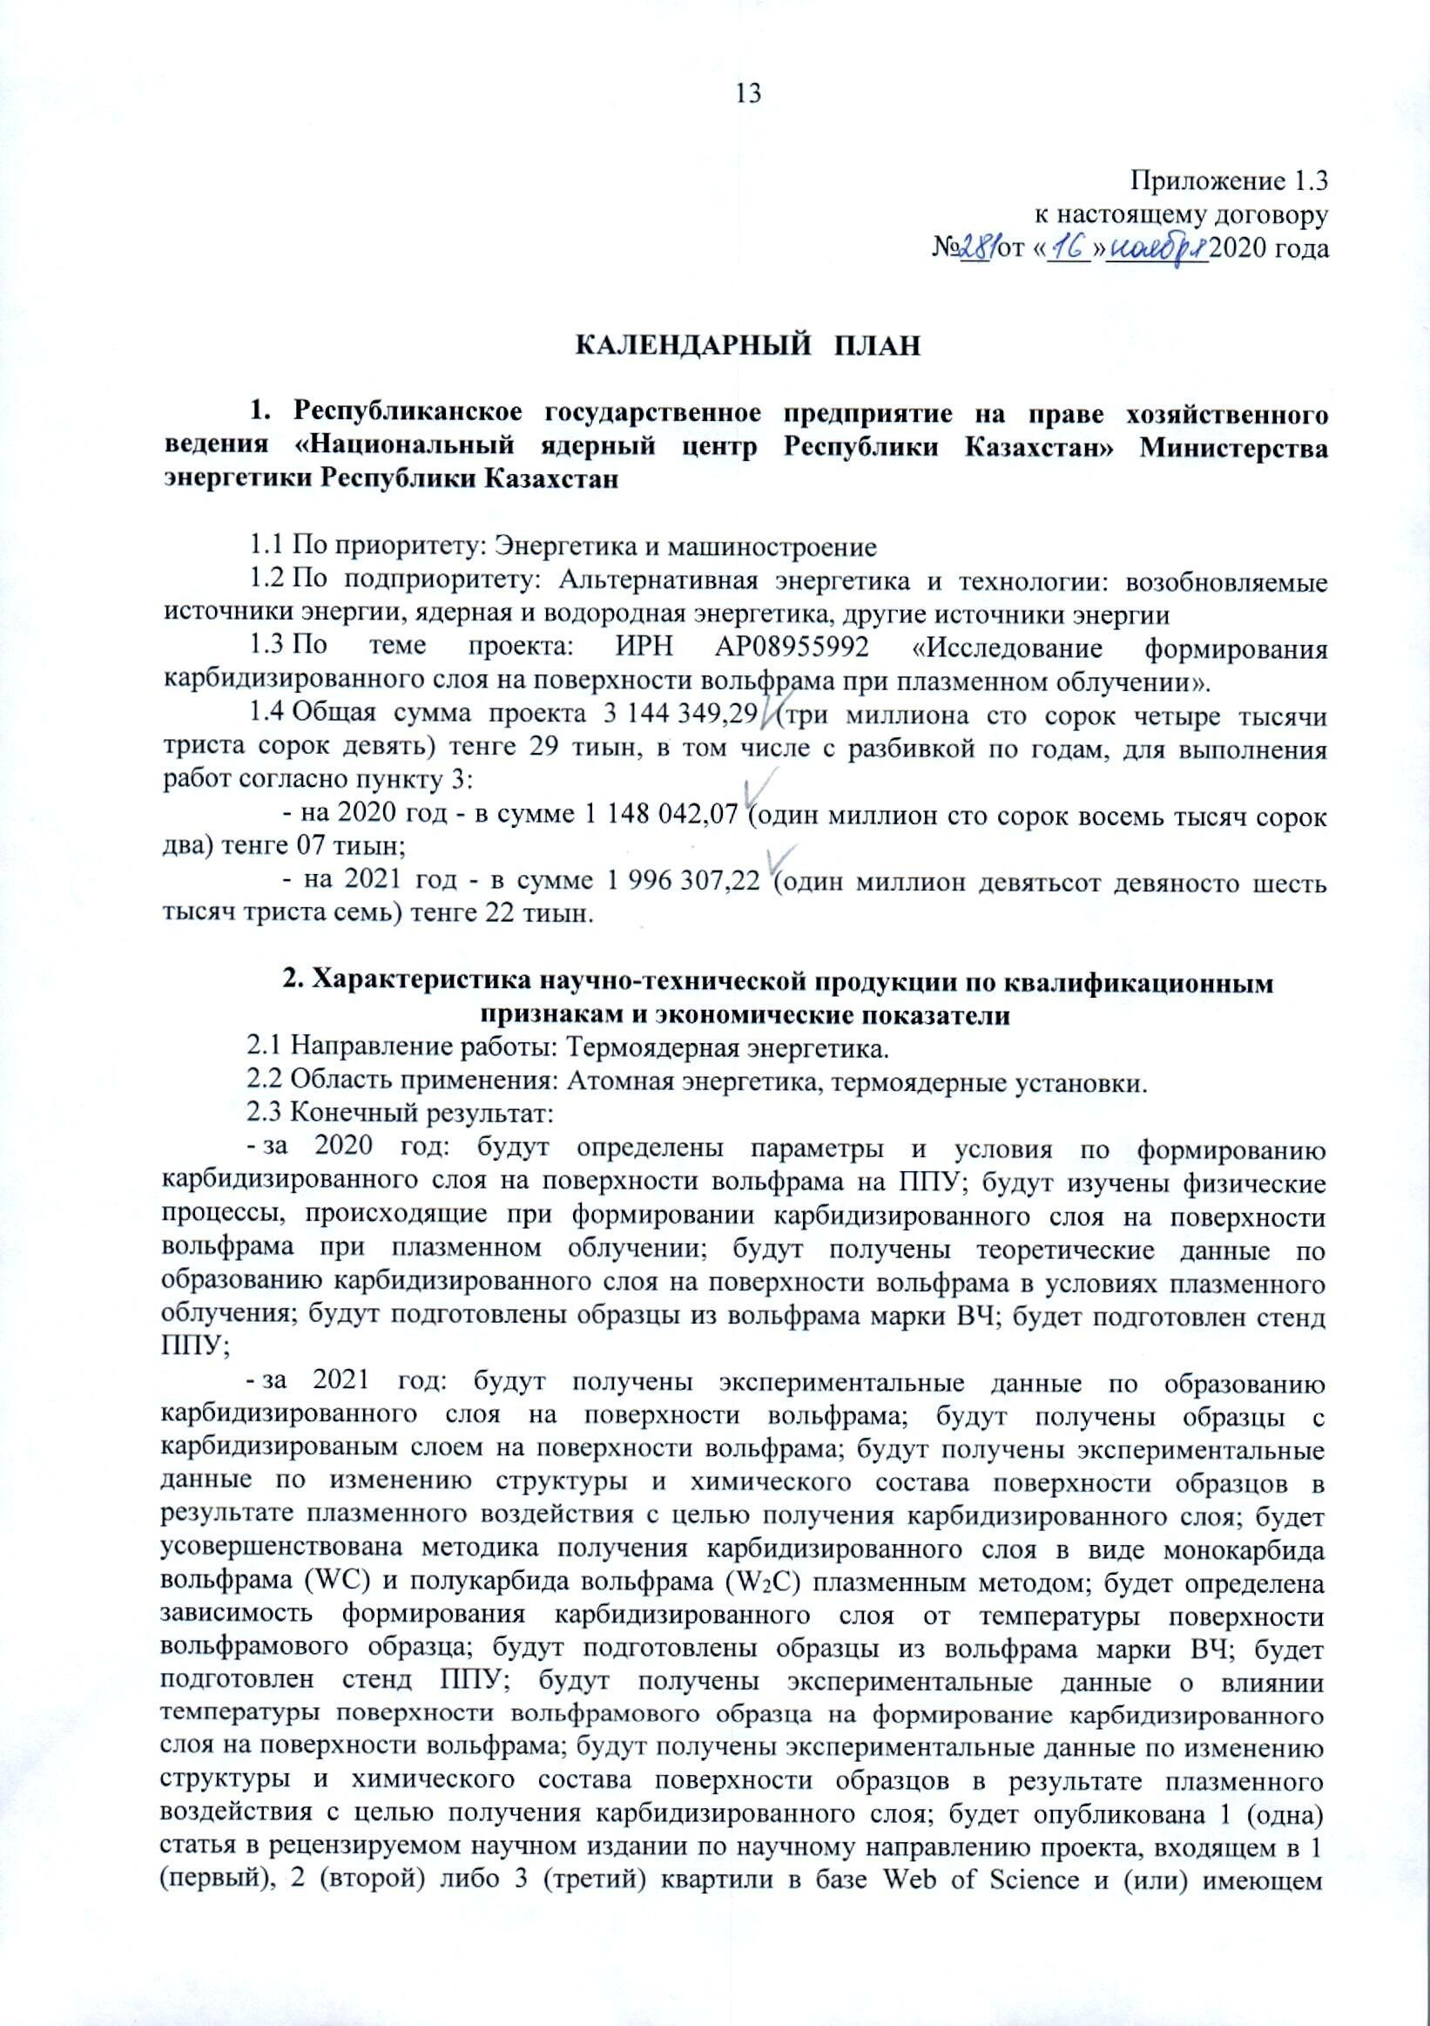

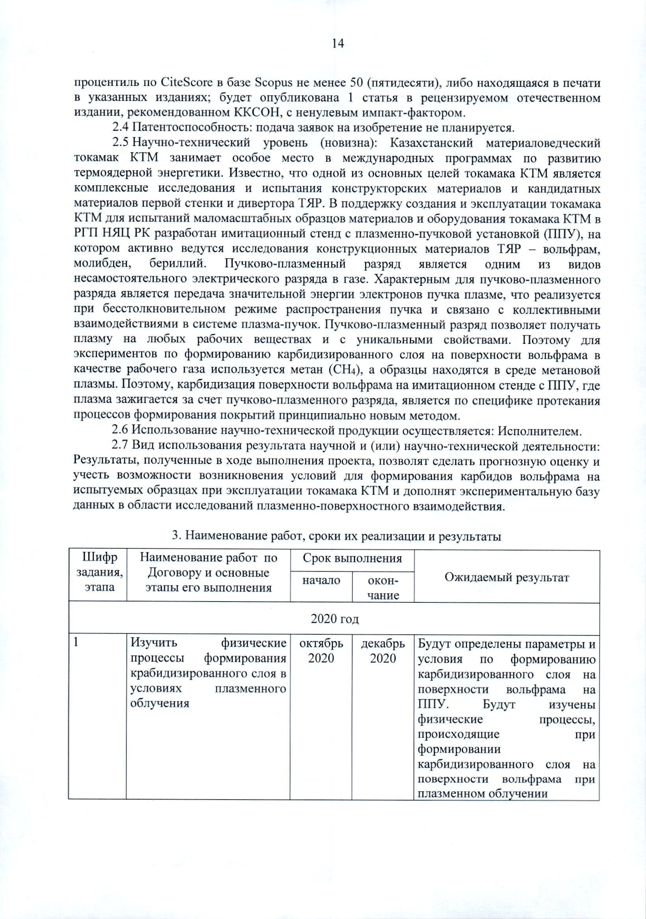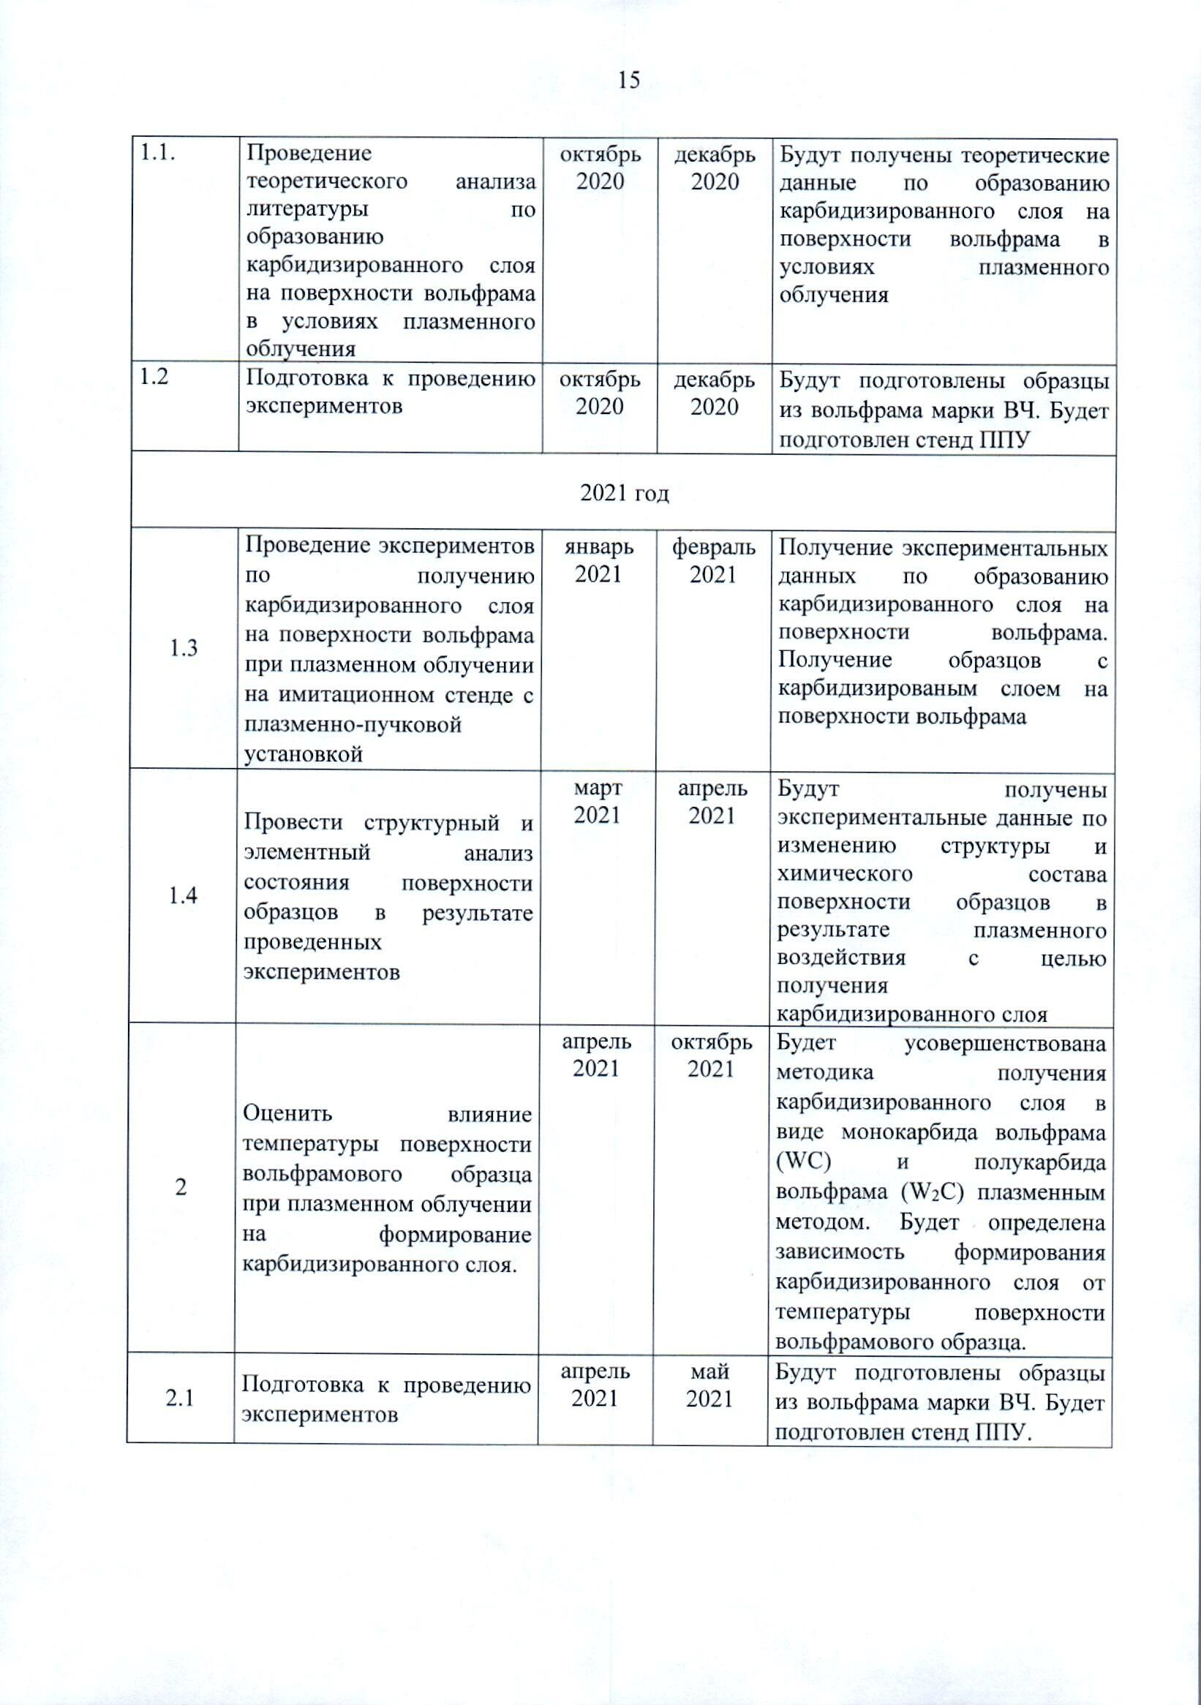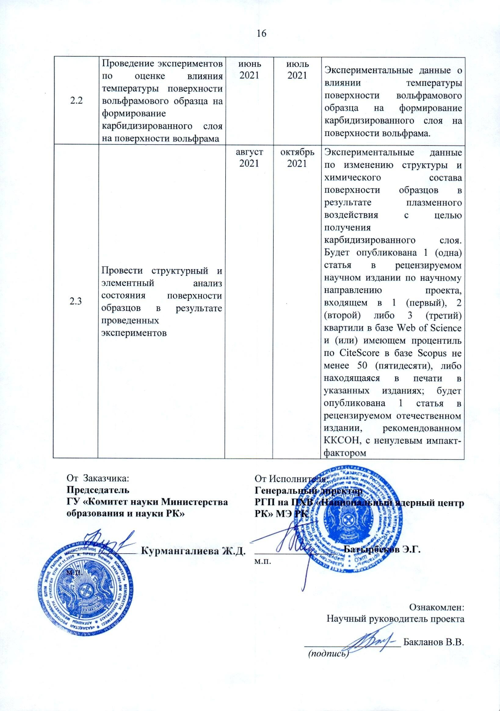

|  |  |  |  |  |  |
| --- | --- | --- | --- | --- | --- |
| No | | Name of work under the Agreement and the main stages of its implementation | Deadline | | Expected results |
| Start | The end |  |
| 2020 year | | | | | | |
| 1 | | To study the physical processes of formation of a carbidized layer under plasma irradiation. | October 2020 | December 2020 | The parameters and conditions for the formation of a carbidized layer on the tungsten surface on PUF will be determined. The physical processes occurring during the formation of a carbidized layer on the surface of tungsten during plasma irradiation will be studied. |
| 1.1. | | Carrying out the theoretical analysis of literature on the formation of a carbidized layer on the tungsten surface under plasma irradiation. | October 2020 | December 2020 | Theoretical data on the formation of a carbidized layer on the tungsten surface under plasma irradiation will be obtained. |
| 1.2 | | Preparations for the experiments | October 2020 | December 2020 | Samples of high-frequency tungsten will be prepared. |
| 2021 year | | | | | | |
| 1.3 | | Conducting experiments on obtaining a carbidized layer on the surface of tungsten under plasma irradiation on a simulation bench with a plasma-beam installation | January 2021 | February  2021 | Obtaining experimental data on the formation of a carbidized layer on the tungsten surface. Obtaining the samples with a carbidized layer on the tungsten surface. |
| 1.4 | | Conducting structural and elemental analysis of the samples surface state as a result of the experiments | March 2021 | April 2021 | Experimental data on changes in the structure and chemical composition of the samples surface as a result of plasma exposure in order to obtain a carbidized layer |
| 2 | | To evaluate the influence of the surface temperature of a tungsten sample under plasma irradiation on the formation of a carbidized layer. | April 2021 | October 2021 | The method of obtaining a carbidized layer in the form of tungsten monocarbide (WC) and tungsten semi-carbide (W2C) by plasma method will be improved. The dependence of the carbidized layer formation upon the surface temperature of the tungsten sample will be determined. |
| 2.1 | | Preparations for the experiments. | April 2021 | May  2021 | Samples of high-frequency tungsten will be prepared.  A PBI bench will be prepared. |
| 2.2 | | Conducting experiments to assess the effect of surface temperature of a tungsten sample on the formation of a carbidized layer on the tungsten surface. | June  2021 | July 2021 | Experimental data on the influence of the surface temperature of a tungsten sample on the formation of a carbidized layer on the tungsten surface. |
| 2.3 | | Conductng structural and elemental analysis of the samples surface state as a result of the experiments | August 2021 | October 2021 | Experimental data on changes in the structure and chemical composition of the samples surface as a result of plasma exposure in order to obtain a carbidized layer |
|  | | | | | | |

APPENDIX B   
(reference)   
Diffractometric Data Cards

Table B.1 – Data from the metal tungsten card of the cubic system

|  |  |  |
| --- | --- | --- |
| Card | 00-004-0806 | |
| Structure: | W | |
| Data base: | ICDD | |
| Primary reference: | Swanson, Tatge., Natl. Bur. Stand. (U.S.), Circ. 539, I, 28, (1953) | |
| Crystal system: | Cubic | |
| Space group (number): | Im-3m (229) | |
| Unit cell parameters: | a = b = с = 3,1648 Å |  |
|  | α = β = γ = 90 ° |  |
| Calculated density (g/cm3): | 19,26 | |
| Unit cell volume  (106 pm3): | 31.70 | |
| RIR (Corundum number): | 18.00 | |

Table B.2 – Data from W2C Tungsten Semi-Carbide Card of Orthorhombic System

|  |  |  |
| --- | --- | --- |
| Card | 01-089-2371 | |
| Structure: | W2C | |
| Data base: | ICDD | |
| Primary reference: | Calculated from ICSD using POWD-12++ | |
| Structure description: | Yvon, K., Nowotny, H., Benesovsky, P., Monatsh. Chem., 99, 726, (1968) | |
| Crystal system: | Orthorhombic | |
| Space group (number): | Pbcn (60) | |
| Unit cell parameters: | a = 4, 728; b = 6,009 Å | c = 5,193 Å |
|  | α = β = γ = 90 ° |  |
| Calculated density (g/cm3): | 17.09 | |
| Unit cell volume  (106 pm3): | 1475.54 | |
| RIR (Corundum number): | 12.84 | | |

Table B.3 - Data from the card of the highest tungsten carbide WC of the hexagonal system

|  |  |  |
| --- | --- | --- |
| Card | 00-051-0939 | |
| Structure: | WC | |
| Data base: | ICDD | |
| Primary reference: | Mayo, W., H&M Analytical Services, Inc., Allentown, NJ, USA., ICDD Grant-in-Aid, (1999) | |
| Lattice parameters determined: | Leciejewicz, J., Acta Crystallogr., 14, 200, (1961) | |
| Crystal system: | Hexagonal | |
| Space group (number): | P-6m2 (187) | |
| Unit cell parameters: | a = b = 2,9063 Å | c = 2,8375 Å |
|  | α = β = 90 ° | γ = 120° |
| Calculated density (g/cm3): | 15.66 | |
| Unit cell volume  (106 pm3): | 20.76 | |
| RIR (Corundum number): | 14.94 | |

Table B.4 – Data from the W2C Hexagonal Tungsten Semi-Carbide Card

|  |  |  |
| --- | --- | --- |
| Карточка | 03-065-3896 | |
| Structure: | W2C | |
| Data base: | ICDD | |
| Primary reference: | Calculated from NIST using POWD-12++ | |
| Structure description: | B.Lonnberg, T.Lundstrom&R.Tellgren, J. Less-Common Met., 120, 239-2, (1986) | |
| Crystal system: | Hexagonal | |
| Space group (number): | P-31m (162) | |
| Unit cell parameters: | a = b = 5,1809 Å | c = 4.7216 Å |
|  | α = β = 90 ° | γ = 120° |
| Calculated density (g/cm3): | 17.14 | |
| Unit cell volume  (106 pm3): | 109.76 | |
| RIR (Corundum number): | 11.12 | |

Table B.5 – Data from the card of the highest tungsten carbide WC of the hexagonal system (identified in the sample after carbidization at 1400 ° C)

|  |  |  |
| --- | --- | --- |
| Card | 03-065-8828 | |
| Structure: | WC | |
| Data base: | ICDD | |
| Primary reference: | Calculated from NIST using POWD-12++ | |
| Structure description: | Schuster, J., Rudy, E., Nowotny, H., Monatsh. Chem., 107, 116, (1976) | |
| Crystal system: | Hexagonal | |
| Space group (number): | P-6m2 (187) | |
| Unit cell parameters: | a = b = 2.9020 Å | c = 2.8380 Å |
|  | α = β = 90 ° | γ = 120° |
| Calculated density (g/cm3): | 15.71 | |
| Unit cell volume  (106 pm3): | 20.70 | |
| RIR (Corundum number): | 14.68 | |

Table B.6 – Data from the card of tungsten semicarbide W2C of the orthorhombic system (identified in the sample that has undergone carbidization at 1400 °C)

|  |  |  |
| --- | --- | --- |
| Card | 03-065-8829 | |
| Structure: | W2C | |
| Data base: | ICDD | |
| Primary reference: | Calculated from ICSD using POWD-12++ | |
| Structure description: | Telegus, V. S., Gladyshevskii, E. I., Kripyakevich, P. I., Sov. Phys. Crystallogr. (Engl. Transl.), 12, 813, (1967) | |
| Crystal system: | Orthorombic | |
| Space group (number): | Pbcn (60) | |
| Unit cell parameters: | a = 4. 7210; b = 0.0300 Å | c = 5.1800 Å |
|  | α = β = γ = 90 ° |  |
| Calculated density (g/cm3): | 17.10 | |
| Unit cell volume  (106 pm3): | 147.46 | |
| RIR (Corundum number): | 14.67 | |

APPENDIX C   
(obligatory)  
List of publications on the theme

Articles:

* 1. Zhanbolatova G.K., Baklanov V.V., Tulenbergenov T.R., Miniyazov A.Zh., Sokolov I.A. Carbidization of the tungsten surface in a beam-plasma discharge // Bulletin of the NNC RK.– 2020.– No. 4.– P.77–81.

Abstracts:

1. Zhanbolatova G.K., Baklanov V.V., Tulenbergenov T.R., Miniyazov A.Zh., Sokolov I.A. Carbidization of a tungsten surface in a beam-plasma discharge // Collection of abstracts of the XXIV Conference of Plasma-Surface Interaction .– Moscow, NRNU MEPhI, February 4–5, 2021 - pp. 46–48.
2. Skakov M.K., Zhanbolatova G.K. Carbidization of the tungsten surface in beam-plasma discharge // Book of Abstracts of International online conference «Advanced manufacturing materials and research: new technologies and techniques AMM&R2021 February 19, 2021».– Ust-kamenogorsk, 2021.– P. 65.
3. Zhanbolatova G.K., Baklanov V.V., Skakov M.K., Bukina O.S., Kozhahmetov Ye.A., Orazgaliev N.A. Influence of temperature on the formation of tungsten carbide in a beam-plasma discharge // Book of Abstracts of 15th International Conference «Gas Discharge Plasmas and Their Applications, September 5–10,2021».– Ekaterinburg, 2021.– P.122.
4. Zhanbolatova G.K., Skakov M.K., Baklanov V.V., Bukina O.S., Kozhakhmetov Ye.A., Orazkaliev N.A., Tulenbergenov T.R., Sokolov I.A., Gradoboev A.V. Influence of temperature on the formation of a carbidized layer on the surface of tungsten in a beam-plasma discharge // Collection of abstracts of the IX international conference "Semipalatinsk test site: heritage and prospects for the development of scientific and technical potential", September 07–09, 2021 - Kurchatov, 2021. - p .72-73.
5. Zhanbolatova N.A., Skakov M.K., Baklanov V.V., Bukina O.S., Kozhakhmetov Ye.A., Orazkaliev N.A., Tulenbergenov T.R., Sokolov I.A., Gradoboev A.V. Formation of a carbidized layer on the surface of tungsten under plasma irradiation//Collection of abstracts of the III International Scientific Forum "Nuclear Science and Technology" dedicated to the 30th anniversary of the Independence of the Republic of Kazakhstan, September 20-24, 2021 - Almaty, 2021.- P.140-141.

Publications submitted for publishing:

Articles:

1. Zhanbolatova G.K., Baklanov V.V., Skakov M.K., Bukina O.S., Kozhahmetov Ye.A., Orazgaliev N.A. Influence of temperature on tungsten carbide formation in a beam plasma discharge // Journal of Physics: Conference Series
2. Baklanov V.V., Zhanbolatova G.K., Skakov M.K., Miniyazov A.Zh., Sokolov I.A., Tulenbergenov T.R., Kozhakhmetov Ye.K., Bukina O.B. and Orazgaliev N.O. Study of the temperature dependence of a carbidized layer formation on the tungsten surface under plasma irradiation // Materials Research Express