
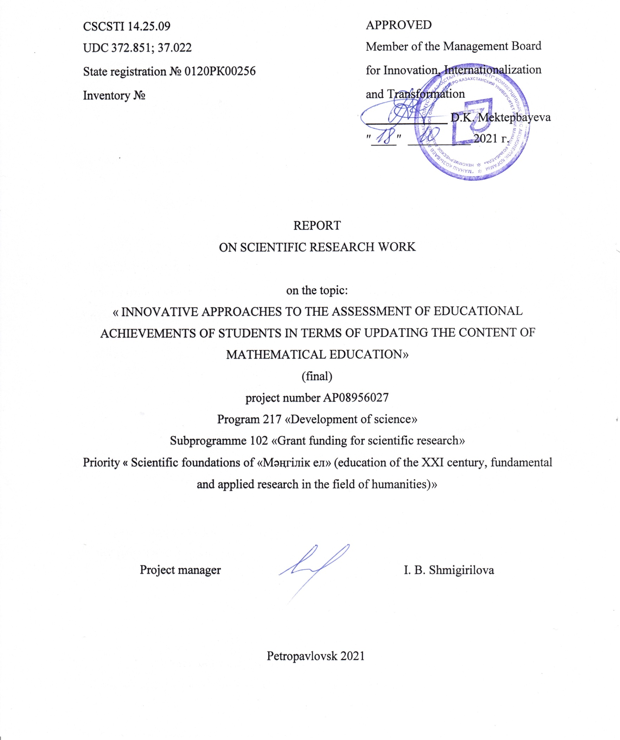
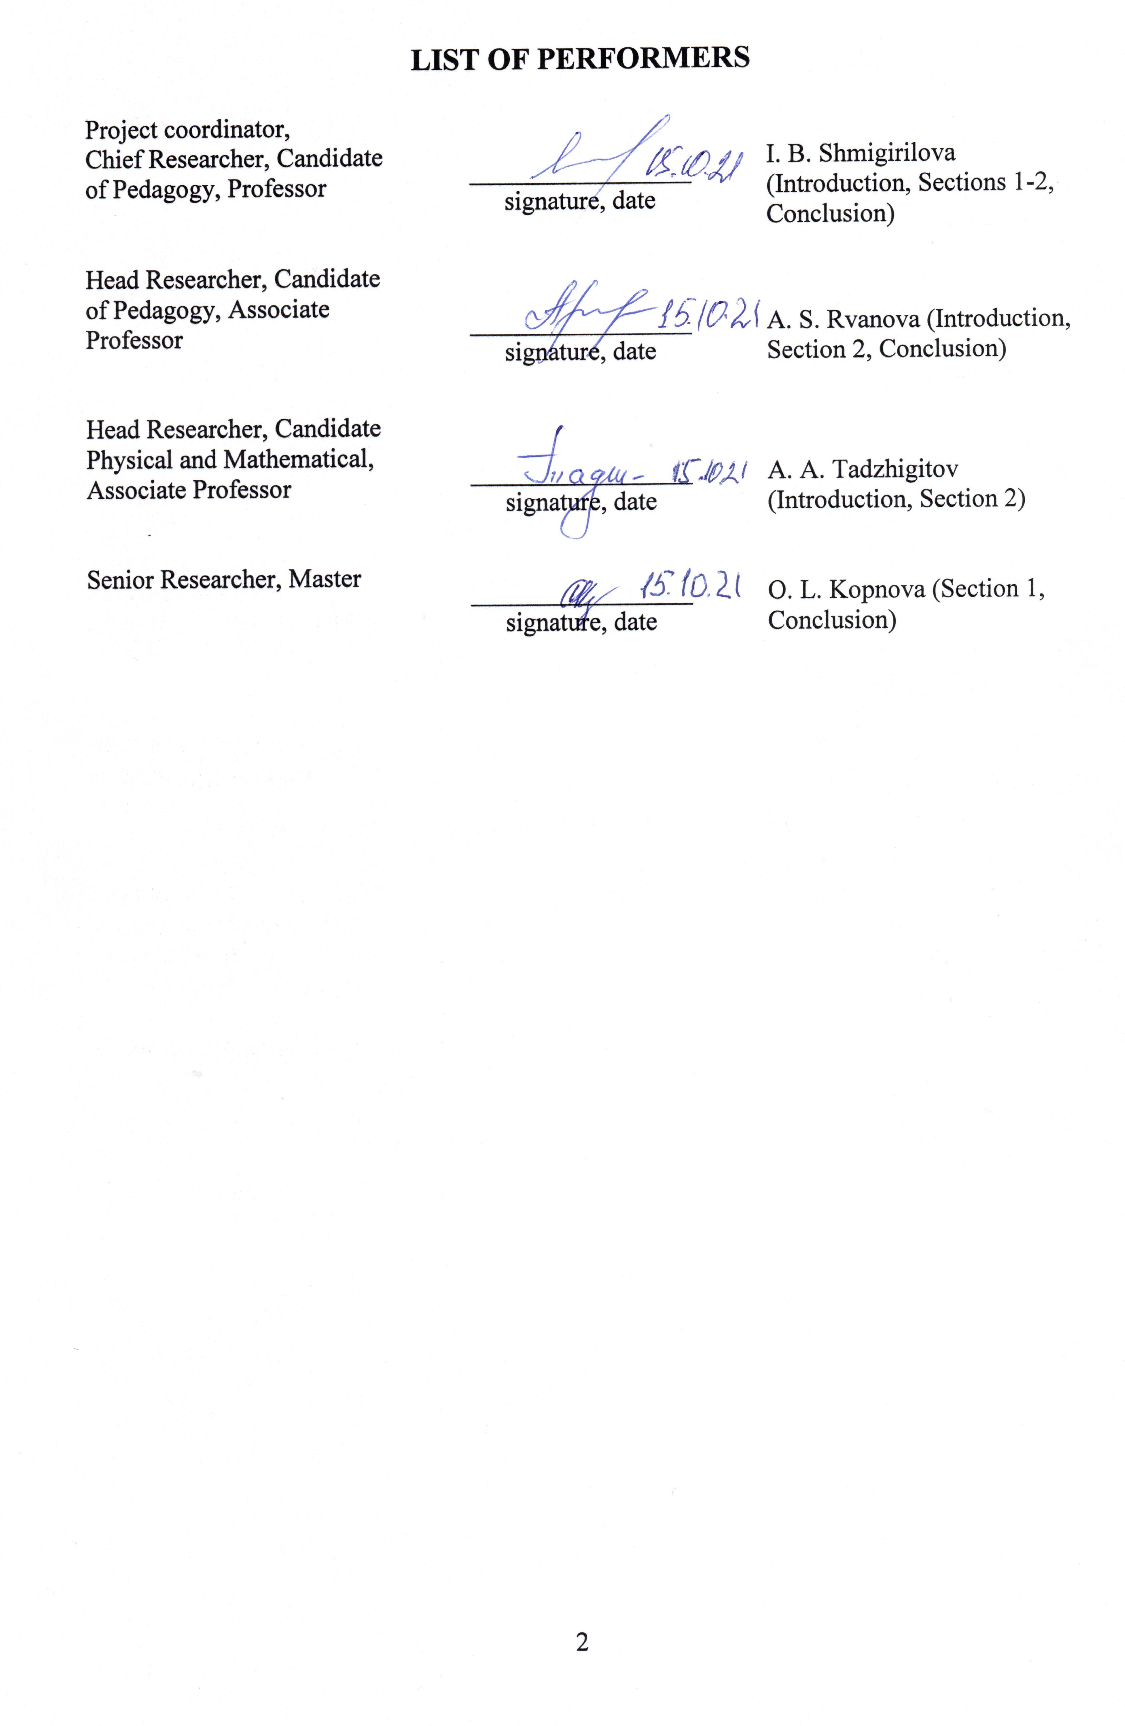
abstract

Report 40 pp., 2 figures, 0 tables, 53 sources, 6 app.
EDUCATIONAL ASSESSMENT, QUALITY OF LEARNING, LEARNING ACHIEVEMENTS OF THE STUDENT, CRITERIAL ASSESSMENT, FORMING ASSESSMENT, ASSESSMENT COMPETENCE OF THE TEACHER
The object of the research is the process of educational assessment in teaching mathematics in the school system.
Purpose of the work: on the basis of a comprehensive analysis of the world practice of educational assessment, to present an innovative model for assessing the educational achievements of students that meets modern requirements for the system of school mathematical education, the introduction of which into the educational process will contribute to the achievement of a set of educational goals and improve the quality of education.
The research was carried out on the use of a set of theoretical and empirical methods: comparative and aspect analysis of scientific sources and normative documents representing the world educational practice and the system of educational assessment in Kazakhstan; primary collection of empirical data (interviews, questioning of subjects of the educational process); analysis and systematization of empirical material; generalization of theoretical research, advanced teaching experience; modeling; initial approbation of the model with the participation of school teachers.
The end result of the study was an innovative model of the system for assessing the educational achievements of students that meets the principles of effective assessment and modern requirements for the system of school mathematical education in Kazakhstan and recommendations for its implementation in school practice.
Field of application of the results: Education.
The significance of the study lies in the fact that its results (conclusions, assessment model and recommendations) are directly aimed at improving educational assessment in the system of school mathematics teaching, which, in turn, due to the importance of assessment as an essential component of a holistic educational process, will have an impact on increasing its effectiveness.
A promising direction for further research can be considered the identification of the most effective practices of summative and formative assessment, taking into account the subject, personal and social contexts of the Kazakhstani school system.
contents

INRODUCTION 5
MAIN PART OF THE REPORT RESEARCH WORK 7
1 Criteria-based assessment: an analysis of theory and practice 7
1.1 Analysis of the questionnaire survey of Kazakhstani teachers on the problem of educational assessment 7
1.2 Analysis and generalization of the most effective approaches to the implementation of educational assessment in school practice 14
2 An innovative model of criteria-based assessment of the educational results of schoolchildren in teaching mathematics 21
2.1 Conceptual basis of an innovative model of criteria-based assessment of educational results of schoolchildren in teaching mathematics 21
2.2 Description of an innovative model of criteria-based assessment of the educational results of schoolchildren in teaching mathematics 24
CONCLUSION 35
REFERENCES 39
APPENDIX A ‒ Results of the questionnaire survey of Kazakhstan teachers 44
APPENDIX B ‒ The results of self-assessment of teachers in the use of the types of assessment activities 54
APPENDIX C– Generalized criteria for assessing the development of students of mathematical content corresponding to the educational tasks of the school course of mathematics 55
APPENDIX D ‒Technological chain «educational purposes – criteria – descriptors – evaluation materials» 57
APPENDIX E – Calendar plan 59
APPENDIX F ‒ List of published manuscripts on the project topic 65

INRODUCTION

One of the areas in which the development of the education system in the Republic of Kazakhstan is being implemented in accordance with the best domestic and world practices is the [1] assessment system. The introduction of a new system for assessing the educational results of Kazakhstani schoolchildren provides teachers with new opportunities to improve the educational process. However, despite the advantages of criteria-based assessment, there are many risks of ill-considered and formal implementation of assessment reform in educational practice, as evidenced by international experience in educational assessment research. The objectification of the risks associated with the introduction of criteria-based assessment of educational achievements in the system of Kazakhstani school education and, in particular, in teaching mathematics, was based on a comparison of the provisions regarding educational assessment presented in the State Compulsory Standards of Basic Secondary Education and General Secondary Education [2], Model curricula in general education subjects [3], Model rules for monitoring progress, intermediate and final certification of students in educational organizations that implement general educational curricula of primary, basic secondary, general secondary education [4], as well as a variety of methodological recommendations and manuals that are offered to help school teachers in organizing assessment. The results of the questionnaire survey of school teachers confirm the manifestation of problems and risks associated with the use of criteria-based assessment in schools in Kazakhstan. Thus, the need to find an optimal model for assessing the educational achievements of schoolchildren is actualized, reasonably combining the advantages of summative and formative assessments, taking into account the peculiarities of a particular school discipline (in our case, mathematics), the implementation of which would ensure the implementation of the principles of effective assessment and minimize possible risks.
The design and development of a model of criteria-based assessment of the educational results of schoolchildren in teaching mathematics was carried out on the basis of a comparative-comparative and aspect analysis of scientific sources representing the world educational practice and the education system of Kazakhstan [5]-[9], based on regulatory documents that determine the requirements for school mathematics education. When constructing the model, the provisions of pedagogical design and modeling [10]–[12] were also taken into account.
The stages of research presented in this report were aimed directly at the implementation of the project goal: substantiation and development of an innovative model for assessing educational achievements of students that meets modern requirements for the system of school mathematics education, the introduction of which into the educational process will contribute to the achievement of a set of educational goals and improve the quality of education.
The realization of this purpose required the solution of the following tasks:
- based on the analysis of the results of the questionnaire survey of school teachers, identify the difficulties associated with the implementation of assessment procedures in school practice;
- to research and summarize the most effective approaches to the implementation of summative and formative assessment in educational practice, which most fully take into account the consistency of subject content, learning characteristics and assessment goals;
- to present a theoretically grounded innovative practice-oriented model of the system for assessing the educational achievements of schoolchildren in teaching mathematics, ensuring objectivity, continuity, reliability and transparency of control and assessment procedures, within which the implementation of the technological chain «educational purposes – criteria – descriptors – assessment materials» and increasing the potential of assessment activities in the direction of improving educational practice;
- primary approbation of the developed model and, if necessary, its correction;
- to develop methodological recommendations: on the introduction of a model for assessing educational achievements in the educational practice of schools in Kazakhstan; on the formation of assessment competence in future mathematics teachers.
This report was preceded by an interim report corresponding to the first stage of the research within the project, under registration number 0120РК00256 dated November 19, 2020. Inventory number 0220RK01629.

MAIN PART OF THE REPORT RESEARCH WORK

1 Criteria-based assessment: an analysis of theory and practice

1.1 Analysis of the questionnaire survey of Kazakhstani teachers on the problem of educational assessment
The analysis of the current state of the world practice of educational assessment, presented in the interim report, drew attention to the fact that this process should be considered as a systemic and multifactorial one. In addition, numerous works devoted to the assessment of educational results indicate that assessment, being the most important component of learning, should be considered from the standpoint of a constructivist approach and constructive alignment [13]-[14]. The use of criteria for assessing the educational achievements of Kazakhstani schoolchildren is aimed at ensuring greater content, objectivity, and humanity in the assessment process. According to domestic scientists and methodologists [15]-[17], criteria-based assessment provides a school teacher with the opportunity to track the knowledge, skills and abilities of students and, without harming their emotional health, create conditions for the development of schoolchildren.
One of the main results of the first stage of the project implementation was the identification in the process of analysis of domestic and foreign scientific literature [18]-[22], assessment materials and methodological recommendations for conducting summative and formative assessment in schools in Kazakhstan, problematic aspects and risks associated with the implementation of educational assessment. student results based on criteria. In the course of systematization and generalization of the identified risks, the main ones were identified, which include:
- complexity of developing clear and unambiguous criteria for assessing complex skills and competencies, a holistic idea of the quality of a student's work is not always possible to express through discrete components;
- structure of very specific descriptors, establishes its relationships between the primary evidence of the quality of work and the assessment criterion, and therefore with the assessment itself;
- danger of the orientation of the teacher and students in the learning process only on specific criteria to the detriment of the rest of the subject content;
- orientation towards uniformity of forms, presentation of assessment criteria within each specific subject area and, as a consequence, uniformity of assessment activities focused on educational results of a certain type and quality;
- assessment by criteria focused on the subject content and the basic level of its development will not allow revealing a higher level of thinking in especially gifted students;
- lack of time for special work to clarify the criteria for students, high-quality and effective feedback;
- priority of summative assessment practices in the beliefs of teachers and, as a result, difficulty in interpreting the assessment in the form of feedback;
- incorrect understanding of the criteria, poorly developed skills of self-assessment of schoolchildren will not provide the desired effect of assessment activities; unpreparedness of students for effective assessment behavior at a level that will orient them towards improving their own educational results.
Establishing the manifestation of the identified problems and risks of criteria-based assessment in the educational practice of schools in Kazakhstan required the development of a questionnaire for interviewing school teachers, which was also done at the first stage of the project. The questionnaire consisted of 4 parts: I – collection of background information (length of service, discipline taught, location of the school where the respondent works), which was used only as statistical data; II – questions aimed at identifying the ideas of teachers about the process of educational assessment; III – part of the survey aimed at studying the assessment practices that school teachers adhere to; IV – a block of the questionnaire, focused on studying the issue of the need to further improve the assessment competence of Kazakhstani teachers. For most of the questions in the questionnaire, teachers could provide additional comments.
The questionnaire passed the peer review and was posted on the Google platform. Letters with a request to participate in the survey were sent to the e-mail addresses of Kazakhstani schools, officially posted on the websites of departments and departments of education and reference sites of cities and regions of Kazakhstan. Letters were sent to about a thousand schools. Unfortunately, not all e-mail addresses, especially of rural schools, turned out to be valid. As a result, 374 school teachers took part in the survey. Note that the results of the survey can be considered reliable because: 1) the teachers who took part in the survey were selected at random – by sending an invitation to participate in the survey to the email address of schools, which were also randomly selected, without any preferences; 2) participation in the survey was voluntary; 3) survey participants represented various regions of Kazakhstan; worked both in urban (61, 2% of respondents) and in rural (38, 8% of respondents) schools; had various teaching experience; belonged to different age categories; taught various subjects of the school course. We will briefly present and comment on the results of the questionnaire survey of teachers on the questions of the II and III blocks of the questionnaire. Diagrams that fully reflect the results of the questionnaire for these blocks are presented in Appendix A.
As noted in the interim project report, distinguishing between the goals and functions of assessment is an important step in building the concept of assessment, designing effective technologies and assessment tools. The survey participants were asked to choose from the listed three main functions of educational assessment. The selection of respondents is presented in Appendix A. The diagram (figure 1 А) clearly demonstrates that 39.21% of respondents are exclusively guided by the summative goals of the assessment (positions 1, 2, 4 and 5). Perhaps this is partly because teachers do not fully distinguish between the functions of summative and formative assessment practices. So, for example, answering the next two questions, 38.24% of teachers attributed positions 3, 6, 7 and 8 to the functions of summative assessment, which reflect the formative functions of assessment (figure 2 А) and, on the contrary, the functions that should be implemented in teaching, formative assessment practices were correlated by 29.67% of respondents with those positions that, in fact, belong to summative assessment (figure 3 А).
Diagram (figure 4 А) illustrates the range of educators' opinions on the positive aspects of criterion-based assessment, a careful analysis of which reveals several aspects that require reflection. So, for example, only 16.06% of respondents believe that criteria-based assessment objectively reflects the educational results of schoolchildren. In addition, despite the fact that 32.85% of teachers believe that such assessment allows students, based on knowledge of the criteria for assessing their work, to reasonably and correctly perform it, however, most teachers believe that assessment based on the criteria does not affect the reduction of students' anxiety and their feelings about assessment activities ‒ this advantage is indicated by only 5.11% of the respondents.
Another notable aspect is related to the fact that 28.9% of the total number of teachers who responded believe that criteria-based assessment is aimed at establishing the correspondence of students' educational outcomes with learning goals, including personal and system-activity goals, versus 17.8% indicating the orientation of such an assessment towards objective goals. At the same time, among teachers-mathematicians, only 10.34% see the possibility of using criteria-based assessment to identify the personal and system-activity educational achievements of schoolchildren, and 33.62% of mathematicians believe that assessment by criteria is aimed at establishing the correspondence of the educational results of students with only subject learning objectives. Discussion of this aspect with school teachers leads to the conclusion that such a difference in the perception of the characteristics of criteria-based assessment by teachers of different school disciplines is associated with differences in approaches to the formulation of criteria and descriptors in each subject area. As you know, the criteria for assessing the tasks of summative assessment in mathematics are directly formulated on the basis of subject learning objectives, reflecting the features of a very specific content. And descriptors, in fact, generally represent the stages of solving a specific problem, and if you notice a problem in the task of summative assessment, then the descriptors for its assessment will already differ. At the same time, when assessment the work and answers of students in teaching other disciplines, especially the humanitarian cycle, the criteria are more generalized and can be used when assessing the results for each section of the subject content, therefore, to a greater extent reflect the personal and system-activity educational achievements of schoolchildren.
The following questions of the questionnaire were aimed at identifying the perception by school teachers of certain aspects associated with the characteristics of criteria-based assessment (figures 5А – 9A). Thus, 68.72% of respondents are confident that descriptors, rather than assessment criteria, make a greater contribution to students' understanding of how their work will be assessment.
Despite the fact that the majority of the interviewed teachers are satisfied with the existing scale for translating points into grades, 17.91% do not think so. At the same time, it is noteworthy that in the sample of teachers leading natural science disciplines, there are already 28.79% of such teachers, and among mathematics teachers ‒ 37.5%.
The issue of changing the teacher's workload in connection with the introduction of criteria-based assessment deserves special study: 33.42% of teachers note that the workload has not changed, 55.08% say that the workload has increased and only 11.5% note that the workload has decreased. The latter mainly include physical education and technology teachers.
As noted in the previous report, foreign studies [19-21] have irrefutably proven that a significant role in increasing the effectiveness of educational assessment is played not only by the introduction of criteria, but also by the use of a wide range of formative assessment practices, including those related to self-assessment students. Answering the question about the readiness of schoolchildren to assess their own educational achievements, only 9, 63% of teachers indicate that their students are completely ready for objective self-assessment, 56.95% of the teachers surveyed, note the readiness of students for self-assessment in some cases, and 33.42% of respondents are not consider schoolchildren to be ready for objective self-assessment. In additional comments to their answers to this question, teachers noted the students' tendency to overestimate self-esteem, and also pointed out that the terms «know», «understand», «apply» used in the assessment criteria (and even more so the verbs used for descriptions of high-order skills) are often interpreted ambiguously by schoolchildren, which prevents them from objectively assessing the results of their own work. Teachers point to the need for serious work to clarify the criteria and descriptors of assessment, however, such work requires a significant investment of study time, which is always lacking.
Another question in the questionnaire related to the demand for parenting headings for monitoring the educational achievements of their children. Only 21.12% of educators believe that all parents are familiar with the content of rubrics and use them to help students improve their results. Another 29.14% of respondents note that parents get acquainted with the content of the rubrics, but do not always understand how they can be used to improve the child's learning, and 43.32% indicate that not all parents get acquainted with the content of the rubrics and nothing more few of them use rubrics to help their child improve their performance. The remaining 6.42% of the teachers surveyed are convinced that parents do not even delve into the content of the rubrics.
The study of assessment practices of Kazakhstani teachers is also interesting in the context of the problem under study. Diagrams (figure 10 А) show the preferences of teachers for the tools used, methods and forms of organizing summative assessment. Analysis of these diagrams, on the one hand, indicates the diversity of the summative assessment tools used by teachers, on the other hand, it allows us to note that 21.39% of teachers never use oral forms of summative assessment; 11.23% of respondents do not use written surveys with a detailed answer, 13.9% never resort to creative assignments in summative assessment practices. And among teachers of mathematics they do not see an opportunity to apply: oral forms of summative assessment – 91.67%; creative tasks ‒ 58.33%. We also note that when studying the subject content, 32.89% of teachers who answered the questionnaire always pay special attention to those elements of it that will be assessment as part of the summative assessment for the section (SAS) and for the quarter (SAQ), and 43.32% do it often (figure 14 А).
Diagrams (figure 11 А) are an analysis of the tools used by school teachers in formative assessment. In our opinion, issues related to formative valuation practices require a special and very detailed discussion. Here we will only point out some of the conclusions that follow from the analysis of the results of this part of the survey. First, we note that the majority of teachers prefer to use oral comments about the quality of students' work in formative assessment: 37.97% of respondents always use them in their assessment practice, and another 33.42% often. Secondly, an alarming factor is that 14.97% of the teachers surveyed indicate that they never and, and 6.42% almost never use a variety of techniques in formative assessment.
Thirdly, it is worth dwelling on the use of self- and mutual assessment by teachers, which are objectively considered to be effective methods of formative assessment. Self-assessment sheets are always used in their practice by only 16.31% of teachers; used often ‒ 36.9%, sometimes ‒ 30.48%, almost never ‒ 4.28%, never – 12.03%. Note that leaving comments on this issue, teachers pointed out that students' self-assessment is often organized using reflexive questions, for example: «What did you succeed in the lesson today and what did not?», «Are you satisfied with your work in the lesson?» etc. However, we note that such an assessment of one's own work, in contrast to self-assessment sheets containing criteria and descriptors, is often less objective and less conducive to the development of the assessment competence of schoolchildren.
When clarifying the frequency of the use of mutual assessment, attention was paid to the work of schoolchildren in pairs, since this type of mutual assessment is considered by psychologists and teachers to be the most effective and comfortable for students. This type of mutual assessment is included in formative practices: always ‒ 13.1%, often ‒ 35.56%, sometimes ‒ 34.76%, almost never ‒ 2.94%, never ‒ 13.64% of teachers.
One of the factors for increasing the effectiveness of educational assessment, identified on the basis of an analysis of scientific sources, is the rational integration of summative and formative assessment practices [8, 23-24]. Such integration is the most expedient and economical from the point of view of time resources and, as was proved in our works [25-27], it can be carried out: through familiarization with the criteria of summative assessment not before studying the topic, but directly in the process of joint discussion of the course of its study; through the involvement of students in the formulation of descriptors for the assessment of tasks directly in the course of their solution; through discussion and analysis of the results of summative assessment together with students. At the same time, to familiarize schoolchildren with the criteria for assessing learning outcomes, only 17.69% of the interviewed teachers always use the method of joint discussion and only 26, 47% use the back-end on the topic (figure 12 А). In addition, only 47.33% of respondents state that they always discuss the results of SAS and SAQ with students, and 6.88% of teachers indicate that they never do this (figure 13 А).
Let's note one more aspect, found in the course of the survey. Of course, a planned, carefully prepared and organized formative assessment event allows solving many problems of quality learning, however, as scientists [28-29] rightly note, timely, and, therefore, often immediate feedback is the most significant factor that increases the effectiveness of formative assessment practices, because it is the most relevant for students. At the same time, only 4.01% of teachers indicated that a situation of improvised formative assessment always occurs in their lessons, 19.52% of respondents have such situations often, 46.79% sometimes, 13.64% almost never, and 16.04% ‒ never (figure 18 А). Clarification of the reasons for the obtained results indicate the prevalence of three of them: first, not all teachers realize the importance of providing feedback to the student at the moment when it is relevant to him; secondly, there is not enough time resources to distract from the lesson plan and provide students with timely feedback for high-quality assimilation of some elements of the subject content to the detriment of others; thirdly, we believe that in fact, situations of improvisational formative assessment in the classroom are much more common, but teachers themselves do not perceive them as such, and, therefore, do not fully realize their full potential.
The last (IV) block of the questionnaire was aimed at studying the level of assessment competence of Kazakhstani teachers and directions for further improvement. The results of this block are presented in Appendix B, the conclusions obtained from these results were presented in our article [30].
Thus, summing up the results of the analysis of the results of the questionnaire survey of school teachers, let us designate in the daily practice of assessing the educational achievements of schoolchildren in Kazakhstan the manifestation of risks, problems and contradictions, the presence of which researchers of educational assessment note in other educational systems around the world:
- not developed mechanisms for integrating assessment into the educational process and, as a result, the discrete nature of assessment activities, the lack of aggregation of summative and formative assessments of the educational results of schoolchildren;
- commitment in educational practice to summative assessment, which is explained by the tendency of teachers to implement the functions of final assessment and the correlation of formative assessment with a certain, rather limited set of techniques and techniques, as well as the limited research base of the problem of supporting teachers in the implementation of the practice of formative assessment;
- incomplete correspondence of mechanisms and assessment tools to the level of the assessed results, subject content and peculiarities of educational activity in the context of the studied subject;
- lack of time resources to conduct effective assessment activities and summarize them;
- excessive concreteness of the structure of the criteria and descriptors of the assessment toolkit for summative assessment, leading to the need for uniformity of forms and methods of its organization, as well as limiting the ability to prove himself the most capable student;
- potential inaccuracy of assessment based on the existing approach to the development of assessment tasks and criteria for them, manifested in the possibility of obtaining a good and even excellent grade in the presence of gaps in knowledge of the educational material and the ability to apply it when performing tasks, which can lead to inflation of assessment;
- the unwillingness of students to actively participate in their own learning and assessment does not allow them to adequately perceive the feedback received in the process of formative assessment and use it to improve their educational achievements.

1.2 Analysis and generalization of the most effective approaches to the implementation of educational assessment in school practice
The creation of an innovative model for assessing the educational achievements of schoolchildren in teaching mathematics required a study of the most effective approaches to the implementation of summative and formative assessment practices, identification and generalization of those that most fully take into account the consistency of learning objectives, subject content and educational and cognitive activities of students in its development.
The selection of two different types of assessment practices, summative and formative (formative), is largely due to the purposes of using the assessment results. Despite some nuances in the definitions of these assessment practices, both foreign and domestic authors interpret formative assessment as a process inseparable from learning, the main purpose of which is to determine the current success of students and to help them achieve educational learning goals. At the same time, the definition of summative assessment emphasizes the fact of fixing (ascertaining) the student's results based on the results of mastering a specific content or for a certain time period.
The difficulty of developing an effective assessment system in teaching mathematics is largely due to the fact that it requires the definition of assessment criteria for each type of problem, the solution of which requires complex types of educational activities that are not reflected through a set of measurable indicators. Orientation to criteria clearly formulated and unambiguously understood by all participants in the educational process is one of the main factors in the effectiveness of educational assessment. An analysis of the approach that is currently being implemented in the Kazakh practice of school mathematics education was presented in the interim report on this project. In this section, we present a generalization of various approaches to solving this problem.
First of all, we note that a comparative analysis of summative and formative assessment practices [24, 31, 32 et al.] leads to the conclusion that their effectiveness largely depends on how their procedures, tools and criteria take into account the subject, activity and personal contexts of the educational process.
We also note that all researchers of the problem of criteria-based assessment agree that when developing criteria for assessing educational results, one should focus on educational goals as the ideal of what students should achieve in mastering a particular subject. Earlier in the interim report, various criteria-based assessment models proposed by D. Sadler were considered [18]. However, these models represent generalized ideas. At the same time, in the scientific and pedagogical literature, four main approaches to the construction of assessment criteria and descriptors corresponding to them are traced, which are most acceptable for assessing the educational results of secondary school students.
The first approach [33-34 et al.] Focuses on the design of criteria based on Bloom's taxonomy. Descriptors for such general criteria reveal them and are expressed in points, taking into account, to one degree or another, the specifics of a particular discipline. A positive aspect of this approach is the orientation of the assessment to a wide range of educational achievements, indicating the level of implementation of the educational goals of the discipline. Such assessment makes it possible to focus on the basic development of the discipline, and to show special abilities in a given subject area, thereby realizing a differentiated and individualized approach to teaching. The disadvantages of such an assessment approach can be attributed to the fact that teachers may experience very significant difficulties in formulating level criteria that correspond to subject specific features, as a result of which the criteria can be very vague.
So, for example, in A. A. Krasnoborova's textbook [35] it is proposed to develop criteria for assessing the educational results of students in grades 5-6, combining them into groups, the number of which differs depending on the subject area (from 3 to 6) and then detailing them, correlating with the goals and objectives of a specific subject block, describe through descriptors, establishing an assessment scale. So, for the subject area «Mathematics» the author identifies four groups of criteria ‒ «knowledge and understanding», «research», «communication», «reflection». And, for example, the general criterion «knowledge and understanding» in the aspect of the objectives of studying the subject block of A. A. Krasnoborova is revealed as: «to use numerical, geometric, graphic and other forms of information presentation; navigate in various forms of information presentation». The only descriptor indicated by the author, for whom 8 points are assigned in the assessment scale, is described as follows: the student correctly solves problems with an unfamiliar situation, masters the forms of presenting information. It is quite clear that in this form the criteria and descriptors are hardly distinguishable and generate mistrust in terms of ensuring the reliability and validity of the assessment of the specific educational and cognitive activity of schoolchildren and its results, since they can be interpreted in different ways. In addition, such criteria and descriptors do not clarify either for the students or for the teacher the exact correspondence of each of the eight points allocated to a specific quality of work, performed more qualitatively, although here too there is an opportunity for the ambiguity of their understanding.
In the second approach [36-37 et al.] the assessment criteria are descriptions of universal educational actions and formed subject skills. Descriptors in this case play the role of additional information explaining the main features of the action being formed and, in accordance with the assessment scale, to determine the progress of students in mastering it at two levels: «the student will learn», «the student will have the opportunity to learn».
In the third approach [38 et al.] the criteria correspond to the stages of solving the educational problem, and the descriptors represent the description of the ideal performance of actions and their results at each stage. A similar approach can be found in the works of I. G. Lipatnikova [49], which, revealing the algorithm for identifying criteria, connects them with step-by-step operations when performing the formed action. In this case, the criteria play, in fact, the role of descriptions – descriptors, in their general meaning, providing additional information for a better understanding of the main meaning of each action and assessing the progress of students in its development.
An intermediate position between the second and third approaches is occupied by ideas for the development of criteria for assessing the educational achievements of schoolchildren in geometry, which are described by L. I. Bozhenkova and E. V. Sokolova [40, 41]. In their interpretation of the process of constructing criteria, special attention is paid to the subject component. The authors, relying on the goals, develop criteria for assessment universal educational actions and subject skills in accordance with the stages of educational and cognitive activities characteristic of teaching geometry. The specification of the criteria is carried out through a list of indicators (descriptors) that clarify the achievement of planned results when solving an educational task and presented at the basic and advanced levels. Specific subject tasks are selected in such a way that they provide coverage of the checked descriptors in accordance with the criteria. Then the methods of assessing the work of students in solving problems are established, weights (points) are determined, which are introduced by the solution of each problem to the assessment for each general criterion. A very significant advantage of this approach to the development of assessment criteria can be considered precisely the orientation towards the subject peculiarities of educational activity, as well as the ability to use the same set of generalized criteria for assessing the educational results of schoolchildren on various topics and sections of educational content. However, the problematic aspect of this approach is also associated with the generalized nature of the criteria and descriptors, requiring the organization of special work to clarify them.
The last, fourth approach [42] can be considered the opposite of the third. It serves as a criterion for the ideal result of solving a particular educational task specific to a particular discipline, and as descriptors – descriptions characterizing specific steps (stages) in solving a specific subject problem, representing a specific example of a particular educational task. In this approach, you can also see the elements of the first approach, in the event that the level of educational result is indicated to which the subject task corresponds. However, as a rule, in this case, there is no provision for the use of tasks corresponding to each of the levels of Bloom's taxonomy. This approach is adopted in Kazakhstani practice of school mathematics education. Its advantages and disadvantages were discussed in the previous report. However, when analyzing the features of the implementation of criteria-based assessment in teaching mathematics in Kazakhstani schools, the previous paragraph did not touch upon one more significant aspect that may adversely affect the quality of mathematics education.
By carrying out assessment focused on specific criteria, which in today's practice of teaching mathematics are formulated directly on the basis of sufficiently detailed subject goals, teachers may lose sight of the systemic nature of mathematical content. The lack of consistency in the perception of the content of the mathematics course can, among other things, explain, for example, that many students approach the solution of each individual task as new one, completely unrelated to previously solved tasks. In the current situation, when schoolchildren in conditions of summative assessment, tasks even within the same topic are correlated with different criteria, in their opinion, little related to each other, this task can only get worse. Therefore, in order to organize criteria-based assessment of students' achievements in teaching mathematics, it is necessary that the results of mastering a certain portion of the educational material not only the teacher himself, but also the students perceived in the unity of the general structure of the subject content.
The solution to this problem requires the selection of a group of criteria, the essence of which will not change when moving from one section to another and which directly reflect the structural and content features of the school mathematics course. To highlight such criteria, you can refer to the concept of a learning task. It is the educational task that is the main structural component of educational activity. The specificity of the educational task, according to D. B. Elkonin [43], lies in the fact that its purpose and result are in changing the subject of activity itself, and not in changing the subject of activity.
Considering the educational task as the basis for organizing the activities of students, E. I. Lyashchenko [44] especially emphasizes its generalized nature. Having defined an educational fact as a direct product of the task, the author understands it as knowledge, «but not any, but at such a level of generalization when it largely performs the functions of a method (method) of teaching or educational cognition» [44, pp. 23-24]. The focus of this category on general educational skills and methods of activity is emphasized by the author in its definition, where the educational task is revealed as: «a task, the goal of solving which is to obtain: 1) a theoretical generalization of mathematical problems of a certain type and 2) a method for solving problems of this type, which is determined by the relationship of specific and general educational and cognitive actions, i.e. trainees master the general method of solving all particular problems of a certain type» [44, pp. 29-30].
Let us turn, first of all, to the system of educational tasks, in which the structural and substantive features of the school mathematics course will be adequately reflected in a generalized form. So, when building a system of typical educational tasks, one can focus on the basic units of educational information in a school mathematics course: definitions of mathematical concepts, rules, identities, formulas, theorems, types of subject problems. In the works of L. I. Bozhenkova [45], O. B. Episheva [46], E. V. Sokolova [47] and other authors offer examples of typical educational tasks focused on mastering these units of mathematical content. Based on the analysis of the authors' ideas, we have developed generalized criteria that are fashionable to use to make a decision and make judgments about the level of mastering by students of the educational content corresponding to the educational tasks of the mathematics course (Appendix С).
The selection of criteria for each of the educational tasks characteristic of the school course of mathematics will make it possible to comprehend the categories «know», «understand», «apply» in the aspect of subject content, as if defining them. The teacher's knowledge of the generalized criteria for the development of educational content by students corresponding to the educational task will make the assessment more reliable and reliable. At the same time, the teacher needs to make sure that students gradually learn these criteria. This will simultaneously contribute to the understanding of the structural and content relationships of the mathematics course and the development of adequate self-esteem, the formation of the assessment culture of students.
These criteria can be placed on the classroom stands, or, if necessary, displayed on an electronic board and gradually, as the material is studied, convey to the students the meaning of one criterion or another using the example of a specific subject content. Note that in certain school disciplines, to assess the performance of students of summative assessment tasks, it is precisely generalized criteria that are used, for example, criteria for assessing the SAS and SAQ of assessment in literature. Of course, it is possible to single out educational tasks that should be attributed to various academic disciplines. The criteria for the fulfillment of such educational tasks will focus on achieving not so much subject educational results as systemic-activity and, possibly, even personal ones. Such learning tasks, for example, include the task «compare objects». There is no doubt that the need to compare objects or phenomena takes place not only in mathematics, therefore this educational task is of a supra-subject nature. Thus, the orientation, both on specific subject criteria and on generalized criteria, will make it possible to realize the requirement of the diagnosability of all educational goals, which, in turn, will help to build a well-defined didactic process that guarantees their achievement.
Summarizing the approaches of the most successful educational assessment practices, it is impossible, at least briefly, not to dwell on formative assessment. Features of the implementation of formative assessment, although they have some nuances from different authors, but in general represent a certain cycle [42, 48 et al.]: determination, fixation of the planned learning outcomes of students; organization of students' activities to achieve the planned results; the implementation of feedback to control the process of achieving the set educational goals by students.
However, one cannot but agree with O. N. Krylova and E. G. Boytsova [49] when they propose an additional stage – the stage of analyzing the data obtained in the process of assessment, identifying the problems of each student and selecting the most optimal technologies, methods and techniques for further development of subject and metasubject educational results.
A scrupulous analysis of scientific and methodological articles and manuals, especially those that reflect the generalization of practical experience in the implementation of formative assessment, leads to the conclusion, confirmed by the questioning of teachers, that two main trends prevail among practicing teachers in the perception of this type of assessment. The first is associated with the traditionally formed understanding of formative assessment as current, in the process of which schoolchildren, completing any assignments, receive a certain grade for their work. In this aspect, the feedback itself is the assessment itself, expressed quantitatively and, in a greater or lesser percentage of cases, separate comments on the quality of knowledge and skills of students demonstrated by them in the process of completing the assignment. This trend continues, since it is consolidated in the experience of teachers with a long pedagogical experience, as well as in their own student experience, which is still relevant for young teachers. The second trend has acquired significant development recently, when articles and teaching aids began to appear, which formative assessment is associated with explaining educational goals to schoolchildren, discussing criteria, as well as certain methods and techniques of teaching. In this regard, for a number of teachers, formative assessment is directly related to such methods. Teachers are of the opinion that if such methods or techniques are not used in the classroom, then formative assessment is not carried out.
These two, somewhat opposite, tendencies are united by one – they violate one of the main principles of effective formative assessment – the principle of continuity. Unfortunately, in the methodological instructions and manuals [42, 50, 51et al.], developed to help Kazakhstan teachers, clearly and in sufficient detail explaining the features of formative assessment, describing the methods of its organization, the idea of its continuity is present, then somewhere on in the background.
In our opinion, formative assessment should permeate the entire learning process. The situation of improvisation in the process of such assessment can be no less frequent than pre-planned and organized feedback. At the same time, the main criterion for the effectiveness of such an assessment is its formative influence on students. Whatever methods and techniques are used in the implementation of assessment activities, if they do not guide the student in his learning, do not form and improve his knowledge, skills, as well as assessment literacy - such an assessment cannot be considered formative.
Thus, the study of the most effective approaches to the implementation of criteria-based assessment of the educational results of schoolchildren allows us to conclude that effective assessment can be realized if the assessment practices will provide:
- observance of the compliance of assessment mechanisms and tools with the level of the assessment results, objectively existing features of the subject area (subject content and features of educational activity in the context of the studied subject, the structure of educational results in the subject);
- integration of assessment into the educational process, ensuring the continuity of formative assessment and its aggregation with summative assessment practices;
- the use of assessment tools, focused not only on specific subject criteria, but also generalized, which will ensure consistency in the perception of students of the content of the mathematics course, focus on systemic-activity and personal educational results, as well as a variety of forms and methods of assessment;
- attracting students to active participation in their own learning and assessment, the formation of their assessment literacy as a system-activity learning outcome.

2 An innovative model of criteria-based assessment of the educational results of schoolchildren in teaching mathematics

2.1 Conceptual basis of an innovative model of criteria-based assessment of educational results of schoolchildren in teaching mathematics
The design and development of a model of criteria-based assessment of the educational results of schoolchildren in teaching mathematics was carried out based on the requirements of regulatory documents defining school mathematics education [1-4] and the conceptual provisions of pedagogical design and modeling [10-12].
The purpose of creating the model is to present a normative image of the system for assessing the educational results of schoolchildren in teaching mathematics, the implementation of which in school mathematics education will contribute to improving the quality of teaching and achieving a set of educational goals (subject, system-activity, personal).
As a conceptual basis for building a model of the assessment process in teaching mathematics, a set of priority in today's conditions, consistent psychological and pedagogical approaches in education, was determined.
The use of the provisions of the systematic approach allowed:
- to define a systematic research program, to apply system analysis as a research method;
- to identify the system of contradictions and risks associated with the introduction of criteria-based assessment in school education;
- to use systemic representations in the design and development of a model of criteria-based assessment of the educational results of schoolchildren in teaching mathematics.
The implementation of the ideas of the activity approach has found an application:
- in considering educational assessment as a means of improving the effectiveness of educational and cognitive activities of students;
- in recognizing the importance of taking into account in assessing the educational results of schoolchildren in teaching mathematics, their activity component.
The provisions of the personal approach are reflected:
- in the actualization of the personal results of mathematical education;
- in the orientation of the assessment model to stimulate the educational needs of students and their personal activity in meeting these requests;
- in the possibility, on the basis of the developed model, to create in the process of assessment conditions for individualization and differentiation, as well as the development of various spheres of the personality of students.
The orientation towards the ideas of the constructivist approach determined:
- consistency of assessment with other components of the educational process;
- the consistency of procedures, activities and technologies and assessment tools among themselves.
The focus on the provisions of the competence-based approach allowed:
- to take into account, when designing and developing a model for assessing the educational results of schoolchildren in teaching mathematics, the possibility and need for the development of assessment literacy (competence) of students;
- to determine as one of the significant conditions necessary for the implementation of the model in educational practice, the sufficient level of formation of the teacher's assessment literacy (competence), as a component of his professional competence.
Analysis and generalization of the requirements for effective educational assessment presented in scientific and methodological sources made it possible to single out a system of principles that reflect the conceptual basis of educational assessment, which was taken into account when creating a model of criteria-based assessment of schoolchildren's educational results in teaching mathematics (Figure 1). These principles are consistent with the system of general didactic principles and complement them. The practice of criteria-based assessment, which implements these principles, makes it possible to create conditions in the educational process for the maintenance and development of the cognitive activity of students, their educational independence, and the introduction of students to reflection and self-esteem.
When constructing a model of criteria-based assessment of the educational results of schoolchildren in teaching mathematics for more complete compliance with its target guidelines and educational approaches adopted as a basis, in addition to the principles of effective assessment presented in Figure 1, the following set of conceptual provisions was implemented.
The first provision identifies formative assessment as a central part of the learning process. This position can be realized through the systematic use of a set of various formative assessment practices that permeate the entire learning process.
The second position indicates the need to integrate summative and formative assessment practices as a factor in increasing the effectiveness of educational assessment.
The third provision determines the feasibility of using the tiered approach in the development and assessment of tasks not only in formative, but also in summative assessment practices, as a means of increasing the reliability and reliability of assessment results and preventing estimated inflation.
In addition, it is worth noting the need for a quantitative-time alignment of summative assessment activities, which requires:
Figure 1 – Principles of Effective Assessment
Principles of Effective Assessment

Continuity principle

Assessment should be an ongoing process, naturally integrated into educational practice.
Constructivism principle
Objectivity, reliability and validity principle

Diversity principle
Development and social and personal actualization principle

Transparency and openness principle
Assessment must be consistent with other components of the educational system; the sub-processes of the assessment itself must be consistent with each other.
Assessment procedures, tools and criteria should objectively, reliably and validity reflect the degree to which students achieve the educational goals.
Assessment should ensure that the procedures and criteria are transparent and understandable to all participants in the learning process.
Assessment should initiate the activity of students, their personal development, as well as determine the direction of development of teachers, educational institutions and the education system as a whole.
In the process of assessment, a variety of procedures, methods, forms and assessment tools should be provided to ensure that students assess the achievement of not only subject, but also personal and system-activity educational goals, as well as take into account the personal characteristics of students.
  - the number of summative assessment activities for a section and the time allotted for each of them should be set separately for each section, based not only on the totality of educational goals implemented in a particular section, but also on the number of educational units (concepts, formulas, rules, theorems, types tasks), the development of which testifies to the achievement of the planned goals;
  - instead of summative assessment in a quarter, carry out assessment for half a year or even for a year, while diversifying the format of such assessment, using a comprehensive check and assessment of learning outcomes, as well as alternative assessment tools and methods.

2.2 Description of an innovative model of criteria-based assessment of the educational results of schoolchildren in teaching mathematics
To create a normative image of an effective system of criteria-based assessment of schoolchildren's educational achievements in teaching mathematics, we will build its model, which will be based on the principles of effective assessment and implement the set of conceptual provisions presented above.
The first provision identifies formative assessment as a central part of the learning process. This position can be realized through the systematic use of a set of various formative assessment practices that permeate the entire learning process. Depending on the goals of formative assessment and the time of its implementation in relation to the stages of mastering the mathematical content, various types of such assessment can be distinguished.
Predictive formative assessment is organized before the study of new material and has three main goals: getting the teacher ahead of time information about how students are ready to master the educational material; focusing the attention of students on those elements of content that were studied earlier and that need to be known in order to successfully master the new material; quick elimination of gaps in the knowledge and skills of schoolchildren.
Such assessment can be implemented both without special tools, for example, using the question-answer method, and with the help of an assessment tool, for example, a short test or mathematical dictation, the results of which can be quickly checked, and with the active participation of the students themselves, including and in the format of self- and mutual assessment. Obviously, this type of assessment does not require quantitative assessment. Regular use of such assessment practice and its competent implementation will reveal to students the intra-subject connections of the mathematics course and gradually form their understanding of the need for systematic mastering of educational content.
Stage formative assessment is used in accordance with the stages of learning new material. The first stage determines the development of educational content at the level of "knowledge and understanding". The objectives of the assessment at this stage are: to make sure that the students understand the essential facts of a certain portion of the new material before moving on to the study of the next part of it; correct misperceptions of certain facts by schoolchildren; to carry out the primary consolidation of what has been learned.
At this stage, as a rule, the question-answer method or special tasks are used, which do not require large time expenditures for their solution. Questions and tasks should be aimed at: understanding the meaning of words in the definitions of concepts, in the formulation of theorems, rules and the meaning of individual components in the studied formulas; on updating the essential properties of the concept, establishing the logical structure of the formulations of definitions, theorems, rules; on the actualization of visual images of concepts, theorems, formulas.
The development of educational content at the levels of "application-analysis-synthesis" due to the subject peculiarities of teaching mathematics is built as a process of acquaintance with new types of mathematical problems, methods and methods of their solution, the formation of skills to solve problems related to the thematic belonging to the studied content. Therefore, organizing assessment at this stage, the teacher pursues the goal: to promote the progress of students from factual knowledge to procedural knowledge, and then to the ability to use the acquired knowledge, first at the reproductive, and then at the productive and, if possible, at the creative level. Assessment procedures at this stage should be aimed at: students' awareness of their successes and problems associated with their advancement in the educational material; on the formation of students' ability to express their own ignorance, misunderstanding, inability and determination on this basis of tactical educational goals; on the teacher's understanding of the possibility of movement from one level of application of the studied content to another; to determine the best learning strategies.
Note that mathematics as an academic subject has great potential, which determines the ability to organize educational and cognitive activities at a level that allows the student to form and develop in the process of interaction with subject content and, especially when solving mathematical problems, such a set of knowledge, skills, ways of activity. , which indicates their achievement of educational results at the system-activity level.
Since the application of knowledge in solving mathematical problems can be carried out at a reproductive, productive and creative level, and the advancement of each individual student at these levels is quite individual, then when organizing such an assessment, the teacher must:
  - be able to correctly determine the level of thinking skills required to solve a specific problem;
  - possess the skills of implementation in the educational process of differentiation and individualization;
  - develop the most effective teaching strategies and instructions for their use, both for the whole class and for individual students, taking into account their personal qualities and abilities;
  - to understand how the educational and cognitive activity of schoolchildren in solving a particular problem contributes to the achievement of systemic-activity learning outcomes and to use the methods and forms of working with problem material that are most effective in this direction;
  - possess stimulating techniques, techniques for including students in assessment activities, the skills of meaningful and effective feedback aimed at the entire class or at a specific student.
Obviously, formative assessment at this stage should be grade-free. Assessment should be implemented as a multi-vector feedback: not only from student to teacher and from teacher to student, but also between individual students, a specific student and a group of students or an entire class.
Since one of the requirements in the technology of criteria-based assessment is students' knowledge of the criteria for assessing their educational achievements, one of the tasks of formative assessment is to ensure that students know and understand these criteria. This task may well be attributed to a stage formative assessment, but due to its importance, we will define a separate type of formative assessment for its implementation, which we will call concomitant.
Let us explain why it is advisable to use this particular term. My own experience, as well as an analysis of the educational practice of teaching mathematics, convinces us that if students are presented with the criteria by which their educational results will be assessment in a specific section of the educational content before studying it, then most of the criteria will be simply incomprehensible to students, because, for example, they even the concepts defining the terminological field of a given portion of educational content are still unknown. Discussion with the students of the criteria at this stage, for the same reason, will also not greatly add clarity. If you organize a special discussion of the criteria, then, as noted earlier, this will require additional time, which is often simply not there. In the case when the criteria arise in the process of working on formulations, rules, formulas or in the process of solving problems, then additional time is not required. Students develop an understanding of what constitutes a certain quality of a specific educational result together with movement towards this very result.
The accompanying formative assessment will be implemented in accordance with the stages of learning new material: the development of concepts by schoolchildren, familiarity with the formulations of theorems and rules will be accompanied by their understanding of the criteria for assessing educational results in this section at the level of «knowledge and understanding»; mastering the methods and methods of solving mathematical problems associated with the use of the studied content will be linked with the understanding by students of the criteria for assessing the results of this type of their educational and cognitive activity. Moreover, since experience shows that it is not so much important for students to know and understand general criteria, to assess their educational results, but to how their specific answer, the exercise performed, the problem solved, will be assessment, it is important that in the process of such assessment attention is paid to detailing the criteria through descriptors that establish a relationship between specific educational results and their assessment. It is the descriptors that give students an understanding of how their educational achievements will be assessment in the framework of summative assessment and how they themselves can assess their results. At the same time, an effective assessment practice can be considered such an organization of the problem-solving process in which students do not receive descriptors ready-made, but develop them themselves. This approach can be implemented in various versions, which are presented in our works [25-27, 52-53].
Concomitant formative assessment is one of the possible ways to ensure the relationship between formative and summative assessments. Thus, it is possible to implement another of the conceptual provisions, which indicates the integration of summative and formative assessment practices, as a factor in increasing the effectiveness of educational assessment.
Diagnostic formative assessment is used at the stage of consolidating the material and preparing for the summative assessment in order to detect and bridge the gap between the planned learning outcomes of students and their actual level. Since not for all schoolchildren qualitative judgments are a significant incentive to overcome difficulties and move towards achieving educational goals, along with such judgments, diagnostic assessment can also have a quantitative expression.
The assessment tools of such an assessment should be sensitive not only in terms of establishing the presence of a gap between the student's real results and their planned level, but also for determining the nature of this gap, as well as for diagnosing the difficulties and problems that the student experiences in the learning process. At this stage, the teacher can use specially designed tasks for the independent work of schoolchildren, diagnostic tests, the answers to which are selected taking into account possible mistakes of schoolchildren, adaptive testing, tasks with pre-planned errors. The use of such tools should be combined with self- and peer review procedures and should be accompanied by feedback.
An effective method of diagnostic assessment is also work on a generalized understanding of the assessment criteria and descriptors that were determined at the stage of studying and primary consolidation of the content. So, in preparation for summative assessment, schoolchildren, independently or with the help of a teacher, can systematize descriptors, highlight repetitive or similar ones and once again comprehend the solutions of those problems to which these descriptors belonged, group them around the assessment criteria. It is important to pay special attention to those descriptors, the correlation of which with the subject content is not completely clear to the student. It is also useful to organize at this stage self- or mutual assessment using the obtained system of criteria and descriptors. Understanding the criteria and especially the descriptors in relation to the subject context will ensure that students are aware of the assessment standards, and, therefore, in which direction they need to move in order to improve their academic achievements. Thus, the preparation of students for summative assessment will become more meaningful and independent, and the process of assessment itself will be perceived by schoolchildren without tension and fear. The use of such a technique will facilitate the further integration of formative and summative assessments.
Another direction of integrating these assessment practices is associated with the understanding that summative assessment should not be perceived by either the student or the teacher as the final result of studying a section or a certain stage of learning. Therefore, it is necessary to note one more type of formative assessment, which we will define as post-summative.
When implementing this type of formative assessment, the teacher must organize work aimed at understanding by students the errors found in solving the problems of summative assessment and their correction, as well as offer students individual recommendations for further correction of knowledge and skills. Thus, the results of the summative assessment become the basis for formative feedback and self-regulatory learning.
Completing the description of the totality of types of formative assessment, we will make a few remarks. First, it is important that the planning and implementation of formative assessment activities and procedures are carried out not as a separate component, additional to the educational process, but in inseparable connection with it. Assessment and teaching should be such a single whole that even direct participants in these educational practices would find it difficult to notice when learning is taking place and when formative assessment.
Secondly, since even an experienced teacher cannot always accurately predict how the educational process will develop, how students will assimilate the educational content, what kind of difficulties and problems they will experience, then along with the planned assessment practices, the teacher must be ready, reacting quickly on the learning situation, use improvisational formative assessment, which will be implemented as immediate feedback, expressed in recommendations, in well-grounded, tactfully expressed, value judgments, in questions, answering which students will be able to comprehend the educational difficulty that has arisen and overcome it, see an opportunity for improvement their educational results.
The use of a systematic approach to the planning and implementation of formative assessment practices really makes such an assessment the central link in training, allows them to be integrated with summative assessment.
In addition, the system of formative assessment practices makes it possible to implement a set of conditions that are significant for creating an effective assessment environment in the lesson and the gradual formation of a culture of self-esteem among schoolchildren.
However, we note that such an effect will be possible only if the teacher plans assessment activities not from the teaching position, but from the position of how students will be implemented in these practices and how the methods, forms, means and technologies of teaching used and assessments will help this implementation.
Presenting the model of the system of criteria-based assessment of the educational results of schoolchildren in teaching mathematics, one cannot but dwell on the summative assessment practices. The criterion-based assessment guideline [51] indicates the recommended time allotted for summative assessment per section (SAS), 15-20 minutes, and emphasizes that we are talking about small assessments that take only part of the lesson. At the same time, the number of objectives for a section can be significant, and in order for the student's assessment to be reliable, the assessment task must take into account all or at least most of the objectives of the section, which is not always possible if you focus on the specified time limit on SAS. In addition, the learning goals themselves are also far from a homogeneous phenomenon: the achievement of each goal presupposes the mastery of a different number of concepts, theorems, formulas, which in their structure and methods of application can also be very different and therefore can be applied in solving problems, the number of types which in each section varies considerably. Therefore, as indicated earlier, the most appropriate and most effective approach will be when the number of SAS per section and the time allotted for each of them are set separately for each section, based not only on the totality of educational goals implemented in a particular section, but also on the number of educational units (concepts, formulas, rules, theorems, types of problems), the development of which testifies to the achievement of the planned goals.
Another provision, voiced earlier, the implementation of which is aimed at increasing the reliability of the assessment and preventing inflation in the assessment, determines the need for a tiered approach in the development and assessment of tasks. This approach can be carried out without going beyond the scale of conversion of points into grades presented in the Model Rules for Conducting Monitoring of Academic Achievement [4].
The first, the simplest, way of implementing the level approach can be carried out if the assessment tasks, as well as the criteria and descriptors for them, are designed in such a way that 85% (or 90%) of the maximum number of points are distributed among the tasks that are directly focused on the planned subject matter. educational results of the assessed section. The remaining 15% (or 10%) of the points are attributed to the assessment of the problem, the solution of which presupposes possession of deep systemic knowledge, skills and abilities, at an advanced level, which are correlated with systemic-activity educational results. One more change must be made in the assessment of such tasks: if a task of any level is not fully solved, or in its partial solution there is no stage (s) directly related to the content of the assessed section, then the points for such a solution in the overall assessment will be taken into account with a predetermined coefficient, for example 0.75 or 0.8, while it is important that the tasks of the assessment task duplicate the same results planned for this section as little as possible.
This approach will allow: to prevent inflation of estimation; more objectively assess the success of schoolchildren; to support the educational motivation of capable students, who, in order to get the maximum score, will be guided by a deeper and more systematic assimilation of the material and their creative application.
The second way to implement the level approach in summative assessment is associated with the fact that the assessment task is a set of tasks clearly focused on demonstrating educational achievements by schoolchildren in accordance with the levels of planned educational results. You can distinguish:
  - for the minimum satisfactory level – tasks for recognition, reproduction, implementation of the simplest algorithms associated with the use of the educational content of the section;
  - for a satisfactory (reproductive) level – tasks requiring the use of knowledge in typical situations, skills acquired in the process of studying a section with minimal involvement of previously studied information;
  - for the basic (reproductive-variable) level – tasks that require analytical reasoning for their solution, the ability to carry out simple modifications of the mastered algorithms, to perform rational actions based on a combination of previously learned information and the content of the evaluated section;
  - for a high (variable) level – tasks, the solution of which requires a deeper analysis, synthesis of knowledge and skills, their transfer to a new situation, taking into account the nuances in the relationship between the previously mastered material and the content of the evaluated section;
  - for the advanced level – tasks, the solution of which will allow students to demonstrate the ability to navigate in a new situation, deep systemic knowledge, their creative application, originality and flexibility of thinking.
The described tasks can be used in the SAS in two ways. The first option provides for the inclusion of tasks of all specified levels in the assessment task. The distribution of points between the tasks and the assessment of the solution of the task can be implemented according to the cumulative scheme: a complete and correct solution of the tasks of the minimum level will allow schoolchildren to receive 40% of the points from their total number allocated for the SAS; having solved the problems of a satisfactory level, the student will be able to increase his scores up to 64%; complete and correct solution of problems of the basic, and then high levels will increase the student's scores to 84% and 90%, respectively, and only if the student solves the problem of all levels, including advanced, will give him the opportunity to receive 100% of the points provided for the assessment of the SAS task. At the same time, for a more reliable and reliable assessment, an additional condition can be introduced, which was already mentioned above: the use of a coefficient when assessing incompletely solved problems.
The second option involves the use of differentiated tasks in the summative assessment: the task for the assessment «satisfactory» (40% – 64%) includes tasks of the minimum and satisfactory levels; assignments for the assessment «good» (65% – 85%) are based on the tasks of the satisfactory and basic levels; an «excellent» task (86% – 90%) consists of basic and high-level tasks; the mark «excellent» (91% – 100%) will be given for the complete and correct solution of the task, including tasks of high and advanced levels. This option in the implementation of the level approach in summative assessment will allow: more capable students not to waste time on solving problems that are focused on reproductive knowledge and skills; less capable and trained learners not to be distracted by problems that they cannot solve.
In addition, this approach will make it possible to actualize the role of students' self-assessment, since the choice of the task will be made by the student himself. In this case, the teacher must help the student in this choice, forming and maintaining his adequate self-esteem. For example, you can negotiate a condition with the students in advance: if a student, choosing an assignment, overestimated his capabilities, then, having failed to cope with the work, he can ask for a lower-level assignment and, if successful, receive appropriate points for the solution; At the same time, if the student coped with the task of the selected level and the time allotted for assessment is not over, then he can ask the teacher for an additional task of a higher level and increase his result.
Quarter Summative Assessment (SAQ) is another assessment practice that is currently being implemented in Kazakh schools. We have already mentioned the problematic aspects related to the implementation of the SAQ. Let us note one more question that arises in connection with this practice in teaching mathematics: if SAS and SAQ are often not far from each other in time and the formats of their implementation are practically the same, how advisable is the combination of these practices? Of course, preparation for SAQ forces students to repeat the educational content of the sections studied in the quarter. But if you carefully study the planning in mathematics, which is proposed in the Model Curriculum [3], you can find that in most cases the sections studied within one quarter logically continue each other and it is impossible to come up with problems to evaluate the results of students mastering one section, in the solution of which knowledge of the previous material is not required. In addition, there are quite a few sections, for mastering the content of which a whole quarter is allotted.
In this regard, it would be advisable, instead of summative assessment for a quarter, to carry out assessment for half a year or even for a year, while changing the format of such an assessment. So, for example, it is possible to organize reviews of knowledge: in grades 5-6 using game, competitive moments; in older grades, building them as a comprehensive check and assessment of the educational achievements of schoolchildren, which will combine the oral answers of students, solving problems at different levels, adaptive testing, and protection of group or individual projects. This approach will allow schoolchildren to show not only the level of achievement of subject and system-activity educational results, but also give them the opportunity to show their personal qualities.
In conclusion, we emphasize once again that the effectiveness of the system for assessing the educational achievements of schoolchildren largely depends on how competently the assessment results will be interpreted and used to improve the teaching and learning processes. A clear demonstration of the described model is presented in Figure 2. More details of the assessment planning process, which ensures the continuity of the technological chain «educational purpose – criteria – descriptors – assessment materials» is disclosed in Appendix D.
Thus, the model is a projected image of a methodological system, the main emergent property of which is its ability to comprehensively determine the process of assessing the educational results of schoolchildren in teaching mathematics. The organization of the system under consideration is determined by the scientifically grounded interaction of its components in order to increase the efficiency of the process of assessing the educational achievements of schoolchildren in the subject area «Mathematics».
Principles of Effective Assessment
Continuity principle
Transparency and openness principle
Constructivism principle
Development and social and personal actualization principle
Conceptual provisions
Diversity principle
Objectivity, reliability and validity principle
Formative assessment is a central part of the learning process
Integration of summative and formative assessment practices ‒ a factor in increasing the efficiency of the educational process
Layered approach in the design and assessment of assignments – a means of increasing the reliability of estimates and preventing inflation of estimates
Assessment planning
Purpose setting
Methodical structuring of assessment criteria
Dosing and methodical structuring of assessment activities
Development of assessment tools
Assessment
prognostic
stage
concomitant
diagnostic
post-summative
improvisational
mastering the educational material at the stages: «knowledge – understanding»,
«application ‒ analysis – synthesis»
mastering by students of criteria in the course of solving mathematical problems, independent development of descriptors
updating knowledge, diagnostics of basic knowledge and their correction
immediate situational feedback
generalized understanding of assessment criteria and descriptors
awareness of mistakes made when solving summative assessment tasks, correction of knowledge and skills
Summative assessment
Tiered approach
Summative assessment per section
1 way
Minimizing duplication of planned results in SAS tasks
85% (90%)
15% (10%)
Planned subject results
System-activity results
Result × 0.75 (0.8),
if the incomplete solution lacks solution steps with verifiable results
2 way
basic (reproductive-varieties) (3)
minimum (1)
Passable
(reproductive) (2)
Task level
productive (5)
высокий (вариативный) (4)
1 variant
(1)40%
(1,2)41%-64%
(1,2,3)65%-84%
(1,2,3,4)85%-89%
(1,2,3,4,5)90%-100%
2 variant
(1,2)41%-64%
(2,3)65%-84%
(3,4)85%-89%
(4,5)90%-100%
Summative assessment for half a year / year
Alternative grading format:
5-6 grades ‒ game, competitive technologies;
in older grades – complex examination and assessment: oral answers of students, solving problems at different levels, adaptive testing, protection of group or individual projects

100%
Figure 2 – Model of criteria-based assessment of educational results of schoolchildren in teaching mathematics
Formative assessment

The organization of the system encompasses its functionality and structure. The structure of the system is determined by the presence of a set of components that are fundamentally necessary for its functioning and their interconnections. The functionality of the methodological system is determined by the possibility of implementing a wide class of functions related to educational assessment. The system also has sufficient adaptability and development, that is, the ability to respond to changes in the environment and develop in accordance with its requirements.
The introduction of the system for assessing the educational results of schoolchildren in teaching mathematics presented in the model will ensure:
- implementation of the technological chain "educational goals - criteria - descriptors - assessment materials
- the continuity of the assessment process;
- integration of learning and assessment processes;
- aggregation of summative and formative assessment practices;
- the authenticity and contextually of assessment practices, in which the processes, mechanisms and assessment tools correspond to the level of the assessed achievements, the subject content and characteristics of educational activities in the context of the studied subject, the age characteristics of students, the time resources allocated for assessment activities and summing up their results;
- orientation of assessment to broader educational results than knowledge of the subject content of the school mathematics course.

CONCLUSION

The research work reflected in this report was consistent with the implementation of the second, third and fourth stages of the project schedule. Earlier, at the first stage of the study, the following tasks were already implemented:
  - the analysis and generalization of world experience on the problem of the implementation of criteria-based assessment in education was carried out, which was based on the selection and careful study of sources of Scopus and Web of Science bibliographic databases, OECD and UNESCO documents, reference books and manuals on the practice of assessment in education;
  - identified the risks of using criteria-based assessment in educational practice, the minimization of which will be focused on the developed model for assessing educational achievements in teaching mathematics;
  - the analysis of methodological recommendations and teaching aids, representing assessment criteria, specifies and samples of tasks for summative assessment in teaching mathematics, used by Kazakhstani teachers in organizing the assessment of educational results of schoolchildren for compliance with regulatory documents regulating the process of educational assessment at the levels of basic secondary and general secondary education in Kazakhstan;
  - a questionnaire was developed to study the level of assessment literacy of teachers and problematic aspects of using criteria-based assessment in Kazakhstan schools, its expert assessment was carried out, and it was sent to schools in Kazakhstan.
The purpose of this stage of the study was to substantiate and develop an innovative model for assessing the educational achievements of students that meets modern requirements for the system of school mathematical education, the introduction of which into the educational process will contribute to the achievement of a set of educational goals and improve the quality of education.
To achieve this goal, the following tasks were solved during the reporting period:
  - based on the analysis of the results of the questionnaire survey of school teachers, difficulties were identified associated with the implementation of assessment procedures in school practice;
  - investigated and generalized the most effective approaches to the implementation of summative and formative assessment in educational practice, most fully taking into account the consistency of the subject content, learning characteristics and assessment goals;
  - a theoretically grounded innovative practice-oriented model of the system for assessing the educational achievements of schoolchildren in teaching mathematics is presented, which ensures the continuity of control and assessment procedures, the objectivity and reliability of their results, within which the implementation of the technological chain "educational goals - criteria - descriptors - assessment materials" and potential of assessment activities in the direction of increasing the effectiveness of training;
  - carried out the initial approbation of the developed model and its minor correction;
  - methodical recommendations have been developed: on the introduction of a model for assessing educational achievements in the educational practice of schools in Kazakhstan; on the formation of assessment competence in future mathematics teachers.
The end result of the study was an innovative model of the system for assessing educational achievements of students, based on the analysis and generalization of world experience in solving problems of educational assessment and meeting modern requirements for the system of school mathematical education in Kazakhstan.
The presentation of the model and its initial approbation was carried out within the framework of the scientific and methodological seminar «Assessment in teaching mathematics: a modern approach», in which school teachers of mathematics from Petropavlovsk actively participated, held in April 2021, the property of inertia, (the required degree of consistency with the educational environment), as well as adequacy, which determines the possibility, in its practical implementation, to achieve the goal of increasing the effectiveness of assessment activities. School teachers made separate comments and suggestions, which were taken into account in the final version of the model.
The presented model expresses a new approach for the Kazakh practice of teaching mathematics to assessing the educational results of schoolchildren, which is not limited to a declaration of adherence to the principles of effective assessment, but actually allows them to be implemented. The implementation of these principles in the process of implementing the developed model will be ensured through:
  - systematic use of a set of various formative assessment practices that continuously accompany the entire learning process and their integration with summative assessment;
  - the adequacy of the assessment procedures and tools to the goals, content, methods and forms of training, the consistency of activities, procedures and assessment tools among themselves, taking into account the balance between competing assessment goals (subject, personal and system-activity);
  - orientation to the level approach in the development and assessment of assignments in summative assessment practices, the use of alternative forms, methods and procedures for carrying out assessment activities at the end of the six months or a year, specific subject and generalized assessment criteria;
- the possibility of comprehension, as well as the independent formulation of assessment criteria by students in parallel with the development of educational content within the framework of concomitant and post-summative types of formative assessment, which will ensure that it will provide not only understanding and acceptance of the criteria by students, without additional time costs, but also the formation and development of their assessment competence;
- introduction into the educational process of methods and techniques aimed at developing the reflexive skills of students, initiating their activity in assessment practices, attracting students to self- and mutual assessment, using assessment tools that allow them to show and develop the personal qualities and abilities of students.
Thus, the developed model can be considered innovative in the context of school mathematics education in Kazakhstan. The model of the system for assessing the educational achievements of schoolchildren in teaching mathematics, realizing the illustrative, analytical-synthetic and normative functions, clearly represents the normative image of the educational assessment system, which is desirable from the point of view of the target guidelines of the school education system reflected in the normative documents. We also note that the presented model is practice-oriented, ensures that the unique identity of the academic discipline «mathematics» is taken into account, but at the same time, having sufficient versatility, it allows it to be extrapolated to other subject areas of school education. In addition, the model itself can be the subject of research, realizing the approximating and predictive function, allowing you to study and predict the properties and states of the modeled system during various interactions with its super system (training system) and providing the possibility of its refinement and improvement.
The theoretical significance of the project is determined by the fact that the study of the «educational assessment» phenomenon and the justification of the criterion-based assessment model of schoolchildren’s academic achievements in teaching mathematics be carried out through the prism of methodological approaches (systemic, constructivist, active, personality-oriented, task-oriented, etc.) and taking into account the principle subject and methodological adequacy, as a result of which its results can serve as the basis for further studies of the problem under consideration by both domestic and foreign scientists.
The practical significance of the study lies in the fact that its results (conclusions, assessment model and recommendations) are directly aimed at improving educational assessment in the system of school mathematical education, which, in turn, due to the importance of assessment as the most important component of a holistic educational process, will affect increase its effectiveness.
Since a concomitant factor that ensures the effectiveness of educational assessment is the assessment literacy of teachers, further research can be aimed at a comprehensive solution to this problem in the process of professional training of students of pedagogical educational programs and through the use of a wide range of forms and methods of advanced training of already practicing teachers.
A promising area of research can also be considered the identification of the most effective practices of summative and formative assessment, taking into account the subject, personal and social contexts of the Kazakhstan school system.

REFERENCES

- Государственная программа развития образования и науки Республики Казахстан на 2020–2025 годы. – URL: https://adilet.zan.kz/rus/docs/P1900000988#z11 (дата обращения 02.09.2021).
- Приказ МОН РК от 31 октября 2018 № 604 «Об утверждении государственных общеобязательных стандартов образования всех уровней образования» (с изменениями и дополнениями от 28.08.2020 г.). – URL: http://adilet.zan.kz/rus/docs/V1800017669 (дата обращения 02.09.2021).
- Приказ Министра образования и науки Республики Казахстан от 3 апреля 2013 года № 115 «Об утверждении Типовых учебных программ по общеобразовательным предметам основного среднего образования и общего среднего образования» (с внесенными изменениями и дополнениями на 25 октября 2017 г. № 545). – URL: http://adilet.zan.kz/rus/docs/V1300008424#z725 (дата обращения 02.09.2021).
- Типовые правила проведения текущего контроля успеваемости, промежуточной и итоговой аттестации обучающихся в организациях образования, реализующих общеобразовательные учебные программы начального, основного среднего, общего среднего образования. Приложение к приказу Министра образования и науки Республики Казахстан от 28 августа 2020 года № 373. – URL: http://adilet.zan.kz/rus/docs/V080005191_#z17 (дата обращения 02.09.2021).
- Archer E. The Assessment Purpose Triangle: Balancing the Purposes of Educational Assessment // Frontiers Education. – 2017. – Vol. 4, Article 41. – URL: https://doi.org/10.3389/feduc.2017.0004 (дата обращения 12.08.2021).
- OECD Synergies for Better Learning. An International Perspective on Evaluation and Assessment. Paris: OECD Publishing. – 2013. – 18 p. – URL: http://www.oecd.org/education/school/Synergies%20for%20Better%20Learning_Summary.pdf (дата обращения 12.08.2021).
- Phelps R. P. Synergies for better learning: an international perspective on evaluation and assessmen // Assessment in Education: Principles, Policy & Practice. – 2014. – Vol. 21(4). – P. 481–493.
- Siarova H., Sternadel D., Mašidlauskaitė R. Assessment practices for 21st century learning: review of evidence, NESET II report. Luxembourg: Publications Office of the European Union. 2017. – URL: https://nesetweb.eu/wp-content/uploads/2019/06/AR1_20172.pdf (дата обращения 13.08.2021).
- Шмигирилова И. Б., Рванова А. С., Григоренко О. В. Оценивание в образовании: современные тенденции, проблемы и противоречия (обзор научных публикаций) // Образование и наука. – 2021. – № 6. – С. 43–83.
- Дахин А. Н. Педагогическое моделирование: монография. – Новосибирск, 2005. – 230 с.
- Ядровская М. Б. Модели и моделирование в педагогике. – Ростов-на Дону, 2014. – 358 с.
- Яковлева Н. О. Концепция педагогического проектирования: методологические аспекты: монография. – М. 2002. – 194 с.
- Zane T.W. Performance assessment design principles gleaned from constructivist learning theory (part 1) // TechTrends. – 2009. – Vol. 53. – P. 81–90.
- Yager R. E. The Constructivist Learning Model: Toward Real Reform in Science Education // The Science Teacher. – 1991. – Vol. 58(6). P. 52–57.
- Абекова Ж. А., Оралбаев А. Б., Ермаханов М. Н., Джакипов А. С. Совершенствование учебного процесса при критериальном оценивании, его главные преимущества и особенности // Успехи современного естествознания. – 2015. – № 1 (2). – С. 295–296.
- Дaвлеткaлиевa Е. С., Мулдaшевa Б. К. Влияние технологии критериaльного оценивaния нa учебно-познaвaтельную мотивaцию учaщихся // Вестник КазНУ. Серия «Педагогические науки». – 2016. – №3 (49). – С. 120–127.
- Жакиянова Ж. Г. (2019). К вопросу о реализации педагогической оценки и ее влиянии на результат обучения.// Вестник КазНПУ им. Абая. Серия «Педагогические науки». – №1 (61). – С. 47–51.
- Sadler D. R. Interpretations of criteria-based assessment and grading in higher education // Assessment & Evaluation in Higher Education. – 2005. – Vol. 30(2). – P. 175–194.
- Torrance H. Formative assessment: Some theoretical problems and empirical questions // Cambridge Journal of Education. –1993. – Vol. 23(3). – P. 333–343.
- Bennett R. E. Formative assessment: a critical review // Assessment in Education: Principles, Policy and Practice. – 2011. – Vol. 18 (1). – P. 5–25.
- Pinger P., Rakoczy K., Besser M., Klieme E. Implementation of formative assessment–Effects of quality of programme delivery on students’ mathematics achievement and interest // Assessment in Education: Principles, Policy & Practic. – 2018. – Vol. 25(2). – P. 160–182.
- Шмигирилова И. Б., Рванова А.С., Таджигитов А.А. Проблемы внедрения критериального оценивания в практику общеобразовательной школы в аспекте обучения математике // Вестник Казахского национального женского педагогического университета. – 2021. – № 2. – С. 90–104.
- Dixson D. D.; Worrell, F. C. Formative and Summative Assessment in the Classroom. // Theory Into Practice. – 2016. – Vol. 55 (2). – P. 153–159.
- Taras M. Assessment – Summative and Formative – some theoretical reflections // Britsh Journal of Educational Studies. – 2005. – Vol. 53(3). – P. 466–478.
- Рванова А.С., Горшков Н.С.Технология критериального оценивания учебных достижений школьников по математике // Вестник КазНПУ им. Абая. Серия «Физико-математические науки». – 2020. – №3. – С. 73 –76.
- Шмигирилова И.Б., Рванова А.С., Таджигитов А.А. Интеграция идей формирующего и суммирующего оценивания в образовательной практике обучения математике // Материалы международной научно-практической конференции «Козыбаевские чтения – 2020: приоритетные направления развития, достижения и инновации современной казахстанской науки». Том 2. –Петропавловск: СКУ, 2020.– С. 241–244.
- Шмигирилова И.Б., Рванова А.С. Оценивание системно-деятельностных результатов в обучении школьников математике // Современные тенденции естественно-математического образования: школа – вуз: материалы X Всероссийской научно-практической конференции, 9 – 10 апреля 2021 года / Соликамский государственный педагогический институт (филиал) ФГАОУ ВО «ПГНИУ». – Соликамск: СГПИ; ООО «Типограф», 2021. – С. 100–104.
- Brown G. T. L., Peterson E. R., Yao E. Student conceptions of feedback: Impact on self-regulation, self-efficacy, and academic achievement // British Journal of Educational Psychology. – 2016. –Vol. 86(4). – P. 606–629.
- Harris L. R., Brown G. T. L., Harnett J. Understanding classroom feedback practices: A study of New Zealand student experiences, perceptions, and emotional responses // Educational Assessment, Evaluation and Accountability. – 2014. – Vol. 26(2). – P. 107–133.
- КАЗНУ стр отчета 14
- Harlen W. Teachers’ summative practices and assessment for learning-tensions and synergies // The Curriculum Journal. –2005. – Vol. 16(2). – P.207–223.
- Newton P.E. Validity, purpose and the recycling of results from educational Assessment, p. 264-276; Assessment and Learning / J. Gardner (eds). – London: Sage, 2012. – 312 p.
- Безукладников К.А., Краснобородова Б.А., Крузе А.А. Критериальное оценивание результатов образования: монография. – Пермь, 2011. – 127 с.
- Романов Ю.В., Тришевская О.М. Покушение на систему. Какие задачи решает критериальное оценивание // Управление школой. – 2009. – № 3. – С. 15–19.
- Красноборова А. А. Критериальное оценивание в школе: учебное пособие. – Пермь. – 2010. – 83 с.
- Чудинский Р. М., Володин А. А., Быканов А. С. Система критериальной накопительной текущей оценки обучающихся на уровне основного общего образования // Стандарты и мониторинг в образовании. – 2014. – № 4. – С. 23–30.
- Шамова Т.И. Современные средства оценивания результатов обучения в школе: Учебное пособие. М.: Педагогическое общество России. – 2007. – 192 с.
- Егупова М.Б. Критерии и показатели оценивания собственных образовательных продуктов студентов в курсе методики обучения математике // Вестник Костромского государственного университета им. Н.А. Некрасова. – 2012. – Т.18. – № 3. – С. 130–133.
- Липатникова И. Г. Оценивание как диагностическая процедура формирования конечных результатов обучения по математике // Педагогическое образование в России. – 2016. – № 7. – С. 177–182.
- Боженкова Л. И., Соколова Е. В. Критериальное оценивание как необходимое условие достижения предметных и метапредметных результатов обучения геометрии // Преподаватель XXI век. ‒ 2014. ‒ № 4. ‒ С. 126‒135.
- Боженкова Л. И., Соколова Е. В. Конструирование диагностических заданий в условиях критериального оценивания достижений учащихся в изучении школьного курса геометрии // Преподаватель XXI век. ‒ 2016. ‒ № 4. ‒ С. 277‒287.
- Айтпукешев А.Т., Кусаинов Г.М., Сагинов К.М. Оценивание результатов обучения: методическое пособие. – Астана: Центр педагогического мастерства, 2014. – 108 с.
- Эльконин Д. Б. Избранные педагогические труды. – М.: Педагогика, 1989. ‒ 432 с.
- Лабораторные и практические работы по методике преподавания математики: Учеб. пособие для студентов физ.-мат. спец. пед. ин-тов / Под ред. Е. И. Лященко. – М: Просвещение, 1988. – 223 с.
- Боженкова Л. И. Методика формирования универсальных учебных действий при обучении алгебре. – М.: Лаборатория знаний. – 2017. – 240 с.
- Епишева О. Б. Технология обучения математике на основе деятельностного подхода. – М: Просвещение, 2003. – 223 с.
- Соколова Е. В. Критериальное внутреннее оценивание учебных достижений учащихся 7-9 классов в обучении геометрии: дис. …канд. пед. наук: 13.00.02 – Москва, 2017. – 195 с.
- Фишман И.С., Голуб Г.Б. Формирующая оценка образовательных результатов учащихся. – Санкт-Петербург: учебная литература, 2007. – 244 с.
- Крылова О.Н., Бойцова Е.Г. Технология формирующего оценивания в современной школе: учебно-методическое пособие.– Санкт-Петербург: КАРО, 2015. – 128 с.
- Кохаева Е.Н. Формативное (формирующее) оценивание: методическое пособие. – Астана: АОО «Назарбаев Интеллектуальные школы» Центр педагогического мастерства, 2014. – 66 с.
- Руководство по критериальному оцениванию для учителей основной и общей средней школ: Учебно-метод. пособие. / Под ред. О. И. Можаевой, А. С. Шилибековой, Д. Б. Зиеденовой. – Астана: АОО «Назарбаев Интеллектуальные школы», 2016. – 56 с.
- Шмигирилова И.Б., Рванова А.С. Организация учебных исследований по математике в условиях критериального оценивания // Вестник Казахского национального женского педагогического университета. – 2019. – №4 (80). – С. 93–98.
- Григоренко О.В., Рванова А.С. Шмигирилова И.Б. Проблемы внедрения критериального оценивания в школьную практику // Сибирский учитель. – 2020. – № 2 (129). – С. 13–19.

APPENDIX A

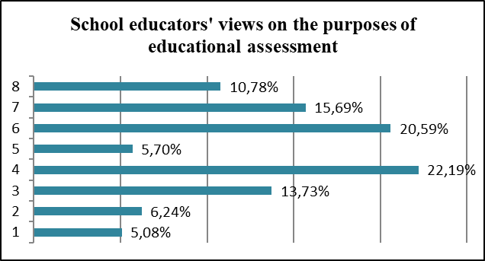
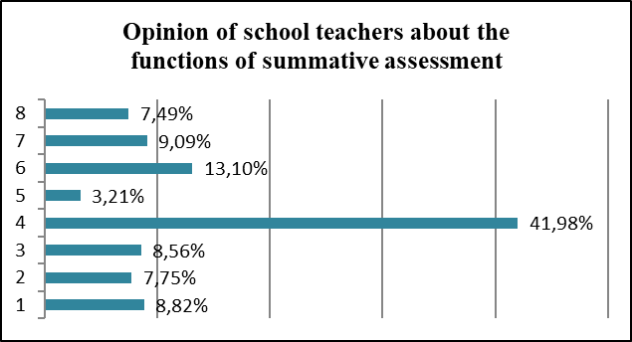
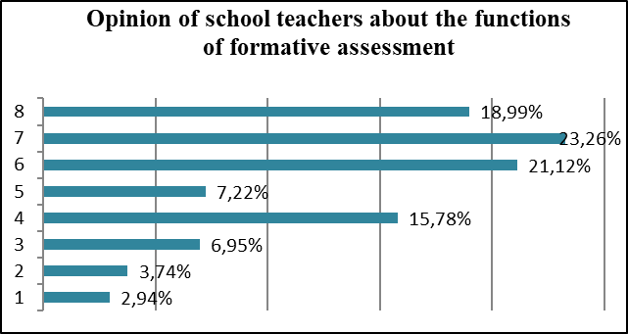
Results of the questionnaire survey of Kazakhstan teachers
Figure 2 А ‒ Functions that, in the opinion of teachers, summative assessment implements
Figure 3 А ‒ Functions that, in the opinion of teachers, are implemented by formative assessment
1 - Assessment provides information about the quality of school performance
2 - Grade is an indicator of the quality of the teacher's work
3 - Assessment makes students more responsible
4 - Assessment determines whether the student has achieved learning goals
5 - Assessment gives an idea of the student's ability
6 - Assessment helps the teacher to see the difficulties of the students in the assimilation of the educational material
7 - Assessment helps the student to see his difficulties in assimilating the educational material
8 - Assessment helps learners improve their learning
Figure 1 А ‒ Perception of educational assessment purposes by Kazakhstan teachers

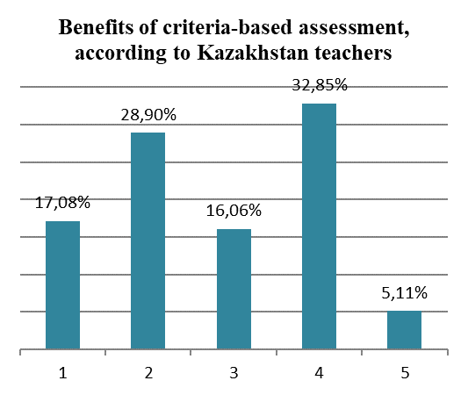

Criteria assessment:
1 − aimed at establishing the correspondence of the educational results of students with the subject learning objectives;
2 − is aimed at establishing the correspondence of the educational results of students with the goals of learning, including personal and system-activity;
3 − objectively reflects the educational results of schoolchildren;
4 − allows students, on the basis of knowledge of the criteria for evaluating his work, to reasonably and correctly perform it;
5 − reduces student anxiety and their feelings about assessment activities.
Figure 4 А ‒ Opinions of school teachers about the advantages of criteria-based assessment

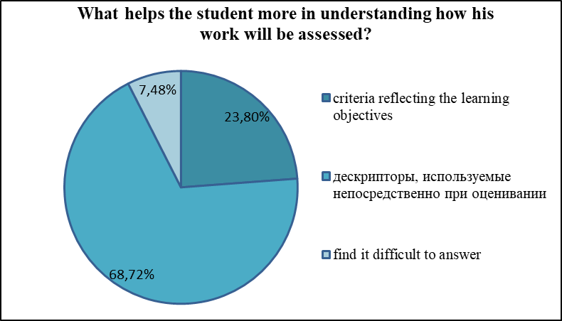
Figure 5 А ‒ Teachers' answer to the question: «What helps the student more in understanding how his work will be assessed?»

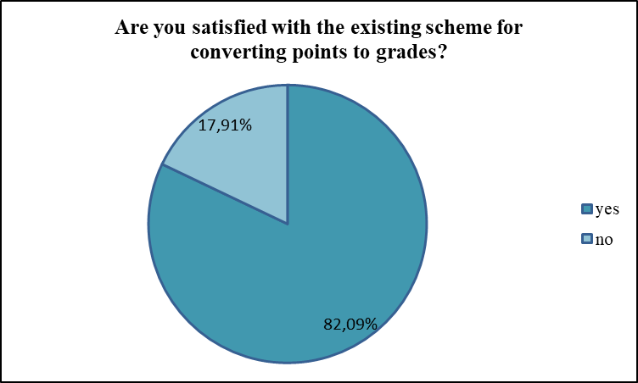
Figure 6 А ‒ Teachers' answer to the question: «Are you satisfied with the existing scheme for translating points into grades?»

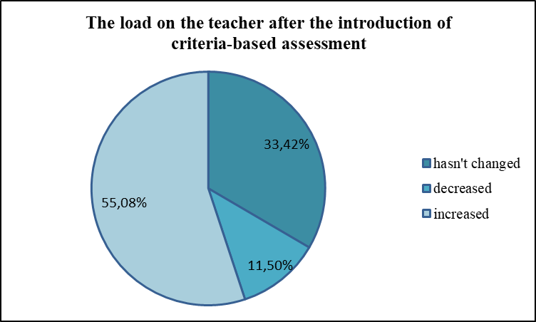
Figure 7 А ‒ Answers of teachers to the question: “How has the load on teachers changed after the introduction of criteria-based assessment?

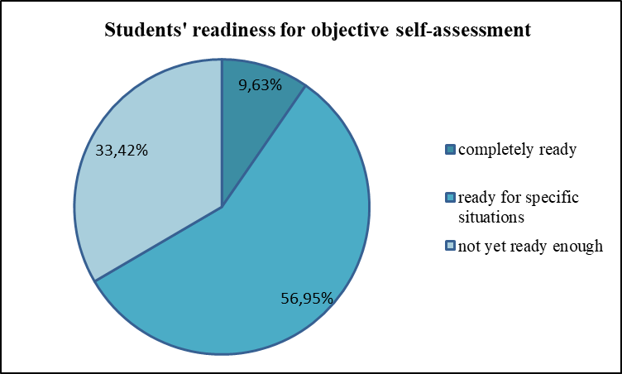
Figure 8 А ‒ Teachers' answer to the question: «Do you think your students are ready for objective self-assessment»?

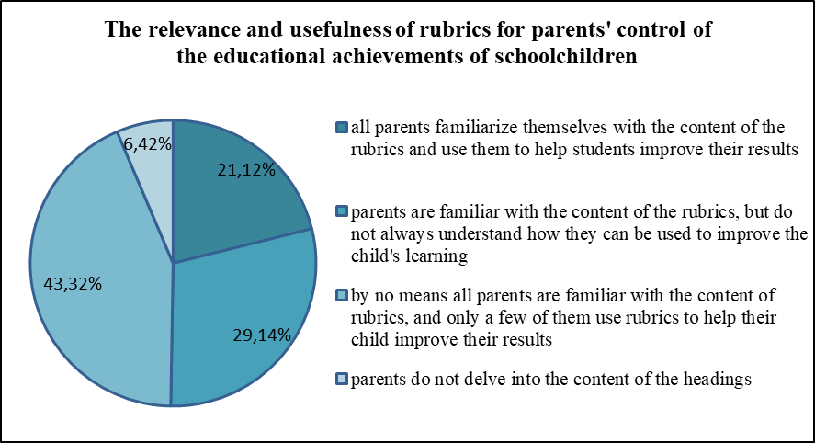
Figure 9 А ‒ Teachers' answer to the question: «What do you think, to what extent are the rubrics in which you reflect the educational achievements of schoolchildren are in demand and useful to parents?»

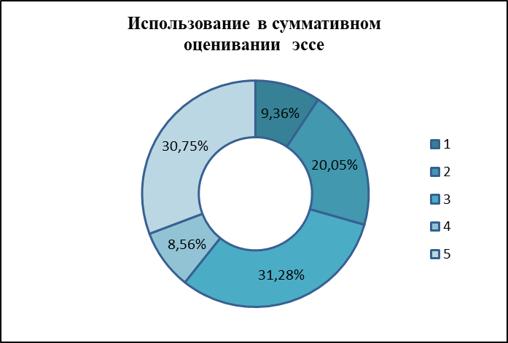
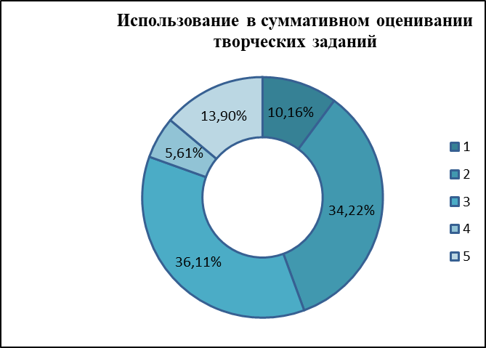
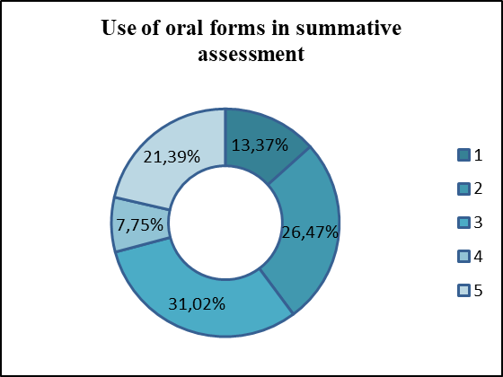
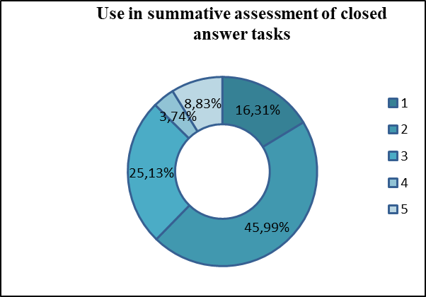
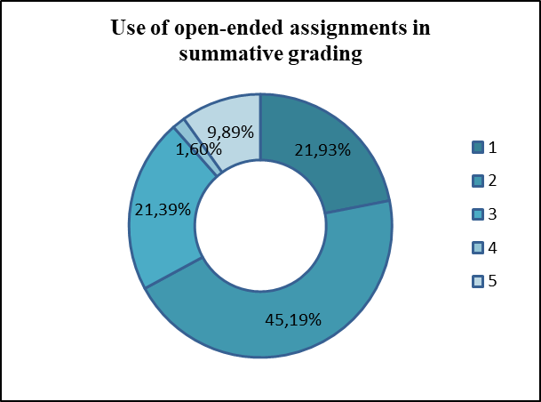
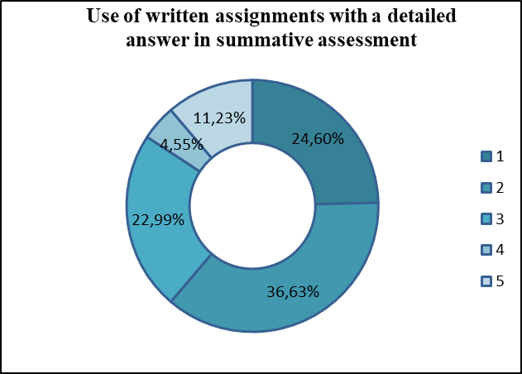
Figure 10 А ‒Teachers' choice of summative assessment tools
1 − always; 2 − often; 3 − sometimes; 4 − almost never; 5 − never

c)
d)
e)
f)
b)
а)
Use in summative assessment of essays
Use in summative assessment of creative tasks

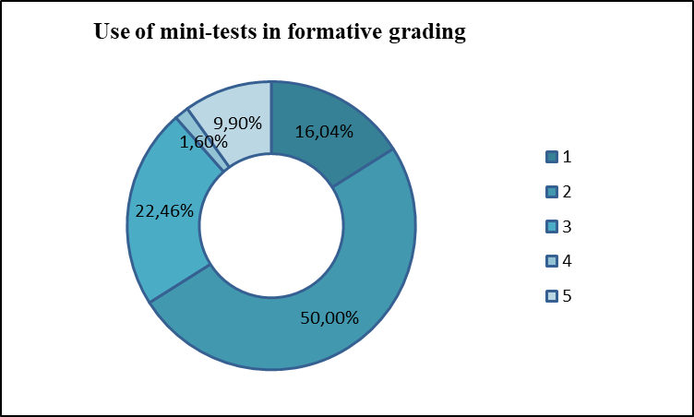
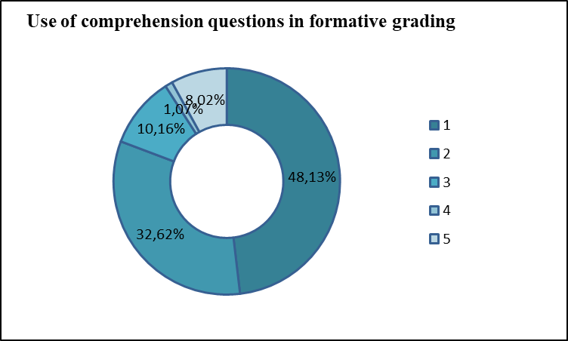
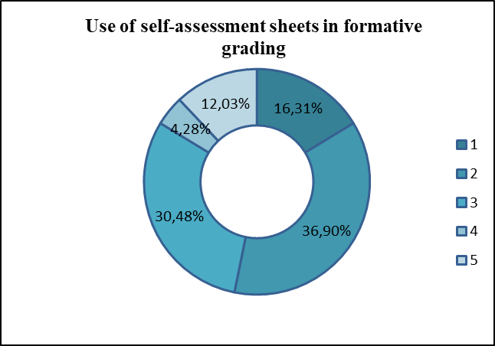
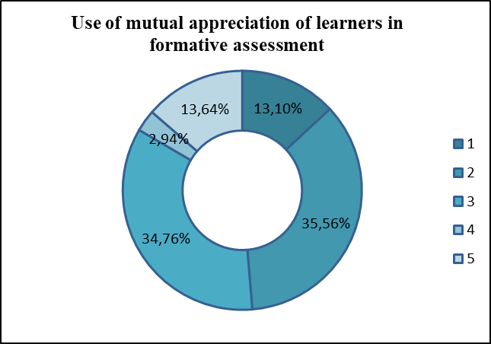
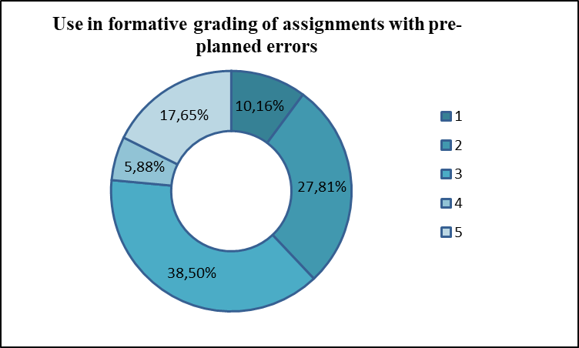
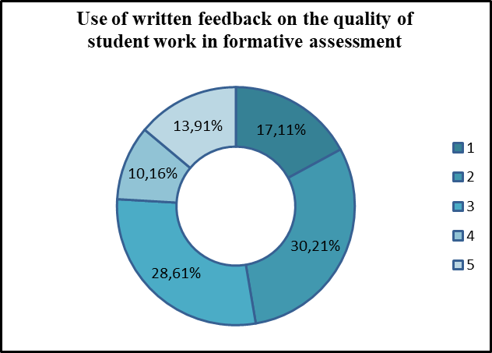
1 − always; 2 − often; 3 − sometimes; 4 − almost never; 5 − never

a)
d)
e)
f)
Figure 11 А ‒ Teachers' choice of formative assessment tools
b)
c)

а)
c)

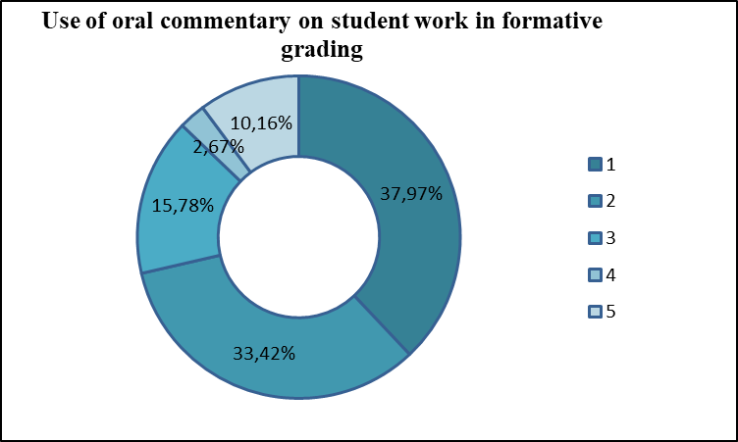
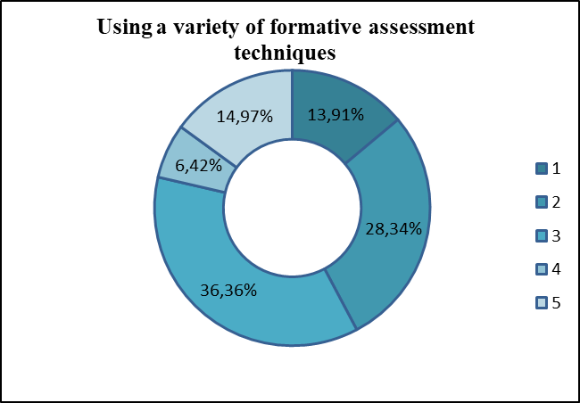
g)
h)
1 − always; 2 − often; 3 − sometimes; 4 − almost never; 5 − never

Continuation of Figure 11 А ‒. Teachers' choice of formative assessment tools

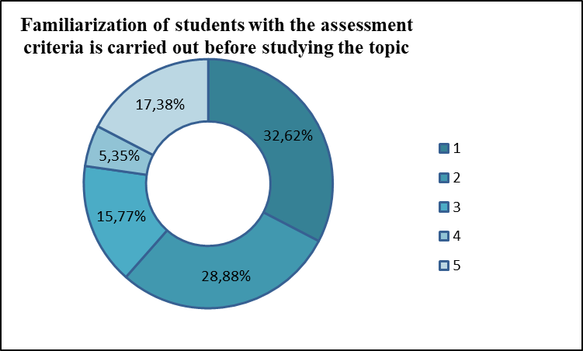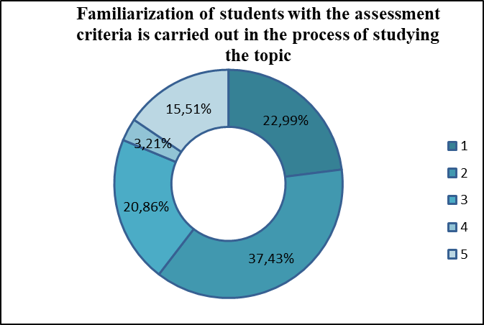
а)
b)
c)
d)
1 − always; 2 − often; 3 − sometimes; 4 − almost never; 5 − never

Figure 12 А ‒ Methods and forms used by educators to familiarize students with assessment criteria

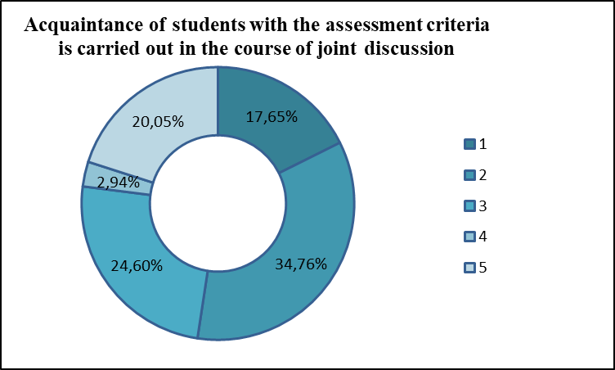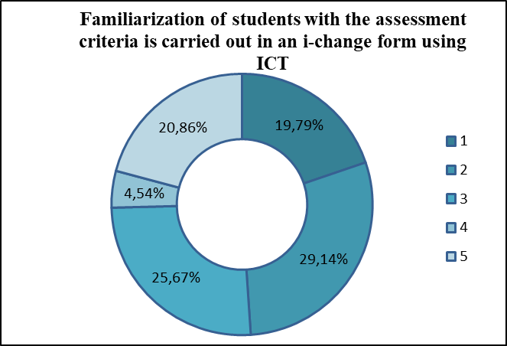

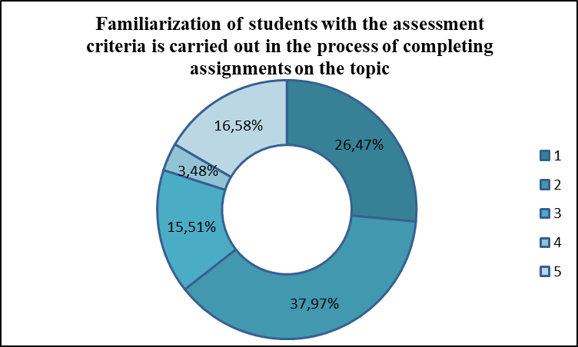
e)
1 − always; 2 − often; 3 − sometimes; 4 − almost never; 5 − never
Continuation of Figure 12 А ‒ Methods and forms used by educators to familiarize students with assessment criteria
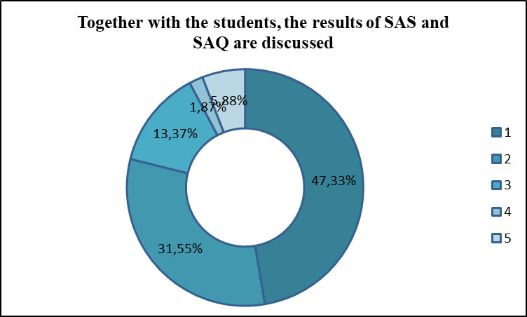
1 − always; 2 − often; 3 − sometimes; 4 − almost never; 5 − never

Figure 13 А ‒ Continuation of the phrase by teachers: «After the SAS, SAQ, we discuss the results together with the students ...»

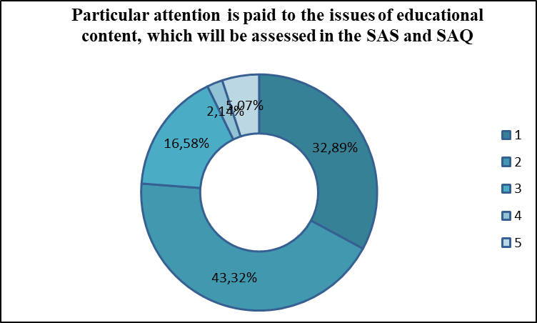
1 − always; 2 − often; 3 − sometimes; 4 − almost never; 5 − never

Figure 14 А ‒ Continuation of the phrase by teachers: «I pay more attention to those issues of the studied material that will be assessed in the SAS or SAQ ...»

1 − always; 2 − often; 3 − sometimes; 4 − almost never; 5 − never

Figure 15 А ‒ Continuation of the phrase by teachers: «I am worried about the monotony of types of summative assessment in my subject ...»

1 − always; 2 − often; 3 − sometimes; 4 − almost never; 5 − never

Figure 16 А ‒ Continuation of the phrase by teachers: «Summative assessment for the section and for the quarter is carried out within one week ...»
…»

1 − always; 2 − often; 3 − sometimes; 4 − almost never; 5 − never

Figure 17 А ‒ Continuation of the phrase by teachers: «I am concerned about the lack of time for proper formative assessment ...»

1 − always; 2 − often; 3 − sometimes; 4 − almost never; 5 − never

Figure 18 А ‒ Continuation of the phrase by teachers: «In my lessons, the situation of improvised formative assessment happens ...»

APPENDIX B

The results of self-assessment of teachers in the use of the types of assessment activities
1 – formulation of criteria focused on subject learning objectives;
2 – formulation of criteria focused on personal and system-activity goals of learning;
3 – development of tasks and descriptors to them for assessing the achievements of the subject learning objectives;
4 – development of tasks and descriptors to them for assessing the achievements of personal and system-activity learning goals;
5 – possession of effective techniques of formative assessment in teaching your subject
Figure B ‒ The results of teachers' assessment of their own knowledge of the types of assessment activities

APPENDIX C

Generalized criteria for assessing the development of students of mathematical content corresponding to the educational tasks of the school course of mathematics
Table C – Generalized criteria for the development of mathematical content, in accordance with educational tasks
№ | Educational task | Generalized criteria
1 | 2 | 3
1 | Possession of the concept | - to formulate the definition of the concept;  - to understand the meaning of terms in the definition of a concept;  - highlight the main parts of the general structure of the definition of a concept and understand the connections between these parts, the logical structure of the definition;  - to depict and recognize objects that fit the concepts in the drawing and / or in symbolic notation;  - give examples of objects that fit the concept;  - give counterexamples;  - to identify the signs of a concept in specific objects, to bring objects under the concept;  - draw conclusions from the fact that the object belongs to this concept;  - build speech statements using this concept;  - to establish connections and relationships between concepts;  - to check the correctness of the formulation and use of the definition.
2 | Know and apply the rule | - formulate a rule;  - understand the meaning of the terms in the rule;  - to highlight separate semantic parts (steps) in the rule;  - to correlate the rule with the task situation;  - meaningfully apply the rule when solving problems;  - exercise self-control of the correct application of the rule and take the necessary corrective actions.
3 | Know and apply formulas (identities) | - reproduce the analytical record of the formula (identity);  - to understand the meaning of each component of the formula (identity);  - reproduce equality expressed by a formula (identity) in verbal form;  - to correlate the formula (identity) with the task situation;  - meaningfully apply the formula (identity) when solving problems;  - to exercise self-control of the correctness of the application of the formula (identity) and to carry out the necessary corrective actions.

Table C continuation
1 | 2 | 3
4 | Know and apply the theorem | - formulate a theorem;  - analyze the formulation of the theorem, highlight its condition and conclusion;  - create a sign and / or visual model of the theorem;  - draw up a plan for proving the theorem, establish the method used in the proof;  - perform a step-by-step recording of the proof of the theorem, implementing the plan and using the necessary argumentation; detect errors in the proof of the theorem;  - to deduce consequences from the theorem;  - to formulate all kinds of statements for the theorem (opposite, opposite, opposite to the opposite) and establish their truth, give counterexamples;  - to correlate the theorem with the task situation;  - to highlight special cases for the theorem;  - to use the theorem in a meaningful way when solving problems;  - to exercise self-control of the correctness of the application of the theorem and to carry out the necessary corrective actions.
5 | Solve math tasks | - to analyze the formulation of the condition of the problem, to highlight its condition and the requirement of the problem;  - create a symbolic and / or visual model of the problem;  - draw up a plan for solving the problem;  - determine the type of task and its thematic affiliation;  - to derive consequences from the conditions and requirements of the problem;  - update the information necessary to solve the problem;  - to analyze, synthesize educational information, complete it in the process of solving problems;  - to establish causal relationships; make inferences; put forward hypotheses and substantiate them, build a logical chain of reasoning; perform a step-by-step recording of the solution to the problem, implementing the plan and using the necessary argumentation;  - to determine a general method for solving problems of a certain type;  - exercise self-control in the process of solving the problem and carry out corrective actions;  - interpret the answer to the problem;  - find various ways to solve problems.

APPENDIX D

Technological chain «educational purposes – criteria – descriptors – evaluation materials»
Table D ‒ Technological chain of planning assessment activities in teaching mathematics to schoolchildren
№ | Stage | Stage content | Note
1 | 2 | 3 | 4
1 | purpose setting | Analysis of regulatory documents (SESO, Model program, Curriculum); highlighting the results of mastering the educational material in this section; determination of criteria by which one can judge the assimilation of the content of the section. | This stage is intended to orient the teacher towards a specific educational result, the focus on which determines the sequence and features of the content of educational and cognitive activities of students.  Highlighting the results of mastering the section, one cannot be limited to fixation. The teacher must imagine how the personal qualities of schoolchildren and their systemic-activity skills, skills and competencies will develop in the learning process.
2 | Methodical structuring of assessment criteria | Selection in the content of the topic of all educational units subject to assimilation; taking into account the possibility of achieving the results of mastering the topic at an advanced level; identification of objects of assessment; highlighting the results of their subsystems in the system, for individual lessons within the framework of the study of the section; structuring assessment criteria in accordance with the levels of assimilation through the definition of a system of basic indicators of the qualities of knowledge, skills and methods of activity that the student must master in the process of assimilating the educational content of the section. | Note that the planned subject results of each individual lesson within the framework of mastering a topic or section can and should have overlaps, but at the same time, their development should be observed as one moves in the material. The formation of the subject's motives, value orientations occurs during the development of educational content indirectly through critical comprehension of the acquired content and its inclusion in individual experience. The development of the subject of learning occurs in the process of carrying out such operations or actions, the implementation of which requires volitional efforts and is impossible without going beyond the level already reached by him. Therefore, personal and system-activity results do not need to be allocated for each specific lesson, since their development cannot be realized in such a short period of time. Moreover, it is important that the achievement of such results be built as a systemic process that lasts throughout the entire period of a child's schooling.

Table D continuation
1 | 2 | 3 | 4
3 | Dosing and methodical structuring of assessment activities | Correlation of the verified results with the content, volume and time frame of assessment activities and procedures in the context of the section and each individual lesson; clarification of the objectives of each of the assessment activities and how the results of the assessment will be used; determination of methods, forms and means of assessment that are most appropriate for the characteristics of the subject content, the stages of its study, the structure of the lesson and the goals of assessment of each of the assessment procedures. | The implementation of this stage requires serious work, the result of which will be not only a clear understanding of the teacher about how the level of achievement of the planned results by students will be monitored in formative and summative assessment activities and procedures, but also the teacher's understanding of how the assessment activities themselves will be integrated into the holistic process. learning, how they will be aligned with other components and how to ensure that they contribute to improving the educational outcomes of students. At the same stage, the teacher needs to determine how students will be familiar with the assessment criteria and how the integration of summative and formative assessment practices will be carried out.
4 | Development of assessment tools | Preparation of assignments that will form the basis of the assessment toolkit in accordance with the assessment criteria for each of the assessment activities and procedures; detailing the criteria through descriptors, establishing the weight of each of the descriptors in a specific criterion; determining which of the assignments will be assessed only in the form of feedback and qualitative judgment, and which require use along with quantitative feedback; preparation of the necessary teaching aids. | It should be noted that the planning of the assessment should in no case be carried out in isolation from the planning of the learning process. On the contrary, since taking into account the mutual influence of assessment and learning is of paramount importance for improving the quality of education, then these two processes should be inseparable. In this case, the allocation of a separate technological chain of planning assessment activities was carried out solely with the aim of emphasizing the need in the course of designing the educational process, focusing the teacher's attention on the aspect of assessment.

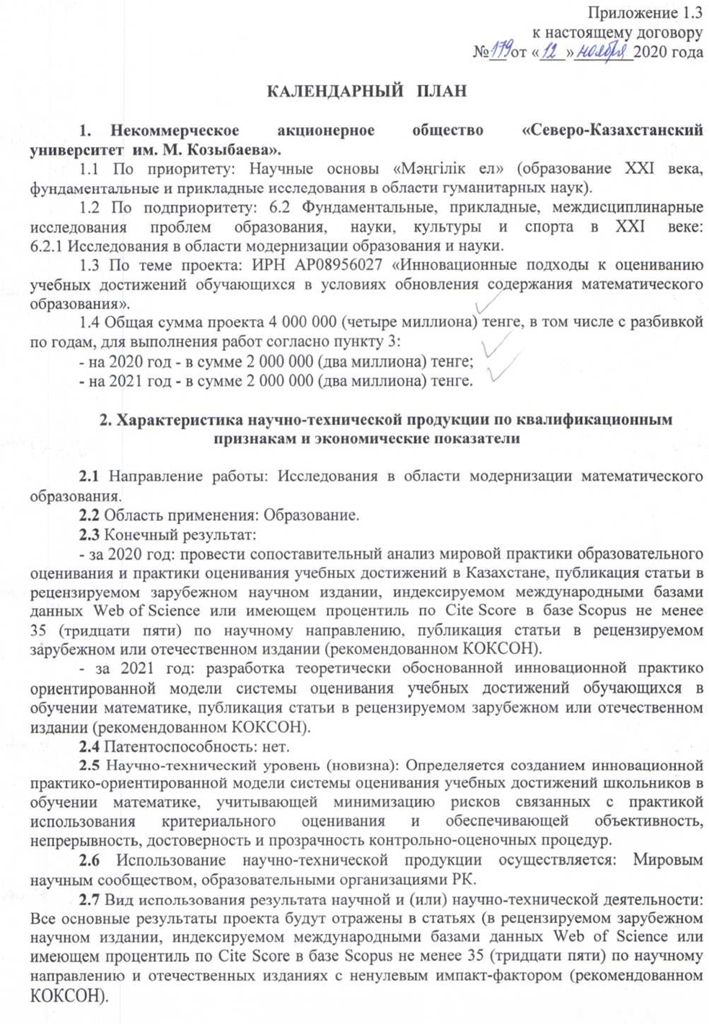
APPENDIX E

Calendar plan

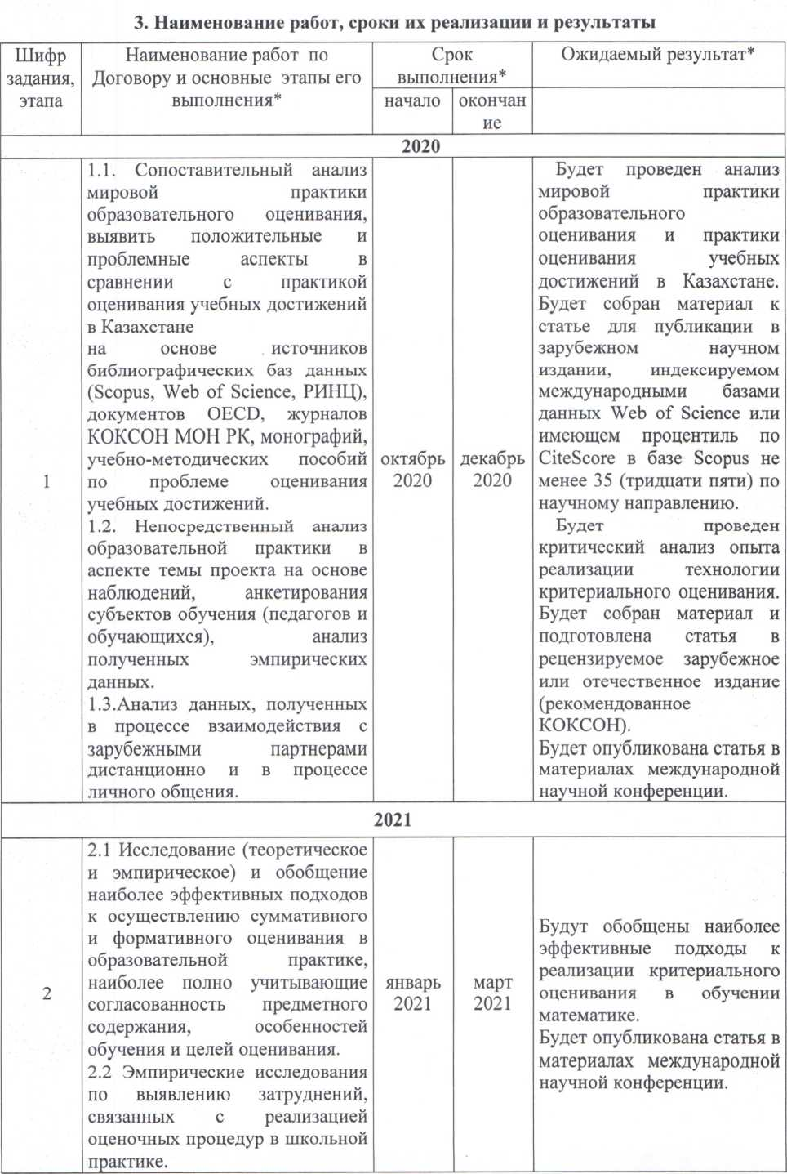

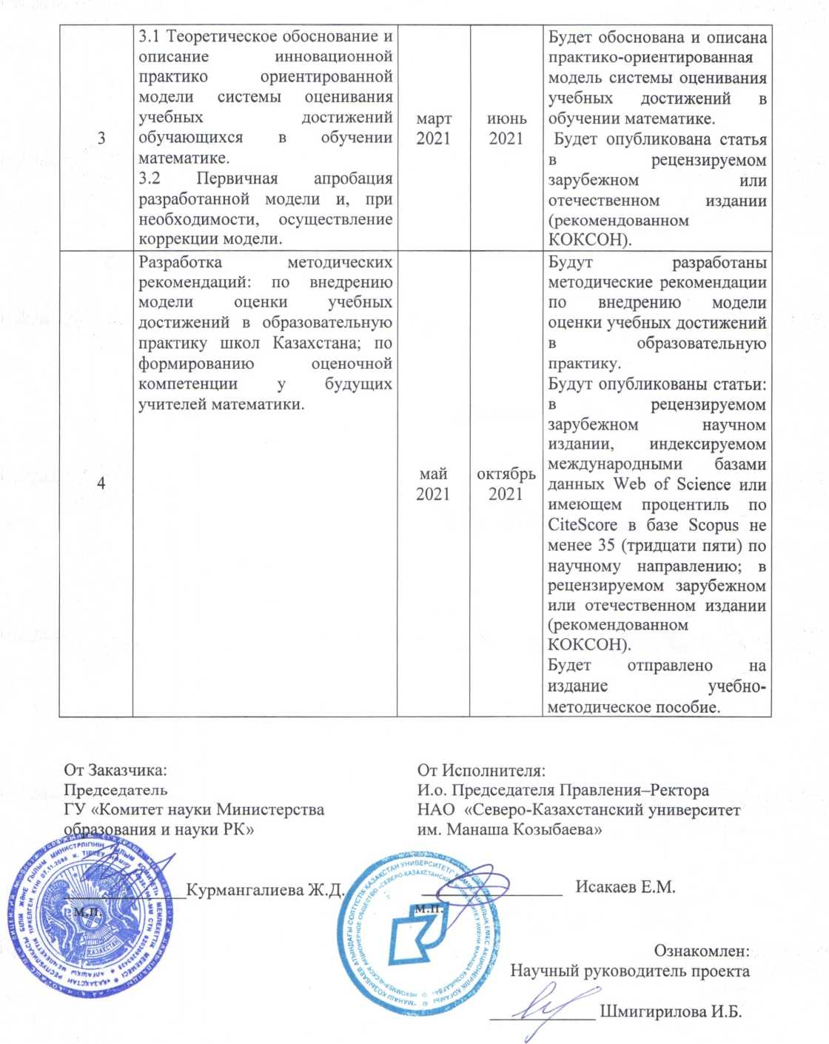

CALENDAR PLAN

- Non-profit limited company «M. KozybayevNorth Kazakhstan university»

1. 1 Priority: Scientific foundations of «Мәңгілік ел» (education of the XXI century, fundamental and applied research in the humanities).
1.2 By sub-priority: 6.2 Fundamental, applied, interdisciplinary research of problems of education, science, culture and sport in the XXI century: 6.2.1 Research in the field of modernization of education and science.
1.3 On the topic of the project: IRN AP08956027 "Innovative approaches to assessing the educational achievements of students in the context of updating the content of mathematical education."
1.4 The total amount of the project is 4,000,000 (four million) tenge, including with a breakdown by years, for the performance of work in accordance with clause 3:
- for 2020 ‒ in the amount of 2,000,000 (two million) tenge;
- for 2021 – in the amount of 2,000,000 (two million) tenge.

2. Characteristics of scientific and technical products by qualification characteristics and economic indicators

2.1 Direction of work: Research in the field of modernization of mathematics education.
2.2 Scope: Education.
2.3 End result:
‒ for 2020: a comparative analysis of the world practice of educational assessment and the practice of assessing educational achievements in Kazakhstan, a critical analysis of the experience in the implementation of criteria-based assessment technology. Publication of an article in the materials of an international scientific conference.
– for 2021: development of a theoretically grounded innovative practice-oriented model of a system for assessing educational achievements of students in teaching mathematics. Publication of the article: in a peer-reviewed foreign scientific publication indexed by international databases Web of Science or having a CiteScore percentile in the Scopus database of at least 35 (thirty five) in the scientific direction; 2 articles in a peer-reviewed foreign or domestic publication (recommended by CCSES); in the materials of the international scientific conference. Publication of a teaching aid.
2.4 Patentability: no.
2.5 Scientific and technical level (novelty): It is determined by the creation of an innovative practice-oriented model of the system for assessing the educational achievements of schoolchildren in teaching mathematics, taking into account the minimization of risks associated with the practice of using criteria-based assessment and ensuring objectivity, continuity, reliability and transparency of control and assessment procedures.
2.6 The use of scientific and technical products is carried out: by the world scientific community, educational organizations of the Republic of Kazakhstan.
2.7 Type of use of the result of scientific and (or) scientific and technical activities: All the main results of the project will be reflected in articles (in a peer-reviewed foreign scientific publication indexed by international databases Web of Science or having a Cite Score percentile in the Scopus database of at least 35 (thirty five) in a scientific direction and in domestic or foreign publications with a nonzero impact factor (recommended by CCSES).

- Name of work, terms of their implementation and results

Job code, stage |  | Name of work under the Agreement and the main stages of its implementation |  | Deadline |  |  |  |  | Expected Result
 |  |  |  | start |  |  | ending
2020
1 |  | 1.1. Comparative analysis of the world practice of educational assessment, to identify positive and problematic aspects in comparison with the practice of assessing educational achievements in Kazakhstan  based on sources of bibliographic databases (Scopus, Web of Science, RSCI), OECD documents, journals CCSES of Ministry of Education and Science of the Republic of Kazakhstan, monographs, teaching aids on the problem of assessing educational achievements.  1.2. Direct analysis of educational practice in the aspect of the project topic based on observations, questionnaires of learning subjects (teachers and students), analysis of the empirical data obtained.  1.3 Analysis of data obtained in the process of interaction with foreign partners remotely and in the process of personal communication. |  | october 2020 |  | december  2020 |  |  | The analysis of the world practice of educational assessment and the practice of assessing educational achievements in Kazakhstan will be carried out. Material for the article will be collected for publication in a foreign scientific journal indexed by international databases Web of Science or having a CiteScore percentile in the Scopus database of at least 35 (thirty five) in the scientific direction.  A critical analysis of the experience in the implementation of criteria-based assessment technology will be carried out. The material will be collected and an article will be prepared for a peer-reviewed foreign or domestic publication (recommended by CCSES).  An article will be published in the materials of an international scientific conference.
2021
2 |  | 2.1 Research (theoretical and empirical) and generalization of the most effective approaches to the implementation of summative and formative assessment in educational practice, most fully taking into account the consistency of subject content, learning characteristics and assessment goals.  2.2 Empirical research to identify difficulties associated with the implementation of assessment procedures in school practice. | january  2021 |  | march  2021 |  |  | The most effective approaches to the implementation of criteria-based assessment in teaching mathematics will be summarized.  An article will be published in the materials of an international scientific conference.
3 |  | 3.1 Theoretical substantiation and description of an innovative practice-oriented model of the system for assessing educational achievements of students in teaching mathematics.  3.2 Initial approbation of the developed model and, if necessary, the implementation of the model correction. | march  2021 |  | june  2021 |  |  | A practice-oriented model of the system for assessing educational achievements in teaching mathematics will be substantiated and described.  The article will be published in a peer-reviewed foreign or domestic edition (recommended by CCSES).
4 |  | Development of methodical recommendations: on the introduction of a model for assessing educational achievements in the educational practice of schools in Kazakhstan; on the formation of assessment competence in future mathematics teachers. | may  2021 |  | october  2021 |  |  | Methodological recommendations will be developed for introducing a model for assessing educational achievements in educational practice.  Articles will be published: in a peer-reviewed foreign scientific publication indexed by international databases Web of Science or having a CiteScore percentile in the Scopus database of at least 35 (thirty five) in the scientific direction; in a peer-reviewed foreign or domestic edition (recommended by CCSES).  A study guide will be sent for publication.

APPENDIX F

List of published manuscripts on the project topic
2020 г.
- Рванова А. С., Горшков Н. С. Технология критериального оценивания учебных достижений школьников по математике // Вестник Казахского национального педагогического университета имени Абая. Серия «Физико-математические науки». ‒ 2020. – № 3 (71). ‒ С. 73-78.(КОКСОН) URL: http://sp.kaznpu.kz/docs/jurnal_file/file20210601033024.pdf
- Шмигирилова И.Б., Рванова А.С., Таджигитов А.А. Педагогическая мастерская как форма развития оценочной компетентности учителя математики //Современные проблемы науки и образования. ‒ 2020. – № 6. ‒ С. 87-95 (ВАК РФ / КОКСОН) https://doi.org/10.17513/spno.30408
- Shmigirilova I., Shestakova L. Formation of Assessment Competence of Future Teachers of Mathematics // Education and Humanities Research, volume 527 Proceedings of the VIII International Scientific and Practical Conference 'Current problems of social and labour relations' (ISPC-CPSLR 2020). С. 624-628 (будет индексироана в WoS). URL: http://creativecommons.org/licenses/by-nc/4.0/
- Шмигирилова И.Б., Рванова А.С. Опыт формирования оценочной компетентности будущих учителей математики // Материалы VI Международной научной интернет-конференции «Актуальные проблемы обучения математике и информатике в школе и вузе» г. Москва, 11–12 декабря 2020 г. С. 373-379 URL: https://www.elibrary.ru/item.asp?id=45670771
- Шмигирилова И.Б., Рванова А.С., Таджигитов А.А. Интеграция идей формирующего и суммирующего оценивания в образовательной практике обучения математике // Материалы международной научно-практической конференции «Козыбаевские чтения – 2020: приоритетные направления развития, достижения и инновации современной казахстанской науки». 2020. – Т. 2, Петропавловск: СКУ. С. 241-244 https://www.nkzu.kz/page/view?id=1694&lang=ru
2021
- Шмигирилова И.Б., Рванова А.С., Григоренко О.В. [Shmigirilova I.B., Rvanova A.S., Grigorenko O.V.] Оценивание в образовании: современные тенденции, проблемы и противоречия (обзор научных публикаций) [Assessment in Education: Current Trends, Problems and Contradictions (Review of Scientific Publications)] //Образование и наука [Obrazovanie i Nauka]. ‒2021. Т. 23, № 6. – С. 43-83. (Scopus: Q2, процентиль 0,59) https://doi.org/10.17853/1994-5639-2021-6-43-83
- Шмигирилова И.Б., Рванова А.С., Таджигитов А.А., Копнова О.Л. Бағалау сауаттылығы қазақстандық мектептерде бағалау жүйесін реформалау жағдайында педагогтің кәсіби құзыреттілігінің компоненті ретінде // ӘЛ-Фараби атындағы Қазақ Ұлттық Университеті Хабаршы. «Педагогикалық ғылымдар» сериясы. – 2021. – № 3(68). – С. 114-126. https://doi.org/10.26577/JES.2021.v68.i3.10 (КОКСОН)
- Шестакова Л.Г., Шмигирилова И.Б. Самооценка обучающимися старших классов владения компонентами исследовательской компетенции (на материале математики) // Russian Journal of Education and Psychology. – 2021. ‒ Т. 12, № 1. ‒ С. 43-65. (ВАК РФ/КОКСОН). URL: http://rjep.ru/jour/index.php/rjep/article/view/16
- Шмигирилова И.Б., Рванова А.С., Таджигитов А.А. Проблемы внедрения критериального оценивания в практику общеобразовательной школы в аспекте обучения математике // Вестник Казахского национального женского педагогического университета. – 2021. ‒ № 2 (86). – С. 90-104. https://doi.org/10.52512/2306-5079-2021-86-2-90-104
- Шмигирилова И.Б., Рванова А.С. Оценивание системно-деятельностных результатов в обучении школьников математике // Современные тенденции естественно-математического образования: школа – вуз: материалы X Международная научно-практическая конференции, 10 – 11 апреля, 2021 г. – Соликамск: СГПИ. ‒ С. 100-104. URL: http://is.nkzu.kz/publishings/%7BF9A1B84B-8630-430A-8AFD-B3C18339E0EA%7D.pdf
- Шмигирилова И.Б., Копнова О.Л. Формативное оценивание студентов в условиях дистанционного обучения // Материалы международной научно-методической конференции «Модель проблемно-ориентированного проектного обучения в современном университете» 26 февраля 2021 г., Новосибирск: СГУГиТ. С. 121-125. URL: https://www.elibrary.ru/item.asp?id=46597962
- Рванова А.С., Шмигирилова И.Б. Оценивание в обучении математике: современный подход: учебно-методическое пособие. Петропавловск: СКУ им. М. Козыбаева, 2021. – 201 с.

