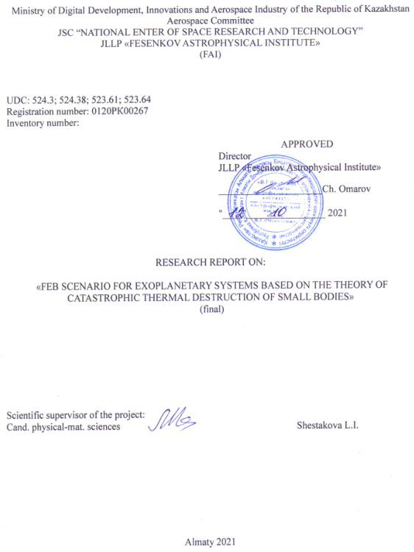
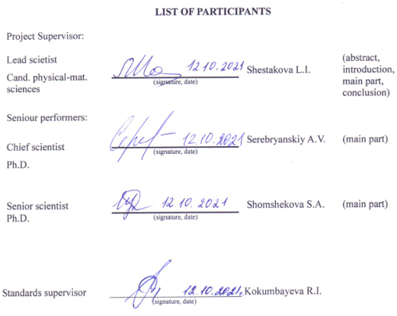

ABSTRACT
Report 27 p., 1V., 7 Fig., 1 Tab., 22 Ref., 2 App.
FEB (falling evaporating bodies) SCENARIO, EXOPLANET SYSTEMS, EXOPLANETS, THERMAL DESTRUCTION, STAR KIC8462852
Subject of research: KIC8462852 system, exoplanets.
The aim of the study is to test the applicability of the theory of catastrophic thermal destruction in the framework of the FEB scenario to explain non-periodic fading of the brightness of a star in an exoplanet system using the case of KIC 8462852.
Research methods: Theory development, search for initial data, computations for the conditions of the exoplanet system KIC 8462852.
The results of the research and their novelty: Calculations of thermal stresses inside and on the surface of small bodies approaching the star in elongated orbits are performed. The results of numerical calculations for the initial data are obtained: the range of body sizes, distances from the star, an estimate of the required mass of the comet to explain the observed changes in the brightness of the star during destruction is obtained. The results were analyzed and the feasibility of the FEB scenario was evaluated to explain the observed irregular fading of the star's brightness in the exoplanet system. Reasonable conclusions are given about the applicability of the theory of catastrophic thermal destruction in the framework of the FEB scenario to explain non-periodic fading of the brightness of a star in an exoplanet system using the case of KIC 8462852. The results were published (1 publication) in the MNRAS journal, which belongs to the Q1 on the Web of Science database, and 1 publication in the domestic journal of the NAS RK with a non-zero impact factor (recommended by CCSES).
Field of application: Astrophysics. Minor planets in exoplanet systems.
Recommendations for implementation: not provided.
Significance of the work: Application of the theory developed at FAI to a unique object discovered during the Kepler space mission
Forward-looking assumptions about the development of the object of research: The development of the research subject of exoplanet systems towards more subtle effects, the enrichment of the research direction with new ideas.

Table of contents
Introduction ..………………………………………………………………………… |  |  |  | 6
MAIN PART OF THE RESEARCH REPORT ………...…………………………………. |  |  |  | 9
1 | Calculations of thermal stresses inside and on the surface of small bodies approaching the star in elongated orbits…… |  |  | 10
1.1 |  | Calculation results of thermal stresses inside and on the surface of cometary bodies ……………………………………………………………………………… |  | 13
1.2 |  | Numerical calculations for various sizes of bodies and distances from the star…….…………………………………..………………………………………………………………………. |  | 15
1.3 |  | Estimation of the required mass of the comet to explain the observed changes in the brightness of the star during destruction……………………………………… |  | 18
2 | analysis of the results and evaluation of the feasibility of the FEB scenario to explain irregular fading of the brightness of a star in an exoplanet system………………………. |  |  | 20
2.1 |  |  | Conclusions on the feasibility of the theory of catastrophic thermal destruction in the framework of the FEB scenario to explain non-periodic fading of the brightness of a star in an exoplanet system using the case of KIC 8462852……. | 21
CONCLUSION………………………………………..………………………………….. |  |  |  | 22
REFERENCES………………………………………..………………………….……….. |  |  |  | 24
APPENDIX A. List of publications……………………..………………………………… |  |  |  | 26
APPENDIX B. PROJECT TIMELINE….…………………………………….…………… |  |  |  | 27

List of abbreviations and notations
The following abbreviations and notation are used in this research report
FEB | - | Falling Evaporating Bodies
KIC 8462852 (Boyajian) | - | Star from Kepler mission catalogue (Boyajian star)
FAI | - | Fesenkov Astrophysical Institute
ρ | - | density
с_{р} | - | heat capacity at constant pressure
c_{v} = ρ с_{р} | - | heat capacity at constant volume
κ | - | heat conductivity
α | - | coefficient of linear expansion
E | - | modulus of elasticity
σ_ | - | compressive strength
σ₊ | - | tensile strength
μ | - | Poisson 's coefficient
а² = κ/ c_{v} | - | thermal conductivity
AU | - | Astronomical Unit
τ_{c} | - | cooling (heating) time of the body
τ(R) | - | the falling time of a body on a star in a parabolic orbit from a distance R
IR | - | Infrared

INTRODUCTION
Since the discovery of the phenomenon of KIC 8462852, several attempts have been made to build hypotheses to explain it. One of the most probable is the hypothesis of the destruction of cometary bodies in the vicinity of KIC 8462852. At the same time, no specific mechanism for the destruction of cometary bodies has been proposed.
During the entire Kepler mission, aimed at searching for exoplanets transiting over the disk of host stars, many stars with various features in the light curves were observed. Among them, the star KIC 8462852 stands out, which shows the non-standard behavior of transit events [1]. It undergoes irregular brightness changes in the form of non-periodic dips in the light curve. The width of these dips is from 1 day to 10 days. In the optical range, their amplitudes reach up to 20% or more of the total radiation flux. The active phase of the flux drop lasts from 5 days to 80 days. The transit duration of a typical D1520 event as part of the group of dips is 16 hours at the level of 50% of the total flux.
In [1], which began the analysis of 4-year observations of the star KIC 8462852 within the framework of the Kepler mission, it was noted that the grouped nature of the star's brightness drops could be explained by cascading destruction of a large body as a result of an earlier event of its disintegration into separate fragments.
Lisse et al. [2] investigated the KIC 8462852 system using a high-resolution spectrometer. In their work, they indicate that there is no excess in the spectrum of the star in the near-IR range from 0.8 microns to 4.2 microns. They also show that the star has no signs of the presence of circumstellar dust or gas clouds.
No known or suspected stellar phenomena can fully explain all aspects of the observed light curve of this star. It is noted in [3] that it is not possible to explain the phenomenon of KIC 8462852 by the presence of any object in orbit around the star. Further, the authors [3] assume the presence of a homogeneous cloud stretched along the orbit like a meteor shower.
Of the ideas that have been proposed so far, the authors [3] suggest that the most promising explanation is a process that involves the recent collision of large bodies (planetesimals or comets) in the KIC 8462852 system, which led to the appearance of a large amount of debris and dust. In this scenario, a recent collision event could create a cloud of fragments and push it into a strongly eccentric orbit.
The fall of comets on a star, as a phenomenon, has been known for quite a long time, since the discovery of signs of their presence in the spectrum of the star β-Pictoris [4], the appearance of which was explained in the framework of the FEB (Falling Evaporating Bodies) scenario [5,6,7].
Our Sun is no exception. Analysis of the orbits of fragments shows that the decay of cometary nuclei can occur at large distances from the Sun, beyond 50 AU for long-period and new comets. It is interesting to note that the typical disintegration behavior due to thermal stresses is demonstrated by the Borisov comet, whose radius according to [8] is about 0.4-0.5 km.
Kűhrt [9] calculated the temperature profiles inside Halley's comet for several heliocentric distances by numerically solving the thermal diffusion equation. According to [9], for an icy body with a radius of 3 km moving in the orbit of Halley's comet, the thermal stresses in its center during the passage of the perihelion are less than the tensile strength by only one order of magnitude. At the same time, the surface compressive stresses to a depth of 10 meters exceed the strength of the material by more than an order of magnitude. Hence, he concludes that thermal stresses can be a plausible explanation for the breakup of comets.
Calculations performed in the works [10] and [11] also showed that thermal stresses inside homogeneous bodies could exceed the strength of terrestrial materials of similar chemical composition by several times, unlike tidal stresses, which are several orders of magnitude weaker. With such a balance of forces, the influence of tidal forces, which are stronger near the Sun or large planets, may manifest itself not in the destruction of the icy body, but in overcoming the self-gravity forces between its fragments, stretching them along the orbit.
The obtained analytical solutions in the work [10] make it possible to analyze thermal stresses arising in bodies of different sizes at different distances from the star for several materials: crystalline ice, silicates, iron, and others. In this work, we have shown that the mechanism of cascade catastrophic disintegration of comets when falling on a star in parabolic orbits can explain the phenomenon of KIC 8462852.
The justification for the implementation of research: the decision of the National Scientific Council on grant funding under the priority "Scientific research in the field of natural sciences" (Protocol No. 4 of October 04, 2020) for grant funding for 2020 -2021. Agreement with the Science Committee of the Ministry of Education and Science of the Republic of Kazakhstan No. 192 dated November 12, 2020, for the implementation of scientific, scientific and technical projects on grant funding.

The relevance, novelty, and perspective of the research lie in the fact that there is still no adequate explanation of non-periodic transit events in the observed light curve to explain the phenomenon of KIC 8462852, which has stimulated great interest in the scientific community.
Information about the scientific and technical level of developments, patent research and conclusions from them, information about metrological support of research
The group of researchers includes scientists with extensive work experience in the field. The head of the project is one of the authors of the theory of catastrophic thermal destruction. The team posses the original software programs developed by the team members performing research on the subject.
The level of research meets modern international scientific standards. The project was carried out in stages, in accordance with the calendar plan (APPENDIX B) and calculation of the estimated cost. Patent research was not planned. Metrological support was carried out within the framework of the department.

Links to other research projects:
Interest in this uncommon and unique phenomenon of KIC 8462852 is still ongoing in the scientific community. In this regard, our solution may be useful and will take its place in a number of research projects. The mechanism of catastrophic thermal destruction proposed by us remains unique, allowing us to explain the observed phenomenon of irregular accretion in the system of the star KIC 8462852. At this stage, we consider the research work accomplished. The results are published in the Monthly Notices of the Royal Astronomical Society (MNRAS) journal, which is part of the Q1 quartile on the Web of Science database (APPENDIX A).
The title of the interim report and its inventory number:
FEB scenario for exoplanetary systems based on the theory of catastrophic thermal destruction of small bodies (interim) // JSC “NATIONAL CENTER OF SPACE RESEARCH AND TECHNOLOGY”, JLLP «Fesenkov astrophysical institute»; Scientific supervisor of the project Shestakova L.I. – Almaty, 2020. – 23р. Registration number: 0120РК00267; Inventory number: 0220РК01560.

Implementation period – 1.10.2020 – 1.11.2021.

Total budget for 2020-2021 – 4 273,232 thousands KZT, including: in 2020 – 2 300,142 thousands KZT, in 2021 – 1 973,090 thousands KZT.

MAIN PART OF THE RESEARCH REPORT
Justification of the research direction
The project proposes the use of the mechanism of catastrophic thermal destruction of comet-like bodies to explain the behavior of the light curve of the star KIC 8462852. The light curve shows irregular brightness drops that cannot be explained by periodic orbital phenomena. Such features of the star were discovered during 4 years of observations as part of the Kepler space mission. Most of the authors analyzing the behavior of the KIC 8462852 concluded that the cluster nature of the drops in its brightness can be explained by cascading destruction of a large body into individual fragments. The problem is that a specific mechanism of disintegration, apart from possible collisions of objects, has not been proposed. We have shown that the mechanism of cascade fragmentation of large bodies, in particular large comet-type bodies consisting of crystalline ice, can be a mechanism of catastrophic thermal destruction, that is, the disintegration of bodies into fragments due to the heating of their surface by star radiation.
We chose this task because having the experience of similar studies for the conditions of the Solar System, it was possible to get its solution in a short period of 12 months. The discovery by the Kepler mission of the exoplanet system KIC 8462852, near which there may be a cloud of comets similar to the Oort cloud, only much more potent, inspired us to solve this problem. We believed that with our means we could be at the forefront of the study of this object. Our assumptions were proved correct since the results were published in the MNRAS journal, which is part of the Q1 quartile on the Web of Science database.
Tools and methods. This project proposes a solution to the problem of non-periodic attenuation of the brightness of the star KIC 8462852 within the framework of the concept of the FEB (falling evaporating bodies) scenario using the solution of the thermal diffusion equation for cometary bodies consisting of their crystalline ice. It is shown that the destruction of bodies by thermal stresses can occur long before they approach the high-temperature region, where their evaporation becomes possible. We had previously developed the corresponding calculation programs at our disposal. In the course of the work in 2020, a significant update of the initial data necessary for the continuation of work in application to the star KIC 8462852 was carried out.

1 Calculations of thermal stresses inside and on the surface of small bodies approaching the star in elongated orbits
Bailey and Weiner [12] obtained relations for radial and tangential stresses in solid spheres, from which it is possible to isolate functions having the dimension of temperature. The analysis of thermal stresses will be simplified if, instead of stresses, we use these functions that depend only on the geometry and the temperature distribution inside the body.
Using these thermal functions as analogs of thermal stresses, we can readily proceed to the stresses themselves by using the relations:

, , (1)

where the tangential stresses σ_{φφ}(x) are characterized by the function T_{φφ}(x), and the radial σ_{rr}(x) by the function T_{rr}(x). Here we use the parameters characterizing the elasticity of bodies: E is the Young's modulus of elasticity, α is the coefficient of linear expansion under heating and μ is the Poisson's ratio. In the future, we will repeatedly find out the convenience of such a representation.
Thermal functions obtained from the solution [12] will have the form:

, (2)
, (3)

where x is the current coordinate along the radius of the body r. T(y) is the radial temperature profile obtained by solving the heat diffusion equation (HDE).
So, the radial and tangential stresses σ_{rr}(x) and σ_{φφ}(x) arising during heating or cooling of bodies are determined by the thermal functions T_{rr}(x) and T_{φφ}(x), as well as the parameters characterizing the elasticity of bodies. If σ_{φφ}(x) or σ_{rr}(x) are negative, then the material undergoes compression, and when they are positive, the material experiences breaking stresses [13]. The same rule applies to thermal functions: the compressive stresses typical for the surface layers of a body approaching a star, T_{φφ}(x), are negative, and the breaking stresses T_{rr}(x) are positive.
The radial temperature profiles T(x) in (2) and (3) are found from the HDE solution for a spherical body according to [9]:
, (4)

where T is temperature, t is time, x is the current coordinate, which is measured from the center along the radius of the body r. c_{v}(T) is the heat capacity per unit volume, expressed in erg/(cm³deg), k(T) is the thermal conductivity of the material, expressed in erg/(sec cm deg). In general, c_{v}(T) and k(T) are functions of temperature. If the parameters k(T) and c_{v}(T) are constant, then equation (4) is linear with respect to T.
When writing and solving equation (4), the parameters a²=k/c_{v}, (dimension cm²/sec) and τ_{с}=(r/πa)² are often used, where r is the radius of the spherical body. The parameter a plays the role of a characteristic linear scale, since at constants k and c_{v}, the temperature T(x,t) ultimately depends on the ratio x/a. It is easy to see this if in equation (4) we replace x → x/a. τ_{с} determines the characteristic heating or cooling time of the body. If τ_{с} is longer than the free-fall time for the star from the distance where the body is situated, then its internal regions do not heat up, and the solution of the thermal diffusion equation can be limited to near-surface layers.
Equation (4) can be solved jointly with the initial condition at t = 0 and two boundary conditions: for the center of the body at x = 0 and for its surface at x = r. The boundary condition for the center of a spherical body is universal, since it follows from its symmetry: ∂T/∂x = 0 at x = 0.
We choose the boundary condition on the surface of the body, as shown in [10], guided by the physical conditions surrounding the body. The choice of the initial condition is also simple: at some initial distance R₀ the whole body is isothermal, so T(x) = T_{S} at t = 0, where T_{S} is the equilibrium surface temperature. We take the boundary condition for the surface in the form of a blackbody approximation:

T_{s}(t) = , (5)

where R is the current distance, R_{T} is the radius of the star, and T_{eff} is the effective temperature of the star's photosphere. We assume that the surface of the body is isothermal and is, on average, in radiation equilibrium with the radiation of the star. This assumption is valid if the body rotates fast enough.
The representation of T_{S}(t) as an explicit function of time is fundamental for obtaining an analytical solution of HDE. This representation turned out to be possible for parabolic orbits with a distance in perigee q ≈ 0. In general, for parabolic orbits, the expression for the transit time from the distance R to the perihelion has the form:

, (6)

where G is the gravitational constant, M is the mass of the star. For q = 0, it follows from (6): τ(R) = (2/GM)^{1/2}R^{3/2}/3. As a result, we obtain the boundary condition necessary for solving HDE in the form of an explicit function of time:

T_{S} (t) , (7)

where - is the body temperature at the initial distance R₀, τ_{o} is the time of falling into the star in a parabolic orbit from this distance, t = τ₀ - τ(R) is the current time. The HDE solution obtained under the specified conditions in (ST97) has the form:

T(x,t)=- (8)

or, after integrating by parts, we get

T(x,t)= +++
. (9)

For bodies of small sizes, for which τ_{c}/τ₀ << 1, the temperature profile is determined only by the first two terms in (9) and, consequently, the temperature difference between the surface of the body and its center in the first approximation has the form:

ΔT = = = . (10)

One can see from equation (10) that while the body is falling on a star, the temperature difference between its center and the surface increases much faster (∆T~τ_{с}/R²) than the surface temperature of the body (T_{s}(t)~1/).
Equation (10) is inapplicable at τ_{с}/τ(R) ≥ 1, that is, when the time constant for cooling (heating) is longer than the time of the body falling on the star from a given distance R.
Using expression (8) for the temperature profile, we obtain a solution for the thermal functions (2) and (3). The first term in (8) is equal to the temperature on the surface of the body T_{S}. Let us denote the second term by J(n). In addition, we introduce the following notation:

, . (11)

After substituting T(y) from equation (8) and integrating, we obtain:

, (12)
.

As a result, expressions for the temperature functions will have the form:

T_{ϕϕ}(x)= A+B(x) – T(x), (13)
T_{rr}(x)=A – 2B(x), (14)

The numerical solution (13) combined with (9) is relatively fast, since most of the time is spent calculating the integral J(n), which is the same for the thermal functions T_{φφ}(x), T_{rr}(x) and temperature T(x). On the surface of the body, the limiting value of the thermal function T_{φφ} for large bodies at r → ∞ tends to the value T_{φφ} = T₀ − T_{S}.

1.1 Calculation results of thermal stresses inside and on the surface of cometary bodies
We have accepted the parameters of the star according to those given in [1]:
М = 1.43 M_{ʘ} , R_{Т} = 1.58R_{ʘ} и T_{eff} =6750 ±140K.
Calculations are carried out up to distances where expression (1) for a² is considered to be true for crystalline ice (T < 153K). At the initial distance, the body temperature is assumed to be uniform throughout the volume and equal to 25K. If we consider this temperature to be equilibrium one, then the initial distance of the ice ball (comet) corresponds to the distance from the star R₀ = 36450R_{T} ≈ 267.8 AU. The initial distance for the parabolic orbit of the comet is invariable in our calculations, and the analysis of surface and internal stresses carried out for various intermediate distances (Table 1). The nearest distance to the star included in our calculations corresponds to the equilibrium temperature of the black body surface of 150K.

Table 1 — Thermal conductivity a² for different temperatures Т(К) and distances R(AU)
Т(К) | 150 | 125 | 100 | 75 | 50 | 40 | 30
R(AU) | 7,44 | 10,71 | 16,74 | 29,76 | 66,96 | 104,6 | 186,0
a² (cm²/s) | 0,03115 | 0.0442 | 0,06758 | 0,115995 | 0,24413 | 0,3638347 | 0.6

Figures 1 and 2 show the results of calculations of stress profiles, that is, stress distributions along the radii of bodies from the surface inward. Figure 1 on the right shows the radii of the bodies, T+ is the tensile strength.
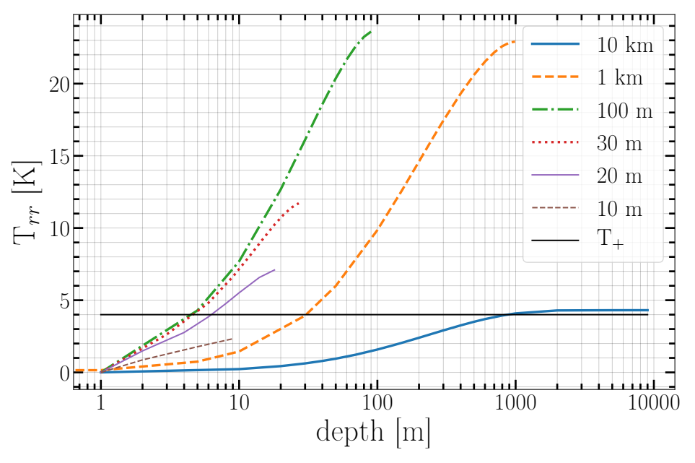
Figure 1 - Profiles of tensile stresses with depth along the radii of ice bodies at an equilibrium surface temperature of 150 K

According to the results (Figures 1-2), it can be concluded that bodies whose radii are in the range of 20 m < r < 10 km will be catastrophically destroyed by internal stresses. It is obvious that the largest bodies with radii r ≤ 10km will be subject to cascade destruction as they approach the star since the thermal stresses inside the formed fragments will also be destructive until the fragments become less than 20m in size. In Figure 2, the radii of the bodies are indicated in the legend, T+ is the tensile strength, T- is the compressive strength.
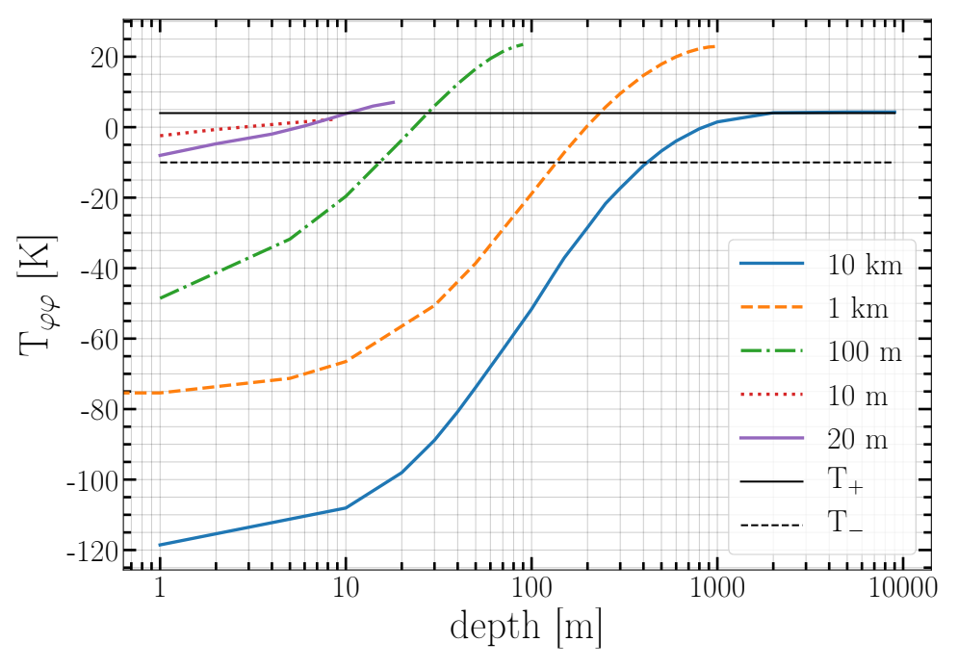

Figure 2 - Compressive stress profiles with depth along the radii of ice bodies at an equilibrium surface temperature of 150 K

Figures 1 and 2 also show that compressive stresses change signs when moving deeper into bodies and coincide with breaking stresses in the center of the body. The processes of destruction at the very surface of bodies due to the action of compression contraction will also be significant. The largest bodies can break down to a depth of 400 m (Figure 2, a body with a diameter of 10 km), which contributes to the formation of a coma.

1.2 Numerical calculations for various sizes of bodies and distances from the star
The speed at which an icy body warms up in the process of approaching the star in a parabolic orbit depends on its size. Consequently, thermal stresses inside and on the surface of these bodies depend both on the size of the bodies and on the distances to the star. The list of intermediate distances for calculations is given in Table 1.
From (13) it is obtained that for r → ∞ the limit value T_{φφ} = T₀ − T_{S}. Since the compressive strength according to [14] is T- = -10K, the destruction processes at the surface of large bodies begin at distances at which the surface temperature is 10K higher than the temperature at depth, that is, under the condition ΔT= T_{S} – T_{c} ≥ 10К. Figure 3 shows that the magnitude of the compressive stress for the largest body with a radius of 10 km practically coincides with the difference T₀ – T_{S}.

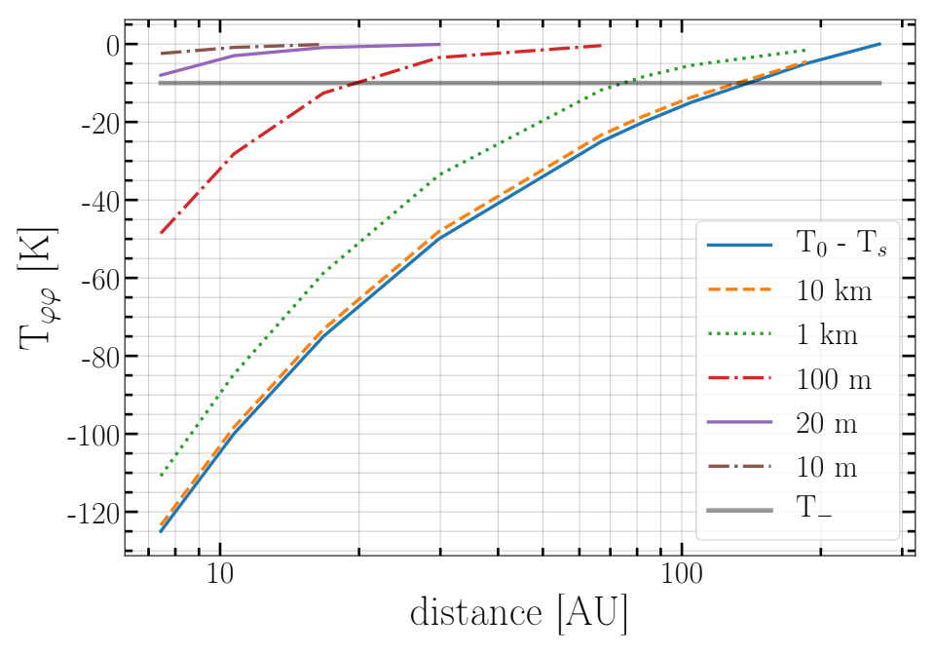
Figure 3 - Compressive thermal stresses on the surface of icy bodies depending on the distance to the star

Figure 4 shows that tensile thermal stresses decrease with increasing radius of bodies: the maximum stresses correspond to bodies with a radius of r = 1 km, the minimum to bodies with r = 10 km.

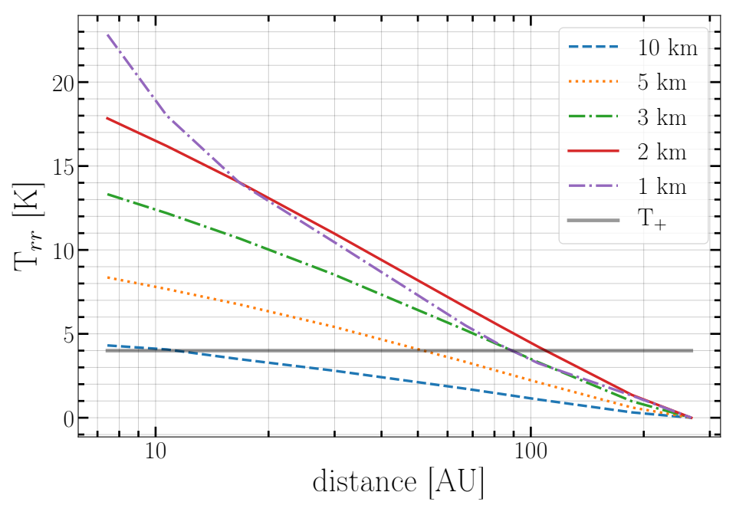
Figure 4 - Tensile thermal stresses in the center of large icy bodies with radii r ≥1km depending on the distance to the star

For bodies with a radius less than 500 m, the stress behavior reverses (Figure 5). The stresses decrease as the size of the bodies decreases: it is maximum for bodies with radii r in the range of 0.5-0.3 km, and minimum for bodies with radius r = 10 m.

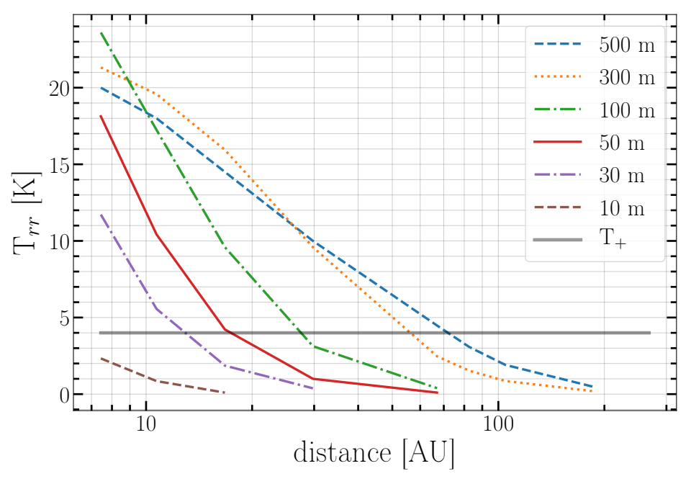
Figure 5 - Tensile thermal stresses in the center of icy bodies with radii r ≤ 0.5 km depending on the distance to the star

From Figures 4-6, it follows that there is a selected range of sizes of bodies whose cracking begins far from the star.

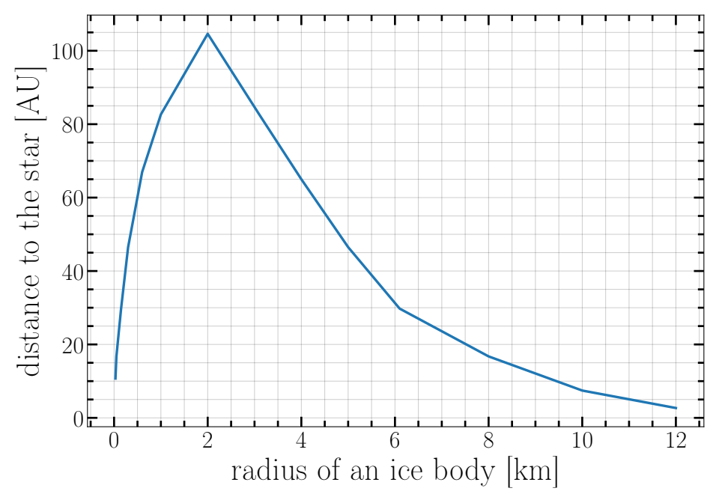

Figure 6 - The distance from the star at which thermal stresses in the center of ice bodies reach the tensile strength of the material, depending on the radii of the bodies

Figure 6 shows a range of radii r = 0.5-3 km with a maximum near r = 2 km. Such bodies can crack from the inside already at distances of 80-100 AU from the star. As they approach the star, such bodies can form a cloud of small fragments, dust and gas as a result of cascade destruction. For comets of the Solar system, according to [11], this size is r = 1 km.

An illustrative example of destruction at distant approaches to the Sun is comet Shoemaker-Levy 9. One can come to this conclusion knowing that according to the estimate [15], the comet had an initial radius of r = 0.9 km and a density of 0.6 g cm⁻³ before fragmentation. At the time of its fall to Jupiter, this comet was a set of fragments stretched into a long chain along its orbit due to differential accelerations. The fall of this comet on Jupiter lasted more than a day. A more recent example is the interstellar comet Borisov with a radius of 0.4-0.5 km according to [8] and comet C/2019 Y4 (ATLAS), which did not have Jupiter in their path.
The fact that there may be a dedicated range of sizes of bodies within which maximum breaking stresses can develop is easily explained by the peculiarities of thermal surface heating of bodies when moving along a parabolic or other highly elongated orbit with a large eccentricity. Very large bodies do not have time to warm up to the center when they move towards the star and the destruction of such bodies is limited to the surface. On the contrary, small bodies warm up so quickly that they can be considered isothermal, so neither internal nor surface stresses arise, as do dust particles. High internal stresses occur in bodies of intermediate sizes, in which "heat waves" have reached the center, but significant warming has not yet occurred (Figures 2, 4 and 6, bodies with a radius of r = 0.5-3 km).

1.3 Estimation of the required mass of the comet to explain the observed changes in the brightness of the star during destruction
Can the clouds of fragments formed as a result of thermal destruction be the cause of a 10-20% drop in the intensity of the star? Let's make a simple estimate of the mass of the body and the size of the particles formed as a result of its disintegration, which will shield the light of the star.
Suppose that the disk of a star is covered by dust particles, the total cross-sectional area of which is 10% of the cross-sectional area of the star, with the condition that the cross-sections of the dust particles do not overlap: Nπs² = 0.1πR_{Т}², where N is the number of dust particles, s is the radius of the dust particle, R_{Т} = 1.58R_{ʘ} = 1.099206 × 10⁹m is the radius of the star. Body mass M=4/3πδr³= Nρ4/3πs³, where the densities δ and ρ can be considered equal. Then, r³=Ns³ = 0.1sR_{Т}² from where you can find the radius of the granules: s = r³/0.1 R_{Т}².
According to our calculations, bodies with a radius of 10 km are destroyed at a distance of 7.44 AU at an equilibrium surface temperature of 150 k. The mass of such a body with δ = 1000kg/m³: M = 4/3πδr³ = 4.18879 × 10¹⁵kg. The resulting mass is close to the lower limit of the mass given in [16], which is 10⁻⁹ Earth masses or ≈ 5.972 × 10¹⁵ kg. As shown in [16], this corresponds to a completely disintegrated object with approximately 30 masses of comet 1P/Halley. The resulting mass estimate can be considered the lower limit since larger cometary bodies will also be destroyed as they approach the star. In addition, several bodies may be responsible for the feinting of the star's brightness, approaching the star with a chain of fragments resulted from the disintegration of a larger body. Additional stellar flux decrease can occur from scattering by atoms and ions formed after dust evaporation.

2 Analysis of the results and evaluation of the feasibility of the FEB scenario to explain irregular fading of the brightness of a star in an exoplanet system
In [17] it was found that the reason for the decrease in the brightness of the star is the presence of sub-micron particles, which can be silicates in the range of radii 0.1 - 0.2 microns and (or) ice particles with radii 0.2 - 0.3 microns. These results were obtained for the events of a star's brightness drop with an amplitude of 1-2.5% of the total flux.
Taking into account the results obtained in [17], the minimum size of a body capable of disintegrating into particles with a radius of s = (0.2-0.3) microns and shielding up to 2.5% of the flux from the star is equal to r = (0.025sR_{T}²)^{1/3} ≈ (1.8 – 2.1) km. According to Figure 6, bodies of this size can experience catastrophic destruction at a significant (about 100 AU) distance from the star. During the approach to the star (τ(R) ≈ 67 years), bodies of this size can turn into a dust cloud as a result of cascading destruction into smaller and smaller fragments.
More complicated to understand is the monotonous flux decrease indicated in [3], first faint, then deeper, close in time with the last group of eclipses near D1520: between 1500-1580.
Figure 7 shows the ratio of the radiation pressure to the gravitational force for small particles depending on their radii for the silicate material of basalt and ice using refraction indices [18] and a later addition [19] for ice according to the algorithms described in [20] and references therein. It can be seen from Figure 7 that the particle sizes of 0.2 microns obtained in [17] correspond exactly to the maximum ratio of the radiation pressure to the gravitational force: β = F_{rad}/F_{grav} ≈ 2.5. Such particles, leaving the parent body, effectively move away from the star, and the flow of these particles can create an additional slight dimming of the star. Thus, it can be assumed that the decrease in the brightness of the star detected in work [3] is caused by the flow of particles leaving the system under the influence of light pressure. The flow of such particles should increase with the approach of the eclipse group D1500-1580, which is noted in work [3] as an increase in the smooth dimming of KIC 8462852.
To refine the particle sizes, it is very important to investigate spectral lines in the IR range and conduct photometry in the far IR in order to detect signs of the presence of cold dust accumulations in this system.
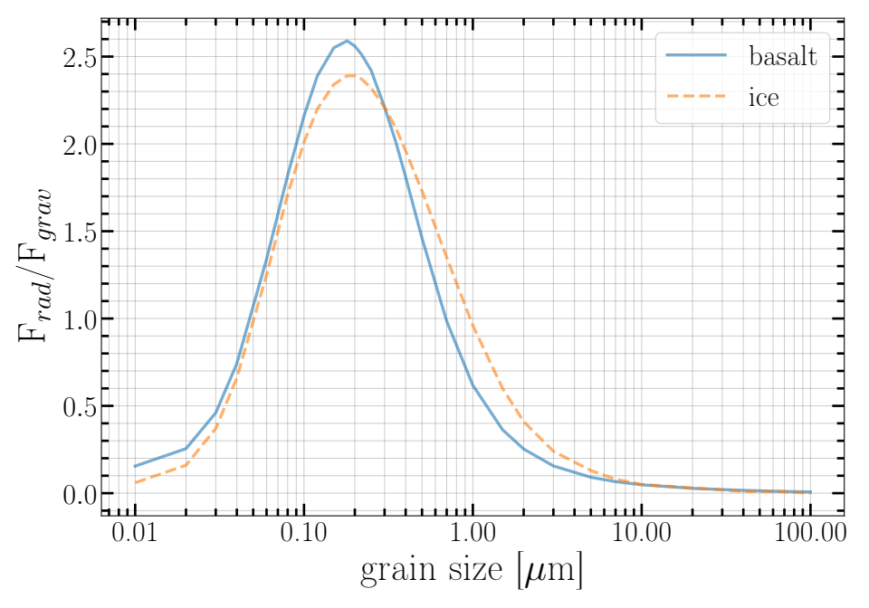
Figure 7 - The ratio of the radiation pressure to the gravitational force for silicate (basalt) and ice particles depending on their radii in the KIC 8462852 system

2.1 Conclusions on the feasibility of the theory of catastrophic thermal destruction in the framework of the FEB scenario to explain non-periodic fading of the brightness of a star in an exoplanetary system using the case of KIC 8462852
As already noted, the works of Marengo et al.[21], Lise et al. [2], Thompson et al. [16], Meng et al.[22] and Montet and Simon [3] support the Boyajian hypothesis [1] that irregular transit events in the KIC 8462852 system are caused by the disintegration of a family of comets. Our results also show that the FEB hypothesis is quite acceptable to explain the irregular transits observed on the light curve of the star KIC 8462852. Our theory allows us to explain the following observational data:
1) The irregularity of the appearance of transit phenomena that cannot be explained by periodic orbital motion.
2) A weak long-term decrease in the brightness of the star after transit events, which is naturally explained by the fragmentation of large bodies to the state of fine dust.
3) The particle sizes determined from observations in the IR range, partially covering the disk of a star, can be explained by the decay of a comet whose mass is sufficient to form the required number of particles.

CONCLUSION
Key results of 2020:
- New initial data for calculations of the thermal diffusion equation, thermal parameters: heat capacity and thermal conductivity, as well as elastic parameters and strength limits of silicate and ice composition materials are selected.
- A range of distances for the star and a range of radii of icy bodies are selected: from 10 m to 10 km for trial calculations.
- The calculation algorithm was verified by comparing the results with analytical calculations using approximate formulas.
- Trial calculations of temperature and stress profiles along the radii of bodies in the selected size range (from 10 m to 10 km) were carried out.

Key results of 2021:
- Calculations of the profiles of tensile stresses inside cometary bodies made of crystalline ice and compressive stresses on their surface in a selected size range (from 10 m to 10 km) at different distances from the star in the course of approaching the star in a parabolic orbit are performed.
- It is found that there is a range of radii of bodies for which the tensile stresses are maximal and become destructive at the maximum distance from the star. At the same time, in both larger and smaller bodies, the tensile stresses weaken and become catastrophic at closer distances.
- We estimate the comet's mass required to explain the observed prolonged attenuation of the star's brightness when the comet breaks into small fragments and turns them into dust.
- It is shown that a comet with a radius of 2 km, which has maximum tensile stresses at the maximum distance from the star, is sufficient to explain the observed prolonged attenuation of the star's brightness when the comet is disintegrated into smaller fragments. This conclusion is based on a comparison with observations obtained by other authors in the IR range.
- The proposed scenario of catastrophic thermal disintegration is considered quite suitable to explain the observed irregular attenuation of the star's brightness in the exoplanet system of the star KIC 8462852.

Assessment of the completeness of solutions to the tasks: the planned task for 2021 was completed in full in accordance with the schedule given in Appendix A.

Recommendations for the specific use of research results: the results can be used in studies of the evolution of exoplanet systems with an abundance of near-stellar material, especially having an analog of the Oort cloud. These results can be used in special astronomy courses at physical, physical-mathematical, and physical-technical faculties of universities of the Republic of Kazakhstan.
Assessment of technical and economic efficiency of implementation – not provided.
Assessment of the scientific and technical level of the completed research: the scientific and technical level of the research carried out corresponds to the international level and is confirmed by publications in peer-reviewed international scientific publications, such as Monthly Notices of the Royal Astronomical Society (MNRAS) listed in Q1 journals.

REFERENCES
- Boyajian T. S., LaCourse D. M., Rappaport S. A. et al. Planet Hunters IX. KIC 8462852 – where’s the flux? // MNRAS. – 2016. – Vol. 457. – Р. 3988-4004.
- Lisse C. M., Sitko M. L., Marengo M., IRTF/SPeX Observations of the Unusual Kepler Light Curve System KIC8462852 // ApJ. – 2015. – Vol.815. – L27.
- Montet B.T. and Simon J.D. KIC 8462852 Faded throughout the Kepler Mission//The Astrophysical Journal Letters. – 2016. – Vol.830. – L39-L 52.
- Vidal-Madjar A., Hobbs L. M., Ferlet R., Gry C., Albert C. E. The circumstellar gas cloud around Beta Pictoris. II // Astron. Astrophys. – 1986. – Vol.167. – P. 325.
- Ferlet R., Hobbs L.M., Vidal-Madjar A. The Beta Pictoris circumstellar disk // Astron.Astrophys. – 1987. – Vol. 185. – P.267-270.
- Beust H., Lagrange-Henri A.-M. , Crawford I.A. et al. The β Pictoris circumstellar disk XXV //Astron. Astrophys. – 1998. – Vol.338. – P.1015-1030.
- Thébault P., Beust H. Falling evaporating bodies in the Pictoris system // Astron. Astrophys. – 2001. – Vol.376. – P. 621-640.
- Jewitt D., Hui M.-T., Kim Y., Mutchler M., Weaver H., Agarwal J. The Nucleus of Interstellar Comet 2I/Borisov arXiv:1912.05422v2 [astro-ph.EP] 8 Jan 2020.
- Kuhrt, E. Temperature profiles and thermal stresses in cometary nuclei // Icarus. - 1984. – Vol.60. – P.512-521.
- Shestakova L.I., Tambovtseva L.V. The thermal destruction of solids near the Sun // Earth, Moon, and Planets. – 1997-1998. – Vol.76. – P.19-45.
- Tambovtseva L.V. and Shestakova L.I. Cometary splitting due to thermal stresses // Planet. Space Sci. – 1999. – Vol.47. – P.319-326.
- Boley B.A. and Weiner J.H. Theory of Thermal stress / Wiley. – New York, 1960. – 302 p.
- Campbell I. E. (ed.) High-temperature technology / Wiley. – New York. – 1956. – 450p.
- Dobrovolskis A.R. Tidal Disruption of Solid Bodies // Icarus. – 1990. – Vol. 88. – P.24-38.
- Solem J.C. Cometary breakup calculations based on a gravitationally-bound agglomeration model: the density and size of Shoemaker-Levy 9 // Astron. Astrophys. – 1995. - Vol.302. – P.596-608.
- Thompson M.A., Scicluna P., Kemper F. et al. Constraints on the circumstellar dust around KIC 8462852// MNRAS. – 2016. – Vol. 458. – L39-L43.
- Boyajian et al. The first post-Kepler brightness dips of KIC 8462852 // The Astrophysical Journal Letters. – 2018. – Vol. 853. – Issue 1. L8-22.
- Warren S. G., Optical constants of ice from the ultraviolet to the microwave // Appl. Opt. – 1984. – Vol. 23. – Issue 8. P.1206-1225.
- Warren S. G. & Brandt R. E. Optical constants of ice from the ultraviolet to the microwave: A revised compilation // Journal of Geophysical Research: Atmospheres. – 2008. – Vol. 113. – Issue D14. CiteID D14220.
- Shestakova L.I., Demchenko B.I., Serebryanskiy A.V. On the orbital evolution of dust grains in the sublimation region around WD1145+017 // MNRAS. – 2019. – Vol.487. – №.3. P.3935-3945.
- Marengo M., Hulsebus A., Willis S., KIC 8462852: The Infrared Flux //The Astrophysical Journal Letters. – 2015. – Vol. 814. – Issue 1. L15-19.
- Meng H.Y. et al. Extinction and the Dimming of KIC 8462852 // Astroph. Journal. – 2017. – Vol.847. – P.131-141.

APPENDIX A
List of publications in 2021
international publication:
1 Shestakova L. I., Serebryanskiy A.V. Demchenko B. I., Infalling thermally destroyed bodies as a possible explanation for the KIC8462852 phenomenon //Monthly Notices of the Royal Astronomical Society. 2021 – Vol.501 – P.5468-5477. IF =5.1, Q1 (Web of Science). https://doi.org/10.1093/mnras/staa4023

domestic publication:
2 L.I. Shestakova , A.I. Kenzhebekova Sublimation of dust particles near the white dwarf G29-38 //News of the National Academy of Sciences of the Republic of Kazakhstan, Physico-mathematical series – 2021. – Vol.3. – Р.156-166.
https://doi.org/10.32014/2020.2518-1726.58

APPENDIX B
PROJECT TIMELINE
Schedule of tasks implementation
Item  # | Title of tasks and measures to implement them | Begin  (DD / mm/yy) | Duration, months | Expected results of the project implementation (in terms of tasks and activities), accomplishment
 |  |  |  | 2020 | 2021
1 | 2 | 4 | 5 | 6 | 7
1 | Development of the algorithm and search for available initial data for calculations: elasticity and thermal parameters, strength limits of materials consisting of silicates and ice, as well as a selection of a range of body sizes and distances from a star. | 01.10.2020 | 3 | Tables of initial data and preliminary computations of the temperature and stress profiles | -
2 | Performing calculations of thermal stresses inside and on the surface of small bodies approaching the star in elongated orbits. | 04.01.2021 | 3 | - | Results of numerical calculations based on initial data: a range of body sizes, distances from the star. Estimation of the comet's mass required to explain the observed changes in the star's brightness as a result of comet destruction.
3 | Analysis of the results  and evaluation of the feasibility of the FEB scenario to explain the observed irregular attenuation of the star's brightness in an exoplanet system. | 01.04.2021 | 6 | - | Reasonable conclusions on the plausibility of the theory of catastrophic thermal destruction in the framework of the FEB scenario for explaining non-periodic attenuation of the star's brightness in an exoplanetary system using as the example KIC 8462852 case.  Way of accomplishment – publication of 1 (one) paper in a journal included in the Web of Science or Scopus database and 1 (one) paper in a domestic publication with a non-zero impact factor

