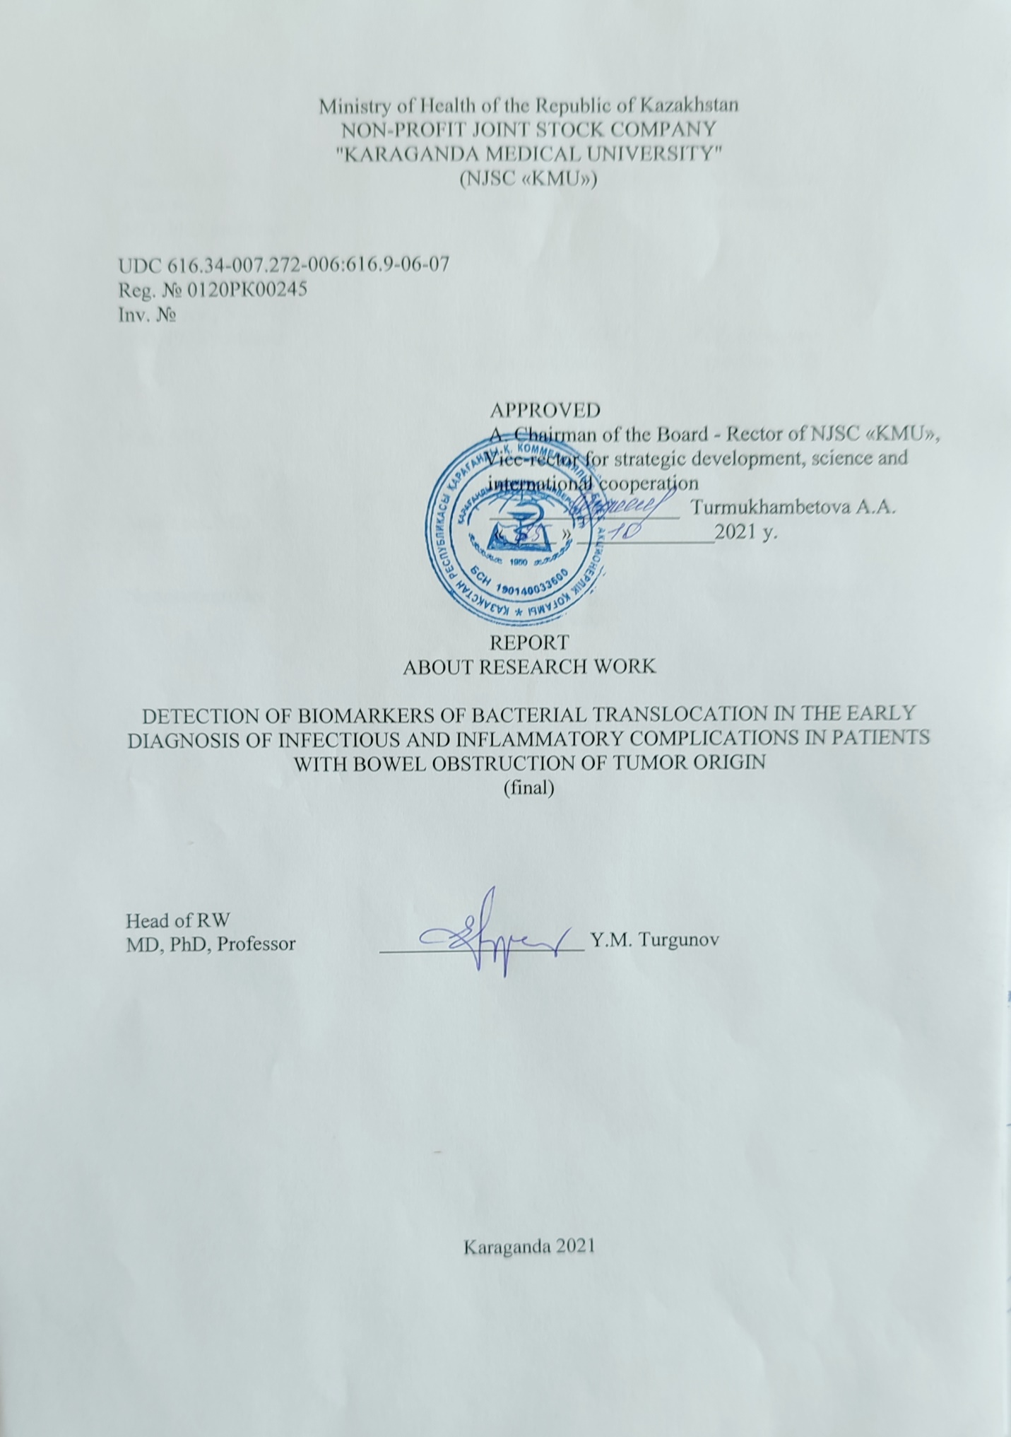

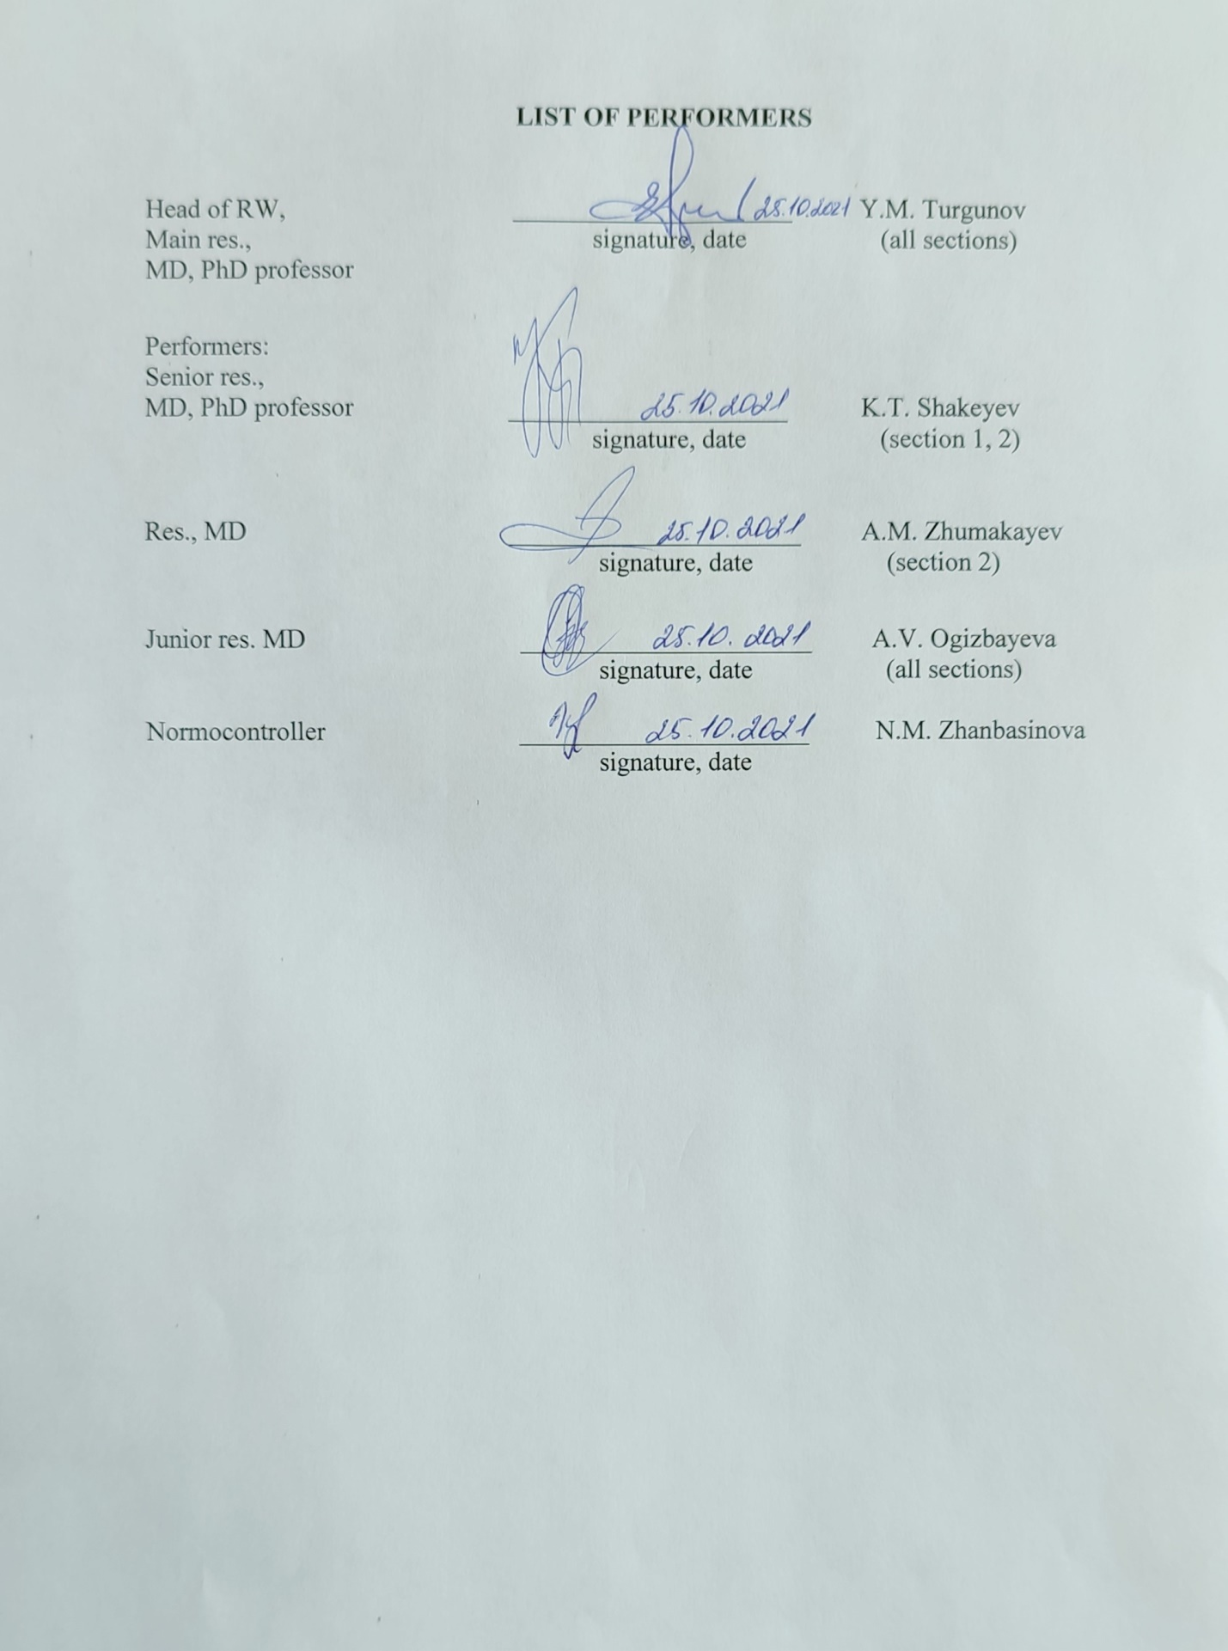

**ABSTRACT**

Report 38 p., 8 figures, 4 tables, 40 references, 4 appendices.

BOWEL OBSTRUCTION, COLON TUMOR, BACTERIAL TRANSLOCATION, BIOMARKERS, 16s rRNA, POLYMERASE CHAIN REACTION

The aim is to determine the diagnostic and prognostic significance of bacterial translocation as a predictor of the complications development in patients with acute bowel obstruction of tumor origin by assessing the relationship of LBP, sCD-14 in the systemic circulation with the detection of microorganism genes in mesenteric lymph nodes.

In 2021, the final stage of research was completed, the purpose of which was to collect the biological material and conduct immunological and molecular genetic studies to detect bacterial translocation in the systemic circulation and mesenteric lymph nodes in operated colorectal cancer patients with and without acute bowel obstruction.

Research methods: enzyme immunoassay of bacterial translocation’s biomarkers; molecular genetic study of bacterial DNA in mesenteric lymph nodes.

Obtained results and novelty:

* the detection of translocation in the systemic circulation using biomarkers (sCD-14, LBP) in operated colorectal cancer patients with and without acute bowel obstruction was performed;
* the methodology and a standard procedure for the detection of bacterial DNA using molecular genetic analysis in mesenteric lymph nodes were developed;
* the molecular genetic study was carried out for the detection of microbial DNA in mesenteric lymph nodes in operated colorectal cancer patients with and without acute bowel obstruction;
* a comparative analysis of the characteristics of the course of bacterial translocation, as well as its relationship with the development of a systemic inflammatory reaction and infectious and inflammatory complications in operated colorectal cancer patients with and without acute bowel obstruction was conducted.

Degree of implementation - all stages of the Project have been implemented, a title of protection has been received (a certificate of entering information into the state register of rights to objects protected by copyright), and the method of detecting bacterial DNA in mesenteric lymph nodes was introduced in the LCU NRC NJSC "KMU".

Applications: medicine, medicine, surgery, immunology, molecular genetics.

**CONTENT**

|  |  |
| --- | --- |
|  |  |
| INTRODUCTION…………………………………………………………………..………..  MAIN PART OF RW……..…………………………………………………………..……... | 6  10 |
| 1 Study of bacterial translocation in acute bowel obstruction of tumor origin…………….... | 10 |
| 2 Materials and methods……………….………….................................................................  2.1 Study design..…….……………………………………………………………………..  2.2 Research methods.…………………………………….…………………………….... | 12  12  13 |
| 3 Research results………........................................................................................................ | 20 |
| 3.1 Characteristics of the patients..........................................................................................  3.2 Results of immunological studies of biomarkers……………......................................... | 20  21 |
| 3.3 Results of molecular genetic research………………....................................................  3.4 The relationship between direct and indirect markers of bacterial translocation……… | 22  24 |
| CONCLUSION ……………………………………………………………………………… | 25 |
| REFERENCES……………………………………..………………………………………... | 26 |
| APPENDIX A Project implementation plan…..……………………………………………..  APPENDIX B Act of implementation …..…………………………………………………  APPENDIX C List of publications..………………………………………………………  APPENDIX D Standard operating procedures….…………………………………………… | 30  34  35  36 |
|  |  |
|  |  |
|  |  |
|  |  |

**ABBREVIATIONS**

In this RW report, the following abbreviations are used

16s rRNA - 16s ribosomal ribonucleic acid

ABO - acute bowel obstruction

BT - bacterial translocation

CFU - colony forming unit

DNA - deoxyribonucleic acid

ELISA - enzyme-linked immunosorbent assay

LBP – lipopolysaccharide-binding protein

MLN - mesenteric lymph nodes

NJSC “KMU” - NON-PROFIT JOINT STOCK COMPANY "KARAGANDA MEDICAL UNIVERSITY"

PCR - polymerase chain reaction

PaO2/FO2 - oxygenation index (partial pressure of oxygen in arterial blood/ fraction of inspired oxygen)

sCD14 – soluble CD14 (presepsin)

SIRS – systemic inflammatory response syndrome

SOP - Standard Operating Procedure

**INTRODUCTION**

Acute bowel obstruction (ABO) accounts for 20% of all cases of acute surgical abdominal pathology. Despite modern approaches to the diagnosis and treatment of ABO, postoperative mortality ranges from 5 to 32%, and complications arise in 23% of cases [1,2,3]. One of the menacing infectious and inflammatory complications of ABO is sepsis. In ABO caused by colorectal cancer, sepsis occurs from 1.7 to 10.5% of cases [4,5,6,7]. Often in cases of ABO, sepsis is not always diagnosed, as there is no specific focus of infection, but there are signs of SIRS (systemic inflammatory response syndrome) and organ dysfunctions. The main component of the development of sepsis in ABO is bacterial translocation (BT) [8].

Bacterial translocation is the penetration of intestinal bacteria or their products through the intestinal mucosa into the mesenteric lymph nodes and then into usually sterile tissues and internal organs. For the first time, the alleged migration of bacteria from the intestine was described in 1881 by Dürvandiering [9], and the term "bacterial translocation" was first introduced by R.D. Berg and A.W. Garlington in 1979. The immune system of a healthy organism quickly reacts to the invasion of pathogenic microorganisms, thereby preventing their migration from the intestine into the systemic circulation [10]. Since critically ill patients are usually accompanied by systemic immune deficiency or immunosuppression, the immune system is unable to eliminate pathogenic bacteria, which leads to uncontrolled BT. In clinical practice, the study of the BT phenomenon is difficult, due to the impossibility of studying the material of various tissues and organs for bacteriological research, while this method has a low sensitivity and allows to determine mostly aerobic flora and can give false negative results. Therefore, other reliable and reliable markers of BT are needed, which can be searched for in this clinical study [11].

Today there are several methods for detecting BT:

1. Direct method – the detection of 16s rRNA in mesenteric lymph nodes (MLN);

2. Indirect method - the detection of serum lipopolysaccharide-binding protein (LPS-binding protein or LBP) and presepsin (sCD-14).

Mesenteric lymph nodes and vessels are probably the most important pathway for bacteria to spread from the intestines to the blood and other organs. Lymphatic drainage in MLN occurs from the small intestine, cecum, and proximal colon. Since MLN is usually sterile, the presence of viable bacteria in them is a marker of increased permeability of the intestinal barrier and bacterial translocation [12,13].

LBP plays an important role in recognizing the main component of the bacteria outer cell wall - lipopolysaccharide (LPS). LBP sensitizes macrophage, monocyte and neutrophil receptors to LPS of bacteria, thereby activating the inflammatory signaling pathway [14,15]. A number of studies have shown that LBP is a reliable biomarker of microbial translocation and sepsis [16,17].

sCD-14 has a high affinity for the lipopolysaccharides of the cell walls of gram-negative bacteria and peptidoglycans of gram-positive bacteria [18,19]. Presepsin has been identified as a biomarker of the early phase of sepsis and its level is a significant prognostic factor in outcomes in patients with sepsis [20,21,22].

Based on the analysis of articles in the databases of Web of Science and Scopus, it can be said that the interest of researchers from different countries in the BT phenomenon is growing, as well as in the problem of ABO of tumor origin. When analyzing studies in databases of publications, it was found that more than 60% of the works were experimental, and most of the clinical studies were conducted in patients with HIV infection and cirrhosis. There are no studies on LBP, sCD-14, as biomarkers of BT in cases of ABO of tumor origin, their correlation with 16s rRNA in MLN, and their role in the development of SIRS and postoperative infectious and inflammatory complications caused by ABO. The questions of the diagnostic value of the proposed biomarkers remain open, their study in dynamics, as well as the relationship between direct and indirect markers of BT. These unresolved problems require further in-depth study, and therefore, in order to early diagnosis of infectious and inflammatory complications, it is necessary to study LBP, sCD-14 and 16sRNA as BT markers in patients with ABO of tumor origin, as well as in patients after elective surgery for colon tumors.

Scientific background on the research topic. The results of experimental studies on a model of acute bowel obstruction.

The object of the study was 162 sexually mature rats weighing from 180 to 220 g, on which mechanical and strangulated bowel obstruction were simulated. Rats with a model of mechanical bowel obstruction were divided into subgroups according to the observation period: 1 and 3 days, with a model of strangulation obstruction also divided into 2 subgroups: with a period of ABO/reperfusion: 60 min/1 hour and 60 min/2 hours, and also there was an intact group, for monitoring ongoing techniques. Surgical interventions were performed under general anesthesia; the animals were withdrawn from the experiment by bleeding in a state of anesthesia, in accordance with paragraph M3.13.1. Guidelines for Animal Euthanasia by the American Veterinary Medical Association [23].

The research group carried out modeling according to its own author's technique, which is characterized by simplicity and speed of execution, reproducibility, low cost and a high degree of survival of animals. The bacterial translocation was detected at different stages of bowel obstruction using various biomarkers by immunological and molecular genetic methods (including LBP and 16s rRNA).

During the study, the maximum incidence of microbial translocation was detected on the first day of obstruction. There were no statistically significant differences in the groups with strangulation and mechanical bowel obstruction, which can indicate a similarity of the pathological mechanisms of bowel obstruction, leading to the occurrence of bacterial translocation. The study evaluated the diagnostic significance of bacterial translocation biomarkers at different periods of mechanical and strangulation bowel obstruction. For example, LBP maximally increased in the early stages of mechanical bowel obstruction with a moderate decrease in dynamics by the third day of obstruction. With strangulation obstruction, an increase in the period of mesenteric blood flow recirculation naturally led to an increase in LBP.

In the process of the research work, a method of molecular genetic research of the blood of experimental animals was developed and tested. In mechanical bowel obstruction 60% of animals had positive results for the presence of bacterial DNA, in strangulation obstruction - 80%, and PCR results were negative for intact rats. This method for detecting bacterial translocation is sensitive to low concentrations of bacterial DNA in blood serum, which allows it to be used as a direct method for detecting microbial translocation.

The results of an experimental study became the basis for the creation of this project, for study the phenomenon of bacterial translocation in acute bowel obstruction of tumor origin and test hypotheses in clinical practice.

The aim and objectives of the research work of the final stage of 2021 were approved in accordance with the work schedule (Appendix A).

The aim is to determine the diagnostic and prognostic significance of bacterial translocation as a predictor of the complications development in patients with acute bowel obstruction of tumor origin by assessing the relationship of LBP, sCD-14 in the systemic circulation with the detection of microorganism genes in mesenteric lymph nodes.

Project objectives:

1. Compare the level and dynamics of changes in the biomarkers of bacterial translocation (LBP, sCD-14) in the blood serum of patients after surgery for a colon tumors planned and complicated by ABO. - It is assumed that in patients with ABO, bacterial translocation rates will be higher due to an increase in intestinal permeability for bacteria in patients with ABO.

2. To determine the effect of clinical and morphological characteristics of a colon tumor on the frequency of bacterial translocation development. - It is assumed that in patients with later stages of the oncological process, the frequency of bacterial translocation will be higher.

3. To evaluate the clinical and laboratory parameters of patients after surgery for colon tumors, depending on the presence of bacterial translocation and SIRS. - In patients with higher levels of bacterial translocation markers, the incidence of a systemic inflammatory reaction and infectious inflammatory complications will be higher.

4. To identify the correlation between 16s rRNA in MLN and LBP, sCD-14 in blood serum. - It is assumed that indirect markers of bacterial translocation will correlate with the presence of microbial DNA in mesenteric lymph nodes, which will indicate the possibility of their use in the early diagnosis of infectious and inflammatory complications.

Scientific novelty:

Based on changes in BT biomarkers in the blood serum, it’s suggested that patients with researched pathology can be stratified according to the risk level of developing infectious and inflammatory complications. It will be possible to take preventive measures to reduce the frequency and severity of these complications and mortality. This method will be a reliable, quick and less expensive, without need for invasive collection of MLN and detection of 16s rRNA. It will be possible to revise the criteria for the diagnosis “sepsis” in these patients: a high level of BT biomarkers, the presence of SIRS and organ dysfunction, will allow early diagnosis of sepsis even without an obvious focus of infection.

Practical significance:

- on the basis of the data obtained, adjustments will be made to the already known pathogenetic mechanisms of the development of infectious and inflammatory complications in operated colorectal cancer patients with and without acute bowel obstruction;

- by the change in the level of markers in the blood serum in dynamics, it will be possible to assume a higher risk of infectious and inflammatory complications after surgery in this category of patients;

- the developed methods of molecular genetic research have been introduced into the list of methods of the Laboratory for Collective Use of the Research Center of NJSC "MUK" (Appendix B);

- standard operating procedures and research methods using RBL technology (research-based learning) will be introduced into the educational process.

Based on the results of the RW, 2 publications of scientific works were made (Appendix C): 1 publication in a journal indexed in the Scopus database with a percentile of 54% (Q2), 1 publication in a peer-reviewed national journal recommended by CQES. An interim report on the topic of RW has been submitted ИРН№ AP08956335-OT-20 (Inv. № 0220РК01534).

**MAIN PART**

**1. Study of bacterial translocation in acute bowel obstruction of tumor origin**

Today, there are several factors that can contribute to BT from the intestines:

a) disturbances in the composition of normal intestinal microflora and excessive bacterial growth;

b) a decrease in the secretion of bile;

c) immunity disorders;

d) circulatory hypoxia of the intestinal wall and violation of antioxidant protection;

e) violation of the barrier function of the intestinal mucosa.

According to the latest data, it turned out that in patients with various diseases (acute pancreatitis, severe trauma, burns, extensive surgical interventions), the composition of the intestinal microflora has changed, characterized by a decrease in the number of commensal bacteria and an excessive growth of pathogenic microorganisms, including Escherichia coli, Pseudomonas spp., Klebsiella spp., Clostridium difficile and vancomycin-resistant enterococcus [24-26]. Van Praagh et al. in operated colorectal cancer patients, confirmed that anastomotic leak and the resulting inflammatory reactions were associated with a decrease in the amount of normal microbiota and an excessive growth of pathogenic bacteria [27]. Some authors have associated dysbiosis with the occurrence of severe complications in critical conditions, including sepsis, multiple organ failure, and even death [28-29].

In obstructive jaundice, a decrease in bile secretion leads to disturbances in the reticuloendothelial system [30], disrupts the activation of macrophages, [31], promotes excessive bacterial growth, and also leads to architectural and functional changes in the intestinal mucosa [32], thereby increasing the permeability of the intestinal barrier.

In immunocompetent people, pathogenic microorganisms, after passing through the mucous and epithelial barriers of the intestine, entering the MLN are recognized and neutralized by macrophages [33], while pro-inflammatory cytokines are not produced and thus an inflammatory response is not induced. Since critically ill patients are usually accompanied by systemic immunodeficiency or immunosuppression, innate immune mechanisms are not able to destroy pathogenic microorganisms, therefore, immunity disorders can lead to increased BT [34].

Disturbances of microcirculation of the intestinal mucosa lead to hypoperfusion, edema of the mucous membrane, its ischemia, an increase in free oxygen radicals, destroying the cytoskeleton of the mucous membrane and contributing to the disruption of the integrity of the intestinal barrier and subsequent BT [35].

In colon tumors, a violation of the intestinal barrier occurs at the site of growth of the tumor itself, because the tumor causes dysplasia of the epithelium, and above the obstruction due to disturbances in the microcirculation of the intestinal wall, its ischemia and hypoxia. M. Schietroma et al. [35] after resection of the large intestine for colorectal cancer confirmed increased permeability of the intestinal wall and a significant increase in endotoxemia already on the first postoperative day, which subsequently correlated with the development of sepsis. Other scientists have found that BT into the mesenteric lymph nodes occurs in 65% of patients with colon cancer, with a predominance in patients with stage III and IV cancer [36]. Today, a number of researchers believe that BT is a trigger for the onset and intensification of SIRS, which can lead to sepsis and multiple organ failure [37].

Detection of bacterial translocation in the systemic circulation using enzyme-linked immunosorbent assay is an indirect indicator of bacterial translocation. Several studies have shown that LBP levels are long-term detectable in serum after bacteremia, and it is a relatively reliable marker for the diagnosis of BT [16,17], and sCD14 has been identified as a biomarker of the early phase of sepsis and its level is a significant predictor of sepsis patient outcomes [20-22].

To date, a promising method for studying bacterial translocation in ABO is the determination of microbial 16s rRNA in MLN using polymerase chain reaction (PCR). The 16s rRNA gene contains hypervariable regions unique to each microorganism and "strict" regions common to all bacteria. There are universal primers that bind to the known common gene sequences of most bacteria [38]. Schoeffel et al. in the BT study in patients with adenocarcinoma of the cecum, compared several methods of BT detection, including the MLN culture and the determination of 16S rRNA in MLN. This study showed that several microorganisms can simultaneously translocate into the mesenteric lymph nodes, as well as in one patient with a negative MLN culture , there were positive PCR results. This confirms that not all bacteria are detected by microbiological methods [39].

**2 Materials and methods**

**2.1 Study design**

Research work was carried out on the basis of the Laboratory for collective use of the research center at NJSC "KMU", as well as on the basis of the "Multidisciplinary hospital №3 of Karaganda" (oncological center).

The study design is shown in Figure 1.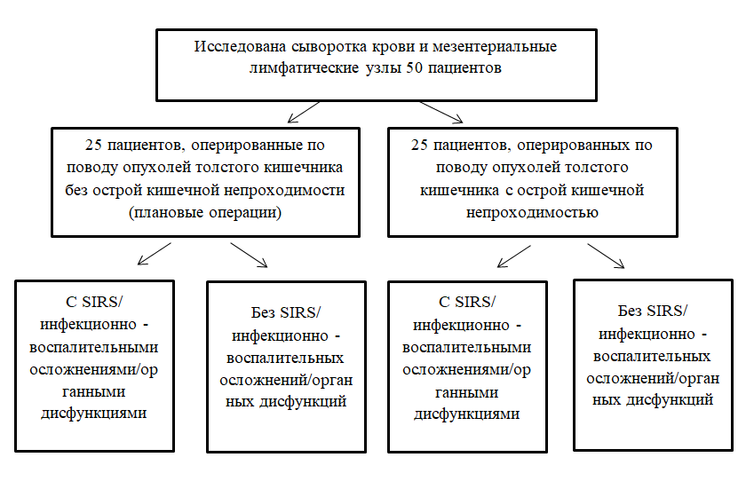

Figure 1 - Study design

Inclusion criteria: patients who undergo planned surgery for a colon tumor, patients with ABO of a tumor origin older than 18 years.

Exclusion criteria: age younger than 18 years, pregnant women, patients with paralytic ABO or ABO of non-tumor origin, patients with HIV infection, cirrhosis of the liver, as well as if the patient has an infection process due to another pathology.

As clinical and laboratory parameters in patients, postoperative infectious and inflammatory complications (clinical component), as well as such laboratory parameters necessary for setting SIRS, assessing organ dysfunctions on the SOFA scale were assessed (Table 1).

SIRS was the case when at least two of the following criteria were met:

* Body temperature ≥ 38 ° C (febrile temperature) or ≤ 36 ° C (hypothermia)
* Heart rate ≥ 90 / min (tachycardia)
* Tachypnea: respiratory rate ≥ 20 / min
* Leukocytosis (≥ 12000 / μl) or leukopenia (≤ 4000 / μl) or shift of the leukocyte count to the left.

Table 1 - Assessment of organ dysfunctions according to the SOFA scale [40]

|  |  |  |  |  |  |
| --- | --- | --- | --- | --- | --- |
| Number of points | 0 | 1 | 2 | 3 | 4 |
| Breath,  PaO2/FiO2, mm Hg | > 400 | <400 | <300 | <200 with respiratory support | <100 with respiratory support |
| Coagulation, platelets, х109/l | >150 | <150 | <100 | <50 | <20 |
| Liver, bilirubin, μmol/l | <20 | 20-32 | 33-101 | 102-204 | > 204 |
| Cardiovascular system, hypotension | Average BP >70 mm Hg | Average BP <70 mm Hg | Dopamine ≤5 mcg/kg/min or dobutamine (any dose) | Dopamine >5, or epinephrine ≤0,1, or norepinefrine ≤0,1 mcg/kg/min | Dopamine >15, or epinephrine >0,1, or norepinefrine >0,1 mcg/kg/min |
| CNS, Glasgow Coma Scale (points) | 15 | 13-14 | 10-12 | 6-9 | <6 |
| Kidney, creatinine, μmol/L or urine output | < 110 | 110-170 | 171-299 | 300-440 or urine output less than 500 ml/day | > 440 or urine output less than 200 ml/day |

This study was approved by the Bioethics Committee of the NJSC "KMU" (Protocol No. 16 of June 19, 2020) and complies with the guidelines of the Declaration of Helsinki. Before taking the biological material, all patients of the study were explained the objectives of the study, after which the patients signed an informed consent to participate in the study.

**2.2 Research methods**

2.2.1 The collection, transportation and storage of venous blood for the enzyme immunoassay were carried out according to the developed SOP "Collection, transportation and storage of venous blood for LBP and sCD14-ST studies by ELISA" (Appendix D).

2.2.2 For ELISA, blood serum is required, therefore, the biological material under study (venous blood) was centrifuged for 20 minutes at 1000 x g and it was made sure that the gel completely separates the serum from the clot, forming a dense barrier (Figure 2).

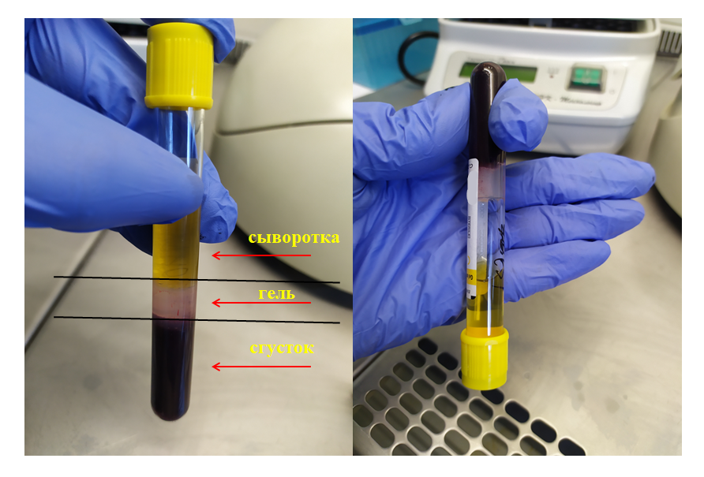

Figure 2 - Centrifuged vacutainer with biomaterial for ELISA

We studied the following btomarkers of bacterial translocation: lipopolysaccharide-binding protein (LPS-binding protein or LBP) and presepsin (sCD14), for the detection of which we used the following commercial kits for human blood with microplates:

- ELISA Kit for Presepsin (sCD14-ST, Human)

- ELISA Kit for Lipopolysaccharide Binding Protein (LBP, Human).

The method for determining markers in blood serum was carried out according to the manufacturer's instructions:

1. During thawing of frozen serum samples to room temperature, eight dilutions of the control standard (included in the kit) were prepared in microcentrifuge tubes depending on the concentration (from 0 to 200 ng / ml) to calibrate the results.

2. For determination of LBP levels only, sample serum was diluted 500 times (10 μl serum and 490 μl PBS solution).

3. Before working with the microplate, a protocol was filled out, where each sample and standards were distributed among the wells so as not to confuse the results of the samples.

4. In the wells of the microplate, coated with biotinylated antibodies specific to the studying markers, 100 μL of samples of the studied serum were placed and in separate wells, 100 μL of the obtained standard dilutions. Then was incubated for 1 hour at 370С.

5. Then all the liquid was removed without washing, 100 μl of Detection reagent A (avidin conjugated with horseradish peroxidase) was added and incubated for 1 hour at 370С.

6. Then, the wells were washed three times in the Evolis ELISA robotic system from BioRad (Figure 3), then 100 μL of Detection reagent B was added and incubated for 30 min at 370С.

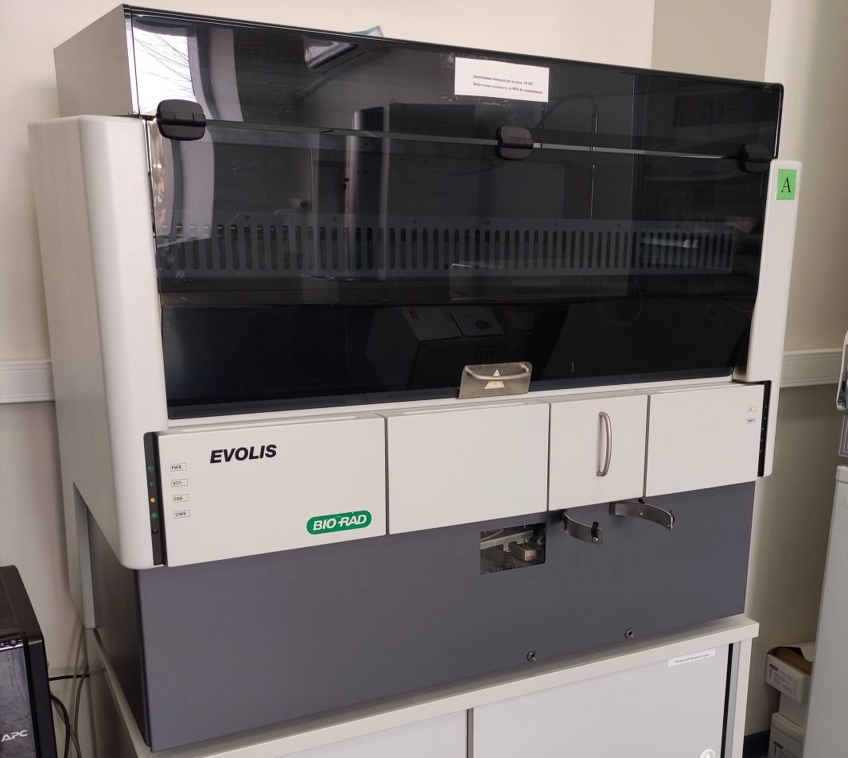

Figure 3 - ELISA robotic system Evolis from BioRad

7. After incubation, the wells were washed again in the Evolis system (five times) and 90 μl of a TMB substrate solution (Substrate solution) was added and incubated for 10-20 min at 37 ° C, while only those wells containing the studied markers changed color depending on the concentration of the marker in serum.

8. After incubation, 50 μL of Stop Solution was added and the wells that changed their color, again changed to yellow (Figure 4).

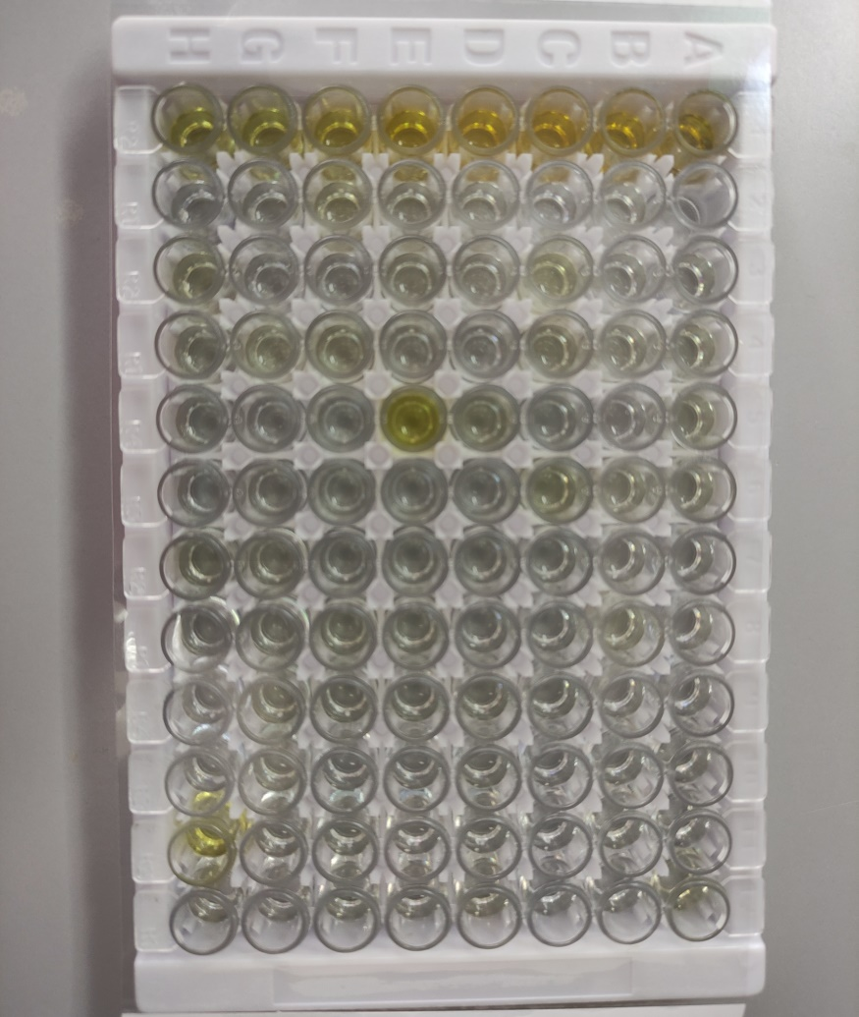

Figure 4 - Microplate for ELISA. Wells containing test markers changed color to yellow depending on the serum concentration of the marker

9. These color changes were measured spectrophotometrically in an Evolis system at a wavelength of 450 nm ± 10 nm, where the concentration of markers in the test samples was determined by comparing the optical density of the samples with standard calibration samples.

The evaluation of the result is carried out after the expiration of the study time specified in the analysis protocols, with saving as files in the memory of the server of the robotic system.

2.2.3 The collection, transportation and storage of mesenteric lymph nodes (Figure 5) for molecular genetic analysis was carried out according to the developed SOP "Collection, transportation and storage of mesenteric lymph nodes for the study of 16sRNA by PCR" (Appendix D).

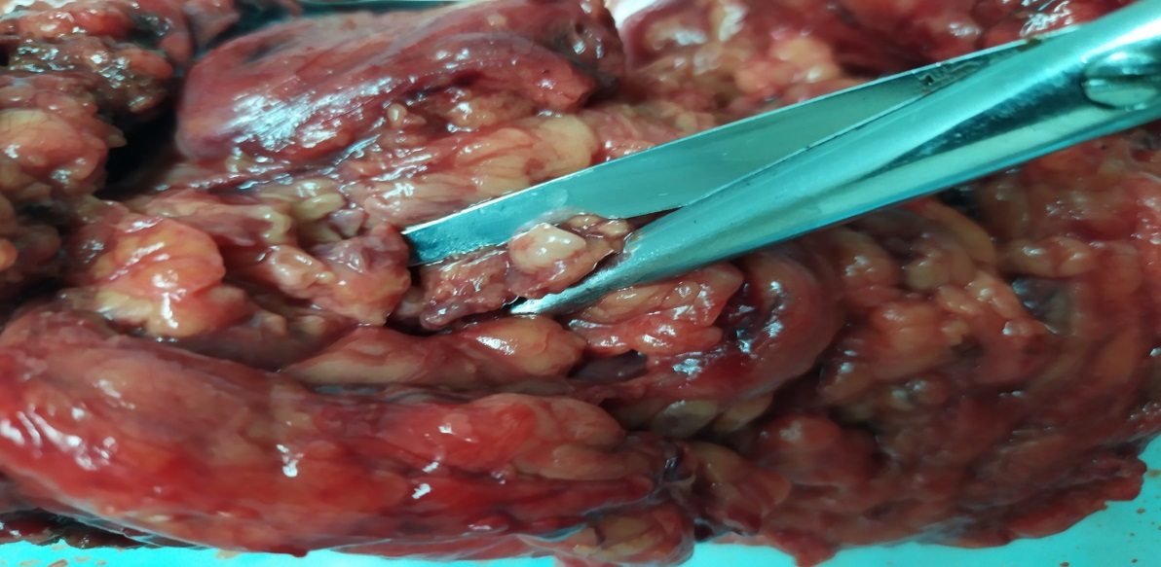

Figure 5 - Sampling of the mesenteric lymph node

Molecular genetic detection of microorganisms in the lymph nodes of patients was carried out using real-time PCR on a BIO-RAD CFX96 amplifier (Figure 6).

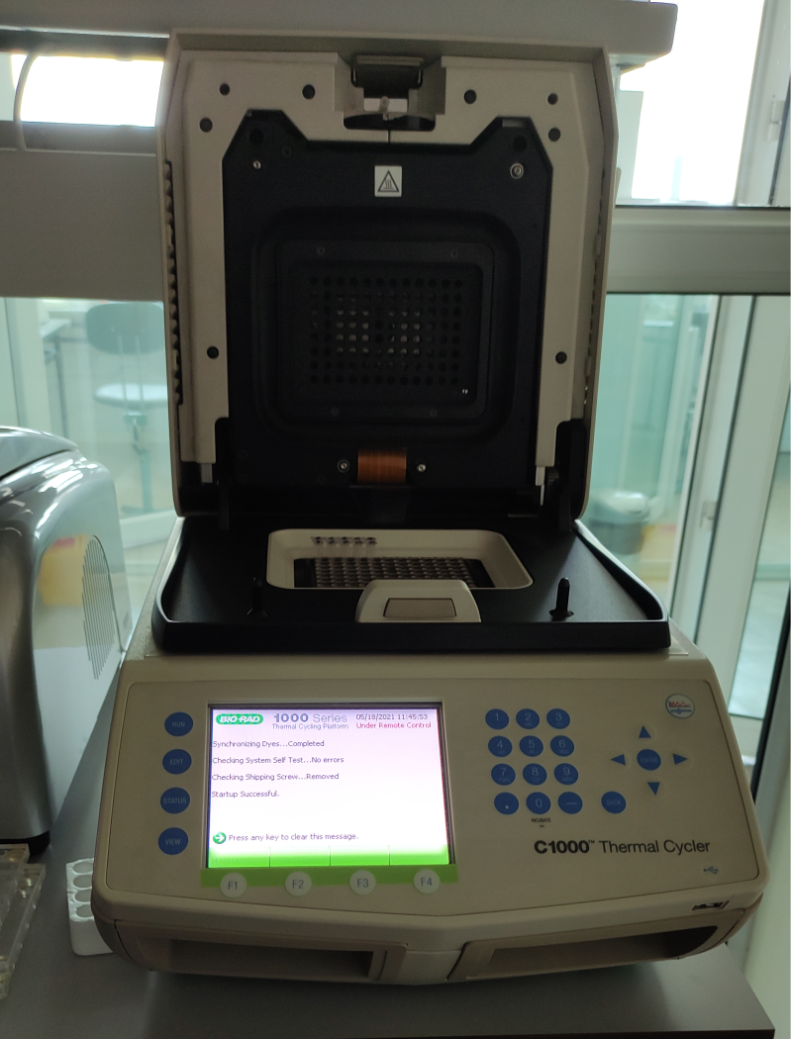

Figure 6 - Amplifier BIO-RAD CFX96

To isolate DNA from MLN samples, a GeneJET Genomic DNA Purification Kit was used. To simulate the translocation of microorganisms in MLN, a suspension of laboratory avirulent Escherichia coli GFP 6 serotype biotype 1 (ATCC® 25922GFP ™) with CFU values from 108 to 102 was added to the obtained samples of lymph nodes (up to 20 mg).

At this stage, MLN samples (up to 20 mg) with an added suspension of bacteria with CFU from 108 to 102, as well as MLN without the addition of a material suspension, were homogenized to reduce the lysis time and placed in microcentrifuge tubes with the addition of 180 μL Digestion Solution and 20 μL Proteinase solution K, thoroughly shaking on a vortex, then incubated at 56 ° C until the tissues are completely lysed (on average, it takes up to 3-4 hours), periodically shaking on a vortex.

In order to destroy RNA, 20 μl of RNase A solution was added, followed by incubation for 10 minutes at room temperature.

To the resulting mixture were added 200 μl of lysis solution and 400 μl of 50% ethanol. After each stage, the sample was thoroughly mixed on a vortex. The prepared mixture was transferred to special spin columns with a collection tube and centrifuged for 1 min at 6000 x g. After each centrifugation, the spin column was placed in a new collection tube. Then the samples were washed with 500 μl of wash buffer I and 500 μl of wash buffer II with centrifugation after each addition. Before the addition of 200 μL of elution buffer, the spin column was placed in a sterile microcentrifuge tube, followed by incubation for 2 min at room temperature and centrifugation for 1 min at 8000 x g.

The resulting DNA was immediately used for real-time PCR.

At the next stage, for amplification from the isolated DNA, a reaction mixture was prepared (the number and name of the components of which are indicated in Table 2).

Table 2 - Components of the reaction mixture for the amplification stage

|  |  |
| --- | --- |
| Component | Required volume |
| Nuclease free water | 4 mkL |
| Master Mix Maxima SYBR Green | 10 mkL |
| Primer U16SRT-F  FACTCCTACGGGAGGCAGCAGT | 1 mkL |
| Primer U16SRT-R  TATTACCGCGGCTGCTGGC | 1 mkL |
| Tested DNA sample | 4 mkL |

A sample without bacterial DNA was used as a negative control. As a positive control, we used a DNA sample of a laboratory avirulent Escherichia coli GFP 6 serotype biotype 1 (ATCC® 25922GFP™).

Then the microcentrifuge tubes were loaded into the plate of the BIO-RAD CFX96 thermocycler. Amplification was carried out with the following parameters: denaturation at 95°C for 10 minutes; "Annealing" and elongation - 40 cycles at 95 ° C for 15 seconds and at 62 ° C for 60 seconds. The detection of the results was carried out according to the value of the threshold cycle of the amplification curve.

2.2.4 Processing of the obtained results by statistical methods will be carried out by the IBM SPSS Statistics 20.0 program, with calculation for each biomarker indicator of mean (M), standard deviation (SD) and interquartile range (IQR). Testing of statistical hypotheses for dependent groups (between marker values before and after surgery on the 1st and 3rd day in each of the groups) will be carried out using the nonparametric Wilcoxon T-test. For 2 independent groups, statistical hypotheses will be tested using the nonparametric Mann - Whitney U-test. To identify the correlation relationship, the Spearman correlation coefficient will be calculated. Moreover, α = 0.05, 1-β = 80%. Results at p <0.05 will be considered statistically significant.

**3 Research results**

**3.1 Characteristics of the patients**

50 operated colorectal cancer patients (21 men and 29 women aged 38–89 years) took part in the study. The average age was 65.7 ± 12.4 years (IQR 60-75 years). All patient characteristics are presented in Table 3.

Table 3 - Basic characteristics of the studied patients

|  |  |
| --- | --- |
| Characteristic | Number (n, %) |
| Age | 65,7±12,4 года (IQR 60-75 years) |
| Gender | |
| Male | 21 (42%) |
| Female | 29 (58%) |
| Cancer staging | |
| I | 7 (14%) |
| II | 23 (46%) |
| III | 12 (24%) |
| IV | 8 (16%) |
| Localization of the tumor |  |
| Rectum | 7 (14%) |
| Rectosigmoid junction | 4 (8%) |
| Sigmoid colon | 20 (40%) |
| Colon | 14 (28%) |
| Cecum | 5 (10%) |
| SIRS | |
| Absence | 13 (52%) without ABO and 17 (68%) with ABO |
| Presence | 12 (48%) without ABO and 8 (32%) with ABO |
| Complications | |
| Absence | 18 (72%) without ABO and 17 (68%) with ABO |
| Presence | 7 (28%) without ABO and 8 (32%) with ABO |
| Wound suppuration | 1 |
| Anastomotic leak | 8 |
| Abdominal abscesses | 6 |
| Peritonitis | 6 |
| Sepsis | 5 |

The most common postoperative complication was anastomotic leakage (8 patients, 16%). Five patients had a combination of several complications, mainly anastomotic leakage and abdominal abscesses. Only in 4 patients developed sepsis (8%) - three in the group with ABO and two without ABO. There was no difference between the incidence of complications in patients with ABO and without it (32% and 28%, respectively).

**3.2 Results of immunological studies of biomarkers**

The study of markers was carried out using special commercial ELISA kits for human blood. Comparison of the level of biomarkers in the experimental and control groups is presented in Table 4.

Table 4 - Comparison of the level of biomarkers of bacterial translocation in operated colorectal cancer patients with and without acute bowel obstruction

|  |  |  |  |  |  |
| --- | --- | --- | --- | --- | --- |
| Markers | Indicators | Groups | | | |
| Operated colorectal cancer patients with acute bowel obstruction | | Operated colorectal cancer patients without acute bowel obstruction | |
| One hour before surgery | 72 hours after surgery | One hour before surgery | 72 hours after surgery |
| LBP ng/mL | N | 25 | | 25 | |
| M | 963,8 | 808,8 | 879,8 | 766,5 |
| SD | 195,2 | 208,4 | 221,8 | 159,4 |
| IQR | 810,7-1044,1 | 644,9-1031,8 | 749,3-1028,8 | 669,5-847,6 |
| sCD-14 pg/mL | N | 25 | | 25 | |
| M | 322,9 | 373,4 | 236,0 | 238,6 |
| SD | 123,9 | 151,7 | 71,6 | 97,0 |
| IQR | 194,4-393,3 | 229,8-499,4 | 198,9-265,2 | 167,9-269,6 |

In both groups, the average LBP level significantly decreased in 72 hours after surgery (p = 0.004 in the group without ABO and p = 0.023 with ABO). There were no statistical differences between LBP levels before and after surgery between the two study groups (p = 0.122). A decrease in LBP levels of more than 280 ng / ml increases the development of SIRS (OR 6.6, 95% CI: 1.1-40.9). In patients with ABO and SIRS, the LBP value decreased significantly more than in patients with ABO and without SIRS (p = 0.046). There were no statistical differences between changes in the dynamics of the LBP level depending on the presence of postoperative complications (p = 0.532). A decrease in LBP levels of more than 280 ng / ml was found to increase the development of complications in operated CRC patients (OR 12.0, 95% CI: 1.8-80.4).

It can be assumed that the decrease in the LBP level over time may be associated with the normalization of intra-abdominal pressure, elimination of obstruction and removal of the tumor itself, which together caused BT. One study showed that the presence of low endotoxin (LPS) levels in patients with chronic disease promotes a persistent state of mild inflammation that interferes with the normal healing process [40], which may explain the high incidence of postoperative complications in these patients. Also, a decrease in the LBP level in operated colorectal cancer patients is possible due to immunodeficiency and inability of an adequate immune response to infectious stimuli, which can lead to a poor prognosis (SIRS and infectious-inflammatory complications).

The mean sCD-14 level was significantly higher in patients with ABO both before and after surgery (p = 0.038 and p = 0.007). It was also found that the average level of sCD14 before surgery above 330 pg / ml increases the development of SIRS and complications in these patients (OR 7.0, 95% CI: 1.3-36.7 and OR 5.5, 95% CI: 1.1-28.2 respectively). Differentiation of patients with or without organ dysfunction depending on the SOFA scale showed a statistical difference in sCD-14 levels 72 hours after surgery (p = 0.049). In the general cohort of patients without organ dysfunction (SOFA score = 0), the sCD-14 value was 260.6 ± 100.3 pg / ml (IQR 194.4-298.3) before surgery and 271.5 ± 118.5 pg / ml (IQR 176.8-360.1) after it. In patients with organ dysfunction 343.6 ± 108.7 pg / ml (IQR 269.6-417.6) and 447.5 ± 189.1 pg / ml (IQR 298.3-596.6), respectively.

There were no differences in the level of sCD14 and LBP before surgery and on the 3rd day after it, depending on the stage of the tumor process (p = 0.23, p = 0.52, p = 0.49 and p = 0.75, respectively).

It can be assumed that the presence of ABO on admission aggravates the violation of the permeability of the intestinal wall and causes the penetration of bacteria and their endotoxins into the systemic circulation, enhancing the immune response and causing SIRS and subsequent infectious and inflammatory complications.

**3.3 Results of molecular genetic research**

To calibrate and simulate the translocation of microorganisms in MLN, a suspension of laboratory avirulent strain Escherichia coli GFP 6 serotype biotype 1 (ATCC® 25922GFP ™) with CFU values from 108 to 102 was added to the obtained samples of lymph nodes (up to 20 mg).

After the stages of DNA extraction and amplification, the detection of the results was carried out according to the value of the threshold cycle of the amplification curve (Figures 7 and 8). An increase in the level of fluorescence was observed at 17-28 cycles for CFU 108-102, respectively. The amplification curves of the positive control and MLN samples differ, which is associated with the presence of elements inhibiting the amplification of DNA, in contrast to the pure culture diluted in saline.

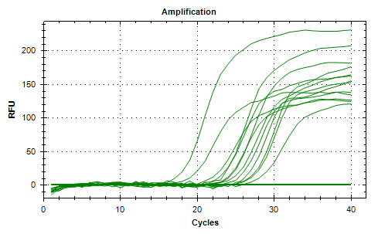

Figure 7 - Graphs of amplification of the tested samples

In order to determine the accumulation of a specific product and to further study the amplicons, the "melt curve" were plotted with a stepwise change in temperature.

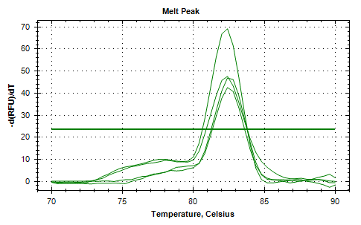

Figure 8 - Melting curves in the tested samples

According to the "melt curve" analysis, the melting temperature was 82°C for all amplicons, which characterizes the accumulation of a specific product. The height of the melting curves corresponded to the concentration of microorganisms in the samples and increased in direct proportion.

The proposed experiment has shown that the real-time PCR method can be used for the detection of microorganisms in MLN. According to the data obtained, the level of CFU / ml in MLN during bacterial translocation does not exceed 102.

A positive PCR result was obtained in the group with acute bowel obstruction in 11 of 25 samples (44%). In the group of patients without acute bowel obstruction, in all 25 samples a negative result was obtained, which was a statistically significant difference in the groups (Fisher's exact test p = 0.00012). Which suggests that with ABO of tumor origin, BT into the mesenteric lymph nodes is more likely than in parients with colorectal cancer without ABO.

**3.4 The relationship between direct and indirect markers of bacterial translocation**

Spearman's correlation coefficient was calculated to reveal the correlation between sCD14, LBP and 16s rRNA. At the same time, only a weak positive correlation was found between LBP levels before surgery and sCD14-ST levels on the 3rd day after surgery (p = 0.0284; r = 0.343). No correlation was found between 16s rRNA in mesenteric lymph nodes and markers of bacterial translocation in blood serum (p = 0.268 and p = 0.144, respectively).

**CONCLUSION**

In this research work:

- standard procedures have been developed for the collection, transportation and storage of the investigated biological material for immunological and molecular genetic research;

- a technique for molecular genetic study of mesenteric lymph nodes has been developed and tested, which makes it possible to use this technique as a direct method for detecting bacterial translocation;

- an immunological analysis of biomarkers of bacterial translocation (LBP, sCD14) in the blood serum of operated colorectal cancer patients with and without acute bowel obstruction was carried out.

It was found that the level of sCD14-ST in patients with acute bowel obstruction was much higher than in patients without acute bowel obstruction. Also, the LBP level in operated patients in both groups tends to decrease on the 3rd day after surgery. There were no differences in the level of sCD14 and LBP before surgery and on the third day after it, depending on the stage of the tumor process (p = 0.23, p = 0.52, p = 0.49 and p = 0.75, respectively). Higher preoperative sCD14-ST levels increase the development of postoperative complications, systemic inflammatory response, and organ dysfunction, making it a viable option as a diagnostic biomarker. A stronger decrease in LBP levels increases the development of a systemic inflammatory response and postoperative infectious and inflammatory complications;

Molecular genetic detection of bacterial DNA in mesenteric lymph nodes was carried out using real-time PCR technology. The developed method allows the qualitative determination of microbial DNA in MLN in a wide range of its concentrations. It was found that the proposed method is sensitive when the number of CFU bacteria is up to 102. Only a weak positive correlation was found between LBP levels before surgery and sCD14-ST levels on the 3rd day after surgery (p = 0.0284; r = 0.343). No correlation was found between 16s rRNA in mesenteric lymph nodes and markers of bacterial translocation in blood serum (p = 0.268 and p = 0.144, respectively).

**REFERENCES**

1 Gore R.M., Silvers R.I., Thakrar K.H., et al. Bowel obstruction // Radiologic Clinics of North America. – 2015. - V. 53(6). P.1225–1240.

2 Taylor M.R., Lalani N. Adult small bowel obstruction // Academic Emergency Medicine. -2013. – V. 20.- P.528–544.

3 Roses R.E., Folkert I.W., Krouse R. S. Malignant Bowel Obstruction // Surgical Oncology Clinics of North America. - 2018. – V. 27(4). - P. 705-715. doi:10.1016/j.soc.2018.05.010.

4 Shwaartz, C., Fields, A.C., Prigoff, J.G., Aalberg, J.J., Divino, C.M. Should patients with obstructing colorectal cancer have proximal diversion? // The American Journal of Surgery. - 2017. – V. 213(4). - P. 742–747. doi:10.1016/j.amjsurg.2016.08.005.

5 Chiu H.-C., Lin Y.-C., Hsieh H.-M., Chen H.-P., Wang H.-L., Wang J.-Y. The impact of complications on prolonged length of hospital stay after resection in colorectal cancer: A retrospective study of Taiwanese patients // Journal of International Medical Research. – 2017. – V. 45(2). - P.691–705. doi:10.1177/0300060516684087.

6 Simillis C., Kalakouti E., Afxentiou T., Kontovounisios C., Smith J.J., Cunningham D., Adamina M., Tekkis P.P. Primary Tumor Resection in Patients with Incurable Localized or Metastatic Colorectal Cancer: A Systematic Review and Meta-analysis // World Journal of Surgery. – 2019 Jul. – V. 43(7). - P.1829-1840. doi: 10.1007/s00268-019-04984-2.

7 Wancata L. M., Abdelsatta, Z. M., Suwanabol P. A., Campbell D. A., & Hendren S. Outcomes After Surgery for Benign and Malignant Small Bowel Obstruction // Journal of Gastrointestinal Surgery. – 2016. – V. 21(2). - P. 363–371. doi:10.1007/s11605-016-3307-8.

8 Stubljar D., Skvarc М. Effective Strategies for Diagnosis of Systemic Inflammatory Response Syndrome (SIRS) due to Bacterial Infection in Surgical Patients // Infection Disorder Drug Targets. – 2015. – V. 15(1). - P.53- 56.

9 Flexner S. Peritonitis caused by the invasion of the micrococcus Lanceolatus from the intestine // Johns Hopkins Hospital bulletin. – 1995. – V. 6. - P.64-67.

10 Levy M., Kolodziejczyk A.A., Thaiss C.A., Elinav E. Dysbiosis and the immune system // Nature Reviews Immunology. - 2017. – V. 17. - P.219-232.

11 Piton G., Capellier G. Biomarkers of gut barrier failure in the ICU. // Current Opinion in Critical Care. - 2016 Apr. – V. 22(2). - P.152-160.

12 Tsujimoto H., Ono S., & Mochizuki H. Role of Translocation of Pathogen-Associated Molecular Patterns in Sepsis // Digestive Surgery. – 2009. – V. 26(2). - P.100–109. doi:10.1159/000206143.

13 MacFie J., Reddy B.S., Gatt M. et al: Bacterial translocation studied in 927 patients over 13 years // British Journal of Surgery. – 2006. – V. 93. - P.87–93.

14 Fang L., Xu Z., Wang G. S., Ji F., Mei C., Liu J., Wu G. Directed evolution of an LBP/ CD14 inhibitory peptide and its anti-endotoxin activity // PLoS One. – 2014. – V .9(7). e101406. doi:10.1371/journal.pone.0101406.

15 Stehle J.R., Leng X., Kitzman D.W., Nicklas B.J., Kritchevsky S.B., High K.P. Lipopolysaccharide-Binding Protein, a Surrogate Marker of Microbial Translocation, Is Associated With Physical Function in Healthy Older Adults // The Journals of Gerontology Series A: Biological Sciences and Medical Sciences. - 2012. – V. 67(11). - P.1212–1218. doi:10.1093/gerona/gls178.

16 Kell D.B., Pretorius E. On the translocation of bacteria and their lipopolysaccharides between blood and peripheral locations in chronic, inflammatory diseases: the central roles of LPS and LPS-induced cell death // Integrative Biology. – 2015. – V. 7(11). -P.1339–1377. doi:10.1039/c5ib00158g.

17 Mierzchala M., Krzystek-Korpacka M., Gamian A., Durek G. Quantitative indices of dynamics in concentrations of lipopolysaccharide-binding protein (LBP) as prognostic factors in severe sepsis/septic shock patients — Comparison with CRP and procalcitonin // Clinical Biochemistry. -2011. – V. 44(5-6).- P.357–363. doi:10.1016/j.clinbiochem.2011.01.012.

18 Mussap M., Noto A., Fravega M., Fanos V. Soluble CD14 subtype presepsin (sCD14-ST) and lipopolysaccharide binding protein (LBP) in neonatal sepsis: new clinical and analytical perspectives for two old biomarkers // The Journal of Maternal-Fetal & Neonatal Medicine. -2011. – V. 24(2). - P.12–14.

19 van Maldeghem I., Charlotte M., Douwe H. Visser Nusman. Soluble CD14 subtype (sCD14-ST) as biomarker in neonatal early-onset sepsis and late-onset sepsis: a systematic review and meta-analysis // BMC Immunology. - 2019. – V. 20(17). doi: 10.1186/s12865-019-0298-8.

20 Hosomi S., Yamagami H., Itani S, Yukawa T., Otani K., Nagami Y. et al. Sepsis Markers Soluble IL-2 Receptor and Soluble CD14 Subtype as Potential Biomarkers for Complete Mucosal Healing in Patients With Inflammatory Bowel Disease // Journal of Crohn's and Colitis. - 2018 Jan. – V. 5:12(1). - P.87-95. doi: 10.1093/ecco-jcc/jjx124.

21 Masson S., Caironi P., Fanizza C., Thomae R., Bernasconi R. et al. Circulating presepsin (soluble CD14 subtype) as a marker of host response in patients with severe sepsis or septic shock: data from the multicenter, randomized ALBIOS trial // Intensive Care Medicine. - 2015 Jan. – V. 41(1). - P.12-20. doi: 10.1007/s00134-014-3514-2. Epub 2014 Oct 16.

22 Endo S., Suzuki Y., Takahashi G., Shozushima T., Ishikura H., Murai A., Okamura, Y. Presepsin as a powerful monitoring tool for the prognosis and treatment of sepsis: A multicenter prospective study // Journal of Infection and Chemotherapy. – 2014. - V. 20(1). -P.30–34. doi:10.1016/j.jiac.2013.07.005.

23 «AVMA Guidelines for the Euthanasia of Animals: 2013 Edition» by the American Veterinary Medical Association. 102P.

24 Ojima M., Motooka D., Shimizu K., Gotoh K., Shintani A., Yoshiya K. et al. Metagenomic analysis reveals dynamic changes of whole gut microbiota in the acute phase of intensive care unit patients // Digestive Diseases and Sciences. – 2016. – V. 61. - P. 1628–34.

25 Lankelma J.M., van Vught L.A., Belzer C., Schultz M.J., van der Poll T. et al. Critically ill patients demonstrate large interpersonal variation in intestinal microbiota dysregulation: a pilot study // Intensive Care Medicine. – 2017. – V. 43. - P.59–68.

26 Freedberg D.E., Zhou M.J., Cohen M.E., Annavajhala M.K., Khan S., Moscoso D.I. et al. Pathogen colonization of the gastrointestinal microbiome at intensive care unit admission and risk for subsequent death or infection // Intensive Care Medicine. – 2018. - V. 44. - P.1203–11.

27 Van Praagh J.B., de Go_au M.C., Bakker I.S. et al. Mucus microbiome of anastomotic tissue during surgery has predictive value for colorectal anastomotic leakage // Annals of Surgery – 2019. – V. 269. - P. 911–916.

28 Klingensmith N.J., Coopersmith C.M. The gut as the motor of multiple organ dysfunction in critical illness // Criticsl Care Clinics. – 2016. – V.32. - P.03–212.

29 Haak B.W., Wiersinga W.J. The role of the gut microbiota in sepsis // Lancet Gastroenterology Hepatology. - 2017. – V. 2. - P.135–143.

30 Ding J.W., Andersson R., Soltesz V., Wille´n R., Bengmark S. Obstructive jaundice impairs reticuloendothelial function and promotes bacterial translocation in the rat // Journal of Surgical Research. – 1994. – V. 57(2). - P.238–245.

31 Reynolds J.V., Murchan P., Redmond H.P., et al. Failure of macrophage activation in experimental obstructive jaundice: association with bacterial translocation // British Journal of Surgery. – 1995. – V. 82(4). - P. 534–538

32 Assimakopoulos S.F., Vagianos C.E., Patsoukis N., Georgiou C., Nikkolopoulou V., Scopa C.D. Evidence for intestinal oxidative stress in obstructive jaundice-induced gut barrier dysfunction in rats // Acta Physiologica Scandinavica. - 2004. – V. 180. - P.177-85.

33 Levy M., Kolodziejczyk A.A., Thaiss C.A., Elinav E. Dysbiosis and the immune system. Nature Reviews Immunology. – 2017. – V. 17. - P.219-32.

34 van der Poll T., van de Veerdonk F.L., Scicluna B.P., Netea M.G. The immunopathology of sepsis and potential therapeutic targets // Nature Reviews Immunology. – 2017. – V. 17. - P.407–420.

35 Schietroma M., Pessia B., Colozzi S. et al. Septic complications after resection for middle or low rectal cancer: role of gut barrier function and inflammatory serum markers // Digestive Surgery- 2017. – V. 34(6). - P. 507–517. doi:10.1159/000475847.

36 Takesue Y., Kakehashi M., Ohge H., et al. Bacterial translocation: not a clinically relevant phenomenon in colorectal cancer // World Journal of Surgery. – 2005. – V. 29(2). - P. 198–202. doi:10.1007/s00268-004-7576-0.

37 Assimakopoulos S. F., Triantos C., Thomopoulos K., Fligou F., Maroulis I., Marangos M., & Gogos C. A. Gut-origin sepsis in the critically ill patient: pathophysiology and treatment // Infection. - 2018. – V. 46(6). – P.751-760. doi:10.1007/s15010-018-1178-5

38 Ames N. J., Ranucci A., Moriyama B., & Wallen, G. R. The Human Microbiome and Understanding the 16S rRNA Gene in Translational Nursing Science // Nursing Research. - 2017. - V. 66(2). - P. 184–197. doi:10.1097/nnr.0000000000000212

39 Schoeffel U., K. Pelz, R. U. Häring, R. Amberg, R. Schandl, R. Urbaschek. Inflammatory consequences of the translocation of bacteria and endotoxin to mesenteric lymph nodes // The American Journal of Surgery.- 2000. – V. 180 (Issue 1). - P. 65-72.

40 Vincent, J.-L., Moreno, R., Takala, J., Willatts, S., De Mendonça, A., Bruining, H., Thijs, L. G. The SOFA (Sepsis-related Organ Failure Assessment) score to describe organ dysfunction/failure // Intensive Care Medicine. – 1996. – V. 22(7). P.707–710. doi:10.1007/bf01709751

**APPENDIX A**

**Project implementation plan**



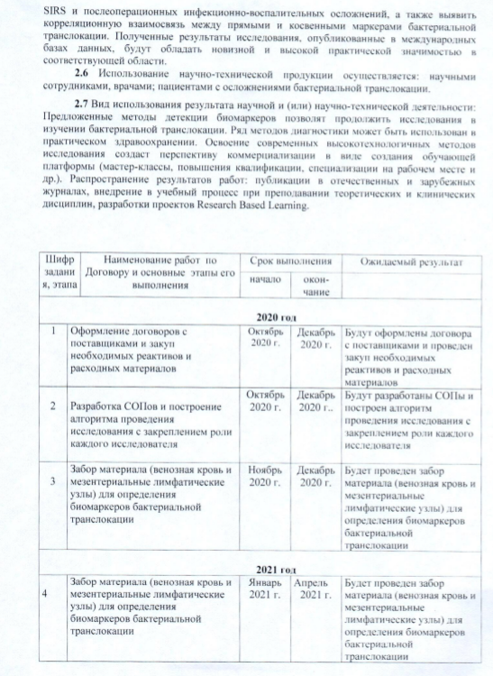

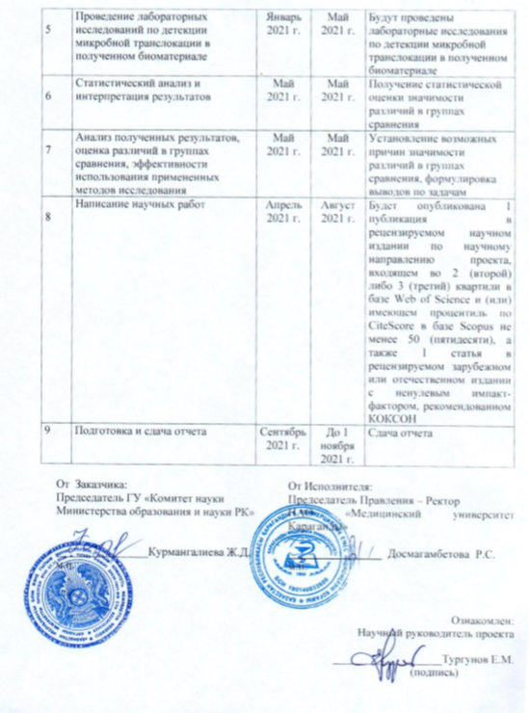

**Project implementation plan**

|  |  |  |  |  |
| --- | --- | --- | --- | --- |
| № | Name of tasks and activities for their implementation | Start of execution (dd / mm / yy) | Expected results of the project (in terms of tasks and activities), completion form | |
| 2020 year | 2021 year |
| 1 | 2 | 4 | 6 | 7 |
| 1 | Drawing up contracts with suppliers and purchasing the necessary tools, equipment, reagents | October 2020 –December 2020 | Contracts with suppliers will be drawn up and the necessary tools, equipment, reagents purchased |  |
| 2 | Development of SOPs and construction of an algorithm for conducting research with fixing the role of each researcher | October 2020 –December 2020 | SOPs will be developed and a research algorithm will be built with the role of each researcher fixed |  |
| 3 | Material sampling (venous blood and mesenteric lymph nodes) for determining biomarkers of bacterial translocation | November 2020 - April 2021 | Material sampling (venous blood and mesenteric lymph nodes) will be carried out to determine bacterial biomarkers | Material sampling (venous blood and mesenteric lymph nodes) will be carried out to determine bacterial biomarkers |
| 4 | Laboratory studies for the detection of microbial translocation in the biomaterial | January 2021 - May 2021 |  | Laboratory studies will be conducted to detect microbial translocation in the resulting biomaterial |
| 5 | Statistical analysis and interpretation of results | May 2021 |  | Obtaining a statistical assessment of the significance of differences in comparison groups |
| 6 | Analysis of the results, assessment of differences in comparison groups, the effectiveness of the use of applied research methods | May 2021 |  | Establishment of possible reasons for the significance of differences in comparison groups, formulation of conclusions on tasks |
| 7 | Writing Scientific Papers | April 2021 - August 2021 |  | Publications according to the requirements of the tender documentation |
| 8 | Report preparation and submission | September 2021 - 1 November 2021 |  | Report submission |

**APPENDIX B**

**Act of implementation**

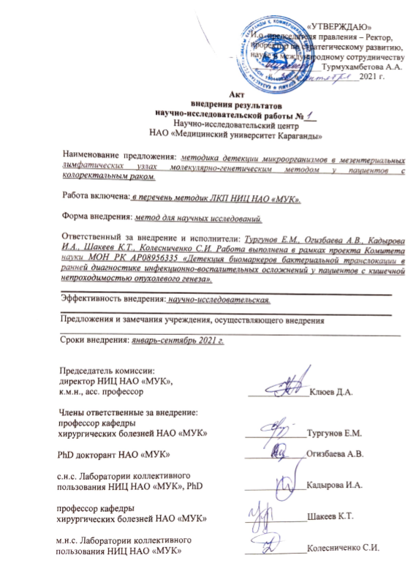

**APPENDIX C**

**List of publications**

1. Alina Ogizbayeva , Yermek Turgunov. Bacterial translocation in colorectal cancer patients. J CLIN MED KAZ, Volume 18, Issue 3, pp. 8-13. <https://doi.org/10.23950/jcmk/10926> (recommended by CQES).
2. Yermek Turgunov, Alina Ogizbayeva, Lyudmila Akhmaltdinova, Kayrat Shakeyev. Lipopolysaccharide-binding protein as a risk factor for development of infectious and inflammatory postsurgical complications in colorectal cancer patients // Contemp oncol (Pozn). – 2021. – V. 25 (3). – P. 198-203. DOI: <https://doi.org/10.5114/wo.2021.110051> (Scopus - Q2, 54%).
3. Ogizbayeva A.V., Kadyrova I.A., Turgunov Y.M., Shakeyev K.T., Kolesnichenko S.I., Savazova K.S.Certificate of entering information into the state register of rights to objects protected by copyright No 19250 dated July 8, 2021 "Detection of microorganisms in mesenteric lymph nodes by the molecular genetic method in patients with colorectal cancer" (a work of science). (Огизбаева А. В., Кадырова И. А., Тургунов Е. М., Шакеев К. Т., Колесниченко С. И., Савазова К. С. Свидетельство о внесение сведений в государственный реестр прав на объекты, охраняемые авторским правом No 19250 от «8» июля 2021 года «Детекция микроорганизмов в мезентериальных лимфатических узлах молекулярно-генетическим методом у пациентов с колоректальным раком» (произведение науки)).

**APPENDIX D**

**Standard operating procedures**

