Ministry of Education and Science of the Republic of Kazakhstan
Committee of Science

REPUBLICAN STATE ENTERPRISE
"INSTITUTE OF ZOOLOGY"
(RSE "IZ" CES MES RK)

UDC 576.895.42 | APPROVED
State registration No. 0120РК00400 | Director General
Inv.No. | RSE "Institute of Zoology" CS MES RK
 | _____________ R.V. Jashenko
 | «____»_________________ 2021 y.

REPORT
ABOUT RESEARCH WORK
АР08956740 DEVELOPMENT OF AN ACARICIDAL PREPARATION AGAINST ANIMAL ARACHNOSES
(annual)

Head of Research work
Candidate of Veterinary
Sciences, Professor ____________________ Suleimenov M.Zh.

Almaty 2021 у
LIST OF PERFORMERS

Project Manager, Leading Researcher | ______________________________  signature, date | M.Zh. Suleimenov  (introduction; sections 1-2, conclusion)
Research Associate | _______________________________.  signature, date | L.O. Zhantelieva  (sections 1-2)
Research Associate | _______________________________.  signature, date | A.M. Myrzhieva  (sections 1-2)
Norm controller | _______________________________.  signature, date | S. K. Khasenova

REPORT
Report 31 p., 15 fig., 13 tables, 37 sources, 8 app.
ARACHNOSES, IXODE MITES, BIOTOPE, ACARICIDES, ECTOPARASITE, TRANSFASE TRANSMISSION, VECTOR-BORNE DISEASES
The objects of the study are slaughtered horses, cattle, dogs.
The aim is to study the species composition of ixodic ticks and develop an effective, environmentally safe means to protect against the most common ectoparasites of animals.
Methods of research - collection of collections of blood-sucking ticks, a patent search was made on ways to detect infection of ticks with blood parasites: anaplasmas, pyroplasmas and teileria, epizootological monitoring of the spread of ticks, epizootic monitoring of the spread of ticks infected with pathogens of infectious and invasive diseases, seasonal and age dynamics of ixodic ticks in the southern regions of Kazakhstan.
The developed drugs of prolonged action containing components that enhance the acaricidal activity of the agent will prolong its activity and thereby reduce by 2-3 times the number of anti-tick treatments of animals.
Scope of application - veterinary medicine, veterinary institutions, laboratories, points, farms and private farms and peasant farms in the Republic of Kazakhstan.
The scientific and practical significance of the work lies in the fact that scientific research was conducted in Kazakhstan, mainly of an epizootological nature, which determined the species composition of ticks. The leading event in the system of combating pathogens of vector-borne diseases is the destruction of their vectors - ixod mites. The development of new acaricidal drugs will contribute to the prevention of economic and social damage and is aimed at improving the safety of the environment and humans. The proposed technology will use compositions of environmentally friendly acaricidal preparations and various means to prolong the action of drugs in order to reduce the number of treatments and reduce the load on the animal body and the external environment.
The developed drugs will have an advantage in duration of action, which will reduce the number of anti-tick treatments of animals compared to similar drugs.
Analyzing the data obtained, it can be noted that the preparations prepared by us showed high efficiency against animal ectoparasites.

CONTENT

 | р.
INTRODUCTION ………………………………………………………………… | 7
THE MAIN PART OF THE RESEARCH REPORT……………………………….. | 9
1 Materials and methods of research ………………………………………………… | 11
2 Research results ......................................................................................................... | 16
2.1 Conducting expedition trips, studying the spread of ticks in some areas of the Zhambyl region ………………………………………………………………………. | 16
2.2 Research and distribution of ticks in the Turkestan region.................................. | 20
2.3 Development of a prolonged-acting drug …………………………………….  2.4 Acaricide drug testing ………………………………………………………… | 24  26
CONCLUSION............................................................................................................. | 31
LIST OF SOURCES USED.......................................................................................... | 32
Appendix A-  .  Calendar plan……………....................................................................... | 36
Appendix В- Testing acts……………………………………………………………… | 38
Appendix C- Seminar information …………………………………………………… | 44
Appendix D – Publications……………………………………………………………. | 45
Appendix E – Patantes………………………………………………………………… | 46
Appendix F - Reprints of published works …………………………………………... | 47
Appendix G - Methodical recommendation…………………………………………… | 50
Appendix H - Certificate of acceptance for publication | 53

TERMS AND DEFINITIONS
In this R& W report, the following terms are used with appropriate definitions:
Acaricides – | a group of drugs aimed at the destruction of ticks
Biological carrier – | the carrier, in whose body the causative agent of the disease develops, passes from one stage to another, changes morphologically
Biotope – | habitat and reproduction of ixodic ticks
DUST | powdered form of insecticide used to kill harmful insects and mites
Two - household ticks– | larvae and nymphs feed on one species of animals, and imagos on the second species (Rhipicephalus bursa, Hyalomma plumbeum, H. detifum)
Ixode ticks – | a group of temporary ectoparasites - blood-sucking ticks whose habitats are pastures
Imago – | male and female stages with a developed reproductive system
Mechanical carrier – | this is a vector (tick) in whose body the causative agent of the disease does not develop
Nymph – | the stage of ticks with an underdeveloped reproductive system
Romanowsky–Giemsa staining – | a method of coloring blood cells and hematopoietic organs in smears with a mixture of eosin, azura and methylene blue paints. The nuclei turn purple, and the cytoplasm turns light blue.
Egg – | the first stage, which is secreted by female ixod mites
Hyalomma (glass eye) – | a genus of ticks from the family Ixodidae (Ixodes)
Ixodes (trailer) - | a genus of ticks from the family Ixodidae (Ixodes)
Dermacentor (leather cutter) - | a genus of ticks from the family Ixodidae (Ixodes)
Haemaphysalis - | a genus of ticks from the family Ixodidae (Ixodes)
Rhipicephalus- | a genus of ticks from the family Ixodidae (Ixodes)

LIST OF ABBREVIATIONS AND DESIGNATIONS
The following designations and abbreviations are used in this research report:
AS - | active substance
AI – | abundance index
EI – | the extent of the invasion
c. – | city
CCHF - | Crimean–Congo hemorrhagic fever
II – | intensity of invasion
ml – | Milliliter
Micro – | Micrograms
PF – | peasant farming
PC – | production cooperative
LLP – | limited liability partnership
RK – | Republic of Kazakhstan
TE – | tick-borne encephalitis
y., yy. | year, years

INTRODUCTION
According to scientific sources, in recent years, ticks have become widespread in Kazakhstan in the southern regions of the country, where blood parasitic diseases are also massively registered, while there is only fragmentary information about tests of known acaricidal drugs. The development of new and improvement of existing antiparasitic (anti-tick) drugs of domestic production will reduce the cost of carrying out complex measures aimed at prevention and therapy against arachnosis, prevent the disease of humans and animals with dangerous infectious and parasitic diseases. The development, testing and introduction into veterinary practice of domestic drugs against parasites will prevent economic damage caused to animal husbandry. In addition, ticks are blood-sucking parasites, when they are massive due to a significant amount of blood being sucked out, animals have a loss in live weight, anemia, severe itching at the bite site, and a decrease in milk yields. Ticks cause especially great damage to animal husbandry as carriers of pathogens of pyroplasmidosis diseases of farm animals [7-9].
In recent years, due to changes in economic conditions, the absence of planned anti-tick measures, an increase in the area of uncultivated land, there has been a trend of a sharp increase in the population of blood-sucking ticks and, as a consequence, the emergence of new foci unfavorable for vector-borne diseases. Example: outbreaks of Congo-Crimean hemorrhagic fever with fatal outcome among the population in the southern regions of the Republic of Kazakhstan [1-7].
Unsystematic, without scientifically based screening, the use of anti-tick drugs generates, in turn, an environmental problem, since many drugs pollute environmental objects, do not disintegrate for a long time, have cumulative, allergic, teratogenic, embryogenic, thyrotoxic and carcinogenic effects. Their use requires certain restrictions in the use of animal products, traces of acaricidal drugs are found even in processed products, for example, in oil.
In solving the problem of tick control, it is of great importance to develop and find new drugs that are low-toxic for warm-blooded animals, do not stand out with milk, do not accumulate in organs and tissues and at the same time have a longer residual effect against blood-sucking ticks on the skin and hair [8-11].
Parasitiform mites (family Ixodidae - ixodes) are widespread in the south of Kazakhstan and cause significant economic damage to livestock farms. The infestation of animals with ticks in dysfunctional farms reaches 100%, and their infection with ticks, which are transmitted by ticks, was 80%. The intensity of invasion, on average, was 15-30 ticks per animal. During the period of parasitization on the host, ticks, on the one hand, cause a decrease in dairy, meat productivity and the quality of raw materials, and on the other hand, they are obligate hematophages and specific biological carriers of dangerous human and animal diseases (Congo - Crimean hemorrhagic fever (CCHF) and tick-borne encephalitis (TE) in humans; brucellosis, encephalitis, teileriosis, piroplasmidosis and other diseases in animals) [10]. Scientifically-based screening of anti-tick drugs can be used by veterinary practitioners and in the educational process in agricultural universities. The introduction of a rational scheme for the use of anti-tick drugs, taking into account the seasonal activity of ticks, saves drugs and prevents environmental problems associated with the unsystematic use of acaricides. Prevention of a whole group of blood-parasitic animal diseases that cause significant economic damage to breeding will solve a number of problems associated with the import of highly productive breeding animals to the region [12-16].
The planned work will allow further development of new acaricidal drugs with prolonged action for the treatment and prevention of animal arachnoses. Patent research has been conducted in search depth for 10 years. At the same time, it was found that in the Republic of Kazakhstan, a description of 7 preliminary and innovative patents, 5 utility model patents was published; in Russia – 2, in the far abroad – 1 on this topic. The urgency of the development problem lies in the fact that new acaricidal drugs with prolonged action will be developed for the treatment and prevention of animal arachnoses. The optimal dosage and regimens for the use of acaricidal drugs have been worked out. Creation of a rational scheme for integrated control of blood-sucking ticks, taking into account the characteristics of tick biotopes and their biological characteristics, as well as the creation of a new product, new compositions of acaricidal drugs with prolonged action, promising in environmental terms. It consists in the fact that for the first time a new acaricidal drug will be developed, as well as measures to combat blood-sucking ticks in the southern regions of the Republic of Kazakhstan.
The aim of the project is to study and spread ticks in the south of Kazakhstan and to find new acaricidal agents for the destruction of blood-sucking ticks - carriers of animal and human diseases.
The name of the interim report and its inventory number:
Development of an acaricidal preparation against animal arachnoses: research report (interim) // RSE at the Institute of Zoology: Head Suleimenov M.Zh. – 2020 – 31 S. SR No.0120RK00400; Inv. number No.0220RK01961.
Project objectives:
1. Conducting expedition trips, studying the spread of ticks in some areas of the Zhambyl region and their role in the spread of diseases carried by ectoparasites.
2. Research and distribution of ticks in the Turkestan region, their role in the spread of diseases carried by ectoparasites.
3. Development of a prolonged-acting drug.
4. Acaricide drug testing.
THE MAIN PART OF THE RESEARCH REPORT
In recent years, due to changes in economic conditions and an increase in the area of uncultivated land, there has been a trend of a sharp increase in the population of blood-sucking ticks - carriers of blood parasitic diseases of animals, and as a consequence, the emergence of new foci of blood parasites. Blood-sucking ticks are a large group of temporary ectoparasites from the family of Ixodid argass mites (ixodidae), which harm livestock and the population as ectoparasites-bloodsuckers, as well as as mechanical and biological carriers of a large number of transmissible infectious and parasitic diseases.
According to literature data, 35 species of blood-sucking ticks have been registered in the south of Kazakhstan. 13 species of ixodes mites have been recorded in cattle [1-9].
Parasitiform ticks (family Ixodidae - ixodes) are widespread in the south of Kazakhstan and cause significant economic damage to livestock farms. The infestation of animals with ticks in dysfunctional farms reaches 100%, and their infection with ticks, which are transmitted by ticks, is 80%. The intensity of invasion, on average, is 15-30 ticks per animal. During the period of parasitization on the host animal, ticks, on the one hand, cause a decrease in dairy, meat productivity and the quality of raw materials, and on the other hand, they are obligate hematophages and specific biological carriers of dangerous human and animal diseases (Congo - Crimean hemorrhagic fever and tick-borne encephalitis in humans; brucellosis, encephalitis, teileriosis, piroplasmidosis and other diseases in animals).
Of epidemiological importance are ticks of the genus Hyalomma, which are carriers of Crimean hemorrhagic fever, while the main ones are Hyalomma asiaticum, Hyalomma anatolicum, Hyalomma turanicum, N. scupense parasitize farm animals [10]. Ticks retain the causative agent of Crimean hemorrhagic fever in their body for life [11]. In the south of the republic, this disease is registered annually among the population, often with a fatal outcome.
Outbreaks of blood parasitic diseases (pyroplasmosis, teileriosis, nuttaliosis, trypanosomiasis, anaplasmosis) among farm animals are noted annually in Zhambyl and Turkestan. In addition, trypanosomiasis, piroplasmosis of horses and anaplasmosis of cattle in the Republic of Kazakhstan are necessarily certified diseases during the import and export of animals, which increases the urgency of the problem of combating blood-sucking mites.
For a number of years, the basis of measures aimed at the destruction of ticks was the treatment of farm animals, livestock yards with aqueous solutions, emulsions or suspensions of acaricidal preparations [12-14]. Organophosphate preparations (chlorophos, trichlorometaphos-3, cyodrine and others), carbamate compounds (sevin, dicrezil and others) were recommended for the deacarization of animals at different times. In recent years, new insecticidal drugs (indicidol, butox, etc.) have been used.
However, the drugs used turned out to be harmful to animals, almost all of them are excreted with milk to one degree or another, they persist for a long time in the animal's body. In addition, the disadvantage of most acaricides is a short residual effect of working solutions or emulsions on the skin and hair, not exceeding 6-7 days, after which there is a threat of an attack on animals by ticks and the occurrence of blood parasitic diseases. In this regard, specialists of farms are forced to carry out weekly treatment of animals with acaricide preparations throughout the summer period, which leads to a large expenditure of drugs, the cost of processing animals, and also creates a risk of environmental pollution with acaricide residues. In addition, acaricides that include a single active substance, as a rule, do not have sufficient effectiveness. Combinations of ingredients with different mechanisms of action are not only reliable, but also reduce the development of drug resistance [15,16].
In recent years, some scientists from far abroad have been studying epizootology and developing therapeutic and prophylactic agents against arachnosis of animals [17-27].
The family of ixodes ticks unites 6 genera, each of which has from 1 to 120 species. Each type of mite lives in areas inherent only to them (biotopes), is active only at certain times of the year, has its own favorite circle of hosts - feeders, its own biological characteristics. Activities carried out without taking into account the listed features of ticks, without a comprehensive integrated approach will not have the desired effect. To do this, it is necessary to develop new, environmentally safe, prolonged-acting acaricidal drugs that are cost-effective for small and large farms [28-34].
The implementation of the project will make it possible to find out how widespread diseases caused by ticks are in the south of Kazakhstan, which will update official data that will correspond to the modern international level. The developed drugs of prolonged action containing components that enhance the acaricidal activity of the agent will prolong its activity and thereby reduce by 2-3 times the number of anti-tick treatments of animals. The data obtained during the implementation of the project will be used in state scientific and educational institutions, as well as agricultural specialists and veterinary parasitologists in their practical activities.

1 Materials and methods
The work was carried out in the laboratory of parasitology of the Institute of Zoology and in the farms of Zhambyl and Turkestan regions.
The collection of ixodic ticks in animals was carried out according to the following method:
Ticks from farm animals were collected on farms, pastures in the presence of the owner or a responsible person. When collecting ticks, attention was paid to the places of their concentration on feeders: neck, underbelly, auricles, eyelids, axillary and inguinal areas, udder, base and end of the tail. The attached ixod mites were removed with hands in medical gloves, grasping the base of the proboscis. In some cases, tweezers were used. Tear off the ticks with any method should be carefully, loosening movements or rotating the tick around the longitudinal axis of the body, so as not to tear off the proboscis. Gloves and tools were disinfected after work, hands were treated with 70% alcohol.
Research of ticks. The ticks collected at various points were fixed with 70% alcohol. Before the study, the ticks were removed from the test tube, placed on filter paper, taken with tweezers and examined under a magnifying glass under side lighting. To determine the genus and species of ticks, the table "Determinant of ticks of the Ixodidae family" was used.
The collection of ticks from small animals (dogs) was carried out according to the following method
Imago of ixod mites were collected from mammals in natural foci. Small animals for research were extracted in various ways: Hero crushers, live traps, traps, into hunting grooves, pouring water, loops, nets, shooting. When catching animals active during the day, a systematic inspection of fishing gear was undertaken, and when catching nocturnal animals, fishing gear was checked at dawn, and possibly at night. The detected ticks were collected in a test tube, which was placed in a bag together with the host, or directly dumped on the host. The ticks collected from each animal and from each place examined were counted and placed in separate test tubes for storage and subsequent processing.
Collection of ixodic ticks in natural biotopes
One-time records of ticks on routes (1-3 times during the period of the greatest activity) allow us to assess their species composition and distribution in the survey area. Collecting ticks in sunny weather was carried out in the morning (before the onset of heat) and evening hours in the absence of dew and strong wind.
Taking into account the nature of the surveyed territory and the environmental characteristics of ticks, various methods of collecting and accounting for them were used. In steppe areas, ticks were collected on a "travois", i.e. on a piece (1.5 x 2.0 m) of plain light fleecy fabric (waffle, flannel). The seams of the opposite narrow sides of the cut were inserted along the rail. A cord was attached to the upper rail, for which a "travois" was slowly stretched (to the side of itself) along the site. The ticks cling to the fabric from which they were removed with tweezers and transferred to a test tube or to a bandage.
In meadow areas and forest areas with tall grass and shrubs, ticks were collected on a flag made of the same fabric. A piece of 60x100 cm cloth was attached with a narrow side to a stick. They dragged the unfolded flag through the vegetation in front of them or from the side, periodically inspecting the flag. The flag should slide over the grass with most of its surface. In the case of collecting ticks from high bushes, the flag cloth was raised vertically and pressed to the ends of the branches from the windward side. It is convenient to calculate the length of the route along 20 - 25 m segments, having determined in advance the number of pairs of steps corresponding to them. In the intervals between the segments, stops were made for records, inspection of the collector's clothes. The total length of the route, when taken into account, was approximately 1 km . The abundance of ticks was expressed by the number of individuals collected from the flag (travois) and the clothes of the accountant for 1 km of the route (1 flago/km).
The collected ticks were placed in glass tubes with a cotton-gauze stopper or plastic tubes with a screw cap. To maintain humidity, a leaf of a cereal plant was usually thrown into the test tube. The test tubes were placed in a linen bag and transported in a metal pencil case. 1/3 - 1/4 volume of water was poured into the test tube and a cotton swab was inserted close to the water with a smooth movement. Then a cotton-gauze swab was placed, tightly fitting to the walls of the test tube. The distance between these tampons was 5 mm. A strong thread was tied to the end of the cotton-gauze swab, one end of which protruded from the test tube by 3-4 cm. It serves to extract the cotton-gauze swab and the ticks on it outside. An accordion made of filter paper can be placed inside the test tube. The test tube was closed with a cotton-gauze stopper. The tubes and the material must be sterile.
Long-term preservation of ixodic ticks alive in a cool place ensures their collection in a wide (14 cm) non-sterile bandage. The bandage was liberally moistened with clean water and lightly wrung out. The end of the bandage was wound several times on a wooden stick with a ribbed or rough surface slightly wider than the bandage (the size of a pencil). The ticks placed on the bandage were fixed with two or three turns of gauze. After each individual collection, a label written in a simple pencil was placed under the bandage. The filled bandage was loosely tied with an elastic band and placed in a calico bag. In this state, we kept certain types of ticks in the refrigerator for up to several days.
Blood-sucking arthropods collected from animals and in natural biotopes were delivered to the laboratory alive. The results were recorded in the journal. Then, under laboratory conditions, they were determined to the genus and species. In the cameral treatment of ticks, the tick-determining keys proposed by B.I.Pomerantsev, G.V.Serdyukova, N.A.Filippova were used [35-37]. The seasonal dynamics of ticks, the extent of invasion (EI, %) and the intensity of invasion (II, ex.) were established.
Well-fed ticks were examined for the presence of pathogens of blood parasitosis. The cultivation of well-nourished female ticks was carried out in order to obtain eggs, which were examined for the presence of pathogens of blood parasites.
Some of the ticks were placed in Canadian balsam for the preparation of visual materials - a collection for the educational process (Figures 1-4).

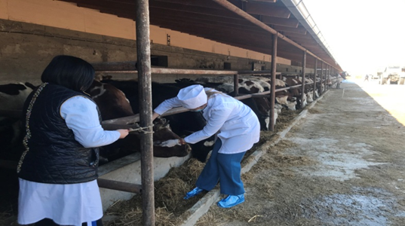 | 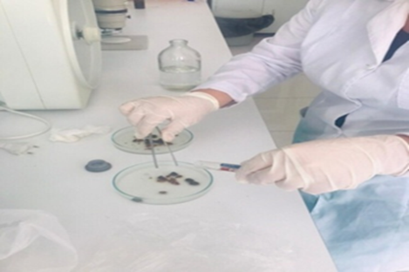
Figure 1 - Inspection of cattle for  Encrustation | Figure 2 - Definition of ticks to genus and species
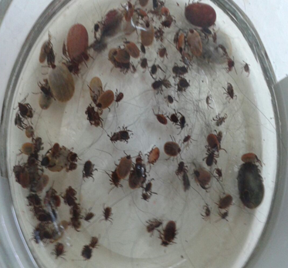 | 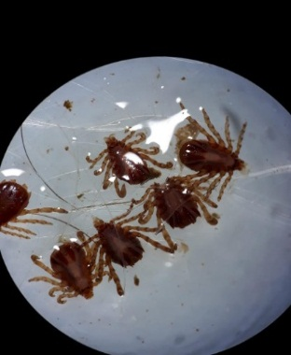
Figure 3 - Ixode pliers assembly | Figure 4 - Hyalomma mites placed in Canadian balm

The organization of the survey of the territories of various points and the collection of ticks, the determination of species, the study of the characteristics of the components of the biotope of ixodic ticks was carried out in the south of the republic.
Parasitiform mites are divided into 3 families of veterinary and medical importance: sem. Ixodidae, sam. Argasidae, sem.Gamasidae. These ticks can transmit infectious and invasive diseases to humans and animals, as well as cause dermatitis. The family Ixodidae is represented by 6 genera: Ixodes, Dermacentor, Haemaphysalis, Hyalomma, Rhipicephalus and Boophilus.
During the period of maximum tick activity (March-April), simultaneously with the examination of natural biotopes, ticks were collected from large animals, mainly cattle, horses, sheep, dogs, for laboratory research, to establish the role of these animals in feeding different types of ixodids and phenological observations.
The project is aimed at developing new technologies in the field of veterinary medicine, at developing acaricides that are not inferior in quality to foreign analogues and superior in price range, for import substitution. This will increase the efficiency of animal husbandry, improve the epizootic situation for vector-borne diseases, receive safe products, and open biotechnological production and jobs in the future.
At the beginning of the research, a patent search was carried out for the problem set for resolution. A working group of project executors has been formed, a staffing table has been compiled.
On the basis of the laboratory of Parasitology of the Institute of Zoology, workplaces for performers have been designed, a material base has been created for the implementation of research planned for 2020. The work was carried out according to the traditional scheme: development of a detailed work program - study and inventory of collection materials - field collection of new materials - desk processing of collected materials - setting up collections - preparation of publications and reports. All stages had sufficient organizational and regulatory and methodological support.
The study and inventory of collection materials were carried out in laboratory conditions at the place of the main work of the performers. In addition to determining the species of a particular collection specimen and providing it with all the necessary labels, the condition of this specimen was determined (in particular, the degree of damage by museum pests), and then all the information received was entered into an electronic data bank.
The collections of the RSE "Institute of Zoology" of the CS of the Ministry of Education and Science of the Republic of Kazakhstan are collections of ixodic ticks placed in glass tubes of various sizes, depending on the size of the ticks themselves, with a volume of 1.0 - 5.0 ml. with a fixing liquid (70% ethyl alcohol, 4% formalin solution). Each tube is provided with a label indicating the type of tick, the place and date of collection, the name of the specialist who determined the species. Test tubes with ticks are closed with cotton plugs and placed in 2-4 layers in glass jars of various volumes with lapped lids, which are also filled with a solution of alcohol or formalin. During operation and storage, the fixing liquid evaporated and needed to be refilled periodically. To improve the storage of collectible materials, we have proposed using plastic containers with an internal lid that prevents the evaporation of the retainer and placing the tubes in one layer to facilitate access to each tube.
Patent research was conducted with a search depth of 10 years. At the same time, it was found that in the Republic of Kazakhstan, a description of 7 preliminary and innovative patents, 5 utility model patents were published; in Russia – 2, in the far abroad - 1 on this topic

2 Research results
2.1 Conducting expedition trips, studying the spread of ticks in some areas of the Zhambyl region
The epizootic situation of blood-sucking ticks in the south of Kazakhstan was studied, in the autumn of 2020, visits were made to several points of the Baizakov, Zhambyl district of the Zhambyl region. The collection and determination of ticks was carried out according to the above methods.
In the Zhambyl region, the epizootic situation for ixodic ticks was studied, tick collections were made, seasonal dynamics was established, the species composition of ticks was determined. In the Bayzakov district, studies were conducted in the following locations: the peasant farm "Nurly Zhay" and "Agali" (located in the locality "Sarykemer"), and the Zhambyl district in the following locations: the peasant farm "Alibi", "Yelzhan" and "Sherkhan" (located in the locality "ASA") (Figures 5-7).
The studies were carried out in the main seasons of tick activity: in the fall of 2020. All data are fixed in the working journal, according to the requirements and forms of parasitological acarological studies.
The collection of ticks was carried out in the autumn months of 2020 of cattle of different ages and different breeds.

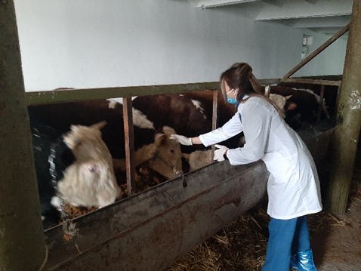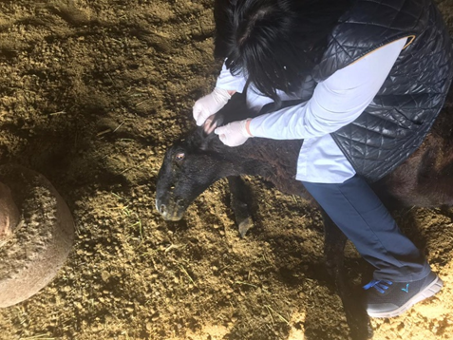

Figure 5 - Employees in the Bayzakovsky district of the village of Sarykemer
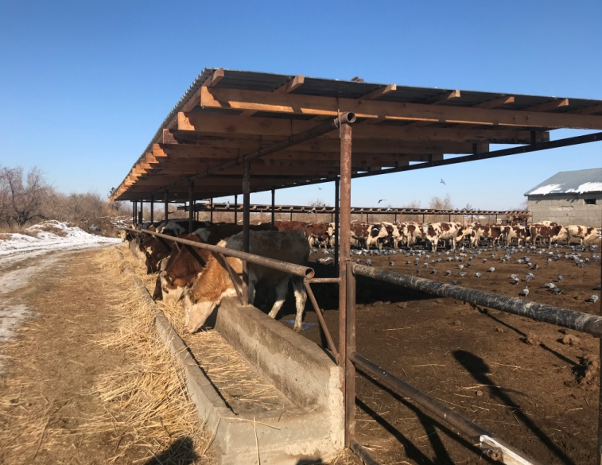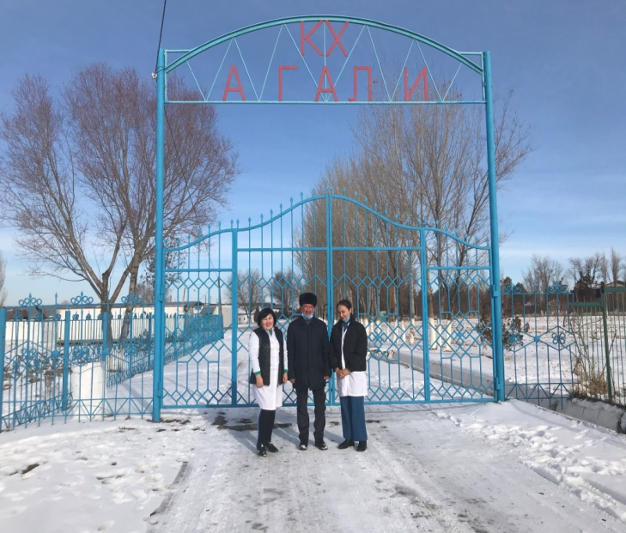
Figure 6 - Peasant farm "Nurly Zhai" Figure 7 - Peasant farm "Agali"

In autumn, a total of 876 specimens of ticks were collected and identified. Including in the PF Hyalomma scupense species was registered in "Agali", the number of which was 22.71%; in "Nurlyzhay" -19.52%. And the species Hyalomma anatolicum in PF "Yelzhan" was 17.12%; in PF "Sherkhan" was 16.21%; the species H. anatolicum in the "Agali" farm was 14.15%. In the total volume of the studied ticks, males accounted for 43.26%, and females - 56.73% (Table 1).
H. anatolicum, H. Scupense pasture stall H. asiaticum pasture tick.

Table 1 - Species composition of ixodids in the Bayzakov and Zhambyl districts of the Zhambyl region
Tick collection point | Types of ticks | Number/ % |  | Including:
 |  |  |  | Males |  | females
 |  |  |  | Number | % | Number | %
 |  | Number | %
PF «Yelzhan» | H. аnatolicum | 150 | 17,12 | 55 | 36,7 | 95 | 63,3
PF «Nurlyzhay» | H. аnatolicum | - | 0,0 | - | 0,0 | - | 0,0
 | H. scupense | 171 | 19,52 | 76 | 44,4 | 95 | 55,6
PF «Sherkhan» | H. аnatolicum | 142 | 16,21 | 46 | 32,4 | 96 | 67,6
 | H. scupense | 90 | 10,29 | 44 | 48,9 | 46 | 51,1
PF «Agali» | H. аnatolicum | 124 | 14,15 | 58 | 46,8 | 66 | 53,2
 | H. scupense | 199 | 22,71 | 100 | 50,3 | 99 | 49,7
Total: |  | 876 | 100,0 | 379 | 43,26 | 497 | 56,73

Table 2 - Seasonal dynamics of animal breeding in the autumn period in Zhambyl region
Type of ticks | Number, | Months
 |  | October |  | November
 |  | Number | % | Number | %
H. аnatolicum | 335 | 183 | 54,62 | 152 | 45,37
H. scupense | 541 | 287 | 53,04 | 254 | 46,95
Total: | 876 | 470 | 53,65 | 406 | 46,34

When studying the fluctuations in the number of ticks recorded in the autumn period, it was found that in October the species of H. anatolicum amounted to 54.62% of collections; in November - 45.37%. The species of H. scupense in October was 53.04%; in November – 46.95%. It is noted that the dynamics of both types of ticks coincide, the largest number of both species was noted in October (54.62% and 53.04%, respectively), then there is a decline in the number of ticks in November to 45.37% and 46.95%, respectively (Table 1,2, Figure 8, 9).

Figure 8 - Dynamics of animal contamination in Zhambyl region (autumn harvest)

Expedition trips were conducted in the spring and autumn of 2021. New knowledge has been obtained about the regularities of the formation of tick foci in the Zhambyl region and their role in the spread of diseases carried by ectoparasites.
Field studies were conducted in two districts of Zhambyl region. A total of 430 specimens of ticks were collected. According to the research results, 170 ticks were collected in the settlement of the Bayzak district of the Zhambyl region, of which 73 were Hyalomma anatolicum (42.9%), 53 were Hyalomma scupense (31.2%) and 44 were collected. were assigned to the species Hyalomma detritum (25.9%).
According to the research results, 260 specimens of ticks were collected in the settlement of Zhambyl district of Zhambyl region, of which 103 specimens were Hyalomma anatolicum (39.6%), 64 specimens were Hyalomma scupense (24.6%) and 93 specimens. were assigned to the species Hyalomma detritum (35.7%).
Natural foci of the disease in the Zhambyl region, pyroplasmidoses (babesiosis and teileriosis) are registered annually.

Table 3 - Species composition of ixodids in Bayzakov and Zhambyl districts of Zhambyl region
Tick collection point | Types of ticks | Number / % |  | Including:
 |  |  |  | Males |  | Females
 |  |  |  | Number | % | Number | %
 |  | Number | %
Zhambyl district | H. аnatolicum | 103 | 39,6 | 33 | 32,0 | 70 | 68,0
 | H. detritum | 93 | 35,7 | 17 | 18,3 | 76 | 81,7
 | H. scupense | 64 | 24,6 | 15 | 23,4 | 49 | 76,5
Bayzak district | H. аnatolicum | 73 | 42,9 | 25 | 34,3 | 48 | 65,7
 | H. scupense | 53 | 31,2 | 13 | 24,5 | 40 | 75,5
 | H. detritum | 44 | 25,9 | 7 | 15,9 | 37 | 84,1
Total: |  | 430 | 100,0 | 110 | 25,6 | 320 | 74,4

Figure 9 - Dynamics of animal contamination in Zhambyl region (spring harvest)

2.2 Research and distribution of ticks in the Turkestan region
To study the fauna and species composition of ixodic ticks of the Turkestan region, parasites were collected in 3 locations: the village of Mynbulak PF "Otesh" in the Baydibek district and in the city of Shymkent (Figures 9-11).
The presence of ticks of 100 heads of cattle and habitats, i.e. biotopes of ticks, was investigated at the point of PF "Otesh", Baydibek district.

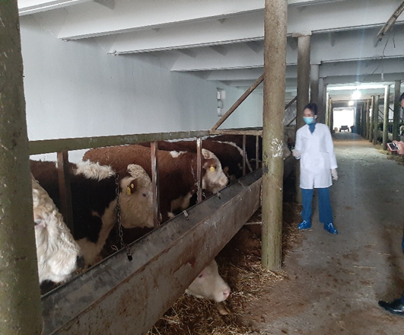
Figure 10 - Baidibexiy district Mynbulak settlement
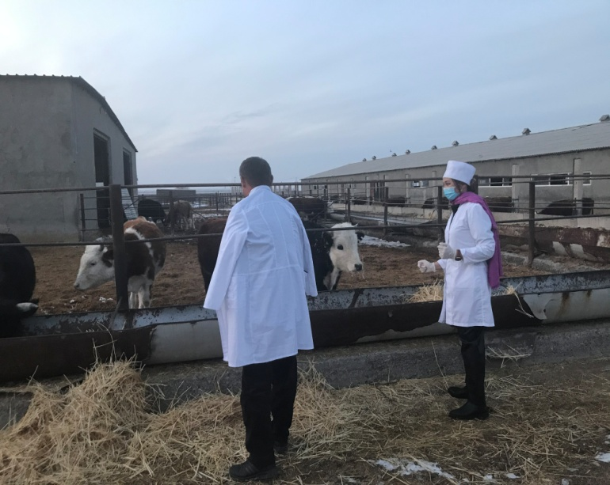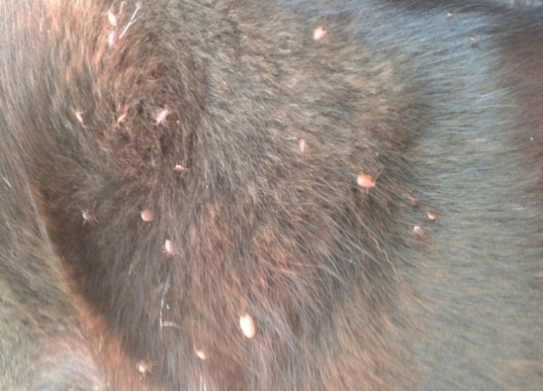
Figure 11- The peasant farm «Otesh» Figure 12 - Animal contamination

The collection and determination of ticks was carried out according to the above methods. The results of the study of animals in the region are as follows and are shown in Table 4.

Table 4 - The number of different animal species in the Baydibek district of Turkestan region
Type of animal | Number of investigated | Еncrustation
 |  | Quantity | %
Horses | 20 | 6 | 30,0
Cattle | 10 | 7 | 35,0
Dogs | 20 | 11 | 55,0
Total: | 100 | 24 | 34,0

The total number of animals of different species was 34 heads or 34.0% out of 100 examined. The highest contamination was observed in dogs (55.0%), then in cattle (35.0%), then in horses (30.0%). Ticks were found in the auricles, in the eyelid area, in the axillary and inguinal areas, on the udder, at the base and tip of the tail.
A total of 403 ticks were collected from animals in the Turkestan region, 251 in Shymkent. The following types of ticks are identified in the collections (Tables 5, 6).

Table 5 - Species composition of ixodes mites in Shymkent
Type of animal | Number of investigated | Encrustation
 |  | Quantity | %
Horses | 20 | 3 | 15,0
Cattle | 20 | 10 | 50,0
Dogs | 20 | 3 | 15,0
Total: | 100 | 18 | 18,0

In the region, out of 100 animals of different species studied, 18 heads or 18% were slaughtered, and the abundance index (IO) was 22.3 copies, on average, per one slaughtered animal.
The species composition of ixodic ticks in the collections is presented in Table 6.

Table 6 - Species composition of ixodic ticks in the peasant farm "Otesh" of the Baydibek district of Turkestan region
Types of ticks | Number /% |  | Tick stages |  |  |  | AI, spec./head.
 | Number, spec. | % | Imago |  | Nymphs
 |  |  | Number | % | Number | %
Hyalomma scupense | 96 | 23,8 | 93 | 96,87 | 3 | 3,13 | 22,3
Hyalomma anatolicum | 147 | 36,5 | 135 | 91,83 | 12 | 8,16
Dermacentor marginatus | 93 | 23,2 | 89 | 95,69 | 4 | 4,30
Hyalomma detritum | 16 | 3,9 | 12 | 75,00 | 4 | 25,00
Dermacentor pictus | 51 | 12,6 | 44 | 82,27 | 7 | 13,73
Total: | 403 | 100,0 | 373 | 92,56 | 30 | 7,44

Thus, the species Hyalomma anatolicum (36.5%) and Hyalomma scupense (23.8%) predominate in the locality "Shayan" of Baidibek district of Turkestan region. Ticks of the genus Dermacentor occupy the second place in the collections, their number by species was Dermacentor marginatus - 23.2% and Dermacentor pictus - 12.6%. The Hyalomma detritum species in our collections in this region was also in single specimens and accounted for 3.9% of the total collection.
The following types of ticks were identified in the collections from this region (Table 7).

Table 7- Species composition of ixodes mites in Shymkent
Types of ticks | Number % |  | Tick stages |  |  |  | AI, spec./head.
 | Number, spec. | % | Imago |  | Nymphs
 |  |  | Number | % | Number | %
Hyalomma scupense | 103 | 41,04 | 98 | 95,14 | 5 | 4,85 | 15,6
Hyalomma anatolicum | 95 | 37,85 | 89 | 93,68 | 6 | 6,32
Dermacentor marginatus | 36 | 14,34 | 31 | 86,11 | 5 | 13,89
Hyalomma detritum | 6 | 2,39 | 4 | 66,67 | 2 | 33,33
Dermacentor pictus | 11 | 4,38 | 9 | 81,81 | 2 | 18,18
Total: | 251 | 100,0 | 231 | 92,03 | 20 | 7,97

Thus, Hyalomma scupense (41.04%) and Hyalomma anatolicum (37.85%) species also predominate in the studied areas of Shymkent and its suburbs. Ticks of the genus Dermacentor occupy the second place in the collections, their number by species was Dermacentor marginatus - 14.34% and Dermacentor pictus - 4.38%. The Hyalomma detritum species in our collections was in single specimens and amounted to 2.39% of the total collection.
Expedition trips were conducted in the spring and autumn of 2021. New knowledge has been obtained about the patterns of formation of tick foci in the Turkestan region and their role in the spread of diseases carried by ectoparasites.
To study the fauna and species composition of ixodic ticks of the Turkestan region, parasites were collected in 3 points: Baidibek district at the point "Shayan", "Borlysay", "Agybet" and 3 points: Ordabasinsky district at the point "Badam", "Bogen" and "Borzhar". New data on the distribution of ticks in the Turkestan region have been obtained through expeditionary research. A total of 183 specimens of ticks were collected. According to the results of research , 118 copies were collected in the settlement of the Baydibek district of the Turkestan region . ticks, of which 68 specimens - Hyalomma anatolicum (57.6%), 17 specimens - Hyalomma scupense (14.4%) and 33 specimens were assigned to the species Hyalomma detritum (28%) (Table 8, Figure 13)

Table 8 - Species composition of ixodic ticks in the point "Shayan", "Borlysai", "Agybet" of the Baydibek district of Turkestan region
Tick collection point | Types of ticks | Number / % |  | Including:
 |  |  |  | Males |  | Females
 |  |  |  | Number | % | Number | %
 |  | Number | %
PF "Borlisai" | H. аnatolicum | 22 | 18,6 | 10 | 45,4 | 12 | 54,5
 | H. scupense | 9 | 7,6 | - | 0,0 | 9 | 100
 | H. detritum | 11 | 9,3 | 8 | 72,7 | 3 | 27,3
PF «Agybek» | H. аnatolicum | 19 | 16,1 | 7 | 36,8 | 12 | 63,2
 | H. scupense | 8 | 6,8 | 2 | 25,0 | 6 | 75,0
 | H. detritum | 8 | 6,8 | 4 | 50,0 | 4 | 50,0
PF «Shayan» | H. аnatolicum | 27 | 22,9 | 9 | 33,3 | 18 | 66,7
 | H. scupense | - | 0,0 | - | 0,0 | - | 0,0
 | H. detritum | 14 | 11,9 | 5 | 35,7 | 9 | 64,3
Total: |  | 118 | 100,0 | 45 | 43,26 | 73 | 56,73

Figure 13 - Dynamics of animal breeding in the "Shayan", "Borlysay", "Agybet" localities of the Baydibek district of Turkestan region

According to the results of research, 65 specimens of ticks were collected in the settlement of Ordabasinsky district of Turkestan region, of which 18 specimens (Table 9). Hyalomma anatolicum (27.7%), 24 specimens - Hyalomma scupense (36.9%) and 23 specimens. were assigned to the species Hyalomma detritum (35.4%).
Natural foci of the disease in the Turkestan region, pyroplasmosis is registered annually - teileriosis, francaiellosis, babesiosis, anaplasmosis. Piroplamidiosis diseases of animals in the epizootic chain have three links. The first is an animal infested with a pathogen; the second is a carrier tick; the third is a susceptible animal. So from year to year, the pathogen circulates between animals and vector ticks until one of the links in the chain is turned off.

Table 9 - Species composition of ixodic ticks of Ordabasу district of Turkestan region
Types of ticks | Number / %
 | Number | %
H. аnatolicum | 23 | 35,4
H. scupense | 18 | 27,7
H. detritum | 24 | 36,9
Total | 65 | 100

2.3 Development of a prolonged-acting drug
Against ectoparasites of animals, mainly bathing insect-acaricidal agents are used. In the cold season, animals are not bathed, injectable insect-acaricidal drugs are often not used. Therefore, the use of insectoacaricides in the form of dust is a cost-effective, labor-intensive process of animal treatment. They are very convenient in practice due to the simplicity of their application, they do not need to be diluted with water, which is mandatory for wetting powders and emulsions. We have prepared an experimental series of the drug and obtained protective documents for the invention. The results of the drug testing showed that a day after the use of the drug, mostly dead parasites were found on the body of animals, and the dead ticks usually dried out 3-5 days after treatment and were easily removed from the animal's skin.
Various compositions and variants of medicinal forms of acaricidal drugs have been selected. The acaricidal activity of the agent against ectoparasites at different component ratios and dosages, as well as in comparison with the prototype, was determined in three examples. Representatives of the genus Hyalomma serve as model objects for determining the acaricidal activity of the proposed drug against ticks.
For the development of acaricidal agents and in order to study their acaricidal effectiveness, various drug compositions have been compiled in order to study the duration of the drug's effect on ticks and determine the concentration of the active substance (DV).
Acaricidal preparation in the form of dust against arachnoses of animals, includes calcium hydroxide, sulfur, sodium tripolyphosphate and filler, additionally contains polyvinyl alcohol, and as a filler dolomite inert dust. Acaricidal preparation in the form of dust was manufactured and tested in four laboratory and two production experiments. The effectiveness of the acaricidal preparation in the form of dust ranged from 82.0 to 98.0% with different ratios of components. Acaricidal preparation in the form of dust has low toxicity, is highly active against harmful ixodes and argass mites and is securely held on the body and coat of the animal after dusting for several days. An acaricidal drug of prolonged action has been developed. A patent for a utility model has been obtained. The drug of prolonged action developed in the future, containing components that enhance the acaricidal activity of the agent, will prolong its activity and thereby reduce the number of anti–tick treatments of animals by 2-3 times.
Epidemiologically, the importance of arthropods as carriers of pathogens of infectious diseases of humans and animals is incomparably greater than their importance as parasites, and in obligate-transmissible diseases, vector ticks play a leading role. They actively participate in the mechanism of transmission of pathogens of infectious diseases, especially from protozoal, rickettsious, viral and bacterial. Ticks carry hemorrhagic fevers, tularemia, pyroplasmosis, tick-borne encephalitis. It is ixodic ticks that most often act as carriers of dangerous encephalitis. The harmful effects of parasites as carriers of infectious diseases are many times greater than their actual parasitic harm. Diseases transmitted to humans and animals by tick bite are called vector-borne diseases. Ticks in this case are a kind of reservoir of infectious agents, retain it throughout their lives and are often transmitted from generation to generation, laying infected eggs, from which infected larvae are born. Encephalitis mite is one of the most common and well-known. It is important to note that the encephalitic tick is not a separate breed (species) of arthropod insects. Encephalitis can infect any species of ticks, so it is impossible to identify signs that determine the degree of danger. But it should be remembered that such an infection can lead to the death of a person.
In the south of Kazakhstan, hundreds of patients are treated annually to doctors and veterinarians due to tick bites, and this is no wonder, the south of Kazakhstan is the largest habitat of ticks. The causative agents of infection enter the human body at the time of the tick bite, along with its "saliva" and the contents of the intestine. All vector-borne diseases are characterized by natural foci, seasonal outbreaks associated with periods of tick activity, acute onset of infection, symptoms of intoxication, damage to the nervous system and the presence of skin rashes. Pathogens of infections are contained in the salivary glands and intestines of the tick and pass into the host body when injecting painkillers and anticoagulants into the skin (prevent blood clotting). Suction is usually painless, favorite places are the neck, chest area, armpits, inguinal folds, as well as the navel and the skin around the anus. The order of ixodid mites (Ixodidae) occupies a leading position among blood-sucking arthropods in terms of the number of transmitted diseases. Among them, there are such dangerous infections as tick-borne typhus, encephalitis, tularemia, pyroplasmosis, hemosporidial diseases of domestic animals and humans. These ticks are under the close attention of medical and veterinary acarology and parasitology in general.
In the southern regions of Kazakhstan, the population has 4 types of vector-borne diseases transmitted by ticks: tick-borne viral encephalitis, Congo-Crimean hemorrhagic fever, Lyme disease and rickettsiosis.
In the south of Kazakhstan, tick-borne viral encephalitis occurs in mountainous and mountainous areas. Congo-Crimean hemorrhagic fever is mainly registered in the Kyzylorda and Turkestan regions, in neighboring regions it is registered to a lesser extent. In 2019, 9 cases were registered in both regions, and in 2020, 9 cases were registered in the Kyzylorda region, 5 cases in the Turkestan region. In 2020, in Zhambyl region, due to quarantine measures, a planned anti-tick measure was carried out late, in connection with this, 3 cases of human disease with Congo-Crimean hemorrhagic fever were registered.
Rickettsiosis occurs mainly in the plains. From the southern regions, it is registered only in the Kyzylorda region. In 2019, 100 cases were recorded in the region, and in 2020, 47 cases.

2.4 Acaricide drug testing
The effectiveness of the acaricidal drug in the form of dust was tested (developed by us) by the farms "Tansengirov" and "Nurly Zhai" in the village of Sarykemer in the Bayzak district of Zhambyl region on 72 cattle animals, 24 heads were treated with the acaricidal drug developed by us, the remaining 24 heads were treated with the drug "Veterin", 24 heads served as a control drug was not received (Table 10).

Table 10 - Tests of acaricidal drugs against ixodic ticks in the farm "Tansengirov" village Sarykemer Bayzak district of Zhambyl region
Group | Tick after using % |  |  | Efficacy of the drug after use %
 | 2 day | 4 day | 6 day | 10 day | 14 day | 16 day
Group 1  "Acaricidal preparation in the form of dust against arachnoses of animals" | 71,0 % | 82,0% | 83,2 % | 85,2% | 87,2 % | 90,2 %
2-group  Veterin Drug | 52,1 % | 55,3 % | 58,4 % | 17,0 % | 12,0 % | 0
3-group  Control | - | - | - | 0 | 0 | 0

Figure 14 - Dynamics of acaricidal preparations against ixodid ticks in the farm "Tansengirov" of the Zhambyl region
The effectiveness of our drug was 83.2 -90.2%. The effectiveness of the base drug on the 6th day was 55.46-58.4%.
The second experiment was carried out by PF "Koshaev Kazhimukan" and "Slamhan" rural district Borzhar Sarykemer in Ordabasi district of Turkestan region on 45 cattle animals, 15 heads were treated with acaricidal drug, the remaining 15 heads were treated with the drug "Veterin", 15 heads were a control group (Table 11).
Table 11 - Tests of acaricidal drugs against ixodic ticks in the PF "Koshaev Kazhimukan" and "Slamhan" rural district Borzhar Sarykemer in Ordabasi district of Turkestan region
Group | PF | Dead tick after use % |  |  | Efficacy of the drug after use %
 |  | 2 day | 4 day | 6 day | 10 day | 14 day | 16 day
Group 1  "Acaricidal preparation in the form of dust against arachnoses of animals" | PF  "Slamhan" | 73,0 % | 77,0 % | 82,3 % | 85,2 % | 87,2 % | 89,2 %
 | PF  «Koshaev Kazhimukan» | 71,0 % | 82,0% | 85,2 % | 87,2% | 90,2 % | 93,2 %
2-group  Veterin Drug | PF  "Slamhan" | 51,0 % | 55,0 % | 55,46 | 20,0 % | 15,0 % | 0
 | PF  «Koshaev Kazhimukan» | 52,1 % | 55,3 % | 58,4 % | 17,0 % | 12,0 % | 0
3-group  Control | PF  "Slamhan" | - | - | - | 0 | 0 | 0
 | PF  «Koshaev Kazhimukan» | - | - | - | 0 | 0 | 0
The effectiveness of our drug was 89.2-93.2%. The effectiveness of the base drug on the 6th day was 55.46- 58.4%.
Patent No. 6062 was obtained for the utility model "Acaricidal preparation in the form of dust against arachnoses of animals" dated 02/18/2021. Authors: Suleimenov Maratbek Zhaksybekovich, Zhantelieva Laura Orazakynovna, Myrzhieva Asem Bekbolatovna.
The effectiveness of the acaricidal agent in the form of dust was tested (developed by us) by the farm "Birlik" and rural district of Grodno in the Zhambyl district of the Zhambyl region on 72 cattle animals, 24 heads were treated with the acaricidal agent developed by us in the form of dust against arachnoses of ruminants, the remaining 24 heads were treated with the drug "Vetin", 24 heads did not receive the drug as a control (Table 12).

Table 12 - Tests of acaricidal drugs against ixodic ticks in the farm "Birlik" and "Khaliev"rural district of Grodnik in the Zhambyl district of the Zhambyl region
Group | PF | Tick after using% |  |  | The effectiveness of the drug after use %
 |  | 2 day | 4 day | 6 day | 10 day | 14 day | 16 day
Acaricidal agent in the form of dust against animal arachnoses | PF «Birlik» | 76,2 % | 78,1 % | 83,8 % | 85,7 % | 88,2 % | 90,2 %
 | PF "Khaliev" | 73,0 % | 75,3 % | 77,6 % | 81,1% | 83,8% | 85,5%
2-group  Veterin Drug | PF «Birlik» | 50,0 % | 52,8 % | 58,4 % | 10,0 % | 17,0 % | 0
 | PF "Khaliev" | 53,1% | 58,8% | 60,8% | 12,0% | 18,0% | 0
3-group  Control | PF «Birlik» | - | - | - | - | - | -
 | PF "Khaliev" | - | - | - | - | - | -

The effectiveness of our drug was 85,5% - 90.2%. The effectiveness of the base drug on the 6th day was 58.4% -60,8%.
The second experiment was carried out in the farm "Dostyk-1" and PF «Eskendir» in the Borzhar rural district and the farm "Eskendir" in the Karapan rural district of the Ordabinsky district of Turkestan region on 72 cattle animals, 24 heads were treated with an acaricidal agent developed by us in the form of dust against arachnoses of ruminants, the remaining 24 heads were treated with the drug "Veterin", 24 heads did not receive the drug as a control (Table 13, p 15)
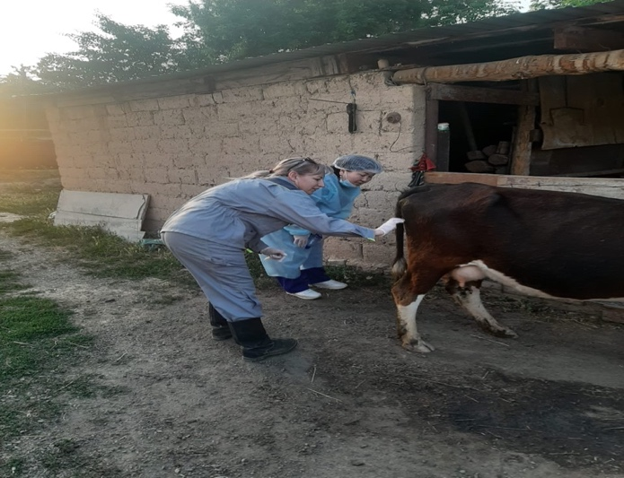 | 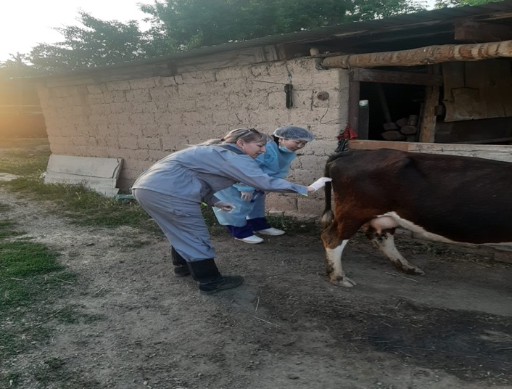
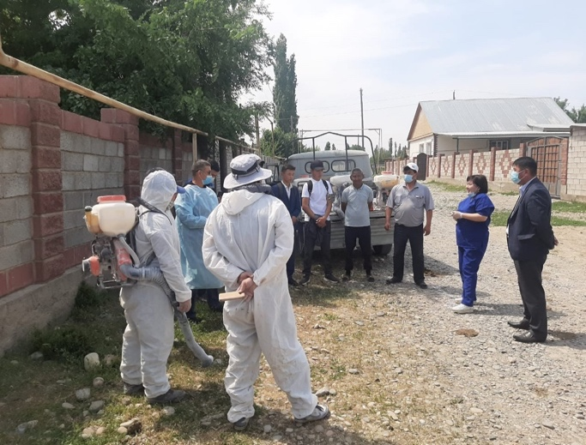 | 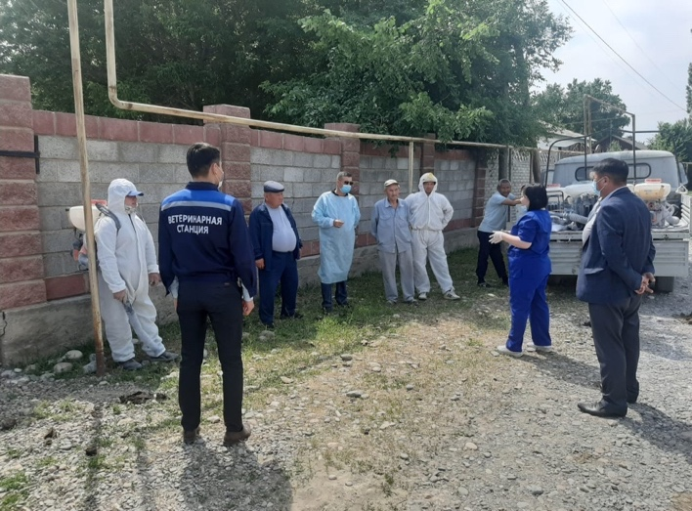
Figure 15 - Tests of acaricidal agents in the Dostyk-1 farm

Table 13 - Tests of acaricidal drugs against ixodic ticks in the farm "Dostyk-1" in the rural district of Borzhar and the farm "Eskendir" in the rural district of Karapan Ordabin district of Turkestan region
Group | PF | Dead tick after using % |  |  | Efficacy of the drug after use %
 |  | 2 day | 4 day | 6 day | 10 day | 14 day | 16 day
Group 1  "Acaricidal preparation in the form of dust against arachnoses of animals" | PF  «Dostyk» | 73,0 % | 77,0 % | 82,3 % | 88,8 % | 89,4 % | 90,4 %
 | PF  «Eskendir» | 71,5 % | 82,4 % | 85,7% | 87,2% | 90,2 % | 93,2 %
2-group  Veterin Drug | PF  «Dostyk» | 51,0 % | 55,0 % | 55,46 | 20,0 % | 15,0 % | 0
 | PF  «Eskendir» | 50,0 % | 52,0 % | 55,4 % | 10,0 % | 8,0 % | 0
3-group  Control | PF  «Dostyk» | - | - | - | 0 | 0 | 0
 | PF  «Eskendir» | - | - | - | 0 | 0 | 0
The effectiveness of our drug was 90.4-93.2%. The effectiveness of the base drug on the 6th day was 55.46- 55.4%.
Patent No. 6096 for a useful model "Acaricidal agent in the form of dust against arachnoses of animals" dated 28.05.2021 was received. Authors: Suleimenov Maratbek Zhaksybekovich, Zhanteliyeva Laura Orazakynovna, Myrzhieva Asem Bekbolatovna.
In solving the problem of tick control, it is of great importance to develop and find new drugs that are low-toxic for warm-blooded animals, do not stand out with milk, do not accumulate in organs and tissues and at the same time have a longer residual effect against blood-sucking mites on the skin and hair. Already this year, cattle have been examined in some points of the Zhambyl and Turkestan regions, the species composition of ticks, their number, the percentage of contamination, abundance indices have been established. The drug of prolonged action developed in the future, containing components that enhance the acaricidal activity of the agent, allowed to prolong its activity and thereby reduce the number of anti–tick treatments of animals by 2-3 times.
Thus, the drugs developed by us had an advantage in duration of action, in efficiency, which allows reducing the number of anti-tick treatments of animals compared to similar drugs used.

CONCLUSION

In the Zhambyl region, in the Bayzak and Zhambyl districts, the total number of animals was from 10 to 22.71%. The species composition of ticks showed that the most widespread species were Hyalomma anatolicum -54.62% and Hyalomma scupense -53.04%.
In the Turkestan region, in the Baydibek district and the vicinity of Shymkent, the total number of animals was up to 34%. The species composition of ticks showed that Hyalomma anatolicum species prevailed -56.5%, Hyalomma scupense - 23.8%. Ticks of the genus Dermacentor -23.2%, Hyalomma detritum was registered in single specimens (3.9%).
To find acaricidal agents, several variants of the composition of substances for influencing ticks and determining the concentration of the active substance were compiled.
Acaricide drug in the farms of Zhambyl region showed effectiveness from 70 to 83.2%, and in Turkestan region the effectiveness of the drug was from 71 to 89.2%.
The effectiveness of acaricide in Zhambyl region ranged from 76 to 90.2%, and in Turkestan region from 71 to 89.2%. Based on the data obtained, it can be recommended to use these drugs for the therapy and prevention of ectoparasites of animals.
Based on the data obtained, it can be recommended to use these drugs for the therapy and prevention of animal ectoparasites.
The use of the developed methods of therapy and prevention of ectoparasites of animals not only ensures the safety of livestock, but also ultimately leads to a significant reduction in the incidence of ectoparasites in animals, and also regulates the number of vector ticks in nature.

LIST OF SOURCES USED
1 Abseitova Z. S., Asylhanov D. W., Turganbaeva G. E., G. S. Shabdarbayeva. The Spread of piroplasmosis of cattle in Zhambyl region // Bulletin of the Kyrgyz national agrarian University. K. I. Skryabin - 2013. №1 (28). –P. 386-391.
2 Akbaev M. S., Vasilevich F. I., Akbaev R. M., Vodyanov A. A., Kosminkov N. E., Pashkin, P.A. I. Matusevich Parasitology and invasive diseases of animals. "Colossus", 2008. - 775 p.
3 Asylkhanov D.U., Turganbayeva G.E., Akhmetzhanova M., Khusainov D.M., Shabdarbayeva G.S., Tulepova G. Feeding and incubation of ixodic ticks // Conceptual and applied aspects of scientific research and education in the field of invertebrate zoology mater of the IV intern. conf. –Tomsk, 2015. - P. 222-225.
4 Akhmetova T.D., Myrzhieva A.B., Balgimbayeva A.I., Shabdarbayeva G.S. - Study of ixodic ticks for the presence of blood parasites // mater. of the inter. conf. of students, postgraduates, young scientists "Studforum", M:, 2019.
5 Akhunjanov M.R., Shabdarbayeva G.S., Balgimbayeva A.I. Ixodofauna of carnivores in the Almaty region // mater.of the inter. scientific forum, M:, 2019. - P 122-128.
6 Abseitova Z.S., Mambetaliev M.A., Nurmagambetov N.A., Shabdarbayeva G.S. - Kyzylorda oblysy, Zhalagash audanindagi ixodid kenelerdin tabigi biotoptaryn anyktau//Materials of the International scientific and practical Conference "Modern problems of combating especially dangerous, exotic and zooanthroponous animal diseases" dedicated to the 70th anniversary of Professor N.G.Asanov. 1 volume. Almaty, 2012. - P. 204-207.
7 Balashov Yu.S. Blood-sucking mites - carriers of human and animal diseases. L., "Science", - 1967.- 800 p.
8 Bespalova N.S. Modern antiparasitic agents in veterinary medicine. M. "Colossus". – 2006 - 192 p.
9 Berdikulov M.A., Zhanbyrbayev M.Zh., Suleimenov M.Zh. Epizootology of ixodic ticks in the South Kazakhstan region // Tr.KazNIVI Modern measures to combat infectious and invasive diseases of agricultural animals in Kazakhstan. - 2003. - Volume 2. - P. 233-236.
10 Boyko A.A., Myrzhieva A.B., Shabdarbayeva G.S. Ticks - carriers of piroplasmosis of dogs//Materials of the international conference of students, postgraduates, young scientists "Studforum-2019", Moscow, 2019.
11 Gallat V.F. et al. Tropical veterinary parasitology. Kiev, "Vischa school", - 1986 p.
12 Zhanbyrbayev M.ZH., Berdikulov M.A., etc. Methods and means of combating ticks of farm animals on the territory of the South Kazakhstan region. //Methodological recommendations. Shymkent, - 2004. - 24 p.
13 Kanbayeva M., Shabdarbayeva G.S. Iri kara teyleriozyn taratatyn keneler.//zh. Izdenister, natizheler. Kosymsha. -Almaty, -2006. - No. 2. - P. 65-68.
14 Suleimenov M.Zh., Amanzhol R.A., Tuleukhanova A., Berdikulov M.A., Kozhabaev M.K. Development and testing of acaricidal agents against ectoparasites of animals in the south of Kazakhstan//zh. Izvestiya NAS RK. Series Of Agricultural Sciences. - P. 13-15.
15 Sabanshiev M.S., Suleimenov M.ZH., Suleimenov T.T. Blood-sucking mites-carriers of pyroplasmidosis in the south of Kazakhstan//Bulletin of the Kyrgyz Scientific Research Institute of Animal Husbandry, Veterinary Medicine and Pastures named after Arystanbek Duisheev,-2007. - No. 1.- P.-328-329.
16 Turganbayeva G.E., Shabdarbayeva G.S., Akhmetsadykov N.N., Khusainov D.M., Asylkhanov D.U., Akhmetzhanova M.M. - Species composition and distribution of ixodic ticks in the southern regions of Kazakhstan // zh Veterinary. -2015. - №3(43). - P. 75-79.
17 Turganbayeva G.E., Asylkhanov D.U., Akhmetzhanova M., Shabdarbayeva G.S., Khusainov D.M., Tulepova G. - Ontustik Kazakhstan zhane Almaty oblysyn aimaktarynda ixodid kenelerin taraluy//zh. Izdenister, natizheler, KazNAU -2015. - №4 (068). - P.7 1-77.
18 Turganbaeva G.E., Shabdarbayeva G.S., Akhmetsadykov N.N., Kozhakov K.K., Akhmetzhanova M.N. - The degree of infection with pyroplasmids of ixodic mites in South Kazakhstan and Almaty regions of the Republic of Kazakhstan//zh. Proceedings of the National Academy of the Republic of Kazakhstan. Series of agricultural sciences. - 2016. - No. 6(36) - P. 48-56.
19 Turganbaeva G.E., Khusainov D.M., Shabdarbayeva G.S. - Effectiveness of acaricidal preparations based on natural biologically active substances against ixodic mites in laboratory conditions//Materials of the International scientific and practical Conference "Veterinary Medicine in the XXI century: problems, methods, solutions" dedicated to the 100th anniversary of the birth of Professor Kadyrov Nurgali Tasilovich, KazATU, Astana. -2016. - P. 196-199.
20 Shabdarbayeva G.S., Balgimbayeva A.I. Ixodofauna and features of epizootology of pyroplasmosis of dogs in the south-east of Kazakhstan // Mater. scientific and practical conference. Innovations in the agricultural sector of Kazakhstan, dedicated. 75th anniversary of Professor K.S.Sabdenov. Almaty:, -2008. - P. 575-581.
21 Shabdarbayeva G.S., Balgimbayeva A.I. Ixodofauna and studies on infection of ixodids with blood parasites//Mater. International Scientific and Practical Conference. // Higher school and agricultural science – agriculture, dedicated. 100th anniversary of Sadykov B.H., 90th anniversary of Fedoseev V.S., 75th anniversary of Abdilmanov U.A., Semey: - 2009. - P. 203-208.
22 Suleimenov T.T., Shabdarbayeva G.S., Akhmetova G.D. Turganbayeva G.E. Insecto-acaricidtik preparattardyn tiimdiligin salystru. // Materials of the International scientific and practical conference "The state and prospects of veterinary medicine development in the Republic of Kazakhstan", dedicated to the 95th anniversary of the birth of Doctor of Veterinary Sciences, Professor Kadyrov N.T. Astana.- 2012. - P. 73-75.
23 Suleimenov T.T., Shabdarbayeva G.S., Akhmetova G.D. Turganbayeva G.E. Insecto-acaricidtik preparattardyn tiimdiligin salystru // Mater. International Scientific and Practical Conference. "The state and prospects of veterinary medicine development in the Republic of Kazakhstan", dedicated. 95th anniversary of the birth of Professor Kadyrov N.T. Astana:. - 2012. -P. 73-75.
24 Omarova N.B., Asylkhanov D.U., Shabdarbayeva G.S. Almaty oblysynda iri kara teyleriozynn kozdyrushysyn Hyalomma anatolicum tur kenesinin taratuy//"News of Modern Science" halykaralyk gylym-practicalyk conference materialdary boyynsha gylym makalalar zhinagi, Almaty:. -2014. - P. 208-214.
25 Fedorov K.P. et al. Fundamentals of general and applied veterinary parasitology. Novosibirsk, -2004. -342 p.
26 Urquhart G. et al. Veterinary parasitology. M:, Aquarium, - 2000, - 430 p.
27 Turganbayeva G., Shabdarbayeva G., Khussainov D., Ibazhanova A., Balgimbayeva A., Myrzhiyeva A. - Distribution and Species Composition of Iksod Mites in the South of Kazakhstan//Abstract Book of International Conference 9-10 April. - Deira Dubai UAE - 2018. -Vol. 4/. - P. 25.
28 Shabdarbayeva G.S., Balgimbayeva A.I., Ibazhanova A.S., Turganbayeva G.E., Myrzhieva A.B., Kenzhebekova Zh.Zh. - Features of epizootology of ticks-carriers of piroplasmosis of dogs//Materials XLVIII International scientific conference on Eurasian scientific Association "of the Modern concept of scientific research - 2019. - Part 2. - P. 122-125.
29 Shabdarbayeva G. S., A. I. Balgimbaev, Baranova A. S., Turganbaeva G. E., Margiev A., Kenzhebekova J. J., Shmanov G. S. - The Study of ticks for the presence of taleri // Topical issues of education and science. Bulletin of Scientific Conferences - 2019.- No.2-3. - P. 108-116.
30 Shabdarbayeva G.S. Blood parasitic diseases of animals (epizootology, diagnostics) // Monograph. – Almaty:, -2012. - 272 p.
31R.I. Rodriguez-Vivas, J.E. Hodgkinson, J.A. Rosado-Aguilar, S.L.Villegas-Perez, A.J.Trees. The prevalence of pyrethroidre sistance phenotype and genotype in Rnipicephalus (Boophilus) microplus in Yucatan, Mexico //Veterinary parasitology. - An international Scientific Journal. -Volume 184.-Issues 2-4, March, 23- 2012. - P. 221-229.
32 Raquel Sobrino, Javier Millan, Alvaro Oleaga, Christian Gortazar, Jose delaFuente, Francisco Ruiz- Fons. Ecological preferences of exophilic andendophilic ticks (AcariIxodidae) parasitizing wild carnivores in the Iberian Peninsula Veterinary parasitology //An international Scientific Journal. -Volume184.- Issues 2-4, March 23, 2012. - P. 248-257.
33 G.M.Klafke, E.CastroJaner, M.C.Mendes, A.Namindome, T.T.S.Schumacer. Applicability of in vitro bioassays for the diagnosis of ivermectin resistance in Rhipichephalusmicroplus (AcariIxodidae) // An international Scientific Journal Veterinary parasitology.-Volume 184.- Issues 2-4, 23 March, 2012. - P. 212-220.
34 Zidan, Z. H. Ovicidal activity of certain mineral ols organic insecticides and mixtures thleir against the cotton leafworm Spodoptera littoralis / Z. H. Zidan //Applied Entomology and Zoology. V. 22., 1987. – P. 241- 247.
35 Pomerantsev B.I., Ixod mites // Fauna of the USSR. Arachnids– -M.-L., 1950. - 224 p.
36 Serdyukova, G.V. Ixodic mites of the fauna of the USSR // G.V. Serdyukova. - M.; L.: Publishing House of the USSR Academy of Sciences, 1956. - 123 p.
37 Filippova N.A., Ixod mites of the subfamily Amblyomminae // Fauna of Russia and neighboring countries.Arachnids. St. Petersburg, 1977. -436 p.

APPENDIX A
Calendar plan
Appendix 1.1
to this agreement
№__ from «___»_______2020 year

TIME SCHEDULE

1. Republic government institution on the right of economic operation «Institute of Zoology» Committee of Science of the Ministry of Education and Science Republic of Kazakhstan.

1 By priority: 4. Sustainable development of the agro-industrial complex and safety of agricultural products.
1.2 By sub-priority: 4.2. Ensuring veterinary safety.
1.3 On the subject of the project: IRN AR08956740 «Development of an acaricidal preparation against animal arachnoses».
1.4 The total amount of the project is 4,880,798 (four million eight hundred and eighty thousand seven hundred and ninety-eight) tenge, including by year, for the performance of work according to paragraph 3:
- for 2020 - in the amount of 2,910,813 (two million nine hundred and ten thousand eight hundred and thirteen) tenge;
- for 2021 - in the amount of 1,969,985 (one million nine hundred sixty-nine thousand nine hundred eighty-five) tenge;

2. Characteristics of scientific and technical products on the basis of qualification and economic indicators

2.1 Direction of work: agriculture, parasitology.
2.2 Scope of application: veterinary medicine.
2.3 Final result:
- for 2020: New knowledge will be gained about the patterns of formation of tick foci in the Zhambyl region and their role in the spread of diseases carried by ectoparasites. New knowledge will be gained about the patterns of formation of tick foci in the Turkestan region and their role in the spread of diseases carried by ectoparasites. An effective acaricidal drug of prolonged action has been developed.
- for 2021: An acaricide drug will be tested in laboratory conditions. At least 1 (one) article or review has been published in a peer-reviewed scientific publication that is included in the 1st (first), 2nd (second), 3rd (third) or 4th (fourth) quartile in the Web of Science database and (or) has a CiteScore percentile in the Scopus database of at least 35 (thirty-five) or is in print in these publications;
- as well as at least 1 (one) article in a peer-reviewed foreign and (or) domestic publication with a non-zero impact factor (recommended by CQAES ), or at least 1 (one) security document.
2.4 Patentability: Patentable.
2.5 Scientific and technical level (novelty): high.
2.6 The use of scientific and technical products is carried out by: the customer and the contractor.
2.7 Type of use of the result of scientific and (or) scientific and technical activities: new knowledge about the patterns of formation of mite foci and their role in the spread of diseases transmitted by ectoparasites, an effective acaricidal drug of prolonged action against animal arachnoses.
3. Name of works, deadlines for their implementation and results
№ | Name of the work under the Contract and the main stages of its implementation | Deadline |  | Expected result
 |  | beginning | еnding
2020 year
1 | Conducting expedition trips, studying the spread of ticks in some areas of the Zhambyl region | October 2020 y. | December 2020 y. | Expedition trips will be held. New knowledge will be gained about the patterns of formation of tick foci in the Zhambyl region and their role in the spread of diseases carried by ectoparasites.
2 | Research and distribution of ticks in the Turkestan region | October 2020 y. | December 2020 y. | New knowledge will be gained about the patterns of formation of mite foci  Turkestan region and their role in the spread of diseases carried by ectoparasites.
3 | Development of a prolonged-acting drug | October 2020 y. | December 2020 y. | The development of an effective acaricidal drug of prolonged action has begun.
2021 year
4 | Conducting expedition trips, studying the spread of ticks in some areas of the Zhambyl region | January 2021 y. | October 2021 y. | Expedition trips will be held. New knowledge will be gained about the patterns of formation of tick foci in the Zhambyl region and their role in the spread of diseases carried by ectoparasites.
5 | Research and distribution of ticks in the Turkestan region | January 2021 y. | October 2021 y. | New knowledge will be gained about the patterns of formation of mite foci  Turkestan region and their role in the spread of diseases carried by ectoparasites.
6 | Development of a prolonged-acting drug | January 2021 y. | October 2021 y. | An effective acaricidal drug of prolonged action has been developed
7 | Drug testing | April  2021 y. | October 2021 y. | The acaricide drug will be tested in the laboratory. At least 1 article or review in a peer-reviewed scientific publication will be published or is in print, which is included in the 1st - 4th quartile in the Web of Science database and (or) has a CiteScore percentile in the Scopus database of at least 35 (thirty-five); as well as at least 1 (one) article in a publication with a non-zero impact factor recommended by CQAES ), or at least 1 (one) security document

APPENDIX B
Testing acts
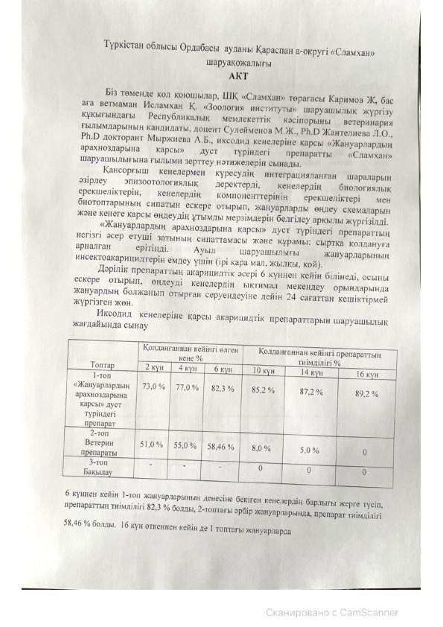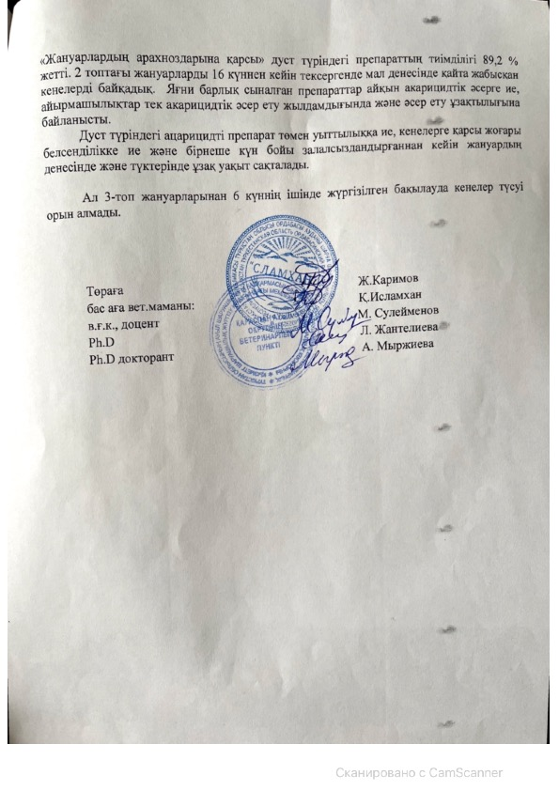
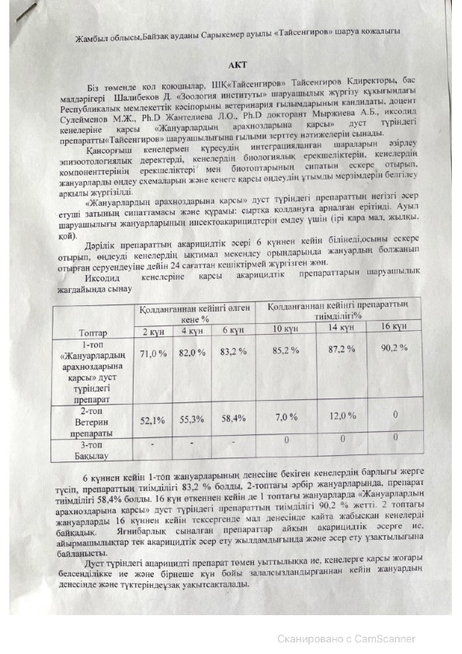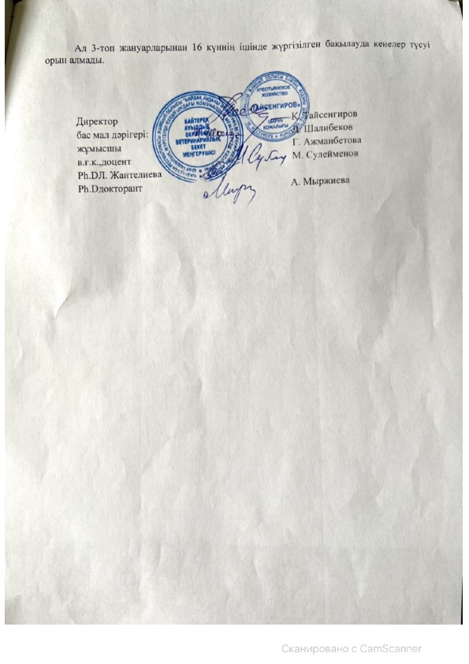
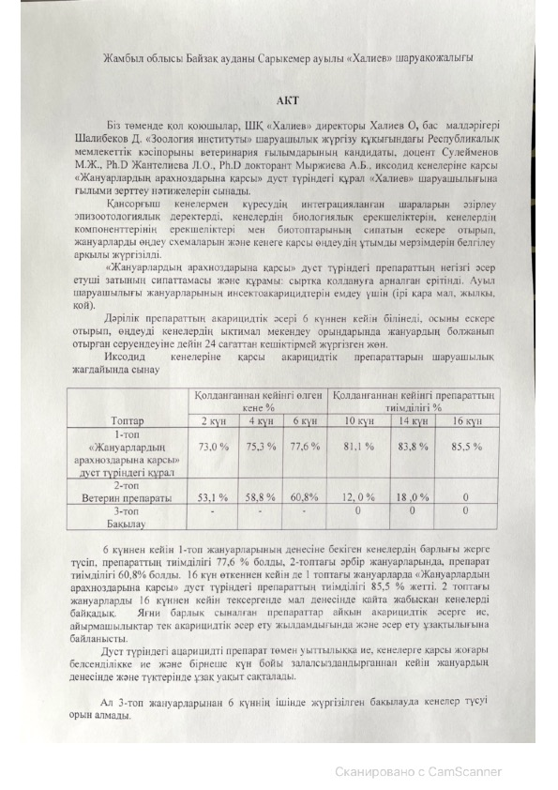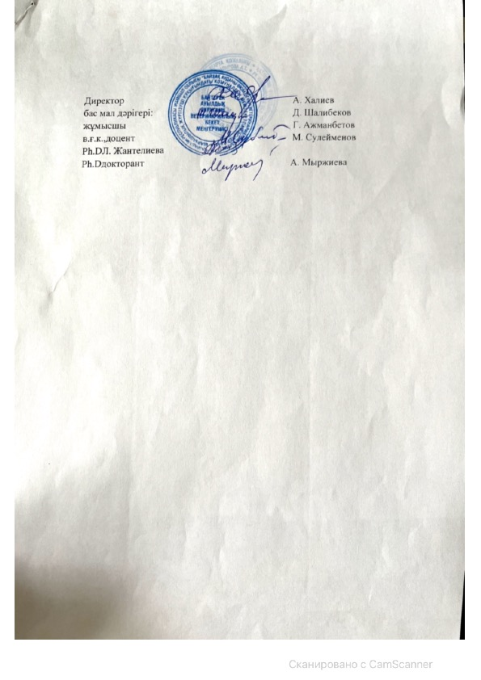
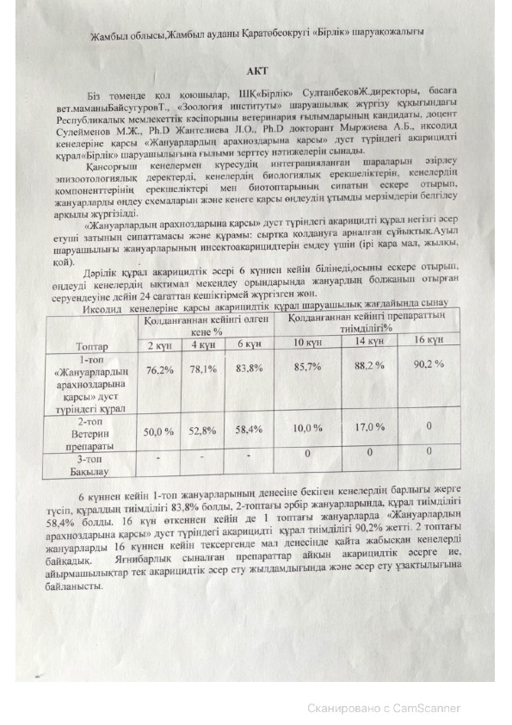
Turkestan region Ordabasy district Karaspan district farm "Slamkhan"
ACT
We are below the signatories, chairman of the peasant farm «Slamkhan» Karimov Zh., chief ыenior veterinary specialist Islamkhan K. Republican state enterprise on the right of Economic Management «Institute of Zoologу» candidate of veterinary sciences, Associate Professor Suleimenov M. Zh., PhD. Zhantelieva L. O., PhD doctoral student Myrzhieva A. B. tested the results of a scientific study of the drug in the form of dust «Against Animal arachnoses» against ixodic mites on the farm «Slamkhan».
The development of integrated measures to combat blood-sucking ticks was carried out by establishing schemes for processing animals and rational deadlines for anti-tick treatment, taking into account epizootological data, biological features of ticks, features of tick components and the nature of biotopes.
Description and composition of the main active substance of the drug in the form of dust «Аgainst animal arachnoses»: solution for external use. For the treatment of insecticides of farm animals (cattle, horses, sheep).
The acaricidal effect of the drug is manifested after 6 days, taking into account this, treatment should be carried out no later than 24 hours before the expected Walk of the animal in possible tick habitats.
On-farm testing of acaricide preparations against ixodide mites
Groups | Dead tick after application % |  |  | Effectiveness of the drug after use %
 | 2 day | 4 day | 6 day | 10 day | 14 day | 16 day
Group 1  Drug in the form of dust «Аgainst animal arachnoses» | 73,0 % | 77,0 % | 82,3 % | 85,2 % | 87,2 % | 89,2 %
Group 2  Veterin drug | 51,0 % | 55,0 % | 58,46 % | 8,0 % | 5,0 % | 0
Group 3  Control | - | - | - | 0 | 0 | 0

After 6 days, all ticks attached to the body of animals of Group 1 fell to the ground, the effectiveness of the drug was 82.3%, in each animals of Group 2, the effectiveness of the drug
It was 58.46%. In Group 1 animals even after 16 days
The effectiveness of the drug in the form of dust" against animal arachnoses " reached 83.2%. When examining animals in Group 2 after 16 days, we noticed ticks that re-stuck in the animal's body. That is, all tested drugs have a pronounced acaricidal effect, the differences are only in the rate of acaricidal action and the duration of action.
Acaricidal drug in the form of dust has a low toxicity, high activity against ticks and is stored for a long time on the body and fur of the animal after disinfection for several days.
And in the control of Group 3 animals for 6 days, ticks did not appear.

Chairman Zh. Karimov
chief senior vet. specialist K. Islamkhan
с.v.s., Associate Professor Suleimenov M. Zh
Ph.D Zhanteliyeva L. O.
Ph.D doctoral student Myrzhieva A. B

Zhambyl region Baizak district Sarykemer village farm «Taisengirov»
ACT
We are following the signatories, director of the peasant farm «Taisengirov» director of the Taisengirov., chief veterinary officer Shalibekov D. Republican state enterprise on the right of Economic Management «Institute of Zoologу» candidate of veterinary sciences, associate professor Suleimenov M. Zh., PhD Zhantelieva L. O., PhD doctoral student Myrzhieva A. B. tested the results of a scientific study on the farm «Taisengirov», a tool in the form of dust «Against Animal arachnoses» against ixodic mites.
The development of integrated measures to combat blood-sucking ticks was carried out by establishing schemes for processing animals and rational deadlines for anti-tick treatment, taking into account epizootological data, biological features of ticks, features of tick components and the nature of biotopes.
Description and composition of the main active substance of the drug in the form of dust" against animal arachnoses": solution for external use. For the treatment of insecticides of farm animals (cattle, horses, sheep).
The acaricidal effect of the drug is manifested after 6 days, taking into account this, treatment should be carried out no later than 24 hours before the expected Walk of the animal in possible tick habitats.
On-farm testing of acaricide preparations against ixodide mites

Groups | Dead tick after application % |  |  | Effectiveness of the drug after use %
 | 2 day | 4 day | 6 day | 10 day | 14 day | 16 day
Group 1  Drug in the form of dust "against animal arachnoses" | 71,0 % | 82,3 % | 83,2 % | 81,1 % | 83,8 % | 85,5 %
Group 2  Veterin Drug | 53,1 % | 58,8 % | 60,8% | 12, 0 % | 18 ,0 % | 0
Group 3  Control | - | - | - | 0 | 0 | 0

After 6 days, all ticks attached to the body of animals of Group 1 fell to the ground, the effectiveness of the drug was 77.6%, in each animals of Group 2, the effectiveness of the drug was 60.8%. Even after 16 days, the effectiveness of the drug in the form of dust "Against Animal arachnoses" in animals of the 1st group reached 85.5%. When examining animals in Group 2 after 16 days, we noticed ticks that re-stuck in the animal's body. That is, all tested drugs have a pronounced acaricidal effect, the differences are only in the rate of acaricidal action and the duration of action.
Acaricidal drug in the form of dust has a low toxicity, high activity against ticks and is stored for a long time on the body and fur of the animal after disinfection for several days.

And in the control of Group 3 animals for 6 days, ticks did not appear.

Director Taisengirov
chief vet. doctor D. A. Shalibekov
worker G.Azhmanbetova
с.v.s., Associate Professor Suleimenov M. Zh
Ph.D Zhantelieva L. O.,
Ph.D doctoral student Myrzhieva A. B

Sarykemer village, Bayzak district, Zhambyl region

ACT

We are below the signatories, director of the peasant farm «Khaliev» Khaliev O., chief veterinary doctor Shalibekov D. candidate of Veterinary Sciences, Associate Professor Suleimenov M. Zh., Ph.D Zhanteliyeva L. O., Ph.D doctoral student Myrzhieva A. B., tested the results of scientific research on the farm «Khaliev», a tool in the form of dust «Аgainst animal arachnoses» against ixodid mites.
The development of integrated measures to combat blood-sucking ticks was carried out by establishing schemes for processing animals and rational deadlines for anti-tick treatment, taking into account epizootological data, biological features of ticks, features of tick components and the nature of biotopes.
Description and composition of the main active substance of the drug in the form of dust «Аgainst animal arachnoses»: solution for external use. For the treatment of insecticides of farm animals (cattle, horses, sheep).
The acaricidal effect of the drug is manifested after 6 days, taking into account this, treatment should be carried out no later than 24 hours before the expected Walk of the animal in possible tick habitats.
On-farm testing of acaricide preparations against ixodide mites
Groups | Dead tick after application % |  |  | Effectiveness of the drug after use %
 | 2 day | 4 day | 6 day | 10 day | 14 day | 16 day
Group 1  Dust-type remedy "Against animal arachnoses" | 73,0 % | 75,3 % | 77,6 % | 81,1 % | 83,8 % | 85,5 %
Group 2  Veterin drug | 53,1 % | 58,8 % | 60,8% | 12, 0 % | 18 ,0 % | 0
Group 3  Control | - | - | - | 0 | 0 | 0

After 6 days, all ticks attached to the body of animals of Group 1 fell to the ground, the effectiveness of the drug was 77.6%, in each animals of Group 2, the effectiveness of the drug was 60.8%. Even after 16 days, the effectiveness of the drug in the form of dust "Against Animal arachnoses" in animals of the 1st group reached 85.5%. When examining animals in Group 2 after 16 days, we noticed ticks that re-stuck in the animal's body. That is, all tested drugs have a pronounced acaricidal effect, the differences are only in the rate of acaricidal action and the duration of action.
Acaricidal drug in the form of dust has a low toxicity, high activity against ticks and is stored for a long time on the body and fur of the animal after disinfection for several days.

And in the control of Group 3 animals for 6 days, ticks did not appear.
Director A. Seуtkadyrova
chief vet. doctor D. A. Shalibekov
worker S.Karayev
с.v.s., Associate Professor Suleimenov M. Zh
Ph.D Zhanteliyeva L. O.,
Ph.D doctoral student Myrzhieva A. B

Sarykemer village, Bayzak district, Zhambyl region
ACT

We are below the signatories, director of the peasant farm «Khaliev» Khaliev O., chief veterinary doctor Shalibekov D. candidate of Veterinary Sciences, Associate Professor Suleimenov M. Zh., Ph.D Zhantelieva L. O., Ph.D doctoral student Myrzhieva A. B., tested the results of scientific research on the farm «Khaliev», a tool in the form of dust «Аgainst animal arachnoses» against ixodid mites.
The development of integrated measures to combat blood-sucking ticks was carried out by establishing schemes for processing animals and rational deadlines for anti-tick treatment, taking into account epizootological data, biological features of ticks, features of tick components and the nature of biotopes.
Description and composition of the main active substance of the drug in the form of dust «Аgainst animal arachnoses»: solution for external use. For the treatment of insecticides of farm animals (cattle, horses, sheep).
The acaricidal effect of the drug is manifested after 6 days, taking into account this, treatment should be carried out no later than 24 hours before the expected Walk of the animal in possible tick habitats.
On-farm testing of acaricide preparations against ixodide mites
Groups | Dead tick after application % |  |  | Effectiveness of the drug after use %
 | 2 day | 4 day | 6 day | 10 day | 14 day | 16 day
Group 1  Dust-type remedy "Against animal arachnoses" | 73,0 % | 75,3 % | 77,6 % | 81,1 % | 83,8 % | 85,5 %
Group 2  Veterin drug | 53,1 % | 58,8 % | 60,8% | 12, 0 % | 18 ,0 % | 0
Group 3  Control | - | - | - | 0 | 0 | 0

After 6 days, all ticks attached to the body of animals of Group 1 fell to the ground, the effectiveness of the drug was 77.6%, in each animals of Group 2, the effectiveness of the drug was 60.8%. Even after 16 days, the effectiveness of the drug in the form of dust "Against Animal arachnoses" in animals of the 1st group reached 85.5%. When examining animals in Group 2 after 16 days, we noticed ticks that re-stuck in the animal's body. That is, all tested drugs have a pronounced acaricidal effect, the differences are only in the rate of acaricidal action and the duration of action.
Acaricidal drug in the form of dust has a low toxicity, high activity against ticks and is stored for a long time on the body and fur of the animal after disinfection for several days.

And in the control of Group 3 animals for 6 days, ticks did not appear.

Director A. Seуtkadyrova
chief vet. doctor D. A. Shalibekov
worker S.Karayev
с.v.s., Associate Professor Suleimenov M. Zh
Ph.D Zhanteliyeva L. O.,
Ph.D doctoral student Myrzhieva A. B

APPENDIX С
Seminar information

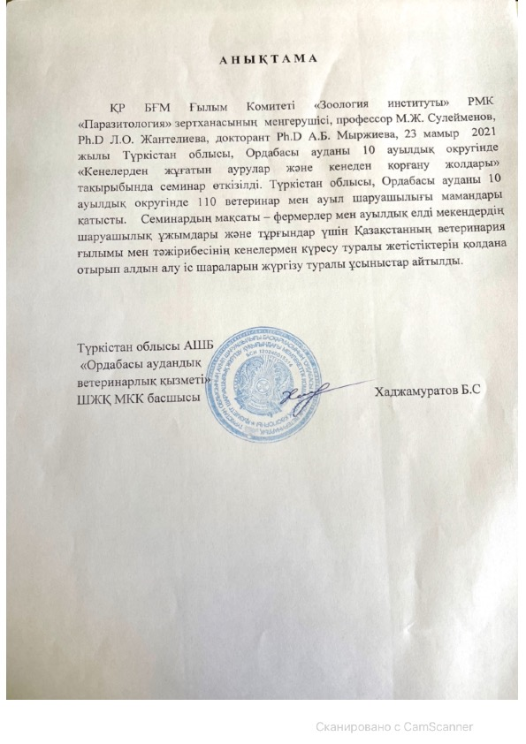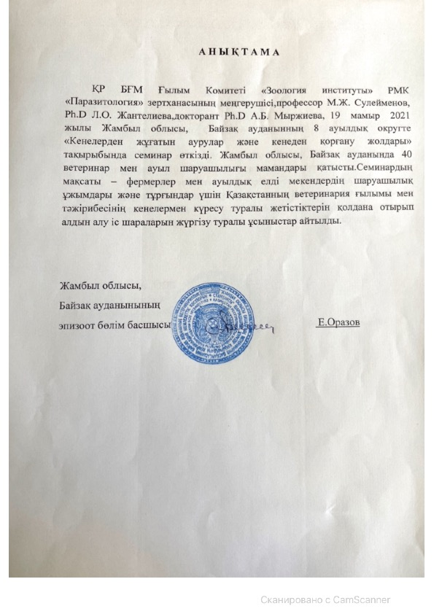Reference
Head of the laboratory "Parasitology" RSE "Institute of Zoology" of the committee of Science of the Ministry of education and science of the Republic of Kazakhstan, professor Suleimenov M. zh., PhDL. O. Zhantelieva, doctoral student PhDA. B. Myrzhieva, on May 19, 2021, held a seminar on "tick-borne diseases and ways to protect against ticks" in 8 rural districts of Baizak district, Zhambyl region. 40 veterinarians and agricultural specialists took part in the event in Baizak District of Zhambyl region. The purpose of the seminar – for farmers, farm collectives of rural settlements and the population, proposals were made to carry out preventive measures using the achievements of Veterinary Science and practice of Kazakhstan in the fight against ticks.

Zhambyl region, Baizak district
Head of the epizootology Department E. Orazov
APPENDIX D
Publications

1. Asem Bekbolatovna Myrzhieva et al. Ixodid Ticks: Epizootic Status and Methods for Tick Population Size reduction // Online Jornal of Biological Sciences 2020,20 (4): - P. 166-175. (Scopus Q3, процентиль 41 %)
2 Myrzhieva A.B., Suleimenov M.Zh., Zhanteliyeva L.O."Turap" sharuashylygyndagy iri kara maldyn teyleriozynyn taraluy// Journal Bulletin of the Shakarim State University of Semey No. 3(91), 2020 ISSN 1607-2774. – P. 347-350.
3 Myrzhieva A.B., Suleimenov M.ZH., UGUR Uslu, Ibazhanova A., Zhanteliyeva L.O. Duration of acaricidal action the drug kenem and economic justification for the protection of cattle from ixodic mites // Izdenister Journal, natizheler - Research, results No. 1, 2021 (89) ISSN 2304-3334. -P. 80-91.
4 Prevention of arachnosis in animals in the south of Kazakhstan // Methodical recommendations. - Almaty, 2021
Utility Model Patents:
1. Patent No. 6062 for the utility model "Acaricidal preparation in the form of dust against arachnoses of animals" dated 02/18/2021. Authors: Suleimenov Maratbek Zhaksybekovich, Zhantelieva Laura Orazakynovna, Myrzhieva Asem Bekbolatovna.
2. Patent No. 6096 for the utility model "Acaricidal agent in the form of dust against arachnoses of animals" dated 28.05.2021. Authors: Suleimenov Maratbek Zhaksybekovich, Zhantelieva Laura Orazakynovna, Myrzhieva Asem Bekbolatovna.
In the press:
- Myrzhieva, Suleimenov M., Zhanteliyeva L. et al. Research of ixodic mites for the presence of theileriosis agents//Jornal of Animal Health and Production. ISSN:2308-2801.
- Ibazhanova A., A. Myrzhieva., Suleimenov M. et al. Effectivenessof Kenem drug against ixodid ticks//Jornal Advences in Animal and Veterinary Scienses. ISSN: 2307-8316.
- Suleimenov M., Zhanteliyeva L., A. Myrzhieva., Barbol B. et al.Testig an effective and environmentally friendly remedy for protection against ticks – ectoparasites of animals. // IRAQI JORNAL OF AGRICULTURAL SCIENCES.
- Myrzhieva A.B., Suleimenov M.ZH., Barbol B., Zhanteliyeva L.O. Bio-diversity of ixod ticks (ARACHNIDA:IXODIDAE) in the southern regions of Kazarhstan // Journal "Bulletin of KazNU. Biological series" No. 4(89), 2021.

APPENDIX E
Patantes
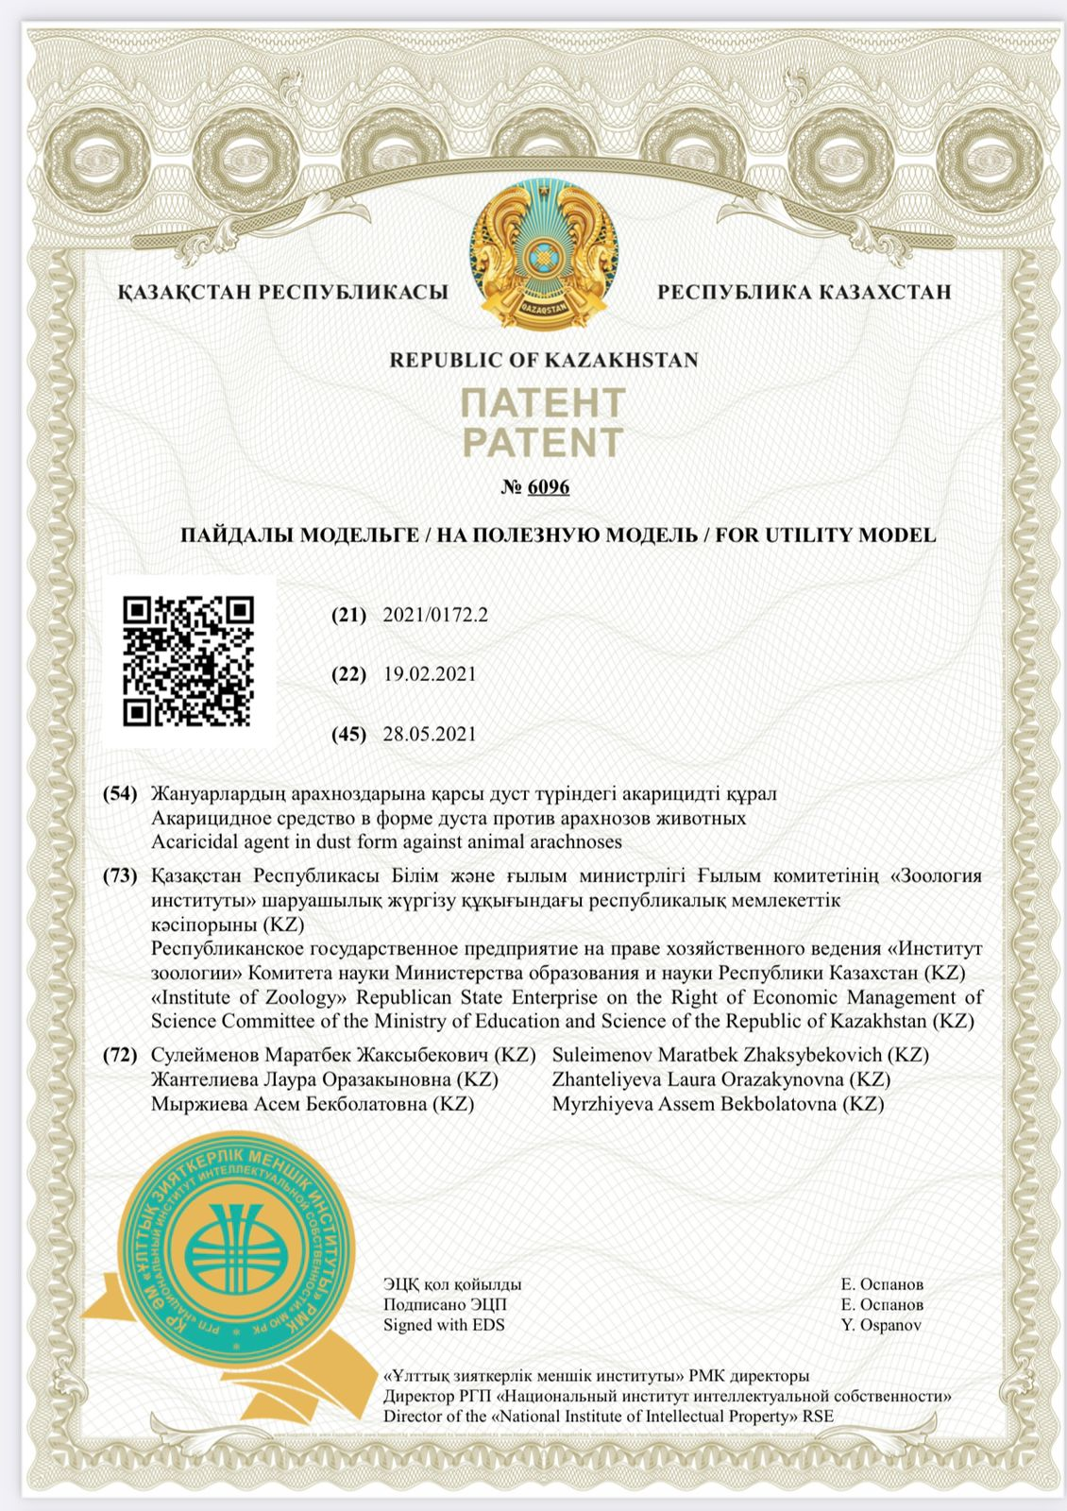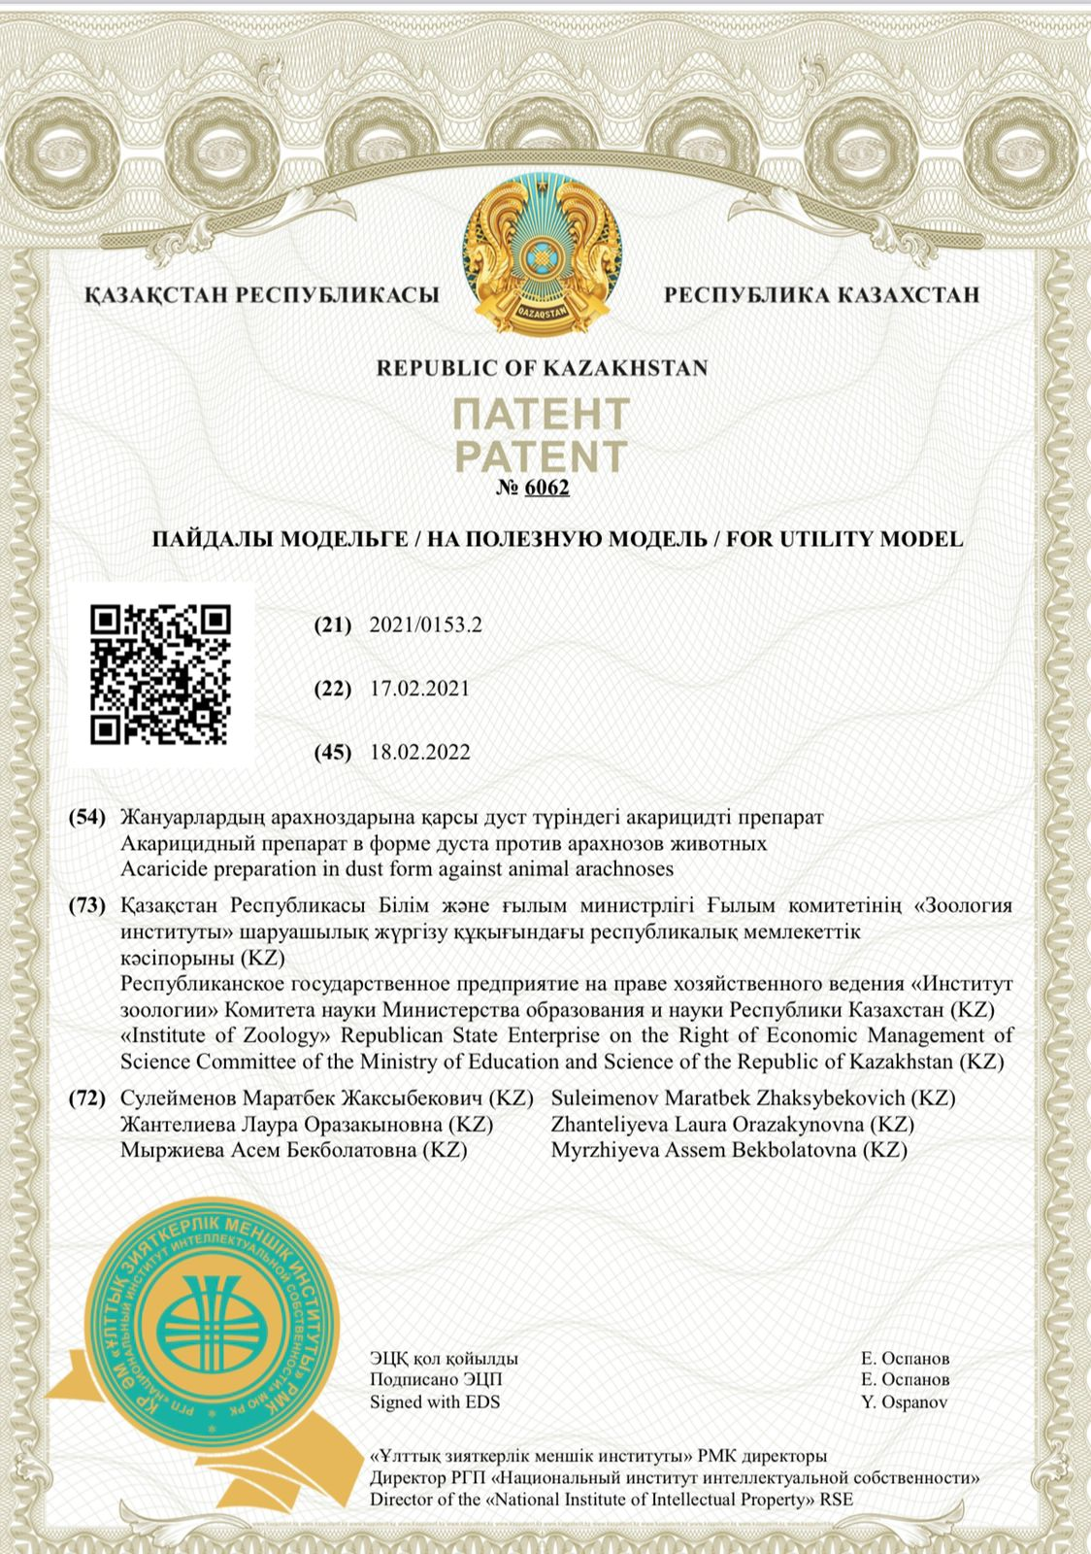

APPENDIX F
Reprints of published works

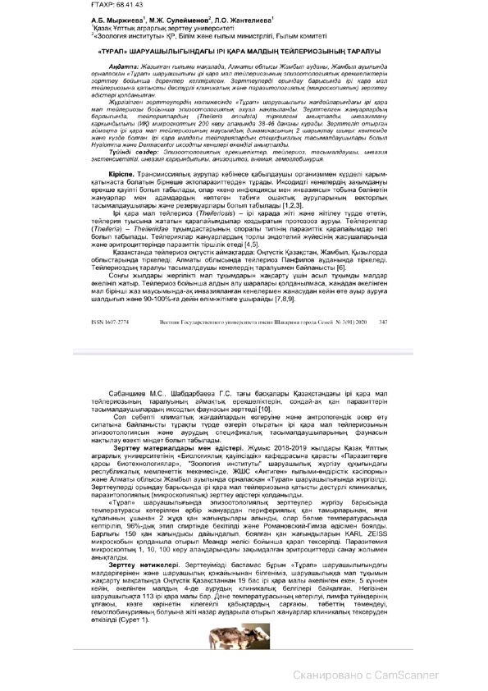

APPENDIX G
Methodical recommendation
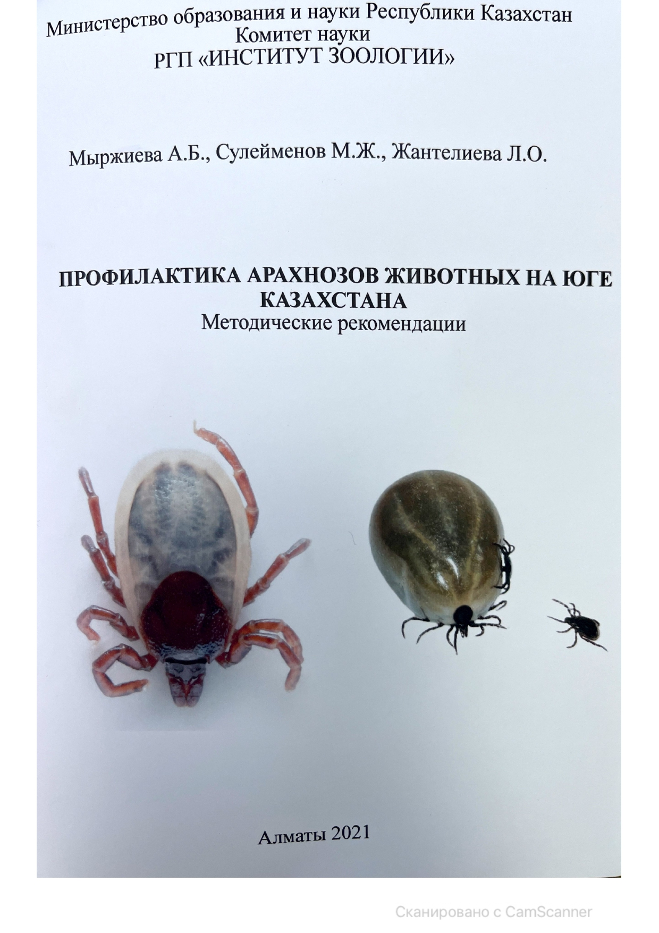

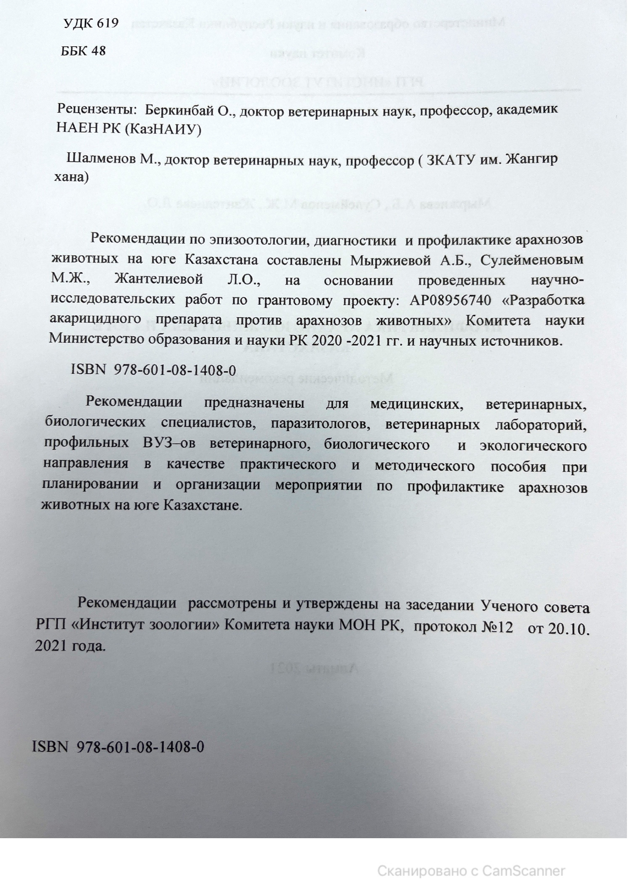
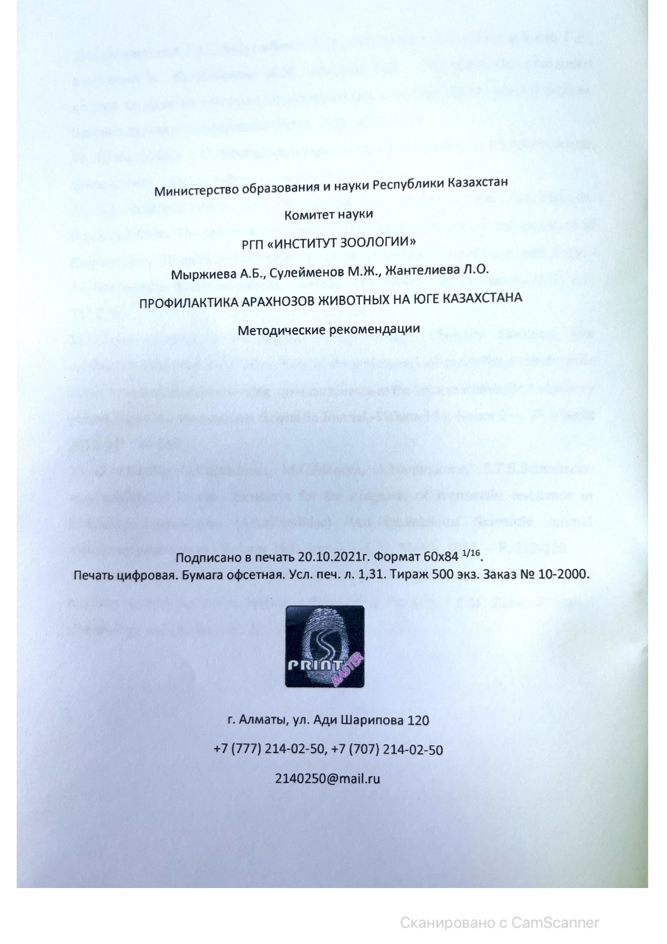

Appendix H
Certificate of acceptance for publication
