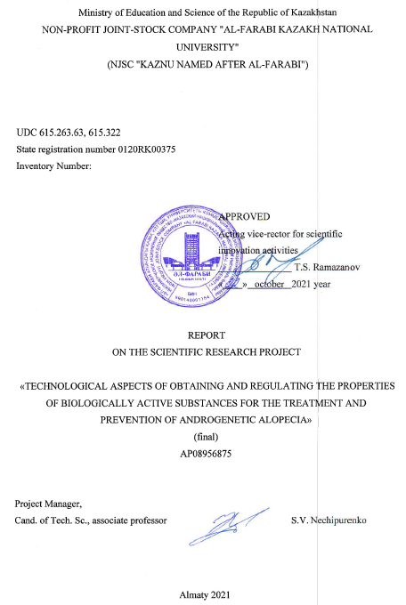

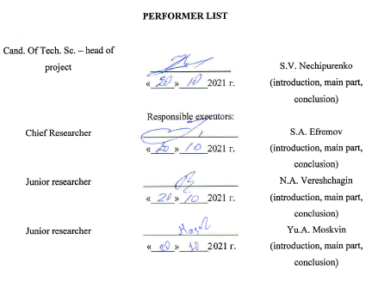

**ABSTRACT**

Report 43 p., 20 figures, 2 tables, 34 ref., 2 appendix.

PHYTOESTROGENS, ALLOPECIA, LIGNANS, ISOFLAVONES, EXTRACTION, COLUMN CHROMATOGRAPHY

Subject of research: the parameters of the technology for the selective extraction of phytoestrogens from plant raw materials for cosmetology.

Purpose of work: the purpose of the project is the extraction isolation and purification of biologically active substances from the ballast impurities contained in the plant raw materials of Kazakhstan and the study of the biological activity of the data by the in vivo method.

Research methods: UV spectroscopy, NMR H1, NMR C13, HPLC, gravimetry, chromatography.

Research results:

- the composition of raw materials has been studied, the qualitative composition of biological groups has been obtained for adjusting the methods of further work, recommendations for decontamination of soils in potential areas of growing raw materials have been proposed;

- methods of extracting the target fraction from raw materials were investigated, the optimal parameters for extracting target substances were established;

- methods of purification of the extract from ballast substances have been established;

- identified target substances in the obtained extract, established the structure of individual substances for obtaining phytoestrogens in the extract;

- the biological activity of the obtained extracts in relation to alopecia in vivo was investigated, the biological activity of individual and sum of substances was established for the possibility of using these substances in androgenetic alopecia.

Implementation recommendations: further work needs to be done to enable implementation in cosmetology technologies.

Applications: biotechnology, cosmetology.

**CONTENT**

|  |  |
| --- | --- |
|  | Р |
| SYMBOLS AND ABBREVIATIONS …………………………………………………… | 5 |
| INTRODUCTION……………………………………...…………………………………. | 6 |
| MAIN PART OF THE R&D REPORT ...………………………………………………… | 8 |
| 1 Study of the composition of raw materials ..……………………………………………. | 8 |
| 2 Research of methods for extracting the target fraction from raw materials…………….. | 12 |
| 3 Study of methods of purification of the obtained extract from ballast substances……… | 15 |
| 4 Identification of target substances in the obtained extract ……………………………… | 18 |
| 5 Investigation of the biological activity of the obtained extracts in relation to alopecia in vivo ……………...………………………………………………………………………... | 30 |
| CONCLUSION .…………………………………………………………………………... | 32 |
| REFERENCES ……………………………………….………………………….……….. | 33 |
| APPENDIX A - Calendar Plan …………..…………………………...………………...… | 37 |
| APPENDIX B - List of published works for 2020-2021 ……………….………………… | 43 |

**SYMBOLS AND ABBREVIATIONS**

In this research report, the following abbreviations and symbols are used

SECO - Secoisolariciresinol

GPM - General Pharmacopoeia Monograph

MCMS - modified carbon-mineral sorbents

rpm - Revolutions per minute

SDH - Secoisolariciresinol diglucoside

HFL - Highly flammable liquid

LV - Medicinal substance

BAS - Biologically active substance

LHC - Biologically active complex

TPV - Triterpenoid substances

TS - technological scheme

**INTRODUCTION**

General description of work. This work is devoted to obtaining extracts of flax seeds, modifying methods and finding new methods for obtaining an extract containing phytoestrogens, as well as developing technology and determining suitable cosmetic forms for placing the obtained extracts.

Relevance of the research topic. At the moment, humanity is faced with a number of problems related to the general state of health. In this paper, the problem of androgenetic alopecia or alopecia is considered and the ways of its solution are proposed.

The necessary substances for the proposed solution to this problem are called phytoestrogens. Flax seeds are the richest raw material for this class of substances. Flax is one of the key industrial crops grown in Kazakhstan. Thus, the study of the properties and the possibility of using phytoestrogens is of interest for the cosmetic field.

The aim of the work is to study and modify various ways of extraction from flax seeds, and to develop a technology for its production and placement in a cosmetic form for further use in cosmetology.

Research objects. Phytoestrogen production technology. Assessment of the current state of the problem being solved. At the moment, the methods of treating androgenetic alopecia by oral administration of medicinal substances, or as an analogue of the path of hair transplantation to problem areas, are quite fully investigated, however, local exposure to problem areas with hormonal substances has been studied to a lesser extent.

Scientific novelty. A technology has been developed that combines the extraction of phytoestrogens and the production of a cosmetic form to reduce the effects of androgenetic alopecia in various places. This method allows you to increase the quantity and quality of the extract obtained and the availability of placing it in a cosmetic form.

Theoretical significance. The influence of various factors (changes in pH, temperature, time, nature) on the completeness and selectivity of the extraction of secoisolariciresinol diglucoside from flax seeds was studied.

Project objectives for 2020:

1. Study of the composition of raw materials.

2. Investigation of methods for extracting the target fraction from raw materials.

3. Study of methods of purification of the obtained extract from ballast substances.

Main results for 2020: work completed in full.

Project objectives for 2021:

1. Study of methods of purification of the obtained extract from ballast substances.

2. Identification of target substances in the obtained extract.

3. Investigation of the biological activity of the obtained extracts in relation to alopecia in vivo.

Key results for 2021: work completed in full.

The practical significance of the study. The results of the work can contribute to the possibility of implementation in cosmetology technologies.

Applications: biotechnology, cosmetology.

Inv. No. 0220RK01735 for 2020.

**MAIN PART ABOUT RESEARCH WORK**

**1 Study of the composition of raw materials**

Flax seeds are one of the main products of the agricultural industry. The initial raw material - the plant flax or common flax (Linum usitatissimum L.) has a predominant distribution in the countries of Europe and the CIS, where targeted cultivation takes place. It is an annual herb belonging to the Flax genus, Flax family. The definition of this type of plant is based on the sum of its characteristics. The external features of the studied seeds are an oval-flattened shape, pointed at one edge. Length 4-6 mm, width 2-3 mm and thickness 2 mm. The surface is smooth, shiny, brown. There is no smell. The authenticity of seeds and their powder is determined by external signs and microscopically [1].

Microscopic signs - peel in the form of a dark brown stripe, endosperm and embryo. Under the microscope, the layers of the seed coat are distinguished. The epidermis consists of large, quadrangular cells, covered with a thick layer of cuticle, containing mucus; the lateral (radial) walls of the cells are slightly tortuous; when mucus swells, they are able to straighten and stretch. Under the epidermis there are 1 - 2 rows of loose cells of an almost round shape. The third layer is represented by mechanical tissue, consisting of one row of strongly thickened, lignified yellow cells, permeated with pore tubules [2].

In the course of the work, it was found that the parameters of the studied culture comply with the following standards: 1) The moisture content of the raw material is no more than 13%. The determination was carried out according to the methodology of the GPM.1.5.3.0007.15; 2) Total ash - no more than 6%. The determination was carried out according to the methodology of the GPM.1.2.2.2.0013.15; 3) Ash insoluble in hydrochloric acid - no more than 0.5%. The determination was carried out according to the methodology of the GPM.1.5.3.0005.15; 4) Mineral impurity - no more than 0.5%. The determination was carried out according to the methodology of the GPM.1.5.3.0004.15; 5) Quantification by polysaccharides - not less than 7%. The determination was carried out according to the method of GPM.1.5.3.0006.15 [3].

Red clover (Trifolium pratense L.) is a perennial herb with straight, slightly pubescent stems, small pale or dark red small flowers, collected in globular heads. Good honey plant and excellent fodder plant. Improves soil fertility by enriching it with nitrogenous compounds. It is widely used in medicine, in particular in dermatology. The definition of this type of plant is based on the sum of its characteristics. External signs of domestic meadow clover: biennial, but more often a perennial herb, reaches a height of 15-55 cm. The branchy stems are ascending. The leaves are trifoliate, with broadly ovate finely toothed lobes, the leaves are whole at the edges, with delicate cilia at the edges. The inflorescences of the head are loose, spherical, often sit in pairs and are often covered with two upper leaves. Corolla red, occasionally white or multicolored; calyx with ten veins. The fruit is an ovoid, single-seeded pod; the seeds are sometimes round, sometimes angular, sometimes yellowish-red, sometimes purple [4].

In the course of the work, it was found that the parameters of the studied culture comply with the following standards: 1) The moisture content of the raw material is no more than 7%. The determination was carried out according to the methodology of the GPM.1.5.3.0007.15; 2) Total ash - no more than 7.5%. The determination was carried out according to the methodology of the GPM.1.2.2.2.0013.15; 3) Ash insoluble in hydrochloric acid - no more than 6.9%. The determination was carried out according to the methodology of the GPM.1.5.3.0005.15; 4) Mineral impurity - no more than 0.02%. The determination was carried out according to the methodology of the GPM.1.5.3.0004.15; 5) The quantitative content of flavonoids in terms of luteolin-7-glucoside was 0.36%. The determination was carried out according to the methodology of GOST R 55312-2012 [5].

Cultivated soybean Glycine max is an annual herb, a species of the genus Soybean (Glycine) of the Legume family.

Outward signs: Stems of cultivated soybeans are thin to thick, pubescent or bare. The height of the stems is from very low (from 15 cm) to very high - up to 2 or more meters. In all species of the genus Soya, including the cultivated soybean species, the leaves are ternary, occasionally 5, 7 and 9-leafed, with pubescent leaves and feathery venation. The first supra-cotyledonous node of the stem has two simple leaves (primordial leaves). These primary leaves, in accordance with the Müller-Haeckel biogenetic law, are considered as phylogenetically older forms of leaves. A common feature for all soybean species is the presence of underdeveloped styloid stipules at the base of the rachis and stipules at the base of a separate leaflet [6].

In the course of the work, it was found that the parameters of the studied culture comply with the following standards: 1) The moisture content of the raw material is no more than 12%. The determination was carried out according to the methodology of the GPM.1.5.3.0007.15; 2) Total ash - no more than 6%. The determination was carried out according to the methodology of the GPM.1.2.2.2.0013.15; 3) Ash insoluble in hydrochloric acid - no more than 3%. The determination was carried out according to the methodology of the GPM.1.5.3.0005.15; 4) Mineral impurity - no more than 0.1%. The determination was carried out according to the methodology of the GPM.1.5.3.0004.15; 5) Oil admixture no more than 6%. The determination was carried out according to the methodology of GOST 10854 [7].

A separate stage in the project is a sorption technology for detoxification of soils contaminated with rocket fuel components modified with carbon-mineral sorbents. This work was carried out due to the fact that the areas affected by rocket and space activities are potential areas for growing the studied crops. In this regard, the issues of localization and detoxification of contaminated areas are becoming more and more urgent in order to restore the ecobalance and return contaminated soil areas for agricultural needs. One of the most promising methods of soil detoxification are adsorption and catalytic methods, the main development trends of which are the search for the cheapest and most effective materials, the improvement of technologies for their regeneration and utilization. The paper presents the results of obtaining modified carbon-mineral systems (MCMS Mn4+ and MCMS Fe3+) based on shungite rocks of Kazakhstan for detoxification of soils contaminated with rocket fuel components. For this, the structure of shungite and the physicochemical parameters of MCMS were studied, the soils from the fall sites of the separating parts of the launch vehicles were studied, and the ways of transforming the rocket fuel in the soils were analyzed. The obtained MCMS showed the efficiency of the sorption-catalytic decomposition of rocket fuel transformation products and determined the optimal conditions for detoxification.

As a result of the research, a basic technological scheme for obtaining MCMS has been developed [8].

In the process of flotation, a concentrate was obtained that was stable in chemical composition. The chemical composition of the enrichment products is represented by the following components [9]: C (40.0%); SiO2 (37.7%); TiO2 (0.2%); Al2O3 (7.8%); Fe2O3 (3.6%); CaO (2.8); MgO (2.7%); Na2O (0.3%); К2О (3.7%). The final stage of obtaining MCMS is modification with transition metal ions. Modifying agents were selected on the basis of X-ray spectral analysis of soils, from which it was found that the ions of manganese and iron are contained in the soil in a fairly small amount. Therefore, manganese and iron were chosen as modifiers as one of the most active oxidizing agents promoting the destruction of rocket fuel with higher MPC values. For the effective use of MCMS, it is necessary to know their standard physicochemical characteristics in sorption practice, such as the specific surface area, pore volume, porosity and sorption capacity for iodine, since the material should have a relatively developed surface and sorption data. It was found that the carbon catalyst based on Mn4+ has the highest sorption capacity with respect to iodine, the capacity is 32 mg/g. The rest of the parameters of the studied MCMS are similar due to the general nature of the origin of the shungite carrier.

IR spectroscopic study of MCMS made it possible to obtain information on the structure of shungite carbon and the qualitative composition of functional groups on their surface. According to the absorption spectra, the samples contain: Muscovit KAl2[(OH, F)2| AlSi3O10] - 3629, 3434, 1622, 1031, 832, 756, 537, 475, 411 cm-1; Quarz SiO2 - 1081, 798, 778, 695, 397, 374 cm-1; Albit Na[AlSi3O8] - 1165, 987, 742, 475 cm-1; Ankerit CaFe (CO3)2 - 1424, 872, 727 cm-1, in the long-wavelength region of the spectrum, there is a manifestation of stretching vibrations v ОН - 3434 cm-1, НОН - 1622 cm-1.

Knowledge of the mineralogical composition of the carrier shungite is necessary in order not to disturb the existing natural soil balance in promising growing areas of the studied crops after field work on soil detoxification. In this regard, X-ray studies of shungite and its concentrate were carried out, in particular, the carbon content averaged 12.0 and 40.0%, respectively.

The processing of the obtained data of diffraction patterns and the calculation of interplanar distances were carried out using the EVA software. Sample decoding and phase search were carried out using the Search/match program using the PDF-2 powder diffractometric data base.

Further, as a result of experimental studies, a technology was developed for the production of Mn4+ MCMS and Fe3+ MCMS for detoxification of soils contaminated with propellant components, a brief mechanism of complete catalytic oxidation of the studied products was proposed. The optimal conditions for detoxification of rocket fuel and its decay products have been determined: 1) the ratio of soil:MCMS = 9:1 (transition metal ions make up 5% of the total mass of the sorbent) 2) the contact time is 24 hours at a concentration of analyzed products from 0.1 mg/kg up to 3.21 mg/kg. The degree of detoxification of soil contaminated with rocket fuel and its transformation products, at these concentrations, is from 81.1 to 98.8%. The developed detoxification technology promotes the decomposition of rocket fuel components to non-toxic components and allows subsequently not to remove MCMS from the soil, because it does not disturb the general background and chemical balances of soils. The use of MCMS can be recommended for the remediation of contaminated soil areas, which will contribute to solving a number of environmental issues.

**2 Research of methods for extracting the target fraction from raw materials**

The methodology for obtaining extracts from the raw materials under study included the dependences of various methods to obtain optimal conditions: alcohol-water extraction: 0/100; 20/80; 40/60; 60/40; 80/20; 90/10, which were accompanied in parallel by acid hydrolysis.

An analysis was carried out of the dependence of the release of substances on time, under the conditions of extraction: ethyl alcohol / water (50/50) at pH = 2 (sulfuric acid). Among the segments of 30, 60, 90, 120, 150, 180, 210, 240 minutes, the peak of extraction falls on 90 minutes at the boiling point of the extractant.

The objects of the study were flax seeds, meadow clover flowers and soybeans as a raw material containing a phytoestrogen fraction. A water-ethanol mixture (50/50) was chosen as extractants.

According to the method (1) of extraction with parallel hydrolysis, the raw material was crushed, a sample weighing 5 g was taken, the raw material was defatted with hexane for 1 hour of boiling in a water bath with a reflux condenser, with the ratio of raw material to hexane equal to 1:6. After degreasing, hexane was removed, the raw material was dried and subjected to extraction in a water-alcohol solvent (50/50) for 1.5 hours. The resulting cake was separated from the extract by filtration through a dense gauze filter, the colloidal suspension was precipitated by centrifugation at 3000 rpm. The obtained extract in the form of a true color solution was subjected to hydrolysis with NaOH at pH = 10 and a temperature of 80 ⁰C for an hour. The resulting extract was acidified to pH = 6 with 0.1 N HCl solution, the residual suspension was precipitated by centrifugation at 3000 rpm [10]. The resulting extract was evaporated to dryness, the dry mass was weighed to determine the yield of the fraction, an exact weighed portion of 0.010 g was taken from it, which was dissolved in 10 ml of solvent (50% ethanol solution in water), an aliquot of 1 ml, which was diluted 10 times to obtain 3 solutions with a concentration of 10; 1; 0.1 mg / ml, these solutions were studied using UV spectroscopy.

The studied Method (2) was in full compliance with the above procedure, with the exception of the stages of hydrolysis and the nature of the hydrolyzate. In the first stage of hydrolysis, the water-ethanol solution was acidified with 1N HCl solution to pH = 2.5, extraction was carried out for 1.5 hours, then the solution was filtered through a thick layer of gauze to separate the cake, the extract was podslushivaet to pH = 10 and boiled at 80 ⁰C within an hour. The extract was acidified to pH = 6 and precipitate flakes were separated by centrifugation at 3000 rpm. Further actions follow the original method described above [11].

Method (3) included degreasing of crushed seeds with hexane at 50 °C for 2 hours. Then hexane was removed, the raw material was dried, and extraction was carried out with 50% ethanol simultaneously with alkaline hydrolysis (NaOH) at pH = 10 at 80 ⁰C for 2 hours. The resulting extract was filtered through cheesecloth, then neutralized, purified and dried in the same way as in method 2.

Method (4) included the preparation of raw materials similar to method 3. De-fat seeds were subjected to extraction with 50% ethanol acidified to pH = 3 (0.2M H2SO4) at 80 ⁰C for 2 hours [12]. The resulting extract was separated from the cake by filtration through gauze, alkalized to pH = 10 and hydrolyzed for 2 hours at 80 ° C. Neutralization, cleaning and dehumidification were carried out similarly to method 2.

Method (5) included pre-treatment of crushed flax seeds with microwave radiation at a power of 800W [13] for 10 s. The processed raw material was further extracted according to method 4.

Methodology (6) included pre-treatment of crushed flax seeds with microwave radiation at a power of 450W [14] for 5 s 4 times with an interval of 5 seconds. Before processing, the seeds were moistened with water in an amount (1 part of raw material to 3 parts of water). The processed raw material was further extracted according to method 1.

Method (7) included pre-treatment of crushed flax seeds with microwave radiation at 800W for 5 s 4 times with an interval of 5 seconds [15]. Before processing, the seeds were moistened with water in an amount (1 part of raw material to 3 parts of water). The processed raw material was further extracted according to method 1.

Methodology (8) included pre-treatment of crushed flax seeds with liquid nitrogen for 10 minutes. The seeds were cryo-treated in a special container without direct contact. The processed raw material was further extracted according to method 1 [16]. Method (5) included pre-treatment of crushed flax seeds with microwave radiation at a power of 800W for 10 s. The processed raw material was further extracted according to method 4.

Method (9) included pretreatment of crushed flax seeds with hexane according to method 1. Extraction was carried out using ultrasound, by immersing defatted raw materials and an extractant into a container equipped with ultrasonic resonators with a power of 1 W/L [17]. The stages of hydrolysis and analysis were carried out in a similar manner to method 1.

Method (10) included pretreatment of crushed flax seeds with hexane according to method 1. Extraction was carried out using ultrasound, by immersing defatted raw materials and extractant into a container equipped with ultrasonic resonators with a power of 3 W/L [18]. The stages of hydrolysis and analysis were carried out in a similar manner to method 1.

Method (11) included pretreatment of crushed flax seeds with hexane according to method 1. Extraction was carried out using ultrasound, by immersing defatted raw materials and extractant into a container equipped with ultrasonic resonators with a power of 6W/L [19]. The stages of hydrolysis and analysis were carried out in the same way as in procedure 1.

Method (12) included pretreatment of crushed flax seeds with hexane according to method 1. Extraction was carried out using ultrasound, by immersing defatted raw materials and an extractant into a container equipped with ultrasonic resonators with a power of 10 W/L [20]. The stages of hydrolysis and analysis were carried out in the same way as in procedure 1.

It was experimentally found that the most suitable and environmentally friendly type of solvent is alcohol. The optimal concentration of alcohol is 50-60%; extraction time - 1.5-2.5 hours, temperature: 60-82 ℃ [21-22], to increase the yield and simplify the equipment, it is necessary to treat the seeds with ultrasound at a power of 6 W/L for 30 minutes.

**3 Study of methods of purification of the obtained extract from ballast substances**

The primary heating in the extraction process is the denaturation of protein and enzymatic structures, which in the process are released in the form of a colloidal solution, which is precipitated during centrifugation.

Polysaccharides are high molecular weight carbohydrates, polymers of monosaccharides (glycans). Polysaccharide molecules are long linear or branched chains of monosaccharide residues linked by a glycosidic bond. Upon hydrolysis, they form monosaccharides or oligosaccharides.

The combined aqueous-alcoholic extracts were cooled to a temperature of 10 °C for 12 hours, after which they were subjected to centrifugation to precipitate the resulting suspension of polysaccharides at 6000 rpm [23].

Tannins are a mixture of various polyphenols with a complex structure and very labile, therefore, the isolation and analysis of individual components of tannins presents great difficulties. To precipitate the amount of tannins, the extract is cooled to 10 ⁰С, and then treated sequentially: 1) petroleum ether (or benzene (to remove chlorophyll, terpenoids, lipids) [24]; 2) diethyl ether, which extracts catechins, hydroxycinnamic acids and others phenolic compounds [25]; 3) ethyl acetate, into which leukoanthocyanidins, oxycinnamic acid esters, etc. are transferred [26].

The resulting fraction is a mixture of phenolic compounds and residual resinous substances. For deeper purification, it is necessary to use chromatographic methods for separating substances.

HPLC analysis. HPLC separation and identification of the extract at various stages of the process were carried out on an Agilent 1200 series (Agilent, USA) equipped with a four-channel gradient pump, degasser, autosampler, column thermostat, and diode array detector. Separation was carried out on a column filled with reversed-phase silica gel (Agilent Zorbax SB-C18 4.6x150 mm, particle diameter 5 μm) at a solvent feed rate of 1 ml/min for a total period of 30 minutes. The target wavelength was set at 280 and 320 nm [27]. The resulting spectrum of 8 peaks is shown in Figure 1.

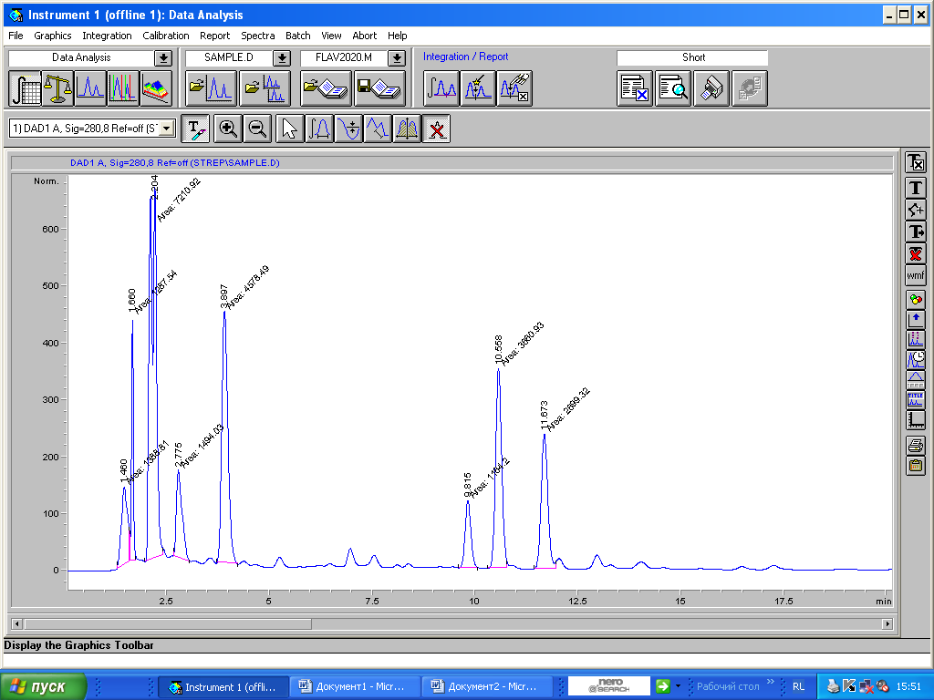

Figure 1 - HPLC spectrum of the obtained extract containing phytoestrogens

The results of the percentage are presented in Table 1. According to the obtained spectra, at 2.7 minutes and 3.6 minutes, compounds were found whose spectra coincide with the spectra of the SGD.

Table 1 - Percentages of fractions depending on the retention time

|  |  |  |  |  |  |  |
| --- | --- | --- | --- | --- | --- | --- |
| № | Time | Area | Height | Width | Area% | Symmetry |
| 1 | 1,46 | 1388,8 | 137,1 | 0,1688 | 5,914 | 0,93 |
| 2 | 1,66 | 1287,5 | 428,2 | 0,0501 | 5,483 | 0,946 |
| 3 | 2,204 | 7210,9 | 653,2 | 0,184 | 30,705 | 2,254 |
| 4 | 2,775 | 1494 | 154,3 | 0,1614 | 6,362 | 0,503 |
| 5 | 3,897 | 4578,5 | 442,2 | 0,1726 | 19,496 | 0,767 |
| 6 | 9,815 | 1164,2 | 118,6 | 0,1636 | 4,957 | 0,896 |
| 7 | 10,558 | 3660,9 | 351 | 0,1739 | 15,589 | 0,909 |
| 8 | 11,673 | 2699,3 | 236,7 | 0,1901 | 11,494 | 0,888 |

According to Table 1, the UV spectra of the peaks, which agree with the literature data of the LDH peaks, fall on peaks 4 - 8. The total yield of the LDH-containing fraction and its isomers is 58% of the obtained peak. For accurate determination, the fractions were subjected to additional isolation.

To confirm the quality of the extraction by the proposed method 2, the extract was purified before isolating the target substances. Separation of the extract by TLC showed a mixture of phenolic acids, higher fatty acids, polysaccharides, proteins, lignans, etc. Preliminary purification of the extract by cooling and centrifugation at 3000-5000 rpm made it possible to separate the fraction of fatty acids, proteins and polysaccharides. This system was separated by HPLC with UV detection. The retention time of the fraction containing secoisolariciresinol diglucoside (SDC) is 15.38 min (Figure 1). Separation of the mixture by TLC after concentration showed the presence of 6 spots. With the development of FeCl3, the color changed on 3 of them. When treated with the Folin-Denis reagent, all stains turn blue (a general reaction to polyphenols), thus it is possible to draw a conclusion about the nature of all stains. Secoisolariciresinol (SECO) and its diglucoside do not have vicinal and neighboring free hydroxyls, therefore, the reaction with FeCl3 is possible with the appearance of a yellow-blue color. The reaction to Folin-Denis polyphenols is characteristic of polyphenols. An additional separation cycle on the column showed the retention time of the LDH fraction of 10-13 minutes. Separation by TLC showed the presence of 2 spots, which stain weakly with FeCl3 and give a blue color with the Folin-Denis reagent. Analysis of this fraction on a UV detector showed the presence of a peak at 280 nm, which is consistent with the literature data of the UV spectrum of SDC and SECO. These substances were sent for recycling before separating the mixture into individual substances.

**4 Identification of target substances in the obtained extract**

Deeper purification of the samples was carried out on a column filled with silica gel (ASKG, 0.2-0.5 mm silica gel, activated large-pore granular). The mobile phase consisted of a water/acetonitrile/acetic acid mixture in the ratio 85/15/0.1. The obtained fractions were submitted for analysis to determine the purity.

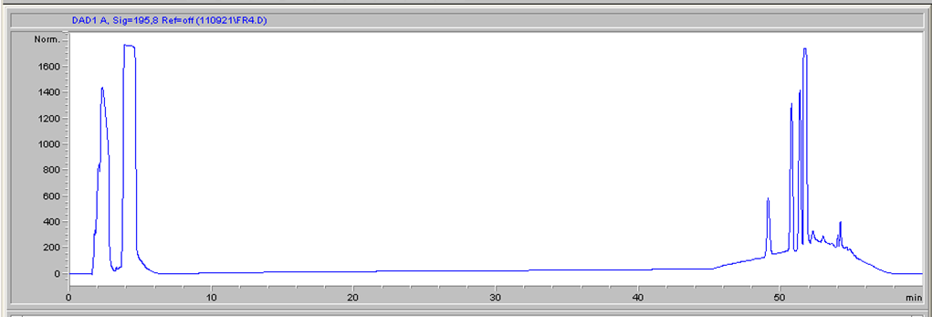

Figure 2 - Chromatogram of fraction 1 of the obtained extract

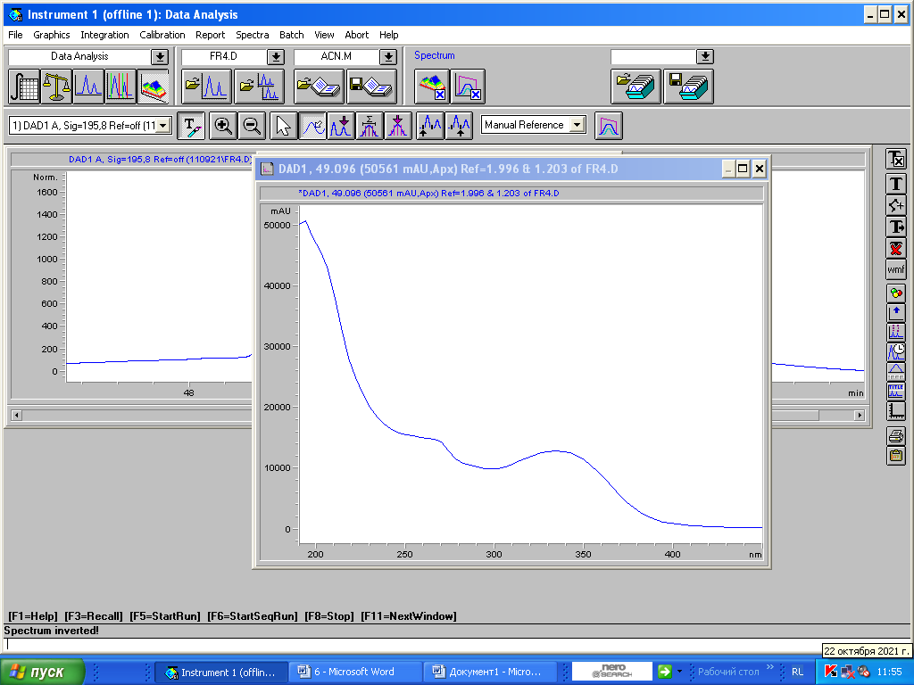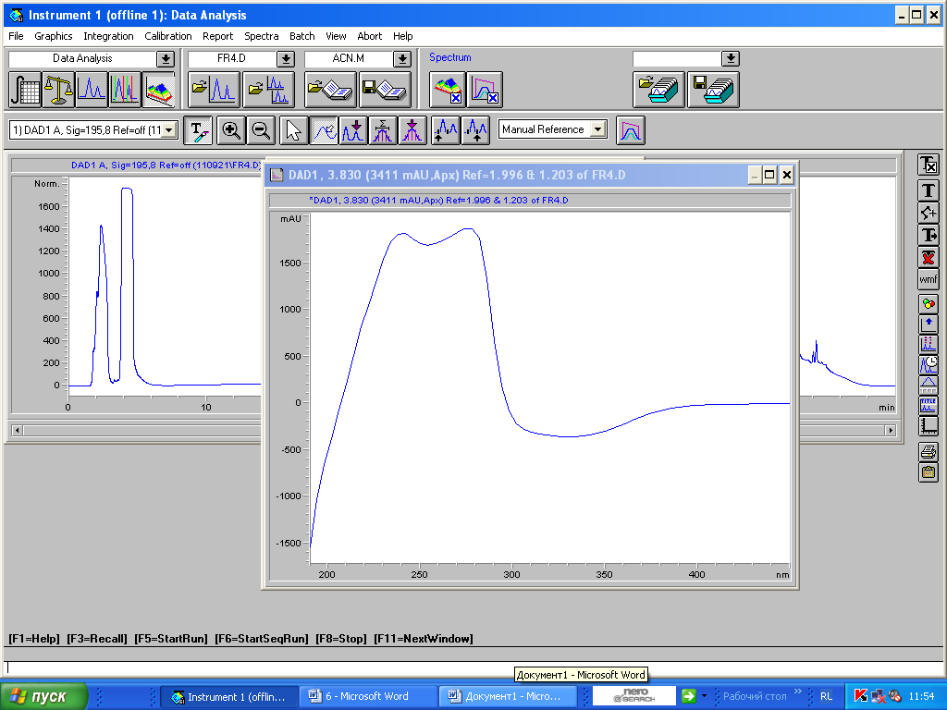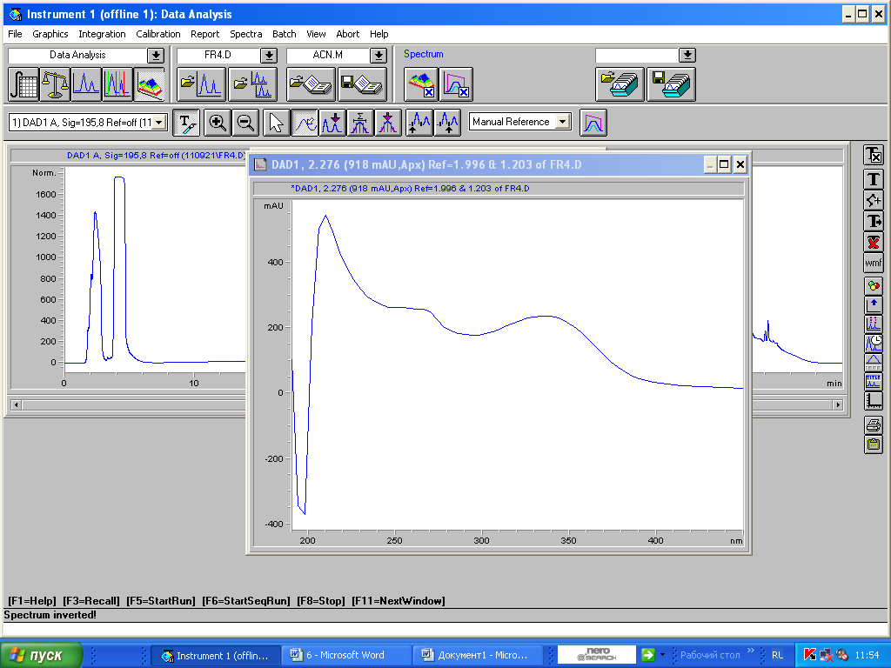

Figure 3 - UV spectra of peaks 1,2,3 chromatograms of fraction 1

In Figures 2 and 3, the resulting fraction 1 chromatogram indicated that the sample was not sufficiently purified. The UV spectra of the first two peaks correspond to the target substances. From this we can conclude that this fraction requires additional purification.

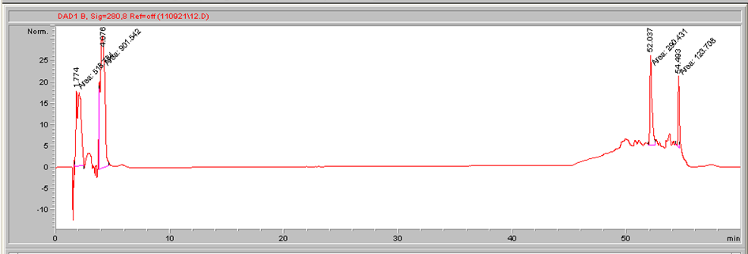

Figure 4 - Chromatogram of fraction 2 of the obtained extract

In Figure 4, the resulting fraction 2 chromatogram indicated that the sample had not gone through sufficient purification. The UV spectra of the first two peaks correspond to the target substances. From this we can conclude that this fraction requires additional purification.

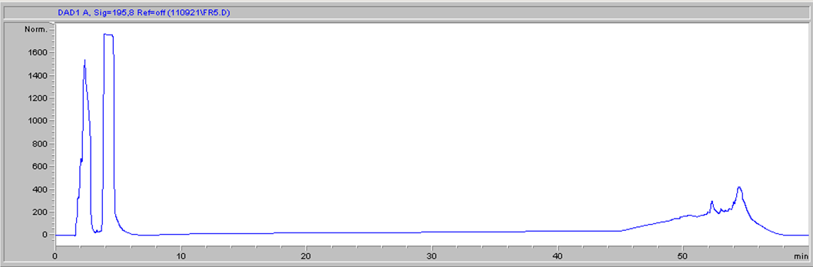

Figure 5 - Chromatogram of fraction 3 of the obtained extract

In Figure 5, the resulting fraction 3 chromatogram indicated that the sample had not gone through sufficient purification. The UV spectra of the first two peaks correspond to the target substances. From this we can conclude that this fraction requires additional purification.

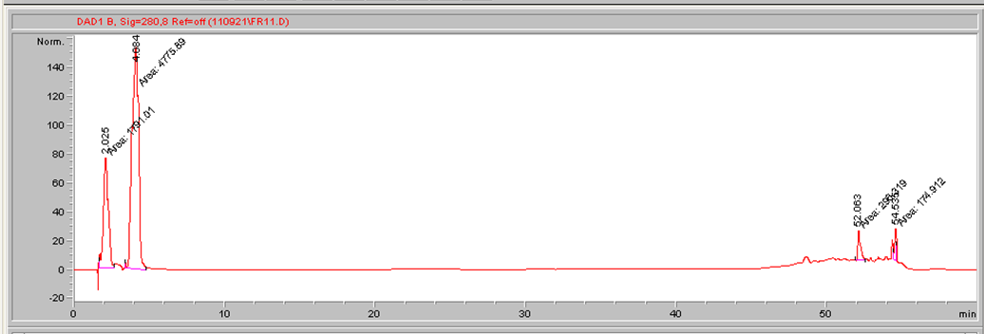

Figure 6 - Chromatogram of fraction 4 of the obtained extract

In Figure 6, the resulting fraction 4 chromatogram showed that the sample had not gone through sufficient purification. The UV spectra of the first two peaks correspond to the target substances. From this we can conclude that this fraction requires additional purification.

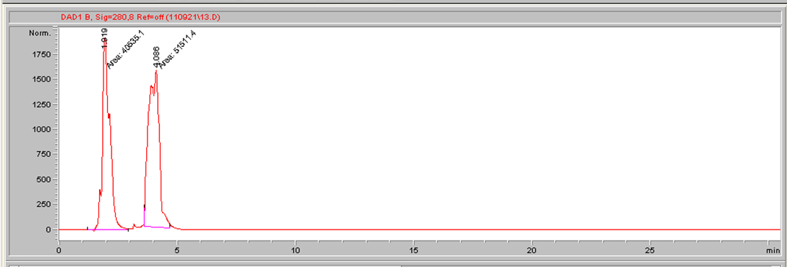

Figure 7 - Chromatogram of fraction 5 of the obtained extract

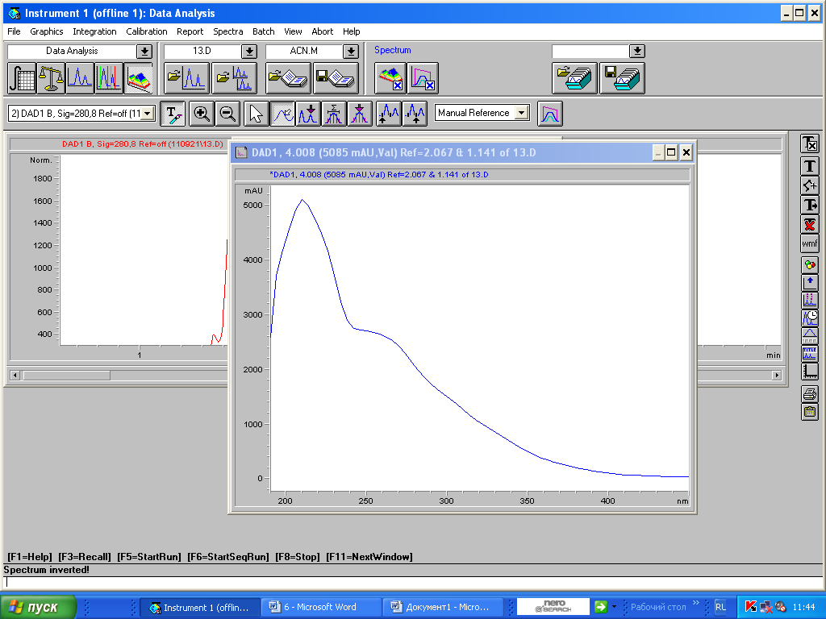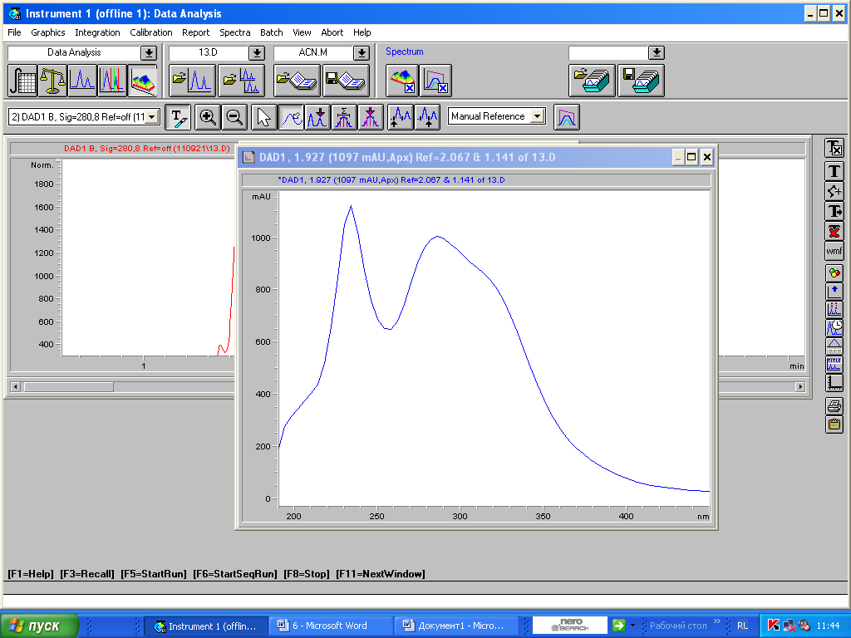

Figure 8 - UV spectra of peaks 1 and 2, chromatograms of fraction 5

In Figures 7.8, the resulting fraction 5 chromatogram showed that the sample was sufficiently purified. The UV spectra of the first two peaks correspond to the target substances. From this it can be concluded that this fraction requires additional purification to isolate individual substances.

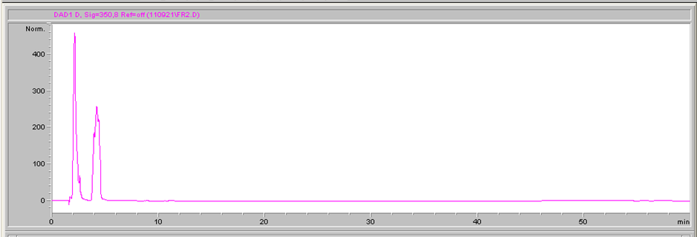

Figure 9 - Chromatogram of fraction 6 of the obtained extract

In Figure 9, the resulting fraction 6 chromatogram showed that the sample was sufficiently purified. The UV spectra of the first two peaks correspond to the target substances - Coumestrol and Biohanin A.

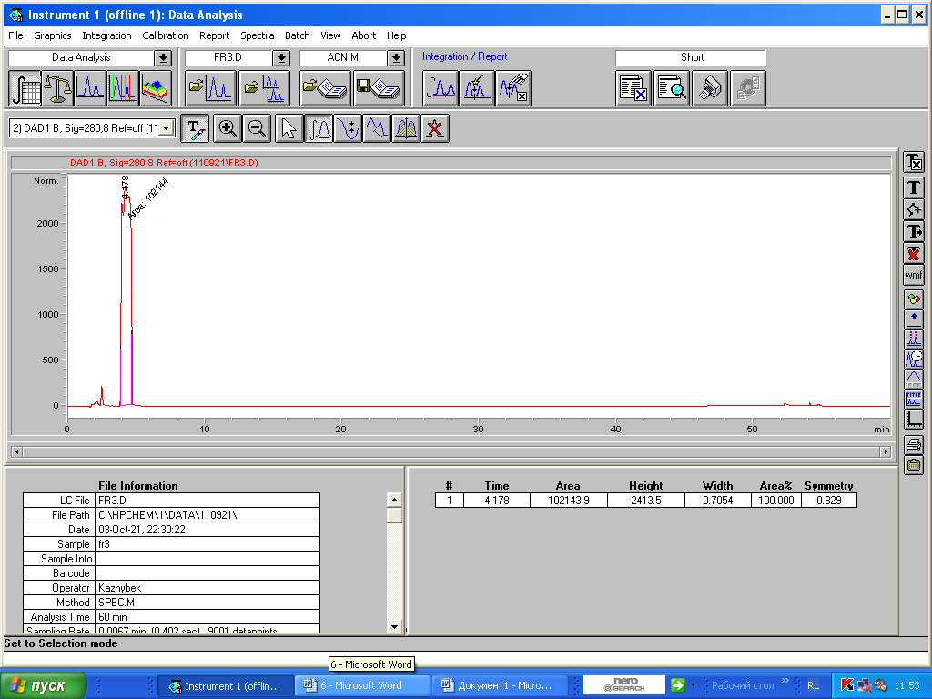

Figure 10 - Chromatogram of fraction 7 of the obtained extract

In Figure 10, the resulting fraction 7 chromatogram showed that the sample was sufficiently purified. The UV spectrum of the peak corresponds to the target substance - Genistein.

The structures of the obtained fractions were analyzed by 1H NMR. Figure 11 shows the spectrum of sample 1 of the Complex extract of Soybean, Flax seed and Red clover. 1H NMR spectra were recorded on a JNM-ECA Jeol 400 spectrometer (frequency 399.78 MHz) using DMSO-d6 solvent. Chemical shifts are measured relative to the residual proton signals of deuterated dimethyl sulfoxide.

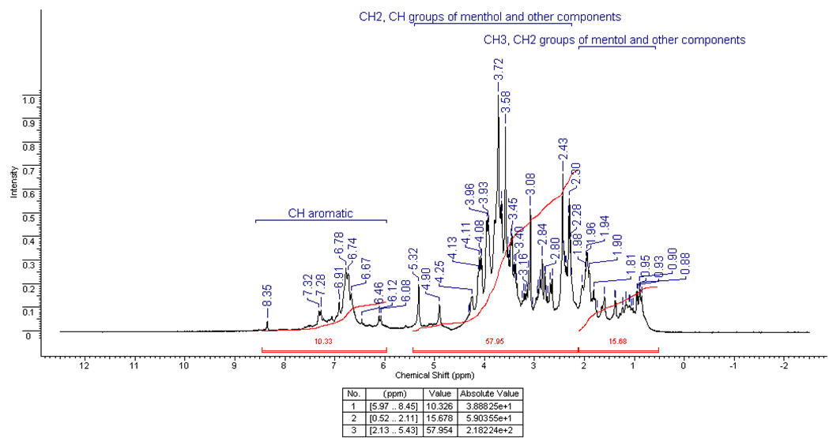

Figure 11 - Shooting 1H spectrum of sample 1 of the Complex Extract of Soybean, Flax seed and Red Clover

The spectrum contains multiple conjugate peaks, which is the reason for incomplete purification of the sample under study. Isolation of individual peaks characterizing a particular substance is impossible.

Figure 12 shows the spectrum of sample 2 of the Complex extract of Soybean, Flax seed and Red clover. 1H NMR spectra were recorded on a JNM-ECA Jeol 400 spectrometer (frequency 399.78 MHz) using DMSO-d6 solvent. Chemical shifts are measured relative to the residual proton signals of deuterated dimethyl sulfoxide.

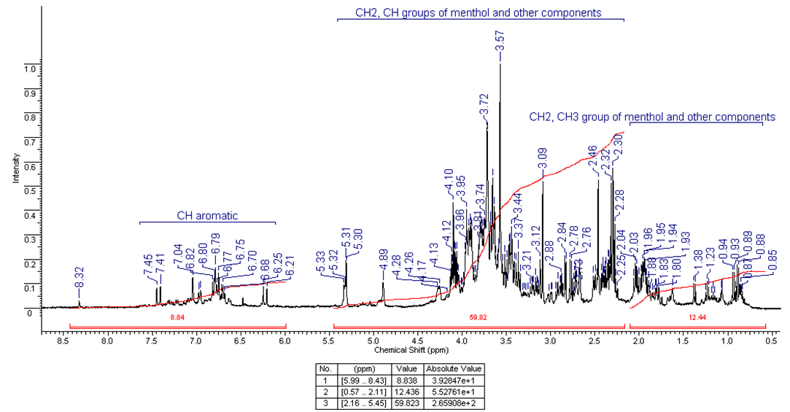

Figure 12 - Shooting 1H spectrum of sample 2 of the extract of Soybean, Flax seed and Red clover Spirt_vit _in_D2O

The spectrum contains multiple conjugate peaks, which is the reason for incomplete purification of the sample under study. Isolation of individual peaks characterizing a particular substance is impossible.

Figure 13 shows the spectrum of sample 3 of the Complex extract of Soybean, Flax seed and Red clover. 1H NMR spectra were recorded on a JNM-ECA Jeol 400 spectrometer (frequency 399.78 MHz) using DMSO-d6 solvent. Chemical shifts are measured relative to the residual proton signals of deuterated dimethyl sulfoxide.

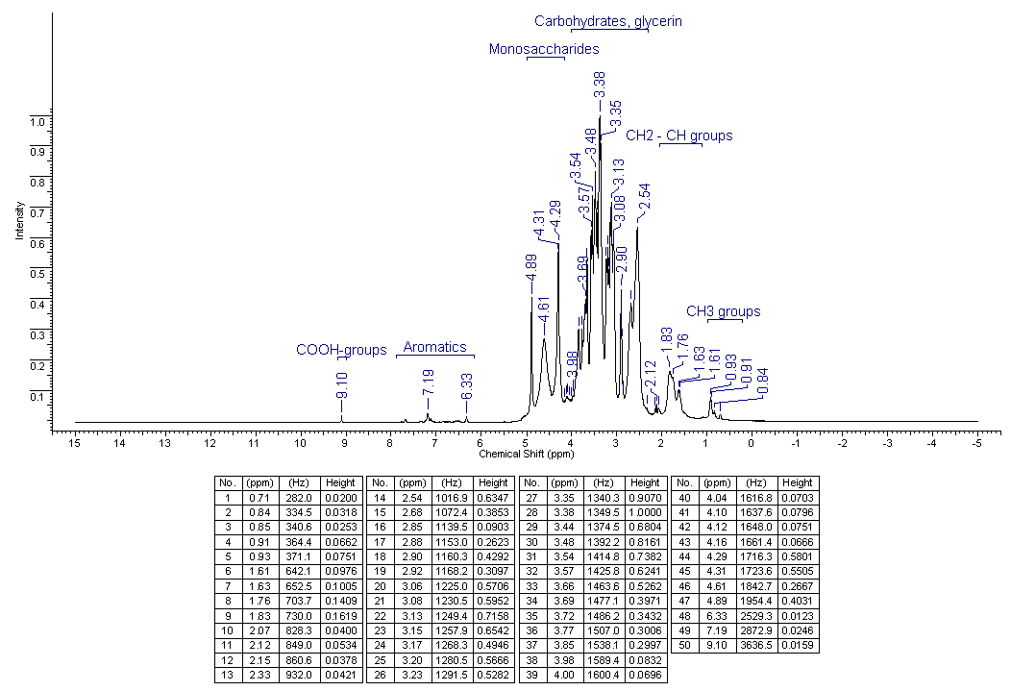

Figure 13 - Shooting 1H spectrum of sample 3 of the Complex extract of Soybean,

Flax seed and Red clover

The spectrum contains multiple conjugate peaks, which is the reason for incomplete purification of the sample under study. Isolation of individual peaks characterizing a particular substance is impossible.

Figure 14 shows the spectrum of sample 4 of the Complex extract of Soybean, Flax seed and Red clover. 1H NMR spectra were recorded on a JNM-ECA Jeol 400 spectrometer (frequency 399.78 MHz) using DMSO-d6 solvent. Chemical shifts are measured relative to the residual proton signals of deuterated dimethyl sulfoxide.

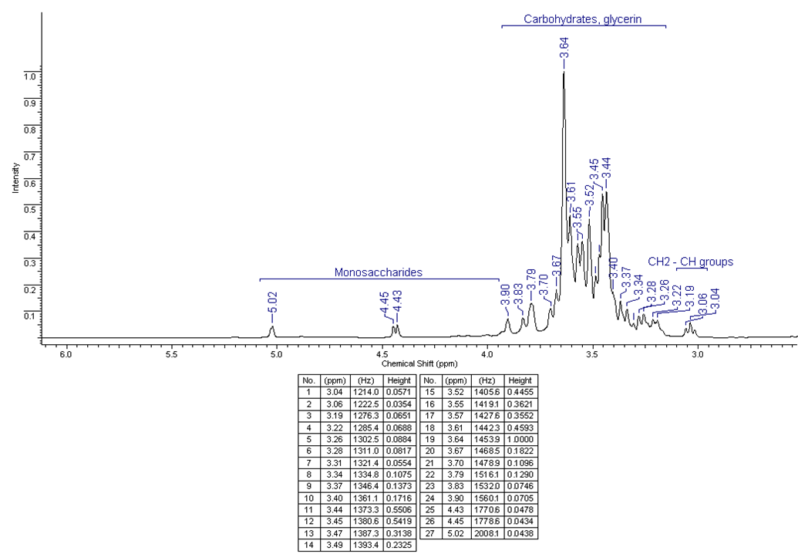

Figure 14 - Shooting 1H NMR spectrum of sample 4 of the Complex Extract of Soybean,

Flax and Red Clover

The spectrum contains multiple conjugate peaks, which is the reason for incomplete purification of the sample under study. Isolation of individual peaks characterizing a particular substance is impossible.

Figure 15 shows the spectrum of sample 5 of the Complex extract of Soybean, Flax seed and Red clover. 1H NMR spectra were recorded on a JNM-ECA Jeol 400 spectrometer (frequency 399.78 MHz) using DMSO-d6 solvent. Chemical shifts are measured relative to the residual proton signals of deuterated dimethyl sulfoxide.

The 1H NMR spectrum of the compound is characterized by the presence in the aromatic region at 7.05 ppm. doublet with intensity 1H with 3J 9.2 Hz of the H2' atom of the benzene nucleus. The proton H6 adjacent to H7, as a result of spin-spin splitting by a neighbor, also appears as a doublet signal at 8.11 ppm. with an integrated intensity of 1H with 3J 8.6, characteristic of aromatic compounds. The H9 proton of the benzene nucleus, which has no proton-containing neighbors, appears as a singlet at 8.69 ppm. with an intensity of 1H.

The equivalent protons of the neighboring ring H3' and H5' resonated with doublet signals with an intensity of two protons at 8.75 (3J 5.5 Hz) and 7.80 (3J 5.5 Hz) ppm. respectively. Proton Н4’,8, which did not have the ability to interact with other protons through three bonds, respectively, appeared in the form of a singler signal at 8.54 ppm. with an irregular intensity of 1H. The protons of the hydroxyl group and the amide bond appeared as broadened singlets with integral 1H each in the lowest-field part of the spectrum at 10.55 and 10.37 ppm. respectively.

1H NMR spectra were recorded on a JNN-ECA Jeol 400 spectrometer (frequency 399.) using DMSO-d6 solvent. Chemical shifts were measured relative to the signals of residual protons of deuterated dimethyl sulfoxide, the numbering of atoms is shown in Figure 16. 1H NMR spectrum: δ 6.939 (d, J = 2.0 Hz, 1H, H-9), 6.960 (dd, J = 8.6, 2.2 Hz, 1H , H-7), 6.960 (d, J = 8.4 2.2 Hz, 1H, H-3'), 7.167 (d, J = 2.2 Hz, 1H, H-5'), 7.702 (d, J = 8.4 Hz, 1H, H-2'), 7.855 (d, J = 8.5, 2.4 Hz, 1H, H-6), 10.045 (br s, 1H, 4'-OH), 10.702 (br s, 1H, 8-OH).

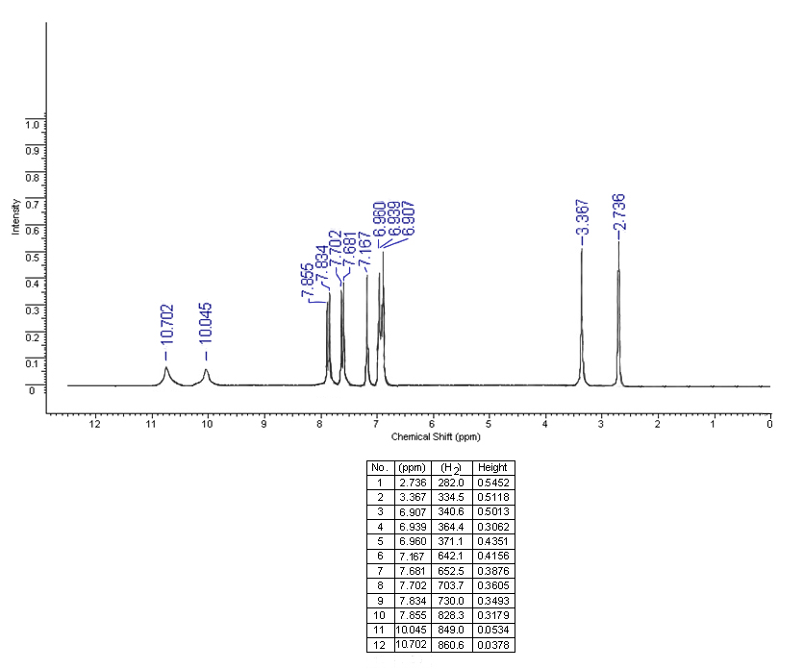

Figure 15 - Shooting 1H NMR spectrum of sample 5 of the Complex Extract of Soybean,

Flax Seed and Red Clover

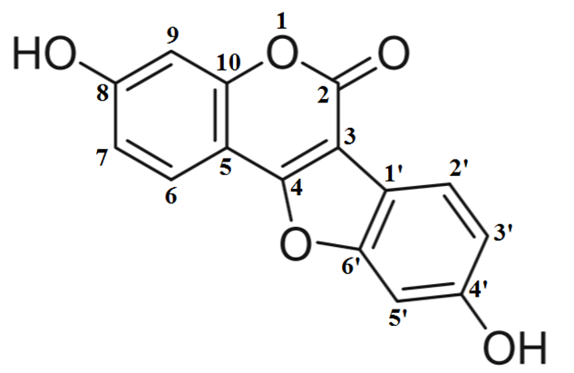

Figure 16 - Numbering of coumestrol atoms according to PMR peaks

Based on the identified peaks, it can be concluded that this substance is coumestrol, since the spectrum of this substance has proton peaks consistent with the literature data on coumestrol spectra [28].

Figure 17 shows the spectrum of sample 6 of the Complex extract of Soybean, Flax seed and Red clover. 1H NMR spectra were recorded on a JNM-ECA Jeol 400 spectrometer (frequency 399.78 MHz) using DMSO-d6 solvent. Chemical shifts are measured relative to the residual proton signals of deuterated dimethyl sulfoxide.

The 1H NMR spectrum of the compound is characterized by the presence in the aromatic region at 7.05 ppm. doublet with intensity 1H with 3J 9.2 Hz of the H2' atom of the benzene nucleus. The proton H3',5' adjacent to H2',6', as a result of spin-spin splitting by a neighbor, also appears as a doublet signal at 8.11 ppm. with an integrated intensity of 1H with 3J 8.6, characteristic of aromatic compounds. The H9 proton of the benzene nucleus, which has no proton-containing neighbors, appears as a singlet at 8.69 ppm. with an intensity of 1H.

The equivalent protons of the neighboring ring H3' and H5' resonated with doublet signals with an intensity of two protons at 8.75 (3J 5.5 Hz) and 7.80 (3J 5.5 Hz) ppm. respectively. The H2,7 proton, which did not have the ability to interact with other protons through three bonds, respectively, appeared in the form of a singler signal at 8.54 ppm. with an irregular intensity of 1H. The protons of the hydroxyl group and the amide bond appeared in the form of broadened singlets with integral 1H each in the lowest-field part of the spectrum at 10.926 and 12.928, respectively.

1H NMR spectra were recorded on a JNN-ECA Jeol 400 spectrometer (frequency 399.) using DMSO-d6 solvent. Chemical shifts were measured relative to the signals of residual protons of deuterated dimethyl sulfoxide, the numbering of atoms is shown in Figure 18. 1H NMR spectrum: δ 3.755 (s, 1H, 4'-OCH3), 6.390 (d, J = 8.4, 2.2 Hz, 1H , H-7), 6.982 (d, J = 2.2 Hz, 1H, H-9), 7.007 (d, J = 8.4 Hz, 1H, H-2'), 7.007 (d, J = 8,4, 8.8 Hz, 1H, H-6'), 7.477 (d, J = 8.4, 8.8 Hz, 1H, H-3'), 7.477 (d, J = 8.4, 8.8 Hz, 1H, H-5'), 8.374 (s, 8.2Hz, 1H, H-2), 10.926 (br s, 1H, 8-OH), 12.928 (br s, 1H, 6-OH).

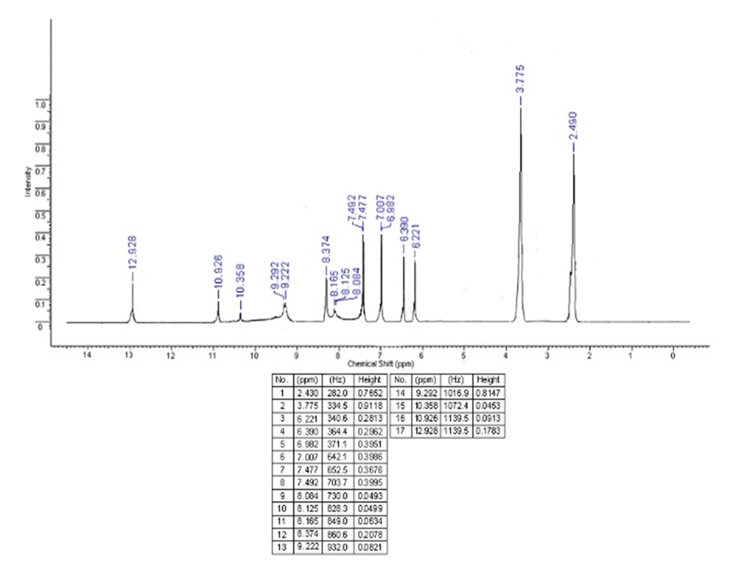

Figure 17 - Shooting 1H NMR spectrum of sample 6 of the Complex

Extract of Soybean, Flax and Red Clover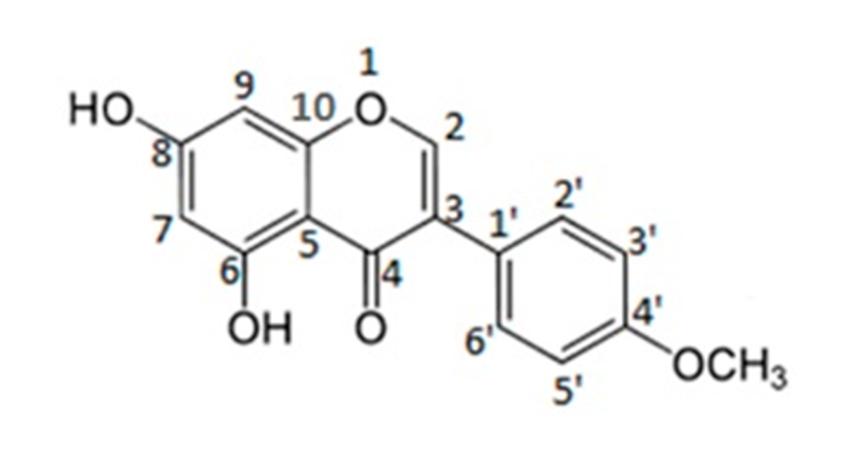

Figure 18 - Numbering of Biochanin A atoms according to PMR peaks

Based on the identified peaks, it can be concluded that this substance is biochanin A, since the spectrum of this substance has proton peaks consistent with the literature data on the spectra of Biochanin A [29].

Figure 19 shows the spectrum of sample 7 of the Complex extract of Soybean, Flax seed and Red clover. 1H NMR spectra were recorded on a JNM-ECA Jeol 400 spectrometer (frequency 399.78 MHz) using DMSO-d6 solvent. Chemical shifts are measured relative to the residual proton signals of deuterated dimethyl sulfoxide.

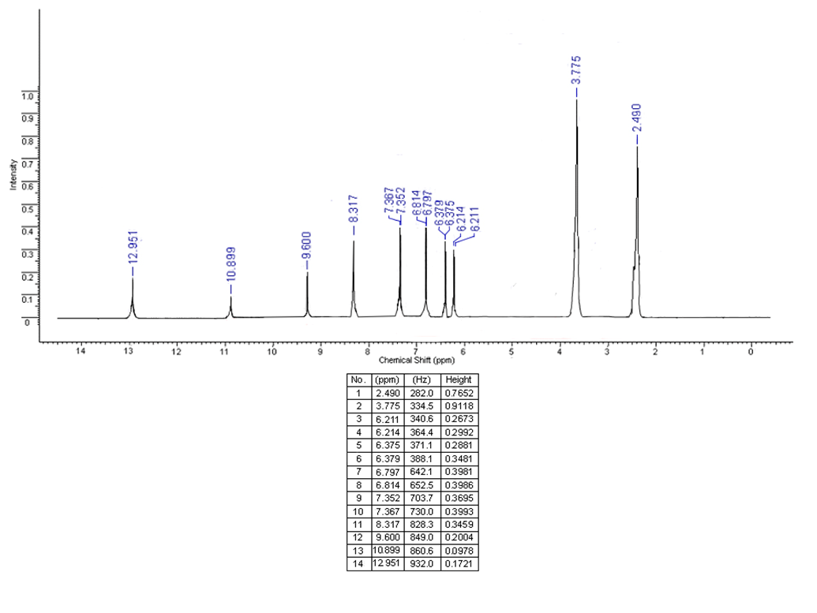

Figure 19 - Shooting 1H NMR spectrum of sample 7 of the Complex Extract of Soybean, Flax and Red Clover

The 1H NMR spectrum of the compound is characterized by the presence in the aromatic region at 7.05 ppm. doublet with intensity 1H with 3J 9.2 Hz of the H2' atom of the benzene nucleus. The proton H3',5' adjacent to H2',6', as a result of spin-spin splitting by a neighbor, also appears as a doublet signal at 8.11 ppm. with an integrated intensity of 1H with 3J 8.6, characteristic of aromatic compounds. The H9 proton of the benzene nucleus, which has no proton-containing neighbors, appears as a singlet at 8.69 ppm. with an intensity of 1H.

The equivalent protons of the neighboring ring H3' and H5' resonated with doublet signals with an intensity of two protons at 8.75 (3J 5.5 Hz) and 7.80 (3J 5.5 Hz) ppm. respectively. The H2,7 proton, which did not have the ability to interact with other protons through three bonds, respectively, appeared in the form of a singler signal at 8.54 ppm. with an irregular intensity of 1H. The protons of the hydroxyl group appeared as broadened singlets with integral 1H each in the lowest-field part of the spectrum at 9.600, 10.899, 12.926, respectively.

1H NMR spectra were recorded on a JNN-ECA Jeol 400 spectrometer (frequency 399.) using DMSO-d6 solvent. Chemical shifts were measured relative to the signals of residual protons of deuterated dimethyl sulfoxide, the numbering of atoms is shown in Figure 20. 1H NMR spectrum: δ 6.214 (d, J = 8.4, 2.2 Hz, 1H, H-7), 6.379 (d, J = 2.2 Hz, 1H, H-9), 6.814 (d, J = 8.4, 8.8 Hz, 1H, H-3'), 6.814 (d, J = 8.4, 8.8 Hz, 1H, H-5'), 7.367 (d, J = 8.4 Hz, 1H, H-2'), 7.367 (d, J = 8.4, 8.8 Hz, 1H, H-6'), 8.317 ( s, 8.2 Hz, 1H, H-2), 9.600 (br s, 1H, 4'-OH), 10.899 (br s, 1H, 8-OH), 12.951 (br s, 1H, 6-OH).

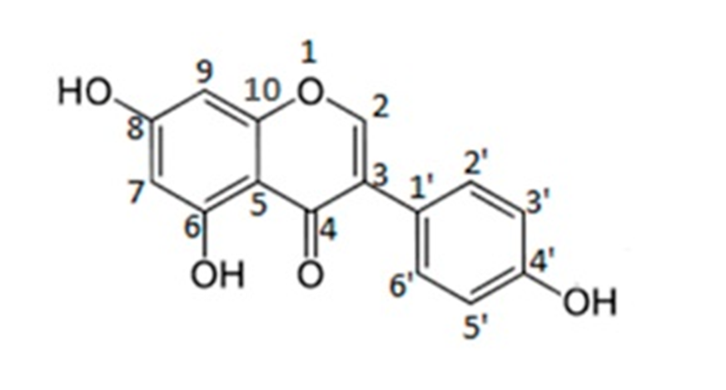

Figure 20 - Numbering of Genistein atoms according to PMR peaks

Based on the identified peaks, it can be concluded that this substance is Genistein, since the spectrum of this substance has proton peaks consistent with the literature data of the Genistein spectra [30].

**5 Study of the biological activity of the obtained extracts in relation to alopecia in vivo**

The term alopecia is quite abstract from the point of view of the causal history, and it is extremely difficult to isolate one root cause. Cicatricial or alopecia areata is associated with the development of diseases like ichthyosis or disorders of skin development [31]. This kind of diseases associated with dermatology are manifested in the form of simultaneous baldness of a certain area of ​​the scalp. The nature of this kind of disease causes damage to the hair follicle and dermal papilla during the anagen, catagen and telogen stages, which provokes hair necrosis and hair loss.

Androgenetic alopecia, as a type of non-cicatricial alopecia, is a premature loss of scalp hair in a smooth course of the disease over time with a pronounced zonal character. From the terminology, this type of disease is directly related to the hormonal level of dihydrotestosterone in the human body, in particular in the skin. This active form of the hormone testosterone, which is the dominant hormone in the male body, binds to the androgen-sensitive receptors of the hair follicles. Further, the "hormone-receptor" complex activates the genes responsible for the transformation of the hair follicle into smaller sizes, and so, over time, the hair follicle clamping and inhibiting the dermal papilla dies, the hair itself narrows with the transition to the degree of weakened hair and complete overgrowth of the hair canal with connective tissue [32]. This process is called hair degradation and is often seen in areas of the scalp. However, there is also a reverse mechanism of hair restoration from the degradation stage to the form of healthy hair. Such a phenomenon in rare cases manifests itself for natural reasons, but it can be provoked by acting on problem areas with special active substances. This type of substance usually has a specific hormone-like, vasodilator, stimulating enzymatic and other properties.

As part of the project, the goal was to assess the feasibility of using a complex extract containing phytoestrogen by measuring the levels of key androgens using the in vitro method.

The study of the inhibitory activity of in vivo was carried out under in vitro conditions by an indirect sign of the transition of the testosterone hormone into a more active form - dihydrotestosterone under the influence of the enzyme 5-alpha-reductase.

50 samples of a solution containing 10 ng / ml testosterone were prepared. All samples were divided into 2 groups of 25 samples: the main group and the intact group (control). The enzyme 5-alpha reductase is added to both groups at a concentration of 100 pm / ml. In parallel, a complex extract at a concentration of 1 mg / ml, containing a group of phytoestrogens, is added to the main group. The obtained samples are placed in an incubator for further observation and monitoring of changes in testosterone levels in the samples.

To determine the concentration of androgens in the samples, a substrate was prepared with a dilution of 1:10, which was centrifuged for 5 min. The hormone concentration was determined by the enzyme immunoassay on an Artemis K-101 HTRF Microplate Reader [33].

The results of the studies are presented in Table 2, which shows the values ​​of changes in the levels of free testosterone and its related androgen, dihydrotestosterone. It can be seen from the data in the table that 1 month after the start of the experiment, a noticeable change in the level of active dihydrotestosterone from 441 to 260 pg / ml is observed in the samples.

Table 2 - Androgen level in samples of both groups within 1 month

|  |  |  |  |  |
| --- | --- | --- | --- | --- |
| No. | No. Testosterone ng / ml | | Dihydrotestosterone pg / ml | |
| Primary | Intact | Primary | Intact |
| 1 | 10±0,6 | 10±0,4 | 11±12 | 14±30 |
| 2 | 9,1±0,8 | 8,3±0,3 | 110±51 | 230±42 |
| 3 | 8,3±0,4 | 6,4±0,5 | 180±18 | 355±22 |
| 4 | 7,5±0,7 | 4,7±0,5 | 330±18 | 510±43 |

The level of testosterone in the intact group is characterized by a rather intense drop in concentration, which indicates the reaction of the hormone itself with reductase. An additional assessment of the completeness of the passage of the reaction was carried out by measuring the level of dihydrotestosterone from time to time. A similar reaction mechanism took place in the main group, however, the change in the concentration of free testosterone was less intense, which indicates the inhibitory activity of the complex extract and indirectly indicates the hormone mimicking the activity of phytoestrogens in this extract. For more accurate measurements of dihydrotestosterone indicators, it can be detected, provided that the experiment is carried out for a longer period by the in vivo method, with further studies on animal organisms as part of the continuation of the project in subsequent grant programs. However, already at this stage it was established that the direct effect of the complex extract showed inhibitory activity towards the target enzyme 5-alpha-reductase and indirect activity in imitating hormonal function. In the samples, there were clear differences in the change in the hormonal levels of the control and main samples. According to the data obtained, the manifestation of the inhibitory activity of the complex extract can be estimated at 50% of the main activity. Based on the data obtained on the decrease in the level of dihydrotestosterone, it can be concluded that this type of extract can be used in the form of external cosmetics, in case of hair loss and degradation associated with androgenetic alopecia, since this disease is directly related to the level of dihydrotestosterone in peripheral tissues and about follicular zones [34].

**CONCLUSION**

A study of the feedstock was carried out. The obtained moisture content for flax seeds was 7.4%, the total ash was 2.34%, the ash insoluble in 10% hydrochloric acid was 0.3%, the polysaccharide content was 9.1%. The obtained moisture content for meadow clover was 7.5%, the total ash was 6.9%, the ash insoluble in 10% hydrochloric acid was 0.02%, the flavonoid content was 0.36%. The obtained moisture content for soybeans was 11.2%, the total ash was 6%, the ash insoluble in 10% hydrochloric acid was 2.9%, the oil impurity content was 6%. These indicators are within acceptable limits, consistent with the literature data.

Work has been done to determine the optimal parameters of the extraction process of a complex extract from flax seeds, red clover and soybeans. The most suitable and environmentally friendly type of solvent is alcohol. The most suitable and environmentally friendly type of solvent is alcohol. The optimal concentration of alcohol is 50-60%; extraction time - 1.5-2.5 hours, temperature: 60-82 ⁰С, to increase the yield and simplify the equipment, it is necessary to treat the seeds with ultrasound at a power of 6 W / l for 30 minutes.

Work has been done to establish the structure of phytoestrogens contained in the complex extract. As a result of purification, the structures of individual substances Kumetrol, Biohanin A and Genistein were isolated and established. According to literature data, these substances are included in the group of phytoestrogens.

The proposed system for obtaining a complex extract is efficient and technologically justified. This technology with combined systems makes it possible to make the system economically and energy efficient, as well as to increase environmental friendliness, taking into account the use of the requirements of "green chemistry".

The results of the study of the indirect method in vivo showed that the level of testosterone in the intact group is characterized by a rather intense drop in concentration, which indicates the reaction of the hormone itself with reductase. At the same time, an additional assessment of the completeness of the passage of the reaction was carried out by measuring the level of dihydrotestosterone from time to time.

**REFERENCES**

1 State Pharmacopoeia of the Republic of Kazakhstan III / MH RK. - 1st ed., Add. - Almaty.: Zhibek Zholy. - 2014. - 872 p.

2 State Pharmacopoeia of the Russian Federation XIII / Ministry of Health of the Russian Federation. - Moscow. - 2015.

3 Osik N.S., Popov P.S. Guidelines for the determination of biochemical indicators of the quality of oil and oilseeds. - Krasnodar: All-Russian Research Institute of Oilseeds. - 1990. - 88 p.

4 Mullagulov R.T., Kozlov V.N., Ponomareva L.F. Study of the antioxidant activity of medicinal herbs by chemiluminescence in in vitro experiments // Vestnik VUiT. - 2012. - No. 1 (9). - P. 1-4.

5 Sayakova G.M., Boshkaeva A.K., Khamitova A.E. Study of the antioxidant activity of domestic plant raw materials Meadow clover (Trifolium pratense) // Bulletin of KazNMU. - 2018. - No. 2. - P. 282-284.

6 Egorchenkova Olga Evgenievna, Sobolev D.N. Methodological techniques for determining the residual amounts of dicamba in soybeans by capillary gas-liquid chromatography with a mass-selective detector // Hygiene and Sanitation. - 2018. - No. 6. - P. 564-567.

7 Addis L.J. Experimental dataset on the effect of soaking time and coagulant type on the overall quality of cheese extracted from Ethiopian belessa-95 (Glycine max) soya bean // Data in Brief. - 2020. - V 31. - P. 1-9.

8 Sergey Efremov, Sergey Nechipurenko, Diyar Tokmurzin, Aigerim Kaiaidarova, Sergey Kalugin, Khaidar Tassibekov. Remediation of soil contaminated by toxic rocket fuel components using modified carbon – mineral adsorbing material produced from shungite rock modified with Mn4+ and Fe3+ // Environmental Technology & Innovation. - 2021. - Volume 24, November 2021. - 101962.

9 Kazankapova M.K., Nauryzbaev M.K., Efremov S.A., Ermagambet B.T., Nurgaliyev N.U., Nechipurenko S.V. Preparation of Activated Shungite and Characterization of Its Chemical Composition and Adsorption Properties // Solid Fuel Chemistry. - 2019.- 53 (4). - P. 241-247.

10 Zhang Zh., Li D., Wang L., Ozkan N., Xiao D., Mao Zh., Yang H. Optimization of ethanol-water extraction of lignans from flaxseed // Separation and Purification Technology. -2007. - No. 57. - P. 17-24.

11 Niyati R., Bhoomika M. Secoisolariciresinol diglucoside rich extract of L. usitatissimum prevents diabetic colon cancer through inhibition of CDK4 // Biomedicine & Pharmacotherapy. - 2016. - No. 83. - P. 733-739.

12 Bravi El., Perretti G., Marconi Om., Patrizi El., Fantozzi P. Secoisolariciresinol diglucoside determination in flaxseed (Linum usitatissimum L.) oil and application to a shelf life study // Food Chemistry. -2011. - No. 126. - P. 1553-1558.

13 Adamtsevich N.Yu., Feskova E.V., Boltovsky V.S., Titok V.V. Extraction of flavonoids from the leaves of the common sparrow Lithospermum officinale L. using microwave energy // Chemistry of vegetable raw materials. - 2021. - No. 1. - P. 85-92.

14 Morad Ch.Ol., Balsa I.Z., Devinc N.B., Nabil Gr. Microwave-assisted extraction of high-molecular-weight hemicelluloses from spruce wood // Comptes Rendus Chimie. - 2019. - V. 22 (8). - P. 574-584.

15 Shchegoleva I.D., Solomon E.A. The use of microwave radiation in the technology of coffee extract // Beer and Drinks. - 2014. - No. 4. - P. 18-20.

16 Lei Q., ​​Chao M., Chugang L., Haifei L., Ping W., Hang L., Dongjie Y. Mechanical damage mechanism of frozen coal subjected to liquid nitrogen freezing // Fuel. - 2021. - V. 309. - P. 122-124.

17 Cyrielle C., Thibaud F., Emilie A., Leclerc E., Barakzoy N., Sagot A., Falguiéres S.R., Blondeau J.-P., Clotilde F., Joël D., Lainé E., Hano Ch. Development and validation of an efficient ultrasound assisted extraction of phenolic compounds from flax (Linum usitatissimum L.) seeds // Ultrasonics Sonochemistry. - 2015. - Vol. 26. - P. 176-185.

18 Bounchez A., Vauchel P., Galvan L., Dimitrov K. Multi-objective optimization tool for ultrasound-assisted extraction including environmental impacts // Chem. Eng. Res. and Design. - 2020. - V. 164. - P. 324-337.

19 Kumar Y., Singhal S., Tarafdar A., ​​Pharande A., Genesan M., Badgujar P. Ultrasound assisted extraction of selected edible macroalgae: Effect on antioxidant activity and quantitative assessment of polyphenols by liquid chromatography with tandem mass spectrometry (LC -MS / MS) // Algal Res. - 2020. - V. 52. - P. 102-114.

20 Yu Sh., Yu T., Song W., Yu X., Qiao J., Wang W., Dong H., Wu Zh., Dai L., Li T. Ultrasound-assisted cyanide extraction of gold from gold concentrate at low temperature // Ultrasonics Sonochemistry. - 2020. - V. 64. - P. 1-10.

21 S.V. Nechipurenko, N.A. Vereshchagin, Yu.A. Shilina, S.A. Efremov, Yu.A. Moskvin, Zh.T. Umirbekova. The Isolation of Lignan Containing Fractions from Flaxseed Linum Usitatissimum L. // International Journal of Biology and Chemistry. - 2021. - 14 (1). - P. 177-183.

22 Adkin A.M., Warren L.K., Silva-Sanchez C., Mortensen C.J. Method development for extraction and quantification of phytoestrogens in equine feeds and serum // J. of Equine Vet. Sci. - 2017. - V. 52. - P. 62-69.

23 Yuan Q., Li H., Wei Z., Lv K., Gao Ch., Liu Y., Zhao L. Isolation, structures and biological activities of polysaccharides from Chlorella: A review // International Journal of Biological Macromolecules. – 2020. – V. 163. – P. 2199-2209.

24 Onem E., Gulumser G., Akay S., Yesil-Celiktas Optimization of tannin isolation from acorn and application in leather processing // Industrial Crops and Products. – 2014. – V. 53. – P. 16-22.

25 Faye A., Leung Alf., Guyot-Reeb S., Ton-That M., Chimeni-Yomeni D., Li H., Stoeffler K., Maillard D., Benali M. Extraction of tannins from yellow birch: Enhanced process for water conservation and energy savings // Journal of Cleaner Production. – 2021. – V. 299. – P. 126-134.

26 Sasaki E., Shimada T., Osawa R., Nishitani Y., Spring S., Lang E. Isolation of tannin-degrading bacteria isolated from feces of the Japanese large wood mouse, Apodemus speciosus, feeding on tannin-rich acorns // Systematic and Applied Microbiology. – 2005. – V. 28(4). – P. 358-365.

27 Zhao M.J., Bergaentzle M., Flieller A., Marchioni E. Development and validation of an ultra-high performance liquid chromatography-high resolution mass spectrometry method for simultaneous quantification of cyanogenic glycosides and secoisolariciresinol diglucoside in flaxseed (Linum usitatissimum L.) // J. Of Chrom. A. – 2019. –V. 1601. – P. 214-223.

28 Franco C., Schwingel L., Lula I., Sinisterra R., Koester L., Bassani V.L. Studies on coumestrol/b-cyclodextrin association: Inclusion complex characterization // Int. J. of Pharm. – 2009. – V. 369. – P. 5-11.

29 Silva B.P., Velozo L.S.M., Parente J.P., Biochanin A triglycoside from Andira inermis // Fitoterapia. – 2000. – V. 71. – P. 663-667.

30 Singh H., Singh Sw., Srivastava A., Tandom P., Bharti P., Kumar S., Dev K., Maurya R. Study of hydrogen-bonding, vibrational dynamics and structure-activity relationship of genistein using spectroscopic techniques coupled with DFT // Journal of Molecular Structure. – 2017. – V. 1130. – P. 929-939.

31 Murashkin N.N., Materikin A.I., Hotko A.A., Knyazev A.S. Features of the clinical course of ichthyosis in children // Kazan Medical Journal. - 2011. – T. 92. - P. 290-295.

32 Geynits A.V., Moskvin S.V. Laser therapy in cosmetology and dermatology. - M.-Tver: Triad. - 2010. - 400 p.

33 Roitberg G.E., Mkrtchyan K.G., Kulchenko N.G. Influence of chronic ischemic disorders in the prostate gland on the development of benign prostatic hyperplasia // Research and practice in medicine. - 2020. - T. 7(2). - P. 75-81.

34 Barat T.M., Abdollahimajd F.M., Dadkhahfar S.M., Moravvej H.M. Evaluation of the efficacy and safety of cow placenta extract lotion versus minoxidil 2% in the treatment of female pattern androgenetic alopecia // Int. J. of Women's Dermatology. - 2020. - V. 6 (4). - P. 318-321.

**APPENDIX A**

**Calendar plan**

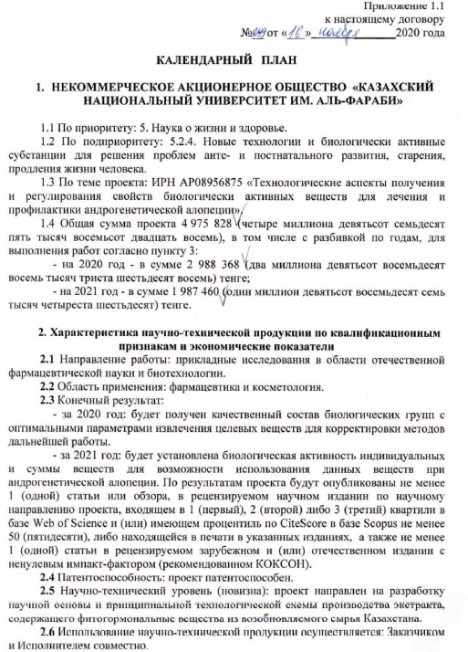

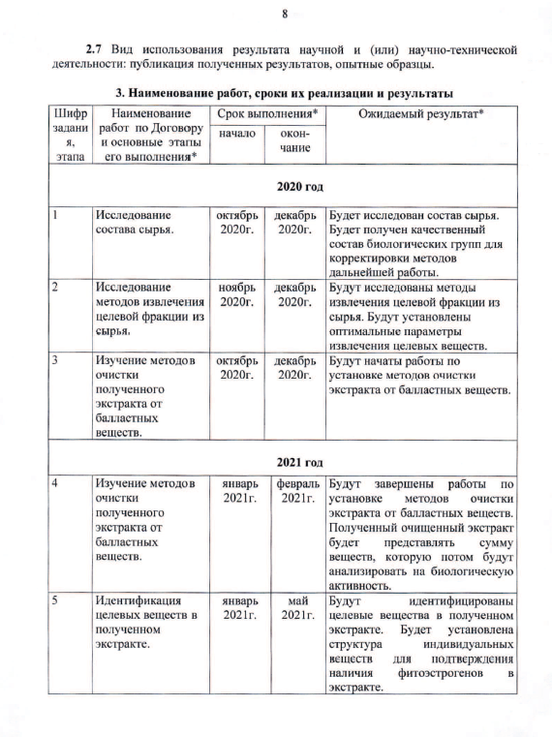

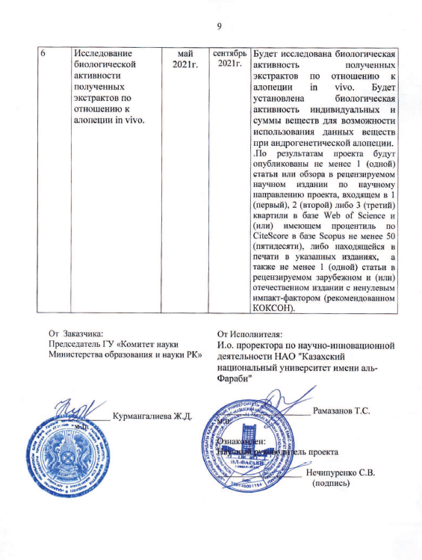

Appendix 1.1

to this agreement

No.299 from "16" november 2020

**CALENDAR PLAN**

**1. NON-PROFIT JOINT-STOCK COMPANY "AL-FARABI KAZAKH NATIONAL UNIVERSITY"**

1.1 By priority: 5. Life and health sciences.

1.2 By sub-priority: 5.2.4. New technologies and biologically active substances for solving the problems of ante- and postnatal development, aging, prolongation of human life.

1.3 On the topic of the project: IRN AR08956875 "Technological aspects of obtaining and regulating the properties of biologically active substances for the treatment and prevention of androgenetic alopecia".

1.4 The total amount of the project 4,975,828 (four million nine hundred seventy-five thousand eight hundred twenty-eight), including with a breakdown by years, for the performance of work in accordance with clause 3:

1.5 for 2020 - in the amount of 2,988,368 (two million nine hundred eighty-eight thousand three hundred sixty-eight) tenge;

1.6 for 2021 - in the amount of 1,987,460 (one million nine hundred eighty-seven thousand four hundred sixty) tenge.

**2. Characteristics of scientific and technical products by qualification characteristics and economic indicators**

2.1 Direction of work: applied research in the field of domestic pharmaceutical science and biotechnology.

2.2 Field of application: pharmaceuticals and cosmetology.

2.3 End result:

- for 2020: a qualitative composition of biological groups with optimal parameters for the extraction of target substances will be obtained for adjusting the methods of further work.

- for 2021: the biological activity of individual and sums of substances will be established for the possibility of using these substances in androgenetic alopecia. Based on the results of the project, at least 1 (one) article or review will be published in a peer-reviewed scientific publication in the scientific direction of the project, included in 1 (first), 2 (second) or 3 (third) quartiles in the Web of Science database and (or) having a CiteScore percentile in the Scopus database of at least 50 (fifty), or in print in the indicated editions, as well as at least 1 (one) article in a peer-reviewed foreign and (or) domestic edition with a non-zero impact factor (recommended by CCES).

2.4 Patentability: the project is patentable.

2.5 Scientific and technical level (novelty): the project is aimed at developing a scientific basis and a basic technological scheme for the production of an extract containing phytohormonal substances from renewable raw materials in Kazakhstan.

2.6 The use of scientific and technical products is carried out: by the Customer and the Contractor together.

2.7 Type of use of the result of scientific and (or) scientific and technical activities: publication of the results obtained, prototypes.

**3. Name of work, terms of their implementation and results**

|  |  |  |  |  |
| --- | --- | --- | --- | --- |
| Job code, stage | Name of work under the Agreement and the main stages of its implementation * | Deadline* | | Expected Result* |
| start | end |
| **2020 year** | | | | |
| 1 | Study of the composition of raw materials. | October 2020 | December 2020 | The composition of the raw materials will be examined. The qualitative composition of biological groups will be obtained for adjusting the methods of further work. |
| 2 | Investigation of methods for extracting the target fraction from raw materials. | November 2020 | December 2020 | Methods for extracting the target fraction from raw materials will be investigated. The optimal parameters for the extraction of target substances will be established. |
| 3 | Study of methods of purification of the obtained extract from ballast substances. | October 2020 | December 2020 | Work will begin on the installation of methods for purifying the extract from ballast substances. |
| **2021 year** | | | | |
| 4 | Study of methods of purification of the obtained extract from ballast substances. | January 2021 | February 2021 | Works on installation of methods for purification of the extract from ballast substances will be completed. The resulting purified extract will represent the sum of substances, which will then be analyzed for biological activity. |
| 5 | Identification of target substances in the obtained extract. | January 2021 | May 2021 | Target substances in the resulting extract will be identified. The structure of individual substances will be established to confirm the presence of phytoestrogens in the extract. |
| 6 | Investigation of the biological activity of the obtained extracts in relation to alopecia in vivo. | May 2021 | September 2021 | The biological activity of the obtained  extracts in relation to alopecia in vivo. The biological activity of the individual and the amount of substances will be established for the possibility of using these substances in androgenetic alopecia. Based on the results of the project, at least 1 (one) article or review will be published in a peer-reviewed scientific publication in the scientific direction of the project, included in 1 (first), 2 (second) or 3 (third) quartiles in the Web of Science database and (or) having The percentile by CiteScore in the Scopus database is at least 50 (fifty), or in print in the indicated editions, as well as at least 1 (one) article in a peer-reviewed foreign and (or) domestic edition with a non-zero impact factor (recommended by CCES). |

**APPENDIX B**

**List of published works for 2020-2021**

1 S.V. Nechipurenko, N.A. Vereshchagin, Yu.A. Shilina, S.A. Efremov, Yu.A. Moskvin, Zh.T. Umirbekova. The Isolation of Lignan Containing Fractions from Flaxseed Linum Usitatissimum L. // International Journal of Biology and Chemistry. - 2021. - 14(1). – Р. 177-183. <https://doi.org/10.26577/ijbch.2021.v14.i1.020>

2 Sergey Efremov, Sergey Nechipurenko, Diyar Tokmurzin, Aigerim Kaiaidarova, Sergey Kalugin, Khaidar Tassibekov. Remediation of soil contaminated by toxic rocket fuel components using modified carbon–mineral adsorbing material produced from shungite rock modified with Mn4+ and Fe3+ // Environmental Technology & Innovation. - 2021. - Volume 24, November 2021, 101962. <https://doi.org/10.1016/j.eti.2021.101962>