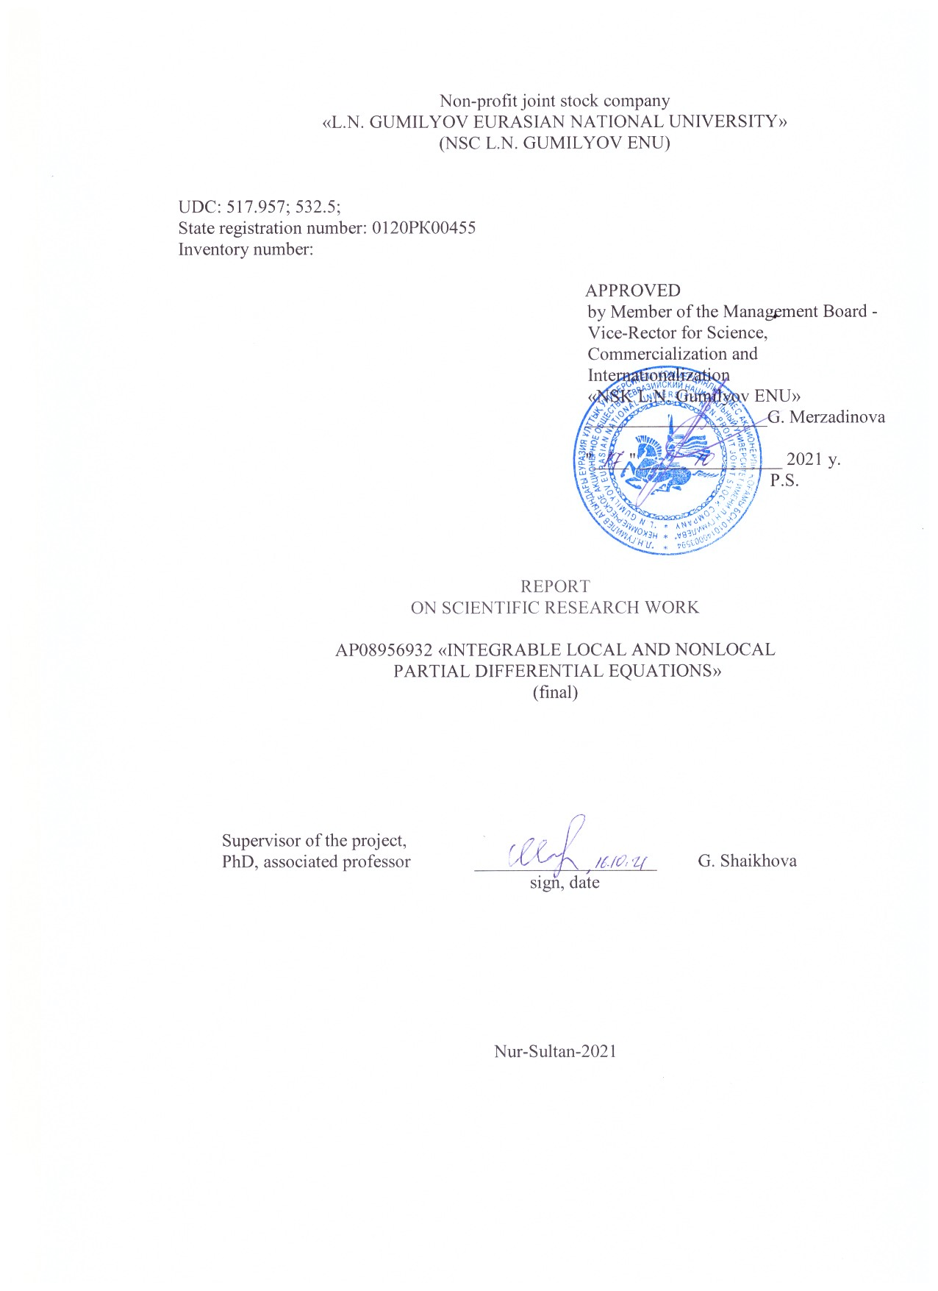

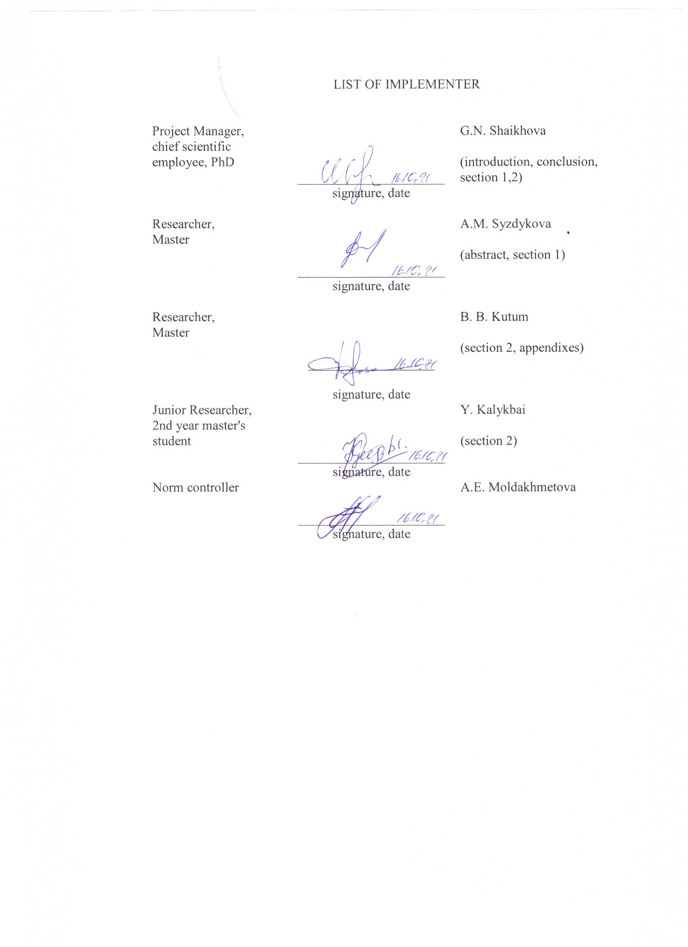

**РЕФЕРАТ**

Есеп 49 бет, 18 сурет, 20 дерек көздер, 2 қосымша.

ДИФФЕРЕНЦИАЛДЫҚ ТЕҢДЕУЛЕР, ИНТЕГРАЛДАНУ, ЛОКАЛЬДЫ ЕМЕС, СОЛИТОН, СЫЗЫҚТЫ ЕМЕС ТЕҢДЕУЛЕР, ЛАКС ҰСЫНЫСЫ

Зерттеу нысанасы. Сызықты емес дербес туынды дифференциалдық теңдеулер.

Жоба мақсаты. Абловиц-Муслимани симметрия шартын пайдаланып локальды емес интегралданатын теңдеулерді алу. Локальды және локальды емес дербес туынды дифференциалдық теңдеулердің шешімдерін табу.

Зерттеу әдістері. Дарбу түрлендіру әдісі, Хирота бисызықты әдісі, гиперболалық тангенс әдісі, синус-косинус әдісі сияқты аналитикалық әдістер.

Жұмыс нәтижелері. Есепті кезеңде Абловиц-Муслимани симметрия шарты негізінде локальды емес теңдеулер алынды. Аналитикалық әдістер көмегімен локальды және локальды емес дифференциалдық теңдеулердің жаңа шешімдері табылды. Шешімдердің динамикасы Wolfram Mathematica, MATLAB, Maple бағдарламалық пакеттерін қолдану арқылы қарастырылды.

Қолдану аясы. Зерттеу нәтижелері теориялық сипатта және оларды білім мен ғылымда, атап айтқанда, математика мен физика бойынша магистратура мен PhD-докторантураға арналған арнайы курстарға бағдарламаларды дайындауда қолдануға болады. Алынған нәтижелердің потенциалды тұтынушылары - ұқсас жобаларда зерттеу жүргізетін ғалымдар.

Экономикалық тиімділігі. Бұл жоба бойынша зерттеулер іргелі болып табылады, сондықтан экономикалық тиімділік анықталмаған.

Жұмыстың маңызы. Жоба нәтижелері теориялық физика саласында жаңа бәсекеге жарамды ғылыми кадрларды дайындауда және осы бағыт бойынша жұмыс жасап жатқан қызметкерді қызықтыруға мүмкіндік береді және осының салдарынан ҚР ғалымдарының ғылыми қызығушылық аясын кеңейтеді.

**ABSTRACT**

Report 49 pages, 18 figures, 20 sources, 2 appendices.

DIFFERENTIAL EQUATIONS, INTEGRABILITY, NONLOCAL, SOLITON, NONLINEAR EQUATIONS, LAX REPRESENTATION

Object of study. Nonlinear partial differential equations.

Purpose of work. Obtain nonlocal integrable equations using the Ablowitz-Muslimani symmetry condition. Find solutions to local and nonlocal partial differential equations.

Research methods. Analytical methods such as Darboux transform method, Hirota bilinear method, hyperbolic tangent method, sine cosine method.

Results of work. In the reporting period, on the basis of the Ablovitz-Muslimani symmetry condition, nonlocal equations were obtained. New solutions of local and nonlocal differential equations are found by analytical methods. The dynamics of solutions is considered using the software packages Wolfram Mathematica, MATLAB, Maple.

Application area. The results of the research are theoretical in nature and can be used in education and science, namely in the preparation of programs for special master's and PhD-doctoral studies in mathematics and physics. Potential consumers of the results obtained are scientists conducting research in similar projects.

Economic efficiency. Research on this project is fundamental, so the economic efficiency has not been determined.

The significance of the work. The results of the project can affect the training of new competitive scientific personnel and contribute to the involvement of already working personnel in this area, thereby expanding the area of scientific interests of scientists of the Republic of Kazakhstan.

**CONTENT**

|  |  |  |
| --- | --- | --- |
|  | INTRODUCTION…………………………………………………………….. | 6 |
|  | MAIN PART OF THE RESEARCH WORK …………………… …………… | 9 |
| 1 | Integrable nonlocal partial differential equations………………………………. | 9 |
| 1.1 | Two-dimensional nonlocal nonlinear Hirota equation ………………………… | 9 |
| 1.1.1 | Lax's representation ……………………………………………………………. | 9 |
| 1.1.2 | T-symmetric nonlocal system of Hirota equations…………………………….. | 10 |
| 1.1.3 | S-symmetric nonlocal system of Hirota equations…………………………….. | 10 |
| 1.1.4 | ST-symmetric nonlocal Hirota system of equations…………………………… | 11 |
| 1.1.5 | Darboux transformation ………………………………………..……….…… .. | 11 |
| 1.1.6 | Exact solutions ………………………………………………………………… | 13 |
| 1.2 | Two-dimensional nonlocal complex modified system of Korteweg-de Vries equations……………………………………………………………………….. | 14 |
| 1.2.1 | Lax representation……………………………………………………………… | 14 |
| 1.2.2 | Darboux transformation ………………...…………………………………… .. | 15 |
| 1.2.3 | Exact solutions ………………………………………………………………… | 17 |
| 2 | Integrable local partial differential equations………………………………….. | 19 |
| 2.1 | Two-dimensional nonlinear Hirota equation………………………………….. | 19 |
| 2.2 | One-dimensional nonlinear Hirota equation…………………………………… | 20 |
| 2.3 | Two-dimensional generalized nonlinear Schrödinger equations……………… | 23 |
| 2.3.1 | Soliton solutions……………………………………………………………….. | 23 |
| 2.3.2 | Traveling wave solutions………………………………………………………. | 27 |
| 2.4 | Two-dimensional complex modified Korteweg-de Vries system of equations... | 31 |
| 2.4.1 | Exact solutions……………………………………………………………….… | 32 |
|  | CONCLUSION………………………………………………..……………… | 39 |
|  | REFERENCES ……………………………………………………………… .. | 41 |
|  | APPENDIX A List of publications based on the research results ................... .. | 43 |
|  | APPENDIX B Calendar plan …………………….…………………………… | 44 |

**INTRODUCTION**

Relevance. Integrable local and nonlocal partial differential equations are widespread in nonlinear science and play an important role in many areas of physics. There are many physically important integrable equations such as the nonlinear Schrödinger equation, the Korteweg-de Vries equation, the Kadomtsev-Petviashvili equation, and the Davey-Stewartson equation. Most of these integrable equations are local equations, which means that the evolution of the solution depends only on the local value of the solution and its local spatial and temporal derivatives [1–4].

In 2013, Ablowitz and Muslimani presented the one-dimensional non-local nonlinear Schrödinger equation in Physical Review Letters

$iq_{t}\left(x,t\right)+q_{xx}\left(x,t\right)+2q^{2}\left(x,t\right)q^{*}\left(-x,t\right)=0,$ (0.1)

and obtained its exact solutions by the method of the inverse scattering problem [5]. Equation (0.1) was obtained using the reduction of the Ablowitz-Kaup-Newel-Segur (AKNS) system

  (0.2)

where

 ,  (0.3)

Substituting matrices (0.3) into the compatibility equation 

we obtain the system of equations

$iq_{t}\left(x,t\right)+q_{xx}\left(x,t\right)+2q^{2}\left(x,t\right)r\left(x,t\right)=0,$ (0.4)

$-ir_{t}\left(x,t\right)+r_{xx}\left(x,t\right)+2r^{2}\left(x,t\right)q\left(x,t\right)=0.$ (0.5)

Under the condition of Ablowitz-Muslimani symmetry $r\left(x,t\right)=δq^{*}\left(x,-t\right)$ in equations (0.4) - (0.5), we obtain the one-dimensional nonlocal nonlinear Schrödinger equation (0.1). Similarly, for other equations, having the Lax representation in the form (0.2), one can obtain the nonlocal Korteweg-de Vries equation, the Sine-Gordon equation, etc. [6-10].

The Ablowitz-Muslimani idea allowed the scientific community to obtain nonlocal equations in two-dimensional space. So Fokas obtained the two-dimensional non-local Schrödinger equation, the two-dimensional Davy Stewartson equation [12]. After this pioneering work, a group of scientists from Bulgaria [7], Turkey [8,11], China [10], USA [5,6] have done several works for this equation and other equations [13–17].

Novelty. Within the framework of this project, a two-dimensional system of Hirota equations was investigated

$\begin{matrix}iq_{t}+αq_{xy}+iβq_{xxy}-vq+i(wq)_{x}=0, \\ v_{x}+2αδ({\left|q\right|}^{2})_{y}-2iβδ\left(q_{xy}^{*}q-q^{*}q_{xy}\right)=0, \\ w_{x}-2βδ({\left|q\right|}^{2})_{y}=0,\end{matrix}$ (0.6)

where $q(x,y,t)$ is a complex function, $v\left(x,y,t\right),$ $v\left(x,y,t\right),$ are real functions, and $α,β$ are constants, $δ=±1$. For the first time, the local two-dimensional system of Hirota equations (0.6) was proposed by prof. R. Myrzakulov in 2015 in [18] and further by the research group of the project obtained soliton solutions in [19-20]. The system of equations (0.6) has applications in some areas of nonlinear science. For example, it has several reductions: for $α=1, β=0$ in (0.6) we obtain the two-dimensional nonlinear Schrödinger equations, for $α=0, β=1$ in (0.6) we obtain the two-dimensional complex modified Korteweg de Vries equation.

Another form of the two-dimensional system of Hirota equations is

$\begin{matrix}iq_{t}+γq_{xy}+iμq_{xxy}-vq+i(wq)_{x}+αq-iβq_{x}=0, \\ v_{x}+2γδ({\left|q\right|}^{2})_{y}-2iμδ\left(q_{xy}^{*}q-q^{*}q_{xy}\right)=0, \\ w_{x}-2μδ({\left|q\right|}^{2})_{y}=0,\end{matrix}$ (0.7)

where $q\left(x,y,t\right)$ is a complex function, $q(x,y,t)$, $w(x,y,t)$ are real functions and $α,β,γ,μ$ are constants, δ = ± 1.

In the theory of solitons (the theory of "solitary waves"), an equation is called integrable if it has a Lax representation and satisfies the compatibility conditions. The Hirota system of equations (0.6) has a Lax representation, thus, by definition, it is integrable. The Lax representation for (0.6) has the form

  (0.8)

where

  (0.9)

with matrices

    

Under the symmetry condition , substituting the matrices (0.9) into the compatibility condition equation

 (0.10)

one can obtain the system of equations (0.6).

The systems of Hirota equations (0.6) and (0.7) in non-local form have not been presented and investigated until now. Thus, we believe that research in this direction has novelty and relevance.

The goal of the project is to obtain nonlocal integrable equations using the Ablowitz-Muslimani symmetry condition. Find solutions to local and nonlocal partial differential equations.

Appendix A contains lists of published works on the subject of this project, and Appendix B - the calendar plan for 2020–2021. The presented final report for 2021 was compiled on the basis of the most important results from the interim report: for 2020 (Inventory No. 0220RK01711) AR08956932 "Integrable local and nonlocal partial differential equations", and includes the main results of the implementer on the project for 2021.

Terms of project implementation - 01.01.2021y. - 30.09. 2021 y.

The amount of funding for 2021 is 1 980 000 tenge.

**MAIN PART OF THE RESEARCH WORK**

**1 Integrable nonlocal partial differential equations**

**1.1 Two-dimensional nonlocal nonlinear Hirota equation**

**1.1.1 Lax representation**

The corresponding Lax representation for the two-dimensional Hirota equation has form

  (1.1)

where – eigen function and – matrixes

  . (1.2)

Here  matrixes :

   (1.3)

, (1.4)

and , where . In this section, we will restrict ourselves to a case . The compatibility condition for equations (1.1) is

$A_{t}-B_{x}+\left[A,B\right]-A_{y}=0,$ (1.5)

where $\left[A,B\right]=AB-BA.$ By substituting (1.3) - (1.4) into (1.5), we obtain the two-dimensional system of equations

 (1.6)

 (1.7)

 . (1.8)

For , in system (1.6)-(1.8), we obtain a two-dimensional local system of Hirota equations

 (1.9)

 (1.10)

 (1.11)

where  is a complex function,  real functions are real constants, the asterisk symbol means complex conjugate.

Using a reduction of the Ablowitz-Muslimani type, one can obtain various two-dimensional nonlocal equations.

**1.1.2 T-symmetric nonlocal system of Hirota equations**

If in the system of equations (1.6) - (1.8) the symmetry condition has the form $r\left(x,y,t\right)=δq^{*}\left(x,y,-t\right)$ then we obtain a two-dimensional T-symmetric nonlocal system of Hirota equations

 (1.12)

 (1.13)

. (1.14)

**1.1.3 S-symmetric nonlocal system of Hirota equations**

If in the system of equations (1.6) - (1.8) the symmetry condition has the form $r\left(x,y,t\right)=δq^{*}\left(-x,-y,t\right)$, we obtain a two-dimensional S-symmetric nonlocal system of Hirota equations

 (1.15)

 (1.16)

. (1.17)

**1.1.4 ST-symmetric nonlocal Hirota system of equations**

If in the system of equations (1.6) - (1.8) the symmetry condition has the form $r\left(x,y,t\right)=δq^{*}\left(-x,-y,-t\right)$, we obtain two-dimensional ST-symmetric nonlocal Hirota equations

 (1.18)

 (1.19)

. (1.20)

* + 1. **Darboux transformation**

We consider the following transformation of equations (1.1) based on the DT for AKNS system

$Ψ'=TΨ=(λI-S)Ψ,$ (1.21)

where

$$S=\left(\begin{matrix}s_{11} & s_{12} \\ s_{21} & s_{22}\end{matrix}\right), I=\left(\begin{matrix}1 & 0 \\ 0 & 1\end{matrix}\right).$$

The new function $Ψ'$ satisfies

${Ψ'}_{x}=A'Ψ',{Ψ'}_{t}=(2αλ+4βλ^{2}){Ψ'}_{y}+B'Ψ',$ (1.22)

where $A'$ and $B'$ depend on $q',v',w'$ and $λ$. In order to hold equation (1.1), the $T$ must satisfies the system

$T_{x}+TA=A'T,$ (1.23)

$T_{t}+TB=(2αλ+4βλ^{2})T_{y}+B'T.$ (1.24)

Collecting the different powers of $λ^{i}$ of the equation (1.23) we obtain the following set of identities

$λ^{0}:S_{x}={A'}_{0}S-SA_{0},$ (1.25)

$λ^{1}:{A'}_{0}=A_{0}+i[S,σ_{3}],$ (1.26)

$λ^{2}:iIσ_{3}=iσ_{3}I.$ (1.27)

Hence from (1.26) we get $s_{21}=s_{12}$. The equation (1.24) gives us the following relations

$I:λ_{t}=(2αλ+4βλ^{2})λ_{y},$ (1.28)

$λ^{0}:-S_{t}=SB_{0}-{B'}_{0}S,$ (1.29)

$λ^{1}:2αS_{y}={B'}_{0}-B_{0}+SB_{1}-B_{1}^{'}S,$ (1.30)

$λ^{2}:4βS_{y}={B'}_{1}-B_{1}.$ (1.31)

Hence we get from the system (1.25)-(1.31) the DT

${A'}_{0}=A_{0}+i[S,σ_{3}],$ (1.32)

${B'}_{0}=B_{0}-SB_{1}+(B_{1}+4βS_{y})S+2αS_{y},$ (1.33)

${B'}_{1}=B_{1}+4βS_{y}.$ (1.34)

At the same time, from the equations (1.32)-(1.34) we get

$q^{[1]}=q-2is_{12},$ (1.35)

$r^{[1]}=r-2is_{21},$ (1.36)

$v^{[1]}=v+4iαs_{11y}+4β(s_{12}r_{y}-s_{21}q_{y}+2is_{11}s_{11y}+2is_{21}s_{12y}),$ (1.37)

$w^{[1]}=w-4iβs_{11y}=w+4iβs_{22y}.$ (1.38)

and we additionally have $s_{22}=-s_{11}$.We now assume that

$S=HΛH^{-1},$ (1.39)

where

$$H=\left(\begin{matrix}ψ_{1} & δψ_{2}^{*} \\ ψ_{2} & ψ_{1}^{*}\end{matrix}\right), Λ=\left(\begin{matrix}λ_{1} & 0 \\ 0 & λ_{2}\end{matrix}\right),$$

where $(ψ_{1},ψ_{2})^{T}=(ψ_{1}(x,y,t),ψ_{2}(x,y,t))^{T}$ is a solution to equation (1.1)-(1.2) with $λ=λ_{1}$ and $(ψ_{1}^{*},ψ_{2}^{*})^{T}=(ψ_{1}^{*}(ϵ_{1}x,ϵ_{2}y,ϵ_{3}t),δψ_{2}^{*}(ϵ_{1}x,ϵ_{2}y,ϵ_{3}t))^{T}$ is the solution when $λ_{2}=-λ_{1}^{*}$ we can obtain the explicit expression of $S$,

$S=\frac{1}{Δ}\left(\begin{matrix}s_{11} & s_{12} \\ s_{21} & s_{22}\end{matrix}\right),$ (1.40)

where

$s_{11}=λ_{1}ψ_{1}ψ_{1}^{*}(ϵ_{1}x,ϵ_{2}y,ϵ_{3}t)+δλ_{1}^{*}ψ_{2}ψ_{2}^{*}(ϵ_{1}x,ϵ_{2}y,ϵ_{3}t),$ $s_{12}=-δ(λ_{1}+λ_{1}^{*})ψ_{1}ψ_{2}^{*}(ϵ_{1}x,ϵ_{2}y,ϵ_{3}t),$

$s_{21}=(λ_{1}+λ_{1}^{*})ψ_{2}ψ_{1}^{*}(ϵ_{1}x,ϵ_{2}y,ϵ_{3}t),$ $s_{22}=-λ_{1}^{*}ψ_{1}ψ_{1}^{*}(ϵ_{1}x,ϵ_{2}y,ϵ_{3}t)-δλ_{1}ψ_{2}ψ_{2}^{*}(ϵ_{1}x,ϵ_{2}y,ϵ_{3}t),$

$$Δ=ψ_{1}ψ_{1}^{*}(ϵ_{1}x,ϵ_{2}y,ϵ_{3}t)-δψ_{2}ψ_{2}^{*}(ϵ_{1}x,ϵ_{2}y,ϵ_{3}t).$$

Hence, the solutions are written as

$q^{[1]}=q-2is_{12},$ (1.41)

$v^{[1]}=v+4iαs_{11y}+4β(δs_{12}q_{y}^{*}+s_{12}^{*}q_{y}+2is_{11}s_{11y}-2is_{12}^{*}s_{12y}),$ (1.42)

$w^{[1]}=w-4iβs_{11y}=w+4iβs_{22y},$ (1.43)

where

* + 1. **Exact solutions**

We consider the case $r(x,y,t)=δq^{*}(x,y,-t)$. It is mean that $ϵ_{1}=1,ϵ_{2}=1,ϵ_{3}=-1.$ Having the explicit form of the DT, we are ready to construct exact solutions of the two-dimensional nonlocal Hirota equation (1.12)-(1.14). We assume trivial seed solutions as $q=v=w=0.$ With the seed solutions the system (1.1) admits the following exact solutions

$ψ_{1}=e^{-iλ_{1}x+iμ_{1}y+i(2αλ+4βλ^{2})μ_{1}t+δ_{1}+iδ_{2}},$ (1.44)

$ψ_{2}=e^{iλ_{1}x-iμ_{1}y-i(2αλ+4βλ^{2})μ_{1}t-δ_{1}-iδ_{2}+iδ_{0}}.$ (1.45)

Then, the solutions of the two-dimensional nonlocal Hirota equation (1.12)-(1.14) are obtained by substituting the equation (1.44)-(1.45) in (1.41)-(1.43):

$q^{[1]}=\frac{2iδ(λ_{1}+λ_{1}^{*})e^{θ_{1}+θ_{2}^{*}(x,y,-t)}}{Δ},$

$v^{[1]}=\frac{8iδ(λ_{1}+λ_{1}^{*})}{Δ^{3}}\left[iα+2β(λ_{1}-iδμ_{1}(λ_{1}+λ_{1}^{*}))\right]e^{θ_{1}+θ_{1}^{*}(x,y,-t)}$

$-\frac{8iδ(λ_{1}+λ_{1}^{*})}{Δ^{3}}\left[iα-2β(λ_{1}^{*}-iδμ_{1}^{*}(λ_{1}+λ_{1}^{*}))\right]e^{θ_{2}+θ_{2}^{*}(x,y,-t)}$

$w^{[1]}=-\frac{8δβ(λ_{1}+λ_{1}^{*})(μ_{1}-μ_{1}^{*})}{Δ^{2}},$

here

$Δ=e^{θ_{1}+θ_{1}^{*}(x,y,-t)}-δe^{θ_{2}+θ_{2}^{*}(x,y,-t)},$

$θ_{1}=-iλ_{1}x+iμ_{1}y+i(2αλ+4βλ^{2})μ_{1}t+δ_{1}+iδ_{2},$

$θ_{2}=iλ_{1}x-iμ_{1}y-i(2αλ+4βλ^{2})μ_{1}t-δ_{1}-iδ_{2}+iδ_{0}.$

**1.2 Two-dimensional nonlocal complex modified Korteweg-de Vries system of equations**

**1.2.1 Lax representation**

This subsection presents a T-symmetric nonlocal complex modified Korteweg-de Vries system of equations with the reduction ${r=q}^{*}\left(x,y,-t\right)$. The non-local system has the following form

 (1. 46) (1.47)

 (1.48)

where  is a complex function,  real functions,  is a real constant, an asterisk symbol means a complex conjugate. The corresponding Lax representation for the system of equations (1.46) - (1.48) has the form

  (1.49)

where – eigenvalue functions with



and – matrixes

  (1.50)

In the system (1.50) are second-order matrices:





and where . In this work, we restrict ourselves to the case. The compatibility condition for equations (1.50) is

$U_{t}-V_{x}+\left[U,V\right]-U_{y}=0,$ (1.51)

where $\left[U,V\right]=UV-VU$. Substituting (1.50) into (1.51) with $r\left(x,y,t\right)=δq^{*}\left(x,y,-t\right)$, we obtain the T-symmetric nonlocal complex modified system of Korteweg-de Vries equations (1.46) - (1.48).

* + 1. **Darboux transformation**

In this subsection, we construct the Darboux transformation for the T-symmetric nonlocal complex modified system of Korteweg-de Vries equations (1.46) - (1.48). Functions  and  are solutions of the system

 (1.52)

 (1.53)

We assume that these two solutions are related by the following transformation of a linear function in the form:

, (1.54)

where



Obviously, the Darboux matrix  satisfies the equations

  (1.55)

Then the relations between the functions  and  can be obtained from (1.55), which are the Darboux transform for the T-symmetric nonlocal system of kmKdV equations. Comparing the coefficients  of the left and right sides of system (1.55), we obtain

, (1.56)

 (1.57)

 (1.58)

 (1.59)

 (1.60)

From the system (1.56) - (1.60), one can obtain a connection between the new and old solutions

 (1.61)

 (1.62)

 (1.63)

 (1.64)

with condition 

We assume that



where



where ${(f_{1,}f_{2})}^{T}={(ψ_{1}\left(x,y,t\right),ψ_{2}(x,y,t))}^{T}$ solutions of equations (4) - (5) for $λ=λ_{1}$ and ${(g_{1,}g_{2})}^{T}={(ψ_{2}^{*}\left(x,y,-t\right),ψ_{1}^{*}\left(x,y,-t\right))}^{T}$ solutions for $λ=-λ_{1}^{*}=λ_{2}$.

Thus, an explicit expression for the matrix M can be obtained,

 (1.65)

where

, ,

, ,



Therefore, new solutions for system (1.46) - (1.48) take the following form

 (1.66)

 (1.67)

, (1.68)

where

 



* + 1. **Exact solutions**

In this subsection, we obtain exact solutions for the T-symmetric nonlocal complex modified system of Korteweg-de Vries equations (1.46) - (1.48) Assuming the initial solutions in the form , we find solutions for the system of equations (1.49) in the form

  (1.69)

Substituting the eigenfunctions  from (1.69) and the eigenvalues ,  into the Darboux transformation (1.66) - (1.68), we obtain exact solutions for the system of equations (1.46) - (1.48) in the following form

 (1.70)

 (1.71)

 (1.72)

where 



**2 Integrable local partial differential equations**

**2.1 Two-dimensional nonlinear Hirota equation**

The two-dimensional nonlinear Hirota equations reads as

$iq_{t}+αq_{xy}+iβq_{xxy}-vq+i(wq)_{x}=0,$ (2.1)

$v_{x}+2αδ(|q|^{2})_{y}-2iβδ(q_{xy}^{*}q-q^{*}q_{xy})=0,$ (2.2)

$w_{x}-2βδ(|q|^{2})_{y}=0,$ (2.3)

where $q(x,y,t)$ is a complex function, $v(x,y,t),w(x,y,t)$ are real functions, $α,β,δ$ are real constants. The symbol $"^{*}"$ denotes the complex conjugate.

The one-fold Darboux transformation (DT) for the two-dimensional HE (2.1)-(2.3) is obtained in [2] that is

$q^{[1]}=q-2is_{12},$ (2.4)

$v^{[1]}=v+4iαs_{11y}+4β(s_{12}q_{y}^{*}+s_{12}^{*}q_{y}+2is_{11}s_{11y}-2is_{12}^{*}s_{12y}),$ (2.5)

$w^{[1]}=w-4iβs_{11y}=w+4iβs_{22y}.$ (2.6)

where

$s_{11}=\frac{λ_{1}|ψ_{1}|^{2}+λ_{1}^{*}|ψ_{2}|^{2}}{Δ}, s_{12}=\frac{(λ_{1}-λ_{1}^{*})ψ_{1}ψ_{2}^{*}}{Δ},Δ=|ψ_{1}|^{2}+|ψ_{2}|^{2}≠0.$

In this subsection, we derive the one-parabola solutions. Taking $q=v=w=0$ as the zero solution of the Eqs. (2.1)-(2.3), we will construct the one-parabola solutions by the DT (2.4)-(2.6). Solving the linear system (1.1) under zero background, we can get the following fundamental solutions:

$ψ_{1}=e^{-iλ_{1}x+f(y,t)},$ $ψ_{2}=e^{iλ_{1}x+g(y,t)},$ (2.7)

where $f(y,t)=(y+(2αλ_{1}+4βλ_{1}^{2})t)^{2}+L$; $g(y,t)=-(y+(2αλ_{1}+4βλ_{1}^{2})t)^{2}-L$; $λ_{1}=a+ib$, $L=c+id$.

We substitute (2.7) into (2.4)-(2.6) and after some algebraic manipulation obtain the one-parabola solutions of the two-dimensional nonlinear Hirota equations (2.1)-(2.3):

$q^{[1]}=4b\frac{e^{χ}}{e^{θ}+e^{-θ}},$ (2.8)

$v^{[1]}=4iα(\frac{(a+ib)e^{θ}+(a-ib)e^{-θ}}{e^{θ}+e^{-θ}})_{y}+$ (2.9)

$+2i(\frac{(a+ib)e^{θ}+(a-ib)e^{-}θ}{e^{θ}+e^{-θ}})(\frac{(a+ib)e^{θ}+(a-ib)e^{-θ}}{e^{θ}+e^{-θ}})_{y}$

$-2i(\frac{e^{χ^{*}}}{e^{θ}+e^{-θ}})(\frac{e^{χ}}{e^{θ}+e^{-θ}})_{y},$

$w^{[1]}=-4iβ(\frac{(a+ib)e^{θ}+(a-ib)e^{-θ}}{e^{θ}+e^{-θ}})_{y},$ (2.10)

where $χ=2i(64a^{3}bβ^{2}-64ab^{3}β^{2}+48a^{2}α-16ab^{3}β+8aα^{2}b)t^{2}+(16abβ+4αb)ty-ax+d$, $θ=32a^{4}β^{2}-192a^{2}b^{2}β^{2}+32b^{4}β^{2}+32a^{3}αβ-96ab^{2}αβ+8a^{2}α^{2}-8α^{2}b^{2})t+(16a^{2}β+8aα)ty+2bx+2y^{2}+2c.$

Bellow 3-D plot of solutions (2.8)-(2.10) are presented

|  |  |  |
| --- | --- | --- |
| q1.jpg | v1.jpg | w1.jpg |

Figure 2.1 – The graphs of the solutions (2.8)-(2.10)

**2.2 One-dimensional nonlinear Hirota equation**

The one-dimensional nonlinear Hirota equation is considered in the form

 (2.11)

where $q(x,t)$ complex function, $α,γ$ const.

By transfomation

 (2.12)

where $a,d$ consts and $Q\left(x,t\right)$ real function, the equation (2.11) transformed to the ordinary diferential equation

 (2.13)

where



We seek solution in the next form

 (2.14)

Substituting (2.14) into (2.13), we obtained

 (2.15)

From (2.15) the value is found

 (2.16)

Substituting (2.16) into (2.15), we obtained

 (2.17)

The system of equations is found from (2.17)

 (2.18)

 (2.19)

Equations (2.18) - (2.19) give

  (2.20)

Substituting (2.20) into (2.14) and then into (2.12), the solution is obtained in the form of the tangent

 (2.21)

Similarly, we can find a solution for the cotangent function, which has the form

 (2.22)

where 

The graphs of the solutions (2.21) - (2.22) are shown in Figure 2.2

|  |  |
| --- | --- |
|  |  |

Figure 2.2 – The graph of the solutions $q_{1}\left(x,t\right), q_{2}\left(x,t\right)$ with parameters **

**2.3 Two-dimensional generalized nonlinear Schrodinger equations**

In this subsection, by Lax pair we introduce a generalization of the two-dimensional nonlinear Schrodinger equations (GNLS) with additional parameters as  that denotes the amplification or absorption and  that relates to dispersion. The obtained two-dimensional GNLS system of equations is

 (2.23)

 (2.24)

**2.3.1 Soliton solutions**

The two-dimensional GNLS system of equations (2.23)-(2.24) can be rewritten in the following bilinear form

 (2.25)

 (2.26)

 (2.27)

by the dependent variable transformations 

2.3.1.1The one-soliton solutions

By expression as

 (2.28)

setting , and substituting them into bilinear forms (2.25)-(2.27), we can obtain the one-soliton solutions for the two-dimensional GNLS system of equations as follows:

  (2.29)

where  with dispersion relation  where

Propagation of the one-soliton solutions (2.29) is shown in Figure 2.3 and Figure 2.4.

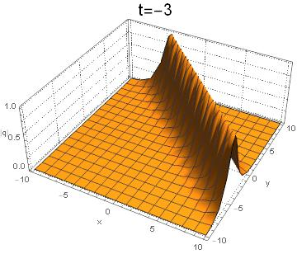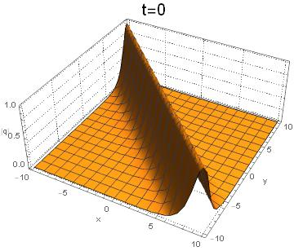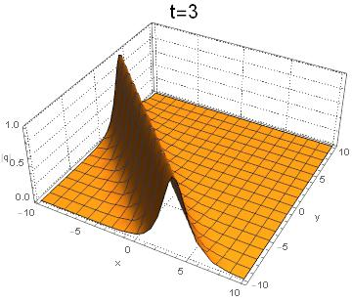

Figure 2.3 - The time evolutions of the one-soliton solution $q(x,y,t)$.

The parameters are: 

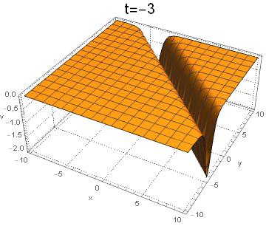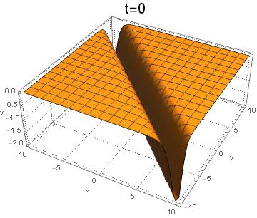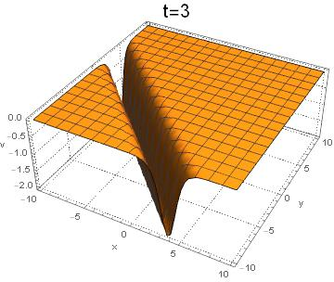

Figure 2.4 - The time evolutions of the one-soliton solution $v(x,y,t)$.

The parameters are:

2.3.1.2 The two-soliton solutions

To derive the two-soliton solutions for equations (2.23)-(2.24) we use the expression

  (2.30)

setting , and substituting them into bilinear forms (2.25)-(2.27) than we get

  (2.31)

where

  

  

With

 









 

with dispersion relation  where The graphs of the solutions (2.31) are presented in the figures 2.5-2.6.

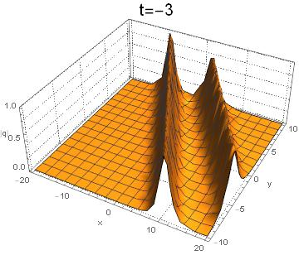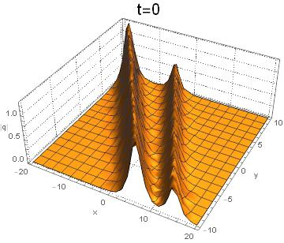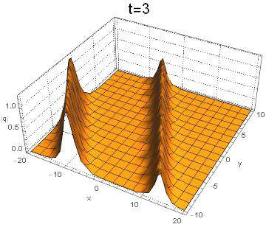

Figure 2.5-The time evolutions of the two-soliton solution $q(x,y,t)$.

The parameters adopted here are:

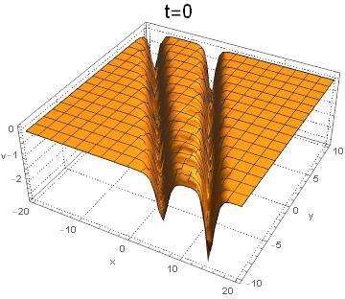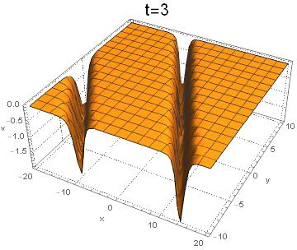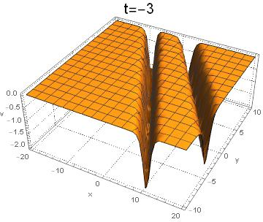

Figure 2.6-The time evolutions of the two-soliton solution $v\left(x,y,t\right).$

The parameters adopted here are 

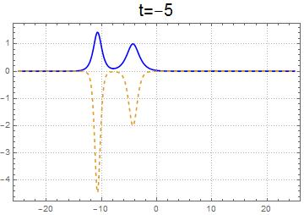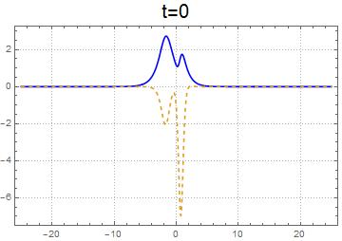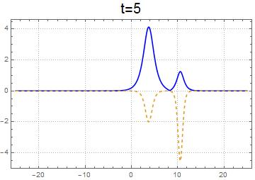

Figure 2.7-Evolution of the two soliton solutions  (blue solid line) and (red dashed line) at  with parameters 

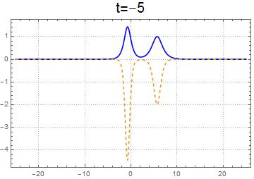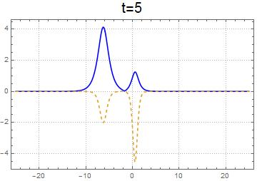

Figure 2.8-Evolution of the two soliton solutions (blue solid line) and (red dashed line) at  with parameters 

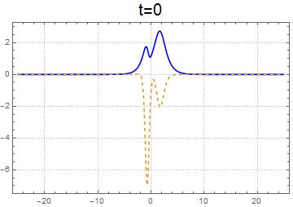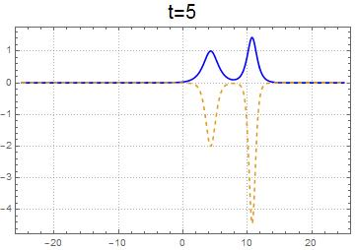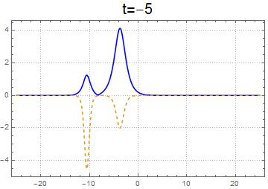

Figure 2.9 - Evolution of the two soliton solutions  (blue solid line) and (red dashed line) at  with parameters 

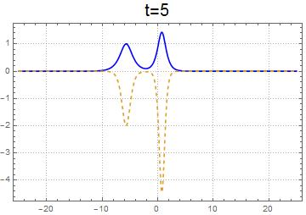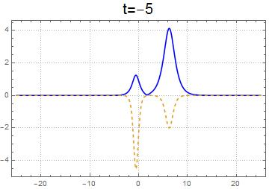

Figure 2.10- Evolution of the two soliton solutions  (blue solid line) and (red dashed line) at  with parameters 

**2.3.2 Traveling wave solutions**

In this subsection, we obtained exact traveling wave solutions of the two-dimensional GNLS system of equations using the extended tanh method. For applying this method, we ought to reduce the system (2.23)-(2.24) to the system of ordinary differential equations. If we consider the transformation

 (2.32)

Substituting equation (2.32) into equation (2.23)-(2.24), we obtain the following ordinary differential equation

 (2.33)

where prime denotes the derivation with respect to . Balancing the nonlinear term , which has the exponent 3M, with the highest order derivative , which has the exponent , in (2.33) yields  that gives . Then the extended tanh method allows us to use the substitution

 (2.34)

Substituting (2.34) into (2.33) and collecting the coefficients of , we obtain a system of algebraic equations for . Solving this system with the aid of Maple, we obtain the following results:

Result 1:

,  (2.35)

  (2.36)

Result 2:

,  (2.37)

Result 3:

,  (2.38)

Result 3:

,  (2.39)

  (2.40)

By substituting equation (2.34) into (2.32), we can obtain solutions for the two-dimensional GNLS system of equations (2.23)-(2.24) in the following form

 (2.41)

 (2.42)

where 

Finally, substituting the results (2.35)-( 2.40) into (2.41)-( 2.42), we can obtain the traveling wave solutions in the next forms



 (2.43)



 (2.44)

 (2.45)

 (2.46)

 (2.47)

 (2.48)



 (2.49)



 (2.50)

where 

The graph of solution (2.43)-(2.50) is presented in the figures (2.11)-(2.13)

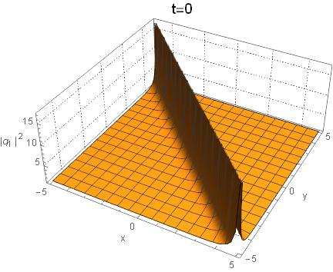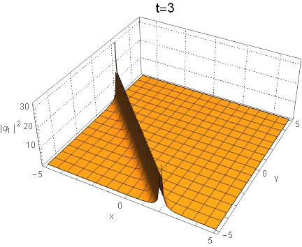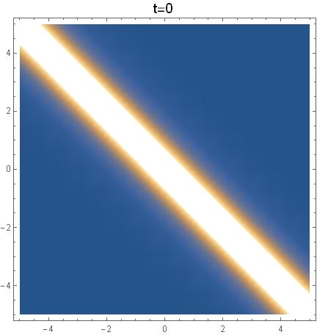

Figure 2.11 -Propagation of the solution  with the 

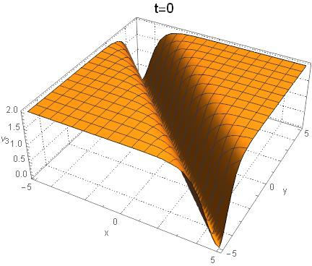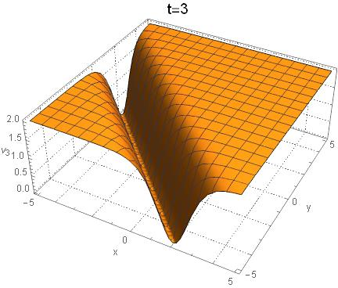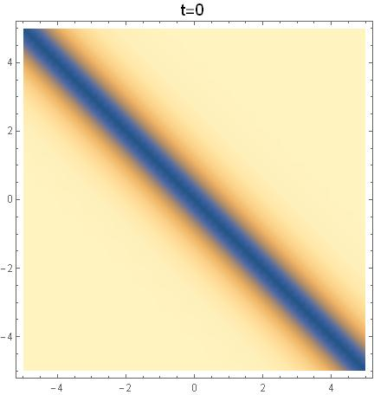

Figure 2.12- Propagation of the solution  with the 

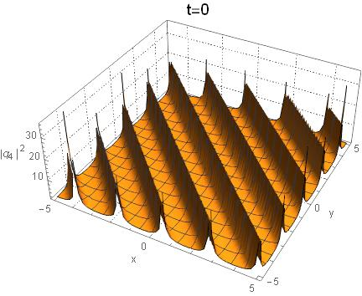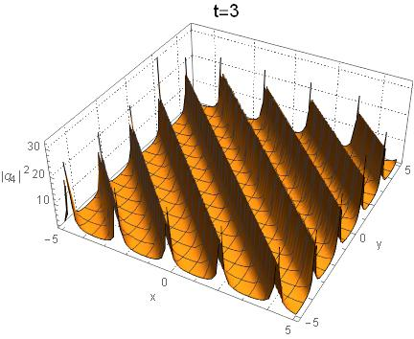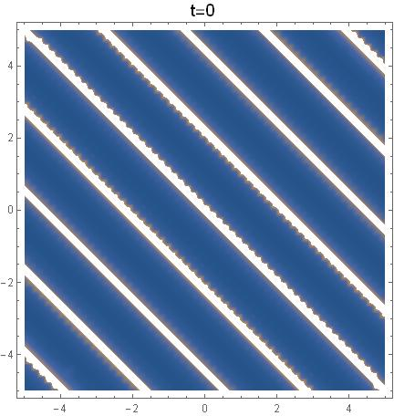

Figure 2.13 - Propagation of the solution  with the 

**2.4 Two-dimensional complex modified Korteweg-de Vries system of equations**

The two-dimensional cmKdV system of equations has the following form

 (2.51)

 (2.52)

 (2.53)

For applying the sine-cosine method, we have to reduce equations (2.51)-(2.53) to ODE. By taking transformation

 (2.54)

The equations (2.51)-(2.53) are transformed

 (2.55)

In the next subsection, we solve equation (2.55) by the sine-cosine method.

**2.4.1 Exact solitions**

According to the sine-cosine method the solution of the equation (2.55) can be found by transformation

 (2.56)

To find the sine solution we use (2.56) and its second order derivative

 (2.57)

Substitute (2.57) and (2.56) into (2.55) we get

(2.58)

Applying the balance method, by equating the exponents of , from (2.58) we determine :

 (2.59)

Substituting equation (2.59) into equation (2.58) to get

 (2.60)

We equate exponents and coefficients of each pair of the functions and obtain a system of algebraic equations

 (2.61)

 (2.62)

By solving the system (2.61)-(2.62) , we obtain:

. (2.63)

By substituting (2.63) into (2.56) and then obtained result in (2.54) we obtain the sine solutions for the two-dimensional cmKdV equations (2.51)-(2.53)

 (2.64)



 (2.65)

,

 (2.66)

,

where 

Bellow 3-D plot of solutions (2.64)-(2.66) are presented. The parameters adopted here are 

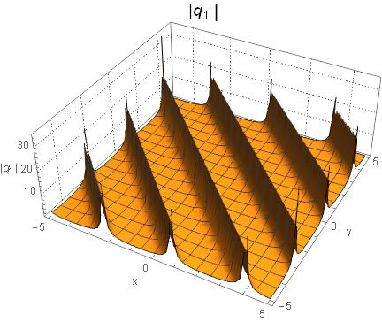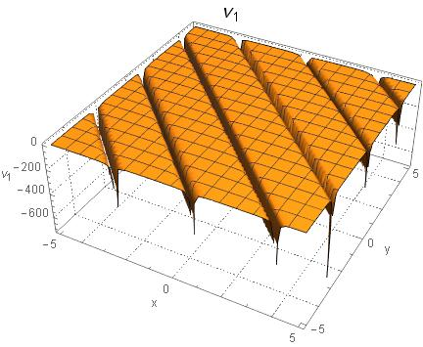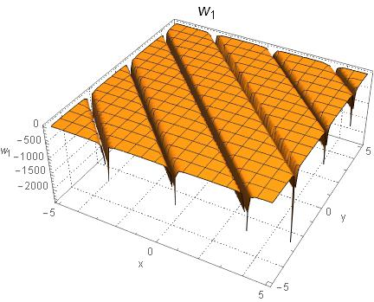

Figure 2.14 **-**Graph of the solutions (2.64)-(2.66) at 

By same way we can obtain the cosine solutions

 (2.67)



 (2.68)

,

 (2.69)

,

where 

Bellow 3-D plot of solutions (2.67) -(2.69) are presented. The parameters adopted here are 

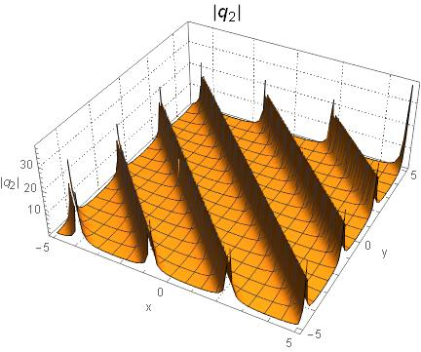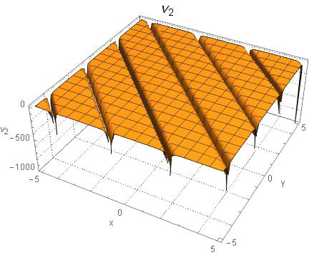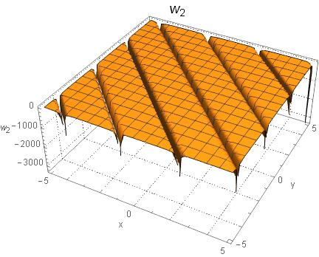

Figure 2.15**-** Graph of the solutions (2.67) -(2.69) at 

In order to obtain the other kind of the solutions we applied the extended tanh method

 (2.70)

We substitute (2.70) into (2.55) and collect the coefficients of , then we have a system of algebraic equations for By solving the obtained system with the aid of Maple, we get the next results:

Result 1  (2.71)

Result 2:  (2.72)

Result 3:  (2.73)

Result 4:  (2.74)

By substituting the equation (2.70) into (2.54) we have general solutions as

 (2.75)

 (2.76)

 (2.77)

where 

Finally, applying the coefficients (2.71)-(2.74) into equation (2.75)-(2.77), we derive exact solutions for the two-dimensional cmKdV equations (2.51)-(2.53) in the next forms

Result 1:

 (2.78)

 (2.79)

 (2.80)

Result 2:

 (2.81)

 (2.82)

 (2.83)

Result 3:

 (2.84)



 (2.85)



 (2.86)



Result 4:

 (2.87)



 (2.88)



 (2.89)



where with 

Dynamics of the solutions (2.78)-(2.89) are shown the next figures

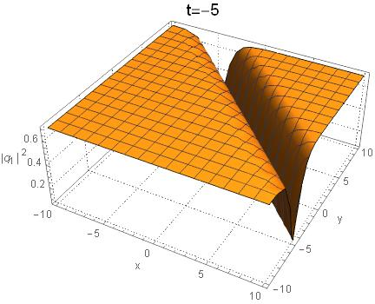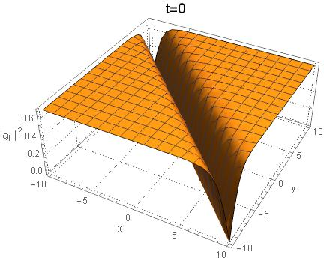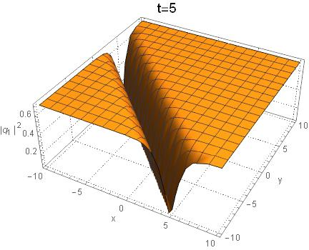

Figure 2.16**-** Dynamics of the solution (2.78). The parameters are

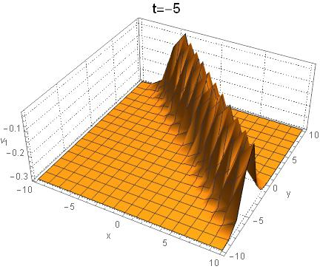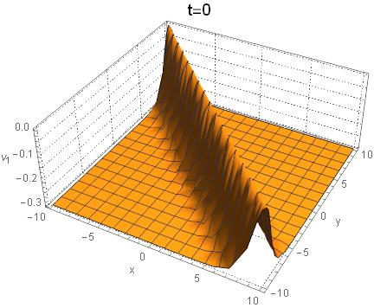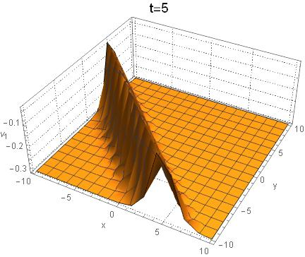

Figure 2.17- Dynamics of the solution (2.70).

The parameters are

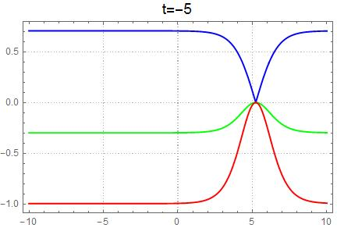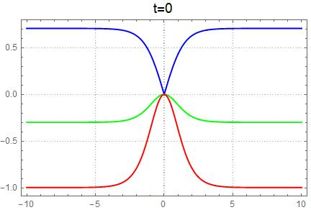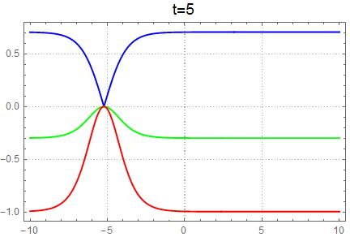

Figure 2.18**-** The time evolutions of the solutions  (blue line);  (green line);

 (red line). The parameters are:

**CONCLUSION**

The report was prepared according to the schedule. The planned volume of research work for 2021 has been completed.

The main results and conclusions of the conducted research in 2021 are as follows:

In Section I, two-dimensional nonlocal nonlinear partial differential equations are obtained based on the Ablowitz-Muslimani symmetry condition. In particular, two-dimensional nonlocal nonlinear Hirota equations and its reductions were obtained, such as the T-symmetric system of Hirota equations, S-symmetric Hirota equations, ST-symmetric Hirota equations, and by the Darboux transformation method exact solutions are found for the two-dimensional nonlocal Hirota equation. In addition, a two-dimensional nonlocal complex modified Korteweg-de Vries (cmKdV) system of equations is presented, in which nonlocality consists of inverse time fields. For this system a Lax pair is presented, the Darboux transformation is constructed, exact solutions are obtained. Note that cmKdV system of equations are a reduction of the two-dimensional nonlocal Hirota equations. The results of this section correspond to the calendar plan of paragraph 1.2.

In Section II deals with two-dimensional local partial differential equations. And by the method of Darboux transformation, solutions of the two-dimensional nonlinear Hirota equation are obtained. In addition, solutions for the one-dimensional Hirota equation are obtained. In this section, studies are presented for the two-dimensional generalized nonlinear Schrödinger (GNLS) equation, where new solutions are obtained by the bilinear method and the hyperbolic tangent method. And also the results of the study are given for the two-dimensional complex modified KdV (cmKdV) equation. Note that the GNLS system and cmKdV equations are a reductions of the nonlinear Hirota equation. The dynamics of solutions are represented by software packages Wolfram Mathematica, Matlab, Maple. The results of this section correspond to the calendar plan of paragraph 1.3 and 1.4.

During the reporting period of the project, the implementers prepared 9 publications, 2 of them are articles for an international scientific publication included in the Web of Science and Scopus databases, as well as 2 publications in the journal recommended by CQAEA; and 5 publications in other editions (see APPENDIX A). Note that 1 article has been accepted for publication for the European Physical Journal Plus with Q1 quartile based on the Web of Science database and an 80 percentile based on the Scopus database. Thus, the requirements for the expected results of the calendar plan are completed.

The results of the study are theoretical in nature and can be used in education and science, namely, in the preparation of programs for special courses for master's and PhD-doctoral studies in mathematics and physics. Potential consumers of the results obtained are scientists conducting research in similar projects.

**REFERENCES**

1. Gergjikov V., Mladenov D., Stefanov A., Varbev S., On mKdV Equations Related to the Afﬁne Kac-Moody Algebra A(2) // International Journal of Geometric Methods in Modern Physics. -2015. ‐39.-P. 17–31
2. Gergjikov V.,Kostov N. Multi-Component Nonlinear Schrodinger Equation on Symmetric Spaces with Constant Boundary Conditions. Part I // J. Geom. and Sym. in Phys.-2010. -Vol. 19. –P. 1–28.
3. Nugmanova G., Sagidullayeva Zh. Generalized Spin Model with Vector Potential and Its Solution. // Bull. Karaganda Univ.-Mathematics.- 2017.-No. 86 . -P. 91–96.
4. Bekova G., Yesmakhanova K., Myrzakulov R and Shaikhova G., Darboux Transformation and Soliton Solution for the (2+1)-dimensional Complex Modifed Kortewegde Vries Equations // J. Phys.: Conference Series. -2017. –Vol. 936. –P. 012045 (1–9).
5. Ablowitz M. and Musslimani Z., Integrable Nonlocal Nonlinear Schrodinger Equation// Phys. Rev. Lett.110 -2013.-P. 064105.
6. Ablowitz M. and Musslimani Z., Integrable Nonlocal Nonlinear Equations. // Stud. Appl. Math. -2016.-Vol.1391. –P. 7–59.
7. Gerdjikov V., Saxena A., Complete Integrability of Nonlocal Nonlinear Schrodinger Equation, J. Math. Phys. -2017. -Vol.58. -P.013502.
8. Gurses M., Pekcan A., Integrable Nonlocal Reductions in Symmetries // Differential Equations and Applications-2018 –Vol. 266.–P.27–52.
9. Lou S., Huang F., Alice-Bob Physics Coherent Solutions of Nonlocal KdV Systems, arXiv:1606.03154v2
10. Shi X., Lv P., Qi Ch., Explicit Solutions to a Nonlocal 2-component Complex Modiﬁed Korteweg-de Vries Equation // Applied Mathematics Letters.-2020.-Vol.100.-P.106043.
11. Gurses M., Pekcan A, Nonlocal Modiﬁed KdV Equations and Their Soliton Solutions by Hirota Method // Commun. Nonlinear Sci. Numer. Simulat.-2019.-Vol.67.-P.427– 448.
12. Fokas A S, Integrable multidimensional versions of the nonlocal nonlinear Schrodinger equation, Nonlinearity.-2016.-Vol.29.-P.319–324.
13. Ma L.Y., Shen S.F., Zhu Z.N., Integrable nonlocal complex mKdV equation: soliton solution and gauge equivalence // arXiv:1612.06723.
14. Ji J.L., Zhu Z.N., On a nonlocal modiﬁed Korteweg-de Vries equation: Integrability, Darboux transformation and soliton solutions // Commun. Non. Sci. Numer. Simulat.-2017. –Vol.42.-P. 699-708.
15. Ji J.L., Zhu Z.N., Soliton solutions of an integrable nonlocal modiﬁed Korteweg-de Vries equation through inverse scattering transform // J. Math. An. and App.-2017.-Vol.453 –P.973–984.
16. Yang B., Yang J., Transformations between nonlocal and local integrable equations // Studies in Applied Mathematics.-2018.-Vol.140.-P.178-201.
17. Lou S. Y., Huang F., Alice-Bob Physics Coherent Solutions of Nonlocal KdV Systems// arXiv:1606.03154v2
18. Myrzakulov R., Mamyrbekova G., Nugmanova G. and Lakshmanan M. Integrable (2 + 1)-Dimensional Spin Models with Self-Consistent Potentials // Symmetry.-2015. –Vol.7. -P. 1352-1375.
19. Yesmakhanova K., Shaikhova G. N, Bekova G., Soliton solutions of the Hirota syste // AIP Conf. Proc.-2016.-Vol.1759, -P. 020147 (1-5).
20. Yesmakanova K R, Shaikhova G N, Bekova G T, MyrzakulovaZh R Determinant Representation of Darboux transformation for the (2+1)-Dimensional Schrodinger-Maxwell-Bloch Equation // Advances in Intelligent Systems and Computing,-2016.-Vol.441.-P.183-198.

**APPENDIX A**

# List of publications based on research results

# *Scientific publications in international scientific journals included in the Web of Science or Scopus database with an impact factor:*

# 2021 year

1. Burdik C., Shaikhova G., Rakhimzhanov B. Soliton solutions and travelling wave solutions for the two-dimensional generalized nonlinear Schrodinger equations*//*European Physical Journal Plus– 2021. [***Web of Scince IF= 3.911, Q1; Scopus процентиль=80****].****DOI:* *10.1140/epjp/s13360-021-02092-6*** *– (****In Press****).*
2. Shaikhova G.N., Kutum B.B., Myrzakulov R. The Sine-cosine and Tanh-coth Methods in the Theory of Nonlinear PDEs: (2+1)-dimensional Complex Modified Korteweg-de Vries System of Equations //Axioms– 2021. [*Scopus процентиль=85]. – (Submited).*

# *Scientific publications in editions recommended by Committee for Quality Assurance in the Field of Education and Science of the Ministry of Education and Science of the Republic of Kazakhstan (CQAEA):*

# 2020 year

1. Syzdykova A.M., Shaikhova G.N., Kutum B.B. Two-dimensional nonlocal nonlinear Schrodinger equation based on the Ablowitz-Musslimani symmetry condition // Вестник КазНПУ им. Абая. Серия «Физико-математические науки»-2020 -№4(72). – С. 56-60. *[In 2020, the Bulletin of Abay KazNPU was on the CQAEA list]*

**2021 year**

1. Shaikhova G.N., Kalykbay Y.S.Exact solutions of the Hirota equation via the sine-cosine method // Вестник Южно-Уральского университета.Серия «Математика. Механика. Физика» -2021 -Том 13, №3. – С. 47-52. *[The specified journal is included in the base of the Russian Science Citation Index, zbMath, thus it belongs to the publication recommended CQAEA ]*

# *Scientific publications in domestic publications:*

# 2020 year

1. Shaikhova G.N., Syzdykova A.M., Rakhimzhanov B.K. Exact solutions for Korteweg-de Vries equation of higher order// Вестник Кокшетауского государственного университета им. Ш. Уалиханова. Серия: естественные науки – 2020. - №3.– С. 60-68.

# 2021 year

1. Сыздыкова А.М., Шайхова Г.Н ., Кутум Б.Б. Преобразование Дарбу для Т-симметричной нелокльной комплексной модифицированной системы уравнений Кортевега-де Фриза //Вестник КазНИТУ им. Сатпаева. Серия «Физико-математические науки»-2021 -№2. – С. 58-65.
2. Сыздыкова А.М., Калыкбай Ы.С. Хирота теңдеуі үшін тангенс және котангенс әдісі // Вестник Кокшетауского государственного университета им. Ш. Уалиханова. Серия: естественные науки – 2021. - №1.– С. 12-21.

# *Scientific publications in international conferences:*

# 2021 year

1. Калыкбай Ы.С. Хирота теңдеуі үшін тангенс әдісі//Сборник материалов международной конференции «ǴYLYM JÁNE BILIM-2021» С. 206-209.
2. Shaikhova G.N.,Solitary wave solutions of the two-dimensional Hirota equations// Proceding International Conference “Differential Equations, Mathematical Modeling and Computational Algorithms”, Belgorod, 2021.

**APPENDIX B**

**Calendar plan** 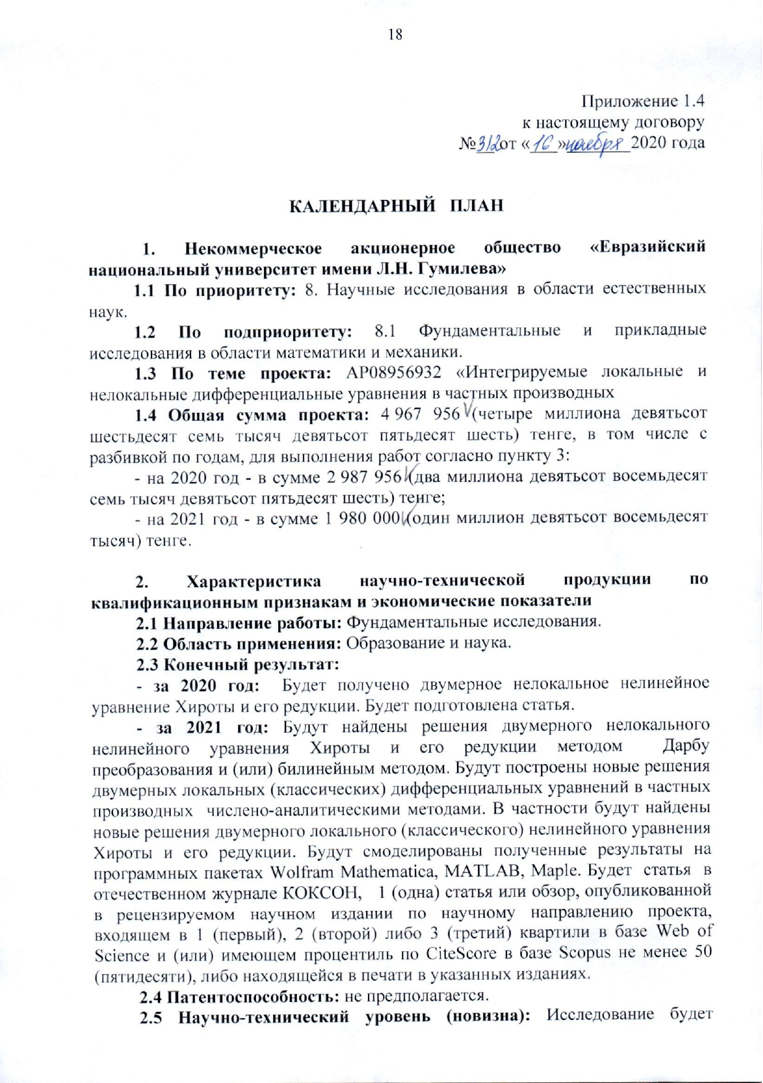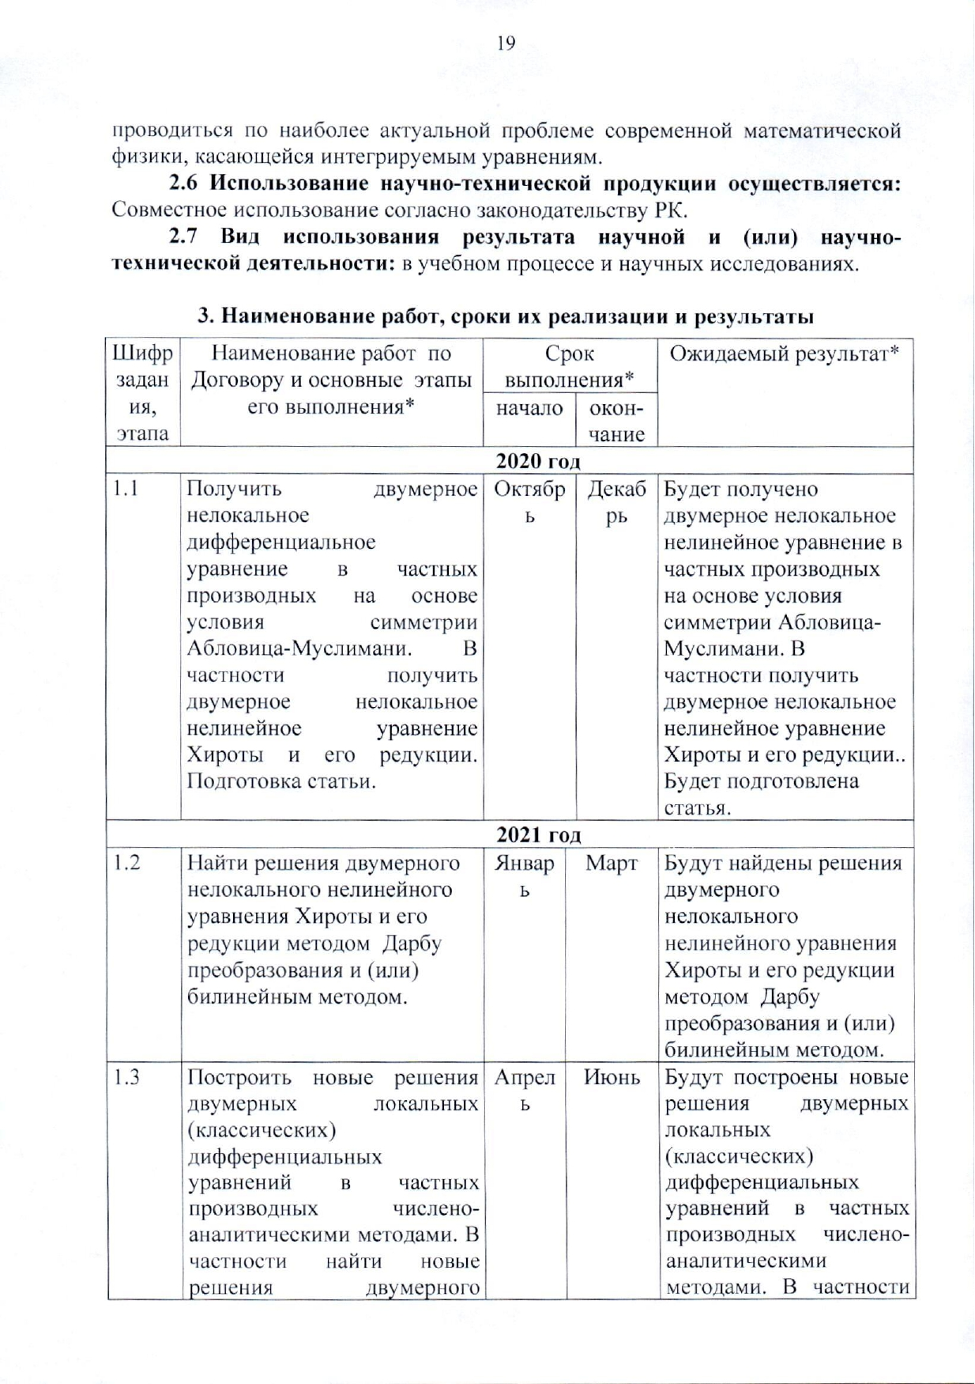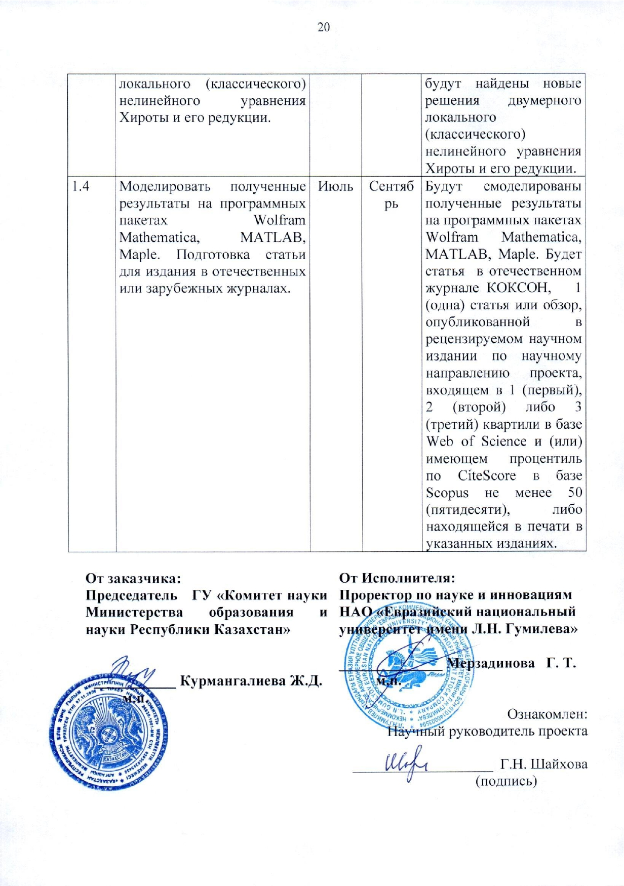

Aplication 1.2

to this agreement

No.*312* dated "*16 November* *2020*

**CALENDAR PLAN**

**1. Non-profit joint-stock company “Eurasian National University named after L.N. Gumilyov "of the Ministry of Education and Science of the Republic of Kazakhstan**

**1.1 By priority:** 8. Scientific research in the field of natural sciences**.**

**1.2 By sub-priority:** 8.1 Fundamental and applied research in the field of mathematics and mechanics.

**1.3 On the topic of the project:** IRN AR08956932 “Integrable local and nonlocal partial differential equations

**1.4 The total amount of the project:** 4,967,956 (four million nine hundred sixty-seven thousand nine hundred fifty-six) tenge 0 tiyn, including with a breakdown by years, to perform work in accordance with clause 3:

- for 2020 - in the amount of 2 987 956 (two million nine hundred eighty seven thousand nine hundred fifty six) tenge 0 tiyn;

- for 2021 - in the amount of 1,980,000 (one million nine hundred and eighty thousand) tenge 0 tiyn.

**2. Characteristics of scientific and technical products by qualification characteristics and economic indicators**

**2.1 Direction of work:** Basic research.

**2.2 Scope:** Education and Science.

**2.3 End result:**

**- for 2020:** A two-dimensional nonlocal nonlinear Hirota equation and its reductions will be obtained. An article will be prepared.

**- for 2021:** Solutions of the two-dimensional nonlocal no-linear Hirota equation and its reductions by the Darboux transformation and / or bilinear method will be found. New solutions of two-dimensional local (classical) partial differential equations will be constructed using numerical-analytical methods. In particular, new solutions will be found for the two-dimensional local (classical) nonlinear Hirota equation and its reduction. The results will be modeled using the Wolfram Mathematica, MATLAB, Maple software packages. An article will be prepared for publication in domestic or foreign journals.

**2.4 Patentability:** not expected.

**2.5 Scientific and technical level (novelty):** The research will be carried out on the most pressing problem of modern mathematical physics concerning integrable equations.

**2.6 The use of scientific and technical products is carried out:** Joint use in accordance with the legislation of the Republic of Kazakhstan.

**2.7 Type of use of the result of scientific and (or) scientific and technical activities:** in the educational process and scientific research.

**3. Name of work, terms of their implementation and results**

|  |  |  |  |  |  |  |  |  |
| --- | --- | --- | --- | --- | --- | --- | --- | --- |
| Job code, stage | | Name of work under the Agreement and the main stages of its implementation * | Deadline * | | | | Expected Result * | |
| Begin | | | End |  | |
| **2020 year** | | | | | | | | |
| 1.1 | | Obtain a two-dimensional nonlocal partial differential equation based on the Ablowitz-Muslimani symmetry condition. In particular, obtain a two-dimensional nonlocal nonlinear Hirota equation and its reduction. Preparation of the article. | October | | | December | | A two-dimensional nonlocal nonlinear Hirota equation and its reduction will be obtained. An article will be prepared. |
| **2021 year** | | | | | | | | |
| 1.2 | | Find solutions of the two-dimensional nonlocal nonlinear Hirota equation and its reduction by the Darboux transformation method and / or the bilinear method. | January | | March | | | Solutions of the two-dimensional nonlocal nonlinear Hirota equation and its reduction by the Darboux transformation and /or bilinear method will be found. |
| 1.3 | | Construct new solutions of two-dimensional local (classical) partial differential equations by numerical-analytical methods. In particular, find new solutions to the two-dimensional local (classical) nonlinear Hirota equation and its reduction. | April | | June | | | New solutions of two-dimensional local (classical) partial differential equations will be constructed using numerical-analytical methods. In particular, new solutions will be found for the two-dimensional local (classical) nonlinear Hirota equation and its reduction. |
| 1.4 | | Simulate the results obtained using software packages Wolfram Mathematica, MATLAB, Maple. Preparation of an article for publication in domestic or foreign journals. | July | | September | | | The results will be modeled using the Wolfram Mathematica, MATLAB, Maple software packages. There will be an article in the national journal  *CQAEA* , 1 (one) article or review published in a peer-reviewed scientific publication in the scientific direction of the project, included in 1 (first), 2 (second) or 3 (third) quartiles in the Web of Science database and (or ) having a CiteScore percentile in the Scopus database of at least 50 (fifty), or in print in the indicated editions. |
|  | | | | | | | | |
| **By customer:**  **Chairman of the State Institution "Science Committee of the Ministry of Education and Science of the Republic of Kazakhstan"**  **________________Kurmangaliyeva Zh.D.**  **m.s.** | | | **From the Contractor:**  **Vice-rector for Science and Innovation of the NJSC "Eurasian National University named after L.N. Gumilyov "**  **______________ G. Merzadinova**  **m.s.**  Familiarized with:  Scientific supervisor of the project  ___________________ G.Shaikhova | | | | | |