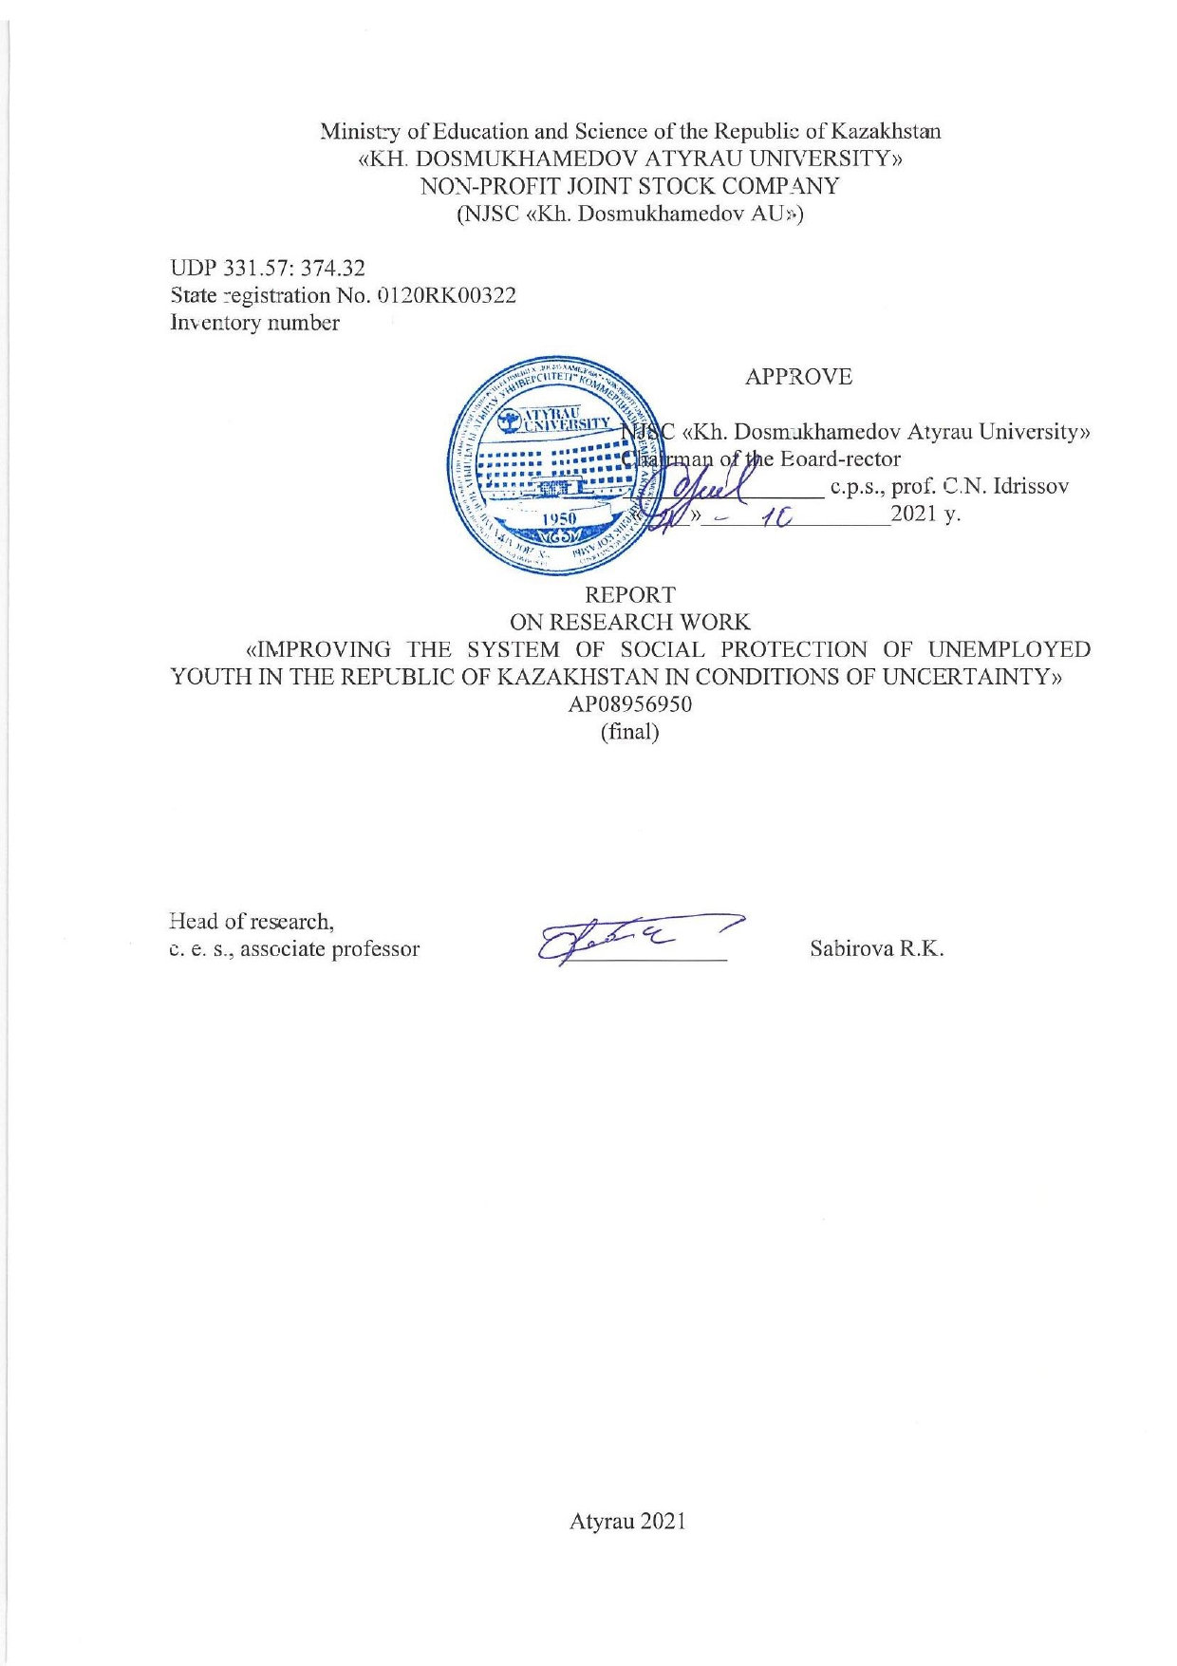

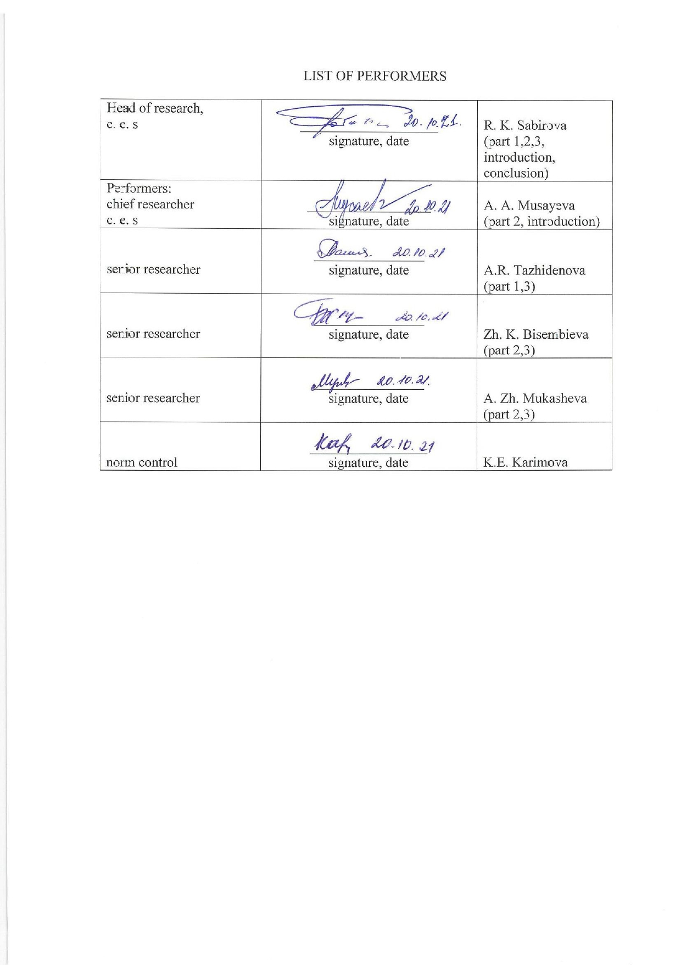

**REPORT**

Report 40 p., 6 fig., 5 tabl., 23 sources, 2 applic.

YOUTH LABOR MARKET, YOUTH UNEMPLOYMENT, YOUTH ENTREPRENEURSHIP, SOCIAL PROTECTION, YOUTH LABOR MIGRATION, PUBLIC POLICY, SOCIAL PROTECTION OF UNEMPLOYED YOUTH, STATE REGULATION OF THE LABOR MARKET

The object of the study is youth unemployment and social protection of unemployed youth in conditions of uncertainty.

The purpose of the work is to study the labor market, youth employment and unemployment, as well as to develop proposals for improving the social protection system for unemployed youth in the Republic of Kazakhstan

The methodological framework of the study included general scientific and special methods of cognition. The use of systematic and integrated research approaches allowed determining the specific features of the youth labour market as an object of state regulation and justifying the need for the development of a comprehensive mechanism for its state regulation.

Research results:

- аn analysis of the problems of employment, labor market and labor migration of youth in Kazakhstan conducted; the main causes of youth unemployment in Kazakhstan identified;

- the best international standards and practices for improving the social protection system for unemployed youth studied;

- regulations, policy documents and other measures aimed at increasing youth employment will be studied and their effectiveness determined;

- a sociological survey conducted and problems of employment, labor market and labor migration of young people in Kazakhstan identified.

The significance of the work. The practical significance of the study is determined by the fact that the increased need for the state to implement measures aimed at preventing the growth of youth unemployment leads to revising and changing the methods of the youth labour market state regulation.

**РЕФЕРАТ**

Есеп 40 бет, 6 сур., 5 кесте, 23 пайд. әдеб., 2 қос.

ЖАСТАР ЕҢБЕК НАРЫҒЫ, ЖАСТАР ЖҰМЫССЫЗДЫҒЫ, ЖАСТАР КӘСІПКЕРЛІГІ, ӘЛЕУМЕТТІК ҚОРҒАУ, ЖАСТАРДЫҢ ЕҢБЕК КӨШІ-ҚОНЫ, МЕМЛЕКЕТТІК САЯСАТ, ЖҰМЫССЫЗ ЖАСТАРДЫ ӘЛЕУМЕТТІК ҚОРҒАУ, ЕҢБЕК НАРЫҒЫН МЕМЛЕКЕТТІК РЕТТЕУ

Зерттеу нысаны - белгісіздік жағдайындағы жастар жұмыссыздығы мен жұмыссыз жастарды әлеуметтік қорғау.

Жұмыстың мақсаты - жастардың еңбек нарығын, жұмыспен қамту және жастар жұмыссыздығын зерттеу, сонымен қатар Қазақстан Республикасында жұмыссыз жастарды әлеуметтік қорғау жүйесін жетілдіру бойынша ұсыныстар әзірлеу

Зерттеу әдістері. Зерттеудің әдістемелік негізі жалпы ғылыми және әдістер болып табылады. Жүйелі және кешенді зерттеу әдістерін қолдану мемлекеттік реттеудің нысаны ретіндегі жастар еңбек нарығы ерекшеліктерін анықтауға және оны мемлекеттік реттеудің кешенді тетіктерін жасау қажеттілігін негіздеуге мүмкіндік берді.

Зерттеу нәтижелері.

- Қазақстанда жастардың жұмыспен қамту, еңбек нарығы және еңбек көші-қоны проблемаларына талдау жүргізілді, Қазақстанда жастардың жұмыссыздығының негізгі себептері анықталды;

- жұмыссыз жастарды әлеуметтік қорғау жүйесін жетілдіру жөніндегі үздік әлемдік стандарттар мен тәжірибелер зерделенді;

- жастардың жұмыспен қамтылуын арттыруға бағытталған нормативтік-құқықтық актілер, бағдарламалық құжаттар және басқа да шаралар зерделенді және олардың тиімділігі айқындалды;

- Қазақстанда әлеуметтік сауалнама жүргізілді және жұмыспен қамту, еңбек нарығы және жастардың еңбек көші-қоны мәселелері анықталды.

Жұмыстың маңыздылығы. Зерттеудің практикалық маңыздылығы жастар арасында жұмыссыздықтың өсуін тоқтатуға бағытталған шараларды жүзеге асыруда мемлекет қажеттілігінің өсуі, жастар еңбек нарығын мемлекеттік реттеу, жастарды әлеуметтік қорғау әдістерін қайта қарау мен өзгертуге әкелетіндігімен анықталды.

**CONTENT**

|  |  |
| --- | --- |
| INTRODUCTION................................................................................................................. | 7 |
| THE MAIN PART OF THE REPORT OF SRW…………………………………………. | 8 |
| 1 Тheoretical foundations of state regulation of the youth labor market and social protection of unemployed youth…….................................................................................... | 8 |
| 2 Analysis of public opinion on the social status of young people aged 18-25 in Kazakhstan.......................................................................................................................................... | 19 |
| 3 Foreign experience of social protection of young people and the possibility of its application in Кazakhstan...................................................................................................... | 25 |
| CONCLUSION...................................................................................................................... | 32 |
| REFERENCES……………………………………………………………………………. | 33 |
| APPENDIX A List of published and published scientific research papers………………... | 35 |
| APPENDIX B Сalendar plan …...……………………………………................................. | 36 |

**DESIGNATIONS AND ABBREVIATIONS**

The following designations and abbreviations were used in this R & D report:

|  |  |  |
| --- | --- | --- |
| US | - | United States of America |
| IT | - | Information Technology |
| UN | - | United Nations |
| R & D | - | scientific research work |
| EU | - | European Union |
| VAT | - | value added tax |
| ILO | - | International Labour Organization |
|  |  |  |

**INTRODUCTION**

The labor market in Kazakhstan, as well as around the world, is changing rapidly and is likely to transform beyond recognition within a year. The pandemic puts its own rules on the labor market: many companies have cut their spending on staff, and some companies have even laid off their valuable employees. In the context of self-isolation during the coronavirus epidemic, the issue of employment came to the fore for many people. People who have worked in quarantined industries are left without living conditions and are forced to look for their place in other industries.

Since the beginning of March 2020, there has been a decrease in quantitative indicators in all sectors. Previously, it was possible to work under the same standard for decades, but now the attitude to work changes several times a year. In a situation where many competencies quickly become obsolete, "flexible skills" come to the fore: logical and critical thinking, creativity, adaptability to change, the ability to build relationships with people and solve complex problems. The pandemic has brought significant changes to the labor market. There is a high probability that most unemployed people who have temporarily lost their jobs will fill the ranks of those who have been unemployed for a long time. Self-development and acquisition of new skills have become the only trend in the modern labor market.

The methodological framework of the study included general scientific and special methods of cognition. The use of systematic and integrated research approaches allowed determining the specific features of the youth labour market as an object of state regulation and justifying the need for the development of a comprehensive mechanism for its state regulation. The authors used the method of analysis and synthesis to identify the content of the terms "youth”, "youth labour market", "state regulation mechanism of the youth labour market". The authors also used the abstraction method to assess the state and trends in the development of the youth labour market. When summarising the above, the state regulation of the youth labour market should be considered as a system of means of state influence to ensure youth employment [1,2]. In turn, the youth labour market regulation is a complex system of measures that cover not only the sphere of employment, but also all elements of the economic system of society.

An interim report was prepared and submitted for this project (inventory number №0220РК01811).

**THE MAIN PART OF THE R & D REPORT**

**1 Theoretical foundations of state regulation of the youth labor market and social protection of unemployed youth**

In the scientific field, the concept of labour market is mainly considered as a system of social relations, within which employers and employees buy and sell labour. “The labour market is an area in which commodity-monetary and social relations regarding the buying and selling labour are developed and implemented” [3].

The labour market as a mechanism for the reproduction of labour potential, which is a combination of market, corporate, state, and interstate regulation [4]. Thus, the study defined the labour market as a system of social relations within buying and selling “labour force”. The authors of the study considered the labour market as a sphere of demand development for labour and its supply and also determined the possibility of its interpretation as a mechanism that ensures the coordination of prices and working conditions between employers and employees [5]. A distinctive feature of the labour market is that it covers not only the sphere of "labour force" turnover, but also the sphere of production where the employee works. The resulting relations affect important socio-economic issues, and therefore require special attention from the state [6].

When defining the youth labour market as an object of state regulation, it is necessary to refer to the interpretation of terms "state regulation” and "labour market" [7]. State regulation of the economy is the influence of the state on the socio-economic development of the country. State regulation is a set of economic and political measures implemented by state bodies to coordinate economic processes and aimed at maintaining optimal proportions of social production and preventing crisis situations in it [8]. State regulation is determined as a set of state measures aimed at managing economic entities in the area necessary to achieve the state authorities' objectives and for management [9].

Such definitions indicate the importance of the complexity and unity of state regulation, yet they exclude the possibility of development and self‐regulation, which should be stimulated by the state [10].

Upon analysing several definitions of state regulation, it can be concluded that they have certain advantages and disadvantages, each of the definitions interprets the essence and purpose of state regulation differently [11]. It is more precise to define state regulation as a set of tools, levers, and methods of influencing the processes and phenomena used by the authorities to streamline the system of socio-economic relations and its development. It is advisable to determine state regulation depending on the sphere on which state influence is exercised [12]. Hence, the state regulation of the youth labour market should be defined based on the interpretation of the youth labour market.

When considering the youth labour market as an object of state regulation, it is necessary to determine the essence of the term “youth” and its inherent features [13]. The analysis of the term “youth” demonstrates discrepancies in its interpretation by various scientists in terms of the age qualification and the features of this category. For example, an American sociologist refers to young people in the age category from 7-8 to 23 years, defines the boundaries depending on the gender, so for girls it is the age from 13 to 19, for boys – from 14 to 20 years. Definitions of "youth" differ not only by age, but also by the general understanding of the concept of youth. Youth is defined as a special social group aged from 14 to 28 years, which, to be involved in productive social work during the initial social development, is legislatively provided with additional benefits and guarantees for employment, occupational training, and labour activity in comparison with other employees. Other scientists refer to youth as people under the age of 30 who have not started independent work and have not created their family. Thus, young people differ from other employees both in age and in the specific features of their status in labour relations; in the legal aspect, the lower age limit of young people coincides with the age from which employment is allowed (15-16 years), and the upper age limit is 27-30 years. By this time, the biological development of the organism, the establishment of professional interests, initial professional training for the majority of young people who start their career, and the term of the established additional guarantees for young workers end.

In total, the age limits of young people in the world range from 13 to 35 years. According to the UN General Assembly, young people are aged from 17 to 25 years. The UN defines youth as people in the period of life between the end of childhood and the beginning of labour activity. The World Health Organization considers a person to be young up to 44 years old. Sociologists in the United States determine the age of young people in the range from 12 to 24 years while dividing the period of youth into "adolescence" aged from 12 to 18 years and "young adults" – from 19 to 24 years. The ILO Convention "On the Minimum Age" sets the maximum age of a person who is hired, not lower than the age at the end of compulsory school education, but not less than 15 years. In Europe as a whole, people from 15 to 30 years old are considered to be youth. In the Republic of Kazakhstan, according to the Law of the Republic of Kazakhstan “On National Youth Policy in the Republic of Kazakhstan”, young people are citizens aged from 14 to 35 years.

The essential characteristics of the youth labour market are determined by the specific features of the young labour force. In particular, the youth labour market is described by:

- the instability of supply and demand, coming from the uncertainty of youth,

- low competitiveness of young people in comparison with the older workforce with work experience,

- a constant increase in the number of the labour force, which is associated with the annual graduation of young workers from educational institutions,

- professional variability due to the professional training of young people in different specialities.

The problem of youth unemployment leads to a decrease in the standard of living, the spread of so-called “dependence” by other family members, shadow employment, an increase in labour migration and generally in the criminal situation. A number of issues of the youth labour market are associated with the presence of such categories of young people in it:

1. dismissed from military service or alternative service. They do not have practical experience in their speciality, previously acquired knowledge is largely lost. There is a need to restore knowledge;
2. young people under the age of 19 – distinguished by the lack of professional education, and sometimes by incomplete general secondary education. These people require special work to improve the level of knowledge and obtain professional education;
3. representatives who, for some reason, did not use the right to occupy the first workplace at the time, that is, they have not worked yet. They are described by a low level of qualification since even the knowledge they received earlier is no longer relevant.

These categories of young people cannot compete with the experienced labour force of older generations, which results in a considerable part of young people entering the unregulated labour market, thereby creating a high level of youth unemployment in the official economy. Young people establish the basis of the future state of the country's economy. The insufficient realisation of the young people's labour potential leads to intellectual losses of society. A flawed career guidance system causes a shortage of qualified labour in the labour market, increases the imbalance between the demand for labour and its supply. The career guidance of youth contributes to the conscientious professional choice, shortens the distance between the profession in demand and the youth, provides interaction and a combination of the individual's interests and the needs of the employer.

State regulation of the youth labor market is a complex mechanism that affects the comprehensive development and formation of young people, as well as the socio-economic state of the country's economy as a whole. The mechanism of state regulation of the youth labor market includes a set of elements used by the state to influence the object of regulation.

Considering the distinctive and essential features of the mechanisms that the state uses to exercise regulatory influence on the youth labour market, it is important, from the standpoint of methodology, to define the term “mechanism of state regulation”. In the scientific literature, along with the term “mechanism of state regulation”, the term “mechanism of state administration” is quite often found, the definitions of which are quite difficult to distinguish. When interpreting the essence of the mechanism of state administration, it is noted that this concept should be considered as the consistent administration performed by public authorities using appropriate methods and means, which is based on the fundamental principles of administration and is aimed at achieving the set objective. The literature provides a definition of the term "the mechanism of state regulation", which is very similar to the definition of the mechanism of state administration. This term means the course of actions of the regulation subject, based on the general functions and principles, providing with the help of forms, methods, and means the effective functioning of the state regulation system to achieve a certain goal and resolve contradictions.

Proceeding from the above, the state regulation mechanism for the youth labour market is a targeted influence of the state on the participants of social and labour relations on the development and placement of youth labour resources using principles, functions, forms, methods, and tools that ensure the socio-economic development of youth and promote its employment. Based on the fact that the state regulation of the youth labour market is a single integrated system, and the functioning mechanism of this system should also be unified. Thus, it is necessary to consider an integral state regulation mechanism, which includes a number of structural elements. The purpose of the state regulation of youth labour market is the development and allocation of youth labour resources, promoting their self-development and employment.

In general, the youth labour market performs several functions, namely:

- mediation: establishment of relations between employers, educational institutions, and young people to satisfy mutual interests and needs;

- informational: provision of information to employers and young people about the state of the labour market, employment conditions, salary level, quality of labour, etc.;

- stimulating: the market requires a high-quality workforce, encouraging employees to improve their level of professional knowledge and skills to be competitive in the labour market;

- organisational and economic: develops the proportions of social production, establishes a balance between the supply and demand of labour, contributes to the uniform economic development of regions, provides financial support to young people;

- social: provides social protection of young people, development, and support.

In the scientific papers, the state regulation of the labour market is also defined differently [14]. When considering the state regulation of the labour market, the scientist focused on the protection of hired labour, which includes the possibility of employment, retraining, professional skills realisation, and professional growth, professional skills recreation, earning money, ensuring safety, and labour protection [15].

For such protection, the state must predominantly establish basic social guarantees by law, introduce a mechanism for their implementation and functions for providing social support [16].

The population's social protection is not a new concept, it has a historal background. The first social protection mechanisms were created in Germany at the end of the 19th century when the state allocated considerable funds for various social programmes for the population. Social protection is a type of state assistance designed to meet the basic human needs of all society members.

Social protection should provide citizens with assistance in meeting the needs for food and housing. In the latest scientific literature, publications on the issues of youth employment are increasingly appearing, wherein attention is mainly paid to the theoretical aspects of this specific market, the authors cover general characteristics, quantitative and qualitative parameters [17].

Quite significant are the studies on the development of youth policy, research on the issues of youth employment and its primary employment [18].

However, despite the European orientation of the Republic of Kazakhstan and economic reform, which leads to changes in the social sphere, the labour market and amendments in legislative acts, scientific research on ensuring effective state regulation does not keep up with the real needs and is not always satisfactory [19]. Therefore, a more substantial study of the youth labour market state regulation is now relevant in order to improve it in accordance with modern requirements [20].

Social protection of the population can be represented in the form of three blocks (or subsystems):

* social protection of the working (employed) population;
* social protection of disabled citizens, as well as socially unprotected segments of the population;
* protection of vital rights and interests of the entire population in the socio-cultural sphere, for example, in the fields of education, healthcare, and culture.

An important component of state social support is the existing unemployment benefit and compensation for young people. The state guarantees the payment to the unemployed, even during periods of their temporary disability. The state also pays scholarships during the training period, as well as during retraining in employment services. Young people are given the opportunity to take part in paid community service. They can also expect to be reimbursed for expenses related to voluntary relocation at the request of the employment service.

Citizens who have registered with the employment service have the right to be consulted on the choice of the activity field, other employment issues, as well as occupational training. Working young people who want to change jobs can also contact the employment service to find a suitable job opportunity and change their employment place. The employment service solves not only social and economic, but also psychological problems of unemployed citizens.

Proceeding from the fact that young people are one of the most considerable components of the national labour market, its environment depends on development and establishment of youth. The vast majority of young people strive for self-fulfilment, desire to work and earn an income. This is confirmed by the relatively high level of economic activity of young citizens. A problematic aspect of the effective functioning of the youth labour market is the imbalance between the supply of labour and the demand for it. The labour market is developed on a national scale under the influence of economic, political, social, demographic, territorial, sectoral, and other factors, acquiring the characteristics of a single national market. In general, the national youth labour market consists of similar markets that are developed at the regional level. Regional youth labour markets are described by a specific development orientation of productive forces and specialisation of the region.

The regional youth labour market combines the features of the national labour market and the specific features of a particular region. The inherent features of the regional labour market should include the region specialisation, the structure of the region's economy, and the pace of its development, the number and structure of the population, the level and living conditions in the region, the work of local authorities and the regional employment centre, programmes, strategies, and plans that operate in the region, the location of the region, etc. Studying the youth labour market of the Atyrau region, the authors of the paper identified several factors that affect its functioning and should be considered when developing the state regulation mechanism for the youth labour market (Table 1).

They are divided into five groups according to demographic, economic, socio-labour, educational, and institutional features. Each group of factors has its impact on the state and development of the youth labour market in the Atyrau region.

In particular, considering the population of the Atyrau region (over 600 thousand people) and the proportion of young people in the age structure of the population (35%), a high level of competition in the labour market among young people is determined.

Economic factors have a great influence on the regional youth labour market. The economic development of the region, investment attractiveness, additional business opportunities in the region determine the general and additional need for qualified labour. The education level of the population has an extremely large impact on the state of the regional youth labour market. If the level, quality of education, and specialisation do not meet the needs of employers, an imbalance in the youth labour market is generated.

Table 1 **-** Influencing factors on the youth labour market in the Atyrau region

|  |  |
| --- | --- |
| Influencing factors | Inherent features |
| Demographics | the number of the working-age population;  a large proportion of young people located in the region;  the age structure of the population dominated by young people;  population migration from the region and from other regions;  the geographical location along with less developed regions |
| Economic | developed economy;  diversified industrial sphere;  investment attractiveness of the region;  favourable reputation of the region;  favourable business environment;  the presence of underdeveloped business areas |
| Social and labour | availability of qualified labour force;  availability of cheap labour;  developed infrastructure;  favourable living conditions in the region |
| Educational | developed educational sphere;  high level of professional education;  a considerable number of educational institutions (schools, vocational schools, and universities) |
| Institutional | a developed system of local authorities;  availability of regional employment centres;  availability of the centre for occupational and technical education of the state employment service;  the developed structure of public organisations, namely youth organisations |

Social and labour factors influence the labour market state through the level and living conditions in the region, which will be manifested in the requirements of young people to working conditions.

The developed infrastructure affects the attractiveness of the region, and therefore affects the population. The Atyrau region is an industrial region of the Republic of Kazakhstan and is described by a capacious labour market, developed infrastructure, which contributes to the family creation, the birth of children, attracts young people.

Institutional factors generally have a positive impact on the development of the youth labour market in the Atyrau region. Annually, local authorities create and implement new programmes and plans to promote youth employment.

The Atyrau Employment Service has enough methods and measures to ensure the employment of young people. To summarise, the authors can state that the factors that affect the labour market of young people in the Atyrau region have both positive and negative effects. The regional labour market has its distinctive features in accordance with the specifics of the region.

One of the important subsystems of the labour market is the regional youth labour market. At the regional level, the youth labour market covers a separate category of people whose establishment and development are influenced by the inherent features of a certain region where they are located.

Therefore, the state regulation of the youth labour market should be directly aimed at young people, considering the specific features of a particular region. When studying the main features of the youth labour market, it is worth paying attention to the features inherent in different age categories of young people. According to its composition, young people can be divided into groups according to different characteristics.

By age:

* from 14 to 18 years – underage youth,
* from 18 to 25 years – students receiving professional education,
* from 25 to 30 years – working youth,
* from 30 to 35 years – socially mature youth.

Depending on the age, young people undergo various stages of development and establishment in the labour market. Reaching the age of 14, young people are in a state of professional knowledge development and self-determination, receive secondary, general, or special education. Upon reaching the age of majority (18 years), young people mainly study in vocational schools or higher education institutions, this period mainly accounts for the beginning of work and family life of young people.

People aged 25-30 years strive for self-development, are vigorously involved in labour activities, are interested in the prospects of work and career growth. Socially mature young people aged 30-35 years, who are at the fourth stage of development and establishment in the labour market, are mainly concerned about family and household issues, but have already developed principles and certain positions, strive for prosperity and stability.

According to the place of residence, young people are divided into:

* urban youth,
* rural youth.

Depending on the place of residence, young people have different life orientations and aspirations. According to the shaped worldview and the territory where the person's life activity takes place, the person makes professional choice, favours and agrees to work with the appropriate level of pay and certain working conditions. According to the activity areas, young people can be distinguished as follows:

* does not continue the education and tries to find a job right after school. The persons of this group have serious competitors – qualified personnel. Therefore, frequently these people are not hired due to their incompetence and fear for their irresponsibility,
* gets a job after finishing their education at a higher or professional educational institution. The main obstacle to the employment of these people is the lack of professional work experience and excessive demands of young people to working conditions and wages,
* tries to combine study and work. The employment of this group of young people is complicated by requirements for the availability of practical knowledge and the need to work full-time.

The employment service can organise assistance to employment and youth employment in several areas:

- youth education,

- support for youth education,

- changing the procedure for recruiting young people for open job opportunities,

- quotas for young people,

- development of entrepreneurial activity,

- attracting young people to paid community service,

- organisation of job fairs,

- creation of special youth organisations,

- creation of a legislative framework on youth policy.

Young people constitute a special category of actors in the national labour market who are in a state of professional and social development. On the one hand, this age group has special value orientations, modern knowledge of professions and technologies, young people are carriers of a new way of life and social dynamism. On the other hand, young people are also described by a low development of their worldview and professional qualities, lack of life and professional experience, orientation towards unclaimed, but prestigious professions.

The tension in the labour market is exacerbated by the issues that arise during the young person's search for the first job, the lack of practical work experience, the discrepancy between the level and quality of the education and the requirements of the employer, the reluctance of young people to work in their speciality.

The undoubted advantages of young people in the labour market are their labour potential, a high level of education, modern and high-quality professional training according to international standards, high mobility, the ability to acquire integrated specialities, the ability to creative activity, creative thinking, high efficiency. Young people are most susceptible to economic, social, and technological innovations.

However, such factors as the choice and training in professions that are not in demand on the labour market, the need to create a family, the birth and upbringing of children negatively affect the competitiveness of young people in the labour market. Excessive ideas and requirements regarding the place of work, working conditions, and wages reduce the labour potential of young people.

The competitive advantages of young people in the labour market comprise three components: demographic (gender and age characteristics, health status (working capacity), marital status), educational and professional (level and quality of education, qualification compliance, professional competence, level of acquired theoretical knowledge, skills and practical skills, professional experience), and personal and social (culture and the moral principles, the ability to criticise and self-criticise, responsibility, adaptability, hard work, sociability, reliability, tolerance, religious preferences, mentality).

In modern conditions, the labour market cannot ensure the full and effective use of the labour force of young people. Therefore, due to lack of competitiveness, the demand for young labour among employers is insignificant, and due to the low level of wages, a considerable part of young people become unemployed or are employed in the shadow sector of the economy. Shadow employment of young people is mainly carried out in the trade areas or in casual earnings from private individuals. In modern conditions, the number of young people forced to leave the official labour market for the shadow one is gradually increasing.

The pension reform may increase the motivation of young people for official employment. The complexity of the self-fulfilment of young people in the labour market is conditioned by certain features of their social status and labour behaviour. Young people are prevented from finding a job by a high educational level, which is combined with the demand for high wages, increased expectations regarding employment, the prestige of the place of work and working conditions, the stability of economic and social ties. Currently, there is a growing trend in the number of unemployed young people with higher education.

This leads to the loss of the qualifications of young specialists. Hereby the authors determine the general causes of youth unemployment in the labour market:

* incomplete awareness of the requirements of the modern labour market. Lack of sufficient information about the profession, the requirements that employers set for the professional and personal qualities of a future employee;
* an unconscious choice of a future profession (without consideration of personal skills and qualities, the choice of a prestigious profession, advised by parents);
* non-compliance of the education level of quality with the requirements of employers regarding the skills of a young employee;
* low wages for young workers, which demotivates young people to work in their field and makes them choose other professions, or find a job in the shadow sector;
* lack of practical experience and skills, work experience, industrial practice during training, as a result – a low professional level of young people;
* unwillingness of employers to hire inexperienced and unskilled young people;
* insufficient incentives for employers to hire young people, a considerable tax burden on business, which reduces the number of employees at enterprises and hinders the creation of new jobs for young people;
* a low level of coordination and interaction between education authorities, employers, employment service bodies, and other structures that operate in the youth labour market;
* underestimation of all young people's advantages by employers, ignoring youth's mobility, flexibility, fresh thinking, and labour potential;
* the ambitions of young people;
* instability of life attitudes;
* low level of social and psychological adaptation to labour market conditions;
* unwillingness to enter the labour market, lack of competitiveness of young people.

These reasons were also revealed during a survey to find out the social well-being of young people aged 18-25 in Kazakhstan, including the public opinion of young people of Kazakhstan on the problems of employment, labor market and labor migration.

Let's show some of the points of this survey in the next chapter.

**2 Analysis of public opinion on the social status of young people aged 18-25 in Kazakhstan**

We conducted a survey on the territory of 14 regions of Kazakhstan and 3 cities of national significance: the settlements of Nur-Sultan, Almaty and Shymkent, the city of Atyrau and 7 districts of Atyrau region to find out the opinion of young people about the social situation of young people aged 18-25 in Kazakhstan, including the problems of employment, labor market and labor migration. Young people of the Republic of Kazakhstan aged 18-25 took part in the survey. The total volume of the sample set of the study was 4,000 people.

First of all, it is worth saying a few words about the structure of the sample population of the study. The majority of respondents (62.4%) were not working at the time of the survey; about a quarter (24.7%) indicated that they work at the enterprise and 12.9% are self-employed (figure 1).

Figure 1 - Employment status of survey participants

Working respondents were asked why they chose this place of work. The leading positions were taken by such answers as "I like what I do" (37.8%); "I like the work team" (22.9%) and "good wages" (22.3%). The least frequent reasons for employment were "flexible working hours" (17.6%), the habit of working in the position (14.7%) and the lack of other alternatives (12.9%). Later, we compared how the opinions of men and women differ as to why they chose this place of work. The data obtained indicate that men more often than women indicated that they liked the work team, were satisfied with wages, were used to work, in addition, male respondents more often indicated the option "other". Women more often mentioned the fact that they like what they do, they are attracted to working conditions, the location of work, the ability to plan their own day, work at a convenient time for themselves, as well as a flexible work schedule. It is also worth noting that women are somewhat more likely than men to note that they have no alternatives to this workplace.

For those persons who noted the status of "unemployed" in the question of employment, the question was asked about why you can't find a job. Based on the data obtained (figure 2), the most popular reason for the lack of work among young people is the closure of small and medium-sized businesses due to the pandemic (29.4%).

Figure 2 - Reasons why respondents do not work

Quite a lot of respondents (22.8%) chose their own answer to this question. Among them, the most popular answers were "I am a student", "I am studying", "I am on maternity leave", in other words, most of the answers from the "other" section can be combined with the option "there is no need to look for a job", which in itself is quite popular (18%).

Comparing the reasons why male and female respondents do not work, it is worth noting that, although the most popular of them was the closure of small and medium-sized businesses due to the pandemic, men more often complained about the overall high unemployment rate, and women more often preferred to give their own answer to this question (see table 2).

Table 4 - Reasons why respondents of different sexes do not work (%)

|  |  |  |
| --- | --- | --- |
| Reasons why the respondent does not work | Men | Women |
| There is no job in my specialty | 11,8 | 10,1 |
| Overall high unemployment rate | 16,9 | 13,9 |
| Closure of small and medium-sized businesses due to the pandemic | 25,1 | 24,3 |
| Discrimination on any grounds | 5,5 | 7,1 |
| Lack of skills required in modern conditions | 8,9 | 9,1 |
| No desire/need to look for a job | 16,8 | 14,1 |
| Other | 15,1 | 21,3 |

Let's analyze the reasons why respondents do not work in the context of their regions of residence. Thus, residents of the North Kazakhstan region (18.6%), Zhambyl region (18%) and Nur-Sultan (14.9%) complained more often about the lack of work in their specialty. The overall high unemployment rate and the absence of any job were more often indicated in Akmola region (23.4%), Mangystau region (23.3%) and Shymkent (19.8%). The closure of small and medium-sized businesses due to the pandemic was most often noted by respondents living in the East Kazakhstan region (32.5%), Turkestan region (32.3%) and Kyzylorda region (28.1%). Kostanay region (12.6%), North Kazakhstan region (9.8%) and Pavlodar region (9.3%) were more likely to complain about discrimination on any basis. The lack of skills needed in modern conditions was most often noted by residents of the East Kazakhstan region (20.5%), Almaty region (15.8%) and North Kazakhstan region (12.7%). There is no desire/need to look for work more often among the population of the North Kazakhstan region (28.4%), Karaganda region (21.3%) and Nur-Sultan (19%). The "other" option was more often noted in the Kyzylorda region (38.5%), the West Kazakhstan region (30.6%) and the Turkestan region (30.1%).

n the future, the respondents were asked whether they considered the option of moving to another region of Kazakhstan to find a job. Almost three quarters of respondents (72.9%) do not consider it necessary to move to another region of Kazakhstan for work (figuret3).

Figure 3 - The desire to move to another region of Kazakhstan in order to find a job

It is also worth noting that men are somewhat more likely than women to express a desire to move to another region of Kazakhstan in order to find a job, 28.1% and 26.6%, respectively (table 3).

Table 3 -The desire to move to another region of Kazakhstan in order to find a job among people of different genders (%)

|  |  |  |
| --- | --- | --- |
| The desire to move to another region of Kazakhstan for the sake of finding a job | Yes | No |
| Men | 28,1 | 71,9 |
| Women | 26,6 | 73,4 |

Examining the parameter in question in the context of the respondents' place of residence, it is worth noting that most often the desire to move to another region of Kazakhstan for the sake of finding a job was noted by residents of the East Kazakhstan region, West Kazakhstan region and Almaty region (47.9%, 47.5% and 39.2%, respectively). At the same time, almost all respondents in the North Kazakhstan region (91.7%) and a large number of respondents in the Akmola region and Karaganda region (84.5% and 82.4%) reject this possibility (see table 4).

Table 4 - The desire to move to another region of Kazakhstan in order to find a job among people living in different regions (%)

|  |  |  |
| --- | --- | --- |
| Region | Yes | No |
| Akmola region (Kokshetau) | 15,5 | 84,5 |
| Aktobe region (Aktobe city) | 29,2 | 70,8 |
| Almaty region (Taldykorgan) | 39,2 | 60,8 |
| Atyrau region (Atyrau city) | 26,7 | 73,3 |
| West Kazakhstan region (Uralsk) | 47,5 | 52,5 |
| Zhambyl region (Taraz) | 26,0 | 74,0 |
| Karaganda region (Karaganda city) | 17,6 | 82,4 |
| Kostanay region (Kostanay city) | 19,0 | 81,0 |
| Kyzylorda region (Kyzylorda city) | 29,8 | 70,2 |
| Mangystau region (Aktau) | 23,0 | 77,0 |
| Turkestan region (Turkestan city) | 34,7 | 65,3 |
| Pavlodar region (Pavlodar city) | 35,9 | 64,1 |
| North Kazakhstan region (Petropavlovsk) | 8,3 | 91,7 |
| East Kazakhstan region (Ust-Kamenogorsk) | 47,9 | 52,1 |
| Nur-Sultan city | 26,1 | 73,9 |
| Almaty city | 22,2 | 77,8 |
| Shymkent city | 21,0 | 79,0 |

In the future, those respondents who are ready to move to another region of Kazakhstan were asked for what reason they would like to move. The most popular reasons were departure for the purpose of work; getting an education and for the purpose of improving housing conditions, purchasing housing (53.1%; 39% and 31.6%, respectively - figure 4).

Figure 4 - Reasons why respondents are ready to move to another region of Kazakhstan (%)

Both men and women named the 3 goals mentioned above. But while men's desire for education is the same as the desire to improve living conditions (16.2% and 15.6%, respectively), women are also ready to move to another city to receive education (23.4%) and improve living conditions (17.6%) (table 5).

Those respondents who noted job search as a reason for moving to another region of Kazakhstan were asked such a question as "Why would you change your place of residence for work?". The main reason why respondents are ready to change their place of residence in order to find a job is the fact that, in their opinion, career prospects are better in another region (39.1%). 38.9% cited large salaries in other regions of Kazakhstan as such a reason. Another popular reason for labor migration was the search for better working conditions (32.7%).

Table 5- Reasons why respondents are willing to move to another region of Kazakhstan among people of different genders (%)

|  |  |  |
| --- | --- | --- |
| Reasons why the respondent is ready to move to another region of the Republic of Kazakhstan | Men | Women |
| To get a job | 26,6 | 29,4 |
| For education | 16,2 | 23,4 |
| For living in the country, in a country house | 5,7 | 2,4 |
| For marriage | 6,0 | 3,2 |
| To help your children, relatives | 10,1 | 5,5 |
| To improve housing conditions, purchase housing | 15,6 | 17,6 |
| To receive medical care | 4,6 | 4,3 |
| To improve the ecological situation of living | 14,4 | 13,0 |
| Other | 0,9 | 1,2 |

The next reason for labor migration was working conditions (32.7%) (figure 5).

Figure 5- Reasons for labor migration (in% of those who agree to change their place of residence for work)

The next question of the questionnaire was devoted to whether the respondents were considering the possibility of moving abroad for any reason. It should be said that only 9.9% of respondents seriously thought about moving, but almost a third (35.2%) sometimes visit such thoughts, that is, in general, 45.1% of respondents express a desire to leave Kazakhstan to one degree or another. Slightly more than half of the respondents (54.9%) are not going to move from their country (figure 6).

Figure 6- Opinion on the possibility of moving to another country

Speaking about the difference of opinion regarding moving to another country, it is worth noting that this idea is more often supported by women (45.8%), but among men there are more those who are serious about moving (12.3%).

**3 Foreign experience of social protection of young people and the possibility of its application in Kazakhstan**

Increasing the level of youth employment is an important condition for the sustainable economic development of any state, so the problems of youth employment abroad are relevant, the solution of which directly affects ensuring the socio-economic stability of society.

Responding to the active challenges of the world economic system, a number of states, supporting the policy of the International Labor Organization (ILO), apply certain mechanisms for regulating the youth labor market, an active role in the implementation of which belongs to individual institutions [21].

In all countries, the coronavirus pandemic and related restrictions have led to the cessation of economic activity, the closure of schools, offices, retail outlets, etc. in the absence of state regulation, such a situation has led to the mass release of employees who cannot be replaced by remote employment.

It is aimed at supporting people who have lost their jobs by facilitating access to unemployment benefits abroad for social protection of young people, increasing their size and duration of payment. This example is used in Bulgaria, Kazakhstan, Norway, Romania, Slovenia, the United States, and Finland. At the same time, workers who leave quarantine and return to their jobs due to the revival of the economy will pay attention to the maximum possible preservation of employment (through wage subsidies and support for part-time employment).

This is provided in countries such as Austria, Belgium, Great Britain, Germany, Denmark, Spain, Italy, the Republic of Korea, The Netherlands, New Zealand, Turkey, France, Estonia, Japan, etc. Some countries combine the use of tools to preserve employment and expand the availability of unemployment benefits. For example, in Armenia, Canada, China, the Philippines, and Sweden.

In addition, some countries have not taken measures to preserve employment to facilitate access to unemployment benefits (for example, Algeria, Brazil, India, Peru, Tajikistan, Tanzania, Tunisia, Ecuador, etc.).

Despite the measures taken to protect employment or support income of people who have lost their jobs, there is a high risk of getting sick during the pandemic, as well as the consequences of restrictive measures (closing kindergartens and schools, switching to online education, suspending the activities of entire sectors of the economy, etc.), which have a negative impact on the quality of life and the standard of living of the broad strata of the population. Therefore, along with measures aimed at supporting the labor market, the governments of many countries (as of May 1, 2020) have taken certain measures of social support for the population in the context of the pandemic.

According to World Bank estimates, as of May 1, 2020, most of the programs adopted in response to COVID-19 were uninsured (455 measures - or 60% of all measures) and only 27% (200 measures) were insured. This is not surprising, if it is necessary to respond quickly to the development of a pandemic, governments rely mainly on existing approaches to organizing social protection, and uninsured social assistance programs, especially in developing countries, are more common than social insurance programs. It is no coincidence that most of the anti-crisis measures within the framework of social insurance are taken by European countries. In countries with lower pre-crisis poverty and unemployment rates, there are fewer new measures of uninsured support for universal social support systems (by coverage) during the crisis, as the available tools are sufficient.

On the contrary, countries where the problems of unemployment and poverty were acute before the crisis, with less developed social support systems, are forced to take more measures to support the population during the crisis.

It is enough to compare Spain and Italy on the one hand, and Germany and Sweden on the other.

Social security measures applied in the context of Covid-19 are becoming more flexible: they are more affordable due to a reduction in the requirements for their receipt, higher in terms of benefits paid, and more focused on supporting the affected categories of the population. According to the report of the World Bank, among social insurance programs, the largest number of anti-crisis measures are Unemployment Insurance (26% of all measures), disability payments (23%), deferral or reduction of insurance payments (23%) and pension insurance (23%).

One of the important features of changing the rules for obtaining social insurance benefits in the context of the crisis is the simplified and reduced procedure for considering the rights to a certain payment, the rapid transfer of funds directly to recipients of insurance payments, as well as the expansion of the group of recipients of such payments in a number of countries - at the expense of temporary employees, self - employed or persons with insufficient insurance experience.

The funds of unemployment insurance funds are used by countries not only for financing unemployment benefits, but also for (partial) reimbursement of expenses for subsidizing wages or part-time employment (for example, Great Britain, Germany, France), covering the difference in insurance payments (Germany).

In Germany, temporary workers received the right to receive unemployment benefits and participate in employment subsidy programs. In France, the requirement for the minimum length of insurance experience for receiving payments within the framework of social unemployment insurance has not yet been abolished. All companies created in Finland will have immediate access to unemployment benefits without a previously valid minimum payment period for insurance contributions, the same conditions were adopted in Spain and Italy. In France, the conditions for training employees at the expense of unemployment insurance funds and obtaining additional skills when starting work after a break have been expanded: support can account for up to 70% of the total cost of Education.

Many countries (Germany, Italy, Spain, China, the Netherlands, the United States, Finland, France, Sweden, South Korea, Japan) have introduced deferral of social insurance payments or reduced insurance premiums for small and medium-sized businesses and the self-employed affected by the crisis, in addition, the measures will apply to part of the pre-crisis months.

The closure of educational institutions has prompted an expansion of social insurance programs for parents whose children have stopped attending kindergartens or schools. In particular, in Italy, workers with children under the age of 12 were able to go on paid leave for 15 days, and in Finland, parents who lost their income due to Child Care received a payment comparable to the minimum parental allowance.

When developing non-insurance measures to support the population in a crisis situation, the focus can be on the entire population (USA, Denmark, Finland, Japan, China) or certain social categories (Armenia, Great Britain, Spain, Italy, Kazakhstan, South Korea). Among the forms of social assistance, the following can be distinguished: (1) Direct cash payments (unconditional or under certain conditions), (2) in-kind assistance, (3) deferral and/ or reduction of utility payments, tax payments, mortgage payments, (4) services (social services, psychological support, etc.).

According to the World Bank, as of May 1, 2020, out of 455 uninsured measures of social support for the current population, 53.6% were accounted for by various payments, 22% - by in-kind assistance and vouchers, and 24.4%-by benefits for various payments.

Direct cash payments for people affected by coronavirus infection are usually made when there are grounds: in Denmark, this is a decrease in the expected income from self-employment or partial employment of students, in Japan and China-the need for households, in the United States-the amount of annual income.

The crisis caused by COVID-19 once again puts on the agenda the issue of providing universal payments to the population and using the guaranteed minimum income for this purpose (a similar one introduced in the United States is considered a temporary measure in Spain). Almost all countries have increased the previously used amount of unemployment benefits, simplified or eliminated the conditions for receiving them during the crisis; and expanded the right to a paid hospital. A number of countries have made direct cash payments to the population, from one-time assistance in the form of checks (vouchers) to self-employed citizens. Thus, the coverage of various social protection tools has now expanded, but this has happened not within the framework of one program and one tool, but through the combination of several different programs and approaches.

Measures to defer various mandatory payments can be universal (Kazakhstan, USA, Finland) or intended for vulnerable segments of the population (Spain, South Korea). In Japan, there is an extensive list of measures aimed at the entire population of the country: a temporary reduction in VAT, an acceleration of the time of issuing loans for those who find it difficult to pay for housing, the distribution of coupons for essential goods, flexible deadlines for water supply.

In the United States and Japan, it was proposed to use a tax deduction refund as an additional source of money for the population, and the conditions for receiving it were changed. Kazakhstan has reduced the VAT rate on socially important food products, monitoring their price, volume and availability; during the quarantine period, tariffs for housing and communal services for the entire population have been reduced.

In South Korea, deferrals of payments when paying for electricity are received by low-income groups of the population, recipients of social or family benefits. or payment, part of which is directed to the subscription fee (Armenia); reduced tariffs for housing and communal services during the state of emergency and quarantine (Kazakhstan). Some of the people who suffered a reduction in income, lost their jobs, tenants of real estate, and the self-employed were deferred from paying mortgage contributions (Spain).

In the EU countries, the Youth Employment Support Package consists of: enhanced youth guarantees, improved vocational education and training, renewed apprenticeship dynamics, and additional measures to support youth employment [22].

Enhanced Youth Guarantee: includes young people between the ages of 15 and 29 (previously the upper limit was 25), addresses vulnerable groups of society, such as minorities and young people with disabilities, offers personal advice, recommendations, and mentoring, it reflects the needs of companies by offering the necessary skills and short training courses.

The EU countries are pursuing a future-oriented policy in the field of vocational education and training, and it has many aspects that it receives in Kazakhstan.

From February 2019 to August 2021, the number of people registered as unemployed in the employment center in Kazakhstan reached 26 thousand to 219 thousand. In the first phase of the COVID-19 pandemic, 4,6 million people were isolated. labor resources, 2.6 million in the 2nd period. the labor resource was left without income. According to the Ministry of Labor and social protection of the population, the number of people registered in the employment center increased by 8 times. Among them, along with a temporary place of work, there are those who have lost their permanent place of work. In connection with the covid-19 Pandemic, there was a pattern of working in isolation [23]. In the future, the process of localization for the purpose of economic digitalization will take place in all spheres of economic activity. Therefore, the unemployment rate among young people who have not mastered digital technologies will increase again.

In the context of the pandemic, the state program for the development of employment and mass entrepreneurship "Enbek" (social workplace) is being implemented in Kazakhstan in order to reduce the unemployment rate. The social workplace is designed for 12 months. On the basis of the state program, a social contract is concluded between the employer, the employment center and the employee. According to the content of the contract, 35% of the total salary is paid by the state, and the remaining 65% is paid by the employer. In total, 739 thousand jobs were created on the basis of the state program" enbek". Additional 50 billion US dollars will be spent on subsidizing youth practice jobs. TG. 115 thousand young people were trained. For example, youth practice is an important process for the first work experience. In general, the annual flow of young people in the labor market is 256 thousand people. Employment of able-bodied resources in 2022 may not be possible. According to forecasts, the maximum shortage of jobs in 2025 will be 87 thousand jobs. Therefore, at the previous stage, it is necessary to create jobs or prepare specialists for the labor market.

In general, there are several factors that increase youth unemployment. In particular: the presence of economic instability; ignorance of young professionals of information about state support for business activities, grants, various competitions; complete lack of skills necessary for the workplace; lack of skills necessary in the framework of legal support for entrepreneurship and business; employers do not want to allocate funds for young professionals; lack of agreed jobs for young professionals to gain experience.

Most of the self-employed youth are engaged in providing services in the IT sector, trade, catering and the fashion industry. In our opinion, in the future, specialties related to the development of innovative digital technologies will be in demand. Therefore, the presence of qualifications and experience in the specialty is not enough for a specialist. Knowledge of information technologies as qualified personnel and their application in practice has become a requirement of the labor market. Therefore, the future specialist must have theoretical training, practical skills and a three-component system of knowledge, such as information and network technologies, and meet the needs of the market.

Global digitalization and robotization will destroy old professions and give rise to new ones. But this process is accompanied by job cuts. Young professionals who do not have work experience are not employed by many companies due to the amount of costs incurred for them. On the other hand, graduates of educational institutions are not satisfied with the salary or working conditions of work in their graduated specialty. Accordingly, the efficiency of the labor market will decrease, and the unemployment rate will increase.

According to the research, there is an increase in the need for labor resources in the cities of Atyrau, Almaty and Nur-Sultan. But most of the young people work in the service sector. And the pandemic situation has had a serious negative impact on the service sector of the economy. As a result, in the second quarter of 2020, the youth unemployment rate was 4%. As a result of youth unemployment, income instability and non-compliance with health measures and social conditions lead to a decrease.

The main problems of youth unemployment:

- a decrease in the level of production and, accordingly, a decrease in the demand for Labor,

- reform of the pension system: increasing competition for jobs among young people and the elderly,

- disagreements between the employer and the employee on the issue of salary,

- lack of employment in the specialty,

- outflow of qualified labor resources abroad.

Directions for eliminating youth unemployment:

1) modernization of the education system: theoretical training, mastering practical skills and information and network technologies,

2) improving the level of training of young people in the field of entrepreneurship,

3) providing young people with innovations in the labor market.

The introduction of new technologies and the absence of real barriers to movement will lead to an increase in the volume of intra-country and cross-border migration. First, there are demographic imbalances. Like most post-Soviet countries, Kazakhstan's birth rate declined significantly in the 90s. As a result, the influx of new workers to the labor market will slow down until 2025

Secondly, the relatively low level of labor productivity in the economy. Insufficient introduction and development of modern technologies hinder the growth of labor productivity. According to this indicator, Kazakhstan is still 4 times behind developed countries on average.

Third, it is necessary to develop the labor market infrastructure.

The vast majority of Kazakhstanis try to find a job on their own, as a result of which not all citizens can find a job in their specialty, and not every employer can find a suitable employee.

The measures taken to modernize employment services, create an electronic labor exchange, and involve private employment agencies in employment procedures require further development. Thus, for the effective development of the labor market, it is necessary to take into account the impact of all factors and minimize their negative consequences. Global trends, demographic problems, the Fourth Industrial Revolution and current problems of employment have a direct impact on the future trajectory of development of the labor market of Kazakhstan. As the technological complexity of production increases, the service sector plays an important role. In this sector, the main potential for employment growth and the emergence of new professions is being formed. Professional technical services for industry, information technology, logistics and transport services can be considered as potential drivers of economic growth in Kazakhstan.

In this regard, the following measures are proposed to improve the position of young people in the labor market of Kazakhstan:

1) improving the system of labor market forecasting and personnel training based on improving the effectiveness of the mechanism of interaction between educational institutions and the business sector;

2) review of the system of career guidance for young people. The main goal should be to organize an information space that will allow you to get complete information about the professional world and its needs in the country, region and society, in a particular city and even at the enterprise, as well as opportunities for further employment. At the same time, the forms of career guidance should be different: Open Days, individual and group consultations, development of various employment benefits, etc. Thus, an adequate self-assessment of personal and professional qualities of the young population is formed, as well as a clear understanding of the modern labor market and popular professions;

3) strengthening the mechanism for conducting short-term professional training (retraining) of personnel using elements of the dual training model. It is also important to improve distance learning technologies using lectures, seminars and master classes of scientists and practitioners;

4) development of mentoring programs in youth entrepreneurship with the possibility of attracting successful entrepreneurs with experience in creating sustainable business processes. Mentor support can be provided in the form of regular meetings with young entrepreneurs, as well as in the form of consultations or clear guidance on doing business.

5) use of communication channels accessible to young people, including social networks, for the purpose of popularizing information about employment opportunities, as well as training young people within the framework of state and industrial programs, as well as private sector initiatives.

**CONCLUSION**

The mechanism of state regulation of the youth labour market should functionally ensure the performance, in particular, of the following functions:

* organisational – makes provision for the combination of efforts of interested parties for the youth's employment, planning certain activities and monitoring their implementation;
* legal – legislative regulation of youth employment issues and guaranteeing employment at the first workplace, regulatory support for the youth's protection in the labour market;
* economic – covers financial support for measures to promote youth employment, encouraging youth to develop entrepreneurship and self-employment, encouraging employers to hire youth, providing tax benefits, applying financial sanctions for refusing to hire young people.

The opportunities and conditions that Kazakhstan offers young people in the labor market are not enough to reveal their creative potential. In the course of the study, it was found that today the value of career growth and gaining experience is higher for young people than material well-being. Educated young people are looking for self-improvement, for whom the political component is not so important. If he is unable to create conditions for self-realization and freedom, then there is a high risk of non-return or labor migration from the side he studied in search of favorable conditions for his own development.

During the study, a survey was conducted in 14 regions of Kazakhstan and 3 cities of national significance (Nur-Sultan, Almaty and Shymkent), Atyrau and 7 districts of Atyrau region to find out the opinion of young people about the social well-being of 18-25-year-olds in Kazakhstan, including the problems of employment, labor market and labor migration.

We believe that it is necessary to analyze foreign experience and apply its key elements in Kazakhstan, to create and constantly improve the state-stimulating system for sending internal migration flows to regional economic growth zones, to improve migration policy in accordance with demographic needs and demand in the labor market, world best practices, to pay attention to youth migration by the state, to create conditions for youth employment, professional training and retraining of young people, their career growth, i.e., it is proposed to widely use active forms of social protection of unemployed youth.

**REFERENCES**

1 Salud-Payumo C., Monsura M.P., Magpantay M., Sanguyo E., Guillo A.C. Socioeconomic profiling of communities surrounding Polytechnic University of the Philippines as basis of extension programs//Annals of Tropical Medicine and Public Health - 2020.- Vol. 23, No.13A. article number 8196.

2 Shibuya K., Guo H., Fong E. Unemployment patterns of local-born and migrant youth in a postcolonial society: a double cohort analysis//Annals of the American Academy of Political and Social Science -2020.- Vol. 688, No.1. Р.20-37.

3 Cheng G.H.-L., Chan D.K.-S., Au W.T. Profiles of employability and their career and psychological implications among unemployed youth//Applied Research in Quality of Life-2020. - URL: https://link.springer.com/article/10.1007%2Fs11482-020-09869-4

4 Koksharov V.A., Agarkov G.A., Sushchenko A.D. Precarisation of labour as a growing form of employment of young specialists in the context of the Сovid-19 pandemic// Economy of Region - 2021.-Vol.16, No.4. Р.1061-1071.

5 Mokona H., Yohannes K., Ayano G. Youth unemployment and mental health: prevalence and associated factors of depression among unemployed young adults in Gedeo zone, Southern Ethiopia//International Journal of Mental Health Systems-2020.- 14, No.1. article number 61.

6 Shah R., Jafeer Q.-U.-A., Saeed S., Aslam S., Ali I. Unemployment and social stigma: naming, blaming and shaming of educated youth in rural Khyber Pakhtunkhwa province of Pakistan// International Journal of Sociology and Social Policy-2020.- Vol. 40, No. 7-8. Р. 543-558.

7 Wesseling W.I.E. Towards a more all-inclusive evaluation of interventions for unemployed youth: a longitudinal investigation of participant, programme, relational and contextual factors//Social Policy and Administration -2021.- URL: <https://onlinelibrary.wiley.com/doi/10.1111/spol.12705>

8 Assmann M.-L., Tolgensbakk I., Vedeler J.S., Bøhler K.K. Public employment services: building social resilience in youth? //Social Policy and Administration-2020. - URL: https://onlinelibrary.wiley.com/doi/10.1111/spol.12649

9 Lindemann K., Gangl M. Parental unemployment and the transition into tertiary education: can institutions moderate the adverse effects? // Social Forces-2020.- Vol. 99, No.2. Р. 616-647.

10 Denny‐Smith G., Sunindijo R.Y., Loosemore M., Williams M., Piggott L. How construction employment can create social value and assist recovery from covid‐19. //Sustainability -2021.-Vol.13, No.2. Р .1-20.

11 Minh A., O’Campo P., Guhn M., McLeod C.B. Out of the labour force and out of school: a population-representative study of youth labour force attachment and mental health // Journal of Youth Studies-2020.-Vol.23, No.7. Р.853-868.

12 Offiong A., Lewis Q., Powell T.W. Making success tangible: reengaging female opportunity youth in Baltimore, MD // Perspectives in Public Health-2020.- Vol.140, No.4. Р. 187-189.

13 Unt M., Täht K. Does early career unemployment at the peak of a recession leave economic scars? Evidence from Estonia //Annals of the American Academy of Political and Social Science – 2020.- Vol.688, No.1. Р. 246-257.

14 Yip P., Chen M., So B.K., Lam K.F., Wat K.P. Optimal strategies for reducing number of people in the social security system// International Journal of Environmental Research and Public Health-2020.- Vol.17, No.4. article number 1305.

15 Sighaldeh S.S., Zarghami F., Charkazi, A., Negarandeh R. A. Qualitative study of factors influencing the onset of hookah smoking among Iranian men with Turkmen ethnicity// Journal of Epidemiology and Global Health-2020.- Vol.10, No. 2. Р. 135-142.

16 Wade-Bohleber L.M., Duss C., Crameri A., von Wyl, A. Associations of social and psychological resources with different facets of chronic stress: a study with employed and unemployed adolescents//International Journal of Environmental Research and Public Health-2020.- Vol.17, No.14. Р. 1-17.

17 Andersson L. Coordination patterns and institutional settings: a comparative study of labour market programs for unemployed youth in Sweden and the United Kingdom// Policy Studies-2020.- <https://www.tandfonline.com/doi/full/10.1080/01442872.2020.1724924>

18 Karabchuk T. Job instability and fertility intentions of young adults in Europe: does labor market legislation matter? // Annals of the American Academy of Political and Social Science -2020.- Vol.688, No.1. Р. 225-245.

19 Mamun M.A., Akter S., Hossain I., Faisal M.T.H., Rahman M.A., Arefin A., Griffiths M.D. Financial threat, hardship and distress predict depression, anxiety and stress among the unemployed youths: a Bangladeshi multi-city study // Journal of Affective Disorders-2020, Vol. 276, Р.1149-1158. [-doi.org/10.1016/j.jad.2020.06.075](https://doi.org/10.1016/j.jad.2020.06.075)

20 Paciello M.C., Pioppi D. Working class youth transitions as a litmus test for change: labour crisis and social conflict in Arab Mediterranean countries// Mediterranean Politics-2020. Vol.26, No.3. Р. 308-329.

21 Полищук Е.А. Институциональные практики регулирования рынка труда молодежи в зарубежных странах// Российское предпринимательство. – 2017. – Том 18. – № 5. – С. 831-848. – doi: 10.18334/rp.18.5.37617

22 Covid-19: как ЕС борется с безработицей среди молодежи URL:<https://www.europarl.europa.eu/news/en/headlines/society/20200709STO83004/covid-19-how-the-eu-fights-youth-unemployment> (электронный ресурс) (дата обращения 2020-07-15)

23 Безработица во время пандемии: что предлагают центры занятости уволенным и работодателям- URL: https://informburo.kz/stati/bezrabotica-vo-vremya-pandemii-chto-predlagayut-centry-zanyatosti-uvolennym-i-rabotodatelyam.html (electronic resource) (date of application 2020-11-17)

**APPENDIX A**

List of submitted and published research papers

|  |  |  |  |  |
| --- | --- | --- | --- | --- |
| р/с  № | Name | article type | publication, magazine (name, number, year, pages). | full name of the authors |
| 1 | The problem of youth unemployment in a state of uncertainty | CCSEC | Central Asian Economic Review//№5 (134) 2020.С.21-31. | Sabirova R.K.,  Mukasheva A.ZH.  Bisembieva Zh.K. |
| 2 | Strategic competitiveness of the oil and gas industry | CCSEC | Bulletin of the National Engineering Academy of the Republic of Kazakhstan. 2020. № 4 (78). Pp. 129-135 | Sabirova R.K.,  Bisembieva Zh.K.  Tazhidenova A.R. |
| 3 | The problem of youth labor migration in Kazakhstan | CCSEC | Bulletin of the University  "Turan". Scientific journal.№ 2 (90) 2021.-P. 95-104 | Sabirova R.K.,  Musaeva A.A., Tazhidenova A.R. |
| 4 | The role of small businesses in reducing youth unemployment | CCSEC | Economics: Strategy and Practice, № 1 (16), 2021 г. -P. 117-129 | Sabirova R.K.,  Musaeva A.A., Tazhidenova A.R. |
| 5 | Employment of youth as a factor of combating crime among adolescents and a social and geographic rhenomenon | Scopus  in print | Journal of Environmental Management and Tourism Journal DOI: <https://doi.org/10.14505/jemt>, December 2021 year | Sabirova R.K.,  Bisembieva Zh.K. |
| 6 | State protection of the youth labor market in the Republic of Kazakhstan in conditions of uncertainty. | Scopus  in print | Review of accounting and finance | Sabirova R. K  Musaeva A.A., Tazhidenova A.R.  Mukasheva A.ZH.  Bisembieva Zh.K. |
| 7 | Social protection of unemployed youth in the context of a pandemic in Kazakhstan Sabirova R. K. | monograph | Kh. Dosmukhamedov Atyrau University Publishing House, 2021 | Sabirova R. K |

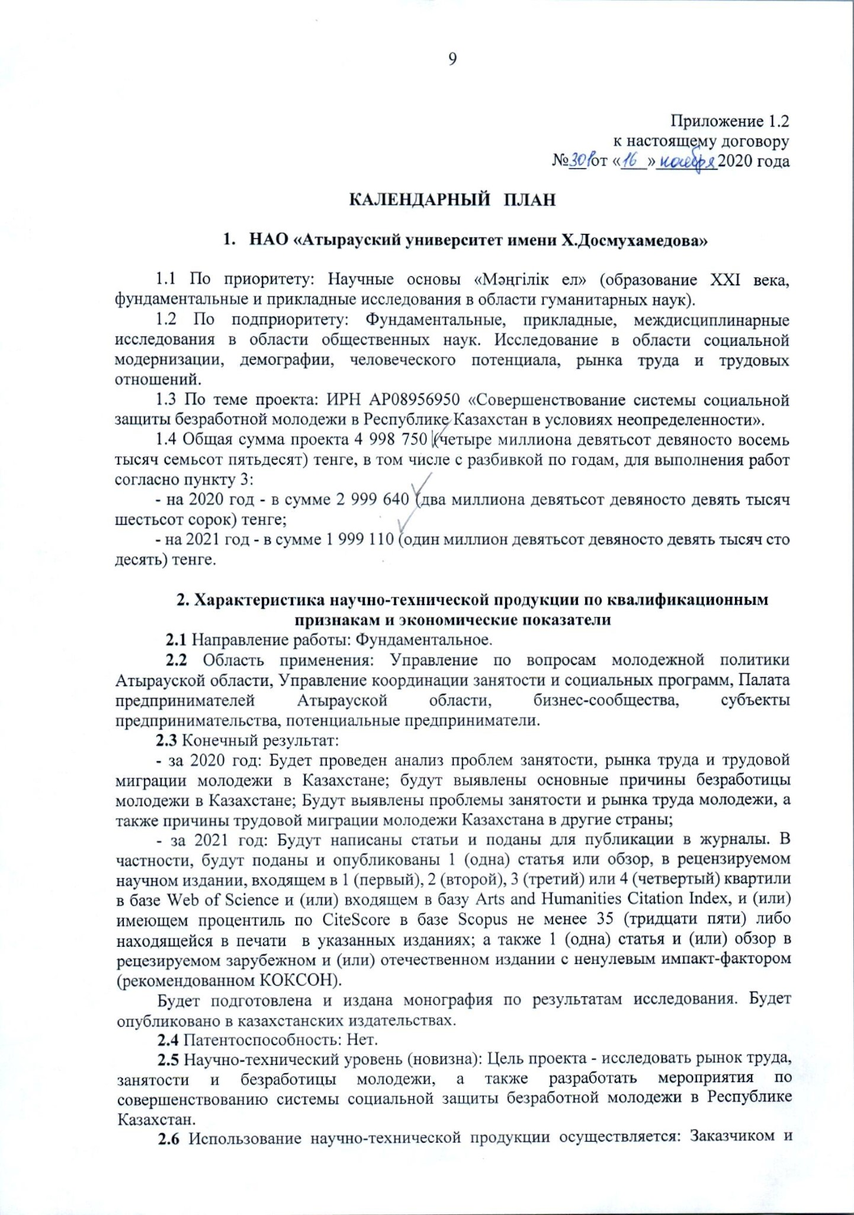**APPENDIX B**

**Сalendar plan**

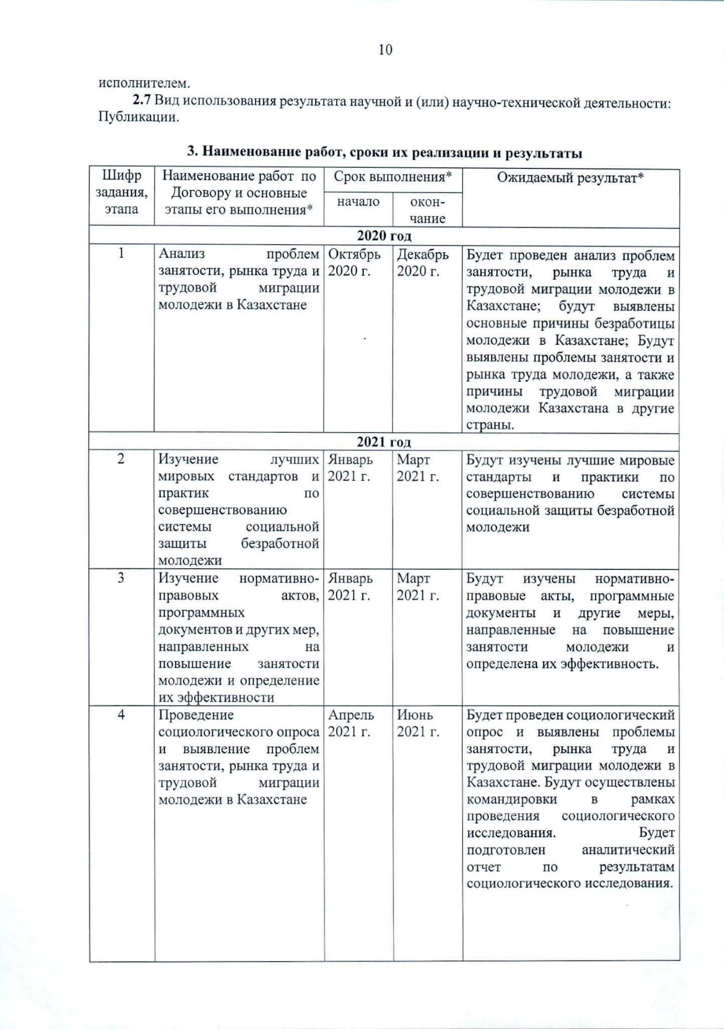

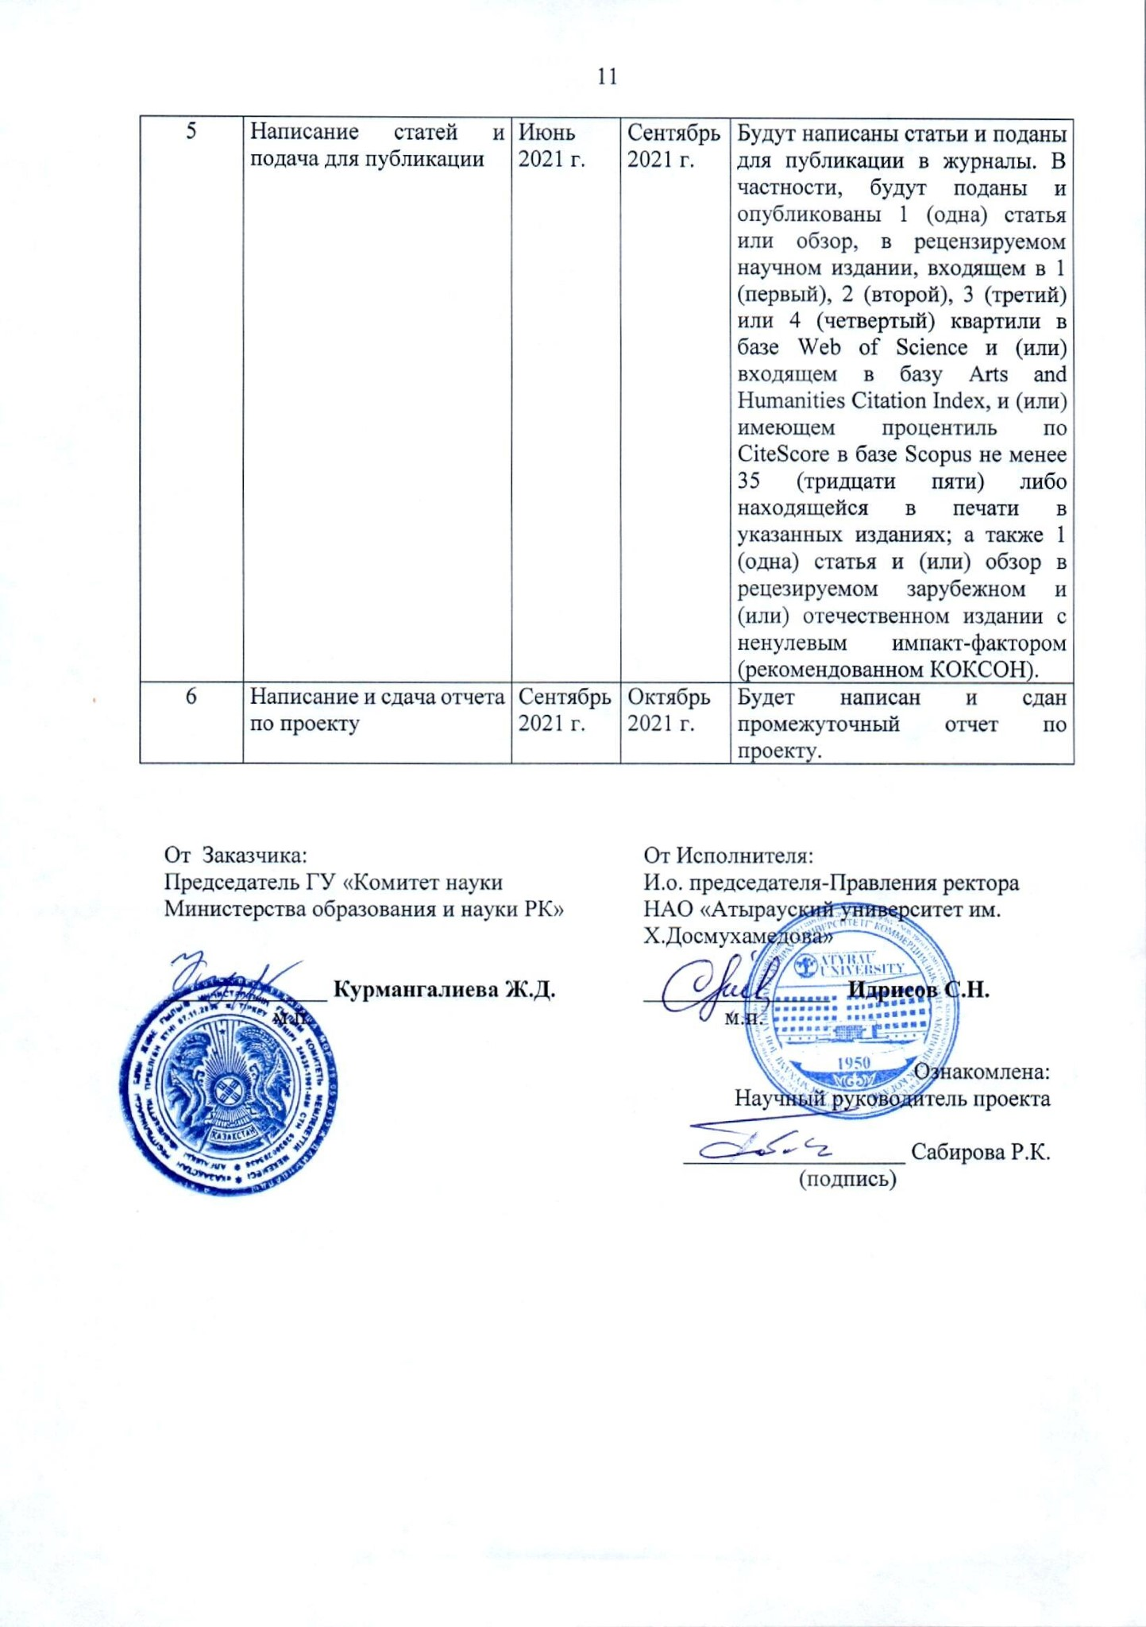

Application 1.2

to this agreement

№ 301 dated November 16, 2020

**CALENDAR PLAN**

1. **NJSC " Kh. Dosmukhamedov Atyrau University "**

1.1 By priority: Scientific foundations of "The Eternal Nation" (education of the 21st century, fundamental and applied research in the humanities).

1.2 By priority: Fundamental, applied, interdisciplinary research in the field of social sciences. Research in the field of social modernization, demography, human potential, labor market and labor relations.

1.3 On the topic of the project: IRN AP08956950 " Improving the system of social protection of unemployed youth in the Republic of Kazakhstan in conditions of uncertainty".

1.4 The total amount of the project is 4,998,750 (four million nine hundred and ninety-eight thousand seven hundred and fifty) tenge, including by year, for the performance of work according to paragraph 3:

- for 2020 - in the amount of 2,999,640 (two million nine hundred and ninety-nine thousand six hundred and forty) tenge;

- for 2021 - in the amount of 1,999,110 (one million nine hundred ninety-nine thousand one hundred and ten) tenge.

**2.** **Characteristics of scientific and technical products by qualification criteria and economic indicators**

2.1 Direction of work: Fundamental.

2.2 Scope of application: Department of Youth Policy of Atyrau region, Department of Coordination of Employment and Social Programs, Chamber of Entrepreneurs of Atyrau region, business communities, business entities, potential entrepreneurs.

2.3 The end result:

for 2020 year: An analysis of the problems of employment, labor market and labor migration of youth in Kazakhstan will be conducted; the main causes of youth unemployment in Kazakhstan will be identified; The problems of youth employment and labor market, as well as the causes of labor migration of young people in Kazakhstan to other countries will be identified.

for 2021 year: Articles will be written and submitted for publication in journals. In particular, 1 article will be submitted and published in a peer-reviewed scientific publication included in 1 (first), 2 (second), 3 (third) or 4 (forth) quartiles in the Web of Science database and (or) having a Cite Score percentile in the Scopus database of at least 35 (thirty five), 1 article will be written and submitted for publication in a peer-reviewed foreign and (or) domestic publication with a non-zero impact factor (recommended by Ministry of Education and Science)

A monograph based on the results of the study will be prepared and published. It will be published in Kazakhstan publishing houses.

2.4 Patentability: None.

2.5 Scientific and technical level (novelty): The purpose of the project is to study the labor market, youth employment and unemployment, as well as to develop measures to improve the social protection system for unemployed youth in the Republic of Kazakhstan.

2.6 The use of scientific and technical products is carried out by: the Customer and the contractor.

2.7 Type of use of the result of scientific and (or) scientific and technical activities: Publications

**3. Наименование работ, сроки их реализации и результаты**

|  |  |  |  |  |
| --- | --- | --- | --- | --- |
| The cipher of the task, stage | The name of the work under the Contract and the main stages of its implementation * | Due date * | | Expected result * |
| beginning | ending |  |
| **2020 year** | | | | |
| 1 | Analysis of problems of employment, labor market and labor migration of youth in Kazakhstan | October  2020 | December 2020 | An analysis of the problems of employment, labor market and labor migration of youth in Kazakhstan will be conducted; the main causes of youth unemployment in Kazakhstan will be identified;  The problems of youth employment and labor market, as well as the causes of labor migration of young people in Kazakhstan to other countries will be identified. |
| **2021 year** | | | | |
| 2 | Studying the best world standards and practices for improving the system of social protection of unemployed youth | January 2021 | March 2021 | The best international standards and practices for improving the social protection system for unemployed youth will be studied |
| 3 | The study of regulatory legal acts, program documents and other measures aimed at increasing youth employment and determining their effectiveness | January 2021 | March 2021 | Regulations, policy documents and other measures aimed at increasing youth employment will be studied and their effectiveness will be determined. |
| 4 | A sociological survey and identification of problems of employment, labor market and labor migration of youth in Kazakhstan | April  2021 | June  2021 | A sociological survey will be conducted and problems of employment, labor market and labor migration of young people in Kazakhstan will be identified. Business trips will be carried out as part of the sociological research.  An analytical report will be prepared based on the results of the sociological research. |
| 5 | Writing articles and submitting for publication | June  2021 | September 2021 | Articles will be written and submitted for publication in journals. In particular, 1 article will be submitted and published in a peer-reviewed scientific publication included in 1 (first), 2 (second), 3 (third) or 4 (forth) quartiles in the Web of Science database and (or) having a CiteScore percentile in the Scopus database of at least 35 (thirty five), 1 article will be written and submitted for publication in a peer-reviewed foreign and (or) domestic publication with a non-zero impact factor (recommended by Ministry of Education and Science) |
| 6 | Writing and submitting a report on the project | September 2021 | October  2021 | A report on the project will be written and submitted. |