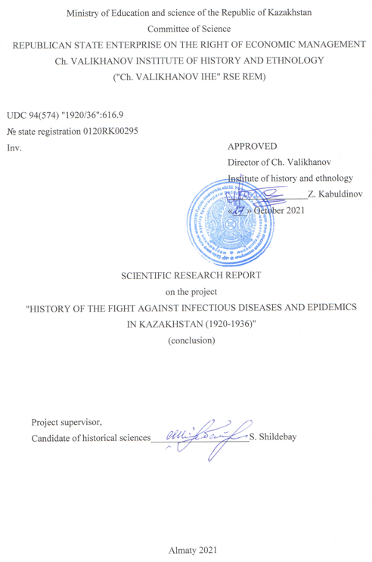

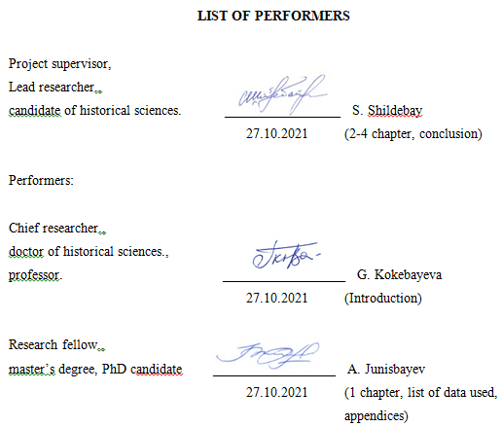

**ABSTRACT**

Report 65 pages., 44 sources., 6 appendices.

KAZAKH ASSR, SOVIET PERIOD, HISTORY OF MEDICINE, HISTORY OF HEALTHCARE, SOVIET HEALTHCARE SYSTEM, FIGHT AGAINST INFECTIOUS DISEASES, FIGHT AGAINST EPIDEMICS, HISTORY OF SOCIAL DISEASES, FAMINE IN KAZAKHSTAN, PEOPLE'S COMMISSARIAT OF HEALTHCARE OF THE KAZAKH ASSR, EPIDEMIOLOGY, SANITARY CONTROL.

The object of research: the fight against infectious diseases and epidemics in Kazakhstan.

The purpose of the work: is to study the history of epidemics and infectious diseases widespread in Kazakhstan in 1920-1936 on the basis of previously unpublished archival documents and sources by analyzing the activities and experience of government and health authorities in fighting them, as well as to identify the consequences and damage to the genetic fund of the Kazakh nation.

Research methods: principles of historicism and objectivism, methods of comparative historical analysis, synchronous and diachronic methods will allow a comprehensive analysis of the history of the fight against infectious diseases and epidemics.

The results of the research and their novelty: as a result of the research on the project, the history of the fight against infectious diseases and epidemics in Kazakhstan (1920-1936) was written on the basis of previously unpublished archival documents and valuable materials of periodicals.

The main design characteristics: the results achieved by the results of the study will contribute to the development of the study of the history of domestic healthcare and medicine, historical experience in the fight against epidemics and infectious diseases.

The degree of implementation: this year, based on the collected materials, 2 scientific articles and 1 monograph were published.

Economic efficiency or significance of the work: it is expected that the results of scientific work published in the form of articles in scientific journals and monographs will certainly attract the attention of domestic and foreign researchers, and will also contribute to the emergence of a separate research direction in historical science, the object of study of which will be the history of medicine.

Scope of use: historical sciences.

**РЕФЕРАТ**

Отчет 65 с., 44 источн., 6 прил.

КАЗАХСКАЯ АССР, СОВЕТСКИЙ ПЕРИОД, ИСТОРИЯ МЕДИЦИНЫ, ИСТОРИЯ ЗДРАВООХРАНЕНИЯ, СОВЕТСКАЯ СИСТЕМА ЗДРАВООХРАНЕНИЯ, БОРЬБА С ИНФЕКЦИОННЫМИ ЗАБОЛЕВАНИЯМИ, БОРЬБА С ЭПИДЕМИЯМИ, ИСТОРИЯ СОЦИАЛЬНЫХ ЗАБОЛЕВАНИЙ, ГОЛОД В КАЗАХСТАНЕ, НАРОДНЫЙ КОМИССАРИАТ ЗДРАВООХРАНЕНИЯ КАЗАХСКОЙ АССР, ЭПИДЕМИОЛОГИЯ, САНИТАРНЫЙ КОНТРОЛЬ

Объект исследования: борьба против инфекционных заболеваний и эпидемий в Казахстане.

Цель работы: на основе новых архивных документов изучить историю эпидемий и инфекционных заболеваний, распространенных на территории Казахстана в 1920-1936 гг., путем проведения анализа деятельности и опыта борьбы против них органов власти и здравоохранения, выявить последствия и нанесенного урона генофонду казахской нации.

Методы исследования: принципы историзма и объективизма, методы сравнительно-исторического анализа, синхронные и диахронные методы позволят комплексно проанализировать историю борьбы против инфекционных заболеваний и эпидемий.

Результаты исследования и их новизна: в результате исследования по проекту на основе ранее неопубликованных архивных документов и ценных материалов периодических изданий была написана история борьбы с инфекционными заболеваниями и эпидемиями в Казахстане (1920-1936).

Основные конструктивные характеристики:результаты, достигнутые по итогам исследования, будут способствовать развитию изучению истории отечественного здравоохранения и медицины, исторического опыта борьбы против эпидемий и инфекционных заболеваний.

Степень внедрения: в этом году на основе собранных материалов опубликовано 2 научные статьи и 1 монография.

Экономическая эффективность или значимость работы: ожидается, что результаты научной работы, опубликованные в виде статей в научных журналах и монографии, непременно обратят внимание отечественных и зарубежных исследователей, а также будут способствовать возникновению отдельного исследовательского направления в исторической науке, объектом изучения которого будет являться история медицины.

Областьприменения:исторические науки.

**CONTENT**

|  |  |
| --- | --- |
| INTRODUCTION ............................................................................................................... | 6 |
| THE MAIN PART OF THE RESEARCH REPORT …...................................................... | 10 |
| 1 Historiography of research work ......................................................................................  2 Factual basis of research work..........................................................................................  3 Fight against infectious diseases and epidemics ...............................................................  4 Kazakh regional sanitary and bacteriological institute – scientific basis of the healthcare system …............................................................................................................. | 10  12  17  22 |
| CONCLUSION .................................................................................................................... | 33 |
| LIST OF DATA USED ...................................................................................................... | 35 |
| Appendix A Calendar plan ..................................................................................................  Appendix B List of prepared works on the project ..............................................................  Appendix C Article included in the list recommended by the CCSES................................  Appendix D Article on the round table ……........................................................................  Appendix E Title pages and content of the monograph ......................................................  Appendix F Information about an article published in a journal included in the Scopus database …….........................................................................…………………………….. | 40  44  45  60  62  66 |
|  |  |

**INTRODUCTION**

Justification of the choice and direction of research. In March 2020, following many other countries, a state of emergency was declared in Kazakhstan and quarantine was introduced as a preventive measure for the non-proliferation of the COVID-19 pandemic in the republic. In the fight against the new epidemic, Kazakhstan, based on the experience of developed countries, began to follow the instructions of international health organizations. In conditions of isolation and concern for their future, Kazakhstanis began to show increased interest in the state of the domestic health care system and began to search for successful examples of confronting epidemics in the foreseeable past. Due to the lack of comprehensive research on the history of the fight against epidemics in previous centuries, Kazakhstani historians were not able to fully respond to the request of the public. For this reason, the declared theme of the project is aimed at studying the history of epidemics and infectious diseases in the Kazakh ASSR.

The history of epidemics and infectious diseases that were widespread in Kazakhstan in the ХХ century, as well as the history of the fight against them, has not yet been comprehensively studied. General issues of the spread and organization of the fight against epidemics and infectious diseases in the Kazakh ASSR were first considered in an article by the head of this project S.Q. Shildebay published in 2020 [1]. Separately, it should be noted that there was not a single work devoted to the history of the fight against infectious diseases and epidemics in 1920-1936 in the Kazakh ASSR. Therefore, this project is designed to fill in the blank spots of the pages of the history of Kazakhstan in the 20-30s of the XX century, to restore the history of the healthcare system that developed during Soviet modernization by fighting infectious diseases and epidemics. In addition, in the future, the history of the formation and development of the healthcare system in Kazakhstan; the historical experience of the system of health protection and sanitary and epidemiological control of the population; the history of combating infectious diseases and epidemics occurring in the Kazakh SSR, the history of medicine, the activities of central health authorities of Kazakhstan will form the necessary basis for studying such topics.

Scientific novelty and significance of the project. The above-mentioned issues, to date, no scientific research has been conducted on the topic of the project either by historians or by representatives of the medical field. Historical processes and phenomena, events that influenced the mass death and destruction of the population under the Soviet regime, due to various objective and subjective reasons, have not become the subject of separate research. Especially the history of the people who died from infectious diseases and epidemics caused by the Famine of 1921-1922 and 1931-1933 has not been mentioned at all to this day. Even the history of the formation of the healthcare system in Kazakhstan, the activities of the people's Commissariat of Health were not specifically studied by historians. Since the establishment of the Kazakh ASSR, infectious diseases and epidemics have been spreading in the region, accompanied by a social catastrophe-famine caused by the Civil War and drought, which has consumed part of our population. Especially common among the population are lung and lung worms, infectious sexual diseases, which are among the social diseases. The newly created Kazakh ASSR authorities have made great efforts to organize measures to combat such terrible hunger, infectious diseases, and epidemics. The task of implementing these measures and implementing them was assigned to the halkomat of Health. In the course of the fight against dangerous infectious diseases and epidemics, a Soviet-based healthcare system was formed.

All the above-mentioned problems were unknown to both historical science and our people. The project's performers plan to fill this gap and study the scale and geography of the spread of infectious diseases and epidemics in the Kazakh ASSR, the causes of their origin, the history of their fight against them, information about the number of deaths from diseases and epidemics with the introduction of archival documents, materials of authorities and periodicals into scientific circulation.

Since the project is dedicated to a new scientific topic that has not yet been studied, all the results achieved should be considered scientific discoveries. For the full implementation of the project, archival documents and materials related to infectious diseases and epidemics that occurred in Kazakhstan between 1920 and 1936, published reviews, reference books, statistical data and other materials of the highest state authorities and higher industry authorities will be collected and taken for scientific analysis.

Scientific and practical significance of the work. During the research of the scientific project, for the first time in historical science, the history of the fight against infectious diseases and epidemics in the Kazakh ASSR will be studied in a comprehensive and systematic manner on the basis of archival documents and new data, periodicals that were not previously involved in scientific circulation. Through this work, medical professionals will receive valuable information about infectious diseases and epidemics that occurred in Kazakhstan in the 20-30s of the XX century and the experience of combating them for the first time.

Since the project is aimed at solving the least studied scientific problem, it is expected that the scientific results obtained as a result will serve as the basis for the formation of a new interdisciplinary research direction at the junction of medical and Historical Sciences, which will study the history of epidemics and Infectious Diseases in Kazakhstan of the XX century, the fight against them as a separate scientific object and subject. Archival data and historical and factual material accumulated during the implementation of the project and scientific research work in the archives will allow members of the research group to further study topical issues of the history of Epidemiology and virology, the history of famine and food crises, the history of healthcare and scientific and medical organizations. Research in this direction will form the basis for creating a targeted database of doctors and medical workers who worked in the healthcare sector of Kazakhstan in the 20-30s of the XX century, updating the biographies of figures who made a great contribution to the development of the healthcare system of that period with new information, and further supplementing the reference book «Who is Who in Medicine».

Goals and objectives of the research at the stage. The aim of the project is to study the history of infectious diseases and epidemics common in the territory of Kazakhstan in 1920-1936 on the basis of virgin archival documents and data that are not involved in scientific circulation, and to identify the consequences of the Kazakh nation only by analyzing the experience of the struggle against them by the authorities and health organizations.

To achieve the project goal, the following tasks must be solved:

1) Collect a database of historical data and documents from the central archives of the country related to the history of infectious diseases and epidemics, central health authorities, scientific and medical research institutions in the Kazakh republic during the period of autonomy, conduct a source-based analysis of them, and introduce them into scientific circulation through scientific articles and monographic research works published within the framework of the project;

2) To determine their importance and role in improving the sanitary and epidemiological situation of the republic by studying the policy and set of measures taken by the party and Soviet bodies of the Kazakh ASSR to combat and prevent infectious diseases and epidemics occurring in Kazakhstan in 1920-1936, the activities of government and departmental commissions, various medical councils, as well as central and local health authorities and sanitary institutions established for this purpose;

3) Determination of the actual scale of the spread (epidemiological map) of the main infectious diseases and epidemics most common in the regions and districts of Kazakhstan in 1920-1936 and the level of mortality (demographic and statistical indicators) as a result of them, presentation of the resulting numerical data in the form of tables, diagrams and diagrams in publications within the framework of the project;

4) To present on the basis of historical data the process of development of the system of sanitary and epidemiological services formed in the fight against infectious diseases and epidemics; to study the history of the development and development of vaccines against the main types of infectious diseases and epidemics in the Kazakh ASSR, the history of free mass vaccination of the population and the history of training and sanitary education of medical and sanitary personnel in the Kazakh ASSR.

In accordance with the calendar plan of the project in 2020, the documents necessary for the project were collected and systematized from the funds of the Central State Archive of the Republic of Kazakhstan and the Archive of the President of the Republic of Kazakhstan. In addition, materials from the collections of the National Library of the Republic of Kazakhstan and the Central Scientific Library were collected and systematized. The historiography of the research work is considered, the analysis of the degree of study of the problem is carried out.

And in 2021, 1 (one) article was published in a peer-reviewed scientific publication that is included in quartiles, indexed by the international database Web of Science, or in a publication that is included in the Social Science Citation Index or Arts and Humanities Citation Index, or in the Scopus database with at least 35 (thirty-five) percentiles on the Cite Score, as well as 1 (one) scientific article in the journal «Otan tarikhy», which is included in the list recommended by the CCSES. A round table was held on the topic: «fight against infectious diseases and epidemics in the Kazakh ASSR: history and experience». The monograph «History of the fight against infectious diseases and epidemics in Kazakhstan (1920-1936)» (10 PP.) was published on the basis of new archival data and materials that were not previously involved in scientific circulation.

According to the calendar plan, all the works planned for 2020-2021 have been completed in full. Their results are presented in the main part.

The first interim report on the project was approved on November 23, 2020 (№ 519 dated 19.11.2020). IRN: AP08957129-OT-20; state registration № 0120RK00295; inventory №. 0220RK01642.

**THE MAIN PART OF THE RESEARCH REPORT**

**1 Historiography of research work**

The history of the fight against infectious diseases and epidemics in the Kazakh ASSR has not been the object of special research in Kazakhstan until now. Among the first books giving general information on the history of healthcare of the Kazakh ASSR are the works of the doctor M. Vilensky [2] and the people's commissar of public health of the Kazakh SSR S. Chesnokov [3]. However, these works provided only overview information about the state of the healthcare sector in Kazakhstan at that time, and were not case of special studies. The monograph by R. Samarin [4] «Essays on the history of health care in Kazakhstan» is the first serious documentary study, which covers the history of health care in Kazakhstan from the XVIII century to 1958. Two chapters of this monograph were devoted to the history of the healthcare system of the Kazakh Autonomous Soviet Socialist Republic (1920-1936). Despite the fact that they provide brief information about epidemics and infectious diseases, this scientific problem was not considered separately in this paper.

Among other works, it is worth noting the book of the Birtanovs «The history of medicine of the Almaty city» [5], which is devoted to the history and activities of the City Clinical Hospital for Emergency Medicine (CCHEM)». The monograph «History of Traditional Medicine and Public Healthcare of Kazakhstan» [6], published in 2004 by the team of medical authors, provides an overview of the history of medicine in Kazakhstan from ancient times to the present day. The scientific article of the associate professor of ENU named after L.N. Gumilev, K. Zhakupova [7]. In the articles of the historian A. Junisbayev, involved as one of the executors of this project on the basis of archival sources, the process of the formation of the health system in the Turkestan ASSR was studied, and the activities of S. Asfendiarov as the people's commissar of healthcare of the Turkestan ASSR in 1923-1924 were studied. [8-9].

This brief review shows that the history of epidemics and infectious diseases, and the history of the fight against them, which are an integral part of the history of medicine in Kazakhstan, is a poorly studied problem, and, unfortunately, no studies were conducted in our country in this direction. Among the summarizing works on the history of public health and the struggle for public health, it is worth noting the monographs of E. Ashurkov [10], academician O. Baroyan [11-13], K. Vasiliev and A. Segal [14], E. Lotova [15] dedicated to the study of measures aimed at developing and improving the Soviet healthcare system. At the same time, various aspects of the history of the formation of the healthcare system were studied in the USSR, including the spread of epidemics and infectious diseases in different historical periods. However, in none of these works, the history of the fight against epidemics and infectious diseases was not considered as a separate scientific problem.

As for foreign historiography, the monograph by A. Sen on the basis of an analysis of the history of the Great Bengal Famine of 1943, the famine of 1973-1974. in Ethiopia, the famine of 1974 in Bangladesh, and the Sahel tragedy in Africa in the 1970s. the relationships between infectious diseases, hunger and poverty are disclosed in detail [16]. The author provides a scientific justification for the assertion that hunger and poverty are certainly accompanied by epidemics and infectious diseases.

Of the recent works, the monograph by the American historian S. Cameron «The Hungry Steppe: Famine, Violence and the Creation of Soviet Kazakhstan» [17], devoted to the history of the famine of 1931-1933 in Kazakhstan, attracts attention. The author in it cites the facts that the neighboring republics, fearing the spread of infectious diseases into their territory, tried to prevent the Kazakh famine refugees from crossing the border. The book contains information on the widespread epidemic of typhoid and smallpox by 1932 in the Kazakh Autonomous Soviet Socialist Republic, on the refusal of the heads of work institutions to recruit hungry refugees on whom they looked as «socially dangerous elements» [17, 173-174-p.].

The German historian R. Kindler in his work «Stalin's nomads: authority and hunger in Kazakhstan» [18] cites evidence that as a result of the famine of 1931-1933, epidemics and various infectious diseases in Kazakhstan killed ¼ of the population or more than 1, 5 million people. On the basis of archival sources, he cites the facts that during the period of famine, cases of mass capture and eating of domestic animals and birds were widespread. He, like many other researchers, argues that hunger was accompanied by unprecedented outbreaks of epidemics and infectious diseases.

**2 Factual basis of research work**

Since October 1, 2020, the Archive of the President of the Republic of Kazakhstan has been opened to readers, and since October 15, the Central State Archive of the Republic of Kazakhstan has started operating in a limited manner. Together, the project manager and performers actively began to identify, collect and systematize the necessary materials from these archival funds.

In the course of the work, the following funds of the Archive of the President of the Republic of Kazakhstan were considered: «fund-140-Kyrgyz (Kazakh) Bureau of the Communist Party of Russia (Kyroblburo, Kyrpartburo)»; «fund – 139-Kyrgyz (Kazakh) Regional Committee of the Communist Party of Russia (Bolsheviks), (Kyrobkom, Kazobkom)»; «fund – 141-Kazakh Regional Committee of the BK(B)P (Kazolkekom)».

From the above-mentioned funds of this archive, reports, letters, resolutions and various party decisions on the health system of Kazakhstan in 1920-1936, Mikhail Shamov, who was people's commissar of health of the Kazakh ASSR in 1920-1936 (time of people’s commissariat: 12.10.1920-02.05.1928), Mukhamedgali Tatimov (02.05.1928-7.06.1930), Bisengali Abdrakhmanov (7.06.1930-?.06.1931), Sanzhar Asfendiarov (June 1931 - July 1933), Mark Donskoy (July-September 1933), Kalap Kulsartov (16.10.1933-4.07.1936), Khasen Nurmukhamedov (4.07.1936-21.10.1937).

The following funds of the CSARK were considered: P-30-fund-the Council of people's commissars of the Kazakh ASSR (1920-1936); P–82-fund-the people's Commissariat of health of the Kazakh ASSR (1920-1936); P–155-fund-the Kazakh Central Administration of the professional union of medical and sanitary workers of the USSR (Health care work) 1923-1936); P–815-fund-the Kazakh Regional Social Fund of the people’s commissariatat of health of the Kazakh ASSR Research Institute of Health and hygiene (1-32-1934); R-1633 – foundation-Kazakh Republican antimalarial station of the people’s commissariatat of health of the Kazakh ASSR (1934-1936); R – 1779-Foundation – Kazakh regional branch of the Central Institute of Hematology and blood transfusion of the people’s commissariatat of health of the USSR (1934-1936); R-1860 – Resort Department of the people’s commissariatat of health of the Kazakh ASSR (1930-1936); R-1891-Kazakh Regional Department of the Pharmacy Department of the people’s commissariatat of health of the Kazakh ASSR (1989-1936).

In addition, the following funds of the Central State Archive of scientific and technical documentation (CSASTD), which are not provided for in the calendar plan of the project, were considered: 73-fund-Kazakh Research Institute of Pediatrics of the Order of friendship of peoples of the Ministry of health of the Republic of Kazakhstan (1932-1992); 84 – fund-Kazakh Research Institute of tuberculosis of the people’s commissariatat of health of the Kazakh ASSR (1931-1936); 85-fund – scientific and methodological support of Epidemiology, microbiology and Infectious Diseases of the Ministry of Education, Culture and health of the Republic of Kazakhstan Research Institute (1925-1998); 89-Foundation-Central Asian Research Institute against plague of the Ministry of health of the USSR (1929, 1932-1967); 90-Foundation – Kazakh Research Institute of skin and Venereology of the Ministry of health of the Kazakh SSR (1928-1986); 94-Foundation-Kazakh Research Institute of eye diseases of the Ministry of health of the Kazakh SSR (1933-1984).

In general, work on collecting, sorting and systematizing archival documents and data, periodicals related to the project will continue until the end of 2020.

The collection of documents and materials on the history of the fight against infectious diseases and epidemics and the formation of the health system in the Soviet Kazakh autonomy, collected from the funds of the National Library of the Republic of Kazakhstan and the Central Scientific library, materials of periodicals and journals and bulletins, which became the official publication of the people’s commissariatat of Health, are distinguished by the fact that historians have not yet been involved in scientific circulation.

The earliest source on this issue is the report of the People's Commissar of Health of the Kazakh ASSR M.S. Shamov [19] on the state of public health, prepared for the 2nd Congress of Soviets of the Kazakh Autonomous Soviet Socialist Republic, held on October 4-10, 1921 in Orenburg, is the first historical source providing information about epidemics and infectious diseases, as well as the fight against them.

This report, consisting of 60 sheets by the sanitary-statistical department of the People’s Commissariat, provides quantitative data on the distribution of the most basic types of epidemics and infectious diseases, as well as the death rate by province for Kazakhstan in 1920-1921. Of particular importance is the information about the cholera epidemic that broke out in the summer months of 1921. The same report provides valuable information about the organization of the Orenburg State Institute of Smallpox Vaccination, specially created to fight the smallpox epidemic. Along with this, it is worth noting the reports of the Labor and Defense Council of the Kazakh Autonomous Soviet Socialist Republic and the statistical and economic review of the Central Statistical Office of the Kazakh Autonomous Soviet Socialist Republic, which contain a lot of valuable information about epidemics and infectious diseases in the republic at that time.

In addition, this report contains a report on the work of the Departments of sanitary-statistical, organizational-instructional, pharmaceutical, sanitary-epidemiological, medical, financial-estimate, sanitary education, publishing, general supply and dental section of the people’s commissariatat, as well as a list of medical institutions in the Kazakh ASSR for 1920 and the number of places in it. Also, in Kazakhstan in 1920-1921, bugorchatka (a type of worm disease, lung disease), mouse disease (dysentery), ash disease (diphtheria-an infectious disease not caused by the bacterium corynebacterium diphtheriae (Leffler's Bacillus, diphtheria stick), most often affects the tongue, throat, pharynx, skin and other organs), pig disease (zausnitsa epedemic (pig) – volatile infectious disease with non-pus lesions of the glandular organs), whooping cough (koklush), measles (Kori), croup (respiratory disease in children under 3 years of age), pneumonia (krupoznaya), Malaria (Malaria), mild chancre (sexually transmitted infectious disease), smallpox (chickenpox), black smallpox, wind smallpox, common smallpox, variable (intermittent) malaria (creeping lichen), leprosy (Leprosy), Roach (a volatile infectious disease observed on the skin and with common phenomena), anthrax (Siberian yazva), syphilis (syphilis), jaundice (scarlet fever), typhoid fever (typhoid fever) rash, typhoid fever, recurrent (recurrent) fever, the number of infectious volatile diseases and epidemics, such as unknown malaria, trachoma (a chronic infectious eye disease caused by chlamydia, leading to blindness), cholera (cholera), shingles or shingles (shingles), plague (Chuma), and the mortality rate from these diseases are indicated in the provinces. Especially important is the information about the cholera epidemic in the summer months of 1921. At the end of the report, we note that the information on the work of the Orenburg State Institute of smallpox vaccination is a very valuable source.

And the report of the Council of Labor and defense of the Kazakh ASSR for April – September 1922 [20] contains detailed information about the state of the health system in Kazakhstan and the provinces during this period, the most common diseases and infectious phytoncides among the population and measures aimed at their prevention. In March 1923, the head of the central statistic Department of the Kazakh ASSR the statistical and economic review of the CSO, published with a preface by Krutulin [21], also contains a lot of data related to the health sector. In particular, we have focused on a number of published sources on the history of the formation of the health sector in the years of the first establishment of the Kazakh ASSR. In addition, it is necessary to give a general batch analysis of the sources related to the history of this issue.

A large group of sources related to the topic of the article consists of resolutions and resolutions, rules and orders published in the «Kazakh ASSR zhumysshy-sharua ukimetinin khabarshysy», «Collection of laws and orders of the workers and peasants Government of the Kazakh ASSR» which were published as periodicals in the 20-30s of the XX century. In addition, the information published in newspapers and magazines published in those years is of great importance.

The main source of the research is the shorthand reports of the eight party conferences held in the Kazakh ASSR and the plenums held between them, the minutes of the meetings of the bureau and secretariat of the regional party committee, the collection of materials prepared for party conferences and plenums, as well as the resolutions and resolutions adopted in them.

In addition, the collections of shorthand reports of the All-Kazakhstan congresses of the Soviets of the Kazakh ASSR and a number of bulletins published in print, decisions of the Congress and reporting materials prepared for the congresses contain a wealth of statistical and informational data. And the materials of the sessions of KazCEC and its presidium, which are the highest state body between all-Kazakhstan congresses, should not be forgotten. There is also a lot of data in the shorthand reports of the 32nd session of the KazCEC, which were held in the 20-30 years. And the minutes of the meetings of the Presidium of KazCEC and the KCP will become the main sources of information on the formation and development of the healthcare system.

In addition, in a small part of the collections of documents and materials published in the soviet era «decrees and resolutions of the CEC of the Kazakh ASSR» [22], «systematic collection of laws of the Kazakh ASSR until January 1, 1930» [23], socialist construction in the Kazakh ASSR: economic and Statistical Handbook for 1920-1935 [24], «cultural construction in Kazakhstan» [25], some information about the health system of Kazakhstan for the period under consideration is grouped. And in the collection of documents and materials related to the health system of the Soviet Union in general 1925-1940 [26], you can see data on the general nature of the Soviet health system.

In the funds of the National Library of the Republic of Kazakhstan, the Central Scientific Library and the National State Book Chamber of the Republic of Kazakhstan, we found the following journals, which became the printing bodies of the people's Commissariat of health of the Kazakh ASSR and were published under different names in different years:

1) The magazine «Vestnik zdravookhraneniya Kirgizii (Kazakstana)» was published in russian in 1923-1927. The 1923 issues of this journal are not kept in the NLRK fund. In total, we know that this magazine has 16 issues. Only 7 issues of the magazine got into our hands. The magazine's issues provide very valuable statistical and historical data on the number and mortality rate of infectious diseases and epidemics occurring in Kazakhstan, as well as the fight against them.

2) The Bulletin «Dvukhnedelnik Narodnogo Komissariata Zdravookhraneniya» was published in russian in 1928. Although we know that the number 6 of this bulletin came out of the NLRK catalog, we received only the № 2 of it. The data contained in this bulletin is also very valuable historical data.

3) In 1929-1930, the magazine «Health in Kazakhstan» published expert articles that provide very valuable information. In the section «chronicle», which is presented at the end of the magazine, there is a systematic presentation of the current news in the field of healthcare in the Kazakh ASSR. In 1929, the magazine published 3 issues, and in 1930-6 issues.

4) The magazine «Densaulyk zholy» was published in the kazakh language in 1929-1930. The magazine was published in 1929 in arabic script, and since 1930 it has been published in latin script. The numbers № 2 of 1929 and № 1.3.4 of 1930 able to get into our hands. For us, this journal is also a very valuable source.

5) The magazinе «Densaulyk» was published in 1931 in the Kazakh language. His numbers № 1-2, 3, 4, 5 able to get into our hands.

6) «Medicinskiy jurnal Kazakshtana» («Kazagystan adam darigerlik jornaly») was published in Russian in 1933-1935. Since 1934 , a summary of articles in Kazakh has been provided at the end of some issues. These magazines are very systematic and informative. In addition, the medical chronicle of Kazakhstan is presented, which gives an opportunity to get acquainted with the latest developments in the field of healthcare in Kazakhstan in those years. In 1933, the magazine published 3 issues, in 1934 – 6 issues, in 1935 – 3 issues. The journal is a very valuable source.

At the same time, despite the fact that it is not specified in the calendar plan, it is kept in the funds of the library of the archive of the president of the Republic of Kazakhstan «Auyl kamonesi», «Bolshevik Kazakhstanа», «Bulleten Kazakhskogo Kraevogo Komiteta ACP(B), «Izvestiya Kirgizskogo oblastnogo Komiteta RCP(B)», «Narodnoe khozyistvo Kazakhstana», «Sovetskaya Kirgiziya», etc. the magazines were reviewed. In particular, official data on the healthcare sector of Kazakhstan in the journals «Bolshevik Kazakhstanа» and «Narodnor khozyaistvo Kazakhstana» are a very valuable source.

**3 Fight against infectious diseases and epidemics**

On December 24, 1920, the people’s commissariat of health M. S. Shamov, together with doctor A. A. Chernogorov, opened the Orenburg state smallpox vaccination institute, the first of which consisted of 17 people. On the day of the opening of the institute, 7 calves are transferred to its disposal. Under the leadership of the head of the institute A. A. Chernogorov, in January 1921, 370,200 doses of high-quality smallpox detritus and lymph were obtained from these calves. In February, the institute received another 7 calves and received 364,000 doses of detritus, 321,800 doses of detritus from 7 heads of calves in March, 306,000 doses of detritus from 7 heads of 4 series of detritus in April, a total of 1,362,000 doses of detritus. In the course of careful scientific verification of these doses, until August 25, 1921, the Institute produced 701,400 doses of the vaccine [19, 27-p.], on the eve of the second All-Kazakhstan Congress, its number was increased to 800 thousand. In the course of the productive work of this institute, in 1921-1922, a total of about 5 million doses of detritus were produced against smallpox and organized measures to protect the population of the Kazakh ASSR from smallpox. In the second half of 1922, the Orenburg state smallpox vaccination Institute, which was one of 10 institutes in the territory of the RSFSR, was closed.

Under the leadership of people 's commissar M. S. Shamov, until the autumn of 1921, a system of hospitals for 3,230 beds was formed in Kazakhstan. At the end of june 1921, a cholera epidemic from Samara hit the territory of Kazakh ASSR, which lasted until the end of August. 13,789 people fell ill and 5,706 people died in this epidemic [19, 30-31-p.]. In 1920-1921, the most common in Kazakhstan were chickenpox (stem), smallpox, scarlet fever (scarlet fever), anthrax, mouse, malaria, whooping cough, cholera, rash typhoid, typhoid, recurrent typhoid, unknown typhoid, tuberculosis, brucellosis, syphilis, etc. it was necessary to take urgent measures against epidemics and infectious diseases.

For example, in 1920, the number of registered diseases in Kazakhstan was as follows: stem – 6,186 people; smallpox – 2,575; andshau – 1,589; measles – 1,887; whooping cough – 2,138; ash – 1,589; typhoid fever – 16,591; rash – 31,435; recurrent typhoid – 28,982; unknown typhoid – 6,271; mouse – 11,447; cholera – 14; anthrax – 225; malaria – 35,572 people [19, 20-21 p]. In 1921, 350,005 people were infected with infectious diseases in the Kazakh ASSR. Namely: 4,776 people with smallpox, 42,230 people with tuberculosis, 3,225 people with chickenpox, 8,523 people with measles, 7,881 people with whooping cough, 21,152 people with typhoid fever, 19,057 people with rash, 61,792 people with recurrent typhoid fever, 11,153 people with unknown typhoid fever, 35,502 people with mice; 30,006 people with Asian cholera, 9,430 people with pulmonary tuberculosis, 2,410 people were registered with bugorchatka, 6,518 people with primary and 2nd-level syphilis, 26 people with mild chancre, 767 people with malaria, and 47,242 people with unknown diseases [19, 20-21, 28-29-p.]. In 1921, only 3,387 people with infectious diseases were hospitalized [21, 129-131-p.]. We show statistics that relate only to the registered types of diseases.

On December 1, 1921, the Central Emergency Sanitary Commission was organized under the people’s commissariatat of health of the people's Republic of Kazakhstan [27] to systematically establish work on combating infectious volatile diseases and epidemics. The commission, created with the aim of mobilizing all forces and capabilities to combat epidemic diseases, included representatives of the people’s commissariat of Health and the plenipotentiary representative of the All-Russian Emergency Commission (AEC). Control, audit, supply, repair, etc.commissions have been established under the commission. Representatives of trade unions, women's and komsomol organizations and the working people were involved in the work of the commission. Emergency sanitary commissions have been organized under local gubatkoms, which carry out control and instructions on combating epidemics.

Of those infected with cholera, 4,733, or 58%, died. 1,764 people infected with cholera turned out to be residents of provincial cities, of which 907 people, which is 51% of all infected, died, 6,394 infected were residents of counties, of which 3,826 people died, in percentage terms this is 59%. In urban areas, 30% of patients were hospitalized, and in counties-14%. Cholera is one of the most dangerous epidemics with a high mortality rate.

In 1920-1921, the Kazakh Central Executive Committee and the people's Commissariat Council took the first steps in the formation of the health system of the Kazakh ASSR, organizing the fight against infectious diseases and epidemics mentioned above. The people's Commissariat apparatus was created and the work of its main Departments was formed. If at the end of 1921 the medical system in the Kazakh Autonomous Soviet Socialist Republic consisted of 9227 places [21, 106-p.], on January 1, 1922, there were 9212 places. As a result of reductions in the administrative apparatus and the medical system since January 1922, on November 1, 1922 there were 4,305 places in the medical system, reduced by 53%, while the administrative apparatus was reduced to 300% [20, 249-p.]. This was a reflection of the difficult situation that had developed in the Kazakh ASSR. Civil war, a region full of suffering, one epidemic after another, famine, lack of funds, all this is a collapse in medical and sanitary affairs. These cuts were made throughout the Soviet Union. According to the budget of the Russian Soviet Federative Socialist Republic, funds were allocated for the healthcare sector in the Kazakh Autonomous Soviet Socialist Republic by the end of 1921, providing 3,421 places and 2,541 medical workers. The medical staff was not enough in all provinces.

People's commissar M. S. Shamov, who made a report «About healthcare in Kazakhstan» at the eleventh meeting of the 6th all–Kazakhs Congress of councils of the Kazakh Autonomous Soviet Socialist Republic, which was held from March 28 to April 3, 1927, said: «all these statistics should be taken into account that our network covers only 1/3 of the population. It would not be a great sin if we multiplied these statistics by two or even three» [27, 179-p.]. Only then will we be able to approach the true picture of the number and movement of diseases in the territory of the Kazakh Autonomous Soviet Socialist Republic.

In addition, the Famine of 1931-1933 was accompanied by an epidemic. During the famine, a significant part of the population died from epidemics and infectious volatile diseases.

One of the main reasons for the occurrence and spread of infectious diseases in the summer months was the poor water supply network in the territory of the Kazakh Autonomous Soviet Socialist Republic. The water supply system existed only in Semipalatinsk and Orenburg provinces. The people of the remaining provinces used well water. In Semipalatinsk province, out of 1,517 existing wells, 754 or 49% needed repair and cleaning, while in other provinces the situation was even worse [20, 256-p.]. Although laboratories of the people’s Commissariat of Health regularly checked well water in Semipalatinsk, Akmola, and Uralsk and carried out measures to prevent cholera, these measures were not carried out for the entire territory of the Kazakh ASSR. And the waste water drainage system (sewerage) worked only partially in Orenburg. The poor state of public utilities in the future greatly influenced the spread of infectious diseases such as cholera, dysentery, etc.

Combating prostitution. There were many sexually transmitted diseases in the Kazakh ASSR. For example, according to recorded data in 1922, 73.4 out of every 10,000 people suffer from trachoma (a chronic infectious eye disease caused by chlamydia that leads to blindness- auth.), 19.8 out of every 10,000 people had syphilis [21, 132-p.]. Trachoma spread especially widely in Akmola and Semipalatinsk provinces, which were visited by White Guards (facts were often established when the White Guard army committed violent acts against women and girls in different localities - auth.). In addition, prostitution, which spreads these types of diseases, became widespread in the years after the revolution. Therefore, one of the tasks facing the people’s Commissariat of Health of the Kazakh ASSR was the fight against prostitution.

On April 19, 1923, Chairman of the Kazakh Central Executive Committee S. Mendeshev approved the «Regulation on the kyrgyz (kazakh) Central Council for combating prostitution». According to the rules, the council was formed from the Republican and provincial councils. The Republican council includes representatives of the people’s Commissariat of Health (Chairman), the head of the Department of social diseases, a representative of the people's Commissariat of Internal Affairs, the Kyrgyz Bureau of the all-russian Central Council of Trade Unions and the women's Department of the Kyrgyz (Kazakh) Regional Committee of the Communist Party of the Soviet Union, the corresponding representatives of these bodies were included in the provincial councils [28]. The council had to take measures to eliminate prostitution, prevent venereal sexually transmitted diseases from prostitutes, and control unemployment. All resolutions and powers adopted by the council were binding on all administrative bodies of the Republic.

The fight against prostitution and sexual diseases continued in the following years. In Kazakh ASSR, in 1925, 28,935 people were infected with syphilis, 19,226 people with trachoma, and in 1926, this figure was 34,765 and 22,647 people, respectively [29]. During this period, not only in Kazakh ASSR, but also in the entire territory of Russia, there was a time when infectious diseases of the genitals flared up after the sexual revolution, which took place after the October Revolution. Therefore, in accordance with the resolution of the all-Union Executive Committee of the Russian Soviet Federative Socialist Republic and the Council of people's Commissars «On measures to combat genital diseases», adopted on January 24, 1927, health authorities were granted the right to compulsory treatment of persons with signs of the disease. If the patient refuses treatment, he will be held liable under articles 150 and 192 of the Criminal Code [30]. On October 1, 1930, the Venereological dispensary was renamed the Regional Venereological Institute and became the regional center for combating skin and sexual diseases in the Republic. The Institute investigated the prevalence of skin and sexual diseases among the population, conducted wellness activities and carried out the preparation of new methods of treatment and prevention. On November 12, 1932, by order of the people's Commissar of Health of the Kazakh ASSR S. Asfendiarov, the Regional Venereological Institute was renamed the Regional Dermotological and Venereological Research Institute. Thus, in Kazakh ASSR has laid the foundation for the fight against infectious skin and sexually transmitted diseases.

From the report compiled for April – September 1922, it can be seen that malaria was one of the highest-rated diseases among the population. On July 16, 1923, a regional antimalarial commission was organized under the people’s Commissariat of Health to unite the activities of organizations and institutions to combat malaria. The commission included representatives of the People's Commissariat of Health, the People's Commissariat of Land and Water Management, the Red Cross Organization, and the Military Department. The Commission consisted of epidemiological, clinical, statistical sections organizing malaria and antimalarial stations, allocating and distributing quinine and other special medicines, as well as seeking funding for malaria control. Thus named commissions were established at the provincial health Departments and regional health Departments [31, 36-p.]. On May 17, 1935, after the reorganization of the regional anti-malaria committee under the Council of people's Commissars of the Kazakh ASSR, this commission ceased to exist.

Managing plague outbreaks. One of the most dangerous diseases in the Kazakh ASSR was the plague epidemic. In the period we are considering, it has not yet been possible to determine how many people were infected with the plague in total according to the Kazakh ASSR. It is only known that in the period from October 1, 1925 to March 15, 1927, 275 cases of plague were registered in the territory of the Kazakh ASSR [27, 181-p.]. Of these, 271 died from the plague (for comparison, in the period from 1920 to 1989, 3,639 people fell ill with the plague in the USSR, of which 2,060 died. Since the end of the 40s of the XX century, plague treatment has gradually become possible). In fact, no one survived the pulmonary plague. There was only one way to avoid it. This is the isolation of an infected patient from people. On February 13, 1930, by the resolution of the Council of People's Commissars of the Kazakh Autonomous Soviet Socialist Republic under the People's Commissariat of Health, the Regulation on the Regional Plague Council of Kazakhstan was created and approved to implement preventive measures and guide the fight against the plague raised in Eastern Kazakhstan. The Council included representatives of the People's Commissariat of Health, the People's Commissariat of Internal Affairs, the State Political Administration, the Kazakh Sanitary and Bacteriological Institute, the Medical and Sanitary Union, the Medical and Sanitary Battalion. The execution of the technical work of the Council is entrusted to the office of the people's Commissars of Health. The Council was convened once a month by the chairman, as needed, when the plague rose. The council was headed by a representative with extraordinary powers, who completely subordinated the local medical staff at the time of the plague [28, 109-110-p.].

**4 Kazakh Regional Sanitary and Bacteriological Institute – scientific basis of the healthcare system**

The Regional Sanitary and Bacteriological Institute named after the Kazakh Central Executive Committee of the people’s Commissariat of Health of the Kazakh ASSR was one of the first and unique research institutes established in the healthcare system of Soviet Kazakhstan. The most unfavorable sanitary and epidemiological situation in Kazakh ASSR has formed the main prerequisites for the organization of such an institute. In the early years of its existence, the Soviet Kazakh Republic, which was plagued by infectious diseases and rapidly spreading epidemics, needed the organization of a research and Production Center for the production of bacterial and vaccine preparations and the development of a comprehensive system of measures against epidemics.

The history of the Kazakh Regional Sanitary and Bacteriological Institute is directly related to the history of the Orenburg Chemical and Bacteriological Institute. Both of these institutions have their origins in the former Orenburg Chemical and Bacteriological Laboratory, which was opened in March 1922 in Orenburg by the People’s Commissariat of Health of the Kazakh ASSR [32]. With a staff of 16 people belonging to him, this laboratory has done a lot of work in a short time. A great contribution to the organization of this laboratory was made by the first woman in the Soviet field of sanitary microbiology, Professor L. V. Horowitz-Vlasova [33]. In 1922, L. V. Horowitz-Vlasova, arrested by the State Political Administration in Petrograd and exiled to Orenburg, established the production of koumiss in Orenburg and was appointed head of the bacteriological laboratory of the people’s Commissariat of Health of the Kazakh ASSR, and then, when the laboratory became an institute, she became director of this institute [34].

At the beginning of 1925, the Orenburg Regional Laboratory of the People’s Commissariat of Health of the Kazakh ASSR had a bacteriological, chemical, clinical diagnostic, serological Department, smallpox and vaccination Department, pasteurized malaria stations, and work was underway to organize a serum Department. Thus, the laboratory provided comprehensive services to all medical and sanitary institutions of the city, provided the region with bacterial preparations and became a consultant to the People’s Commissariat of Health Care on all sanitary and epidemiological issues in the region [33, 35-p.].

The Regional Chemical and Bacteriological Laboratory in Orenburg took part in conducting courses for doctors on sanitation and laboratory work, helped to improve the skills of doctors in the field of sanitation and epidemiology, and participated in the training of heads of Provincial Sanitary and Bacteriological Laboratories. The Laboratory carried out scientific work in several areas, which were published in the press as separate works of the laboratory staff.

Despite the small number of qualified medical professionals, thanks to the love of the laboratory staff and the energy of M.S. Shamov, the people’s Commissariat of Health of the people’s Commissariat of Health of the Kazakh ASSR, the laboratory in Orenburg has become a very important sanitary and bacteriological Center. During the transfer of the capital of the Kazakh ASSR from Orenburg to Kyzylorda, the issue of opening a similar laboratory in the city of Kyzylorda was raised, while preserving the laboratory, which was of particular importance for the city of Orenburg. After a series of meetings in Orenburg, as well as at the People’s Commissariat of Health of the Russian Soviet Federative Socialist Republic, it was decided to allocate part of its equipment for the Institute of the People’s Commissariat of Health of the Kazakh ASSR, which should be opened in Kyzylorda, retaining the regional laboratory operating in Orenburg and renaming it the Orenburg Bacteriological Institute [33, 36-p.].

Together with a part of the equipment of the Orenburg Regional Chemical and Bacteriological Laboratory, its employees V.D. Shtiben, R.I. Felix, L.I. Zimina, N.G. Pisarev, M.M. Romanov, Rozhdestvenskaya and Z.A. Boehmer moved to Kyzylorda and started organizing the regional sanitary and bacteriological institute with the support of the People’s Commissariat of Health of the Kazakh ASSR [33, 36-p.]. They faced the following difficult tasks:

1) Regular repairs and equipment suitable for the Institute;

2) Re-assemble laboratory equipment and equip the institute with reagents and necessary materials;

3) Formation of the laboratory staff and recruitment of qualified personnel;

4) To implement all the ideas for the opening of Departments of the institute by October. In May, the corresponding premises, which are not suitable for housing construction, were identified, the repair of which was carried out by the commission of the Kazakh Council of people's commissars for the transfer of the Center to Kyzylorda.

In July 1925, after the decision was made to establish the regional sanitary and bacteriological Institute in Kyzylorda [31, 40-p.], the Institute gradually began to form in the new capital of the Kazakh ASSR. It was a small laboratory, mainly engaged in diagnostic and research work in the city. The institute was engaged in production and organizational activities to a small extent.

On September 17, 1925, the regulations on the Regional Sanitary and Bacteriological Institute of the people's Commissariat of the Kazakh ASSR were approved [35]. According to the rules, the institute should equip Kazakh ASSR with therapeutic and health-improving vaccines, autovaccins, serums, etc.bacterial drugs; engage in the production necessary for sanitary and hygienic and clinical diagnostic laboratory research; promote the correct establishment of laboratory work; He was to lead the work of the malaria and pasteur stations; organize advanced training courses for doctors in the field of hygiene, sanitation, epidemiology and laboratory affairs.

To implement these tasks, the Institute had to create bacteriological, chemical, bacterial preparations, Serum, smallpox calves, Pasteur station, Malaria station [35, 528-p.].

Since July 26, 1925, the Institute's Pasteur station has been conducting anti-rabies vaccination and continuing its experimental work, which began earlier. And while the Serological Department started taking blood tests with the Wasserman reaction, agglutination and sedimentary reactions on August 13, the bacteriological Department started working on August 15. The Chemical Department has started conducting sanitary analysis of food products and drinking water of wells and Syrdarya River. Together with bacteriological data, these results were of great importance in the construction of the central city water supply system in Kyzylorda. In addition, the Department later began to study mineral waters and mud, most commonly found in Kazakh ASSR.

In the autumn of 1925, the clinical and diagnostic Department constantly accepted materials for all possible types of diagnostic studies, serving all medical institutions of the city. The Serum Department immunized 2 horses to obtain serum against diphtheria, in addition, active immunization of children against diphtheria was carried out. The Department of bacterial preparations began to produce detritus. Since 1926, it has been planned to produce therapeutic and preventive vaccines and autovaccins.

And the malarial station started its operations in May 1925, studying local conditions favorable for the development of malaria and fighting mosquitoes and other carriers during the summer months. At the beginning of 1926, it was planned to open a hospital with 5 beds, study local protozoan diseases in addition to the fight against malaria, and in the future rename the Department to the Department of tropical diseases and helmentology.

In December 1925, at the congress of district doctors and provincial health Departments of Kazakh ASSR in Kyzylorda, the director of the Institute V.D. Shtiben made a report. In it, having familiarized with the tasks of the institute, they reported on the work done from the moment of its creation to the present V.D. Shtiben noted that the central library of the Kazakh People’s Commissariat of Health has been organized at the Institute, which is gradually replenished with the necessary literature, and also publishes about 30 Russian and foreign journals VD. Shtiben: «the task of the new institute is, first of all, to properly conduct the fight against epidemics, to study the features of their development and the causes of their development in Kazakh ASSR, to participate in the organization of provincial laboratories, to provide appropriate personnel, to provide solutions, preventive and drug vaccines, serums and other drugs in leading roles in Kazakh ASSR, to study the local nature of diseases, to organize the Department of tropical and internal diseases (Helminthology)» [33, 38-p.], – and outlined the specific tasks facing the institute. In fact, the Institute had the task of organizing a scientific base for medical workers, creating the necessary conditions for scientific work and laboratory developments on various issues.

The work plan of the Regional Sanitary and Bacteriological Institute for 1925-1926 was as follows:

1. Serum Department. Production of anti-diphtheria serum in the volume of 400 liters (approximately 8,000,000 units.), to begin the production of anti-rabies serum and other therapeutic serums of various agglutinating origin after July 1926; the Department will develop an issue on active immunization of diphtheria with diphtheria anatoxins and on general anatoxins.

2.The Department of Bacterial Preparations will produce 3,000,000 doses of smallpox detritus, 400 liters of divaccin, 10 liters of gonococcal vaccine, 5 liters of staphylococcal and strentococcal, autovaccin in accordance with the requirements of the regions. The Department will deal with the issue of neurovacin.

3. The Bacteriological Department, in addition to the usual diagnostic and epidemiological studies, conducts an inspection of drinking water (wells and the Syrdarya River).

4. The Chemical Department mainly conducts special sanitary and technical analyses of wells and water of the Syrdarya River, with the data of bacteriological analysis, this study reveals the picture of the water supply of Kyzylorda and prepares material on the problem of the central water supply of the city. In the future, the Department will begin to study the mineral therapeutic waters and mud of Kazakh ASSR.

5. The Secrological Department should fully serve all medical institutions of the city with an analysis of Wasserman's reaction. Also, with Bezredka's reaction, there is a transition to the serodiagnosis of T.B.S. and the question of serodiagnosis of gonorrhea by the method of complex contact is being resolved.

6. The Clinical and Diagnostic Department provides services to medical institutions, conducts clinical tests and works on methods of studying stomach contents.

7. The Malaria station continues to study the local conditions favorable for the development of malaria, directly cooperates with sanitary organizations to combat it, and expands its activities to nearby villages within the Kyzylorda region.

8. The Pasteur Station operates normally and continues the experimental work started on rabies [33, 38-41-p.].

Thus, in July 1925, the Regional Sanitary and Bacteriological Institute was established with the direct support of the people's Commissar of Health of the Kazakh ASSR M.S. Shamov, who moved from Orenburg and moved to Kyzylorda. At the end of 1925, although the staff of the Institute was designed for 39 employees, in fact 24 employees worked (4 Doctors, 1 Chemical Engineer, 2 Junior Laboratory Assistants, 3 qualified paramedics and 11 other auxiliary employees).

In February 1926, a government order was issued on granting the regional sanitary and bacteriological Institute the name of the Kazakh Central Executive Committee; on granting the title of director to the head of the Institute, dr. V.D. Shtiben, who made a great contribution to the organization of the Institute, and on a 3-month foreign business trip to improve his education [36]. Dr. V.D. Stibben, who successfully took advantage of this opportunity, came to Frankfurt, Germany in February 1926 to improve his knowledge in the serology Department of the State Institute of experimental therapy headed by Professor Kolle and master methods for the production of therapeutic serums. Then, having not had the opportunity to get acquainted with the methods of obtaining various therapeutic serums by immunizing horses in Germany, he went to Denmark, where he visited professor Madsen's factory in Copenhagen and got acquainted with European advanced methods in the serum Department headed by doctor Schmid [37]. All this knowledge later became widely used in the production of therapeutic and vaccine serums at the regional sanitary bacteriological Institute named after the Kazakh Central Executive Committee.

At the end of 1925, the staff of the Institute consisted of only 24 people instead of the planned 39, and by October 1, 1926, it had reached 36 people (7 doctors, 1 paramedic, 1 entomologist, 2 paramedics and 25 auxiliary workers) [38]. But the shortage of qualified specialists was obvious – several Departments were managed by one person. For example, doctor R. I. Felix was simultaneously the head of the bacteriological Department of the Institute, the Department of Bacterial Preparations and the Pasteur station. Despite this, the Department of bacterial preparations produced preventive and curative vaccines. In the 1st quarter of 1926, the Department produced 20 liters of divaccin, 12 liters of staphylococcal vaccine, 5 liters of streptococcal vaccine and 32 liters of autovaccin [38, 111-p.].

In addition, from October 1, 1925 to October 1, 1926, 1,465,328 doses of smallpox detritus from a strain of lymph obtained by retro-vaccination were produced in the veal coop at the smallpox Department [39]. Received 138,000 doses of smallpox detritus on a paid basis, 1,285,045 doses are released free of charge. Also, on October 1, 1926, the Department's warehouse stored 44,100 doses of detritus, 172.5 grams of unburned raw materials and 50.0 grams of strain [38, 111-p.]. After simple laboratory control of the produced detritus, children who were not previously vaccinated were monitored by vaccination. Before the opening of the children's consultation point in Kyzylorda, the Institute had a smallpox vaccination point. The entire series of detritus produced is 100 percent spent on Immunization of children. Most of the detritus doses produced in the Department were sent to the regions of Kazakh ASSR. But it was not possible to get a full report on detritus vaccination from the regions. In addition, detritus remains on the road for 1 month before being delivered to the Akmola provincial health Department. In addition, improper and effective detritus storage is widespread in the regions. This worsened the quality of detritus, and in most cases led to the fact that the prepared doses became unusable. In this regard, the head of the Department R.I. Felix suggests the need to organize smallpox calves in the remote provinces of Kazakh ASSR and pay special attention to the issue of preserving smallpox detritus in the regions [39, 285-p.].

The work of the bacteriological Department was mainly diagnostic. In total, the Department conducted 1076 examinations during the year, of which only 398 were bacteriological. Since he was the only sanitary doctor in Kyzylorda, it was impossible to carry out epidemiological work. Together with the Bacteriological Department and the Chemical Department, from mid-September 1925 to April 1926, 112 of about 2 thousand wells were examined in Kyzylorda [40, р. 52]. The conclusion of the survey of wells in all parts of the city states: «in general, the titer of Coli is fully confirmed by the chemical research data, and even the best water does not meet the minimum sanitary requirements. Despite the fact that the work has not yet been completed, the material we have gives an idea of the quality of drinking water in wells and makes us pay serious attention to improving water supply» [40, 55-p.].

During the year, 175 patients were treated at the Pasteur station in Kyzylorda (128 of them left after the end of treatment, 45 left before the end of treatment). 100 rabbits were infected from these patients, and vaccines were produced and rabies immunization measures were carried out at the station by preparing Stammlösung (with the addition of 30% glycerin). As can be seen from these examples, patients infected with rabies strains were completely cured.

The Chemical Department, which had been operating since July 1925, was closed in July 1926 after the dismissal of the head of the Department, chemical engineer M.M. Romanov. After that, this Department resumed its work only in January 1927. From October 1, 1925 to June 1926, the Department conducted 341 chemical analyses of drinking water sources in Kyzylorda.

In September 1925, the Serum-Vaccine Department, created by combining the Serum and Vaccine Departments, was headed by Director V. D. Stiben himself. At the end of 1925, in addition to the head, 6 employees worked in the Department. The Department produced a small amount of divaxin, 9,500 cubic centimeters of anti-diphtheria serum, and 4,500 cubic centimeters of normal serum. On the eve of October 1, 1926, the warehouse stored 176 ampoules of 3,000 units, 113 ampoules of 1,000 units and an excess of 2 liters of antiphtheria serum that was not poured [38, 111-p.].

Doctor L.I. Zimina headed the Clinical and Diagnostic Department and the Serological Department. Both of these Departments lacked specialists. In February 1926, the only laboratory assistant of the Clinical Diagnostic Department was unable to continue working due to an outbreak of pulmonary tuberculosis. Working in such difficult conditions, the Department conducted 2,503 conventional clinical and 2,735 bacterioscopic tests during the year.

The work of the serology Department was also limited due to the lack of relevant specialists. The Department could not post Wasserman's reaction more than 50 times a week. And the study of the reactions of Vidal and Weinberg was not limited. Wasserman's reaction was carried out using the Kaup method. Along with the Wasserman reaction, the Meinicke and Sachs-Georgi reactions were introduced. Since January 1926, according to the resolution of the IX Congress of epidemiologists and bacteriologists held in Moscow, the Department has completely switched to the Wasserman reaction. Since June 1926, a card system has been introduced for registration of luetics. During the year, the head of the Department L.I. Zimina together with V.D. Shtiben and the school's sanitary doctor Fedoseeva tested 1,337 students for the reaction of Shik. Since September 1926, Pasteur station is also temporarily under the jurisdiction of L.I. Zimina. When the work on the organization of the Regional Veterinary and Bacteriological Institute [41] was carried out, the work on the diagnosis of rabies in animals was also entrusted to the Pasteur station.

A total of 5,606 studies were conducted by the Serological Department during the year (according to the Wasserman reaction – 2,503; according to the sedimentary method of syphilis (Kahn, Meinicke, Sachs-Georgi, etc.) – 3,013, according to another method (Weinberg, Bezredko, etc.) – 90). In addition, 11 series of extracts were prepared as follows:

1. 3500 cubic centimeters of alcohol, acetone and cholesterol extracts for the Wasserman reaction;

2. Extract 3000 cubic centimeters for Sachs-Georgi;

3. 500 cubic centimeters of extract for Kahn reaction;

4.400 cubic centimeters of hemolytic amboceptor.

Also, 19 rabbits were immunized and monitored for an increase in the hemolytic titer (indicator) caused by an injection of chlorine manganese into the vein. The Serological Department provided all provincial laboratories of Kazakh ASSR with ready-made antigens and hemolytic serums [38, 116-117-p.].

On April 8, 1926, an entomological Office (head of the office – doctor I.P. Gorchakovsky) was opened at the Institute, and in August of this year, a helminthological Office (head of the office – doctor Krepkogorskaya) began its work. The Malaria station, led by Doctor N.G. Pisarev, conducted research work on 3 main factors of epidemiological malaria (parasitic factor, water factor and mosquito factor).

As can be seen from the above specific examples, by mid-1926, the Institute began to fully perform its main functions.

In 1928, new protozoological, occupational hazards, dangerous infectious diseases (infections) Departments were organized within the Institute. In addition, the Regional Forensic Chemistry office was temporarily operating at the Institute. In 1928, the malaria station was separated into a separate institution [31, 40-p.]. The subsequent history of the Institute's development was closely connected with the development of the sanitary and epidemiological service in the Republic.

In connection with the relocation of the capital of Kazakhstan from Kyzylorda to Almaty, the Sanitary and Bacteriological Institute also moved to Almaty. The transfer of the Institute was carried out in the most difficult conditions. The transition, which began on October 1, 1928, lasted 3 months and was completed only in January 1929. The relocation of the institute was the same as its reorganization. The reason is the complete absence of buildings and auxiliary structures suitable for work in the new place, lack of water, and for some time in winter, as a result of the formation of ice on the mountain river of Almaty and changes in its channel, as well as freezing of ditches, lack of fuel and feed, lack of electricity, such conditions greatly hindered the work of the Institute.

On June 18, 1928, P.S. Rosen, who was appointed director of the Sanitary and Bacteriological Institute and took office only on August 18 of this year, carried out work on attracting new employees to the Institute in Almaty. Because only 3 doctors came to Almaty from Kyzylorda. One of them, the head of the Serological Department L.I. Zimina, soon left the Institute. Employees of the former Almaty provincial sanitary and bacteriological laboratory, which stopped its work due to sanbakin's emigration, were invited to the Institute. After the relocation of the institute to Almaty, the Departments for the study of occupational hazards, sanitary-chemical, protozoological and particularly dangerous infections were reorganized.

In the autumn of 1928, there were 3 sanitary educational houses and 3 Permanent sanitary exhibitions in Kazakhstan, but sanitary and educational work was not carried out. The regional sanitary and bacteriological Institute and its branches-local bacteriological laboratories – have done a lot of work to study the epidemiological state of Kazakhstan. Over the past year, the institute has conducted more than 20 thousand analyses, and local laboratories have conducted about 43 thousand Analyses.

There were only a few sanitary doctors in the Kazakh ASSR. Even all nine former provincial and county cities were not provided with medical and sanitary supervision.The regional bacteriological Institute was active in carrying out vaccination against smallpox and rabies. However, not all schoolchildren have been vaccinated against smallpox. Anthrax, plague and leprosy were the most serious scourges of Kazakhstan. All these infectious diseases have become permanent in Kazakhstan [42].

Under the leadership of the Kazakh Regional Sanitary and Bacteriological Institute, 8-10 medical research teams have been operating in Kazakhstan annually since 1925 [43]. They visited nomadic Kazakh districts, conducted research on the health of the population and the level of infectious diseases, epidemics, and social diseases that occur in them. The work of such detachments contributed to a deeper understanding of the epidemiological situation in Kazakhstan and the organization of measures to combat it. In general, such works were planned after 1925 and began to be carried out annually.

The volume of infectious diseases registered in Kazakhstan in 1925-1927 was the same as in the table below:

At the meeting of the Council of the sanitary and bacteriological Institute, which was held on April 2, 1929, the director of the Institute, P. S. Rosen, made a report «On the construction plan of Kazsanbak». The council found that first of all, it was necessary to build 2 Calves, 1 Operating Room, 1 warehouse, and 1 building for animals to be experimented with, if the funds remained. Since October 1929, it was planned to open new Departments of epidemiological and municipal sanitation at the Sanbakinstitut, and a food chemist was included in the chemistry Department [44].

At the beginning of 1930, the institute was completely freed from diagnostic work and switched only to routine research activities. So far, along with the operational anti-epidemic service, there is a need to create a permanent epidemiological Department that can scientifically summarize the experience of anti-epidemic practice, develop theoretical problems of Epidemiology. In 1930, The Sanitary and bacteriological Institute had the following Departments: epidemiological, serum-vaccine; Office of serum and smallpox, vaccine, bacteriological, particularly dangerous infections (plague), serological, protozoological, genentological, clinical and diagnostic, chemical occupational harmfulness, Regional Forensic Chemistry office, municipal sanitation, pathological anatomy.

On August 27, 1931, the Regional Sanitary and Bacteriological Institute named after the Kazakh Central Executive Committee was renamed The Sanitary and Epidemiological Institute named after the Kazakh Central Executive Committee [1]. Since then, the Institute has been conducting research on the epidemiological and sanitary-bacteriological situation in Kazakhstan; has led urgent work to combat epidemics; has carried out preventive work on the Prevention of epidemics, the preparation of bacterial vaccines and smallpox detritus. The structure of the institute was also changed, and instead of Departments, the following Departments were created: epidemiological (consisting of bacteriological, registration of the effectiveness of drugs, anti-plague, protozoal-helminthological Departments); sanitary and hygienic (consisting of occupational diseases, municipal sanitation, household sanitation, food Departments); industrial (consisting of vaccine and smallpox detritus Departments); administrative and economic [40, pp.40-41].

In 1932, the sanitary functions of the institute were completely abolished due to the organization of the Institute of Social Health and acquired a certain profile, becoming the Institute of Epidemiology and Microbiology. Until now, the Department of Epidemiology had only one Bacteriological Department. In 1932, when the doctrine of brucellosis took an important place in epidemiology, the brucellosis Department was organized in this Department. Kazakhstan's discomfort with malaria required the institute to solve the tasks of managing and integrating the fight against this disease. In this regard, in 1932, the Department of malaria was established in the Epidemiological Department, which was engaged in research, methodological work on the fight against malaria and training personnel.

Since the purpose of the Institute's further separate consideration of the fight against epidemics and infectious diseases that were widespread during the Famine of 1931-1933, we decided not to dwell on it in this article.

On May 29, 1934, by Order of the people's Commissar of Health of the Kazakh ASSR K. Kulsartov, The Sanitary and Epidemiological Institute was reorganized into the Regional Institute of Epidemiology and Microbiology named after the Kazakh Central Executive Committee [1].

The structure of the institute was reorganized as follows: the production sector, which includes Departments of smallpox, vaccine, serum, anti-rabies; the epidemiological sector, which includes offices for intestinal infections, children's infections and smallpox, parasitic typhoid; the Department of particularly dangerous infections, which includes offices for plague, tularemia, diagnostic drugs brucellosis, SAP and anthrax; the Bactereological Department (diagnostics and bacterial training); Parasitological sector, which includes offices for menentomological, helminthological and protozoan infections of the malaria Department. Subsequently, these sectors were transformed into Departments and new Departments and divisions were opened: water supply, settlement sewerage (sewerage), food sanitation and hygiene, household planning, industrial sanitation and hygiene.

During 1931-1934, Sanbakin produced about 50 million doses of smallpox detritus. This made it possible to conduct mass vaccination of the population of the Republic. M.A. Morozov, a major Soviet smallpox specialist, correctly pointed out «mandatory smallpox vaccination as the main measure of smallpox control» in the final eradication of smallpox in the country in 1936 [15, 257-p.].

Due to changes in the epidemiological situation of the Republic, the demands of Health Science and Practice, significant changes have taken place in the structure of the Institute. In 1934, the epidemiological sector consisted of the brucellosis office, the bacteriological Department, the intestinal infections office, and the children's infections office. As part of the production sector, smallpox, vaccine, anti-rabies Departments and medium-sized enterprises were operating. The Parasitological sector included the malaria Department, the helminthological office, and the protozoan infections Department. In the following years, the Institute developed and strengthened its main Departments, and all its work was concentrated in three areas: epidemiological, industrial, and parasitological. In 1935, the sanitary and technical Department was reorganized.

In 1936, the Protozoological Department was included in the Epidemiological Department, and an Epidemiological Department was organized here. The Sanitary and Hygienic Department, which was connected at this time, had three Departments: municipal, industrial, food sanitation and hygiene. The accumulation of a wide range of materials on infectious diseases and epidemics and the availability of trained specialists formed prerequisites for the organization of republican institutions similar to the Institute (tropical, anti-brucellosis and anti-plague stations were established in 1935 and 1939).

In short, the history of the Kazakh Regional Sanitary and Bacteriological Institute is a new topic that has not been specifically studied until now. This work, which tells about the history and activities of this institution, is one of the first scientific attempts to specifically study the history of Sanitary and Bacteriological Institute. We believe that today we need a special and comprehensive study of the history of Sanitary and Bacteriological Institute, who played a huge role in the scientific organization of the fight against epidemics and Infectious Diseases in Kazakhstan, the production of vaccines against these diseases and the Prevention of infectious diseases.

**CONCLUSION**

From the funds of the CSA RK, the AP RK and the CSASTDA, which is located in Almaty, the necessary documents and data for research have been collected, and a database based on archival documents of scientific topics has been formed.

Work was carried out to collect and systematize materials from the funds of the National Library of the Republic of Kazakhstan, the Central Scientific Library and the National State Book Chamber of the Republic of Kazakhstan, as a result of which a historiographical analysis of the project was carried out. In the 20-30s of the XX century, a collection of published documents and a database of periodicals were formed.

The collected data and materials give a complete picture of the history of infectious diseases and their control in Kazakhstan in the 20-30s of the XX century. The role and place of research institutes established in Kazakhstan in the fight against infectious diseases and epidemics, the activities of the emergency triad under the Council of people's commissars of the Kazakh ASSR, the work of the Commission to combat prostitution, the work of the Commission to combat the plague and other commissions were analyzed and their work was described.

2 scientific articles and 1 monograph were published on the basis of archival documents and periodical materials collected during the project, as well as very valuable new data that were not previously involved in scientific circulation.

The establishment of the Soviet Government in the Kazakh steppes and the formation of the Kazakh АSSR - the basis for the formation of the Soviet Health care system. This process was carried out through the transformation and modernization of the healthcare system under the former tsarist government. The creation of the people’s Commissariat of Health and the formation of its working apparatus were influenced by hunger and poverty in the region, acute infectious phytoncides and epidemics, lack of material and technical base and lack of funds, and, above all, the lack of qualified medical workers and doctors. The newly created people’s Commissariat of Health was tasked with protecting the health of the working population, creating a treatment network, establishing sanitary and epidemiological control, protecting maternal and child health, combating infectious diseases and epidemics, and so on.

M.S. Shamov, who was elected people's Commissar for 6 consecutive years in 1920-1928, made a special contribution to the formation of the healthcare system. Despite the above difficulties, the healthcare system has been gradually formed on the territory of the Kazakh ASSR, comprehensive therapeutic, preventive and preventive measures have been taken to protect the health of the population, and research institutes have been established. In order to prevent the most common sexual infectious diseases among the population, a fierce fight was fought against prostitution. The health system formed in the Kazakh ASSR has become an invaluable experience and historical basis for the health system of the Kazakh SSR and today's independent Kazakhstan.

**LIST OF DATA USED**

1 Shіldebai S.Q. Qazaq AKSR densaulyq saqtau jüiesіnіŋ qalyptasu tarihynan // «edu.e-hıstory.kz» elektrondyq ğylymi jurnaly. – 2020. – № 2(22), sauіr-mausym // http://edu.e-hıstory.kz/kz/publıcatıons/vıew/1446 (qaralu uaqyty – 09.11.2020) [From the history of the formation of the health care system of the Kazakh SSR.]. [In Kazakh].

2 Vilenskii M.M. Zdravohranenie a Kazakstane. – Kzyl-Orda: Gosplan KSSR, 1928. – 51 s. [Healthcare in Kazakhstan.]. [In Russian].

3 Chesnokov S.A. Zdravoohranenie v Kazahstane. Alma-Ata: KazOGİZ, 1946. – 71 s. [Healthcare in Kazakhstan.]. [In Russian].

4 Samarin R.İ. Ocherki istorii zdravoohraneniя Kazahstana. – Alma-Ata: Kazgosizdat, 1958. – 163 s. [Essays on the history of healthcare in Kazakhstan.]. [In Russian].

5 Birtanov A.B., Birtanov E.A. İstoriя medisiny goroda Almaty (Gorodskaя klinicheskaя bolnisa skoroi medisinskoi pomoi – GKBSMP). – Almaty: Sanat, 1998. – 280 s. [The history of medicine in the city of Almaty (City Clinical Hospital for Emergency Medicine - CCHEM).]. [In Russian].

6 Kamaliev M.A., Bigalieva R.K., Habieva T.H. İstoriя narodnoi medisiny i obestvennogo zdravoohraneniя Kazahstana. – Almaty, 2004. – 173 s. [History of traditional medicine and public healthcare of Kazakhstan.]. [In Russian].

7 Jakupova K. İstoriя medisiny Kazahstana po arhivnym dokumentam (1920-1930 gg.) // Portal «İstoriя Kazahstana», 2014. – 16 inя. // https://e-hıstory.kz/ru/news/show/6228/?sphrase_ıd=26181, (data obraeniя – 09.11.2020) [History of medicine of Kazakhstan according to archival documents (1920-1930).]. [In Russian].

8 Djunisbaev A. İz istorii stanovleniя sistemy zdravoohraneniя v sovetskom Turkestane (1917–1919 gg.) // İstoricheskii ejegodnik (trudy uchenyh İİiE) / Glavnyi redaktor Kabuldinov Z.E. – Almaty, 2019. – 452 s. – S. 321-349. [From the history of the formation of the healthcare system in Soviet Turkestan (1917-1919).]. [In Russian].

9 Jünіsbaev A.A. 1923–1924 jyldary Sanjar Asfendiarovtyŋ Türkіstan Respublikasynyŋ densaulyq saqtau jüiesіn reformalaudağy qyzmetі // Tūlğa jane ūlttyq tarih maselelerі. Respublikalyq ğylymi-tajіribelіk konferensiяsy materialdarynyŋ jinağy. – Almaty: SH.SH. Ualihanov atyndağy Tarih jane etnologiя instituty, 2019. – 226 b. – 184–192-b. [The role of Sanzhar Asfendiarov in the reform of the healthcare system of the Republic of Turkestan in 1923–1924.]. [In Kazakh].

10 Ashurkov E.D. V borbe za narodnoe zdorove: Uchastie trudяihsя v stroitelstve sovetskogo zdravoohraneniя i rol Sovetskogo Krasnogo Kresta / E.D. Ashurkov, L.O. Kanevskii; İspol. kom-t Soza obestv Krasnogo Kresta i Krasnogo Polumesяsa SSSR. – M.: Medgiz, 1958. – 75 s. [In the struggle for public health: the participation of workers in the construction of Soviet healthcare and the role of the Soviet Red Cross.]. [In Russian].

11 Baroяn O.V. Aktualnye voprosy sovremennoi epidemiologii. – Erevan: Aiastan, 1981. – 279 s. [Topical issues of modern epidemiology.]. [In Russian].

12 Baroяn O.V. Kishechnye virusy i vyzyvaemye imi zabolevaniя. – M.: Medgiz, 1962. – 151 s. [Intestinal viruses and diseases caused by them.]. [In Russian].

13 Baroяn O.V. Epidemiologiя: (Vchera, segodnя, zavtra) / O.V. Baroяn. – M.: Medisina, 1985. – 54 s. [Epidemiology: (Yesterday, today, tomorrow).]. [In Russian].

14 Vasilev K.G., Segal A.E. İstoriя epidemii v Rossii. – M.: Gosudarstvennoe izd-vo medisinskoi literatury, 1960. – 397 s. [The history of epidemics in Russia.]. [In Russian].

15 Lotova E.İ. Borba s infeksionnymi boleznяmi v SSSR. 1917-1967: Ocherki istorii / E.İ. Lotova, H.İ. İdelchik. – M.: Medisina, 1967. – 432 s. [The fight against infectious diseases in the USSR. 1917-1967: Essays on History.]. [In Russian].

16 Sen Amartya. Poverty and Famınes: An Essay on Entıtlement and Deprıvatıon. Oxford: Oxford Unıversıty Press, 1981. – 257 pp.

17 Kameron S. Ashtyq jailağan dala. Asharshylyq, ozbyrlyq jane Keŋestіk Qazaqstandy ornatu / Sara Kameron; [ağyl. tіl. aud.: S. Bataeva, Z. Bataeva]. – Almaty: D. Satbaevtyŋ jeke qory, 2020. – 304-b. [The Hungry Steppe Famine, Violence, and the Making of Soviet Kazakhstan.]. [In Kazakh]. [In Russian].

18 Kindler R. Stalinskie kochevniki: vlast i golod v Kazahstane / [per. s nem. L.. Pantinoi]. – M: Politicheskaя ensiklopediя, 2017. – 382 s. [Stalins Nomaden. Herrschaft und Hunger in Kasachstan.]. [In Russian].

19 Otchet narodnogo komissariata zdravoohraneniя KSSR 2-mu vsekirgizskomu sezdu sovetov. – Orenburg: Tip. Gubsovnarhoza № 7, 1921. – 60 s. [Report of the People's Commissariat of Health of the KSSR to the 2nd All-Kyrgyz Congress of Soviets.]. [In Russian].

20 Otchet Soveta truda i oborony Kirgizskoi Sovetskoi Sosialisticheskoi Respubliki za aprel – sentяbr 1922 goda: Ekonomicheskoe izdanie STO i Gosplana KSSR. – Orenburg: Tipografiя № 5 GSNH, 1922. – 309 s. [Report of the Council of Labor and Defense of the Kyrgyz Soviet Socialist Republic for April - September 1922: Economic Publication of the SRT and Gosplan of the KSSR.]. [In Russian].

21 Statistiko-ekonomicheskii obzor Kirgizskoi Sovetskoi Sosialisticheskoi Respubliki. – Orenburg: SSU KSSR, 1923. – 233 s. [Statistical and economic review of the Kyrgyz Soviet Socialist Republic.]. [In Russian].

22 Dekrety i postanovleniя SİK Sovetov Kirgizskoi Sovetskoi Sosialisticheskoi Respubliki. Sb. №1. Kn. I-IV. 14.H.1920 – 1.04.1921 g. – Orenburg: Kirgosizdat, 1921. – 270 s. [Decrees and Resolutions of the Central Executive Committee of the Soviets of the Kyrgyz Soviet Socialist Republic.]. [In Russian].

23 Sistematicheskoe sobranie zakonov Kazakskoi Avtonomnoi Sovetskoi Sosialisticheskoi Respubliki, deistvuih na 1-oe яnvarя 1930 g. (6-oktяbrя 1920 g. – 31 dekabrя 1929 g.). – Alma-Ata: İzdanie upravleniя delami SNK KASSR, 1930. – 220 s. [Systematic collection of laws of the Cossack Autonomous Soviet Socialist Republic, effective on January 1, 1930 (October 6, 1920 - December 31, 1929).]. [In Russian].

24 Sosialisticheskoe stroitelstvo Kazakskoi ASSR: ekonomiko-statisticheskii spravochnik za 1920–1935 gg. – M.-A.-A.: SUNHU Gosplana SSSR, 1936. – 409 s. [Socialist construction of the Cossack ASSR: economic and statistical handbook for 1920-1935.]. [In Russian].

25 Kulturnoe stroitelstvo v Kazahstane (1918-1932 gg.): Sb. dokumentov i materialov. – Alma-Ata: Kazahstan. T.1. 1965. – 566 s. [Cultural construction in Kazakhstan (1918-1932): Collection of documents and materials.]. [In Russian].

26 Zdravoohranenie v gody vosstanovleniя i sosialisticheskoi rekonstruksii narodnogo hozяistva SSSR. 1925–1940: Sbornik dokumentov i materialov. – M.: Medisina, 1973. – 327 s. [Healthcare in the years of restoration and socialist reconstruction of the national economy of the USSR. 1925-1940: Collection of documents and materials.]. [In Russian].

27 6 Vsekazakskii sezd Sovetov i 1-я sessiя KazSİKa 6-go sozyva (stenograficheskii otchet). 28 marta-3 aprelя 1927 goda. – Kzyl-Orda, 1927. – 215 s. [6 All-Kazakh Congress of Soviets and the 1st session of the 6th convocation KazTSIk (verbatim report). March 28-April 3, 1927.]. [In Russian].

28 Sobranie Uzakonenii i Rasporяjenii Rabochego i Krestяnskogo Pravitelstva KSSR, 1923. – 5 maя (№ 6). – S. 7-8. [Collection of Legalizations and Orders of the Workers' and Peasants' Government of the KSSR.]. [In Russian].

29 Materialy k otchetu Kazakskogo Kraevogo Komiteta VKP(b) na VI-i kraevoi partiinoi konferensii. – Kzyl-Orda: Kazkraikom VKP(b), 1927. – 297 s. [Materials for the report of the Kazakh Regional Committee of the CPSU (b) at the VI-th regional Party Conference.]. [In Russian].

30 Vestnik Raboche-krestяnskogo pravitelstva Kirgizskoi Sosialisticheskoi Sovetskoi respubliki, 1927. – 1 aprelя (№ 7). – S. 220-221. [Bulletin of the Workers' and Peasants' Government of the Kyrgyz Socialist Soviet Republic, 1927.]. [In Russian].

31 Gosudarstvennye uchrejdeniя Kazahskoi SSR. Spravochnik: 1.3. Organy upravleniя sosialno-kulturnym stroitelstvom, administrativno-politicheskie organy i organy pravosudiя Kazahskoi ASSR (1920-1936 gg.) – Alma-Ata, 1984. – 132 s. [State institutions of the Kazakh SSR. Reference book: 1.3. Management bodies of socio-cultural construction, administrative and political bodies and judicial bodies of the Kazakh ASSR (1920-1936).]. [In Russian].

32 Otchet o deяtelnosti Kirgizskogo Sentralnogo İspolnitelnogo Komiteta i Narodnyh komissariatov KSSR. Za vremя s III po IV sezd Sovetov kirgizskogo irudovogo naroda, rabochih, krestяnskih i krasnoarmeiskih deputatov (Oktяbr 1922 po dekabr 1923). – Orenburg: Kirgosizdat, 1923. – C. 50. [Report on the activities of the Kyrgyz Central Executive Committee and People's Commissariats of the Kazakh SSR. During the period from the III to the IV Congress of Soviets of the Kyrgyz and Labor people, workers, peasants and Red Army deputies (October 1922 to December 1923).]. [In Russian].

33 Shtiben V.D. İstoriя, zadachi i blijaishie perspektivy Kraevogo Sanitarno-bakteriologicheskogo instituta KazNKZ v Kzyl-orde (s prilojeniem sifrovogo otcheta deяtelnosti po 1-e oktяbrя 1925 goda) i plana raboty i-ta na 1925-26 god. // Vestnik Zdravoohraneniя Kazakstana, 1926. – № 1-2. – S. 35. [History, objectives and near-term prospects of the Regional Sanitary-bacteriological Institute of Casks in Kzyl-Orda (with the application of digital activity report, 1 October 1925) and the work plan and the one for the year 1925-26.]. [In Russian].

34 Skorkin K.V. Oni nosili TVO famili. Biograficheskii spravochnik: zemskaя i sovetskaя medisina, 1900-1941: zolotye tri s polovinoi tysяchi. – Ch. 1. / Sost.: K. V. Skorkin. – Moskva: VıvıdArt, 2012. – S. 373-374. [They had YOUR last name. Biographical directory: Zemstvo and Soviet medicine, 1900-1941: golden three and a half thousand.]. [In Russian].

35 Vestnik Raboche-krestяnskogo pravitelstva Kirgizskoi Sosialisticheskoi Sovetskoi respubliki, 1925. – 1 oktяbrя (№ 19). – S. 527. [Bulletin of the Workers' and Peasants' Government of the Kyrgyz Socialist Soviet Republic, 1925.]. [In Russian].

36 Deistviя i rasporяjeniя pravitelstva: KazSİK Sanbakininstitutu // Vestnik zdravoohraneniя Kazakstana, 1926. – № 1-2. – S. 102. [Actions and orders of the government: Kazakh Central Executive Committee Kazakh Central Executive Committee.]. [In Russian].

37 Shtiben V.D. Otchet o komandirovke za granisu (v Germani i Dani) // Vestnik zdravoohraneniя Kazakstana, 1927. – № 1. – S. 65. [Report on a business trip abroad (to Germany and Denmark).]. [In Russian].

38 Shtiben V.D. Otchet o deяtelnosti Kraevogo Sanitarno-Bakteriologicheskogo İnstituta Kaznarkomzdrava imeni KazSİKa (Kzyl-Orda) // Vestnik zdravoohraneniя Kazakstana, 1927. – № 1. – S. 109. [Report on the activities of the Regional Sanitary and Bacteriological Institute of Kazakh people’s Commissariat of Health named after Kazakh Central Executive Committee (Kzyl-Orda).]. [In Russian].

39 Nauchnye konferensii San.-Bakt. İnstituta // Vestnik zdravoohraneniя Kazakstana, 1927. – № 1. – S. 285. [Scientific conferences San.- Bact. Institute.]. [In Russian].

40 Feliks R.İ., Romanov M.M. Predvaritelnye dannye obsledovaniя pitevoi vody goroda Kzyl-Ordy // Vestnik zdravoohraneniя Kazakstana, 1927. – № 1. – S. 52. [Preliminary data of the survey of drinking water in the city of Kyzyl-Orda.]. [In Russian].

41 Novyi nauchnyi sentr v Kazakstane: Otkrytie Kraevogo Veterinarno-Bakteriologicheskogo İnstituta NKKZ // Vestnik Zdravoohraneniя Kazakstana, 1926. – № 1-2. – S. 98. [New scientific center in Kazakhstan: Opening of the Regional Veterinary and Bacteriological Institute of the NKKZ.]. [In Russian].

42 Materialy k otchetu Sentralnogo İspolnitelnogo komiteta Kazakskoi Avtonomnoi Sosialisticheskoi Respubliki na 3 sessii VSİK 13-go sozyva. – Kzyl-Orda: SİK Kazakstana, 1928. – S.117. [Materials for the report of the Central Executive Committee of the Kazakh Autonomous Socialist Republic at the 3rd session of the Central Executive Committee of the 13th convocation.]. [In Russian].

43 III sessiя Vserossiiskogo Sentralnogo İspolnitelnogo Komiteta HIII sozyva. Stenograficheskii otchet: Blleten № 7. – Moskva: İzdanie VSİK, 1928. – 20 s. [III session of the All-Russian Central Executive Committee of the XIII convocation. Verbatim report: Bulletin No. 7.]. [In Russian].

44 Hronika // Zdravoohranenie v Kazakstane, 1929. – № 2. – S. 23. [Chronicle.]. [In Russian].

**APPENDIX A**

**Calendar plan**

Appendix 1.1

to this agreement

No.__ dated «___» _______ 2020

**CALENDAR PLAN**

**1. RSE «Ch.Ch. VALIKHANOV INSTITUTE OF HISTORY AND ETHNOLOGY»**

**OF THE COMMITTEE OF SCIENCE**

**OF THE MINISTRY OF EDUCATION AND SCIENCE REPUBLIC OF KAZAKHSTAN**

1.1 Priority: Scientific foundations of «Mangilik El» (education of the XXI century, fundamental and applied research in the field of humanitarian science)

1.2 Sub-priority: Fundamental, applied, and interdisciplinary research in the Humanities: Seven traits of the Great Steppe: legacy and origins of spiritual modernization of society

1.3 On the topic of the project: IRN AP08957129 «History of the fight against infectious diseases and epidemics in Kazakhstan (1920-1936)».

1.4 The total amount of the project is 4,932,928 (four million nine hundred and thirty-two thousand nine hundred and twenty-eight) tenge, including by year, for the performance of works according to paragraph 3:

- for 2020 – in the amount of 2,986,656 (two million nine hundred eighty-six thousand six hundred fifty-six) tenge;

- for 2021 – in the amount of 1,946,272 (one million nine hundred forty-six thousand two hundred seventy-two) tenge.

**2. Characteristics of scientific and technical products by qualification criteria and economic indicators**

2.1 Field of work: fundamental research

2.2 Scope of application: historical sciences

2.3 Results:

- for 2020: the formation of a source and historiographical research base.

- for 2021: The article will be sent to the editorial office of the journal, responses to reviewers will be prepared. 1 (one) article or review will be published in a peer-reviewed scientific publication included in the 1st (first), 2nd (second), 3rd (third) or 4th (fourth) quartiles in the Web of Science database and (or) included in the Arts and Humanities Citation Index database, and (or) having a CiteScore percentile in the Scopus database of at least 35 (thirty-five); preparation and publication of 1 (one) article in the national scientific journal included in the list of recommended publications of MESC MES RK, organization and holding of a round table on the theme «The fight against epidemics and infectious diseases in the Kazakh Autonomous Soviet Socialist Republic: history and experience», publication of a monograph «History of the fight against epidemics and infectious diseases in the Kazakh Autonomous Soviet Socialist Republic (1920-1936) », (7 pp.)

2.4 Patentability: not assumed.

2.5 Scientific and technical level (novelty): The project lays the foundation for future research on such topical issues of the history of Kazakhstan as the history of the formation and development of the health system, the historical experience of the sanitary and epidemiological service, the history of medicine, the activities of the People's Commissariat of Health of the Kazakh ASSR and the Ministry of Health of the Kazakh SSR.

2.6 The use of scientific and technical products is carried out: The Ministry of Health of the Republic of Kazakhstan in the development of a strategy to combat epidemics and dangerous infectious diseases, universities in the preparation of special courses on the history of medicine for students, undergraduates and doctoral students, medical and historical scientific communities in the preparation of various scientific reference publications.

2.7 Type of use of the result of scientific and (or) scientific and technical activities: the results will be reflected in scientific publications, articles and will contribute to the development of cooperation between historians, medical professionals in order to study the history of medicine, the historical experience of the combat against epidemics and infectious diseases, the consequences of famine and the damage caused to the gene pool and mentality of the Kazakh nation.

**3. Name of works, terms of their implementation and results**

|  |  |  |  |  |  |  |
| --- | --- | --- | --- | --- | --- | --- |
| The cipher of the task, stage | | The name of the work under the Contract and the main stages of its implementation | Тerm of implementation | | | Expected results |
| beginning | | completion |  |
| **2020** | | | | | | |
| 1 | | Collection and systematization of materials identified in the funds of the Central state archive of the Republic of Kazakhstan and the Archive of the President of the Republic of Kazakhstan | October  2020 | | December  2020 | Collection and systematization of materials identified in the funds of the Central state archive of the Republic of Kazakhstan and the Archive of the President of the Republic of Kazakhstan. A research source base based on archival documents will be created and formed |
| 2 | | Collection and systematization of materials identified in the collections of rare books and manuscripts of the National library of the Republic of Kazakhstan and the Central Library «Gylym Ordasy» of the Ministry of Education and Science of the Republic of Kazakhstan | October  2020 | | December  2020 | Collection and systematization of materials identified in the collections of rare books and manuscripts of the National library of the Republic of Kazakhstan and the Central Library «Gylym Ordasy» of the Ministry of Education and Science of the Republic of Kazakhstan. A literature review and historiographical analysis will be conducted. A database of collections of archival documents and periodical materials published in the 20-30s of the twentieth century will be formed |
| 3 | | Writing and preparing a manuscript of 1 (one) article for publication in a peer-reviewed scientific publication indexed in international databases of Web of Science, which are either 1 (first), 2 (second), or 3 (third) quartiles, and (or) included in the Social Science Citation Index or Arts and Humanities Citation Index, and (or) having a CiteScore percentile in the Scopus database of at least 35 (thirty-five) | October  2020 | | December  2020 | Writing and preparing a manuscript of 1 (one) article for publication in a peer-reviewed scientific publication indexed in international databases of Web of Science, which are either 1 (first), 2 (second), or 3 (third) quartiles, and (or) included in the Social Science Citation Index or Arts and Humanities Citation Index, and (or) having a CiteScore percentile in the Scopus database of at least 35 (thirty-five) |
| **2021** | | | | | | |
| 4 | | Writing and preparing a manuscript of 1 (one) article for publication in a peer-reviewed scientific publication indexed in international databases of Web of Science, which are either 1 (first), 2 (second), or 3 (third) quartiles, and (or) included in the Social Science Citation Index or Arts and Humanities Citation Index, and (or) having a CiteScore percentile in the Scopus database of at least 35 (thirty-five) | January  2021 | | February  2021 | The article will be sent to the editorial office of the journal, responses to reviewers will be prepared. 1 (one) article or review will be published in a peer-reviewed scientific publication included in the 1st (first), 2nd (second), 3rd (third) or 4th (fourth) quartiles in the Web of Science database and (or) included in the Arts and Humanities Citation Index database, and (or) having a CiteScore percentile in the Scopus database of at least 35 (thirty-five) or being in print in these publications. |
| 5 | | Preparation and publication of 1 (one) article in the national scientific journal included in the list of recommended publications of MESC MES RK | January 2021 | | March 2021 | Preparation and publication of 1 (one) article in the national scientific journal included in the list of recommended publications of MESC MES RK |
| 6 | | Collection and systematization of materials identified in the funds of the Central state archive of the Republic of Kazakhstan and the Archive of the President of the Republic of Kazakhstan | January 2021 | | June  2021 | Collection and systematization of materials identified in the funds of the Central state archive of the Republic of Kazakhstan and the Archive of the President of the Republic of Kazakhstan. A research source base based on archival documents will be created and formed |
| 7 | | Collection and systematization of materials identified in the collections of rare books and manuscripts of the National library of the Republic of Kazakhstan and the Central Library «Gylym Ordasy» of the Ministry of Education and Science of the Republic of Kazakhstan | January 2021 | | June  2021 | Collection and systematization of materials identified in the collections of rare books and manuscripts of the National library of the Republic of Kazakhstan and the Central Library «Gylym Ordasy» of the Ministry of Education and Science of the Republic of Kazakhstan. A literature review and historiographical analysis will be conducted. A database of collections of archival documents and periodical materials published in the 20-30s of the twentieth century will be formed |
| 8 | | Organization and holding of a round table on the theme «The fight against epidemics and infectious diseases in the Kazakh Autonomous Soviet Socialist Republic: history and experience» | May  2021 | | May  2021 | Organization and holding of a round table on the theme «The fight against epidemics and infectious diseases in the Kazakh Autonomous Soviet Socialist Republic: history and experience» |
| 9 | | Writing a monograph «History of the fight against epidemics and infectious diseases in the Kazakh Autonomous Soviet Socialist Republic (1920-1936)»,  (7 pp.) | January 2021 | | September2021 | Writing a monograph «History of the fight against epidemics and infectious diseases in the Kazakh Autonomous Soviet Socialist Republic (1920-1936) », (7 pp.) |
|  | | | | | |
| From the Customer:  Chairman  State Institution «Committee of Science of the Ministry of Education and Science of the Republic of Kazakhstan»  ___________________ Kurmangalieva Zh.D.  p.s. | | | From the executor :  Acting Director  RSE Ch.Ch. Valikhanov Institute of History and Ethnology SC MES RK.  ___________________ Kabyldinov Z.E.  p.s.  Familiarized:  Project supervisor  ___________________ Shildebay S.Q.  (signature) | | |

**APPENDIX B**

**List of prepared works on the project**

1 Шілдебай С.Қ., Көкебаева Г.К., Жүнісбаев А.Ә. Қазақ өлкелік санитарлық-бактериологиялық институты тарихынан // Отан тарихы, 2021. - № 1 (93). – 93-107-б. [From the history of the Kazakh Regional Sanitary and Bacteriological Institute.]. [In Kazakh].

2 Как боролись с эпидемией в годы голода //История Казахстана, 2021. – 2 июня: <https://e-history.kz/ru/news/show/32702/?sphrase_id=65268> (27.10.2021 ж. қаралды). [How they fought the epidemic during the famine]. [In Russian].

3 Шілдебай С.Қ., Жүнісбаев А.Ә. Қазақстандағы жұқпалы аурулар мен індеттерге қарсы күрес тарихы (1920-1936) / Шілдебай С.Қ., Жүнісбаев А.Ә. – Алматы: Полиграф-Сервис, 2021. – 167 б. [History of the fight against infectious diseases and epidemics in Kazakhstan (1920-1936).]. [In Kazakh].

4 Кокебаева Г.К., Шилдебай С.К. Борьба с эпидемиями в Казахстане в первой трети ХХ в. // Подана в журнал «Oriental Studies» и находится в рассмотрении редактора. [The fight against epidemics in Kazakhstan in the first third of the twentieth century. // Submitted to the journal "Oriental Studies" and is under consideration by the editor.]. [In Russian].

5 «The Spread of Infectious Diseases in Kazakhstan in the First Third of the 20th Century» // Submitted to the journal «Shaheed Benazir Bhutto Women University Peshawar».

**APPENDIX C**

**Article included in the list recommended by the CCSES**

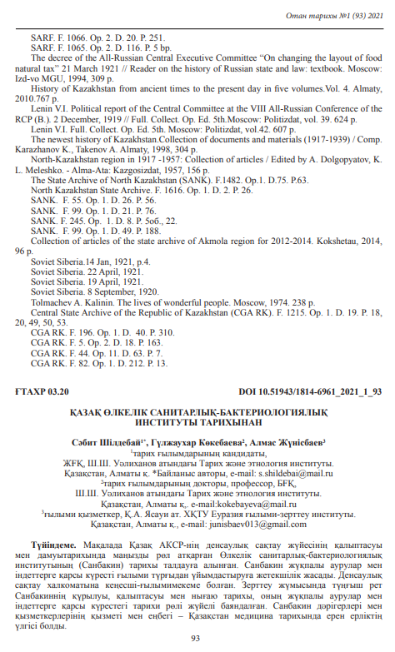

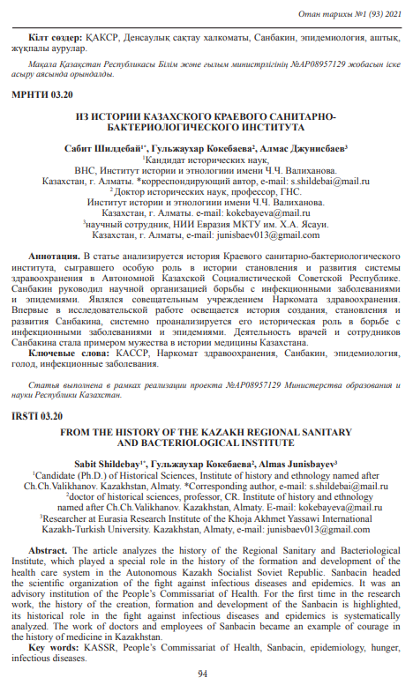

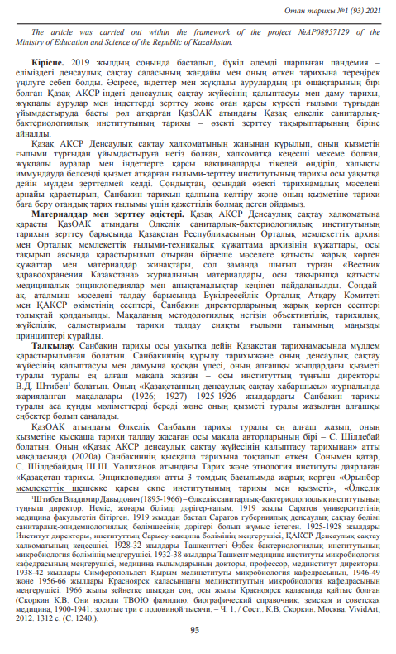

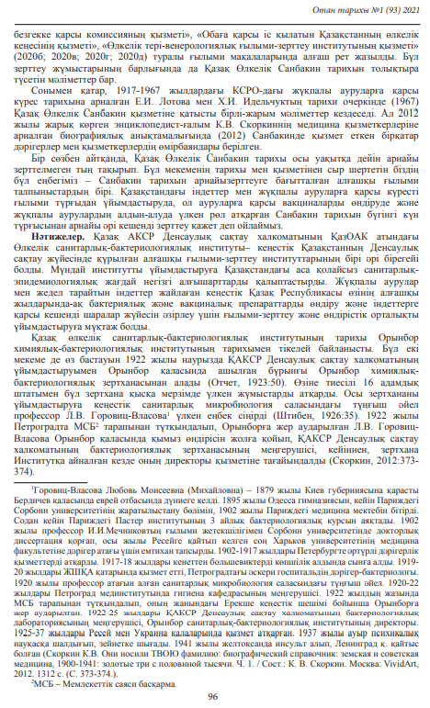

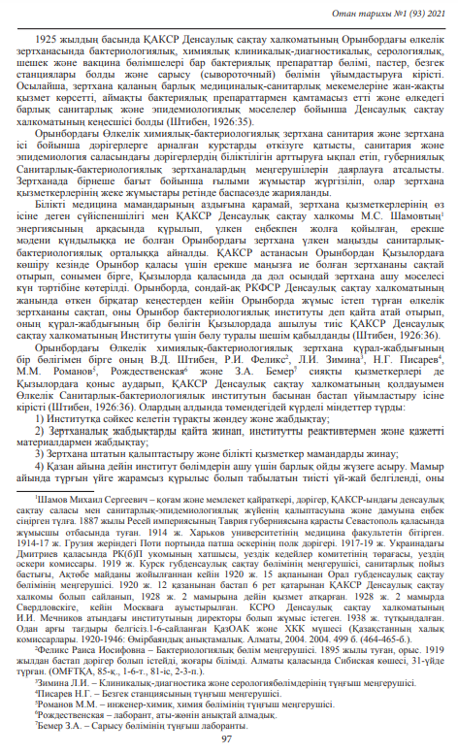

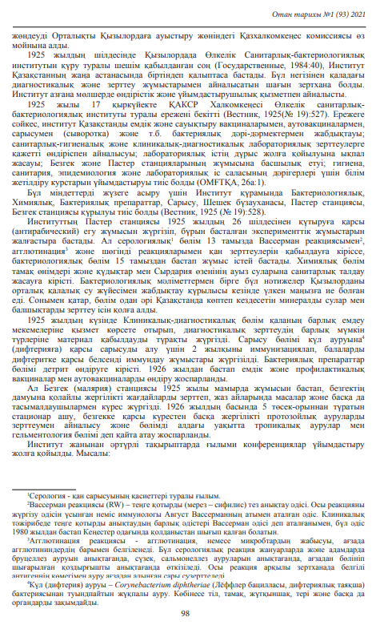

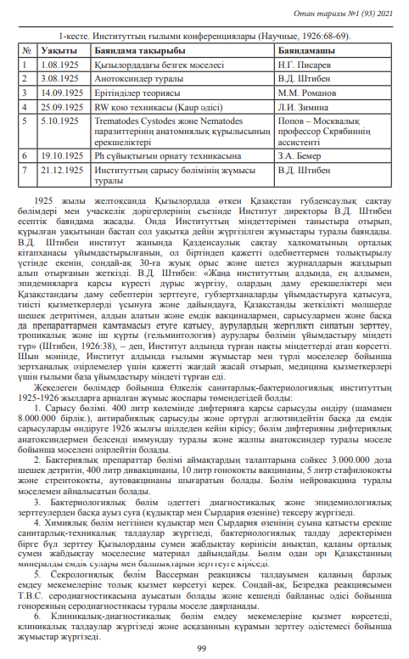

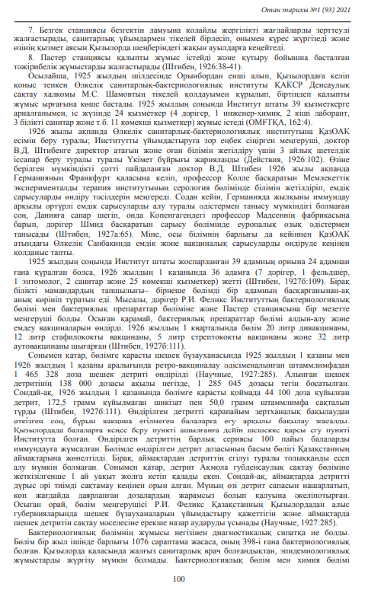

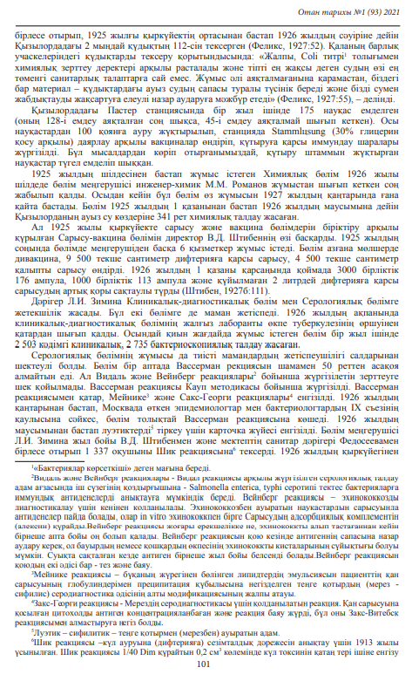

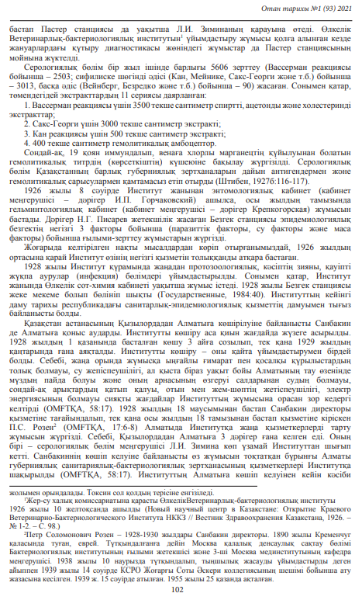

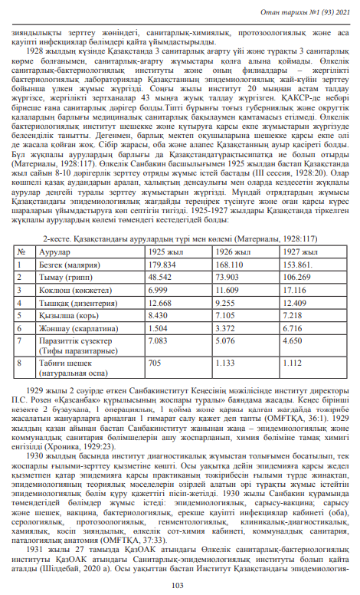

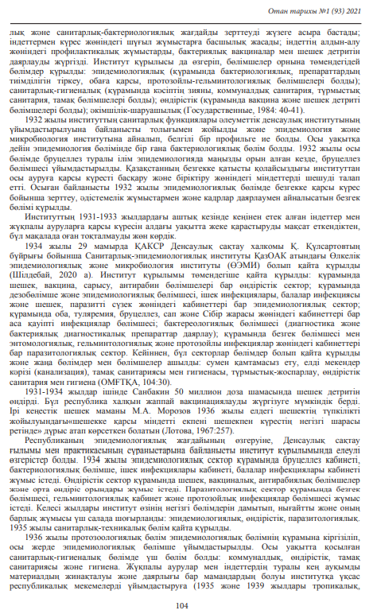

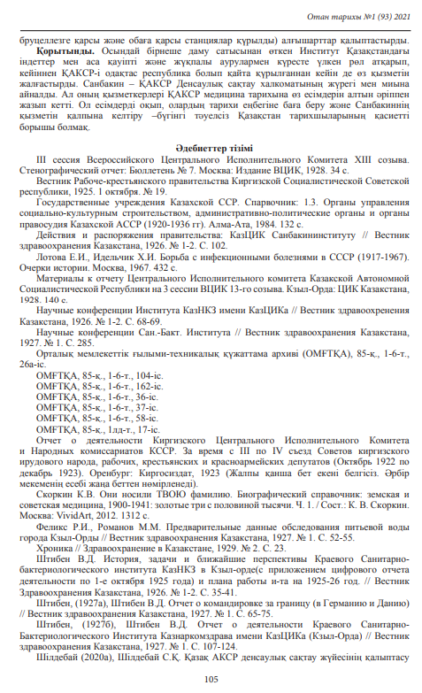

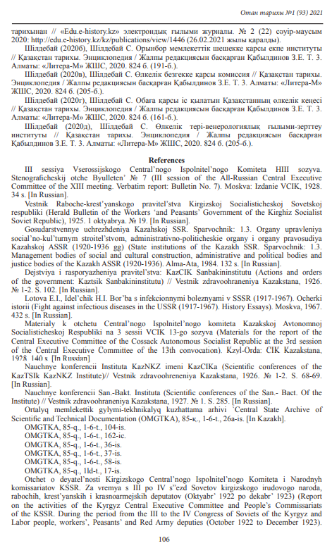

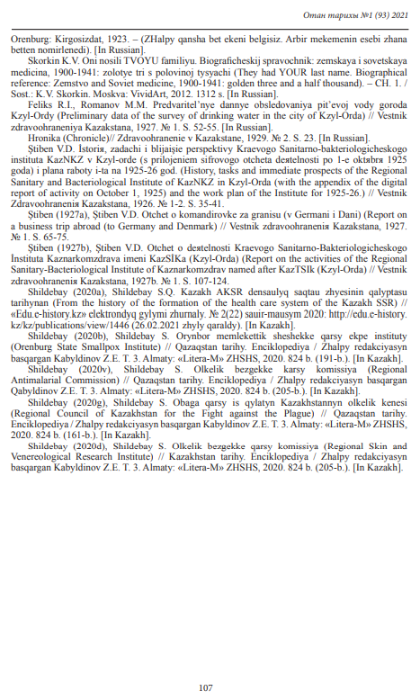

**APPENDIX D**

**Aricle on the round table**

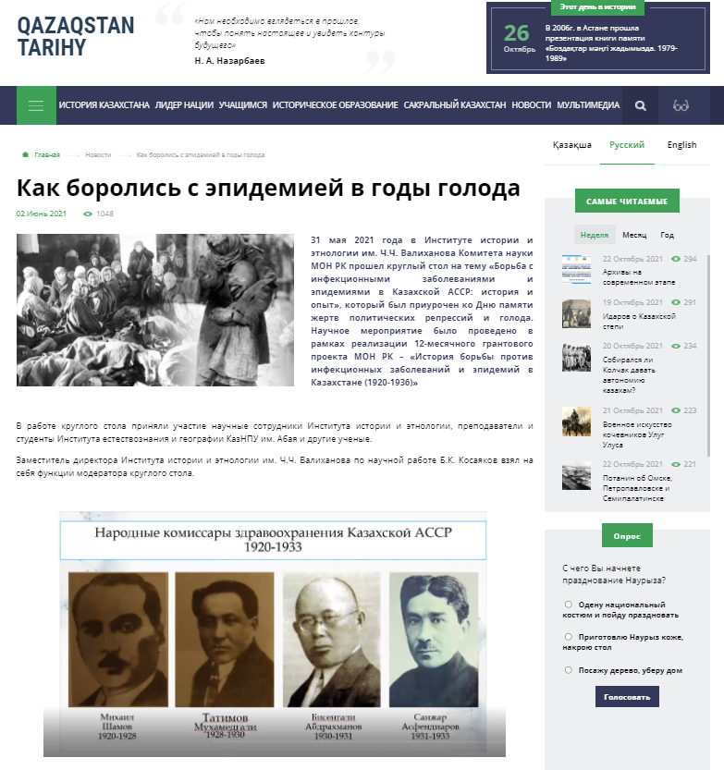

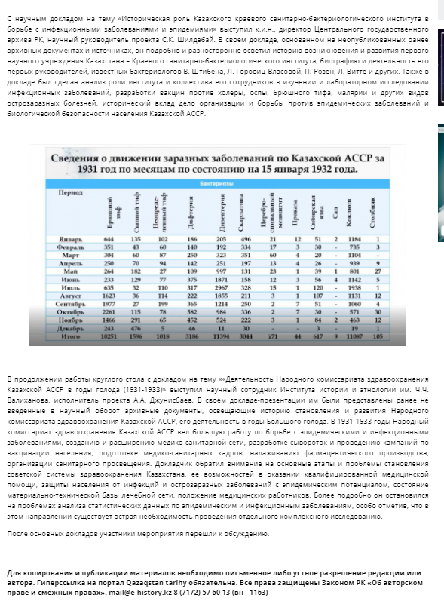

The article can be viewed at the link: <https://e-history.kz/ru/news/show/32702/?sphrase_id=64407>

**APPENDIX E**

**Title pages and content of the monograph**

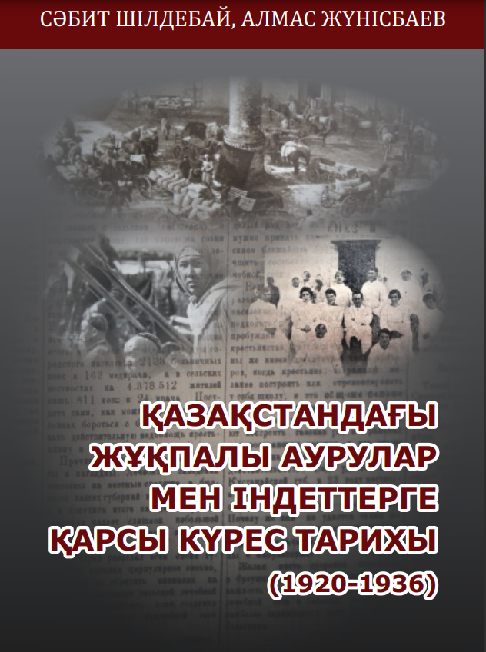

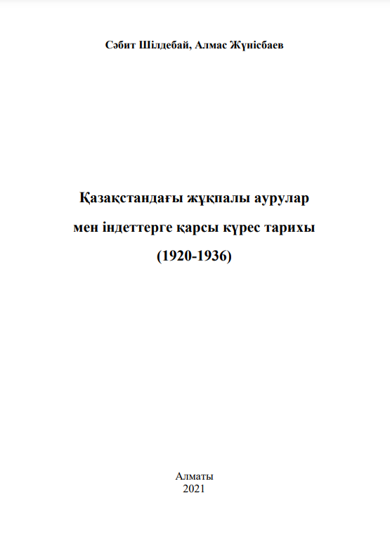

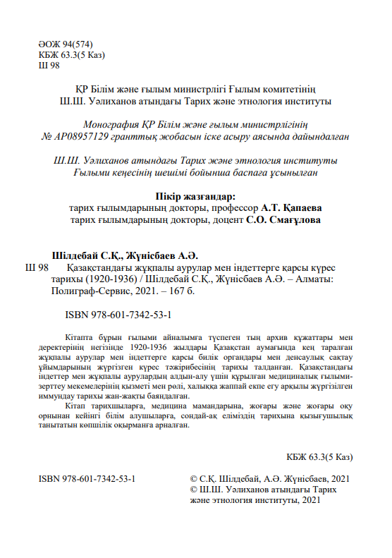

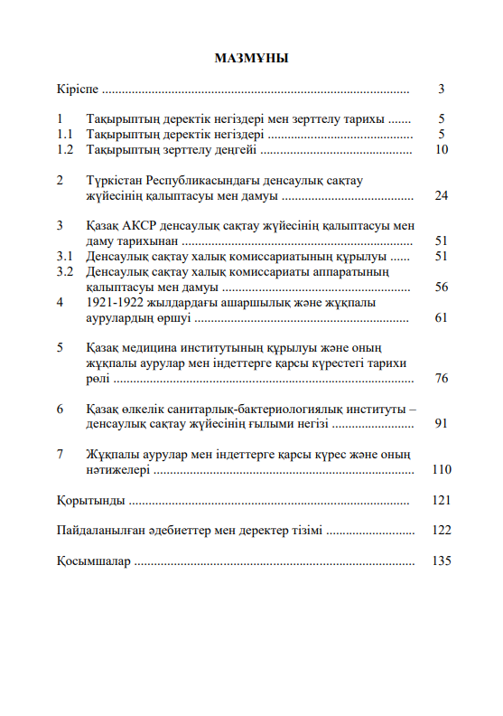

**APPENDIX F**

**Information about an article published in a journal included in the Scopus database**

