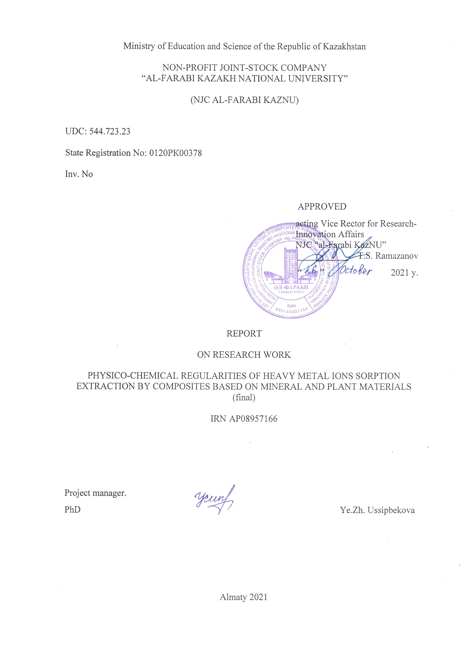

**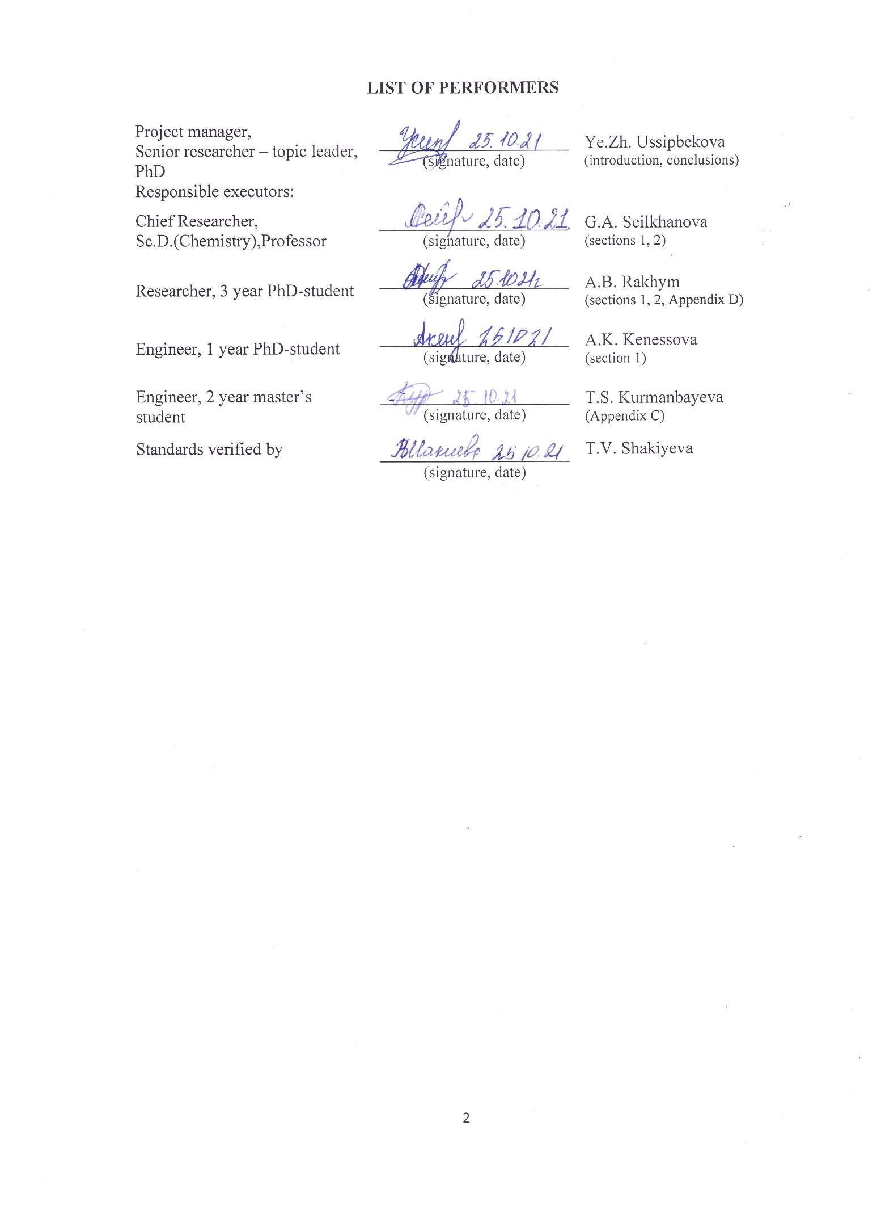**

**ABSTRACT**

Report 50 p., 15 figures, 20 tables, 20 sources, 4 appendixes.

THERMODYNAMICS, KINETICS, SORPTION, HEAVY METAL IONS, OPTIMAL CONDITIONS, COMPOSITE MATERIALS

Research objects:

- composite materials based on mineral raw materials, in particular, chamotte clay (ChC) and natural clay from the Kyzylsok deposit (Almaty region) (KC);

- composite materials based on vegetable raw materials, in particular, wastes from the agricultural industry - sunflower cake (SC) and husk (SH).

The purpose of the research work is to establish the thermodynamic and kinetic regularities of the processes of sorption of heavy metal ions from aqueous solutions by composite materials based on mineral and plant raw materials.

In the course of the work, composite materials (CM) were obtained based on two types of mineral raw materials - chamotte clay (ChC) and natural clay from the Kyzylsok (KC) deposit for the adsorption of Pb2+ and Cd2+ ions, as well as two types of plant raw materials - sunflower cake (SC) and husk (SH) for adsorption of Cu2+ and Zn2+ ions.

Research methods: scanning electron microscopy (SEM), energy dispersive X-ray spectroscopy (EDAX), IR spectroscopy, atomic absorption spectroscopy, pH metering, X-ray diffraction (XRD), BET.

The optimal conditions for the process of sorption of lead and cadmium ions by the obtained CMs based on mineral raw materials have been established: pH = 6, T = 298 K, equilibrium time - 30 minutes. The most optimal plant-based sorbents are composites based on LP and LP carbonizates that have undergone acid treatment, since their use accelerates the adsorption process up to 10 minutes, and also increases the degree of metal recovery up to 100%. Optimal pH of the medium = 6, T = 298 K.

The analysis of the calculated thermodynamic and kinetic characteristics of the HM ions adsor tion process by the obtained sorbents is carried out.

It was found that the adsorption mechanism for the systems under study is a complex process that includes physical adsorption, ion exchange, electrostatic interaction, as well as chemisorption (in particular, complexation) for modified forms of sorbents.

**CONTENTS**

[INTRODUCTION 7](#_Toc86147199)

[MAIN PART OF THE SRW REPORT 9](#_Toc86147200)

[1 Establishment of optimal conditions for the sorption extraction of heavy metal ions by composite materials based on mineral raw materials 9](#_Toc86147201)

[1.1 Physicochemical and textural characteristics of composite materials based on ChC and KC 10](#_Toc86147202)

[1.2 Sorption characteristics of the original and modified clays in relation to metal ions Pb2+ and Cd2+ 17](#_Toc86147203)

[2 Establishment of physicochemical regularities of the sorption process of heavy metal ions by composite materials based on mineral and plant raw materials 21](#_Toc86147204)

[2.1 Establishment of optimal conditions for the sorption extraction of heavy metal ions by composite materials based on plant raw materials 21](#_Toc86147205)

[2.1.1 Physicochemical and textural characteristics of composite materials based on plant raw materials 22](#_Toc86147206)

[2.1.2 Sorption characteristics of composite materials based on SH and SC in relation to Zn2+ and Cu2+ ions 23](#_Toc86147207)

[2.2 Establishment of thermodynamic regularities of the heavy metal ions sorption process from aqueous solutions by composite materials 25](#_Toc86147208)

[2.2.1 Thermodynamic parameters of the sorption process of Pb2+ and Cd2+ ions 25](#_Toc86147209)

[2.2.2 Thermodynamic parameters of the sorption process of Zn2+ and Cu2+ ions 28](#_Toc86147210)

[2.3 Establishment of kinetic regularities of the heavy metal ions sorption process from aqueous solutions by composite materials 30](#_Toc86147211)

[APPENDIX A. Calendar plan 37](#_Toc86147212)

[APPENDIX B. Reference on the results of research work execution 42](#_Toc86147213)

[APPENDIX C. Description of methodologies for obtaining sorbents and for determination of physicochemical and sorption characteristics 44](#_Toc86147214)

[APPENDIX D. Formulas for calculating kinetic and thermodynamic parameters of sorption 48](#_Toc86147215)

**TERMS AND DEFINITIONS**

In this SRW report, the following terms are used with appropriate definitions:

|  |  |
| --- | --- |
| Term | Definition |
| Adsorption | - the process of uptake of gases, vapors, substances from a solution or gas mixture by the surface layer of a liquid or solid, i.e. an adsorbent (activated carbon, etc.), used in chemical engineering for the separation and purification of substances. |
| Sorbent | - solids or liquids that selectively absorb (sorb) gases, vapors or dissolved substances from the environment. |
| Modification | - the impact at which the structure and properties of the material change when modifiers are introduced into its composition. |
| Modifying agent | - this is a substance, small doses of which significantly change the structure and properties of the material processed by it. |
| Composite material | - a multicomponent material made of two or more components with significantly different physical and/or chemical properties, which, in combination, lead to the emergence of a new material with characteristics that differ from the characteristics of the individual components and are not a simple superposition of them. |
| Sorption activity | - this is the amount of absorbed substance per unit mass of the sorbent by the moment of reaching equilibrium. |
| Extraction degree | - it is the percentage of the substance extracted in one phase of the total amount in both phases. |

**LIST OF ABBREVIATIONS AND SYMBOLS**

In this SRW report, the following abbreviations and symbols are used:

AAS - atomic absorption spectroscopy;

ChC - Chamotte clay;

CM - composite material;

CMC - critical micelle formation concentration;

E,% - the degree of extraction;

EDAX - energy dispersive X-ray spectroscopy;

HM - heavy metals;

IR spectroscopy - infrared spectroscopy;

KC - Kyzylsok clay;

PVP - polyvinylpyrrolidone;

SC - sunflower cake;

SEM - scanning electron microscopy;

SH - sunflower husk;

SLES - sodium laureth sulfate.

# **INTRODUCTION**

This project is aimed at establishing the physicochemical regularities of the adsorption of heavy metal (HM) ions by materials based on mineral and plant raw materials. The problem of pollution of water bodies with HM is one of the urgent ones, since they are capable of causing irreparable damage to the environment, in particular to flora, fauna and human health. In the literature, there is a sufficient number of studies aimed at studying the adsorption activity of mineral and plant raw materials in relation to HM ions. However, there are practically no qualitative data on the physicochemical regularities and the mechanism of adsorption of heavy metal ions. As a result, it is rather difficult to choose the most effective material for the extraction of HM ions from aqueous solutions, as well as to predict the purification efficiency, and to determine the optimal process conditions.

The aim of this work is to establish the thermodynamic and kinetic regularities of the processes of sorption of heavy metal ions from aqueous solutions by composite materials based on mineral and plant raw materials.

The tasks of the Project include the following:

1) Establishment of optimal conditions for the process of adsorption of heavy metal ions by materials based on mineral raw materials (pH, sorbent/solution ratio, metal concentration, contact time, T, etc.);

2) Establishment of optimal conditions for the process of adsorption of heavy metal ions by materials based on plant raw materials (pH, sorbent/solution ratio, metal concentration, contact time, T, etc.);

3) Carrying out thermodynamic calculations based on the data obtained (Gibbs energy, enthalpy, entropy, adsorption isotherm models, etc.);

4) Carrying out kinetic calculations based on the data obtained (reaction rate, rate constant, activation energy, reaction order, etc.)

The scientific novelty of this Project lies in the establishment of the physicochemical regularities of the adsorption of HM ions by various groups of sorbents (mineral and plant raw materials), which will make it possible to predict the efficiency and selectivity of water bodies purification, as well as to determine the optimal conditions for the course of sorption processes.

It should also be noted that during the implementation of the Project, new materials based on the mineral and plant raw materials of Kazakhstan will be obtained. Natural clay materials, as well as food and agricultural waste, which are promising raw materials for the creation of cheap sorbents for heavy metal ions (HM), will be used.

This report includes information on the implementation of all project tasks according to the implementation schedule:

1. Establishment of optimal conditions for the sorption extraction of heavy metal ions by composite materials based on mineral raw materials;

2. Establishment of physicochemical regularities of the process of sorption of heavy metal ions by composite materials based on mineral and plant raw materials;

2.1 Establishment of optimal conditions for the sorption extraction of heavy metal ions by composite materials based on plant raw materials;

2.2 Establishment of thermodynamic regularities of the process of sorption of heavy metal ions from aqueous solutions by composite materials;

2.3 Establishment of kinetic regularities of the process of sorption of heavy metal ions from aqueous solutions by composite materials.

In the process of fulfilling the tasks of the project, an intermediate annual report on research work under the project AP08957166 "Physico-chemical regularities of heavy metal ions sorption extraction by composites based on mineral and plant materials" for 2020 inv. No. 0220RK01827.

# **MAIN PART OF THE SRW REPORT**

# **1 Establishment of optimal conditions for the sorption extraction of heavy metal ions by composite materials based on mineral raw materials**

To fulfill the project objectives set for the period from 01.10.2020 to 01.12.2020 – Establishment of optimal conditions for the sorption extraction of heavy metal ions by composite materials based on mineral raw materials, the following research objects were selected as mineral raw materials:

- Chamotte clay (ChC) supplied by Teplosvet Engineering, LLC;

- clay from the Kyzylsok (KC) deposit (Almaty region, Uzynagash village).

The choice of these objects is due to their availability. In addition, the use of ChC and KC as sorbents for the extraction of HM ions is not available in the literature. Therefore, the results of this project are of scientific and practical interest.

The study of the sorption activity of the initial mineral raw materials, as well as composite materials based on them, was carried out in relation to Pb2+ and Cd2+.

To improve the sorption characteristics of the initial clay materials, they were modified with the following substances:

- for KC polyvinylpyrrolidone (PVP) with a molecular weight of 10,000 g/mol, chemically pure grade is used. The choice of PVP as a modifier is due to its environmental friendliness, safety, non-toxicity and low cost. PVP is an amorphous linear polymer. It is hygroscopic, soluble in water, non-toxic, has an affinity for organic polymers. Aqueous solutions have a slightly acidic reaction (pH = 5). The high sorption activity of PVP is associated with its structure. This class of reagents are compounds with grafted complexing groups that form strong bonds with metal ions dissolved in water. Consequently, a possible sorption mechanism can be considered as complexation associated with the presence in the PVP structure of functional groups with donor nitrogen atoms, which, in turn, can bind metal ions into strong complexes;

- for ChC sodium laureth sulfate (SLES), chemically pure grade is used. SLES is an anionic surfactant used to produce most household and technical detergents. SLES is an ethoxylated form of the sodium salt of lauryl sulfuric acid, sodium lauryl sulfate. Due to the amphiphilic structure of the surfactant, it is believed that the adsorption of SLES on the surface of ChC leads to a recharge of the surface of clay.

## **1.1 Physicochemical and textural characteristics of composite materials based on ChC and KC**

The study of the physicochemical properties and textural characteristics provides important information that makes it possible to analyze the effect of the modifier on the sorption activity of the obtained composite materials.

Techniques for obtaining sorbents, as well as studies of their physicochemical characteristics are presented in Appendix B.

The work analyzed the physicochemical characteristics of ChC, as well as a composite material (CM) based on it. At the same time, it was found that the modification of ChC increases such a characteristic as the adsorption activity with respect to iodine by more than 5 times (from 2.41% to 12.54%). Consequently, this causes the predominance of meso- and micropores in the structure of composite materials, thereby contributing to an increase in adsorption activity with respect to metal ions.

By the method of scanning electron microscopy (SEM) (Figure 1) and energy dispersive X-ray spectroscopy (EDAX) (Table 2), the qualitative and quantitative compositions of the initial ChC and CM based on it, as well as the particle size distribution (Table 1) were established.

|  |  |
| --- | --- |
| C:\Users\Акмарал\OneDrive\Докторантура учеба\Диссертация доктор\Израиль\СЭМ\21.7.19\Clay_004.tif  а) ChC | б) ChC + 20 CMC SLES |

Figure 1 - Micrographs of a) the original ChC; b) CM based on ChC

Table 1 - Distribution of the particle size of the objects of study

|  |  |  |  |  |
| --- | --- | --- | --- | --- |
| Material | Particle area, μм2 | Standard deviation | Minimum | Maximum |
| ChC | 1.290 | 1.610 | 0.005 | 9.390 |
| ChC + 10 CMC SLES | 0.410 | 0.680 | 0.001 | 3.610 |

СhC particles are represented by layers of flocculent formations of irregular shape and various sizes. It is known, that clays have a layered structure, as a result they are also porous [1]. The data on the particle size distribution of the test materials are presented in Table 1. According to Table 2, the clay frameworks are composed of SiO2 and Al2O3 oxides [1,2], therefore, the content of such elements as silicon, aluminum and oxygen prevails in their composition. There are also metals such as Na, K, Mg, which act as exchange cations to compensate for the excess negative charge on the surface of minerals [3]. It should be noted that the Si/Al ratio is 1.2 for the clay. The clay framework is composed of silicon and aluminum oxides in a ratio of approximately 1:1, which corresponds to the structure of kaolin clay [1]. After modification using SLES, a significant increase in carbon content is observed, which is associated with the coating of the clay surface with a surfactant.

Table 2 - Elemental composition of research objects

|  |  |  |  |  |  |  |  |
| --- | --- | --- | --- | --- | --- | --- | --- |
| Material | % wt. | | | | | | |
| С | О | Al | Si | Na | K | Mg |
| ChC | 6.71 | 43.22 | 22.40 | 26.62 | 0.44 | 0.86 | 0.50 |
| ChC + 10 CMC SLES | 52.64 | 25.51 | 7.41 | 12.34 | 1.01 | 0.72 | 0.36 |

Thus, the results of physicochemical studies show that the modification of ChC changes its composition and structure, which also affects the sorption capacity of the feedstock.

To obtain information on the presence of SLES particles in the sample on the surface of ChC, IR spectroscopy was used. The IR-spectra are presented in Figures 2-3.

When interpreting the spectrum of the initial ChC, it was found that the main bands belong to the valence bonds of silicon with oxygen (Si-O) and hydrogen with oxygen (O-H). This is shown by a broad band at 1027 cm-1, which corresponds to stretching vibrations of Si-O-Si tetrahedra of the silicon-oxygen framework, and bands at 469 and 540 cm-1 belong to bending vibrations of Me-O bonds. The band in the range of 797.15 cm-1 corresponds to Si-O-Si vibrations of the rings of SiO4 tetrahedra. The absorption bands at 695 and 1448 cm-1 are associated with the presence of calcite impurities. An intense, stretched band in the range of 1882-3697 and a band at 1632 cm-1 refer to OH-stretching and bending vibrations of free and bound water.



Figure 2 - IR spectrum of the original ChC



Figure 3 - IR spectrum of ChC-based CM

In the spectrum of ChC modified with SLES, a decrease in the intensity of the band in the region of 1600 cm-1 is observed, which indicates a decrease in the number of free OH groups, probably due to the formation of a bond with a surfactant. The appearance of a peak at 3617 cm-1 indicates the appearance of a product, CM based on ChC. Also, almost all values of the frequency of the peaks decrease, which indicates an increase in the length of bonds between the atoms of the material, namely, the bonds Si – O, Si – O – Si, and Si – O – Al.



Figure 4 – X-Ray diffraction pattern of ChC

The X-ray diffraction pattern of ChC, obtained by XRD analysis (Figure 4), shows that the crystal structure of ChC consists of kaolinite, mullite and quartz.

Table 3 - Texture characteristics of ChC

|  |  |  |  |
| --- | --- | --- | --- |
| Sorbent | Specific surface area, m2/g | Average pore size, nm | Total pore volume, cm3/g |
| ChC | 8.400 | 0.690 | 0.029 |

Table 3 shows the results of determining the specific surface area, average pore size and total pore volume obtained by adsorption of N2 by the BET method. Thus, the specific surface area is 8.4 m2/g for ChC. According to the IUPAC classification, porous materials are divided into three main categories based on pore size: microporous materials with pore sizes less than 2 nm, mesoporous materials with pore sizes ranging from 2 to 50 nm, and macroporous materials with pore sizes greater than 50 nm. The studied clay belongs to microporous materials.

Cation exchange capacity (CEC) is a value that helps to assess the ability of adsorbents to take part in ion exchange processes. According to reference data [4], CEC of natural clays ranges from 200 to 400 meq/100 g. As can be seen from Table 4, CEC of ChC is 291.3 meq/100 g, which is an average value. However, it should be noted that the largest contribution to CEC is made by Na+ ions, which may indicate a good ability of ChC to ion exchange.

Table 4 - Cation exchange capacity ChC (meq/100 g)

|  |  |  |  |  |  |
| --- | --- | --- | --- | --- | --- |
| Sorbent | K+ | Na+ | Ca2+ | Mg2+ | Total |
| ChC | 11.3 | 166.9 | 5.7 | 50.2 | 234.0 |

Natural clay of the "Kyzylsok" deposit is a product of the weathering of rocks and is of sedimentary origin. Kyzylsok clay (KC) in dry state is a mass of gray-brown color and earthy smell. This color of the clay indicates that it contains iron, potassium and calcium, which is confirmed by the results of the elemental analysis (table 5).

The primary task of the study was to identify the composition and structural features of the initial KC using the SEM and EDAX methods (Table 5, Figure 5).

According to the data presented, it can be seen that the investigated KC belongs to aluminosilicate materials. The Si/Al ratio for KC is 2.77. Along with this, there is a small content of elements such as Mg, Ca, Fe, Na, and K, which are exchangeable cations.

Table 5 - Elemental composition of KC

|  |  |  |
| --- | --- | --- |
| Element | Wt, % | At, % |
| C | 17.02 | 27.01 |
| O | 39.26 | 46.77 |
| Na | 0.89 | 0.74 |
| Mg | 2.24 | 1.76 |
| Al | 6.70 | 4.73 |
| Si | 18.57 | 12.60 |
| K | 2.77 | 1.35 |
| Ca | 5.59 | 2.66 |
| Fe | 6.97 | 2.38 |

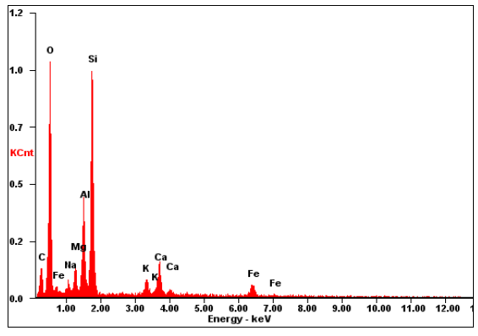

Figure 5 - Results of KC elemental analysis by the EDAX method

The study of morphological and microstructural features, carried out using a scanning electron microscope (Figure 6), showed that the particles of the KC sample are characterized by an anisometric shape. Clay particles are associations of different sizes, the data on the particle size distribution are presented in table 6.

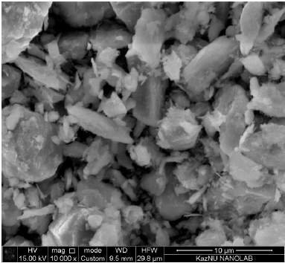

Figure 6 - Micrograph of natural KC

Table 6 – KC particle size distribution

|  |  |  |  |  |
| --- | --- | --- | --- | --- |
| Material | Particle area, μм2 | Standard deviation | Minimum | Maximum |
| KC | 0.420 | 1.575 | 0.006 | 13.446 |

Figure 7 shows the X-ray diffraction pattern of the KC. KC has a more complex phase composition than ChC. The crystal structure of KC contains: quartz, calcite, clinochlore, microcline, albite, muscovite and dolomite.

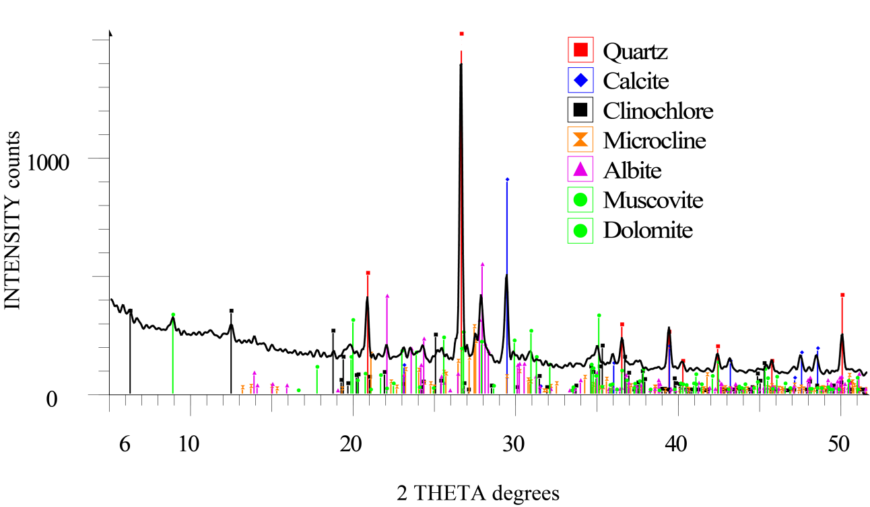

Figure 7 – X-Ray diffraction pattern of KC

CEC of KC (table 7) is significantly lower than that of ChC. This is possibly due to the fact that the main share in the composition of KC is occupied by quartz and calcite, minerals that do not have exchangeable cations on the surface. However, KC has a large specific surface area (Table 8) equal to 36.21 m2/g, which indicates a good potential for physical sorption.

Table 7 - Cation exchange capacity of KC (meq/100 g)

|  |  |  |  |  |  |
| --- | --- | --- | --- | --- | --- |
| Sorbent | Na+ | K+ | Ca2+ | Mg2+ | Total |
| KC | 93.11 | 29.13 | 3.61 | 6.37 | 132.20 |

Table 8 - Texture characteristics of the KC

|  |  |
| --- | --- |
| Sorbent | Specific surface area, m2/g |
| КC | 36.21 |

## **1.2 Sorption characteristics of the original and modified clays in relation to metal ions Pb2+ and Cd2+**

The sorption characteristics of the obtained CMs were studied in relation to Pb2+ and Cd2+, the most toxic metal ions.

The description of the used experimental procedure for studying the sorption characteristics of sorbents is presented in Appendix B.

Figure 8 shows the results of the sorption of metal ions on the initial ChC. The extraction degree of metal ions is influenced by the duration of contact with the aqueous phase containing ions of the extracted metal. It follows from data obtained, that with an increase in the duration of contact between the modified clay and the aqueous phase, the amount of sorbed metal also increases. As can be seen in the figures, the sorption equilibrium during the extraction of metal ions develops in 30 minutes.

The extraction degree of Cd2+ ions by the initial ChC is (68.0 ± 3.25)%, and the extraction degree of Pb2+ ions reaches 100%.

As can be seen from Figure 8, the sorption activity of the samples under study depends on the nature of the sorbed metal, i.e., on the ionic radii and charge densities. The ions of a larger radius exhibit a greater sorption capacity, since they are more polarized and are better attracted by the charged surface of the sorbent, while ions of a smaller radius are more prone to hydration and the formation of a hydration shell, which reduces such electrostatic interaction [5–7].



Figure 8 - Dependence of the extraction degree of Cd2+ and Pb2+ ions by

the initial ChC versus time

Table 9 - Radii of ions and maximum permissible concentrations (MPC) of the investigated metals

|  |  |  |
| --- | --- | --- |
| Metal ion | Ionic radius r, nm | MPC, mg /L |
| Cd2+ | 0.095 | 0.001 |
| Pb2+ | 0.119 | 0.030 |

The radius of the lead ion is greater than the radius of cadmium ion (Table 9), therefore, the sorption capacity of the material in relation to lead ions should be higher than in relation to cadmium ions, which is confirmed by experimental data (Figure 8). This indicates the predominance of electrostatic interaction between the ChC particles and metal ions.

It was found that the initial ChC extracts lead ions by almost 100%; therefore, its modified forms, CMs based on ChC for the sorption of Pb2+ ions were not used.

As shown by the results of the experiment, the extraction degree of cadmium ions by the initial ChC is insufficiently high. The adsorption properties of ChC modified with PVP in relation to Cd(II) and Pb(II) ions are described in our previous work [8]. Modification of KC with PVP made it possible to increase the degree of extraction of lead ions from (68 ± 6.0) % to (86.0 ± 6.4) %, which is also not enough.

In order to increase adsoption efficiency of ChC towards Cd2+ it was modified with SLES, an anionic surfactant. The influence of the SLES concentration in the composite material was studied and the optimal composition of the sorbent for the extraction of Cd2+ ions from aqueous solutions was established.

From the data presented in Figure 9, it can be seen that SLES concentrations above 20 CMC in the sorbent provide 100% extraction of cadmium ions from aqueous solutions. This is probably due to the formation of a double layer due to the diphilic structure of SLES on the surface of ChC, as a result of which the surface of the clay is recharged. This leads to almost complete binding of cadmium ions with the functional groups of the surfactant. It should be noted that almost complete extraction of metal ions is also observed when using 20 CMC SLES; therefore, the use of higher surfactant concentrations is economically inexpedient.

Thus, the optimal modification of CMs based on ChC and SLES for the extraction of cadmium ions is a material containing 20 CMC SLES.

Figure 10 shows the results of sorption of Pb2+ and Cd2+ ions in the initial KC. When metal ions are sorbed by the initial clay, the degree of extraction reaches 98-99% for Cd2+ and 70-80% for Pb2​​+. This suggests that the initial KC can be used for the sorption of Cd2+ ions without any treatment, and for Pb2​​+ ions it must be modified. Apparently, this is due to the fact that the surface of the initial clay has reaction centers that are more selective to Cd2+ ions. This may also be due to the fact that the cadmium ion is smaller and more prone to the formation of a hydration shell, which interferes with electrostatic interaction and ion exchange, but contributes to the predominance of physical adsorption in the mechanism of the process.



Figure 9 - Dependence of the extraction degree of Cd2+ ions by CMs based on ChC modified by SLES with concentrations of 0.5 - 100 CMC on time (Т = 298 К, рН = 6.5-8.3, Сo=100 mg/l)



Figure 10 - Dependence of the extraction degree of Pb2+ and Cd2+ ions by the initial KC on time (Т = 298 К, рН = 6, Сo = 10 mg/l)

Figure 11 shows the results of sorption of Pb2+ ions by KC modified with PVP. The graph shows that the extraction degree of lead ions increases from 70% to 96% after modification.

PVP belongs to the class of reagents that are compounds with grafted complexing groups that form strong bonds with metal ions dissolved in water. Therefore, the probable mechanism of sorption of Pb2+ ions can be considered complexation associated with the presence of functional groups with donor nitrogen atoms in the PVP structure, which, in turn, are able to bind metal ions into strong complexes.



Figure 11 - Dependence of the extraction degree of Pb2+ ions by KC and KC modified with 1% PVP solution on time (Т = 298 К, рН = 6, Сo = 10 mg/L)

The results of the study showed that the equilibrium sorption time for all samples was no more than 30 minutes.

The influence of the concentration of the modifier in CMs on the results of sorption was also investigated (Figure 12). Based on the data obtained, it was revealed that a change in the concentration of the modifier in the composite material practically does not affect its sorption properties. Therefore, in view of economic feasibility, the lowest concentration of the modifier was chosen, i.e., 0.1% PVP.



Figure 12 - Dependence of the extraction degree of Pb2+ ions by CMs based on KC modified with PVP with concentrations of 0.1%, 0.5%, 1% on time (Т = 298 К, рН = 6, Сo = 10 mg/L)

**2 Establishment of physicochemical regularities of the sorption process of heavy metal ions by composite materials based on mineral and plant raw materials**

For the period from 01.01.2021 to 01.11.2021, the following task was set: "Establishing the physicochemical regularities of the process of sorption of heavy metal ions by composite materials based on mineral and plant raw materials."

The objects of research presented in Chapter 1 were used as mineral raw materials: Chamotte clay (ChC) and clay from the Kyzylsok deposit (KC).

Wastes of the agricultural industry such as sunflower cake (SC) and husk (SH) were used as plant raw materials.

**2.1 Establishment of optimal conditions for the sorption extraction of heavy metal ions by composite materials based on plant raw materials**

The choice of SC and SH as objects of research is because there is a very large volume of sunflower waste in the butter industry in the Republic of Kazakhstan. After squeezing the sunflower seeds, such waste as husk and cake remains. In addition, SC contains such substances as cellulose and lignin, due to which it is a good material for the manufacture of a sorbent [9]. SH is also a good sorbent, as it has high retention properties. With further modification of husk and cake, their sorption activity increases [10].

Consequently, materials based on SC and SH are of practical interest for use in the sorption of heavy metal ions.

Thus, the study of the adsorption activity of the materials under study was carried out in relation to the cations of copper (II) and zinc (II).

To increase the sorption capacity of sorbents, modified SC and SH of the following forms were obtained:

- carbonizates;

- carbonizates that have previously undergone acid treatment.

2.1.1 Physicochemical and textural characteristics of composite materials based on plant raw materials

Table 10 shows the interpretation of the IR spectra of SC and SH.

It is known from the literature that the composition of SH includes such compounds as cellulose, lignin, hemicellulose [11]. Therefore, there are peaks characteristic of the following functional groups in the IR spectra of SC and SH: hydroxyl (3400-3200 cm-1), symmetric and asymmetric vibrations in methyl and methylene groups (2900-2800 cm-1), amino groups (2400 cm-1) 1), carbonyl (~ 1750 cm-1), etc. [12].

In addition to the above, characteristic bands of cyclic and aromatic ethers (1250-1100 cm-1) are also observed in the spectrum of the SC, since in addition to the husk, the cake contains residues of seeds and sunflower oil.

Table 10 - Functional groups and wavenumbers of the IR spectra of SH and SC [13]

|  |  |  |
| --- | --- | --- |
| Wavenumbers, cm-1 | | Comments |
| SH | SC |
| 3400-3200 | 3400-3200 | Stretching vibrations – OH  Intra- and intermolecular H-bonds in dimers and polymers |
| 2927 (asym)  2856 (sym) | 2927 (asym)  2856 (sym) | Stretching vibrations of CH bonds in methyl and methylene groups |
| 2400 | 2400 | Stretching vibrations of NH3+ - groups |
| 1745 | 1747 | Stretching vibrations of the carbonyl group C = O in ketones  β-Ketone form  CO-CH2-COOR |
| 1632 | 1632 | β-Ketoesters:  Enol form  -COH = CH-COOR |
| 1500 | - | Stretching vibrations of the aromatic ring |
| 1470 | 1460 | Stretching vibrations of N=O |
| 1430 | - | NO3- |
| 1375 | 1370 | Symmetric bending vibrations of -CH3 |
| 1244 | - | Methoxyl group, asymmetric |
| - | 1240 | Cyclic ethers  Epoxy compounds |
| 1140 | 1160 | Cyclic ethers  Epoxy compounds |
| - | 1100 | Aromatic acid esters |
| 1120 | - | C = C = O (ketenes) |
| 1060 | - | Methoxyl group, symmetric |

The specific surface area is one of the important characteristics for describing the textural characteristics of materials. Table 11 shows the results of studies of the specific surface area of ​​SH carbonizate, as well as acid-treated SH carbonizate. It can be noted that acid treatment significantly affects the porosity of the material and its specific surface area, the value of which increases from 0.492 m2/g to 220.498 m2/g.

Table 11 - Results obtained by the BET method

|  |  |  |
| --- | --- | --- |
| Characteristic | SH carbonizate | SH carbonizate + nitric acid |
| Specific surface area, m2/g | 0.492 | 220.498 |
| Specific pore volume, cm3/g | 0.001 | 0.095 |

### 2.1.2 Sorption characteristics of composite materials based on SH and SC in relation to Zn2+ and Cu2+ ions

The study of the adsorption activity of SH and SC was carried out in relation to Cu (II) and Zn (II) ions. Table 12 shows the results of evaluating the adsorption activity of the materials under study. Conditions for adsorption are a static mode with constant stirring, T = 293 K, pH = 6, the initial concentration of metal ions – 10 mg/l.

Table 12 – Results of adsorption of Cu2+ and Zn2+ ions by the studied materials [13]

|  |  |  |
| --- | --- | --- |
| Sorbent | E, % | |
| Cu2+ | Zn2+ |
| SH | 88.0 3.4 | 81.0 $±$ 5.5 |
| SH ground | 93.0 $±$ 2.6 | 89.0 $±$ 2.4 |
| SC | 72.0 $±$ 5.0 | 80.0 $±$ 3.1 |

As can be seen from Table 12, the maximum extraction degree of Cu2+ and Zn2+ ions by the initial SH reaches 88% for Cu2+ and 81.4% for Zn2+. Grinding of the SH leads to an increase in the degree of extraction (93 and 89% for Cu2+ and Zn2+, respectively), which is associated with an increase in the surface of the material accessible to cations. That is, as the particle size decreases, the specific surface area of ​​sorbent increases.

In the case of SC, the maximum extraction degree reaches 72% for Cu2+ and 80% for Zn2 +.SC is less effective in adsorption processes due to the content of residues of sunflower seeds – fibers and oils, which clog the active centers for the adsorption of metal cations.

The equilibrium time of adsorption of ions of zinc and copper by SH is achieved after 3 hours. In the case of ground SH, the process slows down, the equilibrium time is achieved in 24 hours. This is possibly due to the fact that the force of attraction of the SH particles decreases during grinding. However, with constant stirring, the adsorption efficiency is slightly higher for the ground SH due to the increase in the surface area available for cations. With the adsorption of cations of zinc and copper by SC equilibrium is achieved after 3 hours. Modification of sorbents leads to an increase in the extraction degree of Cu2+ and Zn2+ ions in comparison with the initial sorbents. Table 13 shows the results of evaluating the adsorption activity of the modified sorbents.

Table 13 - Results of adsorption of Cu2+ and Zn2+ ions by modified sorbents [13]

|  |  |  |
| --- | --- | --- |
| Sorbent | E,% | |
| Cu 2+ | Zn 2+ |
| SH carbonizate | 95.0 $±$ 2.3 | 96.0 $±$ 3.41 |
| SC carbonizate | 93.0 $±$ 3.0 | 35.0 $±$ 4.24 |
| SH carbonizate + acid | 96.5 $±$ 3.5 | 97.0 $±$ 3.0 |
| SC carbonizate + acid | 97.0 $±$ 3.0 | 96.4 $±$ 3.6 |

Thus, the extraction degree by SH carbonizate reaches 95% for Cu2+ ions and 96% for Zn2+ ions. The equilibrium of adsorption is reached after 24 hours. The extraction degree of Cu2+ ions by the SC carbonizate reaches 93%. However, the degree of extraction of Zn2+ ions by the SC carbonizate is significantly reduced (35%) as compared to the initial SC. Perhaps this is due to the formation of pyrolysis resins from the residues of essential oils in the composition of the SC, which can clog the adsorption centers on the carbonizate. For the adsorption of Zn2+ ions with the carbonizate of the SC, equilibrium is achieved after 24 hours, and for the adsorption of Cu2+ ions it is 3 hours.

During the adsorption of Cu2+ and Zn2+ ions by SH and SC carbonizates, pretreated with the acid, the extraction degree of metal ions is almost 100%. Equilibrium is also reached much faster (in the first 10 minutes), compared to SH and SC carbonates that have not undergone acid treatment. This may indicate that the pretreatment of carbonizates with acid significantly affects the sorption capacity in relation to the investigated metal ions. An increase in the rate of the process due to acid treatment of the materials under study, followed by carbonization, increases the possibility of practical application of the obtained sorbents.

## **2.2 Establishment of thermodynamic regularities of the heavy metal ions sorption process from aqueous solutions by composite materials**

### 2.2.1 Thermodynamic parameters of the sorption process of Pb2+ and Cd2+ ions

Table 14 shows the thermodynamic parameters of the sorption process of Cd2+ and Pb2+ ions by sorbents based on KC and ChC.

A description of the formulas for calculating thermodynamic characteristics, as well as the application of adsorption isotherms models is presented in Appendix D.

Based on the data obtained, we can conclude that the sorption process for all systems is exothermic (there is a little heat release), which is confirmed by the values ​​of thermodynamic parameters (Table 14): (Pb2+) = -8.46 J/mol and (Cd2+) = -545.18 J/mol (sorbents based on KC) and (Pb2+) = -7.82 kJ/mol and (Cd2+) = - 17.83 kJ/mol (sorbents based on ChC). Negative values ​​of entropy $∆S^{0}$ are due to the transition of many ions from the solution to the sorbent, which indicates active ion exchange processes [3]. Negative Gibbs energy values ​​indicate that the process under study is spontaneous. It should be noted that in the case of sorption of Cd2+ ions by the sorbent ChC + 20 CMC SLES, an increase in temperature leads to a transition of $∆G^{0}$ values ​​from negative to positive, i.e. the process becomes non-spontaneous. This suggests that as the temperature rises, the efficiency of the direct process – adsorption decreases, while the reverse process – desorption increases.

Table 14 - Thermodynamic parameters of the sorption process of Pb2+ and Cd2+ ions by sorbents based on mineral raw materials

|  |  |  |  |  |  |
| --- | --- | --- | --- | --- | --- |
| Sorbent | Ion | T, K | ΔG°,  kJ/mol | - ΔS°, J/mol ∙ K | - ΔH°, J/mol |
| KC + 0.1% PVP | Pb2+ | 298 | 5.72 | 19.11 | 8.46 |
| 308 | 5.90 |
| 318 | 6.09 |
| 328 | 6.23 |
| KC | Cd2+ | 298 | 5.80 | 17.64 | 545.18 |
| 308 | 5.94 |
| 318 | 6.17 |
| 328 | 6.38 |
| ChC | Pb2+ | 288 | 1.69 | 20.88 | 7821.81 |
| 298 | 1.74 |
| 308 | 1.48 |
| 318 | 1.05 |
| ChC + 20 CMC SLES | Cd2+ | 288 | 0.74 | 57.91 | 17834.70 |
| 298 | 2.48 |
| 308 | -0.11 |
| 318 | -0.43 |

The experimental isotherms of the adsorption of Cd2+ ions on the KC and the adsorption of Pb2+ ions on the modified KC are shown in Figure 13.

The adsorption capacity (A, mg/g) of clay minerals in relation to Pb2+ ranges from 0.45 to 239 mg/g and from 3.87 to 981 mg/g in relation to Cd2+ [14]. The maximum adsorption capacity of clay was 11.2 mg/g for Cd2+, and in the case of modified clay it is 7.6 mg/g for Pb2​​+, which is the average result for natural clays [15].

To describe the experimental adsorption isotherms, the most frequently used models of adsorption isotherms, Langmuir [16] and Freundlich [17], were used (Table 15).



Figure 13 – Adsorption isotherms of (1) Cd2+ ions on the KC; (2) Pb2+ ions on KC+0.1% PVP

Table 15 - Results of application of adsorption isotherm models for KG-based sorbents

|  |  |  |
| --- | --- | --- |
| Model parameters | KC + Cd2+ | KC + 0.1% PVP + Pb2+ |
| Experimental isotherm | | |
| Amax, mg/g | 11.20 | 7.56 |
| Langmuir model | | |
| KL, L/mg | 0.01 | 0.02 |
| Amax, mg/g | 10.99 | 4.93 |
| R 2 | 0.99 | 1.00 |
| Freundlich model | | |
| KF | 0.29 | 0.10 |
| n | 1.37 | 1.40 |
| R2 | 0.91 | 0.94 |

Comparing the coefficients of approximation (R2) of the Langmuir and Freundlich models, we can conclude that the Langmuir model better describes the experimental data (R2> 0.99). The Freundlich model makes it possible to calculate the sorption parameters with a lower accuracy (R2> 0.90). Thus, the adsorption of Cd2+ and Pb2+ ions on sorbents based on KC is described by the Langmuir model. Thus, it is monolayer, the adsorption capacity is limited, and all adsorption centers are energetically identical.

The experimental isotherms of the adsorption of Pb2+ ions on the ChC and the adsorption of Cd2+ ions on the modified ChC are shown in Figure 14.



Figure 14 – Adsorption isotherms of (1) Cd2+ ions on ChC + 20 CMC SLES; (2) Pb2+ ions on ChC

The adsorption isotherm of lead ions on ChC, according to the classification of Ch. Gils [18], belongs to the class S2. Class S isotherms have a concave start section. With an increase in the concentration of the adsorptive in the solution, the adsorption capacity of the sorbent sharply increases, which may be associated with a change in the orientation of the adsorbed molecules relative to the sorbent surface or with a rapid transition to polymolecular adsorption. This is followed by an inflection point and a second plateau appears, which gives such isotherms a characteristic S-shaped appearance. The reason is the strong interaction between the adsorbed molecules with a simultaneous weakening of the interaction of the adsorptive molecules with the adsorbent.

The adsorption isotherm of Cd2+ ions by the KC and modified ChC, as well as the adsorption isotherm of Pb2+ ions on the modified KC, belong to the L2 class – the Langmuir isotherm. Class L isotherms are characterized by the independence of the heat of adsorption from the degree of surface filling and the absence of competition from the solvent. Class L2 isotherms are typical for those cases when adsorption reaches a limit at a certain concentration of the adsorptive.

Table 16 shows the results of adsorption isotherm models application for sorbents based on ChC.

Table 16 – Results of adsorption isotherm models application for sorbents based on ChC

|  |  |  |
| --- | --- | --- |
| Model parameters | ChC + Pb2+ | ChC + 0.1% PVP + Cd2+ |
| Experimental isotherm | | |
| Amax, mg/g | 11.05 | 16.00 |
| Langmuir model | | |
| KL, L/mg | 0.85 | 0.01 |
| Amax, mg/g | 11.06 | 20.08 |
| R2 | 0.98 | 0.98 |
| Freundlich model | | |
| KF | 2.81 | 2.90 |
| n | 2.94 | 1.47 |
| R2 | 0.58 | 0.95 |

The values ​​of the correlation coefficients make it possible to judge the possibility of applying a particular theory to describe the process. Based on the obtained analysis results, it can be concluded that the Freundlich isotherm model does not describe the sorption process studied in this work, since it does not correlate with the experimental data (R2 << 1).

The correlation coefficient calculated by the Langmuir model is very close to 1. Consequently, the obtained sorption isotherms of metal ions are best described by the Langmuir equation.

### 2.2.2 Thermodynamic parameters of the sorption process of Zn2+ and Cu2+ ions

Table 17 shows the thermodynamic parameters of the sorption process of Zn2+ and Cu2+ ions by SC and SH treated with 5% nitric acid and heat treated at t = 500-600 °C.

Table 17 - Thermodynamic parameters of the sorption process of Zn2+ and Cu2+ ions by the plant based sorbents

|  |  |  |  |  |
| --- | --- | --- | --- | --- |
| System | T, K | $-{ΔG}^{0}$,  kJ/mol | ${ΔS}^{0}$, J/mol∙K | - ${ΔH}^{0}$, J/mol |
| Zn2+ + SC carbonizate | 298 | 14.63 | 26.25 | 7.14 |
| 308 | 14.85 |
| 318 | 15.18 |
| 328 | 15.40 |
| Zn2+ + SH carbomizate | 298 | 15.26 | 7.18 | 13.17 |
| 308 | 15.32 |
| 318 | 15.41 |
| 328 | 15.59 |
| Cu2+ + SC carbonizate | 298 | 14.43 | 26.89 | 7.55 |
| 308 | 15.04 |
| 318 | 15.28 |
| 328 | 15.46 |
| Cu2+ + SH carbonizate | 298 | 15.13 | 4.91 | 16.80 |
| 308 | 15.58 |
| 318 | 15.70 |
| 328 | 16.09 |

Negative values of $∆H^{0}$ indicate the exothermic nature of the adsorption process carried out. Positive values $∆S^{0}$ indicate that during the process the number of charged particles at the solid-liquid interface increases. In this case, the process itself is spontaneous (spontaneous), as indicated by the negative values of the Gibbs free energy $∆G^{0}$.



а) b)

Figure 15 – Sorption isotherms of (a) Cu2+ and (b) Zn2+ ions by the obtained composite materials

As can be seen from the presented data (Figure 15), the maximum value of the limiting adsorption capacity of a monolayer during the adsorption of Cu2+ ions was 21.44 and 16.01 mg/g for SC carbonizate and SH carbonizate, respectively. For Zn2+ ions, this value was 8.24 mg/g for SC carbonizate and 6.59 mg/g for SH carbonizate.

Table 18 – Comparative characteristics of adsorption isotherms models of Cu2+ and Zn2+ ions

|  |  |  |  |  |
| --- | --- | --- | --- | --- |
| Model parameters | Ions | | | |
| Cu2+ | | Zn2+ | |
| SC  carbonizate | SH  Carbonizate | SC  carbonizate | SH  carbonizate |
| Amax, mg/g | 21.44 | 16.01 | 8.24 | 6.59 |
| Langmuir model | | | | |
| KL\*102 | 0.08 | 0.15 | 2.26 | 2.73 |
| Amax, mg/g | 45.25 | 21.05 | 7.03 | 5.05 |
| R2 | 0.87 | 0.81 | 0.80 | 0.78 |
| Freundlich model | | | | |
| KF\*102 | 1.87 | 1.71 | 5.42 | 9.63 |
| n | 0.90 | 0.93 | 0.39 | 0.56 |
| R2 | 0.95 | 0.93 | 0.94 | 0.96 |

From the analysis of the correlation coefficients values ​​presented by the Langmuir and Freundlich models (Table 18), it follows that the adsorption of the studied metal ions on modified objects is best described by the Freundlich adsorption model. Thus, the adsorption of Cu2+ and Zn2+ ions on sorbents based on SC and SH is multilayer.

## **2.3 Establishment of kinetic regularities of the heavy metal ions sorption process from aqueous solutions by composite materials**

To calculate the kinetic characteristics of the sorption process of the studied metal ions by the obtained sorbents, kinetic models of the pseudo-first [19] and pseudo-second orders [20] were applied. A description of the formulas for applying these models is presented in Appendix D.

Tables 19-20 show the results of processing experimental data according to these models for the obtained sorbents.

The adsorption of Pb2+ and Cd2+ ions by sorbents based on mineral raw materials is described by a pseudo-second order model, since the R2 values ​​are close to 1.

It was found that the adsorption on the SC is satisfactorily described by the pseudo-first-order model for Zn2+ ions and by the pseudo-second-order model for Cu2+; on SH and ground SH – by the pseudo-second order model, adsorption on the SC carbonizate is described by the pseudo-second order model, and on SH carbonizate by the pseudo-first order for Zn2+ ions and the pseudo-second order for Cu2+ ions.

Table 19 – Application of kinetic models for description of Cd2+ and Pb2+ ions adsorption on the mineral based sorbents

|  |  |  |  |  |  |
| --- | --- | --- | --- | --- | --- |
| Sorbent | Ion | R2 | | K1, min-1 | K2, L/mg.min-1 |
| Pseudo-  first order | Pseudo-second order | Pseudo-  first order | Pseudo-second order |
| ChC + 20 CMC SLES | Cd2+ | 0.77 | 1.00 | 0.01 | 0.43 |
| ChC | Pb2+ | 0.27 | 0.99 | 0.01 | 1.00 |
| KC | Cd2+ | 0.31 | 0.94 | 0.03 | 0.01 |
| KC + 0.1% PVP | Pb2+ | 0.48 | 0.98 | 0.02 | 0.02 |

Table 20 - Application of kinetic models to describe the sorption of Cu2+ and Zn2+ ions by the plant based sorbents [13]

|  |  |  |  |  |  |  |  |  |
| --- | --- | --- | --- | --- | --- | --- | --- | --- |
| Sorbent | R2 | | | | K1, min-1 | | K2, L/mg . min-1 | |
| pseudo-first order | | pseudo-second order | | pseudo-first order | | pseudo-second order | |
| Cu2+ | Zn2+ | Cu2+ | Zn2+ | Cu2+ | Zn2+ | Cu2+ | Zn2+ |
| SH | 0.84 | 0.88 | 0.94 | 0.95 | 0.08 | 0.08 | 0.02 | 0.04 |
| SH ground | 0.84 | 0.90 | 0.94 | 0.92 | 0.08 | 0.07 | 0.09 | 0.08 |
| SC | 0.85 | 0.88 | 0.93 | 0.84 | 0.10 | 0.07 | 0.05 | 0.05 |
| SH carbonizate | 0.87 | 0.93 | 0.89 | 0.82 | 0.09 | 0.17 | 0.07 | 0.08 |
| SC carbonizate | 0.89 | 0.82 | 0.95 | 0.88 | 0.08 | 0.27 | 0.05 | 0.06 |
| SH + acid | 0.77 | 0.77 | 0.88 | 0.89 | 0.11 | 0.09 | 0.01 | 0.03 |
| SC + acid | 0.95 | 0.88 | 0.90 | 0.89 | 0.30 | 0.14 | 0.03 | 0.16 |

**CONCLUSIONS**

1 Establishment of optimal conditions for the sorption extraction of heavy metal ions by composite materials based on mineral raw materials

1.1 Physicochemical and textural characteristics of composite materials based on ChC and KC

In the course of the work, composite materials (CM) based on two types of mineral raw materials - Chamotte clay (ChC) and natural clay from the Kyzylsok (KC) deposit, as well as two types of plant raw materials – cake (SC) and husk (SH) of sunflower were obtained.

Based on the results of physicochemical methods of analysis, the qualitative and quantitative composition of the objects of study, their textural and sorption characteristics were studied. Conclusions about the effect of modifiers on the structure and morphology of objects, as well as the size of particles are drawn.

1.2 Sorption characteristics of the original and modified clays in relation to metal ions Pb2+ and Cd2+

It was found that the adsorption activity of ChC in relation to Pb2+ is 100.0%, and in relation to Cd2+ is about 68.0%. In the case of KC, the adsorption capacity was 100.0% for Cd2+ and 70.0% for Pb2​​+. This is due to the fact that ChC has a larger cation exchange capacity, while lead ions have a larger radius and are less prone to the formation of a hydration shell. This promotes electrostatic interaction and ion exchange between ChC and Pb2+. KC has a larger specific surface area, while cadmium ions have a smaller radius and are more prone to the formation of a hydration shell, which promotes physical adsorption.

To improve the sorption properties of materials, an anionic surfactant, sodium laureth sulfate (SLES) - was chosen as a modifier for ChC, and a polymer polyvinylpyrrolidone (PVP) was chosen for KC. CM based on ChC with concentration of SLES equal to 20 CMC allowed increasing the extraction degree of Cd2+ from (68.0 ± 3.25)% to 100.0%. Modification of KC with 0.1% PVP made it possible to increase the extraction degree of cadmium ions from (67.0 ± 6.0) to (86.0 ± 6.4)%.

The optimal conditions for the process of lead and cadmium ions sorption by the obtained CMs based on mineral raw materials have been established: pH = 6, T = 298 K, equilibrium time = 30 minutes.

2 Establishment of physicochemical regularities of the sorption process of heavy metal ions by composite materials based on mineral and plant raw materials

2.1 Establishment of optimal conditions for the sorption extraction of heavy metal ions by composite materials based on plant raw materials

Sorbents based on sunflower cake (SC) and sunflower husk (SH), as well as carbonizates based on them have been obtained. The sorption activity of SC, as well as SH in two forms, ground and non-ground, was investigated with respect to copper (II) and zinc (II) ions. The sorption activity of carbonizates based on SC and SH in two forms - without treatment and with acid treatment was investigated with respect to copper (II) and zinc (II) ions.

It was found that the maximum extraction degree of Cu2+ and Zn2+ ions using SH reaches (88.0±3.4) % for Cu2+ and (81.4±5.5) % for Zn2+. Grinding the SH leads to an increase in the extraction degrees up to (93.0±2.6) % for Cu2+ and (89.0±2.4) % for Zn2+. In the case of sunflower cake, the maximum extraction degree reaches (72.0±4.9) % for Cu2+ and (80.0±3.1) % for Zn2+.

It was found that the extraction degree of Cu2+ and Zn2+ ions by SH carbonizate reaches (95.0±2.3) % for Cu2+ and (96 ± 3.41) % for Zn2+. In the case of SC carbonizate, the extraction degree of Cu2+ ions reaches (93.0±3.0) %, and the extraction degree of Zn2+ ions reaches (35.0±4.2) %. With SH and SC carbonizates that have undergone acid treatment, the degree of extraction of Cu2+ and Zn2+ ions reaches 100%.

The most optimal sorbents are SH and SC carbonizates that have undergone acid treatment, since their use accelerates the adsorption process up to 10 minutes, and also increases the degree of metal extraction up to 100%. Optimal pH of the medium = 6, T = 298 K.

2.2 Establishment of thermodynamic regularities of the heavy metal ions sorption process from aqueous solutions by composite materials

The calculated thermodynamic characteristics of the adsorption of HM ions by the obtained sorbents were analyzed.

The process of sorption of Pb2+ and Cd2+ ions by sorbents based on KC and ChC is exothermic. Negative values ​​of entropy ΔS° are due to the transition of many ions from the solution to the sorbent, which indicates active ion exchange processes. Negative Gibbs energy values ​​indicate that the studying process is spontaneous.

The adsorption of Cd2+ and Pb2+ ions on sorbents based on KC and ChC is described by the Langmuir model, that is, it is monolayer, the adsorption capacity is limited, and all adsorption centers are energetically identical.

In the case of adsorption of Cu2+ and Zn2+ ions by sorbents based on SH and SC, negative values ​​of ΔH0 indicate the exothermic nature of the process. Positive values ​​ΔS0 indicate that during the process there is an increase of charged particles the solid-liquid interface. In this case, the process itself is spontaneous, as indicated by the negative values ​​of the Gibbs free energy ΔG0.

The Freundlich adsorption isotherm model better describes the process of adsorption of Cu2+ and Zn2+ ions by sorbents based on SH and SC, i.e.it is multilayer adsorption.

2.3 Establishment of kinetic regularities of the heavy metal ions sorption process from aqueous solutions by composite materials

To calculate the kinetic characteristics of the sorption process of the studied metal ions by the obtained sorbents, kinetic models of the pseudo-first and pseudo-second orders were applied, results were analyzed.

It was found that the adsorption of Pb2+ and Cd2+ ions by sorbents based on mineral raw materials is described by a pseudo-second order model.

In the case of sorbents based on plant raw materials, the following results were obtained:

- the adsorption on the SC is satisfactorily described by the pseudo-first order model for Zn2+ ions and by the pseudo-second order model for Cu2+;

- adsorption on SH and ground SH – by the pseudo-second order model;

- adsorption on SC carbonizate is described by a pseudo-second order model;

- on SH carbonizate – pseudo-first order for Zn2+ ions and pseudo-second order for Cu2+ ions.

Based on the analysis of the physicochemical characteristics of the sorbents, the thermodynamic and kinetic regularities of the metal ions sorption, it was found that the adsorption mechanism for the studied systems is a complex process, including physical adsorption, ion exchange, electrostatic interaction, as well as chemisorption (in particular, complexation) for modified forms of sorbents.

As a result of the project, 2 articles were published in periodicals recommended by CQAES and 1 article was submitted in a peer-reviewed scientific journal, included in the 2nd (second) quartile in the Web of Science database and with a CiteScore percentile in the Scopus database of 64 (sixty-four) (Appendix B).

To disseminate information about the results, increase the likelihood of their implementation and commercialization for the Project, the following web page:

<https://cfhma.kz/cfhma/structure/research-department/research-department.php?ELEMENT_ID=101>

was created on the organization’s website. It indicates brief information about the Project: relevance, purpose, expected and achieved results, composition of the research group with their identifiers (Scopus Author ID, Researcher ID, ORCID) and links to relevant profiles, a list of publications (with links to them) and patents; information for potential users. Information on the web page will be regularly updated.

**LIST OF USED SOURCES**

1 Gu S., Kang X., Wang L., Lichtfouse E., Wang C. Clay mineral adsorbents for heavy metal removal from wastewater : a review // Environmental Chemistry Letters. - Springer International Publishing, 2019. - Vol. 17, Is. 2. - P. 629–654.

2 Reeve P.J., Fallowfield H.J. Natural and surfactant modified zeolites: A review of their applications for water remediation with a focus on surfactant desorption and toxicity towards microorganisms // Journal of Environmental Management. - 2018. - Vol. 205. - P. 253–261.

3 Zarei M., Djafarzadeh N., Khadir L. Removal of direct blue 129 from aqueous medium using surfactant-modified zeolite: a neural network modeling // Environmental Health Engineering and Management. - 2018. - Vol. 5, Is. 2. - P. 101–113.

4 Noori M., Zendehdel M., Ahmadi A. Using natural zeolite for the improvement of soil salinity and crop yield // Toxicological and Environmental Chemistry. - 2006. - Vol. 88, Is. 1. - P. 77–84.

5 Zuo C.S., Wiest O., Wu Y.D. Parameterization and validation of solvation corrected atomic radii // Journal of Physical Chemistry A. - 2009. - Vol. 113, Is. 43. - P. 12028–12034.

6 Nishizawa M., Menon V.P., Martin C.R. Metal nanotubule membranes with electrochemically switchable ion-transport selectivity // Science. - 1995. - Vol. 268, Is. 5211. - P. 700–702.

7 Choi J., Park H., Hoffmann M.R. Effects of single metal-ion doping on the visible-light photoreactivity of TiO2 // Journal of Physical Chemistry C. - 2010. - .

8 Rakhym A.B., Bekturganova U.Z., Seilkhanova G.A., Csavdari A. Chamotte clay sorbent for the extraction of lead and cadmium ions from aqueous solutions // International Journal of Biology and Chemistry. - 2019. - Vol. 12, Is. 2. - P. 129–134.

9 Gracheva N. V, Zheltobryukhov V.F. Sorption Properties of Sunflower Husk Melanins // Pharmaceutical Chemistry Journal. - 2019. - Vol. 53, Is. 4. - P. 337–341.

10 Goromyko N.V. Primenenie podsolnechnoj luzgi v kachestve sorbenta dlya ochistki prirodnyh vod ot ionov tyazhelyh metallov [The use of sunflower husk as a sorbent for the purification of natural waters from heavy metal ions] // Mezhdunarodnyj nauchnyj zhurnal «Innovacionnaya nauka». - 2019 - Vol. 53, Is. 4. - P. 337–341. (in Russian)

11 Soldatkina L.M., Sagajdak E.V., Menchuk V.V. Adsorbciya kationnyh krasitelej iz vodnyh rastvorov na luzge podsolnechnika [Adsorption of cationic dyes from aqueous solutions on sunflower husks.] // Himiya i tekhnologiya vody. - 2009. - Vol. 31, Is. 4. - P. 417–426. (in Russian)

12 Hegazi H.A. Removal of heavy metals from wastewater using agricultural and industrial wastes as adsorbents // HBRC Journal. - Housing and Building National Research Center, 2013. - Vol. 9, Is. 3. - P. 276–282.

13 Ussipbekova Ye.Zh., Zhagiparova A.D., Rakhym A.B., Kenessova A.K., Seilkhanova G.A., Osmanzhan G.O. Issledovanie adsorbczii ionov medi i czinka sorbentami na osnove rastitel`ny`kh otkhodov – zhmy`kha i luzgi semyan podsolnukha [ Investigation of the adsorption of copper and zinc ions by sorbents based on plant waste - cake and husk of sunflower seeds] // Vestnik KazNU. Seriya e`kologicheskaya. - 2021. - Vol. 2, Is. 67. - P. 22–30. (in Russian)

14 Uddin M.K. A review on the adsorption of heavy metals by clay minerals, with special focus on the past decade. // Chemical Engineering Journal. - 2017. - Vol. 308. - P. 438–462.

15 Baranchiyeva Z., Seilkhanova G., Rakhym A., Mastai Y., Ussipbekova Y. Adsorption of Pb(II) and Cd(II) from aqueous solutions on polyvinylpyrrolidone modified Kyzylsok natural clay // International Journal of Biology and Chemistry. - 2021. - Vol. 14, Is. 1. - P. 164–171.

16 Langmuir I. Through a limited pressure range the degree of adsorption of gas is in fair agreement with the logarithmic isotherm equation of Freundlich , as has already been shown by previous investigators . At higher pres- sures ( above 60 cm .), the adsorption rapid1917. - Vol. 468. – 1848-1906.

17 H. M. F. Freundlich Over the Adsorption in Solution // The Journal of Physical Chemistry. - 1906. - Vol. 57. - P. 385–471.

18 Neczkina O.V. Praktikum po fizicheskoj khimii NGU. Khimicheskaya termodinamika i kinetika. Adsorbcziya iz rastvorov na tverdoj poverkhnosti: Metodicheskoe posobie Novosib. Gos. Un-t. [Workshop on Physical Chemistry NSU. Chemical thermodynamics and kinetics. Adsorption from solutions on a solid surface: Methodological manual Novosib. State Un-ty ] – Novosibirsk: RICz NGU, 2015. - 17 p. (in Russian)

19 Lagergren S.Y. Zur Theorie der sogennanten Adsorption gelöster Stoffe // Kungliga Svenska Vetenskapsakad. Handlingar. - 1898. - Vol. 24. - P. 1–39.

20 Ho Y.S., Mckay G. Pseudo-second order model for sorption processes // Process Biochemistry. - 1999. - Vol. 34. - P. 451–465.

# **APPENDIX A**

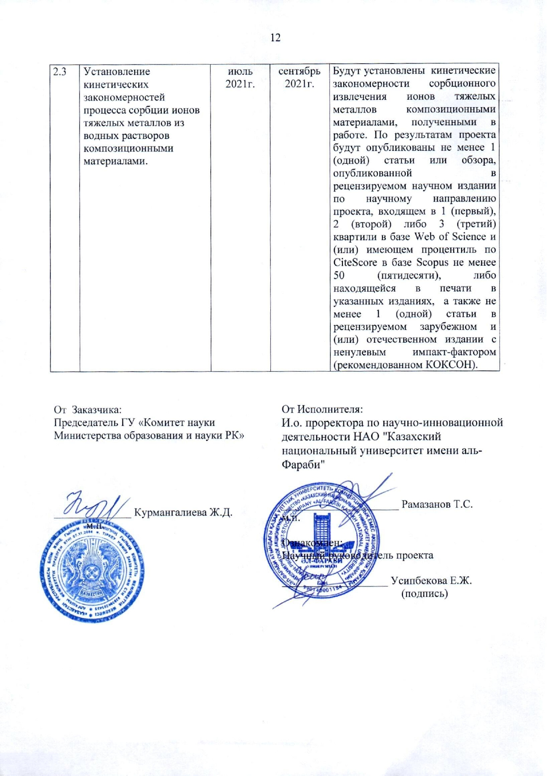

Application1.2

to this Agreement

No. 299 from «16» November 2020 year

**CALENDAR PLAN**

1. **NON-PROFIT JOINT-STOCK COMPANY "AL-FARABI KAZAKH NATIONAL UNIVERSITY"**

**1.1** By priority: 8. Scientific researches in the field of natural sciences

**1.2** By sub-priority: 8.3. Basic and applied research in the field of chemistry

**1.3** On the topic of the project: IRN AP08957166 "Physico-chemical regularities of heavy metal ions sorption extraction by composites based on mineral and plant materials"

**1.4** The total amount of the project is 5,000,000 (five million) tenge, including a breakdown by years, for the performance of work in accordance with paragraph 3:

- for 2020 - in the amount of 3,000,000 (three million) tenge;

- for 2021 - in the amount of 2,000,000 (two million) tenge.

**2. Characteristics of scientific and technical products by qualification characteristics and economic indicators**

**2.1** Direction of work: basic research in the field of chemistry

**2.2** Field of application: metallurgical and chemical industry.

**2.3** Final result:

- for 2020: the optimal conditions for the sorption of heavy metal ions from aqueous solutions by composite materials based on mineral raw materials will be determined.

- for 2021: the physicochemical patterns of the sorption process of heavy metal ions by composite materials based on mineral and plant raw materials will be established. At least 1 (one) article or review will be published based on the project results , published in a peer-reviewed scientific publication in the scientific direction of the project, included in 1 (first), 2 (second) or 3 (third) quartiles in the Web of Science database and (or ) having a CiteScore percentile in the Scopus database of at least 50 (fifty), or in print in the indicated editions, as well as at least 1 (one) article in a peer-reviewed foreign and (or) domestic edition with a non-zero impact factor (recommended by CCSES).

**2.4** Patentability: expected results are new and patentable.

**2.5** Scientific and technical level (novelty): the scientific novelty of this Project lies in the establishment of physicochemical regularities of the adsorption of heavy metal ions by various groups of new sorbents (mineral and plant raw materials), which will make it possible to predict the efficiency and selectivity of the purification process of water bodies, as well as to determine the optimal conditions of the process.

**2.6** The use of scientific and technical products is carried out: the final products of the Project (sorbents) are used by enterprises of the metallurgical, chemical, food, agro-industries, printing houses; the established theoretical regularities of the adsorption process can be applied by researchers from all over the world working in the field of adsorption.

**2.7** Type of use of the result of scientific and (or) scientific and technical activities: enterprises of metallurgical, chemical, food, agro-industries, printing houses can use the final products of the Project (sorbents) to clean contaminated wastewater from heavy metal ions. The obtained theoretical regularities will make it possible to determine the optimal conditions for the process of adsorption of ions of heavy metals, which contributes to an increase in the level of technology for the purification of industrial wastewater.

**3. Name of work, terms of their implementation and results**

|  |  |  |  |  |  |  |  |  |
| --- | --- | --- | --- | --- | --- | --- | --- | --- |
| Code of task, stage | | Name of work under the Agreement and the main stages of its implementation \* | | Deadline \* | | | Expected Result \* | |
| start | | end |  | |
| **2020 year** | | | | | | | | |
| 1 | Establishment of optimal conditions for the sorption extraction of heavy metal ions by composite materials based on mineral raw materials | | October  2020 | | December  2020 | | | The optimal conditions for the sorption of heavy metal ions from aqueous solutions by composite materials based on mineral raw materials will be determined. |
| **2021 year** | | | | | | | | |
| 2 | Establishment of physicochemical regularities of the sorption process of heavy metal ions by composite materials based on mineral and plant raw materials. | | January  2021 | | Until 1 November  2021 | | | Physicochemical regularities of the process of sorption of heavy metal ions by composite materials based on mineral and plant raw materials will be established. |
| 2.1 | Establishment of optimal conditions for the sorption extraction of heavy metal ions by composite materials based on plant raw materials. | | January  2021 | | March  2021 | | | The optimal conditions for the sorption of heavy metal ions from aqueous solutions by composite materials based on plant raw materials will be determined. |
| 2.2 | Establishment of thermodynamic regularities of the sorption process of heavy metal ions from aqueous solutions by composite materials. | | April  2021 | | June  2021 | | | The thermodynamic regularities of the sorption extraction of heavy metal ions by composite materials obtained in this work will be established. |
| 2.3 | Establishment of kinetic regularities of the process of sorption of heavy metal ions from aqueous solutions by composite materials. | | July  2021 | | September 2021 | | | The kinetic regularities of the sorption extraction of heavy metal ions by composite materials obtained in this work will be established. At least 1 (one) article or review will be published based on the results of the project, published in a peer-reviewed scientific publication in the scientific direction of the project, included in 1 (first), 2 (second) or 3 (third) quartiles in the Web of Science database and (or ) having a CiteScore percentile in the Scopus database of at least 50 (fifty), or in print in the indicated editions, as well as at least 1 (one) article in a peer-reviewed foreign and (or) domestic edition with a non-zero impact factor (recommended by CCSES). |

|  |  |
| --- | --- |
| By customer:  Chairman of the State Institution "Science Committee of the Ministry of Education and Science of the Republic of Kazakhstan"  \_\_\_\_\_\_\_\_\_\_\_\_\_\_Kurmangalieva Zh.D.  s.p. | By executer:  Acting Vice-Rector for Scientific and Innovative Activities of the NJSC "Al-Farabi Kazakh National University"  \_\_\_\_\_\_\_\_\_\_\_\_\_\_\_\_\_\_\_\_\_ Ramazanov Т.S.  s.p.  Familiarized with:  Scientific supervisor of the project  \_\_\_\_\_\_\_\_\_\_\_\_\_\_\_\_\_\_\_ Ussipbekova Ye. Zh.  (signature) |

# **APPENDIX B**

**Reference on the results of research work execution**

**B.1 General information**

1.1 By priority: 8. Scientific researches in the field of natural sciences

1.2 By sub-priority: 8.3. Basic and applied research in the field of chemistry

1.3 On the topic: “Physico-chemical regularities of heavy metal ions sorption extraction by composites based on mineral and plant materials”

1.4 Scientific supervisor – PhD, Ussipbekova Ye.Zh.

**B.2 Workforce**

|  |  |
| --- | --- |
| Indicators | For 2021 |
| Total project participants | 5 |
| Of them: |  |
| Academicians of the NAS of the RK | — |
| Doctors of Science | 1 |
| Candidates of Science |  |
| Ph.D | 1 |
| scientists without a degree | — |
| Doctoral students | 1 |
| Graduate students | — |
| Ph.D students | 1 |
| Master students | 1 |
| Bachelors | — |
| Laboratory assistants | — |
| Technical staff |  |
|  | |
| up to 35 years old | 3 |
| 35-50 years old | 2 |
| 50-70 years old | — |

**B.3 Scientific publications**

|  |  |
| --- | --- |
| Indicators | For 2021 |
| Total number of publications, including: | 3 |
| Monographs in far abroad | — |
| Monographs in the CIS countries | — |
| Monographs in the RK | — |
| Textbooks and tutorials | — |
|  | |
| Articles in journals from far abroad | 1 |
| Articles in journals of CIS countries | — |
| Articles in the rating editions of the RK recognized by the CQAES | 2 |
| Articles in journals of the RK that are not included in the rating editions | — |
| Articles in international conference proceedings of far abroad | — |
| Articles in international conference proceedings of CIS countries | — |
| Articles in international conference proceedings of the RK | — |
| Articles in republican conference proceedings | — |
| Protection titles | — |
|  | |
| Theses in international conference proceedings of far abroad | — |
| Theses in international conference proceedings of CIS countries | — |
| Theses in international conference proceedings of the RK | — |
| Theses in republican conference proceedings | — |

Scientific and organizational activities in 2021.

Articles indexed on the Scopus database:

1. Rakhym A.B., Seilkhanova G.A., Kurmanbayeva T.S., Mastai Y. Ussipbekova Ye. Zh. Isotherm, kinetic and thermodynamic studies for adsorption of lead (II) ions onto natural zeolite and Chamotte Clay // Water, Air, & Soil Pollution (IF = 2.52, Q2, 64%) (submitted)

Articles in the rating editions of the RK recognized by the CQAES:

1. Ussipbekova Ye.Zh., Zhagiparova A.D., Rakhym A.B., Kenessova A.K., Seilkhanova G.A., Osmanzhan G.O. Issledovanie adsorbczii ionov medi i czinka sorbentami na osnove rastitel`ny`kh otkhodov – zhmy`kha i luzgi semyan podsolnukha [ Investigation of the adsorption of copper and zinc ions by sorbents based on plant waste - cake and husk of sunflower seeds] // Vestnik KazNU. Seriya e`kologicheskaya. - 2021. - Vol. 2, Is. 67. - P. 22–30. (in Russian)
2. Baranchiyeva Z.E, Seilkhanova G.A. , Rakhym A.B. , Mastai Yitzhak , Ussipbekova Ye.Zh. Adsorption of Pb(II) and Cd(II) from aqueous solutions on polyvinylpyrrolidone modified Kyzylsok natural clay // International Journal of Biology and Chemistry. – V.14. – Is.1. – 2021. – pp. 164-171. <https://doi.org/10.26577/ijbch.2021.v14.i1.018>

**B.4 Training**

Within the framework of this project, PhD doctoral student in the specialty "6D060600 – Chemistry", Rakhym A.B., carries out her dissertation thesis on the topic "Physico-chemical and applied characteristics of new composites based on natural and technogenic raw materials"

Within the framework of this project, master’s student in the specialty "7M05301 – Chemistry", Kurmanbayeva T.S., carries out her dissertation thesis on the topic " Development of sorption materials based on chamotte clay in the "core-shell" type for the treatment of water bodies"

# **APPENDIX C**

**Description of methodologies for obtaining sorbents and for determination of physicochemical and sorption characteristics**

**C.1 Methodology of obtaining sorbents**

1.1 Methodology of obtaining composite materials based on ChC and SLES

The modification of the original ChC was carried out as follows:

- SLES solutions of the following concentrations: 0.5 CMC; 1 CMC; 2 CMC; 10 CMC; 20 CMC; 50 CMC; 100 CMC (1 CMC = 5 \* 10-4 mol/L) were prepared;

- weighed portions of the original ChC of 10.0 g were placed in flat-bottomed flasks with a capacity of 250 cm3;

- 100 cm3 of prepared SLES solutions was poured into flasks; the contents of the flasks were stirred using a magnetic stirrer for 30 minutes at 200 r.p.m. and left for 24 hours at room temperature;

- the sorbent was separated from the solution and dried at t = 100-105 °C for 3-4 hours.

1.2 Methodology of obtaining composite materials based on KC and PVP

The modification of the original natural clay from the Kyzylsok deposit was carried out as follows:

- solutions of PVP concentrations of 1%, 0.5% and 0.1% were prepared;

- weighed portions of the original KC of 10.0 g were placed in flat-bottomed flasks with a capacity of 250 cm3;

- 100 cm3 of prepared PVP solutions was poured into flasks; the contents of the flasks were stirred using a magnetic stirrer for 30 minutes at 200 r.p.m. and left for 24 hours at room temperature;

- the sorbent was separated from the solution and dried at t = 100-105 °C for 1 hour, then left to air dry for 24 hours.

1.3 Methodology of obtaining sorbents based on SH and SC

SH and SC used in this work are waste products from the food industry. Before use, the SH and SC were washed with distilled water to remove dust and other contaminants, then the dried materials were ground and a fraction with a particle size less than 0.1 mm was taken using a sieve. SH was used in adsorption experiments in two forms: initial and ground.

To increase the sorption capacity of sorbents, modified SH and SC were obtained, particularly:

- carbonizates;

- carbonizates that have previously undergone acid treatment.

To obtain SH and SC carbonizates, the crushed and dried initial sorbents were incinerated in a muffle furnace for an hour at a temperature of 500-600 °C.

To obtain carbonizates treated with acid, a sample of SH or SC weighing 25 g was poured with 100 ml of 5% nitric acid solution, mixed until homogeneous state and left for 24 hours. Then the sorbent was washed several times with distilled water in order to remove acid residues and dried at a temperature of 120 °C for 3 hours. After that, the sorbent was burned in a muffle furnace for an hour at a temperature of 500-600 °C.

**C.2 Methodology for determining the physicochemical characteristics of the materials under study**

2.1 Determination of total porosity by acetone

To determine the total porosity with respect to acetone, the test material was placed in the cylinder by 10 cm3 along the mark, the same volume of acetone was added and weighed. The total porosity was determined from the absorption of acetone for 30 min at room temperature and calculated by the formula (1):

$Х=\frac{\left(m_{1}-m_{2 }\right)*100}{ρ*V}$ (1)

where m1 is the mass of the cylinder with material and acetone, g;

m2 is the mass of the cylinder with the original object, g;

ρ is the density of acetone, equal to 0.7908 g/cm3;

V is the volume of the sorbent, cm3.

2.2 Determination of adsorption activity by iodine

The determination of the adsorption activity by iodine was carried out according to the standard method. The sample was dried at 110-115 ºC in a drying oven to constant weight. 1 g of the dried sample was placed in a conical flask with a capacity of 250 cm3. 100 cm3 of solution of iodine in potassium iodide was added, closed with a stopper and shaken for 30 min. Then the solution was allowed to settle, carefully taken with a 10 cm3 Mohr pipette, placed in a 50 cm3 conical flask and titrated with sodium thiosulfate solution, adding starch solution at the end of the titration.

The adsorption activity of the sorbent for iodine in % was calculated by the formula (2):

$Х=\frac{\left(V_{1}-V_{2 }\right)*0,0127*100*100\%}{10*m}$ (2)

where V1 is the volume of sodium thiosulfate solution with a concentration of exactly 0.1 mol/dm3 (0.1N), consumed for titration of 10 cm3 of iodine solution in potassium iodide, cm3;

V2 is the volume of sodium thiosulfate solution with a concentration of exactly 0.1 mol/dm3 (0.1n), consumed for titration of 10 cm3 of a solution of iodine in potassium iodide after treatment with a sorbent, cm3;

0.0127 is the mass of iodine corresponding to 1 cm3 of sodium thiosulfate solution exactly 0.1 mol/dm3 (0.1n), g;

100 is the volume of iodine solution in potassium iodide taken for clarification with sorbent, cm3;

10 is the volume of iodine solution in potassium iodide taken for titration, cm3;

m is the weight of the sample of the sorbent, g.

The arithmetic mean of three analyzes was taken as the result.

2.3 Investigation of the characteristics of objects by physical and chemical methods

A high-resolution scanning electron microscope FEI 400 Magellan, USA, was used to study the morphology of obtained materials. Particle size distribution was studied by processing SEM images using ImageJ software (FIJI). Elemental analysis was performed using the same equipment by Energy Dispersive X-Ray Spectroscopy (EDAX).

FTIR spectra were obtained by Perkin Elmer Spectrum 65 spectrometer using KBr method in the IR region 4000-400 cm-1  at 4 cm-1 resolution.

XRD patterns of the samples were investigated in the two-theta range 10–80° at a step size of 0,05 using a Bruker D8 Advance diffractometer with Cu-Ka source at 40 kV and 40 mA.

The specific surface area and pore volume of the samples were determined by nitrogen sorption to its relative pressure of 0.2 atm. at -196°C, on a Quantachrome Nova 4200e device.

The cation-exchange capacity (CEC) was determined by the standard NH4Cl method. 1 g of sample was mixed with 100 mL of 1 MNH4Cl solution. Suspensions were left for 24 h with periodic shaking and centrifuged, and concentrations of Ca2+, Mg2+, Na+ and K+ were determined using an atomic absorption spectrometer (Shimadzu 6200, Japan). The CEC was calculated by taking the sum of the concentrations of the released cations and expressed in meq/100 g using the following equation:

Mmeq/100g = Cppm / (eq.wt. × 10) (3)

where Mmeq/100g is the concentration of released cation in meq/100 g, Cppm is the concentration of released cation in mg/L, and eq.wt. is the equivalent weight of released cation – the atomic mass multiplied by its equivalence factor.

**C.3 Technique for studying the process of sorption of ions of heavy metals**

The ability of the obtained composite materials to adsorb HM ions was studied at room temperature under static conditions. For this, the following solutions containing metal ions of various concentrations were prepared:

- lead nitrate solution;

- cadmium chloride solution;

- copper chloride solution;

- zinc chloride solution.

1 g of the test material was placed in a beaker, 100 cm3 of each of the indicated solutions was poured in and stirred with a magnetic stirrer at 200 rpm at room temperature (25 ± 5) ºC until equilibrium was established. The onset of equilibrium was determined from the curves of the change in the adsorption capacity versus the time of interaction of the material sample under study with the solution.

The degree of extraction E (%) was calculated using the formula (4):

$E=\frac{c_{0}-c_{e}}{с_{0}}*100\%$ (4)

where C0 and Ce are the initial and residual sorbate concentrations, mg/L, respectively.

The initial and residual metal concentrations were determined using a Shimadzu 6200 atomic absorption spectrophotometer. The results were processed using the ORIGIN Pro 8 software.

To study the thermodynamic characteristics, the process was carried out at several temperatures, which were controlled using a thermostat.

To study the kinetic characteristics in the process of adsorption, aliquots of solutions were taken at certain time intervals. The total volume of the selected aliquots was less than 7% of the total solution volume.

# **APPENDIX D**

**Formulas for calculating kinetic and thermodynamic parameters of sorption**

**D.1 Formulas for calculating the thermodynamic characteristics of the adsorption process**

The following equations (1-3) were used to calculate the thermodynamic parameters:

${ΔG}^{0}= -RTlnK_{d}$ (1)

Where ΔG0 is the standard change in Gibbs free energy, J/mol; R (8.314 J/mol\*K) is the gas constant; T is temperature, K; and Kd is the distribution coefficient for the adsorption process, which is calculated as:

${ K}_{d}=\frac{q_{e}}{c_{e}}$ (2)

The isosteric change in enthalpy ΔH0 and the change in entropy ΔS0 were obtained from the slope and intersection of the linear graph of lnKd versus 1/T:

$lnK_{d}= -\frac{{ΔH}^{0}}{RT}+\frac{{ΔS}^{0}}{R}$ (3)

**D.2 Formulas for applying adsorption isotherm models**

The linear form of the Langmuir equation (4) can be written as:

$\frac{C_{e}}{q_{e}}= \frac{1}{K_{L}∙q_{m}}+\frac{1}{q_{m}}C_{e}$ (4)

where qe is the number of metal ions adsorbed on the solid at equilibrium (mg/kg), Ce is the equilibrium concentration of the liquid (mg/L), qm is the adsorption capacity or maximum adsorption (mg/g), KL is the adsorption rate or Langmuir coefficient ( L/mg).

The Freundlich isotherm is the earliest known experimental equation describing the sorption of material on animal charcoal. This isotherm can be applied to non-ideal sorption on heterogeneous surfaces as well as multilayer sorption. This is expressed by the following equation (5):

${lnC}_{s}= {lnK}_{F}+\frac{1}{n_{f}}{lnC}_{e}$ (5)

where Cs is the adsorbed solute (mg/g), Ce is the concentration of the solute in equilibrium (mg/L); KF is Freundlich's constant, nf is equilibrium constant.

**D.3 Formulas for applying kinetic adsorption models**

Most often in the literature, linear forms of equations are used (6-7 for pseudo-first and pseudo-second order models, respectively):

$\ln\left(q_{e}-q_{t}\right)=\ln{q_{e}-k_{1}t}$ (6)

$\frac{t}{q_{t}}= \frac{t}{q_{e}}+\frac{1}{k_{2}q_{e}^{2}}$ (7)

where k1 and k2 are pseudo-first and pseudo-second order rate constants, qt is the amount of adsorbed solute, qe is its value at equilibrium.