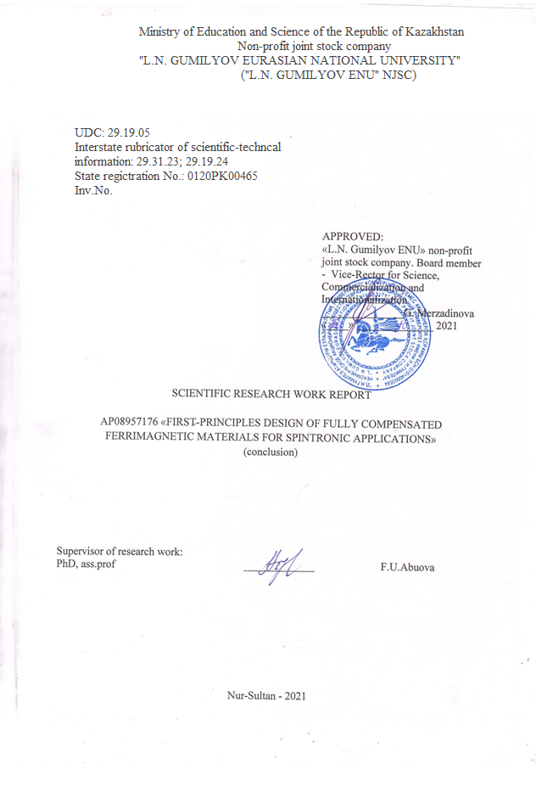

**РЕФЕРАТ**

Есеп 28 бет, 1 кітап, 6 сурет, 39 дерек көзі, 2 кесте, 2 қосымша.

ГЕЙСЛЕР ҚҰЙМАСЫ, ФЕРРОМАГНЕТИЗМ, ЭЛЕКТРОНДЫҚ ҚҰРЫЛЫМ, ТЫҒЫЗДЫҚТЫҢ ФУНКЦИОНАЛДЫҚ ТЕОРИЯ, СПИНТРОНИКА

Зерттеу нысаны - Mn2CoZ (Z = Al, Ga) типіндегі Гейслер қорытпалары, оларды спинтроникада қолдану үшін компенсацияланған ферримагнетиктерді құру негізі. Өтемделген ферримагниттер спинтрондық құрылғыларға арналған жаңа материалдар ретінде айтарлықтай қызығушылық тудырады, олар диполь өрістерін жасамайды және сыртқы магнит өрістеріне өздерінің ферромагниттік аналогтарымен салыстырғанда өте төзімді, сондықтан оларды құрылғыларда қолдану энергия шығынын едәуір азайтады.

Бұл жұмыстың мақсаты - магниттік құбылыстар мен спинтроника физикасындағы Гейслердің ішінара Co, V және басқа элементтермен алмастырылған кездегі Mn2CoGa қорытпаларындағы компенсацияланған ферримагнетиктердің құрылымдық, магниттік және электрондық қасиеттерінің олардың құрамына тәуелділігімен байланысты іргелі мәселені шешу.

Зерттеу әдістері. Бұл жұмыста есептеулер тығыздықтың функционалды теориясын (DFT) қолдану арқылы жүзеге асырылады. DFT әдісі берілген жүйеде ρ электрон тығыздығы мен оның электрон энергиясы арасында бір-біріне сәйкестік бар екендігі туралы Гохенберг - Кон теоремасына негізделген, демек, негізгі күйдегі электрондық энергия толығымен электрон тығыздығымен анықталады.

Негізгі жобалық-техникалық-экономикалық көрсеткіштер. Тәжірибелік және қолда бар теориялық мәліметтермен салыстыру қолданылған әдістердің дәлдігін көрсетті.

Іске асыру дәрежесі. Іске асыру күтілмейді

Тиімділік. Алынған мәліметтер Гейслердің Mn2CoGa қорытпасындағы Co-ны V және Ga мен Al мен Sb алмастырудың термодинамикалық тұрақтылық пен магниттік қасиеттерге әсерін алдын-ала бағалауға мүмкіндік береді. Сәйкес әсерлер осы жобада кейінірек егжей-тегжейлі зерттелетін болады.

Қолдану: Нәтижелердің мақсатты тұтынушылары күн батареялары мен оптоэлектрондық қондырғыларды дамытуда, сондай-ақ осы мақсаттарға жаңа материалдарды синтездеумен айналысатын ғалымдар, технологтар мен инженерлер болып табылады.

**ESSAY**

Report 29 pages, 1 book, 6 figures, 39 source, 2 tables, 2 appendices.

GEISLER ALLOY, FERROMAGNETISM, ELECTRONIC STRUCTURE, DENSITY FUNCTIONAL THEORY, SPINTRONICS

The object of research is Heusler alloys of the type Mn2CoZ (Z = Al, Ga) as a basis for creating compensated ferrimagnets for their use in spintronics. Compensated ferrimagnets are of considerable interest as new materials for spintronic devices, since they do not create dipole fields and are extremely resistant to external magnetic fields compared to their ferromagnetic counterparts. Thus, their use in devices significantly reduces energy losses.

The aim of this work is to solve a fundamental problem in the field of physics of magnetic phenomena and spintronics associated with the dependence of the structural, magnetic and electronic properties of compensated ferrimagnets in Heusler alloys Mn2CoZ on their composition with partial replacement of Co atoms by V.

Research methods. In this work, calculations will be performed using the density functional theory (DFT). Calculations of the structural and magnetic properties of the systems under study were performed using the VASP (Vienna Ab-initio Simulation Package). The exchange correlation potential was processed in the generalized gradient approximation (GGA) in the Perdew-Burke-Ernzerhof (PBE) form.

Basic design and technical and economic indicators. Comparison with experimental and available theoretical data showed good accuracy of the applied methods.

The degree of implementation. Implementation is not expected

Efficiency. The data obtained make it possible to preliminarily evaluate the effect of replacing Co atoms with V and Ga atoms with Al and Sb in Gesler's Mn2CoGa alloys on thermodynamic stability and magnetic properties. The corresponding effects will be investigated in detail later in the framework of this project.

Applications: The target consumers of the results are scientists, technologists and engineers working in the development of solar cells and optoelectronic units, as well as the synthesis of new materials for these purposes.

**CONTENT**

|  |  |
| --- | --- |
| INTRODUCTION...................................................................................................................... | 8 |
| THE MAIN PART ABOUT RESEARCH WORK..................................................................... | 9 |
| 1 Research methods.................................................................................................................... | 9 |
| 2 Results.................................................................................................................................... | 10 |
| 2.1 Calculation of the energy of the main state of the Heusler alloys Mn2Co0.5V0.5Ga and Mn2Co0.5V0.5Al with a change in chemical composition ………………….…… | 10 |
| 2.2 Calculation of the electronic structure of the most energetically advantageous Heusler alloys obtained ………………………………………………………………………. | 12 |
| 2.3 Numerical solution of transport equations for the studied structures depending on spin polarization ……………………………………………........................................... | 16 |
| CONCLUSION ……………………………………………………………………………… | 20 |
| REFERENCES............................................................. .............. .............. .............. .............. | 21 |
| APPENDIX A. List of published works ………………………………………......................... | 24 |
| APPENDIX B. Calendar plan for 2020-2021..……………………………...... .............. ........ | 25 |

**TERMS AND DEFINITIONS**

In this report about research work, the following terms are used with appropriate definitions.

|  |  |
| --- | --- |
| KOHN-SHAM ORBITALS | - in the theory of the density functional, one-electron wave functions are called, obtained as a result of solving the Schrodinger equation with a model effective potential for non-interacting particles, as a result of which the electron density of the system with interaction is reproduced. |
| PAW PSEUDOPOTENTIALS | - pseudopotentials used in calculations of *abinitioPAW* (projected attached waves) by the method, which is a generalization of the pseudopotential method and the method of linearized attached plane waves. |
| DENSITY FUNCTIONAL THEORY | - a method for calculating the electronic structure of systems of many particles in quantum physics and quantum chemistry. It is used to calculate the electronic structure of molecules and condensed matter. |

**INTRODUCTION**

In recent years, Heusler alloys have been studied extensively because of their diverse magnetic phenomena. [1] Among them, Mn-based Heusler alloys have attracted much attention due to their unique properties and potential applications in many technological areas. One of the essential applications of Mn-based Heusler alloys is their use in the field of spintronics - the field of electronics, where the transfer of energy and information is carried out not by an electric current but by a current of spins. Until now, it has been reported that quite a few Mn-based Heusler alloys are half-metals or spin-gapless semiconductors (SGS) [3 ,4, 5, 6, 6]. Half-metallic materials exhibit high spin polarization reaching 100% near the Fermi level (*E*F). These properties allow us to consider them as materials for magnetic sensors or non-volatile random-access memory devices [7]. Thus, their use in devices significantly reduces the energy loss [8].

The SGS are an intermediate state between the well-known half-metallic ferromagnets and gapless semiconductors. In SGS, one spin channel has an open bandgap near *E*F, like a half-metal, and the other spin channel has a zero bandgap, like in a gapless semiconductor. Thus, conducting electrons or holes are not only 100% spin-polarized but can easily be transferred to an excited state. Among these Mn-based Heusler alloys, Mn2CoZ (Z = Al, Ga) are of particular interest since they are not only theoretically predicted as half-metals/SGS but can also be realized experimentally [2, 3, 10, 11].

In 2020, according to this project, a number of compounds of the Heuser alloy Mn2Co1-xVxZ (Z=Al,Ga) were studied by first-principle methods. Changes in the magnetic moment on atoms depending on the chemical composition are investigated. To explain the results obtained, a topological analysis of the charge distribution on ions was carried out. It is shown that changes in magnetic properties are determined by the charge states of the ions of the system. The property that determines the difference between the electronic properties of the studied Al and Ga containing Heusler alloys is revealed, which is that Al ions, unlike Ga ions, do not change their charge state as the relative content of Co and V in the compounds changes.

**THE MAIN PART ABOUT RESEARCH WORK**

**1 Research methods**

Mn2Co1-xVxZ (Z = Al, Ga) Heusler alloy for the case of *L*21 and XA structures density functional theory (DFT) with periodic boundary conditions using projector-augmented wave (PAW) [25] method and Perdew-Burke-Ernzerhof (PBE) functional [26] were performed using the ab initio total energy and molecular dynamics program VASP (Vienna Ab initio Simulation Package) [27,28,29]. All calculations were performed with the 4×4×4 Monkhorst–Pack k-points sampling and 500 eV cut-off energy. The convergence tolerance for the calculations was chosen as the difference in total energy within 10-6 eV / atom. The following electronic configurations were used for the pseudopotentials: Mn (3*p*63*𝑑*54*𝑠*2), Co (3*𝑑*74*𝑠*2), V (3*s*23*p*63*d*34*s*2), Ga (3*𝑠*23*𝑝*13*d*10), Al (3𝑠23𝑝 1), respectively. All calculations were performed using 2×2×2 supercells of the XA and *L2*1 structures, consisting of 128 atoms. Magnetic moments were computed using DDEC6 formalism [30,31].

**2 Results**

**2.1 Calculation of the energy of the main state of the Heusler alloys Mn2Co0.5V0.5Ga and Mn2Co0.5V0.5Al with a change in chemical composition**

Heusler alloys X2YZ (X~~,~~ Y are transition metals, Z is a chemical element from the main group) crystallize in a cubic structure of the Cu2MnAl-type (*L*21 structure, space group *Fm $\overline{3}$ m*), which has four interpenetrating *fcc* sublattices, namely A, B, C, and D with X, Y, and Z atoms occupying Wyckoff positions 8*c* (0.25.0.25.0.25), 4*b* (0.5.0.5.0.5), and 4*a* (0, 0, 0), respectively. The X atoms are equally occupied in the A and C sublattices. The Y and Z atoms occupy B and D sublattices, respectively. Apart from the usual Cu2MnAl structure, Heusler alloys also crystallize in a structure of the Hg2CuTi-type, commonly known as the inverse Heusler structure (XA structure, space group *F $\overline{4}$*3*m*). The main difference of this structure from the conventional *L*21 structure is the interchange between X atoms in the C sublattice and Y atoms in the B sublattice. These structural models are shown in Figure 1 for the case of X = Mn and Y = Co.

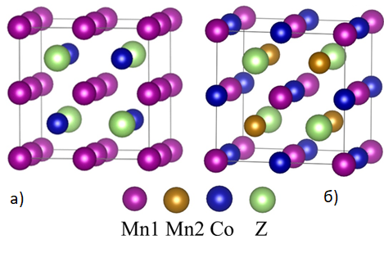

Figure 1 - Unit cells of the Heusler alloys Mn2CoZ of structure (a) *L*21 and (b) XA

It was shown [12], that the Heusler alloy Mn2CoAl has the electronic structure of SGS that is stable against tetragonal lattice distortions. However, it transforms into a semi-metallic state with an excess of Co or atomic swaps even between sites with different local symmetry. In the case of Mn2CoAl, the doping decreases the bandgap while an increase in the bandgap is noticed for Mn2CoGa. The half-metallicity is destroyed in both cases when the doping level is beyond a certain degree [12]. Despite numerous studies devoted to the electronic structure and magnetic properties of Heusler alloys, this problem remains not fully disclosed.

Recently, the existence of several fully compensated ferrimagnets in the Mn-Co-V-Al, Mn-Co-V-Si, and Mn-Co-V-Ga systems was predicted theoretically [13,14]. Some of the predicted half-metallic ferrimagnets Mn2-xCoxVAl were synthesized and studied [15,16]. The main drawback of these alloys is a low Curie temperature, which is an obstacle to the use of alloys in spintronics. For example, for the composition MnCoVAl, the Curie temperature *T*C is 105 K [17,18]. More suitable for the use as a spintronic material is Mn1.5FeV0.5Al with a Curie temperature *T*C = 355 K and almost 100% spin polarization [19]. The highest Curie temperatures were achieved for the Mn-Co-V-Ga system, exceeding 690 K for the Mn2V1-xCoxGa compositions (x = 0; 0.25; 0.5; 0.75; 1). The reported values of *T*C are the highest among the Mn2V-based fully compensated ferrimagnets.

Compensation of the magnetic moment without a significant decrease in *T*C indicates that the substitution of Co for V does not weaken the exchange interaction in the Mn2VGa alloys [19]. On the other hand, substitution of Co for Mn leads to a decrease in the Curie temperature in Mn2-xCoxVGa alloys (x=0.5; 0.75; 1) up to 171 K for MnCoVGa composition. In the mean-field approximation, it was found that the antiferromagnetic Mn-V exchange interaction is the strongest interaction and makes a larger contribution to the Curie temperature than ferromagnetic Mn-Mn and V-V exchange interaction [20]. In the Mn2-xCoxVGa alloys, Curie temperature correlates with the total magnetic moment. With an increase in cobalt concentration, the total magnetic moment per formula unit decreases, which is accompanied by a decrease in *T*C. Consequently, Curie temperature for Co2VGa is almost 300 K lower than that for Mn2VGa. [21] Such a low magnetic ordering temperature of Co2VGa as compared to that of Mn2VGa is a consequence of a weak ferromagnetic interaction between Co and V atoms as compared to the strong antiferromagnetic interaction between Mn and V.

Combined study by neutron diffraction measurements and ab initio calculations revealed the crystal structure and magnetic configuration of the Mn2Co1-xVxZ (Z = Al, Ga) alloy. The neutron diffraction data and detailed ab initio studies confirmed the *L*21 structure for Mn2VGa and the XA structure for Mn2CoGa. It was found that alloys with a high V concentration have ~~an~~ the *L*21 structure. When the Co concentration reaches 75%, a transition from *L*21 to XA was observed [22]. When the content of Co in the substance is higher than 75%, the lattice constants change nonlinearly. With an equal Co and V atoms content, almost complete compensation of the magnetic moment (0.1 μB / f.u.) was found due to the ferrimagnetic coupling of Mn with V and Co [23].

Powder neutron diffraction experiments suggested that in Heusler Mn2CoGa the atomic arrangement can be described by the so-called *L*21b -type structure rather than by the XA structure [24]. The *L*21b-type structure is equivalent to the *L*21-type structure, where a partial disorder exists between Co and Mn atoms. In this case, the atomic configuration becomes “(Mn, Co), Mn, (Mn, Co), and Z.” The magnetic moments obtained experimentally were in good agreement with the theoretical values in the model of the *L*21b structure. At the same time, the calculations showed that the *L*21b structure is metastable with respect to the XA structure [24].

In present work, we theoretically investigate the effect of substitution of Co for V on structural, magnetic, and electronic properties of Mn2Co1-xVxZ (Z = Al, Ga) Heusler alloy for the case of *L*21 and XA structures.

**2.2 Calculation of the electronic structure of the most energetically advantageous Heusler alloys obtained**

In total, the unit cell of X2YZ contains four structural units. In this case, the XA symmetry cell contains two symmetrically nonequivalent atoms X (Mn), which we further denote as Mn1 (Mn2). These atoms differ in their nearest environment. Mn1 atoms are surrounded by 4 Y atoms and 4 Z atoms, while Mn2 atoms are surrounded by 4 Y atoms, 4 Z atoms, and 4 Mn1 atoms. This difference in the local environment determines the difference in the physical properties of the Mn1 and Mn2 atoms. In the *L2*1 symmetry lattice, the X atoms are equivalent and are surrounded by 4 Y and 4 Z atoms. The Y and Z atoms are in the center of the cubes formed by the X atoms. In the XA lattice, the Y atoms are surrounded by 4 Mn2 atoms and 4 Z atoms, while the Z atoms are surrounded by 4 atoms Mn1 and 4 atoms Y.

We simulated the properties of Mn2Co1-xVxZ alloys when V atoms replace Co. Preliminary calculations have showed that when replacing Co atoms with V, it is energetically more favorable to arrange them at the most distant distances from each other. For this reason, the replacement of atoms was carried out randomly so that the average distance between the replacement atoms was maximized.

Comparison of the ground state energies ΔE= E(L21)-E(XA) of the considered crystalline modifications of the Mn2Co1-xVxZ compound (figure 2) showed the presence of a phase transition near x = 0.5. At low x, the XA structure is more energetically favorable, while the L21 is more stable at high V concentrations. This result is in good agreement with the experimental data [22].

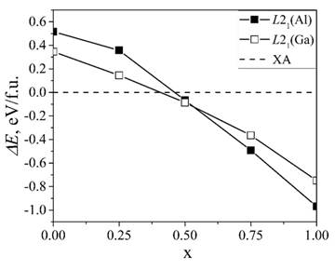

Figure 2 -The ground state energies for the XA and L21 structures in the the Mn2Co1-xVxZ compositions as a function of V concentration x

The transition from one to another structure is explained by the difference in the energies of crystal formation (Eform) for modifications of the crystal structure. For the Heusler X2YZ alloys the Eform values were calculated by the formula

Eform(X2YZ) = Etot - (2E(X) + E(Y) + E(Z)) (1)

The data obtained for the end cases x = 0 and x = 1, of the Mn2Co1-xVxZ compounds are shown in Table 1. It can be seen that Co-containing alloys are more stable in the crystalline modification of the XA type, while the V-containing ones are more stable in the crystalline modification of the L21 type.

To explain this trend, we calculated an electron-localization function (ELF) to study the change in the nature of chemical bonds when replacing Co with V. The ELF is a ground-state property that is useful to visualize and distinguish between different bonding interactions in solids [32].

In regions with higher ELF values, the electrons tend to become paired, which indicates the covalent character of the bonding between the nearest-neighbor atoms in this intermetallic compound [34,33,34]. Figure 3 shows the ELF projections in the (110) plane for the Heusler alloys Mn2Co1-xVxZ (Z = Ga, Al) for x = 0 and x = 1 in the case of XA (аig. 3, left) and L21 (аig. 3, right) structures.

Table 1 - Energies of crystal formation

|  |  |  |  |
| --- | --- | --- | --- |
| Compound | *E*form, eV/atom | | Reference |
| XA | *L2*1 |
| Mn2CoGa | -0.211  -0.192 | -0.127 | Present work  [11] |
| Mn2CoAl | -0.319  -0.286 | -0.190 | Present work  [11] |
| Mn2VGa | -0.080 | -0.267 | Present work |
| Mn2Val | -0.117 | -0.358 | Present work |

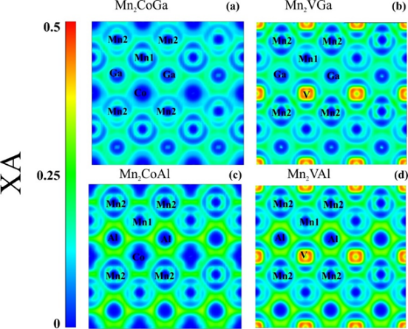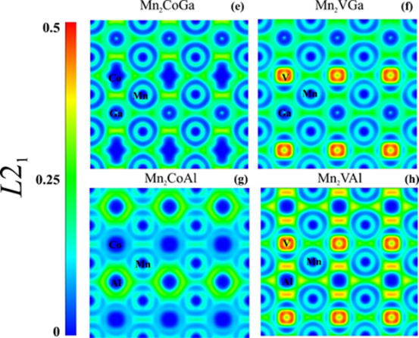

Figure 3 - Calculated ELF in the (110) plane of Mn2CoGa, Mn2VGa, Mn2CoAl, and Mn2VAl of XA (left) and L21 (right) structures

Replacing Co with V leads to an increase in ELF, which means an increase in the covalent nature of the chemical bond between the elements (compare fig. 3a and 3b; 3c and 3d; 3e and 3f; 3g and 3h). Strengthening the covalent bond should lead to an increase in the stability of the compounds. A competing effect leading to the destabilization of alloys is an increase in the degree of polarity of the covalent bond. An effect of this kind was found in the Mn2CoGa alloy when the Ga atoms were replaced by Ti, V, Cr, and Ni [34]. The relatively high ELF values ​​around atoms serve as an indicator of an increase in the polarity of the covalent bond. [34] In our case, high ELF values ​​were found near V atoms. Thus, on the one hand, the substitution of V for Co atoms leads to an increase in the degree of covalence of chemical bonds in Heusler alloys, stabilizing the crystal lattices. On the other hand, the strong polarity of the covalent bond of V atoms with neighboring atoms leads to the destabilization of the crystal lattices. The crystal structures realized are the result of a compromise between these two trends.

The lattice parameters of the L21 and XA structures of the Mn2Co1-xVxZ compound behave differently depending on the V concentration (figure 4).

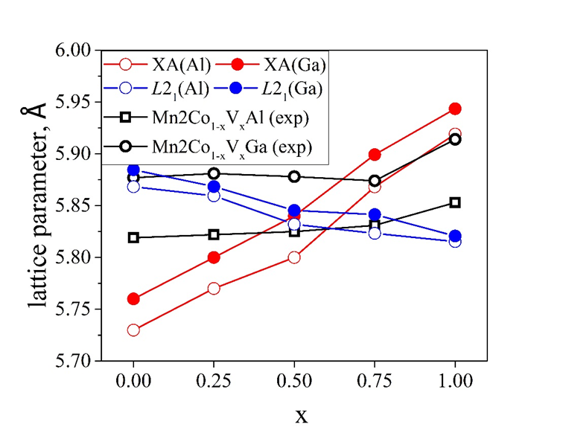

Figure 4 - The calculated values of the lattice constants of the Mn2Co1-xVxZ (Z = Ga, Al) compounds for the case of the L21 and XA structures. Experimental data are adopted from Ref. [20]

It can be seen that the XA structure is characterized by a linear increase in the lattice constants with increasing x. In the L21 structure, an increase in the V concentration leads to a slight decrease in the lattice parameters. A nonlinear dependence of the lattice constants was observed experimentally [20]. There, the crystal lattice was identified, rather, as the structure L21. In another experiment, the XA structure was detected at x <0.75 [22]. Thus, although a good qualitative agreement between theory and experiment was obtained for the lattice parameter in the region of V concentration x ≥ 0.75, it should be noticed that in this region of x the XA structure should theoretically be observed while the experiment poined to the L21 structure. This contradiction indicates that this issue requires further study. The authors of [22,22] point out the difficulties in identifying the crystal structure associated with determining the arrangement of atoms in the lattices. In addition, the samples can represent a mixture of the L21 and XA structures, one of which can be metastable. From the point of view of theory, it is also necessary to take into account the possibility of considering not only the disorder at the Co-V sites but also the other types of disorder.

**2.3 Numerical solution of transport equations for the studied structures depending on spin polarization**

The results of calculating the average values of the magnetic moment on atoms of various types in the Heusler alloys Mn2Co1-xVxZ (Z = Ga, Al) for the case of the L21 and XA structures are shown in Figure 5. The magnetic moment values at x = 0, 0.25, and 1 are in good agreement with the known literature data.

In the case of the L21 ordering, as Co is replaced by V, the absolute values of the magnetic moments on the Mn and V atoms decrease, which is accompanied by an increase in the magnetic moments on the remaining Co atoms (figure 5 a, b). The values of the magnetic moments on the Mn and V atoms at x = 0 are almost 2 times larger than the corresponding values for x = 1. On the Mn and Co atoms, the direction of the magnetic moments is the same, while the moments on the V atoms have the opposite direction.

As compared with the L21 structure, the values of the magnetic moments on the atoms inthe XA structure change much weaker with the increase in V content. Magnetic moment~~s~~ at the Mn1 atoms undergoes the most remarkable change. The absolute value of the magnetic moment increases at x = 1 by approximately 0.8 μB in the x = 1 composition as compared to the corresponding value in the x = 0 composition. In this case, the magnetic moments on the Mn1 and V atoms are parallel, and the moments on the Mn2 and Co atoms have opposite direction. (Figures 5c, d)

The presence of two types of Mn atoms in the XA-type lattice, which have the opposite direction of the magnetic moment, determines the difference in the magnetic properties of these crystalline modifications. The calculated values ​​of the total magnetic moment of the XA and L21 structures are shown in table 2.

The value of the total magnetic moment in the XA ordering obeys the Slater-Pauling rule (S-P rule) [35]. According to this rule, the total magnetic moment in half-metallic Heusler alloys can be found by the formula Mt = Zt - 24, where Zt is the total number of valence electrons per unit cell, and Mt is the total magnetic moment per formula unit. The value of the total magnetic moment of the L21-type lattices does not obey this rule due to the ferromagnetic coupling of the Mn and Co atoms, except the case x = 1. The decrease in the value of the total magnetic moment with increasing x occurs due to the contribution of the antiferromagnetically coupled spins of the V atoms. In contrast to the L21 structure, the spins of Mn1-V and Mn2-Co atom pairs in the XA structure have the opposite direction. In order to make the Mn2Co1-xVxZ compositions obeying the S-P rule in the L21 structure, it is necessary to take into account the disordering of pairs of Mn-Co atoms, i.e., to consider the structure L21b. [24,36] Taking this kind of disordering into account is beyond the scope of this work.

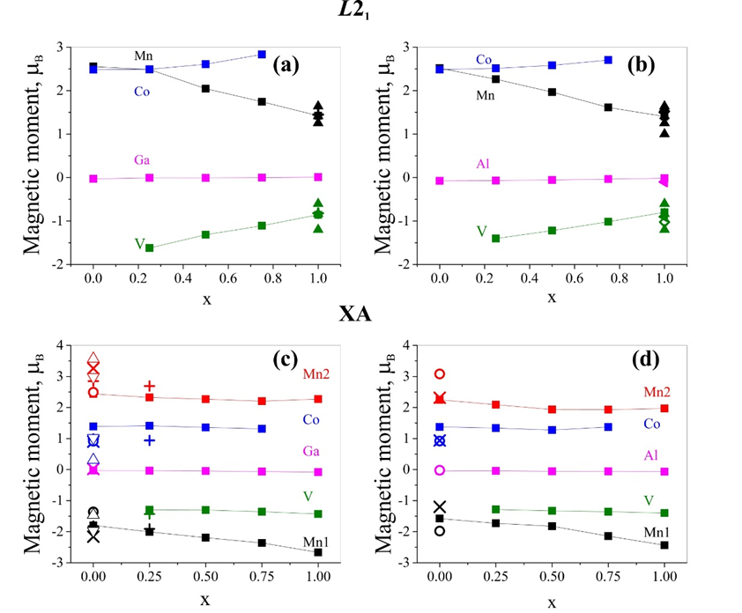

Figure 5 - Average values of magnetic moment on atoms calculated by the DDEC6 method on atoms of the Heusler alloy Mn2Co1-xVxZ of the L21 structure (a) Z=Ga, (b) Z=Al and XA structure (c) Z=Ga, (d) Z=Al. Literature data are given for comparison: × - Ref. [2], ○ – Ref.[ 13], + - Ref. [22], Δ – Ref. [24](theory), ∇ - Ref. [24] (experiment). ◄[2], ● [35], ◊- [37], ▲ - [38]

Electronic properties.Figure 6 shows the calculated electronic densities of states for the Heusler alloys Mn2Co1-xVxZ (Z = Ga, Al) of the ХА structure for various x values.

Since our theroretical consideration indicated that in the L21 type ordering there is no compensation of the magnetic moment required for practical applications, we do not investigate the dependence of the electronic structure of these compounds for the case of L21 ordering. The electronic structure of Mn2VAl and Mn2VGa for the case of L21 ordering was studied in Ref. [2], and [38], respectively.

According to our calculations (figure 6), Mn2CoGa is a half-metal, while Mn2CoAl is SGS, which is consistent with previous studies [10,11,12,39]. As in the case of replacement of the Z element by Fe or Cr [12], the replacement of Co by V destroys the SGS state of Mn2CoAl and its electronic structure becomes half-metallic. As x increases to 0.5, the density of states of spin-up electrons near the Fermi level increases and is formed due to the electronic states on Mn1, Mn2, and V atoms. In this case, the fraction of states near EF on the V atoms increases.

Table 2- Total magnetic moment calculated for the L21 and XA structures of the Mn2Co1-xVxZ (Z = Al, Ga) Heusler alloy

|  |  |  |  |
| --- | --- | --- | --- |
| Z | x | Total magnetic moment per formula unit, μB/f.u. | |
| XA structure | *L*21 structure |
| Ga | 0 | 2.00(a), 2.05(b), 2(c), 1.99(d) | 7.71(a), 7.68(d) |
| 0.25 | 1.00(a), 1.11(b), 1(c) | 6.43(a) |
| 0.5 | 0.06(a), 0.1(b), 0(c) | 4.73(a) |
| 0.75 | 1.05(a), 0.97(b), 1(c) | 3.36(a) |
| 1 | 2.01(a), 1.8(b), 2(c) | 1.98(a) |
| Al | 0 | 2.00(a), 2.06(b), 2(c) | 7.44(a) |
| 0.25 | 1.00(a), 1.09(b),1(c) | 5.99(a) |
| 0.5 | 0.06(a), 0.06(b), 0(c) | 4.56(a) |
| 0.75 | 0.93(a), 0.99(b), 1(c) | 3.11(a) |
| 1 | 1.94(a), 1.863(b), 2(c) | 2.00(a) |

1. – present work, (b) – experimental data from Ref. [12], (c) – S-P rule, (d) – theoretical data from Ref. [24]

In the Mn2CoGa compound, the replacement of Co by V leads to a change in the electronic structure towards an enhancement of the half-metallic properties. As x grows, the DOS minimum at x = 0 near the Fermi level is gradually replaced by a peak. DOS near the Fermi level for the spin-up states, as in the case of Mn2CoAl, is formed by the states on Mn1, Mn2, and V atoms with an increase in the fraction of states on V atoms as x increases. In all the cases considered, the energy gap for spin-down states when Co atoms are replaced by V is filled with d-states on Mn1 and V.

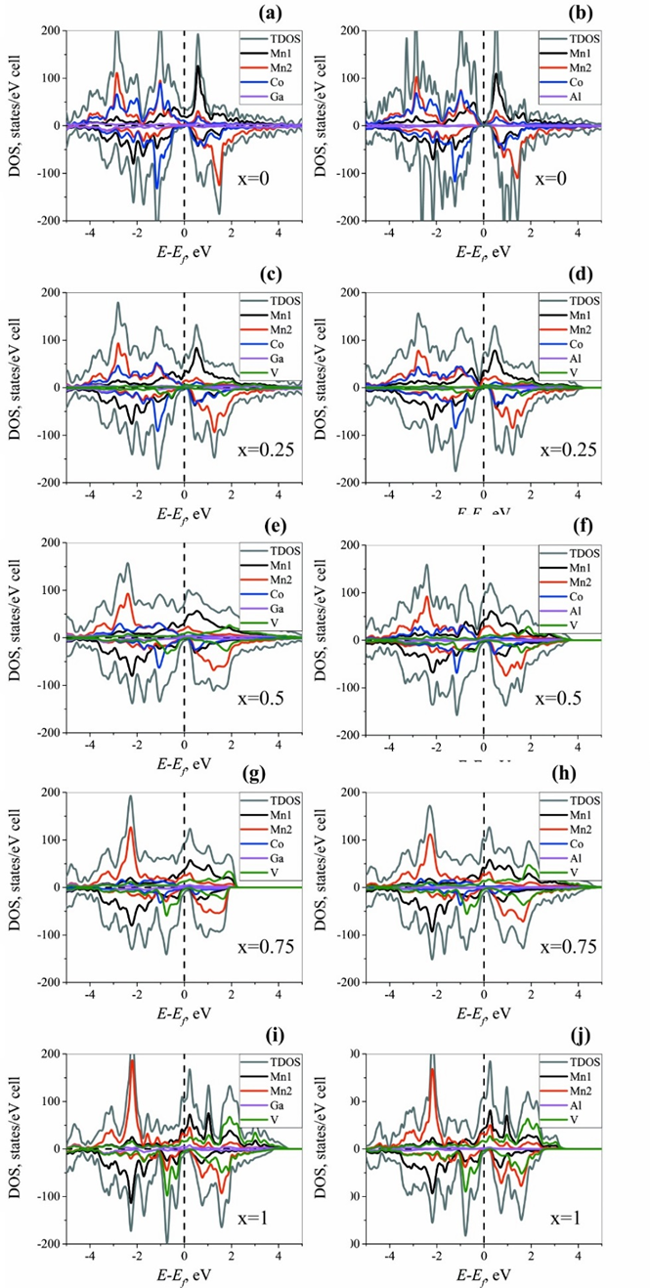

Figure 6 - Electronic DOS of the Mn2Co1-xVxZ (Z = Ga, Al) Heusler alloys for the case of the XA structure

**CONCLUSION**

This paper presents the results of DFT studies of ~~the~~ structural, electronic, and magnetic properties of Heusler alloys Mn2Co1-xVxZ (Z = Ga, Al, x = 0, 0.25, 0.5, 0.75, 1) for the case of L21 and XA structures. It is shown that ~~at~~ for x = 0, the XA structure is more stable, while ~~at~~ for x = 1 the stable is the L21 structure. A transition from one to another type of oredring occurs near x = 0.5. Depending on the degree of Co substitution for V, the lattice constants of the L21 and XA structures change in different ways, explaining the experimentally observed trends of the lattice constants. Almost complete compensation of the magnetic moment was achieved in the Mn2Co0.5V0.5Z (Z=Al,Ga) composition for the case of the ХА structure. The compensated magnetic moment for these alloys is 0.06 μB/f.u. The calculated values ​​of the magnetic moments of the alloys with XA ordering correspond to the values ​​calculated according to the S-P rule. In order to achieve agreement with the S-P rule for the L21 structure, it is necessary to take into consideration other types of the atomic disorder into consideration, such as swap between Co and Mn atoms. Substitution of V for Co atoms leads to a change in the electronic structure of the alloy from SGS to a half-metallic state. At the same time, the bandgap for spin-minority states disappears, and a pseudogap state is formed with DOS 2 orders of magnitude smaller than the same value for spin-majority states.

REFERENCES

1. T.Graf, C.Felser, S.Stuart, P.Parkin. Simple rules for the understanding of Heusler compounds. //Progress in Solid State Chemistry.-2011.-Vol.39.-P. 1-50.
2. R.Weht, W.E. Pickett Half-metallic ferrimagnetism in Mn2Val //Phys. Rev. B -1999.-Vol.60.-P.13006.
3. G.D. Liu, X.F. Dai, H.Y. Liu, J.L.Chen, Y.X.Li, G.Xiao, G.H.Wu. Mn2CoZ (Z=Al,Ga,In,Si,Ge,Sn,Sb) compounds: Structural, electronic, and magnetic properties //Phys. Rev. -2008.-Vol.77. -P.014424.
4. S. Ouardi, G.H. Fecher, C. Felser. Realization of Spin Gapless Semiconductors: The Heusler Compound Mn2CoAl. Phys. Rev. Lett.-2013.-Vol.110.-P. 100401.
5. X.R. Chen, M.M. Zhong, Y. Feng, Y.Zhou, H.K. Yuan H. Chen. Structural, electronic, elastic, and thermodynamic properties of the spin-gapless semiconducting Mn2CoAl inverse Heusler alloy under pressure //Phys. Status Solidi -2015.-Vol.252. – P.2830.
6. H.Z. Luo., G.D. Liu, F.B. Meng, L.L. Wang, E.K. Liu et.al. Slater–Pauling behavior and half-metallicity in Heusler alloys Mn2CuZ (Z = Ge and Sb) //Comput. Mater. -2011.-Vol .50 .-P.3119
7. A. Abada. et. al. First principles study of a new half-metallic ferrimagnets Mn2-based full Heusler compounds: Mn2ZrSi and Mn2ZrGeJ. Magn. Magn. -2015. -Vol.380. -P.59.
8. C.J. Palmstrom. Heusler compounds and spintronics. //Progress in Crystal Growth and Characterization of Materials -2016.-Vol.62,№.2. -P. 371.
9. X. Marti, et.al. Room-temperature antiferromagnetic memory resistor //Nat. Mater. -2014.-Vol.13. –P. 367.
10. M.E. Jamer et.al. Magnetic and transport properties of Mn2CoAl oriented films //Appl. Phys. Lett. -2013.-Vol.103. –P. 142403.
11. M. Seredina. Magnetic and transport properties of Mn2CoGa //J. Magn. Magn. Mater. -2019.-Vol. 470. –P.55.
12. I. Galanakis. Conditions for spin-gapless semiconducting behavior in Mn2CoAl inverse Heusler compound. //J. Appl. Phys. -2014. –Vol.115. –P.093908.
13. R. Dhakal NepalS. et.al. Effect of doping on SGS and weak half-metallic properties of inverse Heusler Alloys //Journal of Magnetism and Magnetic Materials. -2020.-Vol.503. –P. 166588.
14. I. Galanakis. et.al. Doping of Mn2VAl and Mn2VSi Heusler alloys as a route to half-metallic antiferromagnetism //Phys. Rev. B. -2007. -Vol.75. –P.092407.
15. Qing Fang Li, Hao Feng Zhao, Jun Liang Su. Co doping effects on structural, electronic and magnetic properties in Mn2VGa J. Magn. Magn. Mater. -2012. –Vol.324. –P.1463-1467.
16. M. Meinert et.al. Ferrimagnetism and disorder epitaxial Mn2-xCoxVAl Heusler compound thin films //J. Phys. D: Appl. Phys. -2011. –Vol.44. –P. 215003.
17. C. Jiang et. al. Transport and magnetic properties of Mn2VAl: search for half-metallicity. Solid State Commun. -2001.-Vol.117. –P.513.
18. B. Deka, et.al. Effect of Co substitution for Mn on spin polarization and magnetic properties of ferrimagnetic Mn2Val //Journal of Alloys and Compounds -2016. –Vol.662. –P.510-515.
19. R. Stinshoff, et.al. Completely compensated ferrimagnetism and sublattice spin crossing in the half-metallic Heusler compound Mn1.5FeV0.5Al. Phys. Rev -2017. –Vol.95. –P.060410.
20. P. Midhunlal, et.al. Near total magnetic moment compensation with high Curie temperature in Mn2V0,5Co0,5Z (Z = Ga, Al) Heusler alloys //J. Phys. D: Appl. Phys. -2018. -Vol.51. –P.075002.
21. K. Ramesh Kumar, et.al. Effect of Co substitution on the magnetic and transport properties of the half-metalc ferrimagnet Mn2VGa. Solid State Commun. -2010. –Vol.150. –P. 70-73.
22. P. Midhunlal, et.al. Neutron diffraction and ab initio studies on the fully compensated ferrimagnetic characteristics of Mn2V1-xCoxGa Heusler alloys arXiv:2001.00707v1 [cond-mat.mtrl-sci]
23. P.V. Midhunlal, et.al. Mn2V0.5Co0.5Z (Z= Ga, Al) Heusler alloys: High TC compensated P-type ferrimagnetism in arc melted bulk and N-type ferrimagnetism in melt-spun ribbons //J. Magn. Magn. Mater., (2019) 789, 165298.  [DOI: 10.1088/1361-6463/aaa564](https://doi.org/10.1088/1361-6463/aaa564)
24. R. Y. Umetsu, et.al. Atomic ordering, magnetic properties, and electronic structure of Mn2CoGa Heusler alloy //Journal of Physics: Condensed Matter, -2019. –Vol.31.no.6. –P. 065801.
25. P. E. Blöchl. Projector augmented−wave method //Phys. Rev. -1994. –Vol.50. –P. 17953—17979.
26. J. P. Perdew, K. Burke and M.Ernzerhof. Generalize gradient approximation made simple //Phys. Rev. Lett. -1996. -Vol.50. –P. 3865.
27. G. Kresse, J.Furthmüller. [Efficiency of ab-initio total energy calculations for metals and semiconductors using a plane-wave basis set](https://scholar.google.ru/citations?view_op=view_citation&hl=en&user=Pn8ouvAAAAAJ&citation_for_view=Pn8ouvAAAAAJ:OP4eGU-M3BUC). //Comput. Mater. Sci., -1996.-P. 6-15.
28. G. Kresse and J. Furthmüller. Efficient iterative schemes for ab initio total-energy calculations using a plane-wave basis set //Phys. Rev. -1996. –Vol.50. –P. 11169.
29. G. Kresse and D.Joubert. From Ultrasoft Pseudopotentials to the Projector Augmented-Wave Method.Phys. Rev. B: //Condens. Matter Mater. Phys. -1999. –Vol.59. –P.1758-1775.
30. T.A. Manz and N.G. Limas. Introducing DDEC6 atomic population analysis: part 1. Charge partitioning theory and methodology //RSC Adv., -2016. –Vol.53. –P. 47771.
31. A. Clark. Davidson, E. R. Population Analyses That Utilize Projection Operators. Int //J. Quantum chem. -2003. –Vol.93. –P.384–394.
32. A. Savin, et.al. T.F. ELF: The Electron Localization FunctionAngew //Chem. Int. Ed. -1997. –Vol.37. –P. 1808.
33. E.K. Liu et. al. Stable magnetostructural coupling with tunable magnetoresponsive effects in hexagonal ferromagnets //Nat. Commun.-2012. –Vol.3. –P. 873.
34. L.Offernes, P. Ravindran and A. Kjekshus. Electronic structure and chemical bonding in half-Heusler phases //J. Alloys Compd. -2007. –Vol.439. –P.37–54.
35. I. Galanakis, et.al. Slater-Pauling behavior and origin of the half-metallicity of the full-Heusler alloys //Phys. Rev. -2002. –Vol.66. –P. 174429.
36. Y.Xin, et.al. Competition of XA and L21B ordering in Heusler alloys Mn2CoZ (Z = Al, Ga, Si, Ge and Sb) and its influence on electronic structure //Intermetallics, -2017.–Vol.80. –P.10-15.
37. E. Sasioglu, et.al. Stability of ferromagnetism in the half-metallic pnictides and similar compounds: a first-principles study //J. Phys.: Condens. Matter,-2005. –Vol.66. -P995–1001.
38. K. Ramesh Kumar, e.al. Investigation of atomic anti-site disorder and ferrimagnetic order in the half-metallic Heusler alloy Mn2V Ga //J. Phys.: Condens. Matter,-2012. –Vol.24. –P.336007.
39. I. Galanakis, et.al. Özdoğan K., Aktaş B., and Şaşıoğlu E. Effect of doping and disorder on the half metallicity of full heusler alloys //Appl. Phys. Lett, -2006. –Vol.89. –P. 042502.

**APPENDIX A**

**List of published works for 2020**

1. Ф.У.Абуова, Т.М.Инербаев, А.У.Абуова, Г.А.Каптагай, Н.А.Мерәлі, Н.Солтанбек. Электронная структура, магнитные свойства и стабильность сплавов гейслера Mn2Co1-xVxZ(Z=Al,Ga). Вестник. Серия Физика. – НЯЦ РК:, 2020. - №4, - 24-29 стр

**List of published works for 2021**

1. F. Abuova, T. Inerbaev, A. Abuova, N. Merali, N. Soltanbek, G. Kaptagay, M. Seredina, V. Khovaylo. Theoretical Study of the Effect of the Structural, Electronic, and Magnetic Properties in Mn2Co1-xVxZ (Z = Ga, Al) Heusler Alloys. MDPI Magnetochemistry, отправлено в печать.
2. T. Inerbaev, A. Abuova, F. Abuova, G. Kaptagai, Zh. Zakieva. Magnetic anisotropy and stability of Fe3Ga compounds. Вестник НАН РК, -№5

**APPENDIX B**

**Calendar plan for 2020-2021**

**1. NAME OF THE PERFORMER: Non-profit Joint Stock Company "L.N. Gumilyov Eurasian National University"**

**1.1** By priority: 8. Scientific research in the field of natural sciences

**1.2** By sub-priority: 8.2 Fundamental and applied research in physics and astronomy

**1.3** By project topic: IRN AP08957176 "First-principle design of fully compensated ferrimagnetic materials for spintronics applications".

**1.4** The total amount of the project is 4903846 (four million nine hundred three thousand eight hundred forty-six) tenge 00 tiyn, including by year, for the performance of works according to paragraph 3:

- for 2020 - in the amount of 2909281 (two million nine hundred nine thousand two hundred eighty one thousand) tenge 00 tiyn;

- for 2021 - in the amount of 1994565 (one million nine hundred ninety-four thousand five hundred sixty-five) tenge 00 tiyn.

**2. Characteristics of scientific and technical products by qualification criteria and economic indicators**

**2.1** Direction of work: Fundamental research. Computer modeling; density functional method.

**2.2** Scope of application: The fundamental scientific results obtained should find application in the field of electronics and spintorics. The target consumers of the results are scientists, technologists and engineers working in the field of development of solar cells and optoelectronic units, as well as the synthesis of new materials for these purposes.

**2.3** Final result:

- for 2020: electronic structure of the Geisler base alloy Mn2Co0.5V0.5Ga. Issue 1 articles in domestic journals included in the list of CCSON of the Ministry of Education and Science of the Republic of Kazakhstan

- for 2021: the dependence of the magnetic and electronic properties of the Geisler alloy under study on the joint substitution of manganese and cobalt. Issue of 2 articles: including in domestic scientific publications - 1, in peer-reviewed foreign publications indexed in Web of Science or Scopus databases with a non-zero impact factor - 1.

**2.4** Patentability: not expected.

**2.5** Scientific and technical level (novelty): the search for fully compensated semi-metallic ferrimagnets in the Geisler Mn-Co-V-Ga alloy system will be carried out and the regularities between the chemical composition and magnetic properties for spintronics applications will be established.

**2.6** The use of scientific and technical products is carried out: Joint use according to the legislation of the Republic of Kazakhstan

**2.7** Type of use of the result of scientific and (or) scientific and technical activities: The results of scientific and technical activities are used for scientific research.

**3. Name of works, terms of their implementation and results**

|  |  |  |  |  |  |  |  |  |
| --- | --- | --- | --- | --- | --- | --- | --- | --- |
| The cipher of the task, stage | | | The name of the work under the Contract and the main stages of its implementation* | Due date * | | | Expected result * | |
| start | | finish |  | |
| **2020 year** | | | | | | | | |
| 1 | | Calculation of the electronic structure of Mn2Co0.5V0.5Ga and Mn2Co0.5V0.5Al Geisler alloys with different ordering of Co and V atoms. Search for the structure with the lowest energy | | from 1 оctober | | to 31 december | The most energetically advantageous structures in relation to the ordering of Co and V atoms . Properties of the electronic subsystem of these connections. Issue 1 articles in domestic journals included in the list of CCSON of the Ministry of Education and Science of the Republic of Kazakhstan | |
| **2021 year** | | | | | | | | | |
| 2 | | Calculation of the energy of the ground state of the Geisler alloy Mn2Co0.5V0.5Ga and Mn2Co0.5V0.5Al when the chemical composition changes | | from 4 january | | to 30 june | The most energetically advantageous structures of Geisler alloys depending on the modification of the elemental composition | |
| 3 | | Calculation of the electronic structure of the most energetically advantageous Geisler alloys obtained | | from 1 march | | to 30 june | Magnetic and electronic properties of the most energetically advantageous configurations of modified Geisler alloys | |
| 4 | | Numerical solution of transport equations for the studied structures depending on spin polarization | | from 1 july | | to 30 september | Transport properties of modified Geisler alloys depending on the spin polarization of electrons. Issue of 2 articles: including in domestic scientific publications included in the list of COXON MES RK - 1, in peer-reviewed foreign publications indexed in Web of Science or Scopus databases with a non-zero impact factor - 1. | |
|  | | | | | | |
| From the Customer :  _________________________________  State Institution "Committee of Science of the Ministry of Education and Science of the Republic of Kazakhstan"  ______________ ФИО _______________  p.p. | | | | From the Performer :  Vice-Rector for Research at the L.N.Gumilyov Eurasian National University  ________________G. Мerzadinova  p.p.  Familiar with:  Scientific director of the project___________________ F.U.Abuova | | |

