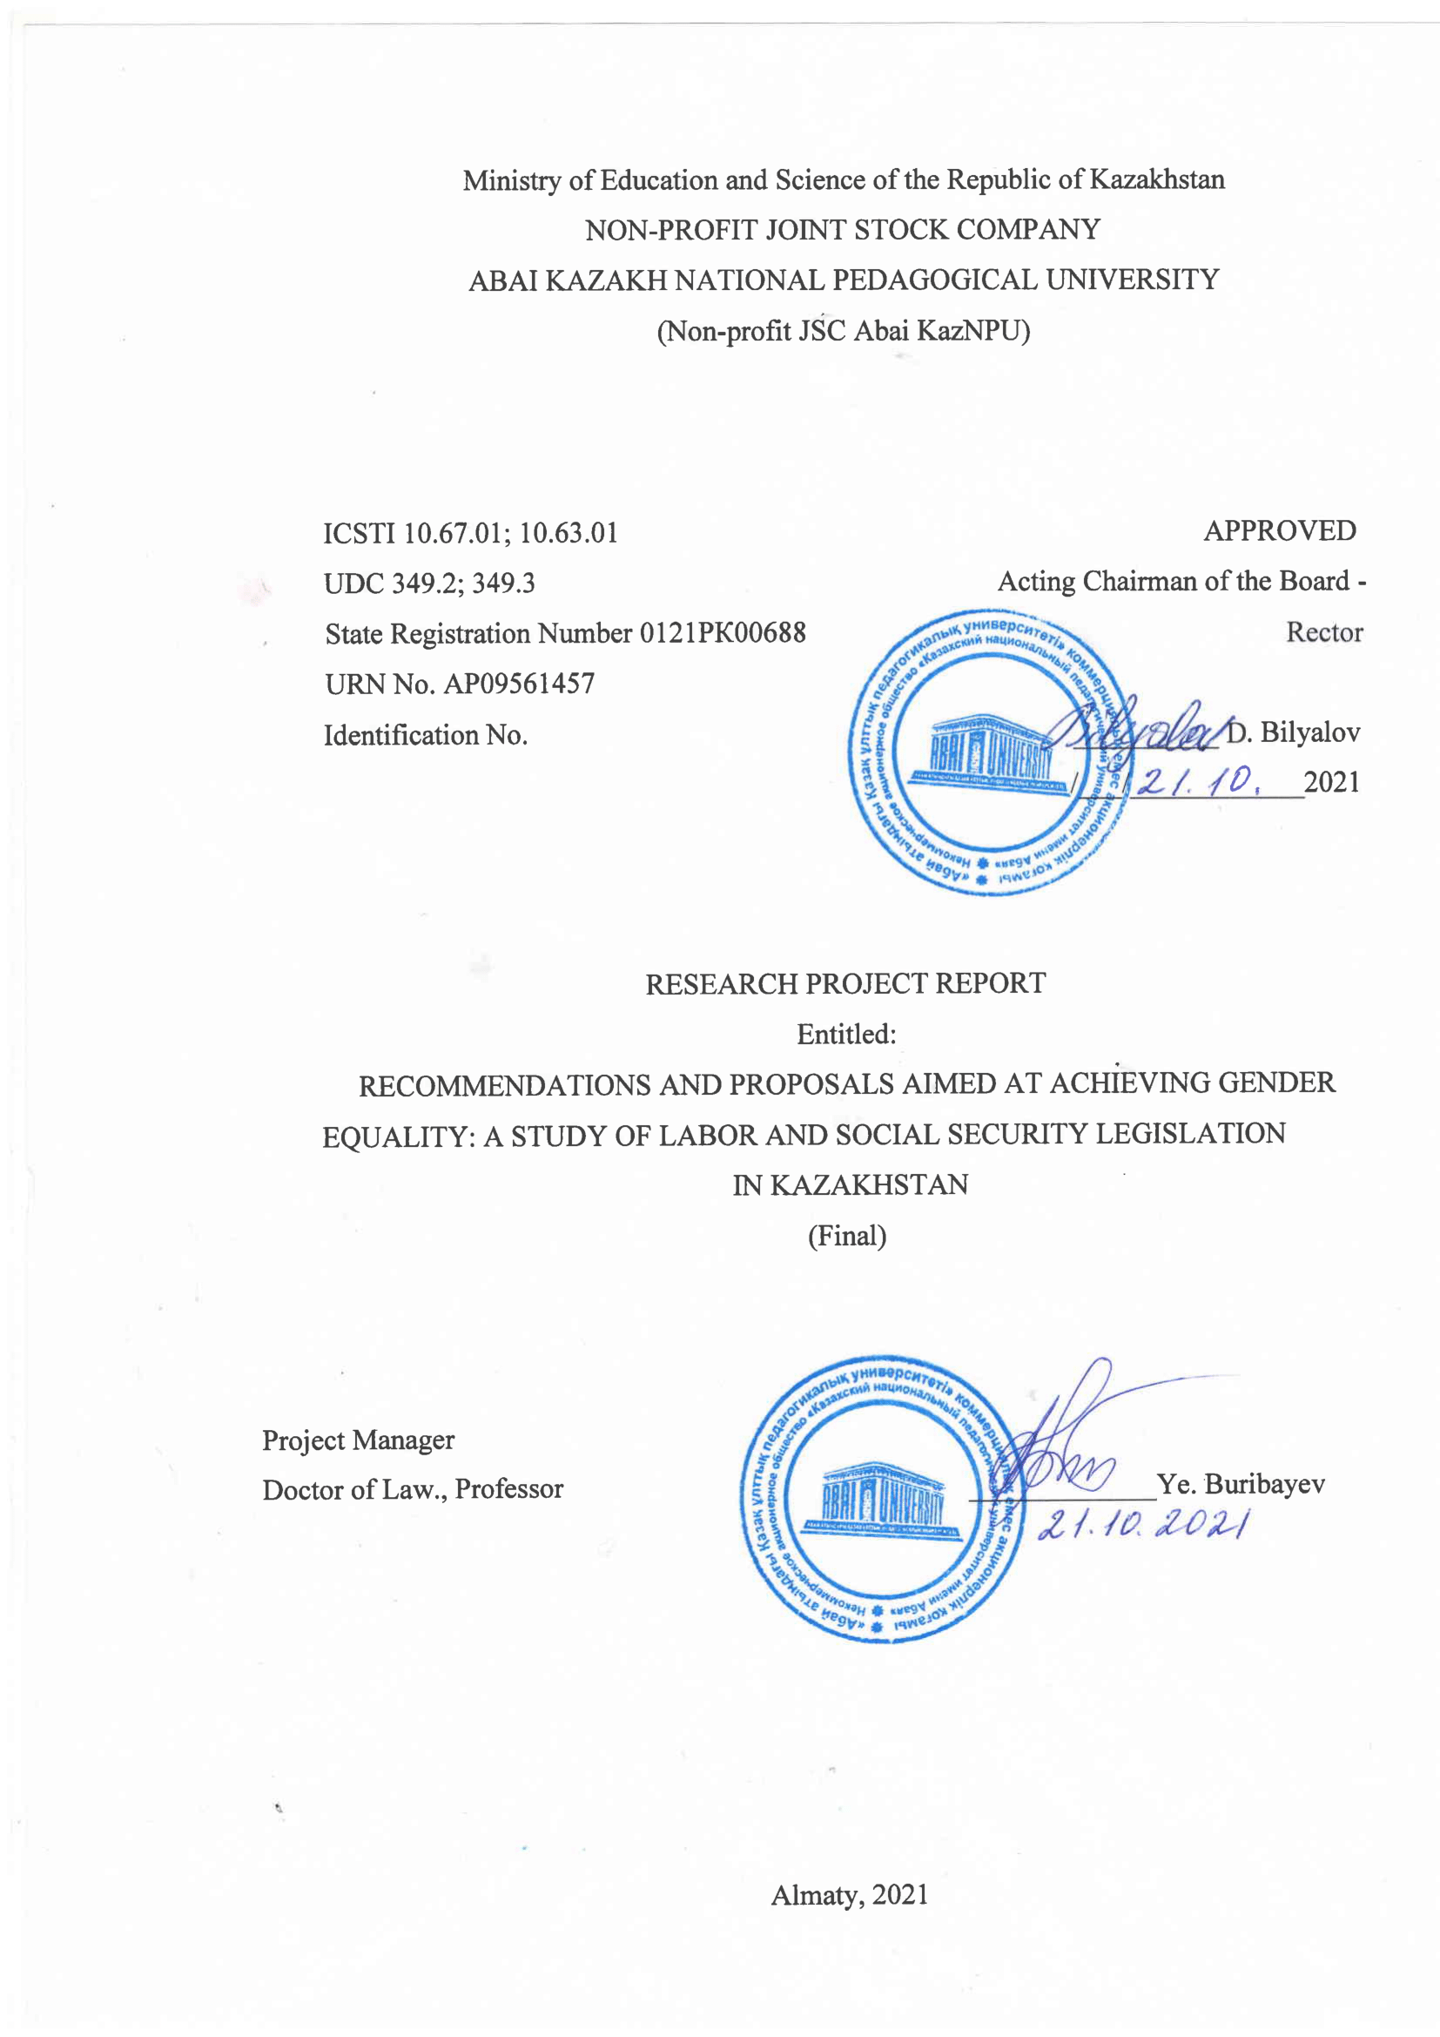

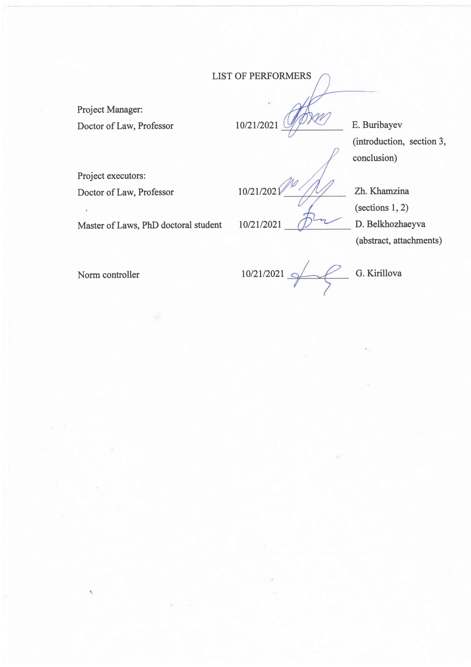

ABSTRACT
Report 79 pages, 1 book, 34 references, 5 annexes.
DISCRIMINATION, EQUALITY, LEGAL REGULATION, LEGAL MECHANISM, LEGISLATION
The object of the research is labor relations, directly related to them, as well as social security social relations.
The goal of the project is to form, disseminate and prepare for the implementation of specific proposals, recommendations for improving the current legislation, mechanisms to ensure guarantees of the principle of prohibition of discrimination in the social and labor sphere. Research methods: formal legal (dogmatic), sociological and legal, legal modeling method, critical legal method of legal knowledge, monitoring of the enforcement of labor and social law from the standpoint of identifying gender problems.
The results are: a comprehensive analysis of the legal basis for the guarantees of the principle of prohibition of gender discrimination in employment and social security; substantiation of legislative proposals, recommendations necessary to eradicate gender inequality in the workplace and in the field of social protection; publication of articles that meet the requirements of the tender documentation, development of a draft regulatory legal act on the improvement of guarantees for the prohibition of discrimination in the field of labor activity and social security; registration of the copyright certificate.
The scope of the research results: the conclusions of the project can be applied in the process of defining and implementing the further internal political course of Kazakhstan in the development of the system of labor relations, employment, social security; in the legislative process in order to improve the quality of legal regulation of social and labor relations, including using the method of implementing universal standards.
The significance of the research lies in the possibilities of using its results in law-making, scientific, educational, practical, social aspects. Application of the project results will ensure: increasing the role of the sciences of labor and social security law in the implementation of the development policy of Kazakhstan; creation of a scientific and theoretical basis for the development of labor and social legislation in Kazakhstan; an integrated approach to the fundamental problems of legal regulation of guarantees of gender equality; preconditions for further development of the scope of application of gender parity standards in all areas of legal regulation; development of the leading scientific school of social and labor law in Kazakhstan, represented by the project group.

CONTENTS

INTRODUCTION ………………………………………………………..  MAIN PART OF THE RESEARCH REPORT…………………………...  1 Choosing a direction of research………………………………………...  2 The theoretical and practical research process…………………………..  3 Generalization and evaluation of research results……………………….  CONCLUSION …………………………………………………………...  REFERENCES…………………………………………………………….  ANNEX A - List of published works………………………………………  ANNEX B - Calendar plan of the research…………………………………  ANNEX C - List of published works for 2021……………………………  ANNEX D - Certificates of entry into the state register of rights to objects protected by copyright……………………….……………………………  ANNEX E - Draft regulatory legal act with accompanying documents…… |  | 6  9  9  14  28  32  34  37  40  45  55  57

INTRODUCTION

Discrimination against women remains the most common form of inequality. Women continue to be discriminated against in almost all aspects of employment. The data of official strategic documents [1], as well as the country's declining positions in specialized international rankings [2] show that gender differentiated differences in wages, professional and vertical segregation, difficulties associated with combining work and family responsibilities, the disproportionate prevalence of women in the sphere of underemployment, informal temporary employment and discrimination based on maternity or marital status continue to persist despite legislative and policy initiatives.
Research results [3, 4, 5, 6, 7] indicate that gender discrimination in the labor market impedes economic growth. Because of their influence on the unequal distribution of family responsibilities between men and women in the family, inequality in the economic sphere and in public life, discriminatory social institutions limit the economic opportunities of women [8].
The absence in Kazakhstan of paid parental leave for a child under three years of age, a sufficient number of childcare facilities, as well as family-friendly policies, coupled with gender pay gaps and domestic work, create obstacles to women's full participation in economic life. The national economy cannot operate at full capacity, since limiting and discriminatory factors restrain half of the population of Kazakhstan.
Research shows that gender-sensitive social protection policies provide an opportunity to accelerate the path to gender equality: applying a gender approach to social protection will better meet the specific needs of women [9, 10]. A gender-sensitive pension scheme will reduce poverty among older women, given their higher life expectancy, gender inequality in labor force participation (wage gap and access to contributory pension schemes), women's specificity in terms of savings. behavior and their care responsibilities [11].
Gender-specific vulnerabilities, risks should be reflected in social security measures. Gender inequality usually manifests itself in the following vulnerabilities: women, to a greater extent than men, are at risk of being left without a livelihood and becoming poor; women make up a growing share of the working-age population, but on average receive lower wages than men; women have the greatest personal care responsibilities and are burdened with a disproportionate share of domestic responsibilities compared to men. If we ignore the gender aspect of the social security system, then the social roles of the sexes and traditional gender inequality will not change [12, 13, 14]. Conversely, gender-responsive social security can address inequalities and play a role in the reallocation of care responsibilities and in the recognition and appreciation of unpaid work. [15] The UN Sustainable Development Goals, set in 2015, unequivocally promote social protection as a means of not only achieving human development, but also improving gender equality outcomes. [16].
Most often, the object of gender studies in Kazakhstan is the national and cultural aspects of the role of women in the development of society or their role in the economic development of the country, as well as the problems of low involvement of women in political decision-making, their small representation in the highest echelons of power.
The above review shows that today in the field of social sciences, legal research, the topic of gender equality is unpopular. Analyzing the sources available on this topic and implemented projects [17], it can be concluded that research into the problems of gender equality, protection of women's rights were more popular in the period from the late nineties to the early two thousandths. After two thousand and ten years, the number of studies, projects on this issue has significantly decreased. On the one hand, we believe that this fact is explained by systemic changes in legislation in this area. On the other hand, the implementation of state program documents aimed at achieving gender balance. With the third, the relative success of Kazakhstan in international rankings of gender equality, achieved in the early 2000s. However, over the past fifteen years, Kazakhstan's assessment in international rankings that take into account gender parity has changed, not for the better.
The project was not aimed at countering recruitment and promotion bias or sexist preferences. We did not oppose the spread of stereotypes in our society, but we set ourselves the goal of developing recommendations aimed at changing the legislation of Kazakhstan, including in terms of excluding legal norms that not only allow discrimination in public relations, but also elevate it to the format of mandatory lawful behavior.
As in the rest of the world, Kazakh women perform most of the childcare, household chores, and are also simultaneously involved in paid employment. The government's family-centered policy aims to help workers achieve a balance between employment and family responsibilities. However, this balance between work and personal life of a woman has not been fully found. As a result of the implementation of the project, we proposed legislative possibilities to neutralize manifestations of discrimination in employment, in the performance of family responsibilities, and in access to the social security system. Based on an analysis of the totality of all elements of legal impact (international, national law, the possibility of applying state coercion measures, etc.), we have proposed specific recommendations for achieving gender equality in the social and labor sphere, which will not only improve parity, but also support policies aimed at elimination of norms that promote bias and discrimination.
We are fully aware that legislative changes alone cannot eliminate gender inequality, but these steps are an important basis for transformation. High-quality legal regulation is the foundation on which relationships in society and the state are built, including in the sphere of guarantees of the prohibition of discrimination and gender parity.
For the project research, we limited ourselves to two related areas of legislation: labor and social security. If discrimination in employment, in the workplace on the basis of gender is an obvious fact, then inequality in the field of social protection is not clearly expressed. Moreover, this area of ​​scientific analysis is outside the attention of Kazakhstani researchers. At the same time, it should be noted that in Kazakhstan, when developing and implementing the main models of social security, gender issues were not taken into account, which in practice leads to unequal social results for men and women. The project was aimed at the formation of two types of proposals, recommendations for the promotion of gender equality. The first recommendations are aimed at eliminating discriminatory norms existing in the legislation. The second is to formulate proposals for the implementation of international equality standards, as well as the best universal legal regulation practices.

MAIN PART OF THE RESEARCH REPORT

1 Choosing a direction of research
The choice of the research direction is based on the provisions, targets and tasks of the strategic and program documents of the development of Kazakhstan. On June 9, 2021, the President of the Republic of Kazakhstan K. Tokayev signed a decree "On further measures of the Republic of Kazakhstan in the field of human rights" (No. 597), approved the Plan of priority measures in the field of human rights, which, women.
According to paragraph 2 of Article 14 of the Constitution of the Republic of Kazakhstan, no one can be subjected to any discrimination based on origin, social, official and property status, sex, race, nationality, language, attitude to religion, beliefs, place of residence or for any other circumstances. Direct or indirect restriction of the rights and freedoms of a person (citizen) for reasons of origin, social, official or property status, sex, race, nationality, language, attitude to religion, beliefs, place of residence, membership of public associations or for any other circumstances is prosecuted for law (Article 145 of the Criminal Code of the Republic of Kazakhstan).
Requirements for further strengthening and deepening guarantees of gender equality in the social and labor sphere, improving legislation in this area on an ongoing basis, tasks, recommendations for bringing legal acts in line with international standards are reflected in the provisions of the Concept of Family and Gender Policy in the Republic of Kazakhstan until 2030 ( approved by the Decree of the President of the Republic of Kazakhstan dated December 6, 2016 No. 384), the Concept for Kazakhstan's entry into the 30 most developed countries in the world (approved by the Decree of the President of the Republic of Kazakhstan dated January 17, 2014 No. 732), the United Nations Convention on the Elimination of All Forms of Discrimination Against women, SDGs and other ratified international treaties and agreements. The Concept establishes the need to solve the problem of improving legislation, as well as bringing it in line with international standards, recommendations of the UN, SDGs and OECD; provides for multifaceted research in the field of gender policy in order to determine its prospects and directions of development.
Concept of social development of the Republic of Kazakhstan until 2030, approved by Decree of the Government of the Republic of Kazakhstan dated April 24, 2014 No. 396, establishes strategic objectives for reforming social and labor relations, the health care system, education and social protection with a separate focus on social support for mothers, childhood and vulnerable groups of families. In the Address of the Head of State Kassym-Zhomart Tokayev to the people of Kazakhstan "Constructive public dialogue is the basis of stability and prosperity in Kazakhstan" (September 2, 2019), the priorities are highlighted: support for the institution of family and childhood, creation of an inclusive society; tougher punishment for sexual violence, domestic violence against women and other serious crimes against individuals, especially against children. In the President's Address to the people of Kazakhstan "The unity of the people and systemic reforms are a solid basis for the country's prosperity" (September 1, 2021), Priority VI is defined: Political modernization and protection of human rights. The task of ensuring gender equality, maximum support for the economic and political positions of women in society; amendments to the Concept of Family and Gender Policy.
The grant project was focused on the formation of recommendations that will contribute to social transformation, the development of social and labor legislation from the standpoint of achieving gender parity.
The choice of the research direction was due to insufficient attention of the legal science of Kazakhstan to the problems of equality regulation. The study offers a comprehensive analysis of legislation in terms of: establishing discriminatory laws that restrict the right to decent work and access to financial resources; regulating equality between women and men in the workplace, including issues related to employment protection during pregnancy, maternity / parental leave, equal pay for work of equal value and equal access to professions; gender equality in access to social safety nets.
We have chosen the following sequence of scientific work: identified the key gender problems in the labor market and in the social protection system; it was established how these problems were taken into account in measures to introduce a gender approach in the formation of labor and social legislation in Kazakhstan; what gender issues were “not noticed by the legislator” at the stage of preparation of draft laws and what problems were revealed by law enforcement practice; identified difficulties in the implementation of anti-discrimination norms that ensure gender equality; trends, opportunities and obstacles to achieving gender equality in the labor market and in the social protection system; recommendations were presented to improve the implementation of a gender approach and gender mainstreaming in legislation.
Methodologically, the study of the labor and social security legislation of Kazakhstan on the subject of high-quality provision of gender equality was built in the following sequence:
- study of the design and guarantees for the implementation of the principle of gender equality in the Constitution of Kazakhstan;
- generalization of international standards of equality between men and women from the position of implementation into national legislation
- research of labor legislation from the standpoint of determining gender differences in employment conditions, including:
• analysis of the implementation of equality in access to employment, in the conclusion of an employment contract, as well as in the use of working and rest time;
• examining guarantees of the right to fair remuneration and equal guarantees of protection against unjustified dismissals;
- study of the problems of gender asymmetry of social security human rights in Kazakhstan;
- identification of discriminatory norms in the appointment of pensions, benefits, targeted social assistance, in the provision of social services;
- generalization and formulation of recommendations, proposals aimed at excluding their legislation discriminatory standards of employment and social protection.
The next step in a qualitative change in legislation is monitoring the enforcement of labor and social law from the standpoint of identifying gender issues. This method includes three areas. The first is analysis and generalization of statistics and practice of civil courts, assessment of gender representation in disputes over the restoration of social and labor rights. It should be noted that in Kazakhstan there is virtually no judicial practice of considering claims for recognition of the facts of discrimination in labor relations. According to the International Commission of Jurists, there has not been a single case in the country where a woman has claimed her rights and brought legal action against public or private actors for cases of discrimination. The absence of such cases is not an indicator that inequality does not exist; rather, this situation indicates shortcomings in the judicial system, in which women cannot fully defend their rights and seek redress in court [18]. This fact was used as the basis for the analysis of law enforcement practice.
A study was conducted of open official judicial statistics [19] in the period 2015–2020, which shows that: there is no judicial practice in cases of restoring equality in access to social protection measures, prosecution for discriminatory actions. A sustainable justice system must support the rule of law, good governance and efforts to tackle inequality and development. However, this mechanism is not actually used in Kazakhstan. The guarantees of gender equality contained in the legislation remain practically unclaimed; in fact, there are no appeals to the courts and other competent authorities for the restoration of rights. We believe that the fact of the absence of appeals indicates not the absence of gender or other discrimination, but the weakness of legal, public, public mechanisms for ensuring and restoring rights.
According to the reports on the work of the courts of first instance, posted on the electronic resource of the Committee for Legal Statistics and Special Accounting of the General Prosecutor's Office of the Republic of Kazakhstan. (https://qamqor.gov.kz/portal/page/portal/ POPageGroup/Services/Pravstat) in 2019-2020 there was not a single fact of involvement in a criminal responsibility for violation of the equality of man and citizen (Article 145 of the Criminal Code of the Republic of Kazakhstan), as well as for unjustified refusal to conclude an employment contract with a woman or unjustified termination of an employment contract with her due to her pregnancy, or unjustified refusal to conclude an employment contract, or unjustified termination of an employment agreements with a woman with children under three years of age, for these reasons, as well as unjustified refusal to conclude an employment contract or unjustified termination of an employment contract with a disabled person on grounds of disability or minors on grounds of his minority (part 2 of article 152 of the Criminal Code of the Republic of Kazakhstan). In 2018, the courts received 1 criminal case under Part 2 of Art. 152 of the Criminal Code of the Republic of Kazakhstan, which were terminated on one of the grounds excluding proceedings on the case and provided for in paragraphs 1), 2), 5), 6), 7) and 8) part 1 of article 35 of the Criminal Procedure Code of the Republic of Kazakhstan; under Art. 145 of the Criminal Code of the Republic of Kazakhstan of productions in 2017-2018. did not have. In 2017, the courts received 2 criminal cases on prosecution under Part 2 of Art. 152 of the Criminal Code of the Republic of Kazakhstan, which were subsequently terminated on the basis of the existence of circumstances precluding the proceedings on the case and on the basis of reconciliation of the parties. In the period 2015-2016. the courts of the Republic of Kazakhstan have not received a single criminal case on charges under Art. 145 and part 2 of Art. 152 of the Criminal Code of the Republic of Kazakhstan. The above statistics can be interpreted in the opposite way: on the one hand, there are no facts of discrimination in society, including when hiring, and, on the other hand, the mechanisms to counteract inequality from the standpoint of real guarantees of prosecution for unlawful behavior do not work.
We proceed from the fact that the level of economic, social, political development of Kazakhstan after thirty years of development as an independent state presupposes the formation of special advanced demands of society and the government to reform guarantees of equality in all areas, including in the field of access to employment and social protection measures. We conducted a study from the point of view of the gender factor, various discriminatory social attitudes, as categories that should be critically assessed in relation to actual conditions in order to achieve real equality proclaimed in the Constitution and based on the transformative role of law and legislation. The existing public, political demand for the empowerment of women determines the relevance of improving the quality of a number of laws regarding gender equality in access to social security measures and the facilitation of unpaid care work.
The most important practical part of the design work was the development of the author's legislative initiative, we summarized recommendations, conclusions aimed at improving the current legislation in the field of ensuring guarantees of the prohibition of discrimination against labor, employment, social security within the framework of an independent draft law and a number of publications.

2 The theoretical and practical research process
The process of research work on the project was built taking into account the goal and objectives, was carried out in the following logical sequence of activities in terms of content.
1. The content of the principle of prohibition of discrimination in the world of work, proclaimed in Art. 4 of the Labor Code of the Republic of Kazakhstan, is the unity of the subjective rights and obligations of employees, their equal volume. In addition, this principle presupposes the provision of equal opportunities in the exercise of labor rights:
the opportunity to get a job and be an employee of an organization of any form of ownership;
the opportunity to get a suitable job, depending on the specialty, qualifications, without discrimination;
the ability to demand safe working conditions;
the opportunity, upon release, unemployment, to receive appropriate guarantees, compensation from the employer; receive from the state authorized body of employment information on employment without discrimination;
the ability to demand through the judicial authorities the restoration of violated labor rights. The principle of prohibition of discrimination in the world of work applies to all subjects of labor law and is implemented in all its institutions.
According to Article 24 of the Constitution, in the Republic of Kazakhstan, everyone has the right to working conditions that meet the requirements of safety and hygiene, to remuneration for work without any discrimination, as well as to social protection from unemployment. Article 14 of the Constitution establishes the provision that no one can be subjected to any discrimination on grounds of origin, social, official and property status, sex, race, nationality, language, attitude to religion, beliefs, place of residence or for any other circumstances. The above constitutional principle is concretized to the sphere of labor and relations directly related to them: everyone has equal opportunities in the exercise of their rights and freedoms in the sphere of labor. No one can be limited in their rights in the labor sphere, except in cases and in the manner provided for by the Labor Code of the Republic of Kazakhstan and other laws of the Republic of Kazakhstan. No one may be subjected to any discrimination in the exercise of labor rights on grounds of origin, social, official and property status, sex, race, nationality, language, attitude to religion, beliefs, place of residence, age or physical disabilities, as well as belonging to public associations. Differences, exceptions, preferences and restrictions, which, in accordance with the laws of the Republic of Kazakhstan, are established for the relevant types of labor activity or are due to the special care of the state for persons in need of increased social and legal protection, are not discrimination. Persons who believe that they have been discriminated against in the field of work have the right to apply to the court or other authorities in the manner prescribed by the laws of the Republic of Kazakhstan (Article 6 of the Labor Code of the Republic of Kazakhstan).
Paragraphs 6), 8) of Article 4 of the Labor Code of the Republic of Kazakhstan concretize the specified constitutional principle, securing the equality of rights and opportunities for workers; ensuring the right to fair remuneration for work not lower than the minimum wage.
Article 25 of the Labor Code of the Republic of Kazakhstan defines guarantees of equality of rights and opportunities when concluding an employment contract, the second paragraph establishes that pregnancy, the presence of children under the age of three years, minority, disability cannot restrict the right to conclude an employment contract, with the exception of cases provided for by the Labor Code of the Republic of Kazakhstan.
In order to ensure the real implementation of the equality of persons claiming to conclude an employment contract, protection from discrimination when entering into labor relations, it seems reasonable to legally secure for all citizens, potential employees, the right to demand that the employer provides in writing a justified refusal to hire, with taking into account the enshrinement of the principles-rights of each person in article 4 of the Labor Code of the Republic of Kazakhstan, the inadmissibility of restricting rights in the world of work; the prohibition of discrimination at work; equality of rights and opportunities for workers.
In our opinion, in the legislation there is an unjustified restriction of citizens in the right to information from the employer about the reasons for refusing to enter into labor relations, which is not only a violation of the principles of labor law and legislation, but one of the conditions for committing corruption offenses, which are expressed in the establishment of excessive requirements for to a person for the exercise of his right.
A guarantee that ensures the prohibition of discrimination in the world of work is the property of the unity of labor legislation, which means the consolidation of the general conditions of labor activity for all entities: a unified procedure for concluding labor contracts for all entities, its general mandatory conditions. Labor legislation provides for general conditions for transfer to another job, termination and termination of an employment contract. The norms, uniform for all subjects, regulating working hours and rest time, issues of labor discipline, material responsibility, guarantees and compensation have been determined. Differentiation of labor legislation should in each specific case be based on objective factors: differences, exclusions, preferences and restrictions, should be determined by the requirements inherent in this type of work, or be conditioned by the special care of the state for persons in need of increased social and legal protection.
But at the same time, an analysis of the norms of labor legislation also reveals norms that significantly infringe upon the rights of workers, depending on the nature of the work they perform and, we believe, are not conditioned by the requirements inherent in this type of labor.
So, for seasonal workers, additional grounds are established for terminating an employment contract: the suspension of work at the employer for a period of more than two weeks for production reasons and the employee's failure to appear at work for one month in a row due to temporary disability. That is, it is possible for a seasonal worker to be temporarily incapacitated for work without the threat of dismissal for only up to one month, unlike an employee whose work is carried out under normal conditions, and whose incapacity for work is possible up to two months, without the threat of termination of the employment contract and with the payment of the appropriate allowance. In fact, an employment contract with domestic workers can be terminated at any time on the initiative of one of the parties, without the restrictions established by the Labor Code of the Republic of Kazakhstan. The ILO Domestic Workers Convention, 2011 (No. 189), is the universal standard against discrimination against domestic workers. Convention No. 189 recognizes the special conditions in which domestic work is performed, which makes it desirable to supplement the general rules with rules specifically targeting domestic workers to enable them to fully exercise their rights; and aims to set standards for decent work for domestic workers. Kazakhstan's ratification of Convention 189 would enable the implementation of advanced standards of prohibition of informal employment and non-discrimination of domestic workers into national legislation.
From the meaning of paragraph 2 of Art. 30 of the Labor Code of the Republic of Kazakhstan, it follows that for employees of small businesses, any term of an employment contract can be established, guarantees for the duration of an employment contract of at least one year, provided for by paragraph 1 of Art. 30 of the Labor Code of the Republic of Kazakhstan does not apply to these legal relations. The stability, lasting nature of labor relations is not guaranteed to employees who are heads of the executive body, members of the collegial executive body of a legal entity, employees of the internal audit service and corporate secretaries. With the listed categories, the employment contract can be terminated at any time by the decision of the owner of the legal entity.
It seems that the consolidation of these provisions in the code indicates discrimination in the use of domestic labor, seasonal labor, employees of small businesses, the head of the executive body of a legal entity and other members of the collegial executive body of a legal entity, as well as employees of the internal audit service and corporate secretary, setting these categories employees in a more dependent position on the employer, infringement of their rights in comparison with other employees.
Practically the most widespread form of discrimination - on the basis of gender, women of any age, with or without children, are less likely to get a job offer if there is a male competitor, even with lower qualifications or work experience; solely through the dismissal of women. Further, discriminatory restrictions are experienced by workers of pre-retirement and retirement age. In the first case, employees experience difficulties in promotion, in the second, they are under pressure from employers to terminate their employment relationship. In this case, it should be borne in mind that applying for a pension, as well as terminating the contract upon reaching retirement age, is the right of the employee and the employer, and not their obligation, the Labor Code of the Republic of Kazakhstan.
There is discrimination in pay for work of equal qualifications against women, national minorities, local populations and migrant workers, and discrimination does not always take place against the latter. In addition, the so-called “occupational segregation” has developed in society, which manifests itself in a stable division of the branches of economic activity into “male” and “female”, “traditional work of the local population” and “labor of migrants”.
In national program and strategic documents, the state sets the following objectives as tasks. Increasing the employment rate based on the principles of gender equality. Reducing the unemployment rate. Optimization of methods for restructuring the economy in order to reduce unemployment and overcome gender asymmetry in the labor market associated with the dominant feminization of employment in the least prestigious and low-paid areas of production. Equalization of the level of wages between sectors of the economy and reduction of differences in the nature and remuneration of labor between women and men with unconditional observance of the requirements of equal pay for equal work. Ensuring equal opportunities in the labor market and promoting the employment of women. Adoption of programs to ensure equal access for rural women to economic resources.
Ensuring the right to fair remuneration for work not lower than the minimum wage concretizes the principle of the prohibition of discrimination, this is the most important principle of labor legislation. The Constitution of the Republic of Kazakhstan (Paragraph 2 of article 24) provides for the right of citizens to remuneration for work without any discrimination. This requirement is general in nature, that is, it applies to all persons, regardless of the scope of employment. Moreover, we are talking about the prohibition of discrimination in any form (Article 14 of the Constitution of the Republic of Kazakhstan). This principle defines the constitutional foundations of social protection of workers in the field of wages in market conditions. The principle applies both to employees of enterprises and institutions of the public sector of the economy, and to employees employed in enterprises and institutions of private ownership. In accordance with the aforementioned principle, the state throughout the territory of the republic provides all employees with uniform conditions for the exercise of their rights in the field of remuneration (size, timing, payment procedure, etc.). At the same time, wages are not limited to the maximum amount.
The implementation of the principles is possible only if enshrined in the law, establishing responsibility for their violation. However, in some cases this kind of responsibility is absent. Thus, paragraph 4 of Article 6 of the Labor Code of the Republic of Kazakhstan determined the right of persons who believe that they have been discriminated against in the field of work to apply to the court or other authorities in the manner prescribed by the laws of the Republic of Kazakhstan. However, the legislation of the Republic of Kazakhstan does not determine the procedure for applying for judicial protection on the fact of discrimination in the world of work, the procedure for limiting discriminatory actions (inaction) is not legally determined, moreover, actions of a discriminatory nature, as a rule, cause a person both material and moral damage. The foregoing testifies to the presence of a defect in the procedures for the judicial protection of violated rights.
Assistance in the implementation of the principle of prohibition of discrimination in the labor sphere by the state is expressed, as already noted, in the establishment of an equal scope of rights of subjects of labor relations and equal opportunities in their implementation. Responsibility for direct or indirect restriction of the rights and freedoms of a person (citizen) based on origin, social, official or property status, gender, race, nationality, language, attitude to religion, beliefs, place of residence, membership of public associations or for any other circumstances, Article 145 of the Criminal Code of the Republic of Kazakhstan is provided. In addition, Art. part 2 tbsp. 152 of the Criminal Code of the Republic of Kazakhstan establishes responsibility for unjustified refusal to conclude an employment contract with a woman or unjustified termination of an employment contract with her due to her pregnancy, or unjustified refusal to conclude an employment contract, or unjustified termination of an employment contract with a woman with children under three years of age, for this motives, as well as unjustified refusal to conclude an employment contract or unjustified termination of an employment contract with a disabled person due to disability or minors due to his minority. The establishment of criminal liability for arbitrary, unjustified restriction, infringement of rights and opportunities in the exercise of labor rights is undoubtedly an important guarantee of the implementation of the principle of prohibition of discrimination in the world of work.
The implementation of the principle of prohibition of discrimination in the world of work is the most important indicator of the development of civilized labor relations. This principle should not only be declared in the relevant legislative acts, it should be reflected and consolidated in all labor legislation, there should be responsibility for its violation, which fully applies to all principles of labor law.
The Code of the Republic of Kazakhstan "On Administrative Offenses" dated July 5, 2014 No. 235-V ЗРК (Article 90) establishes responsibility for admitting discrimination in the labor sphere. Namely: the employer's admission of discrimination in the labor sphere, expressed in violation of the employee's right to equal pay for equal work, as well as to equal production and living conditions, including when performing work under a contract for the provision of personnel services. Placement by the employment center, a private employment agency, and the employer of information on vacancies for employment, containing discriminatory requirements in the world of work.
If discrimination in employment, in the workplace on the basis of gender is an obvious fact, then inequality in the field of social protection is not clearly expressed. Social security legislation contains a number of provisions according to which, in essence, discriminatory actions are a condition of lawful behavior. These are the rules governing: conditions for early registration of pension rights in the presence of five or more children in the family, as well as when living in territories that have been negatively affected as a result of nuclear tests at the Semipalatinsk nuclear test site; the procedure for the emergence of the right to a pension annuity at the expense of mandatory contributions to the pension fund; periods included in the general work experience; as well as the procedure for granting benefits to persons who worked in underground and opencast mining, in jobs with especially harmful and especially difficult working conditions, or in jobs with harmful and difficult working conditions, where gender equality in access to this type of benefit is not ensured: for women and men differ in the age of applying for benefits and the length of service in special jobs.
Social security legislation, unlike labor legislation, does not proclaim the principle of prohibition of discrimination and ensuring equality in this area in none of the numerous acts acting in the form of a law. In general, the equality of everyone before the law and the court; prohibition of any discrimination based on origin, social, official and property status, sex, race, nationality, language, attitude to religion, beliefs, place of residence or for any other circumstances, has not received its development, guarantees in social security legislation.
2. Research of guarantees of prohibition of discrimination in supranational sources of law. Formation of proposals on the possibilities of transforming international standards into the national legislation of Kazakhstan.
The analysis of this part of the study was aimed at the formation of recommendations for the promotion of gender equality, which consist in the formation of proposals for the implementation of international equality standards, as well as the best universal legal regulation practices.
Acts ratified by Kazakhstan: Equal Remuneration Convention, 1951 (No. 100), Law No. 115-II of December 14, 2000; Discrimination (Employment and Occupation) Convention, 1958 (No. 111), Law No. 444-I of 20 July 1999; Workers with Family Responsibilities Convention, 1981 (No. 156), Law No. 50-V of November 16, 2012; Maternity Protection Convention 2000 (No. 183), Law of 14 February 2012 No. 554-IV. Kazakhstan has not ratified the ILO Convention on Violence and Harassment, 2019 (190).
As can be seen from the information provided, the overwhelming majority of the ILO acts in the field of guarantees of equal opportunities and treatment were ratified by Kazakhstan 10–20 years ago, however, adherence to universal standards did not allow for fundamental progress in building an inclusive labor and employment market. In the study, we tested the hypothesis that Kazakhstan's “superficial” compliance with the requirements of the ILO acts, the absence of real mechanisms for the implementation of their provisions, and insufficient implementation in legislation and practice are serious barriers to the promotion of minimum standards of non-discrimination.
The choice of the direction of research and scientific hypothesis was based on the generalization of the conclusions of a number of authoritative studies [20, 21, 22, 23, 24, 25, 26, 27, 28, 29, 30, 31], in which the positive influence of international law on the formation of national legal systems, it is argued that international law has made a positive contribution to the realization of human rights in many countries around the world. In general, the ratification of the main conventions adopted by the ILO creates a legal obligation to improve labor standards in the national economy, especially with regard to trade union rights, minimum age and discrimination in employment, and forced labor. [32]
At the initial stage, we differentiated the ILO conventions in the field of equality depending on the presence or absence of ratification by Kazakhstan. Subsequently, the analysis was divided into two blocks. The first is to conduct a comparative analysis of the content of ratified acts and the actual content of Kazakhstani labor legislation. The second is modeling the possibilities for ratifying conventions for which Kazakhstan refrains from recognition. In this direction, we carried out a comparative analysis of the main provisions of the Conventions requiring reproduction in domestic law, formulated conclusions about the advisability or undesirability of ratifications, and modeled forecasts of positive or negative consequences.
In the first part, we studied specific cases of inconsistency of domestic Kazakhstani labor legislation with international standards. Conducted an analysis of the five main conventions in the field of gender equality, ratified by Kazakhstan. At the same time, they focused not only on the problems of prohibiting gender discrimination in the field of work and occupation, but also studied the issues of the burden of proof of discrimination, prohibition of indirect discrimination, prohibition of victimization, remedies against discrimination, discrimination of persons with family responsibilities. Primary information for this area of ​​research included not only the direct content of international and national law, but also reports of the Government of Kazakhstan on the implementation of the requirements of the conventions, as well as the Comments of the Committee of Experts (CEACR) of the ILO.
In relation to the second part of the study, we examined the questions: does the current state of Kazakhstani labor legislation comply with the ILO acts, whether their ratification will further improve the labor market conditions, and also focused on what changes to the laws will need to be made in the future.
At the final stage, we analyzed the compliance of national legislation with international agreements. Regulatory regulation of discrimination in local conditions is minimal and has been developing extremely slowly since the adoption in 2009 of the Law of Kazakhstan "On State Guarantees of Equal Rights and Equal Opportunities for Men and Women," guarantees or implementing real guarantees of gender equality. Our analysis showed that, contrary to the requirements of international agreements, Kazakhstan lacks: mechanisms for restoring the rights of persons subjected to discrimination; the actual possibilities of prosecution for discrimination; mechanisms to promote prevention and non-discrimination. There is a need for a normative consolidation of the terms, signs and characteristics of direct and indirect discrimination, in Kazakhstani legislation there are no signs separating these two types of discrimination. This innovation is in demand not only for the social and labor sphere, but in general for all national legislation. Art. 145 of the Criminal Code of the Republic of Kazakhstan establishes responsibility for direct or indirect restriction of the rights and freedoms of a person (citizen) based on origin, social, official or property status, gender, race, nationality, language, attitude to religion, beliefs, place of residence, membership of public associations or for any other reason. In the second part of the norm, the qualified corpus delicti of the said crime is fixed. At the same time, the lack of clear characteristics of direct and indirect discrimination in legislation significantly complicates qualifications. Now this norm is actually not a demanded practice of criminal prosecution (as shown by the results of our study), perhaps this is one of the reasons for the lack of scientific and practical interest in the study of the crime in question. However, high-quality law enforcement, guarantees of the constitutional principle of prohibition of discrimination require the provision of conditions for the actual prosecution.
There is a demand for a revision of the procedure for proving the fact of discrimination when an employee applies for protection to the competent authorities, placing the burden of proof in disputes related to violation of equal treatment in relation to gender on the employer. In Kazakhstan, in general, there is little “feel” of the tendency to publicly raise the problem of countering sexual harassment in the workplace. In modern European anti-discrimination legislation in the framework of gender discrimination, such forms as harassment, sexual harassment are distinguished. In Kazakhstan, there are no legal norms as such regulating the inadmissibility of sexual harassment in the workplace. This line of analysis was also included in the research subject.
3. Generalization of previously obtained results, the formation of conclusions, proposals on modern topical directions for improving the quality and forms of legal regulation of guarantees of prohibition of discrimination in the social and labor sphere.
At this stage, we focused on the development of a draft law in order to improve the current legislation in the field of improving guarantees of prohibition of discrimination against labor, employment, and social security.
The bill is aimed at solving the problems of ensuring equality on the basis of gender by assessing the state of legislation and formulating proposals for its improvement. The project contains legislative opportunities to neutralize discrimination in employment, in the performance of family responsibilities, in access to the social security system. Based on an analysis of the totality of all elements of legal impact (international, national law, the possibility of applying state coercion measures, etc.), specific recommendations have been formulated to achieve gender equality in the social and labor sphere, which will not only improve parity, but also support policies aimed at eliminating norms conducive to bias and discrimination.
The draft law brings the definition of discrimination, its signs and grounds in accordance with Article 1 of the ILO Convention No. 111 "On Discrimination in the Field of Labor and Occupation" (ratified by Kazakhstan in accordance with the Law of the Republic of Kazakhstan dated 20.07.1999 No. 444-1). The framework of legislative regulation additionally includes the prohibition of discrimination based on nationality and the position of labor migrants, on political convictions, on the basis of HIV status, on the basis of lifestyle, and civic position. The list of subjects who may be discriminated against is supplemented by “job seekers” by virtue of the implementation of paragraph 3 of Article 1 of Convention No. 111. According to the specified norm of the international act, the areas of work and occupation include access to vocational training, access to work and various occupations, as well as pay and working conditions, that is, it is proposed to expand the legal content of subjects at risk of being exposed to inequality in the sphere of wage labor.
The prohibition of discrimination on the grounds of “appeal or intention to go to court or other bodies to protect their rights or provide support to other workers in protecting their rights” is enshrined, which are guaranteed by Kazakhstan's obligations to comply with the ILO Convention No. 135 “On the Protection of the Rights of Employee Representatives at the Enterprise and the opportunities provided to them ”, ratified in accordance with the Law of the Republic of Kazakhstan dated 30.12.1999 No. 13-II; as well as the ILO Convention No. 98 “On the Application of the Principles of the Right to Organize in Trade Unions and to Conduct Collective Bargaining, ratified by the Law of the Republic of Kazakhstan dated December 14, 2000, No. 118-II.
An "open" list of possible grounds and reasons for discrimination is established in accordance with paragraph 1 of Article 1 of Convention No. 111. In order to ensure mechanisms for the implementation of the possibility of compensation for harm caused by discriminatory actions, civil law enshrines the right of persons who believe that they have been discriminated against in the workplace, to apply to the court for the restoration of violated rights, compensation for material damage and compensation for moral damage or other instances in the manner prescribed by the laws of the Republic of Kazakhstan.
The introduction of guarantees of equality in the extension of labor relations is substantiated. In case of prolongation, the employee is the most vulnerable in labor relations, the Labor Code of the Republic of Kazakhstan leaves the issue of renewal to the discretion of the parties, which is practically decided exclusively by the employer. The norm of the bill establishes more stable rules in order to prevent and suppress the risks of discrimination at the stage of extension of labor relations. The draft law excludes an unjustified gradation of a person's right to equal treatment when concluding an employment contract based on the age of children. The current version of Paragraph 2 of Art. 25 of the Labor Code of the Republic of Kazakhstan establishes the right to equal treatment exclusively for those persons who have children under the age of three. The indicated age threshold of the child has no logical basis. On the contrary, it denies the right to equal treatment of those persons who have children over three years of age. An "open" list of circumstances not related to business qualities is introduced, these can be life circumstances, lifestyle, civic position of a person, which may indicate a restriction of the right when concluding an employment contract. The list of reasons why an employer has no right to refuse a job seeker cannot be established as exhaustive, as is enshrined in the current edition of the Labor Code of the Republic of Kazakhstan. In the event of a litigation, the question of whether a refusal is discriminatory should be decided on the basis of the circumstances of the case.
To ensure the right of a person to protection from discrimination, to equal treatment when applying for a job, including through appeal to the court and other instances, the draft law introduces a rule that, at the written request of a person who is refused to conclude an employment contract, the employer is obliged to inform the reason for the refusal in writing within a period not later than within seven working days from the date of such request. Refusal to conclude an employment contract may be appealed in court or other instances in the manner prescribed by the laws of the Republic of Kazakhstan. Unjustified refusal to hire an applicant should have serious legal consequences, guarantees of the right to appeal and go to court.
Item 5, Art. 30 of the Labor Code of the Republic of Kazakhstan is excluded, since it actually discriminates by age the position in the employment relationship of an employee who has reached retirement age, when the employment contract is extended. If, according to the current edition of the Labor Code of the Republic of Kazakhstan (Article 30), it is allowed to extend the employment contract with an employee no more than two times, with the subsequent extension, the term of the contract is not indicated, that is, an indefinite period of validity is established, then with an employee of retirement age it is allowed to extend an unlimited number of times of urgent labor contract, for such employees there is no guarantee to limit the number of extensions of labor relations.
Pp. 24) Paragraph 1 of Art. 52 of the Labor Code of the Republic of Kazakhstan excludes the draft law. For persons who have reached retirement age, the current edition of the Labor Code of the Republic of Kazakhstan established an additional basis for terminating an employment contract on the initiative of the employer, the basis for the emergence of the employer's right to terminate the employment relationship is the only condition - that the employee reaches retirement age, which is, of course, a discriminatory circumstance. The presence of an excluded norm in the Labor Code of the Republic of Kazakhstan violates the principle of equality and non-discrimination, enshrined in Articles 14 and 24 of the Basic Law.
The relevance of the above proposal is based on the analysis of judicial practice. The study of the judicial practice of cases on the reinstatement of workers who have reached retirement age at the workplace was carried out on the basis of the content and conclusions of the Generalization of judicial practice in cases of consideration of disputes on reinstatement of dismissed workers in 2016, prepared by the Pavlodar Regional Court (electronic service Forum Taldau ": Https://office.sud.kz/forumTaldau/forum.xhtml?view=generalization&category=3&content=classes&article=2203), Bank of judicial acts of courts of first instance for the period 2016-2021. (https://office.sud.kz/courtActs/index.xhtml). Summarizing the results shows, in our opinion, the prevalence of employers exercising the right to terminate the contract, primarily with executives reaching retirement age, failure to comply with the monthly deadline to warn of termination of the contract, issuing a warning before the employee reaches retirement age, as well as non-payment of compensation guaranteed by the Labor Code of the Republic of Kazakhstan. ... The above violations and the use of the right to terminate the contract for the most part with employees holding managerial positions (based on the review of available judicial acts), we believe, only exacerbate the discriminatory position of older workers in the labor market.
Paragraph 2 of Article 54 of the Labor Code of the Republic of Kazakhstan eliminates the unreasonable gender attribute of the benefit norm applied when terminating an employment contract. The guarantee norm for limiting the termination of an employment contract becomes gender neutral.
The draft law eliminates an unjustified gender approach when granting the right to workers to refuse to work at night if there is a child under the age of seven, including those under his guardianship. It obliges the employer, in the presence of the indicated life circumstances, to demand from the employee his written consent to work with deviations from normal conditions.
Amendments and additions are being made to the Law of the Republic of Kazakhstan dated 06.04.2016 No. 482-V ЗРК "On employment of the population" for the purpose of uniform application with the new edition of Art. 6 of the Labor Code of the Republic of Kazakhstan, securing guarantees for ensuring equality in hiring, disseminating information about available vacancies, job competitions. Compliance with the introduced norms will require that the published information on vacancies contains the most neutral information, listing only the business qualities of the applicants. In addition, the introduced norm provides one of the guarantees for the implementation of paragraphs. b) Paragraph 1 of Art. 11 of the Convention on the Elimination of All Forms of Discrimination against Women (12/18/1979, Kazakhstan joined in accordance with the Law of the Republic of Kazakhstan dated 06/29/1998 No. 248), which stipulates that the participating States take all appropriate measures to eliminate discrimination against women in the field of employment, in order to ensure, on a basis of equality between men and women, equal rights, in particular the right to the same employment opportunities, including the application of the same criteria for selection in employment.
Changes and additions to the Law of the Republic of Kazakhstan dated June 21, 2013. No. 105-V "On Pension Provision in the Republic of Kazakhstan" are aimed at implementing the principle of equal access to preferential pension provision. The establishment for women and men of different ages and a single length of experience in territories with a special status has no logical justification, needs to be brought into line with the constitutional guarantees of equality, as well as the requirements of the Convention on the Elimination of All Forms of Discrimination against Women (12/18/1979, Kazakhstan joined in accordance with the Law of the Republic of Kazakhstan dated June 29, 1998 No. 248) on ensuring, on the basis of equality of men and women, equal rights, including the right to social security, in particular, in case of retirement, unemployment, illness, disability, old age and in other cases of incapacity for work, as well as the right to paid leave (subparagraph e) of paragraph 1 of Art. 11 of the Convention).
The bill introduces changes to Art. 11, 13, 59 of the Law of the Republic of Kazakhstan dated June 21, 2013 No. 105-V "On pension provision in the Republic of Kazakhstan in order to implement the principle of equal access to preferential pension provision. Establishing the right to preferential pensions exclusively for women discriminates against the right of male fathers to preferential pensions, including single fathers raising children on their own. The revised version of the norm of Art. 11 will bring it in line with the constitutional values ​​of equality and non-discrimination, as well as the standards of the Convention on the Elimination of All Forms of Discrimination against Women.
Changes are being made to uniformly apply the principle of equal access to social security systems. The consolidation in the law of different periods of the general work experience for the exercise of the rights to pension payments from the solidarity system in full discriminates against men on the basis of gender. The current state of pension legislation is gradually equalizing the age at which men and women are eligible for pensions, and a similar “blurring of boundaries” should also take place in relation to the required total length of service. The changes relate to ensuring gender equality of parents in access to the accounting of periods of time for childcare for inclusion in the total length of service.
Guarantees are introduced to establish equal amounts of the minimum threshold sufficiency when assigning pension payments at the expense of an insurance annuity on all grounds. In the absence of legislative guarantees of equality in access to pensions through a pension annuity, today bylaws establish a different amount of sufficiency of pension savings for men and women for pension provision through compulsory and professional pension contributions, which is a gross violation of the principle of non-discrimination and equality in access. to retirement benefits.
Amendments to the Law of the Republic of Kazakhstan dated July 13, 1999. No. 414 "On the state special allowance for persons who worked in underground and opencast mining, in work with especially harmful and especially difficult working conditions or at work with harmful and difficult working conditions" manual. The existing differentiation in terms of access to benefits for men and women discriminates against the former, securing for them a longer duration of special work experience and an increased age. The proposed amendments are based on the principle of most favored nation, that is, the existing better conditions for women apply to men.
The initiated amendments to paragraphs 1 and 2 of Art. 4 of the Law of the Republic of Kazakhstan dated July 13, 1999. No. 414 "On the state special allowance for persons who worked in underground and opencast mining, in work with especially harmful and especially difficult working conditions or at work with harmful and difficult working conditions" are introduced in order to comply with obligations to fulfill the constitutional guarantees of equality, as well as obligations to fulfill the requirements of Art. 26 of the International Covenant on Civil and Political Rights, which guarantees everyone to equality before the law and the right, without any discrimination, to equal protection of the law. In this respect, any kind of discrimination must be prohibited by law, the law must guarantee all persons equal and effective protection against discrimination on any grounds, such as race, color, sex, language, religion, political or other beliefs, national or social origin, property status, birth or other circumstances.
In order to consolidate responsibility in the legislation and strengthen the existing norms on non-discrimination on any grounds when hiring, promoting in positions and in the process of training, when applying and assigning specific types of social security, when applying norms on social protection, the project provides for the introduction of new edition of Art. 90 of the Code of the Republic of Kazakhstan on Administrative Offenses dated 05.07.2014. No. 235-V. Part 2 of article 152 of the Criminal Code of the Republic of Kazakhstan of July 3, 2014 is supplemented. № 226-V ЗРК in the aspect of criminalization of unjustified refusal to conclude an employment contract, or unjustified termination of an employment contract with a man with children under three years old, for these reasons.

3 Generalization and evaluation of research results
As part of the execution of work on the grant project, the following results were obtained, which can be summarized in the form below the following theses.
For many years, the problem of improving the quality of Kazakhstani legislation from the standpoint of ensuring gender parity has not been resolved. The legal conditions for the implementation of the idea of ​​conducting a gender expertise of draft laws have not been provided. To assist in the development of effective legislation, it is in demand to introduce, as one of the parameters of the examination of a draft normative legal act submitted to Parliament, a study of the draft for the presence of discriminatory norms and gender inequality. Such expert opinions, technical notes on the proposed draft labor and social security legislation should contribute not only to the main goal - to achieve true equality in employment, social protection, but also to promote the dissemination of best practices and standards of the ILO.
The absence of a general comprehensive concept of discrimination enshrined in legislation leads to the impossibility of recognizing the facts of discrimination and the subjective human right not to be discriminated against; the introduction of the concepts of direct and indirect discrimination is in demand.
Back in the 20s and 30s. XX century, the ILO adopted a number of fundamental conventions and recommendations in the field of social security. The ILO Conventions and Recommendations in the field of social security are aimed at realizing the principle of equality. This principle is stated as fundamental in the ILO Convention No. 19 "On Equality in Accident Compensation" (1925). It also forms the basis of the ILO Convention No. 102 on Minimum Standards of Social Security (1952). Subsequently, the ILO adopted a number of new conventions that supplemented and concretized the aforementioned Convention and established higher international standards of social insurance and security. These include Conventions No. 121 on Work Injury Benefits (1964), No. 128 on Disability, Old Age and Survivors Benefits (1967), No. 130 on Medical Care and Sickness Benefits (1969). Unfortunately, over thirty years of development, Kazakhstan, as an independent state, has not ratified a single convention related to the sphere of social security. This is an urgent direction for our country for the prospect of the implementation of international standards for gender equality.
We come to the conclusion that the differentiation of legal regulation in the field of social protection should be based on the separation of the sexes only when it comes to the physiological characteristics of the female body, in other cases (in particular, in relation to persons with family responsibilities), legislative regulation should be gender neutral.
We draw attention to the global trends in the legal regulation of social security for persons with family responsibilities, which are to provide symmetrical rights to persons regardless of gender. In the field of social protection, the legal regulation of the conditions for granting pensions on various grounds contains the largest number of gender-discriminatory norms. These are the nomes that regulate: the conditions for early registration of pension rights in the presence of five or more children in the family, as well as when living in territories that have been negatively affected as a result of nuclear tests at the Semipalatinsk nuclear test site; the procedure for the emergence of the right to a pension annuity at the expense of mandatory contributions to the pension fund; periods included in the general work experience; as well as the procedure for granting benefits to persons who worked in underground and opencast mining, in jobs with especially harmful and especially difficult working conditions, or in jobs with harmful and difficult working conditions, where gender equality in access to this type of benefit is not ensured: for women and men differ in the age of applying for benefits and the length of service in special jobs.
As a result of the research, we have formed proposals on the possibilities of transforming international standards into the national legislation of Kazakhstan. The conclusions were made on the basis of an assessment of Kazakhstan's fulfillment of international obligations in the field of ensuring guarantees of the principle of non-discrimination in labor legislation. We have developed proposals for Kazakhstan's accession to the universal recognized legal standards, formed conclusions, proposals on modern topical directions for improving the quality and forms of legal regulation of guarantees for the prohibition of discrimination in the social and labor sphere, which allows us to summarize the following conclusions.

-In the national context, the following measures are required to promote gender equality in the workplace:

-it is necessary to create a state system for the promotion, analysis and monitoring of issues of equal treatment and equal opportunities in access to work and employment, their implementation in relation to all groups of workers;

-definition in the legislation of the signs and characteristics of direct and indirect discrimination;

-in addition to the prohibition of discrimination on the basis of sex, the introduction of such a provision is required so that the law imposes on the employer legal responsibility for the environment, service contacts and conditions in which employees work, excluding inequality, discrimination, sexual harassment;

-there is a demand to shift the burden of proof to the employer in cases where the employee submits a statement of discrimination, the employer must prove that the differential treatment is based on objective circumstances;

-there is a need to clearly define and prohibit sexual harassment in the world of work and employment. Consideration of the issue of including responsibility for sexual harassment in the workplace as a separate crime in the Criminal Code of Kazakhstan is in demand;

-the introduction of mechanisms of protection and ensuring equality in relation to workers with family responsibilities is in demand;

-the implementation of guarantees of international acts in the field of social protection of working women during pregnancy and childbirth, childcare is required.
-In order to strengthen the quality of national legislation, the implementation of the best modern standards in the field of combating inequality, creating legal prerequisites for improving the conditions for non-discrimination in labor relations, we initiate raising the issue before the Government of Kazakhstan's ratification of the ILO Conventions "On part-time work" and "On violence and harassment (175 and 190). Kazakhstan's ratification of international agreements will allow launching a legislative process that will be aimed at meeting their universal standards, ensuring guarantees of equality in underemployment, as well as preventing violence and harassment in the world of work, including gender-based.
The COVID-19 pandemic has identified and accelerated many manifestations of gender inequality in the labor market in Kazakhstan, as well as around the world. It can be summarized that the traditional "painful areas" of discrimination in the national context have only deepened due to the employment crisis caused by the ongoing pandemic. The most important problems facing the Kazakh society, the solution of which requires the inclusion of international standards, are:
-expanding instruments for ensuring gender parity in wages, including by combating traditional sectoral segregation;
-addressing the issue of ensuring a more equitable distribution of unpaid care from a gender perspective;
-tackling gender-based violence in and outside the workplace.
The draft law developed by us on improving the guarantees of the prohibition of discrimination in the field of labor activity and social security, in the event of its implementation into legislation, will increase the effectiveness of the existing law in the fields of labor, employment, and social security.
If the bill is adopted, the following positive legal and socio-economic consequences are expected:
- guarantees of the principle of prohibition of discrimination in employment and social security will be strengthened;
- the legal conditions will be improved to neutralize the elimination of gender inequality in the workplace and in the field of social protection;
- international standards of equality between men and women will be implemented into national legislation.

CONCLUSION

The total volume of the research results makes it possible to state the achievement of the main indicator - a comprehensive analysis of the legal basis for the guarantees of the principle of prohibition of gender discrimination in employment and social security; substantiation of legislative proposals, recommendations necessary to eradicate gender inequality in the workplace and in the field of social protection.
The scientific effect of the implementation of the project on a national scale lies in the fact that it lays the foundations for an integrated approach to the fundamental problems of legal regulation of guarantees of gender equality in Kazakhstan; the scientific prerequisites and the basis for the further development of the scope of application of gender parity standards in all areas of legal regulation of public relations have been created.
As a result of the study, a comprehensive analysis of legislation was formed on the subject of: establishing discriminatory laws that restrict the right to decent work and access to financial resources of the social security system; regulating equality between women and men in the workplace, including issues related to employment protection during pregnancy, maternity / parental leave, equal pay for work of equal value and equal access to professions; gender equality in access to social protection measures.
Internationally, the project has expanded the science of labor and social security law through peer-reviewed journal publications, scientific contacts, the exchange of scientific advances and best practices, and paves the way for international scientific cooperation.
The study, to a certain extent, satisfies the social and scientific demands for the modernization of guarantees of gender equality, for the wider involvement of women in economic relations and the wider participation of men in the fulfillment of family responsibilities. We have identified key gender issues in the labor market and in the social protection system; trends, opportunities and obstacles to achieving gender equality in the labor market and in the social protection system; made recommendations to improve the implementation of a gender approach and gender mainstreaming in legislation.
We believe that the impact of the project results on the development of science and practice will be complex. On the one hand, the final results of the project in their totality theoretically substantiate the essence and prospects for the further development of guarantees of gender equality as the most important area of ​​legal regulation. On the other hand, the results of the project make it possible to propose measures to improve the efficiency of judicial and administrative forms of restoring violated guarantees of non-discrimination in the workplace, with access to social protection measures.
On the third, the systematization of international universal standards made it possible to formulate recommendations for improving the legal norms that constitute the mechanism of guarantees of the principle of prohibition of discrimination, from the standpoint of the implementation of generally recognized standards in the legislation of Kazakhstan.
The volume of the results obtained under the project is fully consistent with the planned schedule, a significant part of the work was carried out in a larger volume. So, in accordance with the application, it was planned: at least 2 (two) articles published, accepted for publication or submitted to peer-reviewed scientific publications included in the Social Science Citation Index or Arts and Humanities Citation Index of the Web of Science database and (or ) having a CiteScore percentile in the Scopus database of at least 25 (twenty five).
However, in fact, three articles were published in publications indexed in the Scopus database with percentile 76, 44, 58 according to the database for 2021. The requirements of the competition documentation were met: in the articles, at least 50% of the authors are members of the research group; in publications, the authors refer to the received grant indicating the IRN of the project and the source of funding.
Independent forms of project results are:
development of a draft normative legal act with a package of related documents (explanatory note, concept) on improving the guarantees of the prohibition of discrimination in the field of employment and social security;
registration and receipt of a Certificate of entry into the state register of rights to objects protected by copyright.
Dissemination of the results of work among potential users, the community of scientists and the general public is ensured by the publication of the results in peer-reviewed scientific sources, the media, on Internet sites, in social networks, sending proposals, recommendations for improving the legal regulation of gender equality in the form of a draft normative legal act to interested state bodies. A project page has been created on the Abai KazNPU website (link: https://project.abaiuniversity.edu.kz).

REFERENCES

1 Decree of the President of the Republic of Kazakhstan dated December 6, 2016 No. 384 On approval of the Concept of family and gender policy in the Republic of Kazakhstan until 2030. Astana, 2016.
2 Crotti R., Kali Pal K., Ratcheva V., Zahid S. The global gender gap report 2021 / World Economic Forum. 2021, March. - URL: https://www3.weforum.org/docs/WEF_GGGR_2021.pdf (date of the application 2021-10-09).
3 Schober T., Winter-Ebmer R. Gender wage inequality and economic growth: is there really a puzzle? —a comment //World development. – 2011. – Т. 39. – №. 8. – Р. 1476–1484.
4 Agénor P. R., Ozdemir K. K., Pinto Moreira E. Gender Gaps in the Labour Market and Economic Growth //Economica. – 2021. – Т. 88. – №. 350. – Р. 235–270.
5 Kim J., Lee J. W., Shin K. Gender inequality and economic growth in Korea //Pacific Economic Review. – 2018. – Т. 23. – №. 4. – Р. 658–682.
6 Asali M., Gurashvili R. Labour market discrimination and the macroeconomy //Economics of Transition and Institutional Change. – 2020. – Т. 28. – №. 3. – Р. 515-533.
7 Duarte R., Sarasa C., Serrano M. Structural change and female participation in recent economic growth: a multisectoral analysis for the Spanish economy //Economic Systems Research. – 2019. – Т. 31. – №. 4. – Р. 574-593.
8 Organization for Economic Cooperation and Development (OECD). Social Institutions and Gender Index (2014) synthesis report. – 2014. - URL: https://www.oecd.org/dev/development-gender/BrochureSIGI2015-web.pdf (date of the application 2021-10-09).
9 Newton J. Making social protection gender sensitive for inclusive development in Sub-Saharan Africa. – INCLUDE knowledge platform on inclusive development policies, 2016. -URL: https://includeplatform.net/wp-content/uploads/2016/01/INCLUDE-GRF-Newton-Making-Social-Protection-Gender-Sensitive.pdf (date of the application 2021-10-09);
10 Frericks P. Gender equalising and gender neutral policies and their pitfalls: A typology of the gender dimensions of social policies //European Journal of Social Security. – 2012. – Т. 14. – №. 1. – Р. 2-20.
11 Pennings F., Vonk G. (ed.). Research handbook on European social security law. – Edward Elgar Publishing, 2015.
12 OECD. SIGI 2019 global report: Transforming challenges into opportunities, social institutions and gender index. – 2019. - URL: https://doi.org/10.1787/bc56d212-en (date of the application 2021-10-09).
13 Plagerson S., Hochfeld T., Stuart L. Social security and gender justice in South Africa: Policy gaps and opportunities //Journal of Social Policy. – 2019. – Т. 48. – №. 2. – Р. 293-310.
14 Asteria D. et al. Gender and life cycle approach in social protection to improve environmental managemet for urban sustainability //E3S Web of Conferences. – EDP Sciences, 2018. – Т. 74. – Р. 10002.
15 Bilecen B. et al. Gendered dyanamics of transnational social protection //Comparative Migration Studies. – 2019. – Т. 7. – Р. 1-14.
16 International Labour Organization. World Social Protection Report 2017-19: universal social protection to achieve the Sustainable Development Goals. – International Labour Organization, 2017.
17 Nations U. Transforming our world: the 2030 agenda for sustainable development General Assembley 70 session. – 2015.
18 Kodar Z.M. and others. Bibliographic index of publications and dissertations on gender issues in the Republic of Kazakhstan. - Almaty, 2014. - URL: http://kazmkpu.kz (date of the application 2021-10-09).
19 Concluding observations on the combined third and fourth periodic reports of Kazakhstan (Convention on the Elimination of All Forms of Discrimination against Women). Concluding remarks. Committee on the Elimination of Discrimination against Women dated March 10, 2014. - 2014. - URL: http://adilet.zan.kz/eng/docs/O1400000001/compare (date of the application 2021-10-09).
20 Reports on the consideration of civil cases by the courts of first instance. Statistical data on the consideration of civil cases of the Supreme Court of the Republic of Kazakhstan. - 2021. - URL: https: //sud.gov.kz/rus/content/statisticheskie-dannye-o-rassmotrenii-grazhdanskih-del (date of the application 2021-10-09);
21 Reports on the work of the courts of first instance in civil cases on the information service of the Committee for Legal Statistics and Special Accounting of the General Prosecutor's Office of the Republic of Kazakhstan. – 2021. - URL: https: //qamqor.gov.kz (date of the application 2021-10-09).
22 Simmons B. A. Mobilizing for Human Rights: International Law in Domestic Politics. – Cambridge University Press, 2009. – 451 рр.
23 Beitz C. R. The idea of human rights. – Oxford University Press, 2011. – 256 рр.
24 Conforti B. International Law and the Role of Domestic Legal Systems //International Law and the Role of Domestic Legal Systems. – Brill Nijhoff, 1993.
25 Karim S., Hill D. The study of gender and women in cross-national political science research: Rethinking concepts and measurement //Working Pa-per. Accessed January. – 2018. – Т. 18. – Р. 2020.
26 Elkins Z., Ginsburg T., Simmons B. Getting to rights: Treaty ratification, constitutional convergence, and human rights practice //Harv. Int'l LJ. – 2013. – Т. 54. – Р. 61-95.
27 Goodman, R., & Jinks, D. (2013). Socializing states: Promoting human rights through international law. Oxford University Press.
28 Boyle E. H., Kim M. International human rights law, global economic reforms, and child survival and development rights outcomes //Law & Society Review. – 2009. – Т. 43. – №. 3. – Р. 455-490.
29 Nielsen R. A., Simmons B. A. Rewards for Ratification: Payoffs for Participating in the International Human Rights Regime? //International Studies Quarterly. – 2015. – Т. 59. – №. 2. – Р. 197-208.
30 Gray M. M., Kittilson M. C., Sandholtz W. Women and globalization: A study of 180 countries, 1975–2000 //International Organization. – 2006. – Т. 60. – №. 2. – Р. 293-333.
31 Cole W. M. Government respect for gendered rights: The effect of the Convention on the Elimination of Discrimination Against Women on women's rights outcomes, 1981–2004 //International Studies Quarterly. – 2013. – Т. 57. – №. 2. – Р. 233-249.
32 Hill Jr D. W. Estimating the effects of human rights treaties on state behavior //The Journal of Politics. – 2010. – Т. 72. – №. 4. – Р. 1161-1174.
33 Baldez L. The UN Convention to Eliminate All Forms of Discrimination Against Women (CEDAW): A new way to measure women's interests //Politics & Gender. – 2011. – Т. 7. – №. 3. – Р. 419-423.
34 Baccini L., Koenig-Archibugi M. Why do states commit to international labor standards? Interdependent ratification of core ILO conventions, 1948–2009 //World Politics. – 2014. – Т. 66. – №. 3. – Р. 446-490.

ANNEX A
List of published works for 2021

Articles published in journals indexed in Scopus and / or Web of Science databases:
1 Buribayev, Y. A., Khamzina, Z. A., Oryntaev, Z. K., & Khamzin, A. S. (2020). Social security and gender equality in Kazakhstan: Legislative gaps and opportunities. Rivista Di Studi Sulla Sostenibilita, (2), 103-124. doi: 10.3280 / RISS2020-002007. 58th percentile of Scopus. Link: https://www.francoangeli.it/riviste/Scheda_rivista.aspx?IDArticolo=67913. 58th percentile of Scopus. The article was published on the journal's website in 2021; in total, the journal publishes two issues annually. The second issue, in which the article was published, was published in early 2021. In the article, according to the tender documentation, the first author and the author for correspondence are the project leader and a member of the research group; reference is made to the IRN of the project and the funding organization.
2 Khamzina, Z., Buribayev, Y., Taitorina, B., & Baisalova, G. (2021). Gender equality in employment: A view from Kazakhstan. Anais Da Academia Brasileira De Ciencias, 93 (4) doi: 10.1590 / 0001-3765202120190042. 76th percentile of Scopus. Indexed in WoS. Link to article https://www.scielo.br/j/aabc/a/TdWKMx4DHBWV8bXhFCF5ykC. The link to the IRN grant is indicated in the article in the section "Acknowledgments".
3 Buribayev, Y., Khamzina, Z., Belkhozhayeva, D., Meirbekova, G., Kadirkulova, G., & Bogatyreva, L. (2020). Human dignity - the basis of human rights to social protection. Wisdom, 16 (3), 143-155. doi: 10.24234 / WISDOM.V16I3.404. 44th percentile of Scopus. Indexed in WoS. The issue was published on the journal's website on 09.06.2021, which is confirmed by the link https://www.wisdomperiodical.com/index.php/wisdom/article/view/404/269 Link to the article with the IRN in the article section "Acknowledgments" https: / /www.wisdomperiodical.com/index.php/wisdom/article/view/404/269.
Publication in the collection of conference proceedings:
1 Buribayev Y.A., Kuttygalieva A.R., Khamzina Z.A. Social security of families raising children with disabilities: the practice of the Republic of Kazakhstan // State, problems and prospects for the development of legal science and practice: Belarusian and foreign experience: collection of articles. scientific. Art. / GrSU them. Yanka Kupala; editorial board: S.E. Cheburanova (chief editor) [and others]. - Grodno: GrSU, 2021.- 271 p. - S.66-73.
Participation of members of the project group with reports in the work of international conferences and other forms of public discussion of project problems:
1 XXIII International scientific-practical conference "State, problems and prospects of development of legal science and practice: Belarusian and foreign experience", Grodno, Belarus, March 4, 2021. Organizer - Yanka Kupala State University of Grodno.
2 VIII Moscow Legal Forum "Social and Economic Development and the Quality of the Legal Environment", timed to coincide with the 90th anniversary of the O.E. Kutafin (Moscow State Law Academy), Moscow, Russia, April 8-10, 2021, organizers - Moscow State Law University named after O.E. Kutafin (Moscow State Law Academy) with the participation of the Institute of Legislation and Comparative Law under the Government of the Russian Federation and with the support of the Russian Bar Association.
3 II All-Russian Scientific and Practical Conference "Man of Labor and Science", Rostov-on-Don, Russia, October 25, 2021. Organizers - Representation of the FNPR in the Southern Federal District, Federation of Trade Unions of the Rostov Region, Southern Federal University, ATiSO, Russian State Economic University (RINH), DSTU, YRSPU (NPI).
4 International scientific and practical conference "State, labor and people: new challenges (to the 30th anniversary of legal regulation of social partnership)", Moscow, Russia, September 30, 2021, organized by the Institute of State and Law of the Russian Academy of Sciences.
5 Webinar on the topic "The female / non-female face of the pandemic", March 5, 2021, organized by the UNESCO Chair of KazNPU named after Abai.
A copyright certificate for individual results of a project study was issued, issued by the RSE "National Institute of Intellectual Property" of the Ministry of Justice of the Republic of Kazakhstan, Annex D:
1 Certificate of entry into the state register of rights to objects protected by copyright for scientific work "Draft normative legal act with a package of related documents on improving the guarantees of prohibition of discrimination in the field of work and social security" No. 18992, issued on 25.06.2021.
Forms of dissemination of project research results:
Dissemination of the results of work among potential users, the community of scientists and the general public is ensured by sending the draft law (Annex E) to the subjects of legislative initiative: to the Administration of the President of the Republic of Kazakhstan, the Ministry of Labor and Social Protection of the Republic of Kazakhstan, the Senate of the Parliament of the Republic of Kazakhstan, familiarization with the conclusions and theses of the project research of a wide range of stakeholders persons through: participation in international conferences, publication of the results of the project in rating foreign magazines, as well as posting materials on Internet platforms, links in social networks.
The results of the study in the form of the draft Law of the Republic of Kazakhstan "On Amendments and Additions to Certain Legislative Acts of the Republic of Kazakhstan on the Improvement of Guarantees for the Prohibition of Discrimination in the Sphere of Labor and Social Security" were sent as a legislative initiative to interested state bodies: Administration of the President of the Republic of Kazakhstan (on purpose) , Senate of the Parliament of the Republic of Kazakhstan (through the function of sending a bill on the website of the Senate of the Parliament of the Republic of Kazakhstan: http://senate.parlam.kz/ru-RU/offer-law-project), Ministry of Labor and Social Protection of the Republic of Kazakhstan.

ANNEX B
Calendar plan of the research
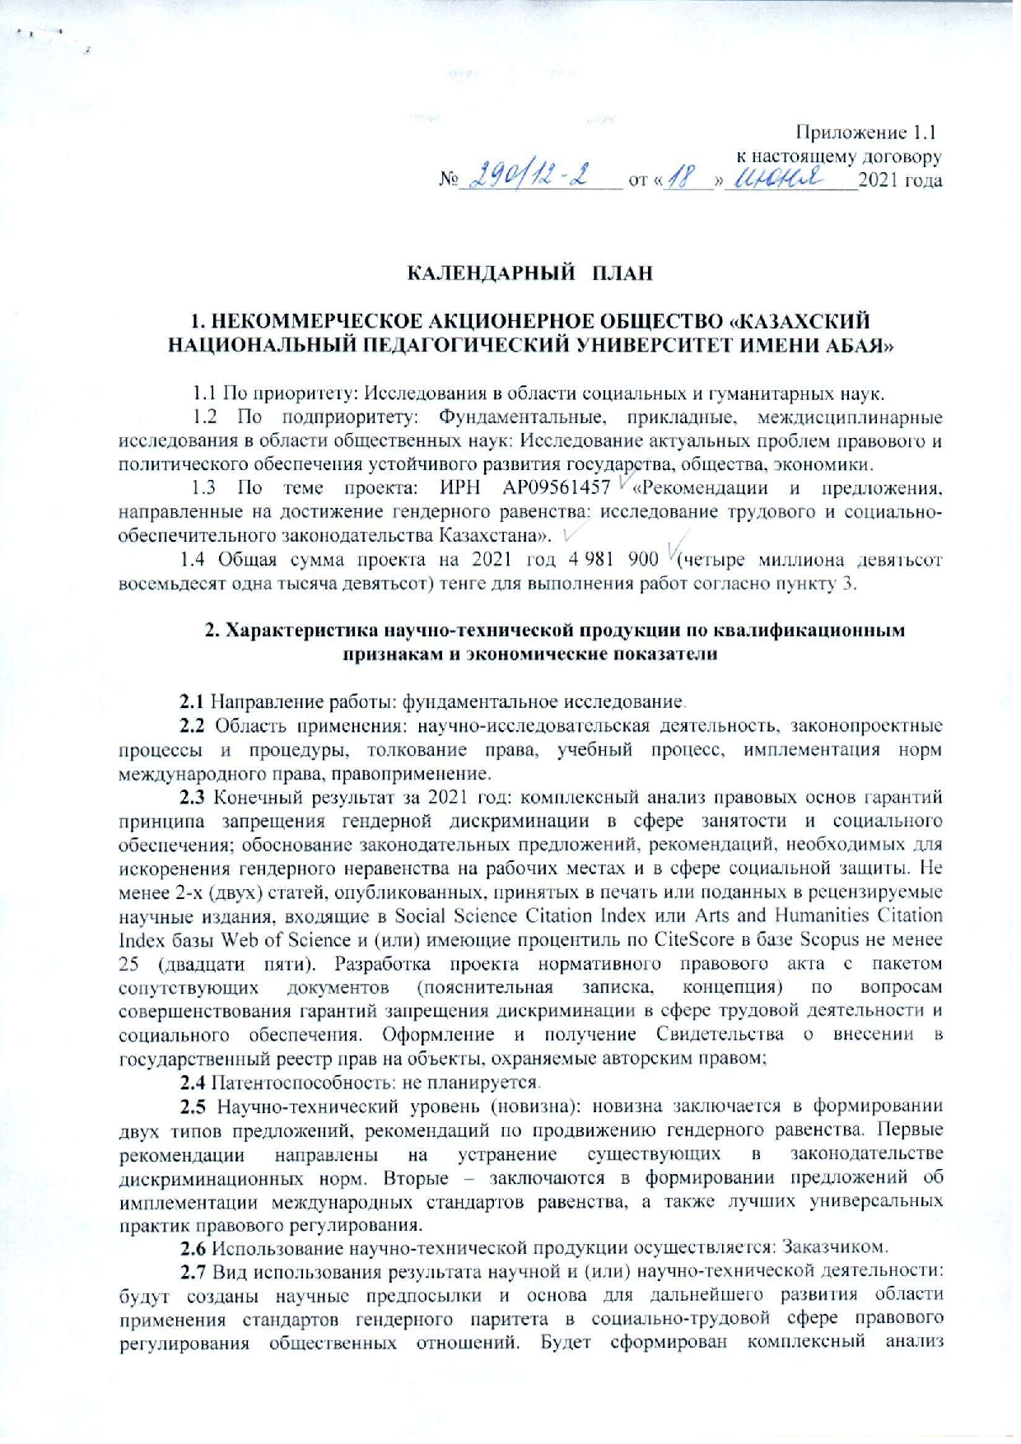
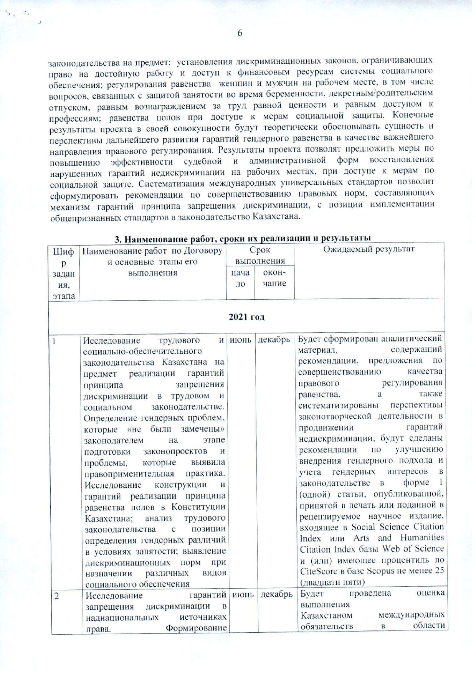
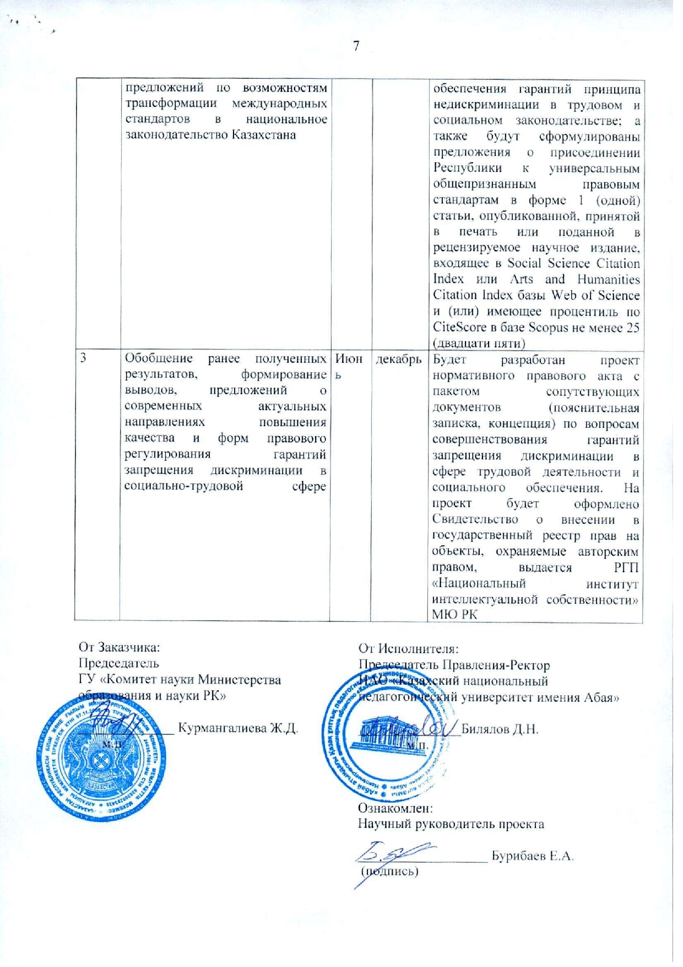
Calendar plan of the research

No. | Name of tasks and measures for their implementation | Start of execution (dd / mm / yy) | Duration, months | Expected results of the project implementation (in the context of tasks and activities), completion form
1 | 2 | 3 | 4 | 5
1 | Study of labor and social security legislation of Kazakhstan for the implementation of guarantees of the principle of prohibition of discrimination in labor and social legislation. Identification of gender issues that were “not noticed” by the legislator at the stage of preparation of draft laws and problems that were identified by law enforcement practice. Study of the design and guarantees for the implementation of the principle of gender equality in the Constitution of Kazakhstan; analysis of labor legislation from the standpoint of determining gender differences in employment conditions; identification of discriminatory norms in the appointment of various types of social security | 04/01/2021 – 31/12/2021 | 12 | Formation of analytical material and results containing recommendations, proposals for improving the quality of legal regulation of equality, as well as systematizing the prospects for legislative activity in promoting guarantees of non-discrimination; recommendations for improving the implementation of a gender approach and gender mainstreaming in legislation in the form of 1 (one) article published, accepted for publication or submitted to a peer-reviewed scientific publication included in the Social Science Citation Index or Arts and Humanities Citation Index of the Web of Science database and ( or) having a CiteScore percentile in the Scopus database of at least 25 (twenty five)
2 | Research of guarantees of prohibition of discrimination in supranational sources of law. Formation of proposals on the possibilities of transforming international standards into the national legislation of Kazakhstan | 04/01/2021 – 31/12/2021 | 12 | Assessment fulfillment Kazakhstan's international obligations in the field of ensuring guarantees of the principle of non-discrimination in labor and social legislation; and proposals will be formulated for the Republic to join the universal generally recognized legal standards in the form of 1 (one) article published, accepted for publication or submitted to a peer-reviewed scientific publication included in the Social Science Citation Index or Arts and Humanities Citation Index of the Web of Science database, and (or) has a CiteScore percentile in the Scopus database of at least 25 (twenty five)
3 | Generalization of previously obtained results, the formation of conclusions, proposals on modern topical directions for improving the quality and forms of legal regulation of guarantees of prohibition of discrimination in the social and labor sphere | 04/01/2021 – 31/12/2021 | 12 | Development of a draft normative legal act with a package of related documents (explanatory note, concept) on improving the guarantees of the prohibition of discrimination in the field of labor activity and social security. The project will be issued a Certificate of entry into the state register of rights to objects protected by copyright, issued by the RSE "National Institute of Intellectual Property" of the Ministry of Justice of the Republic of Kazakhstan

ANNEX C
Reprints of publications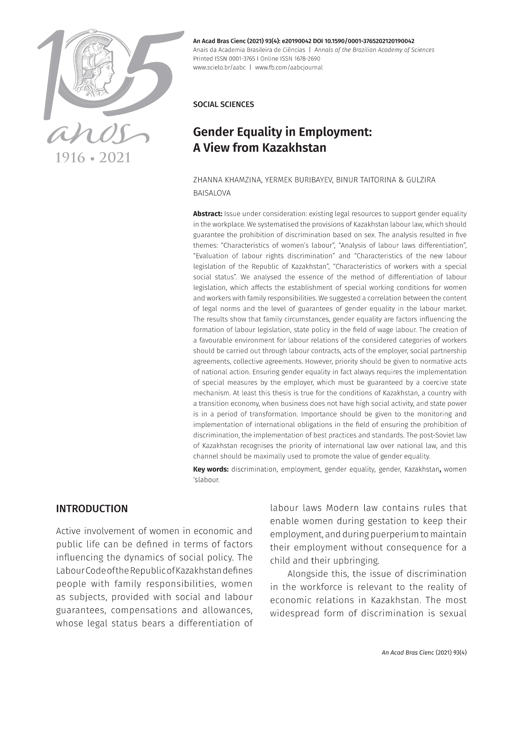
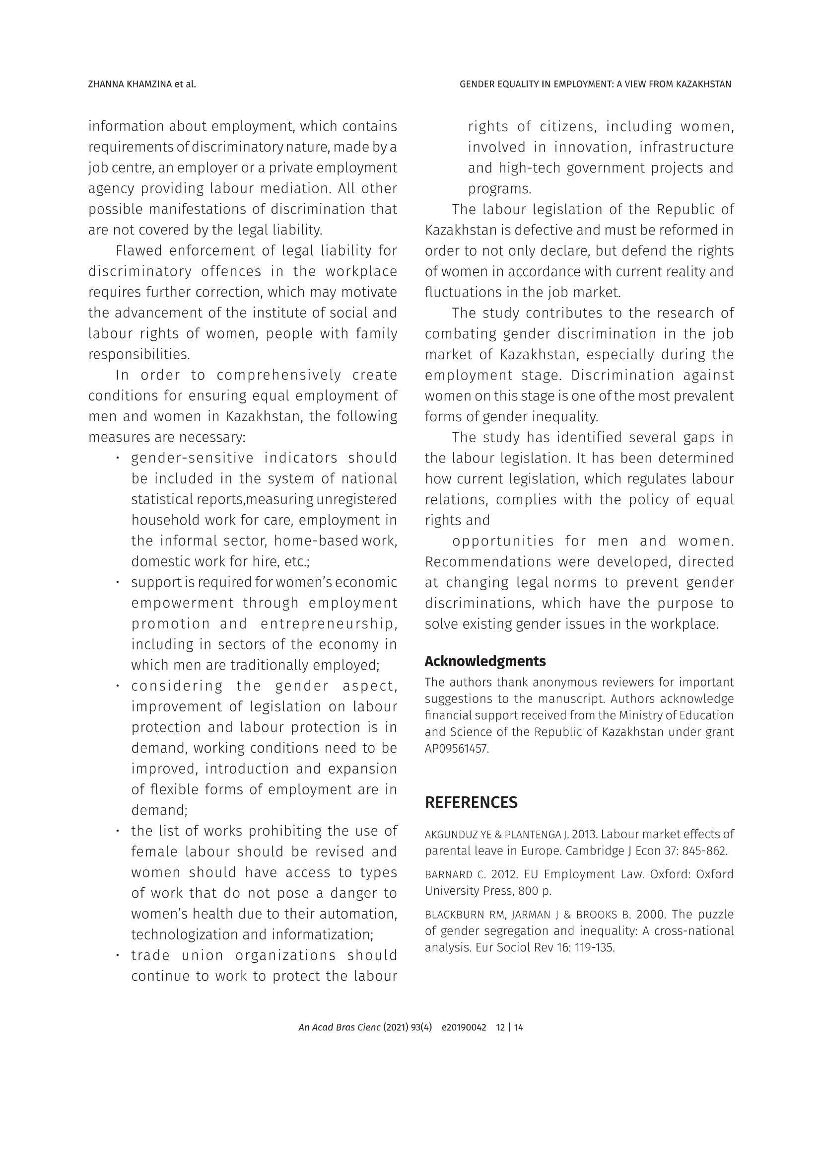
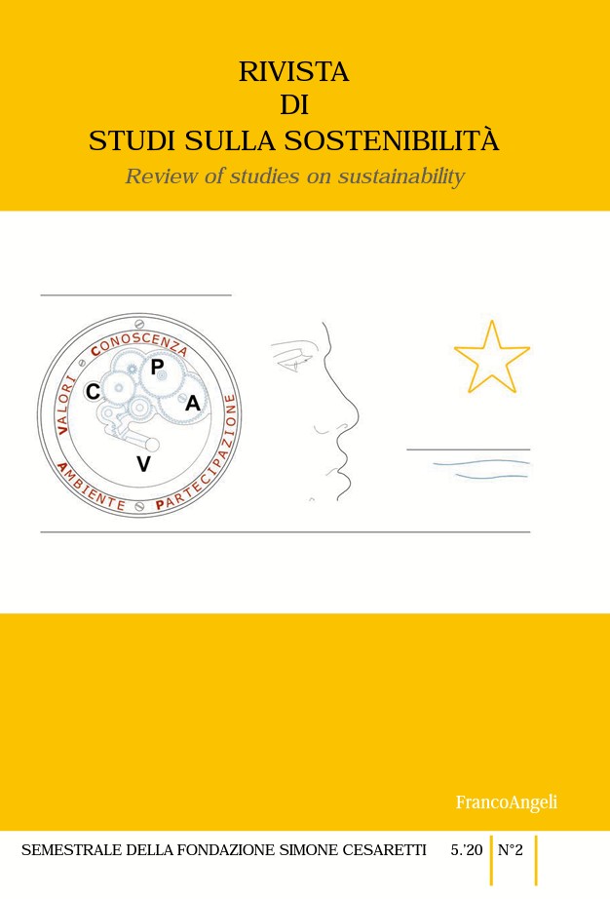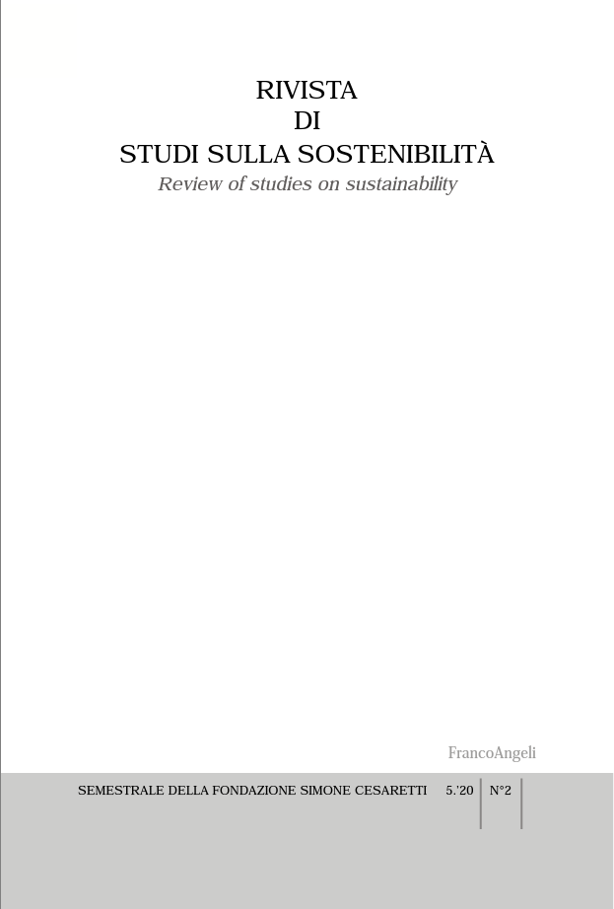

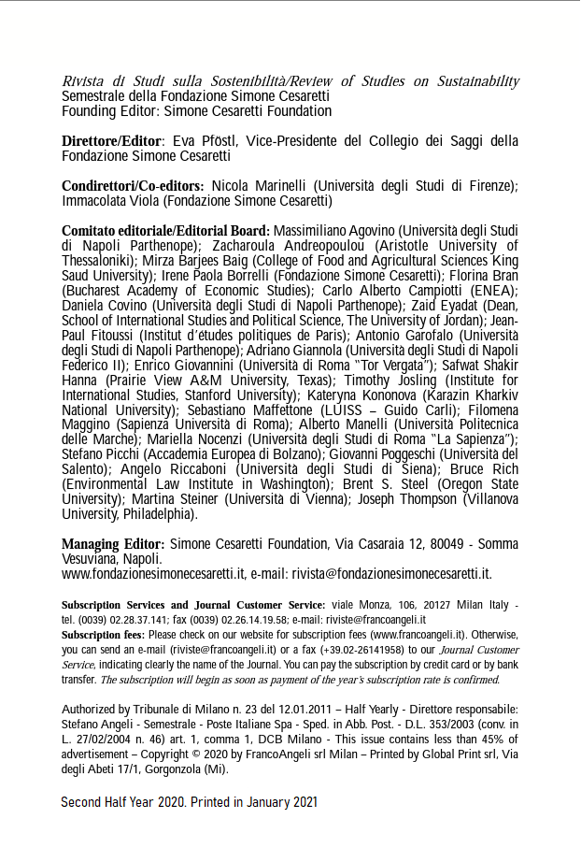
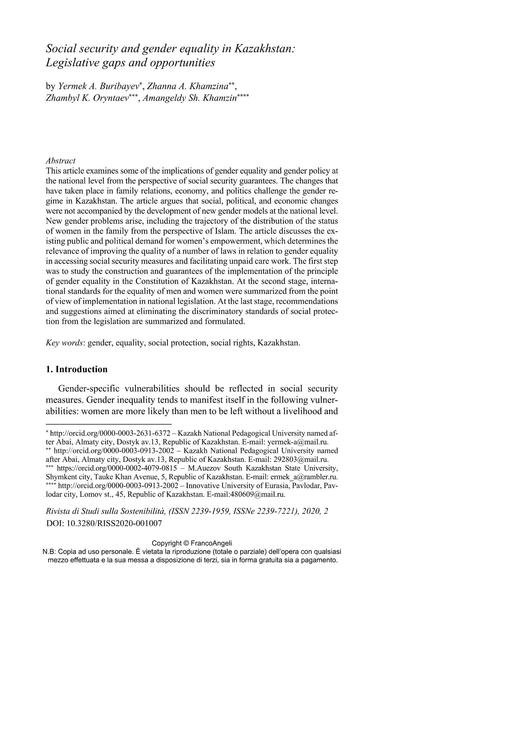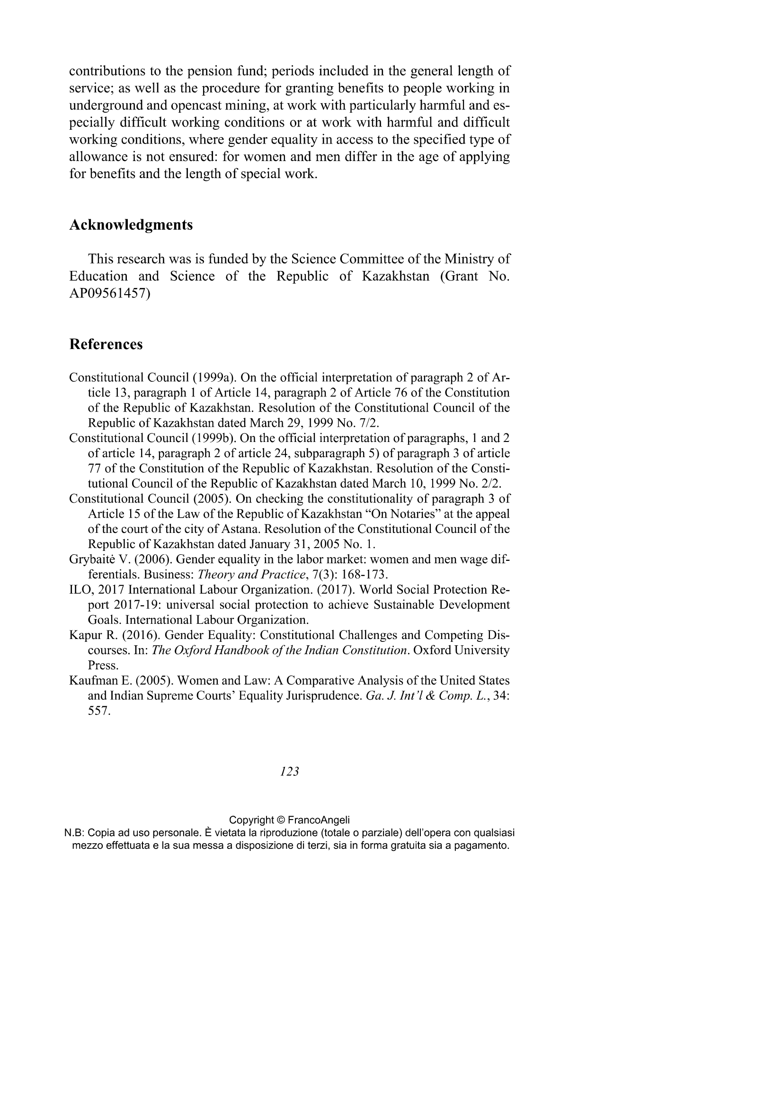
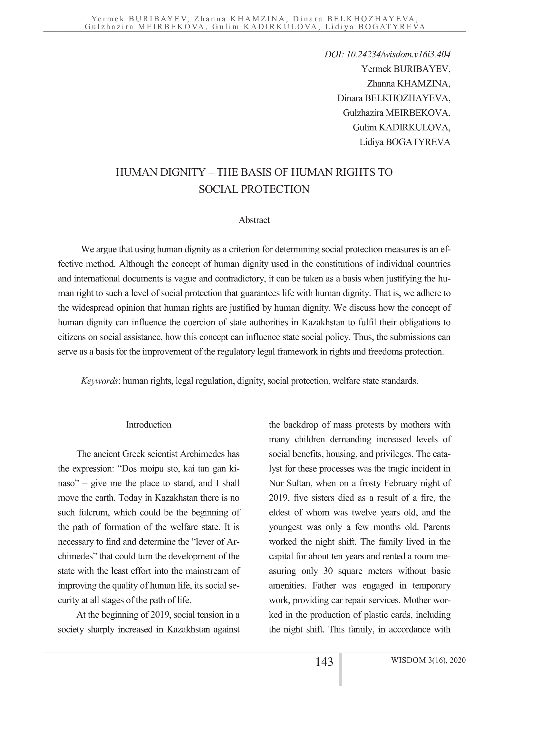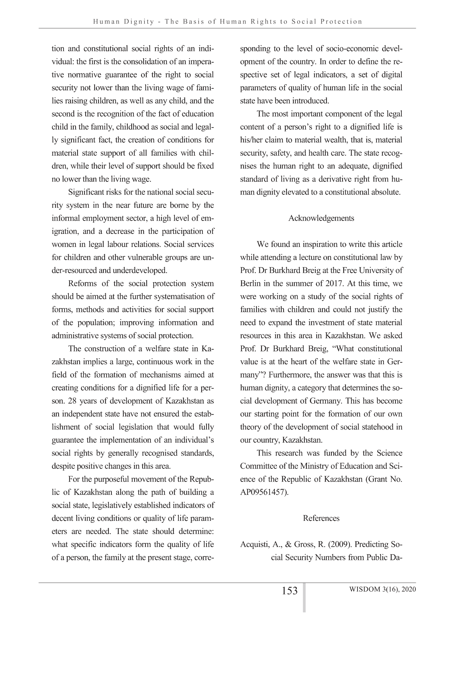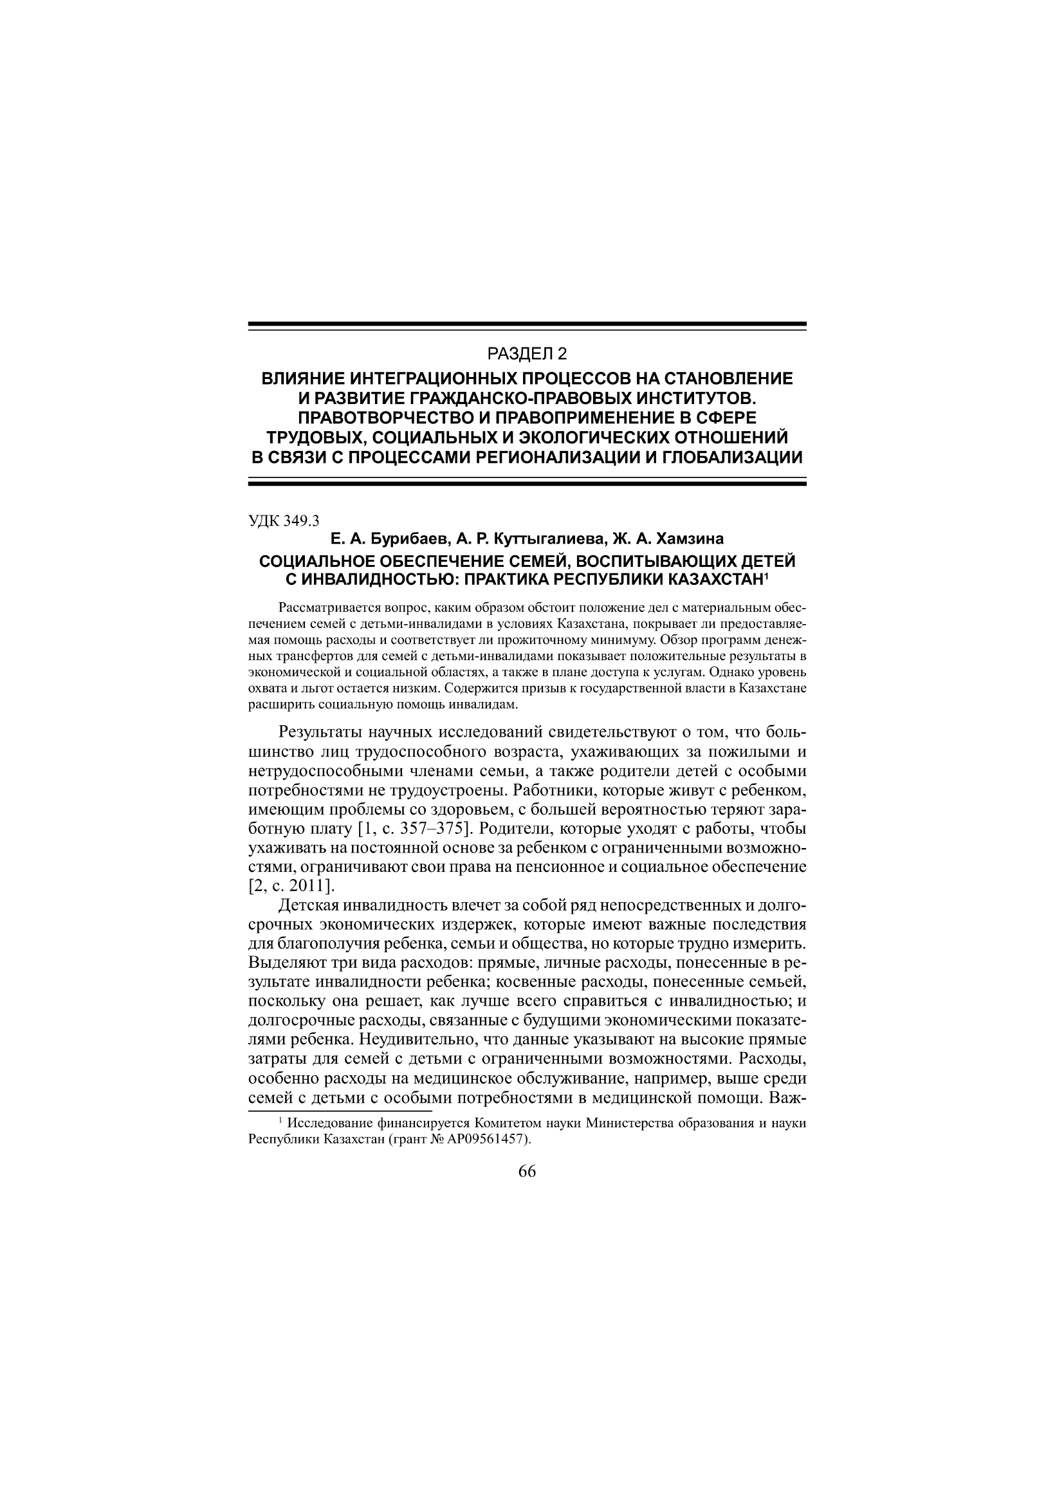

ANNEX D
Certificates of entry into the state register of rights to objects protected by copyright

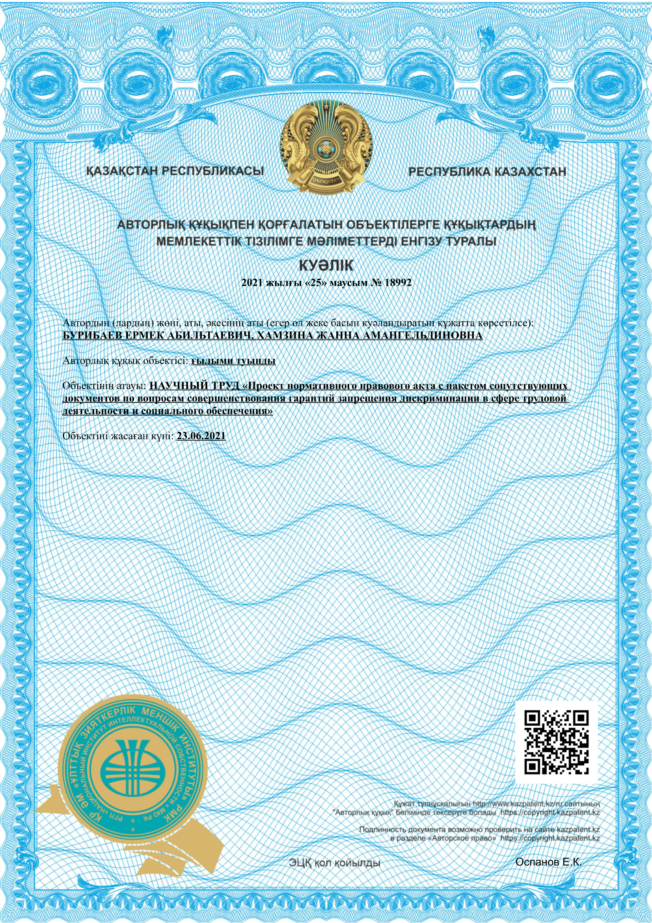

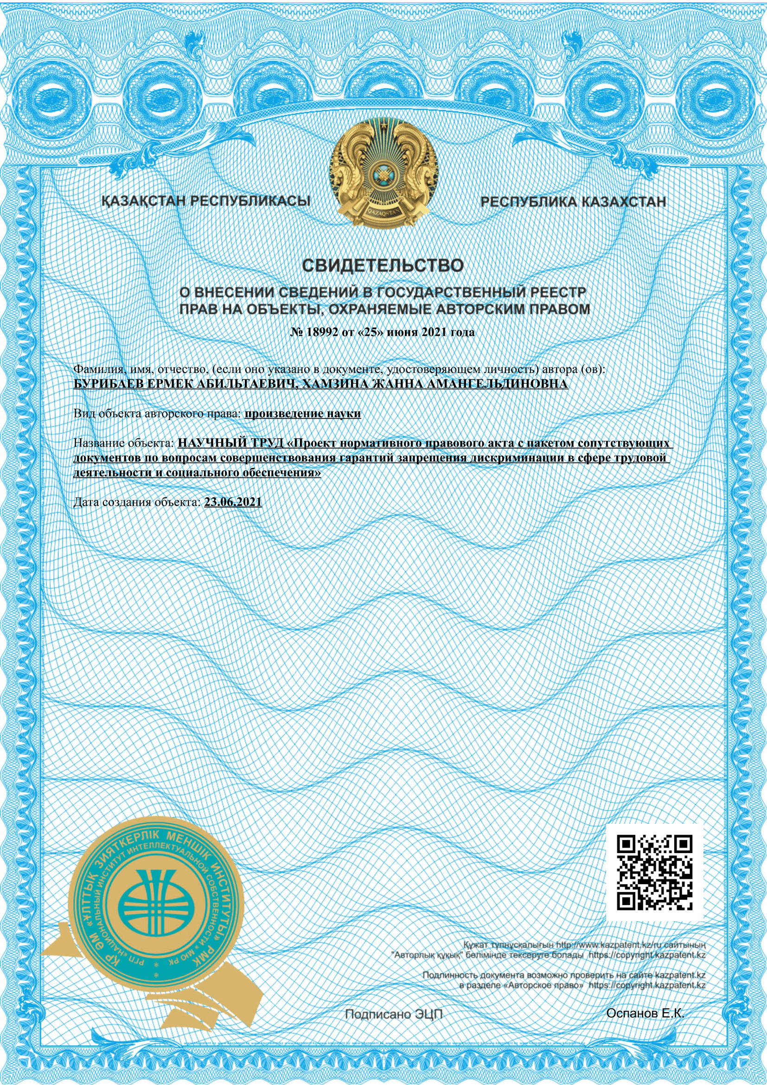
ANNEX E
Draft regulatory legal act with accompanying documents

EXPLANATORY NOTE
to the draft Law of the Republic of Kazakhstan "On Amendments and Additions to Certain Legislative Acts of the Republic of Kazakhstan on the Improvement of Guarantees for the Prohibition of Discrimination in the Sphere of Labor Activity and Social Security"

The bill was developed in order to improve the current legislation in the field of improving guarantees for the prohibition of discrimination against labor, employment, and social security. On June 9, 2021, the President of the Republic of Kazakhstan K. Tokayev signed a decree "On further measures of the Republic of Kazakhstan in the field of human rights" (No. 597), approved the Plan of priority measures in the field of human rights, which, women.
According to paragraph 2 of Article 14 of the Constitution of the Republic of Kazakhstan, no one can be subjected to any discrimination based on origin, social, official and property status, sex, race, nationality, language, attitude to religion, beliefs, place of residence or for any other circumstances. Direct or indirect restriction of the rights and freedoms of a person (citizen) for reasons of origin, social, official or property status, sex, race, nationality, language, attitude to religion, beliefs, place of residence, membership of public associations or for any other circumstances is prosecuted for law (Article 145 of the Criminal Code of the Republic of Kazakhstan).
The need to develop a draft law is due to the importance of gender equality as a key area of ​​social modernization of society, since the creation of equal opportunities is an important component in ensuring the active participation of women in the political, economic and social life of the country.
Requirements for further strengthening and deepening guarantees of gender equality in the social and labor sphere, improving legislation in this area on an ongoing basis, tasks, recommendations for bringing legal acts in line with international standards are reflected in the provisions of the Concept of Family and Gender Policy in the Republic of Kazakhstan until 2030 ( approved by the Decree of the President of the Republic of Kazakhstan dated December 6, 2016 No. 384), the Concept for Kazakhstan's entry into the 30 most developed countries in the world (approved by the Decree of the President of the Republic of Kazakhstan dated January 17, 2014 No. 732), the United Nations Convention on the Elimination of All Forms of Discrimination Against women, SDGs and other ratified international treaties and agreements. The Concept establishes the need to solve the problem of improving legislation, as well as bringing it in line with international standards, recommendations of the UN, SDGs and OECD; provides for multifaceted research in the field of gender policy in order to determine its prospects and directions of development.
The bill is aimed at solving the problems of ensuring equality on the basis of gender by assessing the state of legislation and formulating proposals for its improvement. The project contains legislative opportunities to neutralize discrimination in employment, in the performance of family responsibilities, in access to the social security system. Based on an analysis of the totality of all elements of legal impact (international, national law, the possibility of applying state coercion measures, etc.), specific recommendations have been formulated to achieve gender equality in the social and labor sphere, which will not only improve parity, but also support policies aimed at eliminating norms conducive to bias and discrimination.
If discrimination in employment, in the workplace on the basis of gender is an obvious fact, then inequality in the field of social protection is not clearly expressed. Social security legislation contains a number of provisions that, on the contrary, “normalize” gender discrimination. These are the rules governing: conditions for early registration of pension rights in the presence of five or more children in the family, as well as when living in territories that have been negatively affected as a result of nuclear tests at the Semipalatinsk nuclear test site; the procedure for the emergence of the right to a pension annuity at the expense of mandatory contributions to the pension fund; periods included in the general work experience; as well as the procedure for granting benefits to persons who worked in underground and opencast mining, in jobs with especially harmful and especially difficult working conditions, or in jobs with harmful and difficult working conditions, where gender equality in access to this type of benefit is not ensured: for women and men differ in the age of applying for benefits and the length of service in special jobs.
The draft law brings the definition of discrimination, its signs and grounds in accordance with Article 1 of the ILO Convention No. 111 "On Discrimination in the Field of Labor and Occupation" (ratified by the Republic of Kazakhstan in accordance with the Law of the Republic of Kazakhstan dated 20.07.1999 No. 444-1). The framework of legislative regulation additionally includes the prohibition of discrimination based on nationality and the position of labor migrants, on political convictions, on the basis of HIV status, on the basis of lifestyle, and civic position. The list of subjects who may be discriminated against is supplemented by “job seekers” by virtue of the implementation of paragraph 3 of Article 1 of Convention No. 111. According to the specified norm of the international act, the areas of work and occupation include access to vocational training, access to work and various occupations, as well as pay and working conditions.
There is a prohibition on discrimination on the grounds of “appeal or intention to go to court or other bodies to protect their rights or provide support to other employees in protecting their rights”, which are guaranteed by the obligations of the Republic of Kazakhstan to comply with the ILO Convention No. 135 “On the Protection of the Rights of Employee Representatives at the Enterprise and the opportunities provided to them ”, ratified in accordance with the Law of the Republic of Kazakhstan dated 30.12.1999 No. 13-II; as well as the ILO Convention No. 98 “On the Application of the Principles of the Right to Organize in Trade Unions and to Conduct Collective Bargaining, ratified by the Law of the Republic of Kazakhstan dated December 14, 2000, No. 118-II.
An "open" list of possible grounds and reasons for discrimination is established in accordance with paragraph 1 of Article 1 of Convention No. 111. In order to ensure mechanisms for the implementation of the possibility of compensation for harm caused by discriminatory actions, civil law enshrines the right of persons who believe that they have been discriminated against in the workplace, to apply to the court for the restoration of violated rights, compensation for material damage and compensation for moral damage or other instances in the manner prescribed by the laws of the Republic of Kazakhstan.
The introduction of guarantees of equality in the extension of labor relations is in demand. When renewing an employee, the employee is the most vulnerable in labor relations, the Labor Code leaves to the parties' discretion the issue of extending the contract, which is practically decided exclusively by the employer. The norm of the bill establishes more stable rules in order to prevent and suppress the risks of discrimination at the stage of extension of labor relations. The draft law excludes an unjustified gradation of a person's right to equal treatment when concluding an employment contract based on the age of children. The current version of Paragraph 2 of Art. 25 of the Labor Code of the Republic of Kazakhstan establishes the right to equal treatment exclusively for those persons who have children under the age of three. The indicated age threshold of the child has no logical basis. On the contrary, it denies the right to equal treatment of those persons who have children over three years of age. An "open" list of circumstances not related to business qualities is introduced, these can be life circumstances, lifestyle, civic position of a person, which may indicate a restriction of the right when concluding an employment contract. The list of reasons why an employer has no right to refuse a job seeker cannot be exhaustive, as is enshrined in the current edition of the Labor Code of the Republic of Kazakhstan. In the event of a litigation, the question of whether the refusal is discriminatory should be decided depending on the circumstances of the case, their interpretation by the court.
To ensure the right of a person to protection from discrimination, to equal treatment when applying for a job, including through appeal to the court and other instances, the draft law introduces a rule that, at the written request of a person who is refused to conclude an employment contract, the employer is obliged to inform the reason for the refusal in writing within a period not later than within seven working days from the date of such request. Refusal to conclude an employment contract may be appealed in court or other instances in the manner prescribed by the laws of the Republic of Kazakhstan. Unjustified refusal to hire an applicant should have serious legal consequences, guarantees of the right to appeal and go to court.
Item 5, Art. 30 of the Labor Code of the Republic of Kazakhstan is excluded, since it actually discriminates by age the position in the employment relationship of an employee who has reached retirement age, when the employment contract is extended. If, according to the current edition of the Labor Code of the Republic of Kazakhstan (Article 30), it is allowed to extend the employment contract with an employee no more than two times, with the subsequent extension, the term of the contract is not indicated, that is, an indefinite period of validity is established, then with an employee of retirement age it is allowed to extend an unlimited number of times of urgent labor contract, for such employees there is no guarantee to limit the number of extensions of labor relations.
Pp. 24) Paragraph 1 of Art. 52 of the Labor Code of the Republic of Kazakhstan excludes the draft law. For persons who have reached retirement age, the current edition of the Labor Code of the Republic of Kazakhstan established an additional basis for terminating an employment contract on the initiative of the employer, the basis for the emergence of the employer's right to terminate the employment relationship is the only condition - that the employee reaches retirement age, which is, of course, a discriminatory circumstance. The presence of an excluded norm in the Labor Code of the Republic of Kazakhstan violates the principle of equality and non-discrimination, enshrined in Articles 14 and 24 of the Basic Law.
Paragraph 2 of Article 54 of the Labor Code of the Republic of Kazakhstan eliminates the unreasonable gender attribute of the benefit norm applied when terminating an employment contract. The guarantee norm for limiting the termination of an employment contract becomes gender neutral.
The draft law eliminates an unjustified gender approach when granting the right to workers to refuse to work at night if there is a child under the age of seven, including those under his guardianship. It obliges the employer, in the presence of the indicated life circumstances, to demand from the employee his written consent to work with deviations from normal conditions.
Amendments and additions are being made to the Law of the Republic of Kazakhstan dated 06.04.2016 No. 482-V ЗРК "On employment of the population" for the purpose of uniform application with the new edition of Art. 6 of the Labor Code of the Republic of Kazakhstan, securing guarantees for ensuring equality in hiring, disseminating information about available vacancies, job competitions. Compliance with the introduced norms will require that the published information on vacancies contains the most neutral information, listing only the business qualities of the applicants. In addition, the introduced norm provides one of the guarantees for the implementation of paragraphs. b) Paragraph 1 of Art. 11 of the Convention on the Elimination of All Forms of Discrimination against Women (12/18/1979, Kazakhstan joined in accordance with the Law of the Republic of Kazakhstan dated 06/29/1998 No. 248), which stipulates that the participating States take all appropriate measures to eliminate discrimination against women in the field of employment, in order to ensure, on a basis of equality between men and women, equal rights, in particular the right to the same employment opportunities, including the application of the same criteria for selection in employment.
Amendments and additions to the Law of the Republic of Kazakhstan dated June 21, 2013 No. 105-V "On Pension Provision in the Republic of Kazakhstan" are aimed at implementing the principle of equal access to preferential pension provision. The establishment for women and men of different ages and a single length of service in territories with a special status has no logical justification, needs to be brought into line with the constitutional guarantees of equality, as well as the requirements of the Convention on the Elimination of All Forms of Discrimination against Women (12/18/1979, Kazakhstan joined in accordance with the Law of the Republic of Kazakhstan dated June 29, 1998 No. 248) on ensuring, on the basis of equality of men and women, equal rights, including the right to social security, in particular, in case of retirement, unemployment, illness, disability, old age and in other cases of incapacity for work, as well as the right to paid leave (subparagraph e) of paragraph 1 of Art. 11 of the Convention).
The bill introduces changes to Art. 11, 13, 59 of the Law of the Republic of Kazakhstan dated June 21, 2013 No. 105-V "On pension provision in the Republic of Kazakhstan in order to implement the principle of equal access to preferential pension provision. Establishing the right to preferential pensions exclusively for women discriminates against the right of male fathers to preferential pensions, including single fathers raising children on their own. The revised version of the content of the norm of Art. 11 will bring it in line with the constitutional values ​​of equality and non-discrimination, as well as the standards of the Convention on the Elimination of All Forms of Discrimination against Women.
In addition, changes are being made to uniformly apply the principle of equal access to social security systems. The consolidation in the law of different periods of the general work experience for the exercise of the rights to pension payments from the solidarity system in full discriminates against men on the basis of gender. The current state of pension legislation is gradually equalizing the age at which men and women are eligible for pensions, and a similar “blurring of boundaries” should also take place in relation to the required total length of service. The changes relate to ensuring gender equality of parents in access to the accounting of periods of time for childcare for inclusion in the total length of service.
Guarantees are introduced to establish equal amounts of the minimum threshold sufficiency when assigning pension payments at the expense of an insurance annuity on all grounds. In the absence of legislative guarantees of equality in access to pension provision through a pension annuity, today by-laws establish different amounts of sufficiency of pension savings for men and women for pension provision through compulsory and professional pension contributions, which is a gross violation of the principle of non-discrimination and equality in access. to retirement benefits.
Amendments to the Law of the Republic of Kazakhstan dated July 13, 1999 No. 414 "On state special benefits to persons who worked in underground and open pit mining, at work with especially harmful and especially difficult working conditions or at work with harmful and difficult working conditions" relate to the creation of equal conditions for men and women to access the state special allowance. The existing differentiation in terms of access to benefits for men and women discriminates against the former, securing for them a longer duration of special work experience and a longer older age. The proposed amendments are based on the principle of most favored nation, that is, the existing better conditions for women apply to men.
The initiated amendments to paragraphs 1 and 2 of Art. 4 of the Law of the Republic of Kazakhstan "On state special benefits to persons who worked in underground and opencast mining, in work with especially harmful and especially difficult working conditions or at work with harmful and difficult working conditions" are introduced in order to comply with obligations to fulfill constitutional guarantees of equality, and also obligations to fulfill the requirements of Art. 26 of the International Covenant on Civil and Political Rights, which guarantees everyone to equality before the law and the right, without any discrimination, to equal protection of the law. In this respect, all kinds of discrimination must be prohibited by law, and the law must guarantee to all persons equal and effective protection against discrimination on any grounds, such as race, color, sex, language, religion, political or other opinion, national or social origin, property status, birth or other circumstance.
In order to consolidate responsibility in the legislation and strengthen the existing norms on non-discrimination on any grounds when hiring, promoting and in the process of training, when applying and assigning specific types of social security, when applying norms on social protection, the project provides for the introduction of new edition of Art. 90 of the Code of the Republic of Kazakhstan on Administrative Offenses dated 05.07.2014 No. 235-V. Supplements part 2 of article 152 of the Criminal Code of the Republic of Kazakhstan dated July 3, 2014 No. 226-V ЗРК in the aspect of criminalization of unjustified refusal to conclude an employment contract, or unjustified termination of an employment contract with a man with children under three years old, for these reasons.
The adoption of the bill will increase the effectiveness of the current legislation in the areas of labor, employment, social security.
If the bill is adopted, the following positive legal and socio-economic consequences are expected:
- guarantees of the principle of prohibition of discrimination in employment and social security will be strengthened;
- the legal conditions will be improved to neutralize the elimination of gender inequality in the workplace and in the field of social protection;
- international standards of equality between men and women will be implemented into national legislation.
The adoption of the bill will not entail negative socio-economic and legal consequences.

LAW OF THE REPUBLIC OF KAZAKHSTAN
On making changes and additions to some

legislative acts of the Republic of Kazakhstan on the improvement of guarantees for the prohibition of discrimination in the field of labor activity and social security legislative acts of the Republic of Kazakhstan on the improvement of guarantees for the prohibition of discrimination in the field of labor activity and social security

Article 1. Introduce amendments and additions to the following legislative acts of the Republic of Kazakhstan:

1.In the Labor Code of the Republic of Kazakhstan dated November 23, 2015:

1) Paragraph 2 of Article 6 shall be stated in the following wording:

“2. Any discrimination in the world of work is prohibited, in particular, violation of the principle of equal rights and opportunities, direct or indirect restriction of the rights of workers and job seekers, depending on race, color, political, religious and other beliefs, gender, gender identity, sexual orientation , ethnic, social and foreign origin, age, health status, disability, suspicion or presence of HIV / AIDS, family and property status, family responsibilities, place of residence, membership in a trade union or other association of citizens, participation in a strike, appeal or intention applying to the court or other authorities for the protection of their rights or providing support to other employees in protecting their rights, on the basis of language or other characteristics not related to the nature of the work or the conditions of its performance”;

2) Paragraph 4 of Article 6 shall be stated in the following wording:

"4. Persons who believe that they have been discriminated against in the field of work have the right to apply to the court with an application for the restoration of violated rights, compensation for material damage and compensation for moral damage, or other instances in the manner prescribed by the laws of the Republic of Kazakhstan ";

3) supplement the content of the title of Article 25 and paragraph 1 of Article 25 with the words "extension", stating as follows:

"Article 25. Guarantees of equality of rights and opportunities when concluding, extending an employment contract

1. It is prohibited to violate the equality of rights and opportunities when concluding or extending an employment contract”;

4) exclude the words “under the age of three years” from paragraph 2 of Article 25, and state this paragraph in the following wording:

“2. Pregnancy, the presence of children, minority, disability, as well as other circumstances not related to the specifics of the types of labor activity or due to the special care of the state for persons in need of increased social and legal protection, cannot restrict the right to conclude an employment contract, with the exception of cases provided for this Code ";

5) Article 25 shall be supplemented with a new Paragraph 3 as follows:

"3. At the written request of the person who was refused to conclude an employment contract, the employer is obliged to inform the reason for the refusal in writing no later than within seven working days from the date of such request.

Refusal to conclude an employment contract may be appealed in court or other instances in the manner prescribed by the laws of the Republic of Kazakhstan ";

6) paragraph 5 of Article 30 shall be excluded;

7) subparagraph 24) of paragraph 1 of Article 52 shall be deleted;

8) Paragraph 2 of Article 54 shall be stated in the following wording:

“2. Termination of an employment contract on the initiative of the employer on the grounds provided for in subparagraphs 2) and 3) of paragraph 1 of Article 52 of this Code is not allowed with pregnant women who have provided the employer with a pregnancy certificate, employees with children under the age of three, single parents raising a child under the age of fourteen (a disabled child under eighteen years old), other persons who are guardians (trustees) of these categories of children ";

9) subparagraph 1) of paragraph 4 of Article 76 shall be stated in the following wording:

"1) employees with children under the age of seven, including raising them as guardians."

2. To the Law of the Republic of Kazakhstan dated April 6, 2016, No. 482-V ЗРК "On employment of the population":

1) subparagraph 2) of Article 5 shall be supplemented with the second and third paragraphs of the following content:

“It is prohibited to disseminate information about vacant jobs or vacant positions that contains information about any direct or indirect restriction of rights or the establishment of direct or indirect advantages depending on race, skin color, political, religious and other beliefs, gender, gender identity, sexual orientation, ethnic, social and foreign origin, age, health status, disability, suspicion or presence of HIV / AIDS, family and property status, family responsibilities, place of residence, as well as other circumstances not related to the business qualities of employees, except in cases where the right or obligation to establish such restrictions or benefits is provided by law.

Persons disseminating information about vacant jobs or vacant positions, containing discriminatory restrictions, are held accountable under the law. "

3. In the Law of the Republic of Kazakhstan dated June 21, 2013, No. 105-V "On pension provision in the Republic of Kazakhstan":

1) subparagraphs 1), 2) of paragraph 2 of Article 11 shall be excluded, paragraph 2 of Article 11 shall be stated in the following wording:

“2. Citizens who have lived in areas of extreme and maximum radiation risk in the period from August 29, 1949 to July 5, 1963 for at least 5 years, in accordance with the Law of the Republic of Kazakhstan "On Social Protection of Citizens Affected by Nuclear Tests at the Semipalatinsk Nuclear Test Site" the right to assign old-age pension payments upon reaching 45 years of age”;

2) Paragraph 3 of Article 11 shall be stated in the following wording:

"3. One of the parents who has 5 or more children and raised them up to the age of eight is entitled to pension payments by age upon reaching 53 years of age”;

3) subparagraphs 1), 2) of paragraph 2 of Article 11 shall be excluded, paragraph 2 of Article 11 shall be stated in the following wording:

"4. Pension payments by age in full are assigned to citizens upon reaching the age established in paragraphs 1-3 of this article, if they have a work experience of at least twenty years as of January 1, 1998 ";

4) subparagraph 8) of paragraph 1 of Article 13 shall be supplemented and stated in the following edition:

“8) the time of care of an unemployed mother or an unemployed father (in the course of his actual care) for young children, but not more than until each child reaches the age of 3 years within 12 years in total”;

5) add a new second paragraph of Paragraph 1 of Article 59 as follows:

"For men and women, an equal and uniform level of the threshold amount of sufficiency of pension savings for the conclusion of a pension annuity agreement is guaranteed".

4. In the Law of the Republic of Kazakhstan dated July 13, 1999, No. 414 "On state special benefits to persons who worked in underground and open pit mining, in work with especially harmful and especially difficult working conditions or at work with harmful and difficult working conditions":

1) Paragraph 1 of Article 4 shall be stated in the following wording:

"1. Citizens who, as of January 1, 1998, had work experience according to List No. 1 of industries, works, professions, positions and indicators in underground and open pit mining, in works with especially harmful and especially difficult working conditions, approved by the Government of the Republic of Kazakhstan, have the right for the appointment of benefits upon reaching 48 years of age and with a work experience of at least 15 years, of which at least 7 years 6 months in the specified jobs ";

2) Paragraph 2 of Article 4 shall be stated in the following wording:

“2. Citizens who, as of January 1, 1998, had work experience according to List No. 2 of industries, jobs, professions, positions and indicators with harmful and difficult working conditions, approved by the Government of the Republic of Kazakhstan, have the right to receive benefits upon reaching 53 years of age and with work experience at least 20 years, of which at least 10 years in the specified jobs".

5. In the Code of the Republic of Kazakhstan on Administrative Offenses dated July 5, 2014, No. 235-V:

1) Article 90 shall be stated in the following edition:

“Article 90. Allowing discrimination in the sphere of labor and social security

1. Discrimination in the world of work, that is, violation of the principle of equal rights and opportunities, direct or indirect restriction of the rights of workers, job seekers, as well as persons applying for appointments and receiving types of social security, depending on race, skin color, political , religious and other beliefs, sex, gender identity, sexual orientation, ethnic, social and foreign origin, age, health status, disability, suspicion or presence of HIV / AIDS, family and property status, family responsibilities, place of residence, membership in a professional an alliance or other association of citizens, participation in a strike, appeal or intention to go to court or other bodies to protect their rights or provide support to other employees in protecting their rights, on linguistic or other grounds not related to the nature of the work or the conditions of its performance, and also the requirements of the legislation on social security, -

entails a fine for officials, small businesses or non-profit organizations - in the amount of ten, for medium-sized businesses - in the amount of twenty, for large businesses - in the amount of forty monthly calculation indices.

2. The employer's admission of discrimination in the labor sphere, expressed in violation of the employee's right to equal pay for equal work, as well as to equal production and living conditions and labor protection conditions, -

entails a fine for officials, small businesses or non-profit organizations - in the amount of thirty, for medium-sized businesses - in the amount of sixty, for large businesses - in the amount of one hundred monthly calculation indices.

3. The action provided for by parts one and two of this article, committed repeatedly within a year after the imposition of an administrative penalty -

entails a fine for officials, small businesses or non-profit organizations in the amount of sixty, for medium-sized businesses - in the amount of eighty, for large businesses - in the amount of one hundred and twenty monthly calculation indices.

4. Placement by the employment center, private employment agency, as well as by the employer of information on vacancies for employment, containing discriminatory requirements in the sphere of labor, -

entails a fine for individuals in the amount of fifteen, for small businesses or non-profit organizations - in the amount of thirty, for medium-sized businesses - in the amount of fifty, for large businesses - in the amount of one hundred monthly calculation indices.

5. The action provided for by part four of this article, committed repeatedly within a year after the imposition of an administrative penalty -

entails a fine for individuals in the amount of thirty, for small businesses or non-profit organizations - in the amount of fifty, for medium-sized businesses - in the amount of one hundred, for large businesses - in the amount of two hundred monthly calculation indices.
6. In the Criminal Code of the Republic of Kazakhstan dated July 3, 2014, No. 226-V ЗРК:
1) in the second part of Article 152 the words “or unjustified termination of an employment contract with a woman with children under three years of age” shall be replaced by “or unjustified termination of an employment contract with a person with children under three years of age”.
Article 2. This Law shall enter into force upon the expiration of ten calendar days after the day of its first official publication.
COMPARISON TABLE
on the draft Law of the Republic of Kazakhstan "On Amendments and Additions to Certain Legislative Acts of the Republic of Kazakhstan on the Improvement of Guarantees for the Prohibition of Discrimination in the Sphere of Labor Activity and Social Security"

№ | Structural element | Edition of a legislative act | Revision of the proposed  changes or additions | Justification for the change or  additions
1 | 2 | 3 | 4 | 5
Labor Code of the Republic of Kazakhstan dated November 23, 2015

1 | Article 6, paragraph 2 | Article 6. Prohibition of discrimination at work  2. No one may be subjected to any discrimination in the exercise of labor rights on grounds of origin, social, official and property status, sex, race, nationality, language, attitude to religion, beliefs, place of residence, age or physical disabilities, as well as belonging to public associations. | Paragraph 2 of Article 6 shall be stated as follows:  2. Any discrimination in the sphere of labor is prohibited, in particular, violation of the principle of equal rights and opportunities, direct or indirect restriction of the rights of workers and job seekers, depending on race, color, political, religious and other beliefs, sex, gender identity, sexual orientation, ethnic, social and foreign origin, age, health status, disability, suspicion or presence of HIV / AIDS, family and property status, family responsibilities, place of residence, membership in a trade union or other association of citizens, participation in a strike, appeal or the intention to go to court or other authorities to protect their rights or provide support to other employees in protecting their rights, on the basis of language or other characteristics not related to the nature of the work or the conditions of its performance. | The Labor Code excludes direct citation of the norms of the Constitution of the Republic of Kazakhstan, as having no legal significance. In particular, virtually verbatim repetition (with the exception of clarification about the sphere of public relations) in paragraph 2 of Article 6 of the Labor Code of the Republic of Kazakhstan is excluded of the provision enshrined in paragraph 2 of Article 14 of the Constitution of the Republic of Kazakhstan, which prohibits discrimination in any areas of public relations.  The definition of discrimination, its signs and grounds are brought in line with Article 1 of the ILO Convention No. 111 “On Discrimination in the Field of Labor and Occupation”. The Convention was ratified by the RK in accordance with the Law of the RK dated 20.07.99, No. 444-1. According to Art. 3 of Convention No. 111, the state is obliged to introduce such legislation that can ensure the observance of equality of opportunity and treatment in relation to work and occupation in order to eradicate any discrimination  In the framework of legislative regulation, a prohibition of discrimination on the basis of nationality and the position of labor migrants, on political convictions, on the basis of HIV status, on the basis of lifestyle, and civic position is additionally introduced. The list of subjects that may be discriminated against includes “job seekers” by virtue of the implementation of paragraph 3 of Article 1 of Convention No. 111. According to the specified norm of the international act, the areas of work and occupation include access to vocational training, access to work and various occupations, as well as pay and working conditions.  The prohibition of discrimination on the grounds of “appeal or intention to go to court or other bodies to protect their rights or provide support to other employees in protecting their rights” is enshrined, which are guaranteed by the obligations of the Republic of Kazakhstan to comply with the ILO Convention No. 135 “On the Protection of the Rights of Employee Representatives at the Enterprise and the opportunities provided to them ”, ratified in accordance with the Law of the Republic of Kazakhstan dated December 30, 1999 No. 13-II; as well as the ILO Convention No. 98 “On the Application of the Principles of the Right to Organize in Trade Unions  and to conduct collective bargaining, ratified by the Law of the Republic of Kazakhstan dated 14.12.2000, No. 118-II.  An "open" list of possible grounds and reasons for discrimination is established in accordance with paragraph 1 of Article 1 of Convention No. 111.
1 | 2 | 3 | 4 | 5
2 | Article 6, paragraph 4 | Article 6. Prohibition of discrimination at work  4. Persons who believe that they have been discriminated against in the field of labor have the right to apply to the court or other authorities in the manner prescribed by the laws of the Republic of Kazakhstan. | Paragraph 4 of Article 6 shall be stated as follows:  4. Persons who believe that they have been discriminated against in the field of work have the right to apply to the court for the restoration of violated rights, compensation for material damage and compensation for moral damage, or other instances in the manner prescribed by the laws of the Republic of Kazakhstan. | The amendment is made in order to provide mechanisms for the implementation of the possibility of compensation for harm caused by discriminatory actions in civil law.
3 | Article 25, paragraph 1 | Article 25. Guarantees of equality of rights and opportunities when concluding an employment contract  1. It is prohibited to violate the equality of rights and opportunities when concluding an employment contract. | Supplement the content of the title of Article 25 and paragraph 1 of Article 25 with the words "extension", stating as follows:  Article 25. Guarantees of equality of rights and opportunities when concluding, extending an employment contract  1. It is prohibited to violate the equality of rights and opportunities when concluding or extending an employment contract. | The introduction of guarantees of equality in the extension of labor relations is in demand. In the case of renewal, the employee is the most vulnerable in labor relations, the Labor Code leaves the issue of renewal to the discretion of the parties, which is practically decided exclusively by the employer. The norm of the bill establishes more stable rules in order to prevent and suppress the risks of discrimination at the stage of extension of labor relations.
4 | Article 25, paragraph 2 | Article 25. Guarantees of equality of rights and opportunities when concluding an employment contract  2. Pregnancy, the presence of children under the age of three, minority, disability may not restrict the right to conclude an employment contract, with the exception of cases provided for by this Code. | To exclude the words “under the age of three years” from Paragraph 2 of Article 25, to state this Paragraph in the following wording:  2. Pregnancy, the presence of children, minority, disability, as well as other circumstances not related to the specifics of the types of labor activity or due to the special care of the state for persons in need of increased social and legal protection, cannot restrict the right to conclude an employment contract, except in cases provided by this Code. | Unjustified gradation of a person's right to equal treatment when concluding an employment contract by the age of children is excluded. The current edition establishes the right to equal treatment exclusively for those persons who have children under the age of three. The indicated age threshold of the child has no logical basis. On the contrary, it denies the right to equal treatment of those persons who have children over three years of age.  An "open" list of circumstances not related to business qualities is introduced, these can be life circumstances, lifestyle, civic position of a person, which may indicate a restriction of the right when concluding an employment contract.  This list of reasons why an employer has no right to refuse a job seeker cannot be established exhaustive, as it is enshrined in the current edition of the Labor Code of the Republic of Kazakhstan. In the event of a litigation, the question of whether a refusal is discriminatory should be decided on the basis of the circumstances of the case.
1 | 2 | 3 | 4 | 5
5 | Absent | Paragraph 3 of Article 25 absent | Article 25 shall be supplemented with a new Paragraph 3 as follows:  3. At the written request of the person who has been refused to conclude an employment contract, the employer is obliged to inform the reason for the refusal in writing no later than within seven working days from the date of such request.  Refusal to conclude an employment contract may be appealed in court or other instances in the manner prescribed by the laws of the Republic of Kazakhstan. | To ensure the right of a person to protection from discrimination to equal treatment when applying for a job, including through appeal to the court and other instances. Unjustified refusal to hire an applicant should have serious legal consequences, guarantees of the right to appeal and go to court.
6 | Article 30, paragraph 5 | Article 30. Duration of an employment contract  5. With an employee who has reached retirement age in accordance with paragraph 1 of Article 11 of the Law of the Republic of Kazakhstan "On Pension Provision in the Republic of Kazakhstan" and has a high professional and qualification level, taking into account his working capacity, the employment contract can be renewed annually without the restriction provided for in part four of subparagraph 2) paragraph 1 of this article. | Paragraph 5 of Article 30 shall be deleted | The norm is excluded, since it discriminates by age the position in the employment relationship of an employee who has reached retirement age, upon extension of the employment contract. According to the current version, if an employee is allowed to spit on an employment contract no more than two times, with the subsequent extension, the term of the contract is not indicated, for an indefinite period, then with an employee of retirement age it is allowed to extend an unlimited number of times a fixed-term employment contract, for such employees there is no guarantee to limit the number extension of labor relations.
7 | Subparagraph 24) of paragraph 1 of Article 52 | Article 52. Grounds for termination of an employment contract on the initiative of the employer  1. An employment contract with an employee on the initiative of the employer may be terminated in the following cases:  24) the employee reaches the retirement age established by | Subparagraph 24) of paragraph 1 of Article 52 shall be deleted | The age-discriminatory rule is excluded. For persons who have reached retirement age, the current edition of the Labor Code of the Republic of Kazakhstan established an additional basis for terminating an employment contract on the initiative of the employer, the basis for the emergence of the employer's right to terminate the employment relationship is based on the only condition - that the employee reaches retirement age, which is an unconditional discriminatory circumstance. The existence of an excluded norm in the Labor Code of the Republic of Kazakhstan violates the principle of equality and non-discrimination, enshrined in Articles 14 and 24 of the Basic Law. The Constitution of the Republic of Kazakhstan, along with other provisions, consolidated the grounds for recognizing discrimination and motives of gender.
1 | 2 | 3 | 4 | 5
 |  | paragraph 1 of Article 11 of the Law of the Republic of Kazakhstan "On Pension Provision in the Republic of Kazakhstan", with the right to annually extend the term of the employment contract by mutual agreement of the parties;
8 | Article 54, paragraph 2 | Article 54. Restriction of the possibility of terminating an employment contract on the initiative of the employer  2. Termination of an employment contract on the initiative of the employer on the grounds provided for in subparagraphs 2) and 3) of paragraph 1 of Article 52 of this Code is not allowed with pregnant women who have provided the employer with a pregnancy certificate, women with children under the age of three, single mothers, raising a child under the age of fourteen (a disabled child under eighteen years old), other persons raising the specified category of children without a mother. | Paragraph 2 of Article 54 shall be stated as follows:  2. Termination of an employment contract on the initiative of the employer on the grounds provided for in subparagraphs 2) and 3) of paragraph 1 of Article 52 of this Code is not allowed with pregnant women who have provided the employer with a pregnancy certificate, employees with children under the age of three, single parents, raising a child under the age of fourteen (a disabled child under eighteen years old), other persons who are guardians (trustees) of these categories of children. | The unjustified gender attribute of the benefit norm applied when terminating an employment contract is eliminated. The guarantee norm for limiting the termination of an employment contract becomes gender neutral.
9 | Subparagraph 1) of paragraph 4 of Article 76 | Article 76. Work at night  4. The employer does not have the right to engage the following employees to work at night without the written consent of the following employees:  1) women with children under the age of seven, and other persons raising children under | Subparagraph 1) of paragraph 4 of Article 76 shall be stated in the following wording:  1) employees with children under the age of seven, including raising them as guardians. | The amendment eliminates an unreasonable gender approach when granting the right to workers to refuse to work at night if there is a child under the age of seven, including those under his guardianship. It obliges the employer, in the presence of the indicated life circumstances, to demand from the employee his written consent to work with deviations from normal conditions.
1 | 2 | 3 | 4 | 5
 |  | the age of seven without a mother;
Law of the Republic of Kazakhstan dated April 6, 2016, No. 482-V ЗРК "On employment of the population"

10 | Absent | Article 5. State measures to promote employment of the population  The state provides measures to promote employment of the population based on:  2) protection from any forms of discrimination and equality of opportunities in obtaining a profession and work, choosing the conditions of employment and work; | Subparagraph 2) of Article 5 shall be supplemented with the second and third paragraphs of the following content: It is prohibited to disseminate information about vacant jobs or vacant positions containing information about any direct or indirect restriction of rights or the establishment of direct or indirect advantages depending on race, color skin, political, religious and other beliefs, gender, gender identity, sexual orientation, ethnic, social and foreign origin, age, health status, disability, suspicion or presence of HIV / AIDS, family and property status, family responsibilities, place of residence, as well as other circumstances not related to the professional qualities of employees, except for cases in which the right or obligation to establish such restrictions or advantages is provided for by laws.  Persons who disseminate information about vacant jobs or vacant positions, containing discriminatory restrictions, are prosecuted as established by law. | For the purpose of uniform application with the new edition of Art. 6 of the Labor Code of the Republic of Kazakhstan, securing guarantees for ensuring equality in hiring, disseminating information about available vacancies, job competitions. In order to eradicate the practice of gender and other discrimination in the publication and dissemination of information about vacancies. Compliance with the introduced norms will require that the published information on vacancies contains the most neutral information, listing only the business qualities of the applicants. In addition, the introduced norm provides one of the guarantees for the implementation of paragraphs. b) Paragraph 1 of Art. 11 of the Convention on the Elimination of All Forms of Discrimination  in relation to women (December 18, 1979, Kazakhstan joined in accordance with the Law of the Republic of Kazakhstan dated June 29, 1998 No. 248), stating that the participating States shall take all appropriate measures to eliminate discrimination against women in the field of employment in order to ensure on the basis of equality between men and women, equal rights, in particular the right to the same employment opportunities, including the application of the same criteria for selection in employment.
Law of the Republic of Kazakhstan dated June 21, 2013, No. 105-V "On pension provision in the Republic of Kazakhstan"

1 | 2 | 3 | 4 | 5
11 | Subparagraphs 1), 2) of paragraph 2 of Article 11 | Article 11. Assignment of old-age pension payments  2. Citizens who lived in areas of extreme and maximum radiation risk in the period from August 29, 1949 to July 5, 1963 for at least 5 years, in accordance with the Law of the Republic of Kazakhstan "On Social Protection of Citizens Affected by Nuclear Tests at the Semipalatinsk Nuclear Test Site "are entitled to the appointment of old-age pension payments:  1) men - upon reaching 50 years of age;  2) women - upon reaching the age of 45. | Subparagraphs 1), 2) of paragraph 2 of Article 11 shall be excluded, paragraph 2 of Article 11 shall be amended as follows:  2. Citizens who lived in areas of extreme and maximum radiation risk in the period from August 29, 1949 to July 5, 1963 for at least 5 years, in accordance with the Law of the Republic of Kazakhstan "On social protection of citizens affected by nuclear tests at the Semipalatinsk nuclear test site "are eligible for retirement benefit payments upon reaching 45 years of age. | In order to implement the principle of equal access to preferential pension benefits. The establishment for women and men of different ages and a single length of experience in territories with a special status has no logical justification, needs to be brought into line with the constitutional guarantees of equality, as well as the requirements of the Convention on the Elimination of All Forms of Discrimination  in relation to women (December 18, 1979, Kazakhstan joined in accordance with the Law of the Republic of Kazakhstan dated June 29, 1998 No. 248) on ensuring, on the basis of equality of men and women, equal rights, including the right to social security, in particular, in the case of leaving pension, unemployment, illness, disability, old age and in other cases of disability, as well as the right to paid leave (subparagraph e) of paragraph 1 of Art. 11 of the Convention).
12 | Article 11, paragraph 3 | Article 11. Assignment of old-age pension payments  3. Women who have given birth (adopted, adopted) 5 or more children and raised them up to the age of eight are entitled to pension payments by age upon reaching 53 years of age. | Paragraph 3 of Article 11 shall be stated as follows:  3. One of the parents who has 5 or more children and raised them up to the age of eight is entitled to pension payments by age upon reaching 53 years of age. | In order to implement the principle of equal access to preferential pension benefits. Establishing the right to preferential pensions exclusively for women discriminates against the right of fathers to preferential pensions, including single fathers raising children on their own. The amended version of the norm will bring it in line with the constitutional guarantees of equality, as well as the requirements of the Convention on the Elimination of All Forms of Discrimination  in relation to women (December 18, 1979, Kazakhstan joined in accordance with the Law of the Republic of Kazakhstan dated June 29, 1998 No. 248) on ensuring, on the basis of equality of men and women, equal rights, including the rights to social security, in particular, in the case of leaving pension, unemployment, illness, disability, old age and in other cases of disability, as well as the right to paid leave (subparagraph e) of paragraph 1 of Art. 11 of the Convention).
1 | 2 | 3 | 4 | 5
13 | Subparagraphs 1), 2) of paragraph 4 of Article 11 | Article 11. Assignment of old-age pension payments  4. Pension payments by age in full are assigned upon reaching the age established in paragraphs 1-3 of this article, to the following categories of citizens:  1) men - if they have a work experience of at least twenty-five years as of January 1, 1998;  2) women - if they have a work experience of at least twenty years as of January 1, 1998. | Subparagraphs 1), 2) of paragraph 4 of Article 11 shall be excluded, paragraph 4 of Article 11 shall be stated in the following edition:  4. Pension payments by age in full are assigned to citizens upon reaching the age established in paragraphs 1-3 of this article, if they have a work experience of at least twenty years as of January 1, 1998. | In order to uniformly apply the principle of equal access to social security systems. The consolidation in the law of different periods of the general work experience for the exercise of the rights to pension payments from the solidarity system in full discriminates against men on the basis of gender. The current state of pension legislation is gradually equalizing the age at which men and women are eligible for pensions, and a similar “blurring of boundaries” should also take place in relation to the required total length of service.
14 | Subparagraph 8) of paragraph 1 of Article 13 | Article 13. Calculation of the length of service for the appointment of pension payments by age  1. When calculating the length of service for the appointment of old-age pension benefits, the following shall be taken into account:  8) the time of care of an unemployed mother for young children, but not more than until each child reaches the age of 3 years within 12 years in total; | Subparagraph 8) of paragraph 1 of Article 13 shall be supplemented and stated in the following edition:  8) the time when an unemployed mother or an unemployed father (in the course of his actual care) cares for young children, but not more than until each child reaches the age of 3 years within 12 years in total; | In order to ensure gender equality of parents in access to the accounting of periods of time for caring for a child for inclusion in the total length of service.
15 | Absent | Article 59. Insurance payments from insurance organizations  1. The persons specified in paragraph 1 of Article 11 and subparagraphs 2) and 3) of paragraph 1 of Article 31, subparagraphs 2) and 3) of paragraph 1 of Article 32 of this Law have the right to conclude a pension annuity agreement with an insurance organization on the implementation of | Supplement with a new second paragraph of Paragraph 1 of article 59 as follows:  For men and women, an equal and uniform level of the threshold amount of the sufficiency of pension savings for the conclusion of a pension annuity agreement is guaranteed. | The introduction of a guarantee on the establishment of equal amounts of the minimum threshold sufficiency in the appointment of pension payments at the expense of an insurance annuity on all grounds. In the absence of legislative guarantees of equality in access to pension provision through a pension annuity, today by-laws establish different amounts of sufficiency of pension savings for men and women for pension provision through compulsory and professional pension contributions, which is a gross violation of the principle of non-discrimination and equality in access. to retirement benefits.
1 | 2 | 3 | 4 | 5
insurance payments for life using pension savings formed from compulsory pension contributions and (or) compulsory professional pension contributions.
In case of insufficient pension savings formed from compulsory pension contributions and (or) compulsory professional pension contributions, pension savings generated from voluntary pension contributions can be used to conclude a pension annuity agreement.
Law of the Republic of Kazakhstan dated July 13, 1999, No. 414 "On state special benefits to persons who worked in underground and open pit mining, at work with especially harmful and especially difficult working conditions or at work with harmful and difficult working conditions"
16 | New edition of paragraph 1 of article 4 | Article 4. Citizens eligible for benefits  1. Citizens who, as of January 1, 1998, had work experience according to List No. 1 of industries, works, professions, positions and indicators in underground and open pit mining, in works with especially harmful and especially difficult working conditions, approved by the Government of the Republic of Kazakhstan, have the right to receive benefits:  men - upon reaching 53 years of age and with a work experience of at least 20 years, of which at least 10 years in the specified jobs;  women - upon reaching 48 years of age and with a work experience of at least 15 years, of which at least 7 years 6 months in these jobs. | Paragraph 1 of Article 4 shall be stated as follows:  1. Citizens who, as of January 1, 1998, had work experience according to List No. 1 of industries, works, professions, positions and indicators in underground and open pit mining, in works with especially harmful and especially difficult working conditions, approved by the Government of the Republic of Kazakhstan, have the right to receive benefits upon reaching 48 years of age and with a work experience of at least 15 years, of which at least 7 years 6 months in these jobs. | The new edition of the norm equalizes the right of men and women to access the state special allowance. The existing differentiation in the conditions of access to benefits for men and women discriminates against the former, securing for them a longer duration of special work experience and a longer older age. The proposed amendments are based on the principle of most favored nation, that is, the existing better conditions for women apply to men.
1 | 2 | 3 | 4 | 5
17 | New version of paragraph 2 of article 4 | Article 4. Citizens eligible for benefits  2. Citizens who, as of January 1, 1998, had work experience according to List No. 2 of industries, jobs, professions, positions and indicators with harmful and difficult working conditions, approved by the Government of the Republic of Kazakhstan, have the right to assign benefits:  men - upon reaching 58 years of age and with a work experience of at least 25 years, of which at least 12 years 6 months in the specified jobs;  women - upon reaching 53 years of age and with a work experience of at least 20 years, of which at least 10 years in these jobs. | Paragraph 2 of Article 4 shall be stated as follows:  2. Citizens who, as of January 1, 1998, had work experience according to List No. 2 of industries, jobs, professions, positions and indicators with harmful and difficult working conditions, approved by the Government of the Republic of Kazakhstan, have the right to receive benefits upon reaching 53 years of age and work experience of at least 20 years, of which at least 10 years in the specified jobs. | On similar grounds with the previous proposal. Additionally, we emphasize that the initiated amendments to paragraphs 1 and 2 of Art. 4 of the Law of the Republic of Kazakhstan "On state special benefits to persons who worked in underground and opencast mining, in work with especially harmful and especially difficult working conditions or at work with harmful and difficult working conditions" are introduced in order to comply with obligations to fulfill constitutional guarantees of equality, and also obligations to fulfill the requirements of Art. 26 of the International Covenant on Civil and Political Rights, which guarantees everyone to equality before the law and the right, without any discrimination, to equal protection of the law. In this respect, all kinds of discrimination must be prohibited by law, and the law must guarantee to all persons equal and effective protection against discrimination on any grounds, such as race, color, sex, language, religion, political or other opinion, national or social origin, property status, birth or other circumstance.
The Code of the Republic of Kazakhstan on Administrative Offenses of July 5, 2014, No. 235-V

18 | Article 90. | Article 90. Allowing discrimination at work  1. The employer's admission of discrimination in the sphere of labor, expressed in violation of the employee's right to equal pay for equal work, as well as to equal production and living conditions, -  entails a fine for officials, small businesses or non-profit organizations - in the amount of thirty, for medium-sized | Article 90 shall be amended as follows:  Article 90. Allowing discrimination in the sphere of labor and social security  1. Discrimination in the world of work, that is, violation of the principle of equal rights and opportunities, direct or indirect restriction of the rights of workers, job seekers, as well as persons applying for appointments and receiving types of social security, depending on race, skin color, political , religious and other beliefs, sex, gender identity, sexual orientation, ethnic, | In order to consolidate responsibility in the legislation and strengthen the existing norms on non-discrimination on any grounds when hiring, promoting and in the process of training, when applying and assigning specific types of social security, when applying norms on social protection.
1 | 2 | 3 | 4 | 5
 |  | businesses - in the amount of sixty, for large businesses - in the amount of one hundred monthly calculation indices.  2. The action provided for in the first part of this article, committed repeatedly within a year after the imposition of an administrative penalty -  entails a fine for officials, small businesses or non-profit organizations in the amount of sixty, for medium-sized businesses - in the amount of eighty, for large businesses - in the amount of one hundred and twenty monthly calculation indices.  3. Placement by the employment center, private employment agency, and also by the employer of information on vacancies for employment, containing discriminatory requirements in the sphere of labor, -  entails a fine for individuals in the amount of fifteen, for small businesses or non-profit organizations - in the amount of thirty, for medium-sized businesses - in the amount of fifty, for large businesses - in the amount of one hundred monthly calculation indices.  4. The action provided for by part three of this article, committed repeatedly within a - | -social and foreign origin, age, health status, disability, suspicion or presence of HIV / AIDS, family and property status, family responsibilities, place of residence, membership in a professional an alliance or other association of citizens, participation in a strike, appeal or intention to go to court or other bodies to protect their rights or provide support to other employees in protecting their rights, on linguistic or other grounds not related to the nature of the work or the conditions of its performance, and also the requirements of the legislation on social security, -  entails a fine for officials, small businesses or non-profit organizations - in the amount of ten, for medium-sized businesses - in the amount of twenty, for large businesses - in the amount of forty monthly calculation indices.  2. The employer's admission of discrimination in the labor sphere, expressed in violation of the employee's right to equal pay for equal work, as well as to equal production and living conditions and labor protection conditions -  entails a fine for officials, small businesses or non-profit organizations - in the amount of thirty, for medium-sized businesses - in the amount of sixty, for large businesses - in the amount of one hundred monthly calculation indices.  3. The action provided for by parts one and two of this article, committed repeatedly within a year after the
1 | 2 | 3 | 4 | 5
 |  | year after the imposition of an administrative penalty | imposition of an administrative penalty
 |  | entails a fine for individuals in the amount of thirty, for small businesses or non-profit organizations - in the amount of fifty, for medium-sized businesses - in the amount of one hundred, for large businesses - in the amount of two hundred monthly calculation indices. | entails a fine for officials, small businesses or non-profit organizations in the amount of sixty, for medium-sized businesses - in the amount of eighty, for large businesses - in the amount of one hundred and twenty monthly calculation indices.  4. Placement by the employment center, private employment agency, as well as by the employer of information on vacancies for employment, containing discriminatory requirements in the sphere of labor, -  entails a fine for individuals in the amount of fifteen, for small businesses or non-profit organizations - in the amount of thirty, for medium-sized businesses - in the amount of fifty, for large businesses - in the amount of one hundred monthly calculation indices.  5. The action provided for by part four of this article, committed repeatedly within a year after the imposition of an administrative penalty -  entails a fine for individuals in the amount of thirty, for small businesses or non-profit organizations - in the amount of fifty, for medium-sized businesses - in the amount of one hundred, for large businesses - in the amount of two hundred monthly calculation indices.

The Criminal Code of the Republic of Kazakhstan dated July 3, 2014, No. 226-V ЗРК

1 | 2 | 3 | 4 | 5
19 | Part 2 of Article 152 | Article 152. Violation of the labor legislation of the Republic of Kazakhstan  2. Unjustified refusal to conclude an employment contract with a woman or unjustified termination of an employment contract with her due to her pregnancy, or unjustified refusal to conclude an employment contract, or unjustified termination of an employment contract with a woman with children under three years of age, for these reasons, as well as unjustified refusal to conclude an employment contract or unjustified termination of an employment contract with a disabled person for reasons of disability or minors for reasons of his minority -  shall be punished with a fine in the amount of up to two hundred monthly calculation indices, or correctional labor in the same amount, or engaging in community service for a term of up to two hundred hours, or arrest for a term of up to fifty days, with deprivation of the right to hold certain positions or engage in certain activities for a term of up to one years or not. | Article 152. Violation of the labor legislation of the Republic of Kazakhstan  2. Unjustified refusal to conclude an employment contract with a woman or unjustified termination of an employment contract with her due to her pregnancy, or unjustified refusal to conclude an employment contract, or unjustified termination of an employment contract with a person with children under three years old, for these reasons, as well as unjustified refusal to conclude an employment contract or unjustified termination of an employment contract with a disabled person for reasons of disability or minors for reasons of his minority -  shall be punished with a fine in the amount of up to two hundred monthly calculation indices, or correctional labor in the same amount, or engaging in community service for a term of up to two hundred hours, or arrest for a term of up to fifty days, with deprivation of the right to hold certain positions or engage in certain activities for a term of up to one years or not. | In order to consolidate the gender-neutral formulation of the objective and subjective aspects of the crime, as well as to introduce guarantees of equality in labor relations for men with children under the age of three.

