ABSTRACT

Report 52 pages, 20figures,9 tables, 52 sources, 18 appendices
RAW MATERIALS, GRAIN PULSES, CHICKPEA FLOUR, MICROWAVE PROCESSING, TECHNOLOGY, GLUTEN-FREE CONFECTIONERY, MUFFINS, CUSTARD SEMI-FINISHED PRODUCTS.
Objects of research: "Miras 07" chickpea variety, gluten-free flour confectionery.
Purpose of the work - Development of technology for gluten-free flour confectionery products based on Kazakhstani grain legumes.
Methodology of the work: The research used generally accepted research methods based on the standards of the Republic of Kazakhstan, GOST, ISO, ICC, AACC, which made it possible to monitor raw materials and finished products.
The results of the work and their novelty: 2 recipes and technology of gluten-free confectionery products have been developed; a comprehensive assessment of the chemical composition of products, assessment of nutritional, energy value and safety of gluten-free confectionery products were carried out; 2 recommendations for organizing the technological process for the production of chickpea flour and flour confectionery products were developed; 2 technological instructions were developed for the method of production of flour confectionery products, 1 article was submitted for publication to a peer-reviewed scientific publication included in the Scopus database at least 35 (thirty-five); 1 experimental-industrial approbation of the developed technology in production was carried out and 1 patent application was filed.
Field of application of the results: food and processing industry.
Implementations of the R&D results - The results have been implemented at “KUHN BEL” SPK.
Economic efficiency: the production of the technology will allow flour confectionery products to reduce the dependence of Kazakhstani manufacturers on imports of gluten-free products; will establish the production of functional and specialized products, and expand the range of gluten-free products from domestic raw materials.
The main constrictive and technical-economic indicators are the expansion of the range of flour confectionery products and recommendations for their use in the diet of people to maintain a gluten-free diet for celiac patients.

CONTENTS
INTRODUCTION……………………………………………………………………………… |  | 8
THE MAIN PART ABOUT RESEARCH…………………………………………………...... |  | 10
1 | Choosing a direction of research………………………………………………………. | 10
2 | Objects and methods of research……………………………………………………… | 14
3 | Research results………………………………………………………………………. | 17
3.1 | Research of technological properties and chemical composition of gluten-free raw materials grown in Kazakhstan………………………………………………………. | 17
3.2 | Research on the effect of microwave processing on the quality indicators of chickpea………………………………………………………………………………. | 17
3.3 | Study of the protein fraction of chickpea variety "Miras 07"……………………………………………………………………………………. | 19
3.4 | Studies of the effect of microwave processing on the nutritional, biological value and safety of chickpea flour………………………………………………………….. | 23
3.5 | Study of the morphological structure of chickpea flour……………………………… | 27
3.6 | Development of recipes for biscuit and custard semi-finished products from gluten-free flour……………………………………………………………………………… | 29
3.7 | Studying the nutritional and biological value of gluten-free flour confectionery……. | 38
3.8 | Research on shelf life and safety of gluten-free flour confectionery………………… | 40
3.9 | Assessment of the economic efficiency of the production of gluten-free flour confectionery products………………………………………………………………. | 43
CONCLUSION………………………………………………………………………………… |  | 45
REFERENCES………………………………………………………………………………… |  | 47
ANNEX A - Calendar of work for 2021………………………………………………………. |  | 52
ANNEX B - Minutes of the meeting of the quality evaluation of prototypes of gluten-free flour confectionery ……………………………………………………………………………. |  | 55
ANNEX C - Technological scheme for the production of gluten-free flour confectionery products………………………………………………………………………………………… |  | 61
ANNEX D - Recipe for the production of "Ai-zhan" muffins………………………………………………………………………………………… |  | 63
ANNEX E - Recipe for the production of custard semi-finished product "Aizere"………………………………………………………………………………………. |  | 66
ANNEX F- Technological instructions for the production of gluten-free muffins from a mixture of chickpea, rice and amaranth flour…………………………………………………. |  | 69
ANNEX G - Technological instructions for the production of gluten-free semi-finished custard from a mixture of chickpea and corn flour…………………………………………….. |  | 81
ANNEX H - Recommendations for the technology of flour production from microwave processed chickpeas……………………………………………………………………………. |  | 93
ANNEX J - Recommendations on the organization of the technological process of production of gluten-free confectionery……………………………………………………………………. |  | 102
ANNEX K- Economic calculation of the cost of production of confectionery products based on gluten-free raw materials……………………………………………………………………. |  | 115
ANNEX L - Act on production testing of a method for making gluten-free muffins…………………………………………………………………………………………. |  | 121
Annex M - Act on production testing of a method for making a gluten-free custard semi-finished product………………………………………………………………………………… |  | 125
Annex N - Act of implementation the developed technology for the production of gluten-free flour confectionery products………………………………………………………………. |  | 128
ANNEX P - Project Implementation Act on introduction of materials of research work in educational process ……………………………………………………………………………. |  | 129
annex R - Protocols of research of samples of flour confectionery…………………………. |  | 130
annex S - Patent application…………………………………………………………………. |  | 142
annex T - List of scientific papers submitted for publication……………………………….. |  | 144
annex Y - Supporting documents of the research team……………………………………… |  | 148

TERMS AND DEFINITIONS
In this R&D report, the following terms are used with appropriate definitions:
Pulse crops are legumes that are harvested solely for the purpose of using their dry grains. The most common types of pulses are beans, peas, and lentils.
Nutritional value is a complex of properties of food products that meet the physiological needs of a person for energy and basic nutrients. The main source of energy for humans is proteins, fats and carbohydrates.
Biological value - a set of features of the chemical composition of a food product, determined by the content of essential amino acids, polyunsaturated fatty acids, micronutrients and other minor components of food, dietary fiber, etc.
Gluten-free food products - dietetic food products consisting, or produced, exclusively from one or more ingredients that do not contain wheat, rye, barley, oats or their hybrids, and in which the gluten content does not exceed the level of 20 mg / kg in the entire food product.
Gluten is a vegetable protein found in grains such as wheat, barley, rye and oats.
Grain gluten is a complex of protein substances of grain, capable of forming a coherent elastic mass when swollen in water.
A food product component (food ingredient) (further referred to as a component) is a product or substance (including food additives, flavorings), which, in accordance with the recipe, are used in the production (manufacture) of food products and are an integral part of it.
Muffin is a flour confectionery product of a volumetric shape based on flour, sugar, fat and egg products with large and (or) small additions (candied fruits, nuts, raisins, chocolate chips, etc.) or without them, with or without filling, with surface finishing or without it, sugar mass fraction not less than 9%, fat mass fraction not less than 5%, moisture mass fraction not more than 30%.
Celiac disease is a chronic disease characterized by damage to the lining of the small intestine by gluten, a vegetable protein found in cereals.

SYMBOLS AND ABBREVIATIONS

The following designations and abbreviations are used in this study:

RK | The Republic of Kazakhstan
WHO | World Health Organization
GOST | Interstate Standard
UDC | Indices of the universal decimal classification.
ND | Regulations
FAO | Food and Agriculture Organization - Food and agriculture organization
Kg | Kilogram
W | Humidity
s | Seconds
ml | Millimeters
% | Percent
T | Ton
cm | Centimeters
WAC | water absorption capacity of flour
⁰ C | degree Celsius
µm | Micrometers

INTRODUCTION

One of the main national priorities of the socio-economic development of Kazakhstan is to ensure the sustainable health of the public, which is reflected in the Constitution of the Republic of Kazakhstan, the Strategy of Kazakhstan 2050, the Codex of the Republic of Kazakhstan on public health and the health care system, the Environmental Code of the Republic of Kazakhstan.
One of the relevant social problems in many countries is celiac disease, a genetic disease characterized by indigestion. According to the estimates of physicians and nutritionists, 1 person in 100 is susceptible to this disease [1].
For people with celiac disease, it becomes necessary to replace the traditional diet with gluten with a gluten-free one. It is essential for the nutrition of this a category of people to use crops and products from them that do not contain gluten in their composition, but are able to give a product that does not differ from the grain analogue. The raw material for the production of gluten-free products can be crops and products produced from them: buckwheat, rice, quinoa, millet, amaranth, sorghum, corn, flax, soybeans, sunflower, and amaranth [2].
A gluten-free diet is in high demand among children with severe autism. Some believe that gluten (a protein found in wheat and some other grains) and casein (a protein found in dairy products) can worsen autism symptoms by causing inflammation in the gut that affects brain function [3].
Despite the prevalence of celiac disease among the child population 1: 262 [4, 5], due attention is not paid to resolving this issue in Kazakhstan. Medical institutions in which patients are observed are forced to find ways to provide special healing gluten-free products themselves. Also, there are no enterprises that produce products essential for this segment of consumers. Imported gluten-free products of unknown quality sold in the Kazakhstan market are sold at magnified prices.
There are undoubtedly many recipes for gluten-free products in the world, but the quality of the raw materials used to create them plays a special role. Kazakhstani grain crops have excellent quality, which stands out from analogues. The content of such microelements as boron, iron, zinc and others in them is 30–40% higher than in the grain of foreign varieties [6]. Analysis of the indicators of leguminous crops showed that legumes are characterized by a high content of protein, fat, and minerals [7–9]. The indicated advantages of leguminous crops determine the prospects for the development and improvement of the technology for processing leguminous crops to create flour, and further use in the production of gluten-free confectionery.
In this regard, the creation of domestic innovative technologies for the production of gluten-free products based on domestic raw materials is an urgent task for the science of Kazakhstan, since the high quality of the local grain crops will allow us to obtain high-quality products that will be in demand in the domestic and foreign markets.
The novelty of the research - based on experimental data, the recipe components of chickpea flour have been scientifically substantiated, and technologies for flour confectionery products from domestic raw materials have been developed to provide gluten-free products for celiac disease patients.
Scientific and practical significance of research: the introduction into production of technologies for the production of gluten-free flour confectionery products from domestic raw materials will solve the problem of providing celiac patients with gluten-free products, overcome the dependence of consumers on the purchase of expensive imported gluten-free products, and develop the processing industry in Kazakhstan.
The purpose of the research is to develop a technology for gluten-free flour confectionery products based on Kazakhstani grain legumes.
Research objectives:
- Selection of gluten-free legumes for the production of confectionery;
- Study of the composition of proteins in leguminous crops grown in the Republic of Kazakhstan;
- Development of optimal modes of production of gluten-free confectionery products and assessment of their quality indicators;
- Research of the chemical composition of the developed gluten-free products;
- Development of recommendations for the organization of the technological process for the production of gluten-free confectionery products;
- Development of 1 technology and 2 recipes for the production of flour confectionery;
- Calculation of the economic efficiency of the production of flour confectionery products based on gluten-free grain legumes;
- carrying out 1 experimental-industrial approbation of the developed flour confectionery products into production.

THE MAIN PART ABOUT RESEARCH

1 Choosing a direction of research
Currently, in Kazakhstan, various grains and legumes are grown in sufficient volume, which can be an excellent raw material for obtaining gluten-free products.
There are various technologies for the production of gluten-free products in the world, but the fundamental difference between each technology is various formulations of products and quality of raw materials used.
The list of raw materials for the production of gluten-free products, proposed by the Codex Alimentarius, includes corn, rice - raw materials with high starch content. Recommended for use are buckwheat, millet, amaranth, flax (raw materials with a high content of polysaccharides), as well as high-protein ones - peas and chickpeas [10].
Specialists of VTT, a technical research center in Finland, research centers in northern Europe, have developed a recipe for gluten-free bread with increased nutritional value based on a mixture of corn flour (30%) and fermented horse bean flour (70%) [11].
The Muffin Vitalution has developed gluten-free blends consisting of Spanish sage and flax, almond flour, cinnamon, coconut oil, coconut sugar, eggs and agave inulin. These gluten-free blends are intended for the preparation of muffins in the microwave oven for nutrition of people adhering to the paleo diet [12].
IREK is expanding its range of gluten-free products. The company has developed a mixture "Bou de Quejo", which does not contain gluten, where cassava starch was used as the main raw material, and one of the latest novelties is a mixture of gluten-free MUFFIN-MIX-GLUTEN-FRIENDS for the production of muffins, pies, cantucci, etc. [13].
For flour confectionery products, flour is a key raw material component. Most of the assortment of flour confectionery products, which includes cookies, gingerbread cookies, waffles, cakes, pastries, muffins, etc., is usually made from premium wheat flour. Therefore, the confectionery industry naturally makes high demands on the quality of flour [14-16].
Modern technologies allow only partially replace wheat flour of the highest grade with secondary types of flour obtained from other cereals or legumes of agricultural crops (amaranth, buckwheat, rice, corn, soybeans, peas, chickpeas, lentils, etc.).
At the same time, the use of flour of the above-mentioned crops has led to the creation of gluten-free flour products with an increased content of such important nutrients as protein, fiber, calcium, iron, vitamin E and polyphenols [17]. Based on the biological insufficiency of the modern diet [18], let us consider the biological value of gluten-free flours in more detail. Proteins of flour from leguminous crops are represented mainly by globulins and a small amount of albumin, a low content of glutamic acid and proline. They are characterized by a high content of arginine, lysine and aspartic acid. A distinctive feature of the albumin present in the composition is the high content of methionine, lysine, isoleucine, threonine and tryptophan.
Leguminous crops significantly differ from the grain of traditional grain crops in their technological characteristics; the technology of their industrial processing into flour has been worked out in detail for many years, so it is necessary to search for ways to improve its processing.
The use of leguminous crops in the development of technology, it is very important to take into account their features, which differ from other crops. In addition, pulses are a source of anti-nutritional compounds that interfere with the absorption of essential nutrients [19].
The flour production process consists of two stages - preparatory and direct grinding of grain. To reduce energy consumption for its implementation and increase the yield of flour, it is proposed to carry out preliminary heat treatment of crop, which helps to reduce the strength of raw materials [20].
The problem of using microwave processing for leguminous crops follows from the foregoing.
In the study [21], crops were subjected to heat treatment with ultrahigh-frequency fields, which leads to changes in the structure of starch, contributing to an increase in its sorption activity. Studies have shown that when processing the power of the field in the range of 400-600 W, the organoleptic characteristics of the grain improved. It has also been proven that irradiation in microwave fields reduces the contamination of microorganisms and, consequently, increases the shelf life of finished products [22].
Ultrahigh-frequency processing is one of the promising methods for processing grain crops. During processing in a microwave oven, infrared radiation penetrates the grain, causing a rapid internal heating of the grain from the inside. In this case, the structural frame of the grain is destroyed and the strength of the grain decreases, which contributes to a decrease in energy consumption during its further processing [23].
The research work [24] presents the results of studies of heat treatment of leguminous crops by the micronization method. It shows the selected optimal modes of micronization of leguminous raw materials, i.e. processing time for all crops was 60 seconds, humidity for peas 18%, lentils 15%, chickpeas 20%. Before micronization, a heating process was applied. When heated, the raw material swells, thereby reducing its strength, which helps to reduce energy consumption during its further processing. The disadvantage of this method is the need to cool the heated micronized grain, which consumes additional energy and lengthens the processing time.
The work [25] also presents studies on the extrusion of soy flour. The technology involves preliminary crushing, then removal of the seed coat, inactivation of lipoxygenase by dry heating, followed by moistening to 20% and extrusion of the product. The disadvantages of the extrusion process are the complexity of the design, uncontrollable technological process and significant loss of time for the production of products.
There is a method of heating grain material using (IR) infrared irradiation, in which the grain material is processed at a grain temperature of 15-25 ° C and a moisture content of 10-15% and is heated to a temperature of 170-190 ° C [26]. This method of heat treatment of grain significantly increases the content of dextrins in the grain, contributes to its disinfection and softening. Starch granules of grain undergo deeper changes during IR treatment than with other processing methods. The disadvantage of this method is the duration of the technological process, the need for massive and difficult to operate equipment.
An alternative of overcoming the corresponding disadvantages can be the use of microwave processing of raw materials. This is the approach that is used in the following work [27]. With ultra-high-frequency processing of chickpeas, the organoleptic characteristics of finished products are improved. In addition, the process affects the content of proteins, fats and carbohydrates of the finished products.
Numerous studies are being carried out on the heat treatment of crops to increase the nutritional value. However, studies on ultra-high-frequency processing of leguminous crops of Kazakhstani selection have not been sufficiently studied. In this regard, it is expedient to study the issue of ultra-high-frequency processing of raw materials, which allows obtaining high quality products, stabilizing the output of the finished product and increasing its shelf life.
As gluten-free flour for dietary nutrition of celiac disease patients, the research suggests flour from leguminous crops.
Chickpea flour is flour made from the Bengal variety of Asian peas. Chickpea favorably stands out from other legumes with a higher content of most mineral elements; the vitamin composition is close to soy. It contains selenium necessary for the human body (28.51 mg), which stabilizes the process of hematopoiesis, prevents osteoporosis. In addition, chickpea is a good source of vitamin B2 (0.51 mg / 100 g), B6 ​​(0.56 mg / 100 g) and niacin (2.25 mg / 100 g) [28].
The addition of chickpea flour increases the taste and biological value of the product. Depending on the variety, the protein content ranges from 20 to 30%. Fats are in the range of 4-7%, carbohydrates - 47-50%. The energy value is depends on to the high calorie content (360 kcal) [29].
Despite the fact that various technologies for the production of gluten-free products that are produced on an industrial scale have been developed in the world, research on the development of new technologies and optimization of existing ones in accordance with the requirements of the markets is an urgent task.
Thus, the analysis of literature sources and patent research showed that one of the promising areas of scientific research around the world is the development of highly effective technologies for the production of gluten-free products from domestic raw materials, intended for consumption by celiac disease patients. The developed technologies will solve the problem of providing the patients with gluten-free products. As a result of this work, the dependence of Kazakhstani consumers on the purchase of expensive imported gluten-free products will be stopped. At the same time, we will be able to expand the range of gluten-free confectionery products on the market created from domestic raw materials.

2 Objects and methods of research

Objects of research - Chickpea variety "Miras 07", selected by scientists of the Kazakh Research Institute of Agriculture and Plant Growing ", gluten-free flour confectionery products.
The following research methods were used in the work:
Acceptance rules and sampling methods, test methods for cereals were carried out in accordance with GOST 26312.1-84 and 26312.6-84. Microwave treatment was carried out in a microwave oven at 800 W. The optimal residence time, as well as the heating time of the raw material in the working zone of the microwave equipment of the microwave oven, were studied and determined in the course of the experiment. The research have established the dependences of the influence of the processing method on the nutritional value, culinary and consumer advantages of leguminous flour. Chickpea flour was obtained by grinding in a laboratory mill LZM, the grinding coarseness was controlled by sieves made of polyamide fabric No. 27. The obtained leguminous flour was evaluated according to TU 9293-009-89751414-10 "Pea, chickpea, lentil flour".
In order to establish the optimal grinding size, the grain was ground on a Hawos Pegasus 380 V laboratory mill with built-in sieves Ø1 mm (medium grinding) and Ø2 mm (coarse grinding).
Studies have been carried out to determine the IR spectrum on a Nicolet 5700 spectrophotometer (Thermo Electron Corporation, USA) in tablets with Kbr. The results of processed and unprocessed chickpea flour samples were obtained on this device. This spectral analysis is based on the measurement of various effects arising from the interaction of radiation with the investigated composition [30, 31]. This technique is used in the food industry to obtain an accurate, unambiguous characterization of a substance. The analysis is carried out for any substances and regardless of their state of aggregation, which allows carrying out research at any stage of food production, semi-finished products. That is why spectrophotometers - instruments for this type of testing - are widely used in the food industry.
The water absorption capacity of chickpea flour was determined according to the generally accepted method for changing the mass of samples during their hydration [32]. The moisture content of legumes was determined using a Wile-55 laboratory moisture meter.
Determination of the quality characteristics of gluten-free chickpea flour was carried out in accordance with the standards; chickpea flour - GOST 8758-76. Physicochemical parameters of chickpea flour were determined by standard methods: mass fraction of protein according to GOST 10846-91; mass fraction of fat according to GOST 5899-85 [33].
Microbiological contamination was carried out in accordance with GOST 10444.15-94. The samples of chickpea flour were selected for inoculation, and the washings were performed with a cotton swab into a test tube with 10 ml of sterile saline solution. The cultivation of microorganisms was carried out in accordance with GOST 26670-91.
Determination of colonies of forming units (CFU) was carried out in accordance with GOST 10444.15-94. Determination of yeast and molds is conducted according to GOST 10444.12-2013. The number of mesophilic anaerobic and facultative anaerobic microorganisms was determined according to GOST 33536-2015 [34, 35]. The method is based on sowing a certain amount of the product or its dilution into an agar nutrient medium. Then, the process of aerobic cultivation of crops was carried out at a temperature of (30 ± 1) ° C - (72 ± 3) h, along with the count of grown visible colonies and mesophilic aerobic, facultative anaerobic microorganisms in 1 g of the product.
Determination of gluten in flour mixtures was carried out using an immune-enzymatic analyzer of the Rider Multiscan FC brand (Finland) and the Immunolab Gliadin test kits (Germany).
Protein was determined by nitrogen content on a Kjeldahl analyzer UDK159. Determination of the amino acid composition of the protein was carried out by HPLC on a Knauer Smartline 5000 chromatograph using reverse phase chromatography on a Diasfer - 110 column. Photometric detection at λ 248 nM. The injection volume is 20 μL. The quantitative calculation of the amino acid content was carried out according to the ratio of the peak areas of the standard and the sample.
The content of vitamins (B1 thiamine chloride, B2 riboflavin, B3 pantothenic acid, B5 nicotinic acid, B6 pyridoxine, B9 folic acid, C ascorbic acid) was determined using Kapel 105 electrophoresis (Russia).
The content of aflatoxins - B1, amino acids, carbohydrates, fat-soluble vitamins was determined using a high-performance liquid chromatograph "Agilent-1200" (USA) using diode-matrix, fluorescent and refractometric detectors.
Elemental analysis of liquid samples of various origins and composition at the concentration level measured in μg / L - ng / L was carried out using an atomic absorption spectrometer "KVANT-Z.ETA". The device is used for quantitative determination: 1 - Cu Honey, 2 - Al Aluminum, 3 - Zn Zinc, 4 - Pb Lead, 5 - Cr Chromium, 6 - Ni Nickel, 7 - Cd Cadmium, 8 - As Arsenic, 9 - Sn Tin.
The morphological structure and granulometric composition of chickpea flour was assessed using a Quanta 200i 3D scanning electron microscope at the State Enterprise “National nanotechnological laboratory of open type” of the Republican State Enterprise “Kazakh National al-Farabi University, the Ministry of Education and Science of RK. An electron microscope device is designed to obtain an image of the surface of an object with a high spatial resolution, as well as information about the composition, structure and some other properties of the near-surface layers. It’s based on the principle of interaction of an electron beam with an object under study.
The results of experimental studies were carried out using standard Microsoft Excel computer program.

3 Results of studies

3. 1 Research of technological properties and chemical composition of gluten-free raw materials grown in Kazakhstan
The initial stage of research was the sampling of leguminous crops grown in the Republic of Kazakhstan. The variety "Miras 07", bred by scientists of the Kazakh Research Institute of Agriculture and Plant Growing, was taken as a legume crop. Research has been carried out to determine the quality characteristics of the Miras 07 chickpea variety, presented in table 1.
Table 1-Qualitative characteristics of chickpeas
The name of indicators | Indicators of quality characteristics
The name of indicators | Chickpea by regulations | Miras 07 chickpea variety
Humidity, %, not exceeding | 14.0 | 11.5
Weed impurity, % not exceeding | 1.0 | 0.7
Grain and mixture, %, not exceeding | 2.0 | 2.0
Pest infestation | not allowed | not detected
Protein content, % | 20.47 | 24.6
Starch content, % | 41.8 | 46.0
Fat content, % | 4.3 | 5.8
Ash content, % not exceeding | 3.15 | 3.3

Studies have shown that the sample of chickpea variety "Miras 07" is in a healthy, unheated state. The moisture content of chickpeas was 11.5%, which was in line with the normative data. Table 1 shows that chickpeas are characterized by a high content of protein, starch, and fat. All quality characteristics corresponded to the normative data, therefore the Miras 07 chickpea variety can be used for processing in the food industry.

3.2 Research on the effect of microwave processing on the quality indicators of chickpea
Research has been carried out on the processing of chickpea seeds in a microwave oven. The initial stage for obtaining chickpea flour was thorough cleaning of chickpeas from all impurities, washing and drying for 8 hours, and then the chickpeas were processed for 60–300 sec. in a microwave oven at 800 W. An untreated sample of Miras 07 chickpea variety was taken as a control option.
The dependence on humidity (W, %) and on the duration of microwave processing (t, s) was obtained, and the analysis of the dependence was carried out based on the experimental data. The optimal parameters of ultra-high-frequency processing of a sample of chickpeas of the "Miras" variety have been studied in Table 2.

Table 2- Indicators of the moisture content and processing time of the Miras 07 chickpea variety
Crop | Moisture content after de-wetting, W, % | Moisture content after MWO
Crop | Moisture content after de-wetting, W, % | time, t, s | humidity
Chickpeas (control) | 30.2 | – | Chickpeas (control)
Miras 07 chickpea variety | 30.2 | 60 | Miras 07 chickpea variety
Miras 07 chickpea variety | 30.2 | 180 | 3,5
Miras 07 chickpea variety | 30.2 | 300 | 2,9

Based on the result of our experimental studies, at the ultra-high-frequency treatment of chickpeas for 60 seconds, the moisture content is reduced by 3.25 times; when processing for 180 seconds, respectively, it is reduced by 4 times compared to the control. With an increase in ultra-high-frequency treatment time to 300 seconds, in comparison with the control, the indicator is reduced by 4.8 times, which leads to excessive drying of chickpeas. Chickpeas overheat and the first burnt grains appear. At the same time, the volume of grain changes, along with the technological properties of cereals.
Next, the organoleptic parameters of chickpea flour before and after ultra-high-frequency processing, given in Table 3, were studied.

Table 3- Organoleptic indicators chickpeas before and after ultra-high-frequency processing
Indicator | Chickpeas before treatment | Treated chickpeas
Indicator | Chickpeas before treatment | 60 seconds | 180 seconds | 300 seconds
Color | White-yellow | White-yellow | Color | White-yellow
Smell | Pronounced smell of legumes | The smell of fresh chickpeas | Smell | Pronounced smell of legumes
Taste | Characteristic taste without foreign tastes (not sour), not bitter | Characteristic weakly fried without foreign tastes | Taste | Characteristic taste without foreign tastes (not sour), not bitter

Based on the organoleptic indicators (Table 3), it can be concluded that with ultra-high-frequency processing of 180 seconds, the leguminous taste of chickpeas and the smell are suppressed, they acquire a pleasant aroma characteristic of roasted seeds.
As evidenced by the data given in Tables 2, 3, the ultra-high-frequency chickpea processing over 180 seconds leads to that the moisture content is reduced by 4 times compared to control. With an increase in the time of ultra-high-frequency treatment to 300 seconds, the moisture content index decreased by 4.8 times, while there is a sharp drying of chickpeas, which could make it difficult to process them further.
As a result of ultra-high-frequency processing, the volume of chickpea grain increases in volume in direct proportion to the power of the ultra-high-frequency field. As a result of our research, the most rational time of ultra-high-frequency treatment (180 seconds) was established. In addition, when irradiated in an ultra-high-frequency field, contamination with microorganisms decreases and, consequently, increases the shelf life of chickpeas, by reducing the moisture content index.
Based on our organoleptic analysis (Table 3), it was determined that ultra-high-frequency processing has a positive effect on the main indicators of taste and aromatic properties of the product.

3.3 Study of the protein fraction of chickpea variety "Miras 07"
Next, we performed a study into the fractional composition of flour proteins from the processed Miras 07 chickpea variety, the Republic of Kazakhstan, Almaty region: the results are shown in Fig. 1.

Fig. 1. Fractional composition of chickpea flour proteins

Fig. 1 shows a comparison of the protein composition of flour from the non-treated and treated Miras 07 chickpea variety.
Our study into the fractional composition of chickpea flour revealed that proteins are represented mainly by globulins and albumins. When processing for 60‒180 seconds, the globulin and albumin fractions of the proteins change slightly, and, in 300 seconds, there is a decrease to 75 % (Fig. 2). According to the results of our experiment, it can be explained that the processing of the Miras 07 chickpea variety with an exposure time of 180 seconds confirms the rational mode of ultra-high-frequency treatment.
Next, the processed samples of flour from the Miras 07 chickpea variety (the Republic of Kazakhstan, Almaty region) were taken to study the interpretation of infrared spectra in order to identify the total protein amine groups. The result of the samples' IR spectrum acquisition is the observed bands that differ from the simplest diatomic molecules. The oscillations of visible peaks in polyatomic molecules do not belong to only one bond or group of atoms; on the contrary, all the atoms of the molecules are in small motion (Fig. 2).

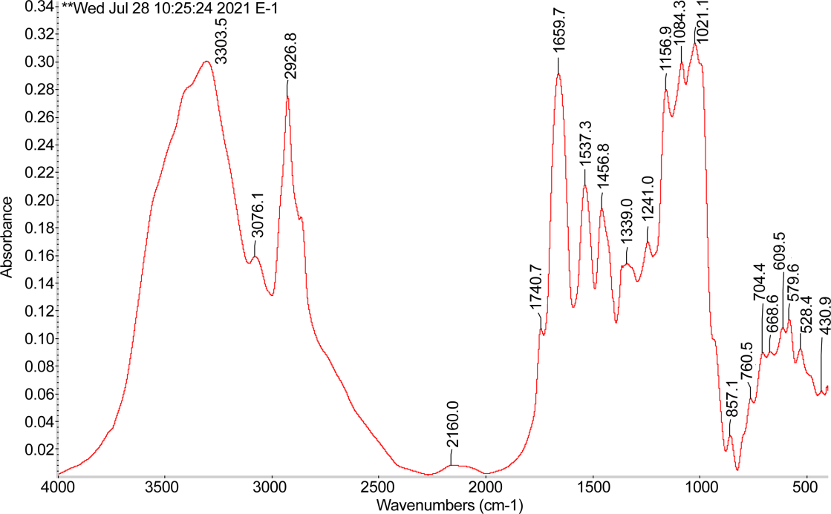
а
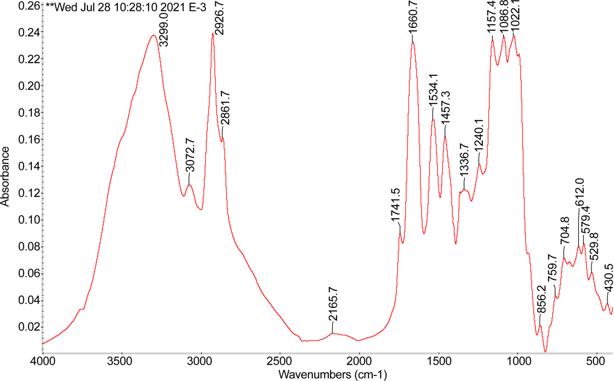
b
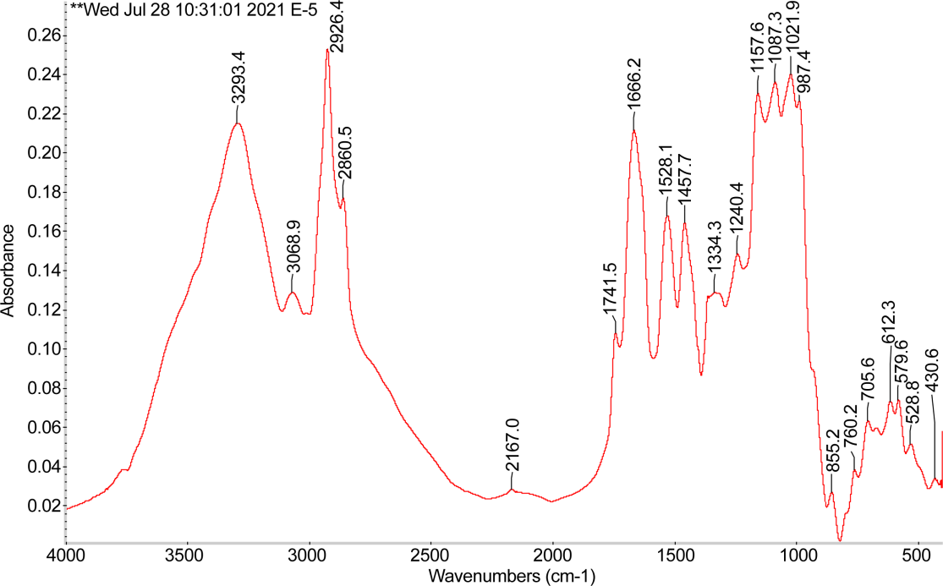
c
Fig. 2. The results of IR analysis at the spectrophotometer "Nicolet 5700" in tablets with Kbr: a – treated chickpeas, 60 seconds; b – treated chickpeas, 180 seconds; c – treated chickpeas, 300 seconds

Fig. 2 shows in the acquired IR spectra of samples No. 1‒3 the found single bands that demonstrate the presence of secondary amines. We observed the absorption bands, protein amines of valent NH₂-groups, and variable bands in the samples, respectively: a – 3,303.5; b – 3,299.0; c – 3,293.4 cm⁻¹.
When a hydrogen bond is formed, the frequency of oscillations decreases while the bands expand. At the same time, there are free and bound hydrogen bonds. The highly structured wide bands of valence oscillations are the total amine groups such as NH₃+, NH₂+, NH+ at: a – 3,076.1; b – 3,072.7; c – 3,068.9 cm⁻¹.
In the intervals at 1,022.1; 1,086.8 cm⁻¹, the interpretation of the spectra of the absorption bands of the valent symmetric and valent asymmetric oscillations is noticed. These fluctuations are identical for the groups of carboxylic acids C–O–C of ethers and acetals in the range from 1,157.4; 1,240.1; 1,336.7 cm⁻¹.
Free groups of carboxylic acids are absorbed in the zone at 1,800‒1,740 cm⁻¹. Our observation showed that sample (c) contains α, β-unsaturated, as well as aromatic carboxylic acids in the presence of hydrogen bonds. The frequency of the bands decreases to 1,741.5‒1,660.7 cm⁻¹; the presence of C=O group of valence oscillations is noticed.
At the interval of two bands of 1,457.3 and 1,534.1 cm⁻¹, the average frequencies of oscillations of chemical bonds of groups of aromatic C‒C hydrocarbons are manifested, as well as 1,660.7 (strong), 1,741.5 (average). For alkyne groups, triple bond oscillations are manifested at the low-frequency end of 2,165.7 cm⁻¹ and very weak C≡C bonds of valence oscillations are noticeable.
The spectra acquired after ultra-high-frequency processing demonstrate new peaks in samples (a) and (c), compared with the control sample, at the frequencies of 668.6 and 987.4 cm⁻¹ (also, 3,299.0 cm⁻¹ wide bands of valence oscillations of the B‒OH bond). This is explained by the fact that these absorption bands correspond to deformation fluctuations of the groups of organophosphorus (P–H grouping) and boron-organic compounds (B–C and B–Cl valence bonds).
The results of the experimental data on the analysis of the IR spectrum confirmed that ultra-high-frequency processing of the Miras 07 chickpea variety for 180 seconds is expedient. Compared with samples (a) and (c), there are no oscillation peaks that affect the organoleptic and technological properties of the raw material.
The results of our studies into the content of the fractional composition of chickpea proteins in the Miras 07 variety (Fig. 1) were compared with those treated samples, compared with the control unprocessed chickpeas. The amino acid content includes globulin – 79.8 %, albumin – 12.2 %, glutelin – 7.9 %. Under the influence of ultra-high-frequency processing, denaturation of proteins occurs, as a result of which the spatial arrangement and shape of polypeptide chains are lost. The native conformation of the protein molecule is disturbed but the primary level of the spatial structure of the protein and its chemical composition remains unchanged.
The results of the samples' acquired IR spectra (Fig. 2) showed that during the ultra-high-frequency treatment of chickpeas, a slight change in protein amine groups occurs. Based on the IR spectrum, changes in absorption bands are observed in the range of 500‒1,000 cm-1 for the C-H valent bonds in the strong region.
With ultra-high-frequency processing, only the initial properties of protein substances change, the reactivity of some chemical groups that make up the molecule increases, solubility and hydrophilicity decrease [27, 32].

3.4 Research on the effect of microwave processing on the nutritional, biological value and safety of chickpea flour
A study was conducted to determine the water absorption capacity of the ultra-high-frequency-processed chickpea flour in comparison with the untreated flour: the results are shown in Fig. 3. The figure illustrates that the lowest water absorption capacity is demonstrated by the flour from unprocessed raw materials.

Fig. 3. The water absorption capacity of chickpea flour

The water absorption capacity of the flour from the Miras 07 chickpea variety, depending on the duration of processing (Fig. 3), is described by the following regression equations:
– for non-treated flour

y=16.87x+40.35, R²=0.96;

– for treated flour

y=15.3x+51.867, R²=0.8461,

where x is the processing time, s;
y – the water absorption capacity of flour, %;
R ‒ the value of the approximation confidence.
Our data (Fig. 3) indicate that with different durations of ultra-high-frequency treatment, an increase in the water absorption capacity of chickpea flour is observed. For comparison, processing over 60 seconds helps increase the water absorption capacity of flour by 1.2 times, over 180-second processing of chickpea flour ‒ by 1.4 times, and, over 300 seconds, by 1.5 times, respectively. The high water-absorbing capacity of chickpea flour is determined by the presence of high-molecular compounds (proteins, polysaccharides) in the chickpea grain, which, in the process of swelling, are able to bind and retain moisture.
Research has been carried out to determine the amino acid and vitamin composition of gluten-free flour from processed and unprocessed chickpeas of the Miras 07 variety.
Figure 4 shows the data on the amino acid composition of chickpea flour processed for 60-300 seconds and unprocessed flour.

Fig. 4. The amino acid composition of chickpea flour

Changing or denaturating protein in foods is important for the food industry as the denatured proteins are well digested and absorbed by the human body. During denaturation, the quaternary, tertiary, and partially secondary structure of the protein molecule is disturbed while their primary structure does not change; the indicators are kept within the normal range or fluctuate at 0.5 units. Protein denaturation leads to an increase in the number of peptides and free amino acids so that the amino acid composition of processed foods does not decrease [36].
A study was conducted to examine the vitamin and mineral composition of the treated samples of chickpea flour. The study results showed that the content of B vitamins is in the range from 0.05 mg to 0.236 mg. The content of such elements as Fe, Ca, Zn, and I in the UHF-treated samples is not significantly reduced compared to the mineral content in the treated samples (Table 4).
The analysis of the amino acid composition of chickpea proteins in the samples processed (Fig. 5) for 60 to 180 seconds showed that chickpea flour from the Miras variety contains a full set of amino acids: arginine (2.23 %), serine (1.26 %), histidine (1.33 %), phenylalanine (1.45 %). Other types of amino acids range from 0.41 % to 0.58 %. With an increase in the ultra-high-frequency processing time to 300 seconds, the amino acid content gradually decreases. Thus, the amount of arginine was 1.52 %, methionine, tyrosine, threonine ‒ from 0.04 to 0.93 %, and the content of serine, proline was from 0.44 to 0.93 % above average.
The obtained data indicate that the amino acid composition of chickpea flour is reduced. With prolonged processing of raw materials (300 seconds), the nutritional value of chickpea flour decreases due to the loss of part of amino acids, which leads to the destruction of proteins.
The results of our studies of vitamin and mineral composition indicate that the content of B vitamins is in the range from 0.05 mg to 0.236 mg. The content of elements such as Fe, Ca, Zn, and I in the treated samples is not significantly reduced compared to the mineral content in the treated samples.
Thus, we can conclude that in the process of ultra-high-frequency treatment, the content of trace element and vitamin composition practically does not change.

Table 4-The content of minerals and vitamins in chickpea flour
Indicator | Flour from non-treated chickpeas | Flour from the treated Miras 07 chickpea variety
Indicator | Flour from non-treated chickpeas | 60 s | 180 с | 300 с
Iron, mg/100 g | 6.61±0.3 | 5.24 ±0.1 | Iron, mg/100 g | 6.61±0.3
Са, mg/100 g | 5.8±0.2 | 71.1±0.2 | Са, mg/100 g | 5.8±0.2
Zn, mg/100 g | 2.72±0.5 | 2.78±0.1 | Zn, mg/100 g | 2.72±0.5
I, mg/100 g | 0.0670±0.002 | 0.067±0.005 | I, mg/100 g | 0.0670±0.002
Vitamin В₁ (thiamine), mg | 0.49 | 0.47 | Vitamin В₁ (thiamine), mg | 0.49
Vitamin В₂ | 0.11 | 0.09 | Vitamin В₂ | 0.11
Vitamin В₆ | 0.49 | 0.46 | Vitamin В₆ | 0.49
Vitamin В₉ | 437 | 389 | Vitamin В₉ | 437
Vitamin РР | 0 | 0 | Vitamin РР | 0

To study the shelf life of chickpea flour, we investigated its microbiological indicators. The results of contamination chickpea flour with microorganisms, in CFU/ml, are shown in Fig. 5.

Fig. 5. Microbiological parameters of chickpea flour during storage, in CFU/g

A study was conducted to determine the gluten content in processed chickpea flour using the Immunolab Gliadin kit at an immune-enzymatic analyzer (Fig. 6). As a result of the study, the detection limit was no more than 10 mg/kg of gluten in the commercial sample.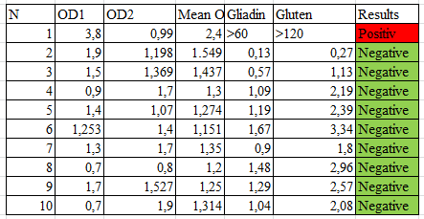
а б

Fig.6. Results of studying the gluten content of chickpea flour: a – the quantitative content of gluten in the sample; b – standard curve for gluten content

In terms of QMAFAnM in the processed chickpea flour, the content of microorganisms is minimal, 1×102 CFU/g; when processing over 60 seconds, the largest growth is 5×103 CFU/g. The largest increase is seen on a raw sample of chickpea flour where the growth of microbes occupies an average position ‒ 1×103 CFU/g.
The maximum level of yeast at 1.0*102 CFU/g and molds at 3.0*103 CFU/g, characterizing the shelf life of chickpea flour, was found in an untreated sample. However, these samples also meet the requirements from regulatory documentation, which makes it possible to guarantee a high level of quality and safety of the raw materials for the further production of gluten-free confectionery. Wheat flour of the highest grade was used for comparison. Studies have shown that a positive result was recorded in wheat flour, and a negative result was recorded in chickpea flour, that is, this indicates that chickpea flour is gluten-free.

3.5 Investigation of the morphological structure of chickpea flour
Research has been carried out to study the microstructure of chickpea grain cuts before and after microwave treatment. Chickpea grain micro particles were examined using a scanning electron microscope.
Micrographs of dry chickpea flour of the "Miras 07" variety were studied under a light microscope. As a result, it can be seen that the temperature fields in the center of the starch grain of chickpea are not determined; then, during microwave processing, the process of swelling continues.
Figure 7 shows a control sample of untreated chickpea flour micro particles at various magnifications (from 50 µm to 10 µm).

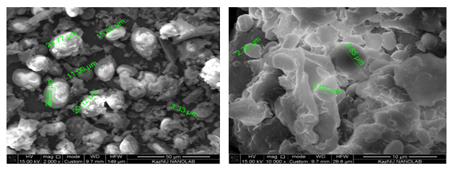
a | b
a - micrographs of untreated chickpea flour (magnification 50 µm);
b - micrographs of untreated chickpea flour (magnification 10 µm)
Figure 7 - Micrographs of a control sample o\f chickpea flour

As can be seen from Figure 1, the microstructure of chickpea grain starch is identical to pea starch, the average size of which ranges from 11-12 microns [37]. When viewed under a microscope, as can be seen from Figure 2, the microstructure of the Miras 07 chickpea flour in milling, oval starch grains are compacted into a protein matrix. The protein mass is presented as a powerful structural element associated not only with starch grains, but also with attached protein. The protein matrix of chickpea variety "Miras 07" had a strong structure, even under strong mechanical stress, many starch granules remain compacted. Globules of the protein in the native state are especially clearly visible. The protein structure of the chickpea grain is associated not only with starch grains, but also with the attached protein of the grain itself.
Starch grains are represented by two fractions - fine-grained and coarse-grained.
Figure 8 shows micrographs processed by microwave beams for 3 to 5 minutes at 800 W.

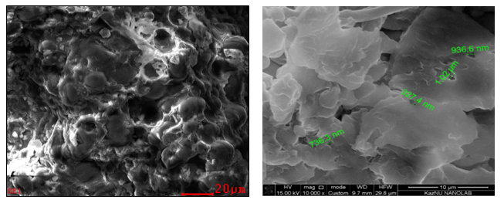
a | b
a - micrographs of processed (3 min) chickpea flour (magnification 20 µm),
b - micrographs of processed (3 min) chickpea flour (magnification 10 µm).
Figure 8 - Micrographs of microwave chickpea flour - processed for 3 minutes
From Figure 8, you can see micrographs of samples of leguminous crops that were treated with microwave rays for 3 minutes. As a result, it can be concluded that the micro particles of this sample differ from the control samples. As can be seen from Figure 2, compared to the original grain, there was a significant change from the original form of starch and protein globules. Starch grains increased in volume, small depressions appeared on the surface. Photographs of the microstructure of starch grains of chickpea flour with an increase of 20 μm are not completely destroyed. The destroyed part of the starch granules is approximately 70-80%.
Furthermore, Figure 3 shows microwave processed samples of chickpea flour for 5 minutes. Micrographs of samples of leguminous crops of chickpea, after treatment with microwave rays for 5 minutes.
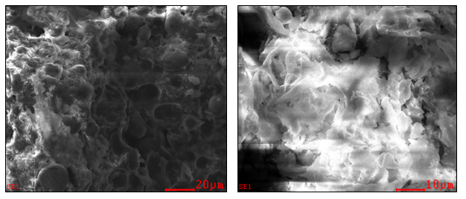
v
a - photomicrographs of processed chickpea flour (5 min) (magnification 50 µm);
b - micrographs of processed chickpea flour (5 min) (magnification 10 µm).
Figure 9 - Micrographs of microwave chickpea flour - processed for 5 minutes
With microwave treatment for up to 5 minutes, the contours of the native forms of cellular structures of chickpea are preserved, the diameters of starch grains somewhat increase in relation to the original sample. The consistency of chickpea during processing in microwave spectra shows changes in rheology, and the mass becomes a viscous form, which is explained by partial denaturation of the protein [38].
Such a change in starch granules is explained by the effect on the grain of significant temperature regimes and moisture content, as well as a conformational change in the polysaccharide chains of amylose, the fastest unfolding of which leads to a sharp increase in the volume of starch granules, polymer destruction by an increase in the degree of starch dextrinization. As a result of the study of microparticles of chickpea grain "Miras 07" subjected to heat treatment, it was revealed that microwave treatment has the least effect on the microstructure of the grain.
Thus, based on the study of the microstructure of chickpea flour from the selection variety Miras07, it should be concluded that chickpea starch has a low gelatinization temperature, which indicates that the chickpea protein contains a large amount of amylose [39, 40]. Starch grains of chickpea "Miras 07" variety are almost completely destroyed at a temperature of 100 ° C, and then the swelling mechanism is suspended; this confirms the high structural and technological properties of chickpea grains, which can be used in the production of flour confectionery.
Pictures of microstructure indicate that starch grains in the "Miras 07" variety chickpea flour are based mainly on amylopectin, and in small amounts of amylose, which confirms their high nutritional value. With increasing temperature, starch particles of chickpea flour begin to break down, which must be taken into account in the process of dough making in the production of flour confectionery products. The use of microwave processed chickpea flour in flour confectionery production is preferable to untreated one.

3.6 Development of recipes for biscuit and custard semi-finished products from gluten-free flours
For the formation of recipes for flour confectionery products from gluten-free types of flour, it is planned to accomplish the following objectives: development of the basic form of the product, formation of consumer properties of a product with a changed chemical composition in order to increase nutritional value by using gluten-free raw materials, organoleptic and physicochemical compatibility of the component composition. When preparing flour culinary and confectionery products, it is known that the physicochemical properties of the flour used have a direct impact on the quality of the final product. For example, the starch and protein content significantly affects the rheology of the dough [41].
Therefore, at the first stage of the experiment, samples of a biscuit semi-finished product prepared from three types of flour: chickpea, rice, corn and amaranth were studied. The samples were prepared according to the traditional technology of biscuit and custard semi-finished product with a complete replacement of premium wheat flour, adapted for all types of flour used. As a control sample, the recipe for biscuit and custard semi-finished product from premium wheat flour was taken.
The organoleptic characteristics of the samples are shown in Table 5. The shape and surface of the test samples significantly differed from the control due to the low gas-holding capacity of gluten-free flour. The color of the products changed from light brown (control sample) to dark brown, at the sectional view - from cream to gray. All types of gluten-free flour introduced negatively affected the taste of the biscuit. Samples showed an unpleasant off-taste and smell characteristic of the flour used. Also, the samples had a very dense consistency; the products had an unbaked crumb with poorly developed porosity. The lowest organoleptic characteristics were demonstrated by a sample from soybean meal. Since the samples from gluten-free types of flour showed low organoleptic qualities, it was concluded that it was necessary to mix mixtures of the considered types of flour in different ratios. Therefore, at the next stage of the experiment, the influence of the mixture of gluten-free types of flour on the quality of the biscuit semi-finished product was investigated. The recipe for biscuit and custard semi-finished product from premium wheat flour was taken as a control sample.
Table 5 - The results of the organoleptic assessment of the quality of gluten-free muffins
Quality indicators | Control Sample | Experimental samples
Quality indicators | Control Sample | Chickpea | Rice | Corn | Amaranth
Appearance | Smooth, smooth  surface, no cracks,  not burnt | With significant irregularities and cracks, not burnt |  | Uneven surface, s  cracked, not  burnt
Sectional View | Baked biscuit without  voids and traces of impurities,  unhardened, uniform in thickness | Baked sponge cake with unsatisfactory porosity, few voids and temper, uneven thickness
Structure and consistency | Correct, without kinks,  dents and damage, with even cut | Concave, with dents,  damage, uneven cut | Irregular, with slight bends and  dents, with minor damage
Taste and smell | Pleasant taste,  characteristic of a biscuit,  no foreign smell or aftertaste | The taste is unpleasant, with a hint of bitterness,  pronounced smell and taste of bean  flour, crumb is  clumping | The taste is soft with light  rice flavor  Flour, foreign smell. Crumb is  clumping, not  chewy | Corn flavor  The smell of cornmeal.  Crumb is  clumping, not  chewy | Amaranth flavor, amaranth flour smell. Clumping crumb  not chewable

A feature of the technology for preparing biscuit dough is a short-term kneading of the whipped egg-sugar mass with flour in order to reduce the swelling of gluten, leading to an increase in its elasticity, as a result of which the biscuit semi-finished product acquires a more dense structure. The structural and mechanical characteristics of the dough are closely related to the internal structure of the substance; therefore, they must be taken into account in order to obtain a product with high organoleptic characteristics [42]. In this regard, experimental studies of the main structural and mechanical characteristics were carried out, on which the formation of biscuit dough from gluten-free flours depends. For this, experimental samples of biscuit dough were prepared from the considered types of flour. Biscuit dough prepared according to a traditional recipe and technology from premium wheat flour was used as a control sample [43].
Water absorption, stability and mechanical parameters of the dough were determined by kneading the dough at a temperature of 30 ° C. The dynamic viscosity of the dough was determined at a temperature of 20 ° C. The results of the study of the structural and mechanical properties of the biscuit dough are presented in table 6.

Table 6 - Structural and mechanical characteristics of biscuit dough made from wheat flour and gluten-free flours
Indicator / Types of test | Wheat flour dough | Chickpea flour dough | Rice flour dough | Amaranth flour dough
Time to reach maximum  torque, min | 1.43 | 0.72 | 8.71 | 4.38
Minimum torque value, Nm | 0.55 | 0.46 | 0.89 | 0.50
Maximum torque value, Nm | 2.35 | 0.78 | 2.81 | 2.65
Temperature at peak viscosity, ° C | 77.90 | 80.0 | 77.40 | 79.6
Minimum torque at 50 ° C, Nm | 2.01 | 0.72 | 2.45 | 2.22
Final torque value at 50 ° C, Nm | 2.75 | 0.99 | 3.09 | 3.32

Analyzing the values ​​of the characteristics of Table 6, it should be noted that during the kneading, the compounds were hydrated, which caused stretching and alignment of the proteins, which ultimately led to the formation of a viscoelastic dough. Wheat flour biscuit dough was characterized by a short time to reach maximum torque, high stability and resistance to mechanical stress. These properties of the dough are associated with the unique structure of the wheat flour protein (gliadin and glutenin complex). The water absorption values ​​of the samples are shown in Figure 10.
The high-water absorption capacity of the chickpea flour dough leads to a greater loss of moisture during baking, which suggests that the biscuit semi-finished product from this type of flour will be very dry [44]. In order to avoid this, it was necessary to add more chicken eggs or other type of flour in this dough in an amount of at least a third to the mass of all flour used. The closest to the wheat flour dough in terms of water absorption was the rice flour biscuit dough. The value of this indicator was slightly higher for the amaranth flour dough; therefore, in order to further achieve the water absorption value of the wheat flour dough in this sample, it would be necessary to create a mixture. Sample stability indicators are shown in Figure 10.

Figure 10-Water binding capacity of flour

The rice flour dough had a low water absorption and stability index in relation to the chickpea and amaranth flour dough.
Analyzing the obtained experimental results, taking into account the chemical composition of the studied gluten-free flours in relation to premium wheat flour, it is worth noting that, as mentioned earlier, rice flour has a significantly lower quantitative protein content compared to premium wheat flour. Chickpea flour is rich in protein, but nevertheless, chickpea flour dough requires significantly more water (100.4%) to achieve a torque of 1.1 Nm, compared to wheat flour dough (60.0%).
When the samples were heated, denaturation of proteins occurred, which led to a deterioration in the viscosity of the dough. At the same time, rice flour proteins were relatively stable within the experimental temperature range. With continued heating, changes in the structure of protein molecules already had an insignificant effect on the structure of the dough.
The highest viscosity was found in chickpea flour dough, which is low in starch and high in lipids. The results obtained are consistent with the conclusion of studies that lipids in combination with amylose lead to an increase in the peak viscosity [45]. Samples of rice and amaranth flour dough, exclusively rich in carbohydrates, had the highest torque values ​​and low viscosity values.
This is also explained by the fact that a protein complex is involved in the formation of a gel-like pseudoplastic dough structure, which is the richest in chickpea flour.
Chickpea flour is a gelling and gel-retaining component of the dough system, due to the high content of pectins, and the increased content of hybrid proteins and fiber, causes good swelling, water-retaining and fat-retaining ability when added to flour mixtures, the yield of semi-finished products increases and the visco-elastin properties of test systems increase.
Sponge cakes from wheat flour, from microwave processed chickpea flour of the "Miras 07" variety and from unprocessed chickpea flour were taken as control options. The main organoleptic indicators of the muffins are taste and smell. At tasting, sample # 2 had an unpleasant bean taste and smell, and sample # 3 had a lighter bean taste compared to sample # 2. Compositions of rice and amaranth flour were chosen to improve the taste and smell.
Rice flour with different content of amylose makes it possible to obtain products with different consumer characteristics at the output. In particular, for baked goods, the use of rice flour with high amylose content gives the product a crunchy texture and makes the crumb more porous. Rice flour is high in starch, has a high moisture binding capacity, and is used as an effective thickener and gelling agent to prevent delamination [47].
Amaranth flour has high functional and technological characteristics, when added to flour mixtures, dough products do not stale for a long time; acquire excellent elastic-elastic characteristics, which is due to a complex of redox reactions occurring during flour kneading. Flour contains a large amount of starch, protein and fiber, which determines the water absorption capacity and water retention capacity. Samples of muffins samples consist of the following flour ratios: # 1 - wheat flour muffins; # 2 - muffins made from 100% untreated chickpea flour; No. 3 - 100% from microwave processed chickpea flour of the Miras 07 variety; No. 4 - muffins made from processed chickpea, rice and amaranth flour - 85: 10: 5; # 5 - Processed chickpea, rice and amaranth flour muffins - 80: 15: 5; No. 6 - Muffins made from processed chickpea, rice and amaranth flour - 70:20:10) presented in Figure 11

Figure 11 - Variants of biscuit muffins samples

Figure 12 shows the appearance of muffins baked from prepared mixes.
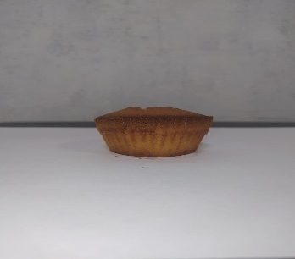 | 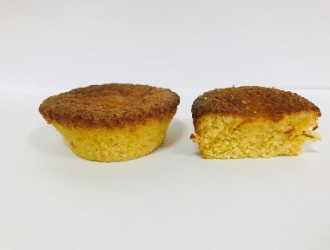 | 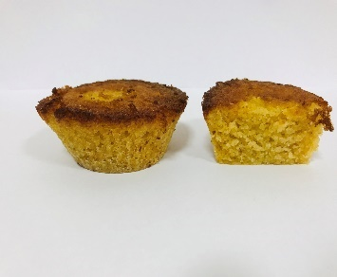
a-control | b | c
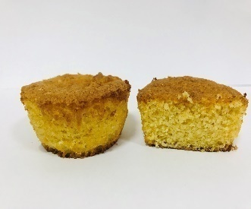  d | 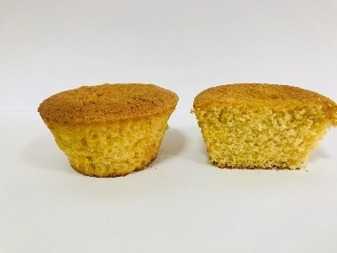  e | 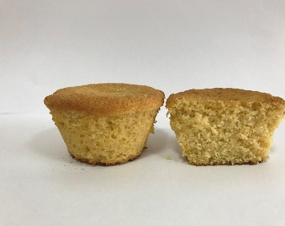  f

a) # 1 - wheat flour muffins; b) No. 2 - muffins made from 100% untreated chickpea flour; c) No. 3 - 100% from microwave processed chickpea flour of "Miras 07" grade; d) No. 4 - muffins made from processed chickpea, rice and amaranth flour - 85: 10: 5; e) No. 5 - Muffins made from processed chickpea, rice and amaranth flour - 80: 15: 5; f) # 6 - Processed chickpea, rice and amaranth flour muffins - 70:20:10
Figure 12 - Appearance of prototypes of muffins

Samples of biscuit muffins made from gluten-free types of flour, developed according to the proposed recipes, were evaluated using a score scale for organoleptic assessment of the quality of gluten-free biscuit semi-finished products presented in Annex B. The results of the tasting evaluation of biscuit semi-finished products are presented in Figure 13.
Figure 13 - Profilogram of the organoleptic indicators of biscuit muffins made from a gluten-free mixture (chickpea, rice and amaranth flour)
A feature of the composition of mixtures No. 4, No. 5 and No. 6 is that, as an improvement in rheological and organoleptic properties, rice and amaranth flour were added in the amount of rice 10-20%, amaranth 5-10%. According to the results of the organoleptic assessment, it can be noted that the parameters of the shape and surface of the studied samples significantly differed from the control. With an increase in the amount of chickpea flour, the color of the products changed from light yellow to dark yellow. At the sectional view - to a yellow-cream color. With an increase in the introduced microwave, processed chickpea flour had a positive effect on the taste of the muffins. The organoleptic evaluation of muffins according to the scoring system showed that muffins from microwave processed chickpea flour No. 5 received 4.77 points and muffins from mixture No. 4 - 4.63 points, muffins from mixture sample No. 4 received the minimum number of points - 3,73 points.
The use of microwave processed chickpea flour can improve the organoleptic characteristics of confectionery.
Thus, as a result of the tasting work, sample No. 5 was chosen as the best options, in the mixtures of which 80% microwave processed chickpea flour was added and, to improve the consistency, rice and amaranth flour were added to the dough in a ratio of 15.0%: 5%. Chickpea flour contains a large amount of protein, which potentially increases the biological value of biscuit muffins.
Further, studies were carried out to find the optimal value of the mixtures for muffins in the recipe of products based on mathematical methods of experiment planning. On the basis of the research carried out, a regression model was built in the form y = -0.0067x2 + 0.043x + 4.7542; the value of the approximation reliability R² = 0.9914 and is shown in Figure 14.

Figure 14 - Scoring of organoleptic indicators of model samples of muffins depending on the amount of chickpea flour
Furthermore, the research on the development of a recipe for a custard semi-finished product, including chickpea and corn flour was carried out. As a control, a sample was taken according to the recipe of a custard semi-finished product from wheat flour. Experimental samples of semi-finished products (choux pastry) were prepared with the addition of chickpea and corn flour to the formulation in different ratios (Figure 14). Variants of samples of custard semi-finished product consist of the following flour ratios: No. 1 - custard semi-finished product from wheat flour; No. 2 - custard semi-finished product from 100% untreated chickpea flour; № 3 - custard semi-finished product from 100% of microwave processed chickpea flour of the "Miras 07" grade; No. 4 - custard semi-finished product from processed chickpea and corn flour 80:20; No. 5 - Custard semi-finished product from processed chickpea and corn flour 60:40; No. 6 - custard semi-finished product from processed chickpea and corn flour - 50:50) presented in Figure 15
Figure 15- Samples of custard semi-finished product

Figure 16 shows the appearance of a gluten-free custard semi-finished product obtained with a different ratio of components.
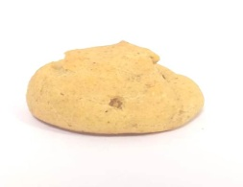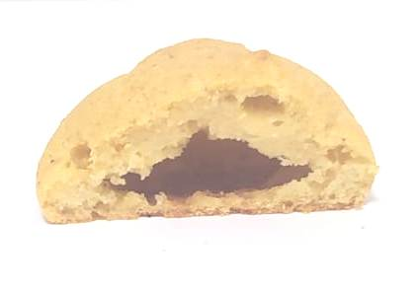 | 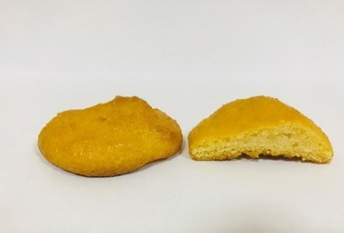 | 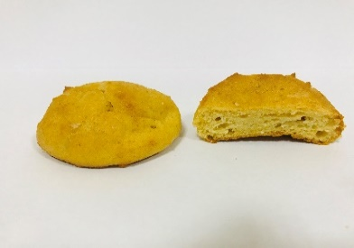
a | b | c
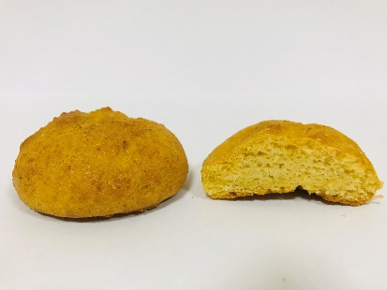 | 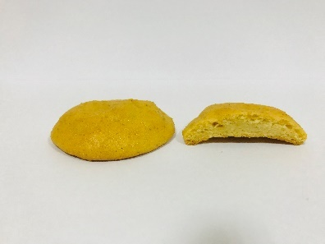 | 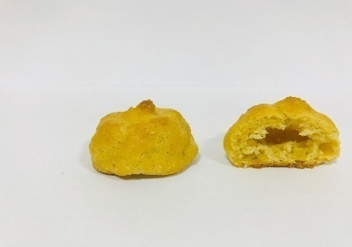
d | e | f
a) No. 1 - custard semi-finished product from wheat flour; b) No. 2 - custard semi-finished product from 100% untreated chickpea flour; c) No. 3 - custard semi-finished product from 100% of microwave processed chickpea flour of the Miras 07 variety; d) No. 4 - custard semi-finished product from processed chickpea and corn flour 80:20; e) No. 5 - Custard semi-finished product from processed chickpea and corn flour 60:40; f) No. 6 - custard semi-finished product from processed chickpea and corn flour - 50:50)
Figure 16 - Appearance of prototypes of custard semi-finished product
Corn flour has a different level of amylase activity, which significantly affects the rheology of the dough made from this flour. Studies [48] found that with an increase in the concentration of amylose in corn flour, the temperature at which starch began to gelatinize increased, and, as a result, the peak viscosity of the mixture significantly decreased. The processing of corn grain into flour does not lead to significant changes in the mass fraction of protein, fat and carbohydrates. However, some studies [46] prove the presence of significant changes in some components of the grain during grinding. At a processing temperature of 60-80 ° C, the mass fraction of starch decreases by 4-15%, but the mechanism of this process has not yet been studied. Products obtained using the specified composite flour were characterized by high organoleptic characteristics and increased nutritional value of finished products: the protein content increases, the amount of carbohydrates decreases, the ash content increases (the latter indicates an increase in the amount of mineral substances).
In the course of work, it was revealed that after kneading the dough for a custard semi-finished product from pure chickpea flour, the dough was not brewed, the dough was poorly formed during baking, and the finished products had an unstable shape. In this regard, it became necessary to increase the proportion of corn flour in the composition with microwave processed chickpea flour. For this, the dough was brewed with the addition of 20% - 50% corn flour. Samples of custard semi-finished product (sample No. 6) had the correct shape, without lumps and traces of impurities, with uniform porosity, without voids. The taste and smell of the custard semi-finished product acquired a special pleasant shade with the increase in corn flour.
The organoleptic assessment of the custard semi-finished product (Figure 16) showed that the highest number of points was received by sample No. 6 (4.94 points) in comparison with the control sample. The custard semi-finished product with a high content of corn flour had a pronounced taste and smell. Custard semi-finished product No. 3 (3.48 points) from 100% processed chickpea flour during baking, the dough spread, did not keep its shape, the crumb fell apart. An increase in the dosage of the introduced chickpea flour leads to a deterioration in the quality of the custard semi-finished product: organoleptic quality indicators decrease, the specific volume - by 1.0%, in comparison with the control sample.

Figure 17 – Profilogram of organoleptic parameters of a custard semi-finished product from gluten-free mixtures (chickpea, corn flour).
Based on the research, a regression model has been built that has the form y = -0.0072x2 + 0.0478x + 4.7463; the value of the accuracy of the approximation R² = 0.9882 and is shown in Figure 18.

Figure 18 - Scoring of organoleptic indicators of model samples of custard semi-finished product from the amount of chickpea flour
Studies have shown that, according to the organoleptic characteristics of the custard semi-finished product, the mixture No. 6 from the composition of microwave-treated chickpea flour and corn flour 50:50 is optimal for baking custard semi-finished products.
Thus, it has been experimentally proven that to give the custard semi-finished product high organoleptic characteristics, it is advisable to use a composition of a mixture of microwave-processed chickpea flour and corn flour in proportions of 50:50
3.7 Studying the nutritional and biological value of gluten-free flour confectionery
A technological scheme for the production of gluten-free flour confectionery products has been developed, and given in Annex C - Figure C1, C2. The amino acid and vitamin composition of gluten-free confectionery muffins and custard semi-finished product have been studied (Figures 18, 19). The content of vitamins and amino acids in gluten-free muffins of custard semi-finished products was compared with the control options.
Based on the data obtained in Figure 18, it was found that when the flour from microwave treated chickpea was introduced into the recipe for cake made from rice and amaranth flour, the amount of the limiting amino acid lysine increased 1.08 times compared to untreated chickpea flour. In general, the biological value of the fortified biscuit muffins is on average 1.5 times the control sample.

Figure 18 - Amino acid content of gluten-free muffins from processed and unprocessed chickpeas of the "Miras" variety
At the next stage of the research, studies were carried out to determine the nutritional value of the developed flour confectionery products in comparison with the control options (Table 7).

Table 7 - Nutritional value of flour confectionery products
The name of indicator, % | Wheat flour muffins | Unprocessed Chickpea flour muffins | Processed Chickpea flour muffins | Brewed p / t of wheat flour | Custard semi-finished product from flour of unprocessed chickpeas and corn flour 50:50 | Custard semi-finished product of processed chickpea flour and corn flour 50:50
Mass fraction of carbohydrates,% | 65.47 ± 0.98 | 64.26 ± 0.96 | 66.18 ± 0.99 | 38.25 ± 0.57 | 23.54 ± 0.32 | 29.22 ± 0.38
Mass fraction of protein,% | 7.12 ± 0.09 | 9.97 ± 0.13 | 9.85 ± 0.12 | 11.09 ± 0.13 | 12.13 ± 0.18 | 13.36 ± 0.19
Mass fraction of fat, % | 22.13 ± 0.33 | 20.49 ± 0.29 | 18.69 ± 0.28 | 12.69 ± 0.19 | 13.49 ± 0.16 | 14.30 ± 0.21
Antioxidant content, mg / 100 g | 178 ± 1.2 | 144 ± 1.5 | 157 ± 5.2 | 107 ± 1.4 | 103 ± 1.3 | 101 ± 1.3
Mass fraction of ash, % | 1.00 ± 0.01 | 1.71 ± 0.02 | 1.64 ± 0.02 | 1.06 ± 0.01 | 1.49 ± 0.02 | 1.48 ± 0.02
Energy value, kcal | 489.53 | 481.33 | 472.33 | 311.57 | 264.09 | 299.02

Table 7 shows that the content of the mass fraction of protein in the developed flour confectionery products increased by almost 1.2 times. Based of the obtained data on the protein composition, it can be concluded that a high protein index was noted in muffins and custard semi-finished product compared to the control options, due to the fact that processed chickpea flour is included in the flour mixture. The content of the mass fraction of fat in the developed products exceeds 0.8 times in comparison with the control variant due to the use of chickpea flour in formulations. In terms of energy value, gluten-free muffins and custard are lower in calories compared to the control sample.
Further, studies were carried out on the content of B vitamins in flour confectionery products, presented in table 8

Table 8 - The content of vitamins in flour confectionery products
Name of the main nutrients,% | Muffins |  |  | Custard semi-finished product
Name of the main nutrients,% | Wheat Flour Muffins (Control) | BG cake made from a mixture of Chickpea, rice and amaranth flour |  | Custard semi-finished product from wheat flour | Brewed semi-finished product from a mixture of chickpea and corn flour
Vitamin E | 2.41 ± 0.04 | 1.17 ± 0.02 |  | 1.98 ± 0.02 | 1.33 ± 0.01
B1 (thymine chloride) | 0.094 ± 0.019 | 0.643 ± 0.129 |  | - | 0.041 ± 0.008
B2 (riboflavin) | 0.088 ± 0.037 | 0.063 ± 0.026 |  | 0.031 ± 0.013 | 0.053 ± 0.022
B6 (pyridoxine) | 0.094 ± 0.019 | 0.143 ± 0.029 |  | 0.060 ± 0.012 | 0.048 ± 0.010
B3 (pantothenic acid) | 0.123 ± 0.025 | 0.345 ± 0.069 |  | 0.275 ± 0.055 | -
B5 (nicotinic acid) | - | 0.046 ± 0.008 |  | - | -
BC (folic acid) | - | 0.020 ± 0.004 |  | -

Based on the data obtained, the content of B vitamins does not change, and remains within the normal range.
As a result of experimental research, 2 technologies, 2 recipes (Annex D, E), 2 technological instructions for the production of muffins and custard semi-finished product (Annex F. G) were developed. Recommendations have been developed on the technology for the production of flour from microwave processed chickpeas (Annex H) and on the technological process for the production of gluten-free confectionery (Annex J).
The introduction of non-traditional types of flour into the recipe makes it possible to expand the range of flour confectionery products of increased nutritional and biological value and impart functional properties to the products.

3.8 Research on shelf life and safety of gluten-free flour confectionery
Determination of microbiological indicators is one of the important components of ensuring the safety of the production of confectionery. Analysis of the literature data showed that unprocessed chickpea flour, as compared to microwave processed chickpea flour, is less stable during storage, because during storage, the index of fat acids rises, and quickly undergoes destruction. Thus, confectionery products are exposed to many unfavorable factors (temperature, moisture, oxygen from the ambient air, microflora and enzymes), which has a significant effect on the intensity of a number of chemical and biochemical processes in them.
The dynamics of the development of various groups of microorganisms in confectionery products during storage is not the same; therefore, the features of the vital activity of sanitary-indicative microorganisms are a factor in the shelf life of confectionery products. In the process of storing confectionery, changes in organoleptic indicators, acid number of fat, microflora, enzymatic activity. Since the quality of confectionery decreases during storage, it was considered expedient to investigate its microflora.
The analyzed samples were stored for 90 days in a packed form in a refrigerator at a temperature of + 8 ° C.
The obtained results of the study of the sanitary and microbiological state of confectionery shops during storage for 3 months were compared with control samples, which were prepared from untreated chickpea flour. The results of seeding with microorganisms in CFU / ml of confectionery are shown in table 9.
Table 9- Microbiological indicators in CFU/ g when stored under various temperature conditions
The name of the product | QMAFanM x 10-3 -  GOST 10444.1594 |  | Spore-forming bacteria x 10-2 |  | Yeast, CFU / g |  | Mold,  CFU / g
The name of the product | 1 month | 3 month | 1 month | 3 months | 1 month | 3 months | 1 month | 3 months
Sample № 1 Untreated chickpea flour muffins; | 2 × 10 ² | 1.0 ∙ 10 ³ | 0.99 × 10 ² | 8 × 10 ² | 2 × 10 ² | 6 × 10 ² | 1.3 × 10 ² | 4 × 10 ²
Sample № 2 - Processed Chickpea Flour Cupcakes | 2 × 10 ² | 4.0 × 10 ² | 0.99 × 10 ² | 3 × 10 ² | 2 × 10 ² | 2.7.0 ∙ 10 ² | 1.03 × 10 ² | 2.09 × 10 ²
Sample No. 3 - Custard semi-finished product from unprocessed chickpea flour | 0.18 × 10 ² | 1.0 ∙ 10 ⁴ | 0.79 × 10 ² | 3.6 × 10 ² | 0.4 × 10 ² | 2.2 × 10 ² | 1.8 × 10 ² | 3 × 10 ²
Sample No. 4 Custard semi-finished product from processed chickpea flour | 0.15 × 10 ² | 0.3 × 10 ² | 0.15 × 10 ² | 3 × 10 ² | - | 0.9 × 10 ² | 0.8 × 10 ² | 1.9 × 10 ²

Studies were carried out on the content of QMAFAnM (the number of mesophilic aerobic and facultative anaerobic microorganisms) before storage and after 3 months. The data obtained on the change in microbiological indicators of quality allow us to conclude that, subject to the requirements and storage conditions, the tested microbiological indicators of the quality of finished confectionery products comply with the requirements of TR TS 021 [150]. It was found that the microbiological safety indicators of the samples corresponded to the hygienic requirements for the test samples with the treated chickpea flour. As shown in Table 11, according to the QMAFAnM index, muffins with the addition of microwave treated flour contain the least amount of microorganisms - 1 × 102 CFU / g. Brewed semi-finished product with the addition of chickpea flour shows big growth - 3.6 × 103 CFU / g, and the greatest growth was seen in the control variant, the growth of microbes occupies an average position - 1.5 × 102 CFU / g. The maximum level of yeast content 2.0 * 102 CFU / g and mold 3.0 * 103 CFU / g, characterizing the shelf life of confectionery products, was found in the control variant of the custard semi-finished product at the end of the storage period. However, these samples also meet the requirements of regulatory documents, which allow us to guarantee a high level of quality and safety of confectionery products during their production cycle.
Thus, according to sanitary and microbiological control, gluten-free confectionery products made from microwave processed chickpea flour testifies that the researched scientific developments meet the requirements of SanPiN and confirm the shelf life established by us.
The content of acid fat at room temperature relative humidity 59 - 60% and during storage of samples in a refrigerator at a temperature of + 80C was measured in order to determine the shelf life of the samples.
The change in moisture, acidity and acid number of fat during storage was studied in order to determine and establish the shelf life in laboratory conditions. Indicators when laying for storage at a temperature of + 18 ° C + 20 ° C, a relative humidity of 58% for 3 months (Figure 20)

Figure 20 - Indicators of the quality of gluten-free flour confectionery products stored at a temperature of + 18 + 20 ° С

The acid number of the fat in the control sample increased from 18.5.1 to 44.06 mg KOH per 1 g of fat. The numbers of the control custard semi-finished product changed from 26.5 to 32.66 mg KOH per 1 g of fat. When placed in storage at a temperature of + 18 + 20 ° С, relative air humidity of 65% for 3 months, the CFC in samples of cake and custard semi-finished product from microwave processed chickpea flour increased from 19.0-28.9 to 29.9-32, 6 mg KOH per 1 g of fat.
As a result of the studies, it was revealed that during the storage of confectionery products from unprocessed chickpeas, the acid number of fat increases over time and, accordingly, the humidity indicator decreases.
In prototypes of cake and custard semi-finished product within 3 months, the acid number of fat increases slightly. Certainly, it is necessary to consider the appropriate packaging for the storage of confectionery products.

3.9 Assessment of the economic efficiency of the production of gluten-free flour confectionery products
As a result of the research, it is proposed to introduce new types of gluten-free flour confectionery products of increased nutritional and biological value from non-traditional types of flour into production.
The outcome of the research work of each enterprise and its self-supporting subdivisions to a decisive extent depends on the cost price and profitability of the products produced.
Profitability characterizes the performance of processing enterprises and depends, first of all, on the cost of production and the price of its sale.
The purpose of cost planning is an economically justified determination of the amount of costs for the planned period for each type of product and all products of the confectionery enterprise as a whole. Planned cost calculations are used when planning profit and product prices. For each type of flour confectionery, the cost is calculated taking into account the output [51].
The cost of production allows determining the reliability of actual costs and ensuring timely control over the use of material and laboring resources [52].
The calculation of the cost of a unit of production is carried out by the calculation method, i.e., the allocation of all costs for the production and sale of products 1 ton of product [51].
The level of profitability is determined by the ratio of net profit indicators to the cost of sold products. The main way to increase profitability is to reduce production costs, increase its output and improve quality [83].
The initial data for determining the competitive capabilities of products are:
- norms and standards for the consumption of main and additional raw materials and auxiliary materials;
- valid formulations and permitted substitutions;
- current wholesale, purchase and contract prices.
The results of calculating the price for the production of gluten-free confectionery (muffins and custard semi-finished product) from non-traditional types of flour are presented in Annex K.
The economic calculation of the cost of the developed flour confectionery products established their profitability (Table Annex I). From the data presented (Annex I), the production of new types of flour confectionery products is profitable, which indicates the feasibility of using the developed technologies and recipes. The cost of 1 kg of gluten-free muffin was 1800 tenge, the production of the custard semi-finished product cost 1500 tenge. The estimated income from the sale of 1 kg of gluten-free muffin is 216 tenge, and the custard semi-finished product - 180 tenge.

CONCLUSION
As a result of the experimental studies, the following results were obtained:
1. The completed set of theoretical and experimental studies resulted in scientifically substantiating and experimentally confirming the feasibility of using the "Miras 07" chickpea legume in the processing of gluten-free flour for the production of flour confectionery products. The possibility of its use as a functional food ingredient has been determined.
2. Studies have proven the effectiveness of microwave processing of chickpeas at 180 seconds, during which the intensification of biochemical processes in the processed product occurs due to the resonant absorption of energy by protein and polysaccharide molecules. With ultra-high-frequency processing of chickpeas at 180 seconds, up to 20% of the starch contained in the grain passes into dextrins, which are easily absorbed by humans, toxic substances are destroyed. Light denaturation of the protein occurs.
3. Determined the change in the protein fraction of chickpea during microwave treatment. With ultra-high-frequency processing of chickpea flour at 180 second exposure, the content of the protein fraction remains unchanged - 79.8%. The obtained result according to the ir spectrum indicates that the ultra-high-frequency treatment did not affect the protein-amino acid composition of the studied chickpea variety "Miras 07".
4. The obtained data on the water absorption capacity of chickpea flour at 180 seconds of processing increases by 1.4 times in comparison with the control option. According to the results of the analysis of the amino acid composition of chickpea proteins in the treated samples during processing for 180 seconds, a complex of essential amino acids was revealed in the range from 1.3 to 2.5%. On the basis of chemical analysis, it was found that with ultra-high-frequency treatment at 180 seconds, the vitamin and mineral complex is completely preserved in comparison with untreated chickpeas. Under the influence of ultra-high-frequency processing, there is a decrease in the microbiological contamination of raw materials, as well as an improvement in organoleptic characteristics. According to the microbiological indicators of chickpea flour, the content of microorganisms was 1 × 103 cfu / g, which meets the requirements of sanitary and hygienic safety.
5. Studied the morphological structure of grape flour. Based on the study of the microstructure of flour from the selection chickpea variety "Miras 07", it indicates that the chickpea protein contains a large amount of amylose. Starch grains of chickpea "Miras 07" variety are almost completely destroyed at a temperature of 100 ° c, and then the swelling mechanism stops, this confirms the high structural and technological properties of chickpea grains, which can be used in the production of flour confectionery. Recommendations on the technology of flour production from microwave processed chickpeas have been developed (Annex H)
6. There are 2 developed recipes of mixtures for baking muffins and custard semi-finished product (Annex D. E). The optimal ratios of the components of the muffins have been determined: 80% of microwave-processed chickpea flour, 15% of rice and 5% of amaranth flour; for samples of custard semi-finished product: 50% flour from microwave processed chickpea and 50% corn flour, regression models of equations for muffins and custard semi-finished product have been developed, which allow predicting the scoring of baked products within the framework of the experiment. Technological instructions and recipes for new types of flour confectionery products have been developed (Annex F, G)
7. Research has been carried out to study the nutritional and biological value of the developed flour confectionery products. It was found that with the introduction of microwave-processed chickpea flour into the recipe for a cake made from rice and amaranth flour, the amount of the limiting amino acid lysine increased 1.08 times compared to untreated chickpea flour. In the custard semi-finished product, the amount of the limiting amino acid arginine increased by 1.97 times compared to untreated chickpea flour. In general, the biological value of the fortified biscuit cake and custard semi-finished product on average exceeds the control sample 1.5 times. The content of vitamins B in the developed products remains within the normal range.
8. Recommendations have been developed for organizing the production of gluten-free custard semi-finished products and muffins with a selection of basic and additional equipment (Annex J).
9. Experimental and industrial approbation of the developed confectionery products in the SPK "KUN BEL" (Annex L, M, N).
10 Research results are introduced into the educational process in the disciplines "Innovative equipment and technology in the food industry", "Scientific foundations of food production", intended for undergraduates in the educational program 7M07239 "food technology" (Annex P).

REFERENCES
- https://kazakh-zerno.net/158824-v-kazahstane-rastet-spros-na-produkty-pitanija-ne-soderzhashhie-gljuten-uchenye/
- Advances in the Understanding of Gluten related Pathology and the Evolution of Gluten-Free FoodsE. Arranz, F. Fernández Bañares, C.M. Rosell, L. Rodrigo and A.S. Peña1st edition © 2015 OmniaScience (Omnia Publisher SL) www.omniascience.com DOI: http://dx.doi.org/10.3926/oms.274ISBN: 978-84-943418-2-3Cover design: OmniaScienceCover image: Sticking out. ZoltánVörös. CC-BY 2.0Sponsorshttps://orcid.org/0000-0003-1957-3186
- Казанцева И. Л. Научно - практическое обоснование и совершенствование технологии комплексной переработки зерна нута с получением ингредиентов для создания продуктов здорового питания. г. Саратов, 2016, 391 с.
- Шарипова М.Н. Клинико-эпидемиологические и генетические особенности целиакии у детей Казахстана / Педиатрия: 2009.-N 1.-С.106-108.
- Назарова Альфия. Целиакия у детей. Казахстанский фармацевтический вестник 02 сентября 2021г
- ZhanarT. Botbayeva1*, TolkynM. Koptleuova1, NurzhanZh. Muslimov1, Kadyrbek A. Baigenzhinov1,Aidana E. Zhanaidarova1 Development of technology for producing gluten-free dry mixes for confectionery products based on Kazakhstani raw materials// Eurasian Journal of Biosciences, 2020 - Volume 14 Issue 1, pp. 483-491.

7 https://health-diet.ru/base_of_food/sostav/239.php

8 Ханмаа Ч.Т., Гончарук О.В. обоснование подходов к созданию безглютеновых мучных кондитерских изделий с использованием второстепенных видов муки, инновации в пищевой промышленности: образование, наука, производство, Материалы 4-й всероссийской научно-практической конференции. Издательство: Дальневосточный государственный аграрный университет (Благовещенск), Благовещенск, 2020, С. 30-34.
- В. Г. Попов, Н. Г. Хайруллина, Х. Н. Садыкова, Тенденции использования безглютеновых видов муки в производстве продукции функционального назначения, Вестник Воронежского государственного университета инженерных технологии, Том 83, № 1 (2021). https://doi.org/10.20914/2310-1202-2021-1-121-128.

10 http://www.fao.org/3/CA1176RU/ca1176ru.pdf
11Пат. No 2466541, РФ, МПК A21D13/08. Способ производства безглютенового сахарного печенья «Веселые звездочки» / Чугунова О.В., Лейберова Н.В. -No2011125436/13; заявл.20.06.2011; опубл. 20.11.2012
12 Электронный ресурс: https://www.sgoodmuffin.com/
13 Островерхова, Т.Н. Некоторые аспекты производства безглютеновых изделий / Т.Н. Островерхова // Кондитерское и хлебопекарное производство.-2012.-No 9.-С. 20-21
14 ГОСТ 3898-56. Мука соевая дезодорированная. Технические условия. М.: Стандартинформ, 2006. – 5 с.
135. ГОСТ 14176-69. Мука кукурузная. Технические условия. М.: Стандартинформ, 2006. – 4 с.
15 ГОСТ 31645-2012. Мука для продуктов детского питания. Технические условия. М.: Стандартинформ, 2013. – 12 с.
16 ГОСТ Р 52189-2003. Мука пшеничная. Общие технические условия. М.: Стандартинформ, 2003. – 11 с.
17 Аромашка: Ксантан [Электронный ресурс]. – Режим доступа. URL: http://www.soyuzopttorg.ru/news/postid/own_news/33
18 Нечаев А.П. Пищевая химия. – Спб.: ГИОРД, 2001. – 592 с
- Кудинов П.И. Современное состояние и структура мировых ресурсов растительного белка/ П.И. Кудинов, Т.В. Щеколдина, А.С. Слизькая // Известия вузов. Пищеваятехнология. 2012. №5-6. С.7-10.
20 Muslimov, N.Z., Borovskiy, A.Y., Kizatova, M.E., Sultanova, M.Z., Omaraliyeva, A.M. FlourreceiptbasedongrainlegumesEurAsianJournalofBioSciencesEurasiaJBiosci 14, 1287-1297 (2020).

21 Шалагина Ю.А., Изменение объема крупы при свч обработке, Евразийский Союз Ученых (ЕСУ), 4 (25), 2016, С.49-52. |

22 Bo Linga, Teng Chenga, and Shaojin Wang, Recent developments in applications of radio frequency heating for improving safety and quality of food grains and their products: A review. Article in Critical Reviews in Food Science and Nutrition · August 2019, 60(15):1-21 DOI:10.1080/10408398.2019.1651690

23 Fedor A. Kipriyanov, Petr A. Savinykh, Alexey Yu. Isupov, Yulia A. lotnikova, natalia a. Medvedeva,Svetlana V. Belozerova Journal of water and land development Institute of Technology and Life Sciences (ITP) 2021, No. 49 (IV–VI): 74–78; https://doi.org/10.24425/jwld.2021.137098

24 Персиановский А. МСХ РФ ДНТП и образования федеральное государственное бюджетное образовательное учреждение высшего образования «Донской ГУ аграрный университет» новые физико-химические и биотехнологические методы обработки пищевого сырья и продуктов. Учебное пособие для обучающихся по программе магистратуры 19.04.03 - Продукты питания животного происхождения 2019.

25БегеуловМ.Ш. Основы переработки семян сои / М.Ш. Бегеулов. – М: ДеЛи принт, 2006. – 181с.

26 KatarzynaSujka, PiotrKoczoń, AlicjaCeglińska, MagdalenaRederandHannaCiemniewska-Żytkiewicz. The Application of FT-IR Spectroscopy for Quality Control of Flours Obtained from Polish Producers Journal of Analytical Methods in Chemistry Volume 2017 |Article ID 4315678 | https://doi.org/10.1155/2017/4315678

27 Sahar Dandachy, Hiba Mawlawiand Omar Obeid ^{3,*}Effect of Processed Chickpea Flour Incorporation on Sensory Properties of Mankoushe Zaatar, Journals Foods Volume 8 Issue 5 DOI: 10.3390/foods8050151
28 Антипова Л.В. Частные исследования технологии получения нутовой муки и ее характеристики / Л.В. Антипова, Н.В. Аникеева // Современные технологии переработки животноводческого сырья в обеспечении здорового питания: наука, образование и производство: материалы междунар. науч.-техн. конф., Воронеж, 1-4 октября 2003 г. – Воронеж, 2003. – С. 153-156
29 Горлов И.Ф. Нут – альтернативная культура многоцелевого назначения: монография / И.Ф. Горлов. – Волгоград: Волгоградское научное издательство, 2012. – 106 с.

30 D. S. Ferreira, O. F. Galão, J. A. L. Pallone, and R. J. Poppi, “Comparison and application of near-infrared (NIR) and mid-infrared (MIR) spectroscopy for determination of quality parameters in soybean samples,” Food Control, vol. 35, no. 1, pp. 227–232, 2014.
31 Профессор Г.О. Магомедов, докторант М.К. Садыгова, доцент С.И. Лукина, Влияние дезинтеграционно-волнового помола на фракционный и аминокислотный состав белков нута. ВестникВГУИТ, №1, 2013. С.94-97.

32 M.A. Gomez-Favela, E. Garc´ıa-Armenta1, C. Reyes-Moreno, J.A. Garzon-Tiznado, J.X.K.Perales-Sanchez , J. Caro-Corrales, R. Gutierrez-Dorado , Analysis of Water Absorption of Bean and Chickpea during Soaking Using Peleg ModelVol. 16, No. 1 (2017) 179-191 Ingeniería de alimentos Revista Mexicana de IngenieríaQuímica
- SinemTuğçeCin, NurdoganTopal, Determination of some Quality Characteristics in Chickpea (Cicer arietinum L.) Genotypes and Relationships between CharacteristicsTurkish Journal of Agriculture - Food Science and Technology, January 2021, 9(1):130-136, DOI:10.24925/turjaf. v9i1.130-136.3761.
34ГОСТ 33536-2015. Изделия кондитерские. Метод определения количества мезофильных аэробных и факультативно-анаэробных микроорганизмов. М.: Стандарт информ, 2016. – 8 с.

35 ГОСТ 33536-2015. Изделия кондитерские. Метод определения количества мезофильных аэробных и факультативно-анаэробных микроорганизмов. М.: Стандартинформ, 2016. – 8 с.
36 Maryam Nikbakht NasrabadiAliSedaghat DoostRaffaele Mezzenga Modification approaches of plant-based proteins to improve their techno-functionality and use in food products, Food Hydrocolloids, Volume 118, September 2021, 106789, https://doi.org/10.1016/j.foodhyd.2021.106789
37 Дмитренко Л.Д., Овсянникова Л.К., Изменение микроструктуры семян нута при различных способах обработки, Одеська національна академія харчових технологій, Одеська національна академія харчових технологій, Наукові праці, випуск, 2014, 46, том 1, С. 33-35.
38 Орлов, А. И. Влияние пропаривания и экструдирования на микроструктуру зерна ячменя, Т р. ВНИИ КП, 1984. – Вып. 25. –С. 67–72.
39 Аксенов В. В. Комплексная переработка растительного крахмалсодеращего сырья в России / В. В. Аксенов //Вестник КрасГАУ. -2013, Вып.4, С. 15-16.
40 Романова Х.С., И.В. Симакова, М. С. Марадудин // Исследования свойств муки сортовой фасоли селекции Омского ГАУ на основе ее микроструктуры, Пищевая промышленность, 2018,10 -С. 90-93
41 Кусова И.У. Разработка промышленной технологии национальных мучных изделий: осетинские пироги [Текст]: диссертация кандидата технических наук 05.18.01/И.У.Кусова. -Москва, 2007.-С.118.
42 Мaлютенковa С.М. Товaроведение и экспертизa кондитерских товaров / С.М.Мaлютенковa. – СПб.: Питер, 2004. – 288 с.
43 Сборник рецептур мучных кондитерских изделий – М.: Гидрометеоиздат,1998. – 300 с
44 Gallagher E. Crust and crumb characteristics of gluten-free breads / E. Gallagher, T.R. Gormley, E.K. Arendt // Food Eng, 2003. – № 56. – P. 153-161
45 Баева Е.А. Российский рынок пищевых микроингредиентов в контексте развития мирового рынка // Пищевые ингредиенты в создание современных продуктов питания / под ред. В.А. Тутельяна, А.П. Нечаева. М.: ДеЛиплюс, 2014. – С. 134
46 Singh V. Starch yield sensitivity of maize hybrids to drying temperature and harvest moisture content / V. Singh, A.E Haken., M.R. Paulsen // Starch/Starke, 2008. – P. 50
47 Turabi E. Rheological properties and quality of rice cakes formulated with different gums and emulsifier blend / E. Turabi, G. Summu, S. Sahin // Food Hydrocolloids, 2008. – № 22. – P. 305-312
48 Gomez M. Influence of flour mill streams on cake quality / M. Gomez, E. RuizParís, B. Oliete // International Journal of Food Science and Technology, 2010. – №45. – P. 1794-1800
49 Шелепина Н.В. Использование различных структурообразователей в производства пищевых продуктов / Н.В. Шелепина, Н.Э. Гусейнова // Научные записки ОрелГИЭТ, 2010. – № 2. – С. 429-431
50Шaкaловa Е.В. Рaзрaботкa технологии печенья нa основе мучных композитных смесей [Текст]: диссертaциякaндидaтa технических нaук: 05.18.15 / Е.В. Шaкaловa. – Воронеж, 2012. – 172 с.
51 Экономическое обоснование предпринимательского проекта: Методическое пособие для выполнения экономической части дипломных проектов / Е.Г. Калабина, УрГЭУ. − Екатеринбург, 2001. – 48 с
52 Экономика и управление производством / И.П. Богомолова, М.В. Филатова, Ю.И. Слепокурова и др. – Воронж. гос. ун-т инж. технол. – Воронеж: ВГУИТ. – 2016. – 287 с

ANNEX A

CALENDAR PLAN
1. JSC "Kazakh University of Technology and Business"

1.1 Priority: Sustainable development of the agro-industrial complex and the safety of agricultural products
1.2 By sub-priority: Processing and storage of agricultural products and raw materials
1.3 On the topic of the project: AR09561622 "Development of technology for the production of gluten-free flour confectionery products using flour from seeds of leguminous crops grown in Kazakhstan"
1.4 The total amount of the project for 2021 is 7,233,263 (Seven million two hundred thirty-three thousand two hundred sixty-three) tenge for the performance of work in accordance with clause 3.
2. Characteristics of scientific and technical products by qualification characteristics and economic indicators

2.1 Direction of work: Development of technology for the production of gluten-free flour confectionery products from domestic raw materials
2.2 Applications: Food and processing industry
2.3 Final result for 2021:
- a technology for gluten-free confectionery products will be developed, 2 recipes for flour confectionery products; a pilot batch of gluten-free confectionery products was received;
- a comprehensive assessment of the chemical composition of gluten-free confectionery products was carried out;
- 1 article will be published in a peer-reviewed scientific journal, including publications recommended by COXON;
- an assessment of the nutritional value, energy value and safety of gluten-free confectionery will be carried out;
- recommendations for the organization of the technological process for the production of gluten-free confectionery products were developed;
1 article will be submitted for publication in a peer-reviewed scientific publication included in the Science Citation Index Expanded or Social Science Citation Index in the Web of Science database and (or) having a CiteScore percentile in the Scopus database of at least 35 (thirty five);
1 experimental-industrial approbation of the developed technology in production will be carried out and 1 patent application will be filed.
2.4 Patentability: Research results are patentable (1 patent application will be filed)
2.5 Scientific and technical level (novelty): the project contributes to solving the problem of providing citizens of Kazakhstan with celiac disease with gluten-free products of domestic production from leguminous crops at affordable prices to improve their quality of life. The scientific novelty of the project lies in the development of theoretical and scientific-practical foundations of gluten-free confectionery products based on high-quality Kazakhstani raw materials.
2.6 The use of scientific and technical products is carried out: the population of the Republic of Kazakhstan, which is recommended to use the obtained products for the prevention of diseases.
2.7 The type of use of the result of scientific and (or) scientific and technical activities: recipes, recommendations, technology for the production of gluten-free products will be used at enterprises for the production of flour confectionery products, bakeries, small enterprises, confectionery shops.

3. Name of work, terms of their implementation and results
Job code, stage | Name of work under the Agreement and the main stages of its implementation * | Deadline* |  | Expected Result*
Job code, stage |  | start | end
2021 год
1 | Scientific substantiation of the choice of legumes for the production of gluten-free confectionery. | June  2021 | July 2021 | The choice of legumes for the production of gluten-free confectionery will be scientifically substantiated.
2 | Development of technology for gluten-free confectionery. Development of 2 recipes for flour confectionery | August 2021 | September 2021 | The technology of gluten-free confectionery will be developed, 2 recipes for flour confectionery products will be developed
3 | Receiving an experimental batch of gluten-free confectionery | August 2021 | September 2021 | A pilot batch of gluten-free confectionery will be received
4 | Comprehensive assessment and chemical composition of gluten-free confectionery | September 2021 | October 2021 | A comprehensive assessment of the chemical composition of gluten-free confectionery will be carried out. Based on the research results, 1 article was published in a peer-reviewed scientific journal, including in publications recommended by COXON.
5 | Assessment of nutritional value, energy value and safety of gluten-free confectionery | September 2021 | October 2021 | An assessment will be made on the nutritional value, energy value and safety of gluten-free confectionery.
6 | Development of technical documentation | October 2021 | November 2021 | Recommendations on the organization of the technological process for the production of gluten-free confectionery will be developed, 1 article submitted for publication in a peer-reviewed scientific publication included in the Science Citation Index Expanded or Social Science Citation Index in the Web of Science database and (or) having a CiteScore percentile in the Scopus database. less than 35 (thirty five);
7 | Pilot industrial testing of the developed technology | November 2021 | December 2021 | 1 experimental-industrial approbation of the developed technology in production was carried out. 1 patent application filed.

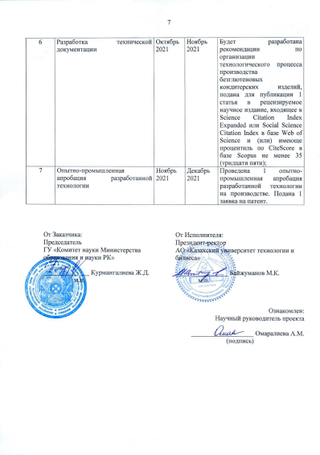

ANNEX B

Table 1 - Results of assessing the quality of gluten-free muffins
Name of products | The form | Surface | Colour | View on the break | Smell | Taste | Chewiness | Final score
Control sample 1 | 5 | 5 | 5 | 5 | 5 | 5 | 5 | 5,0
100% unprocessed chickpea flour sample No. 2 | 3,2 | 3,2 | 4 | 3,5 | 3 | 3 | 3 | 3,27
100% of microwave processed chickpea flour sample No. 3 | 3,2 | 3,2 | 4 | 3,5 | 4 | 3,5 | 3 | 3,48
A mixture of processed chickpea, rice and amaranth flour (85:10:5) sample No. 4 | 3,3 | 3,3 | 4,2 | 3,8 | 4,2 | 3,8 | 3,5 | 3,73
Смесь из обработанной нутовой, рисовой и амарантовой муки (80:15:5) образец №5 | 4,9 | 4,5 | 5 | 4,5 | 5 | 5 | 4,5 | 4,77
A mixture of processed chickpea, rice and amaranth flour (80:15:5) sample No. 5 | 4,8 | 4,4 | 5 | 4,5 | 4,8 | 4,9 | 4 | 4,63
A mixture of processed chickpea, rice and amaranth flour Sample No. 6  (70:20:10) | 4,8 | 4,4 | 5 | 4,5 | 4,8 | 4,9 | 4 | 4,63

Table 1 - Results of assessing the quality of custard semi-finished product
Name of products | The form | Surface | Colour | View on the break | Smell | Taste | Chewiness | Final score
Wheat flour control sample 1 | 5 | 5 | 5 | 5 | 5 | 5 | 5 | 5,0
100% unprocessed chickpea flour sample No. 2 | 3,4 | 3,5 | 5 | 3,5 | 3 | 3 | 3 | 3,27
100% of microwave processed chickpea flour sample No. 3 | 3,6 | 3,5 | 5 | 3,5 | 4 | 3,5 | 3 | 3,48
Sample No. 4 a mixture of chickpea and corn flour  (80:20) | 4,7 | 4,5 | 5 | 5 | 5 | 4,5 | 4,8 | 4,78
Sample No. 5 a mixture of chickpea and corn flour  (60:40) | 4,5 | 4,6 | 5 | 5 | 5 | 4,4 | 4,8 | 4,75
Sample No. 6  a mixture of chickpea and corn flour  (50:50) | 4,8 | 5 | 5 | 4,8 | 5 | 5 | 5 | 4,94

The results of organoleptic research testify to the good consumer qualities of the samples. Good taste, color, aroma and appearance of the products are noted by the commission
The following observations and suggestions were made during the tasting:

ANNEX C
Technological scheme of production of gluten-free flour confectionery products
Butter
Flour mixture (chickpea and corn flour)
Water, milk, salt

Heating the mass to a boil

Adding flour. Welding (5-10 min)
Eggs

Cooling of the mass to 65-70 0C

Adding mélange while stirring

Placing dough on a baking sheet
Baking T=20-30 min, t=170-180 S,

Finishing
cooling, 1-2 hours

Figure С1 - Technological scheme of the production of semi-finished custard

Preparation of raw materials

Mélange, vegetable oil butter
Flour mixture (chickpea, rice and amaranth flour)
baking powder.
Granulated sugar, salt

Dosing and mixing
Whipping the egg-sugar mass until the volume increases by 2.5-3 times
Dosing and mixing

Laying in a whipped mass of flour mixture

Short kneading of the dough T = 7-10 min.

Filling the dough into molds

Baking T=25-30 min, t=180-200⁰ С

Remain standing
T=15 min., t=25 0C

Figure С2 - Technological scheme of muffin production

ANNEX D
MINISTRY OF EDUCATION AND SCIENCE OF THE REPUBLIC OF KAZAKHSTAN
JSC "KAZAKH UNIVERSITY OF TECHNOLOGY AND BUSINESS"

The dough preparation technology includes sequentially carried out operations:
Firstly, a mixture of egg mélange and granulated sugar are whipped in a whipping machine for 15 minutes until the volume increases by 2.5-3 times.
Then add vegetable oil, baking powder and continue whipping for 7-10 minutes. Lastly, add a flour mixture consisting of 80% chickpea flour, 15% rice flour, 5% amaranth flour.
The recipe for the "Ai-Zhan" muffins is presented in table 1.

Table 1 - Recipe for gluten-free muffins "Ai-Zhan"
The name of raw materials and semi-finished products | Mass fraction of dry substances,% | Raw material consumption per 1000 gr. finished products
The name of raw materials and semi-finished products | Mass fraction of dry substances,% | specific performance | dry matter
Flour mixture:
Chickpea flour | 89 | 320 | 284
Rice flour | 86 | 60 | 51,6
Amaranth flour | 89,4 | 20 | 17,8
Mélange | 27 | 153,28 | 41,39
Vegetable oil | 84 | 120 | 100,8
Granulated sugar | 99,85 | 320 | 319,52
Salt | 0,1 |  | 0,1
Baking powder | - | 6,72 | -
Total |  | 1000 | 815,21
Loss of dry matter, kg | 21,63
Output |  | 810 | 793,58

Forming muffins dough.
The finished muffin dough is formed into metal or silicone baking sheet, covered with a special outside layer or lined with paper, or pre-greased.
Muffins are formed when baking, as a result of physicochemical, mainly colloidal processes. At the same time, taste, aroma and color are formed too.
Baking muffins is the final stage in the preparation of confectionery products, which finally completes the cooking process. Technological parameters of baking muffins (temperature, duration) depend on the recipe, mass of dough pieces, their shape and oven designs. Muffins are baked in ovens used for baking semi-finished flour products, cakes and pastries. Baking 0.050 kg gluten-free muffins is carried out for 25-30 minutes at a temperature of 180-200 ° C. The baked muffins are cooled for 1-2 hours. After cooling, the products are packed in plastic wrap.

ANNEX E

MINISTRY OF EDUCATION AND SCIENCE OF THE REPUBLIC OF KAZAKHSTAN
JSC "KAZAKH UNIVERSITY OF TECHNOLOGY AND BUSINESS"

Cooking technology
Dough preparation consists of making flour and combining it with eggs. A 1:1 mixture of chickpea and corn flour is used as flour. Water is poured into the boiler; oil and salt are added bringing it to a boil; then flour is added gradually, stirring with a spatula. After that the mass is heated for 5-10 minutes, while continuing to stir. The mass should be consistent, without lumps. It is transferred to the bowl of the whipping machine and mixed with a hook-shaped whisk to cool the mass to a temperature of 65-70 ° C. Continuing stirring for 10-20 minutes, gradually pour in the eggs. The dough should have 53% of moisture, I.e. it should drain from the spatula forming a triangle. Liquid dough will shrink in the baking process, so the products will turn out with a bad rise. If dough is very thick, products are obtained with poor rise and with cracks on the surface.
The finished custard dough is placed on a baking sheet, slightly greased with oil. The dough should be placed in the form of 1 cm small balls at a distance of 2-2.5 cm from each other; then it is baked at temperature of 180-200 °C. Bake at 180 ° C for 15 minutes, and then lower the temperature to 160 ° C and bake for another 15 minutes.
Use the custard semi-finished product as a side dish for the broth. The baked muffins are cooled for 1-2 hours. After cooling, the products are packed in plastic wrap. Larger size custard is filled with cream and glazed with chocolate or frosting.
The recipe for the custard semi-finished product is presented in Table 1.

Table 1 - Recipe for the "Aizere" custard semi-finished product

Name of raw materials and semi-finished products |  | Mass fraction of dry substances,% | Raw material consumption per 1000 gr. finished products
 |  | Mass fraction of dry substances,% | specific performance | dry matter
Flour mixture (chickpea corn flour)
Chickpea flour | 89,0 |  | 90 |  | 80,1
Corn flour | 85,5 |  | 110 |  | 94,05
Mélange | 27 |  | 340 |  | 91,8
Water | - |  | 160 |  | -
Milk | 91,2 |  | 190 |  | 173,28
Butter | 45,5 |  | 109,9 |  | 50,0
Table salt | 0,1 |  | 0,1 |  | 0,1
Total |  |  | 1000 |  | 649,33
Loss of dry matter, kg |  |  |  |  | 20,83
Output |  |  | 800,8 |  | 628,5

The mode of preparation of the "Aizere" custard semi-finished product is shown in Table 2.

Table 2.
Technological mode name | Custard semi-finished product "Aizere"
Semi-finished product preparation
Dough moisture, % | 53-55
Dough temperature, 0С | 65-70
Duration of brewing, min | 7-10
Baking mode for custard semi-finished product
Baking temperature 0С | 180-200

ANNEX F
Technological instructions for the production of gluten-free cupcakes from a mixture of chickpea, rice and amaranth flour

contents
1 | Field of application | 4
2 | Characteristics of raw materials | 4
3 | Main manufacturing processes of confectionery production | 4
4 | Characteristics of the finished product | 5
5 | Technological scheme for the production of muffins from a gluten-free mixture | 6
6 | The quality of the finished product | 8
7 | Labeling, packaging and transportation | 10
 | References | 12

1. Field of application
This technological instruction establishes the sequence of technological processes for the production of gluten-free confectionery intended for use in the confectionery industry.
2. Characteristics of raw materials: optimal requirements for raw materials
The following raw materials are used for the production of gluten-free confectionery:
- Chickpea flour is produced according to the developed recommendations of the technology of flour production from microwave processed chickpea. A distinctive feature of chickpea flour is the absence of gluten in it; it also serves as a source of vegetable protein, contains sodium, potassium, magnesium, phosphorus, vitamins B1, B2 and PP;
- Rice flour is produced according to GOST 53495-2009. Finely ground rice flour, which looks like wheat flour, is used for the production of flour confectionery products. However, unlike wheat flour, rice flour does not contain gluten and therefore can be eaten by people with celiac disease;
- Vegetable oil (GOST 31754-2012);
- Granulated sugar (GOST 33222-2015);
- Egg liquid and dry food products (GOST 30363-2013).

3. Main manufacturing processes of confectionery production
The main principle of organizing the production process in the workshop is the flow, the forward movement of raw materials, the separation into independent technological lines for the preparation of various types of dough and products from it in one common production room.
Organizing production sites and workplaces.
The organized confectionery workshop provides for the following composition of premises:
- Pantry and refrigerator for daily food storage;
- Egg processing room;
- Rooms for sifting flour, kneading and dough, cutting and baking flour products;
- Washing and pantry of dishes, containers, inventory;
- Pantry and refrigerated chamber of finished confectionery products;
- Room of the shop manager;
- Expedition.
The confectionery workshop uses a wide variety of equipment: sifters, kneading machines, dough-rolling machines, whipping machines, electric stoves, electric baking cabinets, refrigeration equipment, bins for flour, sugar, cargo trolleys, racks, scales, mobile bowls, accessories, production tables, washing baths.
The products necessary for the preparation of food products are supplied to the pantry of the daily supply. Perishable foodstuff (butter, eggs, etc.) is stored in the refrigerator at 2-4 ° C. The main products (flour and eggs) are pre-prepared.
In the egg processing room, there is an ovoscope, which is used to check the quality of eggs. There is a four-section bath for the eggs sanitary treatment.
Flour is sifted in the pantry of the daily stock of raw materials next to the dough kneading department. A screening machine is installed at this workplace. Mobile bowls are used to collect the sifted flour. A drawer is installed to store the bags of flour.
Dough kneading, cutting and baking are carried out in the same room. Commodity scales are used for weighing products.
The washing department of the confectionery workshop is designed for washing dishes and inventory. Baths with two or three compartments are installed in it. Detergents and brushes are used for washing dishes. The inventory is washed in soda water at a temperature not lower than 45 ° С, and then rinsed with hot water (not lower than 60 ° С) and 2% bleach solution.
After washing, the inventory is dried and stored on racks.
All the inventory and in-store containers used in the production of confectionery products are marked by the name of raw materials or semi-finished products. The use of unmarked containers, as well as not in accordance with the marking, is prohibited.
4. Characteristics of the finished product
4.1 Gluten-free muffins are made from non-traditional types of flour and other ingredients according to the recipe.
4.2 Gluten-free muffins are intended for sale through catering establishments or in a retail chain in packaged form, for direct consumption.
4.3 All products, according to their names, must comply with the recipe approved in accordance with the established procedure. Approved recipes for the production of gluten-free muffins must comply with the standards established in this technological instruction.
4.4 Finished products are delivered in transport packaging.
5 Technological scheme of the production of muffins from a gluten-free mixture
The technological process of confectionery production consists of the following stages: storage and preparation of raw materials, preparation and kneading of dough, cutting of dough and its portioning, molding of products, baking and cooling of products.
The technological scheme of the muffins production is shown in Figure 1.

Preparation of raw materials

Mélange, butter
Flour mixture (chickpea, rice and amaranth flour) baking powder.
Granulated sugar

Dosing and mixing
Whipping the egg-sugar mass until the volume increases by 2.5-3 times
Dosing and mixing

Laying in a whipped mass of flour mixture

Short kneading of the dough T = 10-15 s.

Filling the dough into the molds

Baking T=25-30 min, t=180-200⁰ С

Remain standing
T=15 min., t=25 0C

Figure 1 - Technological scheme of cake preparation

Before kneading the dough, the flour mixture is sifted, lumps and foreign impurities are removed, and the mixture is enriched with oxygen. This facilitates the kneading of the dough and contributes to its better rise. Oxygen with such natural maturation easily penetrates the flour, stabilizes and improves its properties.
Dough preparation is the most important and the longest operation in the production of confectionery, taking about 60-80% of the time of the entire production cycle. When choosing a specific method of preparing the dough, it is necessary first of all to take into account the range of products produced, the recipe.

Table 1 shows the formulation of the muffins.
Table 1-Recipe of gluten-free muffins "Ai-Zhan"

The name of raw materials and semi-finished products | Mass fraction of dry substances, % | Raw material consumption per 1000 gr. finished products
The name of raw materials and semi-finished products | Mass fraction of dry substances, % | specific performance | dry matter
Flour mixture:
Chickpea flour | 89 | 320 | 284
Rice flour | 86 | 60 | 51,6
Amaranth flour | 89,4 | 20 | 17,8
Mélange | 27 | 153,28 | 41,39
Vegetable oil | 84 | 120 | 100,8
Granulated sugar | 99,85 | 320 | 319,52
Salt - 0.5 | 0,1 |  | 0,1
Baking powder | - | 6,72 | -
Total |  | 1000 | 815,21
Loss of dry matter, kg | 21,63
Output |  | 810 | 793,58

The dough preparation technology includes sequentially carried out operations: mélange with granulated sugar is whipped for 15 minutes, until the volume increases by 2.5-3 times. Then add softened butter, baking powder and continue whipping for 7-10 minutes. . Lastly, add a flour mixture consisting of 80% chickpea flour, 15% rice flour, 5% amaranth flour.
Forming dough for muffins. The finished muffin dough is formed into metal or silicone baking sheet, covered with a special outside layer or lined with paper, or pre-greased.
Muffins are formed when baking, as a result of physicochemical, mainly colloidal processes. At the same time, taste, aroma and color are formed too.
Baking muffins is the final stage of making confectionery, which finally completes the cooking process. Technological parameters of baking muffins (temperature, duration) depend on the recipe, mass of dough pieces, their shape and oven designs. Muffins are baked in ovens used for baking semi-finished flour products, cakes and pastries. Baking 0.050 kg gluten-free muffins is carried out for 25-30 minutes at a temperature of 180-200 ° C. The baked muffins are cooled for 1-2 hours. After cooling, the products are packed in plastic wrap.
The product is analyzed in 24 hours after baking.
The developed technological scheme serves as the basis for the calculation and selection of the necessary equipment, the organization of workplaces and the entire production process as a whole.

6. Quality of the finished product
The muffins must comply with the requirements of GOST 15052-96 for organoleptic and physicochemical parameters, i.e.: must have a taste and smell characteristic of this product, without any extraneous taste or smell; a surface characteristic of this product; have no burnt spots.
The physicochemical indicators must correspond to the calculated values according to the recipe with permissible deviations in the direction of reduction.
The appearance of the muffin is shown in Figure 2.
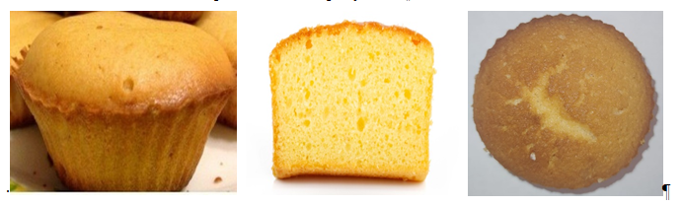
ABC
Figure 2 - A - exterior view; B - top view; C - sectional view.
The organoleptic indicators of muffins are presented in Table 2.

Table 2 - Organoleptic quality indicators of muffins
The name of the indicator | Finished product
Taste and smell | Rich taste, characteristic aroma, without any foreign smell and taste
Surface | Convex with characteristic cracks
Sectional view | Baked product, without lumps and traces of non-kneading, with uniform porosity, without voids
Structure | Porous, without voids and seals
Form | The correct shape with a convex upper surface. The bottom and side surfaces are smooth, without voids.
The size and shape of the finished product is shown in Figure 3, Table 3.
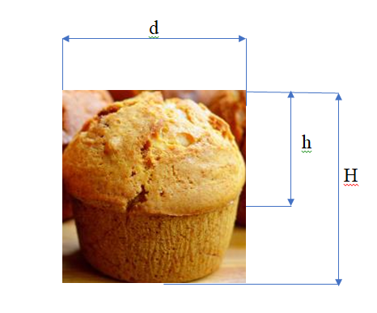
Figure 3 - Diagram of measuring the parameters of the size and shape of the finished product

Table 3 - Size and shape of the finished product (muffin diameter d = 55 mm)
Indicators | Gluten-free muffins
The ratio of the height of the convex part of the upper crust to its diameter (the degree of convexity of the upper crust), h/d | 0,49
The ratio of the height of the lateral crust to its diameter, (H- h)/d | 0,35
Muffin height, H (mm) | 46
Height of the convex part of the upper crust, h (mm) | 27
Height of the side crust, (H- h) | 19

The physicochemical quality indicators of the finished product are presented in Table 4.

Table 4 - Physicochemical quality indicators of the finished product
The name of the indicator | Gluten-free muffins
Moisture, % GOST 5900 | 25,5
Density, % GOST 15810-2014 | 0,50
Alkalinity, GOST 5898. | 1,6
Wetness, % GOST 15810-2014 | 179,7
Porosity, % GOST 5669-96 | 53

The energy value of the finished product is presented in Table 5.

Table 5 - Energy value of the finished product
Food substances | Gluten-free muffins
Carbohydrates, % | 66,18
Fat,% | 18,69
Proteins,% | 9,85
Energy value, kcal | 472,33

The content of toxic elements and microbiological indicators should not exceed the permissible levels established by medical and biological requirements. During the production process of custard semi-finished products, the formation of waste in the form of deformed products or products with a broken surface may be possible. Such waste is used when kneading the dough. Losses of raw materials are formed at all phases of the technological process, for the custard semi-finished product the amount of losses is up to 5.9 - 6.5%. These amounts are included in the recipes.

7. Labeling, packaging and transportation
7.1 The labeling of muffins in consumer and transport packaging must comply with the requirements of TR CU 022/2011 or regulatory legal acts in force on the territory of the state that adopted the standard.
7.2 Muffins are made with a net weight of a single product not exceeding 1500 g and packed one or more pieces in consumer packaging or in transport packaging without consumer packaging.
7.3 Packaging materials, consumer and transport packaging used for packaging muffins must comply with the requirements of TR CU 005/2011 or regulatory legal acts, and ensure the preservation of the quality and safety of muffins during their transportation, storage and sale.
7.4 The net weight of the muffin in one packaging unit must correspond to the net weight indicated in the labeling of the consumer packaging, taking into account the permissible deviations. The limits of permissible negative deviations of the net weight in one packaging unit from the nominal quantity - according to GOST 8.579 or in accordance with the requirements established by regulatory documents.
7.5 Muffins are transported by vehicles in accordance with the requirements of TR CU 021/2011 and taking into account the conditions of transportation established by the manufacturer.
7.6 Muffins should be stored in clean, dry, well-ventilated warehouses, not infested with pests of grain stocks. The recommended storage temperature is 18 ° C, relative humidity - no more than 75%.
Muffins should not be exposed to direct sunlight.
It is not allowed to store and transport muffins together with products that have a specific smell.

REFERENCES
1 Котузаки Е.Н. Разработка технологии и рецептур бисквитных полуфабрикатов на основе не-хлебопекарных видов мук // Автореф. … дис. канд. техн. наук. Одесса: Од.нац. акад. пищ. технол., 2013. 21 с.
2 Петрова К.А., Майорова А.С., Болгов А.Ф. Биологическое обоснование, разработка рецептур и экспериментальных образцов новых функциональных продуктов на основе натуральных ингредиентов // Ученые записки Петрозаводского государственного университета. Биологические науки – 2016. - № 6. - С.159.
3 Грищенко А.М., Подик А.В., Грищенко А.Н. Особенности технологии хлебобулочных изделий для больных целиакией // Aktualnenaukoweproblemy. Rozpratrzenie, decyzja, praktyka: Zbiуrraportуwnaukowych. Wrocław: Sp. zo.o., 2014. P.15-17.
4 Рязанова О.А. Инновационные технологии в производстве продуктов детского питания // Технология и товароведение инновационных пищевых продуктов. 2013. № 2. 27с.
5 Барсукова Н.В. Разработка технологии пряничных изделий на основе безглютенового мучного сырья // Автореф. … дисс. на соис.уч.ст., к.т.н. Санкт-Петербург – 2005. – 25 с.
6 Технология производства мучных кондитерских изделий: учебное пособие / Сост. Т.В. Мамченко. – Брянск: Мичуринский филиал ФГБОУ ВО «Брянский государственный аграрный университет», 2015. - 98 с.
7 ГОСТ 15052-2014 Кексы. Общие технические условия.

ANNEX G
Technological instructions for the production of gluten-free semi-finished custard from a mixture of chickpea and corn flour
"

CONTENTs
1 | Field of application | 4
2 | Characteristics of raw materials | 4
3 | Main manufacturing processes of the production of custard semi-finished products | 4
4 | Characteristics of the complete custard semi-finished product | 5
5 | Technological scheme for the production of custard semi-finished products from a gluten-free mixture | 6
6 | The quality of the finished product | 8
7 | Labeling, packaging and transportation | 11
8 | References | 12

1. Field of application
This technological instruction establishes the sequence of technological processes for the production of gluten-free confectionery intended for use in the confectionery industry.
2. Characteristics of raw materials
The following raw materials are used for the production of gluten-free confectionery:
- Chickpea flour is produced according to the developed recommendations of the technology of flour production from microwave processed chickpea. A distinctive feature of chickpea flour is the absence of gluten in it; it also serves as a source of vegetable protein, contains sodium, potassium, magnesium, phosphorus, vitamins B1, B2 and PP;
- Corn flour is produced according to GOST 14176-69. Finely ground corn flour, which looks like wheat flour, is used for the production of flour confectionery products. However, unlike wheat flour, corn flour does not contain gluten and therefore can be eaten by people with celiac disease;
- Vegetable oil (GOST 31754-2012);
- Granulated sugar (GOST 33222-2015);
- Egg liquid and dry food products (GOST 30363-2013).
3. Main manufacturing processes of the production of custard semi-finished products
The main principle of organizing the production process in the workshop is the flow, the forward movement of raw materials, the separation into independent technological lines for the preparation of various types of dough and products from it in one common production room.
Organizing production sites and workplaces.
The organized confectionery workshop provides for the following composition of premises:
- Pantry and refrigerator for daily food storage;
- Egg processing room;
- Rooms for sifting flour, kneading and dough, cutting and baking flour products;
- Washing and pantry of dishes, containers, inventory;
- Pantry and refrigerated chamber of finished confectionery products;
- Room of the shop manager;
- Expedition.
The confectionery workshop uses a wide variety of equipment: sifters, kneading machines, dough-rolling machines, whipping machines, electric stoves, electric baking cabinets, refrigeration equipment, bins for flour, sugar, cargo trolleys, racks, scales, mobile bowls, accessories, production tables, washing baths.
The products necessary for the preparation of food products are supplied to the pantry of the daily supply. Perishable foodstuff (butter, eggs, etc.) is stored in the refrigerator at 2-4 ° C. The main products (flour and eggs) are pre-prepared.
In the egg processing room, there is an ovoscope, which is used to check the quality of eggs. There is a four-section bath for the eggs sanitary treatment.
Flour is sifted in the pantry of the daily stock of raw materials next to the dough kneading department. A screening machine is installed at this workplace. Mobile bowls are used to collect the sifted flour. A drawer is installed to store the bags of flour.
Dough kneading, cutting and baking are carried out in the same room. Commodity scales are used for weighing products.
The washing department of the confectionery workshop is designed for washing dishes and inventory. Baths with two or three compartments are installed in it. Detergents and brushes are used for washing dishes. The inventory is washed in soda water at a temperature not lower than 45 ° С, and then rinsed with hot water (not lower than 60 ° С) and 2% bleach solution.
After washing, the inventory is dried and stored on racks.
All the inventory and in-store containers used in the production of confectionery products are marked by the name of raw materials or semi-finished products. The use of unmarked containers, as well as not in accordance with the marking, is prohibited.
4. Characteristics of the complete custard semi-finished product
4.1 Semi-finished custard products are produced from non-traditional types of flour and other ingredients according to the recipe.
4.2 Semi-finished custard products are intended for sale through catering establishments or in a retail chain in packaged form, for direct consumption.
4.3 All products, must comply with the recipe approved in accordance with the established procedure, according to their names. Approved recipes for the production of semi-finished custard products must comply with the standards established in this technological instruction.
4.4 Finished products are delivered in transport packaging.
5. Technological scheme for the production of custard semi-finished products from a gluten-free mixture
The technological process of confectionery production consists of the following stages: storage and preparation of raw materials, preparation and kneading of dough, cutting of dough and its portioning, molding of products, baking and cooling of products.
The technological scheme of the production of semi-finished custard is shown in Figure 1.

Preparation of raw materials

Butter
Flour mixture (chickpea and corn flour)
Water, milk, salt

Heating the mass to a boil
Adding flour. Welding (5-10 min)
)

Eggs

Cooling of the mass to 65-70 0C

Adding mélange while stirring

Depositing the dough on a baking sheet

Baking T=20-30 min,
t=170-180⁰ С

cooling, 1-2 hours

Finishing

Figure 2 - Technological scheme of production of semi-finished custard
Before kneading the dough, the flour mixture is sifted, lumps and foreign impurities are removed, and the mixture is enriched with oxygen. This facilitates the kneading of the dough and contributes to its better rise. Oxygen with such natural maturation easily penetrates the flour, stabilizes and improves its properties.
Dough preparation is the most important and the longest process in the production of confectionery, taking about 60-80% of the time of the entire production cycle. When choosing a specific method of preparing the dough, it is necessary first of all to take into account the range of products produced and the recipe.
Table 1 shows the recipe of the custard semi-finished product.
Table 1 - The recipe of the custard semi-finished product
Name of raw materials and semi-finished products | Mass fraction of dry substances,% | Raw material consumption per 1000 gr. finished products
Name of raw materials and semi-finished products | Mass fraction of dry substances,% | specific performance | dry matter
Flour mixture (chickpea, corn flour 50:50)
Chickpea flour | 89,0 | 90 |  | 80,1
Corn flour | 85,5 | 110 |  | 94,05
Mélange | 27 | 340 |  | 91,8
Water | - | 160
Milk | 91,2 | 190 |  | 173,28
Butter | 45,5 | 109,9 |  | 50,0
Table salt | 0,1 | 0,1 |  | 0,1
Loss of dry matter, kg |  |  |  | 20,83
Output |  | 800,8 |  | 780,0

The mode of preparation of the semi-finished custard "Aizere" is shown in Table 2.
Technological mode name | Custard semi-finished product "Aizere"
Dough moisture, % | 53-55
Dough temperature, 0С | 65-70
Duration of brewing, min | 7-10 min
Baking mode of custard semi-finished products
Baking temperature 0С | 180-200
Duration of baking, min | 25-30
Moisture content of the finished product | 22%±2%

The preparation of the dough consists of brewing flour and combining it with eggs. A 1:1 mixture of chickpea and corn flour is used as flour. Pour water into the boiler, add oil, salt and bring to a boil, then gradually, stirring with a spatula, add flour. After that the mass is heated for 5-10 minutes, while continuing to stir. The mass should be consistent, without lumps. It is transferred to the bowl of the whipping machine and mixed with a hook-shaped whisk to cool the mass to a temperature of 65-70 ° C. Continuing stirring for 10-20 minutes, gradually pour in the eggs. The dough should have 53% of moisture, I.e. it should drain from the spatula forming a triangle. Liquid dough will shrink in the baking process, so the products will turn out with a bad rise. If dough is very thick, products are obtained with poor rise and with cracks on the surface.
The finished custard dough is placed on a baking sheet, slightly greased with oil. The dough should be placed in the form of 1 cm small balls at a distance of 2-2.5 cm from each other; then it is baked at temperature of 180-200 °C. Bake at 180 ° C for 15 minutes, and then lower the temperature to 160 ° C and bake for another 15 minutes.
Use the custard semi-finished product as a side dish for the broth. The baked muffins are cooled for 1-2 hours. After cooling, the products are packed in plastic wrap.
Larger-sized custard semi-finished products are filled with cream and glazed with chocolate or frosting.
The product is analyzed in 24 hours after baking.
The developed technological scheme serves as the basis for the calculation and selection of the necessary equipment, the organization of workplaces and the entire production process as a whole.

6. The quality of the finished product
The custard semi-finished product must comply with the requirements of GOST 15052-96 for organoleptic and physicochemical indicators, i.e.: must have a taste and smell characteristic of this product, without any extraneous taste or smell; a surface characteristic of this product; have no burnt spots.
The physicochemical indicators must correspond to the calculated values according to the recipe with permissible deviations in the direction of reduction.
The appearance of the semi-finished custard is shown in Figure 2.
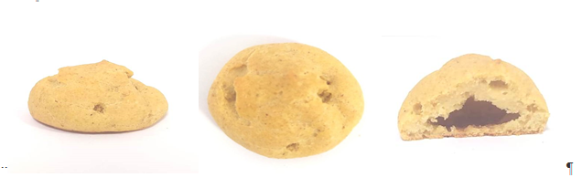
ABC
Figure 2 - A - exterior view; B - top view; C - sectional view.
The organoleptic parameters of the semi-finished custard are presented in Table 3.

Table 3 - Organoleptic indicators of the quality of semi-finished custard
The name of the indicator | Finished product
Appearance | In the form of a cylindrical hollow bun without damage. The surface is rough with specific irregularities.
Color | yellowish
The cavity | pronounced, large
Taste | Pronounced, sweet characteristic of the custard semi-finished product
Surface | Convex with characteristic cracks
Sectional view | Baked product, without lumps and traces of non-kneading, with uniform porosity, without voids
Structure | Porous, without voids and seals
The size and shape of the finished product is shown in Figure 3, Table 4.
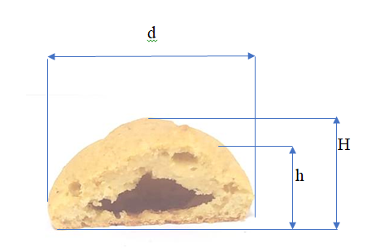
Figure 3 - Diagram of measuring the parameters of the size and shape of the finished product

Table 4 -the proportion and shape of the finished product (the diameter of the custard semi-finished product d = 55mm)
Indicators | Custard semi-finished product
The ratio of the height of the convex part of the upper crust to its diameter (the degree of convexity of the upper crust), h/d | 0,20
The ratio of the height of the lateral crust to its diameter, (H- h)/d | 0,67
Height of the custard semi-finished product, H (mm) | 26
Height of the convex part of the upper crust, h (mm) | 6
Height of the side crust, (H- h) | 20

The physicochemical quality indicators of the finished product are presented in Table 5.
Table 5 - Physicochemical quality indicators of the finished product

The name of the indicator | Custard semi-finished product
Moisture of the dough, % 5902-80 | 22,5
Specific volume, ml/g | 12,0
Moisture of the semi-finished product | 22,5
Porosity, % GOST 5669-96 | 54,0

The energy value of the finished product is presented in Table 6.

Table 6 - Energy value of the finished product
Food substances | Gluten-free custard semi-finished product
Carbohydrates, % | 29,22
Fat,% | 14,3
Proteins,% | 13,36
Energy value, kcal | 299,02

During the production process of custard semi-finished products, the formation of waste in the form of deformed products or products with a broken surface may be possible. Such waste is used when kneading the dough. Losses of raw materials are formed at all phases of the technological process, for the custard semi-finished product the amount of losses is up to 2.6 -5.9%. These amounts are included in the recipes.

7. Labeling, packaging and transportation
7.1 Labeling of custard semi-finished product in consumer and transport packaging must comply with the requirements of TR CU 022/2011 or regulatory legal acts in force on the territory of the state that adopted the standard.
7.2 The custard semi-finished product is made with a net weight of a single product of no more than 350g and packed one or more pieces in consumer packaging or in transport packaging without consumer packaging.
7.3 Packaging materials, consumer and transport packaging used for packaging custard semi-finished product must comply with the requirements of TR CU 005/2011 or regulatory legal acts, and ensure the preservation of the quality and safety of custard semi-finished products during their transportation, storage and sale.
7.4 The net weight of the custard semi-finished product in one packaging unit must correspond to the net weight indicated in the labeling of consumer packaging, taking into account the permissible deviations. The limits of permissible negative deviations of the net weight in one packaging unit from the nominal quantity - according to GOST 8.579 or in accordance with the requirements established by regulatory documents.
7.5 The custard semi-finished product is transported by vehicles in accordance with the requirements of TR CU 021/2011 and taking into account the conditions of transportation established by the manufacturer.
7.6 The custard semi-finished product should be stored in clean, dry, well-ventilated warehouses, not infested with pests of grain stocks. The recommended storage temperature is 18 ° C, relative humidity - no more than 75%.
Custard semi-finished products should not be exposed to direct sunlight.
It is not allowed to store and transport semi-finished custard together with products that have a specific smell.

REFERENCES
1 Котузаки Е.Н. Разработка технологии и рецептур бисквитных полуфабрикатов на основе не-хлебопекарных видов мук // Автореф. … дис. канд. техн. наук. Одесса: Од. нац. акад. пищ. технол., 2013. 21 с.
2 Петрова К.А., Майорова А.С., Болгов А.Ф. Биологическое обоснование, разработка рецептур и экспериментальных образцов новых функциональных продуктов на основе натуральных ингредиентов // Ученые записки Петрозаводского государственного университета. Биологические науки – 2016. - № 6. - С.159.
3 Грищенко А.М., Подик А.В., Грищенко А.Н. Особенности технологии хлебобулочных изделий для больных целиакией // Aktualnenaukoweproblemy. Rozpratrzenie, decyzja, praktyka: Zbiуrraportуwnaukowych. Wrocław: Sp. zo.o., 2014. P.15-17.
4 Рязанова О.А. Инновационные технологии в производстве продуктов детского питания // Технология и товароведение инновационных пищевых продуктов. 2013. № 2. 27с.
5 Барсукова Н.В. Разработка технологии пряничных изделий на основе безглютенового мучного сырья // Автореф. … дисс. на соис.уч.ст., к.т.н. Санкт-Петербург – 2005. – 25 с.
6 Технология производства мучных кондитерских изделий: учебное пособие / Сост. Т.В. Мамченко. – Брянск: Мичуринский филиал ФГБОУ ВО «Брянский государственный аграрный университет», 2015. - 98 с.
7 ГОСТ 15052-2014 Заварные полуфабрикаты. Общие технические условия.

APPLICATION H

Recommendation on the technology of production of flour from microwave processed chickpeas

CONTENT

 | INTRODUCTION……………………………………………………………..……………………….. | 4
1 | GENERAL INFORMATION………………………………………………………………….….…. | 5
2 | RECEPTION, ACCOMMODATION AND STORAGE ……………………………….……………….… | 5
3 | ORGANIZATION OF THE TECHNOLOGICAL PROCESS.................................................. | 5
4 | PRODUCTION OF FLOUR FROM MICROWAVE PROCESSED CHICKPEA ……………………… | 7
5 | CHOOSE AND PACKING OF PRODUCTS …………………..………………………………... | 9
6 | TECHNOLOGICAL PROCESS CONTROL ……………………………………... | 9

INTRODUCTION
Pulses are sources of many functional ingredients - dietary fiber, vegetable proteins, polysaccharides, B vitamins, macro- and microelements. In this regard, the inclusion of products obtained from seeds of leguminous crops in the diet in general and, in the prevention of chronic diseases in particular, is important.
Leguminous crops differ significantly in their characteristics from the grain of traditional grain crops, the technology of industrial processing of which into flour has been worked out in detail over many years. Most leguminous crops have unsatisfactory technological properties, the main of which are: the need for preliminary mechanical preparation - caving, crushing, hydrothermal treatment, prolonged (respectively, high energy costs) heat treatment - cooking. In addition, almost all legumes are sources of anti-alimentary substances (inhibitors of proteinases, phasin, phytates, lectins, raffinose, stachyose, verbascose). All this is the reason for the limited use of legumes in the diet of the population.
Currently, research is underway to develop technologies for obtaining functional food products and their components from composite flour based on leguminous crops, which is a modern direction in the development of the food industry. In particular, to improve the efficiency of the technological process and increase the yield of flour, it is proposed to carry out preliminary heat treatment of cereals. In this direction, infrared processing (IR technology) is one of the promising methods for processing legumes.
In the process of microwave processing, it penetrates deep into the grain and causes its rapid internal heating. At the same time, the structural frame of the weevil is destroyed, its strength decreases, which helps to reduce energy consumption during further processing - grinding, crimping, etc. Infrared radiation intensifies biochemical processes in the processed product due to resonant absorption of energy by protein and polysaccharide molecules. When the caryopsis is heated, up to 20% of the starch is converted into dextrins, which are easily absorbed by humans, and toxic substances are destroyed. There is a slight denaturation of the protein, and due to the short processing time (30-50 sec.), The vitamin complex is almost completely preserved.
The effect of microwave radiation on the seeds of leguminous crops increases the digestibility of nutrients by 30-40%. In addition, under the influence of high temperature, and primarily due to its rapid increase, there is a sharp decrease in microbiological contamination, spores and mycotoxins are destroyed - as a result, almost 100% sterilization of the processed product occurs, the smell and taste also improve, the color changes.
Received after microwave processing, leguminous raw materials subjected to grinding (to the state of flour) can be used as flour for the production of flour confectionery, containing valuable food components.

1 GENERAL INFORMATION
1.1 These guidelines are designed to produce flour from microwave-processed chickpea pulses with the most efficient use of raw materials, equipment and energy.
1.2 When using these recommendations, it is necessary to ensure that the established standards for quality and product yield are met.
1.3 The Recommendations stipulate that the following conditions are met:
-location of incoming legume seeds for processing;
- rational use of raw materials;
-optimal operating mode of individual equipment;
-control of the technological process and product quality;
-packaging and labeling of products;
-compliance with sanitary and hygienic requirements and safety precautions.
1.4 The technology of production of products complies with the rules for organizing and maintaining the technological process.

2 RECEPTION, ACCOMMODATION AND STORAGE
2.1 Each batch of raw materials supplied for processing in quality must not be lower than the conditions approved by the standards:
-GOST 8758-76 "Nut. Requirements for procurement and delivery ";
2.2 Acceptance, placement and storage of raw materials is carried out in accordance with technical documentation No. 4-1 / 573 "Rules for storing grain", "Instruction for the storage of grain, oil seeds, flour and cereals" No. 9-7-88,
2.3 When receiving and placing raw materials in the warehouses of enterprises, it is necessary to ensure:
-compliance with the plan for the placement of consignments of raw materials;
- complete safety of the received raw materials with an all-round improvement in quality;
-movement of batches of raw materials along lines and containers, excluding its scattering and arbitrary mixing.
2.4 The plan for the placement of batches of raw materials is developed by the head of the production laboratory with the participation of the senior technologist. The plan for the placement of raw materials is approved by the head of the enterprise.
2.5 All incoming raw materials must be weighed. If necessary, the raw material must undergo preliminary preparation - cleaning, drying, etc.

3 ORGANIZATION OF THE TECHNOLOGICAL PROCESS
3.1 The technological process at the enterprise should be carried out:
- according to the scheme approved for this type of processing;
- subject to the regime of individual machines, taking into account the technological properties of the processed grain.
3.2 The scheme of the technological process of processing is developed in relation to the conditions of each enterprise on the basis of the recommendations given in this material.
3.3 The technological scheme should ensure the most efficient use of resources:
-processed raw materials;
-equipment, energy, containers and materials;
-working and repair time.
3.4 The development of the technological scheme is carried out by the technologist of the enterprise or the head of the shop with the participation of the head of the production laboratory.
3.5 The technological scheme with the utmost accuracy should reflect the current technological process and its actual communication. In particular, the diagram must necessarily reflect:
- the sequence of use of equipment, their number and brand;
-direction of products to equipment;
- the main technical characteristics of all equipment - technological, transport and aspiration;
-communication links;
-all containers, scales or flow meters, samplers, magnetic columns, weighing apparatus.
3.6 Before being fed to the mixing compartment, the raw material is weighed.
3.7 All equipment provided by the process flow diagram must be included in the operation. The mode of individual equipment is set depending on the quality of the processed raw materials. The established operating mode of the equipment must be observed by the service personnel.

4 PRODUCTION OF FLOUR FROM MICROWAVE PROCESSED CHICKPEA
4.1 Preparation of flour from microwave processed chickpeas includes - preliminary dosing of components (chickpea beans), moistening and tempering, microwave processing, cooling, grinding (Fig. 1).
4.1.1 Pre-batching of components includes the selection of a certain number of beans - chickpeas by weighing with a weighing batcher (type DV-1 200).
4.1.2 The raw material is humidified with water at a temperature of 40-60 ° C in the volume obtained by the calculation method based on the initial moisture content and the volume of the raw material. The optimum moisture content of raw materials before micronization should be within:
-nut - 10%;
4.1.3 The raw material, moistened to the required moisture content, enters the hopper for sedimentation for uniform distribution of moisture. The residence time of raw materials in the bunker for chickpea is 6-8 hours.
4.1.4 A magnetic separator is installed at the entrance to the microwave bean processing line. Due to the high heat capacity and thermal diffusivity during processing, metallic magnetic impurities rise to a temperature higher than the temperature
processed beans and present an increased fire hazard. Therefore, the magnetic separator must provide 100% efficiency of the extraction of magnetic impurities with a size of 1 mm or more and 80% of the extraction of weakly magnetic impurities with a size of 0.5-1.0 mm.
4.1.5 Raw materials cleaned from metal-magnetic impurities undergo microwave processing at 800 W (installed power: infrared emitters - 27 kW, electric motor - 180 W), the heating time during microwave processing (exposure) is 180 sec.
4.1.6 The resulting microwave processed chickpeas should have a pleasant nutty smell and a slightly roasted appearance.
4.1.7 The microwave processed batch of raw materials is cooled and fed for further crushing and grinding. Grinding size is controlled by sieves # 27.
Raw flour (chickpea)
Weighing, dosing
Grinding, crushing
sieve control No. 27
Microwave processing at 800 W t=180 сек.
Moisturizing, dehydration
τ _{chickpea}=8 час, W _{chickpea}=20%
Cooling

Figure 1 - Technological scheme of flour production
4.1.8 The technological line for the production of microwave processed chickpea is represented by a set of the following equipment: raw material bins, a weighing batcher, a humidifier, bunkers, a microwave oven, a belt cooler, a roller grinder, unloading and loading augers (Figure 2).
Grain raw material enters the raw material bins 1, from where it is fed to the weighing feeder via the unloading auger 2 3. The dosed batch is moistened and tempered in the bins 5. After annealing, the grain pulses are fed by the unloading auger 6 to the micronizer 7, where the raw material is heated in accordance with the given mode. The microwave processed raw material is cooled in a belt cooler 8, after which it is fed for grinding in a roller grinder 9.

1
7
8
5
4
3
9
2
6

1 - hoppers for leguminous raw materials; 2, 6 - unloading auger; 3 - weighing batcher; 4 - humidifier; 5 - bunkers-bunkers; 7 - microwave oven; 8 - belt cooler; 9 - roller shredder
Figure 2 - Apparatus and technological scheme of chickpea flour

5 SELECTION AND PACKAGING OF PRODUCTS
5.1 When packing chickpea flour, use consumer packaging on a polyethylene or cardboard-paper base. Packages and packs of flour are packed in a shipping container that ensures their safety during transportation.
5.2 Marking must be affixed to each packaging unit and contain:
- name of the manufacturer, location;
- product name, type, grade;
- net weight (kg.);
- date of production or release (year, month, day, shift number);
- designation of NTD for products;
- storage terms;
-cooking method;
-information about nutritional and energy value (calorie content) in 100 g of the product, protein, fat, carbohydrate content.
5.3 Placement and storage of products in the warehouse is carried out separately for each type, grade and date of pick-up in accordance with the normative and technical documentation.
During storage it is necessary:
-check the condition and quality of products according to the signs and within the time frame provided for by the normative and technical documentation;
- to monitor the temperature and relative humidity of the outside air.
6 PROCESS CONTROL
6.1 Control of the technological process, the quality of raw materials and finished products is carried out in order to identify and establish the modes of obtaining flour. It is necessary to provide conditions that ensure the receipt of products of the highest quality and yield, as well as the fullest use of raw materials and equipment.
6.2 Control is carried out by the production laboratory through laboratory analysis of incoming raw materials, intermediate products, finished flour, selected at control points of the technological process, and by service personnel at workplaces.
6.3 The laboratory conducts systematic control over the correct placement, storage, preparation of raw materials, over the technological efficiency of the line equipment as a whole, over the quality of products, takes measures to prevent the production of low-quality products, timely calculate and prepare reports on outputs and quality.
6.4 Control of the technological process is carried out according to the schedules for control of production and control of the operation of technological equipment, which determine:
-objects of control;
-place method of sampling;
- the name of the monitored indicators;
-regulated standard (according to the current normative and technical documentation);
-methodology for determining indicators (according to the current normative and technical documentation);
-periodicity of control.
The objects of production control must necessarily be raw materials when entering the production line, as well as finished products.
ANNEX J
Recommendations on the organization of the technological process of production of gluten-free confectionery

CONTENTS

 | Introduction | 4
1 | General provisions | 4
2 | Terms and definitions | 4
3 | Characteristics of raw materials and supplies | 5
3.1 | The main raw materials for the production of confectionery | 5
3.2 | The main production processes in the production of confectionery | 5
4. | Organization of the technological process | 6
5 | Quality of the finished products | 8
6 | Process control | 9
 | Appendix | 10
 | References | 14

INTRODUCTION
Currently, one of the problems in the field of food products is the development of technologies of flour products for specialized purposes aimed at the prevention and treatment of congenital diseases. These types of products include gluten-free flour products intended for people with celiac disease.
Gluten sensitive celiac disease (coeliakia; Greek: koilikos - intestinal, suffering from intestinal disorder) is an immune-dependent disease with damage to the small intestine and systemic autoimmune manifestations. It is known that the occurrence of celiac disease is caused by intolerance to one of the components of the cereal protein — prolamine [1, 2]. Cereal proteins have 4 fractions in their composition: albumins, globulins, prolamins and glutenins. The last two fractions are called "gluten". Gluten is a water-insoluble complex of proteins with a low content of lipids, sugars and minerals. Prolamins have different names in various cereals: in wheat - gliadins, in rye - secalinins, in barley - gordeins, in oats - avenins, etc. The matter of avenin oats remains open. A number of authors show in their works that avenin itself does not cause atrophy of the intestinal mucosa. However, given that the risk of eating oat products cannot be completely excluded, it is also not recommended to use it for celiac disease. The highest concentration of prolamins is determined in wheat, barley, rye [3, 4].
There are no medications to treat celiac disease. The only way for patients with celiac disease to avoid damage to the intestinal villi and related symptoms is to follow a gluten-free diet [5, 6, 7].
The spectrum of consumers of gluten-free flour products is not broad, but it is necessary to provide this category of people with specialized food products constantly. At the same time, gluten-free products in the country are represented either by imported products or domestic products produced in the country (often having a high price).
In this regard, there is a need to provide sick people with high-quality and affordable gluten-free flour products of Kazakhstan production. At the same time, a significant role is assigned to the consideration of all aspects, including the study of consumer properties, commodity characteristics and clinical trials of new types of food products.

1. GENERAL PROVISIONS
1.1 The recommendations are designed for the production of confectionery products from gluten-free flour, produced from chickpeas, corn, rice, amaranth of domestic production.
The recommendations include the following basic conditions:
1.2 Compliance with the established procedure for acceptance, storage and preparation of raw materials for production, its rational use.
1.3 It is recommended to use chickpea, corn, rice, and amaranth flour as raw materials for the production of muffins and cookies.

2. TERMS AND DEFINITIONS
Confectionery products are food products, usually with high sugar content, characterized by high calorie content and digestibility.
Gluten is a complex mixture of several plant proteins, mainly from gluten and prolamins.
A component of food products (food ingredient) (hereinafter referred to as a component) is a product or substance (including food additives, flavorings) that, in accordance with the recipe, are used in the production (manufacture) of food products and are an integral part of it.
Grain gluten is a complex of grain protein substances capable of forming a cohesive elastic mass when swelling in water.
Muffin is a flour confectionery product of volumetric shape based on flour, sugar, fat and egg products with large and (or) small additions (candied fruits, nuts, raisins, chocolate chips, etc.) or without them, with or without filling, with or without surface finish, a mass fraction of sugar of at least 9%, a mass fraction of fat of at least 5%, a mass fraction of moisture of not more than 30%.
Flour is a food product obtained as a result of grinding grains of various crops into powder.
Semi-finished custard is a flour confectionery product of various shapes, with a mass fraction of moisture of no more than 22.5%. The presence of cracks on the surface and the formation of a large cavity inside, which is filled with filling, are noticeable in the products.
Celiac disease is a chronic disease characterized by damage to the mucous membrane of the small intestine by gluten, a vegetable protein found in cereals.

3. CHARACTERISTICS OF RAW MATERIALS AND SUPPLIES
Gluten-free flour should be free of any foreign smell, excessive acidity and high humidity. The moisture content of flour according to the standard should be from 12-15%, depending on the type of flour. If the moisture content of flour is higher than set by the standard, then it quickly deteriorates during storage. Besides that, bakery products have a reduced yield because of this.
3. 1 The main raw materials for the production of confectionery

Raw materials for gluten-free confectionery products must meet the requirements of the following regulatory documents (Table 1)

Table 1 - Requirements for raw materials for the production of gluten-free confectionery
Indicator/type of flour | Chickpea flour | Rice flour | Corn flour | Amaranth flour
Indicator/type of flour | State standard 27558-87 | State standard 31645- 2012 | State standard 14176-69 | State standard 31645- 2012
Color | Yellowish, or golden with a yellowish tinge | White, white with cream or yellowish shades | White or yellow | Light beige, cream, beige with a grayish tinge
Smell | Characteristic of chickpea flour, odorless, not musty, not moldy | Characteristic of rice flour, odorless, not musty, not moldy | Characteristic of corn flour, odorless, not musty, not moldy | Characteristic of buckwheat flour, odorless, not musty, not moldy
Taste | Characteristic of chickpea flour, not sour, not bitter, without foreign taste | Characteristic of rice flour, not sour, not bitter, without foreign taste | Characteristic of corn flour, without foreign flavors, not rancid | Characteristic of buckwheat flour, not sour, not bitter, without foreign taste
Presence of mineral impurity | When chewing flour, there should be no crunch | When chewing flour, there should be no crunch | When chewing flour, there should be no crunch | When chewing flour, there should be no crunch
Pest infection | Not allowed | Not allowed | 3·10 ^{– 4} | Not allowed
Mass fraction of moisture, %, no more | 12,0 | 12,0 | 15,00 | 12,0
Ash content, %, no more | - | - | 0,9 | -
Fat content, % | - | - | 2,5 | -
Alkalinity, no more | 2,0 | - | - | 6,0

Acceptance rules - by State standard 15113.0
Control over the content of toxic elements, mycotoxins, pesticides and pathogenic microorganisms is carried out in accordance with the procedure established by the manufacturer of products in coordination with the state sanitary supervision in order to guarantee the safety of products.

3. 2 Main production processes in the production of confectionery products
- The bakery production process for the production of gluten-free confectionery is understood as a set of actions of bakery workers and equipment, as a result of which the raw materials entering the workshop are produced into flour confectionery products in a given quantity and a given property, quality and assortment in a certain time. The production process of the confectionery shop consists of basic, supplementary and service processes.
- The main production process in the workshop includes processes directly related to the processing of raw ingredients that are converted into finished products.
- Supplementary processes of the workshop include equipment repair, cleaning of premises and other types of work that contribute to the flow of the main processes, but do not directly participate in them.
- Service processes in the workshop include processes related to transportation, that is, the delivery of ingredients for production along with the finished products and the provision of energy resources (hot and cold water, electricity, and sewerage).

4. ORGANIZATION OF THE TECHNOLOGICAL PROCESS

4.1 The technological process at the enterprise must be carried out:
-according to the technological scheme approved for this type of product;
- in compliance with the mode of individual machines, taking into account the technological properties of the processed grain..
4.2 The scheme of the technological processing is developed in relation to the conditions of each enterprise on the basis of the recommendations given in this material.
4.3 The technological scheme must provide the most efficient use of resources:
-processed raw materials;
-equipment, containers and materials;
-working and repair time.
4.4 The development of the technological scheme is carried out by the technologist of the enterprise or the head of the workshop with the participation of the head of the production laboratory.
4.5 The technological scheme with the utmost accuracy should reflect the current technological process and its actual communication. In particular, the scheme must necessarily reflect:
-the sequence of equipment use, their number and brand;
-directions of products to equipment;
-the main technical characteristics of all equipment - technological, transport and aspiration;
-communication links;
-the containers, scales or flow meters, samplers, magnetic columns, weighing machines.
3.6 The raw materials are weighed before feeding into the mixing compartment.
3.7 All equipment provided by the process flow diagram must be included in the work. The mode of separate equipment is set depending on the quality of the processed raw materials. The established operating mode of the equipment must be observed by the service personnel.
Figures 1, 2 show the technological scheme of the production of semi-finished custard and muffins.

Preparation of raw materials

Butter
Flour mixture (chickpea and corn flour)
Water, milk, salt

Heating the mass to a boil

Adding flour. Welding (5-10 min)
Eggs

Cooling of the mass to 65-70 0C

Adding mélange while stirring

Placing dough on a baking sheet
Baking T=20-30 min, t=170-180 S,

Finishing
cooling, 1-2 hours

Figure 1 - Technological scheme of the production of semi-finished custard

Granulated sugar, salt
Preparation of raw materials
Mélange, vegetable oil butter
Flour mixture (chickpea, rice and amaranth flour)
baking powder.

Dosing and mixing
Whipping the egg-sugar mass until the volume increases by 2.5-3 times
Dosing and mixing

Laying in a whipped mass of flour mixture

Short kneading of the dough T = 7-10 min.

Filling the dough into molds

Baking T=25-30 min, t=180-200⁰ С

Remain standing
T=15 min., t=25 0C

Figure 2 - Technological scheme of muffin production

5. QUALITY OF FINISHED PRODUCTS

Technical specifications according to GOST 15810-2014 Interstate standard. Confectionery. Gingerbread products. General technical conditions. It applies to confectionery products packaged in consumer containers, baked at the manufacturer and intended for direct consumption, the determination of quality characteristics explains in detail the rules for the reception, control and storage of confectionery products.
According to the above-mentioned GOST, the recommended shelf life of flour confectionery products is established. It generally ranges from 15 days to 3 months.
Production, storage and other regulatory factors for flour confectionery products are contained in the following state standards:
- GOST 15052-2014 Muffins. General technical conditions;
- ST RK 1033-2000 Culinary semi-finished products. Dough. General technical requirements
- GOST 24508 - Packaging and labeling.
In the production of confectionery products, the following basic sanitary rules for bakeries should be observed:
* SP 2.3.6.1066-01 "Sanitary and epidemiological requirements for the organization of trade and turnover of food raw materials and food products in them",
* SanPiN 2.3.2.1078-01. "Hygienic requirements for the safety and nutritional value of food products";
* SanPiN 2.3.6.1079-01. "Sanitary and epidemiological requirements for catering organizations, production and turnover of food products and food raw materials in them";
* SanPiN 2.3.2.1324-03. "Hygienic requirements for shelf life and storage conditions of food products".

6. PROCESS CONTROL

6.1 Control of the technological process, the quality of raw materials and finished products is carried out in order to identify and establish flour production modes. It is necessary to provide conditions that ensure the production of the highest quality and yield, as well as the fullest use of raw materials and equipment.
6.2 The control is carried out by the production laboratory by the analysis of incoming raw materials, intermediate products and finished flour selected by the service personnel at the workplaces along with the control points of the technological process.
6.3 The laboratory conducts systematic control over the correct placement, storage, preparation of raw materials, the technological efficiency of the line equipment as a whole, the quality of products, takes measures to prevent the production of low-quality products, timely calculate and report on outputs and quality.
6.4 The control of the technological process is carried out according to the schedules of production control and control of the operation of technological equipment, which determine:
-objects of control;
-place method of sampling;
-name of controlled indicators;
-regulated standard (according to the current NTD);
-methodology for determining indicators (according to the current NTD);
-frequency of monitoring.
The objects of production control must necessarily be raw materials when entering the production line, as well as finished products.

Annex 1

№ | Name of the main equipment | Specifications |  |  | Type of equipment
 | Main Equipment
1 | Mill Manufacturer MOCKMILL |  | Country of origin Germany  Custom Specifications  Weight (kg)8  Height 380  Length 190  Loading hopper capacity 1100 kg Material Liquid wood  Corundum – ceramic mechanism  Power 600 watts  Purpose Household  Voltage (volts) 220 - 230  Rated shaft speed 1100 rpm  Productivity, g min 200  Adjustment of the grinding degree  Electric Color Light Gray  Width 220 |  | 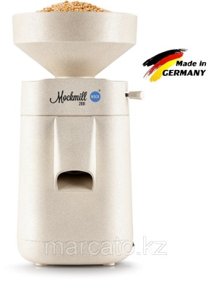
2 | Flour sifter PM/1 |  | Made entirely of stainless steel, the mesh size 1,2x1,2 mm, capacity 150 kg/h  removable hopper for flour, magnetic separation, high-performance oscillator  for better screening, cultivation and oxygen saturation, power 0.09 kW, overall size 458х626х875, gross size 550х716х1125 mm, 0.4 m/3 |  | 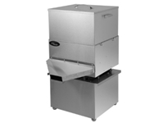
2 | Kneading machine VIATTO DH-20B |  | Sensors 427x675x853 mm  The volume of the bowl is 20 liters  Test tube-6 kg  Number of speeds - 1 speed  The mechanism of cup fasteners is a non-removable bowl  The mechanism of raising the head is an unaffordable traverse  Voltage-220 V  Power-1.1 kW  Weight-78 kg |  | 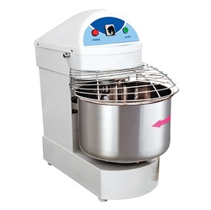
3 | Planetary mixer Sinmag SM-5L |  | Capacity - 150 kg/hour  Loading hopper capacity - 40 l  Quantity of simultaneously loaded flour - 5 kg  Voltage - 380 V  Power - 0.18 kW  The diameter of the sieve wire is 0.32 mm  The mesh size of the sieve is 1,2x1,2 mm  Size - 452x620x870mm  Weigh - 45.1 kg |  | 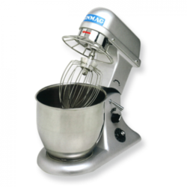
4 | Electric proofing cabinet  SHRE 106-01 |  | Size 1300x1025x840 mm  Weight - 127 kg  Number of heating elements - 2 pcs  The number of temperature controllers - 1 pc  Power consumption to maintain a temperature of 40 ° C - no more than 0.5 kW/h,  Temperature range - from 30 to 90 ° C  The heating time of the cabinet to the operating temperature of 60 ° C is no more than 30 minutes  The useful volume of the chamber is 0.54 m3  The volume of water poured into 1 bath - no more than 1 liter  Number of baths - 2 pcs  The number of installed bread molds No. 7 - 12x6 = 72 pcs  Number of grid shelves - 6 pcs |  | 
5 | Convection oven SINMAG SM 710 EE |  | Number of levels - 10  Connection - 380V  The distance between the levels is 90mm  Baking tray - 600x400 mm  The size of the baking sheet is 600x400 GARBIN, FOINOX  Management - electronic  Temperature range - 300C  Steam humidification - there is  Connection to water - yes  Power - 19 kW  Size - 1253x780x1140  Weigh - 235.9 kg |  | 
6 | Refrigerating chamber POLAIR Standard КХН-7,71 |  | Main Body Color  White Manufacturer Country Russia Manufacturer Polair Warranty period 12 months  Type of equipment  Cold storage  Material Steel  Custom Specifications Camera volume 7.71  Door block  Swing  Warranty period, 12 months  Dimensions (LxWxH), mm  1960x2260x2200  Panel thickness, mm 80 |  | 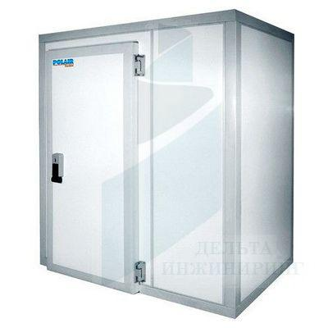
 | Additional and auxiliary materials
1 | Stainless steel stud trolley |  |  | Capacity: 12 baking trays 600x400 mm  Frame material: carbon steel, painted with polymer paint  Overall size : 600x450x1700 mm  Frame: welded  Optional:  rubberized swivel wheels with a diameter of 75 mm (two wheels with brake) | 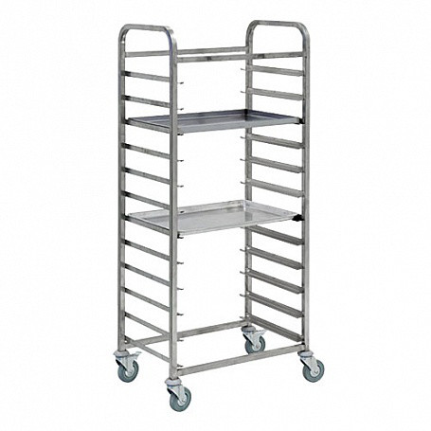
2 | Production table,SPP-10/6 (1000*600*8 50), ASSIM RUSSIA |  |  | Shelf material stainless steel (AISI 430. 0.7 mm)  Collapsible design  Table top material stainless steel (AISI 430. 0.7 mm)  Legs corner 40x40 (stainless steel AISI 430. 1.5 mm)  Reinforcement laminated chipboard (16 mm) | 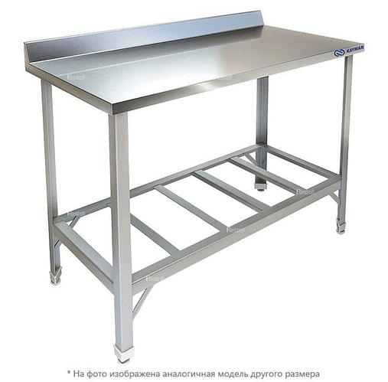
3 | Scales |  |  | Manufacturer VIKA  The warranty period is 1 month  Control type Electronic  Power type Battery, 220 V Mains  Maximum weight 35 kg  Type of scales Commodity | 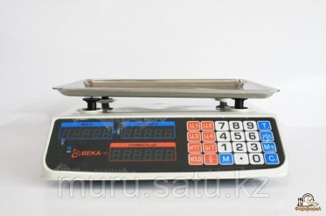
4 | Multi function oven |  |  |  | 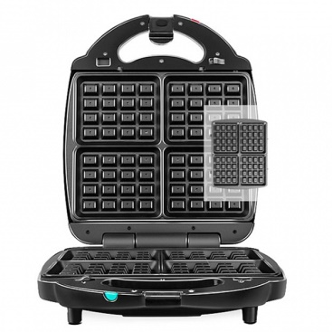
  Adjustment of the degree of  toasting – no  Power W - 700  Color Black, | 700
   | нет
   | черный

LIST OF SOURCES USED

1 Губская, Е. Ю. Целиакия клиника, диагностика, лечение / Е. Ю. Губская // Электронный ресурс. - Электрон, дан. - Режим доступа: http://www.celiac-ukrainexoin/stati-o-tseliakii/tselialdya-klmikalechenie. Загл. с экрана.
2 Ревнова, М. О. Великий мим или заболевание, обиженное в России / М. О. Ревнова // Электронный ресурс. Электрон, дан. - Режим доступа: http://www.celiac.spb.ru.- Загл. с экрана.
3 Ревнова, М. О. Аллергические заболевания и целиакия: механизмы соприкосновения и различия / М. О. Ревнова // Жизнь без глютена. 2006. - № 3. - С. 4-6.
4 Catassi, C. Antiendomysium versus Antigliadin Antibodies in Screening the General Population for Coeliac Disease / C. Catassi, G. Fanciulli, A. R. D'Appello et al./ / Am. J. Gastroenterol. 2000. - № 7. - C. 732 - 736.
5 Поздняковский, В. М. Гигиенические основы питания и экспертизы продовольственных товаров Новосибирск: Изд-во Новосиб. унта, 1996. -432 с.
6 Проект стандартов диагностики и лечения целиакии у детей / C.B. Бельмер и др.// [Электронный ресурс]. Электрон, дан. - Режим доступа: http://medinfa.ru/article/25/ 117406. - Загл. с экрана.
7 Carroccio, A. Exocrine pancreatic function in children with coeliac disease and after a gluten free diet / A. Carroccio et al. //Gut. 1991. - Vol.32. -№ .7. - C.796-799.

ANNEX K
Economic calculation of the cost of production of confectionery products based on gluten-free raw materials

The calculation of the selling price of gluten-free flour confectionery products (Recipe 1 - cupcakes "Ai-Jean" and recipe 2 - semi-finished custard "Aizere") was made on the basis of methodological materials "Cost of production and sale of products".
The calculation of the cost of raw materials and basic materials (Ss.o) was determined based on the following formula:
s.o = Api * Bj* c,
Where Nri is the consumption rate of the i-th raw material for 1t of the j-th product, t;
Bj – output per unit of time, t;
C – the price of raw materials and basic materials for the production of 1 ton of products, tenge.
The calculation of the cost of raw materials and basic materials is presented in Table 1.

Table 1- Calculation of the cost of raw materials and basic materials of new gluten-free flour confectionery products
Name of raw materials and materials | Price for 1 kg, tenge | Consumption per 100 kg of flour | Cost, tenge
Recipe 1 - I-Jean Gluten Free Cupcakes
Chickpea flour | 1200 | 32 | 38400
Rice flour | 1000 | 6 | 6000
Amaranth flour | 3000 | 2 | 6000
Melange | 750 | 15,3 | 11475
Vegetable oil | 680 | 12 | 8160
Granulated sugar | 280 | 32 | 8960
Salt | 52 | 0,3 | 15,6
Baking powder | 84,88 | 0,4 | 33,952
Total: |  | 100 | 79044,5
Recipe 2 - Gluten-free custard semi-finished products "Aizere"
Chickpea flour | 1200 | 9 | 10800
Corn flour | 450 | 11 | 4950
Melange | 750 | 34 | 25500
Butter | 1500 | 10,9 | 16350
Milk | 200 | 19 | 3800
Salt | 52 | 0,1 | 5,2
Water | - | 16 | -
Total: |  | 100 | 61405,2

2) The calculation of the cost of auxiliary materials was determined by the formula:
Cb = Hp * B * C,
where Hp is the consumption rate of auxiliary materials per 1 ton of products, t;
V - output per unit of time, t;
C – the price of auxiliary materials for the production of 1 ton of products, tenge.
The calculation of the cost of auxiliary materials is presented in Table 2.
Table 2- Calculation of the cost of auxiliary materials, tenge
name of raw materials | Unit price | Consumption per 1 t | Price
Sulfuric acid, kg | 16,8 | 43,0 | 722,4
Isoamyl alcohol, g | 0,6 | 2,14 | 1,3
Sodium caustic, g | 17,2 | 0,144 | 2,5
Phenolphthalein, ml | 0,24 | 0,40 | 0,096
Machine oil, ml | 68 | 0,15 | 10,2
Soda ash, kg | 280,0 | 22,00 | 6160
Caustic soda, kg | 520,0 | 16,00 | 8320,0
Laundry soap, kg | 700,0 | 0,40 | 280,0
Chloric lime, kg | 120,0 | 0,16 | 19,2
Packing materials, pcs | 64,0 | 0,05 | 3,2
Total: |  | 15674,9 | 3893,71

3) The calculation of the cost of energy consumption was determined by the formula:
Sen = Hp * V * C,
where Hp is the rate of energy consumption per 1 ton of products, t;
V - output per unit of time, t;
C – the price of energy consumption for the production of 1 ton of products, tenge.

Table 3 - Calculation of the working time of the enterprise
Types of planned stops of the enterprise | Stop period
Calendar actual time, days | 365
Technological stops, days | 2
Decade stops for current repairs, days | 20
Revision of working installations, days | 4
Gassing | 4
Total stops | 60
Total: | 305
Calendar time utilization rate | 83,5

Thus, the annual production capacity, taking into account working hours (305 days), will be (Table 4)
Table 4 - Annual production capacity
№ | Category of the confectionery shop | Productivity, kg / day | Annual production capacity, kg / year
1 | Low productivity (М_{с1}) | 200,0 | 61000 ≈ 61 т

The annual output of confectionery products, taking into account the yield rate (at Hb = 99%), is determined by the formula:
, kg / year, (3)

where Mg is the annual production capacity, kg/year; Nv is the yield rates of finished products, (99%). The
obtained values of the annual output of confectionery products for three categories of productivity are presented in Table M5:
Thus, the costs for the purchase of flour raw materials and basic materials for the organization of the production of confectionery products based on gluten-free raw materials are determined.
When justifying the cost in cost calculations, the calculation sheet includes both economically homogeneous elements (raw materials and materials, electric energy costs, wages of production workers) and complex items that collectively take into account the wages of other categories of workers, materials, depreciation (general production, general economic, commercial). In this regard, we will calculate the cost of the main items of expenditure.
Technological costs of electric energy. Let's determine the energy costs of technological equipment. In accordance with the developed technological scheme for the production of confectionery products from gluten-free raw materials, the main technological equipment consuming electrical energy is the equipment presented in Table M9
Table 5 - Calculation of the cost of energy and water
Name | Consumption rate per hour | Consumption rates per year | Price, tenge | Cost, thousand tenge
Electricity, kW / h | 20 | 48 800 | 0,01687 | 823,25
Water, м³ | 0,2 | 488 | 34,89 | 170,26
Total: |  |  |  | 993,51

The calculation of wages was determined by the formula 1:

Sz.p = P* V* K1*K2, (1)

Where: P – price for 1 ton of products, tenge;
B – the volume of production per unit of time, t;
K1 is a coefficient that takes into account the amount of surcharges;
K2 is a coefficient that takes into account the amount of additional salary.

Table 6- Calculation of the wage fund of workers of the main production
Articles | Amount, tenge
Release plan, kg | 66,6
Enlarged price, tenge / kg | 550
Piecework fund for wages, tenge | 71500
Surcharges, tenge | 27159,8
Basic salary, tenge | 9373,7
Additional salary, tenge | 2812,1
Total salary, tenge | 12185,8

Table 7- Planned calculation of the cost of marketable products, tenge
Costing articles | Production of gluten-free flour confectionery
Raw materials minus waste,  - Recipe No. 1- muffins  - Recipe No. 2 - custard semi-finished product | 79044,5  61405,2
Supporting materials | 15674,9
Power consumption, kW | 823,25
Water | 170,26
Basic salary of workers | 9373,7
Additional salary 30% | 2812,1
Deductions from salary 11.0% (including social tax + OPF - 9.5%, OSM -2%) | 1340,4
Depreciation of OPF | 580,16
TOTAL  - Recipe No. 1- muffins  - Recipe No. 2 - custard semi-finished product | 109819,3  92179,97
Price for 1 ton of products  - Recipe No. 1- muffins  - Recipe No. 2 - custard semi-finished product | 109800, 0  91500, 0
Cost of marketable products, thousand tenge / kg  - Recipe No. 1- muffins  - Recipe No. 2 - custard semi-finished product | 1,8  1,5
Price for 1 ton including VAT  - Recipe No. 1- muffins  - Recipe No. 2 - custard semi-finished product | 122997,62  10324,57

Table 8 - Summary table of economic calculations of the cost of gluten-free flour confectionery
Indicators for 1 ton of products, tenge | Production of gluten-free flour confectionery
Production cost  - Recipe No. 1- muffins  - Recipe No. 2 - custard semi-finished product | 79044,5  61405,2
Profit | 95033,75
Price for 1 ton including VAT  - Recipe No. 1- muffins  - Recipe No. 2 - custard semi-finished product | 122997,62  10324,57
Price for 1 kg, tenge  - Recipe No. 1- muffins  - Recipe No. 2 - custard semi-finished product | 1800  1500
Price 1 kg. including VAT, tenge  - Recipe No. 1- muffins  - Recipe No. 2 - custard semi-finished product | 2016  1680

ANNEX L

Table 1- Recipes and technological modes of dough preparation
The name of raw materials and semi-finished products | Mass fraction of dry substances,% | Raw material consumption per 1000 gr. finished products
The name of raw materials and semi-finished products | Mass fraction of dry substances,% | specific performance | dry matter
Flour mixture:
Chickpea flour | 89 | 320 | 284
Rice flour | 86 | 60 | 51,6
Amaranth flour | 89,4 | 20 | 17,8
Mélange | 27 | 153,28 | 41,39
Vegetable oil | 84 | 120 | 100,8
Granulated sugar | 99,85 | 320 | 319,52
Salt | 0,1 |  | 0,1
Baking powder | - | 6,72 | -
Total |  | 1000 | 815,21
Loss of dry matter, kg | 21,63
Output |  | 810 | 793,58
Dough moisture, % | 23-25
Dough temperature, 0С | 26-28
Whipping duration, min | 7-10
Baking temperature, 0С | 180-200
Duration of baking, min | 25-30

Cutting and baking.
The dough is placed in forms and sent to baking. The baking of the products is carried out in a confectionery oven with the following parameters: the temperature of the baking chamber: 180-200 ° C, the duration of baking cakes weighing 150 g: 25-30 minutes.
Cooling and finishing.
After baking, the muffins are cooled in a workshop conditions for 1 hour, the surface is sprinkled with powdered sugar.
Product quality indicators are shown in Table 2.
The name of indicators | Characteristics and value of indicators of muffins
Surface and shape | Corresponds to the given product name; lumpy surface with peculiar roughness
Taste and smell | The sweetish taste, characteristic of a biscuit semi-finished product, is observed; no foreign smell or taste; with a slight bean aftertaste.
Color | yellowish color with grayish tint
APPENDIX M
The act of production tests of the method of preparation of gluten-free custard semi-finished product
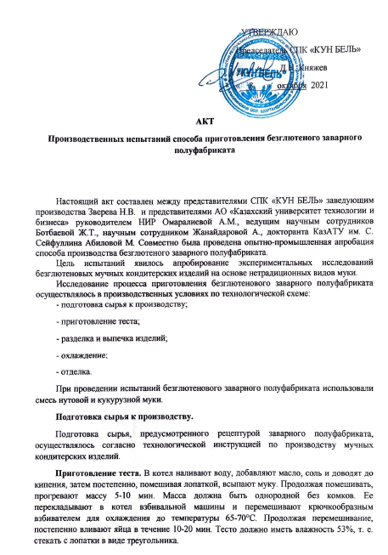
The recipe and technological modes for preparing the dough for the custard semi-finished product are shown in Table 1.
Name of raw materials and semi-finished products | Mass fraction of dry substances,% | Raw material consumption per 1000 gr. finished products
Name of raw materials and semi-finished products | Mass fraction of dry substances,% | specific performance | dry matter
Flour mixture (chickpea corn flour)
Chickpea flour | 89,0 | 90 |  | 80,1
Corn flour | 85,5 | 110 |  | 94,05
Mélange | 27 | 340 |  | 91,8
Water | - | 160 |  | -
Milk | 91,2 | 190 |  | 173,28
Butter | 45,5 | 109,9 |  | 50,0
Table salt | 0,1 | 0,1 |  | 0,1
Total |  | 1000 |  | 649,33
Loss of dry matter, kg |  |  |  | 20,83
Output |  | 800,8 |  | 628,5
Dough moisture, % | 53-55
Dough temperature, 0С | 65-70
Duration of brewing, min | 7-10
Baking temperature 0С | 180-200
Duration of baking, min | 25-30
Moisture content of the finished product | 22%±2%

Cutting and baking.
Using a pastry bag with an attached smooth nozzle, the finished custard dough is placed on a baking sheet, slightly greased with oil. The dough should be placed in the form of 1 cm small balls at a distance of 2-2.5 cm from each other; then it is baked at temperature of 180-200 °C. Bake at 180 ° C for 15 minutes, and then lower the temperature to 160 ° C and bake for another 15 minutes.
Cooling and finishing.
After baking, the pastry is cooled in a workshop conditions for 1 hour, then the surface is filled with cream.

APPENDIX N
The act of implementing the developed technology for the production of gluten-free flour confectionery products

APPENDIX P
Act on the introduction of research materials into the educational process
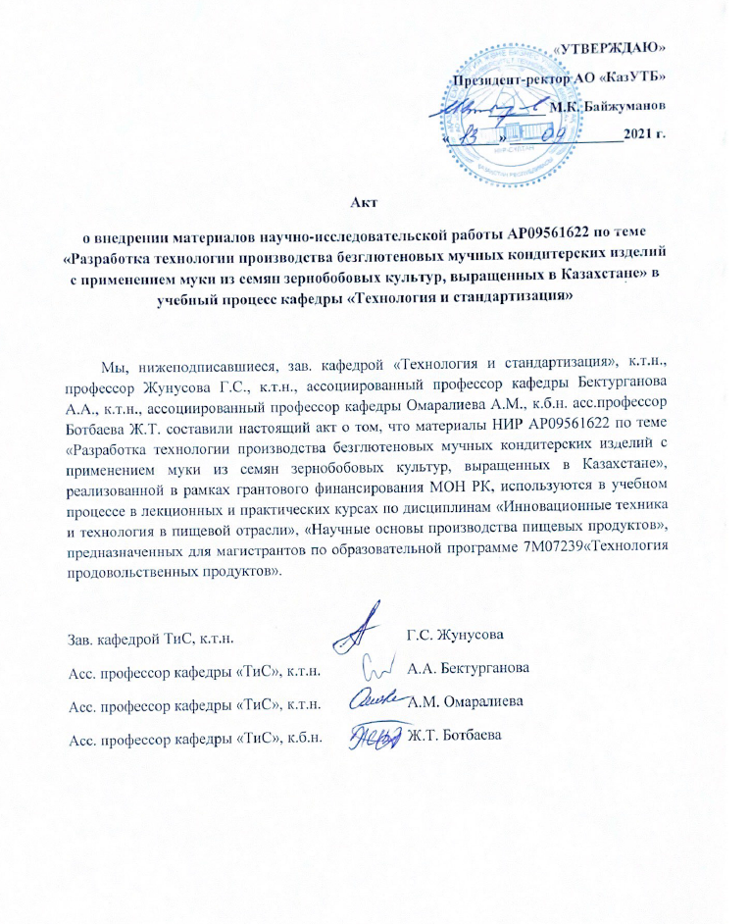

annex R
Protocol of research of samples of flour confectionery products

annex S
Patent application
№  № | Патентуемая разработка | Авторы | Вид охранного документа | Дата и № заявки
 | Способ приготовления диетического заварного полуфабриката | Омаралиева А.М., Абилова М.Б., Ботбаева Ж.Т., Байшугулова Ш.К. | Заявление о выдаче патента РК на полезную модель | 01.10.2021  № 2021/0930.2
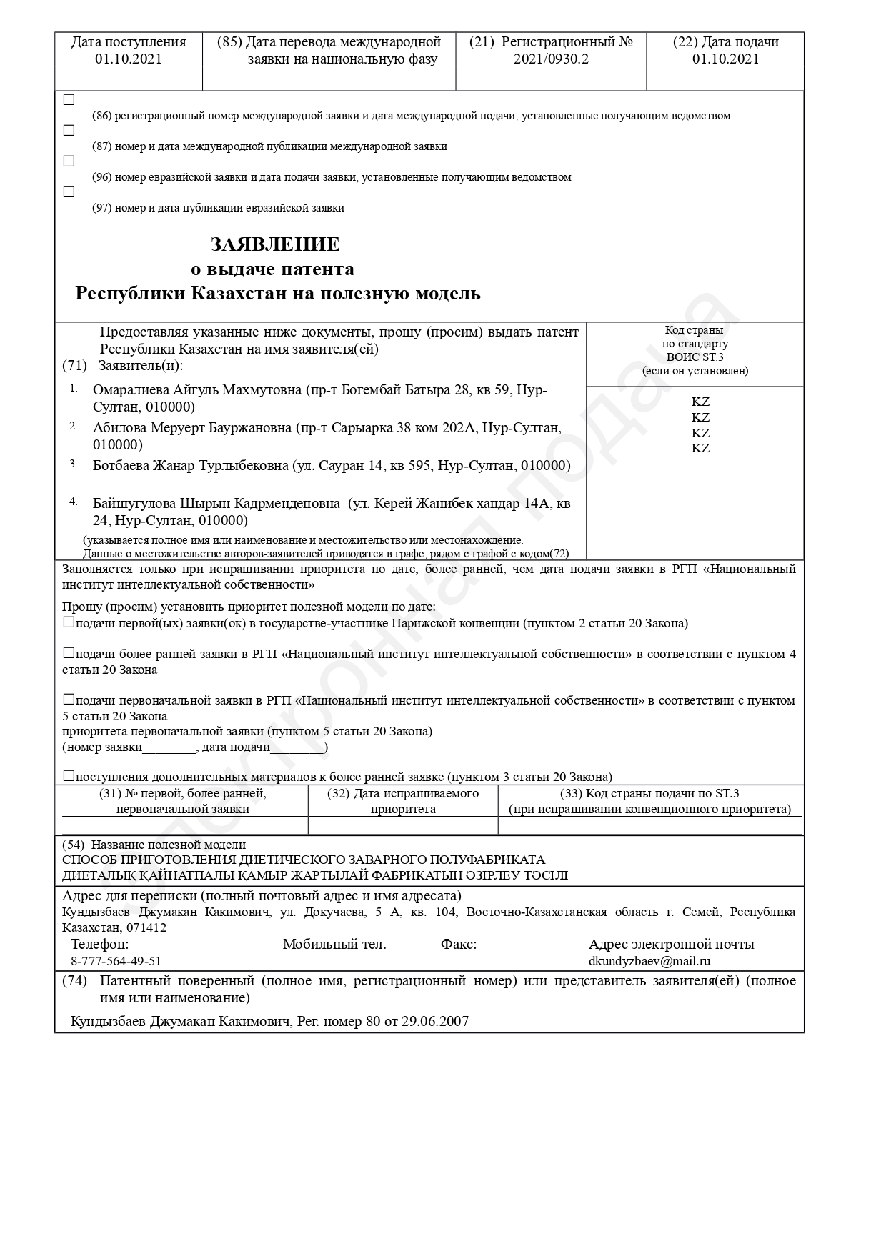
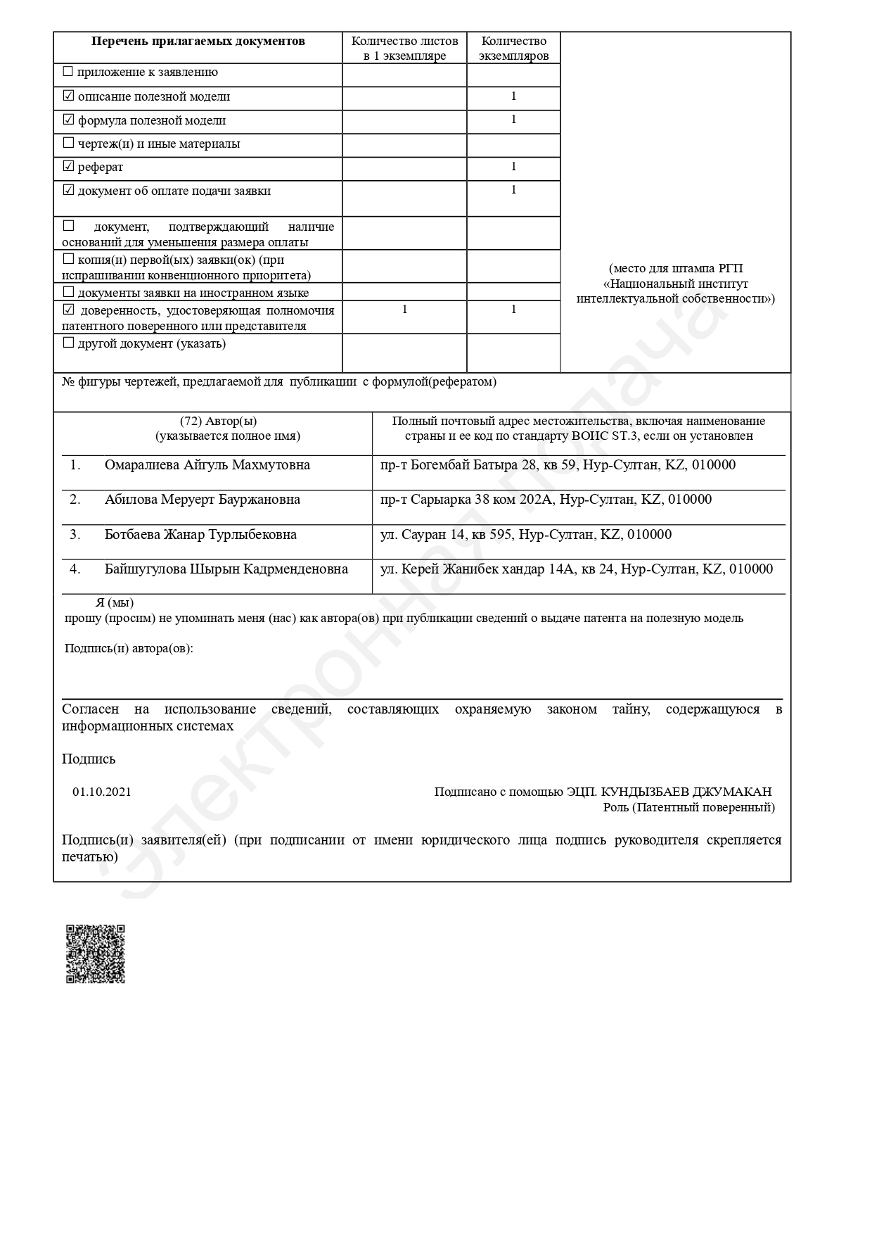

APPENDIX T
PUBLICATION LIST
Submitted for publication of scientific papers

Публикации
Зарубежные публикации  Scopus (процентиль 55) | Отечественные публикации  Импакт фактор  0,127 | Конференции
1 | 1 | 1
ВСЕГО статей за 2021 год |  |  | 3

№ п/п | Наименование публикации | Место и дата публикации | Кол-во стр. | Вид | Авторы
1 | Разработка рецептур смесей из безглютенового сырья зернобобовых культур для приготовления кондитерских изделий | Вестник ЕНУ, Серия «Биологическая» №4, декабрь, 2021 год | 8 | Статья | Омаралиева А. М.,  Ботбаева Ж.Т.,  Жанайдарова А.Е.,  Абилова М. Б.
2 | Defining the optimal parameters of high-frequency processing of chickpeas for the production of gluten-free flour | Eastern-European Journal of Enterprise Technologies 4 stage_No. 5 (113). 2021 г | 25 | Research Article | Aigul Omaraliyeva, Zhanar Botbayeva, Mereke Agedilova, Meruyert Abilova, Aidana Zhanaidarova Б..,
3 | Глютенсіз кондитерлік өнімдерді өндіру үшін бұршақ тұқымдас дақыл ноқаттың селекциялық «Мирас 07» сұрыпын зерттеу | Международное научно-практичсекая кконференция «Инновационное развитие пищевой, легкой промышленности и индустрии гостеприимства», Алматы - 21-22 октября 2021, | 3 | Тезис | Омаралиева А. М.,  Ботбаева Ж.Т.,  Жанайдарова А.Е.,  Абилова М. Б.

Зав кафедрорй «ТиС» Жунусова Г.Е.

APPENDIX Q
Supporting documents of the research group