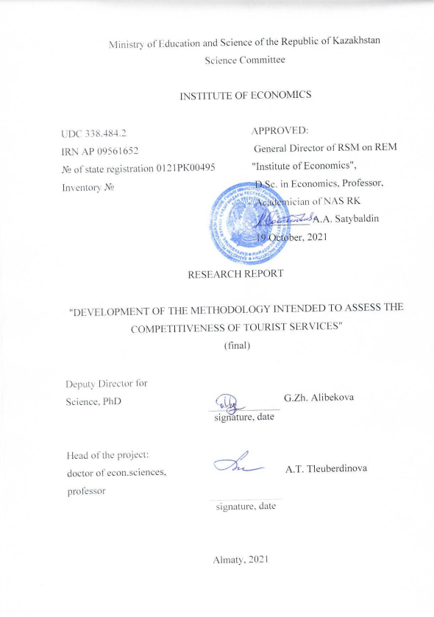

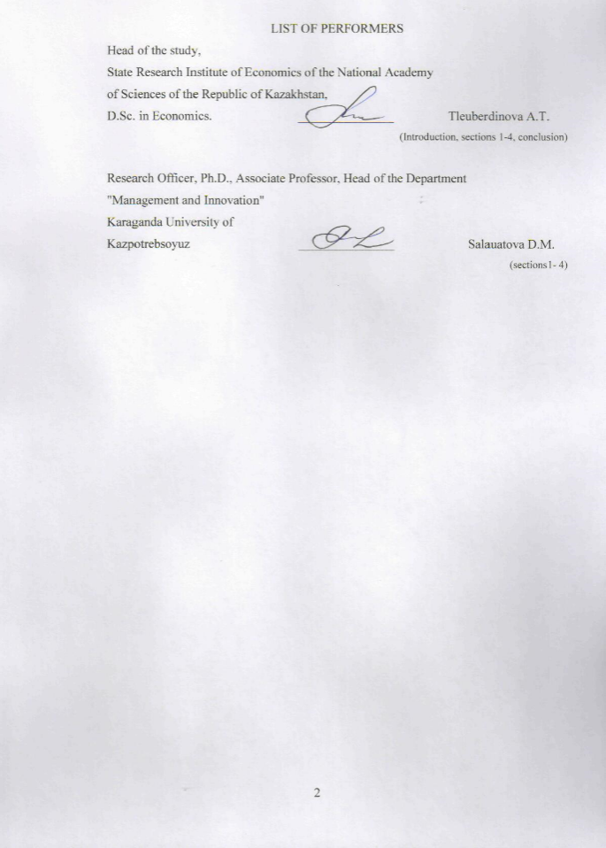

REPORT

Report 74 p., 1 book, 4 figures, 17 tables, 60 sources, 8 annexes.

COMPETITIVENESS, TOURIST SERVICES, METHODOLOGY, EXPERT EVALUATION, APPROBATION

The object of the study is the tourist services of Kazakhstan.

The goal of the project is to determine a methodological approach intended to assess the competitiveness of tourist services in Kazakhstan, corresponding to modern conditions, with the identification of the strengths and weaknesses of the domestic tourism product to determine the reserves for increasing consumer satisfaction.

General scientific methods of scientific abstraction, analysis and synthesis, systematic approach, as well as private methods - graphical, statistical, comparative and factor analysis, method of questioning, expert survey were used during the study.

The analysis of existing modern methods and techniques intended to assess the level of competitiveness of tourist services was performed during the study; the influence of components of tourist products on the level of competitiveness was determined by identifying their importance based on the opinions of experts and consumers of tourist services; methodological basis for quantitative assessment of the competitiveness of tourist services was developed; validation of the methodology to assess the competitiveness of tourist services was conducted; satisfaction with tourists was determined.

The novelty of the project lies in the fact that the method of assessing the level of competitiveness of tourist services, applicable at the regional and country level to identify areas of development of domestic tourism products has been developed and tested for the first time.

New theoretical and methodological knowledge of the formation of competitiveness of tourist services has been obtained in the study, the method of its evaluation has been developed and tested. The results of the project can contribute to the implementation of the Strategy "Kazakhstan-2050", the Strategic Plan 2025, the State Program for the Development of the Tourism Industry of the Republic of Kazakhstan for 2019-2025.

REPORT

Есеп 74 б., 1 кітап, 4 сурет, 17 кесте, 60 дереккөз, 8 қосымша.

БӘСЕКЕГЕ ҚАБІЛЕТТІЛІК, ТУРИСТІК ҚЫЗМЕТТЕР, ӘДІСТЕМЕ ЭКСПЕРТТІК БАҒАЛАУ, АПРОБАЦИЯ

Зерттеу объектісі Қазақстанның туристік қызметі болып табылады.

Жобаның мақсаты ‑ тұтынушылардың қанағаттануын арттыру резервтерін анықтау үшін отандық туристік өнімнің күшті және әлсіз жақтарын анықтай отырып, қазіргі заманғы жағдайларға сәйкес келетін Қазақстандағы туристік қызметтердің бәсекеге қабілеттілігін бағалаудың әдістемелік тәсілін анықтау.

Зерттеу барысында ғылыми абстракциялаудың, талдау мен синтездің жалпы ғылыми әдістері, жүйелік тәсіл қолданылды, сонымен қатар жеке әдістер - графикалық, статистикалық, салыстырмалы және факторлық талдау, сұрақ қою әдісі, сараптамалық сауалнама қолданылды.

ҒЗЖ орындау барысында туристік қызметтердің бәсекеге қабілеттілік деңгейін бағалаудың қазіргі заманғы тәсілдері мен әдістерін талданды;туристік қызмет компоненттерінің сарапшылар мен тұтынушылардың пікірлері негізінде олардың маңыздылығын анықтай отырып, олардың бәсекеге қабілеттілік деңгейіне әсері белгіленді;туристік қызметтердің бәсекеге қабілеттілік деңгейін сандық бағалаудың әдістемелік негіздері жасалды;туристік қызметтердің бәсекеге қабілеттілік деңгейін бағалаудың әзірленген әдістемесі сыналды;тұтынушылардың қазақстандық туристік қызметтер деңгейіне қанағаттану деңгейі анықталды.

Жобаның жаңалығы - бұл бірінші рет туристік қызметтің бәсекеге қабілеттілік деңгейін бағалау әдістемесі әзірленді және сыналды, бұл ішкі туризм өнімдерін дамыту бағыттарын анықтау үшін аймақтық және республикалық деңгейде қолданылады.

Зерттеу барысында туристік қызметтің бәсекеге қабілеттілігін қалыптастыру бойынша жаңа теориялық және әдістемелік білім алынды, оны бағалау әдісі әзірленді және сыналды.

Жоба нәтижелері «Қазақстан-2050» стратегиясын, 2025 ж.стратегиялық жоспарын, 2019-2025 жылдарға арналған Қазақстан Республикасының туризм индустриясын дамытудың мемлекеттік бағдарламасын іске асыруға ықпал етуі мүмкін.

CONTENT

|  |  |  |
| --- | --- | --- |
|  | TERMS AND ABBREVIATIONS…..……………………..………………………….. | 6 |
|  | INTRODUCTION ……………………………………………………………………… | 7 |
| 1 | Theoretical review of existing methods and techniques intended to assess the level of competitiveness of tourist services ……………………………………………………… | 10 |
| 2 | Methodological basis intended to assess the competitiveness of tourist services, taking into account the views of experts and consumers of tourist services …………………… | 20 |
| 2.1 | Expert evaluation of the significance of the components of the competitiveness of tourist services …………………………………………………………………….......... | 20 |
| 2.2 | Author's methodology intended to assess the competitiveness of tourist services ……... | 22 |
| 2.2.1 | Method intended to assess the competitiveness of tourist services of a destination ……. | 24 |
| 2.2.2 | Method intended to assess the competitiveness of the tourism industry ……………….. | 26 |
| 3 | Kazakhstan's position in the world ranking of tourism competitiveness ………………. | 30 |
| 4 | The results of approbation of the author's methodology intended to assess the level of competitiveness of tourist services. Assessment of strengths and weaknesses of the Kazakhstani tourism product ………………………………………………………….. | 36 |
| 4.1 | Testing of the method intended to assess the competitiveness of tourist services at the macro level ……………………………………………………………………………… | 36 |
| 4.2 | Testing of the method intended to assess the competitiveness of tourist services at the micro level ……..……………………………………………………………………….. | 41 |
|  | CONCLUSION ………………………………………………………………………… | 45 |
|  | LIST OF REFERENCES ………………………………………………………………. | 47 |
|  | ANNEX A - Publications on the Subject of the Study …………………………………. ANNEX B- Supporting documents for publications ……………………………………  ANNEX C -Act of implementation of the results of the study in the educational process of Karaganda University of Kazpotrebsoyuz…………………………………………….  ANNEX D - Act of implementation of the results of the study in the activities of the Department of Entrepreneurship of Karaganda region ………………………………….  ANNEX E - Key elements determining competitiveness in tourism  ANNEX F - List of main and additional development parameters under the OECD methodology  ANNEX G - Overview of comparative studies of the competitiveness of destination countries  ANNEX H - The results of the expert survey | 52  54  63  64  65  67  68  70 |

**TERMS AND ABBREVIATIONS**

UNWTO -United Nations World Tourism Organization

COVID-19 – coronavirus infection 2019

STEP –Sustainable Tourism in order to Exterminate Purity

TTCI-Travel and Tourism Competitiveness Index

EFQM - European Foundation for Quality Management

EFILWC -European Foundation for the Improvement of Living and Working Conditions

HOTROC -Hospitality, Hotels and Restaurant Organizing Council

WTTC-World Travel and Tourism Council

GDP - gross domestic product

GRP - gross regional product

SMEs - Small and Medium Enterprises

**INTRODUCTION**

The role of tourism, as one of the key sectors of the economy of most countries, providing significant income, jobs, promoting the image and international perception of the country in the outside world determine the importance of assessing the competitiveness of its services. Proper assessment of competitiveness in the field of tourism is an important aspect for effective decision-making. The difficulty of determining a way to measure the competitiveness of tourist destinations and justifying its reliability is due to the high sensitivity of the structure of the tourism industry to political, economic, social and environmental changes, including risks of natural disasters that is confirmed by the current situation with the pandemic COVID-19.

Global economic and tourism trends, including changing market trends and travel behavior, the role of social media, and the search for new catalysts for demand and growth affect a high degree of variability in competitiveness. These dynamics create an additional need for ongoing research and development of analyzed parameters.

The problem of competitiveness of tourist destinations is the most important for countries and regions that are heavily dependent on tourism [1]. A destination can be considered competitive if it can attract and meet the expectations of potential tourists. The competitiveness of destinations affects not only directly the income from tourism as a result of the increase in the number of visitors and their expenses, it also indirectly affects the entire business associated with tourism: accommodation, food, transport, trade, services. The high degree of competition in the global tourism market determines the need to assess the competitiveness of the services offered by the destination in order to identify their strengths and weaknesses in order to develop strategies for further development.

Competitiveness is an important economic category, considered in different spheres of the economy and different levels of government. Assessment of the level of competitiveness of tourist services has its own fundamental differences associated with the specific features of the service sector.

The need to create a competitive tourism product in the domestic and foreign markets is noted in the State Program for the Development of the Tourism Industry of the Republic of Kazakhstan for 2019-2025 and is considered as one of the factors ensuring comprehensive regional development, since, despite the resource endowment of Kazakhstan, unfortunately, it is still does not realize the existing tourist potential in full [2]. The only way to solve this problem is to increase the level of competitiveness of domestic tourist services.

As a result, the competitiveness of tourist services is a synergistic combination of different components, determined by the ratio of price and quality, including cost parameters, as well as parameters that determine the technical, functional and ethical quality of certain services.

Therefore, the competitiveness of tourism services is a complex concept, because its quantitative assessment involves the formation of a set of different groups of parameters that determine their importance in a comprehensive assessment. Competitiveness is still a dynamic parameter, considered in relation to a specific point in time, taking into account the degree of satisfaction with a product in a given market, despite the fact that tourism specialists offer various assessment methods. Therefore, it is important to choose the right methodology that allows for a qualitative analysis of the main components of Kazakhstani tourism in order to further form an effective strategically oriented policy in this area.

The goal of the project is to determine a methodological approach to assess the competitiveness of tourist services in Kazakhstan, consistent with current conditions, identifying the strengths and weaknesses of domestic tourism products to determine the reserves of improving customer satisfaction.

The following tasks were set and achieved in order to achieve the goal:

- to analyze existing methods and techniques intended to assess the level of competitiveness of tourist services;

- to develop a methodological framework intended to assess the competitiveness of tourist services, taking into account the views of experts and consumers of tourist services;

- to test the author's methodology intended to assess the competitiveness of tourist services.

Tourist services in the Republic of Kazakhstan were the object of the study.

The subject of the study is a method of assessing the competitiveness of tourist services.

The study is based on scientific papers that reflect the results of basic and applied research in the study of competitiveness in tourism.

General scientific methods of scientific abstraction, analysis and synthesis, the systematic approach were used to achieve the goal of the study, the use of which allowed a complex and systematically summarize the totality of scientific approaches to the formation of methods intended to assess the level of competitiveness of tourist destinations.

A review of existing methods and techniques intended to assess the competitiveness of a tourist product is performed, an analysis of foreign practices for conducting similar studies is done in order to identify the possibilities of applying individual elements to the Kazakhstani tourism industry. The methodological basis for quantitative assessment of the level of competitiveness of tourist services was developed based on the results of expert interviews and determining the degree of influence of the components of tourist products on the level of competitiveness with a clarification of their significance.

Scientific novelty of the study lies in the fact that the method of assessing the level of competitiveness of the tourism industry regions and popular among Kazakhstanis tourist destination - Lake Balkhash that revealed the degree of customer satisfaction with the level of Kazakhstan's tourist services was first developed and tested.

The conclusions of the study may be of interest to regional and local authorities, public authorities in the field of tourism in Kazakhstan, the preparation of policy documents for the development of the tourism industry; as well as for scientists, doctoral and master's students involved in research on this topic.

The main provisions of the study have been tested in the open press and reported at the International Scientific and Practical Conference. Six scientific articles were published based on the results of the project, including 2 in scientific journals included in the Scopus database, 2 in journals recommended by the COCSON (Committee for Control in the Sphere of Education and Science of the Ministry of Education and Science of the Republic of Kazakhstan), 2 in the proceedings of international scientific conferences (Annex A, B).

The results of the dissertation were studied and introduced into the educational process of the Karaganda University of Kazpotrebsoyuz as an actual material for increasing the practical significance of the lecture material on the master's disciplines "Assessment of the competitiveness of Kazakhstani enterprises and industries", "Strategic planning", "Modern management problems in the economy of Kazakhstan" (Annex C); into the activities of the State Institution "Department of Entrepreneurship of the Karaganda region" for the practical use of the results in order to assess the level of competitiveness of tourist destinations to determine the state of development of the tourism sector of the Karaganda region and the development of programs for regional tourism development (Annex D).

**1 Theoretical review of existing methods and techniques intended to assess the level of competitiveness of tourist services**

The studies devoted to the topic of competitiveness of tourist services, according to foreign experts, are still insufficient, despite the tightening of competition in the 21st century [3, 4]. The existing methods of assessing the competitiveness of tourism services developed by various scientists and experts over the years have significant differences not only in the methods used, but also the analyzed parameters.

The most widely known method of assessing competitiveness in travel and tourism is the method proposed in 2008 by the World Economic Forum for calculating the Travel and Tourism Competitiveness Index (TTCI) [5]. The purpose of this methodology is to assess the factors and policies of countries that contribute to the attractiveness of tourism in the country. The TTCI is based on three main categories of variables that contribute to competitiveness. These categories are listed in three sub-indices: regulatory framework; business environment and infrastructure; human, cultural and natural resources (Table 1).

Table 1 - Structure of the tourism competitiveness index according to the UNWTO "Travel & Tourism Competitiveness Index" methodology

|  |  |  |
| --- | --- | --- |
| Travel & Tourism Competitiveness Index | | |
| 1 | 2 | 3 |
| Sub-index A:  regulatory framework | Sub-index B:  business environment and infrastructure | Sub-index C:  human, cultural and natural resources |
| The policy of rules and regulations | Air transport infrastructure | Human resources |
| Ensuring environmental sustainability | Land transport infrastructure | Attitude to foreign tourists |
| Safety and Security | Tourist infrastructure | Cultural resources |
| Health and hygiene | Information and communication technology | Natural resources |
| Priority of the tourism industry | Price competitiveness of the tourism industry |  |
| Note - Compiled based on the source [5] | | |

The list of analyzed parameters was not formed from scratch; it is based on research by Gooroochurn, N. and Sugiyarto, G. (2005) that proposed eight main parameters for monitoring the competitiveness of tourism at the initiative of the World Travel and Tourism Council (WTTC) [1].

# Besides the parameters used are determined by the assessment of the availability of factors [6], the concept of environmental quality [7, 8]. Environmental policy, according to experts, is vital for the development of the tourism sector. Besides special attention should be paid to the price competitiveness of the destination, since tourists are mostly price-sensitive. [9]. It has been observed that price has a significant inverse relationship to competitiveness: developed countries tend to be more competitive in terms of other parameters and less competitive in terms of price [1]. Experts identified, among other things, the importance of considering factors such as openness to international trade, technology, infrastructure, social improvement, the environment, and human resources.

The conclusions of experts, as a result, were reflected in the criteria that determine the level of TTCI. Sub-index A includes those elements that are generally the responsibility of the government; sub-index B includes elements of the business environment and "hard" parameters of each country's infrastructure; sub-index C covers softer parameters of human, cultural, and natural resources. Each of these three sub-indices consists in turn of a number of competitiveness criteria.

A number of studies of competitiveness in the tourism industry focus on the firm as a unit of industry analysis [10]. However, this approach has its limitations when applied to the context of tourism destination competitiveness. Thus, the tourism business is not one, according to Bordas, E. (1994), and includes a three-dimensional concept: market, product and technology, satisfying the desires and needs of people during the period of rest. He conceptualized destination competitiveness beyond the firm level, based on the notion that only the totality of tourist attractions, infrastructure, equipment, services together determine the offer of a destination [11].

The Dwyer & Kim (2003) model identifies the key determinants of competitiveness by incorporating them into a systematic perspective that provides them with an integrative and interactive relationship (Figure1).

This model emphasizes resources, destination management, international context, and demand. The ultimate goal relates to social and economic prosperity as measured by parameters of the quality of life of both tourists and residents.

The assessment of the level of competitiveness of destinations, according to the authors, is the result of a comparative analysis of performance levels of the tourism industry and qualitative factors associated with the attractiveness of the destination. These are the areas that should be controlled when the goal is to ensure the sustainability of a destination and its ability to add value along with competition.

Cyclic conditions

Created resources

Competitiveness of destination

Indicators of competitiveness

Destination management

Public sector

Private Sector

Number of indicators

Destination development

Demand

|  |
| --- |
| Local resources |
| Nature |
| Culture |

Supported resources

Figure 1 - Dwyer & Kim (2003) model

Note -Compiled based on the source [12]

Nevertheless, Dwyer, L. et al. organize the model of destination competitiveness according to the reasons of demand, so they distinguish factors related to the social and demographic conditions of tourists, with qualitative factors derived, among others, from the assessment of the image of the destination and the perception of quality of services and with the importance that tourists attach to the price-quality ratio of destinations.

The methodology of Dwyer, L. (2000), based on the calculation of the price competitiveness index, showed that the competitiveness of a destination may differ not only depending on the international tourism sector, but also depending on the period, as a result of changes in the exchange rate, consumer price index or cost of tourist basket in relation to other goods and services within the country [9].

The views of these authors have also evolved, gaining recognition in subsequent publications (Dwyer, Cvelbar, Edwards, & Mihalic, 2012; Dwyer, Forsyth, & Spurr, 2003; Dwyer, Mellor, Livaic, Edwards, & Kim, 2004; Dwyer et al., 2014), having determined that the competitiveness of the destination is the result of a complex political and social process, a trigger of institutional changes and organizational conditions [13, 14, 15, 16]. Dwyer, Cvelbar, Mihalic and Koman (2014) emphasize that the competitiveness of a destination depends on the resources available in the region and the ability to use and manage them to make it attractive [13]. Nevertheless, these authors support the existence of a certain consensus on this issue in the literature when it comes to the ability of destinations to offer a set of products and services that provide an original and quality tourist experience.

Dwyer, L.et al. included different views on the determinants of destination competitiveness in three main areas, in which: "a comparative advantage and/or price competitiveness perspective, a strategic management perspective, and a social and cultural perspective." [12]. Comparative advantage or, in other words, price competitiveness is undoubtedly a strong factor determining the position of a destination in terms of its ability to attract tourists. However, there are factors worth analyzing, such as human resource skills, financial conditions and investment opportunities, company organization and development, resource planning and customer-oriented services, and the social and cultural variables of each territory.

The European Foundation for Quality Management Model (EFQM) is used to assess the competitiveness of European destinations. This model assumes that such factors as the satisfaction of people (customers, employees) and its impact on society is implemented through management policies and strategies to manage people, resources, processes, leading ultimately to high business results. In particular, leadership, planning, human resource development, customer satisfaction and performance measurement have been identified as important conditions for improving service quality [17].

The most important part of choosing a method of competitiveness assessment is to determine the set of applicable parameters. This initially requires the formation of a set of meaningful and reliable parameters to assess and measure the competitiveness of tourist services in their region/country in order to choose a policy direction for their further development.

For example, OECD countries use parameters grouped around the following four categories to analyze the competitiveness of the tourism industry:

- parameters measuring the performance and impact of tourism;

- parameters tracking the ability of a destination to provide quality and competitive travel services;

- parameters tracking the attractiveness of a destination;

- parameters describing policy responses and economic opportunities [18].

The first group of parameters defines the goal of increasing the value of tourism requires closer cooperation throughout the value chain of the tourist product that can help the tourism sector as a whole to overcome its high fragmentation, supporting a more efficient use of existing infrastructure, personnel and resources. Increasing the economic value of tourism is an important task for countries with developed tourism to ensure competitiveness in the global tourism market. Indirect measurement of these problems can be provided using traditional tourism parameters assessing changes and trends in jobs, income and expenses.

The second category of parameters becomes a natural starting point for measuring the competitiveness of a tourist destination and represents the production side and the business environment. A dynamic and fair business environment is a direct source of the competitiveness of a destination. Thus, this group of parameters refers to the supply of the tourism economy.

Finally, the fourth group of parameters relates to the fact that competitiveness and attractiveness are ensured by a dynamic institutional framework that promotes well-designed supportive policies in all areas. Supporting growth and new value creation through the development of innovative tourism services generally requires the necessary new structures. The main focus of this method is on the satisfaction of inbound tourists. However, there are certain difficulties in its use and, above all, related to the availability of information, the difficulty of measuring, especially the costs of visitors, unregistered and private accomodation.

The main goal of this method is to see how best to reflect the value of the action plan to improve the competitiveness of the destination. The measurement system used includes basic and additional parameters applied to measure the competitiveness of destinations (Annex E).

The main parameters are as follows: the share of tourism in the country's GDP; income from inbound tourism per visitor in the source market; the number of overnight stays in all types of accommodation; export of tourism services; labor productivity in tourism services; requirements for an entry visa to the country; natural resources and biodiversity; cultural and creative resources; visitors’ satisfaction; national tourism action plan [18].

Decisions are made for further actions, based on the assessment of the reasons for the attractiveness (or unattractiveness), the ability (or inability) of the destinations to meet the needs of visitors.

OECD countries also largely agree, based on detailed survey data, on the key elements that should be taken into account when assessing the competitiveness of tourism (Annex F).

The information sheet describes the context, implementation challenges, measures and interpretation, data sources and methods for each parameter, and the following steps. Obviously, the criteria intended to assess competitiveness are macro- and micro-level parameters.

The bivariate scoring method proposed by Vavra, T. G. (1997) is a structural picture of customer satisfaction based on criteria significance scores [19]. He hypothesized that tourists can distinguish between the explicit and implicit importance of service functions that, in turn, are able to identify three different levels of satisfaction determinants: satisfying factors, efficiency factors and non-satisfying factors. The advantages of this method are its usefulness in establishing relationships between the values of satisfaction and importance, as well as their application to a relatively large set of variables correlated with a measure of overall satisfaction with the level of tourism services [20]. However, this method has been criticized by various researchers for failing to provide an explanation of why different factors of satisfaction can be obtained by combining implicitly and explicitly derived importance of assessment [17].

Brandt's method has a greater potential for determining the factor-structural configuration of tourist satisfaction, according to which the observed attributes of the destination are classified according to the "penalty/reward" system. This approach focuses only on tourist satisfaction [21]. The method uses a dichotomous regression model with two sets of variables, of which the first is a list of the main factors; the second illustrates the quantitative assessment of satisfaction with the factors. An observed destination attribute should be interpreted as a satisfactory factor if the reward index exceeds the value of the penalty, and vice versa. This means that if the reward and penalty values are equal, it indicates that the tourist is satisfied because the performance level of the attribute is relatively high, while dissatisfaction arises because of the low performance level of the attribute. Fuchs, M. and Weiermair, K. (2004) proposed a further modification of Brandt's method based on multiple regression analysis to empirically quantify baseline requirements (i.e. minimum satisfaction) and satisfying (i.e. motivating) factors. We proposed the use of an 11-point measure of overall satisfaction as the dependent variable and independent variables for each of the seven target areas of the value chain [20]. Low level of customer satisfaction reduces, high level - increases the overall level of competitiveness, according to this methodology.

The overall competitiveness of a destination is determined by socio-economic, demographic and quality factors that determine the demand for tourist services. Song, H., Romilly, P. And Liu, X. (2000) highlighted the importance of non-economic impacts on travel destination choices. They proposed a destination preference index that takes into account social, cultural and psychological factors such as the tourist's social status, personal interests, cultural background and geographic characteristics of the destination country [22].

Ritchie, J. R. B. and Crouch, G. I. (2000) identify five components that affect the competitiveness of destinations, namely: the global environment, the competitive environment, and planning and development policies (at the macro level); main resources, attractions and additional resources (at the micro level) [23]. It is these dimensions in their view that influence destination management and the quality of determinants. The former group combines factors related to the economy, technology, ecology, political, legal, social and cultural conditions, as well as demographic evolution (Figure 2).

The second group focuses on relationships with suppliers and customers, for whom promotion and distribution channels play a particularly important role in stimulating competition between destinations offering similar products, contributing to the development of relationships between tourism organizations, both competitors and partners [24].

This is where civil society organizations play an important role as intermediaries in the relationships built between competitors, depending on the characteristics of the destination, namely:

а) basic resources and attractions, including physiography and climate, culture and heritage; special events and entertainment;

b) supporting resources, including infrastructure, accessibility to destinations, hospitality and services, and the political will required to implement the tourism development strategy;

Global environment

Competitiveness framework

Supporting resources

|  |
| --- |
| Infrastructure and accessibility |
| Hospitality and service |
| Political will |

Planning and development policy

Physiography and climate

Culture and heritage

Events and entertainment

Figure 2 - Model of Ritchie, J. R. B. and Crouch, G. I.

Note - Compiled based on the source [25]

c) destination planning and development policies, as stipulated in agreements between travel agents on strategies to be implemented that increase the economic, social and environmental sustainability of the community, supported by a shared vision of the positive and negative aspects of the destination;

d) destination management establishes a model of management at the micro, meso and macro levels, focusing on human resources, quality of service, marketing policy, investment attraction, crisis management, research and information collection;

e) finally, the factors that contribute to the attractiveness of a destination, according to this model, relate to location, security, proximity to other destinations, image, cost-benefit ratio, and throughput.

Heath, E. (2003) developed a model of strategic and sustainable development and competitiveness of destinations at the macro level, demonstrating the importance of strategic planning, using the analogy of building a house (Figure 3) [24]. The author refers to the parameters that provide essential support for competitiveness: cement provides the bond; the building blocks, without which a house cannot exist, are the actual main tourist activity; and the roof represents the strategic vision, development and activation necessary to enhance the competitiveness of destinations.

Конкурентное

|  |  |
| --- | --- |
| Sustainable Development Policy | Global Strategic Management  Sales management |
| Communication channels  comparative analysis  Balancing engagement  and benefits for stakeholders | Competitive management of indicators, information  and benchmarking |

Strategic Plan

Strategic framework

Building blocks, cement

Implementation

Foundation

|  |
| --- |
| Key attractions |
| Non-negotiable terms |
| Providing of support |
| Competitive advantages / added value |
| Adequacy of supporting structures |
| Skills / Experience |

Figure 3 - Model of Heath, E. (2003)

Note - Compiled based on the source [18]

One can note the existing differences in the methods of data collection used, analyzing the methods intended to assess the competitiveness of destinations, in addition to the differences in the criteria used (Annex G).

Secondary data is used primarily in quantitative analysis, while primary data is focused solely on researching customer attitudes or comparing the perception of attractiveness of destinations.

It was revealed that most of the studies were conducted using primary methods, however, it is impossible to provide a complete picture of the competitiveness of the destination, without evidence of the respondents' visits to selected destinations.

A sample of respondents must have direct experience of the destination in order to accurately answer all questions about their actual experiences. Most empirical studies focus on examining tourist satisfaction and evaluating previous experiences to determine the likelihood of returning to a destination [35].

The competitiveness of a destination can be evaluated both quantitatively and qualitatively. We can see, analyzing the existing experience of research, that the competitiveness of destinations can be determined by physical factors (tourist facilities, infrastructure and environment), human capital (quality of services provided), marketing and promotion, costs. This view is shared by Crouch & Ritchie (1999), Pearce 1997, Grabler 1997, Haahti 1986, Driscoll, Lawson and Niven 1994, Chon & Mayer (1995), Botho, Crompton and Kim 1999, Gooroochurn & Sugiyarto (2005) [6, 4, 26, 31, 32, 36, 33, 1].

The emphasis on quantifiable factors (market share determined by the number of tourist arrivals, the amount of tourism income, annual tourism income, the level of spending per tourist, the duration of overnight stays, etc.) is made in their studies by Dieke (1993), Seaton (1996), Bray (1996), Kozak (1999), Dwyer & Kim (2003), Enright & Newton (2005), Mazanec et al. (2007) [29, 37, 28, 3, 12, 38, 39].

The need to take into account qualitative parameters of competitiveness that ultimately affect quantitative parameters: socio-economic and socio-demographic profiles of tourists, the level of satisfaction/dissatisfaction of tourists, comments of tour operators or other intermediaries, the quality of staff work, the level of quality of facilities and services, is defined in the works of Goodrich (1977 ), Calantone, Benedetto, Hakem, Bojanic (1989), Woodside & Lysonski (1989), Javalgi, Thomas, Rao (1992), Faulkner, Oppermann, Fredline (1999), Kozak&Rimmington (1999), Go&Govers (2000), Fuchs&Weiermair (2004) [40, 41, 42, 43, 44, 34, 45, 20].

Thus, the analysis of existing methods showed that in such a multifaceted industry as tourism and hospitality, the attributes that contribute to the competitiveness of a tourist destination will differ in importance depending on the location, depending on the range of products and target market segments. Therefore, each country should apply its own assessment method based on the selection of the most significant criteria at the moment in tourism development. At the same time, the analysis proves the importance of the parameters of two levels (macro and micro) in ensuring the competitiveness of tourist services of the destination and the need to include them in the assessment. A good understanding of the issue related to the definition of determinants, measurements, frameworks and models can be achieved with the assistance of industry experts who are able to identify areas of tourism that need strengthening and improvement, as the competitiveness of Kazakhstani tourism services continues to be one of the main challenges for the industry. The result of the review of theoretical models of foreign scientists and the sets of parameters and determinants of competitiveness used in them was the definition of a method intended to assess the competitiveness of Kazakhstani tourist services and a list of criteria for identifying the most significant components of the competitiveness of destinations.

Integrated analysis of the nature of parameters on the parameters and various components of competitiveness that most authors believe are key to strengthen the position of destination in a competitive environment, are determined by parameters of external and internal environment that allowed to form its own set of sub-indices to develop a method intended to assess the competitiveness of tourist services of Kazakhstan destinations.

The following evaluation parameters were identified:

- four macro-level sub-indices - environment (13 parameters), tourism policy (15 parameters), tourism market infrastructure (12 parameters), development of the tourism industry (8 parameters);

- two micro-level sub-indices - the ability of a destination to ensure the quality and competitiveness of tourist services (9 parameters), the attractiveness of the destination (14 parameters).

The expert evaluation of the significance of the components in the formation of the level of competitiveness of tourist services will be conducted based on the developed list of parameters that will result in the development of a methodology to assess the competitiveness of Kazakhstan's tourist services with validation on the example of one of the regions of the country.

Competitiveness assessment involves the use of parameters that are considered relevant and reliable. Besides it is necessary to use common parameters throughout the country that makes it possible to conduct comparative studies. Competitiveness includes both internal and external aspects, respectively; the strategic management of the tourism system should take into account both aspects. It is essential to have a set of parameters to provide reliable information and measure the level of competitiveness of tourist services of destinations.

**2 Methodological basis intended to assess the competitiveness of tourist services, taking into account the views of experts and consumers of tourist services**

**2.1 Expert evaluation of the significance of the components of the competitiveness of tourist services**

The analysis of existing theoretical models of destination competitiveness has established the importance of a whole set of factors that determine competitiveness. Assessment of these factors allows to determine the right direction of policy development of the tourism industry, to ensure the effective participation of all stakeholders to ensure the competitiveness of tourist services.

The result of the study was the definition of a system of parameters to provide objective data, including economic, social, cultural and environmental aspects of tourism. The obtained list of parameters is applicable in assessing the level of competitiveness of destinations that, in turn, will allow to diagnose the state and evolution of the tourism sector.

The expert evaluation of the significance of components in the formation of the level of competitiveness of tourist services was conducted based on the developed list of parameters, allowing to develop a methodology intended to assess the level of competitiveness of Kazakhstan's tourist services. The respondents were asked to rank the importance of the criteria of competitiveness of tourism services in descending order to determine their importance.

The questionnaire for the expert survey was made in 3 languages: Russian, Kazakh, and English, consisting of 9 questions. The objectives of the expert survey were: identifying the factors that most ensure the competitiveness of tourism services at the macro and micro levels and assigning them to the appropriate sub-index; as well as ranking the factors of competitiveness of tourism services by importance.

The questionnaire was sent to 400 potential respondents, whose activities are related to the development of tourism services. These are state structures - employees of the Government of the Republic of Kazakhstan; regional departments of entrepreneurship in all areas; structures supporting the development of entrepreneurship in tourism; employees of the National Chamber of Entrepreneurs of the Republic of Kazakhstan "Atameken"; "Entrepreneurship Development Fund" DAMU " Joint Stock Company; Corporate Fund "Fund for Support and Development of Entrepreneurship"; representatives of domestic and foreign travel operators and agents, domestic hotels and sanatoriums; companies engaged in passenger transportation, leisure activities. There were 101 responses from respondents whose activities were either directly related to the implementation of a particular business, or in some way related to the sphere of tourism. The results of the expert survey are presented in Appendix H. Almost half of the respondents are serious entrepreneurs and professionals in the market.

The factors of the "Environment" sub-index according to experts include peace and quiet, quality of life of local people, modern and distinctive society, cultural characteristics of landscape and scenery, wildlife, climatic conditions, political situation in the country, legal protection and security, economic situation in the country, epidemiological and ecological situation in the country.

Factors that most ensure the competitiveness of tourism services at the macro level, experts noted in the first place the landscape and scenery, environmental and epidemiological situation in the country that is determined by the current realities of society and the world as a whole - the pandemic. The next group of factors is the legal protection and safety of stay in the place of rest, climatic conditions and cultural peculiarities. Safety is the first, even when choosing extreme, active recreation, tourists learn the factors and conditions of safe stay. The competitiveness of tourist services at the macro level is determined by the level of state support for tourism and the availability of development programs that determines the course and gives impetus to the development of the tourism industry as a whole.

The determining factors of the competitiveness of tourism services at the macro level of the sub-index "Tourism Policy" are also the country's tourist image and the country's international openness that determines the country's recognition and the influx of foreign tourists.

The next important sub-index that determines the competitiveness of tourism services at the macro level is "Tourism Market Infrastructure". The sub-index, according to respondents, should include factors of transport accessibility of the destination, trade, information and communication technology, entertainment, accommodation, food, the number of international and domestic flights, air service development, road conditions and the development of transport infrastructure in general.

The factors of the sub-index "Tourism Market Infrastructure" that most ensure the competitiveness of tourism services at the macro level are the development of transport infrastructure, the level of development of accommodation, food and entertainment as integral components of the tourism product.

Competitiveness of tourist services at the macro level, according to experts, is largely determined by the share of tourism in GDP as a quantitative parameter of the result of tourism activity, as well as the share of domestic and inbound tourism.

The main feature of competitiveness in tourism is that it should be simultaneously analyzed and considered at interrelated levels: macro- and micro-.

We identified two sub-indices for determining the competitiveness of tourism services at the micro level: "The ability of a destination to ensure the quality and competitiveness of tourist services" and "Attractiveness of the destination".

Experts considered the factors of the sub-index "Ability of a destination to ensure the quality and competitiveness of tourist services" to be the most competitive tourist services at the micro level: the level of service, the state of facilities, the range of tourist services offered, the knowledge of languages by the staff. A tourist destination offering more competitive services and facilities becomes attractive to tourists. Respondents identified the following factors as the most competitive tourist services at the micro level under the sub-index "Destination attractiveness": availability of historical attractions, guaranteed safety, natural resources of the destination. The experts were asked to rank the highlighted sub-indices according to their importance.

The sub-indices “Environment” and “Attractiveness of the destination” were identified as the most significant according to the ranking. The formation and increase of the competitiveness of tourist destinations is determined by a number of complex factors that determine the specifics of the competitiveness of the destination in contrast to other markets, such as the ecological and epidemiological situation in the country, legal security and safety of staying in the resting place, climatic conditions, cultural characteristics, the presence of historical sights, guaranteed safety, natural resources of the destination.

**2.2 Author's methodology intended to assess the competitiveness of tourist services**

Respondents were asked to rank the importance of the criteria of competitiveness of tourist services in descending order as part of the expert survey. Five intervals for each group of the most significant parameters affecting the competitiveness of tourist services were established according to the level of significance of attributes:

* very low significance;
* low significance;
* moderate significance;
* high significance
* very high significance.

The difference between the maximum and minimum values of the trait in each group was used to determine the values of the interval, where h is the value of the interval, Xmax and Xmin are the maximum and minimum values of the trait, and n is the number of groups:

, (1)

The factors falling into the groups of "high" and "very high" significance were selected as a result of groupings (Table 2).

Table 2 - Identification of High Significance Factors

|  |  |  |  |  |  |  |  |  |
| --- | --- | --- | --- | --- | --- | --- | --- | --- |
| Sub-index | Calculated interval | | High Significance Interval | | | Very high significance Interval | | |
| threshold values | | factors included | threshold values | | factors included |
| macrolevel | | | | | | | | |
| Environment | | 11 | 36-47 | legal protection and security (43);  climatic conditions (43);  cultural characteristics (42) | | 48-59 | |  | | --- | | scenery and landscapes (59);  ecological situation in the country (57);  epidemiological situation in the country (56) | | |
| Tourism policy | | 15 | 45-59 | tourism development programs (59);  tourist image of the country (57);  international openness of the country (54);  regulatory framework of the tourism industry (46) | | 60-75 | state support for tourism (75) | |
| Tourism market infrastructure | | 17 | 52-69 | development of the area of accommodation (66);  development of the food sector (62);  development of the entertainment sector (52);  road condition (52) | | 70-87 | development of transport infrastructure (87) | |
| Development of the tourism industry | | 12 | 37-48 | the share of inbound tourism in the country (46);  income from inbound tourism per visitor (42) | | 49-60 | the share of tourism in the country's GDP (60);  share of domestic tourism in the country (49) | |
| microlevel | | | | | | | | |

Continuation of the Table 5

|  |  |  |  |  |  |
| --- | --- | --- | --- | --- | --- |
| Ability of the destination to ensure the quality and competitiveness of tourist services | 15 | 46-60 | pricing policy (60);  professionalism of personnel (54) | 61-75 | service level (75);  the state of the material and technical base of the destination (67);  range of offered travel services (65);  knowledge of languages by staff (64) |
| Destination attractiveness | 16 | 49-64 | natural resources (63);  transport accessibility (61) | 65-79 | availability of historical sites (79); guarantee of security (67) |

2.2.1 Method intended to assess the competitiveness of tourist services of a destination

The level of competitiveness of the tourist services of the destination should be determined based on consumer assessment, i.e. using primary data, direct questioning of visitors about the degree of satisfaction with the services offered. The integral method was used to determine the method of assessing the level of competitiveness.

*K= ΣRiSi,* (2)

where Ri- reduced coefficient (weight) of the i-th single factor of competitiveness; Si - consumer evaluation of factors with a total number of N.

Table 3 shows the calculation of the coefficients of the factors of the competitiveness sub-indices of the tourist services of the destination.

Table 3 - Determination of the specific weights of the factors of the sub-indices of the competitiveness of tourist services of the destination

|  |  |  |  |  |
| --- | --- | --- | --- | --- |
| Sub-index | The number of votes chosen | | Middle rank | Reduced coefficient  (2 - rank) |
| 1st rank | 2 nd rank |
| Ability of the destination to ensure the quality and competitiveness of tourist services | 35 | 66 | 1,65 | 0,35 |
| Destination attractiveness | 66 | 35 | 1,35 | 0,65 |
| Total | 101 | 101 |  | 1 |

The weights of the corresponding parameters are determined by the reduced coefficient, defined as the difference "2 - rank assigned by the experts", where 2 is the maximum value of the rank. The sum of the coefficients is one. As a result, the experts estimated that the cited coefficient of the destination attractiveness sub-index was 0.65 in the total sum of estimates of the level of competitiveness of destination services; while the destination's ability to provide quality and competitiveness of tourist services sub-index is 0,35.

The most important factors coefficients that formed the basis of the method of evaluating the competitiveness of tourist services, were determined based on expert evaluations (Table 4). The most significant criterion for the sub-index “Ability of the destination to ensure the quality and competitiveness of tourist services” was the level of service: specific weight - 0.195; the least significant is the professionalism of the personnel, the specific weight is reduced to 0.14.

Table 4 - Initial data for determining a method intended to assess the competitiveness of tourist services in a tourist destination, taking into account expert assessment (micro level)

|  |  |  |
| --- | --- | --- |
| Parameter | Letter equivalent of consumer grade | Factor coefficient |
| Sub-index "Destination attractiveness" | | |
| Presence of historical landmarks |  | 0,293 |
| Security guarantee |  | 0,248 |
| Natural resources |  | 0,233 |
| Transport accessibility |  | 0,226 |
| Total: |  |  |
| Sub-index "Ability of the destination to ensure the quality and competitiveness of tourist services" | | |
| Service level | *f* | 0,195 |
| The state of the material and technical base of the destination | *g* | 0,174 |
| The range of offered travel services | *h* | 0,169 |
| Knowledge of languages by staff | *j* | 0,166 |
| Price policy | *k* | 0,156 |
| Professionalism of personnel | *l* | 0,14 |
| Total: |  |  |

Thus, the methodology for calculating the competitiveness of tourist services from the perspective of consumers takes the form

$K=0,65*\left(0,239a+0,248b+0,233c+0,226d\right)+0,35*\left(0,194f+0,174g+ +0,169h+0,166j+0,156k+0,14l\right)$ (3)

where  is the coefficient of competitiveness of tourist services of the destination, taking into account the consumer point assessment (); *a, b, c, d, f, g, h, j, k, l* – letter equivalents of the values of the ratings of the corresponding destination factors by consumers on an accepted scale, for example, a 10-point.

2.2.2 Method intended to assess the competitiveness of the tourist industry

The proposed method intended to assess the competitiveness of the country's tourism industry is also based on the use of the integral method and involves the use of both quantitative and expert assessments of factors.

The initial assessment of the significance of the sub-indices was based on a survey of expert evaluation, the results of which are presented in the Table 5.

Table 5 - Determination of rank coefficients of factors of tourism industry competitiveness sub-indexes

|  |  |  |  |  |  |  |  |
| --- | --- | --- | --- | --- | --- | --- | --- |
| Sub-index | The number of votes chosen | | | | Middle rank | Reduced coefficient  ("4" - "rank") | Specific weight |
| 1 rank | 2 rank | 3 rank | 4 rank |
| Environment | 38 | 18 | 24 | 21 | 2,28 | 1,72 | 0,28 |
| Tourism policy | 22 | 32 | 26 | 21 | 2,46 | 1,54 | 0,26 |
| Infrastructure of the tourist market | 24 | 26 | 25 | 26 | 2,52 | 1,48 | 0,25 |
| Development of the tourism industry | 17 | 25 | 26 | 33 | 2,74 | 1,26 | 0,21 |
| Total | 101 | 101 | 101 | 101 |  | 6 | 1 |

Table 6 contains a list of factors of competitiveness of the industry and their coefficients, adjusted for the significance of sub-indexes. This parameter is taken into account as weights in the formula of the integral method:

$K=\sum_{i=1}^{N}{RiKi}$ (4)

where *Ri*– reduced coefficient (weight) of the i-th single factor of competitiveness; Ki - competitiveness of the i-th factor, determined by the formula:

$Ki=\frac{Fi}{Fni}$, (5)

where *Fi* **-** the actual value of the i-th factor;Fni - the reference value of the i-th factor to which one should strive. The best average parameter of the top 5 countries of the world or the macro-region can be taken as a benchmark.

Table 6 - Parameters of competitiveness of the tourism industry

|  |  |  |  |
| --- | --- | --- | --- |
| Parameters of competitiveness of the tourism industry | Significance of the parameter according to experts | Given coefficient taking into account the specific weight of the sub-index | Source of the parameter |
| Sub-index "Environment" | | | |
| landscape and scenery | 0,197 | 0,055 | Expert evaluation |
| environmental situation in the country | 0,19 | 0,053 | Expert evaluation |
| sanitary and epidemiological situation in the country | 0,187 | 0,052 | Expert evaluation |
| legal security and safety | 0,143 | 0,040 | Expert evaluation |
| climate conditions | 0,143 | 0,040 | Expert evaluation |
| cultural and historical features | 0,14 | 0,039 | Expert evaluation |
| Subindex "Policy in the field of tourism" | | | |
| state support for tourism | 0,258 | 0,067 | Expert evaluation |
| tourism development programs | 0,203 | 0,053 | Expert evaluation |
| tourist image of the country | 0,195 | 0,051 | Expert evaluation |
| international openness of the country | 0,186 | 0,048 | Expert evaluation |
| regulatory framework of the tourism industry | 0,158 | 0,041 | Expert evaluation |
| Subindex "Infrastructure of the tourist market" | | | |
| transport infrastructure | 0,273 | 0,068 | Official statistics |
| accommodation development | 0,207 | 0,052 | Official statistics |
| development of the food industry | 0,194 | 0,049 | Official statistics |
| development of the entertainment industry | 0,163 | 0,041 | Official statistics |
| condition of roads | 0,163 | 0,041 | Official statistics |
| Subindex "Development of the tourism industry" | | | |
| the share of tourism in the country's GDP | 0,305 | 0,064 | Official statistics |
| share of domestic tourism in the country | 0,249 | 0,052 | Official statistics |
| share of inbound tourism in the country | 0,233 | 0,049 | Official statistics |
| number of tourist arrivals | 0,213 | 0,045 | Official statistics |
| Total |  | 1 |  |

It is necessary to interview specialists in the relevant fields in order to determine expert evaluations on a number of parameters. For example, it is needed to interview according to the factors "landscape and scenery", "climatic conditions" - geographers; "ecological situation in the country" - ecologists; "cultural and historical features" - historians, archaeologists, ethnographers; "legal security and safety", "regulatory framework of the tourism industry" - lawyers, employees of visa centers, "state support for tourism", "tourism development programs", "tourist image of the country", "international openness of the country" - representatives of the tourism business, government and public agencies, etc. Quantitative factors are collected from statistical agency data and published sources.

Thus, the proposed methods for determining the level of competitiveness of tourist services and the tourism industry can be used to identify bottlenecks and determine the reserves for the development of both tourist destinations and the tourism industry.

The advantage of these approaches is the following circumstance: the logical relationship between individual single parameters of the competitive advantages of tourism services and their competitiveness is revealed. The practical significance of the approaches lies in obtaining models of competitiveness as close as possible to reality and the possibility of determining and predicting the level of competitiveness of tourism services based on expert and consumer assessments. The developed methodology meets the fundamental requirements for it, taking into account the main directions of development of management, marketing, competitiveness management, qualimetry and accumulated knowledge in this area. The resulting methodology is scientifically substantiated, since it is based on scientifically grounded provisions in the field of study and best practices, does not contradict general economic laws, establishes objective links based on a survey of the opinions of experts - specialists, practitioners of the tourism industry and consumers of tourism services.

The integral parameter that is an aggregated form of single parameters, incorporates the most important final criteria of the competitiveness of a tourist product, combining most of the factors that affect the level of the tourism potential of the industry, determining the prospects for its functioning and development that ultimately ensures the maximum reliability of the expected results.

The proposed methods intended to assess the level of competitiveness of tourism services are quite universal tools that allow them to be widely used both in theoretical studies and in the practice of economic analysis. There is the proposed set of parameters to ensure the reliability of information and measure the level of competitiveness of tourism services of destinations and the industry as a whole.

Of course, there are certain limitations in the presented work associated with further empirical research to determine the actual level of a number of parameters, approbation of the methods obtained based on a survey of consumers in the regions of the country. The use of methods throughout the country will provide an opportunity for comparative research. The analysis of the existing theoretical models of the competitiveness of the destination made it possible to establish the importance of a whole set of factors that determine the competitiveness. Assessment of these factors allows us to determine the correct direction of the policy for the development of the tourism industry, to ensure the effective participation of all stakeholders in ensuring the competitiveness of tourist services.

Thus, certain methods intended to assess competitiveness based on the choice of a system of parameters that allow providing objective data, including economic, social, cultural and environmental aspects of tourism, will make it possible to diagnose the state and evolution of the country's tourism sector.

**3 Kazakhstan's position in the world ranking of tourism competitiveness**

Tourism is one of the industries most affected by the coronavirus crisis. The prospects for the development of the tourism industry remain uncertain. The number of international tourists has dropped by 98% compared to 2019, according to the World Tourism Organization. Kazakhstan was no exception, but the pandemic could also be an opportunity to develop local destinations. The tourism sector suffered losses due to the pandemic and isolation measures. But, at the same time, it is an opportunity to prepare domestic destinations, expand the range of tourism products and improve public services. The tourism industry now requires a review of the structure of the tourism economy in order to improve competitiveness.

The identification of the secondary data of the World Economic Forum, published in the rating of the competitiveness of tourism and travel, is performed in this section, the place of Kazakhstan in this rating is determined.

The coronavirus pandemic has very tangible impacts on the tourism sector that plays a significant role in the lives of many people, places and businesses, with the impact especially felt in countries, cities and regions where tourism is a defining industry. Tourism is an important part of many national economies, the unexpected and huge shock to the tourism sector caused by the coronavirus pandemic is affecting the economy as a whole, as governments around the world imposed unprecedented measures to stop the virus, restrictions on travel, business transactions and human interaction have halted the tourism economy. Many countries are now entering a new phase of fighting the virus while managing the recovery of the tourism economy. This is a complex and difficult task, and it is difficult to quantify its impact on the tourism economy.

Tourism generates foreign exchange, stimulates regional development, directly supports many types of jobs and businesses, and supports many local communities. The sector directly accounts for an average of 4.4% of GDP and 21.5% of service exports in OECD countries. For example, tourism in Spain accounts for 11.8% of GDP, while travel accounts for 52.3% of total service exports, in France it is 7.4% and 22.2% [46]. OECD estimates of coronavirus impact show a drop in international tourism of up to 80%. Domestic tourism that accounts for about 75% of the tourism economy in OECD countries, is expected to recover faster. It offers a major chance to accelerate recovery, especially in countries, regions and cities where this sector supports many jobs and businesses.

The World Economic Forum's Travel and Tourism Competitiveness Index has been compiled every two years since 2007, based on publicly available data and a survey of more than 15,000 experts, most of whom are tourism executives [47]. The 2019 Travel and Tourism Competitiveness Index, covering 140 countries in 2019, measures a set of factors and policies that ensure the sustainable development of the travel and tourism sector that contributes to the development and enhancement of the country's competitiveness [48]. It is impossible to abstract from the assessments provided by the World Economic Forum despite their ambiguity.

TOP-10 countries in the rating over the last two reports remain the same. Spain is in first place, while a slight decline in UK competitiveness has led to the fact that it is overtaken by the United States. The top ten includes Spain, France, Germany, Japan, USA, UK, Australia, Italy, Canada and Switzerland. Kazakhstan in the world rating of competitiveness of travel and tourism over the past 5 years has improved its parameters by 13 positions, moving from 93 to 80 (Table 7).

Table 7 - Place of Kazakhstan and TOP-10 countries in the rating of the Competitiveness Index for 2011-2019.

|  |  |  |  |  |  |  |  |  |  |  |
| --- | --- | --- | --- | --- | --- | --- | --- | --- | --- | --- |
| Country | 2011 | | 2013 | | 2015 | | 2017 | | 2019 | |
| place in the ranking (out of 139) | index value | place in the ranking (out of 140) | index value | place in the ranking (out of 141) | index value | place in the ranking (out of 136) | index value | place in the ranking (out of 140) | index value |
| Switzerland | 1 | 5,88 | 1 | 5,66 | 6 | 4,99 | 10 | 4,94 | 10 | 5,0 |
| Germany | 2 | 5,50 | 2 | 5,39 | 3 | 5,22 | 3 | 5,28 | 3 | 5,4 |
| France | 3 | 5,41 | 7 | 5,31 | 2 | 5,24 | 2 | 5,32 | 2 | 5,4 |
| Austria | 4 | 5,41 | 3 | 5,39 |  |  |  |  | 7 | 5,1 |
| Sweden | 5 | 5,34 | 9 | 5,24 |  |  |  |  |  |  |
| USA | 6 | 5,30 | 6 | 5,32 | 4 | 5,12 | 6 | 5,12 | 5 | 5,3 |
| Great Britain | 7 | 5,30 | 5 | 5,38 | 5 | 5,12 | 5 | 5,20 | 6 | 5,2 |
| Spain | 8 | 5,29 | 4 | 5,38 | 1 | 5,31 | 1 | 5,43 | 1 | 5,4 |
| Canada | 9 | 5,29 | 8 | 5,28 | 10 | 4,92 | 9 | 4,97 | 9 | 5,1 |
| Singapore | 10 | 5,23 | 10 | 5,23 |  |  |  |  |  |  |
| Japan |  |  |  |  | 9 | 4,94 | 4 | 5,26 | 4 | 5,4 |
| Italy |  |  |  |  | 8 | 4,98 | 8 | 4,99 | 8 | 5,1 |
| Australia |  |  |  |  | 7 | 4,98 | 7 | 5,10 |  |  |
| Kazakhstan | 93 | 3,70 | 88 | 3,82 | 85 | 3,48 | 81 | 3,59 | 80 | 3,7 |
| Note -Overall scores range from 1 to 7, where 1 = worst, 7 = best  Compiled from sources [46-52] | | | | | | | | | | |

Eurasia as a whole is the least competitive but most developed sub-region in Europe. Countries in the sub-region tend to score higher than the global average for the components of the Business Environment sub-index, in particular for health and hygiene. However, Eurasia surpasses the European average in price competitiveness. The sub-region as a whole is characterized by low international openness, underdeveloped infrastructure, and underutilization of natural and cultural resources. The sub-region's rapid rise in competitiveness partly coincides with recovery from economic downturns and instability. This includes increased security, greater ICT readiness, international openness, prioritization of the country's tourism industry, price competitiveness, and investment in infrastructure. All countries among the states of the post-Soviet space have increased their competitiveness over the past 5 years (Table 8).

Table 8 - Kazakhstan's place in the rating of the Competitiveness Index among the states of the post-Soviet geopolitical space in 2011-2019.

|  |  |  |  |  |  |  |  |  |  |  |
| --- | --- | --- | --- | --- | --- | --- | --- | --- | --- | --- |
| Country | 2011 | | 2013 | | 2015 | | 2017 | | 2019 | |
| place in the ranking (out of 139) | index value | place in the ranking (out of 140) | index value | place in the ranking (out of 141) | index value | place in the ranking (out of 136) | index value | place in the ranking (out of 140) | index value |
| Russian Federation | 59 | 4,23 | 63 | 4,16 | 45 | 4,08 | 43 | 4,13 | 39 | 4,3 |
| Georgia | 73 | 3,98 | 66 | 4,1 | 71 | 3,68 | 70 | 3,70 | 68 | 3,9 |
| Azerbaijan | 83 | 3,85 | 78 | 3,97 | 84 | 3,48 | 71 | 3,70 | 71 | 3,8 |
| Ukraine\* | 85 | 3,83 | 76 | 3,98 |  |  | 88 | 3,50 | 78 | 3,7 |
| Armenia | 90 | 3,77 | 79 | 3,96 | 89 | 3,42 | 84 | 3,53 | 79 | 3,7 |
| Kazakhstan | 93 | 3,70 | 88 | 3,82 | 85 | 3,48 | 81 | 3,59 | 80 | 3,7 |
| \* missing from the 2015 rankings.  Note Overall scores range from 1 to 7, where 1 = worst, 7 = best  Compiled from sources [46-52] | | | | | | | | | | |

The Russian Federation (39th place) is the most competitive technology economy in Eurasia, and accounts for the majority of the sub-region's technology GDP.

Russia has an advanced air transport infrastructure (23rd) that represents most of Eurasia's accessible kilometers, while the country is behind the sub-regional and global averages in business environment (92nd), safety and security (98th) and international openness (123rd). Moreover, it is the only Eurasian economy that exceeds the global average in natural (34th) and cultural (18th) resources. Ukraine has shown the highest growth rate in the sub-region, climbing 10 positions to rank 78th in the world. Specifically, Ukraine significantly improved its business environment (124th to 103rd), security (127th to 107th), international openness (78th to 55th), and overall infrastructure (79th to 73rd) as the country stabilized and recovered economically).

Kazakhstan had the lowest rate of improvement in competitiveness, rising one position to rank 80th in the world. Kazakhstan has become more competitive according to most parameters, but is held back by a deteriorating business environment (36th to 49th), labor market (47th to 57th), and health and hygiene (6th to 12th) (Table 9).

Kazakhstan had the 8th position in 2017 in terms of price competitiveness, and Kazakhstan has become the top performing country in the 2019 ranking in this parameter. The reasons for the low prices for tourists are the decline in hotel and fuel prices, the increased purchasing power of foreign tourists and low taxes and airport taxes.

Table 9 - Assessment of factors of competitiveness of Kazakhstan in the world tourism market for 2011-2019.

|  |  |  |  |  |  |  |  |  |  |  |  |  |  |  |
| --- | --- | --- | --- | --- | --- | --- | --- | --- | --- | --- | --- | --- | --- | --- |
| Year | Business environment | Safety and reliability | Health and hygiene | Human resources and labor market | Development of information and communication technologies | Priority of the tourism industry in the country | International openness of the country | Price competitiveness | Environmental sustainability | Air transport infrastructure | Land and port infrastructure | Infrastructure of tourism services | Natural resources | Cultural resources and business travel |
| 2011 | 4,02 | 4,08 | 6,74 | 4,77 | 3,35 | 4,22 | 4,1 | 4,34 | 3,89 | 2,71 | 3,08 | 3,11 | 2,49 | 1,47 |
| 2013 | 4,2 | 4,2 | 6,8 | 4,9 | 3,7 | 4,2 | 4,03 | 4,5 | 3,9 | 2,7 | 3,3 | 3,1 | 2,7 | 1,5 |
| 2015 | 4,71 | 5,32 | 6,68 | 4,83 | 4,74 | 4,38 | 1,95 | 4,92 | 3,84 | 2,54 | 2,85 | 3,81 | 2,27 | 1,35 |
| 2017 | 4,9 | 5,5 | 6,7 | 4,8 | 4,9 | 4,3 | 2,3 | 5,9 | 3,8 | 2,6 | 2,8 | 3,1 | 2,6 | 1,6 |
| 2019 | 4,7 | 5,6 | 6,5 | 4,7 | 5,0 | 4,3 | 2,5 | 6,3 | 3,8 | 2,7 | 2,9 | 3,4 | 2,6 | 1,7 |
| Note Compiled from sources [46-52]. | | | | | | | | | | | | | | |

Besides Kazakhstan took the 56th position in terms of safety for tourists this year, improving its performance compared to 2017 (58th position). There is generally a positive trend in the development of parameters of Kazakhstan's competitiveness in the world tourism market (Figure 4.).

However, recessions in the business environment, labor market, health and hygiene are identified as problems of the country. Kazakhstan has a total of 80th position in the overall ranking of tourism competitiveness. Thus, Kazakhstan has been improving its position in the ranking for five consecutive years.

All analytical data should be systematized and taken into account in the design of state programs for the development of the tourism industry, including expert assessments of the international community. Only a comprehensive assessment of the tendencies of domestic tourism will make it possible to determine new trends in its development and new mechanisms for increasing the competitiveness of Kazakhstan in the world tourism market.

Figure 4 - Comparative analysis of parameters of Kazakhstan's competitiveness in the world tourism market for 2011-2019.

Note Compiled from sources [46-52]

The impact of the crisis is felt throughout the tourism ecosystem, and a collaborative approach will be required to open and rebuild tourism destinations. Tourism businesses and workers benefit from economy-wide incentive packages, with many governments also introducing special measures for tourism. Governments are focusing on lifting travel restrictions and working with businesses to access liquidity support, apply new health protocols for safe travel, and help diversify their markets; restoring traveler confidence and stimulating demand through new safety and cleanliness actions, visitor information apps and campaigns to promote domestic tourism; preparing comprehensive tourism recovery plans to rebuild destinations, encourage innovation and investment, and rethink the tourism sector.

These actions are very important, but it is necessary to do more in a coordinated way for a successful recovery of the tourism economy and business start-up, because tourism services are very interdependent. The travel and tourism industry and governments should continue to strengthen their coordination mechanisms to accompany businesses, especially the smallest ones. Special attention should be paid to the most sensitive vulnerable destinations during the recovery phase.

**4 The results of approbation of the author's methodology intended to assess the level of competitiveness of tourist services. Assessment of strengths and weaknesses of the Kazakhstani tourism product**

**4.1 Testing of the method intended to assess the competitiveness of tourist services at the macro level**

An expert survey was organized, in accordance with the task of the project to test the author's methodology intended to assess the level of competitiveness of tourism services, to assess the components of the competitiveness of regional tourism services, since it is the level of competitiveness of regional tourism that largely determines the success and prospects of the development of tourism facilities concentrated in the region, and the region itself in relation to other tourist subjects of the state and the world; indicates the existence of certain problems in the industry and allows you to identify ways to solve them.

Specialists-geographers of the Institute of Geography and Water Security of the Republic of Kazakhstan, Al-Farabi Kazakh National University, L.N. Gumilyov Eurasian National University, Academician E.A. Buketov Karaganda University, South Kazakhstan State Pedagogical University were interviewed for a direct quantitative and qualitative assessment of the natural and climatic factors of tourism in the regions of Kazakhstan. The total number of experts was 20. The quantitative assessment of experts made it possible to calculate the average values for each of the components that makes it possible to identify with the greatest accuracy the strengths and weaknesses of the competitiveness of tourist destinations (Table 10). The given estimates of factors are calculated by the formula 5.

Table 10 - The results of the expert assessment of the natural and climatic factors of Kazakhstan in the regional context

|  |  |  |  |  |  |  |  |
| --- | --- | --- | --- | --- | --- | --- | --- |
| Regions | Natural conditions (landscape, natural  monuments, naturalness) | | Climatic conditions | | Ecological situation | | Final assessment |
| General assessment | Average  assessment | General assessment | Average  assessment | General assessment | Average assessment |
| 1 | 2 | 3 | 4 | 5 | 6 | 7 | 8 |
| Akmola | 104 | 5.2 | 78 | 3.9 | 94 | 4.7 | 4.60 |
| Aktobe | 72 | 3.6 | 62 | 3.1 | 74 | 3.7 | 3.47 |
| Almaty | 124 | 6.2 | 118 | 5.9 | 84 | 4.2 | 5.43 |
| Atyrau | 66 | 3.3 | 58 | 2.9 | 52 | 2.6 | 2.93 |
| East Kazakhstan | 124 | 6.2 | 92 | 4.6 | 70 | 3.5 | 4.77 |
| Zhambyl | 88 | 4.4 | 88 | 4.4 | 96 | 4.8 | 4.53 |

Continuation of the table 10

|  |  |  |  |  |  |  |  |
| --- | --- | --- | --- | --- | --- | --- | --- |
| 1 | 2 | 3 | 4 | 5 | 6 | 7 | 8 |
| West Kazakhstan | 72 | 3.6 | 56 | 2.8 | 76 | 3.8 | 3.4 |
| Karaganda | 86 | 4.3 | 68 | 3.4 | 62 | 3.1 | 3.60 |
| Kostanay | 72 | 3.6 | 68 | 3.4 | 90 | 4.5 | 3.83 |
| Kyzylorda | 54 | 2.7 | 46 | 2.3 | 54 | 2.7 | 2.57 |
| Mangystau | 104 | 5.2 | 56 | 2.8 | 58 | 2.9 | 3.63 |
| Pavlodar | 90 | 4.5 | 82 | 4.1 | 74 | 3.7 | 4.10 |
| North Kazakhstan | 84 | 4.2 | 74 | 3.7 | 94 | 4.7 | 4.20 |
| Turkestan | 112 | 5.6 | 98 | 4.9 | 86 | 4.3 | 4.93 |
| The Republic of Kazakhstan |  | 4.5 |  | 3.7 |  | 3.8 | 4.0 |
| Note - Compiled based on expert evaluations | | | | | | | |

It should be noted that the factor score ranged from 1 to 7, where 1 - the minimum, 7 - the maximum value of the factor. Thus, the expert assessment revealed that the average scores of natural-climatic and environmental conditions in Kazakhstan are in the range (2.57-5.43) of 7 possible, the overall score of natural-climatic factors of tourism development in Kazakhstan was 4.0 points. The highest ratings, as expected, were received by Almaty (5.43), Turkestan (4.93), East Kazakhstan (4.77), Akmola (4.60), Zhambyl (4.53) regions.

The given estimates for the republic, calculated by formula 5, were: landscape - 0.64; climatic conditions - 0.53; ecological situation - 0.54.

### The assessment of the historical factors of tourism development was obtained as a result of a survey of historians of Ch. Valikhanov Institute of History and Ethnology, Institute of Archeology named after A.Kh. Margulan, teachers of the history faculties of universities in Kazakhstan. The total number of experts was 32 people. Average and given estimates are presented in table 11.

The uniqueness of the history of Kazakhstan, the concentration of historical sights in the regions, mainly in the southern regions of the country, are undeniable. Nevertheless, the expert assessment of the historical factors of tourism development in Kazakhstan was 4.46 points out of 7 possible. The group of leading regions in terms of historical resources includes Turkestan (5.69), Zhambyl (5.44), Almaty (5.25), Mangistau (4.88), West Kazakhstan (4.69) and Kyzylorda regions. The given overall assessment of cultural and historical resources in the republic was 0,64.

Table 11 - Results of the average expert assessment of cultural and historical factors of Kazakhstan in the regional context

|  |  |  |  |  |  |  |  |
| --- | --- | --- | --- | --- | --- | --- | --- |
| Regions | The presence of historical and architectural monuments in the regions | | The uniqueness of the history of the region | | Preservation of customs, traditions, folk crafts, the originality of folklore, etc. in the regions | | Final assessment |
| General assessment | Average assessment | General assessment | Average assessment | General assessment | Average assessment |
| Akmola | 136 | 4.3 | 144 | 4.5 | 112 | 3.5 | 4.08 |
| Aktobe | 138 | 4.3 | 136 | 4.3 | 148 | 4.6 | 4.40 |
| Almaty | 170 | 5.3 | 186 | 5.8 | 148 | 4.6 | 5.25 |
| Atyrau | 124 | 3.9 | 132 | 4.1 | 168 | 5.3 | 4.42 |
| East Kazakhstan | 140 | 4.4 | 166 | 5.2 | 114 | 3.6 | 4.38 |
| Zhambyl | 176 | 5.5 | 172 | 5.4 | 174 | 5.4 | 5.44 |
| West Kazakhstan | 154 | 4.8 | 144 | 4.5 | 152 | 4.8 | 4.69 |
| Karaganda | 148 | 4.6 | 152 | 4.8 | 114 | 3.6 | 4.31 |
| Kostanay | 100 | 3.1 | 122 | 3.8 | 112 | 3.5 | 3.48 |
| Kyzylorda | 114 | 3.6 | 152 | 4.8 | 160 | 5.0 | 4.44 |
| Mangystau | 154 | 4.8 | 154 | 4.8 | 160 | 5.0 | 4.88 |
| Pavlodar | 124 | 3.9 | 126 | 3.9 | 112 | 3.5 | 3.77 |
| North Kazakhstan | 108 | 3.4 | 112 | 3.5 | 96 | 3.0 | 3.29 |
| Turkestan | 182 | 5.7 | 192 | 6.0 | 172 | 5.4 | 5.69 |
| The Republic of Kazakhstan |  | 4.4 |  | 4.7 |  | 4.3 | 4.46 |
| Note: Compiled based on expert evaluations | | | | | | | |

A survey of representatives of government agencies and entrepreneurs, whose activities are related to the tourism industry: representatives of travel agencies, accommodation facilities, catering, leisure activities, as well as the transport sector, was conducted as part of the assessment of factors of competitiveness of tourist services at the macro level (Table 12). The total number of experts who participated in this survey was 44 people.

Table 12 - Results of the average expert evaluation of the factors of competitiveness of tourist services at the macro level

|  |  |  |  |
| --- | --- | --- | --- |
| Parameters | Total score | Average score | Given score |
| State support for the tourism sector | 206 | 4.7 | 0.67 |
| State program for the development of tourism | 212 | 4.8 | 0.69 |
| Tourist image of Kazakhstan | 196 | 4.5 | 0.64 |
| The degree of international openness of Kazakhstan | 218 | 5.0 | 0.71 |
| Regulatory framework for the tourism industry | 200 | 4.5 | 0.64 |
| Legal security and safety of tourists | 180 | 4.1 | 0.59 |
| Note - Compiled based on expert evaluations | | |  |

The results of the expert survey demonstrates the underdevelopment of factors of legal protection and organization of tourist safety that are rated at 4.1 points out of 7 possible. The highest ratings were received by such factors as "the degree of international openness of Kazakhstan" (5 points), "the state program for the development of the tourism sector" (4.8) and "state support for the tourism sector" (4.7) that gives hope for the activation of tourism entrepreneurship and increasing the recognition of Kazakhstan in the world tourism market. Nevertheless, the placement of ratings in the range (4.1-5.0) indicates the presence of potential for improving the legal aspects of tourism development in Kazakhstan. The values of expert assessments were included in the calculation of the coefficient of competitiveness of the country's tourism industry (Table 13).

Table 13 - Data for calculating the coefficient of competitiveness of the tourism industry in Kazakhstan

|  |  |  |  |
| --- | --- | --- | --- |
| Parameters of the competitiveness of the tourism industry | Reduced/calculated value of the assessment | Coefficient of significance of the parameter | Source of the assessment parameter |
| 1 | 2 | 3 | 4 |
| Sub-index "Environment" | | | |
| landscape and scenery | 0.64 | 0.055 | Expert evaluation |
| environmental situation | 0.54 | 0.053 | Expert evaluation |
| climatic conditions | 0.53 | 0.040 | Expert evaluation |
| cultural and historical features | 0.64 | 0.039 | Expert evaluation |
| sanitary and epidemiological situation in the country | 1.023 | 0.052 | Calculated based on data on the incidence of infectious and parasitic diseases in the population [57, p. 9-11] |
| legal protection and security | 0.59 | 0.040 | Expert evaluation |
| Sub-index "Tourism policy" | | | |
| state support for tourism | 0.67 | 0.067 | Expert evaluation |
| tourism development programs | 0.69 | 0.053 | Expert evaluation |
| tourist image of the country | 0.64 | 0.051 | Expert evaluation |
| international openness of the country | 0.71 | 0.048 | Expert evaluation |
| regulatory framework of the tourism industry | 0.64 | 0.041 | Expert evaluation |
| Sub-index "Infrastructure of the tourist market" | | | |
| development of transport infrastructure | 0.04 | 0.068 | Density of railways and highways [58] |

Continuation of the table 13

|  |  |  |  |
| --- | --- | --- | --- |
| 1 | 2 | 3 | 4 |
| development of the accommodation sector | 0.21 | 0.052 | Calculated based on data on the number of accommodation facilities and the average occupancy rate of hotels [53, p.27] |
| development of the food industry | 1.04 | 0.049 | Growth rate. Calculated based on data on the number of objects in the food sector [53, p. 44] |
| development of the entertainment industry | 1.16 | 0.041 | Calculated based on the data of indices of parameters of enterprises of SMEs and individual entrepreneurs in the entertainment sector [59, p.12] |
| condition of roads | 0.89 | 0.041 | Share of hard surfaced roads [58] |
| Sub-index "Development of the tourism industry" | | | |
| the share of tourism in the country's GDP/GDP | 0.0187 | 0.064 | The structure of the GRP of the Republic of Kazakhstan by type of economic activity in 2019 [60, p.23] |
| the share of domestic tourism in the country | 0.26 | 0.052 | The share of domestic tourists in the total number of tourists served. Calculated based on data on the number of visitors served by types of tourism [53, p.17] |
| the share of inbound tourism in the country | 0.33 | 0.049 | The share of inbound tourists in the total number of tourists served. Calculated based on data on the number of visitors served by types of tourism [53, p.17] |
| number of tourist arrivals | 1.14 | 0.045 | The growth rate of the number of tourists served by 2018. Calculated based on data on the number of visitors served by types of tourism [53, p.17] |
| Total |  | 1 |  |
| Note - Compiled by the authors | | | |

The level of competitiveness of the tourism industry in Kazakhstan in 2019 was calculated based on the data in the table and the application of formula 4 (Table 14).

Table 14 - Calculation of the competitiveness of the tourism industry of Kazakhstan in 2019.

|  |  |  |  |
| --- | --- | --- | --- |
| Sub-index "Environment" | | | |
| landscape and scenery | 0.64 | 0,055 | 0,0352 |
| environmental situation in the country | 0.54 | 0,053 | 0,0286 |
| sanitary and epidemiological situation in the country | 1.023 | 0,052 | 0,0532 |
| legal security and safety | 0.59 | 0,040 |  |
| climatic conditions | 0.53 | 0,040 | 0,0236 |
| cultural-historical features | 0.64 | 0,039 | 0,0250 |
| Sub-index "Tourism policy" | | | |
| state support for tourism | 0.67 | 0,067 | 0,0449 |
| tourism development programs | 0.69 | 0,053 | 0,0366 |
| tourist image of the country | 0.64 | 0,051 | 0,0326 |
| international openness of the country | 0.71 | 0,048 | 0,0341 |
| regulatory framework of the tourism industry | 0.64 | 0,041 | 0,0262 |
| Sub-index "Infrastructure of the tourist market" | | | |
| development of transport infrastructure | 0.04 | 0,068 | 0,0027 |
| development of the accommodation sector | 0.21 | 0,052 | 0,0109 |
| development of the food industry | 1.04 | 0,049 | 0,0510 |
| development of the entertainment industry | 1.16 | 0,041 | 0,0476 |
| condition of roads | 0.89 | 0,041 | 0,0365 |
| Sub-index "Development of the tourism industry" | | | |
| the share of tourism in the country's GDP/GDP | 0.0187 | 0,064 | 0,0012 |
| the share of domestic tourism in the country | 0.26 | 0,052 | 0,0135 |
| the share of inbound tourism in the country | 0.33 | 0,049 | 0,0162 |
| number of tourist arrivals | 1.14 | 0,045 | 0,0513 |
| Industry competitiveness | | | 0.2320 |
| Note - Compiled by the authors | | | |

Thus, the low level (0.232) of the coefficient of competitiveness of the tourism industry of Kazakhstan indicates the presence of significant problems in tourism that require their solutions.

Nevertheless, the objectives of the study included testing of the author's method of assessing the competitiveness of the tourism industry. The results obtained confirm the possibility of using the method in practice to assess the competitiveness of the tourism industry at the level of the country, as well as regions.

**4.2 Testing of the method intended to assess the competitiveness of tourist services at the micro level**

Balkhash was defined as a destination for testing the method of evaluating the competitiveness of tourist services at the micro level, as a tourist destination for beach tourism that has a high demand in the summer period. A survey of tourists vacationing in 2021 was conducted to assess the levels of competitiveness factors. The total number of respondents was 189 people. The results of the survey are presented in Table 15.

Table 15 - Results of consumer assessment of the competitiveness of tourist services at the micro level

|  |  |  |  |
| --- | --- | --- | --- |
| Parameters | General assessment | Average assessment | Factor coefficient |
| 1 | 2 | 3 | 4 |
| Subindex "Destination attractiveness" | | | 0.65 |
| Availability of historical sites | 756 | 4.0 | 0.293 |
| Guaranteed security | 600 | 3.2 | 0.248 |
| Natural resources | 888 | 4.7 | 0.233 |
| Transport accessibility | 615 | 3.3 | 0.226 |
| Subindex "Ability of a destination to provide quality and competitiveness of tourist services". | | | 0.35 |
| Service level | 513 | 2.7 | 0.195 |
| The state of the material and technical base of the destination | 489 | 2.6 | 0.174 |
| The range of offered travel services | 540 | 2.9 | 0.169 |
| Knowledge of languages by staff | 585 | 3.1 | 0.166 |
| Price policy | 492 | 2.6 | 0.156 |
| Professionalism of personnel | 579 | 3.1 | 0.14 |
| Note - Compiled based on consumer survey | | | |

The consumers rated the tourist and recreational resources as the highest (4.7 out of 7 possible) that, most likely, forms the basis for the choice of this tourist destination. At the same time, the results of the assessment demonstrate a low quality of the material and technical base of the recreation area (2.6), an irrational pricing policy (2.6), in particular, the lack of a price-quality ratio, a low level of service (2.7), a narrow range of offered tourist services (2.9), reflected in the general level of competitiveness of tourist services in this area (Table 16).

Table 16 - Calculation of the competitiveness of the destination

|  |  |  |  |  |
| --- | --- | --- | --- | --- |
| Parameters | General assessment | Average assessment | Factor coefficient |  |
| Subindex "Destination attractiveness" | | | 0.65 | 3.8065 |
| Availability of historical sites | 756 | 4.0 | 0.293 | 1.172 |
| Guaranteed security | 600 | 3.2 | 0.248 | 0.7936 |
| Natural resources | 888 | 4.7 | 0.233 | 1.0951 |
| Transport accessibility | 615 | 3.3 | 0.226 | 0.7458 |
| Subindex "Ability of a destination to provide quality and competitiveness of tourist services". | | | 0.35 | 2.8232 |
| Service level | 513 | 2.7 | 0.195 | 0.5265 |
| The state of the material and technical base of the destination | 489 | 2.6 | 0.174 | 0.4524 |
| The range of offered travel services | 540 | 2,9 | 0,169 | 0,4901 |
| Knowledge of languages by staff | 585 | 3,1 | 0,166 | 0,5146 |
| Price policy | 492 | 2,6 | 0,156 | 0,4056 |
| Professionalism of personnel | 579 | 3,1 | 0,14 | 0,434 |
| Competitiveness | | | | 3.462345 |
| Note - Compiled by the authors | | | | |

Approbation of the method intended to assess the competitiveness of tourist services of a destination confirms its practical importance, ease of use and collection of the necessary primary information, since each tourist facility is able to conduct a survey of visitors' opinions at the end of the holiday period.

The analysis of the dynamics of the development of the tourism industry in Kazakhstan, the country's position in the world rating of tourism competitiveness, as well as the results of a survey of the opinions of experts and consumers of tourism services made it possible to identify the following strengths and weaknesses of domestic tourism (Table 17).

Table 17 - Strengths and weaknesses of Kazakhstani tourism

|  |  |
| --- | --- |
| Strengths | Weaknesses |
| Rich natural and recreational potential  Presence of historical sights  Unique history and culture of the country.  Hospitality of the Kazakh people  Preservation of customs and traditions  Government programs and support for the development of the tourism industry  Political stability of the country  International openness of the country  Tourism image of the country  Development of food industry  Opportunities for development of different kinds of tourism | Health risks and poor hygiene  Lack of activity in the tourist business environment  Poor development of transport infrastructure  Low level of accommodation services  The quality of services does not meet international standards  Price policy  Concentration of major tourist resources in major cities, underdevelopment of tourism in rural areas |
| Note - Compiled by the authors | |

**CONCLUSION**

This study has obtained a number of scientific results.

1. The analysis of existing modern methods and techniques intended to assess the level of competitiveness of tourist services is completed.

A review of existing models and methods intended to assess the competitiveness of tourism services is performed, an analysis is made, in particular, of foreign experience in conducting similar studies to identify the possibilities of applying individual components to the domestic tourism industry. The study of methods intended to assess the competitiveness of tourism services made it possible to identify differences and similarities in the criteria used. It was found that most of the research was conducted using primary methods.

The theoretical review made it possible to comprehensively and systematically generalize the totality of scientific approaches to the formation of a methodology intended to assess the level of competitiveness of tourism services. The main criterion for choosing a method intended to assess competitiveness was the identification of a set of parameters that are optimal for Kazakhstani conditions. A set of meaningful and reliable parameters to assess and measure the competitiveness of tourism services of a particular region or country that in turn will form a plan for the development of the tourism industry was initially determined.

Thus, the analysis of existing models and methods of competitiveness of tourism services showed that in the tourism industry, factors contributing to the competitiveness of a tourist destination will differ in importance depending on the geographical location, range of services, target market segments, etc. It follows that each country should apply its own assessment method based on the selection of the most significant criteria at the moment in tourism development.

2. The influence of the components of a tourist product on the level of competitiveness is established with the determination of their importance based on the opinions of experts and consumers of tourist services.

The analysis proved the importance and the need to include in the assessment of two levels of parameters: macro and micro, to ensure the competitiveness of tourist services.

The result of the review of theoretical models and methods for determining the competitiveness of tourist services used in them sets of parameters and criteria of competitiveness was the definition of a method intended to assess the competitiveness of Kazakhstani tourist services and a list of criteria for identifying the most significant components of the competitiveness of a tourist destination. Analysis of the nature of parameters by parameters and various components of competitiveness that most researchers consider to be key for strengthening the position of a tourist destination in a competitive environment, are determined by factors of the external and internal environment that made it possible to form our own set of sub-indices to develop a method intended to assess the competitiveness of services of Kazakhstani tourist destinations. The significance of the indicated sub-indices was determined based on an expert survey, and their assessment was based on a survey of consumers.

3. Methodological foundations for quantitative assessment of the level of competitiveness of tourist services have been developed.

The following assessment parameters were identified: four macro-level sub-indices - environment (13 parameters), tourism policy (15 parameters), tourism market infrastructure (12 parameters), development of the tourism industry (8 parameters); two sub-indices of the micro level - the ability of the destination to ensure the quality and competitiveness of tourist services (9 parameters), the attractiveness of the destination (14 parameters).

The methodological basis for quantitative assessment of the level of competitiveness of tourist services was developed based on the results of expert interviews and determining the degree of influence of the components of tourist products on the level of competitiveness with a clarification of their significance. Methods intended to assess the competitiveness of tourist services of the destination and the tourism industry have been developed.

4. The developed methodology intended to assess the level of competitiveness of tourism services has been tested.

The resulting methodology was tested at the level of the tourism industry regions and popular among Kazakhstanis tourist destination - Lake Balkhash that revealed the degree of customer satisfaction with the level of Kazakhstani tourist services.

5. The degree of consumer satisfaction with the level of Kazakhstani tourism services was revealed.

The survey of consumers of beach tourism in Lake Balkhash revealed the highest score of 7 possible tourist and recreational resources (4.7), low estimate of the quality of material and technical base of the resort (2.6), pricing policy (2.6), the level of service (2.7), the range of tourist services offered (2.9) that in turn affects the overall competitiveness of tourist services in this area.

The project has provided new systematic knowledge about the relationship between the level of competitiveness and its main components. The results of the formation of methods to assess the level of competitiveness of tourist services will contribute to the further development of scientific foundations of the regional economy, the expansion of research, taking into account the specifics of Kazakhstan, improve the level of scientific research. The conclusions and practical recommendations of the study can be used in the development of programs for the improvement of the tourism industry in the regions and the country as a whole.

**LIST OF REFERENCES**

1. Gooroochurn, N. and Sugiyarto, G. 2005. Competitiveness parameters in the travel and tourism industry.. Tourism Economics, 11(1): 25–43.  [[Google Scholar]](http://scholar.google.com/scholar_lookup?hl=en&volume=11&publication_year=2005&pages=25-43&issue=%281%29&author=N.+Gooroochurn&author=G.+Sugiyarto&title=Competitiveness+indicators+in+the+travel+and+tourism+industry.)

2. State program for the development of the tourism industry of the Republic of Kazakhstan for 2019 - 2025 // Information and legal system of regulatory legal acts of the Republic of Kazakhstan. URL: http://adilet.zan.kz/rus/docs/P1900000360 (date of access 2020-12-05)

3. M., Kozak, 1999. Destination Competitiveness Measurement: Analysis of Effective Factors and Parameters. URL: <https://core.ac.uk>[[Google Scholar]](http://scholar.google.com/scholar_lookup?hl=en&volume=11&publication_year=2005&pages=25-43&issue=%281%29&author=N.+Gooroochurn&author=G.+Sugiyarto&title=Competitiveness+indicators+in+the+travel+and+tourism+industry.) (date of the application 2020-12-05)

4. Pearce, D. G. (1997). Competitive Destination Analysis in Southeast Asia. Journal of Travel Study, Spring: 16-24.

# 5. The Travel & Tourism CompetitivenessReport. Official website of World Economic Forum.URL:https://www.weforum.org/focus  (date of the application 2020-12-05)

6. Crouch, G.I. and Ritchie, J.R.B. 1999. Tourism, competitiveness, and societal prosperity. Journal of Business Study, 44(3): 137–152.  [[Crossref]](https://www.tandfonline.com/servlet/linkout?suffix=ref26&dbid=16&doi=10.1080%2F10548400903163079&key=10.1016%2FS0148-2963%2897%2900196-3), [[Web of Science ®]](https://www.tandfonline.com/servlet/linkout?suffix=ref26&dbid=128&doi=10.1080%2F10548400903163079&key=000079319200002), [[Google Scholar]](http://scholar.google.com/scholar_lookup?hl=en&volume=44&publication_year=1999&pages=137-152&issue=%283%29&author=G.+I.+Crouch&author=J.+R.+B.+Ritchie&title=Tourism%2C+competitiveness%2C+and+societal+prosperity.)

7. Inskeep, E. 1991. Tourism planning: An integrated and sustainable development approach, New York: Van Nostrand Reinhold.  [[Google Scholar]](http://scholar.google.com/scholar_lookup?hl=en&publication_year=1991&author=E.+Inskeep&title=+Tourism+planning%3A+An+integrated+and+sustainable+development+approach+)

8. Middleton, V. T. C. 1997. “Sustainable tourism: A marketing perspective.”. In Tourism sustainability: Principles to practice, Edited by: Stabler, M. J. Wallingford, , UK: CAB International.  [[Google Scholar]](http://scholar.google.com/scholar_lookup?hl=en&publication_year=1997&author=V.+T.+C.+Middleton&title=+Tourism+sustainability%3A+Principles+to+practice+)

9. Dwyer, L., Forsyth, P. and Rao, P. 2000. The price competitiveness of travel and tourism: A comparison of 19 destinations.. *Tourism Management*, 21(1): 9–22.  [[Crossref]](https://www.tandfonline.com/servlet/linkout?suffix=ref32&dbid=16&doi=10.1080%2F10548400903163079&key=10.1016%2FS0261-5177%2899%2900081-3), [[Web of Science ®]](https://www.tandfonline.com/servlet/linkout?suffix=ref32&dbid=128&doi=10.1080%2F10548400903163079&key=000084410900002), [[Google Scholar]](http://scholar.google.com/scholar_lookup?hl=en&volume=21&publication_year=2000&pages=9-22&issue=%281%29&author=L.+Dwyer&author=P.+Forsyth&author=P.+Rao&title=The+price+competitiveness+of+travel+and+tourism%3A+A+comparison+of+19+destinations.)

10. K. Mikolaychuk, G.Savina. Features of evaluation of the competitive status of the enterprises. Baltic journal of Economic Studies. – Vol.3, №4, 2017, P.179-184. [[cyberleninka.ru]](http://scholar.google.com/scholar_lookup?hl=en&volume=3&publication_year=1994&pages=3-9&author=E.+Bordas&title=Competitiveness+of+tourist+destinations+in+long+distance+markets.)

11. Bordas, E. 1994. Competitiveness of tourist destinations in long distance markets. The Tourist Review, 3: 3–9.  [[Google Scholar]](http://scholar.google.com/scholar_lookup?hl=en&volume=3&publication_year=1994&pages=3-9&author=E.+Bordas&title=Competitiveness+of+tourist+destinations+in+long+distance+markets.)

12. Dwyer, L. and Kim, C. 2003. Destination competitiveness: Determinants and parameters by current issues. Current Issues in Tourism, 6(5): 369–414. [[Google Scholar]](http://scholar.google.com/scholar_lookup?hl=en&volume=6&publication_year=2003&pages=369-414&issue=%285%29&author=L.+Dwyer&author=C.+Kim&title=Destination+competitiveness%3A+Determinants+and+indicators+by+current+issues.)

13. Dwyer, L., Knežević, L., Edwards, D. and Mihalic T. Fashioning a destination tourism future: The case of Slovenia. [Tourism Management](https://econpapers.repec.org/article/eeetouman/), 2012, vol. 33, issue 2, 305-316.[[Google Scholar]](http://scholar.google.com/scholar_lookup?hl=en&volume=6&publication_year=2003&pages=369-414&issue=%285%29&author=L.+Dwyer&author=C.+Kim&title=Destination+competitiveness%3A+Determinants+and+indicators+by+current+issues.)

14. Dwyer, L., Forsyth, P. & Rao, P. (2000). The price competitiveness of travel and tourism: a comparison of 19 destinations. Tourism Management, 21(1), 9-22. [[Google Scholar]](http://scholar.google.com/scholar_lookup?hl=en&volume=6&publication_year=2003&pages=369-414&issue=%285%29&author=L.+Dwyer&author=C.+Kim&title=Destination+competitiveness%3A+Determinants+and+indicators+by+current+issues.)

15. Dwyer, L., Mellor, R., Livaic, Z., Edwards, D., & Kim, C. (2004). Attributes of destination competitiveness: A factor analysis. Tourism Analysis, 9(1-2), 91-101. URL:<https://doi.org/10.3727/1083542041437558>. [[Google Scholar]](http://scholar.google.com/scholar_lookup?hl=en&volume=6&publication_year=2003&pages=369-414&issue=%285%29&author=L.+Dwyer&author=C.+Kim&title=Destination+competitiveness%3A+Determinants+and+indicators+by+current+issues.)

16. Dwyer, C. P., Hogan, M. J., & Stewart, I. (2014). An integrated critical thinking framework for the 21st century. Thinking Skills and Creativity, 12, 43–52. [https://doi.org/10.1016/j.tsc.2013.12.004](https://psycnet.apa.org/doi/10.1016/j.tsc.2013.12.004)

17. Henry Tsai , Haiyan Song & Kevin K. F. Wong (2009) Tourism and Hotel Competitiveness Study, Journal of Travel & Tourism Marketing, 26:5-6, 522-546, DOI: 10.1080/10548400903163079. [[Google Scholar]](http://scholar.google.com/scholar_lookup?hl=en&volume=6&publication_year=2003&pages=369-414&issue=%285%29&author=L.+Dwyer&author=C.+Kim&title=Destination+competitiveness%3A+Determinants+and+indicators+by+current+issues.)

18.Dupeyras, A. and N. MacCallum (2013), “Parameters for Measuring Competitiveness in Tourism: A Guidance Document”, OECD Tourism Papers, 2013/02, OECD Publishing. URL:<http://dx.doi.org/10.1787/5k47t9q2t923-en>

19. Vavra, T. G. 1997. Improving your measurement of customer satisfaction: A guide to creating, conducting, analyzing and reporting customer satisfaction measurement program, Milwaukee, WI: ASQC Quality Press.  [[Google Scholar]](http://scholar.google.com/scholar_lookup?hl=en&publication_year=1997&author=T.+G.+Vavra&title=+Improving+your+measurement+of+customer+satisfaction%3A+A+guide+to+creating%2C+conducting%2C+analyzing+and+reporting+customer+satisfaction+measurement+program+)

20.Fuchs, M. and Weiermair, K. 2004. Destination benchmarking: An parameter‐system's potential for exploring guest satisfaction.. Journal of Travel Study, 42(3): 212–225.  [[Crossref]](https://www.tandfonline.com/servlet/linkout?suffix=ref42&dbid=16&doi=10.1080%2F10548400903163079&key=10.1177%2F0047287503258827), [[Google Scholar]](http://scholar.google.com/scholar_lookup?hl=en&volume=42&publication_year=2004&pages=212-225&issue=%283%29&author=M.+Fuchs&author=K.+Weiermair&title=Destination+benchmarking%3A+An+indicator%E2%80%90system%27s+potential+for+exploring+guest+satisfaction.)

21. Brandt, R. D. 1987. “A procedure for identifying value‐enhancing service components using customer satisfaction survey data.”. In Add value to your service, Edited by: Surprenant, C. 61–65. Chicago: American Marketing Association.  [[Google Scholar]](http://scholar.google.com/scholar_lookup?hl=en&publication_year=1987&pages=61-65&author=R.+D.+Brandt&title=+Add+value+to+your+service+)

22. Song, H., Romilly, P. and Liu, X. 2000. An empirical study of outbound tourism demand in the UK. Applied Economics, 32(5): 611–624.  [[Web of Science ®]](https://www.tandfonline.com/servlet/linkout?suffix=ref124&dbid=128&doi=10.1080%2F10548400903163079&key=000087122200009), [[Google Scholar]](http://scholar.google.com/scholar_lookup?hl=en&volume=32&publication_year=2000&pages=611-624&issue=%285%29&author=H.+Song&author=P.+Romilly&author=X.+Liu&title=An+empirical+study+of+outbound+tourism+demand+in+the+UK.)

23. Ritchie, J. R. B. and Crouch, G. I. 2000. The competitive destination: A sustainability perspective. Tourism Management, 21(1): 1–7.  [[Web of Science ®]](https://www.tandfonline.com/servlet/linkout?suffix=ref124&dbid=128&doi=10.1080%2F10548400903163079&key=000087122200009), [[Google Scholar]](http://scholar.google.com/scholar_lookup?hl=en&volume=32&publication_year=2000&pages=611-624&issue=%285%29&author=H.+Song&author=P.+Romilly&author=X.+Liu&title=An+empirical+study+of+outbound+tourism+demand+in+the+UK.)

24. Heath, E. 2003, February. Towards a model to enhance destination competitiveness: A Southern African perspective Proceedings of the Council for Australian University Tourism and Hospitality Education (CAUTHE) 2003 National Study Conference, Coffs Harbour, Australia  [[Google Scholar]](http://scholar.google.com/scholar_lookup?hl=en&volume=18&publication_year=1999&pages=273-283&issue=%283%29&author=M.+Kozak&author=M.+Rimmington&title=Measuring+tourist+destination+competitiveness%3A+Conceptual+considerations+and+empirical+findings.)

25. M.R. Mira, A. Moura, Z. Breda. Destination competitiveness and competitiveness parameters: Illustration of the Portuguese reality// TÉKHNE Review of Applied Management Studies (2016) 14, 90---103. http://dx.doi.org/10.1016/j.t[[Google Scholar]](http://scholar.google.com/scholar_lookup?hl=en&volume=18&publication_year=1999&pages=273-283&issue=%283%29&author=M.+Kozak&author=M.+Rimmington&title=Measuring+tourist+destination+competitiveness%3A+Conceptual+considerations+and+empirical+findings." \t "_blank)

26. Grabler, K. (1997) Perceptual Mapping and Positioning of Tourist Cities, in J. A. Mazanec (ed.) International City Tourism: Analysis and Strategy (pp.101-113), London: Pinter.

27. Seaton, A.V. (1996) The Competitive Evaluation of Tourism Destination Performance: Scotland and European Tourism 1985-1994, Report for the Scottish Tourist Board.

28. Bray, R. (1996) The Package Holiday Market in Europe. Travel and Tourism Analyst, 4: 51-71.

29. Dieke, P. U. C. (1993) Cross-National Comparison of Tourism Development: Lessons from Kenya and The Gambia. The Journal of Tourism Studies, 4 (1): 2- 18.

30. Calantone, R. J., C. A. di Benedetto, A .Halam and D.C. Bojanic (1989) Multiple Multinational Tourism Positioning Using Correspondence Analysis. Journal of Travel Study, 28 (Fall): 25-32.

31. Haahti, A. J. (1986) Finland's Competitive Position as a Destination. Annals of Tourism Study, 13: 11-35.

32. Driscoll, A., R. Lawson and B. Niven (1994). Measuring Tourists’ Destination Perceptions. Annals of Tourism Study, 21 (3): 499-51.

33. Botha, C., J. L. Crompton and S. Kim (1999) Developing a Revised Competitive Position for Sun/Lost City, South Africa. Journal of Travel Study, 37 (3): 341- 352.

34. Kozak, M. and Rimmington, M. 1999. Measuring tourist destination competitiveness: Conceptual considerations and empirical findings. International Journal of Hospitality Management, 18(3): 273–283.  [[Crossref]](https://www.tandfonline.com/servlet/linkout?suffix=ref63&dbid=16&doi=10.1080%2F10548400903163079&key=10.1016%2FS0278-4319%2899%2900034-1), [[Google Scholar]](http://scholar.google.com/scholar_lookup?hl=en&volume=18&publication_year=1999&pages=273-283&issue=%283%29&author=M.+Kozak&author=M.+Rimmington&title=Measuring+tourist+destination+competitiveness%3A+Conceptual+considerations+and+empirical+findings.)

35. Gitelson, R. J. and J. L.Crompton (1983) The Planning Horizons and Source of Information used by Pleasure Vacationers. Journal of Travel Study, Winter: 2- 7.

36. Chon, K. S. and Mayer, K. J. 1995. Destination competitiveness models in tourism and their application to Las Vegas. Journal of Tourism Systems & Quality Management, 1(2–4): 227–246.  [[Google Scholar]](http://scholar.google.com/scholar_lookup?hl=en&volume=1&publication_year=1995&pages=227-246&issue=%282%E2%80%934%29&author=K.+S.+Chon&author=K.+J.+Mayer&title=Destination+competitiveness+models+in+tourism+and+their+application+to+Las+Vegas.)

37. Seaton, A.V. (1996) The Competitive Evaluation of Tourism Destination Performance: Scotland and European Tourism 1985-1994, Report for the Scottish Tourist Board.

38. Enright, M. J. and Newton, J. 2004. Tourism destination competitiveness: A quantitative approach. Tourism Management, 25(6): 777–788.  [[Web of Science ®]](https://www.tandfonline.com/servlet/linkout?suffix=ref36&dbid=128&doi=10.1080%2F10548400903163079&key=000224631900013), [[Google Scholar]](http://scholar.google.com/scholar_lookup?hl=en&volume=25&publication_year=2004&pages=777-788&issue=%286%29&author=M.+J.+Enright&author=J.+Newton&title=Tourism+destination+competitiveness%3A+A+quantitative+approach.)

39. Mazanec, J. A., Wober, K. and Zins, A. H. 2007. Tourism destination competitiveness: From definition to explanation?. Journal of Travel Study, 46(1): 86–95.  [[Google Scholar]](http://scholar.google.com/scholar_lookup?hl=en&volume=32&publication_year=2000&pages=611-624&issue=%285%29&author=H.+Song&author=P.+Romilly&author=X.+Liu&title=An+empirical+study+of+outbound+tourism+demand+in+the+UK.)

40. Goodrich, J. N. (1977). Differences in Perceived Similarity of Tourism Regions: A Spatial Analysis. Journal of Travel Study, 16 (Summer): 10-13.

41. Calantone, R. J., C. A. di Benedetto, A .Halam and D.C. Bojanic (1989) Multiple Multinational Tourism Positioning Using Correspondence Analysis. Journal of Travel Study, 28 (Fall): 25-32.

42. Woodside, A. G. and S. Lysonski (1989) A General Model of Traveler Destination Choice. Journal of Travel Study, Spring: 8-14.

43. Javalgi, R.G. and E.G. Thomas and S.R. Rao (1992). US Pleasure Travellers’ Perceptions of Selected European Destinations. European Journal of Marketing, 26 (7): 45-64.

44. Faulkner, B., M. Oppermann and E. Fredline (1999) Destination Competitiveness: An Exploratory Examination of South Australia's Core Attractions. Journal of Vacation Marketing, 5 (2): 125-139.

45. Go, F. M. and Govers, R. 2000. Integrated quality management for tourist destinations: A European perspective on achieving competitiveness.. Tourism Management, 21(1): 79–88[[Web of Science ®]](https://www.tandfonline.com/servlet/linkout?suffix=ref124&dbid=128&doi=10.1080%2F10548400903163079&key=000087122200009), [[Google Scholar]](http://scholar.google.com/scholar_lookup?hl=en&volume=32&publication_year=2000&pages=611-624&issue=%285%29&author=H.+Song&author=P.+Romilly&author=X.+Liu&title=An+empirical+study+of+outbound+tourism+demand+in+the+UK.)

46. Rebuilding tourism for the future: COVID-19 policy responses. Official website of Organisation for Economic Co-operation and Development.[www.oecd.org](http://www.oecd.org)

47. Official website ofWorld Economic Forum. <https://www.weforum.org/>

48. The Travel & Tourism Competitiveness Report 2019. URL: <http://www3.weforum.org/docs/WEF_TTCR_2019.pdf>(date of the application 2021-01-12)

49. The Travel & Tourism Competitiveness Report 2011.URL: <http://www3.weforum.org/docs/TTCR11/>( date of the application 2021-01-12)

50. The Travel & Tourism Competitiveness Report 2013. URL: <http://www3.weforum.org/docs/WEF_TT_Competitiveness_Report_2013.pdf>(date of the application 2021-01-12)

#### 51. Travel and Tourism Competitiveness Report 2015. URL:[https://www.weforum.org/reports?year=2015#filter](https://www.weforum.org/reports?year=2015" \l "filter)(дата обращения 2021-01-12)

52. Travel and Tourism Competitiveness Report 2017.

[http://www3.weforum.org/docs/WEF\_TTCR\_2017\_web\_0401.pdf (date of the application 2021-01-12)](http://www3.weforum.org/docs/WEF_TTCR_2017_web_0401.pdf (дата обращения 2021-01-12)53)

[53](http://www3.weforum.org/docs/WEF_TTCR_2017_web_0401.pdf (дата обращения 2021-01-12)53). Statistical collection “Tourism of Kazakhstan. 2015-2019 ". Publications / Tourism statistics / Official statistics.[http://stat.gov.kz](http://www.stat.gov.kz/)

54. Visitors under the placement for domestic tourism (non-residents) served. Key indicators for 2003-2020. Dynamic Tables / Tourism Statistics / Official Statistics. [http://stat.gov.kz](http://www.stat.gov.kz/)

55. Visitors under the placement for domestic tourism (residents) served. Key indicators for 2003-2020. Dynamic Tables / Tourism Statistics / Official Statistics. [http://stat.gov.kz](http://www.stat.gov.kz/)

56. The scope of services provided by the placements. Key indicators for 2003-2020 / Tourism statistics / Official statistics. [http://stat.gov.kz](http://www.stat.gov.kz/)

57. Environmental protection and sustainable development of Kazakhstan / Statistical collection / Environment statistics. <https://stat.gov.kz/official/industry/157/publication>

58. Distances / Dynamic Tables / Transport Statistics. URL:<https://stat.gov.kz/official/industry/18/statistic/8>(date of access 2021-01-21)

59. Small and medium-sized businesses in the Republic of Kazakhstan in 2015-2019 / Statistical collection / Publications / Enterprise statistics. URL:https://stat.gov.kz/official/industry/13/publication

60. Gross Regional Product of the Republic of Kazakhstan in 2019 / Bulletins / National Accounts Statistics. URL:<https://stat.gov.kz/official/industry/11/statistic/5>(дата обращения 2021-02-12)

## **ANNEX A**

## **Publications on the topic of the study**

## 2.1. MONOGRAPHS, BROCHURES

|  |  |  |  |
| --- | --- | --- | --- |
| No | Authors | Name of the work,  volume (p.p.(printed paper)) | Year of publication,  Publishing house |
|  |  |  |  |

## 2.2. PUBLICATIONS IN DOMESTIC JOURNALS

|  |  |  |  |
| --- | --- | --- | --- |
| No | Authors | Name of the work,  volume (p.p.) | Year of publication,  Publishing house |
| **Journals recommended by COCSON MES RK** | | | |
| 1 | Tleuberdinova A.T., Salauatova D.M. | Analysis of competitive methods of tourist destination services | Bulletin of the University "Turan", No 3 (91), 2021.  P. 194-200 |
| 2 | Tleuberdinova A.T., Salauatova D.M. | The system of parameters that determine the competitiveness of tourist destination services | KazUEMFT Bulletin, No. 3, 2021.  (in the press) |
| **Journals indexed in the RSCI** | | | |
|  |  |  |  |

## 2.3. PUBLICATIONS IN FOREIGN EDITIONS

|  |  |  |  |
| --- | --- | --- | --- |
| No | Authors | Name of the work,  volume (p.p.) | Year of publication,  Publishing house |
| **Publications indexed in Scopus, Thomson Reuters** | | | |
| 1 | Tleuberdinova A.T., Salauatova D.M., Pratt S. | Assessing Tourism Destination Competitiveness: the case of Kazakhstan | Journal of Policy Study in Tourism, Leisure and Events (Scopus).  Percentile 56%.  (in the press) |
| 2 | Tleuberdinova A.T., Salauatova D.M., Pratt S. | Macro-economic Factors Influencing Tourism Entrepreneurship: The Case of Kazakhstan, 2 p.sh. | Journal of Entrepreneurship, 2021, 30(1), PP. 179–209. <https://doi.org/10.1177/0971355720981431>  Percentile – 75% |
| **Foreign publications, including those indexed in other databases** | | | |
|  |  |  |  |

## 2.4. CONFERENCE MATERIALS AND COLLECTIONS

|  |  |  |  |
| --- | --- | --- | --- |
| No | Authors | Name of the work,  volume (p.p.) | Year of publication,  Publishing house |
| **Published in Kazakhstan** | | | |
|  | Tleuberdinova A.T., Salauatova D.M. | Place of Kazakhstan in the world rating of tourism competitiveness | Materials of the International Scientific and Practical Conference "Influence of the Pandemic on Achieving Sustainable Development Goals: Trends and Effects" - Almaty: Al-Farabi Kazakh National University, 2021, P.87-91. |
|  | Tleuberdinova A.T., Salauatova D.M. | Competitiveness of tourist services as a factor in the development of domestic tourism | Materials of the International Scientific and Practical Conference "Innovative and Intellectual Development of the Regions of Kazakhstan in the Conditions of Industry 4.0" Almaty: Institute of Economics of the SC MES RK, 2021. - P.34-40 |

# 2.5. PARTICIPATION IN CONFERENCES, ROUND TABLES, SEMINARS FOR 2021

|  |  |  |  |  |
| --- | --- | --- | --- | --- |
| No | | Participant, title of the report | Name of the conference | Dates and venue |
| **International conferences held in Kazakhstan** | | | | |
|  | Tleuberdinova A.T., Salauatova D.M.  Place of Kazakhstan in the world rating of tourism competitiveness | | International scientific-practical conference "The impact of the pandemic on the achievement of sustainable development goals: trends and effects" - Almaty: Al-Farabi Kazakh National University, | April,2021 |

# ANNEX B

# Supporting documents of publications

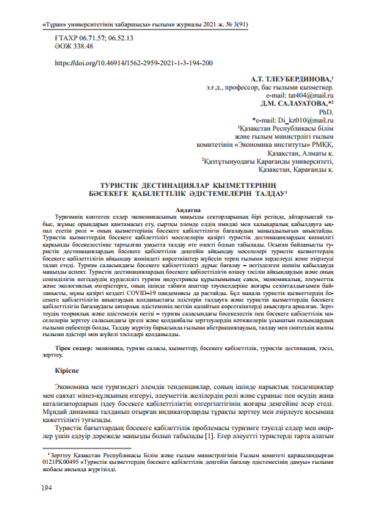

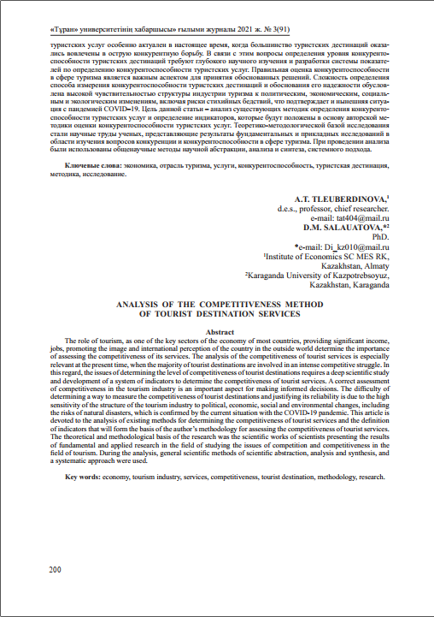

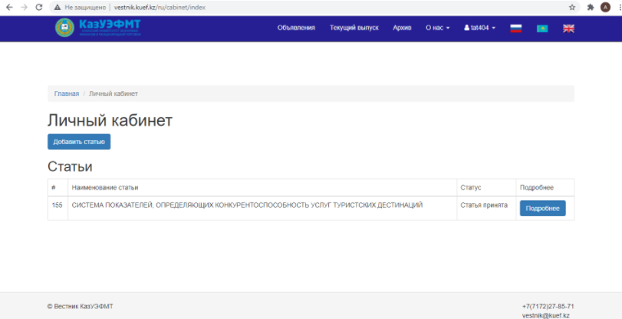

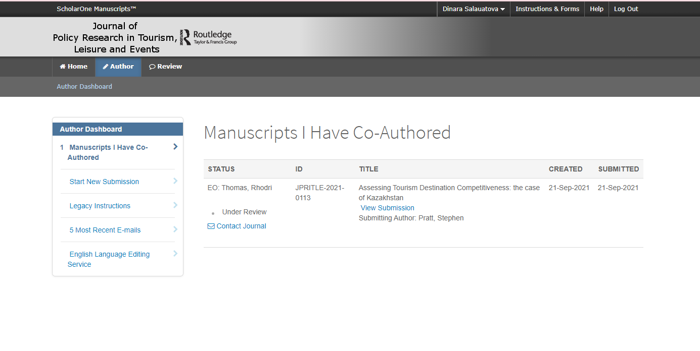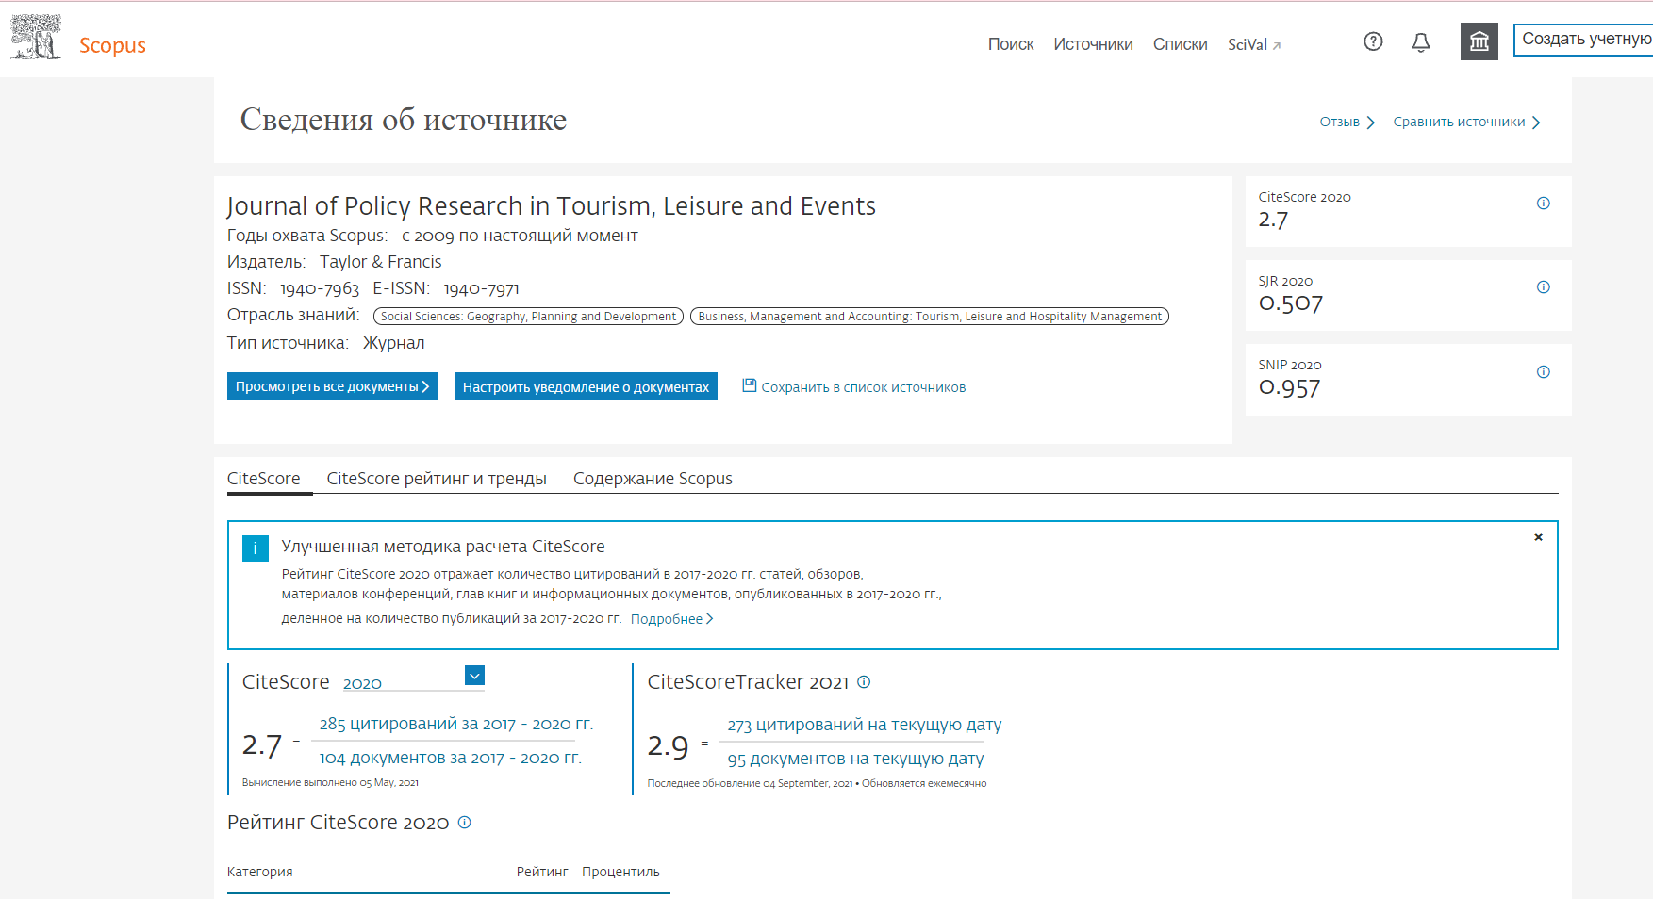

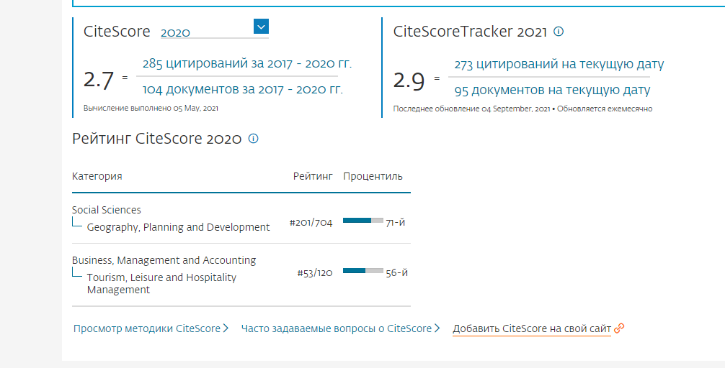

**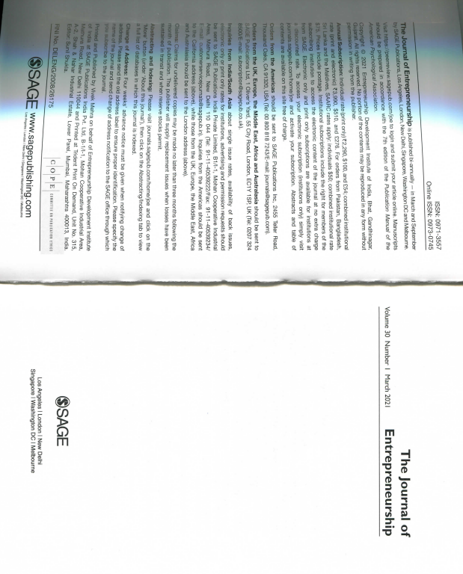**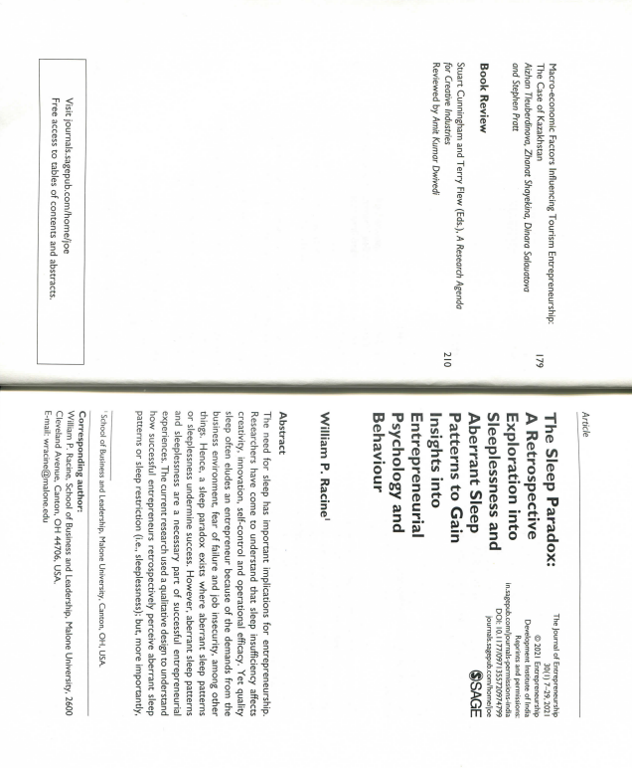

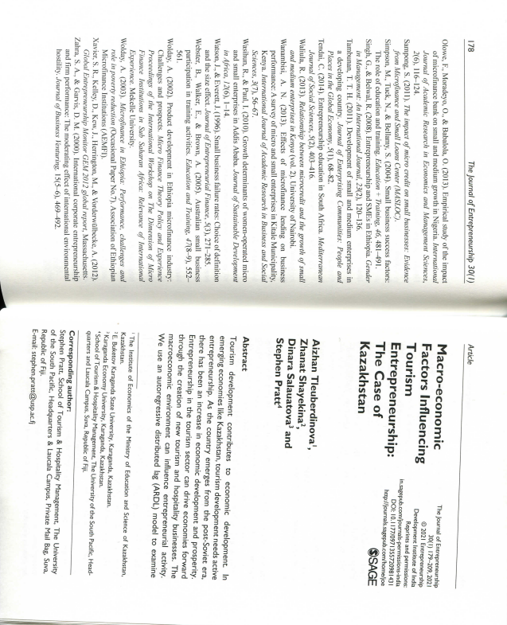

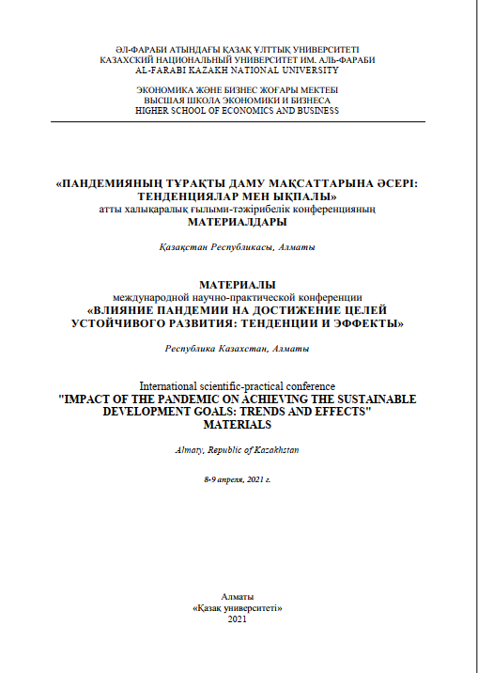

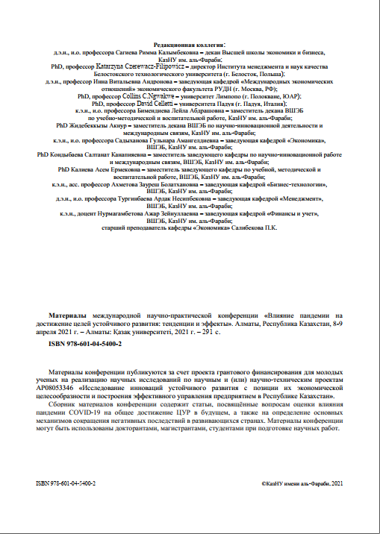

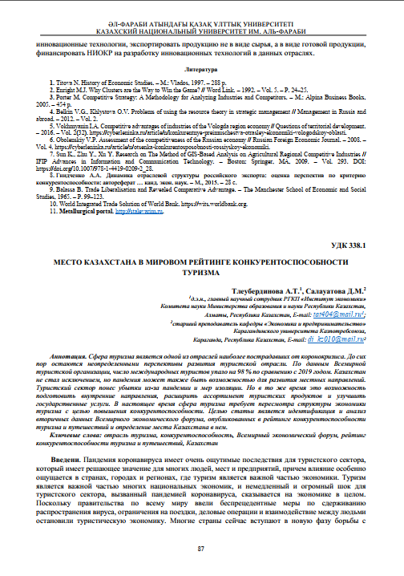

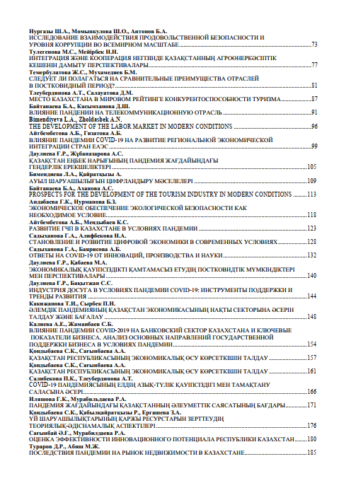

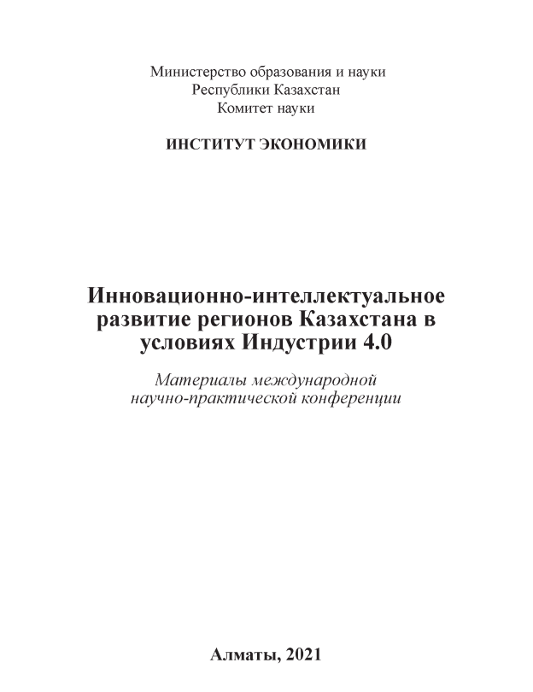

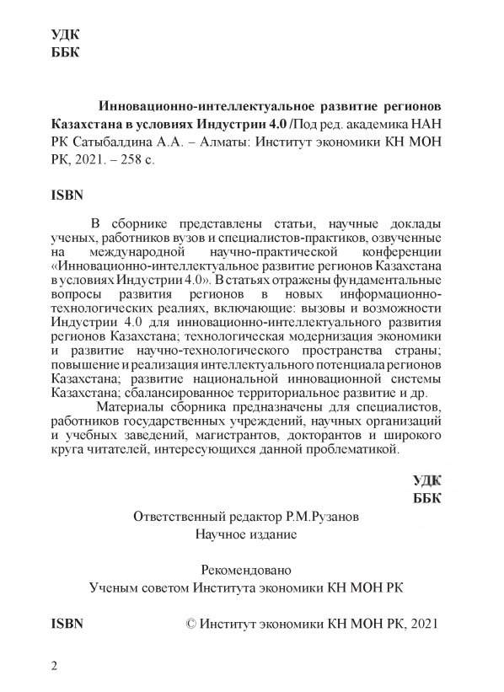

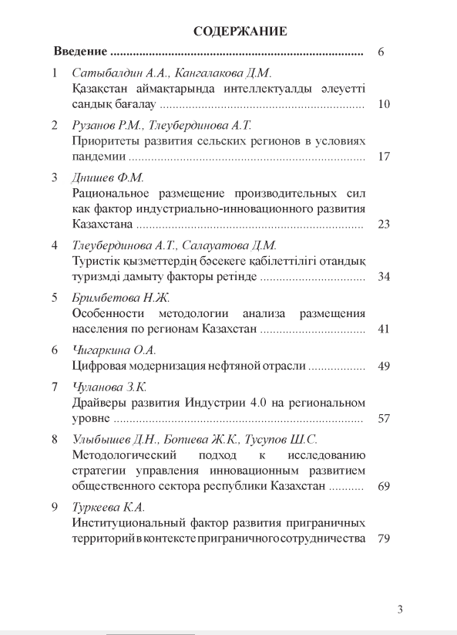

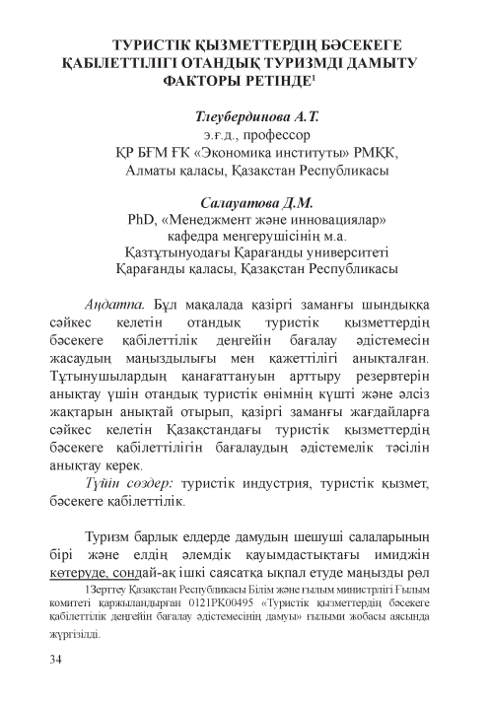

**ANNEX C**

**Act of implementation of the results of the study in the educational process of Karaganda University Kazpotrebsoyuz**

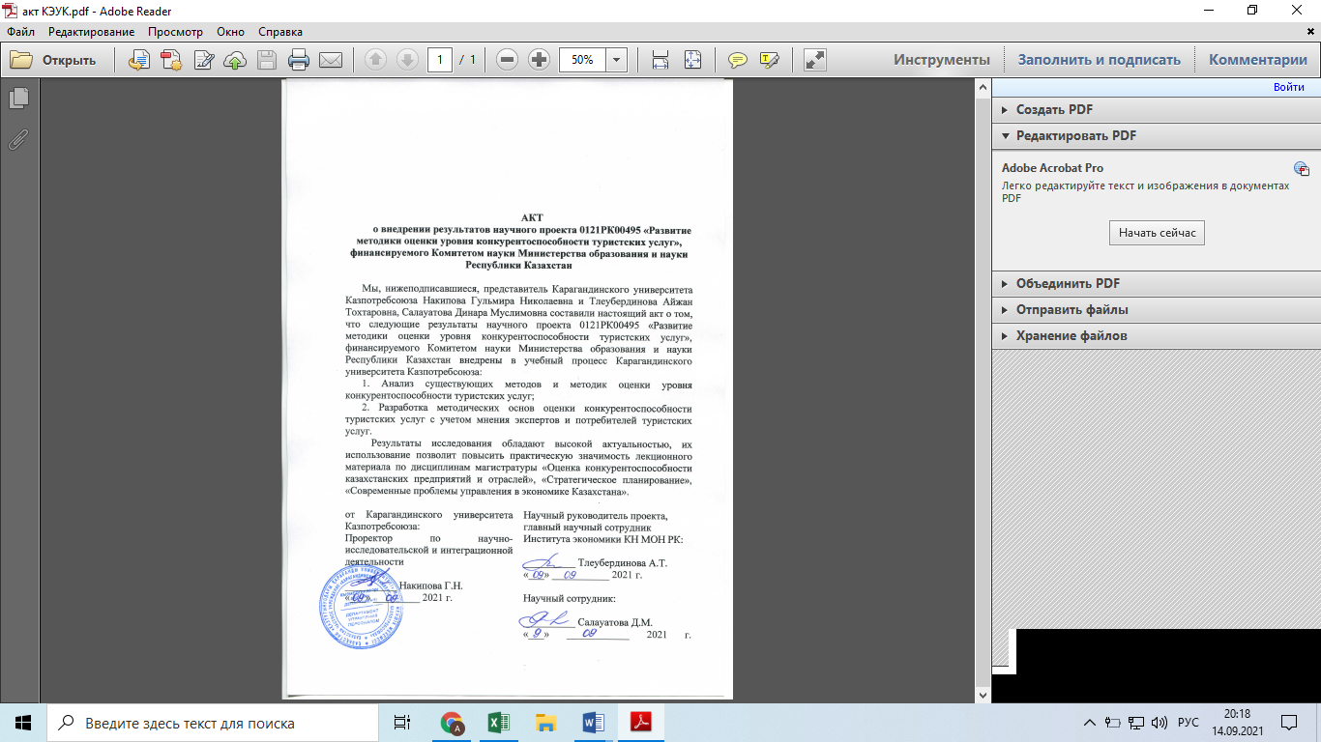

**ANNEX D**

**Act of implementation of the results of the study in the activities of the Department of Entrepreneurship of Karaganda region** 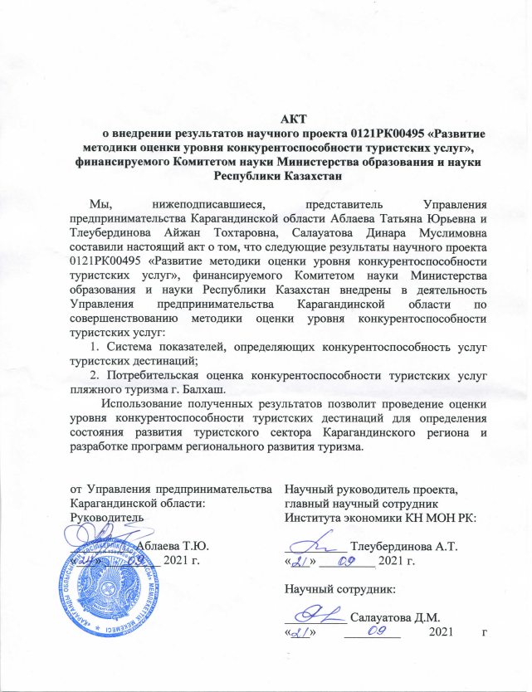

**ANNEX E**

**List of main and additional development parameters under the OECD methodology**

|  |  |  |
| --- | --- | --- |
| Basic parameters | Evaluation Parameters | |
| 1 | 2 | |
| Development of the tourism industry | 1 The share of tourism in a country's GDP is the main international parameter of tourism's contribution to GDP | |
| 2 Inbound tourism revenues per visitor by source market is an parameter of economic activity of visitors | |
| 3 The number of overnight stays in all types of accommodation is an parameter of tourist flows in the sphere of accommodation | |
| 4 Export of tourism services is a measure of tourism's contribution to exports. | |
| The ability of a destination to ensure the quality and competitiveness of tourist services | 5. Labor productivity in tourism services is a measure of the production potential of the tourism industry | |
| 6. Purchasing power parity (PPP) and prices for tourist services is an parameter of the competitiveness of prices for tourist services | |
| 7. Country entry visa requirements is a measure of entry visa requirements, including methods of issuing the visa. | |
| Destination attractiveness | 8. Natural resources and biodiversity is an parameter of a country's natural assets | |
| 9. Cultural and creative resources is an parameter of cultural and creative attractions, events and activities in the country | |
| 10. Visitor satisfaction is a measure of demand-side attractiveness based on present and future competitiveness. | |
| Implemented policies and economic opportunities | 11. National Tourism Action Plan is an parameter of effectiveness in promoting the competitiveness of tourism | |
| Additional parameters |  | |
| Development of the tourism industry | Market diversification and growing markets is the width of the tourism industry's coverage of several markets.  A wide range of source markets and a focus on growth markets are valued above | |
| The ability of a destination to ensure the quality and competitiveness of tourist services | Employment in tourism by age, education and contract type is a measure of the ability to attract, retain and develop talent in the tourism industry to improve competitiveness | |
| Consumer price index for tourism. Additional PPP measures | |
| Air service and intermodality is an parameter of the competitiveness of air services | |
| Destination attractiveness | Quality of life index is an parameter that uses a version of the tourism-oriented index | |
| Parameters of future development is the ability of a destination to ensure the quality and competitiveness of tourist services | |
|  | Allocations from the state budget for tourism development is an parameter of public spending on tourism per capita | |
|  | The vitality of companies is an parameter of the activity of enterprises and business stagnation | |
| Implemented policies and economic opportunities | Use of e-tourism and other innovative services is an index of parameters of innovation and use of social networks in the tourism industry | |
| Table continued | | |
| 1 | | 2 |
|  | | Structure of tourism supply chains is an index that measures the volume of the industry, the competitiveness of existing/potential clusters |
| Note - Compiled based on the source [18] | | |

**ANNEX F**

**Key elements determining competitiveness in tourism**

|  |  |  |
| --- | --- | --- |
| Identified key elements | Comments | Countries using them |
| 1 | 2 | 3 |
| Tourism management | State support and tourism as a priority, Regulations, in general, the state approach, tourism strategy, security and safety, public-private partnerships, vertical cooperation, statistics and data, multilateral cooperation, institutions (e.g. national tourism council), budget allocated to support tourism | Belgium, Canada, Chile, Egypt, Greece, Italy, Poland, Portugal, Spain, Turkey, UK |
| Product development | Product differentiation, innovation, investment, market share, provide a unique experience, increase the added value of tourism, high level of development  value segments, market perspective (including promising travelers, tour operators and small businesses) | Australia, Austria, Belgium, Brazil, Canada, Denmark, Finland, France, Germany, Hungary, Israel, Mexico, New Zealand, Norway, Poland, Spain, Turkey, UK |
| Quality of tourist services | Improving quality, welcoming visitors, quality of life, social justice and cohesion, consumer services | Austria, Belgium, Brazil, Czech Republic, Denmark, Finland, France, Germany, Hungary, Portugal, Slovenia, Spain |
| Price competitiveness | Prices, exchange rates, value for money "value of money", taxation | Australia, Belgium, Czech Republic, Denmark, Egypt, Finland, France, Germany, Greece, Norway, Poland, Great Britain |
| Availability/connectivity | Infrastructure development, geostrategic location of the destination, proximity | Australia, Belgium, Brazil, Chile, Czech Republic, Finland, Greece, Italy, New Zealand, Norway, Poland, Portugal, Slovenia, Spain, Turkey, UK |
| Direction branding | Promotion and marketing, identity, image, destination awareness, width of circulation, market diversification | Australia, Austria, Brazil, Canada, France, United Kingdom |
| Natural and cultural resources | Sustainable development, gastronomy, climate, biodiversity | Belgium, Brazil, Chile, Czech Republic, Denmark, Egypt, Finland, France, Germany, Greece, Hungary, Israel, Italy, Poland, Portugal, Slovenia, Spain, Turkey |
| Human resource development | Skills, education and training, labor, productivity, tourism training centers | Belgium, Chile, Estonia, Greece, Spain, Turkey |
| Note - Compiled based on the source [18] | | |

**ANNEX G**

**Overview of comparative studies of the competitiveness of destination countries**

|  |  |  |  |  |
| --- | --- | --- | --- | --- |
| Author | Method | Type | Criteria | |
| 1 | 2 | 3 | 4 | |
| Pearce 1997 [4] | Secondary data | The competitiveness of destinations | Availability, attractions, housing supply, prices, development processes | |
| Grabler 1997 [26] | Primary data | Positioning of urban destinations | Accommodation, entertainment, atmosphere, cultural resources, price level, availability of amenities and destinations, location, originality, attitude, shops, food and beverage quality | |
| Seaton 1996 [27] | Secondary data | The competitiveness of destinations | Number of tourist arrivals, number of overnight stays, tourism income, employment trends, seasonal trends, balance of payments trends, tourism share in GDP, market dependence trends, tourism employment trends and marketing spending trends | |
| Bray 1996 [28] | Secondary data | Destination competitiveness | Prices, exchange rates, market, access | |
| Dieke 1993 [29] | Secondary data | Comparative analysis of destinations | Number of arrivals, purpose of visits, overnight stays, housing supply, seasonality, tourism income, employment, tourism policy, market and tourism spending | |
| Calantone, Benedetto, Hakem and Bojanic 1989 [30] | Primary data | The competitiveness of destinations | Tourist perception of multiple attributes of a destination (shopping, hospitality, safety, food, culture, tourist attractions, tourist sites, nightlife and entertainment, landscapes, beaches and water sports | |
| Haakhti  1986 [31] | Primary data | The competitiveness of destinations | Value for money, availability of sports facilities and others, nightlife activities and entertainment, peace and quiet, hospitality, wildlife, trekking and camping, cultural experiences, scenery, difference from other destinations | |
| Driscoll, Lawson and Niven 1994 [32] | Primary data | The competitiveness of destinations | | Amenities, landscape, safety, climate, culture, modern society, different experiences, value for money, accessibility, shopping, organized activities, cleanliness, family-oriented, exotic location, outdoor activities, religious values, hospitality, nightlife and entertainment |
| Botho, Crompton and Kim, 1999 [33] | Primary data | The competitiveness of destinations | | Differences in entertainment, infrastructure, physical environment and wildlife |

Table continued

|  |  |  |  |
| --- | --- | --- | --- |
|  |  |  |  |
| M., Kozak. [34] | Secondary data | The competitiveness of destinations | Volume of tourist arrivals, number of repeat tourists, volume of tourist revenues, share of tourism revenues in GNP |
| Note- Compiled by the authors | | | |

**ANNEX H**

**The results of the expert survey**

Figure Н.1 - The sphere of activity of respondents

Figure Н.2 - Length of service of respondents, years

Figure Н.3 - Factors of the "Environment" sub-index

Figure Н.4 - Factors of the sub-index "Tourism Policy "

Figure Н.5 - The sub-index "Factors of the Tourism Market Infrastructure"

Figure Н.6 - Factors of the sub-index "Development of the tourism industry"

Figure Н.7 - Factors of the sub-index "Ability of a destination to provide quality and competitiveness of tourist services"

Figure Н.8 - Factors of the sub-index "Destination Attractiveness"

Figure Н.9 - Ranking of factors of competitiveness of tourism services by importance from 1 to 6 (1 - most significant, 6 - least significant)