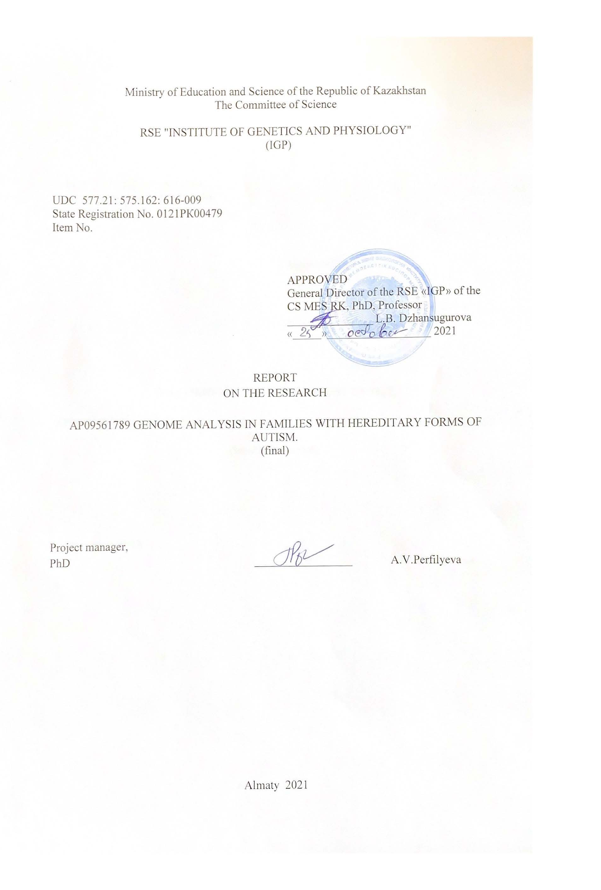
Ministry of Education and Science of the Republic of Kazakhstan

The Committee of Science

RSE "Institute of Genetics and Physiology"
(IGP)

UDC 577.21: 575.162: 616-009
State Registration No. 0121РК00479
Item No.

APPROVED
General Director of the RSE «IGP» of the CS MES RK, PhD, Professor
_______________ L.B. Dzhansugurova «_____»__________________ 2021

REPORT
ON THE RESEARCH

AP09561789 GENOME ANALYSIS IN FAMILIES WITH HEREDITARY FORMS OF AUTISM.
(final)

Project manager,
PhD _________________ A.V.Perfilyeva

Almaty 2021

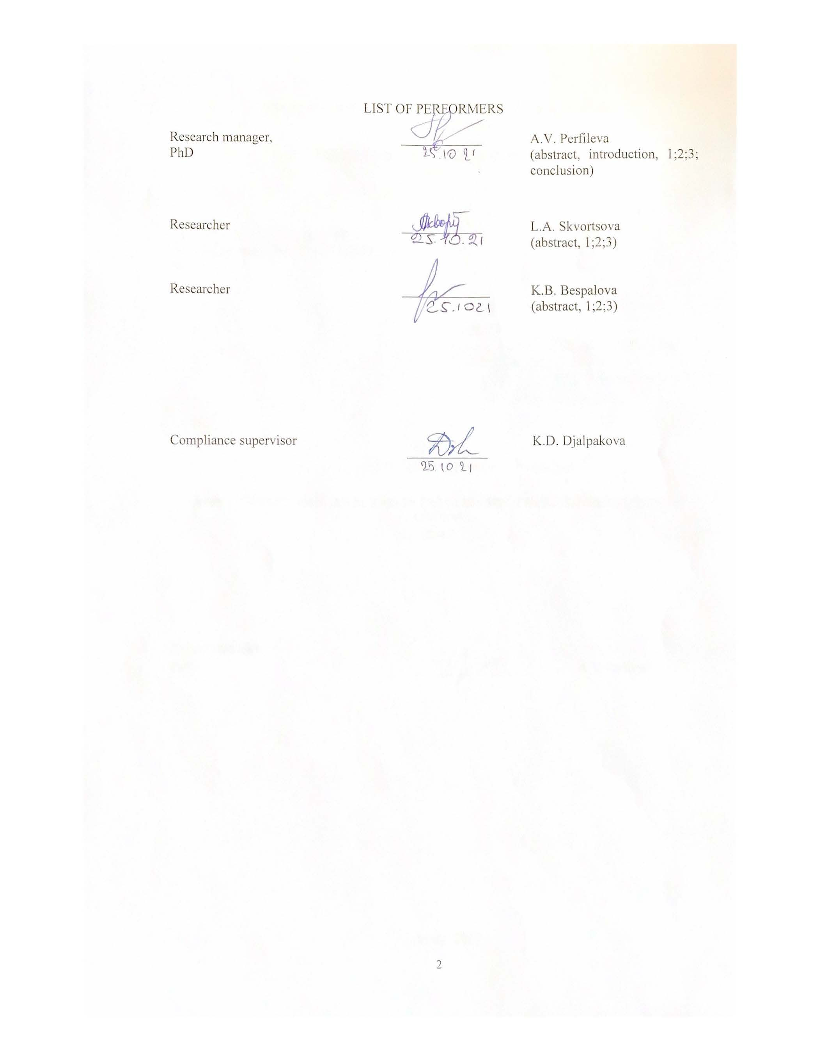LIST OF PERFORMERS
Research manager,  PhD | ____________ | A.V. Perfileva  (abstract, introduction, 1;2;3; conclusion)
Researcher | ____________ | L.A. Skvortsova  (abstract, 1;2;3)
Researcher | _____________ | K.B. Bespalova  (abstract, 1;2;3)
Compliance supervisor | ____________ | K.D. Djalpakova

ТҰЖЫРЫМ

Есеп 44 беттен, 2 суреттен, 79 қолданылған әдебеиттен, 3 қосымшадан тұрады.
АУТИЗМДІК СПЕКТРДІҢ БҰЗЫЛУЫ, ТҰҚЫМ ҚУАЛАЙТЫН АУЫРТПАЛЫҚ, ГЕНЕТИКАЛЫҚ ВАРИАНТ, БІРНУКЛЕОТИДТІ ПОЛИМОРФИЗМ, МУТАЦИЯ
Зерттеу объектісі АСБ тұқым қуалайтын ауыртпалығы бар 4 отбасы болып табылады.
Мақсаты: тұқым қуалайтын аутизм ауыртпалығы бар қазақстандық отбасылардағы, аутизм спектрінің бұзылуының дамуына байланысты, генетикалық варианттарды іздеу.
Жұмыста әлеуметтік, психологиялық, молекулалық-генетикалық әдістер, биоақпараттық талдау әдістері қолданылды.
Нәтижелері және олардың жаңалығы: Аутизмнің тұқым қуалайтын ауыртпалығы бар қазақстандық отбасыларда геномдық зерттеулер алғаш рет жүргізілді. Зерттелген отбасыларда AСБ генетикалық тәуекелінің компоненттері болуы мүмкін 78 dbSNPs, 61 сирек кездесетін тұқым қуалайтын нұсқалар және 14 de-novo мутациясы анықталды, сонымен қатар осы отбасыларда de-novo мутациялары AСБ симптомдарының ауырлығын анықтауы мүмкін екендігі анықталды. Ана мен ұрықтың генетикалық тұрғыдан анықталған энергия тапшылығы жағдайлары стресстік жағдайларда АСБ дамуына ықпал етуі мүмкін екендігі туралы гипотеза ұсынылды. Сонымен қатар, алғашқы АСБ ассоциациялық өзгерістері пренатальды кезеңде пайда болады және балада қоршаған орта факторларының әсеріне ұшырағаннан кейінгі кезеңде пайда болады/күшейеді.
Енгізу деңгейі: жоқ.
Негізгі құрылымдық және техникалық-экономикалық көрсеткіштері: 78 dbSNP, 61 сирек зерттелетін варианттар және de-novo мутациялар.
Нәтижелерді қолдану салалары: медициналық генетика, нейрогенетика.
Нәтижелерді қолданысқа енгізу нұсқаулықтары: нәтижелер аутизм дамуы қаупі факторларын зерттеу үшін ҒЗЖ кезінде зерттеулерде, сонымен қатар тұқым қуалайтын АСБ бар отбасыларға генетикалық кеңес беру үшін қолданылуы мүмкін.
Жұмыстың экономикалық тиімділігі немесе құндылығы: уақтылы және дұрыс диагноз қою, сонымен қатар адам өзінің генетикалық статусын білу арқылы алдын алу шараларын, болашақ ұрпақтың денсаулығын жақсартуға және әрбір отбасының, сондай-ақ жалпы қоғамның генетикалық ауыртпалығын төмендетуге бағытталған алдын алу шараларын қолдануға ықпал етеді.

ABSTRACT

Report 44 pages, 2 figures, 79 references, 2 appendixes.
Autistic spectrum disorders, FAMILY HISTORY, genetic variant, single nucleotide polymorphism, mutation
The object of the study was 4 families with ASD in family history.
Purpose: search for genetic variants that contribute to the risk of ASDs in Kazakhstani families with hereditary autism burden.
Sociological, psychological, molecular genetic methods, bioinformatic methods of analysis were used in the paper.
The results and novelty. For the first time, a genomic study of Kazakhstani families with hereditary autism was carried out. 78 dbSNP, 61 rare inherited variants and 14 de novo mutations, which may contribute to the genetic risk for ASD development , have been identified in the studied families. The results suggest that the identified de novo mutations determine the severity of ASD symptoms in these families. We hypothesized that the genetically determined energy deficiency in the mother and the fetus can contribute to the development of ASD under stressful conditions. At the same time, primary ASD-associated changes occur in the prenatal period and manifest / enhance in a child in the postnatal period, when exposed to environmental factors..
The degree of implementation: no.
Basic constructive and technical economical indicators: 78 dbSNP, 61 rare inherited variant and 14 de novo mutations.
Scope of results: medical genetics, neurogenetics.
Recommendations for the implementation of results: the obtained results can be used for subsequent study of the risk factors for the development of autism, as well as for genetic consultation of families with a hereditary form of ASD.
Economic efficiency or significance of the work: a timely and correct diagnosis, as well as knowledge of your genetic status, contribute to the preventive measures aimed at health promotion of current and future generations thereby reducing the genetic burden of each family and the whole society as a result.

CONTENT
INTRODUCTION ……………………………………………………………………… |  | 7
THE MAIN PART OF THE REPORT ..………………………………………………… |  | 8
1 | Literature review …..…………………………………………………………… | 8
1.1 | Epidemiological data on ASD in the world and Kazakhstan ..…………………. | 8
1.2 | ASD classification ..…………………………………………………………….. | 8
1.3 | Etiology of ASD ………………………………………………………………… | 10
2 | Materials and methods ……………...…………………………………………... | 13
2.1 | Research objects ………………………………………………………………… | 13
2.2 | SNPs genotyping technology……………………………………………............ | 14
2.3 | Data analysis method ………………………………………….……………….. | 14
3 | Results and discussion………………………...................................................... | 15
3.1 | Research objects………. ……………………………………………………...... | 15
3.2 | Genotyping results ……………………………….……………………………... | 16
3.3 | Discussion ……………….……………………………………………………… | 17
CONCLUSION ………………………………………………………………………… |  | 26
REFERENCES ……………………………………..………………………………….. |  | 27
APPENDIX A LEC conclusion………………………………………………………….. |  | 34
APPENDIX B Characteristics of candidate genetic variants in four families with hereditary autism …………………………………………..……………. |  | 37
APPENDIX C List of published works on the topic for 2021…………………................ |  | 44
DEFINITIONS, NOTATION AND ABBREVIATIONS
The following definitions, designations and abbreviations are used in this report:
DNA- | Deoxyribonucleic acid
ICD-10-  DSM-5 - | International Classification of Diseases of the 10th Revision  Diagnostic and Statistical Manual of mental disorders, fifth edition
mtDNA- | mitochondrial DNA
ASD - | autism spectrum disorder
CARS- | Childhood Autism Rating Scale
BAP- | Broad Autism Phenotype
IEM- | inborn errors of metabolism
SCFAs - | Short-chain fatty acids

INRODUCTION
The role of genetic factors and the impact of heredity on the development of the RAS is proved, but the detailed mechanism still remains unclear. In the presence of a high level of heterogeneity of the loci, which is very likely for ASD, a potentially effective approach to identifying candidate variants that caused the disease is the study of family forms of the patology. The establishment of a cascade of genetic defects in genes can serve as a basis for building hypothetical genetic and metabolic paths involved in the focus of the ASD development. In addition, such a study contributes to the identification of the quantitative and qualitative characteristics of the ASD genetic burden in the population. Also, it benefits for a specific family, since it allows to carry out more efficient medical and genetic counseling and the optimal selection of therapeutic intervention. In the Kazakhstani families of autistic children, the genomic screening of mutations and polymorphisms, which may cause the disease in this family have not been carried out previously.
In connection with the above, this project is proposed, the main purpose of which is to search for genetic variants that contribute to the risk of ASDs in Kazakhstani families with hereditary autism burden.

THE MAIN PART OF THE REPORT
1 Literature review

  - Epidemiological data on ASD in the world and Kazakhstan
ASD is a spectrum of psychological characteristics that describe a wide range of abnormal behavior and difficulties in social cooperation and communications, as well as severely limited interests and frequently repetitive behavioral acts.
The relevance of the ASD problem is due to the high frequency of this pathology. According to many experts, in Kazakhstan there is a multiple discrepancy between official data on the number of children suffering from autism, with official statistics data. So, according to the Republican Psychological and Medical and Pedagogical Commission, in 2018, there were 3 thousand 820 children with autism in Kazakhstan, but the experts assumed at least 10 times exceeding this indicator [1].
The basis for these conclusions is the statistics of the World Health Organization, according to which in the world every 160th child suffers from the ASD [2]. According to the CENTERS FOR DISEASE CONTROL AND PREVENTION (CDC), ASD is diagnosed for each 54th child in the world [3]. Based on these indicators, at the present time, at least 30 thousand children with ASD should be counted in Kazakhstan.
The timely detection and early diagnosis are complicated with the fact that ASD is a fairly broad concept, and it includes a number of mental disorders and deviations in the behavior of children and adults. The current classification of the autistic spectrum disorders is considered below.

1.2 ASD classification
There are several approaches to the classification of the autistic spectrum disorders: DSM-5 and ICD-10.
By DSM-5, the following 4 disorders are combined into ASD [4]: autistic disorder; Asperger Syndrome; Children's disintegrative disorder; persival development disorder without additional clarifications (PDD-NOS).
According to the classification of WHO, the ICD-10 disorder of the autistic spectrum, or general disorders of psychological development (F84), is a group of disorders characterized by qualitative deviations in social interactions and indicators of communicability, as well as a limited, stereotypical, repeating complex of interests and actions. These qualitative deviations are a common characteristic feature of an individual activity in all situations. They include:
- Children's autism - the type of general development disturbance, which is determined by the presence: a) anomalies and delays in the development of the child under the age of three years; b) psychopathological changes in all three spheres: equivalent social interactions, communication and behavior functions, which is limited, stereotypically and monotonously. These specific diagnostic traits usually complement other nonspecific problems, such as phobias, sleep disorders and food intake, outbreaks of irritation and autoaggression.
- Atypical autism is the type of general development disturbance, differing from child autism by age, in which the disorder begins, or the absence of the triads of pathological disorders necessary for the diagnosis of child autism. This subheading should be used only if the anomalies and development delays manifested themselves in a child over three years and insufficiently defiantly expressed violations in one or two of the three regions of the psychopathological triad, necessary for the diagnosis of child autism (namely in social cooperation, communication and behavior characterized by limited, stereotype and monotony), despite the presence of characteristic violations in other of the listed areas. Atypical autism is most often developing in persons with deep development delay and in persons having a heavy, specific recipe disorder of speech development.
- Rett syndrome is a state, to date, detectable only in girls, in which the explicitly normal development is complicated by partial or complete loss of speech, locomotor skills and skills of using hands simultaneously with a slowdown of head growth. Violations occur in the age range from 7 to 24 months of life. Characterized loss of arbitrary movements with hands, stereotypical circular movements of hands and reinforced breathing. Social and gaming development stops, but interest in communication has a tendency towards safety. By the age 4, the development of attaxia of the torso and aproxia, often accompanied by choreoathyoid movements begins. Almost invariably marked severe mental retardation.
- Another disintegrative disorder of children's age is the type of total developmental disorder, which is characterized with the presence of a period of absolutely normal development before the manifestation of signs of disorder, accompanied by the pronounced loss of the acquired by the time skills relating to various development areas. Loss occurs within a few months after the development of the disorder. Usually it is accompanied by a pronounced loss of interest in the surrounding, stereotypical, monotonous motor behavior and characteristic of autism disorders in the sphere of social interactions and communication functions. In some cases, the causal relationship of this disorder with encephalopathy can be shown, but the diagnosis should be based on behavioral features.
- Hyperactive disorder, combined with mental retardation and stereotypical movements - poorly indicated disorder of uncertain nosology. This category is intended for a group of children with severe mental retardation (IQ below 35), showing hyperactivity, violation of attention, as well as stereotypical behavior. For these children stimulating drugs may not cause a positive response (as in persons with a normal IQ level), but, on the contrary, a severe dietary response (sometimes with psychomotor retardation). In adolescence, hypraactivity tends to replace with reduced activity (which is atypically for hyprecative children with normal intelligence). This syndrome is often associated with various lags in the development of a general or specific nature. Unknown the degree of etiological participation in this behavior of low IQ or organic brain lesion.
- Asperger's syndrome is an uncertain nosology disorder, characterized by the same high-quality anomalies of social interactions, which are characteristic of autism, in combination with limited, stereotype, monotony of interests and classes. The difference from autism primarily is that there is no normal stop or delay in the development of speech and knowledge. This disorder is often combined with a pronounced clumsy. There is a tendency to preserve the above changes in adolescent and adulthood. In the early period of maturity, psychotic episodes occur periodically.
- Other general development disorders
- general development disorder uncomfortable

1.3 Etiology of ASD
The etiology of this pathology is extremely difficult. Current studies continue to deepen our understanding of the potential etiological mechanisms of ASD, but at present, not a single total cause of all cases found. The various works of recent years are devoted to the study of neuropathological, immunological, structural, functional and genetic factors in etiopathogenesis of ASD.
Neuropathological studies revealed differences in the architecture of the cerebellum, anomalies of the limbic system, cortical changes in the frontal and temporal share and other malformations [5-7]. One small study showed focal violations of the crust laminar architecture in most of the studied patients with ASD, assuming pathology in the formation of the cortical layer and the neuronal differentiation process [8]. Also in children with ASD, an increase in the size of the brain is described, both at the expense of the cortex and by increasing the volume of extraaxial fluid, which is the object of permanent research. [9-10].
As an option, the hypotheses about the origin of ASD is considered a violation of imune activity in critical periods of ontogenesis [11]; increased serotonin level [12]; possible involvement of metabolic disorders [13]; a number of prenatal factors [14, 15], as well as vaccines. In the ratio of the last factor, in 2013, the American Academy of Pediatrics amounted to an impressive list of studies that have proven vaccine safety and the lack of assosiation between the vaccination and the development of ASD [16]. The results of the largest studies have also shown that neither vaccinations nor vaccine components (thimerosal or mercury) nor multiple vaccines (MMR) are not related to the development of ASD.
As external factors that are investigated as possible causes of ASD, such toxicants of the environment can be listed as automotive air pollution, cigarette smoke, heavy metals and pesticides [17]. However, in 2020, the study of the two largest twins cohort in the world showed that the environmental factors associated with ASD, over time, did not acquire special influence and can hardly explain the obvious increase in the incidence of autism in the world, while genetic factors have the predominant value [18].
A number of data support genetic factors as the most significant causes of ASD. Thus, the risk that a child will be diagnosed with autism, in those families where his brother or sister already suffers from it, increases at least 25 times. Second, independent studies of twins show that the frequency of co-morbidity in monozygotic twins (70–90%) is several times higher than the corresponding values ​​for dizygotic twins (0–10%) [19]. Thirdly, siblings, as well as parents of sick children, to a greater extent than representatives of the control groups, demonstrate mild cognitive and behavioral manifestations similar to those observed in probands. This gave rise to the concept of the broader autism phenotype (BAP).
This concept emerged from a twin study in 1977 [20]. The authors demonstrated that even if only one child had autism, the other twin could have delayed speech, reading and spelling difficulties, leading to the conclusion that autism is genetically associated with a wide range of cognitive disorders.
Further research has shown that individual symptoms of autism are more common among parents of children with autism than among parents of neurotypical children. Losh M et.al. found many of these features in mothers of children with fragile X syndrome - the cause of about 5% of all autism cases. These women did not have mutations in the FMR1 gene that cause the syndrome, but there was a "premutation" in this gene [21]. This apparently led to the fact that carriers could not receive a diagnosis of ASD, but were in the borderline range of autism.
Later it was shown that BAP is hereditary, i.e. that subdiagnostic features of autism have the same level of inheritance as ASD [22, 23].
This distribution of "milder phenotypes" in families with ASD supports the multiple interacting loci model. The differences in the phenotypic severity of ASD symptoms in family members identified by the autistic proband are consistent with this hypothesis [24-26].
A recent study provided a basis to propose a more complex model of the onset of autism (bilineal two-hit model) (“bilinear model with two hits”), in which inherited risk is attributable to a combination of two risk variants: a maternally-inherited coding variant of large effect and a paternally-inherited variant of moderate effect [27].
The above shows that family-based search for genetic loci associated with ASD can be effective to understand the nature of autism and the causes leading to its development. A number of studies are devoted to this topic [22, 23, 27-35].
Shi L. et al. analyzed the genomes of a large family with two sons with ASD and six neurotypical siblings. Particular attention was paid to inherited mutations. The ANK3 gene has been identified as the most likely candidate gene [32].
Iossifov I. et al. in a study of 1,866 families of children with ASD indentified 239 genes, the mutation of which can lead to autism [33].
Szatmari P. et.al. performed the largest linkage scan to date, analyzed copy number variations (CNV) in 1168 families, and highlighted the 11p12-p13 region and glutamate-related genes [34].
Yuen R. K. et al. sequenced the genomes of 85 quartet families (families with two children, both diagnosed with ASD) and identified 46 ASD-associated mutations present in 36 of 85 (42.4%) families [35]. At the same time, only 16 identified mutations out of 46 (35%) were detected de novo. Interestingly, the majority of sibling pairs (69.4%) did not have the same mutations associated with ASD.
These and many other works indicate that intensive research efforts have been made to date to identify the genetic basis of ASD. However, there is still no clear concept about the causes of ASD. This is because it is one of the most heterogeneous neurodevelopmental disorders, as reflected in the variations observed in behavioral manifestations and cognitive profiles of ASD. Incredibly, within the spectrum, the number of individual characteristics is so great that often the group differences between people with ASD and normotypical people are less statistically significant than between people within the ASD spectrum [36].
We hypothesize that due to this heterogeneity, success of the study requires a separate consideration of each new case of the disease in order to supplement the list of candidate genes and to better understand the metabolic pathways involved in the scenario of ASD development.
In this project, for the first time in Kazakhstan, it is planned to conduct genomic screening of mutations and polymorphisms in families with hereditary ASD burden.

2 Materials and methods

2.1 Research objects
The object of the study was Kazakhstani families with hereditary burden of autism. Inclusion criteria: family history of maternal or paternal ASD, the presence in the family of more than one child with an official diagnosis of ASD, the presence in the family of people belonging to the ВАР.
Exclusion criteria: sporadic ASD, fragile X syndrome.
Selection of cohorts for the study was based on the existing database of 400 Kazakhstani families with autistic children, which was formed as a result of the previously implemented project AP05130356.
Biomaterials (saliva) were collected from both children with ASD and from their parents and neurotypical siblings using the Saliva DNA sample Collection Kit (Zeesan) provided by TellmeGen.
Collection of clinical material was carried out exclusively on a voluntary basis and was accompanied by the registration of informed consent of at least one of the parents for the study of themselves, their spouse and their children (Appendix A). The protocol, including all stages of the project research, was approved by the Local Ethics Commission of the RSE "Institute of Human and Animal Physiology" of the KN MES RK (LEK Protocol No. 2 (3) dated 16.06.2020, Appendix B). It is based on the principles of "Bioethical rules for conducting research on humans and animals", corresponding to the legislation of the Republic of Kazakhstan; Principles of Medical Ethics, approved by the UN General Assembly (1992); Council of Europe Convention on Bioethics (1997).
In addition to obtaining consent to the study, detailed questionnaires and necessary psychological testing of children were carried out.
The questionnaires were developed for families with ASD children and families with healthy children on the basis of the Institute of General Genetics and Cytology of the KN MES RK and included information about age, gender, nationality, place of birth and family history of neurological diseases (Appendix B). Personal data were processed and entered into an electronic database.
Children in these families were officially diagnosed with ASD. The CARS Child Autism Rating Scale was used to assess the severity of ASD. The BAPQ (The Broad Autism Phenotype Questionnaire) psychometric test was used to assess the main criteria for belonging to the extended autistic phenotype. All data has been processed and entered into the local database.

2.2 SNPs genotyping technology
Isolation of DNA from the collected biomaterial and SNPs genotyping was carried out on the basis of Tellmegen CA LLP using Illumina iScan technology with a GSA (V3) microcircuit for 750,000 genetic markers (99.99% reliability). Triple probes were used, and if the result was not the same in all three probes, the information about the results was not taken into account.

2.3 Data analysis method
The family tree was built using the GenoPro2020 program [https://genopro.com/2020/].
Tellmegen CA used standard data normalization procedures and aggregated all the results obtained into CSV files with a list of all detected genetic variants, which were submitted to the laboratory for further analysis. Bioinformatic analysis of SNP-typing results included the determination of the reliability of the data, determination of the genetic status - homozygosity/ heterozygosity for the identified changes, detection and analysis of the identified variants pathogenicity by comparison with the ASD associated variants approved by known databases and scientific articles. For annotation, we used the RStudio program (rstudio.com/products/rstudio/) and the database of single nucleotide polymorphism dbSNP(http://www.ncbi.nlm.nih.gov/projects/SNP/), ClinVar (https://www.ncbi.nlm.nih.gov/clinvar/), GWAS Catalog (the NHGRI-EBI Catalog of human genome-wide association studies, https://www.ebi.ac.uk/gwas/home). The population frequency of the identified genetic variants was estimated using the "1000 genomes" database (1000 Genomes project, http://www.1000genomes.org/), the Genome Aggregation Database (gnomAD, https://gnomad.broadinstitute.org/), trans-Omics for Precision Medicine (TOPMed, https://www.nhlbi.nih.gov/science/trans-omics-precision-medicine-topmed-program).

3 Results and discussion

3.1 Research objects
The study included 4 families with hereditary ASD burden (figure 1). Children in these families were officially diagnosed with ASD. Two families were from Nur-Sultan, one from Pavlodar and one from Ekibastuz.
The first family from Nur-Sultan has two probands, boys 5 and 11 years old with moderate ASD (CARS score 30 each), and a neurotypical sibling, a girl of 9 years old. The BAPQ test showed the presence of BAP in the father of children (104 points and a high score in personality alienation.), while the mother is neurotypical. All family members are Kazakh.
In the second family from Pavlodar, one of the children, a 9-year-old boy, was diagnosed with severe autism (CARS score 46), his 16-year-old brother has moderate autism (CARS score 30). The sister is neurotypical, doesn’t have BAP (86 points on the BAPQ test). Both the father and mother have BAP (96 and 105 points, respectively). The father has a higher than the critical value on the Pragmatism scale indicators concerning the social use of the language. For the mother, the indicators of such a side of the personality as alienation were above the critical value. All family members are of Kazakh.
The third family from Ekibastuz has two boys, 12 and 10 years old with moderate autism (CARS score 30 and 34.5, respectively). All family members are Kazakh. The mother is neurotypical.
In the fourth family from Nur-Sultan, the mother, a Kazakh woman, either has BAP (128 points on the BAPQ test), or is actually autistic, has two indicators above the critical value: the inflexibility and pragmatism of various interactions. The mother has two children from different marriages. The first 7-year-old son, Kazakh, has severe autism (CARS score 46.5). Daughter from a second marriage, 6 years old, Russian, has moderate autism (CARS score 30).

The filled icon – child with ASD, the half-filled icon is the BAP carrier. Each person is marked with their research code, year of birth, nationality, as well as a score on the CARS or BAPQ scale

Figure 1 - Family trees of families with hereditary burden of ASD included in the study

3.2 Genotyping results
Four families with hereditary ASD burden were selected for genome study by SNP typing on the Illumina® Global Screening Array (GSA) platform. In total, 750 thousand genetic variants were identified.
Our goal was to determine the list of variants/genes that determine the predisposition to the development of ASD in each family and to assess the nature of their transmission in the pedigree. The final list of variants/genes was manually checked to identify any prior association with autism or other neurodevelopmental disorders.
In total, 78 dbSNPs associated with the development of ASD were identified for 4 families based on GWAS studies with a reliability of P <1 × 10⁻⁵ (appendix B, table B.1): 2 variants (3%) - regulatory region variants, 3 variants (4%) - 3 prime UTR variants, 18 variants (23%) - intergenic variants, 47 intron variants (60%) , 1 missense variant (1%), 1 non coding transcript exon variant (1%), 6 undefined variants (8%). The minor allele frequency (MAF) in all variants was more than 1%; however, we assume that among the frequently encountered dbSNPs, some causal variants of the disease may also be present in the selected families [37].
Since in third family both parents are unaffected, a recessive inheritance model was imposed on it, in which each gene must contain two risk alleles (homozygous or compound heterozygous) in order to be declared a putative candidate gene. As a result, 38 dbSNP variants were identified as potentially “harmful” for family # 3.
Analysis of rare inherited variants occurring with a frequency of less than 1% in all four families revealed 61 variants in 49 genes (Appendix B, table B.2). Of these, 51 (83.6%) are missense, 3 (4.9%) are nonsense, 2 (3.3%) are splicing mutations, and 5 (8.2%) are synonymous variants. The largest number of variants was found in family 4 - 28. Most often, rare variants were found in the TTN gene. For it, 11 variants were characterized, with 8 in family No. 3.
De-novo mutations were identified according to the scenario: one parent is homozygous, the other parent is homozygous, and the child is heterozygous. Such mutations have only been found in children with ASD, but not in healthy siblings. In total, 14 de-novo mutations in a heterozygous state were identified in children with ASD in four families (Appendix B, table B.3). In family No. 1, two pathogenic or possibly pathogenic mutations NM_000162.5 and NM_138413.4 were found. Family No. 2 has 5 pathogenic or possibly pathogenic mutations (NM_000090.3, NM_022455.4, NM_172107.4, NM_000071.2, NM_006031.6) and 2 VUS variants (NM_003060.4, NM_014588.5). Family No. 4 has 3 pathogenic or possibly pathogenic mutations (NM_000251.2, NM_000090.3, NM_172056.2) and 2 VUS variants (NM_025216.3, NM_152722.5). Analysis of the spectrum of mutations revealed the following types: missense variants - 10, nonsense mutation - 3, splicing variant - 1.

3.3 Discussion
Although the specific reasons for the development of ASD have not been established to this day, some aspects of genetic disorders in the condition of ASD can provide important information for building a general constructive hypothesis of the development of autism.
The ASD has obvious phenotypic deviations in the functioning of the organism from the normal state; however, it is not possible to capture the specific genetic basis in the development of ASD. The latest genome-wide molecular studies have identified a whole spectrum of genes and their genetic variations associated with ASD. Most of the genetic data comes from the studies of idiopathic, i.e. characterized by unclear origin, cases of ASD (more than 80% of cases). And only a small part are cases of families with ASD, for which a family correlation of the disease with a defect in genes has been established. The list of ASD-associated genes is quite large and almost every chromosome carries potential ASD markers. However, there is no general picture of the involvement of these genes in the development of ASD in each case of the disease, both in the case of idiopathic ASD and familial-hereditary ASD [38]. These genes are so scattered among themselves and functionally have a rather wide range of uptake of metabolic-regulatory pathways that it does not seem realistic to draw up a general genetic and/or genetic-functional concept of the origin and development of ASD. Perhaps the absence of a common, unified molecular hypothesis for the origin of ASD does not allow linking all the accumulated genetic data.
Based on the assumption that ASD is based on a complex intersystem heterogeneity of the involvement of genes in the development of the disease, for this study we selected 4 families (19 people) in which there is at least one child with ASD, as well as relatives belonging to the extended autism phenotype. The establishment of a cascade of genetic defects in genes in cases with a familial predisposition to the development of ASD can serve as a basis for constructing hypothetical genetic and metabolic pathways involved in the “focus” of ASD development.
Genetic data obtained by SNPs genotyping on the Illumina® Global Screening Array (GSA) platform were used to search for genetic markers contributing to the development of familial hereditary ASD in selected families.
In total, 78 dbSNPs associated with the development of ASD were identified for 4 families based on the GWAS studies.
Analysis of rare inherited variants occurring with a frequency of less than 1% in all four families revealed 61 variants in 49 genes. Of these, missense variants were most often encountered (83.6%). Interestingly, the largest number of such variants was found in family No. 4 (28). The largest number of rare variants was found in the TTN gene - 11, 8 of which were registered for family No. 3.
De-novo mutations have only been found in children with ASD, but not in healthy siblings. In total, 14 heterozygous mutations were identified in children with ASD in four families. It is noteworthy that there were no identical mutations in brothers / sisters.
The largest number of newly emerged mutations was found in the probands with the most severe autism, confirmed by the CARS scale: a child AU209 (CARS score 46) - 5 mutations, in a child AU216 (CARS score 45.5) - 4 mutations. Interestingly, in family No. 2 of proband AU209 with both parents with BAP it was revealed the largest number of de-novo mutations - 7. Two mutations in children with ASD in this family, NM_172107.4 in AU209 and NM_006031.6 in AU210, led to the appearance of a stop codon and had clinical significance in diseases of the nervous system.
Thus, the nonsense mutation NM_172107.4 is located in the KCNQ2 gene, which encodes the alpha subunit of the potassium ion channel, and destroys the C-terminus of the protein [39]. This variant has been observed in individuals in a cohort of people with epilepsy and/or other disorders in the development of the nervous system [40]. It has been shown in mice that heterozygous loss of the KCNQ2 gene causes behavioral abnormalities, including those characteristic of autism, such as decreased sociability and increased repetitive behavior [41].
Another mutation, NM_006031.6, occurs with a frequency of less than 1% (The Genome Aggregation Database (gnomAD), exomes 0.00001), damages the centrosomal pericentrin gene PCNT and is associated with microcephaly in the ClinVar database. Previously, Wu J. et al. during the analysis of 32 trios with ASD found two rare de-novo mutations in the same gene, as well as in other genes associated with the centrosome and chromatin. This gave them the opportunity to hypothesize that the gene network associated with microcephaly via centrosome dysfunction and chromatin remodeling is likely to play a role in the pathogenesis of ASD [42].
The second child with severe autism AU216 from family No. 4 carried 4 mutations, one of which, NM_152722.5 in the HEPACAM gene (frequency 0.00020 based on 1000 Genomes project), was previously described in the literature for ASD. It was found that rare mutations in the HEPACAM gene, which is responsible for the adhesion of glial cells and liver cells, cause macrocephaly and mental retardation with or without autism or benign familial macrocephaly [43], since they disrupt the normal localization of its protein product and the MLC1 protein in astrocyte junctions [44].
Another mutation NM_172056.2 in the potassium channel gene KCNH2 results in a non-conservative amino acid substitution of a non-polar alanine residue for a negatively charged aspartic acid residue in a position that is conservative for different species. In silico analysis indicated that Ala797Asp is likely to impair protein structure/function.
Taken together, our results suggest that identified single nucleotide polymorphisms, rare inherited variants as well as de novo mutations are components of the genetic risk of ASD development in the studied families. Previously, such a complex polygenic genetic architecture of ASD was reported in the papers of other authors [37]. Newly emerging mutations, which we found only in children with ASD, cannot explain the hereditary nature of autism in the studied families. However, given the fact that their greatest number was found in children with severe autism, it can be assumed that dbSNP and rare inherited variants formed a general genomic load, while the clinical severity of autism was determined by de novo mutations.
The results also support significant interfamilial and intrafamilial heterogeneity. We did not find a uniform pattern in the distribution of causal variants in probands and their absence in healthy siblings. Also we didn’t observe the inheritance of “harmful” variants from the parent with BAP. It can be assumed that the genetic reasons for the development of ASD in siblings in the studied families were heterogeneous. Previously, the same assumption was made in a study of 85 families with ASD [35]. However, this analysis should be considered exploratory in order to reduce the number of candidate genes to be evaluated.
Some of the obtained results allowed us to highlight the prenatal conditions for the development of the child, which determine the genetic adaptive capabilities of the mother. This hypothesis was prompted by the fact that each of the four families had two compound mutations c.625G> A (Gly185Ser, rs1799958) and c. c.473-116T> C (rs2014355) in the ACADS gene (Figure 2). In families No. 3 and No. 4, compound heterozygosity for the detected mutations (625GA/473-116TC) was found, which is inherited in all members of each family. In family No. 1, only the mother is the carrier of heterozygous compound mutations (625GA/473-116TC), while the father, two ASD children and one healthy child have normal alleles for these mutations (625GG/473-116TT). In family No. 2, compound mutation homozygosity was found in the father with BAP (625АA и 473-116СC). Mother, two children with ASD and one healthy child had compound heterozygotes (625GA/473-116TC) for these mutations. Thus, in the studied families, it was revealed that the ACADS gene has a biallelic genetic defect at positions 625G> A and 473-116T> C.
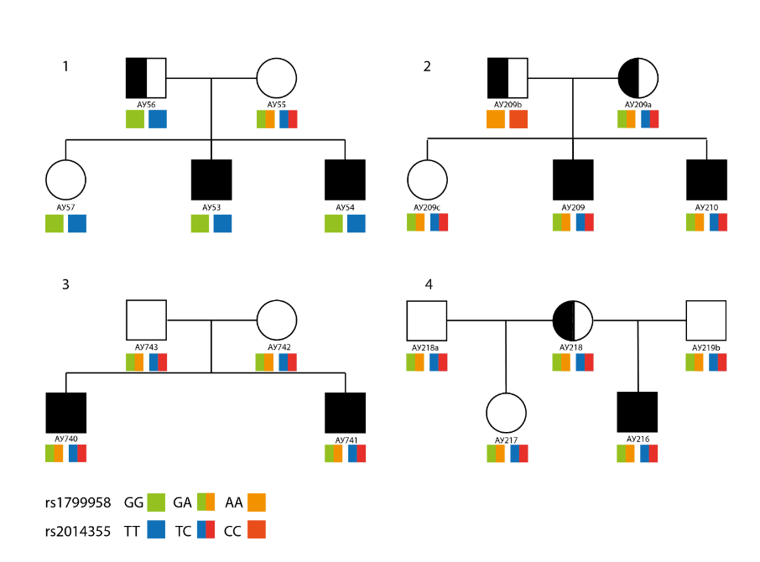

Figure 2 - Inheritance of ACADS gene mutations c.625G> A (Gly185Ser, rs1799958) and c.473-116T> C (rs2014355) in families with hereditary ASD burden

It is known that the ACADS gene encodes the enzyme acyl-CoA dehydrogenase of short-chain fatty acids (SCAD-Short-chain acyl-CoA dehydrogenase), which carries out the first β-oxidation reaction of short-chain fatty acids (C3-C8) in the matrix of cell mitochondria. The ACADS gene is located on the long arm of chromosome 12 and occupies 13 kbp, has 10 exons and 11 GT / AG-like introns. Mutations in the ACADS gene lead to autosomal recessive enzymatic deficiency of the SCAD enzyme, the phenotypic manifestations of which can be very diverse. It is noteworthy that even the carriage of homozygous negative mutations in the ACADS gene does not always correlate with the obvious clinical symptoms of SCAD deficiency: hypoglycemia, nausea, problems with growth and development, tachypnea, decreased muscle tone and problems with the development of the central nervous system [45]. On the contrary, in most cases, homozygous carriers of mutations develop without visible pathologies and are detected randomly in children in adolescence and adults, or during neonatal screening. It should be kept in mind, that neonatal genetic screening for ACADS gene deficiency is associated with a number of financial and economic difficulties and is mandatory only in a number of developed countries. Therefore, it should be expected that SCAD genetic deficiency occurs in a population much more often than it is established for each population based on clinical case registration. And, the global prevalence of SCAD deficiency is less than 1:40 000 - 1: 100 000 [46]. According to the literature, the recessive nature of the ACADS gene mutations is not always observed. For example, Corydon et al. showed the presence of a heterozygous mutation in the ACADS gene, associated with neonatal hypotension and early developmental delay, supplemented by positive tests for the presence of acylcarnitines, ethylmalonic and methylmalonic organic acids in the blood. Sequencing of the ACADS gene did not reveal other mutations the that could serve as an additional genetic factor for such an early and severe manifestation of SCAD deficiency [47]. However, this does not exclude the presence of additional mutations in other genes functionally associated with the activity of the ACADS gene. To date, about 100 mutations in the ACADS gene have been identified, and some of them, apparently, play the role of polymorphisms in the population. For example, two mutations c.511C> T (Arg147Trp) and c.625G> A (Gly185Ser) are marked for the European population as polymorphisms, since they occur in the population much more often than other identified mutations [48]. The significance of these mutations, like other less common nucleotide modifications, has not been sufficiently studied at the molecular level and remains the subject of open discussions.
Despite this, the two mutations identified in our study are of clinical relevance in the literature. The c.625G> A (Gly185Ser) mutation was noted in the ClinVar database [49], OMIM [50], and the second, less common mutation c.473-116T> C (rs2014355), in the ClinVar database [51]. Both mutations are associated with enzymatic deficiency of the SCAD enzyme and are accompanied by various phenotypic manifestations, mainly associated with disorganization of the development and functioning of central nervous system.
There is a wide variability in the manifestations of SCAD deficiency for mutations c.625G> A and / or c.473-116T> C: from the absence of a clinical symptoms to severe malformations and/or functioning. In our study, all patients with ASD, as well as their relatives who are carriers of biallelic mutations 625G> A/473-116T> C, prior to the present SNP typing, did not go to medical institutions for obvious clinical symptoms associated with SCAD deficiency. In this regard, no data on the biochemical blood profile for the presence of characteristic markers of SCAD deficiency were available. Correlation analysis of SCAD enzyme deficiency and genetic status of family members with ASD in this study is not possible, but will be taken into account in subsequent studies.
The role of c.625G> A and/or c.473-116T> C mutations in the development of ASD has not been established, and data on SCAD enzymatic insufficiency in ASD are very limited [52]. Based on the clinical significance of the c.625G> A and/or c.473-116T> C mutations, they refer to inborn errors of metabolism (IEM) and together with other IEMs, are observed only in 1-3% of patients with ASD [53]. Being involved in the disruption of the normal processes of β-oxidation of short-chain fatty acids, these mutations are believed to be potential sources of mitochondrial dysfunction, biochemical markers of which (acyl-carnitine profile, organic acid profile) are often observed in ASD [54]. However, for most cells of the body, the activity of the mitochondrial energy pool through β-oxidation of short-chain fatty acids is insignificant, compared to more energy-intensive medium-chain (MCAD enzyme) and long-chain fatty acids (VLCAD enzyme) [55]. Apparently, in most cases, enzymatic SCAD deficiency in cells can be compensated by the activity of biochemical pathways through MCAD and/or VLCAD, which gives such a heterogeneous clinical picture of SCAD deficiency. However, the functional significance of genetic SCAD deficiency becomes relevant when various kinds of stressful conditions occur. Fasting/high-fat diet, unbalanced physical activity and infections are the most important for SCAD deficiency [56] . It has been shown that even a short-term high-fat diet in SCAD-knockout mice (Acads -/-) promotes the development of energy-deficient states of liver and brain cells and their adaptive peroxisomal/mitochondrial reorganization of fatty acids oxidation with a change in the acylcarnitine profile and activation of pAMP-kinase signals [57, 58].
The only cells for which SCAD deficiency is not energetically compensated are colonocytes (epithelial cells) of the large intestine. The uniqueness of colonocytes lies in the fact that they use exclusively butyric acid (short-chain fatty acid, butyrate, C4) as an energy source for their vital activity. Butyric acid produced by fermenting bacteria in the lumen of the large intestine is actively absorbed by differentiated colonocytes, with its subsequent utilization through β-oxidation. Normally, β-oxidation of butyric acid requires constant activity of the SCAD enzyme in the mitochondria of colonocytes [59], and enzymatic SCAD deficiency will negatively affect the homeostasis of the microbiome-gut system. As shown by the studies of Kaiko et al., bacterial butyric fermentation, the substrate for which is indigestible dietary fiber, negatively modulates the proliferative activity of stem cells located at the base of intestinal crypts [60, 61]. Colonocytes, using metabolites produced by the gut microbiome as an energy source, modulate the proliferative activity of stem cells, maintaining the anatomical and functional integrity of the colon epithelium and functioning of the microbiome-gut-brain axis. Insufficiency of the SCAD enzyme, including mutational, leads to the fact that colonocytes switch to the use of medium and long-chain fatty acids as an energy substrate [62, 63]. ACADS-mediated adaptive reorganization of the colonocyte metabolome affects the functional profile of the microbiome-gut-brain axis, which has its own characteristics in ASD. For example, most patients with ASD already have an extremely unstable and altered intestinal bacterial ecosystem, with a shift in the ratio of the two main groups: Bacteroidetes/Firmicutes [64-68.]. ACADS-mediated reorganization of colonocytes also leads to a negative change in the biodiversity of Firmicutes [69]. The overlap of two pathological processes will tend to further disorganize the intestine microbiological balance in carriers of pathological ACADS mutations, with subsequent synthesis of pro-inflammatory factors, weaken the protective properties of the epithelial barrier and developing leaky gut syndrome.
Presumably, the presence of these pathological mutations does not mean a 100% effect on the development and/or enhancement of ASD symptoms, but is a weak link in signal transmission along the microbiome-gut-brain axis in susceptible individuals. Available contradictory data on a positive direct correlation between the degree of dysbiosis in patients with ASD and the development/aggravation of symptoms of ASD [70], indicate the need for a genetic and functional assessment of the remaining links (clusters) of the microbiome-gut-brain axis, its adaptive capabilities, as well as a thorough assessment of the eating behavior of family members with ASD and their lifestyle.
All of the above confirms the fact that not all carriers of the mutations identified by us in the ACADS gene develop the ASD phenotype, as well as the fact that ACADS normal children have the ASD phenotype. Even the father of family No. 2, carrying homozygous alleles for two mutations, is phenotypically healthy ASD, however, belongs to the extended phenotype group.
But of greatest interest to us was the fact that all women from four families had ACADS mutations.
A woman's health is directly related to the health of her future children. The risk of developing autism increases if a pregnant woman has concomitant diseases, for many of which a statistically significant association has been established [71]. There is no evidence to support any specific etiological factor that provokes ASD-associated changes in the development of the embryo/fetus. The accumulated data suggest that, there is an intrauterine RAS-associated reorganization of embryo/fetus under the influence of factors from the maternal organism and, moreover, it may be one of the important links in pathogenesis. The presence of a protective placental barrier for the fetus limits the impact of many etiological factors directly, but is not an obstacle to the indirect effect of these factors on the fetus through maternal hormones, immunoglobulins, viruses, metabolites and various kinds of toxins [72-75] Transport of small molecules, such as lipids, glucose, amino acids, ions, have practically unlimited transport through the endothelial cells of the capillary barrier, thereby affecting the development of the fetus [76]. In other words, the adaptive capabilities of the mother determine the fate of the developing fetus and are the cause of methodological deviations associated with the heterogeneity of the risk factors for ASD in various studies. Genetic variability underlying the adaptive processes and the woman's predisposition to various kinds of pathological conditions could lead to a familial predisposition for ASD.
Pregnancy is a period of systemic metabolic changes in a woman's body, aimed at rational redistribution of the energy homeostasis of the mother and the developing fetus. Adaptive stress conditions that a woman's body undergoes, primarily contribute to a change in lipid metabolism, the microbiological profile of the intestine and a shift in the ratio of intestinal short-chain fatty acids. Assessment of SCFA levels in the blood plasma of pregnant women shows an increase in the concentrations of acetic and propionic acids, of which, acetic acid is actively metabolized in the mother's liver, providing her and the fetus with energy resources. However, SCAD enzyme deficiency and stressful conditions, with the active mobilization of β-oxidation of SCFA pool, an energy deficiency state is formed, which, apparently, will have negative consequences for the correct development of the fetus and the course of pregnancy. In addition, it is known that propionic acid, through G-protein receptors, determines the development and metabolic reprogramming of the fetus in pregnant women [77]. It has been shown that an increase of propionic acid physiological concentrations, in the blood of experimental mice, promotes disruption of glial cell proliferation and disorganization of neural networks, accompanied by the development of inflammation in the brain in offspring [78]. Taking this into account, it can be assumed that changes in the metabolic-microbiological profile of the intestine during pregnancy, against the background of already existing congenital metabolic errors, will contribute to RAS-associated changes in fetal development. Probably, the family history of ASD, in our study, is associated precisely with the indirect manifestation of the genetic deficiency of the SCAD enzyme, in combination with the influencing risk factors for these families. Unfortunately, the limitation of the study is the inaccessibility of many important clinical and biochemical parameters of the participants, which will be taken into account in further studies.
All the above data give reason to believe that primary ASD-associated disorders occur precisely during the period of intrauterine development of the fetus and depend on the genetic adaptive capabilities of the mother. The manifestation or intensification of the underlying ASD-associated disturbances in the postnatal period, on the background of genetic ACADS deficiency, will most likely depend on the superposition of many external factors.
In conclusion, several limitations of the study should be noted. The investigated markers included a very small number of mtDNA variants, which may lead to an incomplete picture of the complex genetic architecture of ASD. Defects in nDNA genes encoding proteins that are required to maintain mtDNA can lead to mtDNA instability. This can manifest itself through the occurrence of point mutations, multiple deletions, copy number variants, or their combinations in mtDNA [79]. In family No. 4, a mother with BAP has two children from different marriages with healthy men. In this case, autism may be due to mutations in mtDNA, which requires a more complete study of the mitochondrial genome than was carried out by us.
Further, we cannot confirm with certainty whether any of these genes actually contribute to the disease, but the results of this analysis provide a priority list for further validation studies. It is possible that other undetected or uncharacterized variants not considered in this study may contribute. However, many ASD risk genes identified for studied families are considered penetrant enough to induce phenotypes characteristic of ASD.
Although our current study is limited to the number of families surveyed, the findings indicate that the significant genetic heterogeneity of ASD (both between and within a family) requires examination of the genome of each individual. These findings represent an important first step for a much larger initiative to study the genomes of thousands of other families with ASD in Kazakhstan.

CONCLUSION

In the presence of a high level of loci heterogeneity (as is very likely in ASD), a potentially useful approach to identifying candidate variants is to study large families with many affected individuals. Examining broadly defined ASD-related traits, such as BAP, is another potential way to increase power to detect candidate variants.
These approaches were applied in this Project, which is one of the first genomic studies of families with hereditary burden of autism in Kazakhstan. The obtained results allow us to discuss the relative advantages of searching for genetic causes of the disease in large pedigrees in the context of neuropsychiatric diseases, and also clearly show how many genes and metabolic pathways underlie the development of ASD.
A total of 4 families (19 people, including 8 children with ASD) with hereditary ASD burden have been studied. Using genome scanning on the Illumina® Global Screening Array (GSA) platform we identified 78 dbSNPs associated with ASD development, as well as 61 rare inherited variants and 14 de-novo mutations. By examining de novo gene variations, we found that affected siblings carried discordant mutations associated with nervous system disorders while exhibiting different degrees of ASD severity. These data suggest that the identified dbSNPs and rare heritable variants exerted a general genomic load and determined the hereditary form of ASD, while de novo mutations determined the clinical severity of autism. While we were unable to confirm with certainty whether any of the identified genetic variants are actually contributing to the disease, our analysis provides a list of priorities for further validation studies.
The greatest interest in the study is the fact that all mothers from four families showed biallelic mutations in the ACADS gene, which plays a major role in mitochondrial oxidation of short-chain fatty acids. We are putting forward a hypothesis that the energy-deficient states of the mother and the fetus, caused by the mutations in the ACADS gene, may contribute to the development of ASD under stressful conditions. Primary ASD-associated changes occur during the period of intrauterine development of the fetus and are manifested/intensified in the child in the postnatal period, when exposed to environmental factors.
This project should be seen as a way to reaffirm the problem of autism and draw attention to the need of further search for the causes of its development. The project was carried out in close collaboration with the families. The positive feedback received from the parents of children with ASD indicates the relevance of the research and the need for further work in this area. Further deepening of knowledge about the role of candidate variants in the development of ASD will contribute to the emergence of new diagnostic biomarkers and will open up new therapeutic opportunities that affect the genetic pathogenesis of this disease.

REFERENCES

- Why Kazakhstan cannot ignore the problem of autism [Electronic resource]. — 2020. — URL: https://kursiv.kz/news/obschestvo/2020-03/pochemu-kazakhstanu-nelzya-ignorirovat-problemu-autizma (дата обращения 12.03.2021).
- WHO. — URL: https://www.who.int/news-room/fact-sheets/detail/autism-spectrum-disorders (дата обращения 15.10.2021).
- CDC. — URL: https://www.cdc.gov/ncbddd/autism/data.html (дата обращения 15.10.2021).
- NIHDS. — URL: https://www.ninds.nih.gov/Disorders/Patient-Caregiver-Education/Fact-Sheets/Autism-Spectrum-Disorder-Fact-Sheet (дата обращения 15.10.2021).
- Johnson C.P., Myers S.M., Lipkin P.H., Cartwright J.D., Desch L.W., Duby J.C., Elias E.R., et al. Identification and Evaluation of Children with Autism Spectrum Disorders // Pediatrics. - 2007. – Vol. 120. – P. 1183-1215.
- Skefos J., Cummings C., Enzer K., Holiday J., Weed K., Levy E., et al. Regional Alterations in Purkinje Cell Density in Patients with Autism // PLoS One. – 2014. - Vol. 9. – e81255
- Stoodley C.J., D’Mello A.M., Ellegood J., Jakkamsetti V., Liu P., Nebel M.B., et al. Altered Cerebellar Connectivity in Autism and Cerebellar-Mediated Rescue of Autism-Related Behaviors in Mice // Nat. Neurosci. - 2017. - Vol. 20. – P. 1744–1751.
- De Rubeis S., He X., Goldberg A.P., Poultney C.S., Samocha K., Cicek A.E., et al. Synaptic, Transcriptional and Chromatin Genes Disrupted in Autism // Nature. - 2014. - Vol. 515. – P. 209–215.
- Shen M.D., Kim S.H., McKinstry R.C., Gu H., Hazlett H.C., Nordahl C.W., et al. Increased Extra-Axial Cerebrospinal Fluid in High-Risk Infants Who Later Develop Autism // Biol. Psychiatry. - 2017. - Vol. 82. – P. 186-193.
- Hazlett H.C., Gu H., Munsell B.C., Kim S.H., Styner M., Wolff J.J., et al. Early Brain Development in Infants at High Risk for Autism Spectrum Disorder // Nature. - 2017. - Vol. 542. – P. 348–351.
- Ashwood P., Wills S., Van de Water J. The Immune Response in Autism: A New Frontier for Autism Research // J. Leukoc. Biol. - 2006. - Vol. 80. – P. 1-15.
- Penn H.E.. Neurobiological Correlates of Autism: A Review of Recent Research // Child Neuropsychol. - 2006. - Vol. 12. – P. 57-59.
- Manzi B., Loizzo A.L., Giana G., Curatolo P. Autism and metabolic diseases // J Child Neurol. - 2008. - Vol. 23(3). -P. 307-314.
- Ornoy A., Weinstein-Fudim L., Ergaz Z. Prenatal Factors Associated with Autism Spectrum Disorder (ASD) // Reprod. Toxicol. - 2015 - Vol. 15. – P. 155-169.
- Hisle-Gorman E., Susi A., Stokes T., Gorman G., Erdie-Lalena C., Nylund C.M. Prenatal, Perinatal, and Neonatal Risk Factors of Autism Spectrum Disorder // Pediatr. Res. - 2018. - Vol. 84. – P. 190-198.
- AAP. — URL: https://drgreenmom.com/wp-content/uploads/2014/01/AAP-vaccine-studies.pdf (дата обращения 15.10.2021).
- Amaral D.G. Examining the Causes of Autism // Cerebrum. – 2017. - cer-01-17.
- Taylor M.J., Rosenqvist M.A., Larsson H., Gillberg C., D’Onofrio B.M., Lichtenstein P., Lundström S. Etiology of Autism Spectrum Disorders and Autistic Traits over Time // JAMA Psychiatry. - 2020. - Vol. 77.
- Бретт С. А., Даниэль Х. Гешвинд Прогресс в генетике аутизма: на пороге новой нейробиологии [Electronic resource]. http://www.aspergers.ru/system/files/Advances-in-genetics_ru.pdf
- Folstein S., Rutter M. Infantile autism: a genetic study of 21 twin pairs // J. Child Psychol. Psychiatry. – 1977. - Vol. 18. – P. 297-321.
- Losh M., Martin G.E., Klusek J., Hogan-Brown A.L., Sideris J. Social Communication and Theory of Mind in Boys Withautism and Fragile X Syndrome // Front. Psychol. – 2012 - Vol. 3. – P. 266.
- Robinson E.B., Koenen K.C., McCormick M.C., Munir K., Hallett V., Happé F., Plomin R., Ronald A. Evidence That Autistic Traits Show the Same Etiology in the General Population and at the Quantitative Extremes (5%, 2.5%, and 1%) // Arch. Gen. Psychiatry. - 2011. - Vol. 68. – P. 1113-1121.
- Sucksmith E., Roth I., Hoekstra R.A. Autistic Traits below the Clinical Threshold: Re-Examining the Broader Autism Phenotype in the 21st Century // Neuropsychol. Rev. - 2011- Vol. 21. – P. 360–389.
- Pickles A., Bolton P., Macdonald H., Bailey A., Le Couteur A., Sim C.H., Rutter M. Latent-Class Analysis of Recurrence Risks for Complex Phenotypes with Selection and Measurement Error: A Twin and Family History Study of Autism // Am. J. Hum. Genet. - 1995. - Vol. 57. – P. 717–726.
- Risch N., Spiker D., Lotspeich L., Nouri N., Hinds D., Hallmayer J., et al. A Genomic Screen of Autism: Evidence for a Multilocus Etiology // Am. J. Hum. Genet. - 1999. - Vol. 65. – P. 493–507.
- Szatmari P., Paterson A.D., Zwaigenbaum L., Roberts W., Brian J., Liu X.Q., et al. Mapping Autism Risk Loci Using Genetic Linkage and Chromosomal Rearrangements // Nat. Genet. - 2007. - Vol. 39. – P. 319-328.
- Brandler W.M., Antaki D., Gujral M., Kleiber M.L., Whitney J., Maile M.S., et al. Paternally Inherited Cis-Regulatory Structural Variants Are Associated with Autism // Science. - 2018. - Vol. 360. – P. 327–331..
- Nemirovsky S.I., Córdoba M., Zaiat J.J., Completa S.P., Vega P.A., González-Morón D., et al. Whole Genome Sequencing Reveals a de Novo SHANK3 Mutation in Familial Autism Spectrum Disorder // PLoS One. - 2015. - Vol. 10. – e0116358.
- Krumm N., Turner T.N., Baker C., Vives L., Mohajeri K., Witherspoon K., et al. Excess of Rare, Inherited Truncating Mutations in Autism // Nat. Genet. - 2015- Vol. 47. – P. 582–588.
- Chang J., Gilman S.R., Chiang A.H., Sanders S.J., Vitkup D. Genotype to Phenotype Relationships in Autism Spectrum Disorders // Nat. Neurosci. – 2015. - Vol. 18. – P. 191–198.
- Jiang Y.H., Yuen R.K.C., Jin X., Wang M., Chen N., Wu X., et al. Detection of Clinically Relevant Genetic Variants in Autism Spectrum Disorder by Whole-Genome Sequencing // Am. J. Hum. Genet. - 2013. - Vol. 93. – P. 249-263.
- Shi L., Zhang X., Golhar R., Otieno F.G., He M., Hou C., et al. Whole-genome sequencing in an autism multiplex family // Mol Autism. -2013. - Vol. 8.
- Iossifov I., Levy D., Allen J., Ye K., Ronemus M., Lee Y.H., et al. Low Load for Disruptive Mutations in Autism Genes and Their Biased Transmission // Proc. Natl. Acad. Sci. U. S. A. – 2015. - Vol. 112. – P. E5600-E5607.
- Szatmari P., Paterson A.D., Zwaigenbaum L., Roberts W., Brian J., Liu X.Q., et al. Mapping Autism Risk Loci Using Genetic Linkage and Chromosomal Rearrangements // Nat. Genet. - 2007. - Vol. 39. – P. 319-328.
- Yuen R.K.C., Thiruvahindrapuram B., Merico D., Walker S., Tammimies K., Hoang N., et al. Whole-Genome Sequencing of Quartet Families with Autism Spectrum Disorder // Nat. Med. - 2015. - Vol. 21. – P. 185-191.
- Расстройства аутистического спектра. Вводный курс. Учебное пособие для студентов. Григоренко Е.Л. — М.: Практика, 2018. — 280 с
- Iakoucheva L.M., Muotri A.R., Sebat J. Getting to the Cores of Autism // Cell. -2019. - Vol. 178. – P. 1287-1298.
- Ijichi S., Ijichi N., Ijichi Y., Sameshima H., Moriok H. The Genetic Basis of Phenotypic Diversity: Autism as an Extreme Tail of a Complex Dimensional Trait in Autism Spectr. Disord. Role Genet. Diagnosis Treat. - 2011.
- Milh M., Boutry-Kryza N., Sutera-Sardo J., Mignot C., Auvin S., Lacoste C., et al. Similar Early Characteristics but Variable Neurological Outcome of Patients with a de Novo Mutation of KCNQ2 // Orphanet J. Rare Dis. - 2013.
- Lindy A.S., Stosser M.B., Butler E., Downtain-Pickersgill C., Shanmugham A., Retterer K., et al. Diagnostic outcomes for genetic testing of 70 genes in 8565 patients with epilepsy and neurodevelopmental disorders // Epilepsia. – 2018. – Vol. 59. – P. 1062–1071.
- Kim E.C., Patel J., Zhang J., Soh H., Rhodes J.S., Tzingounis A.V., Chung H.J. Heterozygous Loss of Epilepsy Gene KCNQ2 Alters Social, Repetitive and Exploratory Behaviors // Genes, Brain Behav. – 2020. - Vol. 19. – e12599.
- Wu J., Yu P., Jin X., Xu X., Li J., Li Z., et al. Genomic Landscapes of Chinese Sporadic Autism Spectrum Disorders Revealed by Whole-Genome Sequencing // J. Genet. Genomics. - 2018. - Vol. 45. – P. 527-538.
- López-Hernández T., Sirisi S., Capdevila-Nortes X., Montolio M., Fernández-Dueñas V., Scheper G.C., et al. Molecular Mechanisms of MLC1 and GLIALCAM Mutations in Megalencephalic Leukoencephalopathy with Subcortical Cysts // Hum. Mol. Genet. – 2011. - Vol. 20. – P. 3266-3277.
- López-Hernández T., Ridder M.C., Montolio M., Capdevila-Nortes X., Polder E., Sirisi S., et al. Mutant GlialCAM Causes Megalencephalic Leukoencephalopathy with Subcortical Cysts, Benign Familial Macrocephaly, and Macrocephaly with Retardation and Autism // Am. J. Hum. Genet. – 2011. - Vol. 88. – P. 422-432.
- An S.J., Kim S.Z., Kim G.H., Yoo H.W., Lim H.H. Compound Heterozygous Mutations of Acads Gene in Newborn with Short Chain Acyl-CoA Dehydrogenase Deficiency: Case Report and Literatures Review // Korean J. Pediatr. – 2016. - Vol. 59. – S45-S48.
- National Organization for Rare Disorders I. Short Chain Acyl CoA Dehydrogenase Deficiency [Electronic resource]. 2019. URL: https://rarediseases.org/rare-diseases/short-chain-acyl-coa-dehydrogenase-deficiency-scad/.
- Corydon M.J., Vockley J., Rinaldo P., Rhead W.J., Kjeldsen M., Winter V., et al. Role of Common Gene Variations in the Molecular Pathogenesis of Short-Chain Acyl-CoA Dehydrogenase Deficiency // Pediatr. Res. – 2001. – Vol. 49. - P. 18-23.
- Gregersen N., Winter V.S., Corydon M.J., Corydon T.J., Rinaldo P., Ribes A., et al. Identification of Four New Mutations in the Short-Chain Acyl-CoA Dehydrogenase (SCAD) Gene in Two Patients: One of the Variant Alleles, 511C→T, Is Present at an Unexpectedly High Frequency in the General Population, as Was the Case for 625G→A, Together // Co. Hum. Mol. Genet. - 1998. - Vol. 7. – P. 619-627.
- NCBI. ClinVar;NM_000017.4(ACADS):c.625G>A (p.Gly209Ser) [Electronic resource]. - URL: https://www.ncbi.nlm.nih.gov/clinvar/variation/3831/ (дата обращения 15.10.2021).
- OMIM®. 606885: ACYL-CoA DEHYDROGENASE, SHORT-CHAIN; ACADS [Electronic resource]. - 2011. - URL: https://www.omim.org/entry/606885#0007 (дата обращения 15.10.2021).
- NCBI. Reference SNP (refSNP) Cluster Report: rs2014355 [Electronic resource]. - URL: https://www.ncbi.nlm.nih.gov/snp/rs2014355?horizontal_tab=true (дата обращения 15.10.2021).
- Waisbren S.E., Levy H.L., Noble M., Matern D., Gregersen N., Pasley K., Marsden D. Short-Chain Acyl-CoA Dehydrogenase (SCAD) Deficiency: An Examination of the Medical and Neurodevelopmental Characteristics of 14 Cases Identified through Newborn Screening or Clinical Symptoms // Mol. Genet. Metab. - 2008. - Vol. 65. – P. 39-45.
- Kiykim E., Zeybek C.A., Zubarioglu T., Cansever S., Yalcinkaya C., Soyucen E., Aydin A. Inherited Metabolic Disorders in Turkish Patients with Autism Spectrum Disorders // Autism Res. – 2016. - - Vol. 9 – P. 217-223.
- Rossignol D.A., Frye R.E. Mitochondrial Dysfunction in Autism Spectrum Disorders: A Systematic Review and Meta-Analysis // Mol. Psychiatry. – 2012. - - Vol. 17. – P. 290-314.
- Schönfeld P., Wojtczak L. Short- and Medium-Chain Fatty Acids in Energy Metabolism: The Cellular Perspective // J. Lipid Res. - 2016.
- Van Maldegem B.T., Duran M., Wanders R.J.A, Niezen-Koning K.E., Hogeveen M., Ijlst L., et al. Clinical, Biochemical, and Genetic Heterogeneity in Short-Chain Acyl-Coenzyme A Dehydrogenase Deficiency // J. Am. Med. Assoc. – 2006. - Vol. 296. – P. 943-952.
- Ghosh S., Kruger C., Wicks S., Simon J., Kumar K.G., Johnson W.D., et al. Short Chain Acyl-CoA Dehydrogenase Deficiency and Short-Term High-Fat Diet Perturb Mitochondrial Energy Metabolism and Transcriptional Control of Lipid-Handling in Liver // Nutr. Metab. - 2016.
- Kruger C., Kumar K.G., Mynatt R.L., Volaufova J., Richards B.K. Brain Transcriptional Responses to High-Fat Diet in Acads-Deficient Mice Reveal Energy Sensing Pathways // PLoS One. – 2012.
- Bultman S.J. Butyrate Consumption of Differentiated Colonocytes in the Upper Crypt Promotes Homeostatic Proliferation of Stem and Progenitor Cells near the Crypt Base // Transl. Cancer Res. – 2016.
- Kaiko G.E., Ryu S.H., Koues O.I., Collins P.L., Solnica-Krezel L., Pearce E.J., et al. The Colonic Crypt Protects Stem Cells from Microbiota-Derived Metabolites // Cell. - 2016- Vol. 165. – P. 1708-1720.
- Rutering J., Ilmer M., Recio A., Coleman M., Vykoukal J., Alt E., Orleans N. The Colonic Crypt Protects Stem Cells from Microbiota-Derived Metabolites // Cell. - 2016. - Vol. 165. – P. 1708-1720.
- Wood P.A., Amendt B.A., Rhead W.J., Millington D.S., Inoue F., Armstrong D. Short-Chain Acyl-Coenzyme A Dehydrogenase Deficiency in Mice // Pediatr. Res. - 1989. - Vol. 25. - P. 38-43.
- Smith S.A., Ogawa S.A., Chau L., Whelan K.A., Hamilton K.E., Chen J., et al. Mitochondrial Dysfunction in Inflammatory Bowel Disease Alters Intestinal Epithelial Metabolism of Hepatic Acylcarnitines // J. Clin. Invest. - 2021. - Vol. 131. – e133371.
- Peng L., Li Z.R., Green R.S., Holzman I.R., Lin J. Butyrate Enhances the Intestinal Barrier by Facilitating Tight Junction Assembly via Activation of AMP-Activated Protein Kinase in Caco-2 Cell Monolayers // J. Nutr. - 2009. - Vol. 139. – P. 1619-1625.
- Li Q., Han Y., Dy A.B.C., Hagerman R.J. The Gut Microbiota and Autism Spectrum Disorders // Front. Cell. Neurosci. – 2017.
- Liu S., Li E., Sun Z., Fu D., Duan G., Jiang M. et al. Altered Gut Microbiota and Short Chain Fatty Acids in Chinese Children with Autism Spectrum Disorder // Sci. Rep. - 2019.
- Srikantha P., Hasan Mohajeri M. The Possible Role of the Microbiota-Gut-Brain-Axis in Autism Spectrum Disorder // Int. J. Mol. Sci. – 2019. - Vol. 20.
- Choi J., Lee S., Won J., Jin Y., Hong Y., Hur T.Y., et al. Pathophysiological and Neurobehavioral Characteristics of a Propionic Acid-Mediated Autism-like Rat Model // PLoS One. – 2018. - Vol. 13. – e0192925.
- Gasaly N., Hermoso M.A., Gotteland M. Butyrate and the Fine-Tuning of Colonic Homeostasis: Implication for Inflammatory Bowel Diseases // Int. J. Mol. Sci. – 2021. - Vol. 22.
- Ho L.K.H., Tong V.J.W., Syn N., Nagarajan N., Tham E.H., et al. Gut Microbiota Changes in Children with Autism Spectrum Disorder: A Systematic Review // Gut Pathog. - 2020. - Vol. 12.
- Gardener H., Spiegelman D., Buka S.L. Prenatal Risk Factors for Autism: Comprehensive Meta-Analysis // Br. J. Psychiatry. – 2009. - Vol. 1. – P. 7-14.
- Chan S.Y., Vasilopoulou E., Kilby M.D. The Role of the Placenta in Thyroid Hormone Delivery to the Fetus // Nat. Clin. Pract. Endocrinol. Metab. - 2009. - Vol. 5. – P. 45-54.
- Palmeira P., Quinello C., Silveira-Lessa A.L., Zago C.A., Carneiro-Sampaio M. IgG Placental Transfer in Healthy and Pathological Pregnancies // Clin. Dev. Immunol. – 2012.
- Pemathilaka R.L., Caplin J.D,. Aykar S.S., Montazami R., Hashemi N.N. Placenta‐on‐a‐Chip: In Vitro Study of Caffeine Transport across Placental Barrier Using Liquid Chromatography Mass Spectrometry // Glob. Challenges. - 2019.
- Lager S., Powell T.L. Regulation of Nutrient Transport across the Placenta // J. Pregnancy. - 2012. – N. 179827.
- Dumolt J.H., Powell T.L., Jansson T. Placental Function and the Development of Fetal Overgrowth and Fetal Growth Restriction // Obstet. Gynecol. Clin. North Am. – 2021. - Vol. 48. – P. 247-266.
- Ziętek M., Celewicz Z., Szczuko M. Short‐chain Fatty Acids, Maternal Microbiota and Metabolism in Pregnancy // Nutrients. - 2021. - Vol. 13. – P. 1244.
- Abdelli L.S., Samsam A., Naser S.A. Propionic Acid Induces Gliosis and Neuro-Inflammation through Modulation of PTEN/AKT Pathway in Autism Spectrum Disorder // Sci. Rep. – 2019. - N. 8824.
- Ylikallio E., Suomalainen A. Mechanisms of Mitochondrial Diseases // Ann. Med. – 2012. - Vol. 44. – P. 41-59.

APPENDIX A
LEC conclusion
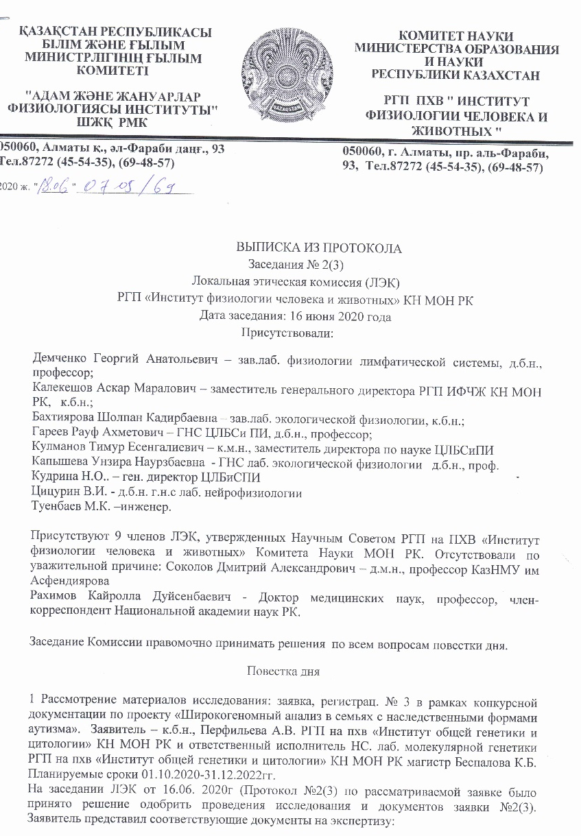
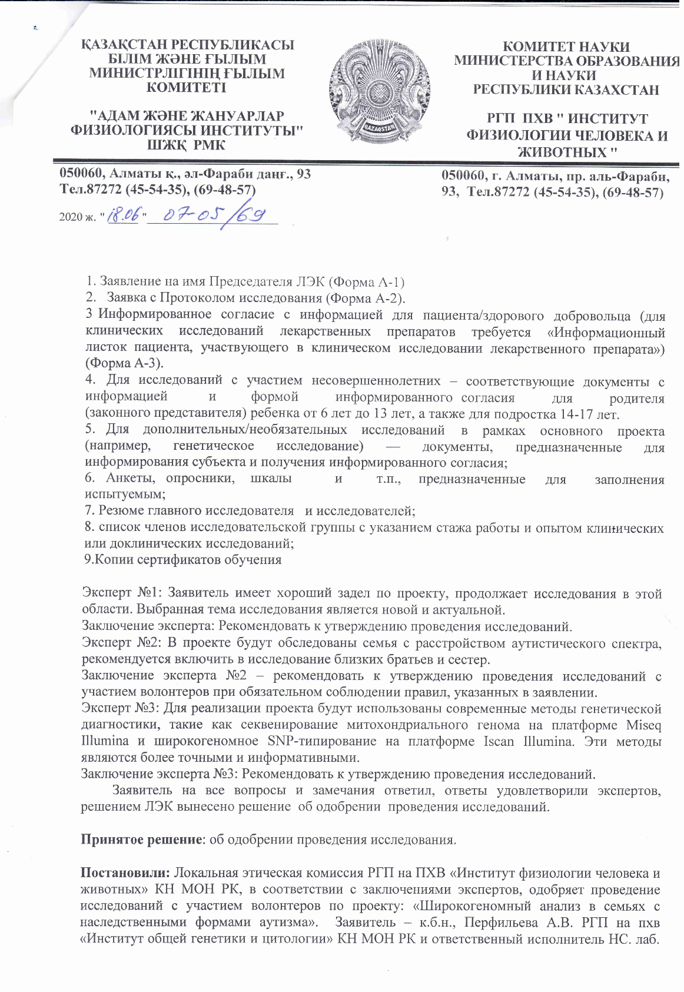
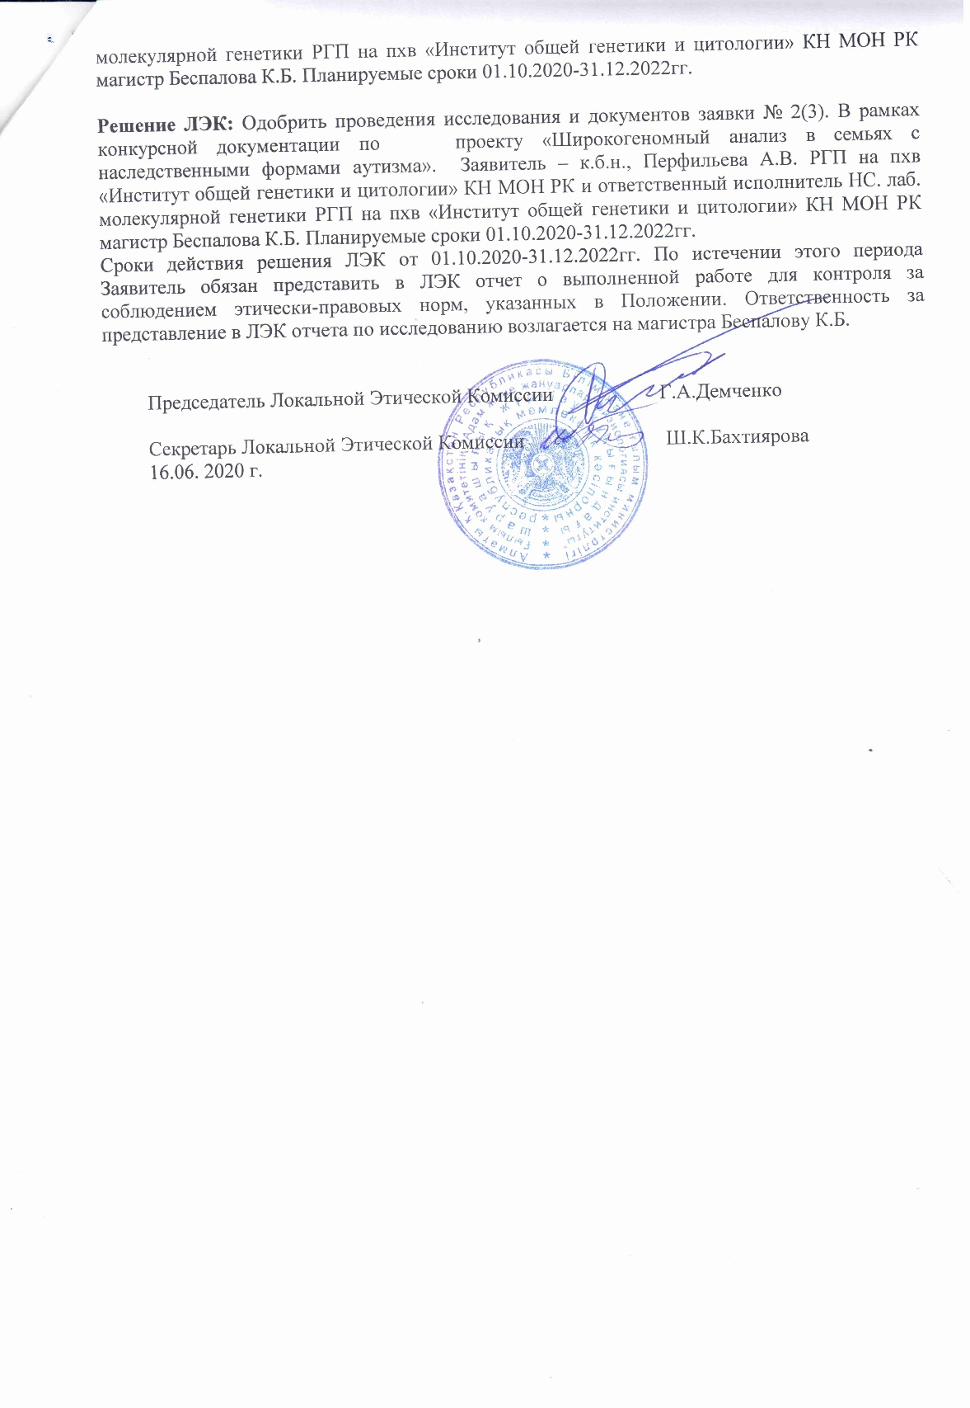

APPENDIX B
Characteristics of candidate genetic variants in four families with hereditary autism
Table B.1 – Characteristics of dbSNPs, associated with ASD according to the GWAS database
No | REGION | MAPPED_GENE | SNPS | CONTEXT | RISK ALLELE FREQUENCY | RISK ALLELE | FAMILY No
1 |  |  | rs6537825 | missense_variant | A=0.085217 (31257/366794, ALFA) | A | 2;3;4
2 |  |  | rs926938 | intergenic_variant | 0.50 | A | 1;2;3;4
3 | 12q23.1 | Y_RNA - NA | rs6538761 | intron_variant | A=0.349973 (99039/282990, ALFA) | A | 1;2;3;4
4 |  |  | rs4307059 | intron_variant | 0.61 | T | 1;2;3;4
5 | 8q24.13 | LINC01151 | rs12543592 | intron_variant | 0.5 | G | 1;2;3;4
6 | 17p13.3 | SGSM2 | rs2447097 | intron_variant | 0.261 | T | 1;2;3;4
7 | 1p21.1 | NA - CDK4P1 | rs11184553 | intergenic_variant | 0.460644 | A | 2;3;4
8 | 5q21.2 |  | rs325485 | intron_variant | 0.3738 | A | 1
9 | 6p22.1 | GPR89P - RSL24D1P1 | rs17693963 | intergenic_variant | 0.9135 | A | 1;2;3;4
10 | 10q25.1 | SORCS3 | rs1021363 | intron_variant | 0.337999999999999 | A | 1;2;3;4
11 | 13q21.32 | PCDH9 | rs77691144 | intron_variant | 0.9682 | T | 1;2;3;4
12 | 14q32.33 | RNU7-160P - BAG5 | rs10149470 | regulatory_region_variant | 0.487 | A | 1;2;3;4
13 | 1p31.1 | NEGR1 | rs1620977 | intron_variant | 0.26 | A | 1;3;4
14 | 3p14.2 | CADPS | rs1452075 | intron_variant | 0.721 | T | 1;2;3;4
15 | 5q21.2 |  | rs325485 | intron_variant | 0.378 | A | 1
16 | 5q33.2 | GALNT10 | rs34509057 | intron_variant | 0.226 | A | 1
17 | 11q24.2 | NRGN | rs55661361 | intron_variant | 0.348 | A | 1;2;3;4
18 | 2p16.1 | ACTG1P22 | rs11682175 | intron_variant | T=0.55781 | T | 1;2;3;4
19 | Xp22.12 | NA - CNKSR2 | rs1378559 | intron_variant | NR | T | 1;2;3;4
20 | Xq13.1 | NA - PJA1 | rs5937157 | intergenic_variant | NR | T | 1;2;3;4
21 | 7q21.11 | PCLO | rs2522831 | intron_variant | NR | T | 2;3;4
22 | 11q23.2 | DRD2 - NA | rs2514218 | intergenic_variant | NR | T | 3
23 | 18q21.2 | DCC | rs10164055 | intron_variant | NR | T | 1;2;3;4
24 | 18q21.2 | TCF4 | rs12967143 | intron_variant | C=0.44220 | C | 1;2;3;4
25 | 20q13.12 | SLC12A5 | rs12624433 | intron_variant | A=0.187508/6001 (ALFA) | A | 1;2;4
26 | 18q21.2 | NA - LINC01929 | rs11874716 | intergenic_variant |  | T | 1;2;3;4
27 |  |  | rs10791097 |  |  | T | 1;2;3;4
28 | 3p14.2 | FHIT | rs1353545 | intron_variant |  | C | 1;2;3;4
29 | 3p22.2 | HSPD1P6 - LINC02033 | rs75968099 | intergenic_variant |  | T | 1;3
30 | 11q24.1 | GRAMD1B | rs77502336 | intron_variant |  | C | 2;3;4
31 | 5q31.2 | ETF1 | rs3849046 | intron_variant |  | T | 1;2;3;4
32 | 14q24.2 | RGS6 | rs2332700 | intron_variant |  | C | 1;2;3;4
33 | 12p13.33 | CACNA1C, CACNA1C | rs1024582 | intron_variant |  | A | 1;2;4
34 | 4q33 | CLCN3 | rs10520163 | intron_variant |  | T | 1;2;3;4
35 | 7q33 | DGKI | rs3735025 | 3_prime_UTR_variant |  | T | 1;2;3;4
36 | 5q12.1 | SMIM15-AS1, LINC02057 | rs171748 | intron_variant |  | A | 1;2;3;4
37 | 17p13.3 | SRR | rs4523957 | intron_variant |  | T | 1;2;3;4
38 | 6p22.2 | BTN2A1 | rs1977199 | intron_variant |  | A | 1;2;3;4
39 |  |  | rs4129585 |  |  | A | 1;2;3;4
40 | 14q32.33 | KLC1, COA8 | rs12887734 | intron_variant |  | T | 1;2;3;4
41 | 5q33.2 | NA - GRIA1 | rs12522290 | regulatory_region_variant |  | C | 1;2;3;4
42 | 6p21.1 | ZNF318 - ABCC10 | rs73416724 | non_coding_transcript_exon_variant |  | A | 1;2;3;4
43 |  |  | rs7893279 |  |  | T | 1;2;3;4
44 | 6p21.33 | MSH5-SAPCD1, MSH5-SAPCD1, MSH5-SAPCD1, MSH5-SAPCD1, MSH5-SAPCD1, MSH5, MSH5, MSH5, MSH5, MSH5 | rs707939 | intron_variant |  | A | 1;2;3;4
45 | 8q24.3 | TSNARE1 | rs67756423 | intron_variant |  | A | 1;2;3;4
46 |  |  | rs5995756 |  |  | T | 1;2;3;4
47 | 6p22.1 | MIR3143 - RPL10P2 | rs911186 | intergenic_variant |  | A | 1;2;3;4
48 | 15q25.1 | CHRNA3 | rs8042374 | intron_variant |  | A | 1;2;3;4
49 | 3p26.3 | CNTN4 | rs17194490 | intron_variant |  | T | 3;4
50 | 6p22.2 | BTN3A2 | rs13218591 | 3_prime_UTR_variant |  | T | 1;2;3;4
51 | 6p21.33 | MUCL3, MUCL3, MUCL3, SFTA2 | rs3132581 | intron_variant |  | G | 1;2;3;4
52 | 2q37.1 | SNORC | rs2675968 | intron_variant | NR | T | 1;2;4
53 | 10q22.3 | ZMIZ1 | rs703970 | intron_variant | NR | C | 1;2;3;4
54 | 2q32.1 | ZNF804A | rs7597593 | intron_variant | NR | T | 3;4
55 | 7q33 | NA - ZP3P2 | rs10250997 | intergenic_variant | NR | C | 1;2;3;4
56 |  |  | rs9834970 |  | NR | C | 1;2;3
57 | 2p16.3 | FOXN2 - PPP1R21-DT | rs7565792 | intergenic_variant | NR | C | 1;2;3;4
58 | 10p14 | LINC00707 - NA | rs6602217 | intron_variant |  | T | 1;2;3;4
59 | 16p13.2 | RNA5SP403 - RNA5SP404 | rs12325410 | intron_variant |  | T | 1;2;3;4
60 | 16p13.2 | GRIN2A | rs8058295 | intron_variant |  | A | 3;4
61 |  |  | rs6694545 |  |  | A | 1;3;4
62 | 8p12 | RPL10AP3 - NA | rs2609653 | intergenic_variant |  | T | 1;2;3;4
63 | 18q21.2 | RNA5SP459 - TCF4 | rs9951150 | intergenic_variant |  | A | 1;2;3;4
64 | 1p31.1 | NA - ADGRL4 | rs10873998 | intergenic_variant |  | T | 1;2;3;4
65 | 15q25.3 | NTRK3 | rs1104918 | intron_variant |  | T | 1;2;3;4
66 | 2q11.2 | IL1R2 - IL1R1 | rs2310173 | intron_variant |  | T | 2;3;4
67 | 13q33.3 |  | rs12871532 | intergenic_variant |  | T | 1;2;3;4
68 | 5q23.3 | NA - HINT1 | rs6867265 | intergenic_variant |  | A | 1;2;3;4
69 | 5q32 | PPP2R2B | rs609412 | intron_variant |  | A | 1;2;3;4
70 | 4q31.3 | RNA5SP169 - NA | rs360932 | intron_variant |  | A | 1;2;4
71 | 2q31.3 |  | rs13418455 | intergenic_variant |  | T | 2;3;4
72 | 2q37.3 | HDAC4 | rs3791556 | intron_variant |  | A | 1;2;3;4
73 | 1p31.1 |  | rs4650608 | intergenic_variant | NR | T | 1;2;3;4
74 | 7p22.3 | MRM2 | rs7799006 | 3_prime_UTR_variant | NR | C | 1;2;3;4
75 | 8p12 | PPP1R3B - RPL10AP3 | rs6990255 | intron_variant | NR | T | 2;4
76 | 9p24.3 | SMARCA2 - RN7SL592P | rs4741652 | intergenic_variant | NR | T | 1;2;3;4
77 | 10q21.2 | ANK3 | rs10994359 | intron_variant | NR | C | 1;2;3;4
78 | 8q23.1 | ZFPM2 | rs9297357 | intron_variant | NR | T | 1;2;3;4
Continuation of table B.1
Table B.2 - Characteristics of rare inherited variants
Continuation of table B.2
No | Name | Gene(s) | Protein change | Clinical significance (Last reviewed) | Chromosome | dbSNP ID | GMAF | Type | Family No
1 | NM_003060.4(SLC22A5):c.248G>T (p.Arg83Leu) | SLC22A5 | R83L | Pathogenic/Likely pathogenic(Last reviewed: Oct 31, 2020) | 5 | rs72552726 | 0.00080 (T) | Missense Variant | 4
2 | NM_000055.2(BCHE):c.293A>G (p.Asp98Gly) | BCHE | D98G | Pathogenic/Likely pathogenic(Last reviewed: May 29, 2020) | 3 | rs1799807 | 0.00599 (C) | Missense Variant | 1
3 | NM_019000.4(RETREG1):c.503C>G (p.Ser168Ter) | RETREG1 | S309*, S168* | Pathogenic(Last reviewed: Jun 3, 2020) | 5 | rs137852739 | 0.00020 (A) | Stop Gained | 1;2;3;4
4 | NM_020975.6(RET):c.2418C>G (p.Tyr806Ter) | RET | Y806*, Y552* | Pathogenic(Last reviewed: Aug 30, 2016) | 10 | rs553418132 | 0.00020 (T) | Stop Gained | 4
5 | NM_004646.3(NPHS1):c.2869G>A (p.Val957Met) | NPHS1 | V957M | Likely pathogenic(Last reviewed: May 25, 2018) | 19 | rs114849139 | 0.00280 (G | Missense Variant | 2
6 | NM_017882.3(CLN6):c.307C>T (p.Arg103Trp) | CLN6 | R103W | Conflicting interpretations of pathogenicity(Last reviewed: Sep 21, 2020) | 15 | rs201095412 | 0.00020 (A) | Missense Variant | 4
7 | NM_000256.3(MYBPC3):c.649A>G (p.Ser217Gly) | MYBPC3 | S217G | Conflicting interpretations of pathogenicity(Last reviewed: Sep 20, 2021) | 11 | rs138753870 | 0.00180 (C) | Missense Variant | 4
8 | NM_000369.5(TSHR):c.1349G>A (p.Arg450His) | TSHR | R450H | Conflicting interpretations of pathogenicity(Last reviewed: Sep 1, 2021) | 14 | rs189261858 | 0.00020 (A) | Missense Variant | 4
9 | NM_003122.4(SPINK1):c.194+2T>C | SPINK1 |  | Conflicting interpretations of pathogenicity(Last reviewed: Oct 7, 2020) | 5 | rs148954387 | 0.00080 (G) | Splice Donor Variant | 3
10 | NM_000036.2(AMPD1):c.959A>T (p.Lys320Ile) | AMPD1 | K320I, K316I | Conflicting interpretations of pathogenicity(Last reviewed: Oct 31, 2018) | 1 | rs34526199 | 0.01098 (A) | Missense Variant | 1;4
11 | NM_020631.5(PLEKHG5):c.2485G>T (p.Asp829Tyr) | PLEKHG5 | D829Y, D898Y, D908Y, D906Y, D885Y | Conflicting interpretations of pathogenicity(Last reviewed: Oct 29, 2020) | 1 | rs200162521 | 0.00020 (A) | Missense Variant | 1
12 | NM_080911.3(UNG):c.262C>T (p.Arg88Cys) | UNG | R88C, R79C | Conflicting interpretations of pathogenicity(Last reviewed: Oct 19, 2020) | 12 | rs151095402 | 0.00140 (T) | Missense Variant | 4
13 | NM_000540.3(RYR1):c.9713A>G (p.Glu3238Gly) | RYR1 | E3238G | Conflicting interpretations of pathogenicity(Last reviewed: Nov 3, 2020) | 19 | rs200950673 | 0.00020 (G) | Missense Variant | 4
14 | NM_000371.4(TTR):c.371G>A (p.Arg124His) | TTR | R124H | Conflicting interpretations of pathogenicity(Last reviewed: Nov 27, 2020) | 18 | rs121918095 | 0.00260 (A) | Missense Variant | 4
15 | NM_001849.4(COL6A2):c.2795C>T | COL6A2 | P932L | Conflicting interpretations of pathogenicity(Last reviewed: Nov 27, 2020) | 21 | rs117725825 | 0.00160 (T) | Missense Variant | 4
16 | NM_000335.5(SCN5A):c.4821C>T (p.Leu1607=) | SCN5A |  | Conflicting interpretations of pathogenicity(Last reviewed: Nov 25, 2020) | 3 | rs45437099 | 0.00100 (A) | Synonymous Variant | 2;3;4
17 | NM_000243.2(MEFV):c.586G>T (p.Gly196Trp) | MEFV | G196W | Conflicting interpretations of pathogenicity(Last reviewed: Nov 23, 2020) | 16 | rs104895179 | 0.00559 (A) | Missense Variant | 4
Continuation of table B.2
No | Name | Gene(s) | Protein change | Clinical significance (Last reviewed) | Chromosome | dbSNP ID | GMAF | Type | Family No
18 | NM_001267550.2(TTN):c.102595A>G (p.Ile34199Val) | TTN|TTN-AS1 | I34199V, I31631V, I32558V, I25134V, I25259V, I25326V | Conflicting interpretations of pathogenicity(Last reviewed: Nov 21, 2020) | 2 | rs56347248 | 0.00599 (C) | Missense Variant | 3
19 | NM_001267550. 2(TTN) :c.101891G>A (p.Arg33964His) | TTN|TTN-AS1 | R33964H, R31396H, R32323H, R24899H, R25024H, R25091H | Conflicting interpretations of pathogenicity(Last reviewed: Nov 21, 2020) | 2 | rs55669553 | 0.00599 (T) | Missense Variant | 3
20 | NM_001267550.2(TTN):c.95297C>T (p.Ser31766Phe) | TTN|TTN-AS1 | S31766F, S29198F, S30125F, S22701F, S22826F, S22893F | Conflicting interpretations of pathogenicity(Last reviewed: Nov 21, 2020) | 2 | rs191484894 | 0.00599 (A) | Missense Variant | 3
21 | NM_001267550.2(TTN):c.90536G>A (p.Arg30179His) | TTN|TTN-AS1 | R30179H, R27611H, R28538H, R21114H, R21306H, R21239H | Conflicting interpretations of pathogenicity(Last reviewed: Nov 21, 2020) | 2 | rs149567378 | 0.00619 (T) | Missense Variant | 3
22 | NM_001267550.2(TTN):c.82560C>A (p.Asn27520Lys) | TTN|TTN-AS1 | N27520K, N24952K, N25879K, N18455K, N18580K, N18647K | Conflicting interpretations of pathogenicity(Last reviewed: Nov 21, 2020) | 2 | rs56264840 | 0.00579 (T) | Missense Variant | 3
23 | NM_001267550.2(TTN):c.49919G>C (p.Ser16640Thr) | TTN|TTN-AS1 | S16640T, S14072T, S14999T, S7575T, S7700T, S7767T | Conflicting interpretations of pathogenicity(Last reviewed: Nov 21, 2020) | 2 | rs55663050 | 0.00599 (G) | Missense Variant | 3
24 | NM_001267550.2(TTN):c.47545C>A (p.Pro15849Thr) | TTN-AS1|TTN | P15849T, P13281T, P14208T, P6784T, P6976T, P6909T | Conflicting interpretations of pathogenicity(Last reviewed: Nov 21, 2020) | 2 | rs146181477 | 0.00599 (T) | Missense Variant | 3
25 | NM_001267550.2(TTN):c.1137A>G (p.Arg379=) | TTN |  | Conflicting interpretations of pathogenicity(Last reviewed: Nov 21, 2020) | 2 | rs55972547 | 0.00599 (C) | Synonymous Variant | 3
26 | NM_172364.5(CACNA2D4):c.2120G>A (p.Arg707His) | CACNA2D4 | R707H | Conflicting interpretations of pathogenicity(Last reviewed: Nov 18, 2020) | 12 | rs76064926 | 0.00719 (T) | Missense Variant | 3
27 | NM_018100.4(EFHC1):c.685T>C (p.Phe229Leu) | EFHC1 | F229L, F210L | Conflicting interpretations of pathogenicity(Last reviewed: May 5, 2021) | 6 | rs137852776 | 0.00180 (C) | Missense Variant | 3
28 | NM_003126.4(SPTA1):c.6421C>T (p.Arg2141Trp) | SPTA1 | R2141W | Conflicting interpretations of pathogenicity(Last reviewed: May 30, 2019) | 1 | rs41273519 | 0.00160 (A) | Missense Variant | 4
29 | NM_001271208.2(NEB):c.571G>C (p.Glu191Gln) | NEB | E191Q | Conflicting interpretations of pathogenicity(Last reviewed: May 18, 2021) | 2 | rs35686968 | 0.00719 (G) | Missense Variant | 3

Continuation of table B.2
No | Name | Gene(s) | Protein change | Clinical significance (Last reviewed) | Chromosome | dbSNP ID | GMAF | Type | Family No
30 | NM_000784.4(CYP27A1):c.1151C>T (p.Pro384Leu) | CYP27A1 | P384L | Conflicting interpretations of pathogenicity(Last reviewed: May 18, 2021) | 2 | rs41272687 | 0.00859 (T) | Missense Variant | 3
31 | NM_000237.3(LPL):c.953A>G (p.Asn318Ser) | LPL | N318S | Conflicting interpretations of pathogenicity(Last reviewed: May 18, 2021) | 8 | rs268 | 0.00519 (G) | Missense Variant | 1
32 | NM_000243.2(MEFV):c.1772T>C (p.Ile591Thr) | MEFV |  | Conflicting interpretations of pathogenicity(Last reviewed: May 18, 2021) | 16 | rs11466045 | 0.00439 (G) | Missense Variant | 1
33 | NM_001370466.1(NOD2):c.332G>A (p.Arg111Gln) | NOD2 | R138Q, R111Q | Conflicting interpretations of pathogenicity(Last reviewed: May 14, 2018) | 16 | rs104895456 | 0.00020 (A) | Missense Variant | 4
34 | NM_014588.5(VSX1):c.479G>A (p.Gly160Asp) | VSX1 | G160D | Conflicting interpretations of pathogenicity(Last reviewed: Mar 6, 2018) | 20 | rs74315433 | 0.00260 (A) | Missense Variant | 4
35 | NM_020812.4(DOCK6):c.4862T>C (p.Val1621Ala) | DOCK6|LOC105372273 | V1621A, V1656A | Conflicting interpretations of pathogenicity(Last reviewed: Mar 19, 2021) | 19 | rs201738818 | 0.00120 (G) | Missense Variant | 2
36 | NM_000136.3(FANCC):c.77C>T (p.Ser26Phe) | FANCC | S26F | Conflicting interpretations of pathogenicity(Last reviewed: Jun 1, 2021) | 9 | rs1800361 | 0.00260 (A) | Missense Variant | 2
37 | NM_006432.4(NPC2):c.441+1G>A | ACYP1|NPC2 | V148I | Conflicting interpretations of pathogenicity(Last reviewed: Jun 1, 2021) | 14 | rs140130028 | 0.00100 (T) | Missense Variant | 3;4
38 | NM_000492.4(CFTR):c.1584G>A (p.Glu528=) | CFTR|CFTR-AS1 |  | Conflicting interpretations of pathogenicity(Last reviewed: Jul 22, 2021) | 7 | rs1800095 | 0.01058 (A) | Missense Variant | 4
39 | NM_001267550.2(TTN):c.14698G>A (p.Ala4900Thr) | TTN | A4900T, A3656T, A4583T | Conflicting interpretations of pathogenicity(Last reviewed: Jul 1, 2021) | 2 | rs72648923 | 0.00180 (T) | Missense Variant | 2
40 | NM_001079802.2(FKTN):c.1297A>G (p.Thr433Ala) | FKTN | T433A, T301A, T410A | Conflicting interpretations of pathogenicity(Last reviewed: Jul 1, 2021) | 9 | rs141918432 | 0.00100 (G) | Missense Variant | 4
41 | NM_032409.3(PINK1):c.1015G>A (p.Ala339Thr) | PINK1|PINK1-AS | A339T | Conflicting interpretations of pathogenicity(Last reviewed: Jan 12, 2021) | 1 | rs55831733 | 0.00060 (A) | Missense Variant | 4
42 | NM_022168.4(IFIH1):c.1879G>T (p.Glu627Ter) | IFIH1 | E627* | Conflicting interpretations of pathogenicity(Last reviewed: Jan 1, 2021) | 2 | rs35744605 | 0.00140 (A) | Stop Gained | 1
43 | NM_001267550.2(TTN):c.48727C>T (p.Pro16243Ser) | TTN|TTN-AS1 | P16243S, P13675S, P14602S, P7303S, P7178S, P7370S | Conflicting interpretations of pathogenicity(Last reviewed: Feb 4, 2021) | 2 | rs72677242 | 0.00160 (A) | Missense Variant | 2
44 | NM_005327.5(HADH):c.275T>G (p.Phe92Cys) | HADH | F92C, F96C | Conflicting interpretations of pathogenicity(Last reviewed: Feb 19, 2020) | 4 | rs61735992 | 0.00260 (G) | Missense Variant | 4
45 | NM_000384.3(APOB):c.9294C>T (p.Tyr3098=) | APOB |  | Conflicting interpretations of pathogenicity(Last reviewed: Dec 8, 2020) | 2 | rs145777339 | 0.00100 (A) | Synonymous Variant | 4
Continuation of table B.2
No | Name | Gene(s) | Protein change | Clinical significance (Last reviewed) | Chromosome | dbSNP ID | GMAF | Type | Family No
46 | NM_000548.5(TSC2):c.1939G>A (p.Asp647Asn) | TSC2 | D647N, D447N, D610N, D598N, D658N | Conflicting interpretations of pathogenicity(Last reviewed: Dec 7, 2020) | 16 | rs45509392 | 0.00040 (A) | Missense Variant | 2
47 | NM_000371.4(TTR):c.417G>A (p.Thr139=) | TTR |  | Conflicting interpretations of pathogenicity(Last reviewed: Dec 7, 2020) | 18 | rs2276382 | 0.00359 (A) | Synonymous Variant | 1
48 | NM_001267550.2(TTN):c.65775C>T (p.Ser21925=) | TTN-AS1|TTN |  | Conflicting interpretations of pathogenicity(Last reviewed: Dec 6, 2020) | 2 | rs72646867 | 0.00160 (A) | Missense Variant | 2
49 | NM_000527.5(LDLR):c.148G>T (p.Ala50Ser) | LDLR | A50S | Conflicting interpretations of pathogenicity(Last reviewed: Dec 6, 2020) | 19 | rs137853960 | 0.00060 (A) | Missense Variant | 1
50 | NM_012472.6(DNAAF11):c.1391C>T (p.Pro464Leu) | DNAAF11 | P464L, P324L, P382L, P444L, P344L | Conflicting interpretations of pathogenicity(Last reviewed: Dec 31, 2019) | 8 | rs139131485 | 0.00080 (A) | Missense Variant | 1
51 | NM_005634.2(SOX3):c.157G>C (p.Val53Leu) | LOC108281134|SOX3 | V53L | Conflicting interpretations of pathogenicity(Last reviewed: Dec 31, 2019) | X | rs200361128 | 0.00265 (G) | Missense Variant | 4
52 | NM_000065.4(C6):c.2381+2T>C | C6 |  | Conflicting interpretations of pathogenicity(Last reviewed: Dec 22, 2017) | 5 | rs76202909 | 0.00120 (G) | Splice Donor Variant | 1
53 | NM_032383.5(HPS3):c.51C>T (p.Pro17=) | HPS3 |  | Conflicting interpretations of pathogenicity(Last reviewed: Dec 2, 2020) | 3 | rs141883346 | 0.00020 (T) | Synonymous Variant | 4
54 | NM_001037.5(SCN1B):c.28G>A (p.Gly10Ser) | SCN1B | G10S | Conflicting interpretations of pathogenicity(Last reviewed: Dec 2, 2020) | 19 | rs72552027 | 0.00319 (A) | Missense Variant | 2
55 | NM_006214.4(PHYH):c.734G>A (p.Arg245Gln) | PHYH | R245Q, R145Q, R247Q, R147Q, R157Q | Conflicting interpretations of pathogenicity(Last reviewed: Aug 6, 2020) | 10 | rs62619919 | 0.00539 (T) | Missense Variant | 4
56 | NM_201596.3(CACNB2):c.1816C>T (p.Arg606Trp) | CACNB2|NSUN6 | R551W, R552W, R606W, R513W, R540W, R554W, R568W, R558W, R582W, R578W | Conflicting interpretations of pathogenicity(Last reviewed: Aug 6, 2020) | 10 | rs61733968 | 0.00439 (G) | Missense Variant | 4
57 | NM_014049.5(ACAD9):c.976G>C (p.Ala326Pro) | ACAD9 | A326P | Conflicting interpretations of pathogenicity(Last reviewed: Aug 19, 2021) | 3 | rs115532916 | 0.00779 (A) | Missense Variant | 2
58 | NM_000275.3(OCA2):c.1441G>A (p.Ala481Thr) | OCA2 | A481T, A457T | Conflicting interpretations of pathogenicity(Last reviewed: Apr 20, 2021) | 15 | rs74653330 | 0.00799 (T) | Missense Variant | 1;3
59 | NM_025216.3(WNT10A):c.511C>T (p.Arg171Cys) | WNT10A | R171C | Conflicting interpretations of pathogenicity(Last reviewed: Apr 13, 2021) | 2 | rs116998555 | 0.00319 (T) | Missense Variant | 1;2;3;4
60 | NM_001164617.2(GPC3):c.1354G>A (p.Val452Met) | GPC3 | V429M, V452M, V413M, V375M | Benign/Likely benign(Last reviewed: Dec 8, 2020) | X | rs11539789 | 0.00450 (T) | Missense Variant | 2
61 | NM_001110792.2(MECP2):c.638C>T (p.Ala213Val) | MECP2 | A201V, A213V, A108V | Benign/Likely benign(Last reviewed: Dec 31, 2019) | X | rs61748381 | 0.00477 (A | Missense Variant | 4

Table B.3 – de novo variance in children with ASD
Child | Family No | Name | Gene(s) | Protein change | Clinical significance (Last reviewed) ClinVar | Type | Chromosome | dbSNP ID | GMAF
АУ  53 | 1 | NM_000162.5(GCK):c.1018A>G (p.Ser340Gly) | GCK | S340G, S341G, S339G | Likely pathogenic(Last reviewed: Aug 18, 2011) | missense variant | 7 | rs193922255 | NA
АУ  54 | 1 | NM_138413.4(HOGA1):c.769T>G (p.Cys257Gly) | HOGA1 | C257G, C94G | Pathogenic/Likely pathogenic(Last reviewed: Sep 21, 2020) | missense variant | 10 | rs267606764 | 1000 Genomes project 0.00020
АУ  209 | 2 | NM_000090.3(COL3A1):c.637G>A (p.Gly213Ser) | COL3A1 |  | Pathogenic | missense variant | 2 | rs587779557 | NA
АУ  209 | 2 | NM_003060.4(SLC22A5):c.287G>C (p.Gly96Ala) | SLC22A5 | G96A | Conflicting interpretations of pathogenicity(Last reviewed: Dec 6, 2020) | missense variant | 5 | rs377767450 | gnomAD 0.00013
АУ  209 | 2 | NM_014588.5(VSX1):c.173C>T (p.Pro58Leu) | VSX1 | P58L | Conflicting interpretations of pathogenicity(Last reviewed: Dec 31, 2019) | missense variant | 20 | rs369865672 | 1000 Genomes project 0.00020
АУ  209 | 2 | NM_172107.4(KCNQ2):c.2245G>T (p.Glu749Ter) | KCNQ2 | E749*, E718*, E721*, E731*, E767* | Pathogenic(Last reviewed: Jan 21, 2020) | stop Gained | 20 | rs796052658 | NA
АУ  209 | 2 | NM_000071.2(CBS):c.457G>A (p.Gly153Arg) | CBS | G153R, G48R | Pathogenic/Likely pathogenic(Last reviewed: Jul 24, 2019) | missense variant | 21 | rs745704046 | gnomAD, exomes 0.00004
АУ  210 | 2 | NM_022455.4(NSD1):c.5146+1G>A | NSD1 |  | Pathogenic/Likely pathogenic(Last reviewed: Jul 30, 2019) | splice Donor Variant | 5 | rs587784139 | NA
АУ  210 | 2 | NM_006031.6(PCNT):c.5767C>T (p.Arg1923Ter) | PCNT | R1923*, R1805* | Pathogenic/Likely pathogenic(Last reviewed: Feb 12, 2020) | stop Gained | 21 | rs119479062 | gnomAD, exomes 0.00001
АУ  216 | 4 | NM_000251.2(MSH2):c.350G>A (p.Trp117Ter) | MSH2 | W117*, W51* | Pathogenic(Last reviewed: Mar 20, 2017) | stop Gained | 2 | rs786202083 | NA
АУ  216 | 4 | NM_000090.3(COL3A1):c.2022G>T (p.Lys674Asn) | COL3A1 | K674N | Pathogenic | missense variant | 2 | rs587779643 | NA
АУ  216 | 4 | NM_172056.2(KCNH2):c.2390C>A (p.Ala797Asp) | KCNH2 | A457D, A797D | Likely pathogenic(Last reviewed: Jun 12, 2013) | missense variant | 7 | rs794728389 | NA
АУ  216 | 4 | NM_152722.5(HEPACAM):c.740C>T (p.Thr247Ile) | HEPACAM | T247I | Uncertain significance(Last reviewed: Jan 13, 2018) | missense variant | 11 | rs145619784 | 1000 Genomes project 0.00020
АУ  217 | 4 | NM_025216.3(WNT10A):c.1087A>C (p.Asn363His) | WNT10A | N363H | Conflicting interpretations of pathogenicity(Last reviewed: Dec 3, 2020) | missense variant | 2 | rs34972707 | NHLBI ESP Exome Variant 0.00028

APPENDIX C
List of published works on the topic for 2021
Table C.1 – List of publications

No | Output data of works | Link
 | К. Беспалова, А. Перфильева, Э. Хусаинова, С. Абдикерим, А. Чильдебаева, Б. Бекманов, Л. Джансугурова Описание вариантов митохондриальной ДНК в семье с наследственной формой аутизма // Современные биотехнологии для науки и практики : сборник тезисов VIII Международной конференции, посвященной Дню ДНК-2021. 22-23 апреля 2021 года. – СПб. :РИЦ ПСПбГМУ, 2021. – 60 с | https://neurologycongress.com/uploads/files/4IhW8INBC_2018_Conference_Program.pdf
 | Беспалова К.Б., Перфильева А.В., Скворцова Л.С., Абылкасымова Г.М., Мурзатаева С., Бекманов Б.О. Изучение ассоциации полиморфизма гена GC с развитием расстройств аутистического спектра // Всероссийская научно-практическая конференция с международным участием «Молекулярная диагностика— 2021», Москва 9-11 ноября 2021 г. в печати | https://mdx2021.ru/rus/trudi-conferencii.phtml
 | Anastassiya Perfilyeva, Kira Bespalova, Liliya Skvortsova, Gulnara Abylkassymova, Bakhytzhan Bekmanov, Leyla Djansugurova Rs2710102 polymorphism of the CNTNAP2 gene is related to autism susceptibility in a Kazakhstani population // Psychiatric Genetics (Q3, Scopus Percentile – 56) подана | sent

