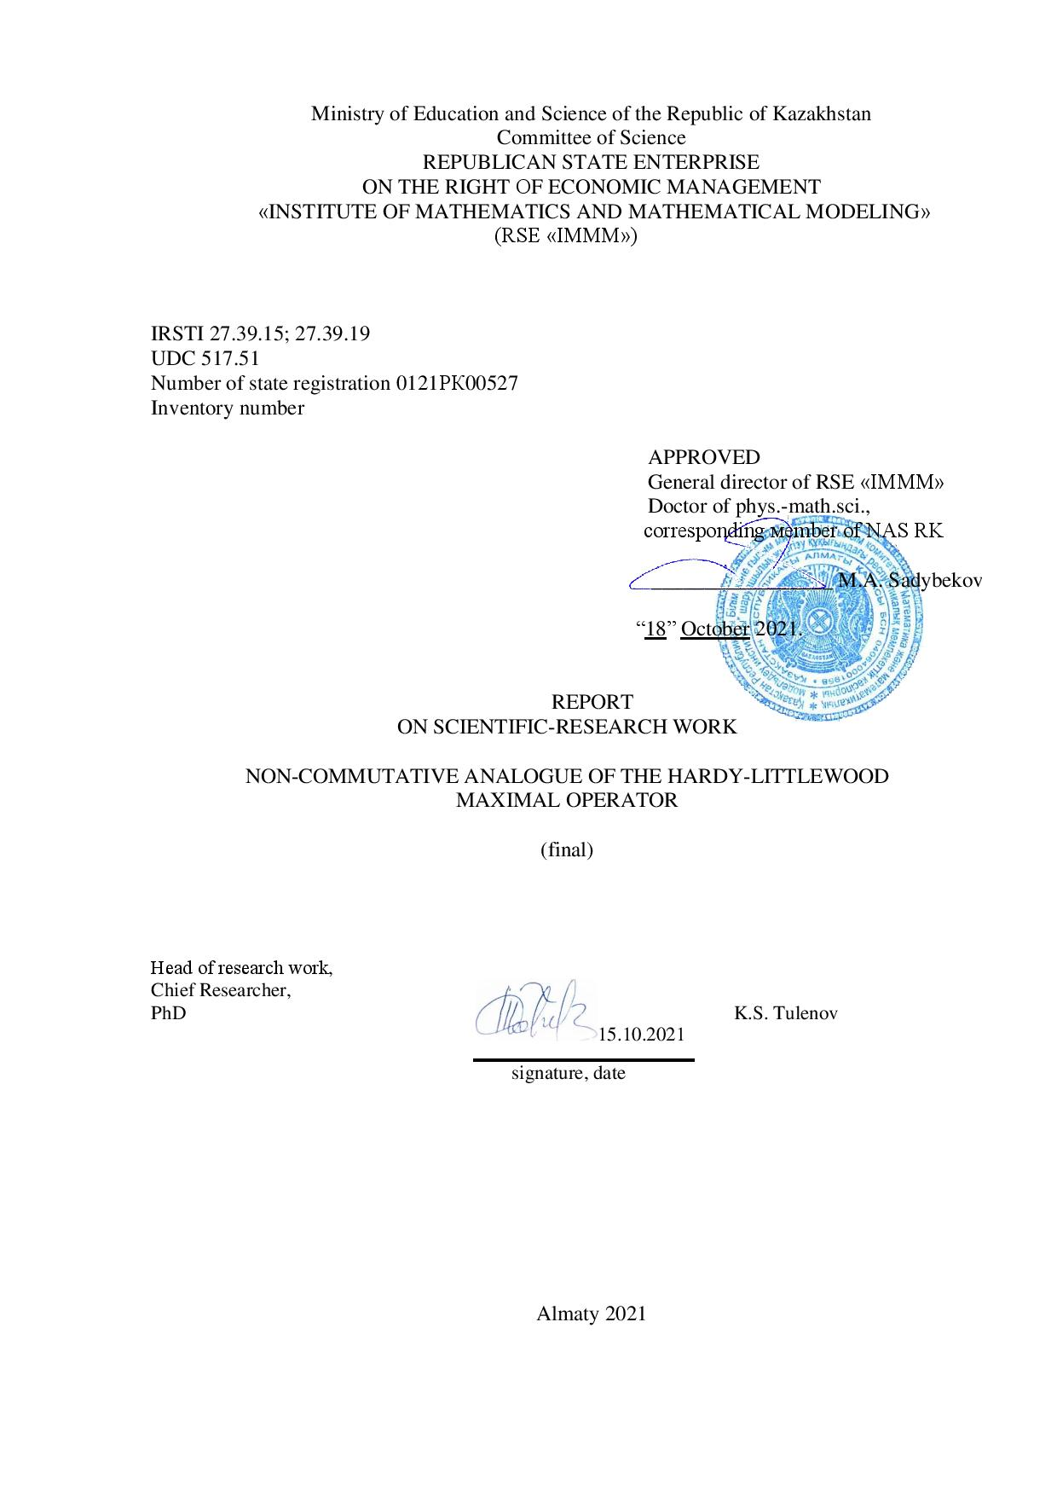

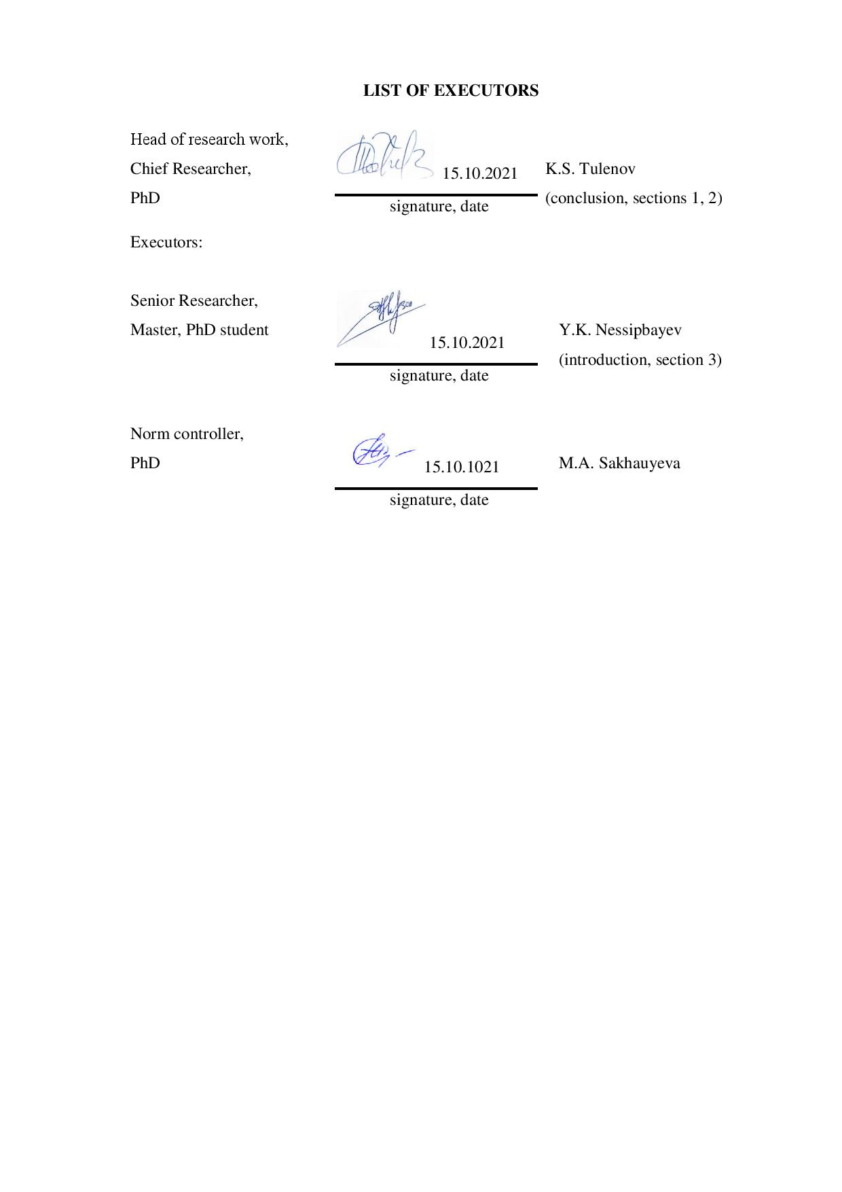

ABSTRACT

Report 23 pp., 1 book, 12 sources, 2 annexes.
MAXIMAL HARDY-LITTLEWOOD OPERATOR, SYMMETRIC SPACES OF FUNCTIONS AND OPERATORS, VON NEUMAN ALGEBRA, CESARO OPERATOR, (NON-COMMUTATIVE) LORENTZ AND MARCINKIEWICZ SPACES
Research objects:
- Non-commutative $L_{p}$ -spaces;
- Theory of symmetric spaces and their non-commutative extensions;
- Non-commutative Lorentz and Marcinkiewicz spaces.
Results of the work: For the reporting time, according to the project schedule, an upper bound for the distribution of the non-commutative maximum Hardy-Littlewood operator (in the sense of T. Bekjan) was obtained using the Cesaro operator (Section 1); studied the boundedness of the non-commutative maximal Hardy-Littlewood operator in the non-commutative Lorentz and Marcinkiewicz spaces (Section 2); investigated the boundedness of the non-commutative maximal Hardy-Littlewood operator in general non-commutative symmetric spaces of measurable operators (Section 3).
According to the project schedule for 2021, 3 types of work were envisaged, which correspond to three sections of this report.
The introduction provides basic concepts and terms.
All the expected results of these points have been achieved and published in the rating journal Annals of Functional Analysis Scopus: SJR 0.476 (2020), -54th percentile. The first author is the executor of the project, and the second author is the project manager.
Thus, all expected R&D results have been completed according to the schedule.

РЕФЕРАТ

Отчет 23c., 1кн., 12 источн., 2 прил.
МАКСИМАЛЬНЫЙ ОПЕРАТОР ХАРДИ-ЛИТТЛВУДА, СИММЕТРИЧНЫЕ ПРОСТРАНСТВА ФУНКЦИЙ И ОПЕРАТОРОВ, АЛГЕБРА ФОН НЕЙМАНА, ОПЕРАТОР ЧЕЗАРО, (НЕКОММУТАТИВНЫЕ) ПРОСТРАНСТВА ЛОРЕНЦА И МАРЦИНКЕВИЧА
Объекты исследования:
- Некоммутативные $L_{p}$ –пространства;
- Теория симметричных пространств и их некоммутативных расширений;
- Некоммутативные пространства Лоренца и Марцинкевича.
Результаты работы: За отчетное время, согласно календарному плану проекта, получена верхняя оценка распределения некоммутативного максимального оператора Харди-Литтлвуда (в смысле Т. Бекжана) с помощью оператора Чезаро (раздел 1); изучена ограниченность некоммутативного максимального оператора Харди-Литтлвуда в некоммутативных пространствах Лоренца и Марцинкевича (раздел 2); исследована ограниченность некоммутативного максимального оператора Харди-Литтлвуда в общих некоммутативных симметричных пространствах измеримых операторов (раздел 3).
Согласно календарному плану проекта на 2021 год были предусмотрены 3 вида работ, которым соответствуют три раздела данного отчета.
Во введении приводятся основные понятия и термины.
Все ожидаемые результаты данных пунктов достигнуты и опубликованы в рейтинговом журнале Annals of Functional Analysis Scopus: SJR 0.476 (2020), процентиль -54-ый. Первый автор является исполнителем проекта, а второй автор руководителем проекта.
Таким образом, все ожидаемые результаты НИР согласно календарному плану выполнены.

CONTENT

INTRODUCTION 5
MAIN PART OF THE REPORT ON SRW 10
1 An upper bound for the distribution of the non-commutative maximal Hardy-Littlewood operator (in the sense of T. Bekjan) by the Cesaro operator 10
2 Boundedness of the non-commutative maximal Hardy-Littlewood operator in the non-commutative Lorentz and Marcinkiewicz spaces ……… 12
3 Boundedness of the non-commutative maximal Hardy-Littlewood operator in general non-commutative symmetric spaces of measurable operators. 14
CONCLUSION 16
LIST OF USED SOURCES 17
APPENDIX А - Publications of emloyees of the theme 18

APPENDIX B - Calendar work plan ………………………………………………………...……..19

INTRODUCTION

In this project, we investigated the maximum Hardy-Littlewood operator (in the sense of T. Bekjan) on non-commutative symmetric spaces. An upper bound (using the Cesaro operator) of the generalized singular number of the non-commutative maximal Hardy-Littlewood operator is obtained. We also show that the maximal Hardy-Littlewood operator is bounded from a general non-commutative symmetric space to another.

During the execution of the project, we investigated the maximum Hardy - Littlewood operator $M$, which is given (in the classical literature) by the following formula:

$Mf(x)=\sup_{r>0}\frac{1}{|B(x,r)|}\int_{B(x,r)}{‍}|f(y)|dy,$ (1)

where $B(x,r)$ denotes the (closed) ball in $R^{d}(d≥1)$ centered at $x$ with radius $r>0$, and $|B(x,r)|$ denotes its Lebesgue measure. In other words,$M$ is a nonlinear operator that transforms $f:R^{d}→C$ into a function $Mf$, that is, the maximum value that $f$ can attain on the balls $B(x,r)$. Countless articles are devoted to the study of the maximum Hardy - Littlewood operator defined by formula (1). For example, see [1, 2, 3] and the references therein.
It is well known that there exist positive constants $c_{1}$ and $c_{2}$, depending only on $d$, such that

$c_{1}μ(Mf)≤Cμ(f)≤c_{2}μ(Mf)$ (2)

for any locally integrable function $f$ on $R^{d}$ (see [1, Theorem III. 3.8, p. 122]), where $C$ denotes the Cesaro operator (see formula (5) below), and $μ(f)$ is a decreasing rearrangement of a function $|f|$.
In this project, we are mainly dealing with a non-commutative version of the double inequality (2). In fact, for our purposes, it is sufficient to consider only the first inequality in (2). We supplement and refine the main results of Bekjan [4] and Shao [5]. More precisely, this project studies the boundedness properties of the non-commutative maximal Hardy - Littlewood operator on symmetric spaces of τ-measurable operators. Recently, a special interest has arisen in the study of non-commutative maximal inequalities, see, for example, the works of Junge and Xu [6, 7]. Subsequently, Mei [8] proposed a slightly different version of the non-commutative maximal Hardy – Littlewood inequality for an operator function. Another version of the (non-commutative) maximal Hardy - Littlewood operator (for τ-measurable operators) was introduced by Bekjan [4]. In addition, in his article, T. Bekjan obtained weak (1,1) - and (p, p) –type inequalities for the maximum Hardy - Littlewood operator (in new settings). Later Shao investigated the maximum Hardy-Littlewood operator (in the sense of T. Bekjan) on non-commutative Lorentz spaces associated with a finite atomless von Neumann algebra (see [5]). Using methods from [2], J. Shao obtained the (p, q) - (p, q) - type inequality for the maximal Hardy - Littlewood operator on noncommutative Lorentz spaces. In the sense of T. Bekjan, the maximum Hardy - Littlewood operator for $A$ is defined by the formula (see [4])

$$MA(x)=\sup_{r>0}\frac{1}{τ(E_{[x-r,x+r]}(|A|))}τ(|A|E_{[x-r,x+r]}(|A|)), x≥0,$$

where the operator $A$ is related to the general semifinite von Neumann algebra $M$. For comparison with the classical definition, recall that the classical maximum Hardy-Littlewood operator of a measurable real-valued function $f$ is defined as follows:

$$Mf\left(x\right)=\sup_{r>0}\frac{1}{m\left(\left[x-r,x+r\right]\right)}\int_{\left[x-r,x+r\right]}{‍}\left|f\left(t\right)\right|dt, x≥0,$$

where $m$ denotes the usual Lebesgue measure, see [3]. Note that $|A|$ can be represented a

$$\left|A\right|=\int_{σ\left(\left|A\right|\right)}{‍}tdE_{t}$$

from the point of view of spectral theory, $MA(|A|)$ is also represented as $MA(x)$. Thus, for the operator $A$, from Bekjan's point of view, $MA(|A|)$ is defined as the operator analogue of the maximal Hardy-Littlewood operator in the classical case. Hence, roughly speaking, $MA(|A|)$ relates to $A$ as $Mf(x)$ relates to $f$ in classical analysis, i.e.

$MA(|A|)=\int_{σ(|A|)}{‍}MA(λ)dE_{λ}(|A|),$ (3)

where $σ(|A|)$ is the spectrum of the operator $|A|$. Our goal is to investigate the non-commutative maximal Hardy-Littlewood operator M in the sense of T. Bekjan (see [4]).
In Section 1, we obtain an upper bound for the generalized singular value of the non-commutative maximal Hardy - Littlewood operator. In particular, we show that the generalized singular number of the maximal Hardy-Littlewood operator is bounded above by means of Cesaro operator. This, in turn, entails certain consequences concerning the maximum Hardy-Littlewood operator. We also refine Theorem 1 in [4] by showing that the non-commutative maximal Hardy-Littlewood operator is bounded when it acts from the non-commutative space $L_{1}$ to the separable part of the (non-commutative) weak $L_{1}$ space (see Theorem 3.2 in the published paper [1]).
In Section 2, we extend some results obtained by J. Shao (see [5]) from a finite von Neumann algebra $M$ to a general semifinite algebra $M$. J. Shao considered the boundedness of the non-commutative maximal Hardy-Littlewood operator on Lorentz spaces, and we also obtained a more general result that shows that it is bounded from one general non-commutative symmetric space to another (see Theorem 4.1 in the published paper [1]). In particular, we show that it is bounded from some non-commutative Lorentz space to another non-commutative Lorentz space (see Proposition 4.1 in the published paper [1]) and from some non-commutative Marcinkiewicz space to another non-commutative Marcinkiewicz space (see Proposition 4.2 in the published paper [1]). In fact, these results are direct consequences of results obtained in the next section. To do this, we use an approach similar to the commutative case. The main results that we apply to the project can be found in [4]. Finally, we give specific examples showing that the non-commutative maximal Hardy-Littlewood operator is bounded from one particular non-commutative Lorentz space to another, as well as from one particular non-commutative Marcinkiewicz space to another.
Next, we will introduce the necessary terms, definitions and concepts that will be used in this report. We denote by $(R_{+},m)$ (where $R_{+}=(0,∞)$) the measure space endowed with the Lebesgue measure $m$. Let $L(R_{+},m)$ be the space of all measurable real functions on $R_{+}$ equipped with the Lebesgue measure $m$. We define $S(R_{+},m)$ as a subset of $L(R_{+},m)$ consisting of all functions $f$ (hereinafter we denote functions $f$ or $g$) such that $m(\{t:|f(t)|>s\})<∞$ for some $s>0$. For $f∈S(R_{+},m)$ we define a decreasing rearrangement $μ(f)$ of the function $|f$| by the following expression:

$$μ\left(t,f\right)=\inf\left\{s≥0: m\left(\left\{\left|f\right|>s\right\}\right)≤t\right\}, t>0.$$

Submajorization in the sense of the Hardy - Littlewood - Polya of functions $f$ and $g$ (denoted by $g≺≺f$) is defined as follow

$$\int_{0}^{t}{‍}μ\left(s,g\right)ds≤\int_{0}^{t}{‍}μ\left(s,f\right)ds for all t≥0.$$

Let $M$ denote a semifinite von Neumann algebra on a separable Hilbert space $H$ equipped with an faithful normal semifinite trace τ. A closed and densely defined operator $A$ associated with $M$ is called τ-measurable if $τ(E_{|A|}(s,∞))<∞$ for sufficiently large $s≥0$. We denote the set of all τ-measurable operators by $S(M,τ).$ We denote by $Proj(M)$ the lattice of all projections in $M$. For each $A∈S\left(M,τ\right)$, we define its singular value function $μ\left(A\right)$ by setting

$μ(t,A)=inf\{||A(1-P){||}_{L_{∞}(M)}:P∈Proj(M), τ(P)≤t\}, t>0,$

where the norm $||⋅{||}_{L_{∞}(M)}$ is the usual operator (uniform) norm. Equivalently, for positive self-adjoint operators $A∈S(M,τ),$ we have

$n_{A}(s)=τ(E_{A}(s,∞)), s>0,$

$μ(t,A)=inf\{s:n_{A}(s)<t\}, t>0.$

An operator $A$ in $S(M,τ)$ is called τ-compact if $μ(∞,A)=0$. This concept is a direct generalization of the ideal of compact operators in the Hilbert space $H$. For more information about generalized singular functions and τ-compact operators, we refer the reader to [9] and [10]. Let $L_{loc}(M,τ)$ be the set of all τ-measurable operators $A$ such that

$τ(|A|E_{I}(|A|))<+∞$ (4)

for all bounded intervals $I⊂[0,+∞)$.

Let $A,B∈S(M,τ),$ then we say that $B$ is submajorized by $A$ (in the sense of Hardy - Littlewood - Polya), denoted by $μ(B)≺≺μ(A),$ if

$\int_{0}^{t}{‍}μ\left(s,B\right)ds≤\int_{0}^{t}{‍}μ\left(s,A\right)ds for all t≥0.$

Definition. For $A∈L_{loc}(M,τ)$, we define the maximal operator for $А$ by the formula

$$MA(x)=\sup_{r>0}\frac{1}{τ(E_{[x-r,x+r]}(|A|))}τ(|A|E_{[x-r,x+r]}(|A|)), x≥0,$$

(as usual we let 0/0 = 0).

$M$ is called the non-commutative maximal Hardy - Littlewood operator.

We define the Cesaro operator $C:(L_{1}+L_{∞})(R_{+})→S(R_{+})$ (see [10]) as follows:

$(Cf)(t):=\frac{1}{t}\int_{0}^{t}{‍}f(s)ds, f∈L_{1}(R_{+}), t>0.$ (5)

MAIN PART OF THE REPORT ON SRW

1 Upper bound for the distribution of the non-commutative maximal Hardy-Littlewood operator (in the sense of T. Bekjan) by the Cesaro operator

In the period from May to June 2021, according to the schedule, the project executors investigated the upper bound for the distribution of the non-commutative maximum Hardy-Littlewood operator (in the sense of T. Bekjan) by means of the Cesaro operator.
As a result, an upper bound for the distribution of the non-commutative maximal Hardy-Littlewood operator (in the sense of T. Bekjan) was obtained in terms of the Cesaro operator.
All work on Section 1 has been completed and published in [1].
To prove the main result of this subsection, we first obtained the following lemma (see Lemma 3.1 in [1]):
Lemma 1.1. If an operator $A$ belongs to $L_{loc}(M,τ)$ then it is τ-compact.

Section 3 in the published paper is devoted to the study of the upper bound for the distribution of the non-commutative maximal Hardy-Littlewood operator (in the sense of T. Bekjan) using the Cesaro operator, namely, the following result was obtained (Theorem 3.1 in paper [1]):
Theorem 1.1. For any $A∈L_{loc}(M,τ)$ we have:

$μ(t,MA(|A|))≤32⋅(Cμ(A))(t), ∀t>0.$

Here $C:(L_{1}+L_{∞})(R_{+})→S(R_{+})$ is the Cesaro operator, given by:

$(Cf)(t):=\frac{1}{t}\int_{0}^{t}{‍}f(s)ds, f∈L_{1}(R_{+}), t>0,$

$μ(f)$ is a non-decreasing rearrangement:

$μ(t,f)=inf\{s≥0: m(\{|f|>s\})≤t\}, t>0.$

and the maximum Hardy-Littlewood operator (in the sense of T. Bekjan) is given by the formula:

$MA(x)=\sup_{r>0}\frac{1}{τ(E_{[x-r,x+r]}(|A|))}τ(|A|E_{[x-r,x+r]}(|A|)), x≥0,$

In addition, we also obtained some important consequences from the main Theorem 3.1 [1]. Namely, we obtained an upper bound for the norm of the non-commutative maximal Hardy-Littlewood operator $M$ (in the sense of T. Bekjan) using the norm of the operator $A$ in the spaces $L_{p}\left(M\right), L_{p,q}\left(M\right)$.
Below we give their statements (see Corollaries 3.1 and 3.2, respectively, in [1]):
Corollary 1.1. Let $0<q<∞$, $1<p,p_{0},p_{1}<∞$and $p_{0}≠p_{1}$ such that $\frac{1}{p}=\frac{1-θ}{p_{0}}+\frac{θ}{p_{1}}$ for some $0<θ<1$. Then there is a constant $c_{pq}>0$ such that for all $A∈L_{p,q}\left(M\right)$ the inequality

$||MA(|A|){||}_{L_{p,q}\left(M\right)}≤c_{p,q}⋅||A{||}_{L_{p,q}(M)}$

holds.

Corollary 1.2. Let $1<p<∞$ and $A∈L_{p}(M),$ then there exists a constant $c_{p}>0$ such that

$||MA(|A|){||}_{L_{p}\left(M\right)}≤c_{p}⋅||A{||}_{L_{p}(M)}.$

2 Boundedness of the non-commutative maximal Hardy-Littlewood operator in the non-commutative Lorentz and Marcinkiewicz spaces

Let $E(R_{+})$ be a symmetric function space. In [11, Theorem 2.3], [12, Theorem 3.5], the authors obtained the minimal (smallest) symmetric space

$F(R_{+}):=\{f∈\left(L_{1}+L_{∞}\right)\left(R_{+}\right): μ\left(f\right)≺≺Cμ\left(g\right) for some g∈E(R_{+})\}$ (6)

with a Fatou norm such that the Cesaro operator defined in (5) $C:E(R_{+})→F(R_{+})$ is bounded.
In particular, if φ is a quasiconcave function satisfying

$φ(t)≥c_{abs}⋅tlog(1+1/t),$ (7)

then the Cesaro operator (see [11, Theorem 2.3])

$C:Λ_{φ}(R_{+})→F(Λ_{φ}):=\left\{f∈(L_{1}+L_{∞})(R_{+}):∃g∈Λ_{φ}(R_{+}) μ(f)≺≺Cμ(g)\right\}$

is bounded. Similarly to the symmetric operator space $E(M)$, we define the symmetric operator space

$F(M):=\{A∈S(M,τ):μ(A)∈F(R_{+})\},$

equipped with the norm
$||A||_{F(M)}:=||μ(A)||_{F(R_{+})},$

where $F(R_{+})$ is defined as in (6).
We also obtained a theorem on the boundedness of the non-commutative maximal Hardy-Littlewood operator in non-commutative Lorentz spaces (Proposition 4.1 in [1]):
Theorem 2.1. Let φ be an increasing convex function such that φ (+0) = 0 and satisfying (7), and let ψ be an increasing convex function such that ψ (+0) = 0 and

$\int_{t}^{∞}{‍}\frac{ψ(s)}{s^{2}}ds≤c_{abs}\frac{φ(t)}{t}.$ (8)

Then the non-commutative Hardy-Littlewood operator

$MA(⋅):Λ_{φ}(M)→Λ_{ψ}(M)$

is bounded.
We also obtained a theorem on the boundedness of the non-commutative maximal Hardy-Littlewood operator in non-commutative Marcinkiewicz spaces (Proposition 4.2 in paper [1]):

Theorem 2.2. Let $ϕ$ be an increasing quasiconvex function such that $1/ϕ$ is locally integrable at zero. Then the non-commutative maximal Hardy-Littlewood operator

$MA(⋅):M_{ϕ}(M)→M_{ψ}(M)$

is bounded.
Here

$ψ(t)=t⋅{\left(\int_{0}^{t}{‍}\frac{ds}{ϕ(s)}\right)}^{-1}, t>0.$ (9)

Thus, the work on this section has also been completed.

- Boundedness of the non-commutative maximal Hardy-Littlewood operator in general non-commutative symmetric spaces of measurable operators

To prove the main result of this section, we used the following well-known results:
Let φ be a quasiconvex function satisfying the condition

$φ(t)≥c_{abs}⋅tlog(1+1/t),$

then the Cesaro operator

$C:Λ_{φ}(R_{+})→F(Λ_{φ}):=\left\{f∈(L_{1}+L_{∞})(R_{+}):∃g∈Λ_{φ}(R_{+}) μ(f)≺≺Cμ(g)\right\}$

is bounded.
The following theorem is the main result of this section, which shows that the non-commutative maximal Hardy – Littlewood operator from a general symmetric space of operators to another is bounded (Theorem 4.1 in the published paper [1]).

Theorem 3.1. The Hardy - Littlewood non-commutative maximal operator

$MA(⋅):E(M)→F(M)$

is bounded.
Here the symmetric operator space $F(M)$ is defined as follows:

$F(M):=\{A∈S(M,τ):μ(A)∈F(R_{+})\},$

Below we give two examples showing that the non-commutative maximal Hardy-Littlewood operator is bounded from one particular non-commutative Lorentz space to another, as well as from one particular non-commutative Marcinkiewicz space to another.
$Example 3.1.$ Let $φ(t)=t\log^{2}(1+\frac{1}{\sqrt{t}}),t>0.$ Then it is easy to check that $φ$ satisfies condition (7). Let $ψ\left(t\right)=tlog\left(1+\frac{1}{t}\right).$ Then

$\int_{t}^{∞}{‍}\frac{ψ(s)}{s^{2}}ds≤c_{abs}\frac{φ(t)}{t}, t>0.$

The latter follows directly from Example 4.5 in [12] with α = 1.
Hence, by Theorem 2.2, we obtain
$MA(⋅):Λ_{t\log^{2}(1+\frac{1}{\sqrt{t}})}(M)→Λ_{tlog(1+\frac{1}{t})}(M)$

is bounded.

$Example 3.2.$ Consider the function $ϕ\left(t\right)=max\left\{1,t\right\}, t>0.$ Then by (9) it follows that $ψ(t)≈\frac{t}{log(1+t)}.$ Since $M_{ϕ}\left(M\right)=\left(L_{1}+L_{∞}\right)\left(M\right),$ by Theorem 2.2 from Section 2 we obtain that

$MA(⋅):Λ_{t\log^{2}(1+\frac{1}{\sqrt{t}})}(M)→Λ_{tlog(1+\frac{1}{t})}(M)$

is bounded.

CONCLUSION

During the reporting time, according to the project schedule for 2021, we investigated the Hardy-Littlewood maximum operator (in the sense of T. Bekjan) in non-commutative symmetric spaces. We have obtained an upper bound (in terms of the Cesaro operator) for the generalized singular number of the non-commutative maximal Hardy-Littlewood operator. We also showed the boundedness of the maximal Hardy-Littlewood operator from a general non-commutative symmetric space to another.
The main objectives of the project:
- Obtaining an upper bound for the distribution of the non-commutative maximal Hardy-Littlewood operator (in the sense of T. Bekjan) in terms of the Cesaro operator;
- Investigating the boundedness of the non-commutative maximal Hardy-Littlewood operator in the non-commutative Lorentz and Marcinkiewicz spaces;
- Investigating the boundedness of the non-commutative maximal Hardy - Littlewood operator in general non-commutative symmetric spaces of measurable operators
are executed and published in an international peer-reviewed journal.
According to the calendar plan for 2021, 3 types of work were envisaged, which correspond to 3 sections of this report.
All the expected results of these sections have been achieved and published in the following journal:
Y. Nessipbayev, K. Tulenov, Non-commutative Hardy-Littlewood maximal operator on symmetric spaces of τ-measurable operators // Annals of Functional Analysis. -2021.- V.12 (1), # 11. Scopus: SJR 0.476 (2020), 54th percentile. doi.org/10.1007/s43034-020-00097-3
Both authors are the executors of the project.

Thus, all expected results according to the calendar plan for 2021 have been achieved.

LIST OF USED SOURCES

1 Bennett C. and Sharpley R. Interpolation of Operators. Pure and Applied Mathematics. Boston: Academic Press, 1988. – Vol. 129 – 469 p.
2 Grafakos L. Classical fourier analysis. – New York : Springer, 2008. – Vol. 2.-492 p.
3 Stein E. M., Weiss G. Introduction to Fourier Analysis on Euclidean Spaces (PMS-32). – 1972.-312 p.
4 Bekjan T. N. Hardy–Littlewood maximal function of τ-measurable operators //Journal of mathematical analysis and applications. – 2006. – Vol. 322. – №. 1. – P. 87-96.
5 Shao J. Hardy-Littlewood maximal function on noncommutative Lorentz spaces //Journal of Inequalities and Applications. – 2013. – Vol. 2013. – №. 1. – P. 1-8.
6 M. Junge, Doob's inequality for non-commutative martingales, // J.Reine Angew.Math. 549, (2002), P. 149-190.
7 Junge M., Xu Q. Noncommutative maximal ergodic theorems //Journal of the American Mathematical Society. – 2007. – Vol. 20. – №. 2. – P. 385-439.
8 T. Mei, Operator valued Hardy spaces, Mem.Am.Math.Soc. 188, 881, -2007- 60 p.
9 T. Fack, H. Kosaki, Generalized $s$-numbers of $τ$-measurable operators, // Pacific J. Math., - Vol. 123(2) – 1986. - P. 269--300.
10 Lord S., Sukochev F., Zanin D. Singular traces: theory and applications. – Berlin: Walterde Gruyter, 2013. – Vol. 46. – 445 p.
11 J. Soria, P. Tradacete, Characterization of the restricted type spaces $R(X)$, // Math. Ineq. Applic. - Vol. 18 -2015.- P. 295--319.
12 J. Soria, P. Tradacete, Optimal rearrangement invariant range for Hardy-type operators, // Proc. of the Royal Soc. of Edinburgh, - Vol. 146A – 2016.- P. 865--893.

APPENDIX A

Publications of emloyees of the theme

- Y. Nessipbayev, K. Tulenov, Non-commutative Hardy-Littlewood maximal operator on symmetric spaces of $τ$-measurable operators // Annals of Functional Analysis. -2021.- V.12(1), No 11. Scopus: SJR 0.476 (2020), 54-th procentile.
doi.org/10.1007/s43034-020-00097-3

APPENDIX B

Calendar work plan
TECHNICAL SPECIFICATION AND WORK SCHEDULE
Under agreement № 268 from July 18, 2021
- RSE on the right of economic management “Institute of mathematics and mathematical modeling” of the Committee of science of the Ministry of education and science of the Republic of Kazakhstan
  - By priority: 10. Scientific research in the field of natural sciences.
By sub-priority: 10.1 Fundamental and applied research in the field of mathematics and mechanics.
  - On the theme of the project: No. AP09561870 “Non-commutative analogue of the maximal Hardy-Littlewood operator”.
  - The total amount of the project for 2021 is 8 000 000 (eight million) tenge, for implementing the works according to item 3.
- Characteristics of scientific and technical products by qualification features and economic indicators
  - Direction of the work: Mathematics, Functional Analysis.
  - Scope: Mathematics: operator theory, symmetric spaces of functions and operators.
  - Final result for 2021: An upper bound for the distribution of the non-commutative maximal Hardy-Littlewood operator (in the sense of T. Bekjan) will be obtained using the Cesaro operator. The boundedness of the non-commutative maximal Hardy-Littlewood operator in the non-commutative Lorentz and Marcinkiewicz spaces will be studied. The boundedness of the non-commutative maximal Hardy-Littlewood operator in general non-commutative symmetric spaces of measurable operators will be investigated.
  - Patentability: not patentable.
  - Scientific and technical level (novelty): a high level.
  - The use of scientific and technical products is carried out: by the Executor.
  - Type of use of the result of scientific and (or) scientific and technical activities: theoretical.
- Name of work, terms of their implementation and results
№ | Name of tasks and measures for their implementation | Start of execution (dd / mm / yy) | Duration, months | Expected results of the project implementation (in the context of tasks and activities), completion form
1 | 2 | 3 | 4 | 5
1 | An upper estimate for the distribution of the non-commutative maximal Hardy-Littlewood operator (in the sense of T. Bekjan) by the Cesaro operator | 04.01.2021 | 3 | An upper estimate for the distribution of the non-commutative maximal Hardy-Littlewood operator (in the sense of T. Bekjan) will be obtained using the Cesaro operator.
2 | Boundedness of the non-commutative maximal Hardy-Littlewood operator in the non-commutative Lorentz, Orlicz and Marcinkiewicz spaces. | 01.04.2021 | 3 | The boundedness of the non-commutative maximal Hardy-Littlewood operator in the non-commutative Lorentz and Marcinkiewicz spaces will be studied.
3 | Boundedness of the non-commutative maximal Hardy-Littlewood operator in general non-commutative symmetric spaces of measurable operators. | 01.07. 2021 | 6 | The boundedness of the non-commutative maximal Hardy-Littlewood operator in general non-commutative symmetric spaces of measurable operators will be investigated.

From customer:  Chairman of the State Institution "Science Committee of the Ministry of Education and Science of the Republic of Kazakhstan"  ______________ Kurmangalieva Zh.D.  м.п. | From the Contractor:  General Director of the RSE on the RK "Institute  of Mathematics and Mathematical Modeling" of the  Science Committee of the Ministry of Education  and Science of the Republic of Kazakhstan  ________________ Sadybekov M.A.  м.п.  Familiarized with:  Scientific supervisor of the project  ___________________ Tulenov K.S.

