

ABSTRACT
Report 96 p., fig. 7, 103 sources, appendix 11.
HYPERSPECTRAL AEROSPACE IMAGES, COMPRESSION ALGORITHM, DISCRETE TRANSFORMATIONS, COMPRESSION RATIO, DISCRETE-COSINE TRANSFORMATION, PHYTOSANITARY CONTROL.
The object of the study is hyperspectral aerospace images for phytosanitary inspection of grain crops.
The purpose of the work is to analyze the use of hyperspectral images to identify a specific disease of grain crops in the development of optimal mathematical solutions and software by effectively compressing the flow of information while maintaining a high archiving coefficient, without loss of image quality in order to reduce the volume of information flow.
Research methods. In the course of the research, spectral correlation accounting, regression analysis, difference-discrete transformations, evaluation of quality criteria of reconstructed hyperspectral images were used.
As a result of the research, the need to create methods that are currently used in managing the storage of large archives of aerospace data was justified. The available developed lossless compression methods and algorithms for hyperspectral images are analyzed, which can be improved by reducing their computational efficiency and increasing the compression ratio due to significant preprocessing steps. A mathematical apparatus based on a difference-discrete transformation for compressing hyperspectral images has been developed and adapted. Hyperspectral image compression algorithms have been developed and modified.
As a result, software has been developed designed to compress hyperspectral data, taking into account the characteristic features and qualitative indicators of hyperspectral cameras for phytosanitary inspection of grain crops.
The degree of implementation. The obtained research results will be used in the Center of Geoinformation Technologies of the Kazakh Agrotechnical University of Nur-Sultan.
The effectiveness is determined by using the results of research and the developed hyperspectral image compression software to identify a specific disease of grain crops.
Scope of application. Aerospace data processing centers, agricultural facilities.

CONTENT
INTRODUCTION ………....…………………………………………….…………………..... | 7
THE MAIN PART OF THE RESEARCH REPORT.………................................................. | 9
1 Analysis and choice of research direction ....……………………………………………....... | 9
2 Research methods ………………………………………………………...………………..... | 11
3 Research results ..............…………………………………………………………………..... | 14
3.1 Research results of existing algorithms and methods of compression of hyperspectral aerospace images, literature review ............................……………………………………....... | 14
3.2 Development of algorithms and methods for compressing hyperspectral images ............... | 15
3.3 Description of the results of experimental studies of encoding and decoding of lossless and lossy hyperspectral aerospace images .............………………………………………….... | 20
4 Generalization and evaluation of research results …………………………………………... | 25
CONCLUSION……………………………………………………………………………..…. | 26
LIST OF SOURCES USED .....................................………………………………………..... | 28
APPENDIX A – Calendar plan for 2021 y….............………………………………………… | 37
APPENDIX B – Hyperspectral images ……………….........................................…………..... | 44
APPENDIX C – List of publications for 2021 y.……………………...........………………..... | 51
APPENDIX D – Certificate of state registration of software ...……………………………..... | 52
APPENDIX E – Recommendations for the use and dissemination of the results of the work………………………………………………………………………………………......... | 53
APPENDIX F – Methodological instructions for using the software package.......................... | 72
APPENDIX G – The process of submitting an article to the journal «Journal of applied remote sensing»…………………………….........…………………………………………….. | 92
APPENDIX H – The process of submitting an article to the journal «journal of theoretical and applied information technology»………………………………………………………… | 93
APPENDIX J – The process of submitting an article by Committee for Quality Assurance in the Field of Education and Science of the Ministry of Education and Science to the journal «Proceedings of the university»…………………………………………….……………....… | 94
APPENDIX K – Abstract submission process «20th International conference named after A.F. Terpugov Information technologies and mathematical modelling» (ITMM’2021)………………………………………………………………………………….. | 95
APPENDIX L – The process of submitting abstracts for the «XIII All-russian scientific and technical conference with international participation «robotics and artificial intelligence» (RAI-21)…………………………………………………..……………………………........... | 96

TERMS AND DEFINITIONS
In this research report, the following terms are used with appropriate definitions:
TERMS | DEFINITIONS
Compression of hyperspectral images | - this is archiving and the process of encoding/decoding hyperspectral images, taking into account their characteristics
Lossless hyperspectral image compression algorithms | - - these are algorithms that restore and decode images with bit accuracy
Lossy hyperspectral image compression algorithms | - these are algorithms that restore and decode images with a certain level of data loss with an adjustable quality parameter
Phytosanitary control | - this is a set of measures aimed at improving the quality of products in agriculture
Preprocessing of hyperspectral images | - radiometric correction (elimination of distortions due to uneven sensitivity of detector elements, taking into account the influence of the atmosphere); geometric correction (elimination of the shift, taking into account the curvature of the earth; landscape features); geographical reference, synthesis of color and pseudo-color images from channel images
Remote sensing of the earth | - observation of the Earth's surface by ground, aviation and space facilities equipped with various types of shooting equipment

LIST OF ABBREVIATIONS AND DESIGNATIONS
The following abbreviations and designations are used in this research report
RSE – remote sensing of the Earth
GI – hyperspectral images
KA – spacecraft
SW – software
PC – electronic computer
DCT – discrete-cosine transformation
DWP – discrete wavelet transform
UHT – Walsh-Hadamard transformation
KL – Karunena-Loeva
SPIHT – set partitioning in hierarchical trees
PPM – prediction by Partial Matching
JPEG – Joint Photographic Experts Group
JPEG-LS – Joint Photographic Experts Group-Lossless
ECW – Enhanced Compression Wavelet
MrSID – multiresolution seamless image database
EZW – Embedded Zerotrees of Wavelet
BpP – bit per pixel
PSNR – peak signal-to-noise ratio
MSE – mean square error
PMSE – peak mean square error
SD - standard deviation
PCA – principal component analysis
AI – Aerospace images
WS-SLCT – weighted spatial-spectral lossless coding technique
IP3-BPS – interband predictor and the backward pixel search scheme
HGI – hierarchical grid interpolation
SLSQ – spectral-oriented least SQuares
M-OBSI – multiband prediction quantized index options band-sequential

INTRODUCTION
In Kazakhstan, the average sown area annually is about 18 million hectares, including 11 million hectares of spring wheat. Spring wheat can be threatened by many diseases: brown rust, powdery mildew, root rot, septoria, etc. Under favorable environmental conditions, an outbreak of these diseases can spread rapidly, leading to significant losses in yield and quality. Each disease has its own characteristics and, therefore, requires appropriate measures.
Therefore, the development of technologies for accurate monitoring and detection of the occurrence of diseases is an extremely important task in the management of agriculture. To monitor crop diseases, several areas of survey methods have been studied, including X-ray, ultrasound and multispectral and hyperspectral technologies.
Among these technologies, the hyperspectral method has a number of advantages for detecting and monitoring diseases over a wide area. Using existing indices to identify a specific disease remains difficult, since the unique spectral characteristics of each condition have not yet been studied. Consequently, there is a need to develop new methods and algorithms of spectral analysis for the detection of diseases; which can be achieved using a combination of wavelengths.
The GIS Technology Center of the Kazakh Agrotechnical University named after Seifullina is conducting research in conducting hyperspectral analysis of infected wheat in order to develop a methodology for detecting diseases using remote sensing. By identifying specific spectral ranges indicating the manifestation of changes caused by exposure to diseases, the center plans to develop methods for early detection of spring wheat diseases from hyperspectral images. Conducted ground, space, measurements with the Headwall Nano Hyperspec UAV allow us to determine the technical requirements for hyperspectrometer projects that can be laid down when creating spacecraft used for agricultural monitoring. Thus, this study is limited to a large volume of hyperspectral images, sometimes amounting to hundreds of gigabytes. To simplify the research tasks, it is necessary to archive hyperspectral images, which fully give a complete picture of the detection and monitoring of diseases, rather than multispectral ones.
Relevance. One of the urgent tasks is archiving hyperspectral images due to their large volume occupied on disk. Therefore, the research is aimed at analyzing and developing software that allows compressing hyperspectral images in order to reduce the volume occupied by them, using new mathematical and adaptive compression algorithms to identify diseases during phytosanitary control of grain crops.
Novelty. A comprehensive study of methods and algorithms for lossless and lossless compression of hyperspectral images, as well as comparative experiments on various criteria for the quality of restored images, has been carried out. The novelty lies in the improvement of existing methods, algorithms and formats of compression of aerospace data optimized for the currently used data format of the Headwall Nano Hyperspec device, allowing to increase the compression rates and the quality of restored images in order to identify diseases during phytosanitary control of grain crops.
All studies were carried out according to the approved work schedule, according to Contract No. 309/12-2 dated 21.06.2021 (Appendix A - Calendar Plan 2021).
THE MAIN PART OF THE RESEARCH REPORT
1 Analysis and choice of research direction
Modern satellite centers for space monitoring and remote sensing of the Earth allow you to quickly receive, register, process, archive and distribute large amounts of data, sometimes amounting to hundreds of gigabytes. The transmitted data is accumulated at ground stations, while occupying a huge disk space, which in turn requires the cost of their storage [1]-[25].
During the phytosanitary survey, measurements of wheat infected with helminthosporiosis root rot were carried out. Helminthosporous root rot is a disease affecting all parts of the plant and is widespread throughout the areas of grain cultivation. All crops are affected, but most often wheat and barley. The disease manifests itself on seedlings and seedlings by browning of the coleoptile, yellowing and deformation of leaves, general oppression of plants; in adult plants - rotting, browning and blackening of primary and secondary roots, the tillering node and the ground part of the stem. Light brown spots are formed on the leaves, elongated along the plate, often surrounded by chlorosis, merging. Plants lag behind in growth, there is whiteness and the death of productive stems. Sometimes the grains in the ear turn brown, shrivel. The reflection coefficient in the infrared region is much lower, and in the spectrum range of 520-680 nm, the reflection of diseased wheat is relatively higher.
Thus, the spectral reflection of healthy wheat and wheat with powdery mildew were recorded using a PSR 1100 field spectrometer. The main symptoms of powdery mildew disease are: a white cobwebby plaque consisting of mycelium and conidia of the pathogen forms on leaves, stems, and rarely ears.
In general, studies have shown that the approach of calculating vegetation indices allows us to obtain generalized estimates of the condition of crops. This fact can lead to significant errors and serious methodological errors for assessing the sanitary condition of crops, where the appearance of weeds, diseases and pests in conditions of initial uncertainty is a random event.
Thus, the existing methods of processing multispectral images for phytosanitary control do not provide more accurate data due to excessive information, for this purpose it is proposed to use hyperspectral images, which have a number of advantages for determining diseases of grain crops. The main direction of the project is to reduce the flow of information, which will allow determining the ranges of hyperspectral images, while identifying various diseases of grain crops [26]-[50].
Thus, the work carried out the determination of the phytosanitary condition of crops based on hyperspectral data, as well as the analysis and improvement of existing methods and algorithms for compressing hyperspectral images optimized for the currently used data format of the Headwall Nano Hyperspec device, allowing to increase the compression rates and the quality of restored images in the identification of diseases of grain crops. The Headwall Nano Hyperspec Hyperspectral camera allows you to collect a series of continuous, very narrow spectral bands, providing an almost continuous spectrum of an object, commonly referred to as a spectral signature. This method has a number of advantages over more traditional multispectral sensors, in which several relatively wide ranges are implemented [51]-[62].
While multispectral sensors typically consist of 5-12 bands, hyperspectral sensors can contain hundreds of bands, with a bandwidth typically in the 5-20 nm range. Experimental studies of the developed algorithms and software for compressing hyperspectral images were carried out, as well as testing and evaluation according to the criteria of the compression ratio and quality of decoded images in comparison with the original images of the developed system.

2 Methods of research
The research work was carried out on the basis of the GIS Center of the NAO "S. Seifullin KATU". In the course of scientific research, spectral correlation accounting, regression analysis, difference-discrete transformations, evaluation of quality criteria of reconstructed hyperspectral images and statistical methods were used.
To conduct the study, hyperspectral images were used to identify a specific disease of grain crops, in particular, the use of the Headwall Nano Hyperspec 270 channels hyperspectral camera. The justification of the need to create or improve the methods that are currently used in the storage management of large archives of aerospace data is presented.
The generally accepted methods of phytosanitary inspection are based on conducting a ground diagnosis of the disease by examining the field diagonally at an average of 10 points. This method is very time-consuming and expensive, which is impossible for large-scale farming. Therefore, it is important to have an automated solution to detect these diseases.
Among remote sensing technologies, the hyperspectral method has a number of advantages for detecting and monitoring diseases over a wide area. The fundamental principle of detecting infected plants is the analysis of the spectral reflection coefficient of electromagnetic radiation. Plants in a state of disease have a decrease in the reflection coefficient in the near infrared range (750-1300 nm). When shooting by remote sensing methods, the images have three types of resolution: temporal, spatial and spectral [63]-[73].
Field studies were conducted on the territory of the North Kazakhstan Agricultural Experimental Station LLP in the North Kazakhstan region of the Akkayynsky district of the village of Shagalaly. In the scientific department of the farm, experimental plots were laid for 4 crops: sunflower, wheat, triticale, peas, flax. Field measurements were carried out by ground and remote methods. Phytosanitary monitoring is based on visual diagnostics (Figure 1).

Figure 1 – Ground surveys of diseases of agricultural crops (sunflower on the left, wheat on the right).
Samples were taken to the laboratory to determine the type of diseases. In addition, ground-based imaging was carried out using a PSR 2500f field spectrometer. PCR-2500f makes it possible to shoot objects in the range from 350 nm to 2500 nm. The spectrometer was taken in direct contact with 15 measurements of each plant to determine the average spectral curve. Calibration measurements were carried out every 10 measurements on a white calibration panel coated with BaSO4. Shooting is carried out in clear weather from 11.00 to 17.00. Aerial photography of test polygons was carried out using a GAIA 120 with a Headwall Nano hyperspectral camera.
The advantages of quantifying the spectral characteristics of an object or material are recognized and used in phytosanitary control in the identification of landings, and their application in various disciplines covering plant sciences for the production of plant pigment, biochemistry and evaluation of various plant species, geology for mineral exploration and marine sciences for water quality assessment and mapping of benthic communities, among many others. The usefulness of hyperspectral sensors has been enhanced by relatively recent developments in the use of unmanned aerial vehicles (UAVs) as an observation platform. Thanks to developments in the field of sensor miniaturization, power supply stability, communication and storage requirements, the use of unmanned aerial vehicles for hyperspectral remote sensing has become a possible option for obtaining hyperspectral data of ultra-high spatial resolution. Hyperspectral sensors based on unmanned aerial vehicles can be broadly divided into several groups.
Application of the Headwall Nano Hyperspec hyperspectral camera, which has 270 channels per 640 spatial pixels in the range from visible to near infrared from 400 nm to 1000 nm.
It is determined that hyperspectral data have great opportunities for phytosanitary control due to the high correlation of spectral channels. The Headwall Nano Hyperspec family of hyperspectral sensors and imaging systems are small, lightweight and durable, the design uses precisely designed high-quality holographic diffraction gratings and mirrors to ensure a high signal-to-noise ratio, high spectral and spatial resolution and a wide field of view with aberration correction, this indicator allows you to more accurately determine a specific disease of grain crops. But, due to the fact that the hyperspectral camera in aerial photography has a large amount of data, characterized by a variety of spectral channels, rather than multispectral cameras, archiving of images is required. For such tasks, a large range of methods and algorithms have been developed in the scientific space, specialized for a specific data compression format. Thus, the mathematical apparatus and algorithms for compressing hyperspectral Headwall Nano Hyperspec data were developed in order to identify diseases of grain crops.
The shooting was carried out at an altitude of 50 m, with a flight speed of 4-5 m/ s. The flight is carried out in automatic mode according to a pre-created flight plan in the UgCS application (or any other for controlling the drone). Before shooting with a hyperspectral camera, calibration is performed in the HyperSpec application on a white calibration panel and a picture is taken with a closed lens for subsequent processing. As a result of shooting, each image forms 270 images of the electromagnetic spectrum that require pre-processing of converting images into spectral reflection (Appendix B).
Before compressing the obtained hyperspectral images from the HyperSpec camera, preliminary processing was carried out, which includes: radiometric calibration and orthotransformation of the images.
Based on the studies of hyperspectral images in the field of compression presented in the works of scientists from Russia, China, the USA, India, etc., suggest that the developed lossless compression methods and algorithms for hyperspectral images can be improved by reducing their computational efficiency and increasing the compression ratio due to significant stages of preprocessing. In addition, new compression preprocessing steps can be proposed that effectively increase the compression ratio and reduce the compression process time.
To solve this problem, the following approaches and scientific research methods were used [74-103]:
- accounting for spectral correlation, which gives certain advantages based on the calculated correlation matrix and regression analysis;
- discrete-cosine transformation with high quality and minimal loss of hyperspectral data;
- evaluation of quality criteria of reconstructed hyperspectral images PSNR, MSE, PMSE, etc. for lossless compression;
- adaptive arithmetic coding, the introduction of which will improve the results of compression, because it is one of the best among statistical methods;
- the use of parallel compression algorithms to reduce the cost of computer computing resources.
3 Research results
3.1 Research results of existing algorithms and methods of compression of hyperspectral aerospace images, literature review
According to the calendar plan, the justification of the effectiveness of using hyperspectral images to identify a specific disease of grain crops and a comparative characteristic of the qualitative indicators of multi- and hyperspectral images is presented.
The risks and the achievement of the goal are assessed, the research directions are selected. The efficiency of using hyperspectral images is substantiated and a comparative characteristic of the qualitative indicators of multi- and hyperspectral images is carried out.
The analysis of the literature sources of domestic and foreign scientists in the field of the use of hyperspectral images for the identification of a specific disease of grain crops, in particular the use of the Headwall Nano Hyperspec hyperspectral camera.
The necessity of creating methods that are currently used in managing the storage of large archives of aerospace data is substantiated. The technical specification for the created software systems has been compiled.
The available developed lossless compression methods and algorithms for hyperspectral images are analyzed, which can be improved by reducing their computational efficiency and increasing the compression ratio due to significant preprocessing steps.
To solve this problem, the following approaches and scientific research methods will be presented within the framework of the scientific project, which effectively increase the compression ratio without loss and with loss and reduce the time of the compression process:
- accounting for spectral correlation, which gives certain advantages based on the calculated correlation matrix and regression analysis;
- discrete-cosine transformation with high quality and minimal loss of hyperspectral data;
- evaluation of quality criteria of restored PSNR, MSE, PMSE, etc. for lossless compression;
- adaptive arithmetic coding, the introduction of which will improve the results of compression, because it is one of the best among statistical methods;
- the use of parallel compression algorithms to reduce the cost of computer computing resources.
Test samples of image files were obtained in the format used by existing systems for subsequent tests.
According to the calendar plan, it was investigated that software designed to compress hyperspectral data that does not take into account the characteristic features and quality indicators of hyperspectral cameras has been developed and is being used.
Thus, the sample files depend on the method or algorithm used to compress hyperspectral data. The solution of the research problem in the field of available transformation methods and algorithms shows that the current trend in the field of compression is the use of hyperspectral data characteristics, which is of great importance for compression methods. In this regard, it is necessary to develop new approaches to compression and processing aimed at increasing the efficiency in the compression ratio and reducing the computational complexity of the algorithms used.
It was determined that the efficiency in the compression ratio is achieved by using the proposed mathematical apparatus and compression algorithm, taking into account the correlation and ordering of groups of G channels using difference transformations, which finds the best pairs of correlated channels than without ordering (with the selected reference channel).
The results obtained during the research allow us to determine the optimal parameters for compression:
1. The results of the compression ratio indicators improve with an increase in the size of the channels of parameter R. This is due to the fact that the more values to be converted, the fewer bits are required to store them.
2. The best values of the compression ratio are achieved by choosing the number of channels in an ordered group, at 10< K<15.
3. Taking into account the interchannel correlation of the Cog parameter shows that the greatest values in the compression ratio of the channel number, at 0<N<210.
4. The algorithm, taking into account correlation and grouping at G [2..10], shows the most effective growth in the compression ratio due to the formed groups of channels and their ordering.
The proposed approach to the formation and ordering of a set of channel groups with a high intra-group correlation has increased the efficiency of using the channel subtraction stage (difference transformation) and subsequent coding of spectral channels.
3.2 Development of algorithms and methods of compression of hyperspectral images
A mathematical apparatus based on a difference-discrete transformation has been developed and adapted to determine the identification of the incidence of grain crops and the compression of hyperspectral images.
The sequence of stages of the developed mathematical apparatus is as follows.
1. The original transformation of the data structure based on the original hyperspectral AI, storing the values of the coefficients, based on the discrete-cosine transformation with the generated quantization table.
2. Transformation of the data structure based on the original hyperspectral AI, coefficient values, based on Walsh-Hadamard three levels.
3 Transformation of the obtained data structures based on steps 1-2 by means of the generated coefficient quantization table.
4 The use of standard criteria for the quality of restored images.
5 Compression of the obtained structures of stage 4 by one of the standard entropy algorithms.
6 Experimental study of conversion algorithms by compression ratio and quality of recovered data.
The advantage of the Walsh-Hadamard transform is the increased ability to detect low-frequency components due to the separation of hyperspectral AI channel regions into sublevels and the generated quantization coefficient.
For a step-by-step description of the transformation, the following objects must be introduced into consideration:
- source image - matrix of image values I[m,n,k], when m,n,k – indexes of rows, columns and channels of the source image, m = 1,2,…,M, n = 1,2,…,N, k = 1,2,…,K;
- transformation WHT – these are filters that divide the image into low-frequency and high-frequency components (to get the original image, you need to combine the components again);
- SC – spectral component of the matrix I[m, n, k].
Consider an example of the Walsh-Hadamard transformation (WHT) for a fragment of hyperspectral AI.
Let the fragment AI represent a matrix consisting of m rows, n columns and k channels: I[m, n, k] = I[10, 10, 10].
The direct WHT transformation is represented in matrix form H_{wt2}, a fragment of AI is taken (123, 105, 121, 103, 118, 100, 123, 123, 122, 104), l. e.,.
As a result, after such a transformation, we obtain the coefficients of the low-frequency and high-frequency components SC = 114, 9, 112, 9, 114, 9, 123, 0, 123, 9. During quantization, high-frequency coefficients (close to zero and negative values) are rounded to zero.
It should be noted that the level matrices H_{wt4} и H_{wt8} are calculated similarly as and H_{wt2}.
At the stage of restoring the original image channels, the SC is decoded. , when - inverse wavelet transform WHT, - spectral component.
The advantage of the Walsh-Hadamard transform is the increased ability to detect low-frequency components due to the separation of hyperspectral AI channel regions into sublevels and the generated quantization coefficient.
Sequence of processing steps and compression algorithm:
1) calculation of the correlation value between all pairs of hyperspectral image channels and determination of the channel encoding and decoding sequence;
2) regression transformation algorithm;
3) obtaining channel differences and their block-by-block conversion;
4) compression by statistical algorithm.
Description of the lossless compression algorithm.
Step 1. Let's calculate the values of the correlation matrix between all pairs of channels A and, while identifying the most correlated groups of channel pairs. Based on the matrix, we will form and determine the sequence of transformation (encoding) and reverse transformation by constructing a strongly branching tree.
Step 2. Regression analysis based on step 1. We calculate the linear regression coefficients between the values of the generative (the main vertex of the tree, BI) and the regressed (RI) channels of hyperspectral AI by creating optimal values for the formation of arrays of differences between BI and RI.
Step 3. Block-by-block conversion. The idea of the transformation is to calculate the differences based on step 2 by the block-by-block separation of hyperspectral data. The effectiveness of this separation is that the differences obtained do not cover the entire range of the image, but only a certain block. Due to this, they are effectively compressed by an entropy algorithm.
Step 4. Compression by a well-known statistical algorithm.
Let's consider the proposed algorithm in detail.
Knowing that hyperspectral aerospace images are obtained in the spectrum of a single wave, we assume that some degree of dependence can be determined between pairs of channels. To determine the magnitude of this dependence, we use the Pearson correlation coefficient calculation formula (aka linear correlation coefficient). The formula requires two sequences of data, so we first extract two sequences of samples from a pair of files. This happens as follows: we represent a two-dimensional data matrix of one channel in the form of a linear array (passing the matrix line by line from left to right and rows from top to bottom), then we select a certain number of samples in it (denote the number by the letter m; dividing the array into approximately identical segments. From the second channel, we extract a sequence of samples that are located in the matrix at the same positions as the samples from the first channel. We denote the resulting sequences with the letters x and y, and the unit values are xi and yi (i from 1 to m inclusive). Also, the arithmetic averages of both sample sequences (1) will be needed for the formula.
$\overline{x}=\frac{1}{m}\sum_{i=1}^{m}{x_{i}},\overline{y}=\frac{1}{m}\sum_{i=1}^{m}{y_{i}}$ (1)
Next , you need to apply the formula:
$r=\frac{\sum_{i=1}^{m}{\left(x_{i}-\overline{x}\right)\left(y_{i}-\overline{y}\right)}}{\sqrt{\sum_{i=1}^{m}{{\left(x_{i}-\overline{x}\right)}^{2}}\sum_{i=1}^{m}{{\left(y_{i}-\overline{y}\right)}^{2}}}}$ (2)

Why we extract samples – for large channel matrices, calculating the formula for all values would take a huge amount of time. By setting the upper threshold for the number of samples, we remove the dependence of the calculation time on the image size.
By calculating the coefficients for all possible pairs of channels of the same image, we build a coding sequence - naturally, starting from large values to smaller ones.
Regression (regressive) transformation
The essence of the transformation is to bring into compliance with the encoded pair of channels some structure that would:
1) allowed to unambiguously restore one of the original channels according to the data of another channel,
2) occupied as little disk space as possible.
To do this, the following algorithm was defined. In each encoded pair of channels, we define a generating channel (master) and a regressed channel (slave, compressible). It has been experimentally confirmed that the principle of definition has a rather insignificant effect on the compression index; therefore, without wasting time on sorting through both options, we choose the channel with a smaller index as the generating channel (assuming that all channels were originally numbered).
Now let's explain how the difference matrix is considered (then it will be clear why the desired structure is so named). Before that, we calculated the linear correlation coefficient. The idea of linear regression in our case is to find such real values of k and b such that the matrix formed from the data of the encoded pair according to the following formula (3):
$d_{ij}=\left(x_{ij}*k+b\right)-y_{ij}$ (3)
(here and further x_{ij} и y_{ij} – the values in the master and slave matrices, respectively) would have as small values as possible. Next, we will call the matrix d with the values d_{ij} « the difference matrix». A sufficiently good linear correlation indicator (close to one), calculated beforehand, leads to sufficiently low values d_{ij}. Knowing the values of k, b and the matrix d, can reconstruct the matrix y from the values of the matrix x (5):
$y_{ij}=\left(x_{ij}*k+b\right)-d_{ij}$ (5)
Standard formulas used to calculate linear regression parameters (6):
$k=\frac{\overline{xy}-\overline{x}×\overline{y}}{\overline{x^{2}}-{\left(\overline{x}\right)}^{2}}, b=\frac{\overline{x^{2}}×\overline{y}-\overline{x}×\overline{xy}}{\overline{x^{2}}-{\left(\overline{x}\right)}^{2}}$ (6)

when $\overline{x}$ will be calculated (7) and $\overline{xy}$ (8):

$\overline{x}=\frac{1}{i×j}\sum_{i=1}^{m}{\sum_{j=1}^{n}{x_{ij}}}; \overline{y}=\frac{1}{i×j}\sum_{i=1}^{m}{\sum_{j=1}^{n}{y_{ij}}}$ (7)

$\overline{xy}=\frac{1}{i×j}\sum_{i=1}^{m}{\sum_{j=1}^{n}{\left(x_{ij}×y_{ij}\right)}};\overline{x^{2}}=\frac{1}{i×j}\sum_{i=1}^{m}{\sum_{j=1}^{n}{{x_{ij}}^{2}}}$ (8)
(m – image height, n – width).
In each compressed channel, we put the values k and b in Double format (8 bytes, 15 decimal places in decimal format). By encoding the only main generating channel for the image (the generating channel of the first pair) independently of the others, will be able to restore it later in the first place, then gradually restore all the other compressed channels (as mentioned earlier, through the coefficients k and b).
The absence of losses is ensured during transformations. After receiving the matrix d and before writing it to the file, we round the values to the nearest integer (in the case of a fractional part equal to 0.5 – to a smaller integer). This does not prevent a lossless recovery. Let's explain why. Let's pay attention to the formula (9):
$d_{ij}=\left(x_{ij}*k+b\right)-y_{ij}$ (9)
The matrices x and y are integers, so the value$w_{ij}=\left(x_{ij}*k+b\right)$ has the same fractional part (let's denote it q) as the number $d_{ij}$ before rounding. We will denote the integer part of the numbers through square brackets, the fractional part through curly ones. So, $q=\left\{d_{ij}\right\}=\{w_{ij}\}$.
After rounding, rounded values are written to the difference file$d_{ij}^{'}$. Moving on to recovery (10):
$y_{ij}^{'}=\left(x_{ij}*k+b\right)-d_{ij}^{'}=\left(d_{ij}+y_{ij}\right)-d_{ij}^{'}.$ (10)
The value of w_ij remains unchanged, since k and b were calculated earlier and written in Double format (that is, lossless), the values of x are integer and do not undergo losses.
If q <= 0.5, then $d_{ij}^{'}=[d_{ij}]$ and: (11)
$y_{ij}^{'}=\left(d_{ij}+y_{ij}\right)-d_{ij}^{'}=q+y_{ij}$ (11)
So, rounded $y_{ij}^{'}$, get the original value $y_{ij}$.
If же q > 0.5, then $d_{ij}^{'}=\left[d_{ij}\right]+1$, and (12):
$y_{ij}^{'}=\left(d_{ij}+y_{ij}\right)-d_{ij}^{'}=q+y_{ij}-1=y_{ij}-(1-q)$ (12)
Value (1 - q) <= 0.5, and $y_{ij}$ - the whole. It also means: rounding $y_{ij}^{'}$, get the original value $y_{ij}$.
Thus, the regressive transformation does not incur losses.
To reverse decode hyperspectral AI, we perform the following actions:
Step 1. Decoding arrays of differences by the Huffman algorithm.
Step 2. Formation of regression transformation arrays by finding the sums between the generating channel and its average value.
Step 3. Formation of the initial arrays based on the available OHR coefficients and obtaining the initial data of hyperspectral AI.
As a result, compression methods and algorithms were selected to develop methods for determining phytosanitary control of diseases of grain crops. Based on the above results of the compression experiment based on orthogonal and wavelet transformations of hyperspectral AI with losses, it can be concluded that the developed mathematical and software compression, to some extent occupies a leading position in the degree of compression and quality of the restored images, depending on the selected preparatory processing, significantly demonstrates and surpasses analogues on all test sets.
Based on the conducted research, the following conclusions are made
- разработка the development of algorithms based on discrete-difference transformations allows to increase the compression ratio to (R=12);
- the proposed lossy approach is determined in adaptive transformations based on the Walsh-Hadamard transformation, discrete-cosine transformation and the generated quantization table and subsequent adaptive coding;
- the obtained results of comparing the transformed hyperspectral AI using the obtained coefficients suggest the effectiveness of using these studies with adaptive Huffman coding.
- a comparison of quality criteria using standard quality metrics allows us to note that hypospectral AI has been restored with high quality and minimal losses.
3.3 Description of the results of experimental studies of encoding and decoding of lossless and lossy hyperspectral aerospace images
Figure 2 shows spectral reflections of wheat with helminthosporous root rot. The reflection coefficient in the infrared region is much lower, and in the spectrum range of 520-680 nm, the reflection of diseased wheat is relatively higher. For the infrared channel, on the contrary, the reflectivity is lower. The absorption in this area is dominated by the internal structure of the sheet. The reflection coefficient, usually high in this region, is associated with refractive gaps between intercellular air spaces and cell walls. However, during the pathogenesis of the disease, these structures are damaged by the disease, which leads to a decrease in reflectivity.
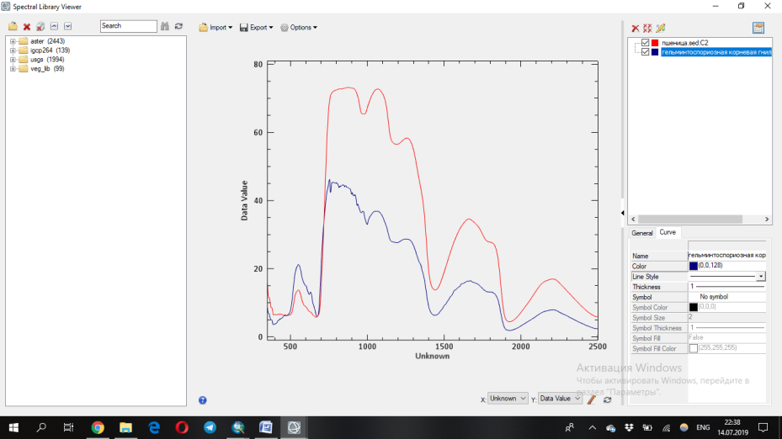

Figure 2 – Spectral reflection of healthy wheat and wheat with helminthosporous root rot
Thus, the spectral reflection of healthy wheat and wheat with powdery mildew were recorded using a PSR 1100 field spectrometer. The main symptoms of powdery mildew disease are: a white cobwebby plaque consisting of mycelium and conidia of the pathogen forms on leaves, stems, and rarely ears. Powdery mildew causes premature leaf death, plant depression, grain frailty, resulting in a yield reduced to 30% or more. In Figure 3, it is noticeable that the reflectivity of the disease is susceptible to both red and red edge ranges increased. This can be explained by the strong reflection of pigments in the red-red marginal ranges. Pigments such as chlorophyll A and B, and carotenoids decrease as plants get sick.

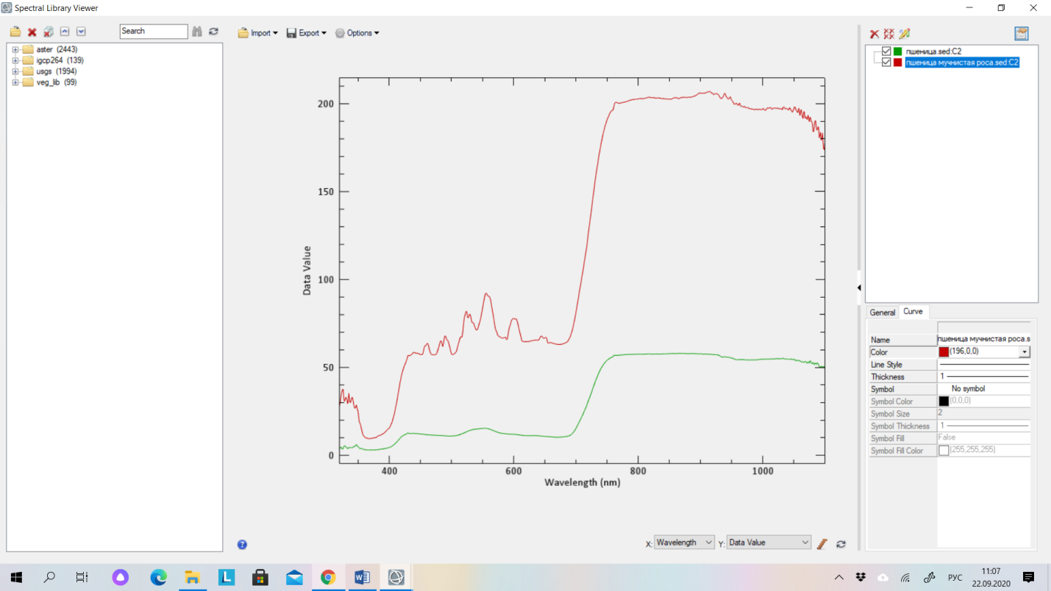

Figure 3 – Spectral reflection of healthy wheat and wheat with powdery mildew
The spectral reflection of a diseased plant differs significantly from the spectral reflection of a healthy one. Each disease on each culture can be recognized using spectral characteristics. Early recognition of diseases and the application of appropriate measures in time will increase the productivity and yield of crops.
The results of experimental studies of the original algorithms are obtained in comparison with standard and specialized analogues in terms of compression ratio, computational efficiency and loss level. It is noted that lossless compression algorithms, taking into account inter-band correlation, using difference-discrete transformations, are superior to other algorithms in terms of a set of indicators. To assess the quality of the reconstructed hyperspectral AI, the results of experimental studies of the proposed lossy compression algorithms using various quality metrics are presented. The proposed lossy and lossless compression algorithms demonstrate high compression ratios, as well as high quality indicators of the restored images.
Figure 4 and Figure 5 show compression algorithms with a variable number of channels K and a geometric size R (100×100) in comparison with the universal Winrar, 7Z archivers and the specialized JPEG Lossless algorithm. Compression ratio indicators exceed by 75 percent or more than universal algorithms, due to the consideration of cross-channel correlation, regression and difference transformation.

Figure 4 - Comparison of algorithms by number of channels
Figure 5 – Comparison of algorithms by geometric size of images
As a result of experiments based on the algorithm described in [10-11], the groups with the highest correlation were determined. In which the compression ratio varies from 5 to 8. This suggests that taking into account the interchannel correlation for hyperspectral AI is crucial in the compression problem.
To speed up the calculation of intermediate calculations, multithreaded processing was applied, in which certain results were obtained when AI was compressed. Figure 6 shows a graph of the calculation time of the experiment in comparison with universal archivers and the JPEG Lossless algorithm.

Figure 6 – Comparison of compression algorithms by calculation time
From Fig. 4, it can be seen that the dependencies of the compression ratio of the algorithms, taking into account the correlation and grouping of channels, are higher than if all 224 channels are fed to the input. This means that subtraction (difference transformations) using regression analysis are effective when selecting certain groups of channels, then the values of the differences will be the smallest, which will allow you to store the original channels in the smallest amount on disk.
Thus, the features of the practical implementation of HI compression algorithms are analyzed. A generalized structure for hyperspectral AI compression is proposed, including coding and decoding subsystems
1. The lossless compression algorithm, taking into account inter-band correlation and regression analysis, allows you to increase the compression ratio to (D>8) than in the use of universal archivers.
2. The proposed approach of finding the best groups of channels at a given correlation value increases the efficiency of using the difference transformation stage.
3. The experimental results obtained show the effectiveness of using the stages of regression transformation and parallel processing, which allow to obtain advantages over analogues

4 Generalization and evaluation of the results obtained
Comparative studies of compression performance characteristics in terms of peak signal-to-noise ratio, peak signal-to-noise ratio (PSNR) were carried out for the algorithm with minimizing the loss level. An example of calculating quality metrics.

then, PSNR = 10×log₁₀(255² / MSD). PSNR = 10×log₁₀ (255² /) = 32,56.
Based on experimental studies and calculated metrics of the quality of the original and restored images, the quality of the restored hyperspectral AI was analyzed.
Indicators of the quality metrics of the restored images are determined using PSNR and MSD. The degree of distortion compares the ratio between compression and distortion in lossy algorithms. Distortion is measured using PSNR. Figure 7 shows the dependence of D on PSNR.

Figure 7 – Comparative evaluation of the quality criteria of the restored images

CONCLUSION
Based on the above results of experimental studies of compression using difference-discrete hyperspectral images, it should be concluded that the developed mathematical and compression software occupies a leading position in terms of compression ratio and quality of the reconstructed images, depending on the chosen algorithm, since it significantly exceeds analogues on all test sets.
Comparative results of experimental studies of lossless compression algorithms, taking into account interchannel correlation, based on difference and regression transformations, which are superior to other algorithms in terms of a set of indicators, are presented.
To assess the quality of the reconstructed hyperspectral AI, experimental data of the proposed lossy compression algorithms with quality metrics are presented. It is concluded that the proposed lossy and lossless compression algorithms show high compression ratios along with high quality indicators of the restored images.
An estimate of the complexity of the developed algorithmic support for compression of hyperspectral images of various remote sensing systems is given, showing the computational complexity of the algorithms. At the same time, the dependence on the number of iterations of the procedures performed and the compression functions of hyperspectral images is shown. This suggests that the developed algorithms have minimal computational complexity.
The results of comparative experiments indicate that the developed algorithmic and software occupies a leading position in terms of compression ratio, computational efficiency, minimizing the level of losses and surpasses analogues on experimental sets of real data that vary widely.
Based on the above results of the compression experiment based on orthogonal and wavelet transformations of hyperspectral AI with losses, it can be concluded that the developed mathematical and software compression, to some extent occupies a leading position in the degree of compression and quality of the restored images, depending on the selected preparatory processing, significantly demonstrates and surpasses analogues on all test sets.
Based on the conducted research, the following conclusions should be drawn: the development of algorithms based on discrete transformations makes it possible to increase the compression ratio to (R=12); the proposed lossy approach is determined in adaptive transformations based on the Walsh-Hadamard transformation, discrete-cosine transformation and the generated quantization table and subsequent adaptive coding; the obtained results of comparing the transformed hyperspectral AI using the obtained coefficients suggest the effectiveness of using these studies with adaptive Huffman coding; comparison of quality criteria using standard quality metrics allows us to note that the hyperspectral AI was restored with high quality and minimal losses.
In 2021, 1 article recommended by Committee for Quality Assurance in the Field of Education and Science of the Ministry of Education and Science was submitted, 2 articles were submitted to print in the foreign peer-reviewed journal "Journal of Theoretical and Applied Information Technology", included in the Scopus database (percentile in international sciences -36) and "Journal of Applied Remote Sensing" (included in the Scopus database (percentile in international sciences - 69)), as well as abstracts in the international scientific and practical conference XIII All-Russian Scientific and Technical Conference with international participation "Robotics and Artificial intellect" (RII-21), abstracts submitted to the XX International Conference named after A.F. Terpugova "Information Technologies and mathematical modeling" (ITMM - 2021). Recommendations for the application and dissemination of the results of research work and Methodological instructions for the use of the software package "Compression of hyperspectral images for phytosanitary inspection of grain crops during aerospace survey" have been developed. One certificate of state registration of a computer program has been obtained.

LIST OF SOURCES USED
- Гук А. П. Анализ эффективности применения метода главных компонент при использовании непараметрического статистического подхода к дешифрированию снимков / А. П. Гук, М. М. Шляхова // Материалы IV Международной научной конференции «Региональные проблемы дистанционного зондирования Земли», – Красноярск: СФУ, 2017. – С.89–94.
- Добронец Б. С. Кусочно-полиномиальные модели для агрегации и регрессионного анализа в задачах ДЗЗ / Б. С. Добронец, О. А. Попова // Материалы IV Международной научной конференции «Региональные проблемы дистанционного зондирования Земли». – Красноярск: СФУ, 2017. – С. 98–102.
- Дружинин Д.В. Гибридный алгоритм сжатия дискретно-тоновой графики // Компьютерная безопасность и криптография: Труды Всероссийской конференции «XII Сибирская школа-семинар с международным участием» (8 – 13 сентября 2014 г.). – Томск, Изд-во Том.ун-та, 2014, № 7. – С. 116–118.
- Замятин А. В. Дифференцированное сжатие аэрокосмических изображений с потерями // Информационные технологии. – 2011. – № 6. – С.60-65.
- Замятин А. В. Сжатие многозональных аэрокосмических изображений с использованием вейвлет-преобразования и учетом междиапазонной зависимости / А. В. Замятин, То Динь Чыонг// Известия Томского политехнического университета. – 2008.– T.313, № 5. – С.20–24.
- Замятин А. В. Алгоритм сжатия гиперспектральных аэрокосмических изображений с учетом байтовой обработки и междиапазонной корреляции / А. В. Замятин, А. Ж. Саринова // Прикладная информатика. – 2013. №5 (47), – С. 37–42.
- Захарова Т. В. Вейвлет-анализ и его приложения. Учебное пособие / Т. В. Захарова, О. В. Шестаков. – М.: ИНФРА-М, 2012. – С. 124–135.
- Журавель Ю.Н. Особенности обработки гиперспектральных данных дистанционного зондирования при решении задач мониторинга окружающей среды / Ю. Н. Журавель, А. А. Федосеев // Компьютерная оптика. – 2013. – Т.37, № 4. – С. 471–476.
- Кашкин В. Б. Цифровая обработка аэрокосмических изображений / В. Б. Кашкин, Сухинин А. И. – Красноярск: СФУ, 2008. – 278 с.
- Кобзарь А. И. Прикладная и математическая статистика. Для инженеров и научных сотрудников. – М: ФИЗМАТЛИТ, 2012 – 816 с.
- Лупян Е. А. Современные подходы и технологии организационной работы с данными дистанционного зондирования Земли для решения научных задач / Е. А. Лупян, В. П. Саворский, Ю. И. Шокин, А. И. Алексанин, Р. Р. Назиров, И. В. Недолужко, О. Ю. Панова // Современные проблемы дистанционного зондирования Земли из космоса. – 2012. Т.9, № 5. – С.21–44.
- Малахов Э. В. Сжатие в архивировании и каталогизации данных дистанционного зондирования Земли / Э. В. Малахов, А. В. Замятин // Земля из космоса: наиболее эффективные решения, 5-ая международная конференция: тезисы докл. – М: Издательство Бином. – 2011. – С.140–142.
- Миклашевич C. Э. Программно-апппаратный комплекс для сбора, обработки, архивации и распространения спутниковых данных и продуктов их тематической обработки / И. В. Балашов, М. А. Бурцев, В. Ю.Ефремов, А. А. Мазуров и др. // Современные проблемы дистанционного зондирования земли из космоса. – 2012. Т.9, № 4. – С.47–56.
- Остриков В. H. Обработка гиперспектральных данных, получаемых с авиационных и космических носителей / В. H. Остриков, О. В. Плахотников, A. В. Кириенко // Современные проблемы дистанционного зондирования Земли из космоса. –2013. –Т.10, № 2. –С. 243–251.
- Остриков В. Н. Применение рандомиированного мтеода главных компонент для сжатия и тематической обработки гиперспектральных данных / В. Н. Остриков, В. В. Михайлов, С. И. Смирнов // Доклады Одиннадцатой Всероссийской Открытой конференции (11-15 ноября 2013 г.). – Москва. – 2013.
- Петров Е. П. Математическая модель цифровых полутоновых изображений Земли из космоса / Е. П. Петров, Е. В. Медведева, Н. Л. Харина // Актуальные проблемы ракетно-космической техники. – 2011. – С. 179–185.
- Петров Е. П. Метод сжатия цифровых полутоновых изображений на основе цепей Маркова с несколькими состояниями / Е. П. Петров, Н. Л. Харина, Е.Д. Ржаникова // Труды РНТОРЭС им. А. С. Попова. Серия: Цифровая обработка сигналов и ее применение. – 2013. Т.XV. – С. 132-135.
- Петров Е.П. Метод быстрого сжатия изображений без потерь / Е. П. Петров, Н. Л. Харина, П. Н. Сухих // Машинное обучение и анализ данных. –2015. – Т. 1, №12. – С.1762–1770.
- Петров Е.П. Метод сжатия многоразрядных спутниковых снимков без потерь / Е. П. Петров, Н. Л. Харина, П. Н. Сухих // Современные проблемы дистанционного зондирования Земли из космоса. – 2016. Т.13,№ 2. – С. 203–210.
- Петров Е.П. Метод сжатия изображений в системах ДЗЗ без потерь / Е. П. Петров, Н. Л. Харина, П. Н. Сухих // Вестник Самарского государственного аэрокосмического университета имени академика С.П. Королёва. – 2016. Т. 15, № 2. – С. 18–189.
- Саринова А. Ж. Программное обеспечение для сжатия гиперспектральных аэрокосмических изображений без потерь / А. Ж. Саринова, А. В. Замятин, А. А. Афанасьев // Свидетельство о государственной регистрации программы для ЭВМ № 2014660049 от 1.10.2014 г.
- Саринова А. Ж. Кодирование и декодирование гиперспектральных аэрокосмических изображений с применением вейвлет- преобразований / А. Ж. Саринова, М. Е. Исин // Современные наукоемкие технологии. Региональное приложение. –2016. – № 4 (48). – С. 67–73.
- Саринова А. Ж. Алгоритмы сжатия гиперспектральных аэрокосмических изображений с учётом межканальной корреляции //Информационные технологии и математическое моделирование (ИТММ-2017) : материалы XVI Междунар. конф. имени А. Ф. Терпугова, 29 сент. - 3 окт. 2017 г. Ч. 2. Томск: Изд-во НТЛ. – 2017. – С. 114–120.
- Саринова А. Ж. Алгоритм сжатия гиперспектральных аэрокосмических изображений с использованием математической обработки и учетом междиапазонной корреляции / А. Ж. Саринова, А. В. Замятин // Материалы IV Международной научной конференции «Региональные проблемы дистанционного зондирования Земли». – 2017. – С.157–160.
- Саринова А. Ж. Регрессионный подход к алгоритму сжатия гиперспектральных аэрокосмических изображений без потерь / Саринова А. Ж., Замятин А. В. // Вестник ТГУ. Серия «Управление, вычислительная техника и информатика (в печати) WebofSience.
- Сергеев В. В. Анализ и обработка изображений, получаемых при наблюдениях земли из космоса / В. В. Сергеев // Компьютерная оптика. – 2006. №29. – С.41–44.
- Сойфер В. А. Методы компьютерной обработки изображений. Учебное пособие, издание второе, исправленное / В. А. Сойфер. М.: Физматлит, 2003. – 782 с.
- Сэломон Д. Сжатие данных, изображений и звука. М.: Техносфера, 2004. – 368 с.
- Тропченко А.Ю. Методы сжатия изображений, аудиосигналов и видео: Учебное пособие / А. Ю. Тропченко, А. А. Тропченко. – СПб.: СПбГУ ИТМО, 2009. – 108 с.
- Уэлстид С. Фракталы и вейвлеты для сжатия изображений в действии. Издательство: Триумф, 2003. – 319 c.
- Чичева М. А. Сжатие гиперспектральных данных на основе кодирования с преобразованием. / М. А. Чичева, Р. Р. Юзькив // Компьютерная оптика. – 2014. – Т. 38, № 4. – С. 798–803.
- Чобану М. Многомерные многоскоростные системы обработки сигналов. М.: Техносфера, 2009. – 480с.
- Штарк Г. Г. Применение вейвлетов для ЦОС. М.:Техносфера, 2007. – С. 165–177.
- Яне Б. Цифровая обработка изображений. Пер. с англ. М.: Техносфера, – 2007. – 584 с.
- Acevedo D. Lossless compression of hyperspectral images: look-up tables with varying degrees of confidence / D. Acevedo, Ruedin A. // Universidad de Buenos Aires X199. ISASSP. – 2010. – Р.1314–1317.
- Aiazzi B. Near-lossless image compression by relaxation-labeled prediction / B. Aiazzi, L. Alparone, Baronti S. // Signal Process. – 2002. – №11. –Р.1619–1631.
- Aiazzi B. Spectral Distortion in Lossy Compression of Hyperspectral Data / B. Aiazzi, L. Alparone, S. Baronti, C. Lastri, M. Selva // Journal of Electrical and Computer Engineering. – 2012. – №10. – 8 p.
- Aiazzi B. Lossless compression of hyperspectral images using multiband lookup tables / B. Aiazzi, L. Alparone, Baronti S. // IEEE Signal Process. Letters – 2009. – Vol.6, №16.– Р.481–484.
- AVIRIS Data [Электронный ресурс] / URL: http://aviris.jpl.nasa.gov /data/free_data.html (дата обращения 25.06.2018).
- Ahmed A. Hyperspectral Data Compression Using Weighted Spatial-Spectral Lossless Coding Technique / A. Ahmed, S. Ramly, M. El. Sharkawy // International Journal of Image Processing.– 2012. – Vol.6, № 6. – P. 468–477.
- Ahmed A. Regrouping of Hyperspectral Data Based on Spectral Correlation Matrix Analysis / A. Ahmed, S. Ramly, M. El. Sharkawy // International Journal of Video & Image Processing and Network Security IJVIPNS-IJENS. – 2012. – Vol.12, № 04. – P. 1–8.
- Bruno А. Spectral Distortion in Lossy Compression of Hyperspectral Data / А. Bruno, А. Luciano, В. Stefano, L. Cinzia, S. Massimo. // Journal of Electrical and Computer Engineering. – Hindawi Publishing Corporation. – 2012. – 8 p. doi:10.1155/2012/850637.
- Changguo Li. Lossless Compression of Hyperspectral Images Using Three-Stage Prediction with Adaptive Search Threshold / Li Changguo, Ke Guo // International Journal of Signal Processing, Image Processing and Pattern Recognition. – 2014. – Vol.7, No.3. – Р. 305–316.
- Сhengfu H. Compression techniques for hyperspectral images. Department of Electronic Engineering and Information Science / H. Сhengfu, R. Zhang, D.Yin // University of Science and Technology of China, Hefei. – China, – 2010. – 18 p.
- Gashnikov M.V. Hierarchical GRID interpolation under hyperspectral images compression / M. V.Gashnikov, N. I. Glumov // Optical Memory and Neural Networks. – 2014. – Vol. 23(4). – Р. 246–253.
- Gashnikov M. V. Hyperspectral remote sensing data compression and protection / M. V.Gashnikov, N. I. Glumov, A. V. Kuznetsov, V. A. Mitekin, V. V. Myasnikov, V. V. Sergeev // Computer Optics. – 2016. –Vol. 41. No.5. – P. 689–712.
- Gashnikov M. V. Hyperspectral image compression for transmission over communication channel / M. V.Gashnikov, N. I. Glumov // Information Technology and Nanotechnology. – 2016. – Р. 334–339.
- Дудкин А. А. Алгоритм сжатия гиперспектральных данных дистанционного зондирования земли / А. А. Дудкин, Д. Ю. Перцев // Proceedings of the National academy of sciences of Belarus, рhysic and mathematics series.– 2017. – № 1. – С. 120–126.
- Cheng-chen L. Lossless Compression of Hyperspectral Images Using Adaptive Prediction and Backward Search Schemes / L. Cheng-chen, H. Yin-tsung // Journal of Information Science and Engineering. – 2011. – №27. – P. 419-435.
- Chengfu H. Lossless Compression of Hyperspectral Images Based on Searching Optimal Multibands for Prediction / H. Chengfu, R. Zhang, Р. Tianxiang. – 2009. – Vol.6, №2. – Р. 339–343.
- Chourasiy R. A study of image compression based transmission algorithm using spiht for low bit rate application / R. Chourasiy, Ajit Shrivastava // Advanced Computing: An International Journal. – 2012. – Vol.3, No.6. – Р. 47–54.
- Daubechies, I. 1992. Ten Lectures on Wavelets, SIAM.
- Dharam S. Software Implementation of CCSDS Recommended Hyperspectral Lossless Image Compression. / S. Dharam, B. Kuhelika, S. Joshi // I.J. Image, Graphics and Signal Processing. – 2015, – №4, – Р. 35–41.
- Valsesia D. A Novel Rate Control Algorithm for Onboard Predictive Coding of Multispectral and Hyperspectral Images / D. Valsesia, E. Magli. // Computer science. – 2014.– 15 р.
- Dubey V. A new Set Partitioning in Hierarchical (SPIHT) Algorithm and Analysis with Wavelet Filters / V. Dubey, R. Dubey // International Journal of Innovative Technology and Exploring Engineering. – 2013. – Vol.3. – Р. 125–128.
- Ramesh S. M. Analysis of Lossy Hyperspectral Image Compression Techniques / S. M. Ramesh, P. Bharat, J. Anand, J. Selvan // International Journal of Computer Science and Mobile Computing. – 2014. – Vol.3, № 2. – Р. 302–307.
- Emmanuel Christophe. Hyperspectral Data Compression Tradeoff. Optical Remote Sensing, Augmented Vision and Reality / Springer-Verlag Berlin Heidelberg. – 2011.– P. 9–29.
- Eastman J.R. Idrisi Selva Tutorial / Clark University. Manual version 17. – 2012. – 354p.
- Ganeshraj P. Scalable Compression Method for Hyperspectral Images / P. Ganeshraj, A. Sivasankar // Research Journal of Engineering Sciences. – 2013. Vol.2(3). – Р. 1–5.
- Gashnikov MV, Glumov NI, Kuznetsov AV, Mitekin VA, Myasnikov VV, Sergeev VV. Hyperspectral remote sensing data compression and protection. Computer Optics 2016; 41(5): 689–712.
- Shen H. Predictive Lossless Compression of Regions of Interest in Hyperspectral Images With No-Data Regions / H. Shen, W. Pan // IEEE. Transactions on geoscience and remote sensing. – 2017. – Vol. 55, №1. – Р. 173–182.
- Chauhan P. Compression and Classification of Hyperspectral Images using an Algorithm based on DWT and NTD / P. Chauhan, R. Chauhan // Advance in Electronic and Electric Engineering. – 2013. – Vol. 3, № 4, – Р. 447–456.
- García-Vílchez F. On the Impact of Lossy Compression on Hyperspectral Image Classification and Unmixing / F. García-Vílchez, J. Muñoz-Marí, M. Zortea, I. Blanes, V. González-Ruiz, G. Camps-Valls, A. Plaza. // IEEE Geoscience and remote sensing letters. – 2011. – Vol. 8, № 2. – Р. 253–257.
- JPEG 2000. [Электронный ресурс] / MainConcept. URL: http://www.mainconcept.com/products/sdks/video/jpeg-2000.html (дата обращения 15.04.2018).
- Cheng K. An Improved EZW Hyperspectral Image Compression. School of Electrical Engineering and Computer Science / K. Cheng, J. C. Dill // Ohio University, Athens, USA. Journal of Computer and Communications. – 2014. – Р. 31–36.
- Cheng K. Compression of Hyperspectral Images / School of Electrical Engineering and Computer Science and the Russ College of Engineering and Technology by. Dissertation. – 2013.
- Karami A. Hyperspectral image compression using 3D discrete cosine transform and support vector machine learning / A. Karami, S. Beheshti, M. Yazdi // The 11th IEEE International Conference on Information Sciences, Signal Processing and their Applications: main tracks. – 2012. – P.826–829.
- Keerthana P. The Impact of Lossy Compression on Hyperspectral Data Adaptive Spectral Unmixing and PCA Classification / P. Keerthana, A. Sivasankar // International Journal of Science and Modern Engineering. – 2013. – Vol.1, № 7. – Р. 35–37.
- Zhanga L. Compression of hyperspectral remote sensing images by tensor approach / L. Zhanga, L. Zhangb, D. Taoc, X. Huangb, B. Dua // Neurocomputing. –2015. – Vol. 147. – P. 358–363.
- Liang Y. Lossless compression of hyperspectral images using hybrid context prediction / Y. Liang, L. Jianping, G. Ke // Optical Society of America. – 2012. – Vol.20, №7. – Р. 199–206.
- Lin C. Lossless Compression of Hyperspectral Images Using Adaptive Prediction and Backward Search Schemes / C. Lin, Y. Hwang // Journal Of Information Science And Engineering 27. – 2011. – P. 419–435.
- Lossless multispectral & hyperspectral image compression. CCSDS Recommended standard for lossless multispectral & hyperspectral image compression. Recommended Standard, Issue 1. CCSDS Secretariat. Space Communications and Navigation Office, 7L70 / NASA Headquarters. Washington, DC 20546-0001, USA. – 2012. – 52 p.
- Santos L. Lossy hyperspectral image compression on a graphics processing unit: parallelization strategy and performance evaluation / L. Santos, E. Magli, R. Vitulli, A. Núñez, J. F. López, R. Sarmiento // Journal of Applied Remote Sensing. – 2013. – Vol. 7. – P. 074599-1–15.
- Magli E. Optimized onboard lossless and near-lossless compression of hyperspectral data using CALIC / E. Magli, G. Olmo, E. Quacchio // IEEE Geoscience and remote sensing letters. – 2004. – №1. – Р.21–25.
- Mahendran M. Compression of Hyperspectral Images Using PCA with Lifting Transform / M. Mahendran, S. D. Jayavathi // International Conference on Emerging Engineering Trends and Science. –2016. – Р.68–73.
- Mallat S. A Wavelet Tour of Signal Processing. – 1999. – 851 p.
- Meena B. Low Complexity DCT-based DSC approach for Hyperspectral Image Compression with Arithmetic Code / B. Meena, V. Sedamkar, R. R. Sedamkar // IJCSI International Journal of Computer Science Issues. – 2012. – Vol. 9, № 5. – Р. 277–284.
- Sindhuja N.M. SPIHT based compression of hyperspectral images / N.M. Sindhuja, A.S. Arumugam // International Journal of Advanced Research in Electrical, Electronics and Instrumentation Engineering. – 2013. – Vol. 2, № 10. – Р. 4933–4938.
- Nian Y. Lossless and near-lossless compression of hyperspectral images based on distributed source coding / Y. Nian, M. He, J. Wan // Journal of Visual Communication and Image Representation. – 2015. – Р.113–119.
- Nutan C. Novel K-Means Clustering Approach for Compressing Hyperspectral Image / C. Nutan, R.R. Sedamkar // International Journal of Advancements in Research & Technology. – 2014. – Vol.3, № 1. – P. 140–145.
- Ouahioune M. Aviris Hyperspectral Images Compression Using 3d Spiht Algorithm / M. Ouahioune, L. Akrour, M. Lahdir, S. Ameur // IOSR Journal of Engineering. – 2012. – Vol.2, № 10. – P. 31–36.
- Zhang Q. Randomized methods in lossless compression of hyperspectral data / Q. Zhang, V. Paúl Pauca, R. Plemmons // Journal of Applied Remote Sensing. – 2013. – Vol. 7. – P. 2–16.
- Pizzolante R. Band Clustering for the Lossless Compression of AVIRIS Hyperspectral Images / R. Pizzolante, B. Carpentieri // ACEEE Int. J. on Signal and Image Processing. – 2014. – Vol. 5, No. 1. – P. 1–14.
- Pizzolante R. On the Compression of Hyperspectral Data / R. Pizzolante, B. Carpentieri // IT CoNvergence PRActice (INPRA). – 2013. –Vol.1, № 4. – Р. 24–38.
- Sanjith S. A Review on Hyperspectral Image Compression / S. Sanjith, R. Ganesan // International Conference on Control, Instrumentation, Communication and Computational Technologies (ICCICCT). – 2014. – P. 1159–1163.
- Sarinova A. Lossless compression of hyperspectral images with pre-byte processing and intra-bands correlation / A. Sarinova, A. Zamyatin, P. Cabral // Dyna-Colombia. – 2015. –Т. 82, № 190. – P. 166–172.
- Sarinova A. Processing the algorithms, compression of hyperspectral images based on aerospace crossband correlation with and without losses / A. Sarinova, A.V. Zamyatin // Distributed computer and communication networks: Control, Computation, Communications (DCCN-2016). – 2016. – Р. 291–298.
- Salomon D. Data compression. The complete reference / Springer-Verlag, 2007. –1118 p.
- Sayood K. Introduction to Data Compression / USA. Universitet Nebraska. Morgan Kaufmann Publishers is an imprint of Elsevier, 2006. – San Francisco, CA 94111. – 703 p.
- Zhu S. Hybrid Prediction and Fractal Hyperspectral Image Compression / S. Zhu, D. Zhao, F. Wang // Hindawi Publishing Corporation Mathematical Problems in Engineering. – 2015. – P.2–10.
- Sepehrband F. Efficient Adaptive Lossless Compression of Hyperspectral Data using Enhanced DPCM / F. Sepehrband, Р. Ghamisi, A. Mohammadzadeh, M. P. Sahebi, J. Choupan // International Journal of Computer Applications. – 2011. – Vol. 35, № 4. – Р. 6–11.
- SpecTIR Data – Advanced Hyperspectral and Geospatial Solutions / URL: http://www.spectir.com/free-data-samples (дата обращения - 23.05.2021).
- Sridevi M. Comparative study of image forgery and copy-move techniques / M. Sridevi, С. Mala, S. Sanyam // Second International Conference on Computer Science, Engineering and Applications (ICCSEA 2012). New Delhi, India. – 2012. –P.715–723.
- Sujithra D. S. Compression of hyperspectral image using discrete wavelet transform and Walsh Hadamard transform / D. S. Sujithra, T. Manickam, D.S. Sudheer // International journal of advanced research in electronics and communication engineering (IJARECE). – 2013. – Vol. 2, № 3. – P. 314–319.
- WinZip. Программа cжатиядля Windows URL: http://www.winzip.Com/ru/ prodpagewz.htm (датаобращения – 11.05. 2021).
- Nian Y. Low-Complexity Compression Algorithm for Hyperspectral Images Based on Distributed Source Coding / Y. Nian, M. He, J. Wan // Hindawi Publishing Corporation. Mathematical Problems in Engineering. – 2013. – 7 p.
- Yuan Liang, Jianping Li and Ke Guo. Lossless compression of hyperspectral images using hybrid context prediction / OPTICS EXPRESS 8199 March 2012 / Vol. 20, No. 7.
- Zamyatin A. V. The Compression Algorithm of Hyperspectral Space Images Using Pre-byte Processing and Intra-bands Correlation / A. V. Zamyatin, A. Zh Sarinova, P. Cabral //GEOProcessing 2014, The Sixth International Conference on Advanced Geographic Information Systems, Applications, and Services, Испания. – 2014. – Р. 70–75.
- Zhang J. An efficient reordering prediction-based lossless compression algorithm for hyperspectral images / J. Zhang, G. Liu // IEEE Geoscience and remote sensing letters. – 2007. – Vol.2, №4. – P.283–287.
- William K. Pratt. Digital Image Processing: PIKS Inside, Third Edition. John Wiley & Sons, Inc, 2001. – 738 p.
- Woods E. Digital Image Processing / E. Woods, R. Gonzalez // Prentice Hall, 3ed., 2007. – 1104 р.
- Wallace G. The JPEG Still Picture Compression Standard. Communications of the ACM. – 1991. – Vol.34(4). –Р.30–44.
- URL: http://www.gisa.ru (дата обращения 12.08.2021).

APPENDIX A
Calendar plan for 2021







Appendix 1.5
to this Agreement
№________________ from «_____»_____________2021 year

CALENDAR PLAN

NJSC "Kazakh Agrotechnical University named after S.Seifullin"

1.1 Priority: Sustainable development of the agro-industrial complex and safety of agricultural products.
1.2 By sub-priority: Technical support for the modernization of the agro-industrial complex.
1.3 On the topic of the project: AP09561922 «Development of a mathematical apparatus for the use of hyperspectral images for phytosanitary examination of grain crops in aerospace imagery».
1.4 The total amount of the project for 2021 is 7 943 066,77 tenge (seven million nine hundred forty-three thousand sixty-six) tenge 77 tiyn to perform work according to paragraph 3.

2. Characteristics of scientific and technical products by qualification criteria and economic indicators

2.1 Field of work: aerospace survey.
2.2 Scope of application: software.
2.3 Final result for 2021:
- The need to create or improve the methods that are currently used in managing the storage of large archives of aerospace data will be justified. A technical specification for the software systems being created will be drawn up.
- Test samples of image files will be received in the format used by existing systems for subsequent tests.
- A mathematical apparatus based on a difference-discrete transformation for compressing hyperspectral images will be developed and adapted. The proposed compression methods and algorithms for development will be selected.
- The results of testing, reproducing the results and the adequacy of the developed mathematical models for determining the identification of the morbidity of grain crops will be obtained. Mathematical methods for processing hyperspectral images will be developed.
- The results of preliminary preprocessing of hyperspectral images will be obtained. Image preprocessing methods will be selected
- The results of experimental studies of the developed algorithms and software for compressing hyperspectral images will be obtained.
- Experimental research reports will be generated.
- The results of testing and evaluation will be obtained according to the criteria of compression ratio and quality of decoded images in comparison with the original images of the developed system.
- The results of elimination of identified deficiencies and adjustments in accordance with technical requirements will be obtained.
- Software will be developed with support for working through graphical or/and command interfaces. The results of the software implementation of high-performance compression algorithms in the Visual Studio 2019 software environment using the C# language will be obtained.
- High-performance software-ready algorithms for compression of aerospace data will be developed to optimize their storage and perform conversion, both with and without losses.
- Recommendations will be developed for further application and dissemination of the results of the work. Methodological instructions on the use of the software package will be developed.
- 1 (one) article will be submitted to the press, to a peer-reviewed scientific publication included in the Science Citation Index Expanded or Social Science Citation Index in the Web of Science database and (or) having a CiteScore percentile in the Scopus database of at least 35 (thirty-five); 1 (one) article will be submitted to the publication from the list of CQAFES of the MES RK.
2.4 Patentability: The results are patentable.
2.5 Scientific and technical level (novelty): The use of image archiving is an innovation in the development of space technologies and the agro-industrial complex of the republic and will ensure its scientific competitiveness in the global industry. The study will allow a more rational use of disk space for storing aerospace data, so the result is cost-effective. The developed and improved data compression algorithms can subsequently be used for other various digital formats. The novelty of the research will be an incentive for the introduction of own solutions in all scientific branches of digital development of the agro-industrial complex of the Republic of Kazakhstan.
2.6 The use of scientific and technical products is carried out by: the contractor.
2.7 Type of use of the result of scientific and (or) scientific and technical activities: publications, reports.

3 Name of works, terms of their implementation and results
The cipher of the task, stage |  | The name of the work under the Contract and the main stages of its execution | Deadline |  |  | Expected result
 |  |  | beginning | ending
1 |  | Substantiation of the effectiveness of using hyperspectral images to identify a specific disease of grain crops and comparative characteristics of the qualitative indicators of multi- and hyperspectral images. | may  2021 y. | june 2021 y. |  | Risks and achievements of the goal will be assessed, research directions will be selected. The effectiveness of the use of hyperspectral images for the identification of a specific disease of grain crops will be justified and a comparative characteristic of the qualitative indicators of multi- and hyperspectral images will be carried out.
1.1 |  | Justification of the need to create or improve methods that are currently used in the storage management of large archives of aerospace data. | may  2021 y. | june 2021 y. |  | The need to create or improve the methods that are currently used in the storage management of large archives of aerospace data will be justified. A technical specification for the software systems being created will be drawn up.
1.2 |  | Получение образцов файлов в используемом существующими системами формате для последующего проведения тестов. | may  2021 y. | june 2021 y. |  | Будут получены тестовые образцы файлов изображений в используемом существующими системами формате для последующего проведения тестов.
2 |  | Development and adaptation of a mathematical apparatus based on a difference-discrete transformation for compression of hyperspectral images. | July  2021 y. | August 2021 y. |  | A mathematical apparatus based on a difference-discrete transformation for compressing hyperspectral images will be developed and adapted. The proposed compression methods and algorithms for development will be selected.
2.1 |  | Testing, reproduction of the results and adequacy of the developed mathematical models for determining the identification of the morbidity of grain crops | July  2021 y. | August 2021 y. |  | The results of testing, reproducing the results and the adequacy of the developed mathematical models for determining the identification of the morbidity of grain crops will be obtained. Mathematical methods for processing hyperspectral images will be developed.
2.2 |  | Preliminary preprocessing of hyperspectral images. | July  2021 y. | August 2021 y. |  | The results of preliminary processing of hyperspectral images will be obtained. Image preprocessing methods will be selected
3 |  | Conducting experimental studies of the developed algorithms and software for compressing hyperspectral images. | September 2021 y. | October 2021 y. |  | The results of experimental studies of the developed algorithms and software for compressing hyperspectral images will be obtained.
4 |  | Software implementation of high-performance compression algorithms in the Visual Studio 2019 software environment using the C# language. | November 2021 y. | December 2021 y. |  | Experimental research reports will be generated.
5 |  | Development of high-performance algorithms for compression of aerospace data, allowing to optimize their storage. | November 2021 y. | December 2021 y. |  | Software will be developed with support for working through graphical or/and command interfaces. The results of the software implementation of high-performance compression algorithms in the Visual Studio 2019 software environment using the C# language will be obtained.
5.1 |  | Testing and evaluation according to the criteria of compression ratio and quality of decoded images in comparison with the original images of the developed system. | September 2021 y. | October 2021 y. |  | The results of testing and evaluation will be obtained according to the criteria of compression ratio and quality of decoded images in comparison with the original images of the developed system.  Abstracts will be submitted for participation in the international conference.
5.2 |  | Elimination of identified deficiencies and adjustment in accordance with technical requirements. | September 2021 y. | October 2021 y. |  | The results of the elimination of the identified deficiencies and adjustments in accordance with the technical requirements will be obtained. A fully functional software ready for use will be created.
6 |  | Development of recommendations for further application and dissemination of the results of the work. | November 2021 y. | December 2021 y. |  | Recommendations for further application and dissemination of the results of the work will be developed. Methodological instructions on the use of the software package will be developed.  1 (one) article will be submitted to the press, to a peer-reviewed scientific publication included in the Science Citation Index Expanded or Social Science Citation Index in the Web of Science database and (or) having a CiteScore percentile in the Scopus database of at least 35 (thirty-five); 1 (one) article will be submitted to the publication from the list of CQAFES of the MES RK.
 | From the Customer:  Chairman  State Institution «Committee of Science of the Ministry of Education and Science of the Republic of Kazakhstan»  ______________ Kurmangalieva Zh.D.  p.p. |  |  |  | From the Performer:  Chairman of the Management Board  NJSC «Kazakh Agrotechnical University named after S. Seifullin»  ________________ Aituganov K.K.  p.p.  Familiarized with:  Scientific director of the project  ___________________ Sarinova A.Zh. (signature)

APPENDIX B
Images of hyperspectral images per channel №№ 1, 10, 25, 50, 75, 100, 120, 140, 160, 180, 200, 210, 250, 270

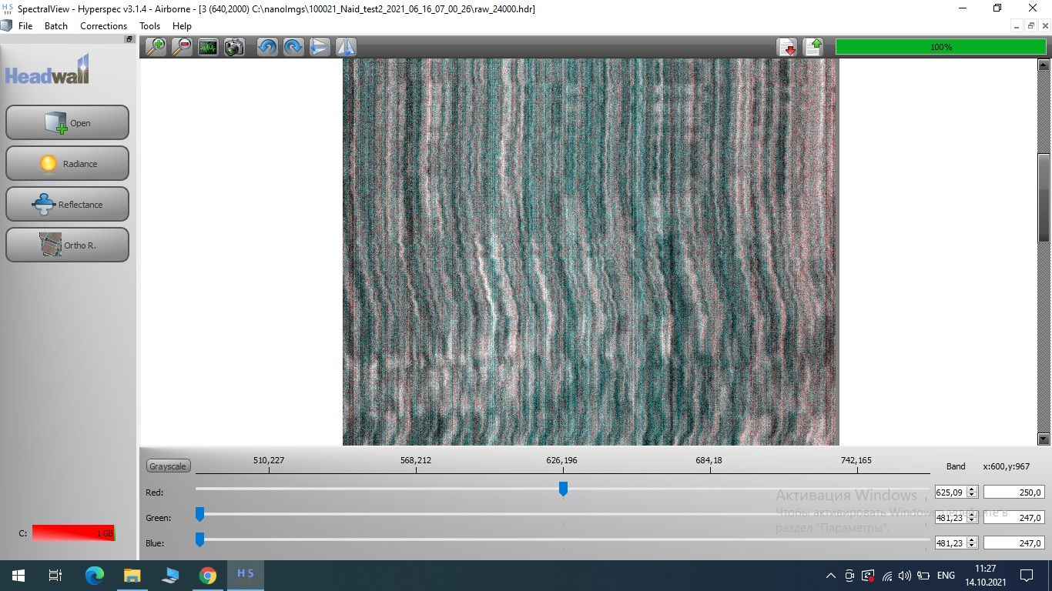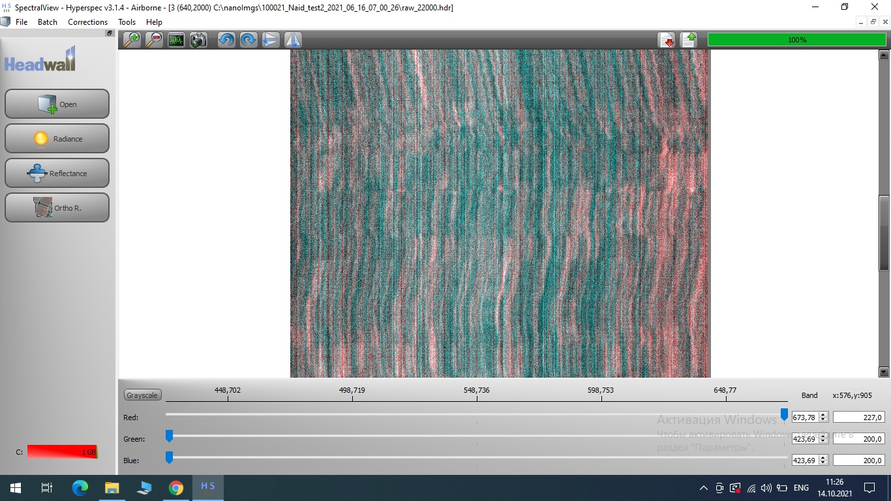

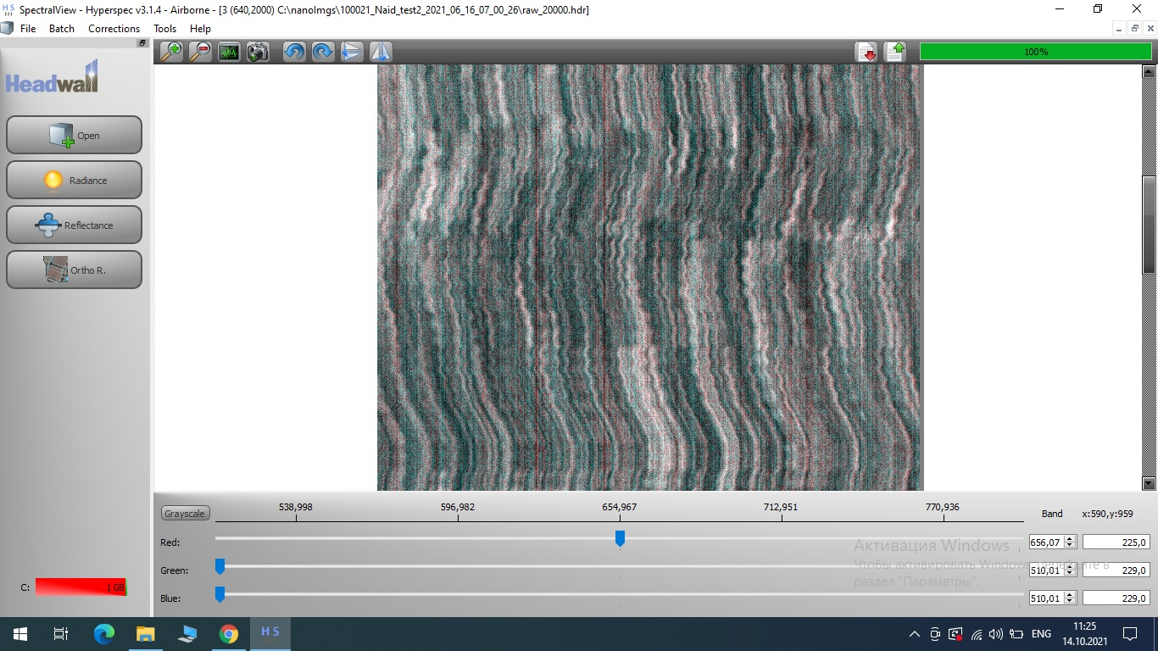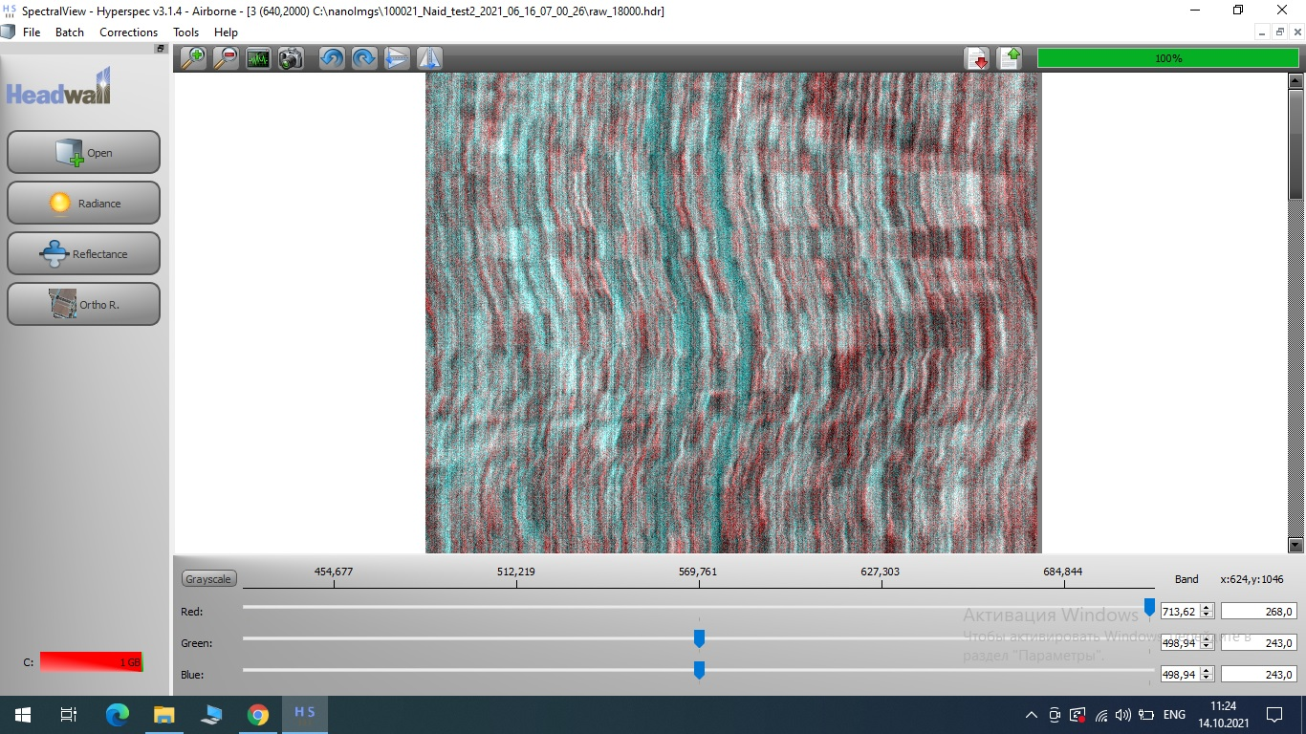

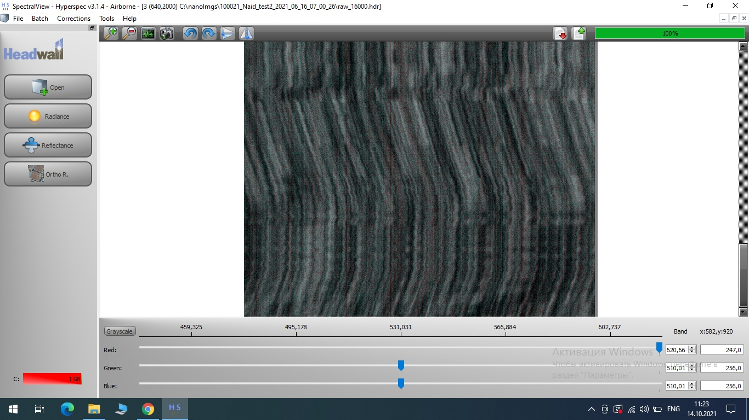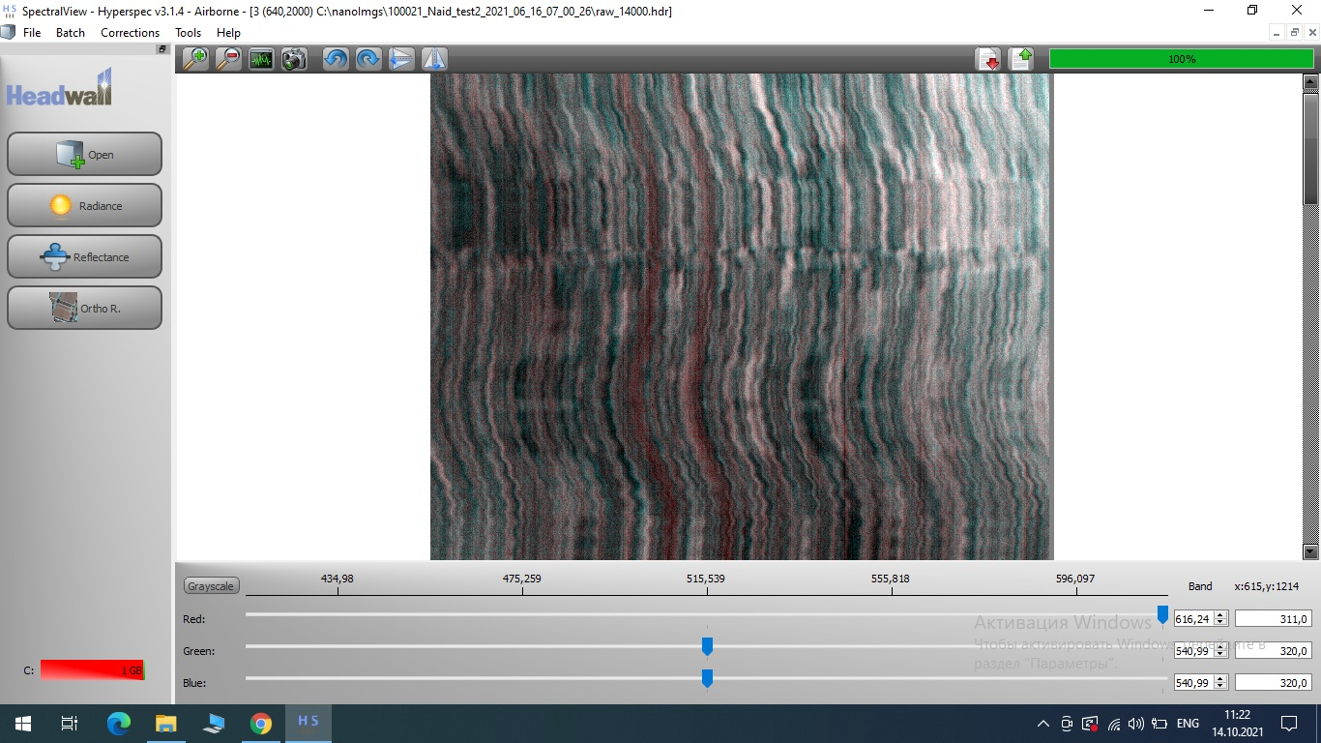

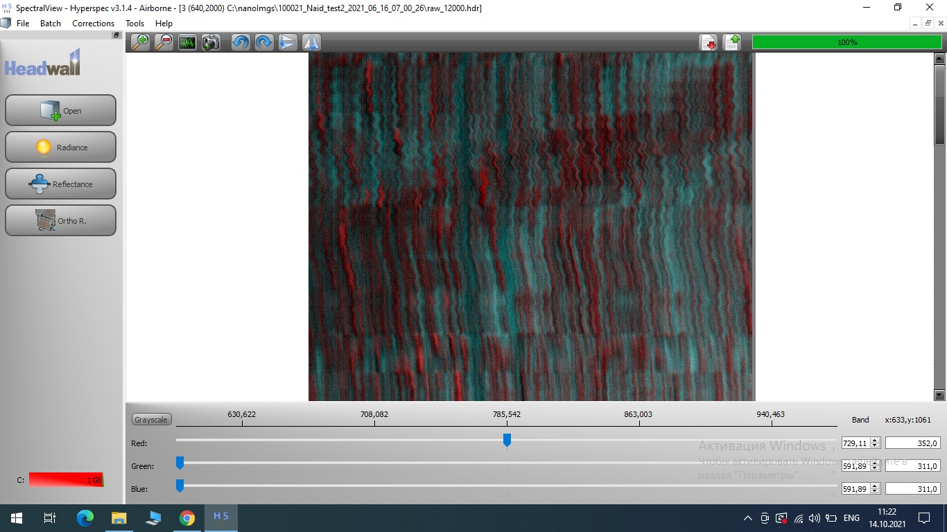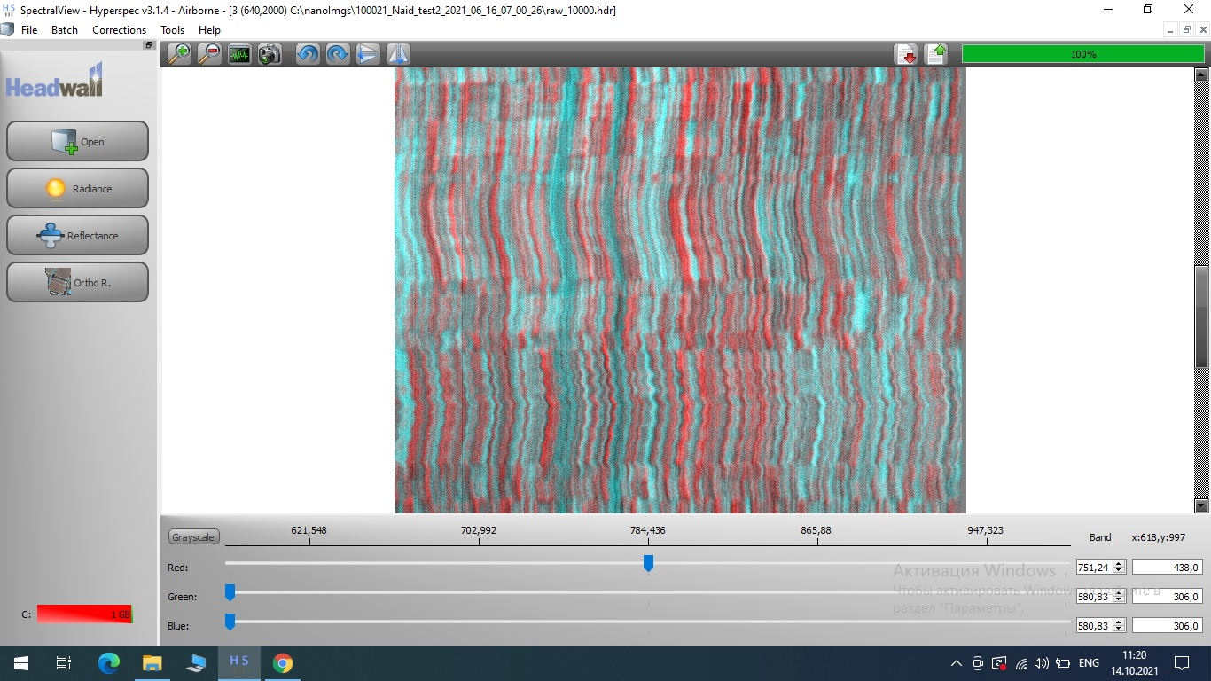

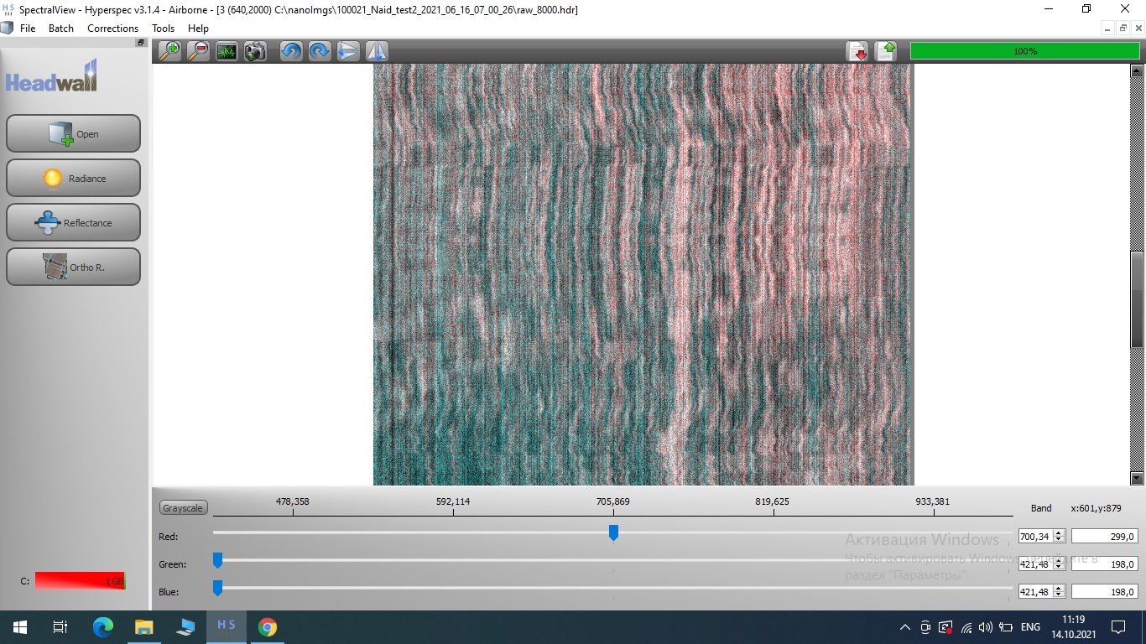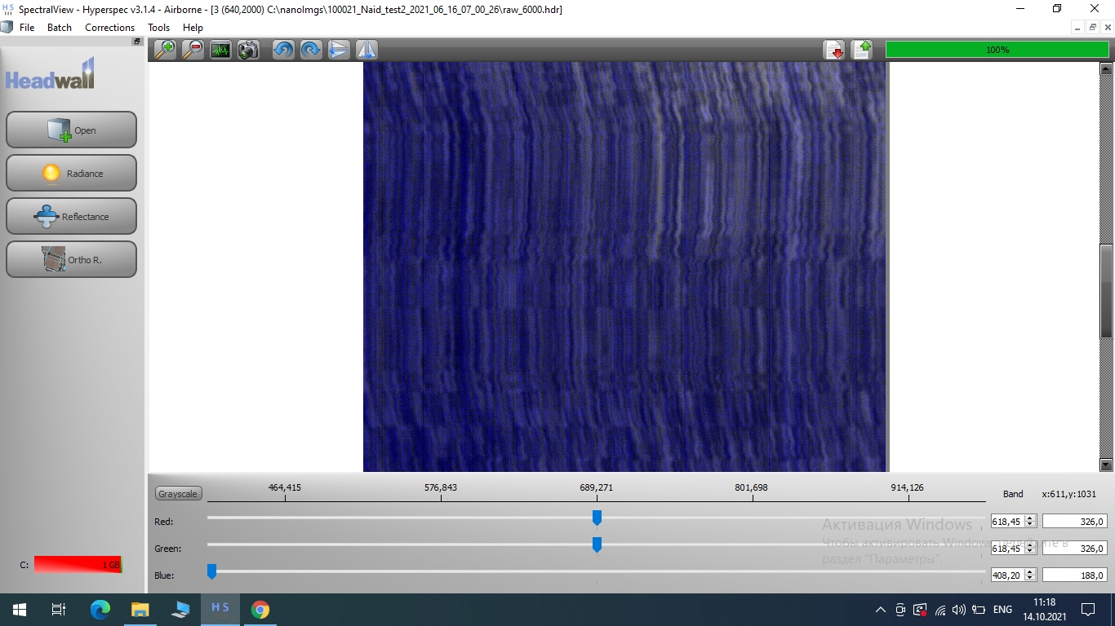

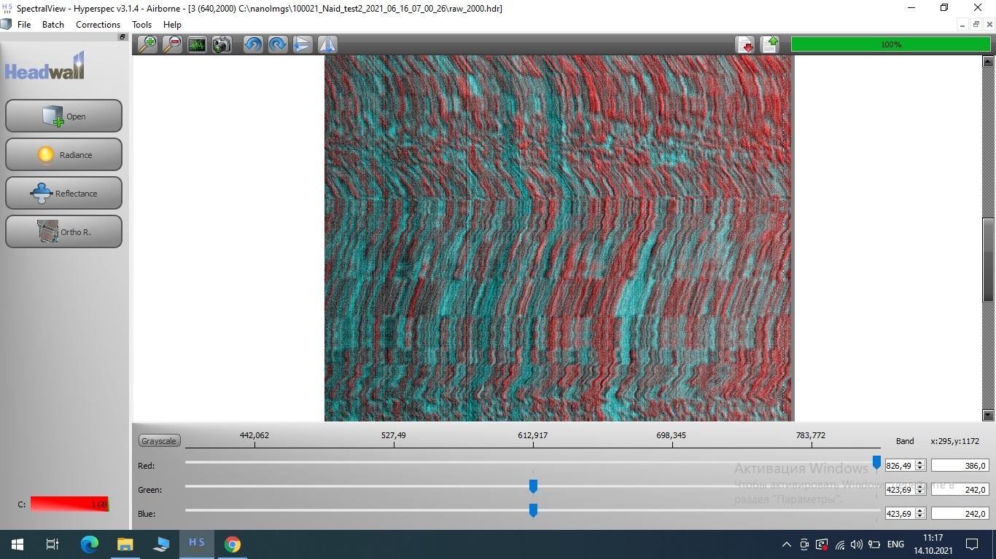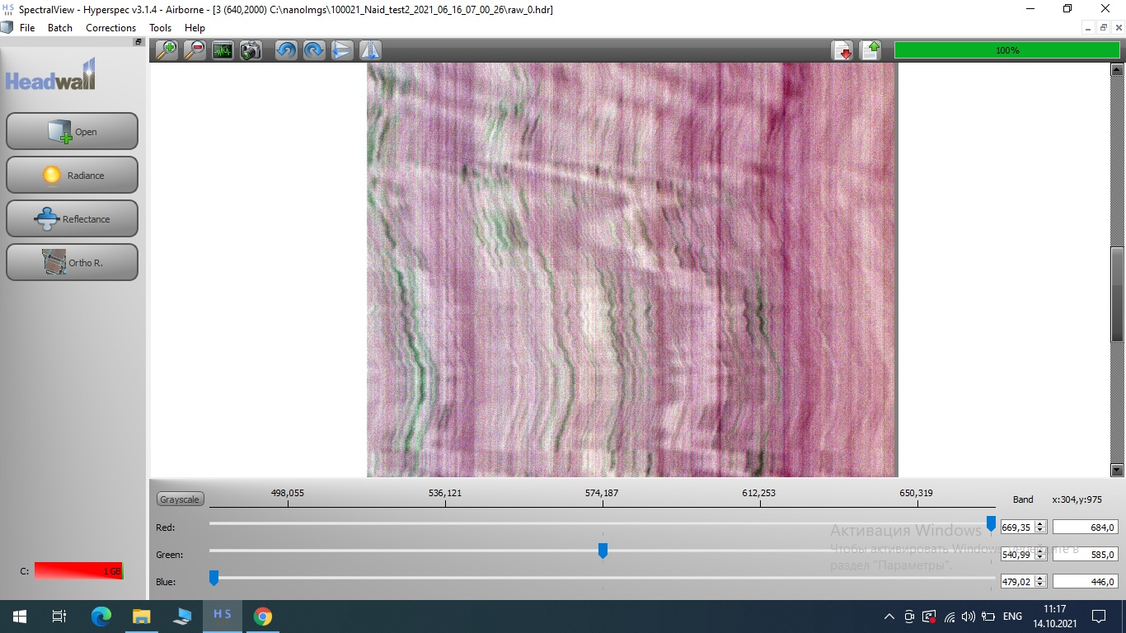

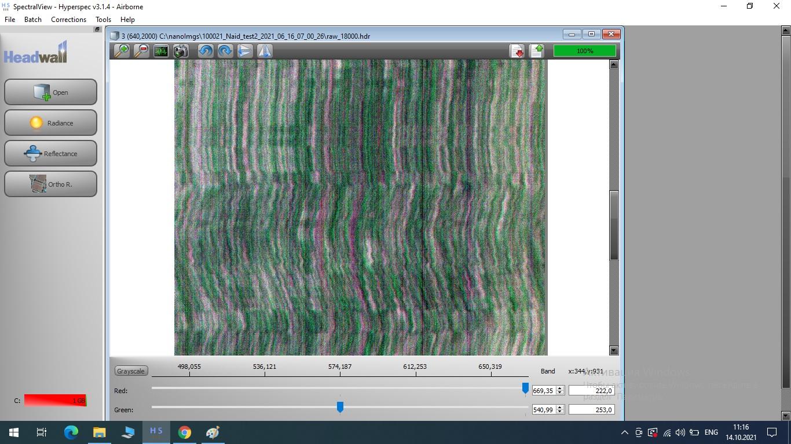

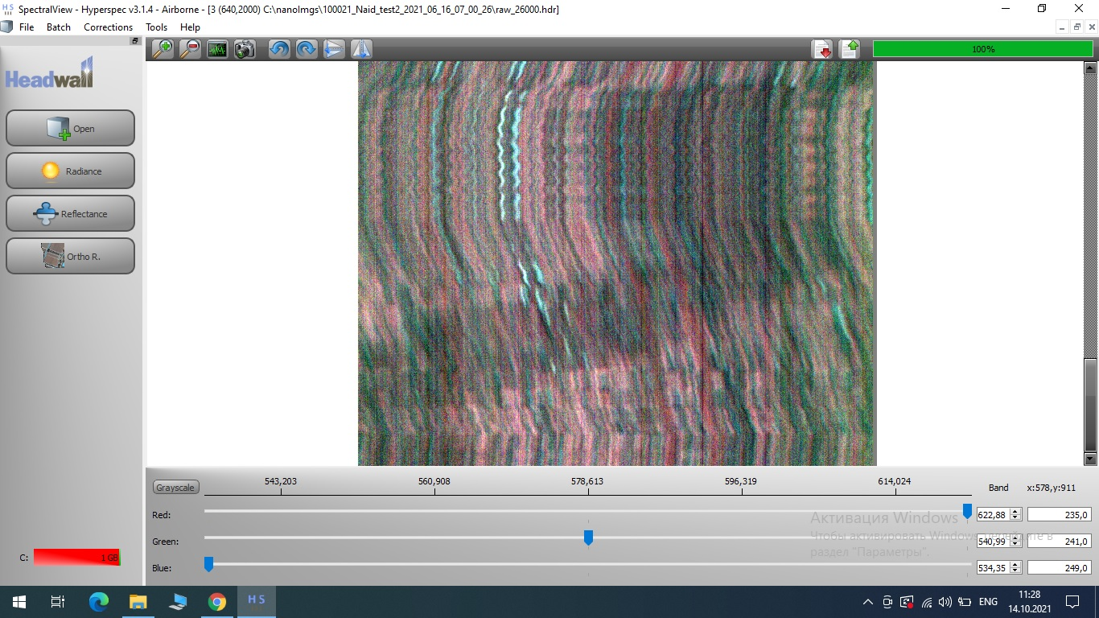

APPENDIX C
List of publications for 2021

1. A.Zh. Sarinova, P. A. Dunayev, A.М. Bekbayeva. Methodology for developing algorithms for compressing hyperspectral aerospace images used on board spacecraft. Журнал КОКСОН МОН РК «Труды университета». Карагандинский технический университет. In print
2. A.Zh. Sarinova, P. A. Dunayev, A.М. Bekbayeva, Y. Zh. Sarsikeyev, A. D. Mekchtiyev Development of compression algorithms for hyperspectral aerospace images based on discrete orthogonal transformations. Journal Applied Remote Sensing. Scopus. In print
3. A.Zh. Sarinova, P. A. Dunayev, A.М. Bekbayeva, Y. Zh. Sarsikeyev, K. M. Sansyzbay Hyperspectral image compression algorithms for phytosanitary inspection of agricultural crops in aerospace photography. Journal of Theoretical and Applied Information Technology. Scopus. In print
4. А. Ж. Саринова, П. А. Дунаев, А. М. Бекбаева. Discrete-cosine transformation for compression of hyperspectral images in phytosanitary control of grain crops. Abstracts have been submitted for the XX International Conference named after A.F. Terpugov "Information Technologies and Mathematical modeling" (ITMM - 2021). In print
5. А. Ж. Саринова, П. А. Дунаев, А. М. Бекбаева. Features of compression of hyperspectral images on board the spacecraft. Abstracts have been submitted for the XIII All-Russian Scientific and Technical Conference with international participation "Robotics and Artificial Intelligence" (RII-21). In print

APPENDIX D
Certificate for a computer program

APPENDIX E
Recommendations for the application and dissemination of the results of research work on the project

Ministry of agriculture of the Republic of Kazakhstan
NJSC «KAZAKH AGROTECHNICAL UNIVERSITY
NAMED AFTER SAKEN SEIFULLIN»
(NJSC «KATU named after S. SEIFULLIN»)

RECOMMENDATIONS FOR THE APPLICATION AND DISSEMINATION OF THE RESULTS OF RESEARCH WORK ON THE PROJECT
"Development of a mathematical apparatus for the use of hyperspectral images for phytosanitary inspection of grain crops in aerospace photography" for specialties: Automation and energy efficiency of processes and production, Energy supply and automation of agriculture

Authors: PhD, senior lecturer Sarinova A.Zh. of the department "Operation
electrical equipment"
PhD, senior lecturer Dunaev P.A. of the Department "Radio Engineering,
electronics and telecommunications"

Nur-Sultan 2021

CONTENT

Introduction...................................................................................................................
Main part.......................................................................................................................
Conclusion.....................................................................................................................
References.....................................................................................................................
INTRODUCTION
As part of the grant financing of the AP AP09561922 project "Development of a mathematical apparatus for the use of hyperspectral images for phytosanitary inspection of grain crops in aerospace photography", it was investigated that software designed to compress hyperspectral data that does not take into account the characteristic features and qualitative indicators of hyperspectral cameras has been developed and is being used. These include ERDASImagine, ERDASERMapper, ArcViewGIS, GeoExpress, etc., which is increasingly supplemented with specialized modules for compressing hyperspectral data. So, the package ERDAS Imagine, as well as ArcViewGIS have image compression tools in the MrSID format (IMAGINE MrSID Desktop Encoder and IMAGINE MrSID Workstation Encoder). Based on the analysis of existing specialized systems for compressing hyperspectral data, it is shown that the systems use a small range of lossy and lossless compression formats JPEG 2000, MrSID and ECV. These formats have three main stages of image compression processing. At the first stage – the transformation of the original image, at the second – the quantization of the converted values obtained and at the third stage – entropy coding. The main idea of the transformation is to change the source data in order to give it a different form.
Thus, the sample files depend on the method or algorithm used to compress hyperspectral data. The solution of the research problem in the field of available transformation methods and algorithms shows that the current trend in the field of compression is the use of hyperspectral data characteristics, which is of great importance for compression methods. In this regard, it is necessary to develop new approaches to compression and processing aimed at increasing the efficiency in the compression ratio and reducing the computational complexity of the algorithms used.
According to the calendar plan for 2021, the analysis of literature sources of domestic and foreign scientists in the field of the use of hyperspectral images for the identification of a specific disease of grain crops, in particular, the use of a hyperspectral Headwall Nano Hyperspec camera with 270 channels per 640 spatial pixels in the range from visible to near infrared from 400 nm to 1000 nm. It is determined that hyperspectral data have great opportunities for phytosanitary control due to the high correlation of spectral channels. The Headwall Nano Hyperspec family of hyperspectral sensors and imaging systems are small, lightweight and durable, the design uses precisely designed high-quality holographic diffraction gratings and mirrors to ensure a high signal-to-noise ratio, high spectral and spatial resolution and a wide field of view with aberration correction, this indicator allows you to more accurately determine a specific disease of grain crops.
Based on the conducted research, recommendations are proposed for the application and dissemination of the results of research work on the project "Development of a mathematical apparatus for the use of hyperspectral images for phytosanitary inspection of grain crops in aerospace photography" for specialties: "Automation and energy efficiency of processes and productions, energy supply and automation of agriculture". The proposed recommendations on the application of the results and dissemination of the project will be of interest to specialists in the field of developing image compression algorithms, doctoral students, undergraduates and undergraduates.

THE MAIN PART
Based on the studies of hyperspectral images in the field of compression presented in the works of scientists from Russia, China, the USA, India, etc., suggest that the developed lossless compression methods and algorithms for hyperspectral images can be improved by reducing their computational efficiency and increasing the compression ratio due to significant stages of preprocessing. In addition, new compression preprocessing steps can be proposed that effectively increase the compression ratio and reduce the compression process time.
To solve this task, the following approaches and scientific research methods will be used [1-19]:
- accounting for spectral correlation, which gives certain advantages based on the calculated correlation matrix and regression analysis;
- discrete-cosine transformation with high quality and minimal loss of hyperspectral data;
- evaluation of quality criteria of restored PSNR, MSE, PMSE, etc. for lossless compression;
- adaptive arithmetic coding, the introduction of which will improve the results of compression, because it is one of the best among statistical methods;
- the use of parallel compression algorithms to reduce the cost of computer computing resources.
Consider the proposed sequence of processing steps and compression algorithm:
1) calculation of the correlation value between all pairs of hyperspectral image channels and determination of the channel encoding and decoding sequence;
2) regression transformation algorithm;
3) obtaining channel differences and their block-by-block conversion;
4) compression by statistical algorithm.
Description of the lossless compression algorithm.
1 step. Let's calculate the values of the correlation matrix between all pairs of AI channels, while identifying the most correlated groups of channel pairs. Based on the matrix, we will form and determine the sequence of transformation (encoding) and reverse transformation by constructing a strongly branching tree.
Step 2. Regression analysis based on step 1. We calculate the linear regression coefficients between the values of the generative (the main vertex of the tree, BI) and the regressed (RI) channels of hyperspectral AI by creating optimal values for the formation of arrays of differences between BI and RI.
Step 3. Block-by-block conversion. The idea of the transformation is to calculate the differences based on step 2 by the block-by-block separation of hyperspectral data. The effectiveness of this separation is that the differences obtained do not cover the entire range of the image, but only a certain block. Due to this, they are effectively compressed by an entropy algorithm.
Step 4. Compression by a well-known statistical algorithm.
Methods of writing and reading from a file. To implement these functions, the following modules were used in the program: BinaryFileRead, BinaryFileWrite, WHReader, WHWriter. "binaryfileread– - reading data from a file (Table. 1), "binaryfilewriter– - writing data to a file (Table 2). "Whreader" - reading data from a file, as part of the Walsh-Hadamard transformation (Table. 3), "whwriter" - writing data to a file, as part of the Walsh-Hadamard transformation (Table 4).
Table 1 – Модуль BinaryFileRead
Класс TFileBinaryReader
ReadBit | The method reads one bit from the file.
ReadBits | The method reads the specified number of bits from the file.
Create | Constructor of the TFileFileBinaryReader class. Initializes fields and class variables, allocates memory for them.
Destroy | The destructor of the TFileFileBinaryReader class. Frees up memory occupied by class resources.
ReadByte | The method reads a byte from the specified file.
ReadDouble | The method reads a real number from the specified file.
ReadWord | The method reads a string from the specified file.

Table 2 – Module BinaryFileWrite
Класс TFileFileBinaryWriter
Create | Constructor of the TFileFileBinaryWriter class. Initializes fields and class variables, allocates memory for them.
WriteFullByte | The method writes a byte to the specified file.
Write | The method writes data of various types to the specified file.
WriteBytes | The method writes bytes to the specified file.
WriteDouble | The method writes a real number to the specified file.
WriteEnd | The method writes the remaining data to a file.

Table 3 – Module WHReader
Класс TWHReader
LoadMatrixFromFile | The method is necessary for downloading hyperspectral AI from a binary file. The full path to the file and the dimensions of the matrix are passed as arguments.
LoadMatrixFromZipFile | The method is necessary for loading a hyperspectral archive. The full path to the archived file and the dimensions of the matrix are taken as parameters.
LoadMatrixWithoutColumnsFromFile | The method is necessary for downloading hyperspectral A and from a binary file. Unlike other methods, this one returns a matrix without extra columns.The full path to the file and the dimensions of the matrix are taken as parameters.
LoadStructureFromFile | The method is necessary to load the structure of a hyperspectral and binary file. The full path to the file and the size of the structure are passed as arguments.
LoadRDCInfo | The method reads and returns basic information from the configuration file: the number of rows and columns, the minimum and maximum values of the structure.
LoadColumnsRows | The method is necessary to load the number of rows and columns of hyperspectral A and from a binary file.

Table 4 – Module WHWriter
Класс TWHWriter
WriteCopyRST | The method copies the source matrix file from the directory to the folder of the current session.
WriteLog | The method writes the session log to the corresponding file.
WriteMatrixToFile | The method writes the matrix to a file. A folder, file name, matrix and its size are passed as arguments to the procedure.
WriterRDC | The method overwrites the configuration file from the source directory to the directory with the converted file.
WriteSGridToFile | The method overwrites the configuration file from the source directory to the directory with the converted file. Accepts a component of the TStringGrid type as parameters.

Matrices, RT and RC files, working with them. To implement these functions, the following modules were used in the program: Matrix, Matrix Compare, WHMatrixUtils, RST, WHStatistics, SatImage, SatImageDecode.
"Matrix" - surface processing of the matrix and storage of the basic properties of the matrix (Table.5), "Matrixcompare" - comparison of two matrices and analysis between them (Table. 6), "whmatrixutils" - performing various operations related to the matrix within the Walsh-Hadamard transformation (Table 7), "RST" - primary actions with RST files and extracting information from the RDC file (Table.8), "Whstatistics" - carrying out statistics between the initial and final matrices, within the framework of the Walsh-Hadamard transformation (Table.9), "Satimage" - working with multi-channel images and their encoding (Table 10), "Satimagedecode" - decoding multi-channel images (Table 11).
Table 5 – Matrix module
ArrayToPlainString | The method converts an array into a single string.
DbgSaveMatrixToRSTFile | A method for debugging the application. Saves the matrix to the specified RST file.
DestroyArray | The method frees up the memory occupied by the array.
DestroyMatrix | The method resets the values of the matrix.
GetSizes | The method returns the number of rows and columns in the specified matrix.
IteratelnMatrix | The method iterates for the matrix, depending on the overloaded procedure.
PushToArray | The method sets the length for the array and inserts the specified element at the end.
MatrixBlockToPlainString | The method converts a given section of the matrix into a single row.
SameSizes | The method calculates whether two matrices have the same dimensions.
Класс TMatrixIntHolder
Create | Constructor of the Classtmatrixintholder. Initializes fields and class variables, allocates memory for them.
Destroy | The destructor of the TMatrixIntHolder class. Frees up memory occupied by class resources.
DisplayContentsOnTable | The method displays the current matrix in the specified table.
Get | The method returns an element, taking a row and a column as arguments.
GetAmplitude | The method calculates the amplitude using the maximum and minimum values of the matrix.
GetAvgInFragment | The method calculates the average value of the matrix in a particular fragment.
GetFullName | The method returns the full path to the original matrix.
GetHeight | The method returns the number of rows in the original matrix.
GetMatrixInitialPtr | The method returns a pointer to the original matrix.
GetStringfieldData | The method returns a string containing all statistics for the original matrix.
GetWidth | The method returns the number of columns in the original matrix.
SaveToFile | The method saves the matrix to a file.

Table 6 – Module MatrixCompare
GetCapacity | The method returns the total number of elements in the matrix.
CompareMatrices | The method compares two matrices using all the methods of the class.
Класс TmatrixCompare
Create | Constructor of the Classtmatrixcompare. Initializes fields and class variables, allocates memory for them.
GetColsDelta | The method calculates the difference in the number of columns of two matrices.
GetRowsDelta | The method calculates the difference in the number of rows of two matrices.
GetStringFieldData | The method returns a string with the full statistics that the class calculates.
SameSizes | The method calculates whether two matrices have the same dimensions.

Table 7. Module WHMatrixUtils
Класс TWHMatrixUtils
ConvertMatrixToStructure | The method converts the original matrix into a structure. Gets the matrix itself and its size as arguments.
AddColumnsToMatrix | The method adds columns from one matrix to another.
RemoveColumnsFromMatrix | The method removes extra columns from the matrix.
FreeMatrix | The method frees up the RAM occupied by the matrix.

Table 8 – Module RST
BlockToInt | The method converts an array of bytes into a structure number.
ReadMatrixFromRSTFile | The method reads the matrix from the PST file.
ReadRDCData | The method reads the parameters of the current matrix from the RC file.
Класс TRSTHolder
_EnsureMatrixHolder | The method checks the source matrix for availability and performs initial initialization.
Create | Constructor of the TRSTHolder class. Initializes fields and class variables, allocates memory for them.
Destroy | The destructor of the TRSTHolder class. Frees up memory occupied by class resources.
GetCols | The method returns the number of columns in the current matrix.
GetFileSize | The method returns the file size of the current matrix.
GetMatrixHolder | The method returns the current matrix.
GetName | The method returns the file name of the current matrix.
GetRows | The method returns the number of rows in the current matrix.

Table 9 - Module WHStatistics
Класс TWHStatistics
CompareMatrixes | The method compares two matrices with each other and returns the number of changed, saved elements, as well as their maximum difference.
GetCompressInfo | The method calculates the compression ratio of the source file and the archived converted one.
GetMatrixPSNR | The method calculates the MSD and PSNR of two matrices.

Table 10 – Module SatImage
Класс TSatImage
_BuildCorrelTree | The method builds a tree of channels according to the correlation coefficients.
_EncodeChannels | The method encodes all available channels.
_EncodeFirst | The method encodes the channel first.
_EncodeIndexFile | The method encodes a channel with a specific index.
EncodeCorrelTable | The method returns the availability of the correlation table for calculations.
Create | Constructor of the TSatImage class. Initializes fields and class variables, allocates memory for them.
Destroy | The destructor of the TSatImage class. Frees up memory occupied by class resources.
AddChannel | The method adds a channel to the current group.
CalculateCorrelTableAndTree | The method performs calculations when creating a correlation table and a channel tree.
Count | The method returns the number of channels.
DisplayCorrelCoeffsOnGri | The method displays a table of correlation coefficients on the form.
EncodeChannels | The method encodes all available channels.
EnsureTree | The method returns the availability of the tree to build.
EnsureGroupHelper | The method returns the availability of the methods needed to build channel groups.
GetFileName | The method returns the file name of the current channel.
GetOutFolder | The method returns the path to the program results folder.
GetStringFieldTree | The method returns a tree of channels as a single line.
GroupHelperBuild | The method is an auxiliary procedure for grouping channels.
IndexToFormattedName | The method returns the file name by index without extension.
IsCorrelCoeffsAvailable | The method checks the number of elements in the coefficient matrix.
IsTreeListAvailable | The method checks the number of elements in the tree.
Reset | The method frees up the memory occupied by the array of coefficients and source channels.

Table 11 – Module SatImageDecode
Pop | The method returns the specified element and removes it from the list.
PopHead | The method returns the first element and removes it from the list.
Класс TPair
Create | Constructor of the TPair class. Initializes fields and class variables, allocates memory for them.
ToString | The method returns the values of the collection "main", "auxiliary".
DecodeHeadFile | The method decodes the most important file.
_DecodeIndexFile | The method decodes the file specified in the index.
Create | Constructor of the TSatDecoder class. Initializes fields and class variables, allocates memory for them.
Destroy | The destructor of the TSatDecoder class. Frees up memory occupied by class resources
Execute | The method is the main function of the class. All calculations are performed in it.
GetOutFolder | The method returns a folder with the program results.
Software user interface. The software system "Compression of hyperspectral images" is designed to compress and transform hyperspectral images with and without loss. When the executable file is launched, the main window of the program opens (Figure 1).

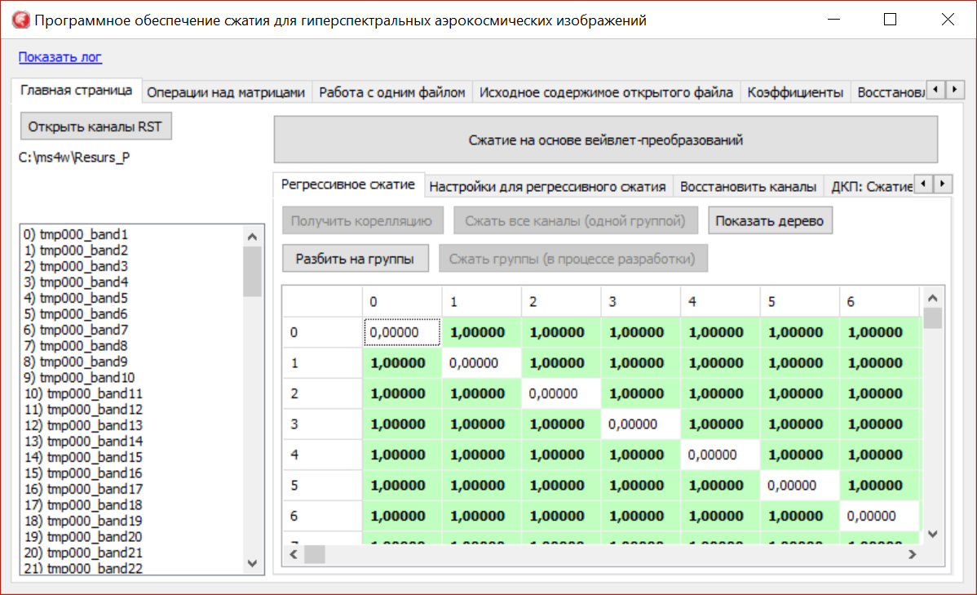

Figure 1 – The main window of the program

Technology of practical application. At the first step, we select the required number of hyperspectral image channels, the storage location on the disk at the second step and at the third step, we calculate the correlation and determine the sequence of groups (Figure 2)

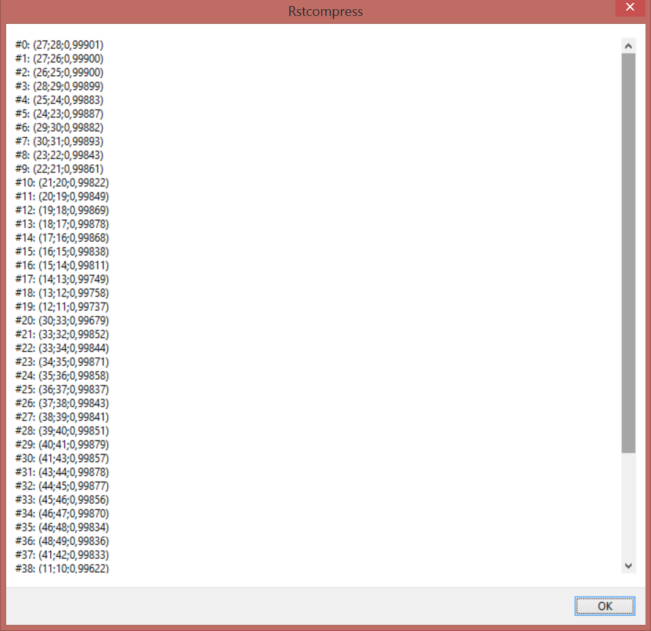

Figure 2 – Compression sequence tree taking into account correlation
It is possible to configure during compression: saving the average values for the fragment to an external application, saving the differences between the original images and those transformed by calculating regression analysis, the possibility of choosing to save the difference in the format of raster files without compressing them, choosing the number of groups of hyperspectral image channels (Figure 3).
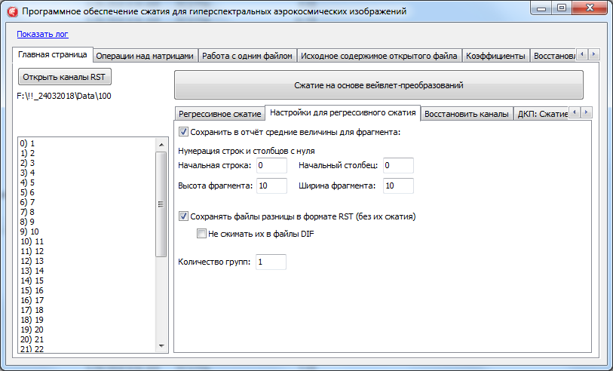

Figure 3 – Settings for hyperspectral image compression

CONCLUSION
Recommendations for the application and dissemination of the results of research work on the project "Development of a mathematical apparatus for the use of hyperspectral images for phytosanitary inspection of grain crops in aerospace photography" are devoted to the study of effective lossless and lossy image compression algorithms for determining diseases of grain crops phytosanitary control in agriculture.
As a mathematical tool, difference-discrete transformations are used, which are used in compression algorithms taking into account inter-band correlation and regression analysis in order to increase the compression ratio and calculation speed.
The conducted research is relevant because the existing compression algorithms for hyperspectral images are inferior to the compression ratio and processing speed at times to the algorithmic software developed in this work. In particular, the results of the study can be useful in the development of information theory and coding, wavelet analysis and other discrete transformations.
The paper uses an adequate mathematical apparatus in the problem being solved, the results are verified using statistical analysis methods, which guarantees its reliability. The conducted studies of the created lossless and lossless compression software for phytosanitary inspection of grain crops during aerospace survey show superiority over analogues and high performance.

LIST OF SOURCES USED
- Захарова Т. В. Вейвлет-анализ и его приложения. Учебное пособие / Т. В. Захарова, О. В. Шестаков. – М.: ИНФРА-М, 2012. – С. 124–135.
- Журавель Ю.Н. Особенности обработки гиперспектральных данных дистанционного зондирования при решении задач мониторинга окружающей среды / Ю. Н. Журавель, А. А. Федосеев // Компьютерная оптика. – 2013. – Т.37, № 4. – С. 471–476.
- Кашкин В. Б. Цифровая обработка аэрокосмических изображений / В. Б. Кашкин, Сухинин А. И. – Красноярск: СФУ, 2008. – 278 с.
- Кобзарь А. И. Прикладная и математическая статистика. Для инженеров и научных сотрудников. – М: ФИЗМАТЛИТ, 2012 – 816 с.
- Лупян Е. А. Современные подходы и технологии организационной работы с данными дистанционного зондирования Земли для решения научных задач / Е. А. Лупян, В. П. Саворский, Ю. И. Шокин, А. И. Алексанин, Р. Р. Назиров, И. В. Недолужко, О. Ю. Панова // Современные проблемы дистанционного зондирования Земли из космоса. – 2012. Т.9, № 5. – С.21–44.
- Малахов Э. В. Сжатие в архивировании и каталогизации данных дистанционного зондирования Земли / Э. В. Малахов, А. В. Замятин // Земля из космоса: наиболее эффективные решения, 5-ая международная конференция: тезисы докл. – М: Издательство Бином. – 2011. – С.140–142.
- Миклашевич C. Э. Программно-апппаратный комплекс для сбора, обработки, архивации и распространения спутниковых данных и продуктов их тематической обработки / И. В. Балашов, М. А. Бурцев, В. Ю.Ефремов, А. А. Мазуров и др. // Современные проблемы дистанционного зондирования земли из космоса. – 2012. Т.9, № 4. – С.47–56.
- Остриков В. H. Обработка гиперспектральных данных, получаемых с авиационных и космических носителей / В. H. Остриков, О. В. Плахотников, A. В. Кириенко // Современные проблемы дистанционного зондирования Земли из космоса. –2013. –Т.10, № 2. –С. 243–251.
- Остриков В. Н. Применение рандомиированного мтеода главных компонент для сжатия и тематической обработки гиперспектральных данных / В. Н. Остриков, В. В. Михайлов, С. И. Смирнов // Доклады Одиннадцатой Всероссийской Открытой конференции (11-15 ноября 2013 г.). – Москва. – 2013.
- Петров Е. П. Математическая модель цифровых полутоновых изображений Земли из космоса / Е. П. Петров, Е. В. Медведева, Н. Л. Харина // Актуальные проблемы ракетно-космической техники. – 2011. – С. 179–185.
- Петров Е.П. Метод быстрого сжатия изображений без потерь / Е. П. Петров, Н. Л. Харина, П. Н. Сухих // Машинное обучение и анализ данных. –2015. – Т. 1, №12. – С.1762–1770.
- Петров Е.П. Метод сжатия многоразрядных спутниковых снимков без потерь / Е. П. Петров, Н. Л. Харина, П. Н. Сухих // Современные проблемы дистанционного зондирования Земли из космоса. – 2016. Т.13,№ 2. – С. 203–210.
- Петров Е.П. Метод сжатия изображений в системах ДЗЗ без потерь / Е. П. Петров, Н. Л. Харина, П. Н. Сухих // Вестник Самарского государственного аэрокосмического университета имени академика С.П. Королёва. – 2016. Т. 15, № 2. – С. 18–189.
- Саринова А. Ж. Программное обеспечение для сжатия гиперспектральных аэрокосмических изображений без потерь / А. Ж. Саринова, А. В. Замятин, А. А. Афанасьев // Свидетельство о государственной регистрации программы для ЭВМ № 2014660049 от 1.10.2014 г.
- Саринова А. Ж. Алгоритм сжатия гиперспектральных аэрокосмических изображений с использованием математической обработки и учетом междиапазонной корреляции / А. Ж. Саринова, А. В. Замятин // Материалы IV Международной научной конференции «Региональные проблемы дистанционного зондирования Земли». – 2017. – С.157–160.
- Саринова А. Ж. Регрессионный подход к алгоритму сжатия гиперспектральных аэрокосмических изображений без потерь / Саринова А. Ж., Замятин А. В. // Вестник ТГУ. Серия «Управление, вычислительная техника и информатика (в печати) WebofSience.
- Сергеев В. В. Анализ и обработка изображений, получаемых при наблюдениях земли из космоса / В. В. Сергеев // Компьютерная оптика. – 2006. №29. – С.41–44.
- Сойфер В. А. Методы компьютерной обработки изображений. Учебное пособие, издание второе, исправленное / В. А. Сойфер. М.: Физматлит, 2003. – 782 с.
- Сэломон Д. Сжатие данных, изображений и звука. М.: Техносфера, 2004. – 368 с.

APPENDIX F
Methodological instructions for using the software package

Ministry of agriculture of the Republic of Kazakhstan
NJSC «KAZAKH AGROTECHNICAL UNIVERSITY
NAMED AFTER SAKEN SEIFULLIN»
(NJSC «KATU named after S. SEIFULLIN»)

METHODOLOGICAL INSTRUCTIONS FOR USING THE SOFTWARE PACKAGE
"Application and compression of hyperspectral images for phytosanitary inspection of grain crops in aerospace survey" under the grant funding project "Development of a mathematical apparatus for the use of hyperspectral images for phytosanitary inspection of grain crops in aerospace survey" for specialties: Automation and energy efficiency of processes and production, Energy supply and automation of agriculture

Authors: PhD, senior lecturer Sarinova A.Zh. of the department "Operation
electrical equipment"
PhD, senior lecturer Dunaev P.A. of the Department "Radio Engineering,
electronics and telecommunications"

Nur-Sultan 2021
CONTENT

Introduction...................................................................................................................
Main part.......................................................................................................................
Conclusion.....................................................................................................................
References.....................................................................................................................

INTRODUCTION
As part of the grant financing of the AP09561922 AR project "Development of a mathematical apparatus for the use of hyperspectral images for phytosanitary inspection of grain crops during aerospace survey", mathematical and software compression was developed and applied on the basis of the GIS Center of the S. Seifullin NAO KATU, to some extent occupies a leading position in the degree of compression and quality of the restored images, depending on the selected preparatory processing, significantly demonstrates and surpasses analogues on all test sets.
Scope of application: monitoring of Remote sensing of the Earth
Purpose: compression of hyperspectral aerospace images for the purpose of rational use of data storage and transmission devices, with the possibility of data transformation and restoration of their initial state.
Functionality: Allows you to analyze the use of hyperspectral images to identify a specific disease of grain crops in the development of optimal mathematical solutions and software by effectively compressing the flow of information while maintaining a high archiving coefficient, without loss of image quality in order to reduce the volume of information flow.
Technical specifications: volume - 15 MB
Programming Language: Visual studio 2017
Computer type: personal computer with support for Windows 7, Windows 8, Windows 10 operating systems

THE MAIN PART
Software implementation of the hyperspectral aerospace image compression system
Modern requirements for software quality suggest that the software system being developed should have the following characteristics:
- correct solution of the problem of compression of hyperspectral AI by a software system;
- a clear reaction of the system to incorrect values of input parameters;
- high performance of the software application and the proposed algorithms;
- the program must have a modular architecture, and each of the modules must be used to solve a separate compression problem.
The developed hyperspectral AI compression software system must meet the following functional requirements:
1. The ability to perform preprocessing of the original image channels for their conversion and compression.
2. Performing the operation of reading and writing the transformed image channel without losing important structural elements based on algorithms with polynomial computational complexity.
3. Isolation of structural components on the channels of hypospectral AI and subsequent construction of modified data structures based on them.
4. Performing reconstruction of input images using intermediate structural models.
5. Providing the user with data on the results of solving the problem of compression of the input image.
Choosing a programming language and software tools for software development
Among programming languages, C# is one of the most common algorithmic languages currently used in programming on mini and micro computers. The C# programming language is a high-level programming language or algorithmic language specifically designed to write algorithms of calculations. The main advantages of the language: flexibility and versatility; simplicity and clarity of designs; ease of implementation on most modern computers; the possibility of sufficiently complete control of the correctness of the program both at the stage of translation and during the execution of the program; the ability to meet the requirements of structural programming; the presence of a set of structural data types: arrays, records, records with variants, sets, files, etc.
The freely distributed object-oriented programming environment Visual studio 2017 / Visual studio 2017 was chosen as the development environment. It is one of the most powerful systems (based on the C# language) that allows creating both separate Windows application programs and software complexes designed to work in various fields of activity at the most modern level. Tasks solved using the object-oriented programming environment Visual studio 2017
быстрое fast creation of a professional application of any complexity and any purpose;
создание creation of powerful systems for working with local and remote databases of all types and files;
создание creating databases of various types using a wide range of Visual studio 2017 tools.
Development of a software system.
When developing hyperspectral AI compression software, a choice was made in favor of a modular application architecture. This approach, using several modules, each of which solves its own task of transformation and compression, makes it possible to simplify the development and testing processes.
The developed software system has a modular architecture. Each of the modules contains its own specific functions that have a similar functional purpose for the compression task.
Based on the algorithms described in the previous sections, the author has developed software for compressing hyperspectral AI. Lossless encoding and decoding structure (Fig.1), lossy (Fig.2).

Lossless compression
Hyperspectral AI
Multithreaded processing
Image Archive
Encoding subsystem
Conversion to original images
Reverse conversion (сложение)
Reverse entropy coding
Coding subsystem
Regression transformation
Difference transformation
Adaptive entropy coding

Figure 1 – Structure of encoding and decoding of lossless hyperspectral AI
Сжатие с потерями
Hyperspectral AI

Image Archive

Encoding subsystem

Conversion to original images
Reverse conversion
Reverse entropy coding
Multithreaded processing
Coding subsystem

1. Discrete-cosine transformation
2. Walsh-Hadamard transformation
3. Haar and Dobeshi Wavelet
Optimal quantization level
Adaptive entropy coding

Figure 2 – Structure of encoding and decoding of hyperspectral AI with losses
Modules of the developed software system. The relationship of the modules of the software system can be represented using the component diagram shown in Figure 3.
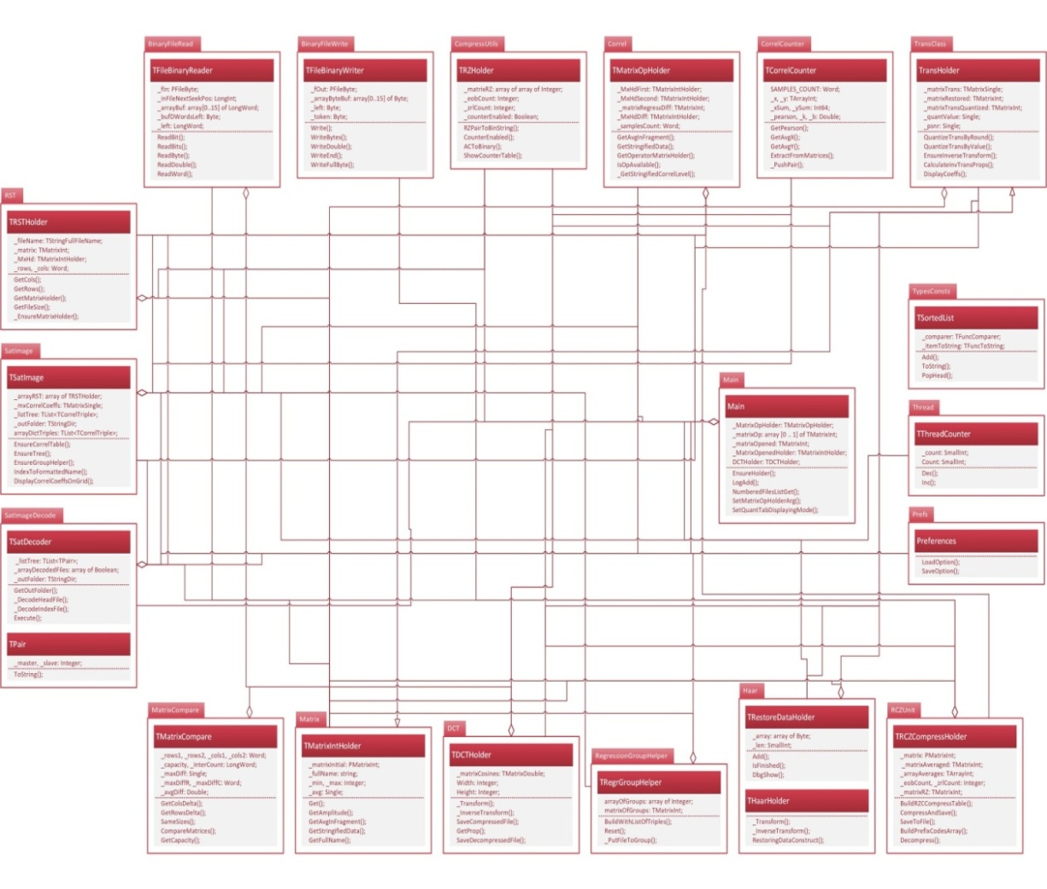
Figure 3 – Diagram of the components of the developed software system

The software system "Compression of hyperspectral AI" is designed for compression and transformation of hyperspectral AI with and without losses. When the executable file is launched, the main window of the program opens (Fig. 4).
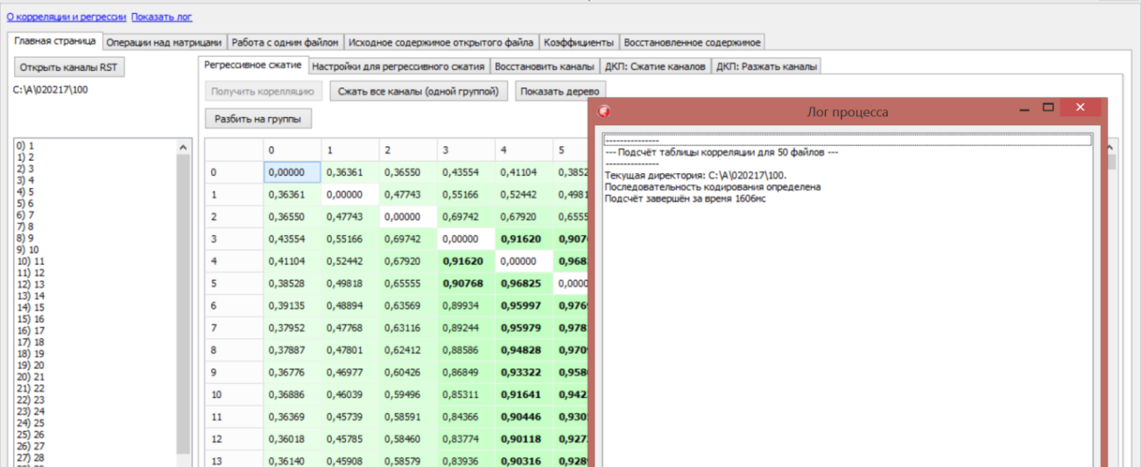

Figure 4 – The main window of the program
At the first step, we select the required number of hyperspectral AI channels, the storage location on the disk at the second step and at the third step, we calculate the correlation and determine the sequence of groups (Fig. 5).

Figure 5 – Compression sequence tree taking into account correlation

It is possible to configure during compression: saving the average values for the fragment to an external application, saving the differences between the original images and those transformed by calculating regression analysis, the possibility of choosing to save the difference in the format of raster files without compressing them, choosing the number of groups of hyperspectral AI channels, Fig.6.
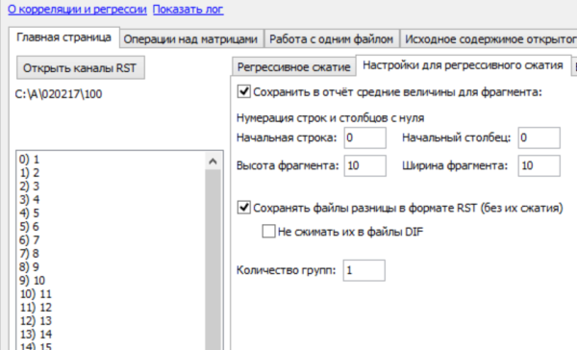

Figure 6 – Settings for hyperspectral AI compression
Figure 7 shows the organization of multithreaded compression processing in the compression process log, which shows the interaction of threads to improve compression performance and reduce its time.
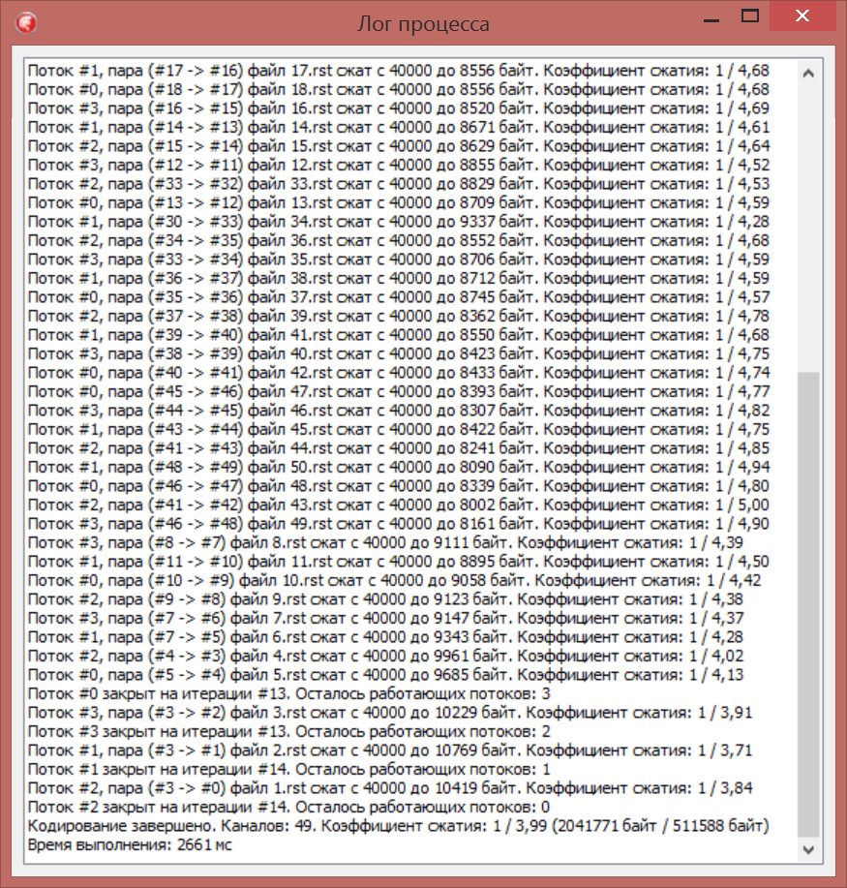

Figure 7 – Log of the compression process

Figure 8 shows the sequence of operation of the streams when decoding hyperspectral AI.
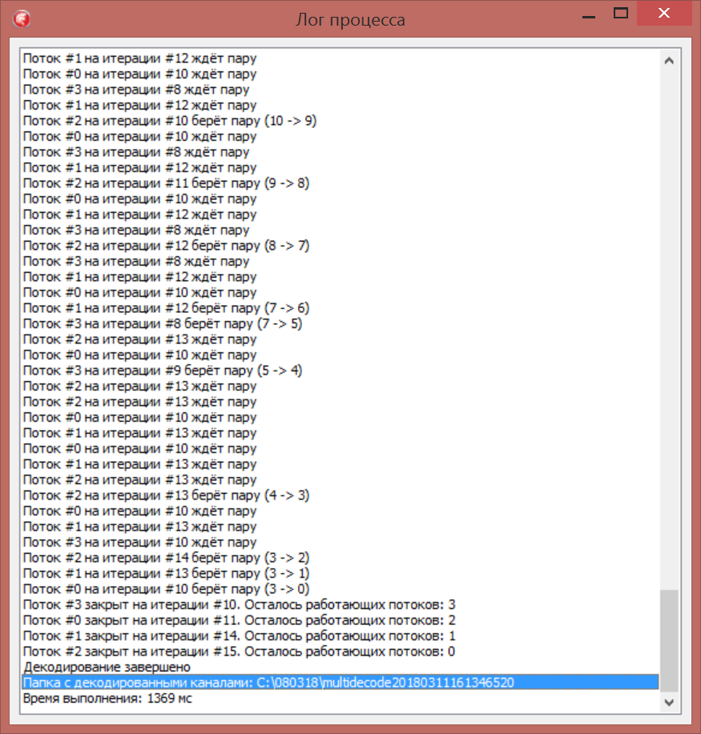

Figure 8 – Log decoding process

It is also possible to view the contents of the matrices of the main and generating channels. In the test mode: the matrix of the first selected channel (Fig. 9) and the matrix of the second selected channel (Fig. 10).

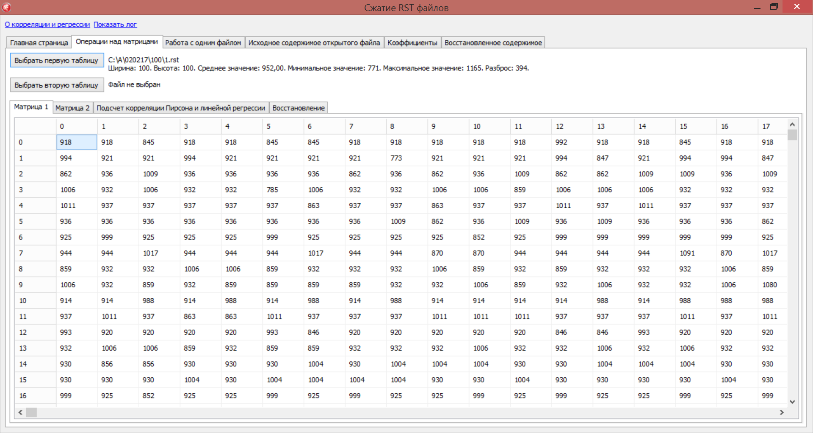

Figure 9 – Matrix of the generating channel
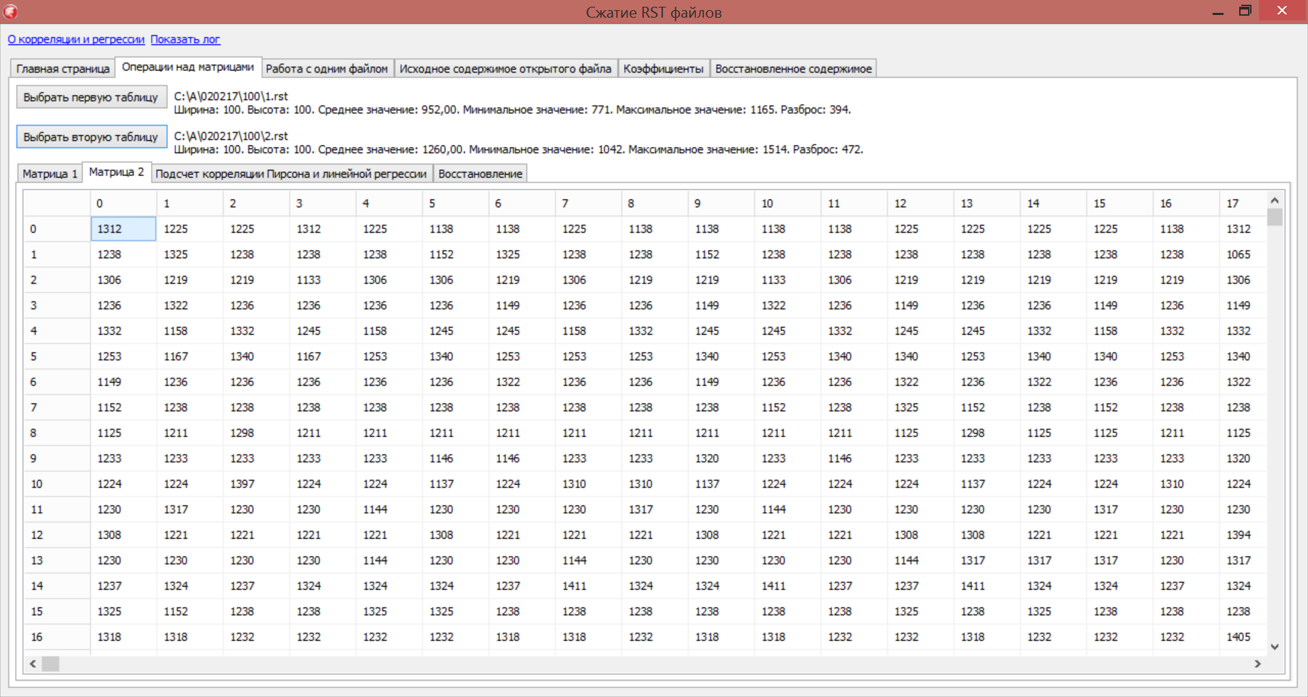

Figure 10 – Marix of the regressed channel

In Fig .11 correlation and linear regression are calculated, on the basis of which the difference transformation of the matrices of the generating and regressed channel is calculated.

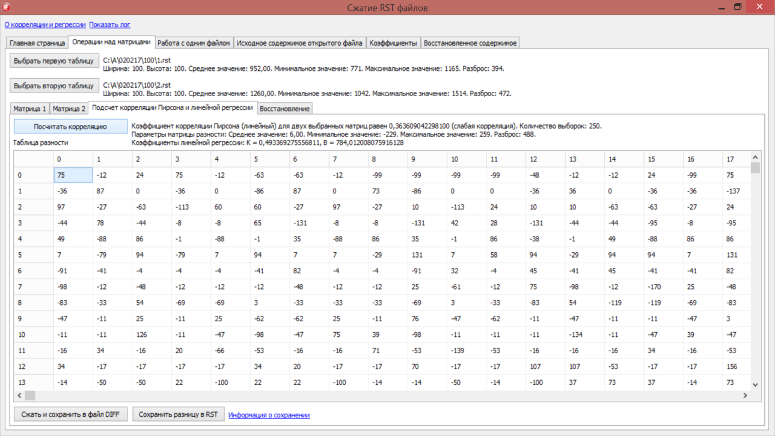

Figure 11 – Difference transformation

Figure 12 shows the decoding matrix of the lossless compression channel being regressed.
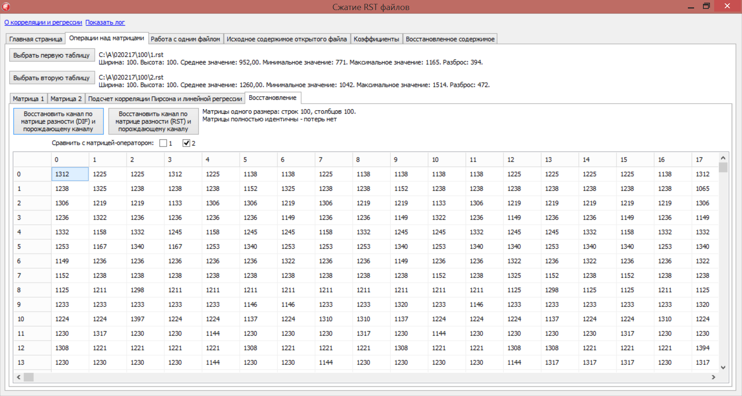

Figure 12 – Decoded matrix

Compression based on the DCT and the adapted (modified) Huffman algorithm, Fig.13, the possibility of choosing a quantization parameter.


Figure 13 – Compression based on DCT

Matrix before and after compression based on DCT, fig. 14.
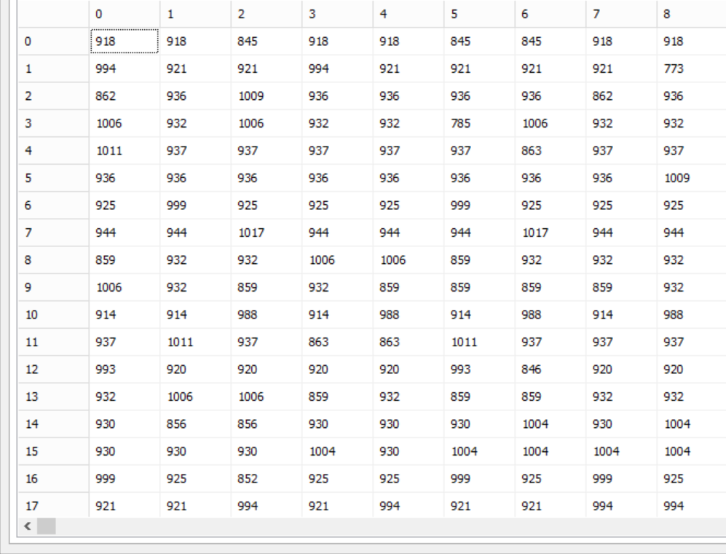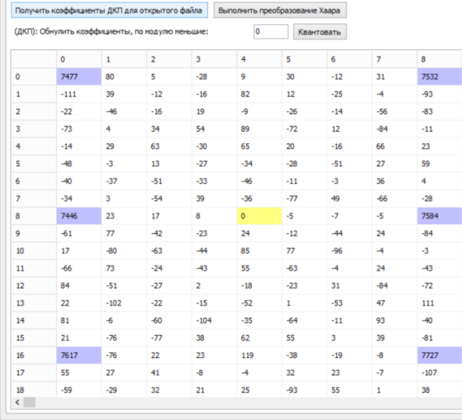

Figure 14 – Original and transformed matrix

Transformation of the one-dimensional Haar wavelet, Fig. 15

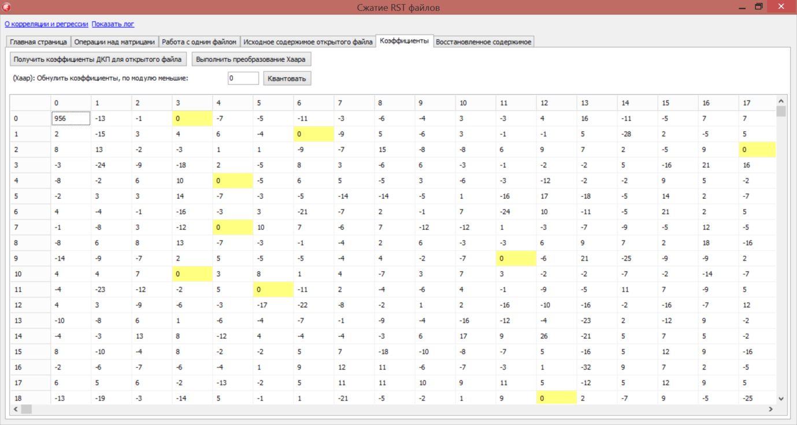

Figure 15 – Transformed Haar matrix

DCT recovery (Fig. 16) and Haar wavelets (Fig. 17): calculation of average and maximum errors, PSNR.
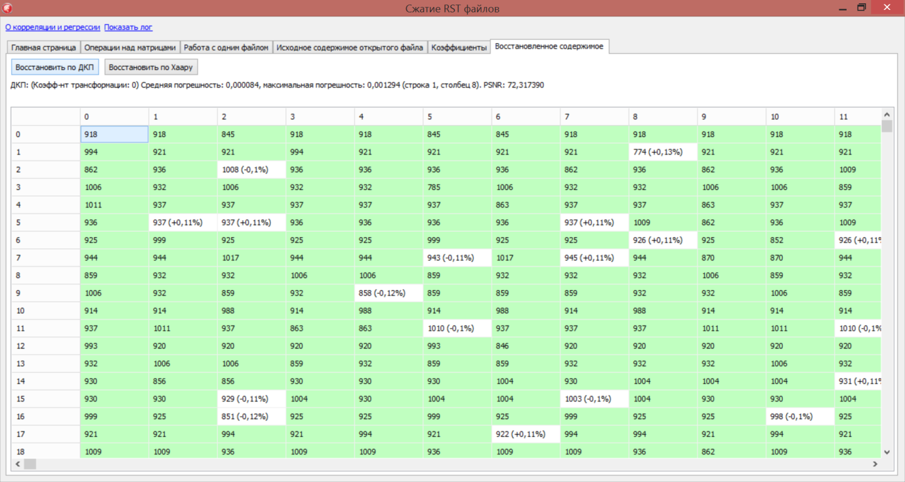

Figure 16 – Matrix after restoration of PREP
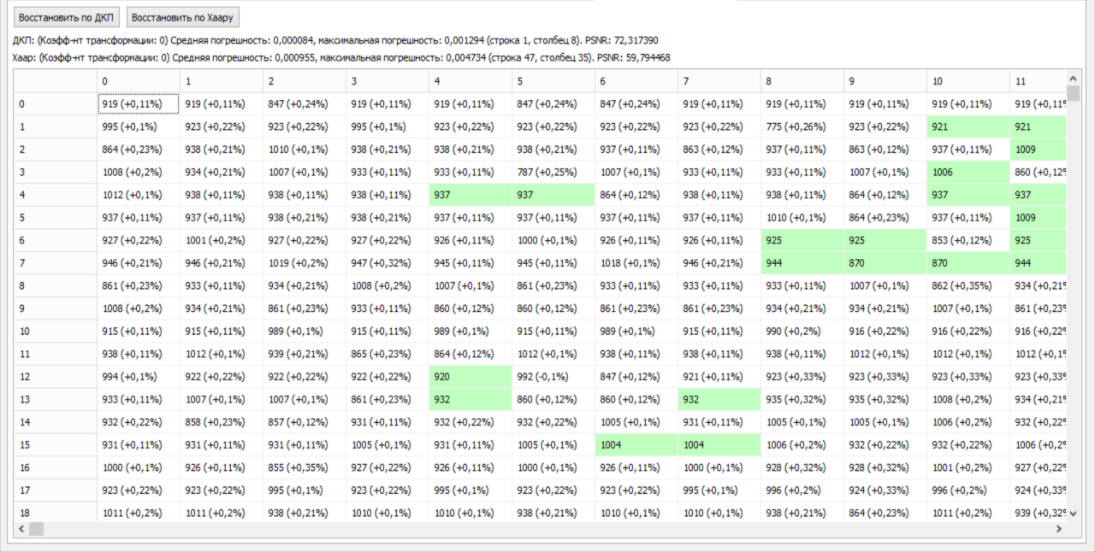

Figure 17 – Haar Recovery

Walsh-Hadamard transformation based on three levels, Fig. 18

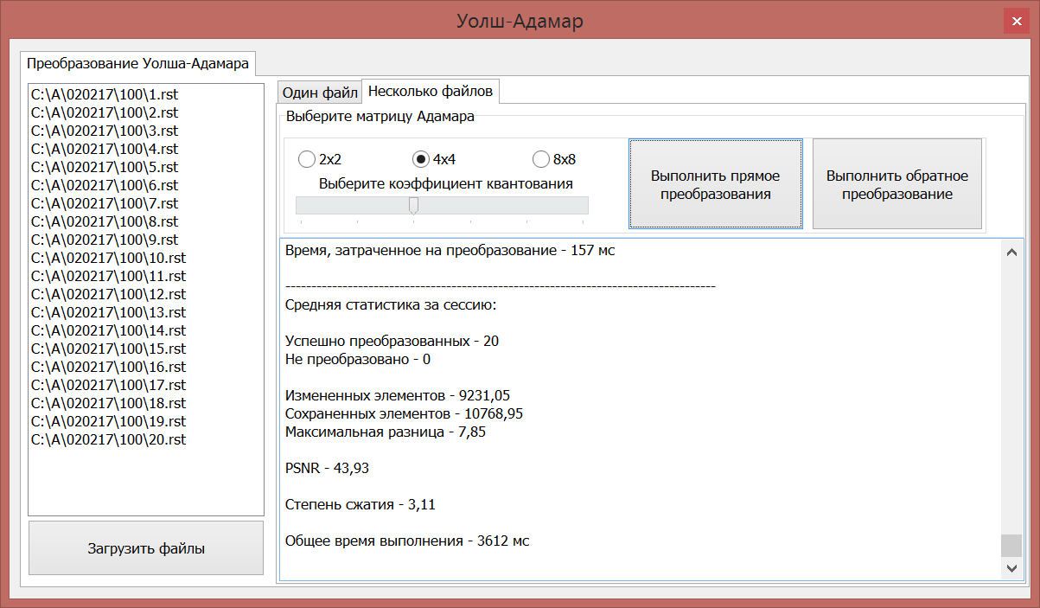

Figure 18 – Walsh-Hadamard transformation

Figure 19 shows the Walsh-Hadamard transformation of the second level.
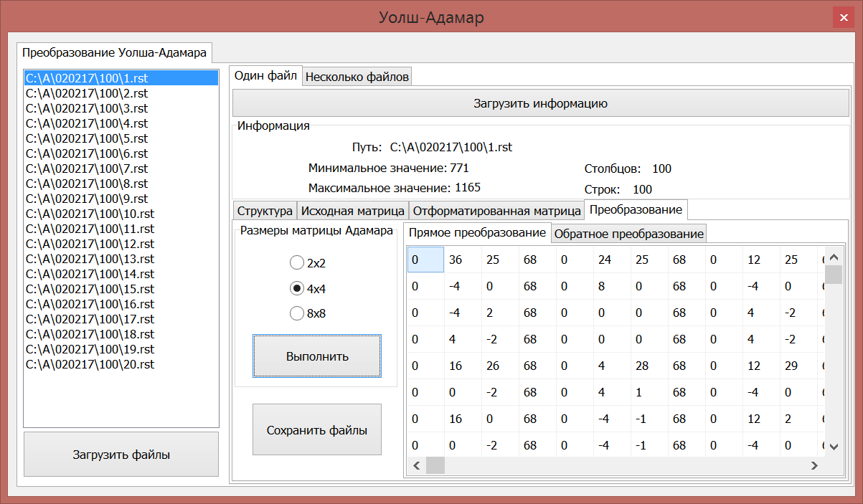

Figure 19 – Direct transformation of the second Walsh-Hadamard level

Figure 20 shows the inverse Walsh-Hadamard transformation
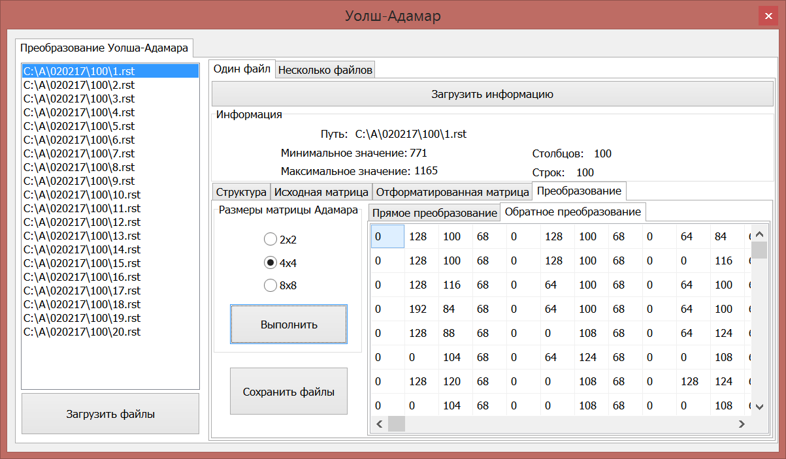

Figure 20 – Inverse Walsh-Hadamard transformation
CONCLUSION
Methodological instructions for the use of the software package "Application and compression of hyperspectral images for phytosanitary inspection of grain crops in aerospace survey" under the grant financing project "Development of mathematical apparatus for the use of hyperspectral images for phytosanitary inspection of grain crops in aerospace survey" for specialties: Automation and energy efficiency of processes and production, Energy supply and automation of agriculture.
The proposed lossy approach is determined in adaptive transformations based on the Walsh-Hadamard transformation, discrete-cosine transformation and the generated quantization table and subsequent adaptive coding; the obtained results of comparing the transformed hyperspectral AI using the obtained coefficients suggest the effectiveness of using these studies with adaptive Huffman coding; comparison of quality criteria using standard quality metrics allows us to note that hypospectral AI was restored with high quality and minimal losses.
The conducted studies of the created lossless and lossless compression software for phytosanitary inspection of grain crops during aerospace survey show superiority over analogues and high performance.
Based on the above results of experimental studies of compression using difference-discrete hyperspectral images, it should be concluded that the developed mathematical and compression software occupies a leading position in terms of compression ratio and quality of the reconstructed images, depending on the chosen algorithm, since it significantly exceeds analogues on all test sets.
LIST OF SOURCES USED
- Захарова Т. В. Вейвлет-анализ и его приложения. Учебное пособие / Т. В. Захарова, О. В. Шестаков. – М.: ИНФРА-М, 2012. – С. 124–135.
- Журавель Ю.Н. Особенности обработки гиперспектральных данных дистанционного зондирования при решении задач мониторинга окружающей среды / Ю. Н. Журавель, А. А. Федосеев // Компьютерная оптика. – 2013. – Т.37, № 4. – С. 471–476.
- Кашкин В. Б. Цифровая обработка аэрокосмических изображений / В. Б. Кашкин, Сухинин А. И. – Красноярск: СФУ, 2008. – 278 с.
- Кобзарь А. И. Прикладная и математическая статистика. Для инженеров и научных сотрудников. – М: ФИЗМАТЛИТ, 2012 – 816 с.
- Лупян Е. А. Современные подходы и технологии организационной работы с данными дистанционного зондирования Земли для решения научных задач / Е. А. Лупян, В. П. Саворский, Ю. И. Шокин, А. И. Алексанин, Р. Р. Назиров, И. В. Недолужко, О. Ю. Панова // Современные проблемы дистанционного зондирования Земли из космоса. – 2012. Т.9, № 5. – С.21–44.
- Малахов Э. В. Сжатие в архивировании и каталогизации данных дистанционного зондирования Земли / Э. В. Малахов, А. В. Замятин // Земля из космоса: наиболее эффективные решения, 5-ая международная конференция: тезисы докл. – М: Издательство Бином. – 2011. – С.140–142.
- Миклашевич C. Э. Программно-апппаратный комплекс для сбора, обработки, архивации и распространения спутниковых данных и продуктов их тематической обработки / И. В. Балашов, М. А. Бурцев, В. Ю.Ефремов, А. А. Мазуров и др. // Современные проблемы дистанционного зондирования земли из космоса. – 2012. Т.9, № 4. – С.47–56.
- Остриков В. H. Обработка гиперспектральных данных, получаемых с авиационных и космических носителей / В. H. Остриков, О. В. Плахотников, A. В. Кириенко // Современные проблемы дистанционного зондирования Земли из космоса. –2013. –Т.10, № 2. –С. 243–251.
- Остриков В. Н. Применение рандомиированного мтеода главных компонент для сжатия и тематической обработки гиперспектральных данных / В. Н. Остриков, В. В. Михайлов, С. И. Смирнов // Доклады Одиннадцатой Всероссийской Открытой конференции (11-15 ноября 2013 г.). – Москва. – 2013.
- Петров Е. П. Математическая модель цифровых полутоновых изображений Земли из космоса / Е. П. Петров, Е. В. Медведева, Н. Л. Харина // Актуальные проблемы ракетно-космической техники. – 2011. – С. 179–185.
- Петров Е.П. Метод быстрого сжатия изображений без потерь / Е. П. Петров, Н. Л. Харина, П. Н. Сухих // Машинное обучение и анализ данных. –2015. – Т. 1, №12. – С.1762–1770.
- Петров Е.П. Метод сжатия многоразрядных спутниковых снимков без потерь / Е. П. Петров, Н. Л. Харина, П. Н. Сухих // Современные проблемы дистанционного зондирования Земли из космоса. – 2016. Т.13,№ 2. – С. 203–210.
- Петров Е.П. Метод сжатия изображений в системах ДЗЗ без потерь / Е. П. Петров, Н. Л. Харина, П. Н. Сухих // Вестник Самарского государственного аэрокосмического университета имени академика С.П. Королёва. – 2016. Т. 15, № 2. – С. 18–189.
- Саринова А. Ж. Программное обеспечение для сжатия гиперспектральных аэрокосмических изображений без потерь / А. Ж. Саринова, А. В. Замятин, А. А. Афанасьев // Свидетельство о государственной регистрации программы для ЭВМ № 2014660049 от 1.10.2014 г.
- Саринова А. Ж. Алгоритм сжатия гиперспектральных аэрокосмических изображений с использованием математической обработки и учетом междиапазонной корреляции / А. Ж. Саринова, А. В. Замятин // Материалы IV Международной научной конференции «Региональные проблемы дистанционного зондирования Земли». – 2017. – С.157–160.
- Саринова А. Ж. Регрессионный подход к алгоритму сжатия гиперспектральных аэрокосмических изображений без потерь / Саринова А. Ж., Замятин А. В. // Вестник ТГУ. Серия «Управление, вычислительная техника и информатика (в печати) WebofSience.
- Сергеев В. В. Анализ и обработка изображений, получаемых при наблюдениях земли из космоса / В. В. Сергеев // Компьютерная оптика. – 2006. №29. – С.41–44.
- Сойфер В. А. Методы компьютерной обработки изображений. Учебное пособие, издание второе, исправленное / В. А. Сойфер. М.: Физматлит, 2003. – 782 с.
- Сэломон Д. Сжатие данных, изображений и звука. М.: Техносфера, 2004. – 368 с.

APPENDIX G
The process of submitting an article to the journal «Journal of applied remote sensing»




APPENDIX H
The process of submitting an article to the journal «Journal of theoretical and applied information technology»




APPENDIX J
The process of submitting an article by to the Journal «Proceedings of the university»



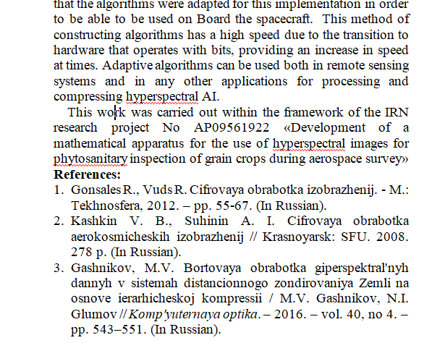
APPENDIX K
Abstract submission process «20th international conference named after A.F. Terpugov information technologies and mathematical modelling» (ITMM’2021)



APPENDIX L
The process of submitting abstracts for the «XIII all-russian scientific and technical conference with international participation «robotics and artificial intelligence» (RAI-21)




