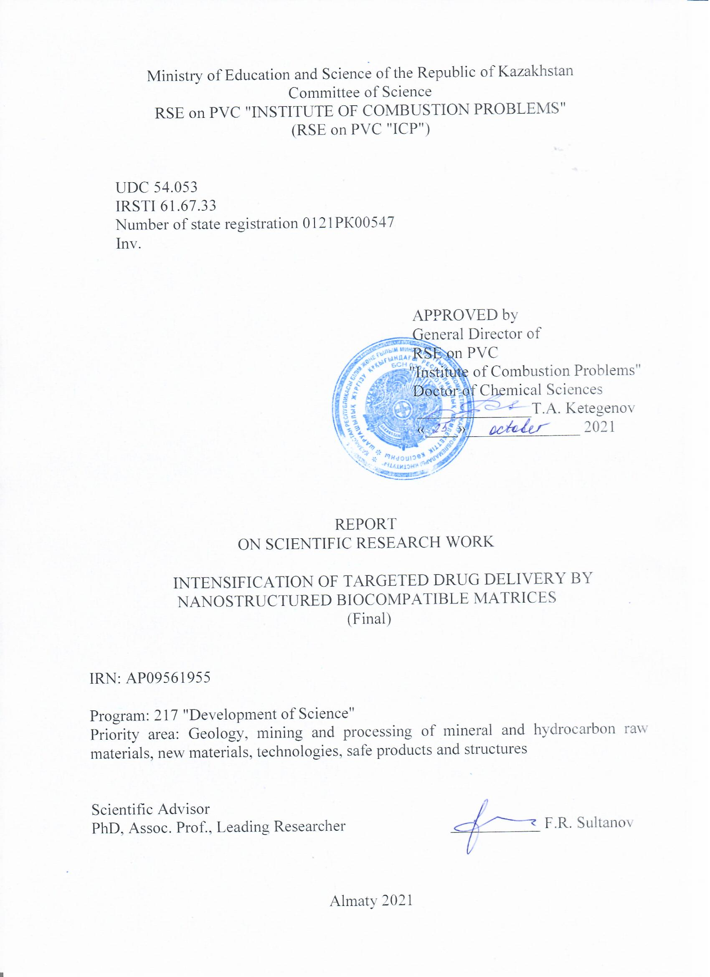
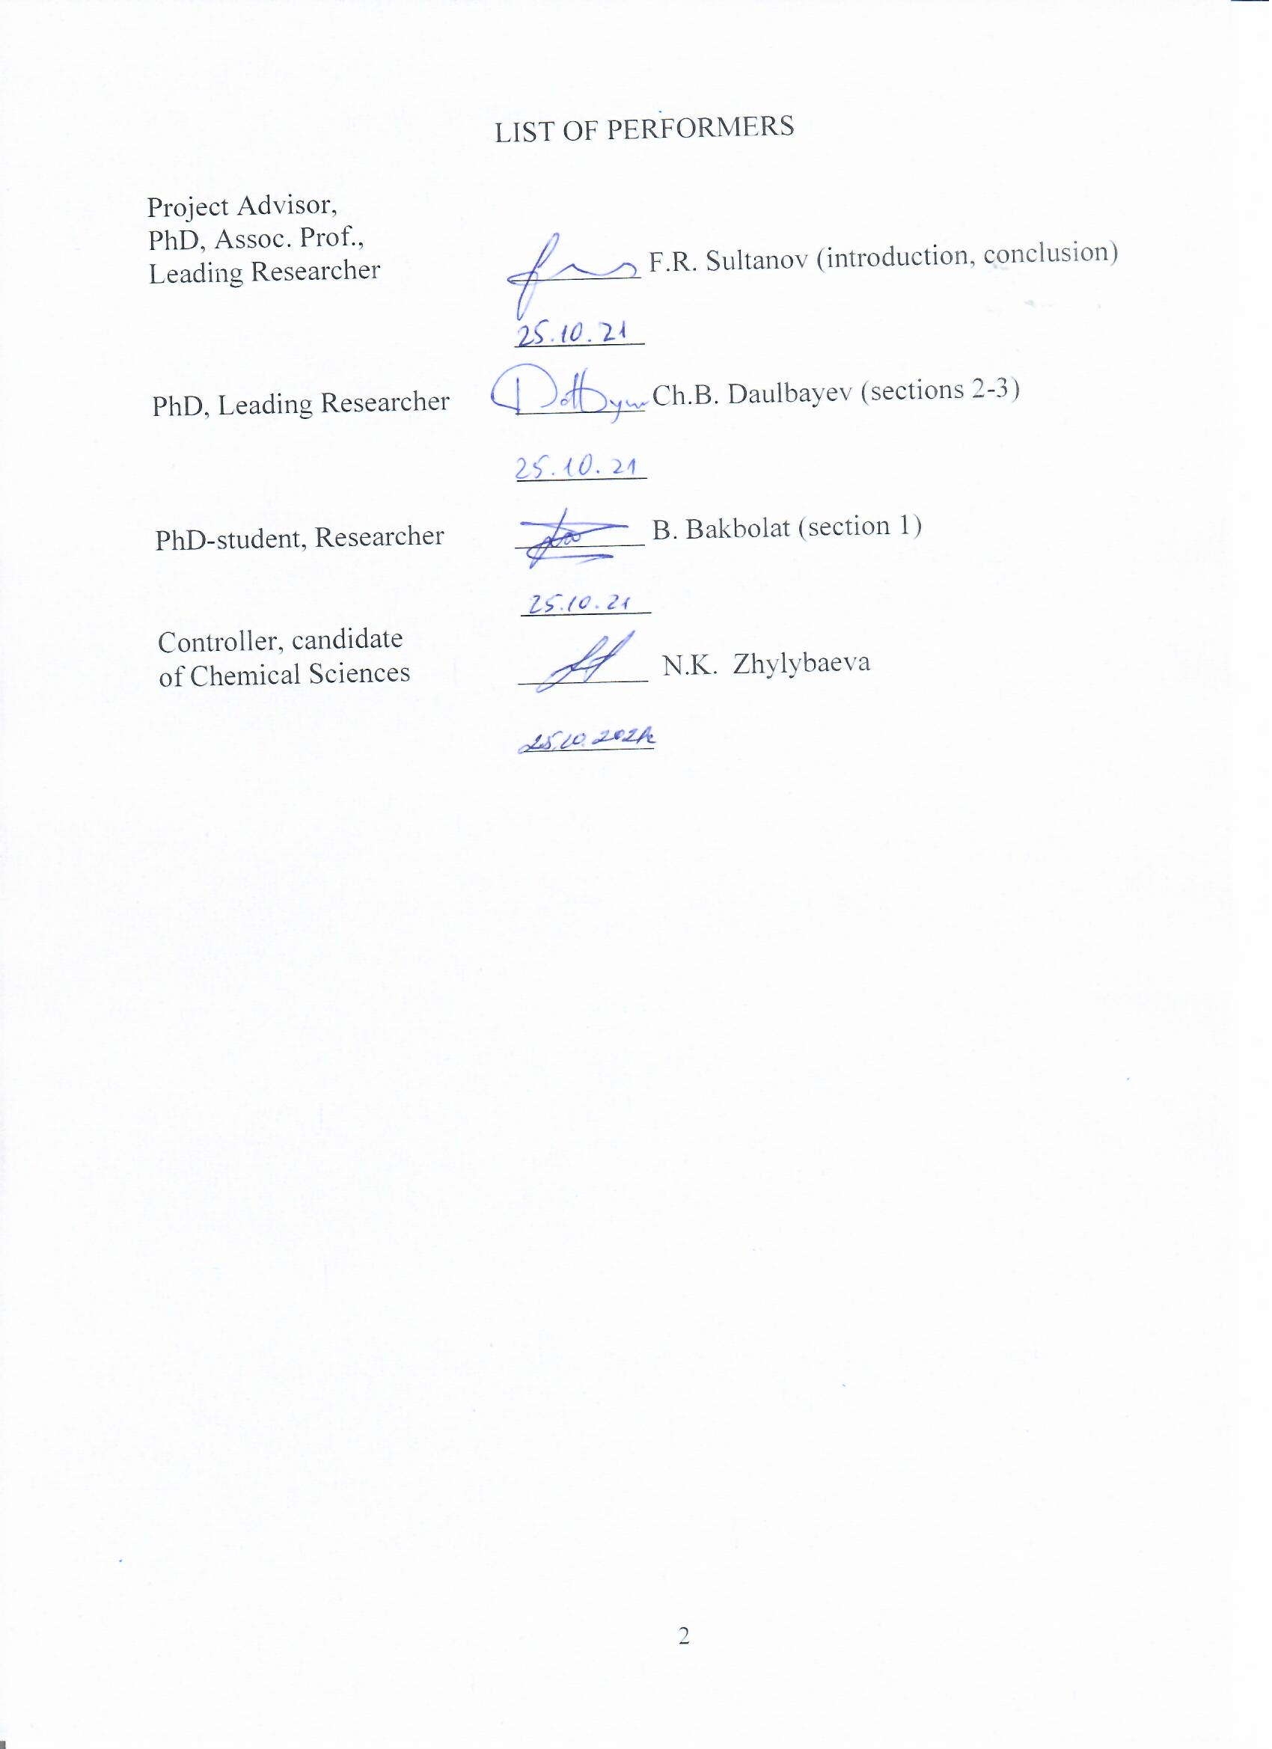
ABSTRACT

The report consists of 46 pages, 20 figures, 5 tables, 95 sources.
TARGETED DELIVERY, FILMS BASED ON MICRO- AND NANOSCALE FIBERS, NANOSTRUCTURED MATRICES, ELECTROSPINNING, CALCIUM HYDROXYAPATITE, GRAPHENE OXIDE.
In this report, the objects of research are nanostructured matrices based on polymer fibers with the addition of biologically active materials and a drug. Calcium hydroxyapatite and graphene oxide were used as biologically active materials, which are able to improve the structure of the matrix in order to maintain the basis for proliferation, as well as to increase antimicrobial activity. Amoxicillin, a widespread antibiotic with favorable organoleptic properties, was chosen as the drug.
The aim of the project is to obtain and study the possibility of nanostructured matrices based on polymer fibers with the addition of biologically active materials and a drug utilization in the field of effective targeted drug delivery.
The objectives of the project are to obtain effective systems for targeted delivery of drugs based on nanostructured polymer matrices with the addition of biologically active materials.
The main parameters of the process of electrospinning of micro- and nanoscale fibers with the addition of a drug, graphene oxide and calcium hydroxyapatite have been investigated.
The physicochemical properties and surface morphology of biologically soluble matrices based on polymer fibers with the addition of a drug, graphene oxide, and calcium hydroxyapatite have been studied.
The antibacterial properties and cytotoxicity of the obtained biologically soluble matrices based on polymer fibers were studied by exposure to model bacteria such as S. aureus and E. Coli. To study cytotoxicity, the CKK-8 assay was used, and the preosteoblasts MC3E3-E1 were used as cells. A mechanism for the antibacterial effect of graphene oxide has been proposed.
The kinetics and microbiological evaluation of the drug release efficiency from the obtained biologically soluble matrices, which were observed over a 4-week period were investigated.

CONTENT

 | DEFINITIONS, SYMBOLS AND ABBREVIATIONS | 5
 | INTRODUCTION | 6
1 | Literature review | 7
1.1 | Application of calcium hydroxyapatite in medicine | 7
1.1.1 | Tissue engineering | 7
1.1.2 | Drug delivery | 9
1.2 | Carbon nanomaterials in biomedicine | 10
1.2.1 | Carbon nanotubes | 10
1.2.2 | Graphene oxide | 13
1.3 | HAP based composites | 14
2 | Experimental | 16
2.1 | Source materials | 16
2.2 | Synthesis of HAP | 16
2.3 | GO synthesis | 16
2.4 | Obtaining nanoscale fibers with the addition of GO, HAP and a drug | 17
2.5 | Determination of the kinetics of drug release from the obtained fibers and study of their antibacterial properties | 17
2.6 | X-ray phase analysis of samples | 18
2.7 | Scanning electron microscopy of samples | 18
2.8 | Raman-spectroscopy of samples | 18
2.9 | Transmission electron microscopy of samples | 18
3 | Results and their discussion | 19
3.1 | Investigation of the parameters of the electrospinning process of micro- and nano-sized fibers, process optimization | 19
3.2 | Electrospinning of biologically soluble matrices based on polymer fibers and drugs during their mechanical mixing | 20
3.3 | Investigation of the physicochemical properties and surface morphology of biologically soluble matrices based on polymer fibers and drugs obtained by mechanical mixing of substances with subsequent electrospinning | 23
3.4 | Study of kinetics and microbiological evaluation of the effectiveness of drug release by the obtained biologically soluble matrices (in vitro) | 26
 | CONCLUSION | 31
 | REFERENCES | 32
APPENDIX А - List of published articles on the project 40
APPENDIX B - Work schedule 41
APPENDIX C - Extract from the protocol 45

DEFINITIONS, SYMBOLS AND ABBREVIATIONS
The following terms are used in this research report with the corresponding definitions:
HAP − calcium hydroxyapatite;
GO − graphene oxide;
AMX – amoxicillin;
PCL – polycaprolactone;
CNT − carbon nanotube;
SWCNT – single-walled carbon nanotube;
MWCNT – multi-walled carbon nanotube;
BBB − blood-brain barrier;
GNT − Galloisite nanotubes;
rGO − reduced graphene oxide;
DNA − deoxyribonucleic acid;
ssDNA − single-stranded deoxyribonucleic acid;
dsDNA − double-stranded deoxyribonucleic acid;
PLA − polylactide;
PVA − polyvinyl alcohol.

INTRODUCTION
Today, the targeted drug delivery is a promising area of ​​research, since it allows to maximize the therapeutic effects of the delivered drug while minimizing undesirable side effects. The development of new effective and innovative systems for targeted delivery of drugs is possible only with the use of modern methods of nanomaterials obtaining. In recent years, the method of electrospinning of polymer nanoscale fibers has attracted much attention due to its simplicity and the possibility of using various composites, including various types of drugs, polymers, and other biologically compatible materials, such as calcium hydroxyapatite, which promotes bone tissue regeneration and graphene oxide, which has antibacterial properties. The incorporation of these active components into films based on polymer nanoscale fibers is an effective method for delivering a wide range of drugs, expanding the possibilities and applicability of these systems. Thus, a biologically soluble film based on polymer nanoscale fibers with the addition of a drug, graphene oxide and calcium hydroxyapatite not only makes it possible to increase the efficiency of disinfection, but is also capable of targeted drug delivery to the affected tissue area, while calcium hydroxyapatite particles make it possible to create a scaffold to maintain the basis for proliferation cells and bone regeneration.
Another significant advantage of this method is the similarity of the fibers to the natural fibrillar extracellular matrix, which facilitates cell interaction and proliferation. Electrospinning of polymer nanoscale fibers with the addition of drugs and biologically active materials is carried out by applying a high voltage electrostatic field to the polymer solution flowing out from the needle. A feature of this method is that the characteristics of the formed fibers, such as diameter, porosity, morphology, and surface area, are easily controlled by changing the parameters of the electrospinning process in accordance with the specific requirements for the conditions of targeted delivery.
The current report presents experimental data on the development of effective systems for the intensification of targeted drug delivery by nanostructured biocompatible matrices.
The main parameters of the process of electrospinning of micro- and nanoscale fibers with the addition of a drug, graphene oxide and calcium hydroxyapatite have been investigated and determined.
The physicochemical properties and surface morphology of biologically soluble matrices based on polymer fibers with the addition of a drug, graphene oxide, and calcium hydroxyapatite have been investigated.
The antibacterial properties and cytotoxicity of the obtained biologically soluble matrices based on polymer fibers were studied by exposure to model bacteria such as S. aureus and E. Coli. To study cytotoxicity, the CKK-8 assay was used, and the preosteoblasts MC3E3-E1 were used as cells. A mechanism for the antibacterial effect of graphene oxide has been proposed.
The kinetics and microbiological evaluation of the effectiveness of drug release from the obtained biologically soluble matrices, which were observed over a 4-week period, were studied.
1 Literature review

  - Application of calcium hydroxyapatite in medicine
Calcium hydroxyapatite (HAP) is the stoichiometric phase of calcium phosphate Ca₁₀(PO₄)₆(OH)₂ [1], which is the main inorganic component of human bones, cartilage and teeth. According to [2, 3], Methods for obtaining HAP can be classified into dry and wet methods, high-temperature processes, synthesis from biogenic sources, and various combinations of these methods. There are many biogenic sources of HAP, among which the most common are eggshells, animal bones, fish scales, algae [4].
The properties of HAP are known to be highly similar to the calcium phosphate apatite phase in the human body and include bioactivity, biocompatibility, osteoconductivity, and osseointegration. Based on these properties, HAP is used as one of the most studied materials for various biomedical purposes. Extensive research is aimed at creating HAP-based composites that can mimic and replace damaged bones and be used in reconstructive tissue engineering. These composites have low cost, high efficiency, and the ability to induce bone formation and vascularization. In addition, HAP can have an enhancing effect as an encapsulating agent [5].

1.1.1 Tissue engineering
Tissue engineering deals with the control of reactions at the cellular level for the integration of implanted materials into tissue, developing a three-dimensional functional tissue for in-vitro transplantation: living cells are used to make new functional tissues associated with an extracellular matrix or scaffold material for regeneration [6, 7]. The framework must be strong enough to provide good mechanical support while maintaining a potential "gap", free space for further independent tissue development. According to [6], HAP can be used for these purposes in combination with materials of both fully synthetic origin (polymers and copolymers) and natural or identical to natural composition (collagen, gelatin, silk).
For example, 3D composite bioceramic scaffolds of calcium silicate nanofibers and HAP nanowires with a gelatin coating have shown efficiency in the proliferation and osteogenic differentiation of mesenchymal bone marrow stromal cells, which indicates the prospect of using composites for bone tissue regeneration. Due to the polymer coating, the porous structure and mechanical properties of the frameworks were significantly enhanced, while the characteristics were further adjusted depending on the hydrophobicity/hydrophilicity and the rate of degradation of the polymers. As shown in figure 1, the cells attached to the macroporous structure of the scaffolds, were located inside the pores, and spread without showing anomalous morphology [8].
In [9] Stasys Tautkus et al. proposed a feasible method for producing highly homogeneous bioceramics based on zinc and chromium doped HAP by aqueous sol-gel treatment. Single-phase samples were immersed in a solution simulating human body fluids for one month. The formation of low-crystalline HAP was observed, possibly as a result of the dissolution-precipitation reaction. After heating these powders at 800 °C, FTIR spectroscopic analysis (figure 2) confirmed the formation of β-tricalcium phosphate Ca3(PO4)2, which has long been a commercial product as a bioresorbable synthetic bone substitute used in the reconstruction of all types of bone defects [10, 11].

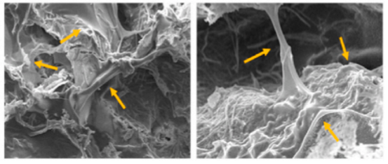
a b

a – scaffolds with the 3:1 weight fraction of silicate and HAP, b – scaffolds with the 1: 3 of silicate and HAP

Figure 1 − Attachment and spread of bone marrow mesenchymal stromal cells after seeding on various scaffolds of calcium silicate nanofibers and gelatin-coated HAP nanowires. Arrows indicate attached cells on scaffolds [8]

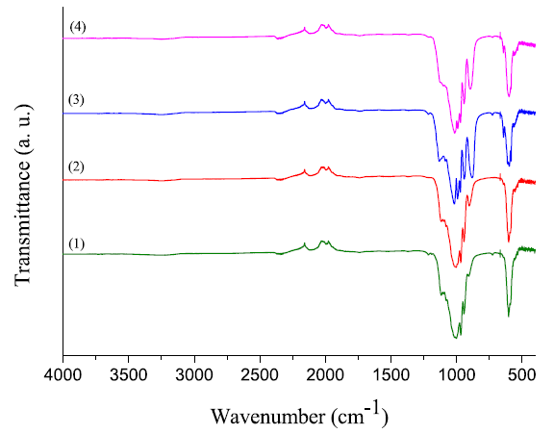

Figure 2 − FTIR spectra of HAP (1), Ca_{9.8}Zn_{0.1}Cr_{0.1}(PO₄)₆(OH)₂ (2), Ca_{9.5}Zn_{0.25}Cr_{0.25}(PO₄)₆(OH)₂ (3) and Ca_{9.3}Zn_{0.4}Cr_{0.3}(PO₄)₆(OH)₂ (4) after immersion and reheating [9]

In dentistry, HAP has been successfully used since the early 80s of the last century: at first it was used to replace teeth, a little later for fixation. Today, HAP is contained not only in dental fillings and dental cement, but is even present in toothpastes as a component aimed at reducing plaque [6]. In work [10] montmorillonite with a HAP layer has been used as fillers with remineralizing potential in dental composites. The team of Mariusz Sandomierski successfully mineralized HAP on the montmorillonite surface to effectively incorporate calcium, and silanize the particles to improve adhesion of the material to the methacrylic resin. According to them, the fillers demonstrated excellent remineralizing potential, defined by the authors as the ability to release calcium ions under conditions that mimic the natural environment of the oral cavity. The efficiency of ion exchange and the formation of a HAP layer is confirmed by the results obtained using energy dispersive spectroscopic analysis: the amount of calcium and phosphorus in the filler increased after mineralization in the material without a HAP layer to 5.81 and 5.48% for calcium and phosphorus, respectively, in a material with a HAP layer.

1.1.2 Drug delivery
Drug delivery systems are used to transport drugs as needed to safely achieve the desired therapeutic effect, the purpose of which is to ensure and maintain drug concentrations in a biological target [11]. Fundamental aspects of HAP as a biomaterial determine its practicality in drug delivery systems, especially orthopedic ones, since the biocompatibility of nanostructured HAP turned out to be as good as that of macroscopic or bulk analogs, due to its compositional similarity with minerals present in the body. According to [12], HAP is converted to Ca²⁺ and PO₄^{3–} ions by a natural metabolic process and excreted within 6 weeks. Research on HAP has increased dramatically in recent years, especially the most attractive are frameworks based on it with high porosity, controlled pore size and sufficient hardness [13].
The research in [14] was focused at developing a chitosan-alginate framework composite based on HAP, obtained by using casein micelles. The HAP sample substituted with 5% fluorine exhibited antifungal and antibacterial activity, and the highest activity being observed against Gram-positive Staphylococcus aureus with an inhibition zone of 47 mm. These scaffolds have porosity, hydrophilicity, biodegradability (67.5% in 21 days in a human body fluid solution), along with a controlled release of the bactericidal drug ciprofloxacin (60% in 11 days in phosphate buffered saline, figure 3).
It was reported that HAP nanoparticles have a cytotoxic effect against cancer cells, therefore, in the study [15] the effect of modification of the HAP surface by curcumin nanoparticles targeting cancer cells was evaluated. To regulate the adsorption capacity of nanoparticles, HAP was also functionalized with various carboxylic acids (lactic, tartaric, and citric), and the presence of carboxyl groups significantly influenced the binding and release profile of nanoparticles. The anti-cancer effect was evaluated on a breast cancer cell line that included cell proliferation, cellular uptake of curcumin, apoptosis, and cell cycle analysis. Functionalization of HAP with carboxylic acid in the presence of curcumin resulted in an increase in the population of apoptotic cells compared to unmodified HAP (figure 4). Apoptosis indexes in cells depending on functionalization with acids are as follows: HAP/curcumin/lactic acid – 67.33±6.37%, HAP/curcumin/tartaric acid – 53.24±1.39%, HAP/curcumin/citric acid – 47.39±2.

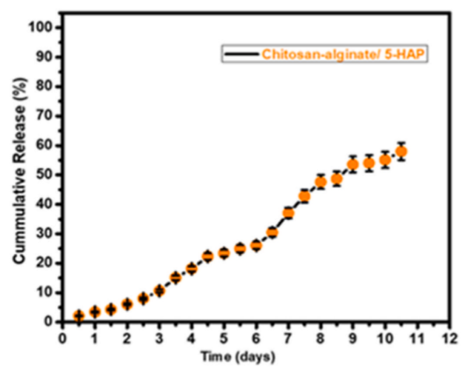

Figure 3 − Drug release profile from the chitosan-alginate/HAP composite [14]

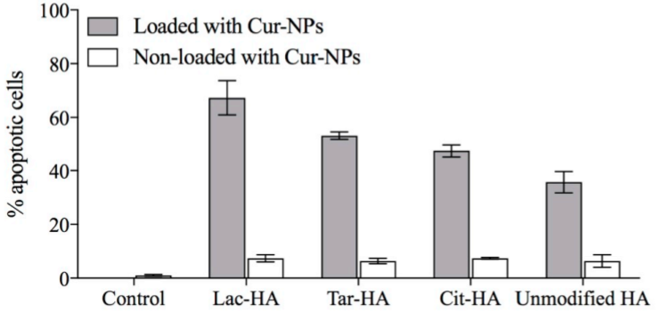
Figure 4 − Effect of functionalized and non-functionalized HAP/curcumin on cancer cell apoptosis (assessed by annexin V-FITC and PI staining) [15]

  - Carbon nanomaterials in biomedicine
    - Carbon nanotubes
Carbon nanotubes (CNTs) are one of the allotropic forms of carbon, in which sp²-hybridized carbon atoms are arranged in a tubular form [16, 17]. After the discovery, CNTs have become one of the most studied nanomaterials. The ability to exist both in a single-layer and multilayer form, as well as a variety of their structures, unique physical and chemical properties have opened up the possibility of their application in many fields [18-20].
The ability of CNTs to be easily absorbed by cells makes them promising for their use in biomedicine, namely for targeted delivery of drugs necessary for treatment and detection of diseases (biosensors), which helps to study the patterns of development of the pathological process of diseases. For medical applications, surface chemical modification of CNTs is required, since they are insoluble or slightly soluble in many solvents. Such CNTs are able to transport drugs in large quantities (especially nucleic acids) and penetrate into the tissues of the body. Functionalization of the CNT surface makes them biodegradable.
In the case of targeted drug delivery, CNTs are useful for delivering hydrophobic drugs. However, there are some barriers to overcome. One of them is epithelial cells that specialize in absorption and secretion. In [21] the scientists performed visualization using a multi-microscopic approach, combining soft X-ray spectromicroscopy on the TwinMic channel (Elettra Synchrotron, Trieste, Italy) with light and scanning electron microscopy (SEM), which is important for tracking the movement and changes of nanodrugs in epithelial cells. To do this, they conducted tests on the Chang-Liver (HeLa) cell line. Scientists exposed them to untreated and purified single-walled CNTs (SWCNTs) (figure 5). It was shown that despite the temporary disturbances in the membrane and intracellular structures, the effect of SWCNTs on epithelial cells for 4 hours is not toxic, which means that there are no changes in their viability.

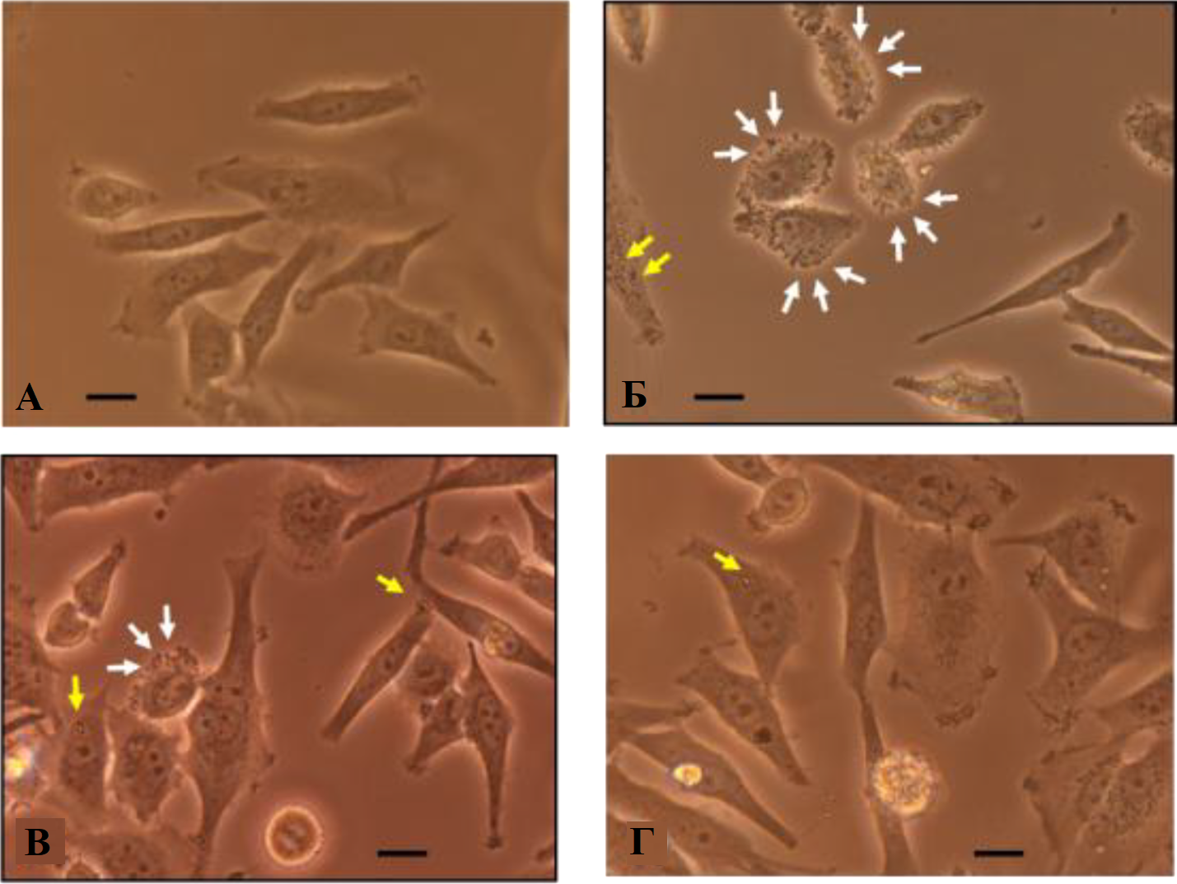

Figure 5 − Visible light images of control cells (A) and cells exposed to a
20 μg/ml solution of untreated SWCNTs for 4 hours (B), a 20 μg/ml solution of purified SWCNTs for 4 hours (C) and a 20 μg solution/ml of purified SWCNTs for 4 h + reduction (D). Scale is 10 microns. Yellow arrows indicate the presence of nanotube bundles, and white arrows indicate bubbles in the cytoplasm [21]
One of the hard-to-reach places for the targeted drug delivery is the brain. This is due to the difficulty of crossing drugs across the blood-brain barrier (BBB). Recently, studies have emerged showing the possibility of effects on the brain of functionalized Multi-walled CNTs (MWCNTs). Scientists confirm that due to their optical and thermal properties, they have advantages over other nanocarriers. In addition, their optimality lies in the fact that functionalized MWCNTs are able to overcome biological barriers through transcytosis and a passive process [22]. The first evidence of the ability of functionalized MWCNTs to overcome the BBB was obtained in experiments on the porcine brain (figure 6). Scientists have determined that functionalized MWCNTs cross the BBB in a transcellular way without any significant obstacles. The obtained results demonstrated the potential of functionalized MWCNTs for drug delivery over other nanocarriers, which usually do not penetrate the BBB [23].

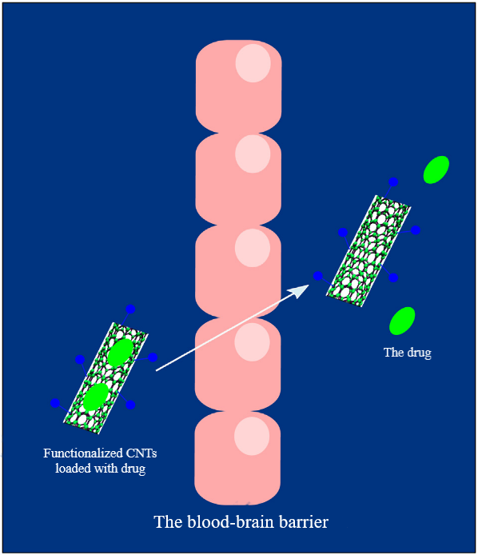

Figure 6 − Schematic representation of targeted delivery of drugs loaded in CNTs through the BBB [23]

MWCNTs are the most widely used among tubular 1D nanomaterials [24-27]. However, their use in biomedicine is limited due to possible toxic properties [28-30]. Liu Y. et al. [31] compared the toxicity of MWCNTs and halloysite nanotubes (HNTs) to human umbilical vein endothelial cells (HUVEC), a widely used primary cell model in vitro for assessing vascular toxicity of nanomaterials. Cytotoxicity for equal amounts of MWCNTs and HNTs was assessed by cell counting kit-8, thiol depletion and ultrastructural changes. Then they applied the lipidomics method to study lipid accumulation, since nanomaterials can have toxic effects on them.
Despite numerous works on the possibility of using CNTs in biological and medical fields, the biocompatibility and cytotoxicity of CNTs remains a big problem, since there are results of experiments on animals, which demonstrate both their harmlessness and toxicity to the body. For example, depending on the amount, the CNTs can lead to cell death and DNA damage. [32, 33]. In this regard, it is necessary to investigate all possible consequences of their use. The rapid pace of research related to the use of CNTs in biomedicine and the development of new nanocomposites based on them with unique parameters will undoubtedly lead to new advances in the near future.

1.2.2 Graphene oxide
Graphene is a new 2D advanced carbon nanomaterial [34-36]. Its advantages, such as mechanical characteristics, large specific surface area, and most importantly, lower toxicity and biocompatibility, make it a potentially important material for biomedicine [37, 38]. Considering that materials must be stable in a physiological environment for use in biomedicine, oxidative graphene derivatives are more suitable for these purposes. Among them are graphene oxide (GO) and reduced graphene oxide (rGO). In addition, these materials have the ability to easily change characteristics through surface modification, as well as excellent hydrophilicity, which facilitates their interaction with water, prevents the adhesion of microorganisms and biofouling. The structure of GO contains carboxyl groups at the edges, as well as hydroxyl and epoxy groups covalently linked to each other on both sides of the plane. Due to the presence of such groups, GO is able to interact with different molecules in solution [39]. In other words, GO can be viewed as a weakly acidic cation exchange resin due to the carboxyl groups that allow ion exchange with metal cations or positively charged organic molecules.
In 2010, Balapanuru J. et al. reported the creation of an ionic complex based on GO and an organic dye for DNA detection [40]. To use Pyrene derivatives in biosensors, they developed a water-soluble and positively charged dye: 4-(1-pyrenylvinyl)-N-butylpyridinium bromide (PNPB). When this positive dye interacts with negatively charged GO, the PNP⁺GO⁻ complex is formed, at which a decrease in fluorescence is observed. According to the authors, this composite can be used as an optical sensor due to its selectivity in regard to a variety of biomolecules (figure 7). This type of analysis is safe, while other methods for quantitative DNA analysis require special precautions.

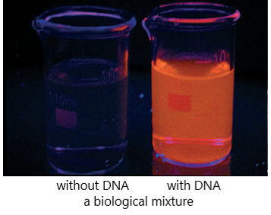

Figure 7 − Image of the PNP+GO- complex in a biological mixture of RNA, bovine serum albumin, glucose, with and without DNA, in UV light [40]
In [41] the GO-based bionsensor platform was presented. Its principle of operation is based on the fact that GO interacts more easily with single-stranded DNA (ssDNA) than with double-stranded DNA (dsDNA). This is due to the adsorption of nitrogenous bases of ssDNA with the surface of GO, whereas in dsDNA, nitrogenous bases are located in a less accessible place of the spiral structure. Scientists have shown that this method can successfully detect multiple ssDNA and microribonucleic acids.
Table 1 shows information on GO-based biosensors for biomaterial detection.

Table 1 − Variety of biosensors based on GO
Material | Aim | Sensor type | Reference
GO/dsDNA | Helicase activity | Fluorescent | [42]
Functionalized by GO long-period fiber array | Hemoglobin | Optic | [43]
GO/Au layer/antibody | Cytokeratin | Surface plasmon resonance | [44]
GO/Ag nanoparticles/antibodies | Prostate specific antigen | Surface-enhanced Raman scattering | [45]

In general, GO is a material with great potential for creating biosensors. Combining it with other materials makes it possible to develop biosensors of electrochemical, fluorescent, optical types, as well as surface plasmon resonance and surface-enhanced Raman scattering biosensors.

1.3 HAP based composites
In the past few decades, an active search for biocompatible materials with physicochemical properties similar to human bone tissue, which can be used as an alternative biological scaffold or matrix in targeted drug delivery has been underway all over the world. As described earlier, the crystal-chemical analogue of the mineral component of bone tissue is HAP. The presence of this biomineral in natural structures in a nanocrystalline state (~5-10 nm) is determined by osteogenesis processes and promotes the natural exchange of calcium in the body and, as a result, affects all interactions in which this compound participates. The applicability of biomaterials obtained in laboratory conditions is determined by such characteristics of the samples as structure, composition and crystallinity. In turn, these parameters depend on the characteristics of the synthesis of materials. Table 2 presents the types of HAP-based composites used for targeted drug delivery.
However, a number of studies [46-50] showed that HAP has weak mechanical strength, low specific surface area, low wear resistance, and low fracture toughness in comparison with natural human bone tissue, which has a negative effect on the proliferation and differentiation of osteoblasts during bone tissue regeneration. The solution to these disadvantages is possible by creating hybrid complex composite polymer matrices based on it with the addition of various materials such as carbon fibers, graphene, GO and metal oxides. Firstly, polymers with high mechanical stability and biological compatibility play the role of an osteoconductive framework that promotes the migration of osteoblastic cells. [51]. Secondly, the presence, for example, of GO in the structure significantly improves the mechanical characteristics of HAP, which is due not only to its good biological compatibility, but also to the presence of many oxygen-containing groups, such as hydroxyl, epoxy, carboxyl on its planes and at the edges. Moreover, in the past few years, interesting results have been published on the study of the antimicrobial effect of graphene oxide [52-54], at the same time, the mechanism of action on microbes is still a controversial issue.

Table 2 − Composites based on HAP in targeted drug delivery
Composite | Type of medication | In vivo | Release efficiency | Drug loading, mg of drug / g of HAP
Pure HAP powder | Vancomycin | New Zealand white rabbits | 42 days | 160
HAP with Fe, Co, Ni | Vancomycin | New Zealand white rabbits | 20 days | 160
HAP/Fe₂O₄ | Ciprofloxacin | Modeling with blood | 24 days | -
HAP/gold particles | Doxorubicin | MG-63 Osteosarcoma | 48 hours | 58,22
HAP/carbon fiber | Anticancer drugs | MG-63 Osteosarcoma | 6 hours | 167,2
HAP nanorods | Ibuprofen | - | 10 days | 260,3
HAP nanorods with Sr | Lysozyme | - | 30 hours | 55,52

Thus, the composite structure of graphene oxide and HAP on a polymer framework/matrix is ​​one of the promising candidates for application in the field of targeted dosage delivery of drugs. These and many other HAP composites used in targeted delivery indicate the importance of the choice of materials and methods for the synthesis of composites. To date, there are a number of methods for obtaining these composites, such as plasma sintering [55], sol-gel method [56], biomimetic mineralization [57], and electrospinning [58]. Among the listed methods, electrospinning has a number of advantages, which are its simplicity, the possibility of creating a polymer framework, as well as the ability to control the diameter of polymer fibers and drug concentration.
2 Experimental

2.1 Source materials
Phosphoric acid (H₃PO₄, 85%, Sigma Aldrich), eggshell, polycaprolactone (PCL, MW 1,300,000, Sigma Aldrich), Staphylococcus aureus (ATCC 25923, BioVitrum) and Escherichia coli (ATCC 25922, BioVitrum) were provided by Nanjing University of Science and Technology, Nanjing, China), ethanol (C₂H₆OH, 90%, “ChemPharm”, Kazakhstan), nitric acid (HNO₃, 70%, Sigma Aldrich), urea
(8 M in H₂O, BioUltra), walnut shell nuts (Turkestan, Kazakhstan), hydrochloric acid (HCl, 37%, Sigma Aldrich), amoxicillin (AMX) capsules 500 mg (Almaty, Kazakhstan).

2.2 Synthesis of HAP
The method for obtaining HAP from eggshell has been described and studied in detail in our previous works [59, 60]. The method of precipitation from solution was used for the synthesis of HAP. The eggshells were preliminarily annealed at a temperature of 950 °C for 2 hours in a muffle furnace (SNOL 30/1300) in air at a heating rate of 30 °C/min. The CaO weighed portion of 1 g obtained as a result of thermal treatment was stirred for 1 hour on a magnetic stirrer at a rotation rate of 100 rpm with an aqueous solution of phosphoric acid (6%, 20 ml). Then the solution was settled for 5 days, followed by decantation and drying at a temperature of
100 °C for 4 hours. The synthesized HAP powder was post-thermally treated in air at a temperature of 1200 °C for 2 hours with a heating rate of 25 °C/min. The general scheme of the HAP synthesis process is presented in figure 8.
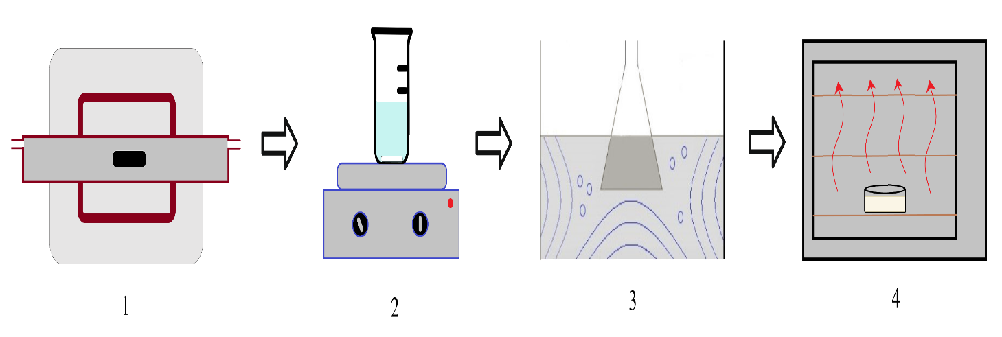
1 - high-temperature oven; 2 - magnetic stirrer; 3 - ultrasonic bath; 4 – drying oven

Figure 8 – Scheme of the HAP synthesis process

2.3 GO synthesis
The method for obtaining a graphene-like structures from walnut shells has been described and studied in detail in our previous works [61, 62]. To obtain GO, the formed after pyrolysis and chemical activation carbonaceous material was further functionalized. As the oxidizing composition, mixtures of nitric acid (35%) and urea (78 g/l) were used in the ratios: 10:90, 20:80 and 30:70. 2 g of samples of a graphene-like structure were treated with these solutions for 3 hours during heating at 80 °C. After the processing, the samples were repeatedly washed with distilled water under the influence of ultrasound with a frequency of 32 kHz, followed by centrifugation until pH reached 4. Then the resulting powders were treated with 10% hydrochloric acid solution, washed with distilled water until pH reached 3, and dried at 100 °C for 12 hours.

2.4 Obtaining nanoscale fibers with the addition of GO, HAP and a drug
To obtain composites based on GO, AMX, and HAP, the electrospinning method was used. 0.5 g of PCL was dissolved in 10 ml of ethanol and GO, AMX and HAP were added in certain ratios under constant stirring for 30 minutes on a magnetic stirrer at a rate of 120 rpm and ultrasonic treatment for 30 minutes (frequency 35 kHz) to ensure uniform distribution of GO, AMX and HAP in solution. The resulting solution was loaded into a medical syringe with a volume of 2.5 ml and on an experimental setup, the scheme of which is shown in figure 9, the fibers were electrospinned at room temperature and voltage of 16 kV with a precursor flow rate of 1.5 ml/h. The collector was located at a distance of 15 cm from the needle. Aluminum foil with the 20 cm in diameter was used as a collector, which was replaced every 1.5 hours during the entire deposition process.

Figure 9 − Scheme of the process of electrospinning polymer fibers with the addition of GO, AMX and HAP

2.5 Method for determining the kinetics of drug release from the obtained fibers and studying their antibacterial properties
The obtained films with the addition of GO/HAP and antibiotic were loaded into flasks with 10 ml of phosphate buffer solution, placed in a horizontal incubator at 40 rpm and 33 °C. The amount of drug was determined using a Varian Cary 300 spectrophotometer under UV irradiation with a wavelength of 272 nm. Cell proliferation was investigated by CCK-8 assay, MC3T3-E1 preosteoblasts were selected as cells. The cells were seeded in well plates at 37 °C with the addition of the obtained samples (HAP, GO, GO/HAP composite) for 24 hours. Further, according to the technique described in the works [63–65] the cell proliferation profile was calculated. The antibacterial properties of the obtained samples were evaluated using the bacteria Staphylococcus aureus (ATCC 25923) and Escherichia coli (ATCC 25922). The GO/HAP composite and the control sample were sterilized and mixed with bacteria. The cultivation was implemented in plates with Mueller-Hinton agar and then incubated for 24 hours at a temperature of 37 °C. Further, according to the method described in the works [66, 67] the antibacterial activity of the samples was calculated.

2.6 X-ray phase analysis of the samples
XRD analysis was carried out on an X-ray diffractometer of the Dron-4 type, which has a range of angles of rotation of the detection diffraction unit from -100° to 168°. The minimum step of movement of the detecting unit was 0.001°. The admissible connection of the detecting unit from a given rotation angle was ±0.015°. The transport speed of the goniometer is 820°/min. The main instrumental error in measuring the counting of X-ray pulses was no more than 0.4%.

2.7 Scanning electron microscopy of the samples
Investigations of the surface morphology of the obtained samples were carried out on a QUANTA 3D 200i microscope with an accelerating voltage of 30 kV. For investigation the sample was attached to a copper holder.

2.8 Raman-spectroscopy of the samples
Raman-spectroscopy was performed on an NTEGRA SPECTRA ™ Raman spectrometer (NT-MDT Spectrum) equipped with a solid-state laser that generated an excitation wavelength of 473 nm.

2.9 Transmission electron microscopy of the samples
The structure of the obtained samples was investigated by transmission electron microscopy using a JEM-2100 (JEOL, Japan) with high voltage and current stability.

3 Results and their discussion

3.1 Investigation of the parameters of the electrospinning process of micro- and nano-sized fibers, process optimization
The main parameters of the electrospinning that significantly determine the structure and morphology of the fibers are: concentration and rate of solution feed, the value of high-voltage and the distance between the collector and the needle (figure 9). In our previous works [68-70] we have studied in detail the influence of each of these parameters on the process of fiber electrospinning, however, for their possible use in the field of targeted drug delivery, two other factors must be taken into account: first, the similarity between the polymer and the polarity of the drug, and secondly, the polymer must be completely dissolved in order to avoid the formation of agglomerates, which can adversely affect the formation of fibers, and hence the efficiency of drug release. Considering the above, a series of experiments were carried out to select a solvent, a type of polymer and study the parameters affecting the formation of micro- and nano-sized polymer fibers. Table 3 summarizes the experimental results on dissolution of various biodegradable polymers with similar polarity to AMX (antibiotic).

Table 3 – Experimental results on the solubility of synthetic and natural polymers used to create matrices based on micro- and nanoscale fibers
Polymer type | Polymer concentration, % | Solvent type
Polycaprolactone (PCL) | 10 | Dimethylformamide - completely soluble
Polylactide (PLA) | 4 | Dimethylformamide - undissolved agglomerates are observed
Polyvinyl alcohol (PVA) | 8 | Water - undissolved agglomerates are observed
Polyethylene oxide (PEG/PEO) | 1 | Water/Ethanol (7:3) - undissolved agglomerates are observed
Gelatin | 50 | Dichloromethane/Dimethylformamide (4:1) - undissolved agglomerates are observed
Chitosan | 2 | Acetic acid - completely soluble
Polyvinylpyrrolidone (PVA) | 10 | Ethanol - undissolved agglomerates are observed
Note – All experiments were carried out with mechanical stirring for 30 minutes at room temperature

From table 3 among the studied types of polymers, PCL and chitosan are the most suitable. However, most natural polymers, including chitosan, are not stable in the physiological state and have poor mechanical properties, in this regard the PCL was chosen for further experiments. Obviously, the time and temperature during stirring has a significant effect on the solubility, however, according to [71], prolonged stirring in a solvent can adversely affect the drug. Studies have shown that the optimal parameters for mixing PCL and dimethylformamide are: 30 minutes on a magnetic stirrer with a rotation rate of 120 rpm (figure 10).

a b

a - 10 min; b - 30 min

Figure 10 − SEM images of films based on polymer fibers at different mixing times

The analysis of the obtained data demonstrates that with incomplete dissolution of the polymer, fibers with a large diameter of up to 2 microns are formed, since the average size of the fibers is directly dependent on the concentration of the polymer in the solution (figure 10, a). In addition, the electrospinning process is unstable due to clogging of the needle with large polymer particles. From figure 10, b, the obtained nanoscale fibers based on PCL dissolved in dimethylformamide under stirring on a magnetic stirrer for 30 minutes at a rotational rate of 120 rpm at room temperature have an average diameter of 200 nm. Thus, the optimal parameters of the process of electrospinning of nanosized fibers based on PCL have been determined, which make it possible to use them as effective matrices for targeted delivery of drugs with the addition of active substances, and presented as follows: stirring time - 30 min; stirring rate - 120 rpm; the solvent is dimethylformamide.

3.2 Electrospinning of biologically soluble matrices based on polymer fibers and drugs during their mechanical mixing
In the course of experimental work, composite polymer matrices with the addition of GO, HAP, and a drug were obtained. AMX was used in the synthesis as a drug, an important advantage of which is its favorable organoleptic properties, which make it possible to improve the tolerance of antibacterial therapy. PCL was used as a polymer, which has high mechanical stability and biological compatibility.
The main parameters influencing the electrospinning process are divided into three categories: solution characteristics (such as solution concentration and/or viscosity, solution surface tension and solution conductivity), process characteristics (such as solution feed rate, applied voltage and distance from the needle to the collector) and environmental conditions (ambient temperature and humidity). To study the effect of the concentration of the polymer solution on the diameter of nanoscale fibers, mixtures of PCL, AMX, HAP and GO were prepared at certain ratios (table 4).

Table 4 − Ratios of substances in the solution for the process of electrospinning of nanoscale fibers of a certain diameter
№ of the sample | GO, wt. % | HAP, wt.% | АМХ, wt.% | PCL, wt. % | Solvent, wt. % | Fibers average diameter, nm
1 | 0.01 | 1.97 | 1.00 | 11.03 | 86.99 | 1240
2 | 0.05 | 1.93 | 2.00 | 11.03 | 86.99 | 840
3 | 0.10 | 1.88 | 3.00 | 11.03 | 86.99 | 650
4 | 0.50 | 1.48 | 4.00 | 11.03 | 86.99 | 300

The obtained experimental results indicate the influence of the concentration of GO, AMX, and HAP on the formation of fibers. An increase in the concentration of GO leads to a decrease in the diameter, which is explained by the high electrical conductivity of the GO. On the other hand, the electrospinning of the fibers was carried out using the horizontal arrangement of the syringe pump, which led to the formation of a sediment by gravity and a decrease in the viscosity of the solution at the exit from the needle, thereby affecting the diameter of the formed polymer fibers. In further experiments a 2.5 ml syringe was used to exclude sediment formation. It was empirically found that the optimal amount of substances in a solution for the electrospinning of fibers with the addition of GO and HAP is as follows: 0.5 wt.% of GO, 1.48 wt.% of HAP, 11.03 wt.% of PCL, 4 wt.% of AMX, 86.99 wt.% of solvent. Additionally, it was found that, despite the fact that HAP with an average particle size of 1–2 μm was used to prepare the solution, after the electrospinning process, HAP particles with sizes less than 100 nm were found in the structure of the obtained fibers. This can be explained by the behavior of HAP particles during spinning the polymer fibers under high voltage. Studies demonstrate that electrical action leads to the predominant destruction of HAP particles. The presumable reason for this destruction is the effect of an electric field, which is concentrated inside a solid dielectric, leading to the destruction of large HAP particles. During the experiment, it was noticed that the formation of polymer fibers was not stable with a decrease in the voltage value. The conducted semi-quantitative analysis indicates the presence of HAP particles in the structure of polymer fibers (figure 11).
The characteristics of the electroforming process (such as feed rate of the solution, applied voltage and distance from the needle to the collector) are presented in table 5.
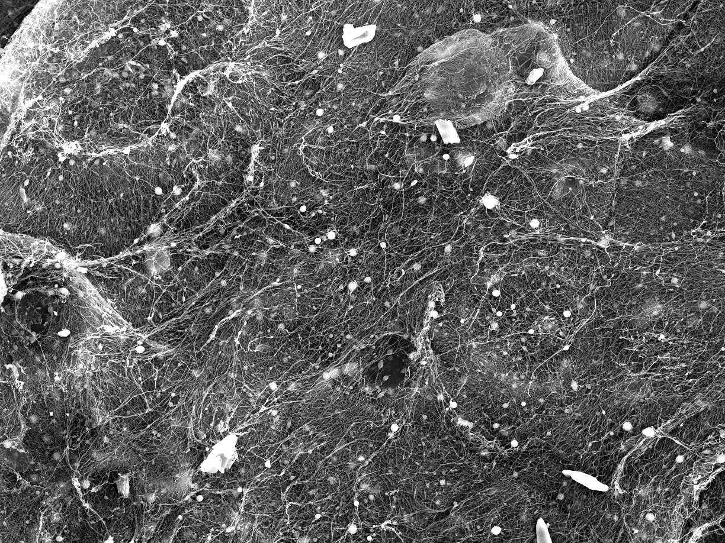
  Element | Line | Wt. % | Atomic wt. %
  C | K | 60.46±0.04 | 64.74±0.04
  N | K | 31.76±0.13 | 29.16±0.12
  O | K | 7.35±0.06 | 5.91±0.05
  Na | K | 0.13±0.01 | 0.07±0.00
  Si | K | 0.19±0.01 | 0.09±0.00
  Ca | K | 0.12±0.00 | 0.04±0.00
  Total |  | 100.00 | 100.00
  Map_007_wholespectrum |  | Fitting ratio 0.0395
Figure 11 − Semi-quantitative analysis data of the obtained polymer fibers

Table 5 − Parameters of the electrospinning process of nanosized fibers based on PCL/HAP/GO/AMX
Solution feed rate, ml/h | High voltage value, kV/cm | Distance from the needle to the collector, cm | Average diameter of nanoscale fibers, nm
0.02 | 1.5 | 15 | 300
0.10 | 1.5 | 15 | 450
0.15 | 1.8 | 15 | 600
0.25 | 2.0 | 15 | 1200

In contrast to the concentration of the solution, which affects the fiber diameter, the precursor feed rate by a syringe pump and the high voltage value significantly affect the structure and morphology of the resulting fibers. From table 5 it can be seen that an increase in the feed rate of the solution leads to unstable fiber formation, which is explained by the formation of an unstable jet. On the other hand, the high voltage applied to the needle and collector also affects the shape of the initial droplet, which leads to a change in the structure and morphology of the fibers. It has been experimentally established that to produce fibers with the addition of GO and HAP, the optimal voltage and feed rate of the syringe pump are 1.5 kV/cm and 0.02 ml/h, respectively. Figure 12 presents the optical photographs of the obtained films based on polymer fibers with the addition of GO, AMX, and HAP.
As a result of the implemented research, the following optimal parameters for the electrospinning nanoscale films with the addition of biologically compatible materials such as GO and HAP, as well as a drug were determined: the composition of the solution for electrospinning matrices based on PCL/HAP/GO/AMX − 0.5wt.% of GO, 1.48 wt.% of HAP, 4 wt.% of AMX, 11.03 wt.% of PCL, 86.99 wt.% of solvent; syringe pump feed rate − 0.02 ml/h; high voltage value − 1.5 kV/cm.

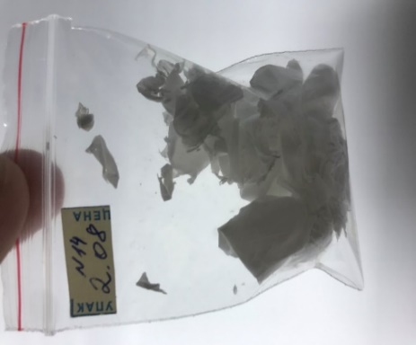 | 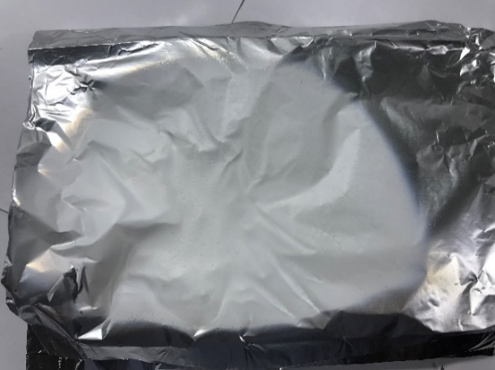

Figure 12 – Optical photographs of films based on polymer fibers with the addition of GO, AMX and HAP

3.3 Investigation of the physicochemical properties and surface morphology of biologically soluble matrices based on polymer fibers and drugs obtained by mechanical mixing of substances with subsequent electrospinning
Raman-spectroscopy was applied to investigate the resulting GO and the graphene-like structure of carbon (figure 13). According to the obtained data, the typical Raman spectra for GO are characterized by the following peaks: the G band at 1582 cm⁻¹ and the D band at 1357 cm⁻¹. Unlike GO for graphene-like carbon, the G band is observed at 1584 cm⁻¹. In this case, the D band at 1354 cm⁻¹ for graphene-like carbon has a high intensity, which characterizes the defect structure of the sample and the presence of amorphous carbon. All this suggests that the functionalization of the graphene-like structure of carbon makes it possible to reduce defects in the obtained samples, as evidenced by the low intensity of the D band for GO. These results are confirmed by the data obtained in the works [72-74], where it was found that the reduction of GO makes it possible to reduce the number of defects in the structure.

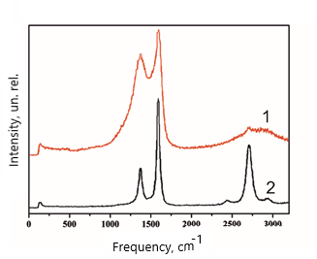
1 − GO; 2 − graphene-like carbon

Figure 13 − Raman spectra of the obtained graphene-containing materials
To study the surface morphology and structure of the reduced GO, the TEM method was used, the images of which are presented in figure 14. The analysis of the images indicates a typical morphology characteristic of graphene-like materials. High orderliness and orientation of the carbon structure with transparent edges, according to [75] indicates its small thickness. At the same time, the determination of the distance between the layers, which was also carried out from the analysis of the images of transmission electron microscopy, indicates the values of 0.4 nm, this value is consistent with the data shown in the work [76], where GO was also obtained from biomass. Obviously, the distance between the layers for GO is greater than that for carbon with a graphene-like structure, due to the presence of different functional groups.

Figure 14 − TEM images of synthesized GO

The study of the synthesized HAP powder was carried out using X-ray phase analysis (figure 15, a) and SEM (figure 15, b). In our previous works [59, 60] the method for the synthesis of HAP from biologically waste materials has been described in detail. X-ray diffraction data indicate the complete transformation of the raw material into HAP as a result of the synthesis. The planes (002), (210), (211), (112), (300), (222) and (213) completely coincide with the data from the Joint Committee for Powder Diffraction Standards data No. 96-900-2219, while the calculated crystal size was 171 nm. The lattice parameters are also consistent with the data obtained in the works [77-79] and have the following meanings: a = 9.8218±0.004; b = 2a; c = 9.473±0.002. Analysis of SEM images of the surface morphology of the obtained HAP powder indicates the presence of particles up to 10 μm in size in its structure. However, as described earlier, in the composite matrix obtained by the electrospinning method, the sizes of HAP particles were less than 100 nm (figure 15) [80-82].

Figure 15 − X-ray (a) and SEM images (b) of synthesized HAP

Figure 16 demonstrates the surface morphology of the obtained composite, which is presented in the form of typical filamentous polymer fibers of various diameters with the inclusion of GO, AMX and HAP. It is obvious that an increase in the concentration of GO and HAP will lead to a significant increase in the diameter of the fibers, at the same time, according to [83] the rough spots on SEM images indicate the presence of GO in the composite.

Figure 16 − SEM images of the resulting PCL/HAP/GO/AMX composite
The TGA curves for the initial walnut shell show that the pyrolysis process can be divided into 3 main stages: I - refers to weight loss due to evaporation of moisture (50-200 °C); II - corresponds to rapid thermal transformation of the main components, cellulose, hemicellulose and part of lignin (200-500 °C), accompanied by the release of gaseous products, which leads to a high value of weight loss of materials and their rapid decomposition in them; III - high-temperature charring of residues, in which mass loss occurs very slowly. According to the isotherms of adsorption and desorption of N2 and BET analysis, the specific surface area of the exhaust gas obtained from walnut shell is 2760 m²/g, the specific pore volume is 1.49 cm³/g, the average pore diameter is 2.9 nm.

3.4 Study of kinetics and microbiological evaluation of the effectiveness of drug release by the obtained biologically soluble matrices (in vitro)
The antibacterial properties of the obtained composite fibrous structures were investigated by exposure to model bacteria such as S. aureus and E. coli. These studies were carried out on the martices without the addition of AMX to determine the antibacterial properties and cytotoxicity of GO and HAP. The obtained results are presented in figure 17 that demonstrate the effect of GO on the antibacterial properties of composite structures, which in some cases exceeds 97%. In a number of research works [84-86], devoted to the use of graphene and graphene-like structures in various fields of medicine, the assumptions were made on the mechanisms of the antimicrobial effect of GO. In [87] the assumption that the free electron of the GO prevents the growth of microbes is considered. On the other hand, the possessing antibacterial properties by GO can be associated with its sharp edges, as well as with the presence of functional groups that lead to physical damage to the membranes of bacterial cells. Evaluation of the antibacterial properties of the obtained composite structures showed a significant increase in the diameter of the zone of inhibition (figure 17) from 5.2 to 9.1 mm with an increase in the content of GO in the composite from 0.05 to 0.1 wt.%. The obtained results are in agreement with the works [88-90] and confirm the excellent antibacterial properties of the GO.
To study the cytotoxicity and cell proliferation of the obtained samples, the CKK-8 assay was used, where MC3T3-E1 preosteoblasts were utilized as cells. Cell survival under the influence of HAP, GO and a composite based on them (figure 18) sharply decreased with an increase in their concentration. The obtained data indicate that the cell viability for HAP was 100, 98, 97, 95, 97, 89, 84, 57, 51, 48, 37 and 34% for concentrations of 0 (control), 50, 100, 150, 200 , 250, 300, 350, 400, 450, 500 and 550 mg/ml, respectively. At the same time, for a HAP concentration of 369 mg/ml, cell viability decreased to 57%, which is associated with a change in the pH of the medium upon the addition of HAP, leading to a sharp decrease in cell proliferation. In works [91, 92], it was shown that even though the size and shape of HAP particles significantly affect cytotoxicity, they can be used as bone transplants. In its turn, cell viability for the GO/HAP/PCL composite was 100, 99, 99, 97, 93, 91, 90, 86, 77, 63, 60, and 58% for concentrations of 0 (control), 50, 100, 150, 200, 250, 300, 350, 400, 450, 500 and 550 mg/ml, respectively, indicating a gradual decrease in viability with increasing concentration of the composite. The obtained data indicate an insignificant cytotoxicity of the GO/HAP/PCL composite at a concentration of 55 mg/ml. Thus, a positive effect of GO in a composite structure with HAP on the viability of MC3T3-E1 preosteoblasts, associated with the ability of graphene nanosheets to sequester was reported in [50]. In addition, it is believed that GO in the structure of the GO/HAP/PCL composite binds HAP particles, which also significantly affects cytotoxicity.

Figure 17 − Antibacterial activity of GO in PCL/HAP fibers against E. coli and S. aureus

Figure 18 − In vitro analysis of cytotoxicity of samples of GO, HAP and their composite

The use of polymer scaffolds with the addition of various kinds of materials such as graphene, GO, CNTs, as well as biocompatible materials, is of great interest in tissue engineering. These composite scaffolds can be used as an extracellular matrix, providing not only mechanical support for cells, but also forming intercellular contacts and connections with the matrix material, effectively influencing the migration of both nutrients and individual components. In addition, the creation of such a composite on a biologically compatible polymer framework or matrix makes it possible to achieve antibacterial properties due to the addition of GO. Various existing models describing the effect of GO on bacteria indicate the need for a more detailed study, both in vivo and in vitro, for a deep understanding of the influence of various factors, including methods and starting materials for the synthesis of GO, HAP and the composite itself, as well as biological compatibility and degradation rate of the polymer matrix.
GO has the highest antibacterial activity among carbonaceous materials [87], which is explained by the high specific surface area that provides high adsorption activity. In addition, the presence of a defective structure leads to mechanical destruction of bacteria through direct interaction (figure 19). At the same time, a number of studies [93-95] indicate the effect of free electrons on bacteria, which lead to their destruction. The performed studies are in agreement with pioneering works in the field of studying the mechanism of bacterial inactivation by creating composites based on GO, reduced GO, and pure graphene. Presumably, this mechanism is based on the mechanical effect of a defective structure on cell membranes, thereby causing their destruction and death. Such effect on bacteria is also observed for other carbon materials such as CNTs, graphite and amorphous carbon. Despite the fact that the mechanism of the antibacterial activity of GO is extremely complex and the described pathways of action on bacterial membranes have not been fully studied, it can be concluded that structural defects, the number of layers, and functional groups provide a membrane load. Obviously, GO obtained from biologically waste materials with many defects and the content of other carbon structures has an advantage over commercial analogues. The complex composite polymer matrices containing GO and HAP are successfully applied as biologically compatible scaffolds that can be used as an extracellular matrix, providing mechanical support, cell growth, and nutrient transport.
On the other hand, the drug (AMX) used in the work, which has favorable organoleptic properties, is necessary to improve the tolerability of antibacterial therapy of the resulting film based on polymer fibers with the addition of HAP and GO. To confirm the presence of AMX in the structure of a matrice based on polymer fibers with the addition of HAP and GO, the investigations were carried out to determine the kinetics of AMX release from the obtained matrice, which was observed over a 4-week period. The drug release curves are shown in figure 20.
The obtained results indicate that the kinetics of AMX release from matrices based on nanosized fibers with the addition of HAP and GO is about 90% at the AMX content of 4 wt.% (figure 20, a). In addition, it was found that the presence of HAP and GO practically does not affect the dynamics of drug release. However, a significant dependence of the release kinetics is observed on the diameter of the polymer fibers. This is, obviously, due to the surface morphology of polymer fibers, as well as the distribution of the antibiotic over the entire structure of the film. It has been experimentally established that an increase in the fiber diameter from 100 to 300 nm leads to an increase in drug release from 25 to 45 mg/ml, respectively. It was shown that the obtained biodegradable films based on polymer nanosized fibers with the addition of GO, HAP and AMX not only inhibit the growth of pathogenic microorganisms, but also have a favorable effect on the prolonged release of the antibiotic, and the presence of HAP promotes the formation of hard bone tissues. The undoubted advantage of composite matrices obtained by electrospinning is their high degree of homogeneity due to the integration of active substances, and the possibility of targeted delivery of the antibiotic to the lesion, as well as the possibility of choosing one or another drug and its optimal concentration depending on the nature and severity of the lesion.

Figure 19 − Schematic diagram of the mechanisms of the GO antibacterial effect (ROS stands for reactive oxygen species)

a b
a – polymer fibers of normal size; b – polymer fibers of increased diameter

Figure 20 − Kinetics of AMX release from the obtained matrices at different contents: 1 line – 1 wt. %, 2 line – 2 wt.%, 3 line – 3 wt.%, 4 line – 4 wt.%
Thus, the results of the performed research have shown that the electrospinning method is promising for creating effective and innovative drug delivery systems in order to improve their therapeutic properties. The creation of complex composite structures with the addition of GO and HAP not only affects the enhancement of antibacterial activity, but also contributes to the regeneration of bone tissue. The undoubted advantage of this method is its simplicity and the possibility of using a wide range of drugs, at the same time, control of the diameter of polymer fibers during the synthesis process allows to manipulate the kinetics of drug release.

CONCLUSION
- As a result of the implemented research, the parameters of the process of nanosized fibers electrospinning were investigated and optimized. The optimal polymer and solvent were selected experimentally to reduce the agglomeration of the formed fibers. The optimal parameters of the process of electrospinning of nanosized fibers based on PCL have been determined, which make it possible to use them as effective matrices for targeted delivery of drugs with the addition of active substances: stirring time – 30 min; stirring speed – 120 rpm; the solvent is dimethylformamide.
- The parameters of the process of electrospinning nanostructured matrices based on polymer fibers with the addition of drugs and biologically active substances have been investigated. It was found that during addition of a drug by mechanical mixing, the optimal parameters of the electrospinning are as follows: the precursor contained 0.5 wt.% of GO, 1.48 wt.% of HAP, 4 wt.% of AMX, 11.03 wt.% of PCL, 86.99 wt.% of solvent; syringe pump speed – 0.02 ml/h; high voltage value – 1.5 kV/cm. It has been experimentally established that when a drug is added, additional treatment in an ultrasonic bath for 30 (frequency 35 kHz) is required to avoid particle agglomeration, which prevents stable fiber formation.
- The comprehensive analysis of physicochemical properties and surface morphology showed that the surfaces of the obtained nanostructured matrices based on polymer fibers with the addition of drug (AMX) and biologically active substances (GO and HAP) are presented by typical filamentous polymer fibers with physical inclusions of GO and HAP. The average diameter of the obtained fibers is 300 nm. It is shown that the obtained HAP has a purity of more than 97 %, and the parameters of its crystal lattice completely coincide with biological apatite. It was found that GO obtained from biologically waste material with carbon-containing impurities, such as amorphous carbon and graphene-like carbon, has a morphology characteristic of graphene-like materials, and the high ordering and orientation of the carbon structure with the presence of transparent edges indicates a small number of layers in its structure, the thickness of which is 0.399 nm.
- It was determined that the obtained matrices have a high antimicrobial activity against strains of gram-positive and gram-negative bacteria (S. aureus and E. Coli). In addition, the studied matrices have no cytotoxic effect on MC3T3-E1 preosteoblast cells, and the observed decrease in cell proliferation is associated with a high load (350 mg/ml and higher). The study of the kinetics of the AMX release from the obtained nanostructured matrices based on polymer fibers with the addition of GO and HAP showed that the cumulative percentage of release from the samples was 98% of the total mass of the antibiotic during the 4-week observation period. It was shown that the obtained biodegradable matrices based on HAP and AMX not only inhibit the growth of pathogenic microorganisms, but also have a beneficial effect on the prolonged release of the antibiotic, while the presence of HAP in the matrix structure promotes the formation of hard bone tissues.

REFERENCES

1 Gibson I.R. 1.3.4A - Natural and Synthetic Hydroxyapatites // Biomaterials Science (Fourth Edition) // Academic Press. –2020. –P. 307-317.
2 Sadat-Shojai M., Khorasani M.-T., Dinpanah-Khoshdargi E., Jamshidi A. Synthesis methods for nanosized hydroxyapatite with diverse structures // Acta Biomaterialia. –2013. –Vol. 9. –P. 7591-7621.
3 Mazumder S., Nayak A.K., Ara J.K., Hasnain M.S. Hydroxyapatite composites for dentistry // Applications of Nanocomposite Materials in Dentistry // Elsevier. –2019. –P. 123-143.
4 Khalid H., Chaudhry A.A. Basics of hydroxyapatite—structure, synthesis, properties, and clinical applications // Handbook of Ionic Substituted Hydroxyapatites // Elsevier. –2020. –P. 85-115.
5 del Valle L.J., Puiggalí J. Hydroxyapatite Based Polymer Composites for Regenerative Medicine Applications // Encyclopedia of Materials: Composites // Elsevier. –2021. –P. 785-803.
6 Rahman S.U. Hydroxyapatite and tissue engineering // Handbook of Ionic Substituted Hydroxyapatites // Elsevier. –2020. –P. 383-400.
7 Rahman S.U., Oh J.-H., Cho Y.-D., Chung S.H., Lee G., Baek J.-M., Ryoo H.-M., Woo K.-M. Fibrous Topography-Potentiated Canonical Wnt Signaling Directs the Odontoblastic Differentiation of Dental Pulp-Derived Stem Cells // ACS Appl. Mater. Interfaces // American Chemical Society. –2018. –Vol. 10. –P. 17526-17541.
8 Zheng T., Guo L., Du Z., Leng H., Cai Q., Yang X. Bioceramic fibrous scaffolds built with calcium silicate/hydroxyapatite nanofibers showing advantages for bone regeneration // Ceramics International. –2021. –Vol. 47. –P. 18920-18930.
9 Tautkus S., Ishikawa K., Ramanauskas R., Kareiva A. Zinc and chromium co-doped calcium hydroxyapatite: Sol-gel synthesis, characterization, behaviour in simulated body fluid and phase transformations // Journal of Solid State Chemistry. –2020. –Vol. 284. –P. 121202.
10 Sandomierski M., Buchwald Z., Voelkel A. Calcium montmorillonite and montmorillonite with hydroxyapatite layer as fillers in dental composites with remineralizing potential // Applied Clay Science. –2020. –Vol. 198. –P. 105822.
11 Li C., ang J., Wang W.,Gao H., Wei G., Huang Y., Yue H., Gan Y., Wang Y., Mei L., Chen H., Hui H., Zhang Z., Jin Y. Recent progress in drug delivery // Acta Pharmaceutica Sinica B. –2019. –Vol. 9. –P. 1145-1162.
12 Saber-Samandari S., Nezafati N., Saber-Samandari S. The Effective Role of Hydroxyapatite Based Composites in Anticancer Drug Delivery Systems // Crit Rev Ther Drug Carrier Syst. –2016. –Vol. 33. –P. 41-75.
13 Mondal S., Pal U. 3D hydroxyapatite scaffold for bone regeneration and local drug delivery applications // Journal of Drug Delivery Science and Technology. –2019. –Vol. 53. –P. 101131.
14 Jariya S.A.I., Varun PrasathPadmanabhan V.P., Kulandaivelu R., Prakash N., Mohammad F., Al-Lohedan H.A., Paiman S., Hossain M.A.M., Sagadevan S. Drug delivery and antimicrobial studies of chitosan-alginate based hydroxyapatite bioscaffolds formed by the Casein micelle assisted synthesis // Materials Chemistry and Physics. –2021. –Vol. 272. –P. 125019.
15 Lee W.-H., Loo C.-Y., Rohanizadeh R. Functionalizing the surface of hydroxyapatite drug carrier with carboxylic acid groups to modulate the loading and release of curcumin nanoparticles // Materials Science and Engineering: C. –2019. –Vol. 99. –P. 929-939.
16 Iijima S., Ichihashi T. Single-shell carbon nanotubes of 1-nm diameter // Nature. –1993. –Vol. 363. –P. 603-605.
17 Iijima S. Helical microtubules of graphitic carbon // Nature. –1991. –Vol. 354. –P. 56-58.
18 Diel J.C., Franco D.S.P., Igansi A.V., Cadaval Jr T.R.S., Pereira H.A., Nunes I.D.S., Basso C.W., Alves M., Morais J., Pinto D., Dotto G.L. Green synthesis of carbon nanotubes impregnated with metallic nanoparticles: Characterization and application in glyphosate adsorption // Chemosphere. –2021. –Vol. 283. –P. 131193.
19 Yuan X., Liang C.,Ruan C., Chang Y., Xu L., Huang H., Chen M., Yong Z. Low-cost synthesis of multi-walled carbon nanotubes using red soil as catalyst // Diamond and Related Materials. –2021. –Vol. 112. –P. 108241.
20 Sawant S.V., Patwardhan A. W., Joshia J.B., Dasgupta K. Boron doped carbon nanotubes: Synthesis, characterization and emerging applications – A review // Chemical Engineering Journal. –2022. –Vol. 427. –P. 131616.
21 Gianoncelli A., Delfino R., Sala S., Kourousias G., Giordani G., Romano F., Riccid G., Pascolo L. Synchrotron soft X-ray microscopy and XRF to image Single-walled carbon nanotubes in epithelial cells // Nuclear Instruments and Methods in Physics Research Section B: Beam Interactions with Materials and Atoms. –2020. –Vol. 465. –P. 79-84.
22 Zhou J., Li J., Wu D., Hong C. CNT-Based and MSN-Based Organic/Inorganic Hybrid Nanocomposites for Biomedical Applications // ACS Symposium Series // American Chemical Society. –2017. –Vol. 1253. –P. 169-192.
23 Costa P.M., Wang J. T.-W., Morfin J.-F., Khanum Y., To W., Sosabowski J., Tóth E., Al-Jamal K. Functionalised Carbon Nanotubes Enhance Brain Delivery of Amyloid-Targeting Pittsburgh Compound B (PiB)-Derived Ligands // Nanotheranostics. –2018. –Vol. 2. –P. 168-183.
24 Zhang Y., Sun J., Tan J., Ma C.H., Luo S., Li W., Liu S. Multi-walled carbon nanotubes/carbon foam nanocomposites derived from biomass for CO2 capture and supercapacitor applications // Fuel. –2021. –Vol. 305. –P. 121622.
25 Shao Y., Dong Y.,Bin L., Fan L.,Wang L.,Yuan X., Li D., Liu X., Zhao S. Application of gold nanoparticles/polyaniline-multi-walled carbon nanotubes modified screen-printed carbon electrode for electrochemical sensing of zinc, lead, and copper // Microchemical Journal. –2021. –Vol. 170. –P. 106726.
26 Zhao H., Ma H., Li X., Liu B., Liu R., Komarneni S. Nanocomposite of halloysite nanotubes/multi-walled carbon nanotubes for methyl parathion electrochemical sensor application // Applied Clay Science. –2021. –Vol. 200. –P. 105907.
27 Raju V., Rani J.V., Basak P. Self-arranged polythiophene on multi-walled carbon nanotube templated composites: Synthesis and application in rechargeable aluminium battery // Electrochimica Acta. –2020. –Vol. 361. –P. 137097.
28 Raftis J.B., Miller M.R. Nanoparticle translocation and multi-organ toxicity: particularly small problem // Nano Today. –2019. –Vol. 26. –P. 8-12.
29 Li Z., Liu T., Long J., Wu Y., Biao Y., Ma P., Cao Y. The toxicity of hydroxylated and carboxylated multi-walled carbon nanotubes to human endothelial cells was not exacerbated by ER stress inducer // Chinese Chemical Letters. –2019. –Vol. 30. –P. 582-586.
30 Lin J., Jiang Y, Luo Y, Guo H, Huang C, Peng J, Cao Y. Multi-walled carbon nanotubes (MWCNTs) transformed THP-1 macrophages into foam cells: Impact of pulmonary surfactant component dipalmitoylphosphatidylcholine // Journal of Hazardous Materials. –2020. –Vol. 392. –P. 122286.
31 Liu Y., Hua Q., Huang C., Cao Y. Comparison of multi-walled carbon nanotubes and halloysite nanotubes on lipid profiles in human umbilical vein endothelial cells // NanoImpact. –2021. –Vol. 23. –P. 100333.
32 Gao X., Zheng X, Gao S., Huang Y., Xiong J., Ren H. Toxicity of amine-functionalized single-carbon nanotube (NH2 f-SWCNT) to Channel Catfish (Ietalurus Punetaus): Organ pathologies, oxidative stress, inflammation, and apoptosis // Chemosphere. –2021. –Vol. 282. –P. 131133.
33 Mia Md.B., Saxena R.K. Toxicity of poly-dispersed single-walled carbon nanotubes on bone marrow derived Hematopoietic Stem and Progenitor Cells // Current Research in Toxicology. –2021. –Vol. 2. –P. 82-92.
34 Bleu Y., Bourquard F., Michalo J.-Y., Lefkir Y., Reynaud S., Loir A.-S., Barnier V., Garrelie F., Donnet C. Transfer-free graphene synthesis by nickel catalyst dewetting using rapid thermal annealing // Applied Surface Science. –2021. –Vol. 555. –P. 149492.
35 Sahoo P., Shubhadarshinee L.,Jali B.R., Mohapatra P., Barick A.K. Synthesis and characterization of graphene oxide and graphene from coal // Materials Today: Proceedings. –2021. –P. S2214785321056443.
36 Kumar N., Salehiyan R., Chauke V., Botlhoko O.J., Manfred S., Masukume M., Ray S.S. Top-down synthesis of graphene: A comprehensive review // FlatChem. –2021. –Vol. 27. –P. 100224.
37 Valencia A.M., Valencia C.H., Zuluagaa F., Grande-Tovar C.D. Synthesis and fabrication of films including graphene oxide functionalized with chitosan for regenerative medicine applications // Heliyon. –2021. –Vol. 7. –P. e07058.
38 Zambrano-Andazol I., Vázquez N., Chacón M., Sánchez-Avila R. M., Persinal M., Blanco Rodríguez C., González Arias Z.Menéndez López R.M., Sierra M., Fernández-Vega Á., Sánchez T., Meana Á. Reduced graphene oxide membranes in ocular regenerative medicine // Materials Science and Engineering: C. –2020. –Vol. 114. –P. 111075.
39 Si Y., Samulski E.T. Synthesis of Water Soluble Graphene // Nano Lett. –2008. –Vol. 8. –P. 1679-1682.
40 Balapanuru J., Yang J.-H., Xiao S., Bao W., Jahan M., Polavarapu L., Wei J., Xu Q.-H., Loh K.P. A Graphene Oxide-Organic Dye Ionic Complex with DNA-Sensing and Optical-Limiting Properties // Angewandte Chemie International Edition. –2010. –Vol. 49. –P. 6549-6553.
41 Lu C.-H., Yang H.-H., Zhu C.-L., Chen X., Chen G.-N. A Graphene Platform for Sensing Biomolecules // Angew. Chem. Int. Ed. –2009. –Vol. 48. –P. 4785-4787.
42 Jang H., Kim Y.-K., Kwon H.-M., Yeo W.S., Kim D. E., Min D.-H. A Graphene-Based Platform for the Assay of Duplex-DNA Unwinding by Helicase // Angewandte Chemie International Edition. –2010. –Vol. 49. –P. 5703-5707.
43 Liu C., Xu B.J., Zhou L., Sun Z., Mao H.J., Zhao J.L., Zhang L., Chen X. Graphene oxide functionalized long period fiber grating for highly sensitive hemoglobin detection // Sensors and Actuators B: Chemical. –2018. –Vol. 261. –P. 91-96.
44 Chiu N.-F., Lin T.-L., Kuo C.-T. Highly sensitive carboxyl-graphene oxide-based surface plasmon resonance immunosensor for the detection of lung cancer for cytokeratin 19 biomarker in human plasma // Sensors and Actuators B: Chemical. –2018. –Vol. 265. –P. 264-272.
45 Yang L., Zhen S.J., Li Y.F., Huang C.Z. Silver nanoparticles deposited on graphene oxide for ultrasensitive surface-enhanced Raman scattering immunoassay of cancer biomarker // Nanoscale. –2018. –Vol. 10. –P. 11942-11947.
46 Bensalem A., Kucukosman O.K., Raszkiewicz J., Topkaya F. Synthesis, Characterization, Bactericidal Activity, and Mechanical Properties of Hydroxyapatite Nano powders impregnated with Silver and Zinc oxide nanoparticles (Ag-ZnO-Hap) // Ceramics International. –2021. –P. S0272884221011834.
47 Mohseni Taromsari S., Salari M., Bagheri R., Faghihi Sani M.A. Optimizing tribological, tensile & in-vitro biofunctional properties of UHMWPE based nanocomposites with simultaneous incorporation of graphene nanoplatelets (GNP) & hydroxyapatite (HAp) via a facile approach for biomedical applications // Composites Part B: Engineering. –2019. –Vol. 175. –P. 107181.
48 Behera K., Sivanjineyulu V., Chang Y.-H., Chiu F.-C. Thermal properties, phase morphology and stability of biodegradable PLA/PBSL/HAp composites // Polymer Degradation and Stability. –2018. –Vol. 154. –P. 248-260.
49 Janovák L., Deák A., Tallósy S.P., Sebők D., Csapó E., Bohinc K., Abram M., Pálinkó I., Dékány I. Hydroxyapatite-enhanced structural, photocatalytic and antibacterial properties of photoreactive TiO2/HAp/polyacrylate hybrid thin films // Surface and Coatings Technology. –2017. –Vol. 326. –P. 316-326.
50 Ramadas M. Bharath G., Ponpandian N., Ballamurugan A.M. Investigation on biophysical properties of Hydroxyapatite/Graphene oxide (HAp/GO) based binary nanocomposite for biomedical applications // Materials Chemistry and Physics. –2017. –Vol. 199. –P. 179-184.
51 Shapourzadeh A., Atyabi S.M., Irani S., Bakhshi H. Osteoinductivity of polycaprolactone nanofibers grafted functionalized with carboxymethyl chitosan: Synergic effect of β-carotene and electromagnetic field // International Journal of Biological Macromolecules. –2020. –Vol. 150. –P. 152-160.
52 Azizi-Lalabadi M., Hashemi M., Feng J., Jafari S.M. Carbon nanomaterials against pathogens; the antimicrobial activity of carbon nanotubes, graphene/graphene oxide, fullerenes, and their nanocomposites // Advances in Colloid and Interface Science. –2020. –Vol. 284. –P. 102250.
53 Sahu G., Das M., Sethy C., Wazalwar R., Kundu C.N., Raichur A.M., Tripathy J. Ionic liquid-assisted fabrication of poly(vinyl alcohol)/nanosilver/graphene oxide composites and their cytotoxicity/antimicrobial activity // Materials Chemistry and Physics. –2021. –Vol. 266. –P. 124524.
54 Kim Y.N., Ha Y.-M., Park J.E., Kim Y.-O., Jo J. Y., Han H., Lee D.C. Kim J., Jung Y.C. Flame retardant, antimicrobial, and mechanical properties of multifunctional polyurethane nanofibers containing tannic acid-coated reduced graphene oxide // Polymer Testing. –2021. –Vol. 93. –P. 107006.
55 Nizami M.Z.I., Takashiba S., Nishina Y. Graphene oxide: A new direction in dentistry // Applied Materials Today. –2020. –Vol. 19. –P. 100576.
56 Yılmaz P., Öztürk Er E., Bakırdere S., Ülgen K., Özbek B. Application of supercritical gel drying method on fabrication of mechanically improved and biologically safe three-component scaffold composed of graphene oxide/chitosan/hydroxyapatite and characterization studies // Journal of Materials Research and Technology. –2019. –Vol. 8. –P. 5201-5216.
57 Wang Q., Chu Y., He J., Shao W., Zhou Y., Qi K., Wang L. A graded graphene oxide-hydroxyapatite/silk fibroin biomimetic scaffold for bone tissue engineering // Materials Science and Engineering: C. –2017. –Vol. 80. –P. 232-242.
58 Al-Wafi R., Ahmed M.K., Mansour S.F. Tuning the synthetic conditions of graphene oxide/magnetite/ hydroxyapatite/cellulose acetate nanofibrous membranes for removing Cr(VI), Se(IV) and methylene blue from aqueous solutions // Journal of Water Process Engineering. –2020. –Vol. 38. –P. 101543.
59 Daulbayev C., Sultanov F., Aldasheva M., Abdybekova A., Bakbolat B., Shams M., Chekiyeva A., Mansurov Z. Nanofibrous biologically soluble scaffolds as an effective drug delivery system // Comptes Rendus. Chimie. –2021. –P. 1-9.
60 Daulbayev Ch. , Mansurov Z., Mitchell G., Zakhidov A. Obtaining of Biologically Soluble Membranes Based on Polymeric Nanofibres and Hydroxyapatite of Calcium // Eurasian Chem. Tech. J. –2018. –Vol. 20. –P. 119.
61 Yeleuov M., Seidl C., Temirgaliyeva T., Taurbekov A., Prikhodko N., Lesbayev B., Sultanov F., Daulbayev C., Kumekov S. Modified Activated Graphene-Based Carbon Electrodes from Rice Husk for Supercapacitor Applications: 18 // Energies. –2020. –Vol. 13. –P. 4943.
62 Daulbayev C. Sultanov F., Korobeinyk A., Yeleuov M., Azat S., Bakbolat B., Umirzakov A., Mansurov Z. Bio-waste-derived few-layered graphene/SrTiO3/PAN as efficient photocatalytic system for water splitting // Applied Surface Science. –2021. –Vol. 549. –P. 149176.
63 Ou L., Wang H., Wu Z., Yang L., Li L., Sun X., Zhu K., X., Zhang R. Effects of cadmium on osteoblast cell line: Exportin 1 accumulation, p-JNK activation, DNA damage and cell apoptosis // Ecotoxicology and Environmental Safety. –2021. –Vol. 208. –P. 111668.
64 Pang S., He Y., He P., Luo X., Guo Z., Li H. Fabrication of two distinct hydroxyapatite coatings and their effects on MC3T3-E1 cell behavior // Colloids and Surfaces B: Biointerfaces. –2018. –Vol. 171. –P. 40-48.
65 Shin Y.C., Lee J.H., Jin O.S., Kang S.H., Hong S.W., Kim B., Park J.-C., Han D.-W. Synergistic effects of reduced graphene oxide and hydroxyapatite on osteogenic differentiation of MC3T3-E1 preosteoblasts // Carbon. –2015. –Vol. 95. –P. 1051-1060.
66 Song X., Xie L., Zhang M., Wang W., Li L., Lu X., Lei P., Liu D., Chen Y., Chen H., Zhao C. Cu-decorated graphene oxide coatings with enhanced antibacterial activity for surface modification of implant // Materials Research Bulletin. –2021. –Vol. 141. –P. 111345.
67 Menazea A.A., Ahmed M.K. Synthesis and antibacterial activity of graphene oxide decorated by silver and copper oxide nanoparticles // Journal of Molecular Structure. –2020. –Vol. 1218. –P. 128536.
68 Разработка и создание эффективных трехмерных нанопористых фотокаталитических покрытий для производства водорода»: отчет о НИР / – РГП на ПХВ «Институт проблем горения»: рук. Султанов Ф.Р. –Алматы, 2018. – 41 c. –
69 Разработка и создание эффективных трехмерных нанопористых фотокаталитических покрытий для производства водорода» : отчет о НИР / – РГП на ПХВ «Институт проблем горения»: рук. Султанов Ф.Р. –Алматы, 2019. –45 с. –
70 Разработка и создание эффективных трехмерных нанопористых фотокаталитических покрытий для производства водорода»: отчет о НИР / – РГП на ПХВ «Институт проблем горения»: рук. Султанов Ф.Р. –Алматы, 2020. –29 с. –
71 Wang Z., Wang H.,, Xiong J., Li J., Miao X., Lan X., Liu X., Wang W., Cai N., Tang F. Fabrication and in vitro evaluation of PCL/gelatin hierarchical scaffolds based on melt electrospinning writing and solution electrospinning for bone regeneration // Materials Science and Engineering: C. –2021. –Vol. 128. –P. 112287.
72 McDonald-Wharry J., Manley-Harris M., Pickering K. Carbonisation of biomass-derived chars and the thermal reduction of a graphene oxide sample studied using Raman spectroscopy // Carbon. –2013. –Vol. 59. –P. 383-405.
73 Yarmand H., Gharehkhani S., Shirazi S.F.S., Amiri A., Montazer E., Arzani H.K., Sadri R., Dahari M., Kazi S.N. Nanofluid based on activated hybrid of biomass carbon/graphene oxide: Synthesis, thermo-physical and electrical properties // International Communications in Heat and Mass Transfer. –2016. –Vol. 72. –P. 10-15.
74 Chen F., Yang J., Bai T., Long B., Zhou X. Facile synthesis of few-layer graphene from biomass waste and its application in lithium ion batteries // Journal of Electroanalytical Chemistry. –2016. –Vol. 768. –P. 18-26.
75 Li C., Zhuang Z., Jin X., Chen Z. A facile and green preparation of reduced graphene oxide using Eucalyptus leaf extract // Applied Surface Science. –2017. –Vol. 422. –P. 469-474.
76 Yaqoob A.A., Serrà A., Ibrahim M.N.M., Yaakop A.S. Self-assembled oil palm biomass-derived modified graphene oxide anode: An efficient medium for energy transportation and bioremediating Cd (II) via microbial fuel cells // Arabian Journal of Chemistry. –2021. –Vol. 14, № 5. –P. 103121.
77 Klinkaewnarong J., Swatsitang E., Masingboon C., Seraphin S., Maensiri S. Synthesis and characterization of nanocrystalline HAp powders prepared by using aloe vera plant extracted solution // Current Applied Physics. –2010. –Vol. 10. –P. 521-525.
78 Rodriguez R., Estevez M., Vargas S., Gonzalez M., Salazar R., Pacheco F. Synthesis and characterization of HAp-based porous materials // Materials Letters. –2009. –Vol. 63. –P. 1558-1561.
79 González M. Merino U., Vargas S., Quintanilla F., Rodríguez R. Synthesis and characterization of a HAp-based biomarker with controlled drug release for breast cancer // Materials Science and Engineering: C. –2016. –Vol. 61. –P. 801-808.
80 Wang S., Hu F., Li J., Zhang S., Shen M., Huang M., Shi X. Design of electrospun nanofibrous mats for osteogenic differentiation of mesenchymal stem cells // Nanomedicine: Nanotechnology, Biology and Medicine. –2018. –Vol. 14. –P. 2505-2520.
81 Cheng H., Yang X., Che X., Yang M., Zhai G. Biomedical application and controlled drug release of electrospun fibrous materials // Materials Science and Engineering: C. –2018. –Vol. 90. –P. 750-763.
82 Chlanda A, Rebis J., Kijeńska E., Wozniak M.J., Rozniatowski K., Swieszkowski W., Kurzydlowski K.J. Quantitative imaging of electrospun fibers by PeakForce Quantitative NanoMechanics atomic force microscopy using etched scanning probes // Micron. –2015. –Vol. 72. –P. 1-7.
83 Ahmed M.K., Mansour S.F., Al-Wafi R., Menazea A.A. Composition and design of nanofibrous scaffolds of Mg/Se- hydroxyapatite/graphene oxide @ ε-polycaprolactone for wound healing applications // Journal of Materials Research and Technology. –2020. –Vol. 9. –P. 7472-7485.
84 Wang M., Li Z, Zhang Y., Li Y., Li N, Huang D., Xu B. Interaction with teichoic acids contributes to highly effective antibacterial activity of graphene oxide on Gram-positive bacteria // Journal of Hazardous Materials. –2021. –Vol. 412. –P. 125333.
85 Fathalipour S., Mardi M. Synthesis of silane ligand-modified graphene oxide and antibacterial activity of modified graphene-silver nanocomposite // Materials Science and Engineering: C. –2017. –Vol. 79. –P. 55-65.
86 Yousefi M., Dadashpour M., Hejazi M., Hasanzadeh M., Behnam B., de la Guardia M., Shadjou N., Mokhtarzadeh A. Anti-bacterial activity of graphene oxide as a new weapon nanomaterial to combat multidrug-resistance bacteria // Materials Science and Engineering: C. –2017. –Vol. 74. –P. 568-581.
87 Pulingam T., Thong K., Appaturi J.M., Lai C.W., Leo B.F. Mechanistic Actions and Contributing Factors affecting the Antibacterial Property and Cytotoxicity of Graphene Oxide // Chemosphere. –2021. –P. 130739.
88 Narayanan K.B., Park G.T., Han S.S. Antibacterial properties of starch-reduced graphene oxide–polyiodide nanocomposite // Food Chemistry. –2021. –Vol. 342. –P. 128385.
89 Prusty S., Pal K., Bera D., Paul A., Mukherjee M., Khan F., Das S., Dey A. Enhanced antibacterial activity of a novel biocompatible triarylmethane based ionic liquid-graphene oxide nanocomposite // Colloids and Surfaces B: Biointerfaces. –2021. –Vol. 203. –P. 111729.
90 Menazea A.A., Ahmed M.K. Silver and copper oxide nanoparticles-decorated graphene oxide via pulsed laser ablation technique: Preparation, characterization, and photoactivated antibacterial activity // Nano-Structures & Nano-Objects. –2020. –Vol. 22. –P. 100464.
91 Jegatheeswaran S., Selvam S., Sri Ramkumar V., Sundraraja M. Novel strategy for f-HAp/PVP/Ag nanocomposite synthesis from fluoro based ionic liquid assistance: Systematic investigations on its antibacterial and cytotoxicity behaviors // Materials Science and Engineering: C. –2016. –Vol. 67. –P. 8-19.
92 Yuvaraj S., Muthukumarasamy N., Flores M., Rajesh G., Paraskevopoulos K.M., Pouroutzidou G.K., Theodorou G.S., Ioannidou K., Lusvarghi L., Velauthapillai D., Yoganand C.P. Incorporation of nanosized carbon over hydroxyapatite (HAp) surface using DC glow discharge plasma for biomedical application // Vacuum. –2021. –Vol. 190. –P. 110300.
93 Yang M., Liu H., Qiu C., Iatsunskyi I., Coy E., Moya S., Wang Z., Wu W., Zhao X., Wang G. Electron transfer correlated antibacterial activity of biocompatible graphene Nanosheets-TiO2 coatings // Carbon. –2020. –Vol. 166. –P. 350-360.
94 Huo S., Gao Y.,Fang L., Jiang Z., Xie Q., Meng Q., Fei G., Ding S. Graphene oxide with acid-activated bacterial membrane anchoring for improving synergistic antibacterial performances // Applied Surface Science. –2021. –Vol. 551. –P. 149444.
95 Cao G., Yan j., Ning x., Zhang Q., Wu Q., Bi L., Zhang Y., Han Y., Guo J. Antibacterial and antibiofilm properties of graphene and its derivatives // Colloids and Surfaces B: Biointerfaces. –2021. –Vol. 200. –P. 111588.

APPENDIX А

List of published articles on the project
- Kenzhebaeva A., Bakbolat B., Sultanov F., Daulbaev Ch., Mansurov Z., Aldasheva M. Nanofibrous bio-soluble frameworks as an effective drug delivery system // Combustion and Plasma Chemistry (under review)
- Ch. Daulbayev, F. Sultanov, A.V. Korobeinyk, M. Yeleuov, A.Taurbekov, B. Bakbolat, A. Umirzakov, A. Baimenov, O. Daulbayev. Effect of graphene oxide/hydroxyapatite nanocomposite on osteogenic differentiation and antimicrobial activity // Surfaces and Interfaces (under review)

APPENDIX B

Work schedule
№ п/п | Name of tasks and activities for their implementation | Start of implementation (dd/mm/yy) | Duration, months | Expected results of the project (in terms of tasks and activities), the form of completion
1 | 2 | 3 | 4 | 5
1 | Investigation of the parameters of the electrospinning process of micro- and nanoscale fibers, process optimization | 05.01.2021 | 2 | The parameters influencing the electrospinning of micro- and nano-sized fibers will be investigated, the dependence of the fiber sizes on the process parameters will be optimized
2 | Electrospinning of biologically soluble matrices based on polymer fibers and drugs during their mechanical mixing | 01.03.2021 | 3 | Biologically soluble matrices based on polymer fibers and drugs will be obtained by the method of electrospinning during their mechanical mixing
3 | Investigation of the physicochemical properties and surface morphology of biologically soluble matrices based on polymer fibers and drugs obtained by mechanical mixing of substances with subsequent electrospinning | 01.06.2021 | 3 | The physicochemical properties and surface morphology of biologically soluble matrices obtained by mechanical mixing of substances with the subsequent electrospinning will be investigated by SEM, XRD, TGA, and BET analysis
4 | Study of kinetics and microbiological evaluation of the effectiveness of drug release by the obtained biologically soluble matrices (in vitro) | 01.09.2021 | 4 | The kinetics of drug release by the obtained biologically soluble matrices will be studied, and the influence of their structural features on the nature of drug release will be analyzed
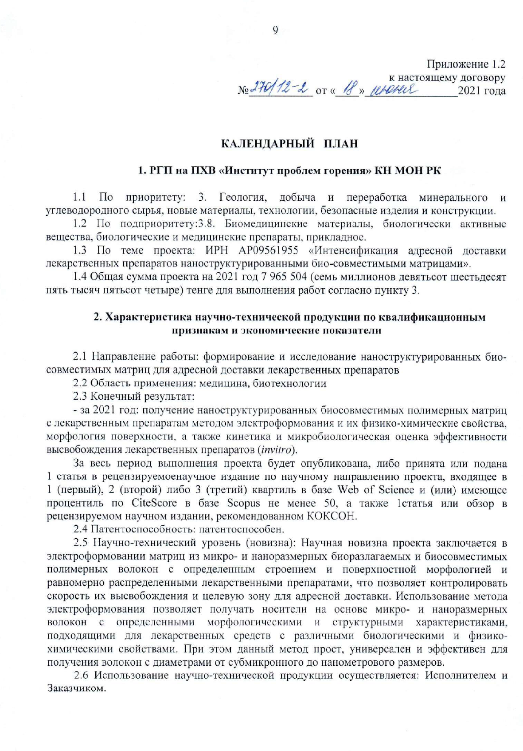
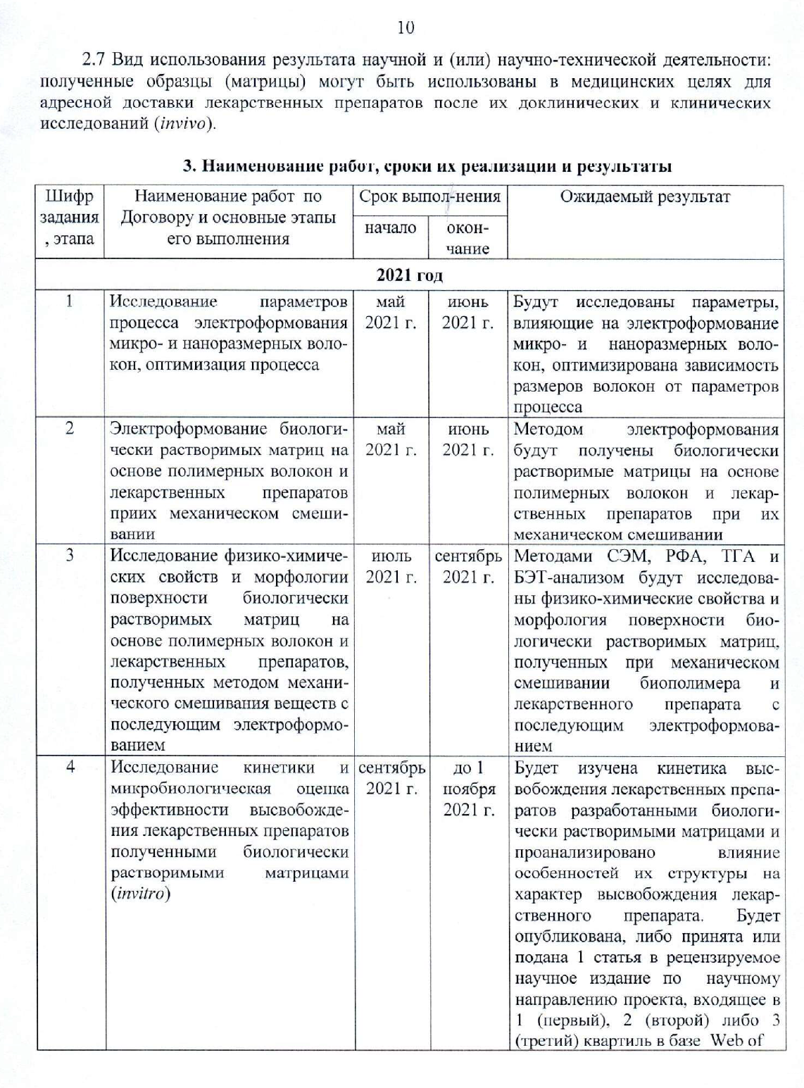
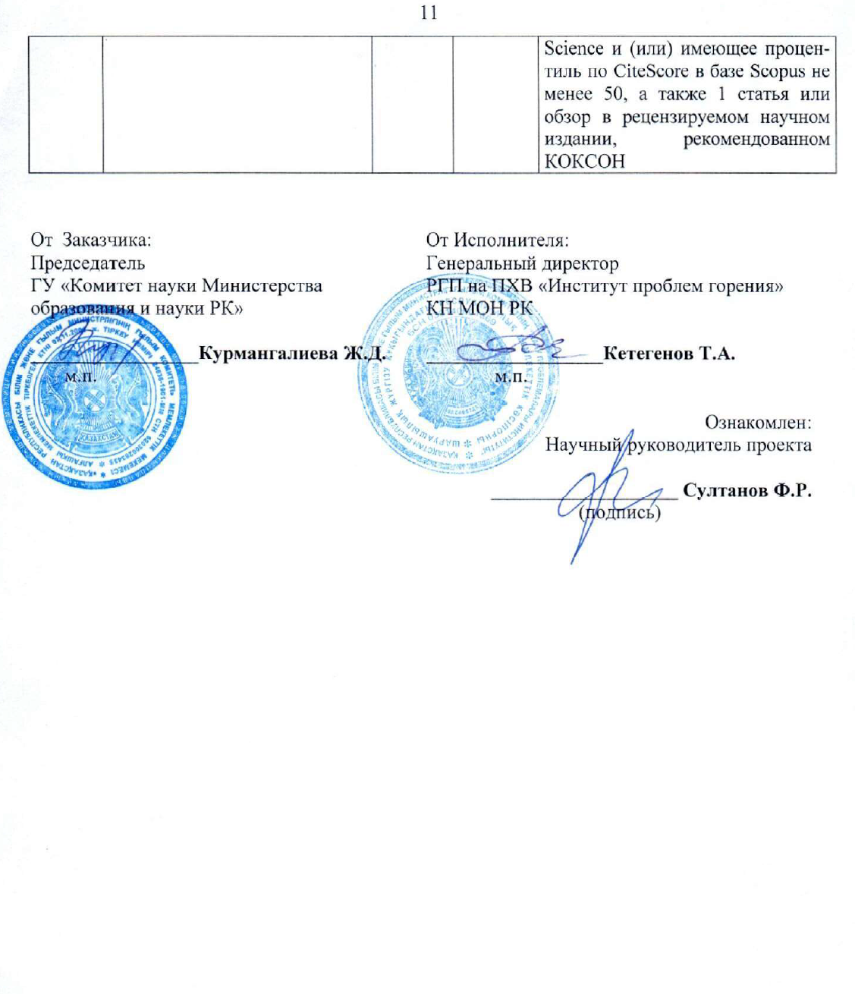

APPENDIX С

Extract from the protocol
