РЕФЕРАТ

Есеп 43 б., 1 к., 24 сур., 52 д., 2 қос.
КЕҢЕЙГЕН ШЫНДЫҚ, UNITY, Е-ОҚУ, ВИРТУАЛДЫҚ ШЫНДЫҚ, ФИЗИКА, ВИРТУАЛДЫҚ ЭКСПЕРИМЕНТ, НОВАЦИЯЛЫҚ ОҚЫТУ ӘДІСТЕРІ, ФИЗИКАЛЫҚ ПРОЦЕСТЕРДІҢ АНИМАЦИЯСЫ
Зерттеу объектісі - кеңейтілген шындық технологиясын қолданатын мобильді қосымша.
Жұмыстың мақсаты: кеңейтілген шындық технологиясын қолдана отырып, жоғары және орта оқу орындарында физиканы қашықтықтан оқытуға арналған көп тілді мобильді қосымшаны (қазақ, орыс, ағылшын) әзірлеу.
Әдіснамасы: Бағдарламалық жасақтаманы әзірлеудің жылдам әдістері, компьютерлік модельдеу және объектіге бағытталған бағдарламалау әдістері.
Жаңалық: кеңейтілген шындық технологиясын қолдана отырып, физиканы зерттеуге арналған мобильді қосымшаны жасаудың әдістемесін жасауда жатыр. Сондай -ақ, барлық өлшеу құралдарының жұмысы, сонымен қатар зерттелетін физикалық құбылыстар мен құрылғылар компьютерлік модельдер мен сәйкес математикалық аппараттардың көмегімен сипатталатын болады.
Нәтижелердің қысқаша сипаттамасы: кеңейтілген шындық технологиясын қолдана отырып зертханалық жұмыстарды орындау арқылы физиканы оқуға арналған мобильді қосымша әзірленетін болады. Зерттеу нәтижелері Қазақстанда ақпараттық -коммуникациялық технологиялар саласындағы жаңа бағыттардың дамуына әсер етеді - компьютерлік визуализация, кеңейтілген және виртуалды шындық, сонымен қатар цифрлық, интеллектуалды өндіріс пен телекоммуникацияның озық технологияларына көшу, робот жүйелері, жаңа материалдар мен жобалау әдістері, үлкен көлемді деректерді өңдеу жүйелерін құру, машиналық оқыту және жасанды интеллект.
Қолданылу аясы: дамыған виртуалды электронды зертхананың негізгі қолдану аймағы орта және жоғары оқу орындары болып табылады.

REPORT

The report is composed of 43 pag., 1 b., 24 fig., 52 ref., 2 app.
AUGMENTED REALITY, UNITY, DISTANCE LEARNING, VIRTUAL REALITY, PHYSICS, VIRTUAL EXPERIMENT, INNOVATIVE TEACHING METHODS, ANIMATIONS OF PHYSICAL PROCESSES
The object of the study is a mobile application using augmented reality technology.
The purpose of the work: to develop a mobile application of a multilingual educational platform (Kazakh, Russian, English) for the remote study of physics in higher and secondary educational institutions using augmented reality technology.
Methodology: flexible software development methodologies, methods of computer modeling, and object-oriented programming.
Novelty: it consists in developing a methodology and creating a mobile application for studying physics using augmented reality technology. The functioning of all measuring equipment, as well as the studied physical phenomena and devices, will be described using computer models and appropriate mathematical apparatus.
Brief description of the results: a mobile application will be developed to study physics by performing laboratory work using augmented reality technology. The results obtained in the study will affect the development in Kazakhstan of new directions in the field of information and communication technologies - computer visualization, augmented and virtual reality, as well as the transition to advanced digital, intelligent, manufacturing, and telecommunications technologies, robotic systems, new materials and methods of construction, the creation of systems for processing large amounts of data, machine learning and artificial intelligence.
Scope of application: the main field of application of the virtual electronic laboratory being developed is secondary and higher educational institutions.

CONTENT

INTRODUCTION | 6
1 New technology in modern education | 7
1.1 Using mobile technology for physics studying | 7
1.2 Augmented reality technology in education | 10
1.3 Project’s goals and objectives set up | 13
1.4 Justification of the relevance and practical significance | 14
2 Implementation of distance learning augmented reality mobile application for physics studying | 16
2.1 Development of the application requirements | 16
2.2 Software choice rationale | 17
2.3 Virtual physics laboratory prototyping | 18
2.4 Physical processes animation | 20
2.5 Development of the mobile application for physics studying using augmented reality | 23
2.6 Writing guidelines and documentation for the developed mobile application | 34
2.7 Implementation of the developed virtual laboratory into the educational process | 34
CONCLUSION | 36
REFERENCES | 37
Appendix A. List of publications of the project members for 2021 | 41
Appendix B. Calendar plan for 2021 | 42

INTRODUCTION
Mobile devices are blurring the boundaries between everyday life, work, entertainment, and learning. The reason for this is the huge pace of expansion of the mobile communications market. 66.53% of the world's population has mobile devices, including phones, tablets, and other cellular devices [1]. The functions of modern mobile devices include Internet access, email, messaging, audio/video recording, and image acquisition.
The development of information and communication technologies poses new challenges for the school. The textbook ceases to be the only source of knowledge for the student. There is a need for the formation of such skills as orientation in the modern information space, solving non-standard tasks, the ability to work in a team, independently plan, analyze and evaluate their activities. This can be achieved thanks to mobile devices, which are a powerful tool for modeling, interaction, and observation. Thus, the idea of using mobile technologies in education is becoming more relevant.
In teaching, mobile devices have advantages such as instant feedback and evaluation of learning outcomes, learning anytime and anywhere, effective use of time in classroom lessons, support for situational learning, development of continuous "seamless" learning, communication between formal and informal learning, continuity of the educational process in a crisis period, inclusive education, improving the quality of communication and management, maximizing cost-effectiveness [2]. However, it should be noted that mobile learning will not completely replace traditional classroom learning. The opportunity to get to know each other, develop relationships, interact in dialogue, mentoring is the basis of human education.
The project aims to develop a mobile application of a multilingual educational platform (Kazakh, Russian, English) for the remote study of physics in higher and secondary educational institutions using augmented reality. This will allow students to immerse themselves in the studied environment, thereby better understanding the physical laws involved. The game form of learning, due to the use of augmented reality, increases the interest of students in the subject.
This report presents the results of the development of a mobile application using augmented reality technology for the study of physics. The application consists of laboratory work and physical animations. All documentation of the application is compiled in three languages - Kazakh, Russian and English.

- New technology in modern education

The excess of information and technology has led to the fact that its assimilation is becoming an increasingly complex process. In this regard, there was a need to organize the data for their presentation. New ways of presenting material have become fashionable: storytelling, infographics, etc. Their key feature is the involvement of a person in the data flow, while their presentation and perception are facilitated, among other things, by the appearance of visual images.
According to research results [3], 90% of the information processed by the brain is visual information. Therefore, the use of means that involve the visual organs is more preferable in the learning process. It is for this purpose that augmented reality is used in this project.
Augmented reality is a technology that complements the surrounding world with virtual objects. Its use in everyday life has the widest application [4]. For example, mechanics can see instructions when repairing unknown equipment, surgeons can perform ultrasound scanning of organs during operations, firefighters can see building plans, which will protect them from unforeseen obstacles.
In our case, students can conduct and observe the course of the experiment in virtual space, while seeing even those processes that usually remain invisible. This makes it easier to understand complex physical processes. Augmented reality allows you to project images, text materials, 3D volumetric models, video and audio components onto existing images or space, thereby complementing our environment with new elements. In addition, studies of the results of using AR confirm its usefulness also for increasing the motivation of students in the learning process [5-9].
And although augmented reality already helps to improve the educational process, to assimilate information in a lighter form [10], it remains an innovation in learning. Therefore, one of the goals of the project is to demonstrate AR as an effective tool that should become an integral part of the curriculum [11].

  - Using mobile technology for physics studying
The unplanned closure of schools due to the Covid-19 pandemic had obvious consequences for the education industry worldwide and contributed to the accelerated introduction of digital and mobile technologies into the education system. Consequently, mobile phones have entered the scene as an alternative for many schools. The life changes that have arisen in connection with social distancing and self-isolation, on the one hand, and the development and spread of mobile technologies, on the other, have led to the emergence of new teaching methods. The traditional form of education has suffered a serious setback, it was necessary to rethink the paradigm of education with a focus on the use of digital and mobile technologies.
During the forced self-isolation, teaching students practical skills in the subject of "Physics" had certain difficulties due to the lack of laboratory facilities for conducting experiments. The general physics course, as a rule, includes both practical classes and laboratory work. Practical teaching methods are problem-solving, laboratory work, and home experiments. At the same time, students develop the ability to apply theoretical knowledge, measurement skills, and mathematical data processing. The acquisition of practical skills in performing experiments, measurements, recording, and processing results is of fundamental importance for the development of this subject. During distance learning, it is more expedient to use virtual laboratories and simulators with elements of virtual and augmented reality to form students' necessary practical skills.
Today, almost all students use mobile devices for educational purposes. There is a transformation in the attitude of students to electronic devices - from considering gadgets as means of communication and devices for the consumption of gaming and music content and communication in social networks - to the factor of online education. At the same time, due to some circumstances, the laboratory facilities and equipment of educational institutions are becoming obsolete morally and physically, out of order. Considering these factors, it would be methodically correct and useful to offer students to conduct an independent study using smartphones, using them as a means of measuring and recording results [12].
According to UNESCO, mobile technologies can significantly expand and improve learning opportunities in a variety of conditions [13]. The growing number of projects related to the use of mobile technologies in education is an example of this. For example, the Nokia Life project [14] is a series of mobile educational services that include advanced information on education, health, agriculture, and entrepreneurship, designed specifically for the population of agricultural regions and small towns in developing countries. The Bridge IT project uses mobile phones to provide teachers with materials for professional development and access to educational resources in the Philippines [15].
The article by Bourekkache S. and Kazar O. [16] presents an educational system for mobile devices that provides students with the opportunity to learn English outside the classroom and encourages them to actively participate in the learning process itself. In the work of Lottery M.J. and Jacobs L. [17], a study was conducted that focuses on the use of smartphones as a tool of social constructivism. The results showed that through the use of smartphones as a tool to promote collaborative learning, students' learning improves. At the same time, universities can reduce costs by encouraging students to bring their devices (BYOD) to study. Kamruzzaman N.A., Badusah J., and Ruzanna W.M. show that smartphones are the most suitable devices for continuing education [18].
In [19], the authors developed an innovative educational model, which, along with project-based outdoor learning, includes the use of mobile, information, and communication technologies. The developed model has such advantages as an effective combination of various pedagogical approaches using ICT to increase the motivation of schoolchildren to study, an interdisciplinary approach, as well as the development of a wide range of knowledge, skills, and competencies. The article [20] reviewed the advantages that mobile devices provide in the process of teaching students. The results showed that mobile learning increases students' interest. The most effective mobile applications that allow improving the learning and teaching processes are also given.
Very often, when developing online courses, their use in mobile learning is not taken into account. In the work of Baldwin S.J. and Ching Y.H. [21], tools for evaluating online courses were identified and studied, as well as the criteria that guide developers when creating online courses for learning on mobile devices were studied. Thus, the authors note such factors as device compatibility, easy-to-read content, format optimization, and convenient navigation. The article [22] examines how mobile devices can be integrated into radiology workflows, as well as the impact of IoT on education, research, and patient involvement in the field of radiology. In [23], the authors studied the impact of mobile devices on academic performance and students' interest in the subject of "Databases" at the college level. In the course of the study, the authors investigated both quantitative (student ratings and attendance) and qualitative characteristics (opinions of students and teachers). Using the example of the course "Databases", it is shown that at the college level, mobile devices can successfully replace traditional computers and positively affect the educational activities of students.
In the article [24], the authors present their results of the implementation of the U-Fraction application in the education of the 5th-grade students in a pandemic. Thanks to him, students received a more flexible learning system, which influenced the increase in the level of understanding of the material.
Tavares R., Vieira R. are engaged in the creation of an educational framework. And Pedro L. [25]. One of the stages of the development of a large-scale project that will regulate the process of self-education of elementary school students is being considered. The essence of the framework is to create an effective system with the collection of information about the behavior of students, their interaction with the system. It is assumed that this approach will have a beneficial effect on learning outcomes.
Technologies are also being introduced into the training of more adult users. For example, in [26] the experience of developing and using an application with augmented reality technology in the study of computer networks is given. The authors conclude that thanks to this, the understanding of the material has increased, the interest of students in studying the subject has grown. All this was confirmed by the data collected from users after the experience of interacting with the system.
Thus, mobile devices have a high potential, which, with proper integration, can form a new effective model in learning.

  - Augmented reality technology in education
Augmented reality (AR) is a live direct or indirect representation of a physical real environment, the elements of which are "augmented" by computer-generated or extracted from the real world sensory data, such as sound, video, graphics, or GPS data. It is related to the more general concept of "computer-mediated reality", in which the representation of reality is changed (perhaps even reduced, rather than supplemented) with the help of a computer. Augmented reality improves the current perception of reality, while virtual reality, on the contrary, replaces the real world with a simulated one [27]. With the help of advanced AR technologies (for example, the addition of computer vision and object recognition), information about the real world surrounding the user becomes interactive and amenable to digital manipulation. Information about the environment and its objects is superimposed on the real world. This information can be virtual or real, for example, a vision of other felt or measured information, such as electromagnetic radio waves superimposed in exact accordance with where they are in space [28, 29]. Augmented reality brings the components of the digital world into the real world perceived by a person. One example is an AR helmet for builders, which displays information about construction sites. The first AR systems that provide users with immersion in mixed reality were invented in the early 1990s, starting with the Virtual Fixtures system developed at the Armstrong Labs of the US Air Force in 1992.
Augmented reality improves the user's perception and interaction with the real world. Virtual objects display information that the user cannot determine directly with their senses. The information transmitted by virtual objects helps the user to perform real tasks. AR is a concrete example of what Fred Brooks called intelligence enhancement (IA): using a computer as a tool to facilitate the task of a person [30]. As the power of computers increases and their size decreases, new mobile, wearable, and pervasive computing applications are rapidly becoming feasible, providing people with access to online resources anytime and everywhere [31]. This new flexibility makes possible a new class of applications that use the human context [32]. Augmented reality has already introduced a particularly powerful user interface (UI) for context-sensitive computing environments. AR systems integrate virtual information into a person's physical environment so that he or she perceives this information as existing in his or her environment [33]. Mobile AR systems provide this service without limiting a person's location to a specially equipped place [34]. Augmented reality has many uses. At first, it was used for military, industrial, and medical purposes, and by 2012 its use had spread to the entertainment industry and other commercial industries [35].
The rapid development of hardware and software, combined with the active use of mobile devices such as smartphones and tablets, increases the activity of students in learning through practical tasks that can provide answers to many problems that need to be solved in practice. There is usually a widespread use of such technologies in lecture teaching methods that provide more active learning. For the successful integration of such technologies, AR remains one of the most promising today, able to attract the attention of teachers and scientists. It provides diverse potential and opportunities for creating interactive applications that can be used in most academic subjects and fields [36]. AR as a visualization system or method involves three main aspects: (a) a combination of real and digital (virtual) environments; (b) real-time interaction; and (c) accurate three-dimensional registration between digital and real objects. Razuma [37] was the first to point out that "AR complements reality, not completely replaces it". In addition, the human senses with the help of additional information can be enhanced beyond what the natural environment provides. In this regard, AR technology and its current use for application development allow users to effectively understand abstract or complex concepts, which can also lead to improved learning outcomes in various educational fields.
As mentioned earlier, mobile devices and, in particular, smartphones have been recognized as necessary in the context of the school age. This technology is called "mobile AR" and is considered one of the most promising, easily accessible due to the high penetration of mobile phones [38]. This topic is also important and requires further study of the educational potential of AR applications, which is recognized by international reports and projects. For example, International Data Corp (IDC) reported that the total use of AR/VR products and services grew to $9.1 billion in 2017. The same organization predicts that in 2021, many companies and organizations will spend almost $ 160 billion, increasing this figure to 113.2%. The 2016 Horizon Report also mentions that AR is a "technology that will soon be adopted" for training [39].
Currently, several noteworthy AR systems are available to the general public [40], and a wide range of free mobile applications created using such "tools" as Blippar and HP Reveal, since the use of such tools allows users to create and share superimposed digital content tied to real-world objects. Both AR "tools" can provide a new option within their set of digital functions/elements by adding "target tracking" to the physical object, which will allow users to create an AR experience initiated by the image content. In addition, the potential use of Blippar and HP Reveal does not require deep knowledge of computer programming, and novice media designers can create significant effects where they can put visualized 3D objects into physical objects and interact in real-time, adding target tracking capabilities. According to this concept, users can get an immersive experience that is created as a "bridge" between physical and digital objects using, for example, a smartphone camera. Each "AR target tracker" allows users to create permanent AR experiences tied to images, logos, and signs directly from the context of the real world. Applications capable of providing information about a specific object or place using visual markers are widely used in museums, art exhibitions, field research (for example, identification of plant species), in educational institutions [38, 41], or for other general purposes [42]. Similarly, research data show that AR can increase students' motivation in the learning process [42, 43], contribute to the state of the "optimal experience" (flow) of the user [44], thereby making a positive contribution to the overall learning experience [45].
Notable work on the use of AR applications has also been done in mathematics. Buyak et al. [42] presented a framework for understanding AR learning from three perspectives. The first is the "physical" dimension, which allows you to manipulate natural interactions and create embodied representations. The second is the "cognitive" dimension. It provides information on how the spatial-temporal alignment of information through the AR experience can help students in symbolic understanding to improve their understanding of abstract concepts. The third is the "contextual" dimension, in which AR technology can create opportunities for collaborative learning based on virtual content and in an unconventional environment.
Cascales-Martínez et al. [46] suggested several reasons for using AR technology with a desktop computer, which may become more effective for learning than traditional approaches. The same authors argued that the tabletop is shown as an artifact that can offer new ways of interaction. Experimental experience has confirmed that AR technology in education increases students' current motivation to learn and serves as a platform that improves their academic performance through the use of visual and tangible mathematical applications. In addition, two studies offered design recommendations and a description of how to create interactive games for mathematics based on AR. Firstly, Lee. H. S. and Lee, J. W. [47] presented a board game on mathematical education for kindergarten and elementary school students to expand the user experience and improve the usability of the system. Secondly, Radu et al. [48] discovered educational AR applications for mathematics by creating their prototype at the elementary school level.
To study the educational potential of AR technology, Pallas et al. [50] conducted a literature review with the following main conclusions: a) support for several methods or models of educational design based on a theoretical basis; b) scientific construction and understanding of knowledge and learning goals; c) the impact and/or effectiveness of AR applications on student engagement after various approaches to learning; d) improving student performance by increasing their productivity using AR with game conditions.
Despite the obvious educational potential, Palace and others [50] also pointed out some disadvantages of using AR technologies in educational institutions. These include the following: a) students pay significant attention to virtual information (the novelty factor), b) it will be difficult for teachers to develop additional training material each time that meets the needs of AR, and c) teachers and developers of training software sometimes create more complex AR systems that can cause a modest learning curve. Such participation makes it possible to strengthen information with an extremely cost-effective presentation using AR.
Following the above, a notable use case for AR applications may be a classroom in which students can interact with relevant learning materials using visual objects and functions to gain knowledge, rather than being passive listeners to teacher instructions. Given the expectations of researchers, many educators and scientists focused on curriculum-based learning approaches tend to pay more attention to investing the time and effort that can be spent on traditional lecture-based learning approaches. Thus, the approach to learning should be aimed at making the best use of technology in the classroom and encourage trainees to move on to solving problematic learning tasks in which they play an active role to understand the concepts of the course.

  - Project’s goals and objectives set up
The project aims to develop a mobile application of a multilingual educational platform (Kazakh, Russian, English) for the remote study of physics in higher and secondary educational institutions using augmented reality technology. The goal of the project will be achieved through the effective use of interdisciplinary connections and advanced innovations in the field of smart technologies in scientific and electronic educational processes.
To achieve this goal, the following tasks were formulated:
- Develop general requirements for a mobile application designed to perform laboratory work in physics. One of the main requirements is computer modeling of physical processes and devices, as close as possible to the real one;
- Creation of a prototype of a virtual physics laboratory;
- Computer modeling of the used devices;
- Computer modeling of physical processes;
- Development of the interface of the virtual physical laboratory;
- Development of a mobile application for studying physics by performing laboratory work using augmented reality technology;
- Writing guidelines for the implementation of virtual laboratory work on the study of physics and documentation for the developed mobile application.
The calendar plan with the tasks of the current year is presented in Appendix A.
A mobile application developed within the framework of the project, consisting of laboratory work and animations using augmented reality, should provide the following functionality:
- The interface of all software elements must be presented in three languages - Kazakh, Russian or English;
- Animation and visualization of physical processes should be implemented using 3D scenes, allowing you to observe phenomena in space;
- When performing laboratory work, students should be able to control the visualization of the studied phenomena by simulating various initial conditions, and not be simple observers;
- Laboratory work and animations of physical processes should be implemented using augmented reality technology.
The listed requirements for the developed mobile application are drawn up considering the analysis of similar solutions existing in the world practice and their shortcomings.

  - Justification of the relevance and practical significance of the project
Over the past two decades, the world of technology has significantly influenced all areas of life. This could not but affect the penetration of new methods into the educational sphere. The 2020 pandemic has once again demonstrated the relevance of the distance learning format. However, in addition to advantages such as safety, time, and cost savings, a major drawback was identified, namely the lack of practical skills, especially when studying subjects that require performing various kinds of experiments. Pupils did not have access to the necessary equipment, which forced them to study the material on their fingers. The solution is to develop the appropriate software since the implementation of laboratory workshops is quite feasible remotely using the same new technologies and methods. [49, 50].
Many technologies, such as computer modeling, multimedia tools, help to interest students in the educational process. This provides students with a deeper understanding of the subject being studied and increases the level of comprehension. Also, the user is more actively involved in the process itself, since a greater degree of freedom is provided, the choice of performing various tasks. In addition, this approach helps to realize the idea of distance learning, which facilitates access to the educational process without reference to geographic location and reduces the total cost of education.
The mobile application developed in this project, in contrast to those offered on the market, will allow the study and research of physical phenomena, performing laboratory work using augmented reality technology. At the same time, a user interface will be developed that is identical to the real equipment. Using the proposed mobile platform, the student becomes a direct participant in the studied process, which is an indisputable advantage of this approach and one of the fundamental factors of effective learning. On the other hand, the practical value of the product developed within the framework of the project is also expressed in the possibility of its wide application. The proposed mobile application is intended for the study of physics in the secondary, specialized secondary, and higher educational institutions and will be implemented in three languages (Kazakh, Russian, English), which will make it possible to use it not only in Kazakhstan but also abroad. In addition, such a development will be of interest to any interested user.

- Implementation of distance learning augmented reality mobile application for physics studying

One of the disadvantages of virtual laboratory work is the lack of novelty in the presentation of the material. Modern students - Generation Z, is considered the first fully digital generation, which from birth uses all the technological achievements of our civilization. Therefore, the presentation of material in the form of an application is no longer so new. To increase the students' interest in the studied material, it was decided to use augmented reality. Its implementation makes the use of the program more interesting because it allows you to supplement the world with volumetric models. To create own project, the market for similar projects was studied to determine general trends and directions.

  - Development of the application requirements
To think over how the application will work, it was decided to conduct market research for the availability of similar products, to determine their disadvantages and advantages. In addition, possible vulnerabilities of the project were identified, which in the future should be paid more attention to. This applies, for example, to the further placement of the application on the AppStore and PlayMarket platforms. Based on the results of the work at this stage, a set of requirements for the mobile application was determined:
- Realistic models that simulate laboratory equipment;
- Compatibility with the most popular platforms: iOS, Android;
- Correspondence of the simulated process to a real physical experiment.
Along with this, a list of possible user actions within the application was determined. Figure 1 provides a use case diagram that reflects all possible types of user activities. It can be seen from it that the most common settings are the application settings with changing the language and sound volume level, exiting the application, as well as the execution of laboratory work itself, or viewing animations with the ability to read the text of the paragraph. Inside the laboratory, the user can study what he needs to do to conduct the experiment, perform it, enter data.
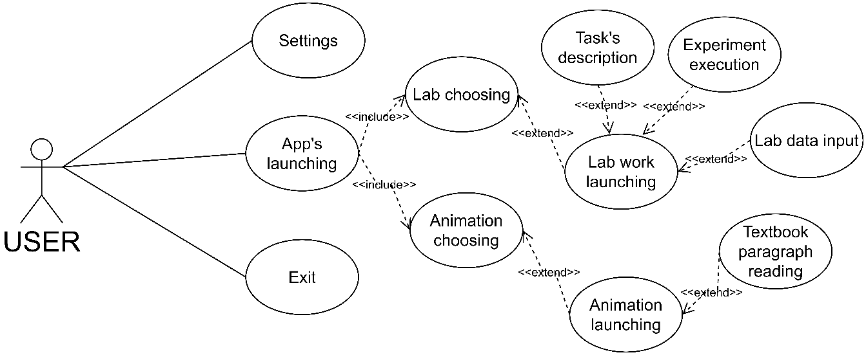

Figure 1 – Use case diagram

The diagram also shows the dependence of precedents on each other. For example, launching an application includes the ability to select animations or labs. And functions that facilitate the execution of work expand their functionality.

  - Software choice rationale
Computer modeling of physical processes was carried out using Autodesk Maya based on the Unity 3D game engine.
The reason for choosing these tools is their wide range of capabilities and ease of interaction. Autodesk Maya software allows you to recreate three-dimensional models of any complexity. Therefore, the equipment models are implemented as realistic as possible.
The choice of a game engine was one of the priority tasks since the project is completely assembled with the help of it. The choice of Unity 3D is based on its popularity and, as a result, a large community in a professional environment, as well as a large number of possible integrations in the form of additional libraries. In addition, the engine allows you to create applications for most of the possible platforms: Windows, Microsoft Hololens, Oculus, Linux, macOS, Android, iOS, etc. There is no need to create a separate product for each type of target device. It is enough to create a project, define the settings and select the target platform.
Unity's animation system allows you to recreate highly accurate physics processes. It supports blending, mixing, animation stacking, walk cycle timing, animation layers, control of all aspects of playback (timing, speed, blending weights), procedural animation, etc.
For animation in the project, the classes AnimationController, Animation were used, as well as their own scripts that allow you to control the process in the required form.
Animation creation consists of several steps. First, you need to create a sequence of states that will be executed and, as a result, will allow you to get animated movement. These states are determined by adding keyframes in a special Animation object that also has a timeline. After that, the AnimationController is configured. It allows you to work with multiple Animation objects if the movement is more complex.
After the creation of animations is completed, the process of writing logic for the object itself takes place, which is also controlled by the AnimationController class.
Agile software development is used as the project methodology. Her iterative approach to project implementation allows you to speed up the process, improve its quality, and correct emerging difficulties as they arise.
The library that implements AR in the application is EasyAR. The choice was made based on the provided capabilities and integration into the Unity engine. EasyAR allows you to set up an augmented reality scene in three steps, making it easy to work with the library. In addition, the module has a large set of various properties and functions in the form of tracking not only images but also planes, objects of various kinds.
To implement the process of translating user interface elements, the LeanLocalization plugin was chosen. It has a simple and flexible configuration, easy to integrate, and adapts to the needs of the project.
All program code is written in the C # programming language since the engine supports it. The language itself is also convenient for development, as it has many libraries that facilitate the implementation of physical processes in a virtual environment.

  - Virtual physics laboratory prototyping
After defining the necessary functions, choosing the tools, as well as selecting the content: the choice of laboratory work, the stage of project prototyping began. Taking into account the specifics of the project - the possibility of conducting physical experiments, it was decided that the screen of the device should be divided in such a way that it would be convenient for the user to work with the application. Therefore, a significant part of the screen is defined as a field for independent work.
In addition, a prototype of the main menu was developed, a menu inside the program scenes with a common interface. This meets one of the requirements for user interface development, namely consistency. It follows from it that fonts, colors, and other interface elements should not confuse the user, mislead, and should also be familiar to him. For this, the buttons and their names, fonts, and color scheme of control panels in the program were created using a common design and look uniformly. This will allow users to quickly learn how to interact with the application, which will also have a beneficial effect on their experience and help them better understand the material being presented.
Figure 2 shows the template for the main menu. It shows that the user sees four operational buttons: LABS, ANIMATIONS, SETTINGS, EXIT. The heading MENU allows you to inform the user about his current position in the program. The monosyllabic names of the buttons fully reflect their functions. The "LABS" button leads to laboratory work, the "SETTINGS" button will open the settings, the "ANIMATIONS" button shows animations of physical processes, and the "EXIT" button will close the application.
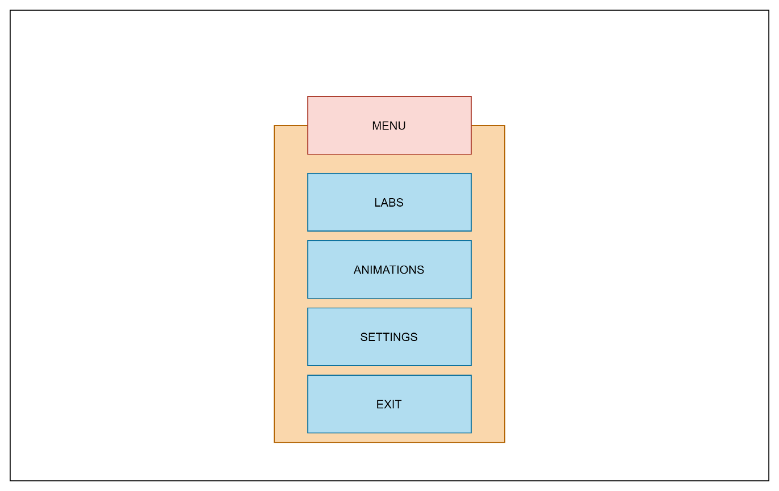
Figure 2 – The main menu prototype

Figure 3 shows the application scene template. Within the scene menu, there are three buttons, the names of which also correspond to their function. The “MENU” button will open the panel of the internal menu, the “TASK” button will open a panel describing the step-by-step execution of the task, the “TABLE” button will open a panel with a table for entering data received during operation. The "SETUP" panel refers to the laboratory setup that the user is supposed to work with.
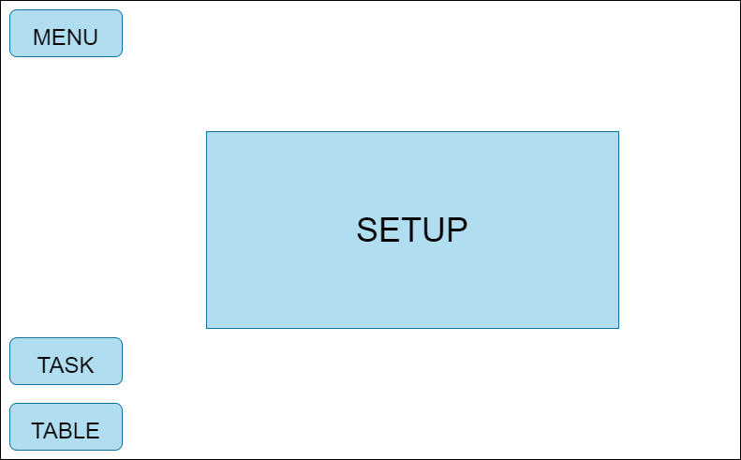
The scene prototype for displaying physical animations is almost identical, only instead of the "TASK" button, it has a "DESCRIPTION" button, which contains a description of the animation shown.

Рисунок 3 – A virtual lab scene prototype

As a result of the work, a prototype of the application was created, based on which the application itself is created directly. The prototype-development link helps speed up the application implementation process by having a clear understanding of the layout of the elements.
Designing such an application is impossible without 3D models because the entire educational process is based on them. For this purpose, according to the work performed, visual materials were selected that would allow the study of the necessary objects from different angles. For this, a search was conducted for video and photographic materials.

  - Physical processes animation
With the development of computer science, animation takes up more and more of the applications of information technology. The use of animations is quite wide since they can be found both in the field of entertainment and in the scientific field. Animation is also actively used in the process of teaching the exact sciences, such as physics.
Computer animation is a type of animation that implies a sequential display of images. The word "animate" in English and French means "to animate" [51]. Being a derivative of computer graphics, the animation is subdivided according to the method of creating images into the same types [52]:
- Vector graphics;
- Raster graphics;
- Fractal graphics;
- Three-dimensional graphics (3D).
The advantages of using computer animation in the field of education are obvious since animation has high information content, the ability to manipulate an object, present it from different angles, assess the real proportions of objects, and their location in space.
By the principle of animation, several types of computer animation can be distinguished:
- Frame-by-frame animation;
- Animation by keyframes;
- Motion recording;
- Procedural animation.
Frame-by-frame animation is considered to be the main method of creating "traditional" animation, in which each subsequent frame contains one, but slightly modified image. When all frames are played back, the image comes to life. This is the same technique used by freehand animators.
Keyframe animation is an animation technique in which the placement of keyframes is performed by the animator. Intermediate blocks are generated by a special program. This method is the closest to traditional hand-drawn animation, while the role of the phaser is taken over by a computer, not a person.
Motion recording. These animations are recorded by special equipment with real moving objects and transferred to their imitation in a computer. A common example of such a technique is Motion capture. Actors in special suits with sensors make movements that are recorded by cameras and analyzed by special software. The final data on the movement of the joints and limbs of the actors is applied to the three-dimensional skeletons of virtual characters, thereby achieving a high level of reliability of their movements. The same method is used to transfer the facial expressions of a live actor to his three-dimensional analog in a computer.
A common example of such a technique is Motion capture. Actors in special suits with sensors make movements that are recorded by cameras and analyzed by special software. The final data on the movement of the joints and limbs of the actors is applied to the three-dimensional skeletons of virtual characters, thereby achieving a high level of reliability of their movements. The same method is used to transfer the facial expressions of a live actor to his three-dimensional analog in a computer.
Procedural animation is fully or partially calculated by the computer. This can include the following types of it: simulation of the physical interaction of solids, imitation of the movement of systems of particles, liquids, and gases, imitation of the interaction of soft bodies (tissue, hair), calculation of the movement of the hierarchical structure of connections (character skeleton) under the external influence (Ragdoll). Based on the above analysis, Unity was chosen to create the animations for the project.
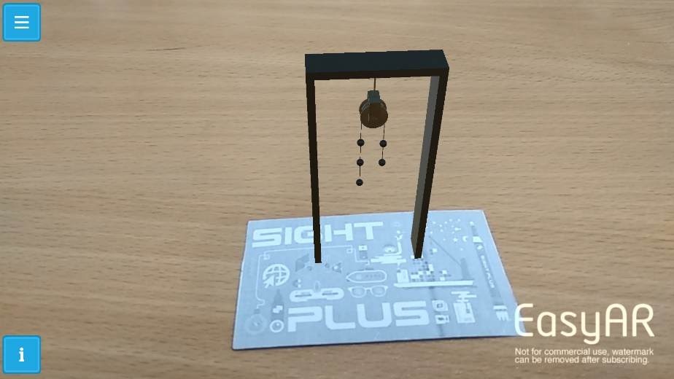
Figure 4 – A physical animation screenshot

Figure 4 shows an example with physical animation. When choosing an animation from the menu, such a scene opens. By hovering the device's camera at the corresponding marker, an animation appears. Also, the user has access to the "Information" button, which describes the animation process.
For the convenience of students, an electronic textbook was added to the mobile application. For this, a physics textbook for the 10th grade of the natural-mathematical direction of general education schools, authors B. Krongart, V. Kem, N. Koishybaev, was fully animated. Second edition, revised, enlarged, publishing house "Mektep", 2010. By rendering the physical illustrations accompanying the theoretical material, 3D animations were created based on the Adobe Animate software in the following areas of physics for secondary educational institutions: "Mechanics", "Molecular Physics" and "Electrodynamics". After that, the executed animations were combined into an electronic textbook in Figure 5, which provides access to the theoretical material, as well as to the animations from a specific paragraph. The tutorial has convenient navigation through the sections using a table of contents implemented through hypertext links, as well as navigation between pictures from text and animated views.
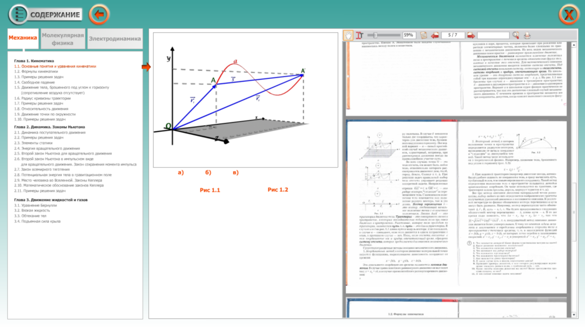
Figure 5 – the 10th-grade electronic textbook

This experience demonstrates the need to introduce digital tools into education. There is also a clear trend towards choosing mobile platforms as more promising due to market growth. There is an inclusion in mobile educational resources of educational text, animations, audio accompaniment, video materials, virtual laboratory work, and tasks for self-control. The presentation of the material is also important, the game approach is important, which facilitates the assimilation of information. Such mobile applications can be used as an independent resource or used as an additional means of didactic support of the educational process in the subject.
Laboratory work in electronic format allows you to study both the theoretical basis of the experiment being carried out and to study the device of various equipment. Therefore, it is very important to pay attention to the replica of 3D models. They must completely repeat the look of real devices so that the entire interaction process is close to real experience.

  - Development of a mobile application for studying physics by performing laboratory work using augmented reality
After all the preparatory work was completed, the transition was made directly to the implementation of the project. The work on the project consisted of several tasks:
- Creation of 3D models;
- Implementation of the user interface;
- Implementation of application localization;
- Implementation of laboratory work;
- Implementation of animations inside the application.
Figure 6 shows examples of a lamp model after simulation and during operation in the application.
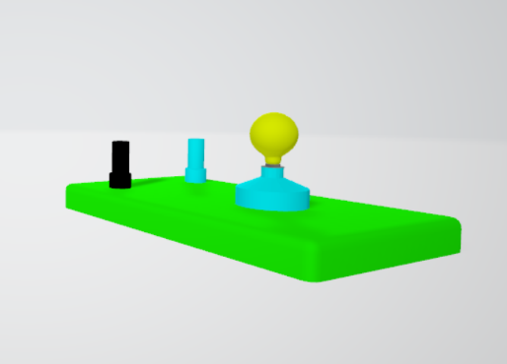 | 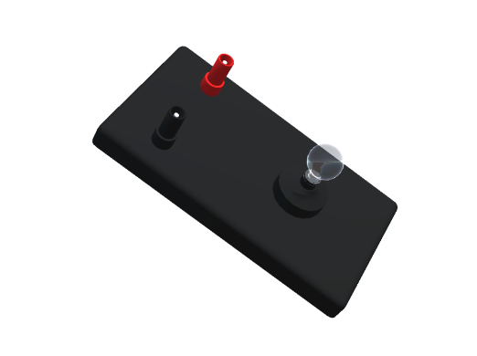
а) a model during the creation | б) the model within lab work
Figure 6 – A lab work’s device modeling

The process of creating models consists of two stages:
- Collection of visual information;
- Modeling.
Gathering information means searching for or creating photographs, video sources to have an idea of ​​how an object should look. In addition, object texturing is also important for the created model to match its real prototype.
The number of polygons in the model is also important since this directly affects its size and post-processing. In order not to waste an unnecessary number of resources on a mobile device, the models are low poly - one of the ways to optimize the rendering of virtual objects.
At the development stage of the menu, it was necessary to make sure that the interface elements did not interfere with the user during the execution of work. The menu prototype was used to create prefabs - the structural elements of Unity designed for reusability. They are game objects that can be redefined in different scenes. For example, when creating a scene, a menu was created with many nested items. To avoid repeating this process in each of the lab scenes, a prefab for this menu was created and then moved to each of them. Figure 7 shows the project folder with prefabs. This feature drastically reduces development time since repeating elements do not need to be created every time.

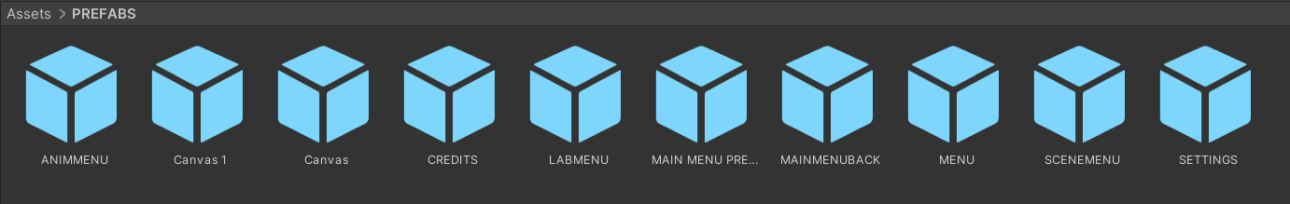
Figure 7 – Prefabs folder

For the application to support work in three different languages - Kazakh, Russian and English - localization was necessary. For this purpose, the LeanLocalization framework was used. With the help of simple settings, it allows you to change the language of the displayed text, as well as labels for interface elements. There is no need to create additional files. Figure 8 shows the settings menu, where the language switching process takes place.
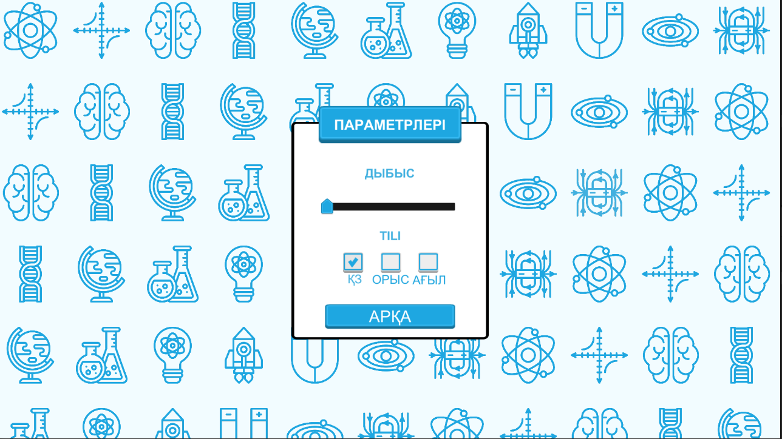
Figure 8 – Settings menu in the Kazakh language

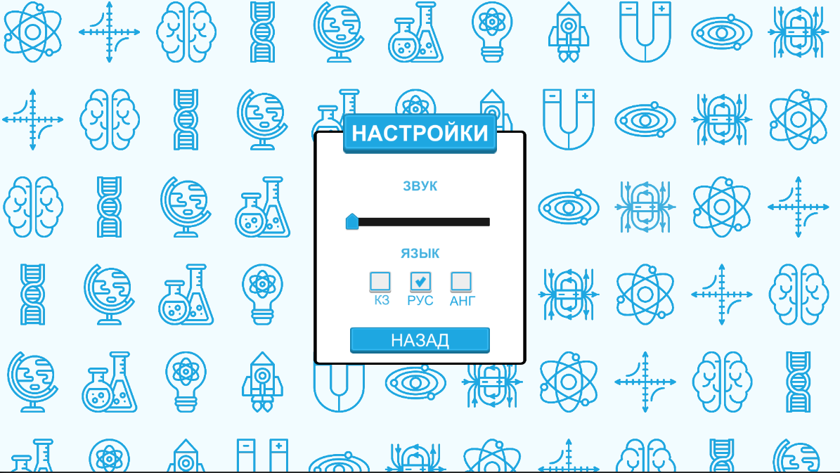
Figure 9 – Settings menu in the Russian language

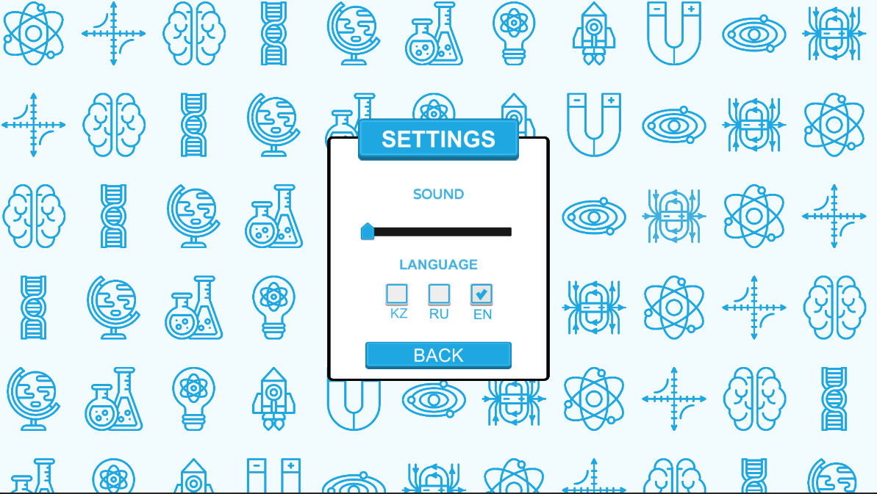
Figure 10 – Settings menu in the English language
Figure 10 shows the menu after switching the application to English. In total, four labs were selected for development, dedicated to the following topics:
1) Comparison of molar heat capacities of metals;
2) Comparison of the elastic force with the change in the kinetic energy of the body;
3) Measurement of the surface tension of water by the methods of separating drops and raising the liquid in the capillary;
4) Study of the mixed connection of conductors.
Each of the laboratory works has its own set of equipment. Therefore, corresponding models were created for each of them. Let's take a look at each of the lab scenes below.
Comparison of molar heat capacities of metals
In this laboratory work, the student needs to carry out a comparative analysis of the heat capacities of metals by alternately placing their samples in a calorimeter.
Of the equipment, a calorimeter, metal samples, scales, an electric stove, a beaker, and weighted scales are involved in laboratory work. The models of this equipment correspond to the real ones, which allows the user to get a real working experience. Also, thanks to a simulation close to the real one, the student learns the concept of heat capacity, heat exchange.
To work in this scene, the user must click on the "Task" button, then he will see a panel with an algorithm for performing the work. Figure 11 shows a screenshot of the developed scene.
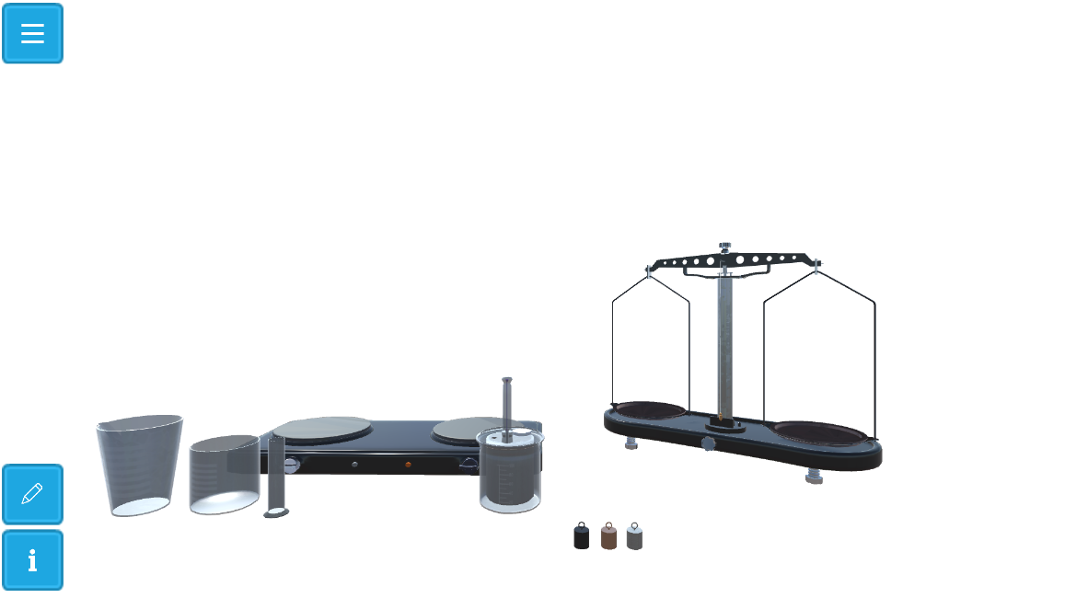
Кнопка «Таблица»
Кнопка «Задание»
Кнопка «Меню»

Figure 11 – Scene from the application for the laboratory work "Comparison of the molar heat capacities of metals"

By clicking on the tools, the user can transfer them to the scene, perform the actions necessary to complete the tasks. To enter data with the parameters of metal bodies, the user must click on the "Table" button.
Comparison of the elastic force with the change in the kinetic energy of the body
This laboratory work is devoted to the study of the kinetic energy of the body. To complete the work, the user must familiarize himself with the equipment, which consists of the following objects: two stands, dynamometer, ball, threads, measuring tape, weights, and scales.
By attaching a dynamometer to one end of the thread that connects to the ball, it is necessary to arrange the tripods to tension a certain amount of force. After the ball is lowered, it is necessary to measure the place where the ball falls.
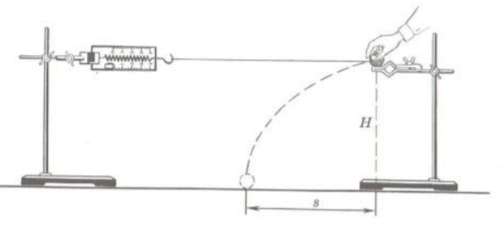
Figure 12 – Illustration for the laboratory work "Comparison of the elastic force with the change in the kinetic energy of the body"

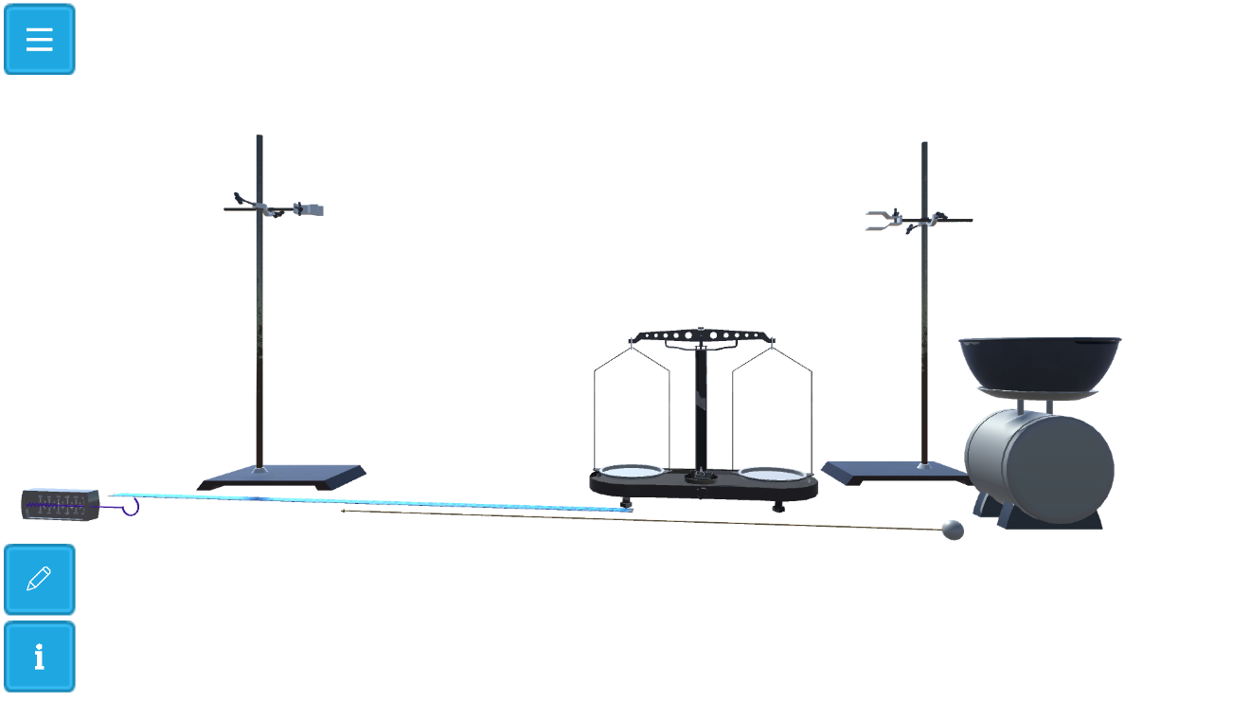
Figure 13 – Scene from the application for the laboratory work "Comparison of the elastic force with the change in the kinetic energy of the body"

The models used in the lab are also consistent with those presented as requested. The simulation provides the user with the experience of doing the job. Since Unity has a high-precision physics engine, simulating the tension effect in a scene is close to a real experiment. This was realized thanks to one of the types of connections: Spring Joint, which in turn simulates the behavior of spring installations. To track the falling of the body, the properties of the game objects Rigidbody and different types of Colliders are used. Rigidbody allows you to simulate the behavior of solid objects, changing their mass, acceleration, friction force, etc. Collider allows you to track collisions of objects, to perform certain actions when they occur.
To see how similar, the laboratory work is with the tasks, you can look at Figures 12 and 13. It can be seen from them that the settings inside the scenes completely repeat the required configuration of the equipment.
Measurement of the surface tension of water by the methods of separating drops and raising the liquid in the capillary
The main task of this work is to estimate surface tension and study this concept in general. To do this, you need to do several actions, one of the main ones is counting the drops falling into the glass. In addition, you need a vernier caliper, a conical flask, a rubber tube, a tripod, a funnel, a scale, a needle, and weights. The complete algorithm of actions is also available to the user by clicking on the "Assignment" button, and measurements taken in the course of work can be entered into the table by clicking the "Table" button.
To simulate water droplets in the work, the effect of the Unity engine – “Particles” was used.
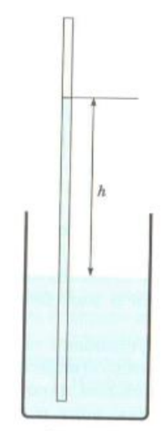
Figure 14 – Illustration for the laboratory work "Measurement of the surface tension of water by the methods of tearing off drops and raising the liquid in the capillary"

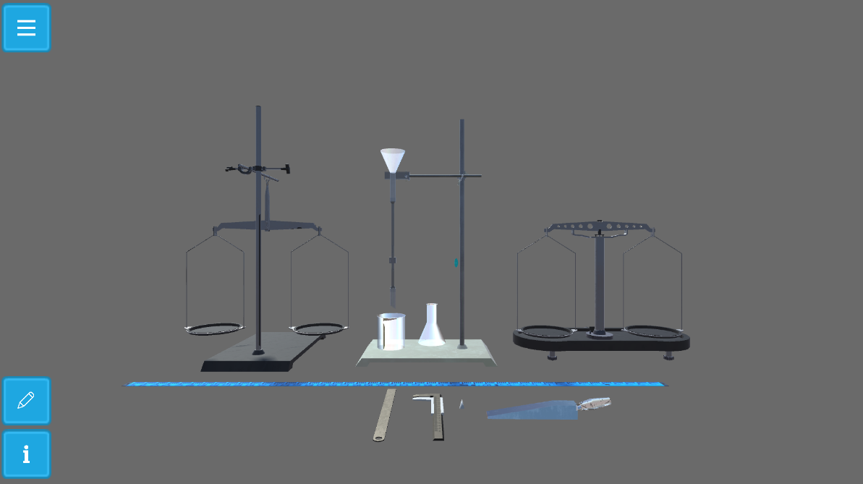
Figure 15 – Installation in the application for the laboratory work "Measurement of the surface tension of water by the methods of tearing off drops and raising the liquid in the capillary"

By clicking on the equipment, the user can transfer it to the scene, perform the necessary actions to complete the tasks. For example, turn on and off the water supply, measure the glass.
Study of the mixed connection of conductorsравнение
The purpose of this work is to enable the student to understand how the current distribution occurs when mixed conductors are connected. So the equipment for this work includes lamps, a voltmeter, a rheostat. By assembling the circuits following the tasks, the user can change the position of the rheostat slider, observing the process of changing the brightness of the glow of the lamps, as well as changing the parameters on the voltmeter screens.
As in previous works, there are buttons "Assignment" with a description of the assignments and "Table" for entering the values of the measured parameters.
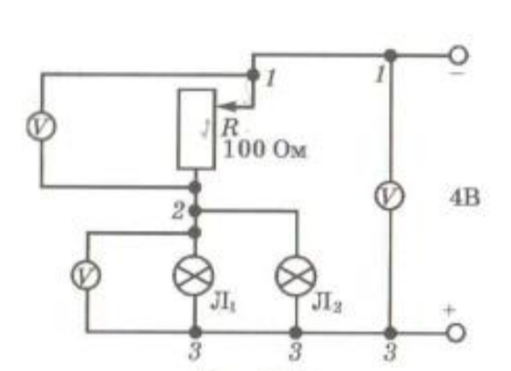
Figure 16 – Installation in the application for the laboratory work "Measurement of the surface tension of water by the methods of tearing off drops and raising the liquid in the capillary"
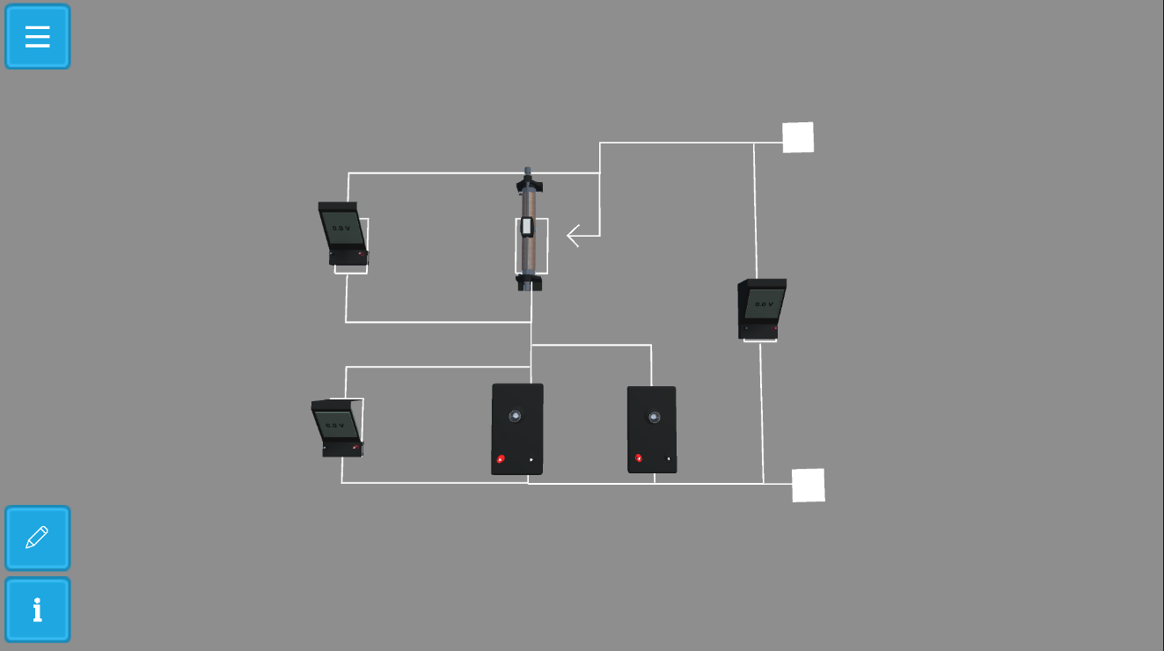
Figure 17 – Screenshot from the laboratory work "Investigating a mixed connection of conductors"
By clicking on the equipment, the user can change its position in the scene space, perform the activities necessary for work.
Figure 18 provides a component diagram. From it, you can understand in what dependencies the elements of the project are located. The entry point shortcut “Launch Menu” is marked in red. The green labels are the components that make up the application, that is, the four labs and animations. Each of these modules has access to auxiliary components, presented in the form of 3D models, program code, as well as additional resources of various kinds. These include a library that implements the functionality of augmented reality, program localization, text data for output, as well as markers - images onto which equipment from laboratory work and animation is projected.
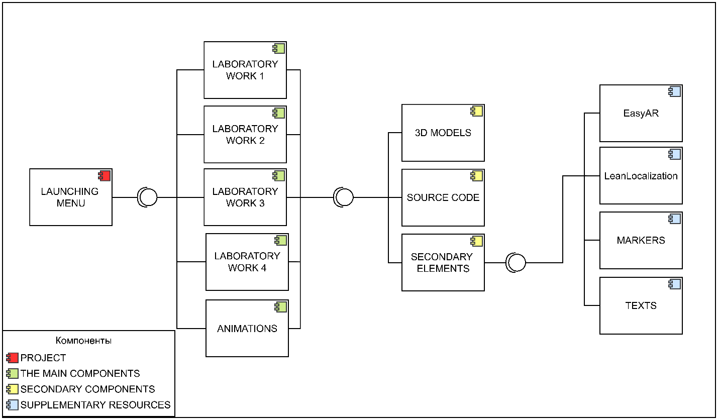
Figure 18 – Component diagram

To describe the processes occurring within the project, Figure 19 shows an activity diagram. The entry point or start point is the launch of the application. Then you need to select any of the options of interest: laboratory work, animations, settings, information about the application, or close the application. When choosing options for labs and animations, you need to select one of the proposed labs and animations, after which the corresponding scenes are launched. Inside the laboratory work, it is possible to carry out an experiment, see the order of the task, and also enter the data obtained into a special table.
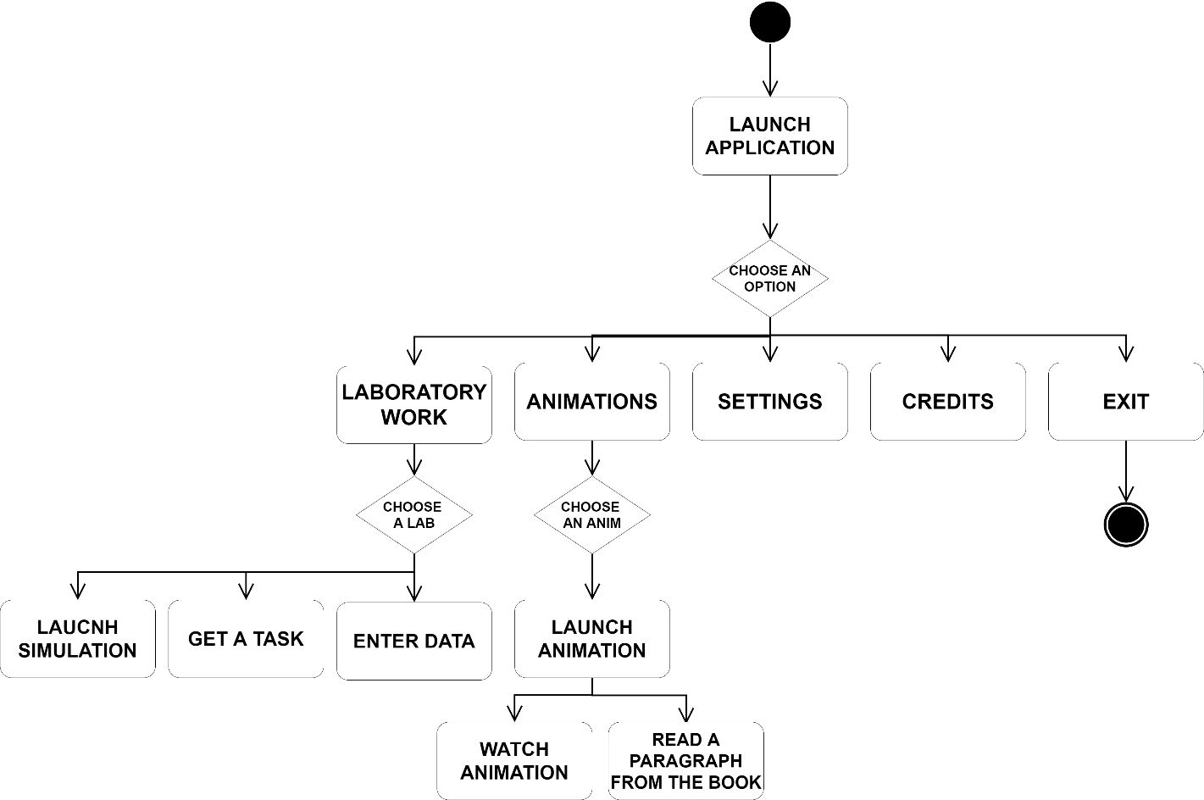
Figure 19 – Project’s activity diagram

The software cannot be implemented without code. All the functionality of the application works thanks to a set of classes and properties - functions that control the processes within the project. To illustrate this relationship, a class diagram is shown in Figure 20 for an example. It describes how the elements within the game scene relate to each other and how all the work happens.
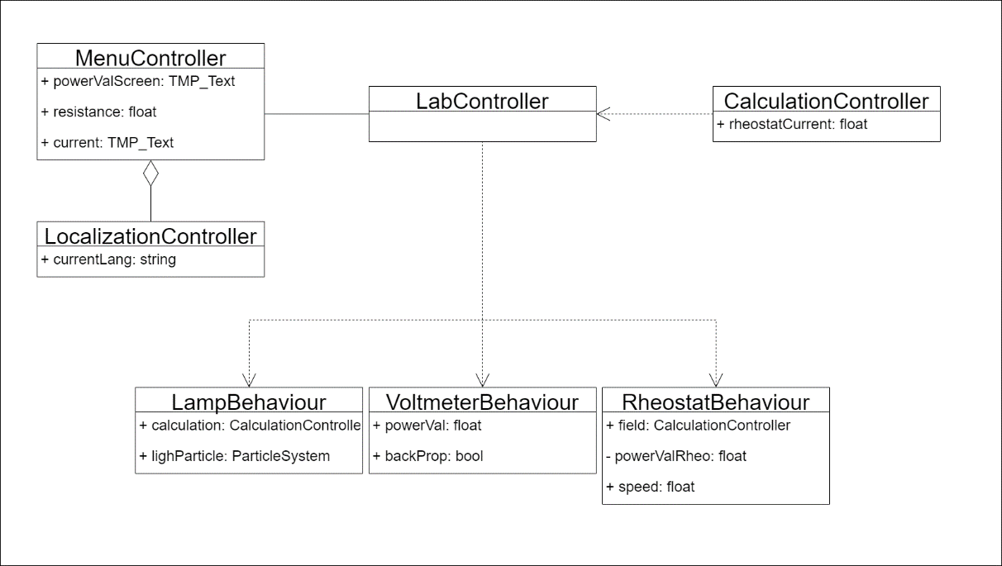
Figure 20 – Class diagram using the example of the laboratory work "Studying a mixed connection of conductors"

From the diagram, you can note the LabController class, which is the control point for the rest of the components. In addition, some classes determine the behavior of laboratory equipment objects: LampBehaviour, VoltmeterBehaviour, RheostatBehaviour. From their names, it can be understood that they control the behavior of lamps, voltmeters, and rheostat. The calculations that are performed when the hardware parameters are changed are done in the CalculationController. MenuContoller controls the output of information on the execution of tasks, generation of tables for data entry, as well as switching between scenes. LocalizationController is responsible for switching the interface language.
The result of the work on the project was a mobile application using augmented reality technology for studying physics. Figure 21 shows the main menu of the application, which corresponds to the designed template. From there, the user can proceed to the choice of laboratory work or animations.

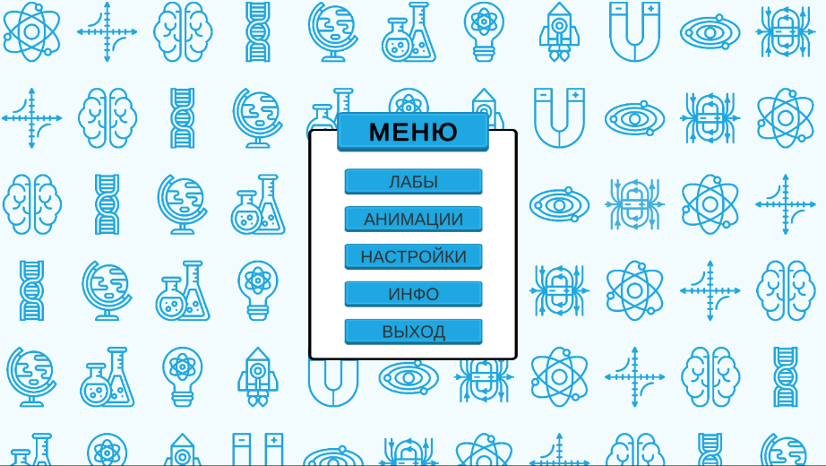
Figure 21 – The main menu screenshot

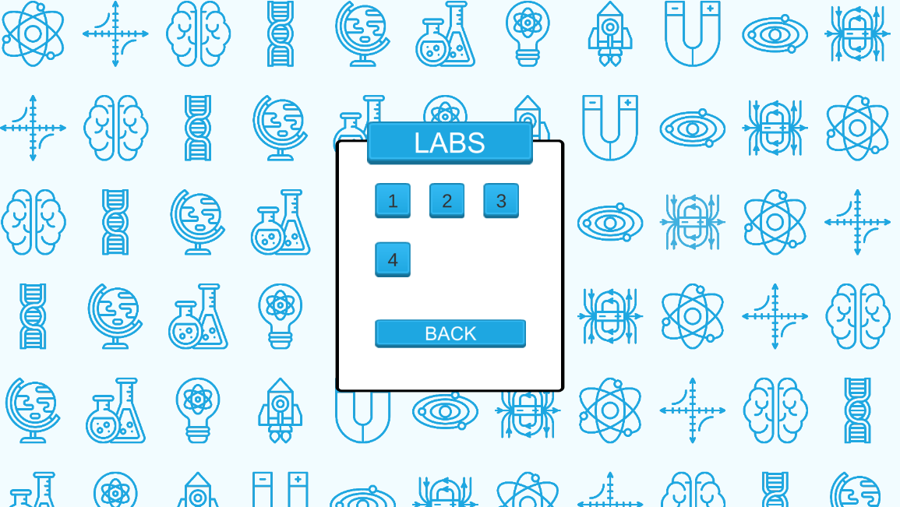
Figure 22 – Laboratory works launching menu

Figure 23 shows a screenshot of the work “Study Mixed Conductor Connection”, and Figure 24 shows the ability to study tasks to complete the work.

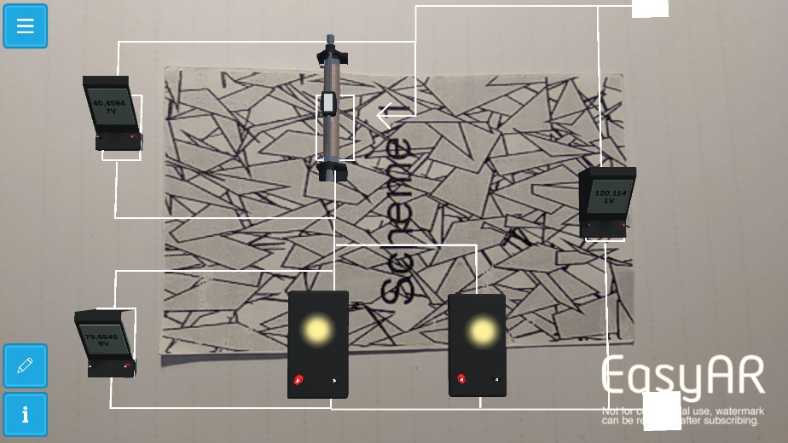
Figure 23 – Laboratory work execution screenshot
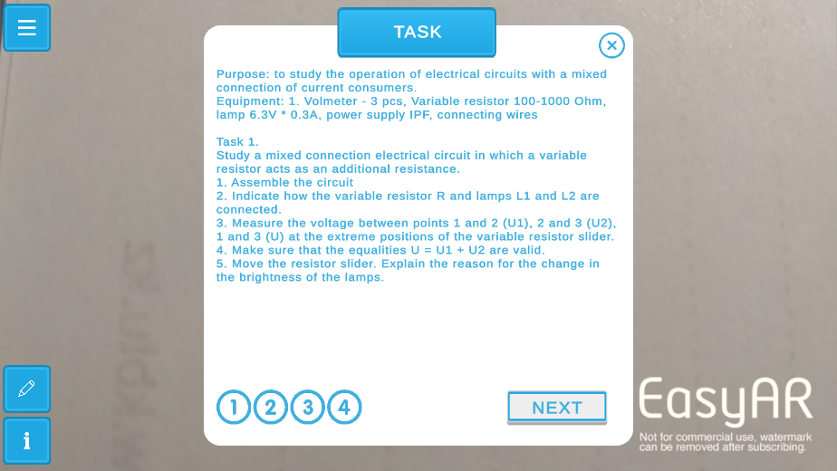
Figure 24 – Task description within laboratory work

  - Writing guidelines and documentation for the developed mobile application
Software documentation documents, in our case, a document that contains data about an application.
To this end, the development of the project was accompanied by documentation for convenient future support. It describes the classes, their properties, and their parameters. In the future, this will contribute to finalizing the project, adding new functions, connecting new libraries, and more. Writing programming documentation is good practice and avoids the hassle of updating a project.
Methodological guidelines are a set of rules that describe the process of correct interaction with a project. In this case, guidelines were developed to understand the use of the application by users. They describe the algorithm for working with the program, which will simplify the interaction of users with unfamiliar elements. These instructions will be especially useful for inexperienced users who experience difficulties in working with the software. In addition, the order of execution of each laboratory work is given, as well as the structural elements and their functions are explained.

  - Implementation of the developed virtual laboratory into the educational process
To evaluate the operation of the application and improve it, fix faults, it was decided to analyze the project. For this purpose, a questionnaire was created to assess the various aspects of the program.
Since the application is mobile, access to it must be provided by placing it on Android and iOS platforms. To do this, it is necessary to assemble a project for its future deployment on the appropriate marketplaces. For devices running on Android, it is enough to collect a .apk file, create a digital signature, which will help encrypt the version and upload it all through DevConsole.
Then, after unloading the program itself, you need to design the version, providing it with text and visual information in the form of banners, etc. After that, you have access to sending the application for verification, as a result of which the application will either be posted on the platform or it will be proposed to make certain changes.
In the case of iOS devices, to deploy the application to the device, you need to build the package with the application, then build it in the Xcode program. A version of the application will be created there, which must also be unloaded through the developer's console. The further process is similar to the algorithm for uploading a project to Google Play, but Apple's policy is stricter and takes a longer time.
As a result of uploading the application to marketplaces, it will be possible to distribute the application to a larger number of people, to receive feedback from them, which will eliminate errors and vulnerabilities of the project.

CONCLUSION

As a result of the work done, according to this project, an analysis was carried out in the field of distance education, new methods of teaching the exact sciences, the use of augmented reality in teaching. The experience of developing educational mobile applications was also studied, the purpose of which was a new form of material presentation.
As a result of completing each of the tasks, a software product was implemented, consisting of four laboratory works, physical animations, and an electronic textbook operating in augmented reality mode.
To create an application, the market for similar programs and solutions was studied, a set of development requirements was created, a prototype of the application was developed to facilitate its execution, equipment models were created that correspond to real tools, libraries were introduced that ensure the operation of augmented reality, a menu localization module was connected, logic was written for execution laboratory work, as well as developed guidelines and project documentation.
The result of the project was:
1) Development of general requirements for a mobile application designed to perform laboratory work in physics.
2) Creation of a prototype of a virtual physics laboratory.
3) Development of a mobile application for studying physics by performing laboratory work using augmented reality technology.
4) Development of an electronic textbook on physics for the 10th grade of the natural and mathematical direction of secondary schools, authors B. Krongart, V. Kem, N. Koishybaev. The second edition, revised, enlarged, publishing house "Mektep", 2010 with 3D animations using augmented reality technology.
5) Writing guidelines for the implementation of virtual laboratory work for the study of physics and documentation for the developed mobile application.
The planned amount of research and development work under the schedule has been completed in full.

REFERENCES

- Gartner Says Global Smartphone Sales Continued to Decline in Second Quarter of 2019. - URL: https://www.gartner.com/en/newsroom/press-releases/2019-08-27-gartner-says-global-smartphone-sales-continued-to-dec (accessed 11.08.2021).
- West M., Vosloo S. Policy guidelines for mobile learning. – UNESCO Publishing, 2015. -43 p.
- Studies Confirm the Power of Visuals to Engage Your Audience in eLearning. - URL: https://www.shiftelearning.com/blog/bid/350326/studies-confirm-the-power-of-visuals-in-elearning (accessed 11.08.2021).
- Van Krevelen D. W. F., Poelman R. A survey of augmented reality technologies, applications and limitations //International journal of virtual reality. – 2010. – Vol. 9. – No. 2. – P. 1-20.
- Jara C. A. et al. Hands-on experiences of undergraduate students in Automatics and Robotics using a virtual and remote laboratory //Computers & Education. – 2011. – Vol. 57. – No 4. – P. 2451-2461.
- Liu T. Y., Chu Y. L. Using ubiquitous games in an English listening and speaking course: Impact on learning outcomes and motivation //Computers & Education. – 2010. – Vol. 55. – No. 2. – P. 630-643.
- Di Serio Á., Ibáñez M. B., Kloos C. D. Impact of an augmented reality system on students' motivation for a visual art course //Computers & Education. – 2013. – Vol. 68. – P. 586-596.
- Chang H. Y., Wu H. K., Hsu Y. S. Integrating a mobile augmented reality activity to contextualize student learning of a socioscientific issue //British Journal of Educational Technology. – 2013. – Vol. 44. – No 3. – P. E95-E99.
- Bujak K. R. et al. A psychological perspective on augmented reality in the mathematics classroom //Computers & Education. – 2013. – Vol. 68. – P. 536-544.
- Billinghurst M., Duenser A. Augmented reality in the classroom //Computer. – 2012. – Vol. 45. – No. 7. – P. 56-63.
- Van Krevelen D. W. F., Poelman R. A survey of augmented reality technologies, applications and limitations //International journal of virtual reality. – 2010. – Vol. 9. – No. 2. – P. 1-20.
- Потапова М. В. Методика проведения лабораторных и творческих работ с применением мобильных гаджетов //Концепт. – 2021. – №. 7. – С. 13-30.
- West M., Vosloo S. Policy guidelines for mobile learning. – UNESCO Publishing, 2015. -43 p.
- Nokia life project. - URL - https://www.gsma.com/mobilefordevelopment/wp-content/uploads/2016/02/Case_Study_-Nokia_Life.pdf (accessed 11.08.2021).
- BridgeIT. - URL https://educationinnovations.org/ (accessed 19.08.2021).
- Bourekkache S., Kazar O. Mobile and adaptive learning application for English language learning //International Journal of Information and Communication Technology Education (IJICTE). – 2020. – Vol. 16. – No. 2. – P. 36-46.
- Lötter M. J., Jacobs L. Using smartphones as a social constructivist pedagogical tool for inquiry-supported problem-solving: An exploratory study //Journal of Teaching in Travel & Tourism. – 2020. – Vol. 20. – No. 4. – P. 347-363.
- Kamrozzaman N. A., Badusah J., Ruzanna W. M. Development of heutagogy approach in M-learning for sustainability education //Education and Information Technologies. – 2020. – Vol. 25. – P. 3035-3047.
- Burianova, M., Turcani, M. Non-traditional Education Using Smart Devices // 11th International Scientific Conference on Distance Learning in Applied Informatic (DiVAi). – MAY 02-04, 2016. – Sturovo, SLOVAKIA, P. 77-86
- García-Martínez I. et al. Using mobile devices for improving learning outcomes and teachers’ professionalization //Sustainability. – 2019. – Vol. 11. – No. 24. – P. 6917.
- Baldwin S. J., Ching Y. H. Guidelines for designing online courses for mobile devices //TechTrends. – 2020. – Vol. 64. – No. 3. – P. 413-422.
- Gupta S. et al. Radiology, mobile devices, and internet of things (IoT) //Journal of digital imaging. – 2020. – Vol. 33. – No. 3. – P. 735-746.
- Sakibayev S., Sakibayev R., Sakibayeva B. The educational impact of using mobile technology in a database course in college // INTERACTIVE TECHNOLOGY AND SMART EDUCATION. – 2019. – Vol. 16. – No. 4. – P. 363-380.
- Rochmah I. N. et al. Students’s acceptance toward the use of mobile learning in fractions //Journal of Physics: Conference Series. – IOP Publishing, 2021. – Vol. 1810. – No. 1. – P. 12-37
- Tavares R., Vieira R., Pedro L. A preliminary proposal of a conceptual educational data mining framework for science education: Scientific competences development and self-regulated learning //2017 International Symposium on Computers in Education (SIIE). – IEEE, 2017. – P. 1-6.
- Hamzah M. L. et al. Development of Augmented Reality Application for Learning Computer Network Device //International Journal of Interactive Mobile Technologies. – 2021. – Vol. 15. – No. 12. – P. 47-64.
- Steuer J. Defining virtual reality: Dimensions determining telepresence //Journal of communication. – 1992. – Vol. 42. – No. 4. – P. 73-93.
- If You’re Not Seeing Data, You’re Not Seeing. - URL: https://www.wired.com/2009/08/augmented-reality/ (accessed 13.09.2021).
- Rosenberg L. B. The Use of Virtual Fixtures as Perceptual Overlays to Enhance Operator Performance in Remote Environments. –Stanford Univ Ca Center for Design Research, 1992. -52 p.
- Brooks Jr F. P. The computer scientist as toolsmith II //Communications of the ACM. – 1996. – Vol. 39. – No. 3. – P. 61-68.
- Shatte A., Holdsworth J., Lee I. Mobile augmented reality based context-aware library management system //Expert systems with applications. – 2014. – Vol. 41. – No. 5. – P. 2174-2185.
- Land S. M., Zimmerman H. T. Synthesizing perspectives on augmented reality and mobile learning //TechTrends. – 2014. – Vol. 58. – No. 1. – P. 2-5.
- Chang H. Y., Wu H. K., Hsu Y. S. Integrating a mobile augmented reality activity to contextualize student learning of a socioscientific issue //British Journal of Educational Technology. – 2013. – Vol. 44. – No. 3. – P. E95-E99.
- Alem L., Huang W. (ed.). Recent trends of mobile collaborative augmented reality systems. – Springer Science & Business Media, 2011. - 175 p.
- Augmented Reality Landscape. - URL: https://en.bywiki.com/wiki/Augmented_reality (accessed 11.08.2021).
- Wu H. K. et al. Current status, opportunities and challenges of augmented reality in education //Computers & education. – 2013. – Vol. 62. – P. 41-49.
- Azuma R. T. A survey of augmented reality //Presence: teleoperators & virtual environments. – 1997. – Vol. 6. – No. 4. – P. 355-385.
- Alakärppä I. et al. Using nature elements in mobile AR for education with children //Proceedings of the 19th International Conference on human-computer interaction with mobile devices and Services. – 2017. – P. 1-13.
- Adams Becker S., Freeman A. Giesinger Hall, C., Cummins, M., & Yuhnke, B. CoSN horizon report: 2016 K. – The New Media Consortium, 2016. –58 p.
- Pellas N. et al. Augmenting the learning experience in primary and secondary school education: A systematic review of recent trends in augmented reality game-based learning //Virtual Reality. – 2019. – Vol. 23. – No. 4. – P. 329-346.
- Tobar-Muñoz H., Baldiris S., Fabregat R. Augmented reality game-based learning: Enriching students’ experience during reading comprehension activities //Journal of Educational Computing Research. – 2017. – Vol. 55. – No. 7. – P. 901-936.
- Lytridis C., Tsinakos A., Kazanidis I. ARTutor—an augmented reality platform for interactive distance learning //Education Sciences. – 2018. – Vol. 8. – No. 1. – P. 6.
- Bujak K. R. et al. A psychological perspective on augmented reality in the mathematics classroom //Computers & Education. – 2013. – Vol. 68. – P. 536-544.
- Liu T. Y., Chu Y. L. Using ubiquitous games in an English listening and speaking course: Impact on learning outcomes and motivation //Computers & Education. – 2010. – Vol. 55. – No. 2. – P. 630-643.
- Chang K. E. et al. Development and behavioral pattern analysis of a mobile guide system with augmented reality for painting appreciation instruction in an art museum //Computers & education. – 2014. – Vol. 71. – P. 185-197.
- Chen C. H., Chou Y. Y., Huang C. Y. An augmented-reality-based concept map to support mobile learning for science //The Asia-Pacific Education Researcher. – 2016. – Vol. 25. – No. 4. – P. 567-578.
- Cascales-Martínez A. et al. Using an augmented reality enhanced tabletop system to promote learning of mathematics: A case study with students with special educational needs //Eurasia Journal of Mathematics, Science and Technology Education. – 2016. – Vol. 13. – No. 2. – P. 355-380.
- Lee H. S., Lee J. W. Mathematical education game based on augmented reality //International Conference on Technologies for E-Learning and Digital Entertainment. – Springer, Berlin, Heidelberg, 2008. – P. 442-450.
- Radu I., McCarthy B., Kao Y. Discovering educational augmented reality math applications by prototyping with elementary-school teachers //2016 IEEE Virtual Reality (VR). – IEEE, 2016. – P. 271-272.
- Pellas N. et al. Augmenting the learning experience in primary and secondary school education: A systematic review of recent trends in augmented reality game-based learning //Virtual Reality. – 2019. – Vol. 23. – No. 4. – P. 329-346.
- Март. Технологии и маркетинг для музеев. Компьютерная анимация. - URL: http://mart-museum.ru/personnel/kompyuternaya-animatsiya/ (accessed 18.09.2019).
- Компьютерная анимация. - URL: http://bourabai.kz/mmt/animation.htm (accessed 20.09.2021).

Appendix A.
List of publications of the project members for 2021

- Y.A. Daineko, D.D. Tsoy, A.M. Seitnur, M.T. Ipalakova, Zh.B. Kalpeeva. Development of a mobile application for studying physics using augmented reality technology. Bulletin of EKSTU. (Accepted for publication)
- Ye. Daineko, A. Seitnur, D. Tsoy, M. Ipalakova, R. Sharshova, “Development of a mobile textbook using augmented Reality technology for studying physics”, International Conference of Education, Research and Innovation, November 2021 (Accepted for publication)
- A. Niyazgulova, N. Ibragimov, G. Zakirova, Y. Daineko, D. Tsoy, A. Seitnur, “Implementation of bologna process tools in the technology of education in secondary vocational School”, International Conference of Education, Research and Innovation, November 2021 (Accepted for publication)
- Yevgeniya Daineko, Aigerim Seitnur, Dana Tsoy, Dmitry Gubsky, Madina Ipalakova. Development of a training system in physics using virtual reality technology. Journal of Theoretical and Applied Information Technology (Under the review)
- Y.A. Daineko, D.D. Tsoy, A.M. Seitnur, M.T. Ipalakova. Development of a mobile e-learning platform on physics using augmented reality technology. International Journal of Interactive Mobile Technologies (Under the review)

AUTHOR'S CERTIFICATES
- Certificate of entering information into the state register of rights to objects protected by copyright, No. 21094 dated October 22, 2021, "Development of a multilingual mobile application (Kazakh, Russian, English) for distance learning of physics in higher and secondary educational institutions using technology augmented reality ". Ipalakova M.T., Daineko E.A., Tsoy D.D., Seitnur A.M.

Appendix B.
Calendar plan for 2021

- “INTERNATIONAL INFORMATION TECHNOLOGY UNIVERSITY” JOINT STOCK COMPANY
  - Priority: 4. Information, communication and space technologies.
1.2. Sub-priority: 4.1 Artificial intelligence and information technology. 4.1.8 Smart technologies in scientific and electronic educational processes.
1.3. Theme of the project: ИРН AP09563181 “Development of a mobile application for distance learning physics using augmented reality technology”
1.4. The total amount of the project for 2021 is 8000 000 (eight million) tenge for the performance of work in accordance with paragraph 3

- CHARACTERISTICS OF SCIENTIFIC AND TECHNICAL PRODUCTS BY QUALIFICATION CHARACTERISTICS AND ECONOMIC INDICATORS

  - Direction of work: Smart technologies in scientific and electronic educational processes
  - Application area: Education
  - Final result for 2021: The developed mobile application for a multilingual educational platform (Kazakh, Russian, English) for distance learning of physics in higher and secondary educational institutions using augmented reality technology.
Based on the research results, at least 1 article will be published, accepted for publication or submitted to a peer-reviewed scientific publication, included into Science Citation Index or Social Science Citation Index in the Web of Science database, and (or) having CiteScore percentile in Scopus database at least 35 (thirty-five)
  - Patentability: No.
  - Scientific and technical level (novelty): Development of a methodology and creation of an application for studying physics using mobile augmented reality technology. Also, the functioning of all measuring equipment, as well as the studied physical phenomena and devices, will be described using computer models and the corresponding mathematical apparatus.
  - The use of scientific and technical products is carried out by the customer and the contractor:
  - Type of use of the result of scientific and (or) scientific and technical activities: Copyright certificates, publications

NAME OF WORK, TERMS OF THEIR IMPLEMENTATION AND RESULTS

№ | Name of the tasks under the contract, the main stages of execution* | Duration* |  | Expected result
№ |  | The start | The end | Expected result
2021 year
1 | Development of general requirements for the mobile application designed to perform laboratory work in physics. | May 2021 | May 2021 | General requirements for a mobile application designed for laboratory work in physics will be developed.
2 | Creation of a prototype of a virtual physics laboratory. | June 2021 | July 2021 | A prototype of a virtual physics laboratory will be developed.
3 | Development of the mobile application for studying physics by performing laboratory work using augmented reality technology. | August 2021 | October 2021 | A mobile application will be developed to study physics by performing laboratory work using augmented reality technology.
4 | Guidelines writing for the implementation of virtual laboratory work on the study of physics and documentation for the developed mobile application. | November 2021 | November 2021 | Methodical instructions for the use of the developed laboratory work and documentation for the developed mobile application.  Based on the research results, at least 1 article will be published, accepted for publication or submitted to a peer-reviewed scientific publication, included into Science Citation Index or Social Science Citation Index in the Web of Science database, and (or) having CiteScore percentile in Scopus database at least 35 (thirty-five)

