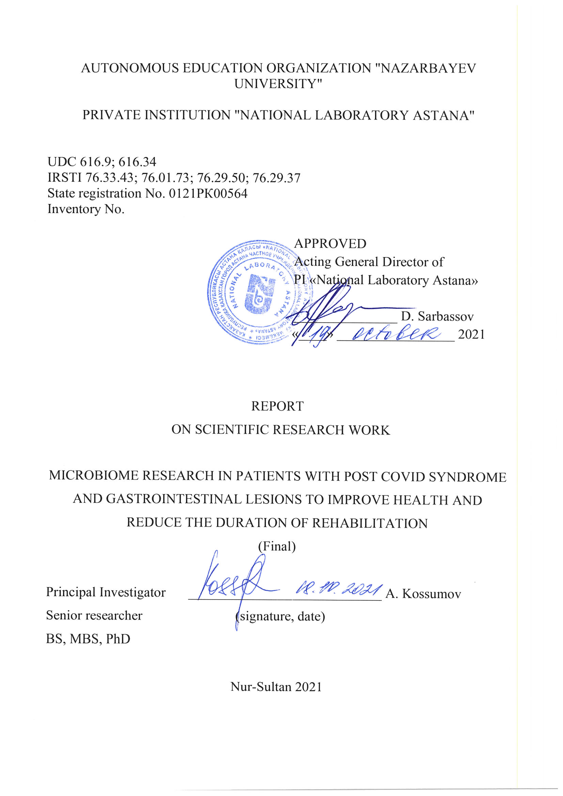

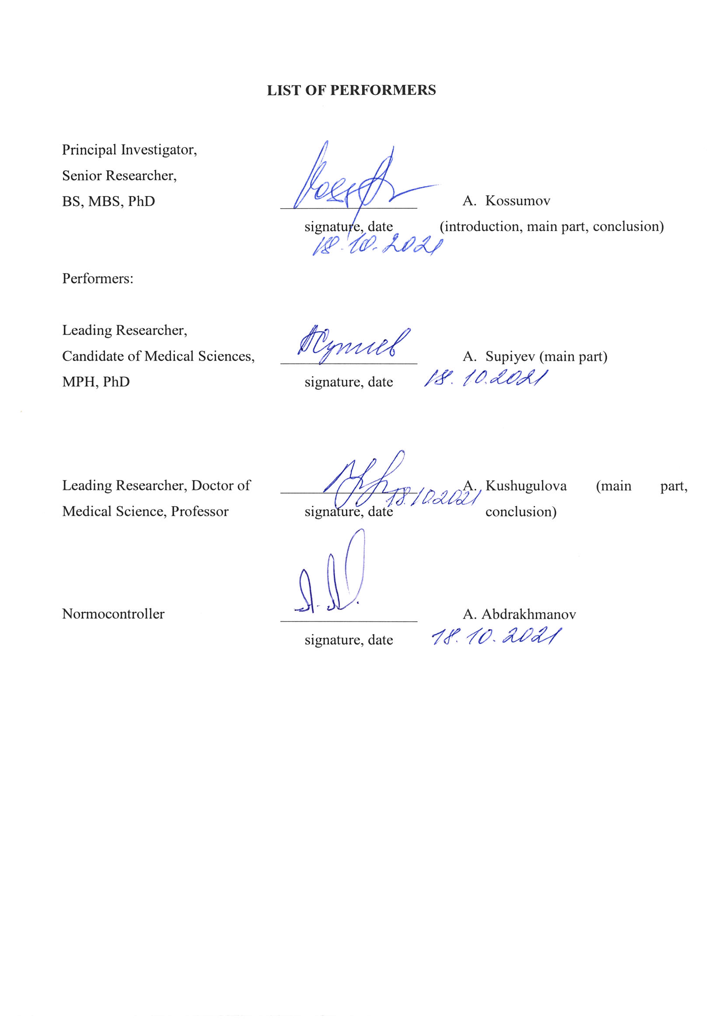 ABSTRACT
Report 80 pages, 11 figures, 2 tables, 50 references, 6 app., 1 book.
CORONAVIRUS INFECTION, GASTROINTESTINAL TRACT, MICROBIOME, DIARRHEA, VOMITING, DIGESTIVE SYSTEM, DIGESTIVE DISORDERS
The goal of the project is a comprehensive study of various indicators of the gastrointestinal tract microbiome and predictors of assessing the health status of patients after a coronavirus infection to improve rehabilitation.
Research methods: epidemiological, genetic, molecular biological and statistical methods of analysis.
As a result of the work planned for the project, the following results were obtained:
- A retrospective epidemiological analysis of cases of coronavirus infection was carried out, and an assessment was made of the prevalence of symptoms associated with disorders of the digestive system;
- Studied the main genetic characteristics of the intestinal microbiome in coronavirus infection and systemic damage to the patient's body after suffering COVID-19 (postcoid syndrome, manifested by complications of the respiratory, cardiovascular, digestive and excretory systems of organs during SARS-CoV-2 viral infection);
- Proposals are given for improving clinical protocols for managing patients and revising the terms of rehabilitation of patients with previous COVID-19 based on the results obtained during the study of the intestinal microbiome.
As part of the publication of research materials in scientific peer-reviewed journals, an article was submitted (to a peer-reviewed foreign scientific journal, (Q1 / 84 percentile) indexed in the Web of Science and Scopus databases with a nonzero impact factor, and 3 theses were published at the International Conference).
Applications: Epidemiology, Public Health, Microbiology, Infectious Diseases, Clinical Medicine.
Thus, the main points of the assignments in accordance with the tasks of the technical specification under the agreement with the Science Committee of the Ministry of Education and Science of the Republic of Kazakhstan were completed in full.
CONTENT
TERMS AND DEFINITIONS……..................................................................................................... | 5
LIST OF ABBREVIATIONS AND SYMBOLS……......................................................................... | 6
INTRODUCTION............................................................................................................................... | 7
MAIN PART OF THE R&D REPORT…........................................................................................... | 12
1 Conduct a retrospective, epidemiological analysis of cases of coronavirus infection, and assess the prevalence of symptoms associated with disorders of the digestive system .......................... | 12
2 Materials and research methods…………………………………………………………………… | 24
3 Study of the main genetic characteristics of the intestinal microbiome in case of coronavirus infection and systemic damage to the patient's body after suffering COVID-19 (post COVID syndrome, manifested by complications of the respiratory, cardiovascular, digestive and excretory systems of organs during SARS-CoV-2 viral infection) …………………………….. | 27
4 Improvement of clinical protocols for the management of patients and revision of the terms of rehabilitation of patients with previous CVI based on the results obtained during the study of the intestinal microbiome…………………….…………………..………........................................... | 36
CONCLUSION…................................................................................................................................ | 40
REFERENCES………………………………………........................................................................ | 44
APPENDIX А – Timetable and technical specification 2021 ……………………………………..... | 49
APPENDIX B – List of publications, abstracts and results of scientific and technical activities ….. | 55
APPENDIX C – Screenshot from the official online journal submission system …..……………… | 57
APPENDIX D – Manuscript reprint ………………………………………………………………… | 58
APPENDIX E – Abstracts reprints in the conference collection …………………………………… | 70
APPENDIX F – Screenshots of certificates ………………………………………………………… | 74

TERMS AND DEFINITIONS
In this report of the scientific research work, the following terms are used with appropriate definitions.
PREBIOTICS | - these are food components that are not digested or absorbed in the upper gastrointestinal tract, but are fermented by the microflora of the human large intestine and stimulate its growth and vital activity.
PROBIOTICS | - live microorganisms that benefit the host when administered in adequate amounts. According to another definition, these are microorganisms used for therapeutic purposes, as well as food products and dietary supplements containing live microcultures.
SYNBIOTICS | - these are physiologically functional food ingredients that include a combination of prebiotics and probiotics (probiotic cultures together with a substrate stimulating their reproduction), which has the property of a mutually reinforcing (positive) effect on physiological functions and processes.

LIST OF ABBREVIATIONS AND SYMBOLS
The following symbols and abbreviations are used in this R&D report:
AAD | – antibiotic-associated diarrhea
ACE2 | – angiotensin-converting enzyme type II
ARVI | – acute respiratory viral infection
COVID-19 | – coronavirus disease 2019
CVD | – cardio-vascular diseases
DNA | – deoxyribonucleic acid
ECMO | – extracorporeal membrane oxygenation
GIT | – gastrointestinal tract
GCP | – good clinical practice
GLP | – good laboratory practice
PCR | – polymerase chain reaction
RNA | – ribonucleic acid
rRNA | – ribosome RNA
SARS-CoV-2 | – severe acute respiratory syndrome coronavirus 2
USA | – United States of America
WHO | – World Health Organization

introduction
Coronavirus Disease 2019 (COVID-19) is defined as a disease caused by a novel coronavirus, now called Severe Acute Respiratory Syndrome Coronavirus 2 (SARS-CoV-2; formerly 2019-nCoV), which was first identified during a respiratory disease outbreak in Wuhan city, Hubei province, China. This was originally reported to WHO on December 31, 2019, and on January 30, 2020, WHO declared the COVID-19 outbreak a global health emergency. Subsequently, on March 11, 2020, WHO declared COVID-19 a global pandemic, which was the first such designation since the H1N1 flu was declared a pandemic in 2009 [1].
The disease caused by SARS-CoV-2 has been named by the WHO CoViD-19, an acronym for coronavirus disease 2019. The name was chosen to avoid stigmatizing the origin of the virus in terms of populations, geography, or animal associations. On February 11, 2020, a group of scientists studying the coronavirus of the International Committee on Taxonomy of Viruses published a statement announcing the official designation of the new virus: Severe Acute Respiratory Syndrome Coronavirus 2 (SARS-CoV-2) [2].
The global pandemic resulting from the coronavirus infection COVID-19 (SARS-CoV-2) and manifested by severe respiratory syndrome still persists and continues to spread. Today, the fifth wave is already underway around the world, the number of cases of infection with CVI around the world is more than 234 million and more than 4.5 million deaths, according to statistics from the Coronavirus Resource Center of Johns Hopkins University, USA and WHO [3, 4].
The highest level of infection (more than 7 million cases) was recorded in the United States (more than 43.8 million cases of infection and 703.2 thousand deaths), India (more than 33.8 million / 449.2 thousand), Brazil ( more than 21.4 million / 598.1 thousand), Great Britain (more than 7.9 million / 137.3 thousand), Russia (more than 7.5 million / 207.0 thousand), Turkey (more than 7 , 2 million / 64.9 thousand), France (more than 7.1 million / 117.6 thousand), China (more than 108 thousand cases of infection and 4.8 thousand deaths) in our country, more than 960 thousand cases of infection and more than 16.1 thousand deaths [3, 4].
Being highly contagious and pathogenic, COVID-19 not only causes damage to the respiratory system, causing pneumonia and its more severe forms, but also affects other organ systems - the cardiovascular system, digestive and excretory systems.
According to available data published in international publications, a significant proportion of patients with COVID-19 have digestive disorders [5-8]. For the first time, researchers have discovered an active and long-term infection of the SARS-CoV-2 virus in the gastrointestinal tract (GIT) in people with a confirmed diagnosis of COVID-19. Stool tests were positive in people without gastrointestinal symptoms, and in some cases negative results were obtained within 6 days of nasopharyngeal swabs. That is, even after recovery, pathogens of coronavirus infection remained active in the intestines in patients [5, 8].
A small pilot study in Hong Kong found asymptomatic but active coronavirus gut infection. Stool testing revealed genomic evidence of active infection in seven of 15 participants tested at one of two hospitals in Hong Kong [5, 8-10].
Based on the available data, from retrospective clinical studies conducted during the first wave in hospitals in Wuhan, (Hubei province, Central China), it is known that the majority of patients with COVID-19, along with respiratory diseases, had symptoms such as fever (fever) , cough, shortness of breath [5-8]. Extrapulmonary symptoms from the gastrointestinal tract also spread [9, 10]. In some cases, patients initially developed signs of a digestive disorder, such as diarrhea, anorexia, nausea and vomiting, rather than respiratory symptoms. At the initial stages, the presence of concomitant symptoms of disorders of the digestive system often interfered with the diagnosis of coronavirus infection, since typical respiratory symptoms were not initially predominant, which also lengthened the time of manifestation of the main symptoms of the disease [11, 12]. And as the available data show, they are manifested in a delayed effect of recovery and in the severity of the course of rehabilitation processes, manifested in the form of a postcoid syndrome [13].
Although previous researchers have identified SARS-CoV-2 in stool, the activity and infectivity of the virus in the gastrointestinal tract during and after COVID-19 respiratory infection remained largely unknown.
Interestingly, the bacterial strains differed between people with high SARS-CoV-2 infection and those with low or no infection activity. More pathogenic bacteria were found in stools with high viral activity. When, how, people with low infection or asymptomatic course had more beneficial strains of bacteria, including bacteria that play a crucial role in enhancing the host's immunity.
It is necessary to study therapeutic approaches, issues of recovery and rehabilitation after the transferred COVID-19, including neutralizing the activity of the SARS-CoV-2 virus in the intestine and changing the composition and functions of the intestinal microbiome.
The composition of the microbiome of each patient changed during the course of both the main and concomitant diseases. The question of whether the microbiome influences the course of COVID-19 or COVID-19 on the composition of the microbiome requires further study.
Further research is needed to identify infection and pathogenesis of SARS-CoV-2 in the gastrointestinal tract. It is also worth investigating the implications of altering the human gut microbiome in this patient population over time.
To date, there are no approved guidelines for the management of patients with gastrointestinal disorders associated with coronavirus infection.
Thus, there is an urgent need, within the framework of the existing national health system, based on the experience gained during the global pandemic, the outbreak of COVID-19, with systemic damage to the respiratory, cardiovascular, digestive and excretory systems, to study the role of the intestinal microbiome in patients, who have had a coronavirus infection. In order to improve the outcomes of the course of the disease itself, as well as early rehabilitation and improve the health of patients.
The goal of the project is to comprehensively study various indicators of the gastrointestinal tract microbiome and predictors of assessing the health status of patients after a coronavirus infection in order to improve rehabilitation.
To achieve this goal, it is proposed to solve the following main tasks:
1) Conduct a retrospective, epidemiological analysis of cases of coronavirus infection, and assess the prevalence of symptoms associated with disorders of the digestive system;
2) Study of the main genetic characteristics of the intestinal microbiome in case of coronavirus infection and systemic damage to the patient's body after suffering COVID-19 (postcoid syndrome, manifested by complications of the respiratory, cardiovascular, digestive and excretory systems of organs during SARS-CoV-2 viral infection);
3) Improvement of clinical protocols for the management of patients and revision of the terms of rehabilitation of patients with a history of COVID-19 based on the results obtained during the study of the intestinal microbiome.
In the course of the project, the analysis of the data obtained was carried out, medico-biological and social variables were studied, and their mechanisms of action (associations) were clarified. To analyze the data, a software package of data - STATA 12 was used. The obtained results of the study were reported at an international conference, as well as in an article submitted to an international journal.
In order to implement the project, all tasks of the schedule and technical specification were completed in full (Appendix A).
As part of the publication of research materials in peer-reviewed scientific journals, the article “Digestive system and SARS-COV-2: new era of microbiome study and gastrointestinal tract manifestations during the Covid-19 pandemic. Review article "(in a peer-reviewed foreign scientific journal, (Q1 / 84th percentile) indexed in the Web of Science and Scopus databases with a non-zero impact factor (Appendix B, C, D), and 3 theses were published at the International Conference (Appendix B , E).
As part of the implementation of the project task, it took part in international conferences, teleconferences and seminars regarding the research topic:
- participation in the work of the online teleconference "Euro-Asian teleconference" COVID-19 - about the important ", January 21, 2021, Kiev, Ukraine (Appendix F);
- participation in the seminar "The first year of the COVID-19 pandemic in Russia (April 2020-March 2021)" on June 3, 2021, Higher School of Economics, National Research University, Moscow, Russian Federation (Appendix F);
- participation in the online teleconference "New Wave COVID-19: Strain" Delta "Another - Threat", July 23, 2021, Center for the Development of Professional Qualifications of Medical Workers at the Ministry of Health of the Republic of Uzbekistan, Tashkent, Uzbekistan (Appendix F);
- Online course on research methods of the European Academy of Science and Research, August 5, 2021, Hamburg, Germany (Appendix F);
- participation in the work of the online teleconference “Euro-Asian teleconference. Delta strain. Experience of international experts ”, September 16, 2021, Center for the Development of Professional Qualifications of Medical Workers under the Ministry of Health of the Republic of Uzbekistan, Tashkent, Uzbekistan (Appendix F);
- participation in the International online conference "Topical issues of biological safety in modern conditions", September 22-23, 2021, Nur-Sultan, Kazakhstan (International online conference "Topical issues of biological safety in modern conditions", September 22-23, 2021, Nur-Sultan, Kazakhstan) (Appendix F);
- participation in the II Kazakhstan Congress of Infectious Diseases "Infectious Diseases in the Context of Globalization: Challenges and Solutions", October 7-8, 2021, Nur-Sultan, Kazakhstan (Appendix F).
Due to the relevance of the issue under study and the direct influence of the composition of the intestinal microbiome on the course of COVID-19 disease, diagnosis of coronavirus infection in the gastrointestinal tract and the high role of the microbiome in enhancing immunity, a detailed study of the main genetic characteristics of the intestinal microbiome in coronavirus infection and systemic damage to the body is necessary. a patient after suffering COVID-19 (post-coid syndrome, manifested by complications of the respiratory, cardiovascular, digestive and excretory systems of organs during SARS-CoV-2 viral infection).
The results obtained will improve the clinical protocols for the management of patients with a previous coronavirus infection and will make it possible to correct the state of the body after systemic damage and shorten the rehabilitation period. Thus, to reduce the prevalence of postcoid syndrome and reduce the workload of the domestic healthcare system during the global pandemic for coronavirus infection COVID-19 (SARS-CoV-2).
MAIN PART OF THE R&D REPORT

1 Conduct a retrospective, epidemiological analysis of cases of coronavirus infection, and assess the prevalence of symptoms associated with disorders of the digestive system
The global pandemic resulting from the coronavirus infection COVID-19 (SARS-CoV-2) and manifested by severe respiratory syndrome still persists and continues to spread. To date, the world is already undergoing the fifth wave, the number of cases of COVID-19 infection worldwide is more than 234 million and more than 4.5 million deaths [3, 4], according to statistics from the Johns Hopkins University Coronavirus Resource Center, USA (Johns Hopkins University , USA) and the World Health Organization (Figure 1).

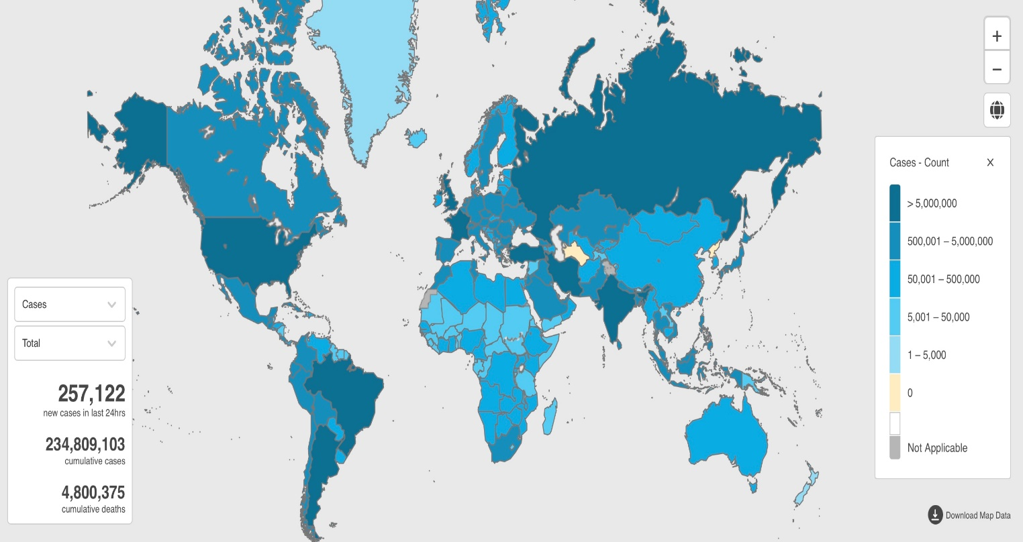

Figure 1 - The situation with coronavirus infection in the world

According to Figure 1, a richer blue color indicates the prevalence of COVID-19, the countries with the most common cases of coronavirus infection (more than 5,000,000) include countries such as the United States (more than 43.8 million cases of infection and 703 , 2 thousand deaths), India (more than 33.8 million / 449.2 thousand), Brazil (more than 21.4 million / 598.1 thousand), Great Britain (more than 7.9 million / 137, 3 thousand), Russia (more than 7.5 million / 207.0 thousand), Turkey (more than 7.2 million / 64.9 thousand), France (more than 7.1 million / 117.6 thousand .) other.
European countries (except France and Great Britain) belong to the second category of countries with a prevalence of coronavirus infection from 500.001 to 5, 000.000 cases. Our country also belongs to the same category; more than 960 thousand cases of infection and more than 16.1 thousand deaths have been detected (Figure 2).

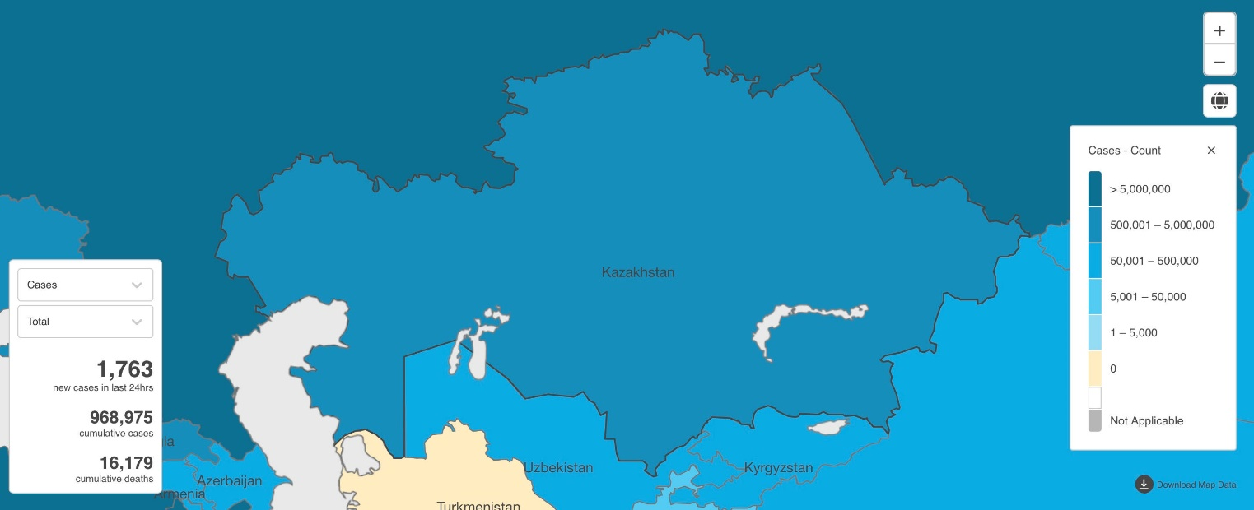

Figure 2 - The spread of COVID-19 in the Republic of Kazakhstan

It is also worth noting that China, the country in which the first case of SARS-CoV-2 coronavirus infection was detected for the first time, belongs to the third category of countries, with a spread of infection from 50,001 to 500,000 cases.
It is also worth noting that on the map with the general level of spread of the SARS-CoV-2 coronavirus infection, there are also countries designated as countries with the absence of this virus on their territory, these are Turkmenistan and North Korea.
Also indicated are places on the map for which there is no official information regarding the spread of infection - Western Sahara and the mountainous regions of North India (the regions of Jammu and Kashmir, as well as disputed areas).
Globally, the number of weekly COVID-19 cases and deaths continued to decline (Figure 3). More than 3.3 million new cases and more than 55,000 new deaths were recorded in the week 20-26 September 2021, a 10% decrease from the previous week for both cases and deaths (Table 1). The largest declines in new weekly cases were reported in the Eastern Mediterranean Region (17%), followed by the Western Pacific Region (15%), the Region of the Americas (14%), the African Region (12%) and the Southern Region. East Asia Region (10%); while the weekly cases in the European Region were similar to the previous week. The total number of confirmed cases reported worldwide now exceeds 234 million and the total number of deaths exceeds 4.8 million.

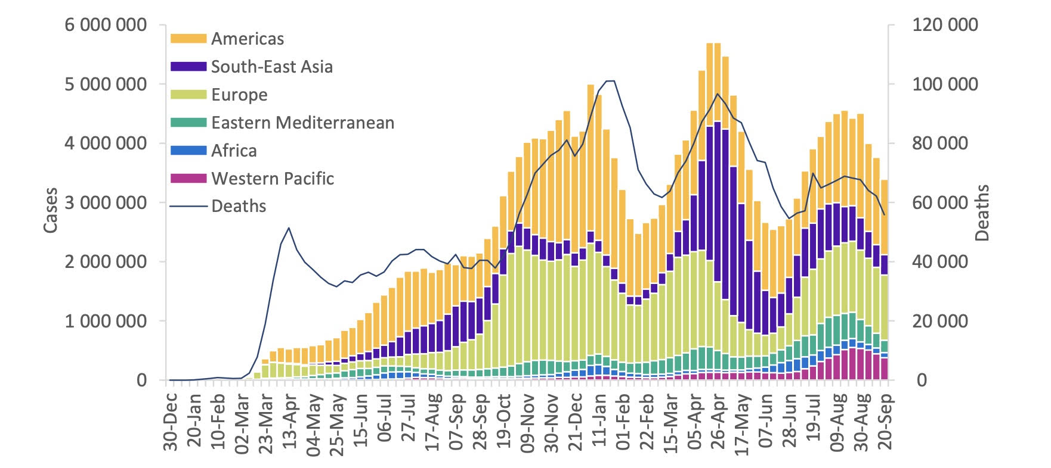
Figure 3 - Weekly COVID-19 Cases in the WHO Region and Global Deaths as of 26 September 2021

Newly reported weekly deaths fell significantly (> 15%) in all regions, except for the European Region, which recorded the same number of weekly deaths as in the previous week, and the African Region, which recorded a small increase (5%). The largest decrease in weekly mortality was recorded in the Western Pacific Region, down 24% from the previous week.
Regions (Table 1) reporting the highest weekly morbidity and mortality rates per 100,000 population remain the same as in previous weeks: Region of the Americas (124.6 new cases per 100,000 population; 2.3 deaths per 100,000 population) and European Region (117.6 new cases per 100,000 population; 1.6 deaths per 100,000 population).
The largest number of new cases were reported in the United States of America (765,827 new cases; a 31% decrease), Brazil (247,397 new cases; a 135% increase due to changes in reporting), the United Kingdom (230,494 new cases); An increase of 14%), India (204,582 new cases; similar to the previous week) and Turkey (192,778 new cases; similar to the previous week), while the largest number of new deaths was from the United States of America (14,842 new deaths, a decrease of 17%), the Russian Federation (5,469 new deaths, similar to the previous week), Mexico (3,689 new deaths, an increase of 13%), Brazil (3,727 new deaths, an increase of 10%) and the Islamic Republic of Iran (2,967 new deaths, decrease by 23%), respectively.

Table 1 - Epidemiological data on the prevalence and mortality from SARS-CoV-2 coronavirus infection
Name | WHO Region | Cases - cumulative total | Cases - cumulative total per 100000 population | Deaths - cumulative total | Deaths - cumulative total per 100000 population
Global |  | 234809103 | 3012.481714 | 4800375 | 61.58637686
United States of America | Americas | 43329413 | 13090.35 | 695238 | 210.04
India | South-East Asia | 33834702 | 2451.78 | 448997 | 32.54
Brazil | Americas | 21459117 | 10095.59 | 597723 | 281.2
The United Kingdom | Europe | 7900684 | 11638.16 | 136953 | 201.74
Russian Federation | Europe | 7612317 | 5216.26 | 210801 | 144.45
Turkey | Europe | 7238267 | 8582.34 | 64661 | 76.67
France | Europe | 6812247 | 10474.04 | 114548 | 176.12
Spain | Europe | 4961129 | 10481.42 | 86463 | 182.67
Italy | Europe | 4682034 | 7850.3 | 131031 | 219.7
Germany | Europe | 4255388 | 5116.7 | 93793 | 112.78
Ukraine | Europe | 2460010 | 5624.97 | 56889 | 130.08
Japan | Western Pacific | 1705046 | 1348.11 | 17730 | 14.02
Israel | Europe | 1291110 | 14916.57 | 7825 | 90.4
Kazakhstan | Europe | 968975 | 5160.52 | 16179 | 86.17
United Arab Emirates | Eastern Mediterranean | 736708 | 7448.72 | 2102 | 21.25
Kyrgyzstan | Europe | 178783 | 2740.31 | 2608 | 39.97
Uzbekistan | Europe | 175715 | 525.01 | 1249 | 3.73
China | Western Pacific | 124805 | 8.48 | 5692 | 0.39

Figure 4 shows the world figures for the number of confirmed cases of infection with the SARS-CoV-2 coronavirus infection and the number of deaths from this infection.

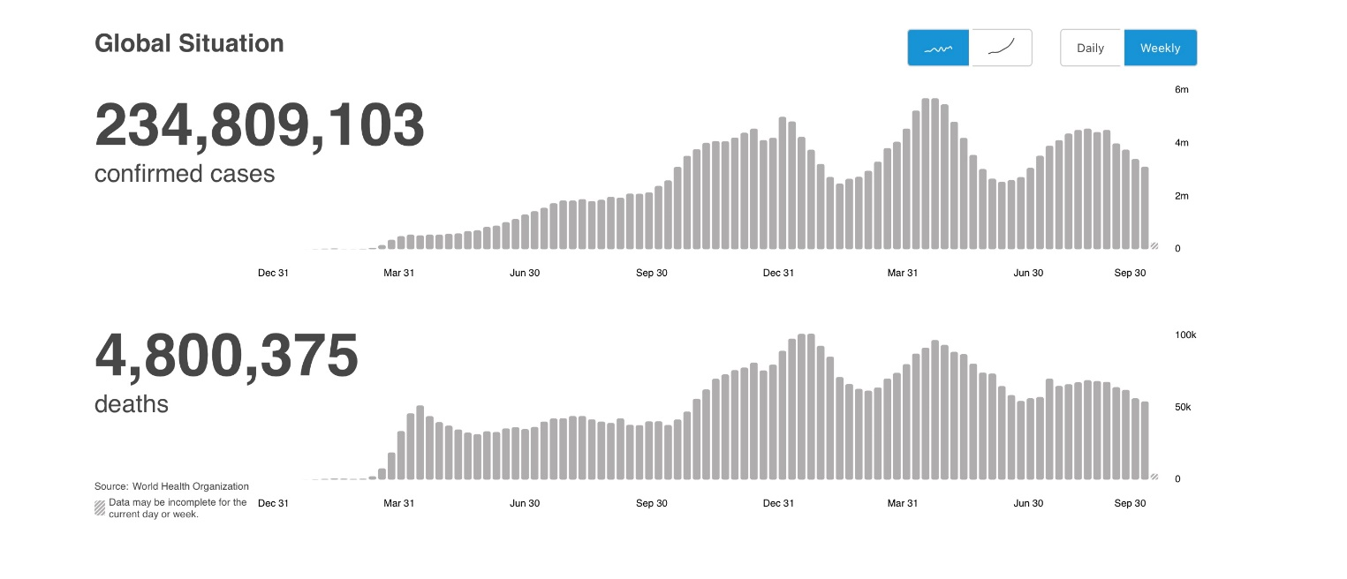
Figure 4 - Epidemiological data on morbidity and mortality from COVID-19

As can be seen in the graph in Figure 3, five waves have already swept the world in terms of the spread of coronavirus infection. The first wave of the pandemic was around the end of March-early April 2020, the second wave occurred in the summer, the surge began roughly in the second or third decade of July 2020. In October 2020, the third wave began to rise, and its maximum peak was reached in early January 2021. In early March 2021, when exactly one year has passed since the start of the global pandemic, the world was again covered by another wave with the maximum peak of infection in mid-April 2021. By the end of June 2021, the fifth wave began with a maximum peak in mid-August 2021. The wave is currently declining. Considering all of the above, we can see the cyclical nature of the waves. What indicates the manifestation of the seasonal characteristics of the virus. And in the future, it will acquire a seasonal character and will be like an ordinary viral disease. Since the general globalization of vaccination against coronavirus infection, as a result, will form a global herd immunity.
It is also worth noting that each emergence of waves of the spread of infection on a global scale was characterized by the emergence of a new virus strain (table 2).
Globally, alpha variant cases have been reported in 193 countries, territories or regions (hereinafter countries; no new countries have been added in the past two weeks), while 142 countries (no new countries since last week) reported Beta cases; and 96 countries (no new countries since last week) reported cases of gamma variant. The Delta variant has been reported in 187 countries (two new countries from last week) in all six WHO regions as of 28 September (Figure 5).

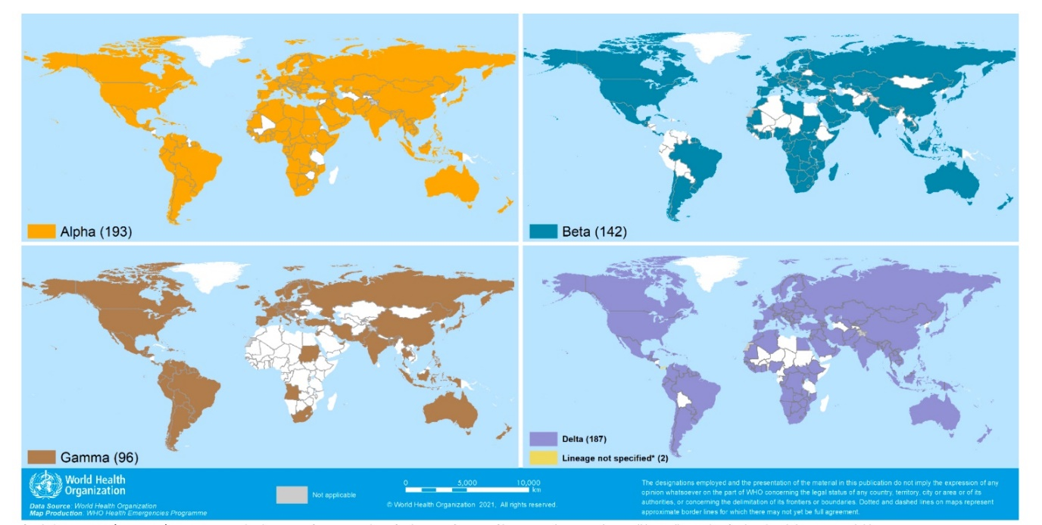
Figure 5 - Distribution of cases of alpha, beta, gamma and delta virus strains

As the COVID-19 pandemic develops, the SARS-CoV-2 coronavirus that causes this disease continues to mutate, that is, change. This means that its properties are also changing, and new strains may well pose a great threat - for example, it is easier to transmit from person to person or cause a more serious disease. There are seven main strains of the new coronavirus, they are designated by the letters GR, G, GH, O, S, L and V. It all started with the L strain - it was he who was discovered in Chinese Wuhan in December 2019. However, now it is gradually disappearing.

Table 2 - List of countries where strains of the SARS-CoV-2 virus are common
Country | Alpha strain | Beta strain | Gamma strain | Delta strain | Undefined strain В.1.617
1 | 2 | 3 | 4 | 5 | 6
United States of America | ● | ● | ● | ● | -
India | ● | ● | ● | ● | -
Brazil | ● | ● | ● | ● | -
The United Kingdom | ● | ● | ● | ● | -
Russian Federation | ● | ● | ○ | ● | -
Turkey | ● | ● | ● | ● | -

Continuation of Table 2
1 | 2 | 3 | 4 | 5 | 6
France | ● | ● | ● | ● | -
Spain | ● | ● | ● | ● | -
Italy | ● | ● | ● | ● | -
Germany | ● | ● | ● | ● | -
Ukraine | ● | ○ | - | ○ | -
Japan | ● | ● | ● | ● | -
Israel | ● | ● | ● | ● | -
Kazakhstan | ● | ○ | - | ● | -
United Arab Emirates | ● | ● | ● | ● | -
Kyrgyzstan | ● | ● | - | ● | -
Uzbekistan | ● | ● | - | ○ | -
China | ● | ● | ● | ○ | -
Панама | ● | ● | ● | ● | ●
Note: “Unspecified B.1.617” reflects countries / territories / areas reporting the sighting of B.1.617 without further specifying the origin at this time. They will be redistributed as more information becomes available.
«●»means that information on this option was obtained by WHO from official sources.
«○»means that information on this option was obtained by WHO from unofficial sources and will be revised as additional information becomes available.

The rest of the strains are distributed unevenly around the world: on each continent, the most common, as a rule, no more than two main variations. Their distribution can be observed on the interactive map compiled by scientists Nextstrain, which tracks virus mutations (Figure 6).
Each strain of the SARS-CoV-2 virus has individual contagiousness characterized by certain symptoms. For example, the Wuhan strain - contagiousness is 2.4-2.6; strain of the first wave in Europe - 3; British strain (Alpha) - 4-5; Indian strain (Delta) - 5-8 (Figure 7, 8).
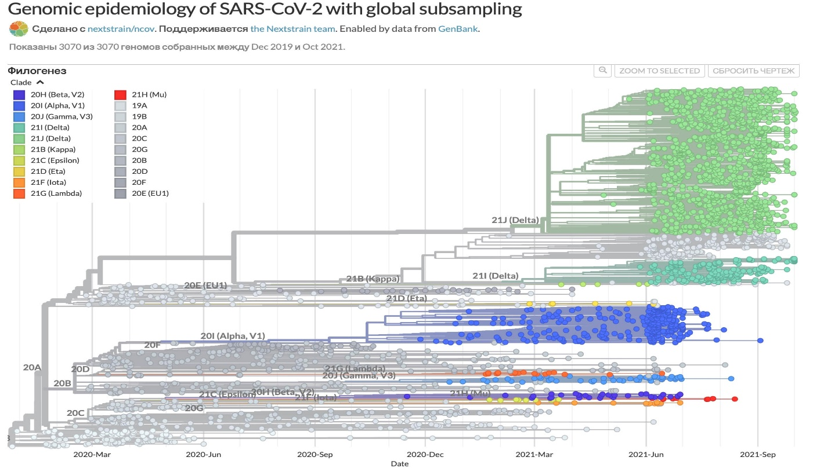
Figure 6 - Phylogenetic tree of SARS-CoV-2 virus mutations

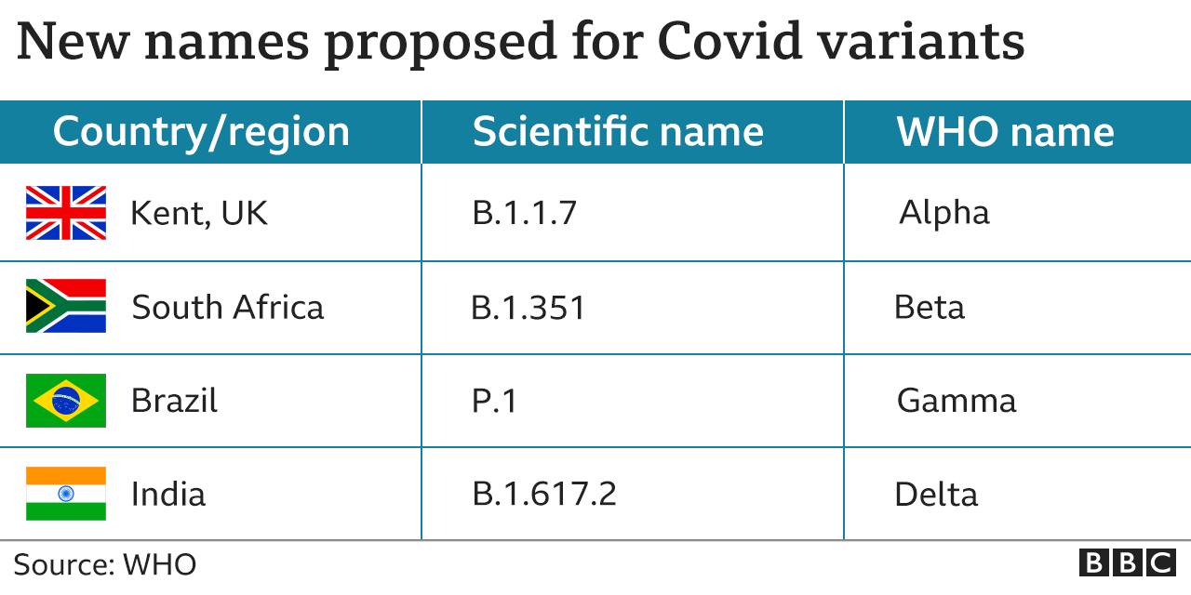
Figure 7 - Name of strains

Viruses are constantly mutating. Some variants may be more contagious. To avoid being tied to any territory and associated negative associations, WHO introduced letter designations for new dangerous strains of viruses: alpha (British), beta (South African), gamma (Brazilian), delta (Indian). In May 2021, due to the spread of the Delta variant, WHO ranked it among the variants of viruses of concern.

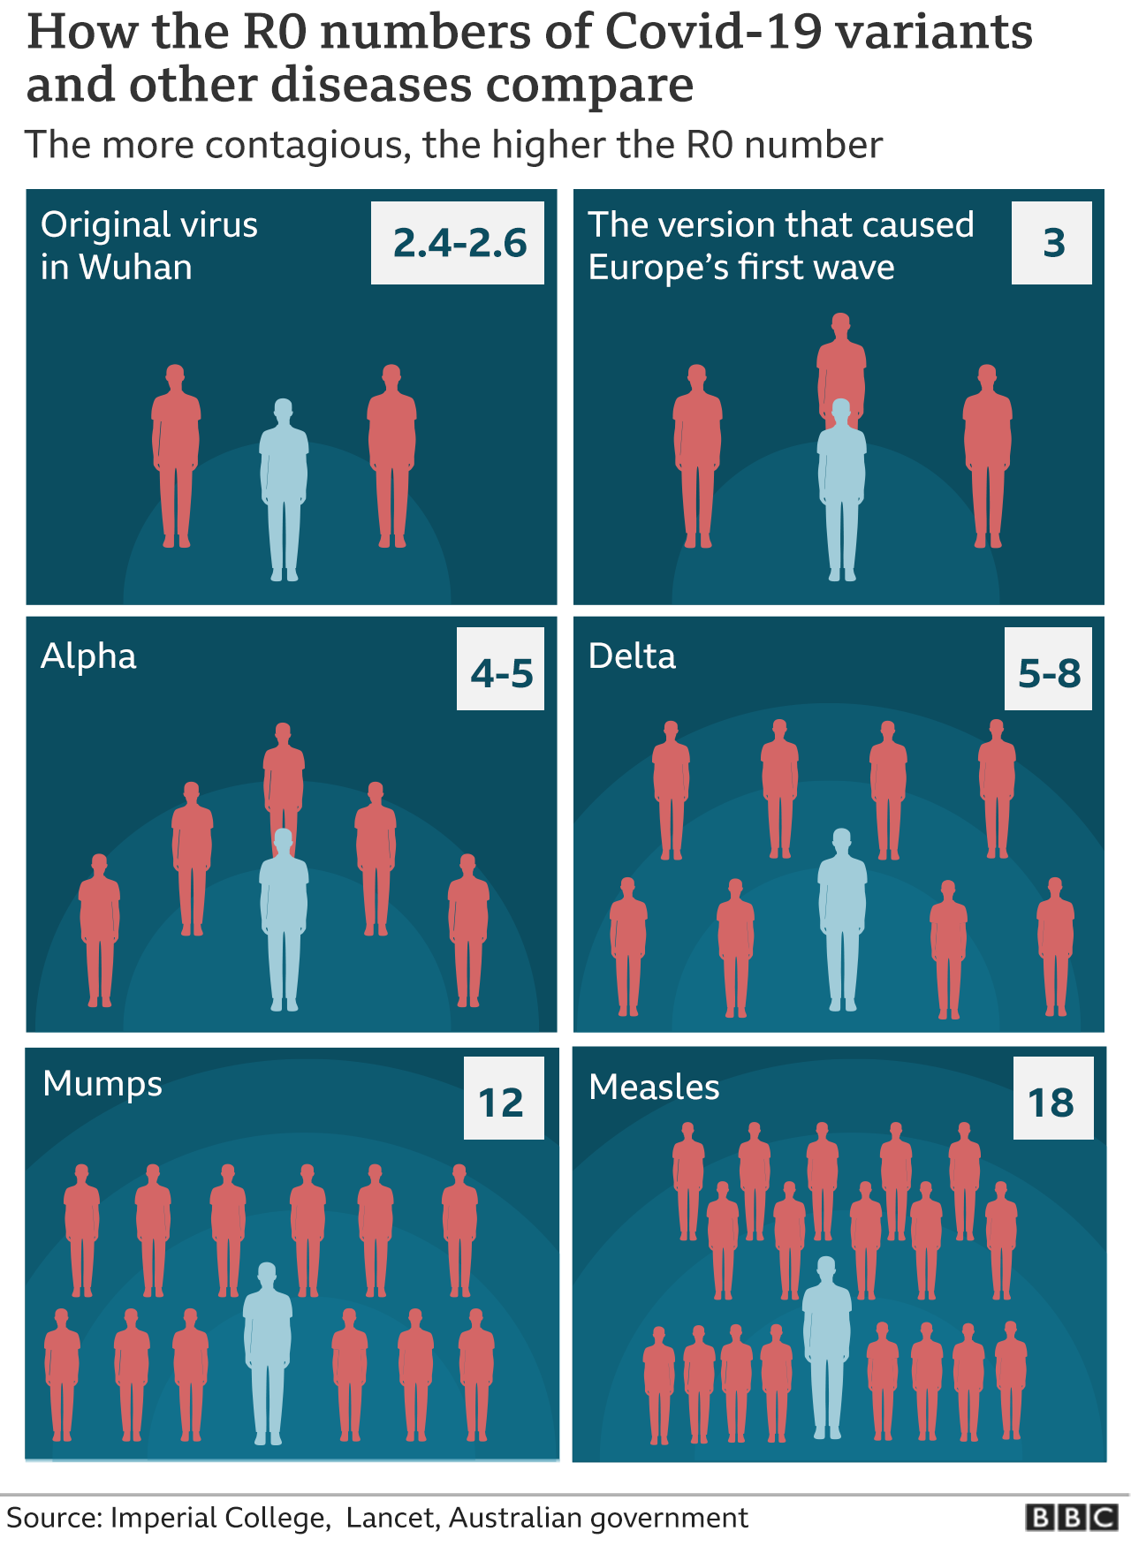
Рисунок 8 – Контагиозность штаммов SARS-CoV-2

In May 2021, in a genomic analysis of the B.1.617 strain, Indian scientists from the National Institute of Virology (NIV) identified eight mutations in the spike protein of the virus, thanks to which it enters cells. Two of these allow the virus to spread at a faster rate. The third mutation is similar to that of the Brazilian strain P.1 (variant "gamma") and helps the virus to partially escape from the immune system.
British experts believe B.1.617.2 (Delta) is 50% more infectious. German virologists received similar data - "Delta" spreads faster and more effectively escapes the action of antibodies [14].
According to available information, after processing data from a random sample of 6,000 people in England who contracted COVID-19 from mid-November 2020 to mid-January 2021. Symptoms such as loss of smell and taste are less common with the new strain. But they are still among the three main symptoms of the disease: high fever, recent persistent cough, and changes in taste sensitivity. Most infected people show at least one of these three symptoms.
From a group of 3.5 thousand people infected with a new ("British") strain: 35% coughed, 32% experienced fatigue, 25% complained of pain in muscles and in the body as a whole, 21.8% experienced a sore throat, 18 % experienced a change in taste and smell. From a group of 2.5 thousand people infected with the previous strain: 28% coughed, 29% experienced fatigue, 21% complained of pain in the muscles and in the whole body, 19% experienced a sore throat, 16% lost taste sensitivity, 15% lost their sense of smell. Data for headache, difficulty breathing or diarrhea and vomiting were identical.
Fever, dry cough, headache, loss of taste and smell - the list of symptoms of coronavirus infection is constantly growing. Researchers at the Medical University of Vienna decided to streamline this list and identified seven forms that COVID-19 disease can take. In a paper published in the scientific journal Allergy, researchers led by immunologist Winfried Pickle and allergist Rudolph Walente write that the disease leaves a significant mark on the human immune system, even ten weeks after infection. This discovery could play an important role in the treatment of patients and in the further development of potential vaccines [15].
As part of the study, scientists interviewed 109 recovering and 98 healthy people from the control group and examined their blood. According to the data obtained, some of the symptoms of COVID-19 are related and form several groups:
- Flu-like symptoms (fever, chills, weakness and cough),
- Symptoms similar to the common cold (runny nose, sneezing, sore throat and nasal congestion),
- Pain in joints and muscles,
- Inflammation of the eyes and mucous membranes,
- Lung problems, including pneumonia and shortness of breath,
- Gastrointestinal problems including diarrhea, nausea and headache,
- Loss of smell and taste and other symptoms.
The Indian strain of the coronavirus, dubbed "Delta", can manifest itself as an upset gastrointestinal tract. Many patients who have contracted the coronavirus have recently begun to complain of such a symptom. Disorders of the gastrointestinal tract, manifested in the form of - diarrhea, nausea, abdominal pain, vomiting.
In our study, we also collected and analyzed the clinical data of the patients of the City Infection Center of the "Multidisciplinary Medical Center" of the Akimat of the city of Nur-Sultan. Among all recruited patients, the most frequent were patients with pneumonia - 82% of cases, with obesity of 1-3 degrees and diseases of the circulatory system (CVD) - 52%, with disorders of the gastrointestinal tract (GIT) - 37%, diabetes mellitus 2 degrees - 20% (Figure 9).

Figure 9 - Level of prevalence of comorbidities in COVID-19

As can be seen in Figure 9, gastrointestinal disorders in COVID-19 are not the last. The defeat of the gastrointestinal tract is directly related to the pathways of penetration of the virus into the human body.
It has now been established that the initial stage of infection is the penetration of the SARS-CoV-2 virus into target cells by attaching type II angiotensin converting enzyme (ACE2) receptors in epithelial cells of the upper respiratory tract [16, 17]. It is noteworthy that ACE2 receptors are also abundant in the renal tissue and enterocytes [18-20]. The upper esophagus, epithelial cells of the stomach, duodenum, ileum, and colon also contain a large number of ACE2 receptors, which may indicate the possibility of the SARS-CoV-2 virus affecting the cells of the gastrointestinal tract (GIT). In biotopes of the small and large intestine obtained during colonoscopy / autopsy, the virus was also detected, and in stool samples it was present for more than 70 days after the onset of the first symptoms of the disease [21-23].
The incidence of gastrointestinal symptoms of COVID-19 varies widely, ranging, according to various authors, from 2-10% to 20% [24]. According to other scientists, approximately 3.34-11.4% of patients with COVID-19 may have symptoms of gastrointestinal tract damage [25, 26]. In patients with diarrhea against the background of COVID-19, an increased level of fecal calprotectin was detected, which may serve as confirmation of the presence of inflammatory changes in the intestine against the background of infection [27].

2 Materials and research methods
The sample consisted of a cohort of patients who underwent COVID-19, confirmed by PCR positive results and a CT scan during the acute phase of the disease, men and women over the age of 18 and who underwent hospitalization and inpatient treatment in clinics in the city of Nur-Sultan. Patients who have had concomitant symptoms of a disorder from the digestive system will be additionally examined for metagenome-associated pathologies (study of the intestinal microbiome).
In the first phase of the study, at the beginning of 2021, a retrospective analysis of the case histories of all patients who were hospitalized at the City Infection Center of the "Multidisciplinary Medical Center" of the Akimat of the city of Nur-Sultan was carried out, and the prevalence of symptoms of gastrointestinal tract disorders was assessed.
In the second phase of the study, material was collected for the study of the intestinal microbiome, after the patients had previously signed the Informed Consent Form. In which all procedures were described in detail and in a language accessible to the patient. All information was used in the study for analysis only with the permission of the patient. All personal identification data has been anonymized. To conduct this study, the approval of the local ethical commission of the Center for Life Sciences of the National Laboratory Astana was obtained (extract of their protocol No. 06-2020 of 10/28/2020).
Clinical laboratory studies were conducted in accordance with GCP and GLP standards. The collection of samples for stool analysis was carried out in special containers. After instructing by the investigator, the collection of the stool sample was carried out by the patient independently. DNA extraction procedures were performed using the commercial PureLink kit within 24 hours of collection.
Sequencing was performed using two high-throughput platforms: 454 FLX Titanium sequencing of bacterial metagenomic 16s rRNA genes and Illumina WGS sequencing. Platform 2, Illumina WGS sequencing, a DNA fragmentation technique, has unprecedented coverage of sequence coverage, the ability to identify new genes and new genomes beyond those in databases. We used HiSeq for sequencing and characterization of metagenomic associations at the pangenomic level in a large number of samples. Sequencing of about 5 Gb of information was carried out for each sample, which made it possible to compare the total content of genes associated with the microbiota of each type of association.
DNA extraction using QIAamp DNA Stool Mini Kit, Qiagen, 51504
1. Weigh 180-220 mg stool into a 2 ml microcentrifuge tube and place the tube on ice. If the sample has been frozen, use a scalpel or spatula to separate the stool pieces into a 2 ml microcentrifuge tube.
2. Add 1.4 ml ASL buffer to each stool sample. Vortex continuously for 1 min or until the stool sample is thoroughly homogenized.
3. Incubate the suspension for 5 min at 70 ° C. This stage increases the overall DNA yield by 3-5 times and helps lyse bacteria and other parasites. The lysis temperature can be increased to 95 ° C for cells that are difficult to lyse (eg gram-positive bacteria).
4. Vortex for 15 sec and centrifuge at full speed for 1 min until stool particles settle.
5. Transfer 1.2 ml of supernatant to a new 2 ml microcentrifuge tube.
6. Add 1 InhibitEX tablet to each sample and vortex for 1 min or until the tablet is completely dissolved. Incubate the suspension for 1 min at room temperature so that inhibitors can adsorb to the InhibitEX matrix.
7. The sample is centrifuged at full speed for 3 min until the inhibitor beads are bound to the inhibitor matrix.
8. Transfer the supernatant to a new 1.5 ml microcentrifuge tube and discard the pellet. Centrifuge the sample at full speed for 3 minutes.
9. Pipette 15 µl of Proteinase K into a new 1.5 ml microcentrifuge tube.
10. Transfer 200 µl of the supernatant from step 8 into a 1.5 ml microcentrifuge tube containing Proteinase K.
11. Add 200 μL Buffer AL and vortex for 15 sec.
12. Incubate at 70 ° C for 10 min.
13. Add 200 µl ethanol (96-100%) to the lysate and mix by vortexing. Centrifuge briefly to remove droplets from inside the tube lid.
14. Place the QIAamp spin column in a 2 ml collection tube. Carefully load all of the lysate from step 13 onto the QIAamp column. Close the spin column lid and centrifuge at full speed for 1 min. Place the QIAamp spin column in a new 2 ml collection tube and discard the used tube containing the filtrate.
15. Carefully open the QIAamp spin column and add 500 µl AW1 Buffer. Close the spin column lid and centrifuge at full speed for 1 min. Place the QIAamp spin column in a new 2 ml tube and discard the collection tube containing the filtrate.
16. Carefully open the QIAamp spin column and add 500 µl AW2 Buffer. Close the spin column lid and centrifuge at full speed for 3 min. Discard the collection tube containing the filtrate.
17. Recommended: Place the QIAamp spin column in a new 2 ml tube and discard the old filtrate collection tube. Centrifuge at full speed for 1 min.
18. Transfer the QIAamp column to a new, labeled 1.5 ml microcentrifuge tube. Carefully open the QIAamp spin column and add 200 µl of Buffer AE directly onto the QIAamp membrane. Close the lid of the spin column and incubate for 1 min in the room then centrifuge at full speed for 1 min to elute the DNA.
3 Study of the main genetic characteristics of the intestinal microbiome in case of coronavirus infection and systemic damage to the patient's body after suffering COVID-19 (post COVID syndrome, manifested by complications of the respiratory, cardiovascular, digestive and excretory systems of organs during SARS-CoV-2 viral infection)
It is now known that the intestinal microbiota performs essential functions in the human body, such as protective, digestive, metabolic and immunomodulatory. The intestinal microbiota is involved in the formation of colonization resistance to potentially pathogenic bacteria through the secretion of bacteriostatic and antimicrobial metabolites, in the degradation of bacterial toxins, and deconjugation of bile acids, thus maintaining the state of microbial homeostasis in the intestine [16, 28].
The immunomodulatory role of the microbiota is the formation of nonspecific defense factors, the regulation of the adaptive immune response. The intestinal microbiota takes part in the synthesis of nonspecific humoral defense factors (lysozyme, properdin, complement), phagocytosis, stimulation of the maturation of the intestinal lymphoid apparatus, as well as in the synthesis of immunoglobulin A, cytokines and interferons [28, 29]. A healthy intestinal microbiome is of great importance (Figure 10) in maintaining the immune system in an optimal state, in which both a hyperreactive and a reduced immune response are not observed when meeting an infectious agent. It is in this state that adequate protection of the body from various infections, including from a new coronavirus infection, will be possible. As you know, the intestinal microbiota is involved in the secretion of short-chain fatty acids such as acetic, propionic and butyric acids, secondary bile acids secreted by the commensals of the microbiota. Microbiota metabolites, in turn, can also regulate the functions of immune cells such as dendritic cells and macrophages [30].
In the course of the analysis of the compositional composition of the intestinal microbiota of the study participants using 16S rRNA as a marker, more than 35 species of bacteria were identified, most of which belong to four types: Firmicutes, Actinobacteria, Bacteroides, and Proteobacteria, which, according to the literature, corresponds to information on the intestinal microflora conditionally - a healthy adult in accordance with Figure 10. Representatives of other phyla have also been identified, including Fusobacteria, Elusimicrobia, Synergistetes, Spirochaetes, and Verrucomicrobia. Strains of Streptophyta (Eukaryota) have also been found.
Violations of the intestinal microbiota composition are possible in many diseases of both the gastrointestinal tract and other organs and systems (for example, obesity, diabetes mellitus, cardiovascular, autoimmune, mental illnesses, etc.) [31]. The available literature provides information that the gut microbiota can influence the functioning of the respiratory system through the interaction of organs within the gut-lung axis. It is assumed that this interaction occurs both in the forward and reverse directions, that is, endotoxins and microbial metabolites present in lung tissues can also affect the composition of the intestinal microbiota [32]. Thus, given the relationship between the gut microbiota and the respiratory system, it can be assumed that the novel SARS-CoV-2 coronavirus may also have an impact on the gut microbiota. This fact was reflected in the results of a number of studies in which it was shown that in infectious diseases of the respiratory system, violations of the composition of the intestinal microbiota occur [33]. According to the literature, the risk of viral infections increases in the presence of disturbances in the composition of the intestinal microbiota, while a number of studies demonstrate that the viral infections themselves, for example, influenza and respiratory syncytial viral infection, can lead to changes in the composition of the fecal microbiota [24].
In particular, in the work of H.S. Gill et al. (2001) demonstrated that the use of probiotics based on the bacteria Bifidobacterium lactis in healthy elderly volunteers led to an increase in the proportion of mononuclear leukocytes and the activity of NK cells in the blood serum [34]. Some researchers believe that the gut microbiome may underlie the predisposition of healthy people to COVID-19. Moreover, based on the proteomic analysis of blood samples from patients with COVID-19, 20 proteomic biomarkers were identified that could potentially be associated with the severity of the course of the infection based on the proteomic risk scale for the course of COVID-19 [26].
The above facts and the results of individual studies suggest that the intestinal microbiota is able to play a significant role in the formation of immunity, which in turn can determine the risk of disease and the characteristics of the course of the infectious process caused by the SARS-CoV-2 virus.

Figure 10 - Composition of the intestinal microbiome of a conditionally healthy population

However, most aspects of the relationship between gut microbiota and COVID-19 disease remain open at this time, as well as many other questions regarding the new coronavirus infection. As you know, the intestinal microbiota of the elderly is characterized by a low diversity and a lower representation of beneficial bacteria, such as bifidobacteria and a number of others [35]. The existing experience with COVID-19 has shown that elderly patients, patients with weakened immune systems, as well as patients with concomitant diseases such as arterial hypertension, diabetes mellitus, obesity and a number of others, have an increased risk of a severe course of COVID-19 and high mortality rates. This fact indirectly suggests a relationship between the state of the intestinal microbiota and the severity of COVID-19 [24]. It should be noted that the literature provides limited information on the effect of coronavirus infection in its natural course on the intestinal microbiota. This is probably due to the fact that in any form of the disease, from the most mild to severe forms, as a rule, therapeutic measures are used. Separate studies have shown that the composition of the gut microbiota of patients with COVID-19 is characterized by a lower abundance of "beneficial" bacteria, such as Bifidobacterium, Lactobacillus and Eubacterium, and a higher abundance of opportunistic bacteria, such as Corynebacterium (Actinobacteria) and Ruthenibacterium (Firmicutes) [ 26].
An interesting study by T. Zuo et al. (2020), which studied the composition of the gut microbiota in patients with COVID-19 infection hospitalized in the hospital. A total of 15 patients with COVID-19 were included in the study (7 patients did not take antibiotics, 8 people received empiric antibiotics until hospitalization), the control group consisted of 15 people. All patients had respiratory symptoms, only 1 patient complained of diarrhea on admission; during hospitalization, none of the patients developed other gastrointestinal symptoms. The composition of the intestinal microbiota was studied by metagenomic shotgun sequencing of stool samples (Illumina NextSeq 550). The patients were divided into the following clinical variants of the course of infection: mild (without radiographic signs of pneumonia), moderate (with signs of pulmonary involvement), severe (respiratory rate ≥30 per minute or oxygen saturation ≤93%), or extremely severe (respiratory failure, necessity artificial ventilation of the lungs, etc.). The authors of the work compared the initial composition of the intestinal microbiota of the compared groups, adjusted for age, sex, antibiotic use, and concomitant diseases [24].
It was found that the intestinal microbiota of patients with COVID-19 who did not take any antibacterial drugs until hospitalization was characterized by a higher prevalence of pathogenic and opportunistic bacteria, such as Clostridium hathewayi, Bacteroides nordii, Actinomyces viscosus. The gut microbiota of patients with severe COVID-19 was characterized by an initially higher prevalence of Clostridium hathewayi. The researchers noted that most of the above bacteria are potentially capable of causing the development of bacterial infections, which can also serve as an indicator of a severe course of the disease, including due to the risk of secondary bacterial complications. In the group of patients who received antibiotic therapy at the time of admission to the hospital, during the period of hospitalization, a further decrease in the presence of potentially beneficial bacteria, such as Fecalibacterium prausnitzii, Lachnospiraceae bacterium, Eubacterium rectale, Ruminococcus obeum, Dorea formicigenerans in the microbiota that did not take antibacterial drugs. Firmicuts contain the class Clostridia and Bacillus in accordance with Figure 11. They are involved in the hydrolysis of complex polymer compounds to monomers. Bacteroids contain the class Bacteroidia. They participate in fermentation processes and form organic acids. Synergists include the Synergistia class. They break down amino acids and produce acetate, butyrate, hydrogen and carbon dioxide. Actinobacteria play an important role in the degradation of cellulose, and thus take part in the circulation of organic matter and in the carbon cycle. Actinomycetes also play an important role in the production of secondary metabolites, natural organic antibiotics of actinomycin. Comparative taxonomic analysis of the microbiota in the samples revealed significant individual differences between the participants in the presented composition of the microbiota. The results obtained made it possible to determine the belonging of the participants to a certain enterotype with the dominance of a certain taxon.
The researchers also found that the abundance of the phylum Firmicutes bacteria, namely Clostridium ramosum and Clostridium hathewayi, correlated with the severity of COVID-19 infection. In contrast, the abundance of bacteria Alistipes onderdonkii and Faecalibacterium prausnitzii was inversely correlated with the severity of the COVID-19 infection. According to various sources, bacteria of the genus Alistipes can participate in the metabolism of tryptophan and maintenance of homeostasis of the intestinal microbiota [36, 37], while the bacterium Faecalibacterium prausnitzii is well known for its anti-inflammatory properties [38]. The presence of certain bacteria in the gut microbiota, such as Bacteroides dorei, Bacteroides thetaiotaomicron, Bacteroides massiliensis, Bacteroides ovatus, correlated inversely with the SARS-CoV-2 viral load determined in the gut microbiota. The researchers noted that all four of these bacteria are associated with decreased expression of ACE2 receptors in the colon of mice.

Figure 11 - Percentage of dominant classes of gut microbiome in COVID-19 patients

According to the compositional analysis of samples from patients with COVID-19, two enterotypes of the intestinal microbiome were identified with clear differences: in the first case, the Bacteroidetes enterotype prevailed, and in the second case, the Firmicutes enterotype. The percentage differences between the above systematic groups in most of the samples were insignificant. It is also important to note that the study of species diversity between groups showed the greatest diversity in the case-control groups, and the poorest diversity was observed in persons aged 70 and older. Moreover, it was noted that the presence of certain types of gut microbiota depends on the age and sex factor.
Thus, according to the authors, bacteria of the genus Bacteroides can be potentially protective against the SARS-CoV-2 virus. A positive correlation was found between the presence of the bacterium Erysipelotrichaceae bacterium and the level of SARS-CoV-2 viral load in the fecal microbiota. The results of separate studies have shown that bacteria of the genus Erysipelotrichaceae may be involved in the development of inflammatory bowel diseases [39]. In general, the composition of the intestinal microbiota of patients with COVID-19 significantly differed from the composition of the intestinal microbiota of the control group in the form of a higher representation of opportunistic bacteria and a lower relative representation of beneficial commensals, both at baseline and during hospitalization. Moreover, even after clinical improvement and the disappearance of complaints from the respiratory system, these patients retained a lower representation of beneficial bacteria in the intestinal microbiota.
The authors of the work concluded that the intestinal microbiota of patients with COVID-19 infection is characterized by a longer preservation of changes in its composition compared to healthy people. At the same time, the severity of the changes was associated with the degree of viral load in the intestine and the severity of the course of the disease. According to the authors, therapeutic measures aimed at correcting the composition of the intestinal microbiota may become an additional direction in the treatment of COVID-19 infection [24].
In the work of Y.K. Yeoh et al. (2020) studied the effect of microbiota composition on the immune response and the severity of COVID-19 infection. The authors of the work conducted a cohort study that included 100 patients with laboratory confirmed infection caused by SARS-CoV-2 (positive nasopharyngeal swab). Feces and blood samples were taken from the patients. The composition of the microbiota was studied by carrying out genome-wide sequencing (Illumina NovaSeq 6000) of total bacterial deoxyribonucleic acid isolated from stool samples, and the immune response was analyzed by determining the level of inflammatory biomarkers and cytokines in the blood. The gut microbiome composition of COVID-19 patients differed significantly from healthy controls, whether or not they received antibiotic therapy. At the same time, the composition of the microbiota of patients during the period of illness and within 30 days after clinical recovery was distinguished by a lower representation of intestinal microbiota commensals with a known immunomodulatory potential, such as bifidobacteria, Faecalibacterium prausnitzii, and Eubacterium rectale. The authors revealed a negative correlation between the presence of the bacteria Faecalibacterium prausnitzii and Bifidobacterium bifidum and the severity of the disease (after adjusting for the use of antibiotics and the age of patients; p <0.05). In addition, a more severe course of the disease was characterized by a higher level of inflammatory cytokines and biomarkers in the blood (C-reactive protein, lactate dehydrogenase, aspartate aminotransferase and γ-glutamyl transferase) [40].
In the previously described work, it was also revealed that the composition of the intestinal microbiota of patients with signs of a higher infectious activity of SARS-CoV-2 was characterized by a higher representation of opportunistic bacteria, such as Collinsella aerofaciens, Collinsella tanakaei, Streptococcus infantis, Morganella morganii, and a lower representation of "useful" microorganisms. At the same time, the composition of the intestinal microbiota of patients with signs of low infectious activity of the virus was characterized by a higher abundance of bacteria producing short-chain fatty acids, Parabacteroides merdae, Bacteroides stercoris, Alistipes onderdonkii, Lachnospiraceae bacterium [41].
The composition of the intestinal microbiota was studied by sequencing the V3 – V4 regions of the 16S ribosomal RNA gene. The authors of the work showed that the intestinal microbiota of patients with COVID-19 was characterized by a low diversity, a high representation of opportunistic bacteria, a low representation of beneficial microbiota representatives, and the dominance of bacteria of the genera Streptococcus, Rothia, Veillonella, Erysipelatoclostridium, Actinomyces in comparison with the microbiota of healthy volunteers. At the same time, in patients with COVID-19, the representation of bacteria of the Lachnospiraceae families (Fusicatenibacter, Anaerostipes, Agathobacter, Lachnospiraceae, Eubacterium hallii group) was significantly less than in the group of patients with influenza. Microbial diversity scores were significantly reduced in COVID-19 and H1N1 patients compared with healthy volunteers, in line with the literature on other respiratory viral infections that also saw similar changes in gut microbiota composition.
The authors noted that the structure of the intestinal microbiome and its diversity did not differ statistically significantly between patients with varying degrees of severity of the course of infection. The study also examined correlations between various laboratory markers of inflammation and the state of the gut microbiota. Thus, it was found that the representation of bacteria Agathobacter, Fusicatenibacter, Roseburia, Ruminococcaceae, which was reduced in patients with COVID-19 compared with healthy volunteers, inversely correlated with the level of laboratory markers of inflammation: C-reactive protein, D-dimer and procalcitonin. The levels of C-reactive protein and D-dimer directly correlated with the presence of Streptococcus, Rothia, Veillonella, Actinomyces bacteria in the intestinal microbiota. These bacteria were more abundant in the fecal microbiota of COVID-19 patients. It is known that bacteria of the genus Rothia can be an etiopathogenetic link in the development of pneumonia, especially in immunocompromised people [42], the role of Streptococcus and Rothia bacteria in the occurrence of secondary bacterial infections in patients with the virus is discussed [43].
According to the authors, the gut microbiota can serve as both a potential biomarker of the severity of COVID-19 and a potential therapeutic target in the treatment of infection, but further research is needed in this area [25].

4 Improvement of clinical protocols for the management of patients and revision of the terms of rehabilitation of patients with previous CVI based on the results obtained during the study of the intestinal microbiome
The gut microbiome is the main source of microorganisms for the formation of microbiomes of other organs and tissues. Gut and lung dysbiosis associated with COVID-19 leads to increased inflammatory responses and stimulates the development of a cytokine storm through increased receptor activity. The patient's intestinal dysbiosis facilitates the invasion of coronaviruses and intensifies inflammatory responses. Conversely, the progression of COVID-19 leads to increased dysbiosis in both the lungs and intestines. Improving the microbiome through probiotic strains of bifido / lactobacilli and prebiotic substances is an important approach to smoothing the “wave” of COVID-19 at the population level [44].
The results of a long-term study of the microbiome, including data from such world-famous projects as the Human Microbiome Project and Metagenomics of the human intestinal tract, indicate that the intestinal microflora is represented by two dominant types of bacteria: Bacteroidetes (typical representatives are B. vulgatus, B. dorei, B. uniformis, B. ovatus) and Firmicutes (it includes the class Bacilli, which includes such well-known genera as Lactobacillus, Enterococcus, and Streptococcus) with a relatively low content of actinomycetes (genus Bifidobacterium) [45].
Currently, no one doubts the participation of intestinal microbiota in digestion processes (breakdown of dietary fiber, synthesis of short-chain fatty acids (SCFA) and digestive enzymes, metabolism of bile acids), synthesis of B, K vitamins, amino acids (arginine, glutamine), detoxification of certain types of drugs and xenobiotics, regulation of the activity of the immune, endocrine and nervous systems (intestine-brain axis).
The most significant in the era of the COVID-19 pandemic were the protective and immunomodulatory functions of the microbiota. An increase in the synthesis of mucus and mucin by goblet cells, noted under the influence of lacto-, bifidobacteria, streptococci, leads to an improvement in the protective properties of the intestinal mucosa and avoids the adhesion / invasion of pathogenic microorganisms [46].
It is assumed that the stimulation of the production of mucus, mucin, bacteriocins, the preservation of the integrity of the epithelium and tight intercellular contacts is one of the main mechanisms that allow the microbiota to resist the penetration and replication of SARS-CoV-2 in the intestine and prevent further progression of viral infection.
The concept of an axis connecting the intestine and lungs into a single whole appeared relatively recently. According to the formulated theory, the "intestine - lungs" axis, the state of the intestinal microbiome has a significant effect on the microbiota of the respiratory tract, the functional state of the lungs [16, 26, 46]. It is believed that this axis is bi-directional, i.e., not only metabolites of probiotics and bacterial endotoxins are able to affect the respiratory tract through the bloodstream, but also the inflammatory process in the lungs leads to a change in the composition, quantity and function of the intestinal microbiome [16, 18, 26, 46].
The anti-inflammatory and immunomodulatory properties of some probiotic strains can improve the functioning of the intestinal-lung axis and, possibly, prevent the development, mitigate the course of COVID-19, and increase the effectiveness of vaccination against SARS-CoV-2. The intake of probiotic strains, the effectiveness and safety of which is confirmed by evidence-based medicine data in the treatment and prevention of ARVI / diarrhea (L. rhamnosus, L. plantarum, L. acidophilus, B. bifidum, S. boulardii, Streptococcus thermophilus), can be recommended for patients from the group risk, as well as for patients with COVID-19, respectively, as a prophylactic and / or adjuvant agent. The potential benefits of probiotics for COVID-19 remain to be explored, but there is good reason to use them as an effective weapon against the new and insidious SARS-CoV-2 virus [16, 18, 26, 46].
Another impetus to the use of probiotics for COVID-19 was the features of infection and excretion of SARS-CoV-2, suggesting damage to the gastrointestinal tract, the development of diarrhea and the excretion of the virus in feces. At the same time, the use of massive antibiotic therapy for the treatment of secondary bacterial therapy in patients with COVID-19 is a risk factor for the development of antibiotic-associated diarrhea (AAD), for the treatment and prevention of which probiotic drugs are widely used.
To date, international medical databases do not yet have a sufficient number of clinical studies, meta-analyzes, in which the effectiveness of probiotics in patients with COVID-19 was studied, on the basis of which it was possible to unequivocally say about the positive effect of using probiotics. However, the high efficacy of probiotics and the intestinal-lung axis in the treatment of COVID-19 is emphasized by many teams of authors, G. d'Ettorre et al., Who prescribed PCR-positive inpatients COVID-19 with 50% lung damage, febrile temperature in non-invasive oxygen therapy, multicomponent probiotics [46, 47, 48].
Italian scientists called the use of probiotics oral bacteriotherapy. Bacteriotherapy using probiotic strains Streptococcus thermophilus, L. acidophilus, L. helveticus, L. paracasei, L. plantarum, L. brevis, B. lactis, B. lactis contributed to the relief of diarrhea, remission of other symptoms in almost all patients taking probiotics, compared with patients who did not receive these drugs. In addition, the risk of developing respiratory failure was eight times lower in patients receiving oral bacteriotherapy. The prevalence of respiratory failure and the mortality rate of patients transferred to the intensive care unit and who did not receive oral probiotics were significantly higher than those in patients who took beneficial bacteria. Based on the data obtained, the researchers believe that probiotics can significantly improve the clinical condition of patients infected with SARS-CoV-2 [47, 48].
The expediency of using Lactobacillus strains in COVID-19 is supported by the authors of a detailed literature review, who presented evidence-based medicine data accumulated over several decades and revealing the effectiveness of these probiotic strains in the treatment of ARVI [49]. Based on these data, S. Zrelli et al. (2021) suggest the ability of lactobacilli to strengthen the cell barrier, prevent the penetration of SARS-CoV-2 and modulate the immune response [49].
Prescribing prebiotics / synbiotics to patients with COVID-19 may be associated with a milder course of the disease, rapid relief of respiratory symptoms and normalization of temperature, a decrease in the need for oxygen therapy and prevention of the development of ventilator-associated pneumonia, and a leveling of gastroenterological manifestations of SARS-CoV-2 infection and AAD. They can also be used in cases of manifestation of COVID-19 with severe diarrhea, due to the presence of S. boulardii strains with pronounced antidiarrheal activity in the composition. Prophylactic use of synbiotics can be recommended for patients at risk of severe COVID-19: the elderly, patients with weakened immunity, comorbid pathology (diabetes mellitus, cardiovascular diseases, liver and kidney disease). Perhaps the use of probiotics / synbiotics is advisable before vaccination against SARS-CoV ‑ 2 in order to increase the effectiveness of vaccination. The optimal duration, frequency, and dosage regimens for probiotics are not yet precisely known; the answers to these questions are hidden in the near future.
The choice of the optimal tactics of nutritional support for patients with COVID-19 is largely determined by the timely and high-quality diagnosis of the state of the intestinal microbiocenosis. At present, a persistent violation of the intraintestinal balance of the obligate and opportunistic microflora is referred to as "dysbiosis". Intestinal dysbiosis is understood as a clinical and laboratory syndrome associated with a change in the qualitative and / or quantitative composition of the intestinal microflora with the subsequent development of metabolic and immunological disorders, as well as with the possible development of gastrointestinal disorders. The severity of dysbiotic changes affects the course of the underlying disease, as well as the activity of almost all systems and organs [50].
It is known that, on the one hand, the pathological process of any localization can lead to changes in the intestinal microbiocenosis, on the other hand, the presence of dysbiosis is a factor aggravating the underlying disease. The most common method of microbiological determination of the degree of dysbiotic disorders of microbial ecology in the colon is the analysis of feces and its decoding for dysbiosis.
Nutritional support is based on screening and nutritional deficiencies. Choice of nutritional support method - dietary nutrition, oral enteral nutrition, enteral tube feeding; parenteral nutrition is determined by the severity of the course of coronavirus infection, the functional state of the gastrointestinal tract, the presence of organ / multiple organ failure, the use of intensive therapy methods (mechanical ventilation, extraorgan detoxification, ECMO, etc.).
Thus, the prevention, diagnosis and correction of nutritional status disorders is considered by us as one of the main methods of treatment aimed at resolving the systemic inflammatory response and correcting the metabolic response to viral infection in patients with COVID-19. The manifestation of a systemic inflammatory reaction as a result of a viral infection leads to severe metabolic disorders. The main metabolic manifestations of the systemic inflammatory reaction are expressed by the hypermetabolic-hypercatabolic syndrome with complex disorders of protein, lipid and carbohydrate metabolism, increased consumption of carbohydrate-lipid reserves and the breakdown of tissue proteins. However, adequate correction of metabolic disorders and full nutritional support for patients with COVID-19, taking into account the clinical picture, the severity of the disease, respiratory and intensive care, is an integral part of the treatment of infection, which determines its effectiveness and reduces mortality.

CONCLUSION
During the implementation of the project and the execution of all tasks, according to the calendar plan for 2021, the following results were obtained:
- As part of a retrospective, epidemiological analysis of cases of coronavirus infection, and an assessment of the prevalence of symptoms associated with disorders of the digestive system, the following results were obtained:
It has now been established that the initial stage of infection is the penetration of the SARS-CoV-2 virus into target cells by attaching type II angiotensin converting enzyme (ACE2) receptors in epithelial cells of the upper respiratory tract. The upper esophagus, epithelial cells of the stomach, duodenum, ileum, and colon also contain a large number of ACE2 receptors, which may indicate the possibility of the SARS-CoV-2 virus affecting the cells of the gastrointestinal tract (GIT). In our study, among all recruited patients, the most frequent were patients with pneumonia - 82% of cases, with obesity of 1-3 degrees and diseases of the circulatory system (CVD) - 52%, with disorders of the gastrointestinal tract (GIT) - 37%, diabetes mellitus 2 - 20%. In biotopes of the small and large intestine obtained during colonoscopy / autopsy, the virus was also detected, and in stool samples it was present for more than 70 days after the onset of the first symptoms of the disease. The main symptom of the Indian strain of coronavirus is gastrointestinal upset. Disorders of the gastrointestinal tract, manifested in the form of - diarrhea, nausea, abdominal pain, vomiting. The incidence of COVID-19 gastrointestinal symptoms varies widely, ranging from about 2-10% to 20%. According to other sources, approximately 3.34-11.4% of patients with COVID-19 may experience gastrointestinal symptoms. In patients with diarrhea against the background of COVID-19, an increased level of fecal calprotectin was detected, which indicates the presence of inflammatory changes in the intestine against the background of SARS-CoV-2 infection.
- As part of the study of the main genetic characteristics of the intestinal microbiome in coronavirus infection and systemic damage to the patient's body after suffering COVID-19 (post-coccygeal syndrome, manifested by complications of the respiratory, cardiovascular, digestive and excretory systems of organs during SARS-CoV-2 viral infection) were the following results were obtained:
In the course of the analysis of the compositional composition of the intestinal microbiota of the study participants using 16S rRNA as a marker, more than 35 species of bacteria were identified, most of which belong to four types: Firmicutes, Actinobacteria, Bacteroides, and Proteobacteria, which, according to the literature, corresponds to information on the intestinal microflora conditionally - a healthy adult. Representatives of other phyla have also been identified, including Fusobacteria, Elusimicrobia, Synergistetes, Spirochaetes, and Verrucomicrobia. Strains of Streptophyta (Eukaryota) have also been found.
Violations of the intestinal microbiota composition are possible in many diseases of both the gastrointestinal tract and other organs and systems (for example, obesity, diabetes mellitus, cardiovascular, autoimmune, mental illnesses, etc.). It was found that the intestinal microbiota of patients with COVID-19 who did not take any antibacterial drugs until hospitalization was characterized by a higher prevalence of pathogenic and opportunistic bacteria, such as Clostridium hathewayi, Bacteroides nordii, Actinomyces viscosus. The intestinal microbiota of patients with a severe course of COVID-19 was distinguished by an initially higher representation of such strains as Clostridium hathewayi, Collinsella aerofaciens, Collinsella tanakaei, Streptococcus infantis, Morganella morganii. Firmicuts contain the class Clostridia and Bacillus. It was also found that the presence of bacteria of the phylum Firmicutes, especially Clostridium ramosum and Clostridium hathewayi, correlated with the severity of COVID-19 infection. In contrast, the abundance of bacteria Alistipes onderdonkii and Faecalibacterium prausnitzii was inversely correlated with the severity of the COVID-19 infection. Bacteroides can be potentially protective against the SARS-CoV-2 virus. A positive correlation was found between the presence of the bacterium Erysipelotrichaceae bacterium and the level of SARS-CoV-2 viral load in the fecal microbiota. Some studies have shown that bacteria from the genus Erysipelotrichaceae may be involved in inflammatory bowel disease.
- As part of the task of improving clinical protocols for the management of patients and revising the terms of rehabilitation of patients with previous CVI, based on the results obtained during the study of the intestinal microbiome, the following results were obtained:
The most significant in the era of the COVID-19 pandemic were the protective and immunomodulatory functions of the microbiota. The anti-inflammatory and immunomodulatory properties of some probiotic strains can improve the functioning of the intestinal-lung axis and, possibly, prevent the development, mitigate the course of COVID-19, and increase the effectiveness of vaccination against SARS-CoV-2.
The intake of probiotic strains, the effectiveness and safety of which is confirmed by evidence-based medicine data in the treatment and prevention of ARVI / diarrhea (L. rhamnosus, L. plantarum, L. acidophilus, B. bifidum, S. boulardii, Streptococcus thermophilus), can be recommended for patients from the group risk, as well as for patients with COVID-19, respectively, as a prophylactic and / or adjuvant agent.
Bacteriotherapy using probiotic strains Streptococcus thermophilus, L. acidophilus, L. helveticus, L. paracasei, L. plantarum, L. brevis, B. lactis, B. lactis contributed to the relief of diarrhea, remission of other symptoms in almost all patients taking probiotics, compared with patients who did not receive these drugs. In addition, the risk of developing respiratory failure was eight times lower in patients receiving oral bacteriotherapy. The prevalence of respiratory failure and the mortality rate of patients transferred to the intensive care unit and who did not receive oral probiotics were significantly higher than those in patients who took beneficial bacteria. Based on the findings, the researchers believe that probiotics can significantly improve the clinical condition of patients infected with SARS-CoV‑2.
Understanding the pathophysiological mechanisms of SARS-CoV-2 infection and the progression of COVID-19 made it possible to identify potential goals of treatment and prevention of the disease by inhibiting the penetration and / or replication of the virus, blocking an excessive immune response. At the cost of the lives of many patients, the first successes in the treatment and prevention of COVID-19 were made: drugs and nutrients with direct and indirect antiviral effects were discovered, the first standards of therapy appeared, the newest mRNA vaccines were developed, and active vaccination is being carried out.
Despite the global successes achieved in the fight against COVID-19, a number of problems remain, among which the most urgent are the prevention of SARS-CoV-2 infection, the prevention of a severe course of the disease, and the acceleration of recovery from COVID-19. Scientists around the world have high hopes for probiotic bacteria, believing that they can enhance the immunomodulatory properties of the gut microbiome and improve the functioning of the gut-lung axis.
As part of the publication of research materials in peer-reviewed scientific journals, the article “Digestive system and SARS-COV-2: new era of microbiome study and gastrointestinal tract manifestations during the Covid-19 pandemic. Review article "(in a peer-reviewed foreign scientific journal, (Q1 / 84th percentile) indexed in the Web of Science and Scopus databases with a non-zero impact factor (Appendix B, C, D), and 3 theses were published at the International Conference (Appendix B , E).
As part of the implementation of the project task, it took part in international conferences, teleconferences and seminars regarding the research topic:
- participation in the work of the online teleconference "Euro-Asian teleconference" COVID-19 - about the important ", January 21, 2021, Kiev, Ukraine (Appendix F);
- participation in the seminar "The first year of the COVID-19 pandemic in Russia (April 2020-March 2021)" on June 3, 2021, Higher School of Economics, National Research University, Moscow, Russian Federation (Appendix F);
- participation in the online teleconference "New Wave COVID-19: Strain" Delta "Another - Threat", July 23, 2021, Center for the Development of Professional Qualifications of Medical Workers at the Ministry of Health of the Republic of Uzbekistan, Tashkent, Uzbekistan (Appendix F);
- Online course on research methods of the European Academy of Science and Research, August 5, 2021, Hamburg, Germany (Appendix F);
- participation in the work of the online teleconference “Euro-Asian teleconference. Delta strain. Experience of international experts ”, September 16, 2021, Center for the Development of Professional Qualifications of Medical Workers under the Ministry of Health of the Republic of Uzbekistan, Tashkent, Uzbekistan (Appendix F);
- participation in the International online conference "Topical issues of biological safety in modern conditions", September 22-23, 2021, Nur-Sultan, Kazakhstan (International online conference "Topical issues of biological safety in modern conditions", September 22-23, 2021, Nur-Sultan, Kazakhstan) (Appendix F);
- participation in the II Kazakhstan Congress of Infectious Diseases "Infectious Diseases in the Context of Globalization: Challenges and Solutions", October 7-8, 2021, Nur-Sultan, Kazakhstan (Appendix F).
Thus, the main points of the assignments in accordance with the tasks for 2021 and the technical specification under the agreement with the Science Committee of the Ministry of Education and Science of the Republic of Kazakhstan were completed in full.
REFERENCES
- Coronavirus disease (COVID-19). – URL: https://www.who.int/emergencies/diseases/novel-coronavirus-2019.
- Gorbalenya A., Baker S., Baric R., De Groot R., Drosten C., Gulyaeva A., Haagmans B., Lauber C., Leontovich A., Neuman B., Penzar D., Perlman S., Poon L., Samborskiy D., Sidorov I., Sola I., Ziebuhr J.. Severe acute respiratory syndrome-related coronavirus: The species and its viruses – a statement of the Coronavirus Study Group. Nature Microbiology. – Vol. 5, P. 536–544(2020) doi: 10.1038/s41564-020-0695-z
- Coronavirus Resource Centre. – URL: https://coronavirus.jhu.edu/
- WHO Coronavirus (COVID-19) Dashboard. – URL: https://covid19.who.int/
- Wang D, Hu B, Hu C, et al. Clinical Characteristics of 138 Hospitalized Patients With 2019 Novel Coronavirus-Infected Pneumonia in Wuhan, China. JAMA. 2020.
- Cascella M, Rajnik M, Cuomo A, Dulebohn SC, Di Napoli R. Features, Evaluation and Treatment Coronavirus (COVID-19). StatPearls. Treasure Island (FL)2020.
- Young BE, Ong SWX, Kalimuddin S, et al. Epidemiologic Features and Clinical Course of Patients Infected With SARS-CoV-2 in Singapore. JAMA. 2020.
- Chen N, Zhou M, Dong X, et al. Epidemiological and clinical characteristics of 99 cases of 2019 novel coronavirus pneumonia in Wuhan, China: a descriptive study. Lancet. 2020;395:507-13.
- Gao QY, Chen YX, Fang JY. 2019 novel coronavirus infection and gastrointestinal tract. J Dig Dis. 2020.
- Ma Chunxiang, Cong Yingzi, Zhang Hu. COVID-19 and the Digestive System. The American Journal of Gastroenterology – 2020. – Vol. 115, Issue 7. P. 1003-1006 doi: 10.14309/ajg.0000000000000691
- Huang C, Wang Y, Li X, et al. Clinical features of patients infected with 2019 novel coronavirus in Wuhan, China. Lancet. 2020;395:497-506.
- Yang X, Yu Y, Xu J, et al. Clinical course and outcomes of critically ill patients with SARSCoV-2 pneumonia in Wuhan, China: a single-centered, retrospective, observational study. Lancet Respir Med. 2020.
- Wade D. Rehabilitation after COVID-19: an evidence-based approach. Clin Med (Lond). 2020 Jul; 20(4): 359–365. doi: 10.7861/clinmed.2020-0353
- Sayeed N., Patel S., Das S. Development of the Indian scale of the fear of COVID-19 // Ind Psychiatry J. 2020. - 29(1): 47–50. doi: 10.4103/ipj.ipj_90_20
- Kratzer B., Trapin D., Ettel P., Körmöczi U., Rottal A., Tuppy F., Feichter M., Gattinger P., Borochova K., Dorofeeva Y., Tulaeva I., Weber M. Immunological imprint of COVID-19 on human peripheral blood leukocyte populations // Allergy. – 2021. Vol.76, P. 751–765. https://doi.org/10.1111/all.14647
- Safina D.D., Abdulkhakov S.R. Coronavirus infection and gut microbiota. Kazan Medical Journal. 2021; 102 (4):518–527. DOI: 10.17816/KMJ2021-518.
- Sanders J.M., Monogue M.L., Jodlowski T.Z., Cutrell J.B. Pharmacologic treatments for coronavirus disease 2019 (COVID-19). JAMA. 2020; 323 (18): 1824–1836. DOI:10.1001/jama.2020.6019.
- Cole-Jeffrey C.T., Liu M., Katovich M.J., Raizada M.K., Shenoy V. ACE2 and microbiota: emerging targets for cardiopulmonary disease therapy. J. Cardiovasc. Pharmacol. 2015; 66 (6): 540–550. DOI: 10.1097/FJC.0000000000000307.
- Shang J., Ye G., Shi K., Wan Y., Luo C., Aihara H., Geng Q., Auerbach A., Li F. Structural basis of receptor recognition by SARS-CoV-2. Nature. 2020; 581 (7807):221–224. DOI: 10.1038/s41586-020-2179-y.
- Wang J., Zhao S., Liu M., Zhao Z., Xu Y., Wang P., Lin M., Xu Y., Huang B., Zuo X., Chen Z., Bai F., Cui J., Lew A.M., Zhao J., Zhang Y., Luo H., Zhang Y. ACE2 expression by colonic epithelial cells is associated with viral infection, immunity and energy metabolism. MedRxiv. 2020. DOI: 10.1101/2020.02.05.20020545.
- Zhang H., Kang Z., Gong H., Xu D., Wang J., Li Z., Cui Х., Xiao J., Meng T., Zhou W., Liu J. The digestive system is a potential route of 2019-nCov infection: a bioinformatics analysis based on single-cell transcriptomes. BioRxiv. 2020. DOI: 10.1101/2020.01.30.927806.
- Mohan S.V., Hemalatha M., Kopperi H., Ranjith I., Kumar A.K. SARS-CoV-2 in environmental perspective: Occurrence, persistence, surveillance, inactivation and challenges. Chem. Eng. J. 2021; 405: 126 893. DOI:10.1016/j.cej.2020.126893.
- Kitajima M., Ahmed W., Bibby K., Carducci A., Gerba C.P., Hamilton K.A., Haramoto E., Rose J.B. SARSCoV-2 in wastewater: State of the knowledge and research needs. Sci. Total Environ. 2020; 739: 139076. DOI: 10.1016/j.scitotenv.2020.139076.
- Zuo T., Zhang F., Lui G.C.Y., Yeoh Y.K., Li A.Y.L., Zhan H., Wan Y., Chung A., Cheung C.P., Chen N., Lai C.K.C., Chen Z., Tso E.Y.K., Fung K.S.C., Chan V., Ling L., Joynt G., Hui D.S.C., Chan F.K.L., Chan P.K.C., Ng S.C. Alterations in gut microbiota of patients with COVID-19 during time of hospitalization. Gastroenterology. 2020; 159 (3): 944–955. DOI: 10.1053/j.gastro.2020.05.048.
- Gu S., Chen Y., Wu Z., Chen Y., Gao H., Lv L., Guo F., Zhang X., Luo R., Huang C., Lu H., Zheng B., Zhang J., Yan R., Zhang H., Jiang H., Xu Q., Guo J., Gong Y., Tang L., Li L. Alterations of the gut microbiota in patients with COVID-19 or H1N1 influenza. Clin. Infect. Dis. 2020; 71 (10): 2669–2678. DOI: 10.1093/cid/ciaa709.
- Allali I., Bakri Y., Amzazi S., Ghazal H. Gut-lung axis in COVID-19. Interdiscip. Perspect. Infect. Dis. 2021; 2021: 6655380. DOI: 10.1155/2021/6655380.
- Effenberger M., Grabherr F., Mayr L., Schwaerzler J., Nairz M., Seifert M., Hilbe R., Seiwald S., Scholl-Buergi S., Fritsche G., Bellmann-Weiler R., Weiss G., Müller T., Adolph T.E., Tilg H. Faecal calprotectin indicates intestinal inflammation in COVID-19. Gut. 2020; 69: 1543–1544. DOI: 10.1136/gutjnl-2020-321388.
- Булатова Е.М., Богданова Н.М., Лобанова Е.А., Габрусская Т.В. Кишечная микробиота: современные представления. Педиатрия. Ж. им. Г.Н. Сперанского. 2009; 87 (3): 104–109. [Bulatova E.M., Bogdanova N.M., Lobanova E.A, Gabruskaya T.V. Intestinal microbiota: modern concepts. Pediatriya. Zhurnal im. G.N. Speranskogo. 2009; 87 (3): 104–109. (In Russ.)]
- Negi S., Das D.K., Pahari S., Nadeem S., Agrewala J.N. Potential role of gut microbiota in induction and regulation of innate immune memory. Front. Immunol. 2019; 10: 2441. DOI:10.3389/fimmu.2019.02441.
- Dhar D., Mohanty A. Gut microbiota and COVID-19-possible link and implications. Virus Res. 2020; 285: 198018. DOI: 10.1016/j.virusres.2020.198018.
- Durack J., Lynch S.V. The gut microbiome: Relationships with disease and opportunities for therapy. J. Exp. Med. 2019; 216 (1): 20–40. DOI: 10.1053/j.gastro. 2020.02.054.
- Dumas A., Bernard L., Poquet Y., Lugo-Villarino G., Neyrolles O. The role of the lung microbiota and the gut-lung axis in respiratory infectious diseases. Cell Microbiol. 2018; 20 (12): e12966. DOI: 10.1111/cmi.12966.
- Groves H.T., Higham S.L., Moffatt M.F., Cox M.J., Tregoning J.S. Respiratory viral infection alters the gut microbiota by inducing inappetence. mBio. 2020; 11 (1):e03236-19. DOI: 10.1128/mBio.03236-19.
- Gill H.S., Rutherfurd K.J., Cross M.L., Gopal P.K. Enhancement of immunity in the elderly by dietary supplementation with the probiotic Bifidobacterium lactis HN019. Am. J. Clin. Nutr. 2001; 74 (6): 833–839. DOI: 10.1093/ajcn/74.6.833.
- Nagpal R., Mainali R., Ahmadi S., Wang S., Singh R., Kavanagh K., Kitzman D.W., Kushugulova A., Marotta F., Yadav H. Gut microbiome and aging: Physiological and mechanistic insights. Nutr. Healthy Aging. 2018; 4 (4): 267–285. DOI: 10.3233/NHA-170030
- Gao J., Xu K., Liu H., Liu G., Bai M., Peng C., Li T., Yin Y. Impact of the gut microbiota on intestinal immunity mediated by tryptophan metabolism. Front. Cell Infect. Microbiol. 2018; 8: 13. DOI: 10.3389/fcimb.2018.00013.
- Verdu E.F., Hayes C.L., O’Mahony S.M. The gutbrain axis: Dietary, probiotic, and prebiotic interventions on the microbiota. Importance of the microbiota in early life and influence on future health. Academic Press. 2016; 159–184. DOI: 10.1016/C2014-0-02907-3.
- Miquel S., Martin R., Rossi O., Bermúdez-Humarán L.G., Chatel J.M., Sokol H., Thomas M., Wells J.M., Langella P. Faecalibacterium prausnitzii and human intestinal health. Curr. Opin. Microbiol. 2013; 16 (3): 255–261. DOI: 10.1016/j.mib.2013.06.003.
- Kaakoush N.O. Insights into the role of Erysipelotrichaceae in the human host. Front. Cell Infect. Microbiol. 2015; 5: 84. DOI: 10.3389/fcimb.2015.00084.
- Yeoh Y.K., Zuo T., Lui G.C., Zhang F., Liu Q., Li A.Y., Chung A.C., Cheung C.P., Tso E.Y., Fung K.S., Chan V., Ling L., Joynt G., Hui D.S., Chow K.M., Ng S.S.S., Li T.C., Ng R.W., Yip T.C., Wong G.L., Chan F.K., Wong C.K., Chan P.K., Ng S.C. Gut microbiota composition reflects disease severity and dysfunctional immune responses in patients with COVID-19. Gut. 2021; 70 (4): 698-706. DOI: 10.1136/gutjnl-2020-323020.
- Zuo T., Liu Q., Zhang F., Lui G.C., Tso E.Y., Yeoh Y.K., Chen Z., Boon S.S., Chan F.K., Chan P.K., Ng S.C. Depicting SARS-CoV-2 faecal viral activity in association with gut microbiota composition in patients with COVID-19. Gut. 2021; 70 (2): 276–284. DOI: 10.1136/gutjnl-2020-322294.
- Ramanan P., Barreto J.N., Osmon D.R., Tosh P.K. Rothia bacteremia: a 10-year experience at Mayo Clinic, Rochester, Minnesota. J. Clin. Microbiol. 2 014; 5 2 (9):3184–3189. DOI: 10.1128/JCM.01270-14.
- Lu H.F., Li A., Zhang T., Ren Z., He K., Zhang H., Yang J., Luo Q., Zhou K., Chen C., Chen X., Wu Z., Li L. Disordered oropharyngeal microbial communities in H7N9 patients with or without secondary bacterial lung infection. Emerg. Microbes Infect. 2017; 6 (1): e112. DOI: 10.1038/emi. 2017.101.
- Громова О.А. и др. Микробиом, пробиотики и COVID-19: перспективные подходы к поддержке систем врожденного и приобретенного иммунитета // Экспериментальная и клиническая гастроэнтерология. – 2021. – № 4. – С. 68–75. [Gromova O.A. et al. Microbiome, probiotics and COVID-19: promising approaches to support the systems of innate and acquired immunity // Experimental and clinical gastroenterology. - 2021. - No. 4. - P. 68–75].
- Turnbaugh, P., Ley, R., Hamady, M. et al. The Human Microbiome Project. Nature 449, 804–810 (2007). https://doi.org/10.1038/nature06244
- Fugue – prescribing probiotics. – URL: https://health-ua.com/article/66657-fuga-naznacheniyu-probiotikov
- F. Infusino, M. Marazzato, M. Mancone, F. Fedele, C. M. Mastroianni, P. Severino, G. Ceccarelli, L. Santinelli, E. Cavarretta, A.G.M. Marullo, F. Miraldi, R. Carnevale, C. Nocella, G. Biondi-Zoccai, C. Pagnini, S. Schiavon, F. Pugliese, G. Frati and G. d’Ettorre. Diet Supplementation, Probiotics, and Nutraceuticals in SARS-CoV-2 Infection: A Scoping Review // Nutrients 2020, 12(6), 1718; https://doi.org/10.3390/nu12061718
- G. Ceccarelli, C. Scagnolari, F. Pugliese, C.M. Mastroianni, G. d’Ettorre. Probiotics and COVID-19 // The Lancet Gastroenterology & Hepatology. - Volume 5, Issue 8, P721-722, DOI:https://doi.org/10.1016/S2468-1253(20)30196-5
- S. Zrelli, S. Amairia, M. Zrelli. Respiratory syndrome coronavirus-2 response: Microbiota as lactobacilli could make the difference // Journal of Medical Virology. – Volume 93, Issue 6, P3288-3293. - https://doi.org/10.1002/jmv.26746
- Гречко А. В., Евдокимов Е. А., Котенко О. Н., Крылов К. Ю., Крюков Е. В., Луфт В. М., Никитюк Д. Б., Петриков С. С., Петрова М. В., Погожева А. В., Попова Т. С., Проценко Д. Н., Рык А. А., Свиридов С. В., Стародубова А. В., Стец В. В., Тармаева И. Ю., Тутельян В. А., Шарафетдинов Х. Х., Шестопалов А. Е., Яковлева А. В. Нутритивная поддержка пациентов с коронавирусной инфекцией COVID-19 // Клиническое питание и метаболизм. – 2020. - 1(2):56–91.DOI: https://doi.org/10.36425/clinnutrit42278 [Grechko A.V., Evdokimov E.A., Kotenko O.N., Krylov K.Yu., Kryukov E.V., Luft V.M., Nikityuk D.B., Petrikov S.S., Petrova M.V., Pogozheva A.V., Popova T.S., Protsenko D.N., Ryk A.A., Sviridov S.V., Starodubova A.V., Stets V.V., Tarmayeva I.Yu., Tutelyan V.A., Sharafetdinov Kh. Kh., Shestopalov A.E., Yakovleva A.V. // Nutritional Support for Patients with COVID-19 Coronavirus Infection. Clinical nutrition and metabolism. – 2020. -1(2):56–91. DOI: https://doi.org/10.36425/clinnutrit42278]

APPENDIX A
Timetable and technical specification 2021
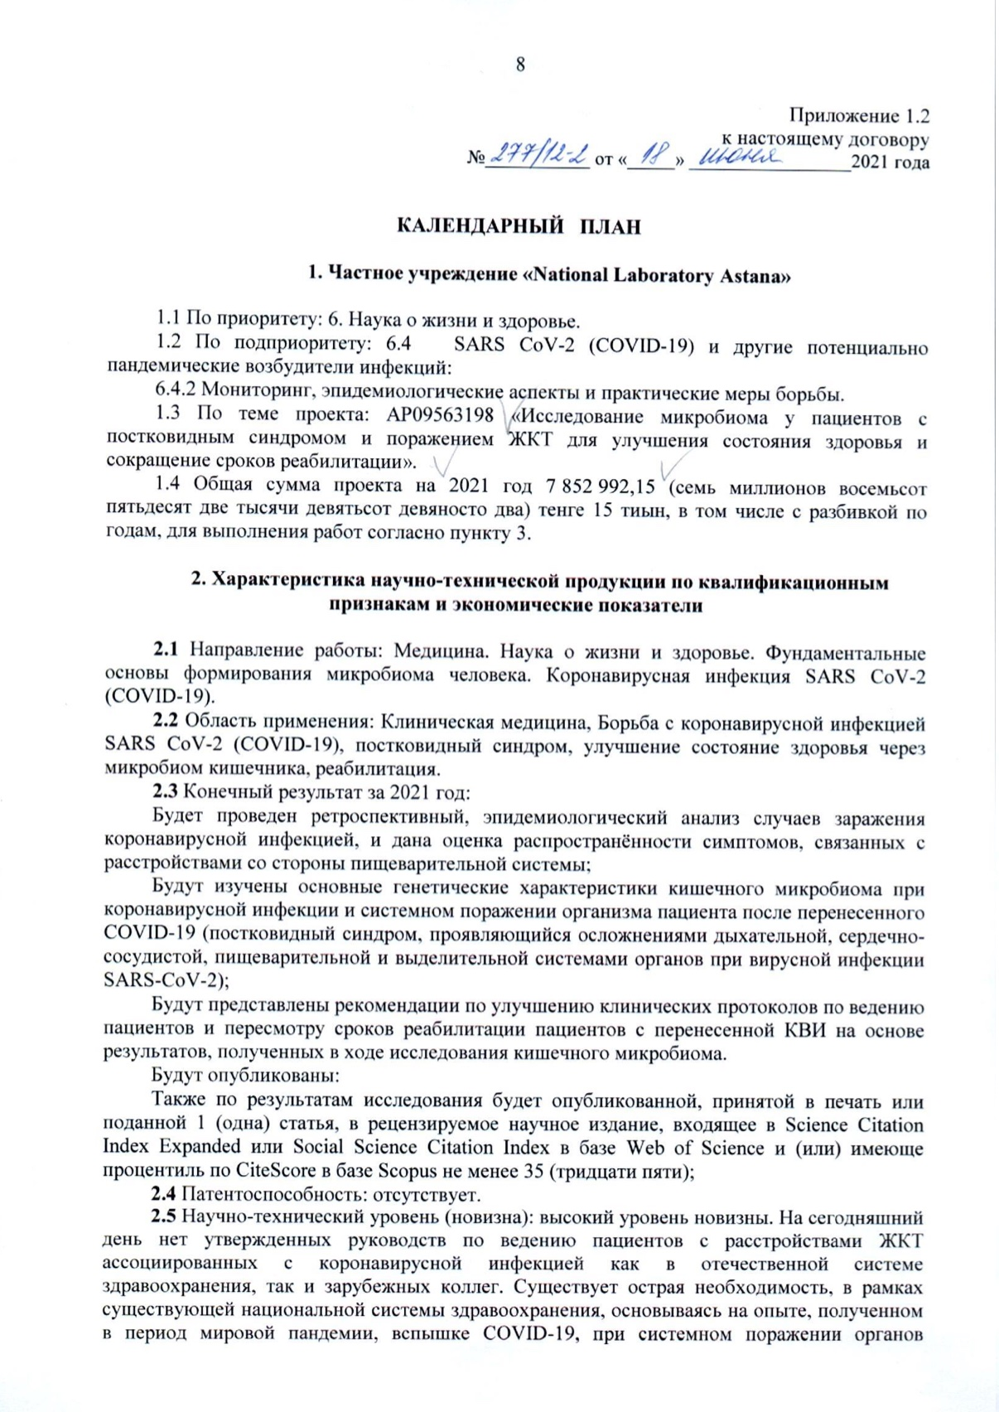
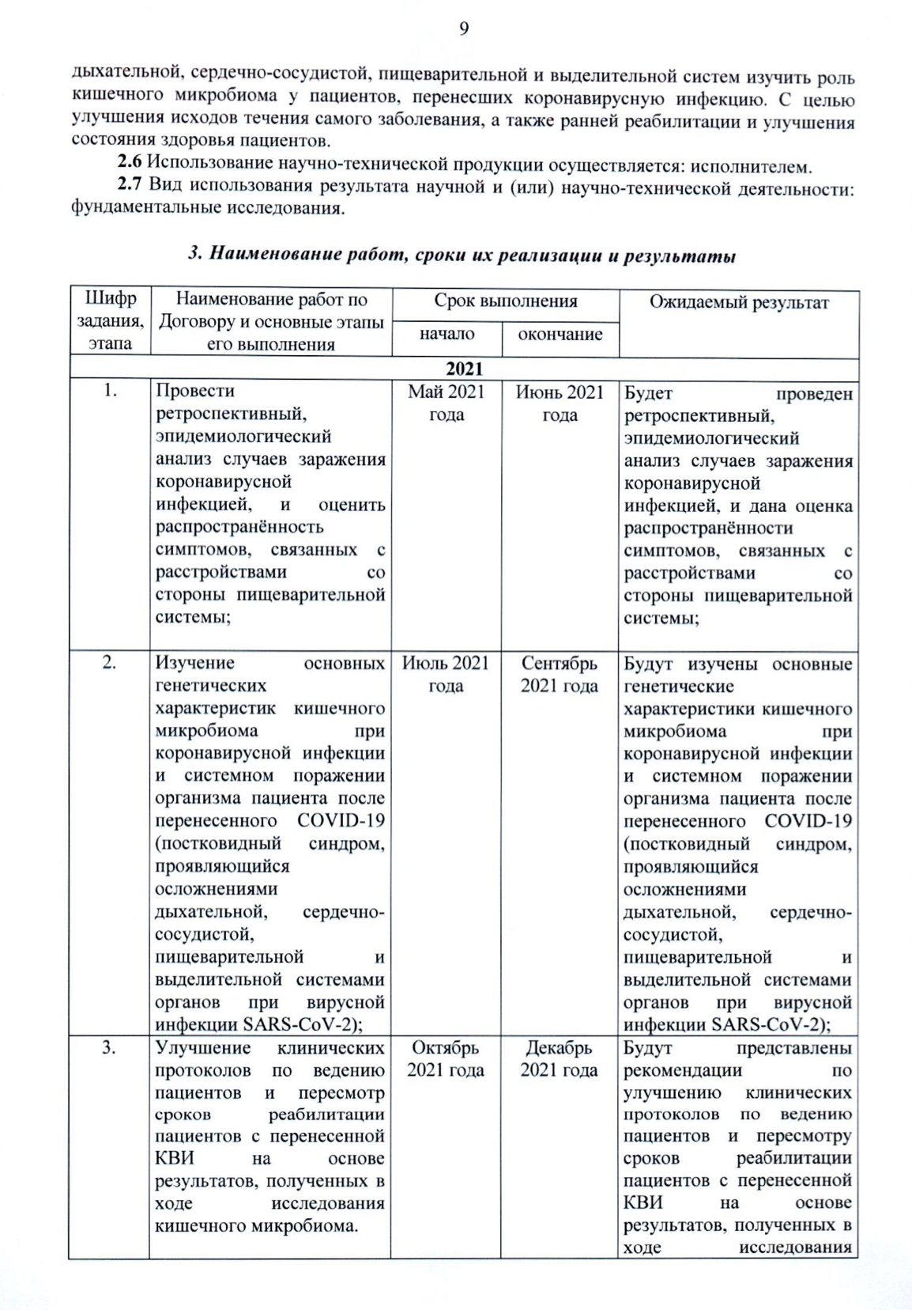
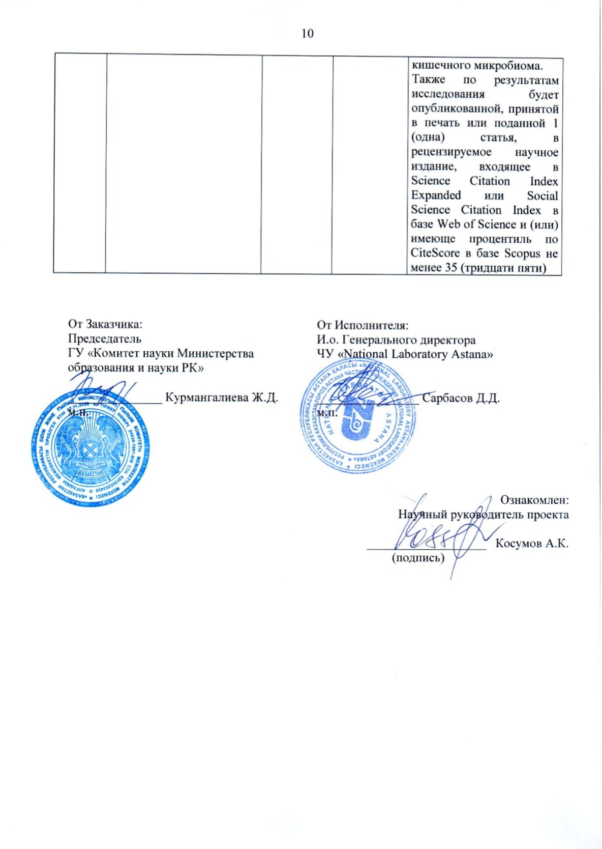

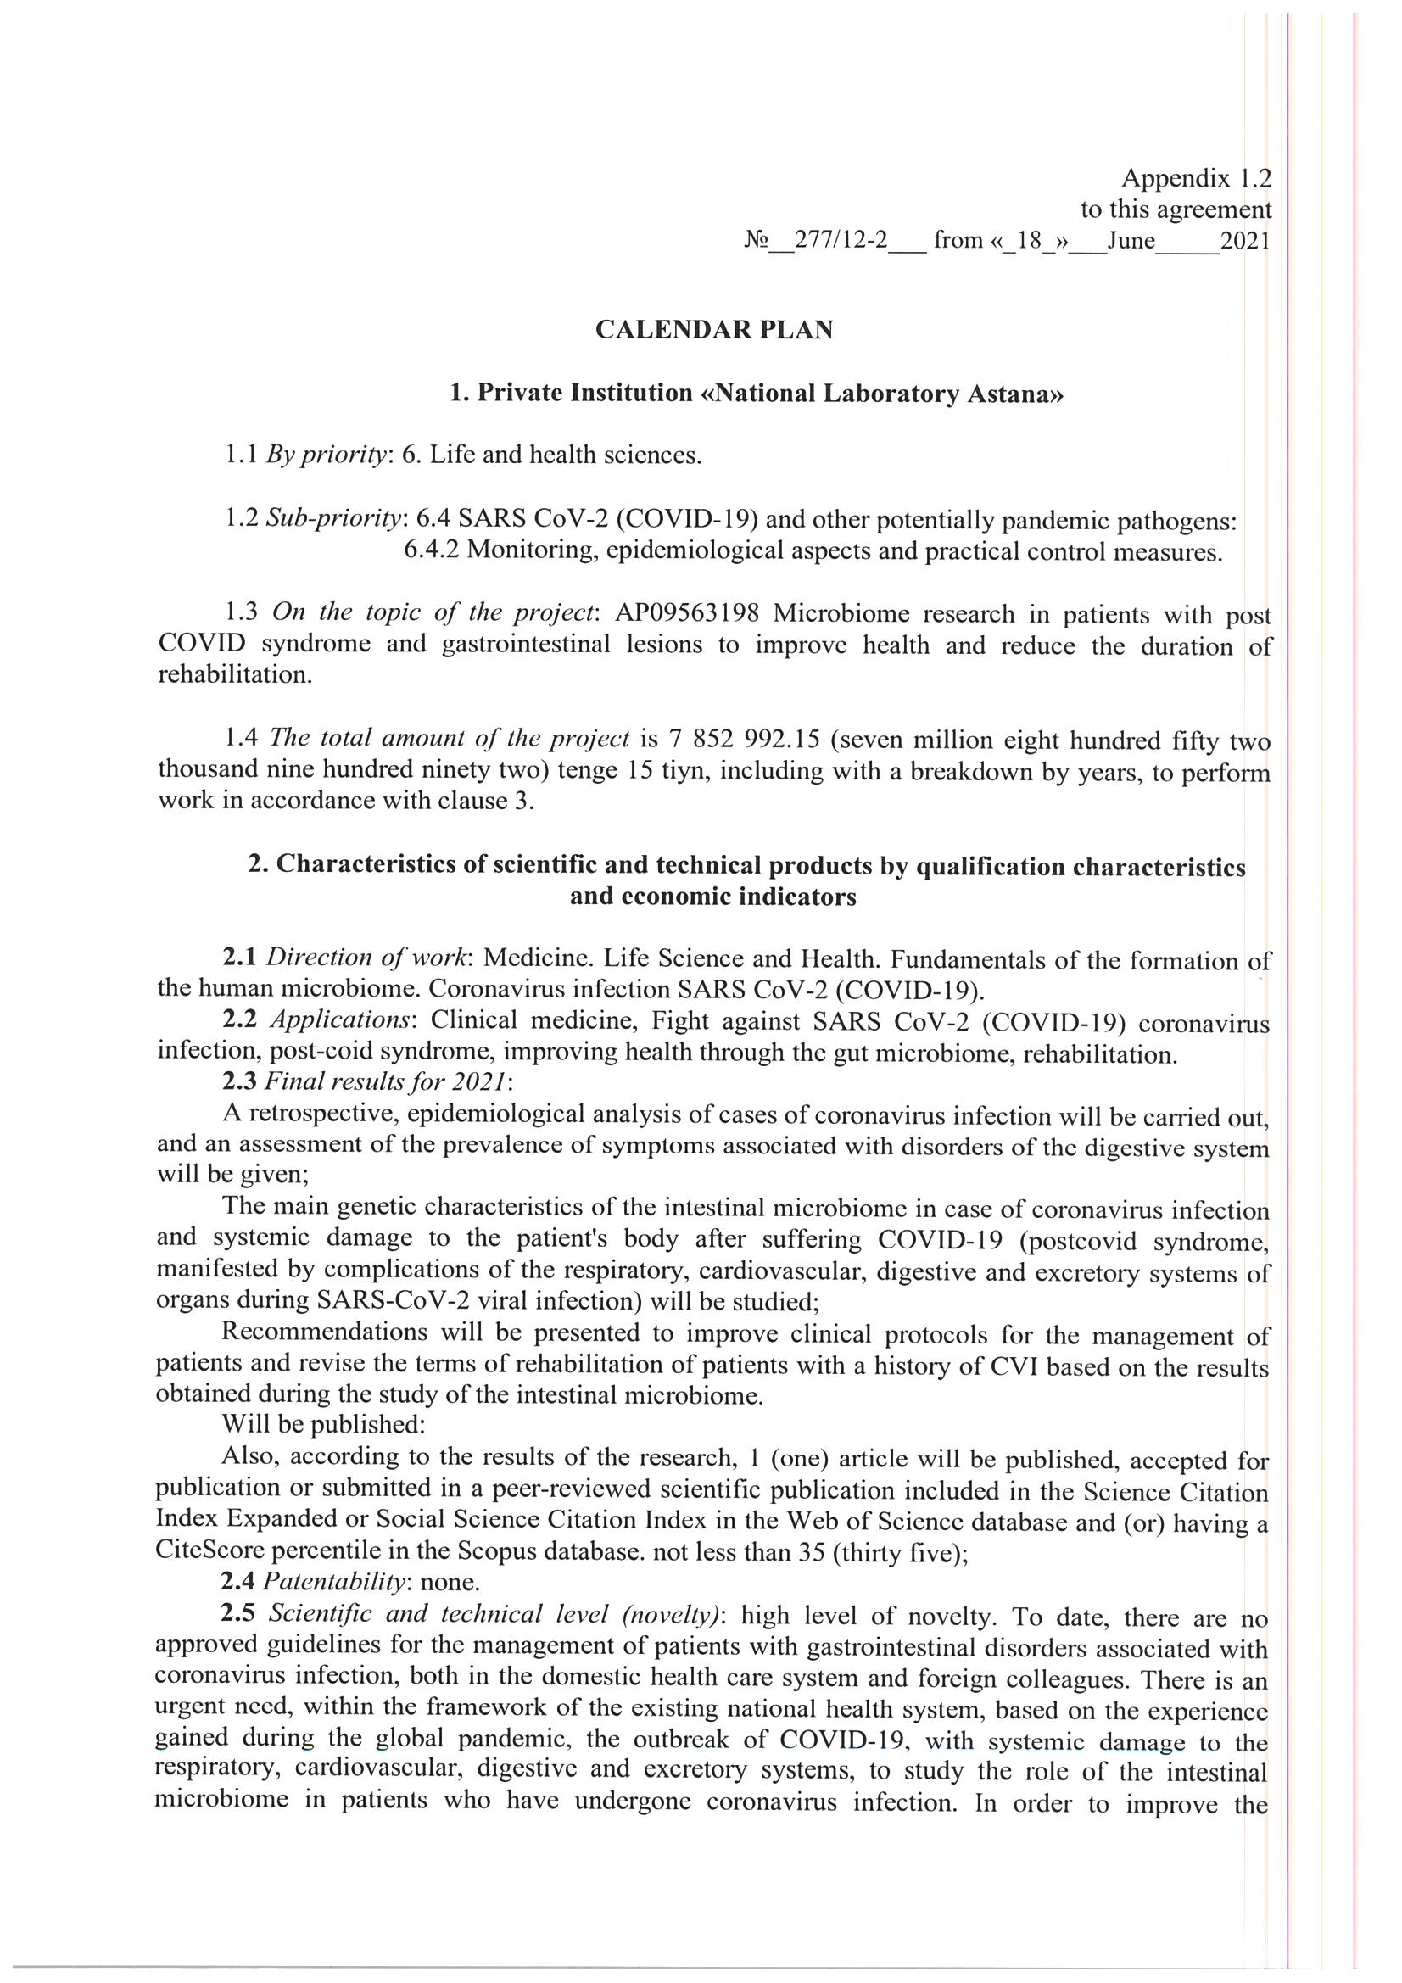

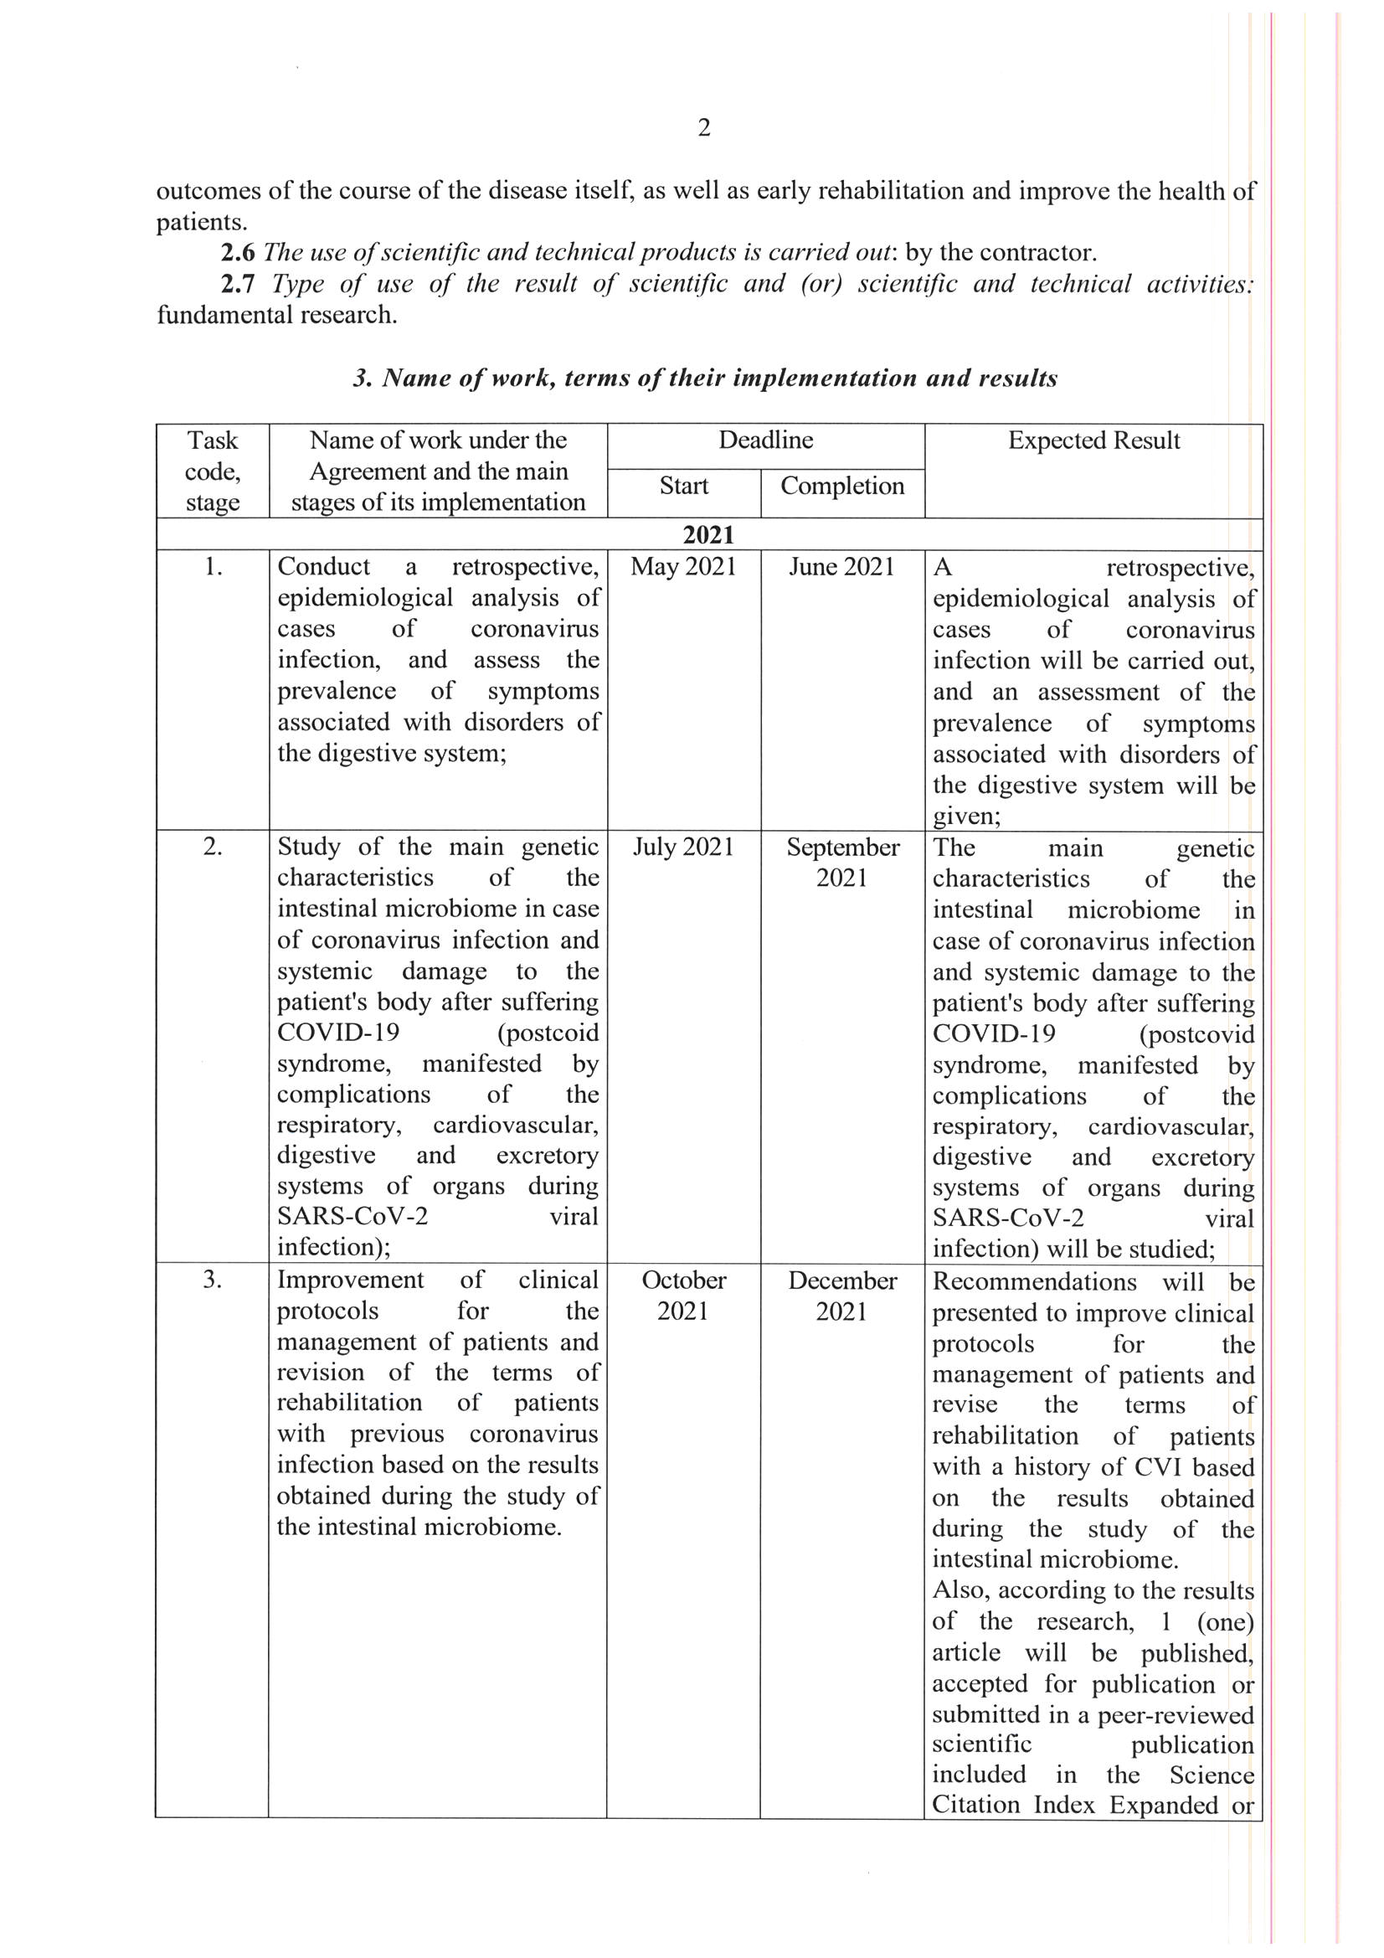
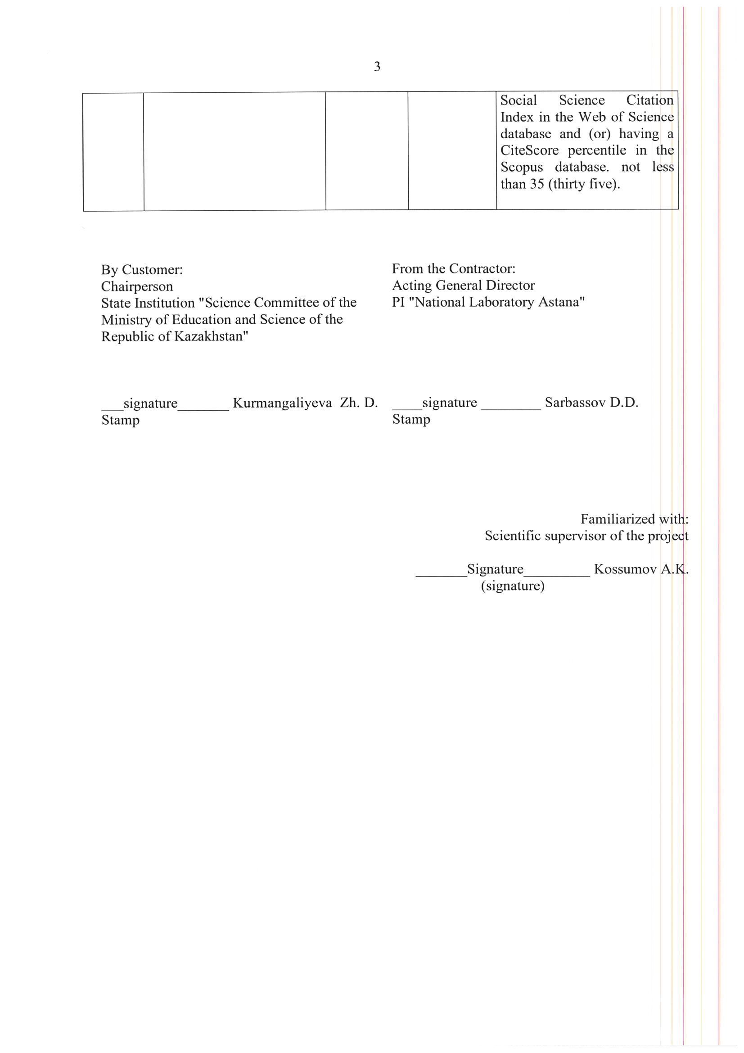

APPENDIX B
List of publications, abstracts and results of scientific and technical activities
№ | Article title | Authors | Journal | Database | Impact factor | Quartile
1 | Digestive system and SARS-COV-2: new era of microbiome study and gastrointestinal tract manifestations during the Covid-19 pandemic. Review article.  Status - manuscript submitted  (Appendix D) | Alibek Kossumov*, Karakoz Mussabay, Astghik Pepoyan, Vardan Tsaturyan, Ketevan Sidamonidze, David Tsereteli, Adil Supiyev, Samat Kozhakhmetov, Laura Chulenbayeva, Marat Dusmagambetov, Massimo Pignatelli, Zhaxybay Zhumadilov, Francesco Marotta, Almagul Kushugulova  *Corresponding authors e-mail addresses: Alibek Kossumov, 53 Kabanbay Batyr Avenue  Nur-Sultan, KZ 010000, Mobile: +7 701 925 74 99. E-mail: alibek.kossumov@nu.edu.kz | Rejuvenation Research | Scopus | 5.8 | Q1/  84th percentile

List of abstracts at international conferences
№ | Conference | Participation type | Title of the report | Authors  (project participants)
1 | International conference «Topical issues of biological safety in modern conditions», September 22-23, 2021 | Thesis | Gut microbiota composition and disease severity in patients with COVID-19: Armenian population  (Appendix E) | V.V. Tsaturyan, A. Kushugulova, K. Sidamonidze, D. Tsereteli, A.Z. Pepoyan
2 | International conference «Topical issues of biological safety in modern conditions», September 22-23, 2021 | Thesis | Relevance of the study of the intestinal microbiome in coronavirus infection SARS-CoV-2 (Актуальность исследования микробиома кишечника при коронавирусной инфекции SARS-CoV-2)  (Appendix E) | К.Mussabai, А.Kossumov, А.Kushugulova
3 | International conference «Topical issues of biological safety in modern conditions», September 22-23, 2021 | Thesis | Histological data of lung autopsies during the COVID-19 pandemic in Nur-Sultan (Гистологические данные аутопсий легких в период пандемии COVID-19 в городе Нур-Султан)  (Appendix E) | K.Osspanova, T.Zhakupova, T. Omarov, A.Kossumov

APPENDIX C
Screenshot from the official online journal submission system
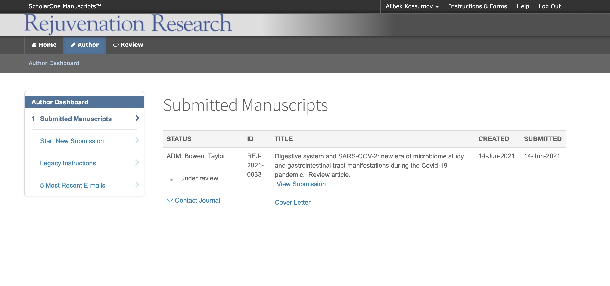
APPENDIX D
Manuscript reprint

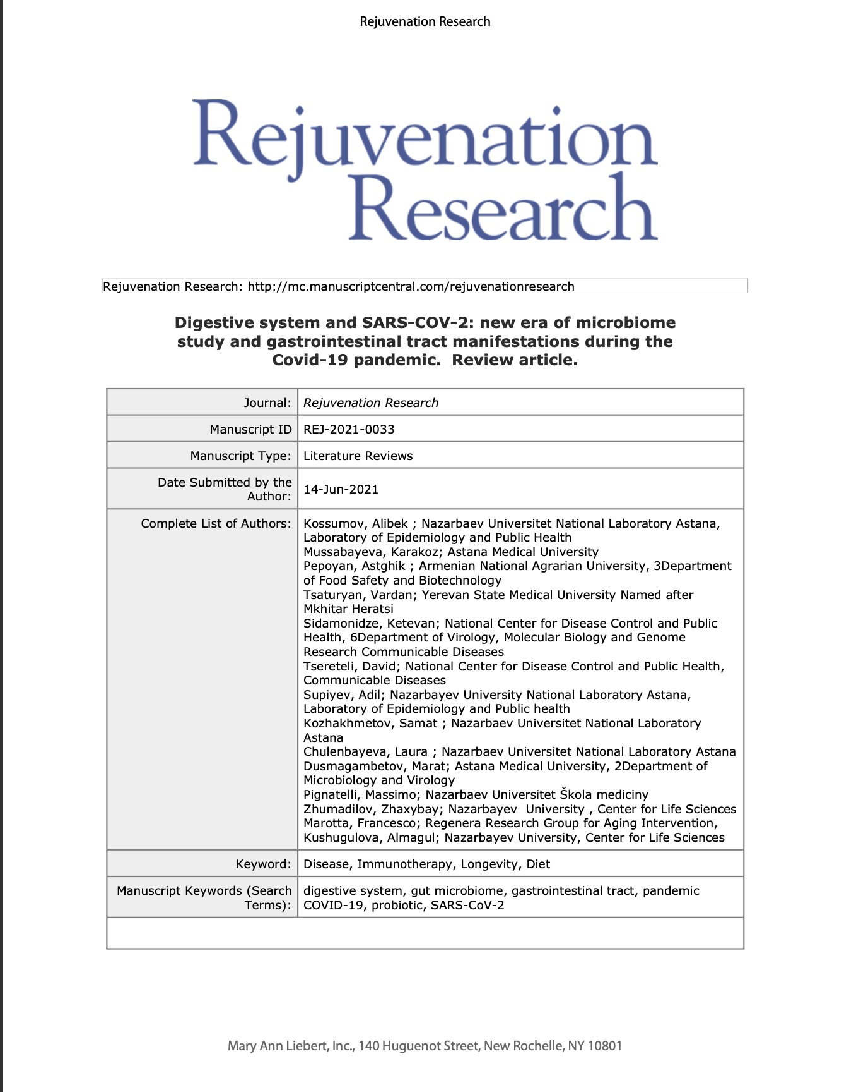
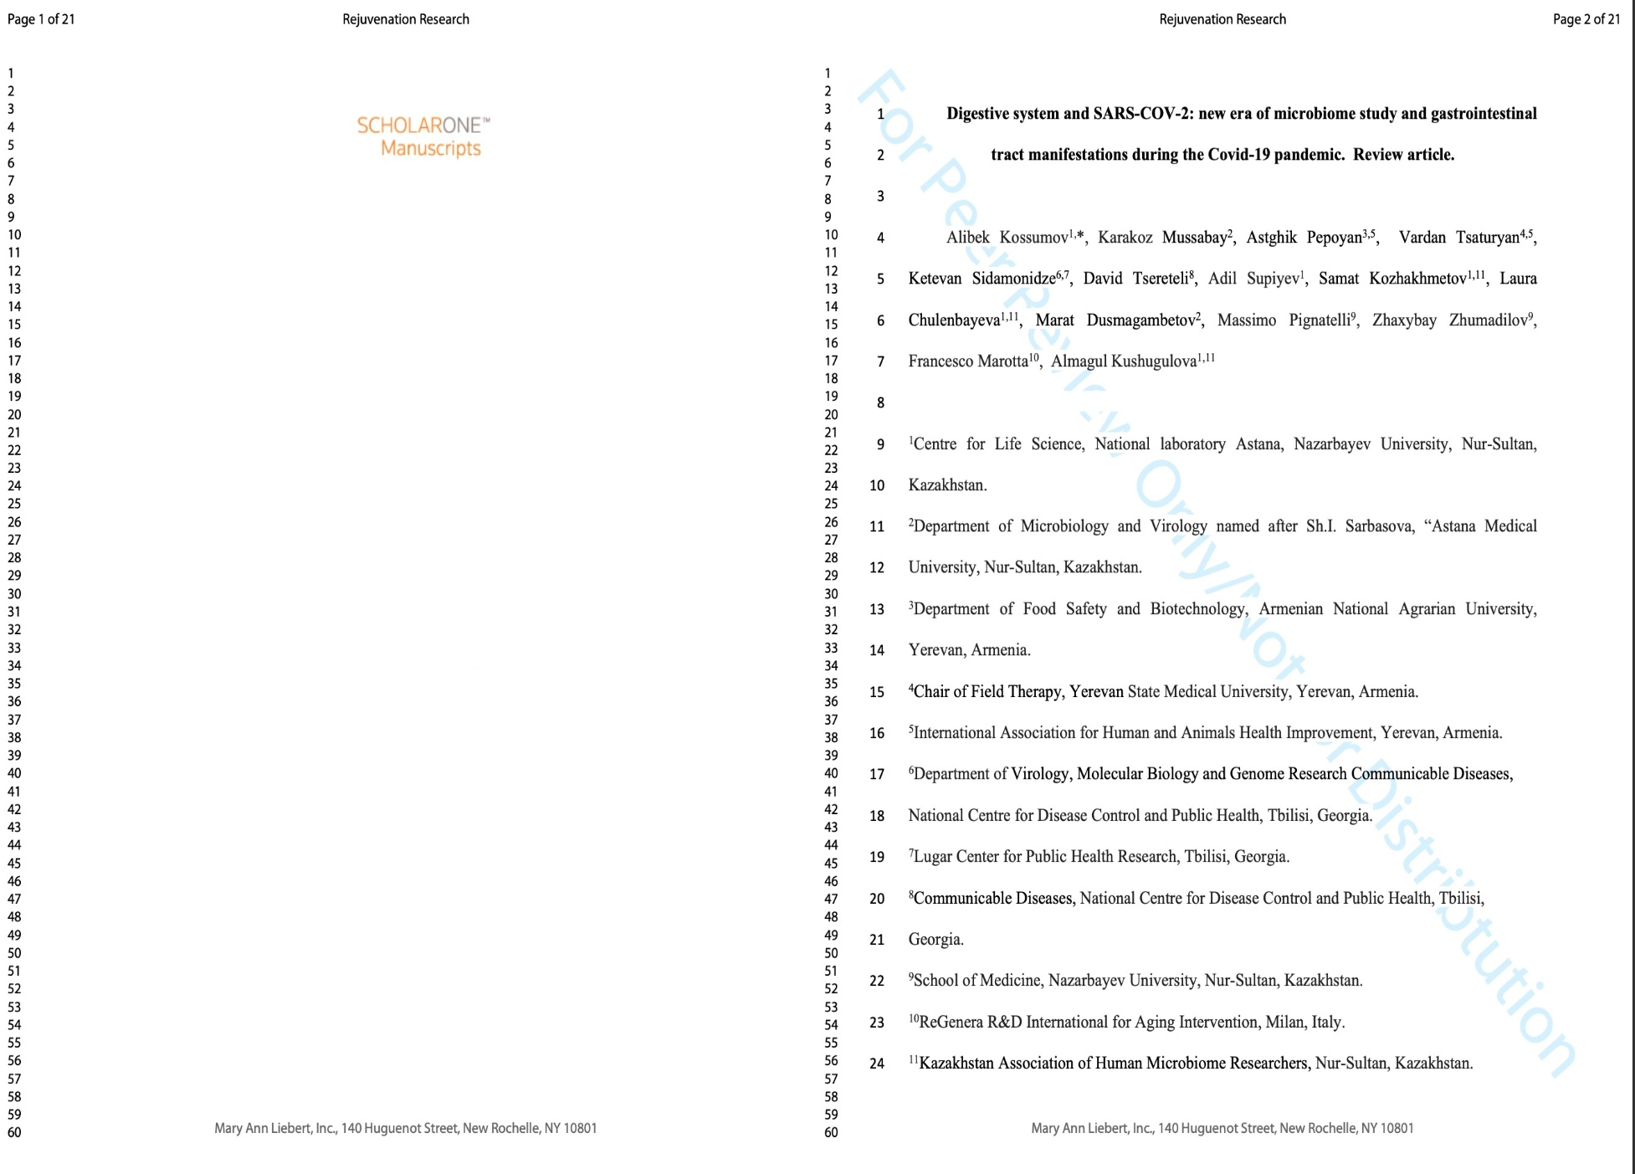

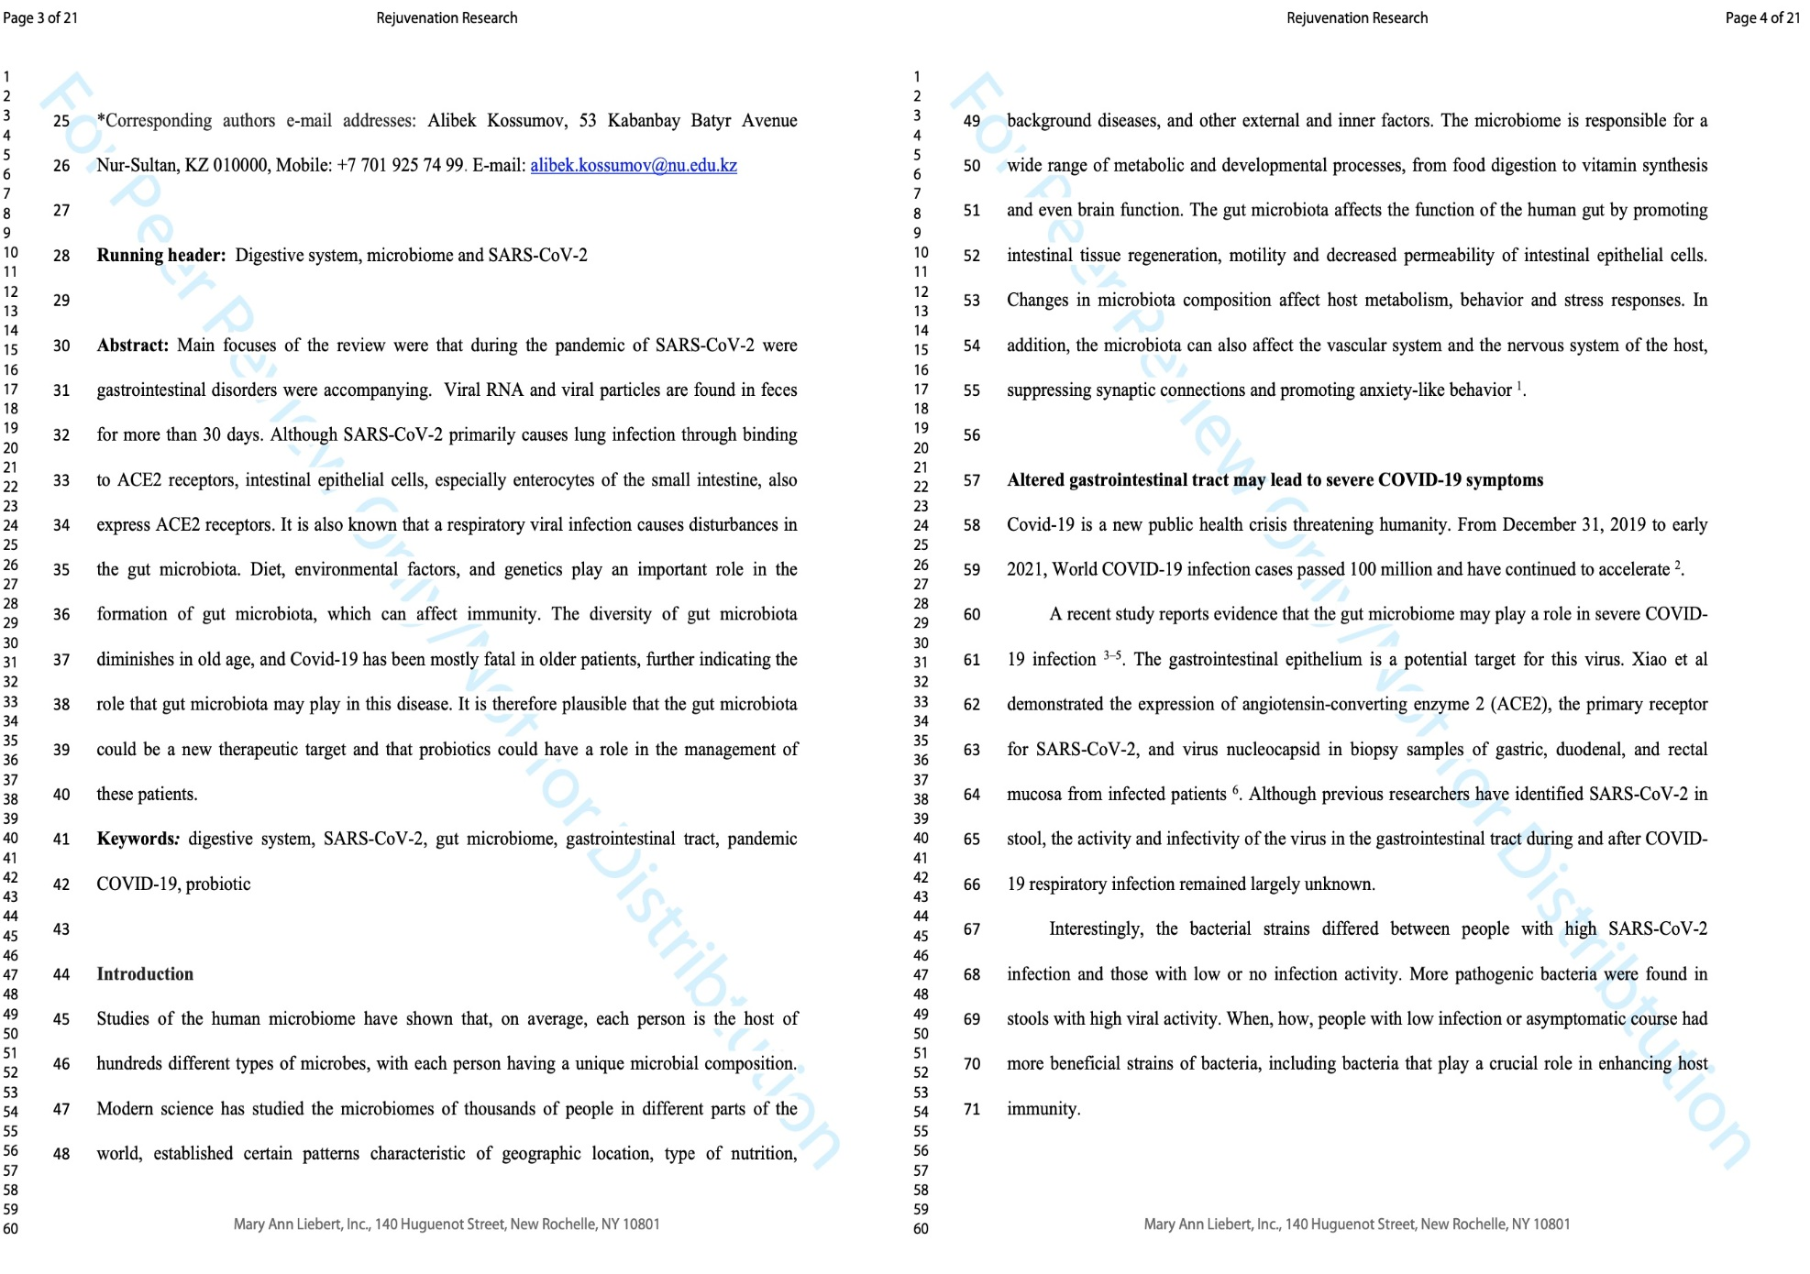

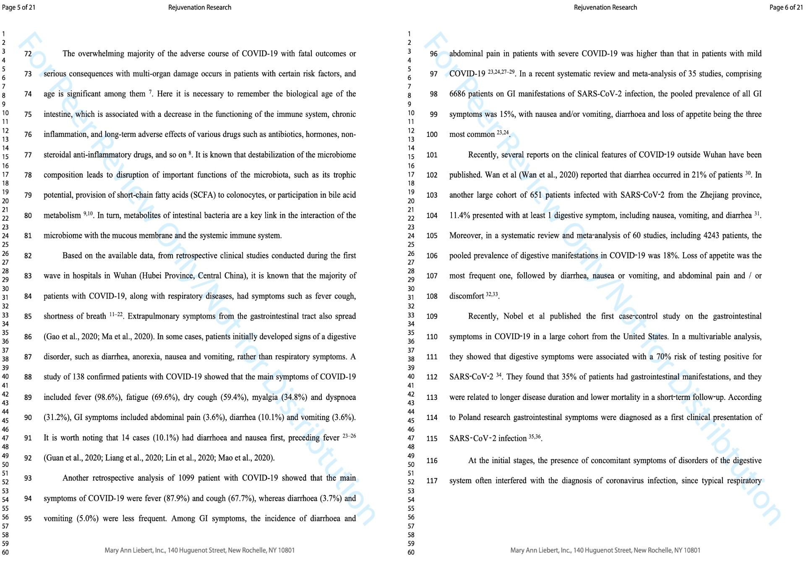
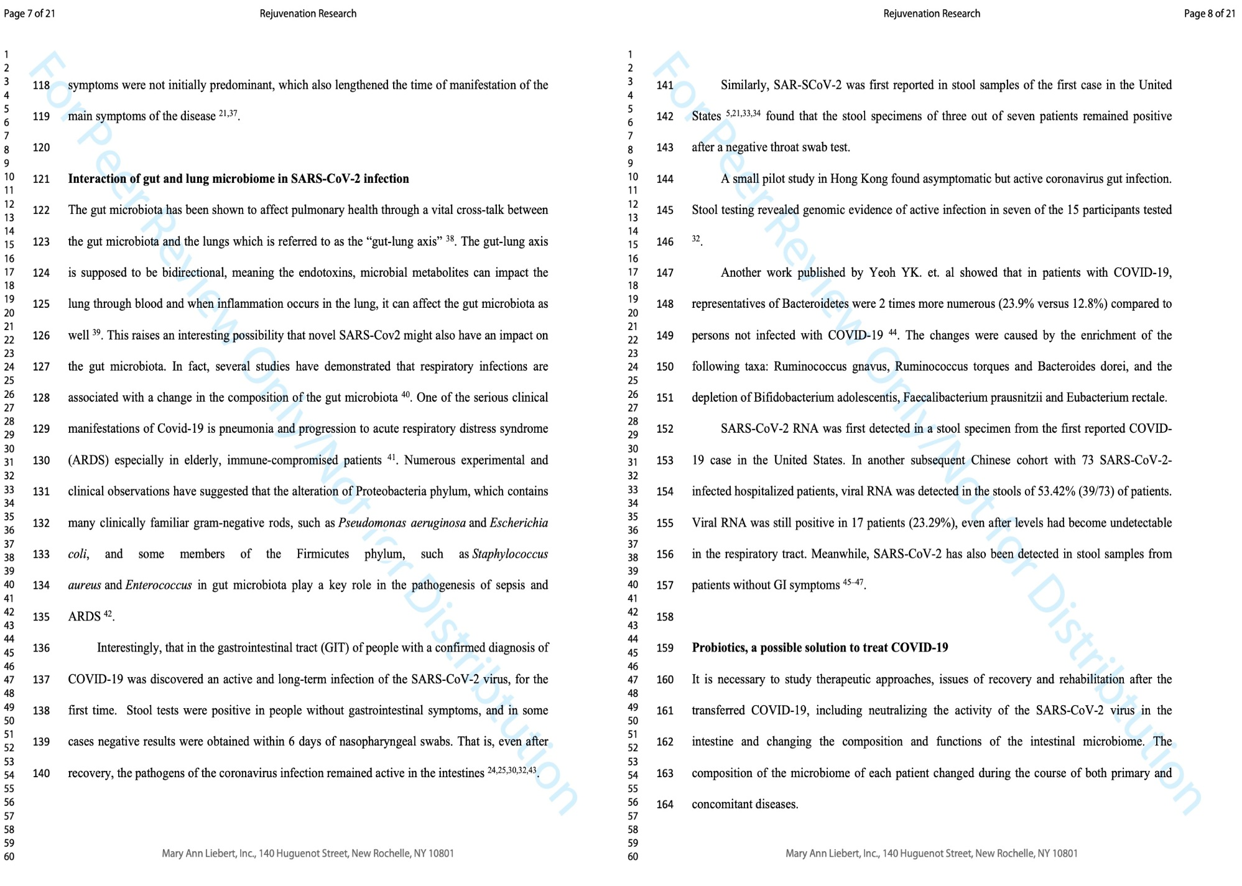
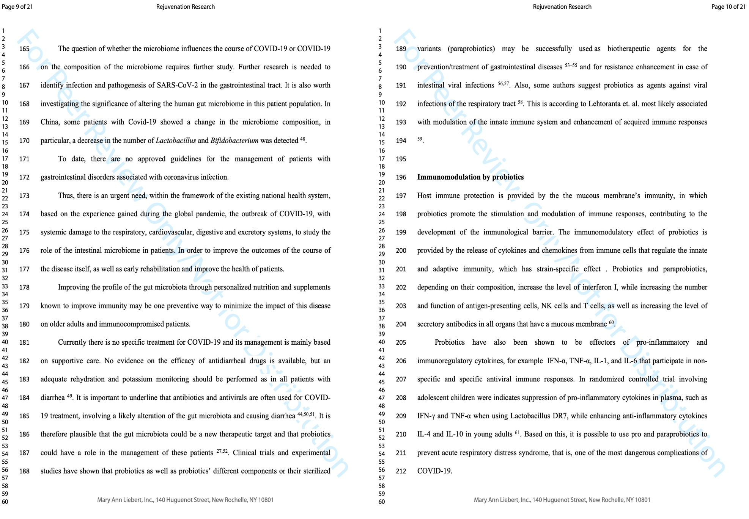
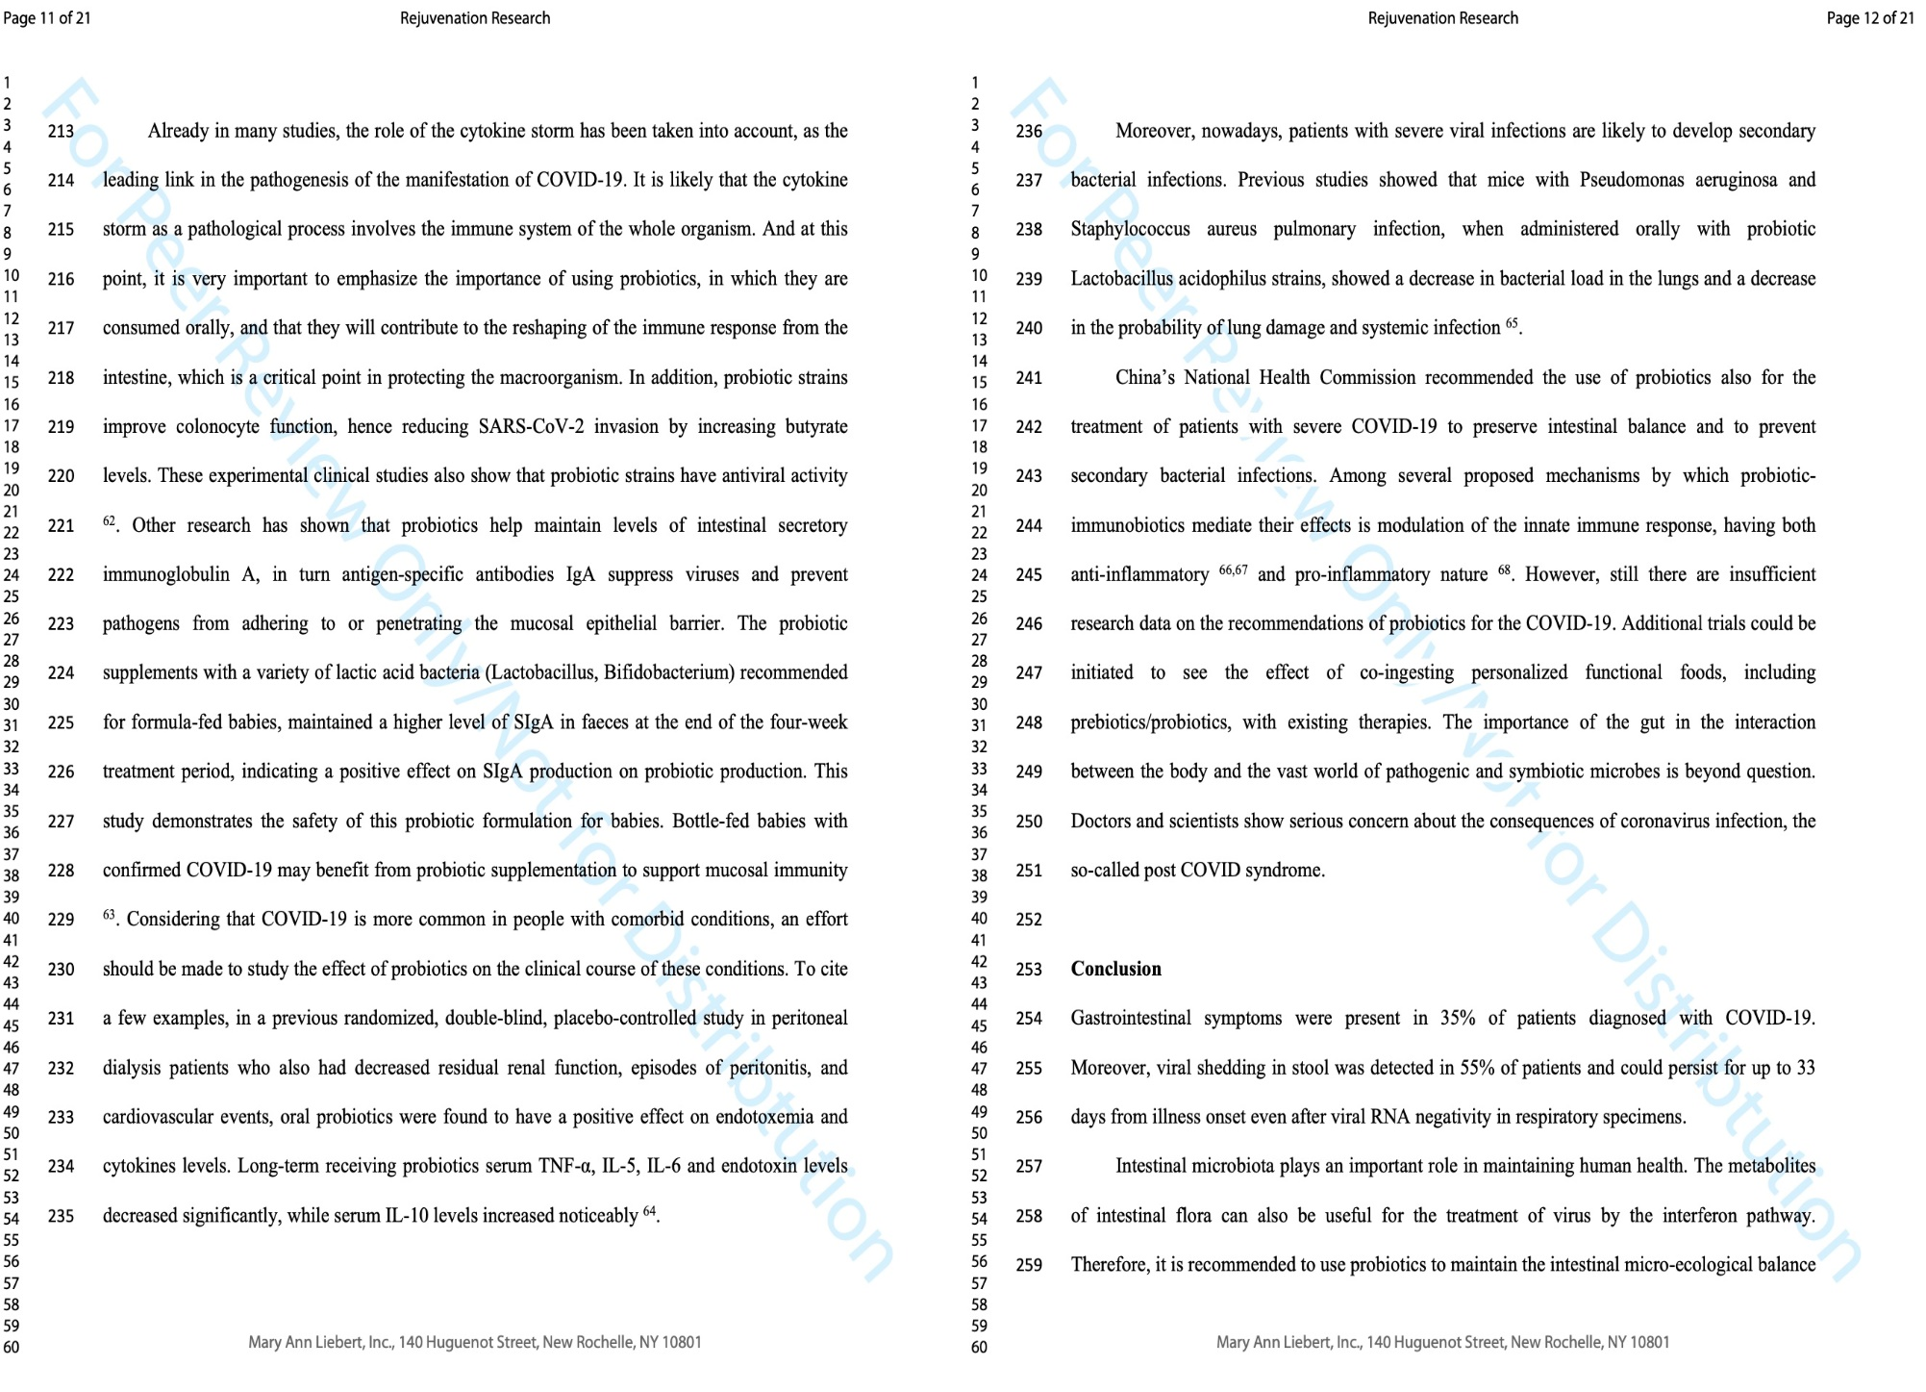
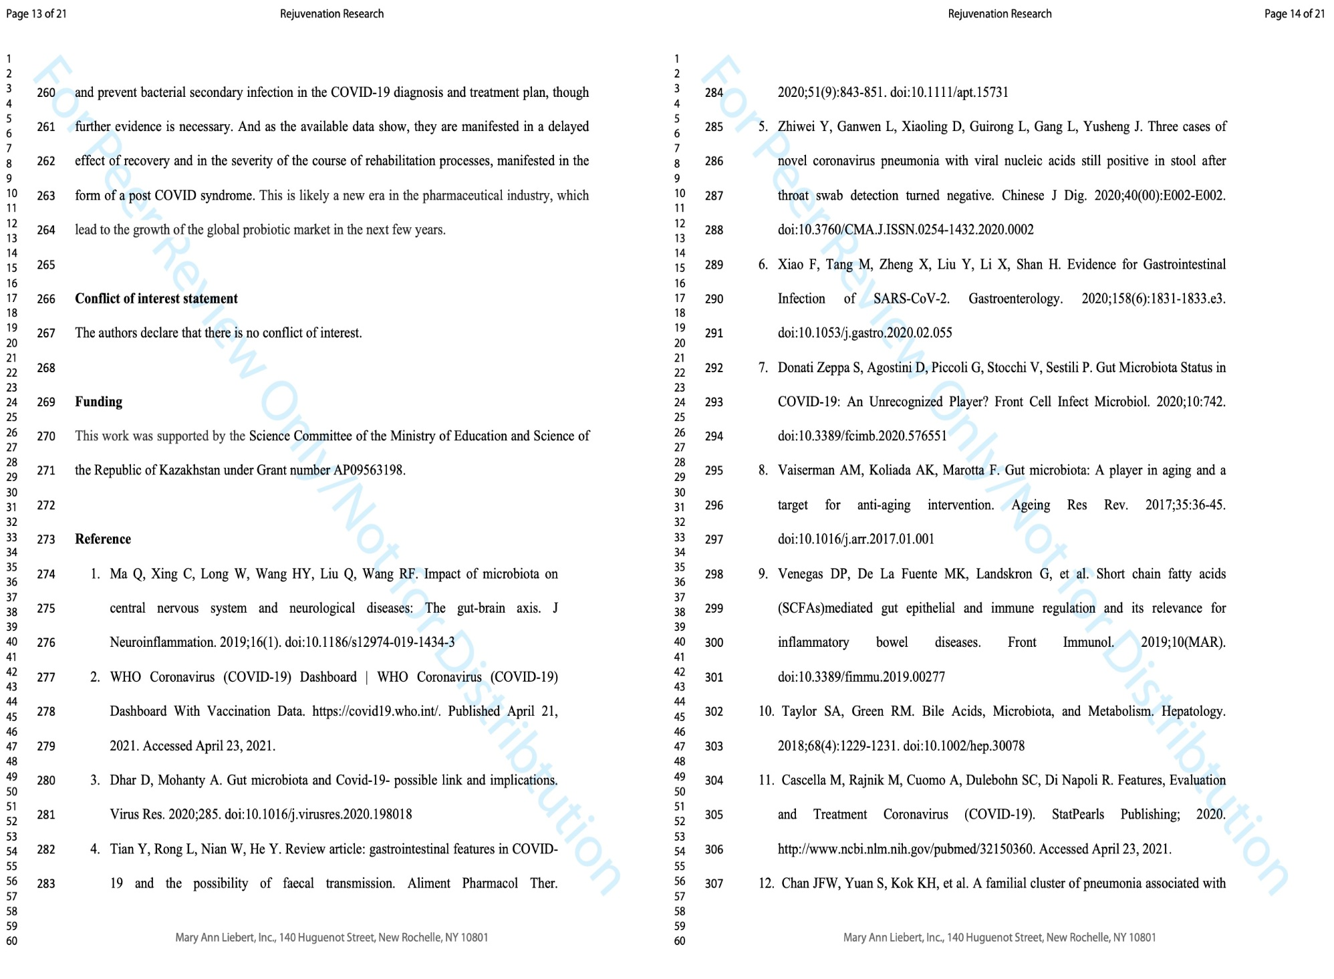
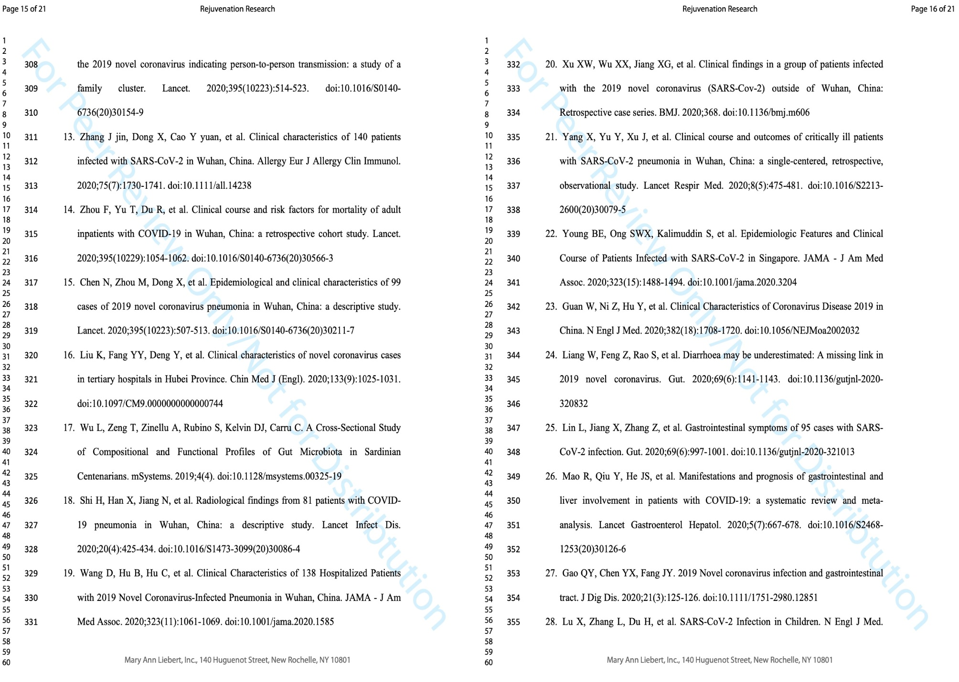
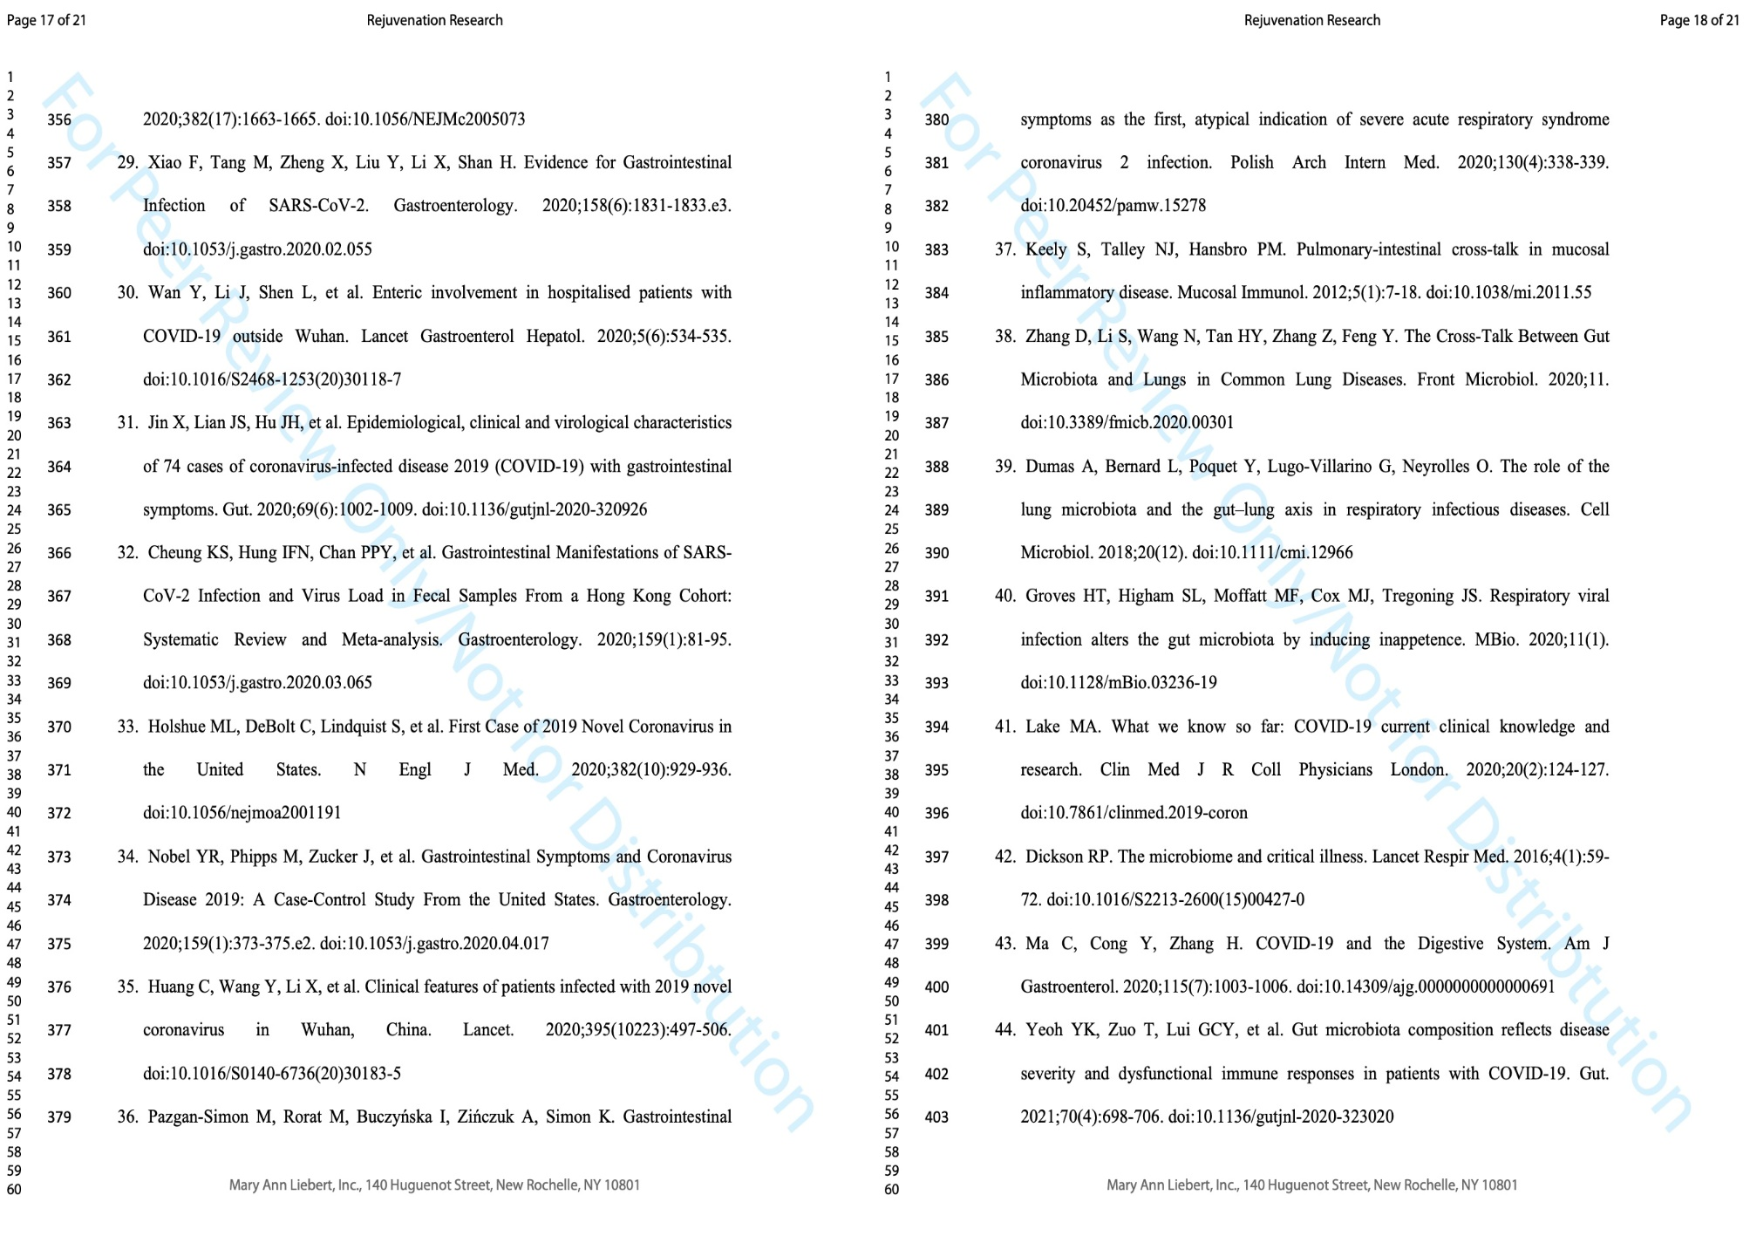
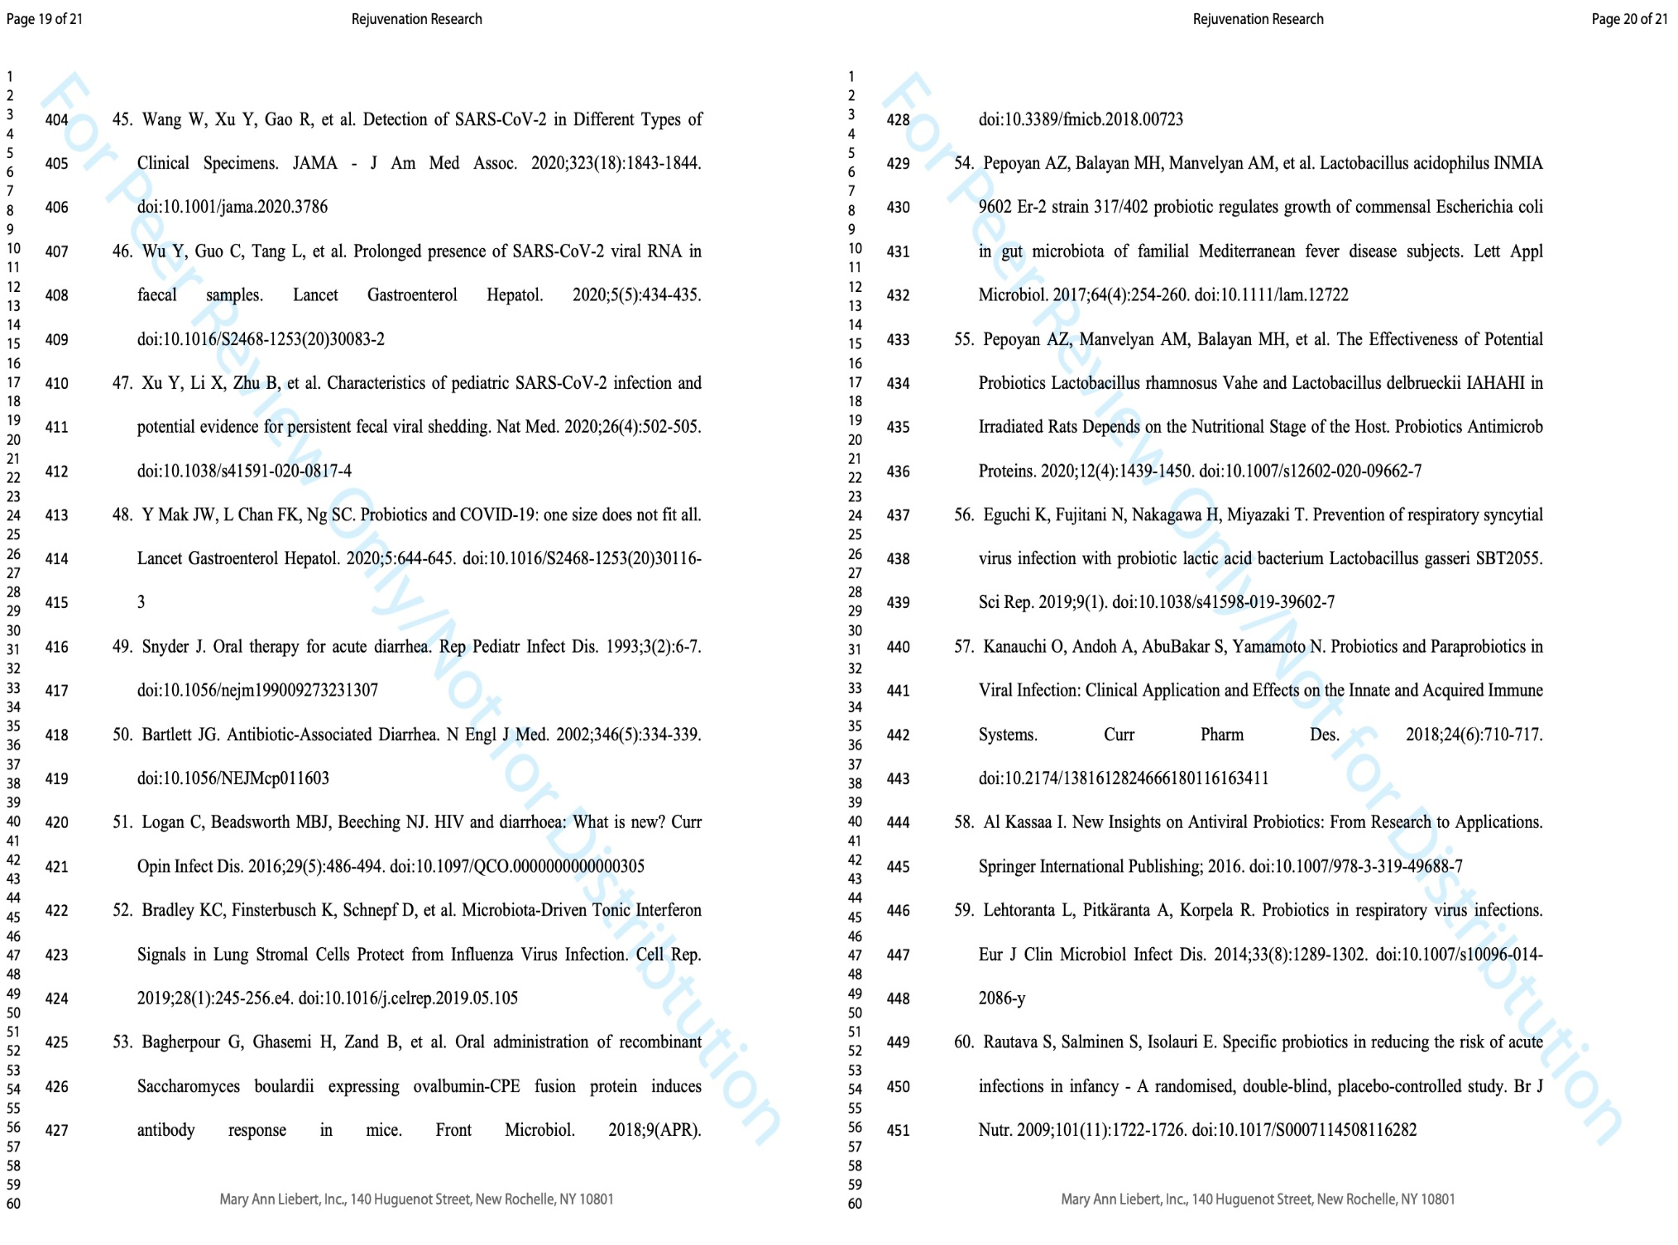
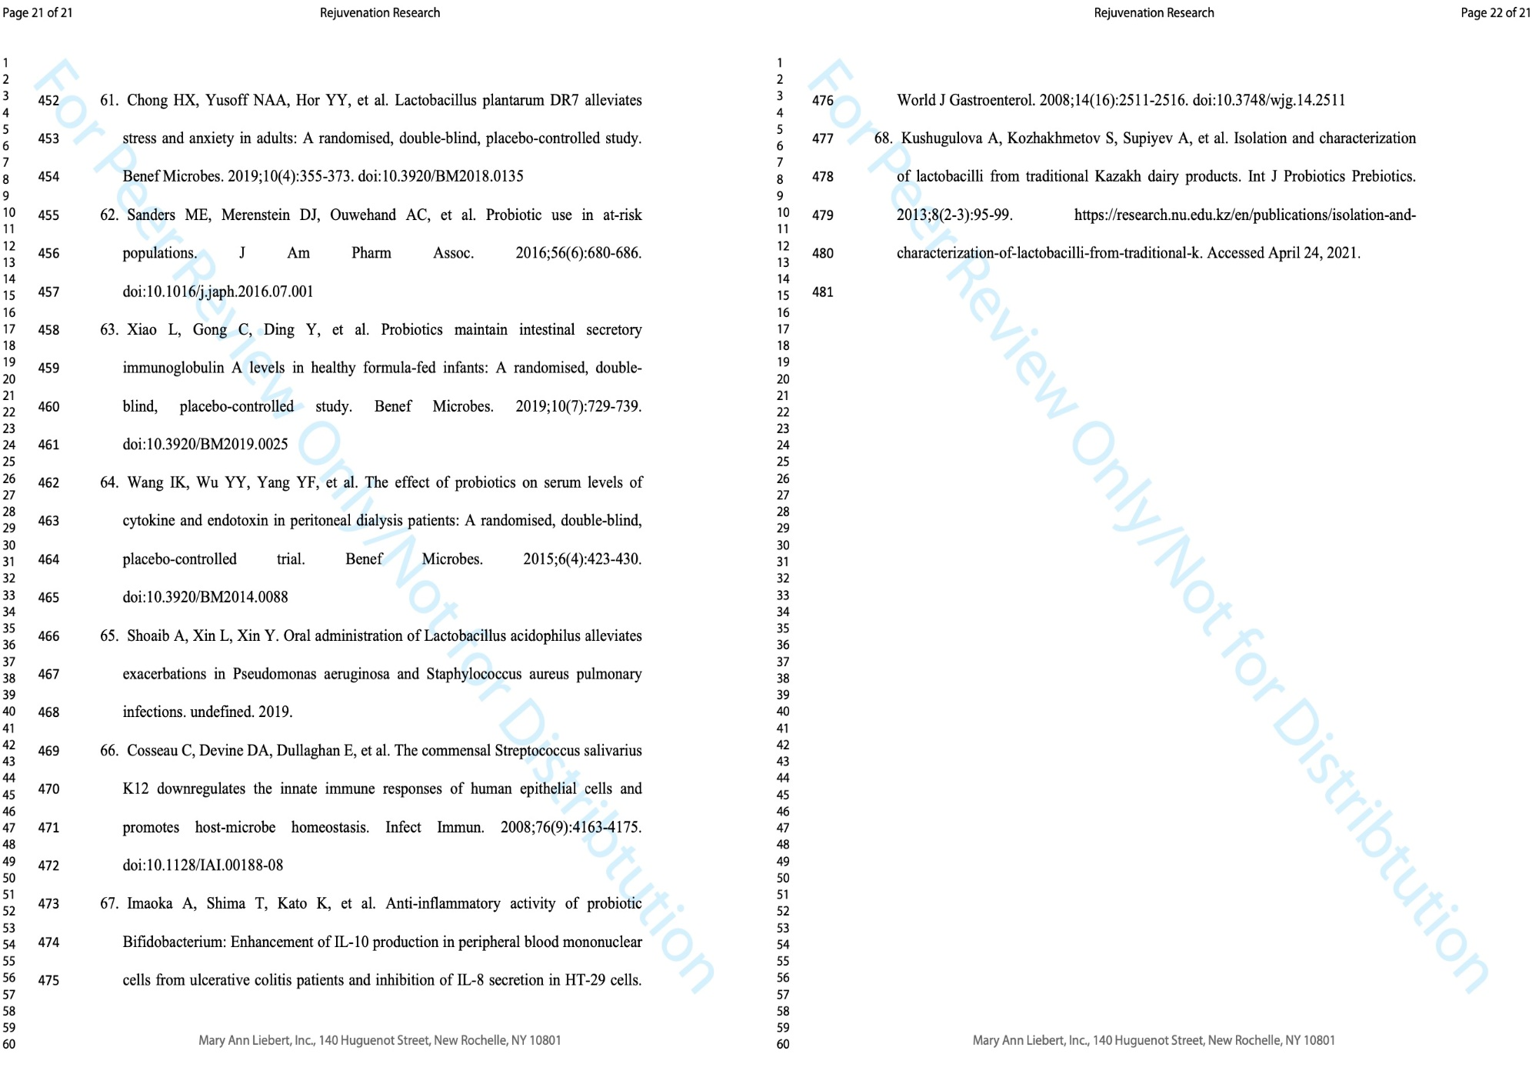
APPENDIX E
Abstracts reprints in the conference collection
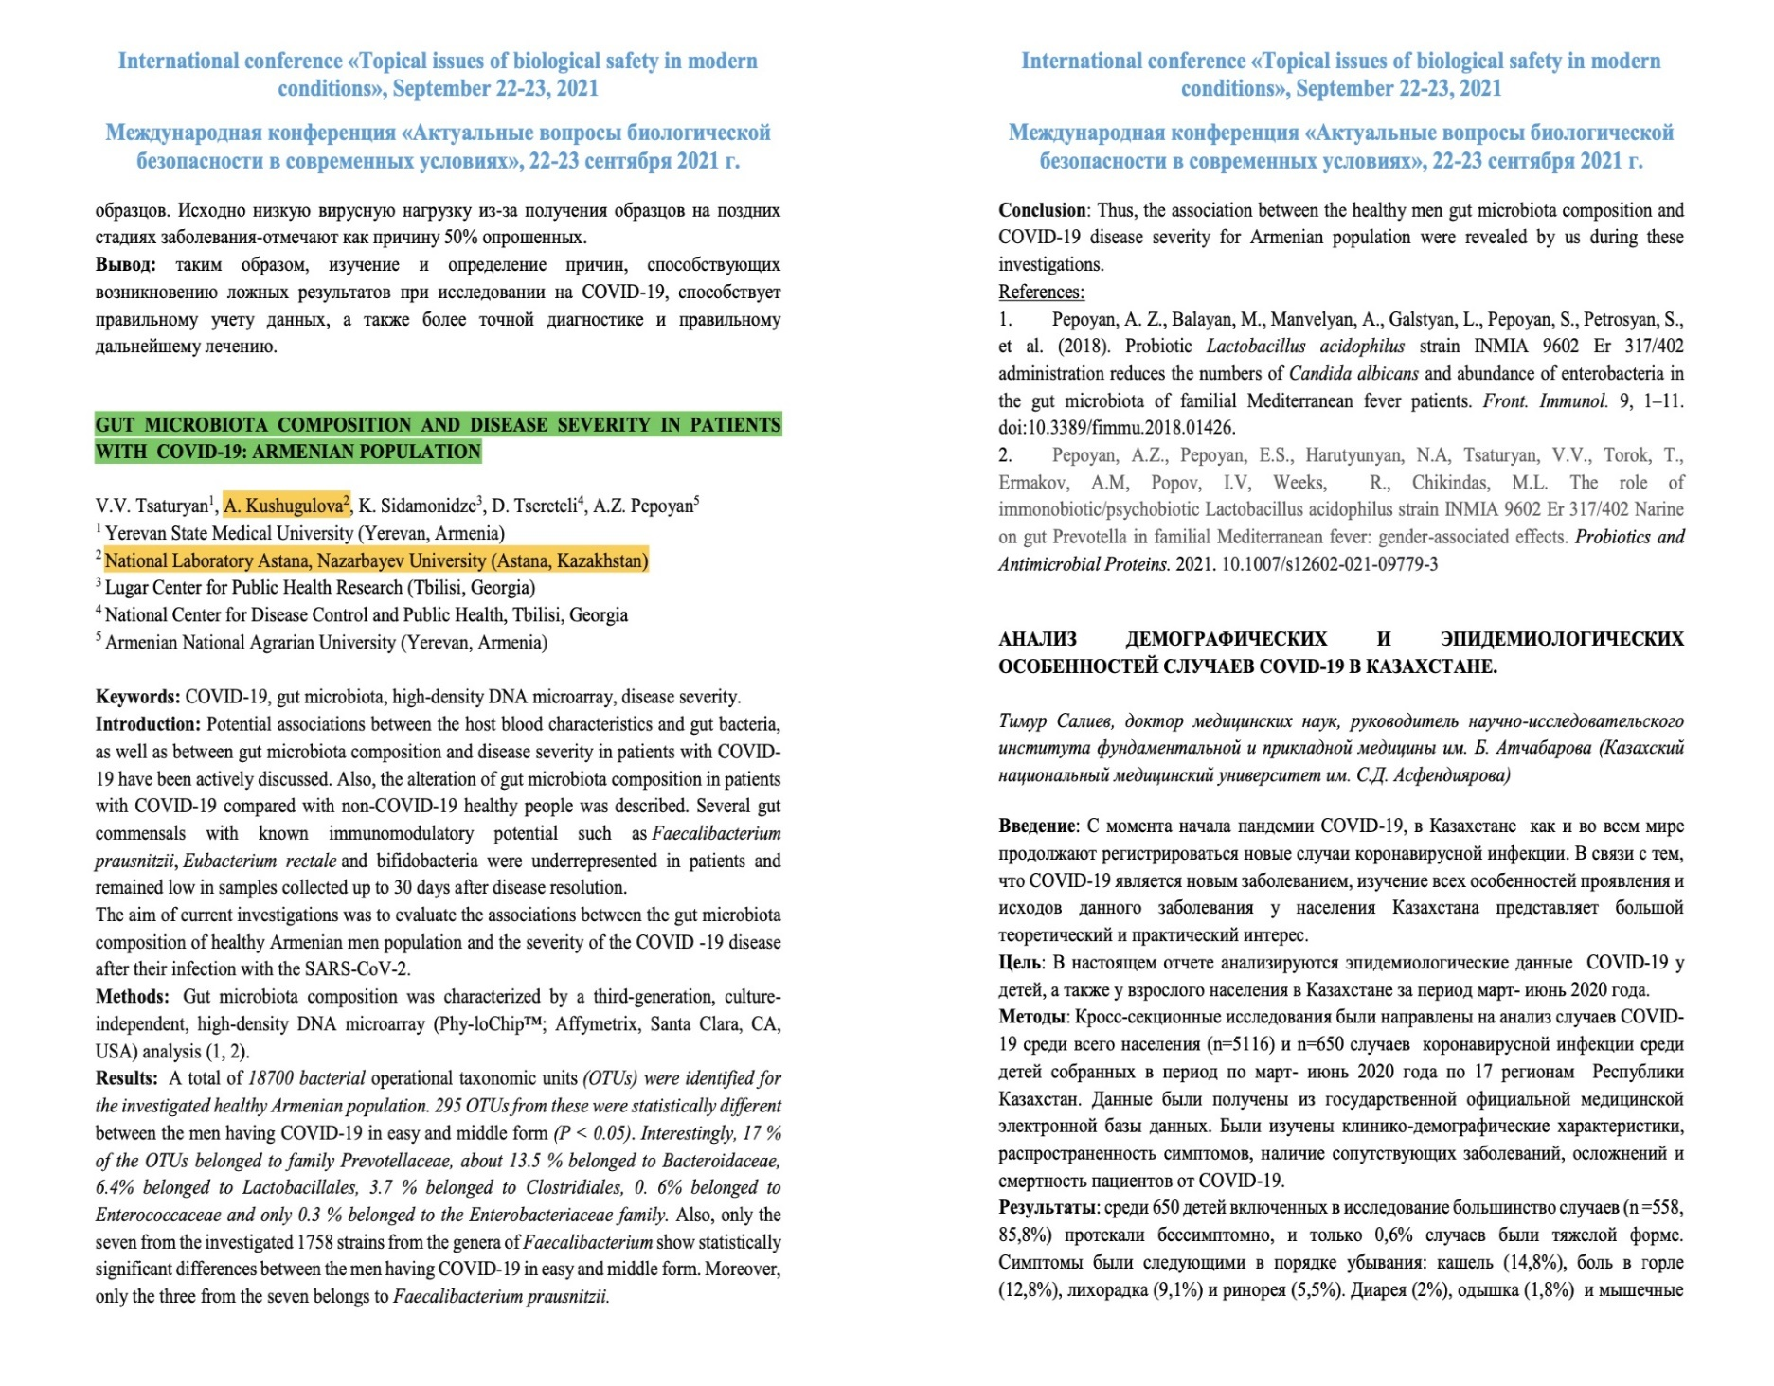
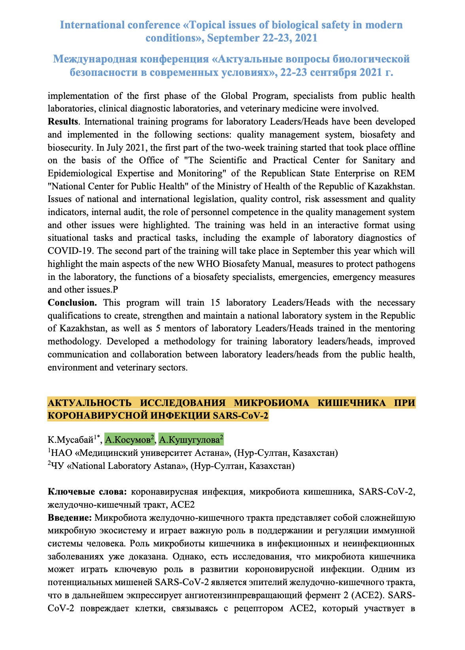
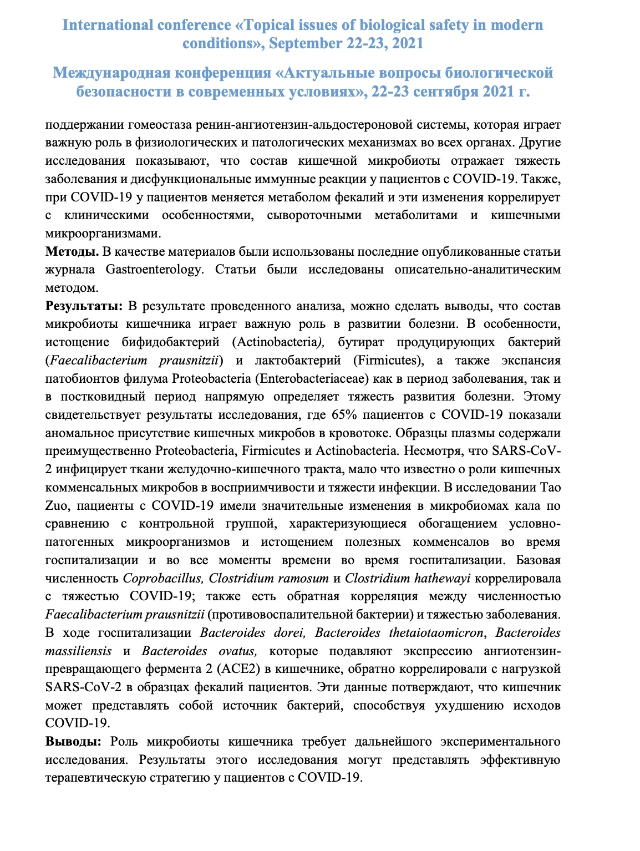
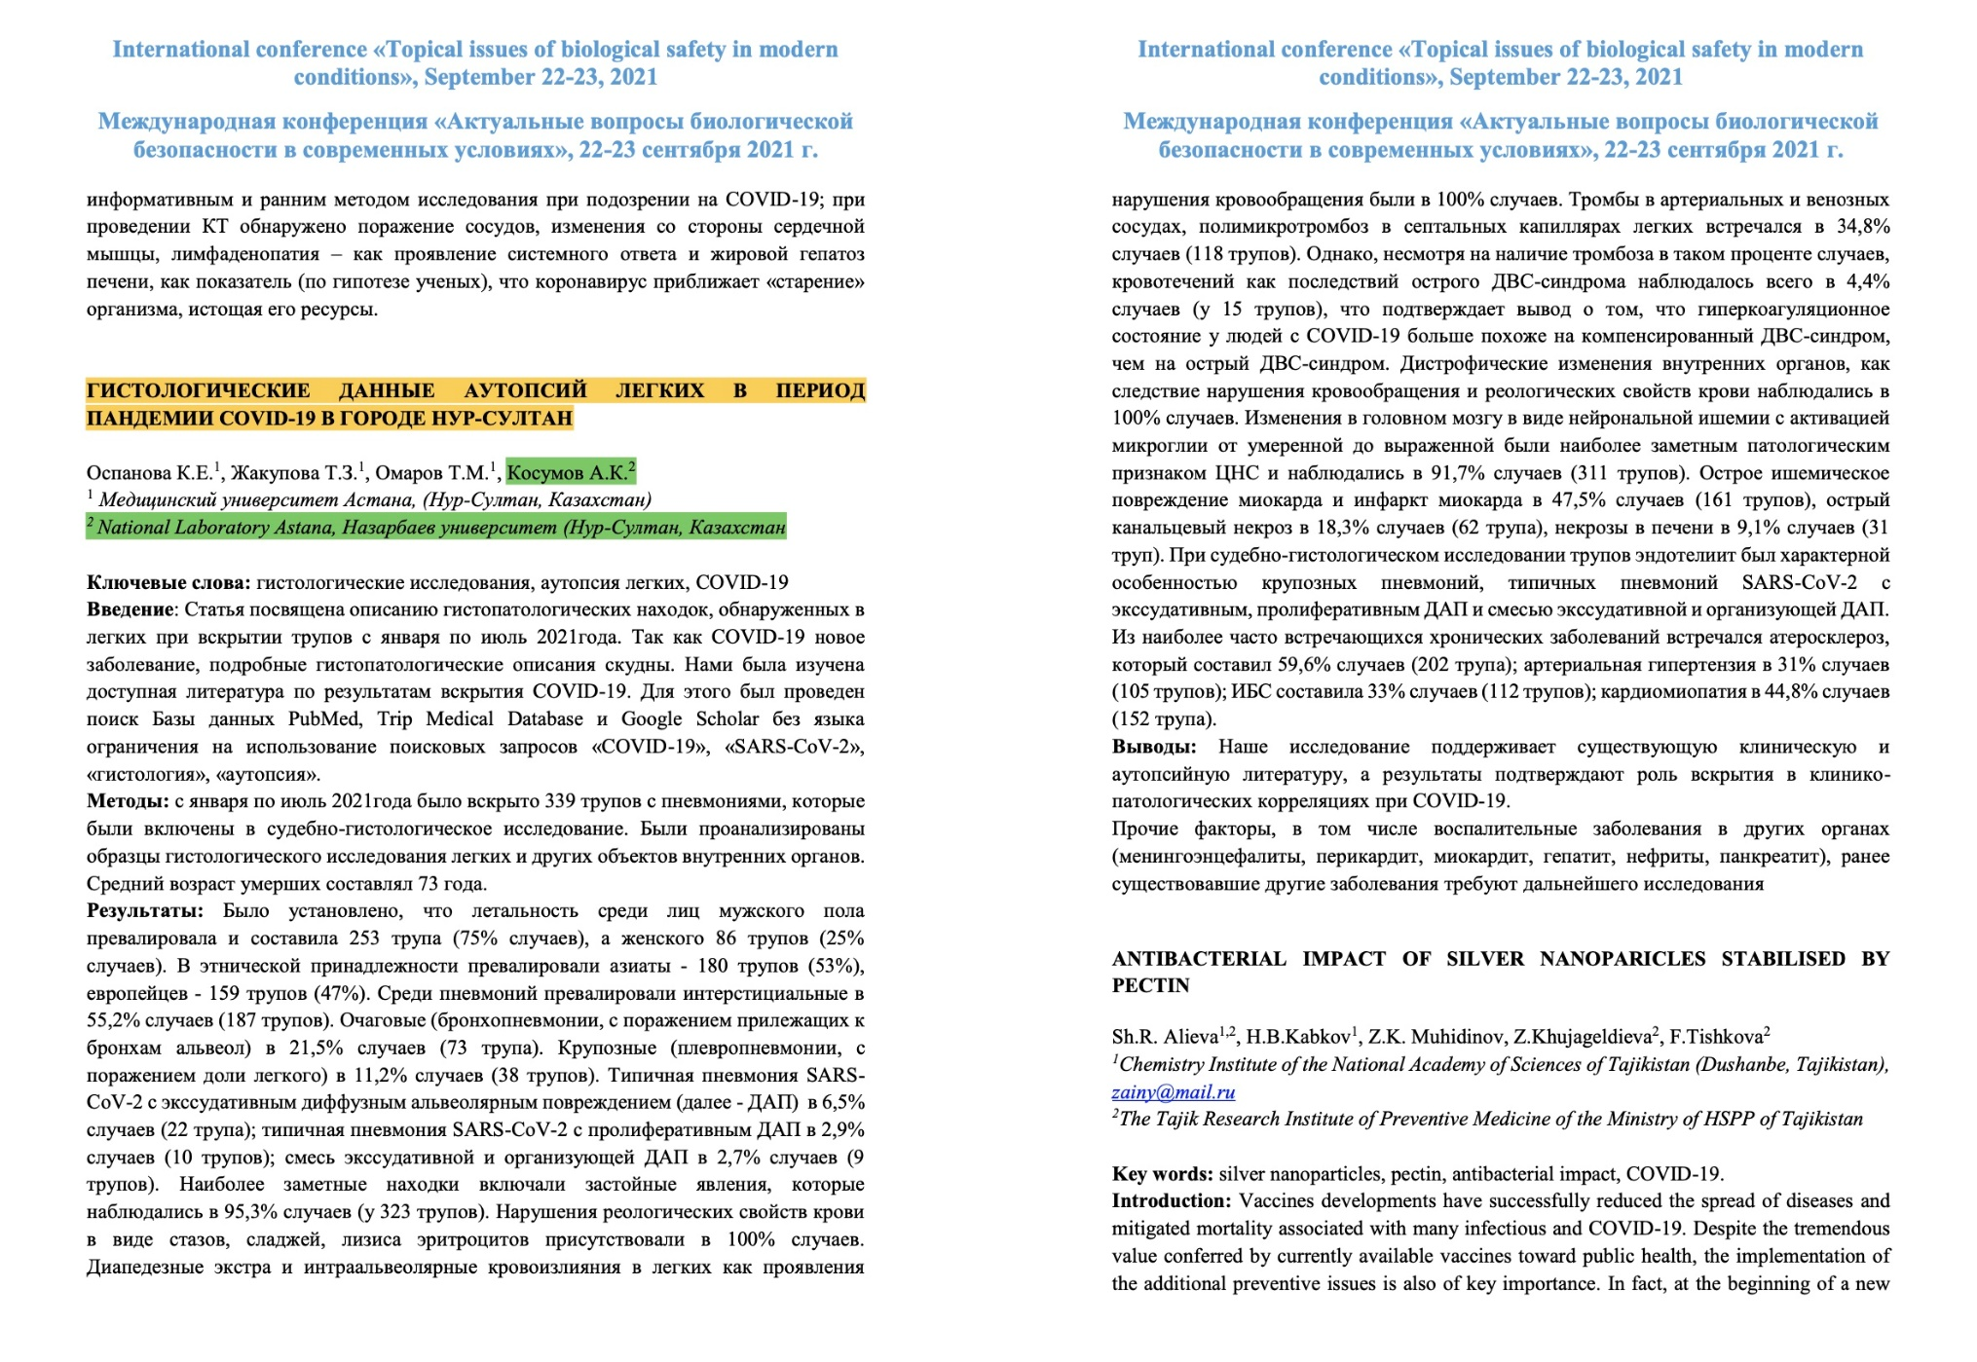
APPENDIX F
Screenshots of t certificates
