AUTONOMOUS ORGANIZATION OF EDUCATION «NAZARBAYEV UNIVERSITY»
(AOE NU)

УДК 82.01.05  ГРНТИ: 005, 006, 35, 658, 338  № госрегистрации:  Инв. № | APPROVE  Provost  AOE «Nazarbayev University»  __________________ I. Adesida  «____»________________2021

REPORT
ON RESEARCH WORK

THE EFFECTIVENESS OF QUARANTINE MEASURES IN LIMITING THE SPREAD OF COVID-19 IN CENTRAL ASIA
(final report)

Principal investigator,  PhD, Assistant Professor  Graduate School of  Public Policy | _____________________ S. Nanovsky

Nur-Sultan 2021
LIST OF RESEARCH CONTRIBUTORS

Principal investigator,  Assistant Professor  Graduate School of  Public Policy,  Nazarbayev University, PhD | __________________________ S. Nanovsky  signature, date (introduction, methodology, results, conclusion)

REPORT
Report 22 p., 2 pic., 2 tables., 9 sources., 1 appendix.
PANDEMIC, LOCKDOWN, STAGE OF EMERGENCY, COVID-19 RESTRICTIONS, NON-PHARMACEUTICAL INTERVENTIONS
The object of the study - in March 2020, one by one, countries closed their borders imposing compulsory quarantine requirements in order to reduce the burden on health systems and stop the spread of the pandemic. The governments of the countries have taken various measures. The countries of Central Asia were no exception. Kazakhstan and Kyrgyzstan registered their first Covid-19 cases around the same dates in March 2020. On March 13, two Kazakh citizens were tested positive on their return from Germany, whereas Kyrgyzstan officially acknowledged positive coronavirus cases in the country on March 18. In Kazakhstan, President Tokayev immediately declared a countrywide state of emergency effective from March 16. The government created a State Commission responsible for ensuring the state of emergency and coordinating the fight against Covid-19 in the country. As for Kyrgyzstan, a countrywide state of emergency was introduced on March 22. Moreover, on March 25, President Jeenbekov announced an even more restrictive regime with curfews in Bishkek.
The goal of the project is to identify the effectiveness of imposed restrictions on the spread of COVID-19 introduced by the Governments of Kazakhstan and Kyrgyzstan. The main argument in this research is that when one studies the data of a country that has recently imposed restrictions, the country might not experience a reduction in new cases, but it should experience a reduction in the growth rate of new cases; this is what should be measured as a success.
Research methods:
The modeling approach taken in this work is empirical with a theoretical drive. It fits a regression model that studies the impact of the non-pharmaceutical interventions (NPIs also known as quarantine restrictions) on the growth rate of new cases. The model can reasonably predict the growth rate and the level of new cases. Lastly a thought experiment is done that shows how new cases would have evolved had NPIs not occurred.
Research results:
Results show that quarantine restrictions influence the growth rate of new cases for Kazakhstan and Kyrgyzstan. Therefore, when one studies the data of a country that has recently imposed restrictions, the country might not experience a reduction in new cases, but it should experience a reduction in the growth rate of new cases; this is what should be measured as a success. A theoretical epidemiological model also confirms that if restrictions do indeed reduce the reproductive number, then this would show as a reduction in the growth rate of new cases in the data.
There are two main limitations worth mentioning. First, as shown in the data, for these two countries the growth rate continues to increase when there are no restrictions and continues do decrease when there are restrictions. The data does not show a maximum or minimum in the growth rate, although in theory this could be reached given both countries reach specific steady states in their corresponding reproduction numbers; this does not appear to be the case.
Furthermore, as the population becomes infected, recovered, and develops immunity, they are removed from being in the susceptible population. As more and more people recover there would be less and less susceptible people who could get infected. This immunity overtime should impact the growth rate in new cases in a negative way as the susceptible population decreases. However, taking into account immunity overtime will overcomplicate this simple model. If one assumes that for a short quarantine period, the susceptible population remains roughly the same then the present results will hold. In the case of the two countries, the official statistics indicate that roughly one percent of the population was ever infected with the virus, and in accordance with the data the growth rate did not tend to decrease without restrictions. Therefore, in this context the decline in the susceptible population overtime was insignificant.
The results of the analysis are presented in two research articles, which are currently being considered for publication in international rating journals.

TABLE OF CONTENT
INTRODUCTION.............................................................................................................  MAIN PART OF THE REPORT......................................................................................  1 NPIs in Kazakhstan and Kyrgyzstan..............................................................................  2 The spread of the pandemic in two countries from March to December.......................  3 Empirical model.............................................................................................................  4 Simulation and counterfactual scenarios........................................................................  CONCLUSION.................................................................................................................  REFERENCES..................................................................................................................  APPENDIX А – Calendar plan......................................................................................... | 6  7  7  11  14  16  17  18  19

INTRODUCTION
Are quarantine restrictions effective? This is a question that everyone wonders about. Intuitively perhaps quarantine restrictions should decrease the number of new COVID-19 cases. Let’s see if this is the case. This work examines the effectiveness of measures to protect against COVID-19 infection by the Governments of two Central Asian countries: Kazakhstan, which introduced periodically strict lockdowns, and Kyrgyzstan, which introduced partial lockdowns.
Like many countries around the world the COVID-19 pandemic has taken its toll on the Central Asian countries of Kazakhstan and Kyrgyzstan. By the end of 2020, Kazakhstan had officially over 150,000 cases and 2200 deaths while Kyrgyzstan had over 80,000 cases and 1300 deaths. To stop the spread of the virus both countries imposed various non-pharmaceutical interventions (NPIs also known as quarantine restrictions). The goal of this research is to evaluate the impact of these various NPIs on the spread of the virus. Picture 1 shows the natural log of new cases from May to December 2020. As can be seen both countries are very similar and have very similar trends in the number of new cases.

MAIN PART OF THE REPORT
- NPIs in Kazakhstan and Kyrgyzstan
Both Kazakhstan and Kyrgyzstan registered their first Covid-19 cases around the same dates in March 2020. On March 13, two Kazakh citizens were tested positive on their return from Germany, whereas Kyrgyzstan officially acknowledged positive coronavirus cases in the country on March 18. In Kazakhstan, President Tokayev immediately declared a countrywide state of emergency effective from March 16. The government created a State Commission responsible for ensuring the state of emergency and coordinating the fight against Covid-19 in the country. As for Kyrgyzstan, a countrywide state of emergency was introduced on March 22. Moreover, on March 25, President Jeenbekov announced an even more restrictive regime with curfews in Bishkek.
The content of preventive measures under a state of emergency was largely similar in Kazakhstan and Kyrgyzstan. The first group of measures related to a restriction of people’s movement. First of all, both countries restricted cross-border movement for citizens as well as for foreigners, except for the personnel of diplomatic services. Operation of public transportation, access to public spaces, and organization of public events and large family gatherings were limited or fully prohibited in both countries. These measures significantly restricted people’s movement internally. The second group of measures restricted the functioning of business objects. The activities of trade and shopping centers, entertainment objects, cinemas and theaters, and etc. were suspended in both countries. Cafes and restaurants were allowed to work for delivery only. Only essential businesses like groceries and pharmacies continued operating during fixed working hours. Finally, the third group of preventive steps related to sanitary and anti-epidemic measures, including disinfection of streets and buildings, installation of hand sanitizers and temperature checks in public places, as well as obliging people to maintain social distance and wear masks.
Although the state of emergency was initially introduced for one month only, it lasted until May 10 and May 11 in Kyrgyzstan and Kazakhstan, respectively, when the governments of these countries started gradually easing some of the restrictions. For instance, a limited number of internal flights and train/bus connections resumed; parks and squares became accessible for people; and some business objects including open-air markets, non-food stores, and cafes and restaurants partially renewed their work.
With the easing of quarantine restrictions, Kazakhstan and Kyrgyzstan witnessed a surge in the growth rate of coronavirus cases from late May and early June. The situation became critical in the second half of June with shortages in hospital-beds, lack of medical equipment and testing kits, and long queues in pharmacies.
The growth rate in Kyrgyzstan reached its peak on June 22, whereas Kazakhstan registered the highest growth rate on June 26. After these dates, we see the decline in the growth rate despite the fact that new restrictions in both countries were introduced in early July only. This decline in growth rate before the introduction of new restrictions could possibly be explained by the serious shortage of Covid-19 testing-kits observed in Kazakhstan and Kyrgyzstan in the last weeks of June and early July. For example, two biggest private laboratories in Kazakhstan suspended a coronavirus PCR testing on June 18. On June 23, the Chief Sanitary Doctor of the country officially recognized the shortage of testing-kits, and asked people to take a test only if they had Covid-19 symptoms. A similarly difficult situation with PCR tests for Covid-19 was reported from Kyrgyzstan too.
Another reason for the decline in growth rates before the beginning of summer lockdowns was perhaps extra caution exercised by the public. In particular, for Kazakhstan starting on June 26th, some regions started to impose restrictions. In the context of such an alarming situation, on June 29, President Tokayev of Kazakhstan criticized the government for its failure to tackle the spread of Covid-19, and ordered to prepare a proposal on the re-introduction of strict lockdown in the country, despite its sensitivity for the economy. The second countrywide lockdown in Kazakhstan started on July 5 and lasted until August 16. It implied that the government had to return again some of the restrictions applied in March-May. Yet, compared to the first lockdown, now people were given access to parks and squares, and some business objects were allowed to function with certain restrictions.
Starting on June 22nd Kyrgyzstan reached over 205 new cases, the highest since the begging of the pandemic; at the same time people were unable to reach the call center. Unlike in Kazakhstan, government officials in Kyrgyzstan refused to go to a countrywide lockdown again despite the seriousness of the situation. On June 30, President Jeenbekov stated that not only the well-being of citizens but also the economy of the country was important. As a result, there was no full lockdown in Kyrgyzstan during the summer of 2020, and many business objects remained operational, though with certain quarantine regulations and curfews. Only targeted additional restrictions were introduced in cities such as Bishkek and Osh in early July, where the most severe situation was observed. For instance, working hours for business objects such as restaurants, cafes, supermarkets, and open-air markets were shortened in these cities (Sputnik 2020a, 2020b). Restrictions also applied to public transportation.
Summer lockdowns lasted until mid-August, when the situation in both countries stabilized. The governments then again started gradually removing some of the restrictions. For example, Kyrgyzstan expanded working hours for some business objects and opened its borders for citizens of several countries starting from mid-August. Similarly, Kazakhstan allowed the work of some business types with strict precursory measures, resumed the operation of public transport with restrictions on weekends, and recommenced international flights in several directions.
During the fall of 2020, the situation in both Kazakhstan and Kyrgyzstan still remained unstable, yet, relatively better compared to the summer period. Given the increase in the number of registered Covid-19 cases in September-November, some experts even predicted the second wave of the pandemic in these countries. In this context, the governments did not rush to announce new country-wide restrictions given their sensitivity to the economy. Instead, a more targeted approach was adopted, meaning that the response was more local and targeted at only those cities and regions, which witnessed a significantly worsening situation. For instance, Kyrgyzstan introduced localized restrictions in the Batken region from September 28, including the suspension of public transportation and more control over the mask regime and social distancing. The government in Kazakhstan was more reactive to the aggravation of the situation during the fall period. Starting from mid-October, regional Chief Sanitary Doctors in several regions of the country had to announce new restrictions due to the increasing number of coronavirus cases. From October 21-24th, the Ministry of Healthcare introduced the zoning system with green, yellow, and red zones and respective restrictions for each zone. On October 24th Nur-Sultan, the capital of Kazakhstan was added to the restriction zone.
Since then, the kind of restrictions to be introduced depends on in which zone a particular city/region is. During November-December, several regions, mostly in Northern, Eastern, and Western parts of the country, appeared in the red zone, but then successfully returned to the yellow and green zones. Although state officials reiterated the possibility of announcing another state of emergency in the country, in practice, the restrictions introduced during the fall period appeared to be much softer, and mostly related to the limiting of working hours for both the public and private sectors; restricting a number of visitors for business objects; restrictions during weekends, including for the public transportation; and also stricter control over the mask regime and social distancing. In other words, compared to the summer period, the fall restrictions in both Kazakhstan and Kyrgyzstan did not significantly paralyze the operation of businesses, the public sector, as well as people’s movement.
Despite a still alarming situation, both Kazakhstan and Kyrgyzstan tried to lift the restrictions sooner than later where it was possible given their high economic cost. Kyrgyzstan, for instance, allowed the opening of cinemas, food-courts, and computer clubs in Bishkek from December 1, as well as lifted restrictions for foreigners coming to the country from December 4. Also, kindergartens and schools opened doors to students of certain grades in Bishkek in the second half of January 2021. Similarly, Kazakhstan re-opened cinemas and some other business objects in those regions/cities with a stable epidemiological situation. Also, schools were allowed to function in a combined format, again, depending on the situation in a particular city or region. All these and other similar easing of restrictions led to another increase in the number of infected cases in March 2021, especially in Kazakhstan.

- The spread of the pandemic in two countries from March to December 2020
Picture 1 shows the number of new cases for Kazakhstan (in red) and Kyrgyzstan (in black) along with a trend line. Quarantine restrictions are given as the vertical lines for both countries. Kazakhstan had a full lockdown from July 5th until August 16th, and zoning restrictions from October 24th onwards, while Kyrgyzstan had a partial lockdown between July 1st and August 15th and further restrictions from September 28th. The vertical bars represent these restrictions. The trend line is the Hodrick-Prescott (HP) filter used to smooth the series. At a first glance it appears that the measures taken did not really influence the number of new cases, at least initially. Although both countries entered lockdown in the beginning of July new cases peaked around July 20th. Further, their lockdowns ended mid-August but new cases continued to decline until mid September. Kyrgyzstan imposed further restrictions late September but its new cases did not start decreasing until the beginning of November. Kazakhstan also imposed zoning restrictions late October but its cases continued to increase.

Picture 1 – New COVID-19 cases with an HP trend

To compute the growth rate of new cases the trend line from the levels time series in Picture 1 is first differenced daily. Along with this growth rate computed from trend is a 2 week moving average of the actual daily growth rates. The results are shown in Picture 2. Both countries had strict lockdowns from late March until mid May. From Picture 2, the growth rate increased in June for both countries and peaked around 10 days prior to the second lockdown. The growth rate then started slowing; as shown in the next section this is perhaps due to lack of testing kits and lockdown announcements in the end of June thus giving the population extra caution. After the lockdown implementations in the beginning of July, the growth rates continued to decrease until the end of the lockdown in mid -August and began increase again afterwards. The increase continued until a few days after the countries’ respective third wave of restrictions in September 28, and October 24; a few days after the imposition of these the growth rate began to gradually decrease again. Overall it appears that the restrictions fit much better with the growth rates rather than the levels series.
In particular, they gradually reduce the growth rate of new cases; the growth rate eventually turns negative and that is when the reduction in the levels of new cases actually occurs. Theoretically, in the context of epidemiological models, it is argued that the growth rate of new cases is related to the reproduction number and that is what is gradually reduced during NPIs.

Picture 2 - Growth rate of new cases: two week moving average and first difference of
HP trend line

The most effective restrictions were the summer lockdowns for both countries. The growth rate in Kazakhstan dropped roughly from .04 (or 4% increase in new cases per day) in the begging of July to -.08 (or an 8% decrease in new cases per day) in the middle of August. This is a 12 percentage point drop. On the other hand, for Kyrgyzstan the growth rate dropped from .06 in the begging of July to -.06 in the middle of August. This is again a 12 percentage point drop. Interesting enough, although it appears that the summer quarantines were just as effective for both countries, Kazakhstan had a very strict quarantine with many business closures while Kyrgyzstan only had a partial quarantine. As of April 2021 both countries have seen an explosion in new cases. Therefore, as a policy recommendation it is not necessary to have a very strict quarantine. The partial quarantine imposed by Kyrgyzstan will work just as well.

- Empirical model
As seen from the graphs, and as derived from theory (in the appendix) it appears that the quarantine restrictions are able to gradually decrease the growth rate of new cases g. In this case the change in the growth rate (the acceleration) of new cases should be negative when a restriction is imposed. Therefore, what is modeled is the daily change in the growth rate of new cases for both countries:

$$∆g_{t}=α+β_{1}NPI1_{t}+β_{2}NPI2_{t}+β_{3}A_{t}+e_{t}$$ | (1)

where $∆g_{t}$ is the daily change in the growth rate computed from an HP filtered daily time series as indicated in Pic.2.
$NPI1_{t}$ is a dummy variable coded as 1 during the summer lockdown days.
$NPI2_{t}$ is a dummy variable coded as 1 during the fall restrictions period for both countries.
$A_{t}$ is the announcement period that occurred at the end of June for both countries. It is coded as 1 at 10 days before the countries’ respective summer lockdowns. As argued above, this was a time of increased caution due to a new peak in cases and lockdown announcements. Further this period experienced a shortage of CPR tests in both countries.
The coefficients also have an interesting interpretation:
α - is the constant and represents the daily gradual increase in the growth rate without any quarantine restrictions.
$β$ - represent the daily additional impact of quarantine. Whenever a quarantine is in place for the day it additionally (relative to the day prior) reduces the growth rate by β points for that day on average. The average daily net effect of reduction is α+β.
Table 1: Model Estimates
 | Variables | (1) Kazakhstan |  | (2) Kyrgyzstan
 | Variables | Growth rate  ∆g | Net effect alpha + beta | Growth rate  ∆g | Net effect alpha + beta
 | NPI summer | -0.00494***  (0.000146) | -.00283***  (.00012) | -0.00591***  (0.000258) | -.00292***  (.0002)
 | NPI fall | -0.00375***  (0.000227) | -.00164***  (0.00021) | -0.00408***  (0.000212) | -0.00109***  (0.00014)
 | Announce | -0.00265***  (0.000186) | -.00055***  (.00016) | -0.00480***  (0.000373) | -00181***  (0.00034)
 | Constant | 0.00211***  (8.79e-05) |  | 0.00299***  (0.000158)
 | Observations | 184 |  | 184
 | R-squared | 0.847 |  | 0.792
Note - Robust standard errors in parentheses
***p<0.01, **p<0.05, *p<0.1
As seen in the pictures, May was a very volatile month in terms of growth rates. Therefore, the model is run for six months from June 1st until December 1st for both countries. The results are shown in table 1. As can be seen the average daily increase in the growth rate without quarantine was .00211 and .003 for Kazakhstan and Kyrgyzstan respectively. The average daily impact of the first quarantine on the reduction of the growth rate for Kazahstan was -.00494 per day (or -.494 percentage points). The net effect (after accounting for the natural increase in the growth rate was) -.00494+.00211 = -.00283. Similarly for Kyrgystan the impact of the first quarantine was a reduction of -.00591 and a net effect was -.00591 + .003 = -.00292. The rest of the coefficients can be similarly interpreted. Notice that the impact of quarantine in Kyrgyzstan was larger (more negative) than Kazakhstan although Kyrgyzstan never had a full lockdown! This indicates that the partial lockdown with curfews was just as effective. The rest of the coefficients may be similarly interpreted. It can be seen that the fall restrictions were less effective in reducing the growth rate.
How well do NPIs explain the growth rate of new cases? As can be seen the R squared in the regressions from Table 1 is close to .85 and .8, indicating that the NPIs explain 85% and 80% of the variation in the growth rate in new cases for Kazakhstan and Kyrgyzstan respectively.

- Simulation and counterfactual scenarios
It is also possible to do simulations of the model to predict the growth rate. Given starting values of the growth rate in early June the model can solve for all future growth values. Similarly, given starting values of the growth rate and new cases the model solves for all trend new cases until December.
Due to the dynamic nature of the solution (the previous value is used to solve the future value) the simulated values closer to the initial value (in June) will be closer to the actual. The model appears to be pretty good fit for the data considering that it is only based on the variation of NPIs.
What will be the impact on new cases if NPIs were never implemented? In the counterfactual scenario the growth rate of new cases is assumed to stay constant and is at the level of growth at the time of implementation of the NPI. In it, if the summer lockdown did not occur, Kazakhstan registers 6,000 cases per day while Kyrgyzstan 10,000 per day by the mid August. In the fall scenarios, by December first, Kazakhstan registers 2,500 while Kyrgyzstan 5,000 cases per day. Table 2 shows the difference between the counterfactual and actual levels depending on the day after NPI is imposed. As can be seen, the totals are significant in magnitude. If NPIs were not implemented, by the end of 2020, Kazakhstan would have roughly fifty percent more cases while Kyrgyzstan would have twice as many.
Table 2: Difference of counterfactual to actual (number of additional cases due to removal of NPIs)
 | Summer |  | Fall
Starting growth | 0.034 | 0.064 | 0.069 | 0.057
Day after NPI | Kazakhstan | Kyrgyzstan | Kazakhstan | Kyrgyzstan
5 | 45 | 42 | -4 | -2
10 | 212 | 197 | -5 | -7
15 | 552 | 534 | 22 | -5
20 | 1086 | 1110 | 118 | 20
25 | 1807 | 1964 | 323 | 93
30 | 2675 | 3128 | 679 | 237
35 | 3644 | 4668 | 1234 | 469
40 | 4683 | 6713 |  | 803
45 |  | 9454 |  | 1258
60 |  |  |  | 3710
Total | 73755 | 118887 | 13687 | 65057
Days | 42 | 45 | 38 | 64
Notes
1 Total additional counterfactual cases Kazakhstan = 87,442
2 Total additional counterfactual cases Kyrgyzstan = 183,944

CONCLUSION
The results of the model indicate that both rounds of summer and fall NPIs were effective in decreasing the growth rate of new cases gradually. The paper further explores the impact and magnitude of the different restrictions provided in Table 2. The empirical model fits reasonably well. NPIs explain 80% and 85% of the variation in the growth of new cases for Kazakhstan and Kyrgyzstan respectively. Further the model is simulated and provides a good fit with the actual growth rate and levels data for both countries. Conclusions based on a conservative counterfactual scenario indicate that if the countries had not imposed NPIs, Kazakhstan would have fifty percent more cases while Kyrgyzstan would have had twice as many cases in 2020.
In accordance with the estimates from the summer, the partial lockdown in Kyrgyzstan was slightly more effective than the full lockdown in Kazakhstan in the reduction of the growth rate. As Kazakhstan and Kyrgyzstan are similar countries, evidenced by their very similar trends in the number of new cases, it can be reasoned that they would both react a similar way due to policies. Therefore, in accordance with the results a partial lockdown is just as effective as a full lockdown. The policy recommendation is indeed have NPIs to reduce the spread of the virus; however, a full lockdown is not necessary, a partial lockdown is just as effective. The partial lockdown imposed by Kyrgyzstan let businesses such as restaurants and shopping centers continue to operate but with curfews; there were closures however on cinemas, bars, karaoke, nightclubs, and fitness gyms. Perhaps these are locations more prone to spreading the virus. The results of the work are presented in two articles, which are currently being considered for publication in international rating journals:
- Nanovsky, S. Are quarantine restrictions effective at reducing the growth rate of COVID-19 in Central Asia? // BMJ Open
- Nanovsky, S., Arynov, Zh., Alzhanova, A. The Impact of Non-Pharmaceutical Interventions on the Growth Rate of New COVID-19 Cases: Evidence from Kazakhstan and Kyrgyzstan. // Epidemiology and Infection

REFERENCES
- Ajide KB, Ibrahim RL, Alimi OY. Estimating the impacts of lockdown on Covid-19 cases in Nigeria // Transportation Research Interdisciplinary Perspectives. – 2020. – No. 7, 100217.
- Alfano V, Ercolano S. The efficacy of lockdown against COVID-19: a cross-country panel analysis. // Applied Health Economics and Health Policy. – 2020. – No. 18 – P. 509-517.
- Chaudhry R, Dranitsaris G, Mubashir T, Bartoszko J, Riazi S. A country level analysis measuring the impact of government actions, country preparedness and socioeconomic factors on COVID-19 mortality and related health outcomes. // EClinicalMedicine. – 2020. – No. 25, 100464.
- Flaxman S, Mishra S, Gandy A, Unwin HJT, Mellan TA, Coupland, Whittaker C, Zhu H, Berah T, Eaton JW, Monod M, Bhatt S. Estimating the effects of non-pharmaceutical interventions on COVID-19 in Europe. // Nature. – 2020. – No. 584(7820). – P. 257-261.
- Hyafil A, Moriña D. Analysis of the impact of lockdown on the reproduction number of the SARS-Cov-2 in Spain. // Gaceta Sanitaria. - 2020.
- Lai S, Ruktanonchai NW, Zhou L, Prosper O, Luo W, Floyd JR, Wesolowski A, Santillana M, Zhang C, Du X, Yu H, Tatem AJ. Effect of non-pharmaceutical interventions to contain COVID-19 in China. // Nature. – 2020. – No. 585(7825). – P. 410-413.
- Roques L, Klein EK, Papaix J, Sar A, Soubeyrand S. Impact of lockdown on the epidemic dynamics of COVID-19 in France. // Frontiers in Medicine. – 2020. – Vol. 7. – No. 274.
- Siqueira CADS, Freitas YNLD, Cancela MDC, Carvalho M, Oliveras-Fabregas A, de Souza DLB (2020). The effect of lockdown on the outcomes of COVID-19 in Spain: An ecological study. // Plos One. – 2020. – No. 15(7), e0236779.
- Timelli, L, Girardi E. Effect of timing of implementation of containment measures on Covid-19 epidemic. The case of the first wave in Italy. // Plos One. – 2021. – No. 16(1), e0245656.

APPENDIX А

Calendar plan

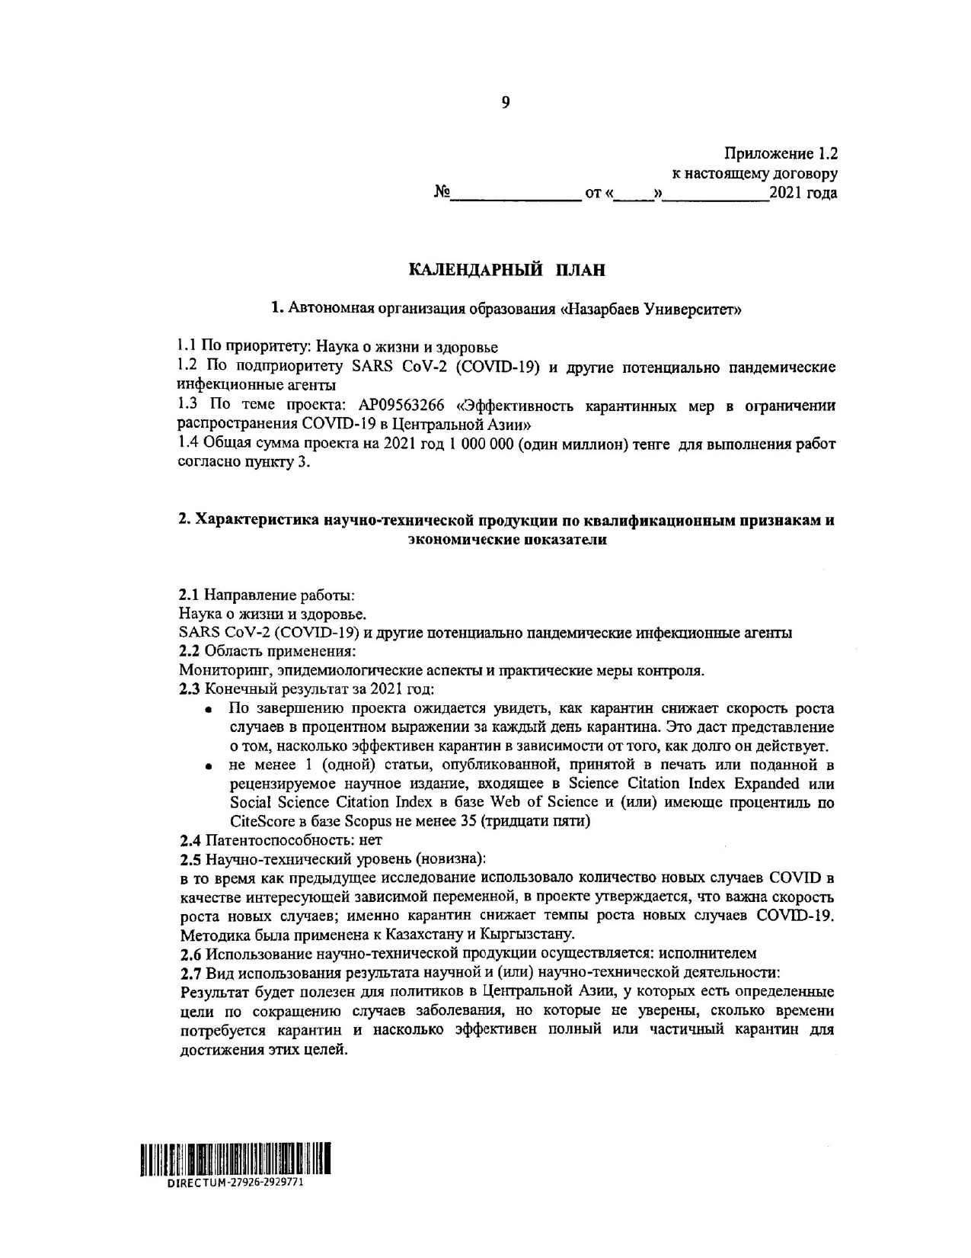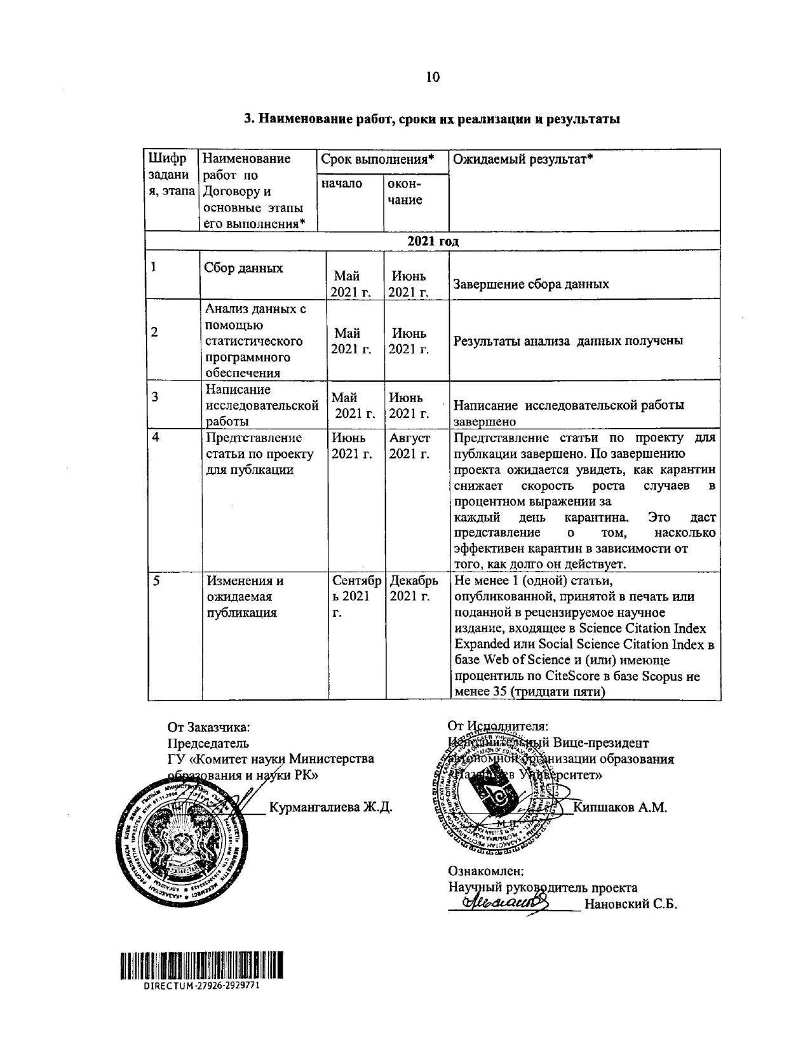

Appendix 1.2

to this agreement

#________ dated “___” _________2021

Calendar plan

1. Autonomous Organization of Education «Nazarbayev University»

1.1 Priority: Life science and health

1.2 Sub-priority SARS CoV-2 (COVID-19) and other potentially pandemic infectious agents

1.3 Topic of the project: AP09563266 “The Effectiveness of Quarantine Measures in Limiting the Spread of COVID-19 in Central Asia”

1.4 Total amount of the project for 2021 is 1 000 000 (one million) tenge for the performance of work in accordance with clause 3.

2. Characteristics of scientific and technical solutions by qualification characteristics and

economic indicators

2.1 Focus area:

Life science and health.

SARS CoV-2 (COVID-19) and other potentially pandemic infectious agents

2.2 Application field:

Monitoring, epidemiological aspects and practical control measures.

2.3 Final results for 2021:
- upon project completion, it is expected to see how quarantine measures reduces the growth of cases in percentage points per day. This will give an idea of effectiveness of quarantine measures.
- at least 1 (one) article published, accepted for publication or submitted to the international rating journals, included in Science Citation Index Expanded or Social Science Citation Index in Web of Science database and (or) having CiteScore percentile in Scopus database of not less than 35 (thirty-five)

2.4 Patentability: no

2.5 scientific and technical level (novelty):

while the previous study considered the number of new COVID cases as the dependent variable, the project argues that the rate at which new cases grow is important; it is quarantine measures that reduces the growth rate of new cases of COVID-19. The model was applied to Kazakhstan and Kyrgyzstan.

2.6 The use of scientific and technical solutions is carried out: by the principal investigator

2.7 Applicability of the obtained scientific and technical work:

The result will be useful for policymakers in Central Asia who have specific targets to reduce number of cases, but who are not confident about duration of quarantine and how effective will be full or partial quarantines restrictions.

3. Name of work, terms of implementation and results

Task code, stage | Name of works under the Agreement and main stages of its implementation* | Period of implementation* |  |  | Expected result*
Task code, stage |  | start |  | end

2021
1 | Data collection |  | May 2021 | June 2021 | Ending of data collection process
2 | Data analysis using statistical software |  | May 2021 | June 2021 | Results of data analysis obtained
3 | Writing research paper |  | May 2021 | June 2021 | Research paper completed
4 | Present article for publication |  | June 2021 | August 2021 | Submit article for publication. Upon completion of the project, it is expected to see how quarantine measures reduces the growth rate of cases in percentage points per day. This will give an idea of effectiveness of quarantine measures.
5 | Changes and expected publication |  | September 2021 | December 2021 | At least 1 (one) article published, accepted for publication or submitted to the international rating journals, included in Science Citation Index Expanded or Social Science Citation Index in Web of Science database and (or) having CiteScore percentile in Scopus database of not less than 35 (thirty-five)

For and on behalf of the Ordering Party:  Chairman  SA “Committee of Science of the  Ministry of Education and Science  of the Republic of Kazakhstan”  Kurmangalieva Zh. D.  [signature, stamp] | For and on behalf of the Contractor:  Executive Vice President  AOE “Nazarbayev University”  Kipshakov A.M.  [signature, stamp]  Read and understood:  Principal investigator  Nanovsky S.B.  [signature]

